GROUND TIRE RUBBER (GTR) CONSTRUCTION REPORT, SH-3 Canadian County
Project No.: SPRY-0010(73)RS, Job Piece No.: 01946(72)
Task Order 2400-19-04, Bryan W. Cooper
JUNE 18, 2019

PRE-WORK
The project is located on SH-3 in Canadian County, beginning at SH-4 near Piedmont and proceeding west toward Okarche. The project is 6 miles in length and is a four-lane divided facility.
A Pre-work meeting was held at the Division 4 Annex in Oklahoma City, Oklahoma on March 1, 2019 to discuss the upcoming project that would incorporate a recycled Ground Tire Rubber (GTR) into the asphalt mix design, producing a Dry Process Rubberized Asphalt, for a demonstration project. Partial funding for the project came through Oklahoma’s State Transportation Innovation Council’s (STIC) Incentive Grant Program.
During the pre-work meeting, Dr. Redmond Clark of Asphalt Plus, LLC, gave a brief presentation about GTR. GTR is an Engineered Crumb Rubber and is considered a dry process. The GTR is injected through what Dr. Clark called a RAP Collar into the drum at the asphalt plant and creates something that is similar to a polymer and is equal to a 70-28 mix design and replacing the polymer. GTR is shipped in bulk bags that weigh 2,100 lbs. each. Dr. Clark said that it is an ISO compliant manufacturing process; which is a quality control system; and it has reliable flow characteristics through a precision pneumatic injection system. The process has a maximum plant output of 400 Tons per hour. GTR does not create any build-up in the plant process and runs at the normal plant operating temperatures, running at about 325º. GTR will meet the required compaction specifications.
The mean size of the rubber particles is 1/50th of an inch. GTR reduces the binder costs by $2.00 per mix Ton. It reduces or eliminates workability agents and anti-stripping additives. GTR eliminates the use of fibers and creates less waste. It reduces the number of roller passes and reduces or eliminates slip-aids.
Dr, Clark also stated that the material should come off of the truck at about 275º and trucking times would be 20-40 minutes per load. The properties of the rubber tends to incorporate a self-healing aspect to the cracking in the pavement.
The Oklahoma Department of Environmental Quality (DEQ) has been well represented in STIC for several years as they have a large interest in the highway construction industry. DEQ has long advocated for finding ways to recycle waste materials in the course of constructing highways, and have a huge interest in finding ways to rid the environment of waste tires.

PRE-GTR CONSTRUCTION PHASE
Cummins Construction was awarded the contract for the project, with Action Safety contracted for the signing and traffic control. The GTR Supplier is Asphalt Plus, LLC, represented by Dr. Redmond Clark. The project was slated for 90 calendar days and the contract start date was March 4, 2019. The signing and traffic control began on March 11, 2019. Construction of the GTR Section was scheduled to begin toward the end of project. The polymer based portion of the construction was begun on March 18, 2019 with a 4” milling operation.
The existing highway was plagued with some very wide and deep cracks, going all the way through the base and the subgrade and appeared pretty consistently at intervals of probably 50 to 100 feet throughout the entire project. Some of the cracks had opened to about a 2” to 4” gap throughout the project. See Figure 1.

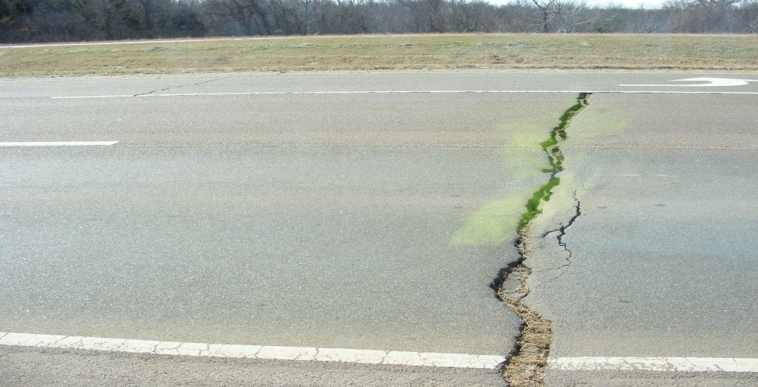
FIGURE 1
The Contractor’s preparation of the cracking will play a significant role in the performance of the pavement in this project. After the milling of the surface, it was swept and workers blew off the dust with blowers. The cracks were then filled with asphalt by hand and compacted with a roller. The crew then took a blow torch and melted the asphalt into the cracks. The next step was to place a 12” strip of PetroMat over the heated asphalt on each crack. See Figures 2, 3, and 4.
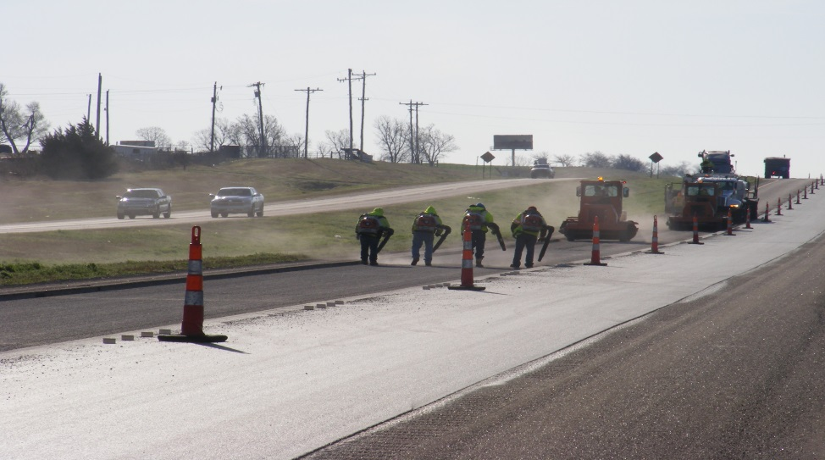
FIGURE 2

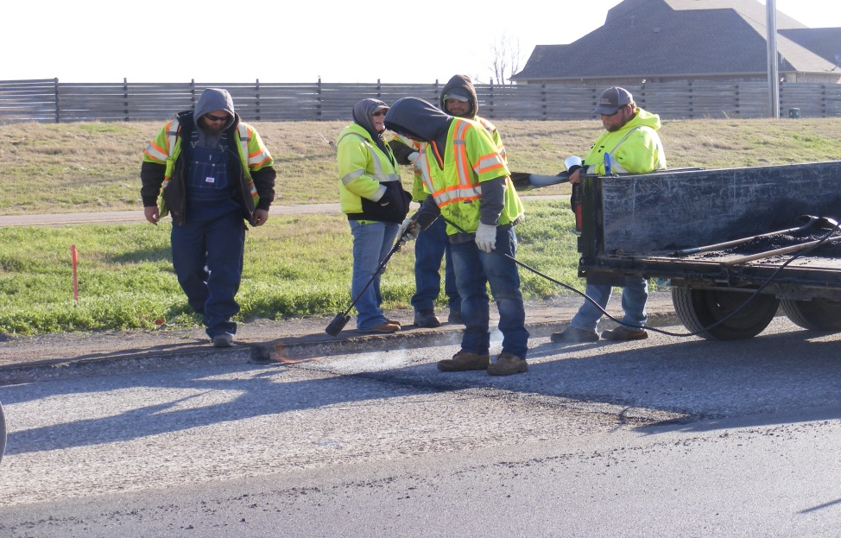
FIGURE 3

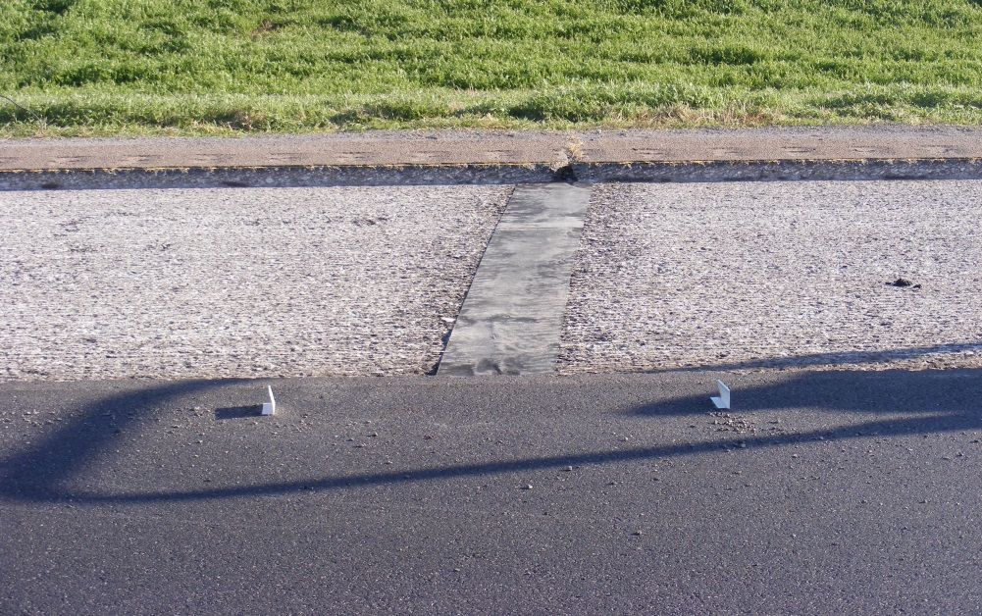
FIGURE 4

The next phase in the construction was to place what has been termed as a Rich Intermediate Layer (RIL) of asphalt. The RIL is a 2” layer of asphalt with a 6-7% binder content.
In addition to being a STIC Incentive Project, a Task Order was also issued for Dr. Kelvin Wang of Oklahoma State University, to perform scans of the roadway using the PaveVision 3D Ultra System van. They will be collecting data on cracking and rutting and will also collect the pavement macro-texture with an AMES Profiler. They wil also be deploying the LS-40 Surface Scanner. OSU made their initial pre-construction road scan in March 2019.
The weather has played a significant role in this project as it has created some delays throughout the process. The state of Oklahoma has experienced record rainfall amounts around the state. The Oklahoma City metro area has had its fair share of rainfall, but the Muskogee area has been dealing with flooding of historic proportions, some say maybe even in the 500 year range. The significance of the event in Muskogee is that the plant that supplies the polymer for the RIL was under water and trucks could not get into that facility to pump it into the trucks. This caused a delay of about a week.
One other aspect of the project is that there are a lot of other interested parties looking at this project. We have asked our Video Production unit to record and produce video of the project. They have been involved throughout the entire process. Mr. Eric Leslie of ODOT’s Video Production Branch conducted on-camera interviews with Dr. Redmond Clark and myself, Bryan Cooper, on June 4, 2019. He also interviewed the asphalt plant manager for Cummins Construction. It was also decided that we would place some signs on the Right-of-Way, denoting the beginning and end of the GTR section, which have been fabricated. See Figure 5.

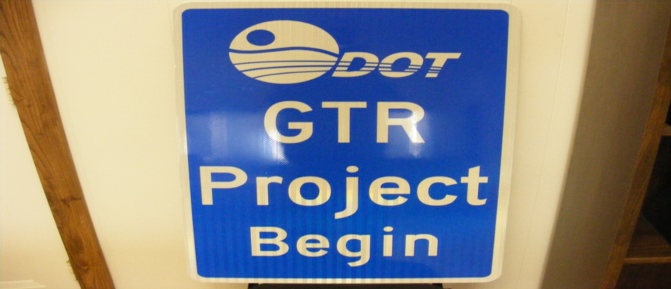
FIGURE 5

GTR CONSTRUCTION PHASE
Dr. Redmond Clark of Aspalt Plus, along with some of the company’s other personnel, arrived at the Cummins’ asphalt plant on June 13, 2019 to attach the Fiber Machine to the asphalt plant and to calibrate it. The Fiber Machine was attached to a port on the side of the large rotating mixing drum. There was also a controller that was set up in the plant operator’s control booth, that monitors the rate of the injection of the GTR product into the asphalt mix. See Figures 6 and 7.
Those present during the day of construction were the Oklahoma Asphalt Pavement Association (OAPA), The University of Oklahoma, The University of Missouri, Texas Department of Transportation, APAC, and TJ Campbell Construction. The Universities were on hand to collect samples for further testing and research.

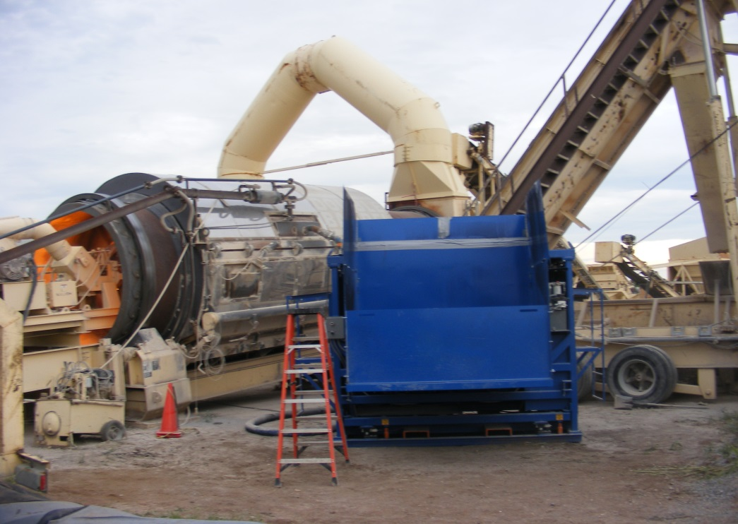
FIGURE 6

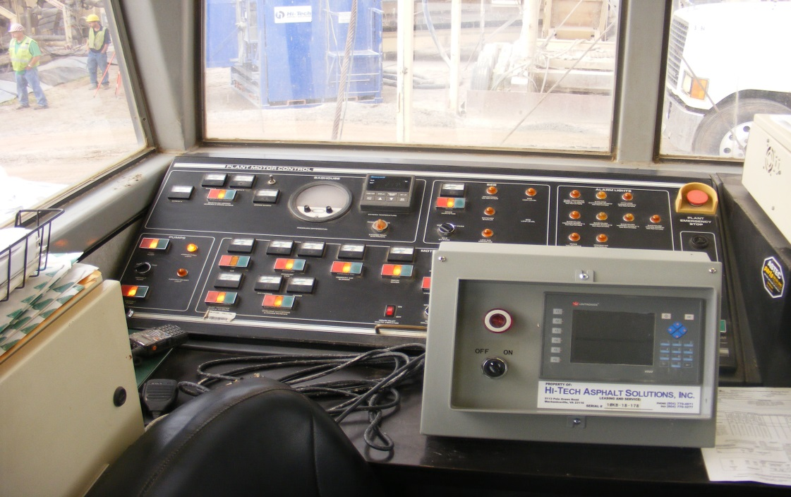
FIGURE 7

The construction of the GTR section began on Friday, June 14, 2019. Mr. Kevin Suitor, Bituminous Engineer, Materials Division, of the Oklahoma Department of Transportation (ODOT), Larry Patrick, Executive Director of the OAPA, and me met at Cummin’s asphalt plant around 7:15 am that morning. The weather was cloudy and the air temperature was 65º. My first order of business was to survey the equipment at the plant. The Pug Mill is an ASTEC Super Six Pack Plant, Model Number SEB-7536. See Figure 8. The Fiber Machine that Asphalt Plus had delivered to the plant is manufactured by Hi-Tech Asphalt Solutions, Inc. 5113 Pole Green Road, Mechanicsville, Virginia, 23116. The Fiber Machine has a double auger system that keeps the rubber loose in the machine and has + or – 1% regulation of the weight of the material over 1 minute. The monitoring system was supposed to take about 500 measurements during the entire process. The GTR additive was around 5% of the asphalt mixture. The plant was producing asphalt at 325º.
There were 7 - 2,100 lb. bags delivered to the plant, but only 2 were required for the entire job. The remaining bags will be shipped back to Asphalt Plus. The day was begun by producing the polymer based asphalt. The GTR production began at 9:30am. During the transition, the 1st truck had ½ load of polymer based and ½ load of GTR. This truck was not counted as the beginning of the GTR section. The next truck, Stan’s Asphalt and Construction, USDOT No. 893304 was the first full truck and counted as the beginning of the GTR section. Once this truck left the yard, I followed to the job site. GTR started coming out of the laydown machine at 10:02am. See Figure 9.

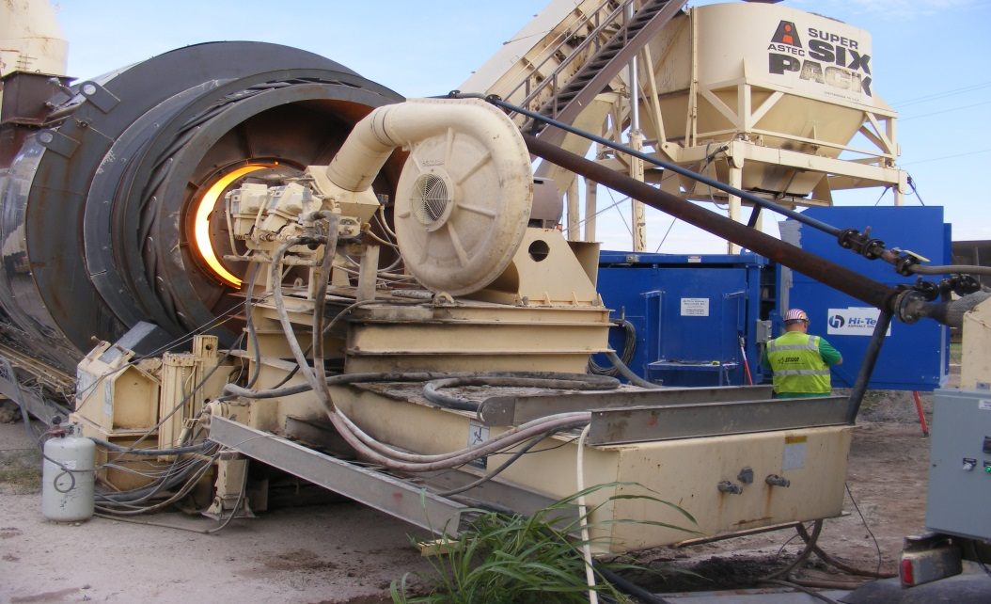
FIGURE 8

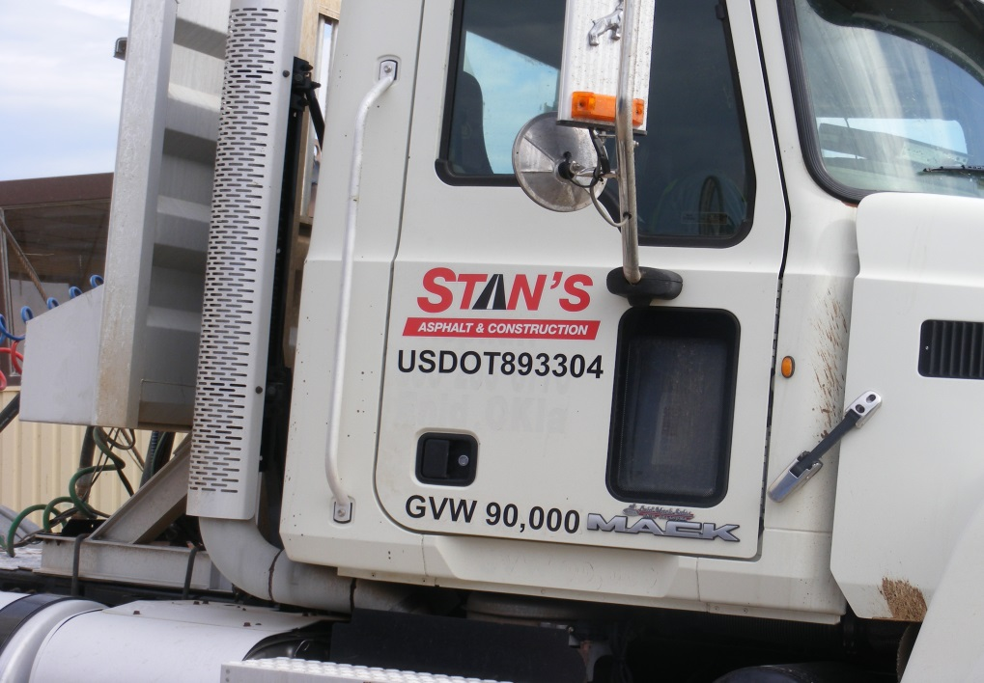
FIGURE 9
Once the GTR began to come out of the laydown machine, I obtained the GPS coordinates of the beginning of the section. The reading was N 35º 37’ 53.7” W 97º 48’ 22.7” and at station 132+97. The temperature on the mat at the laydown machine was 297º. The thickness of the GTR overlay was 2”.
During the course of construction, I did a survey of all of the equipment that was being used in the construction project. I also have provided photographs of the various pieces of equipment. See Table 1.
TABLE 1
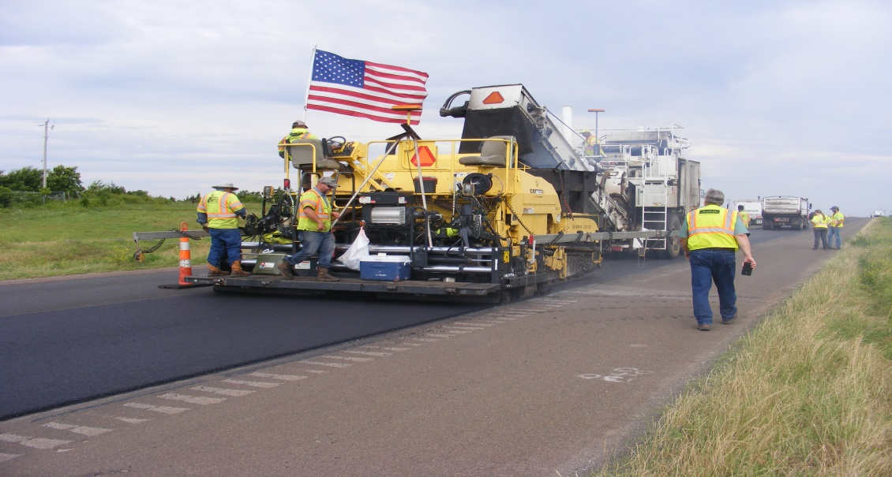
FIGURE 10 LAYDOWN MACHINE
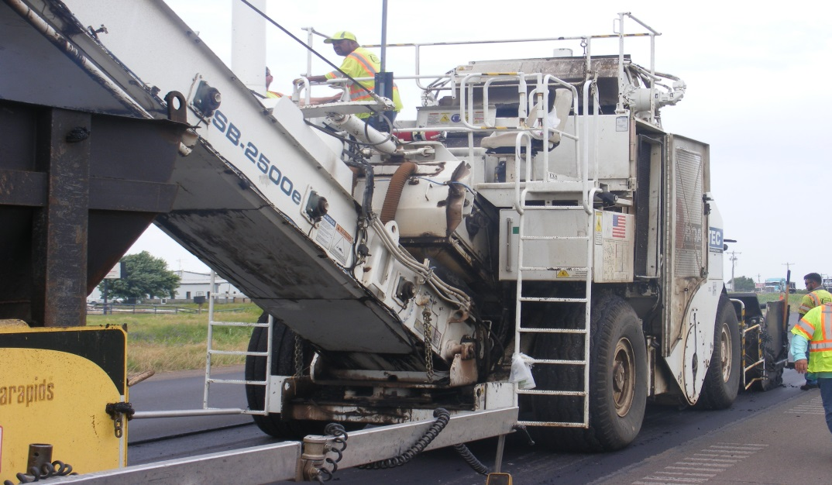
FIGURE 11 SHUTTLE BUGGY

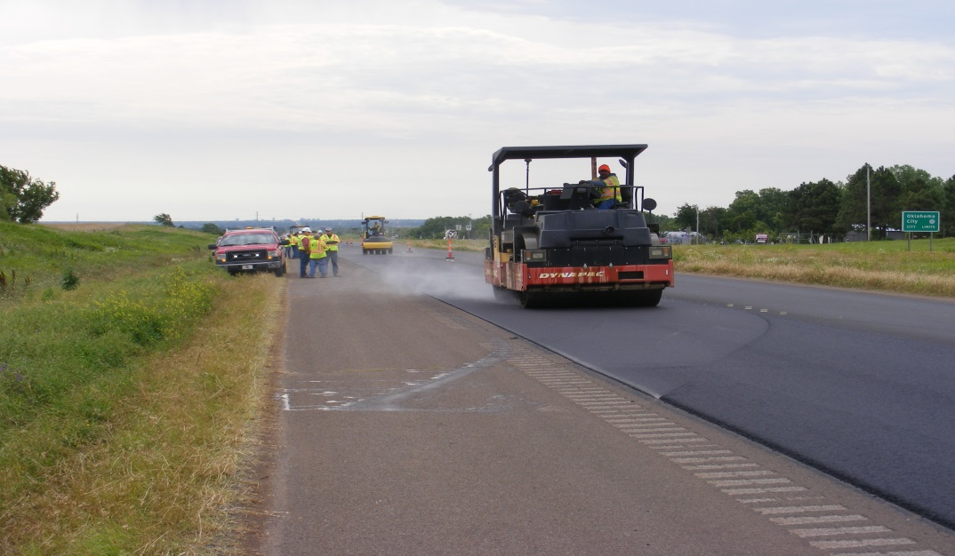
FIGURE 12 BREAKDOWN ROLLER
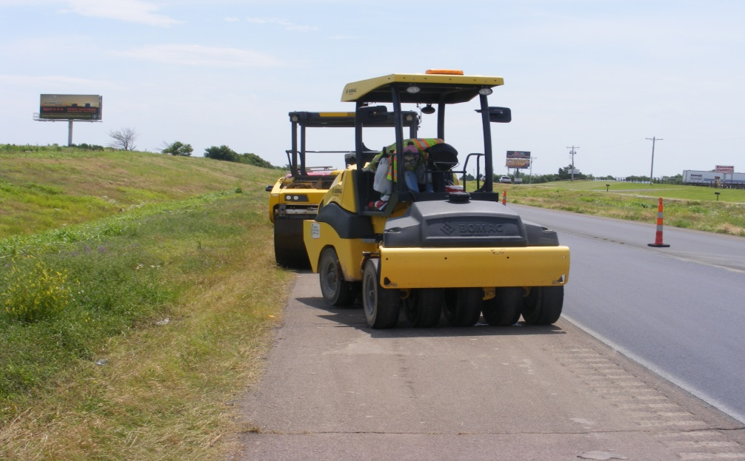
FIGURE 13 PNEUMATIC TIRE ROLLER

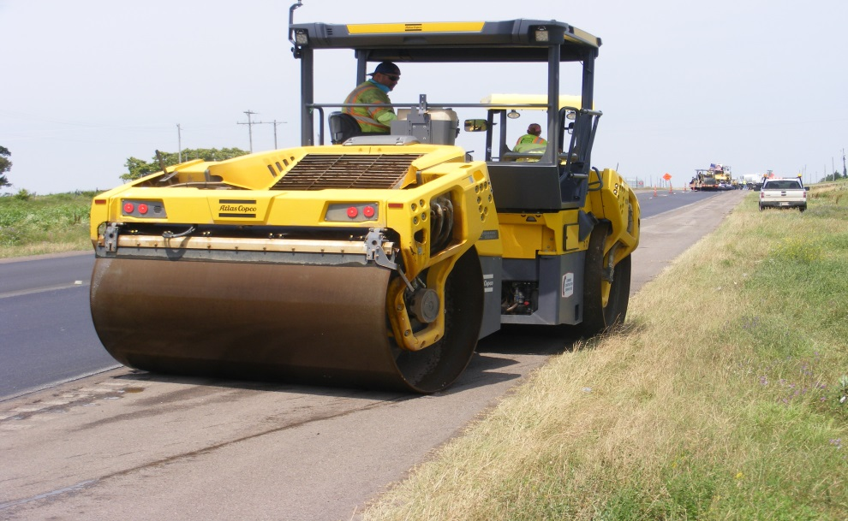
FIGURE 14 STEEL DRUM FINISH ROLLER

One anomaly did occur during the course of the paving operation. A 15” piece of what appeared to be a piece of tire tread or some other piece of rubber; came out of the laydown machine into the asphalt mat. One of the construction workers quickly raked the piece out from the mat. Dr. Clark said that it must have made it into the GTR after processing because of their extensive filtering of the material. See Figure 15.

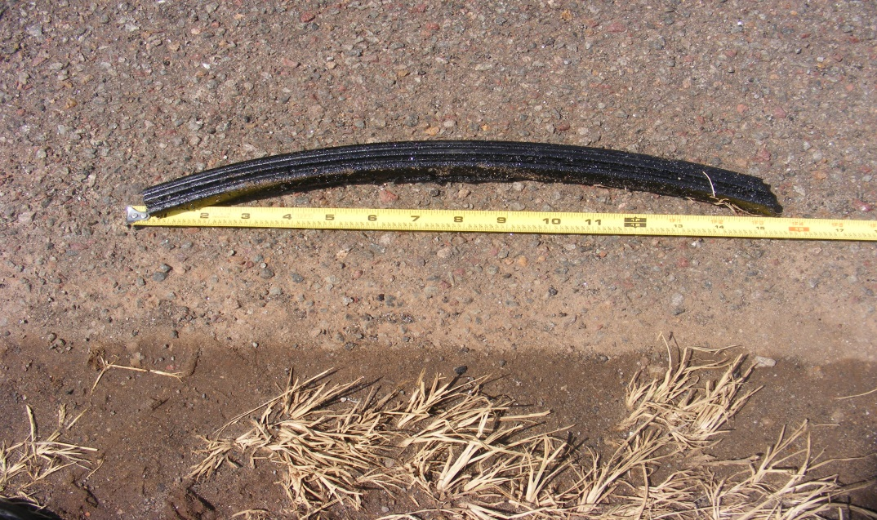
FIGURE 15

Around 12:00pm, Dr. Clark informed me that during the polymer based phase of the construction that it was requiring 7 passes of the roller to get to the breakdown point. One of the advertised benefits of the GTR product is that it reduces the number of roller passes. In this case it was reduced to 5 passes; a 30% reduction. It supposedly reduces costs, but we debated in our office about where the savings is realized. The rollers are still deployed and burning fuel, waiting for the procession of the paving train. The only conclusion that we could come to was that perhaps the reduction would be reflected in the overall bid.
During construction I randomly noted some of the temperatures that Dr. Clark was recording from every truck. He was collecting the temperature at the truck and at the mat, coming out of the paver. I was also recording the GPS location of each truck and relaying the reading to Dr., Clark for his data sheet, until my GPS unit began to fail to acquire the satellites in the sky. We had collected the GPS data on about 2/3 of the trucks that had come, so Dr. Clark felt comfortable in estimating the rest of the locations. I was able to calculate that each truck contained enough GTR to pave about 169’. I have supplied a table of the random temperatures that were recorded from the process. See Table 2.

TABLE 2
One other thing that was observed and noted was that Cummins had a water truck on the project that periodically would be deployed to the shuttle buggy. The shuttle buggy has a misting system that sprays water on tires that are next to the asphalt trucks. The water minimizes the build-up of asphalt on the tires through the paving process. See Figure 16.
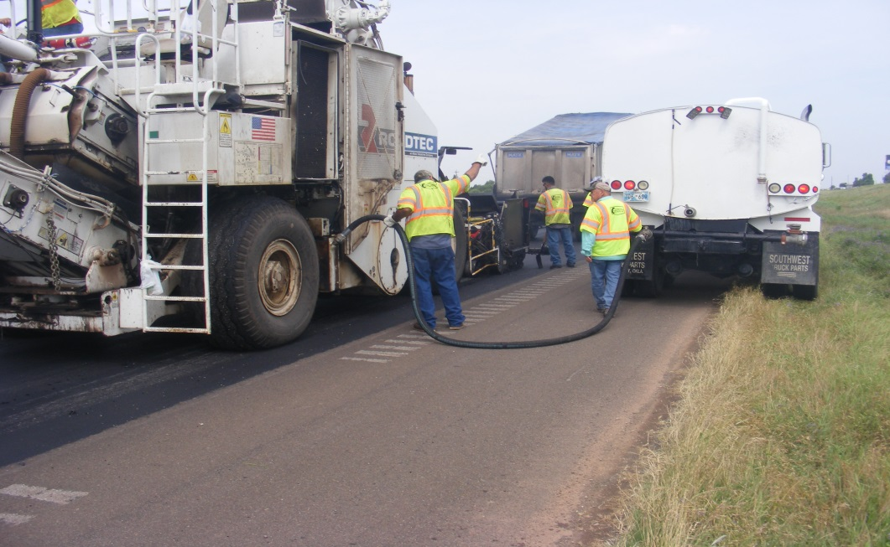
FIGURE 16

Truck Number 45 was the last load of the GTR product and it arrived at 3:00pm. The ending station for the GTR section is 55+71, making the length of the entire section 7,726’ or 1.46 miles.

POST GTR CONSTRUCTION PHASE
As I stated earlier, Dr. Clark was recording temperatures throughout the process and will be also writing some type of report that wil be forthcoming.
I will go out to the jobsite sometime during the week of June 17, 2019, to check on the contractor’s progress in completing the rest of the job with polymer based asphalt. I will be taking the signs that I had made and installing them on the right-of-way in the very near future. Once the construction is completed, I will be setting up test sections in the GTR portion of the project. The plan is to lay out 3 – 500’ sections. The first one will begin at 132+97. The next test section will be in the center beginning at 96+84. And the last test section will begin at 60+71. These sections will be monitored for condition, observing and recording any events of cracking and rutting. See Figure 17.

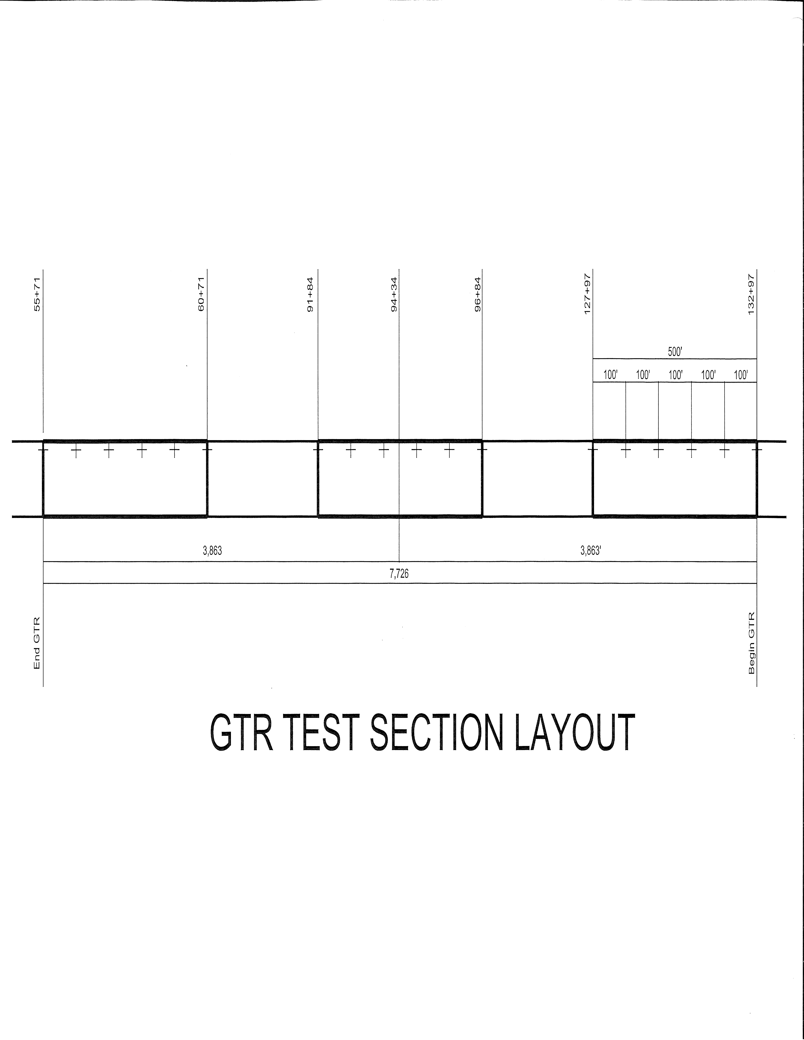
FIGURE 17

Also, in accordance with the contract of Task Order 2400-19-04, OSU is obligated to conduct their planned testing, on the new GTR section. I have been in contact with Dr. Qiang “Joshua” Li from OSU and he has requested that I check into seeing if they would be allowed to conduct their testing under the traffic control that is already in place for the construction project. We will need to act soon to take advantage of this situation and will be checking into that scenario in the next day or so.

CONCLUSION
Somehow, we need to be able to pull together all of everyone’s research into one report. I don’t know of anyone who has been tasked with that effort, but this is something that I will discuss with a couple of the interests party to this project. We have OSU’s Task Order report and Dr. Clark of Asphalt Plus will be preparing some kind of report. OU took samples from the plant during production and I assume they will have something published on their findings. I don’t know what role TxDot played in this situation, but perhaps they will have something to add. Kevin Suitor has also contracted with the University of Missouri for some kind of analysis on the GTR material. And finally, ODOT’s own Video Production unit will be masterfully creating some kind package to tell the story about ODOT’s experience with this technology, Ground Tire Rubber.

