OKLAHOMA STATE TRANSORTATION INNOVATION COUNCIL (STIC) ACCELERATING INNOVATION DEPLOYMENT (AID) PROJECT: DIVERGING DIAMOND INTERCHANGE (DDI) IN ELK CITY, OK. SH-6 over I-40

Submitted to:
The Federal Highway Administration (FHWA)

Submitted by:
Office of Research and Implementation
Oklahoma Transportation

March 2021

TABLE OF CONTENTS

List of Figures…………………………………………………………………………………. i

Construction Project Information…………………………………………………………. 1

Report Scope and Organization…………………………………………………………… 1

Project Location Map………………………………………………………………………... 2

Project Aerial Photograph…………………………………………………………………. 2

Accelerating Innovation Deployment (AID) Demonstration Grants……………. 3 – 4

Diverging Diamond Interchange (DDI) Technical Briefing…………………………… 5

Geometrics…………………………………………………………………………………5 – 6

Pedestrians…………………………………………………………………………………6 - 7

Traffic Signal Control…………………………………………………………………………7

Operational Performance…………………………………………………………………….8

Benefits………………………………………………………………………………………8 - 9

Oklahoma and Every Day Counts (EDC)…………………………………………………. 9

Technology and Innovation Deployment Program (TIDP)…………………………... 10

Lessons Learned………………………………………………………………………. 10 - 11

Pre-Work Meeting…………………………………………………………………………… 11

Pre-Construction………………………………………………………………………. 12 - 13

Traffic Control and Work Zone Set-Up…………………………………………………. 14

Construction Highlights Timeline……………………………………………………15 - 17

Construction Photographs…………...……………………………………………….17 - 19

Artwork Elements………………………………………………………………………. 20 -25

Conclusion, Cost and Completed Project Photographs…………………………26 - 28

LIST OF FIGURES

FIGURE 1: Crossover Movement in a DDI………………………………………………. 6

FIGURE 2: Typical DDI Movements……………………………………………………… 7

FIGURE 3: Existing Bridges in 2017 over I-40………………………………………… 12

FIGURE 4: Existing Bridges in 2017 on SH-6…………………………………………...13

FIGURE 5: Traffic Control at I-40 WB and Ramp “C” ...………………………………. 14

FIGURE 6: Drilled Shafts and Pier Columns, Phase I…………………………………. 17

FIGURE 7: W 33 x 130 Steel Beams, Phase I…………………………………………. 18

FIGURE 8: Placement of Dowel Bars and Reinforcement……………………………. 18

FIGURE 9: Phase II, Bridge Removed……………………………………………………19

FIGURE 10: Light Poles Installed………………………………………………………….19

FIGURE 11: Artwork, Stone Masonry Pattern at Wing Wall…………………………… 21

FIGURE 12: Artwork, Stone Masonry Pattern on Traffic Rail……………………………21

FIGURE 13: Artwork, Monotube Monument for Directional and Destination Signage. 22

FIGURE 14: Artwork, Slope Wall with Antler Pattern……………………………………. 22

FIGURE 15: Artwork, Oil Derricks…………………………………………………………. 23

FIGURE 16: Artwork, Oil Derricks…………………………………………………………. 23

FIGURE 17: Artwork, Elk Head Medallion………………………………………………... 24

FIGURE 18: Artwork, West Bound Elk Statue……………………………………………. 25

FIGURE 19: Artwork, East Bound Elk Statue……………………………………………...25
FIGURES 20 AND 21: Completed Project Photographs………………………………....27

i
CONSTRUCTION PROJECT INFORMATION

LOCATION: Beckham County, Elk City, Oklahoma: SH-6 over Interstate 40
FEDERAL AID PROJECT NO.: ACNHPPI-4000-(061) PM
STATE JOB NO.: 30998(04)
CONTROL SECTION: 06-05-14
BRIDGE “A” LOCATION NO.: 0504-1378X
NEW NBI NO.: 31995
OLD NBI NOS.: 17557 & 17558
BRIDGE LENGTH: 283.66’
CONTRACTOR: FRONTIER BRIDGE

REPORT SCOPE AND ORGANIZATION
This report documents the Oklahoma Transportation demonstration grant award for the installation of a Diverging Diamond Interchange (DDI) in Beckham County at the intersection of State Highway 6 over Interstate 40 in Elk City, Oklahoma. The report presents details relevant to the deployed project innovation(s), the overarching TIDP goals, performance metrics measurement and analysis, lessons learned, and the status of activities related to adoption of the Diverging Diamond Interchange as conventional practice by Oklahoma Transportation.

1
PROJECT LOCATION MAP

ELK CITY, OKLAHOMA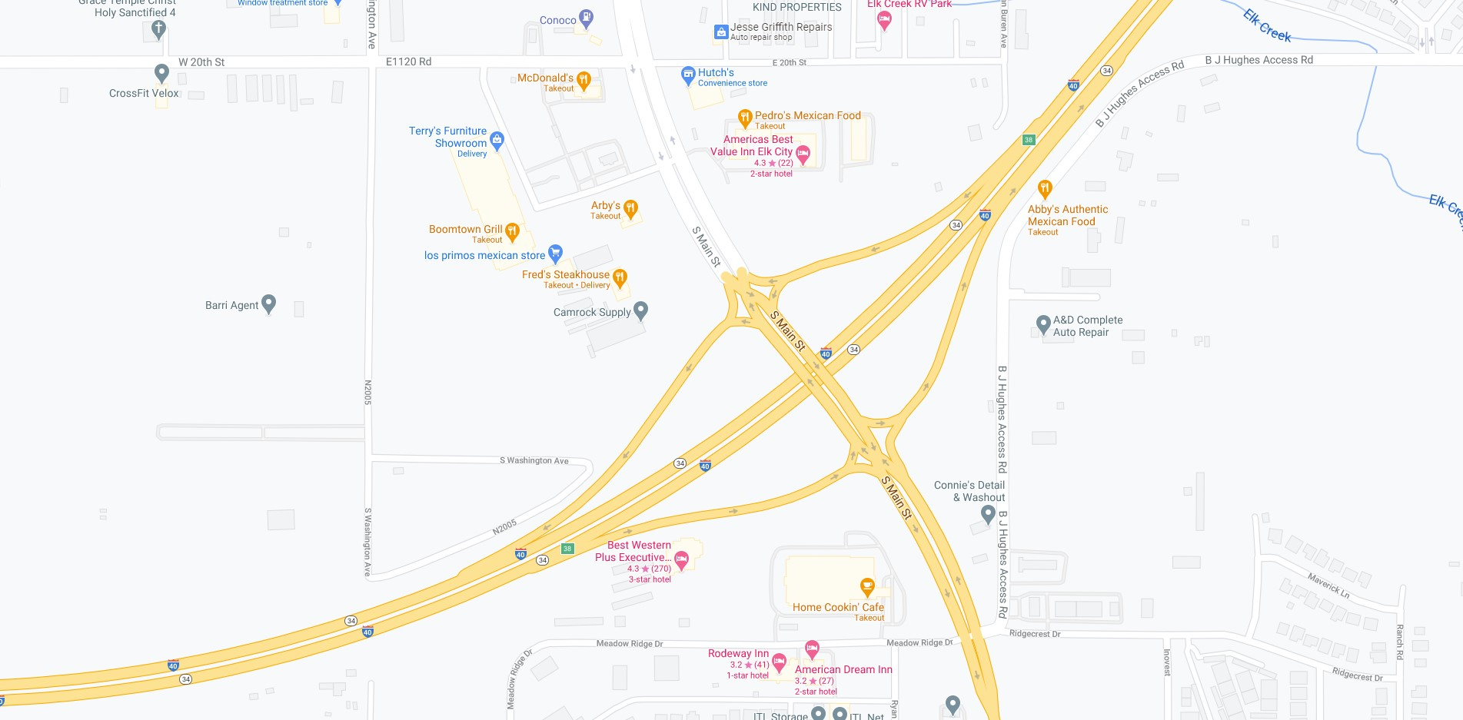
Map data ©2021
200
ft

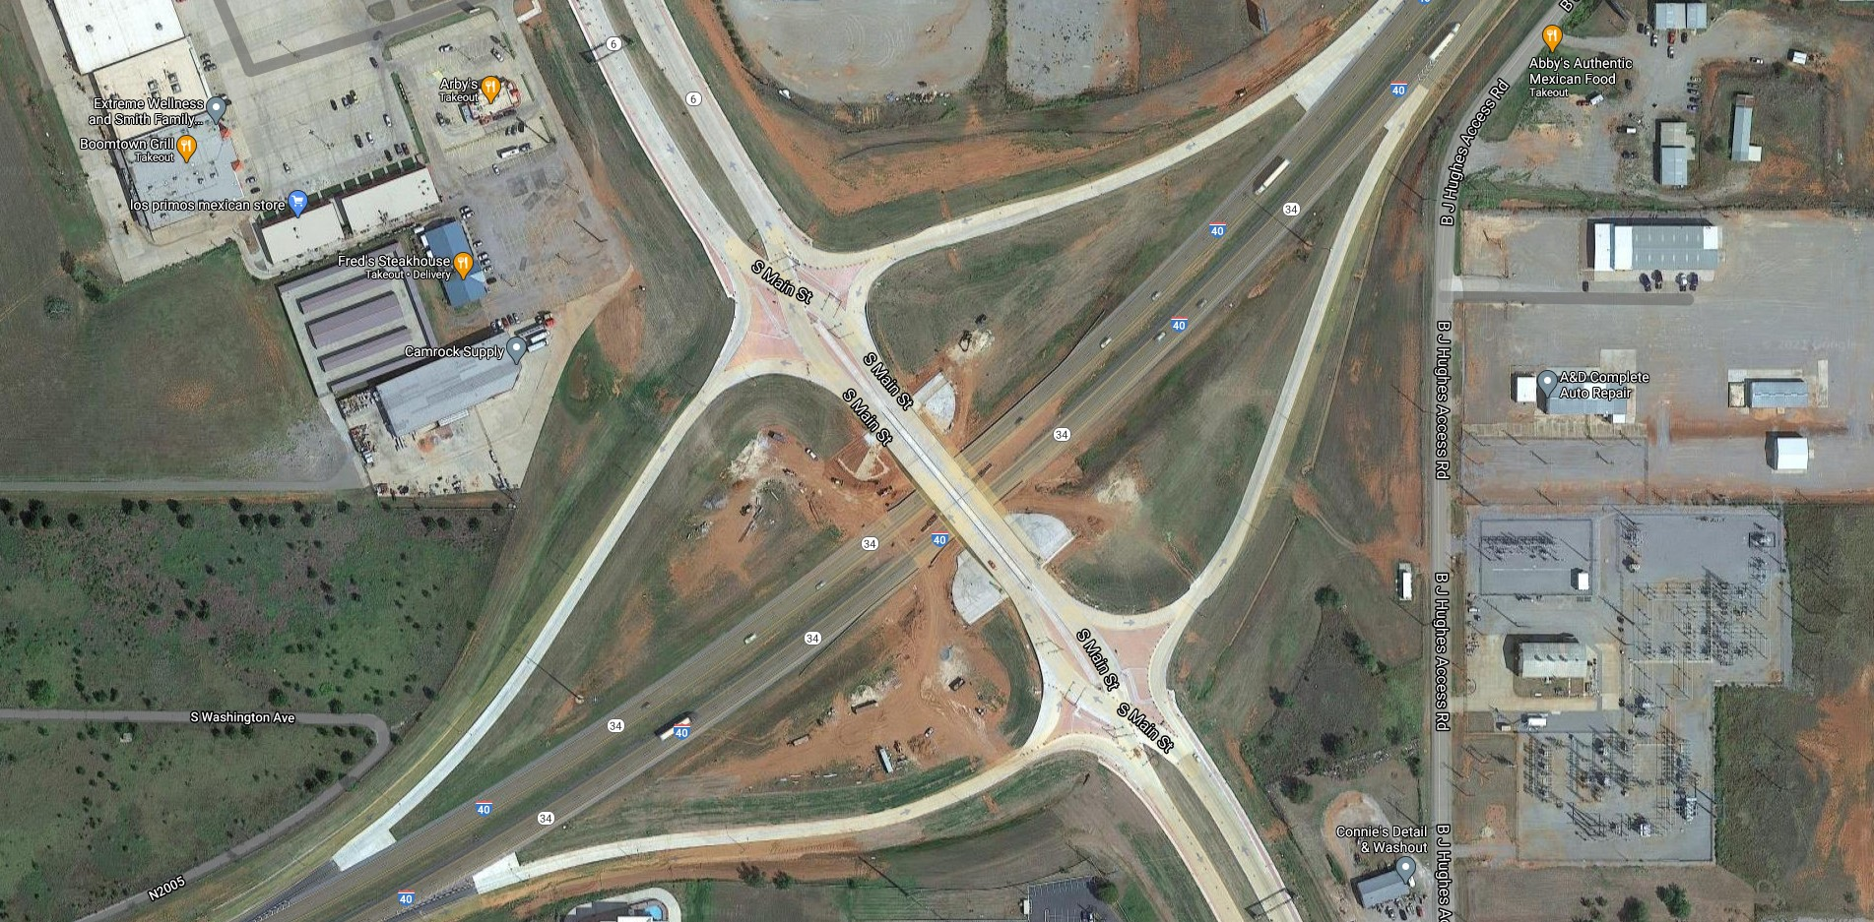
100
ft

PROJECT AERIAL PHOTOGRAPH
2
ACCELERATED INNOVATION DEPLOYMENT (AID) DEMONSTRATION GRANTS

AID DEMONSTRATION GRANT BASICS

The AID Demonstration Program provides funding as an incentive to accelerate the use of innovation in highway transportation projects. The Federal Highway Administration (FHWA) expects approximately $10 million to be made available for AID Demonstration grants in each of fiscal years 2016 through 2020 from amounts authorized within the Technology and Innovation Deployment Program (TIDP) under the Fixing America’s Surface Transportation (FAST) Act. The grants are administered through the FHWA Center for Accelerating Innovation.

WHAT TYPES OF PROJECTS ARE ELIGIBLE?

Projects submitted for an AID Demonstration grant must:
- Be eligible for assistance under title 23, United States Code.
- Be ready to initiate within 12 months of applying for AID Demonstration funding.
- Involve any phase of a highway transportation project between project planning and project delivery including planning, financing, operation, structures, materials, pavements, environment, and construction.
- Include an innovation proven in real-world highway transportation application, though not routinely used by the applicant or the subrecipient. Address TIDP goals.

3

WHAT AMOUNT OF ASSISTANCE IS AVAILABLE?

The AID Demonstration award is based on the cost of the innovation in a project (rather than the total project cost). The award amount may be up to the full cost of the innovation in the project, to a maximum of $1 million. AID Demonstration funds are available at an 80 percent federal share, which require a minimum 20 percent cost share.

WHICH AGENCIES CAN APPLY?

Eligible entities are state departments of transportation (DOTs), federal land management agencies, and tribal governments. Metropolitan Planning Organizations (MPO’s) and local governments may apply through the state DOT as subrecipients. The Notice of Funding Opportunity published on September 1, 2016 provides additional eligibility and application information.

WHEN IS THE DEADLINE?

Completed applications are evaluated and award determinations are made on an open, rolling basis until the program ends or funding is no longer available. Go to Grants.gov to apply (search for Opportunity Number FHWA-2016-21063).

4
DIVERGING DIAMOND INTERCHANGE TECHNICAL BRIEFING
The Diverging Diamond Interchange (DDI), is a fairly new interchange design that has much in common with the design of a conventional diamond interchange. The main difference between a DDI and a conventional diamond interchange is in the way left and through movements navigate between the cross-street intersections with ramps. The DDI design accommodates left turning movements onto arterials and limited access highways while eliminating the need for a left-turn signal phase at signalized ramp terminal intersections. On the cross-street, the traffic moves to the left side of the roadway between the signalized ramp intersections. This allows drivers of vehicles on the cross-street who want to turn left onto the ramps the chance to continue to the ramps without conflicting with opposing through traffic and without stopping.
The first DDI to be built in the United States was in Springfield, Missouri and it was opened to traffic on June 21, 2009. It is located at the intersection of Interstate 44 and MO 13. According to divergingdiamond.com, there have been 99 DDI’s built and opened to traffic; the last one listed as number 99 being the DDI at the intersection of I-24 and US-60 in Paducah, Kentucky. If this data is up to date, then the Oklahoma DDI could be the 100th installation in the United States.

GEOMETRICS
The primary elements of a Diverging Diamond Interchange design are as follows:
- Left-turn and through movements are relocated to the opposite side of the road on the bridge structure. Turning radii used at the crossover junction are typically in the 150 – 300 ft. range. See Figure 1.
- Median width is increased to allow for the flaring required for reverse curves on the interchange approaches.

5
- The skew angle between the intersecting directions is closer to perpendicular when possible.
- Median openings are placed upstream of the interchange to allow U-turn movements on the arterial roadway.

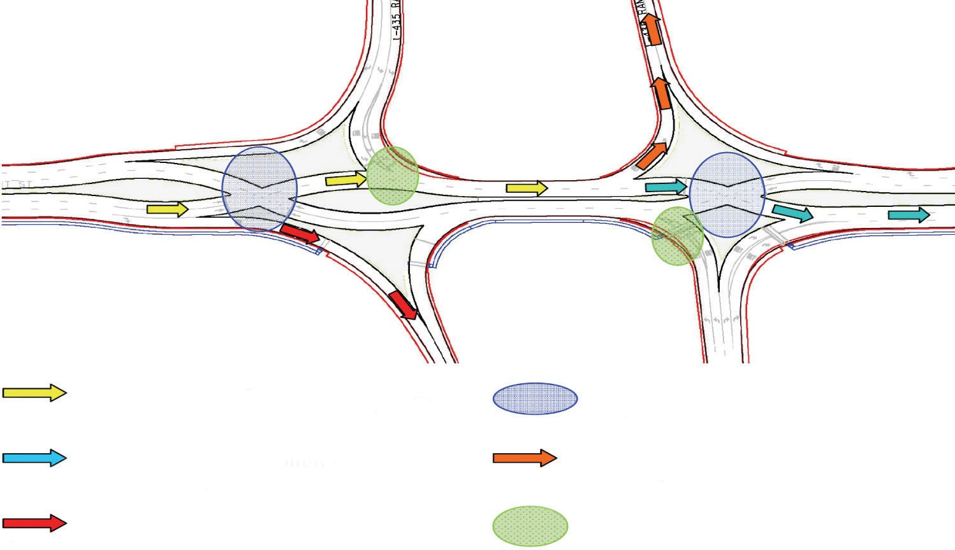

Freeway

Freeway

“Crossed-over” through and left-turn movement in one direction on arterial

Signal-controlled crossovers

“Crossed-back” through movement in one direction on arterial

Unopposed left-turn movement onto freeway on-ramp

Right-turn movement onto freeway on-ramp

Signal-controlled off-ramp
FIGURE 1: CROSS OVER MOVEMENT IN A DDI

PEDESTRIANS
Pedestrian crossings are accommodated by installing crosswalks and signalization at the junctions or nodes of the interchange. See Figure 2. The two-phase signal control possible in the Diverging Diamond Interchange is more efficient for pedestrians, but it requires them to cross the junction in two stages with the central island serving as a refuge between signal phases. Additionally, pedestrians could have the option to walk in the middle of the DDI.
6

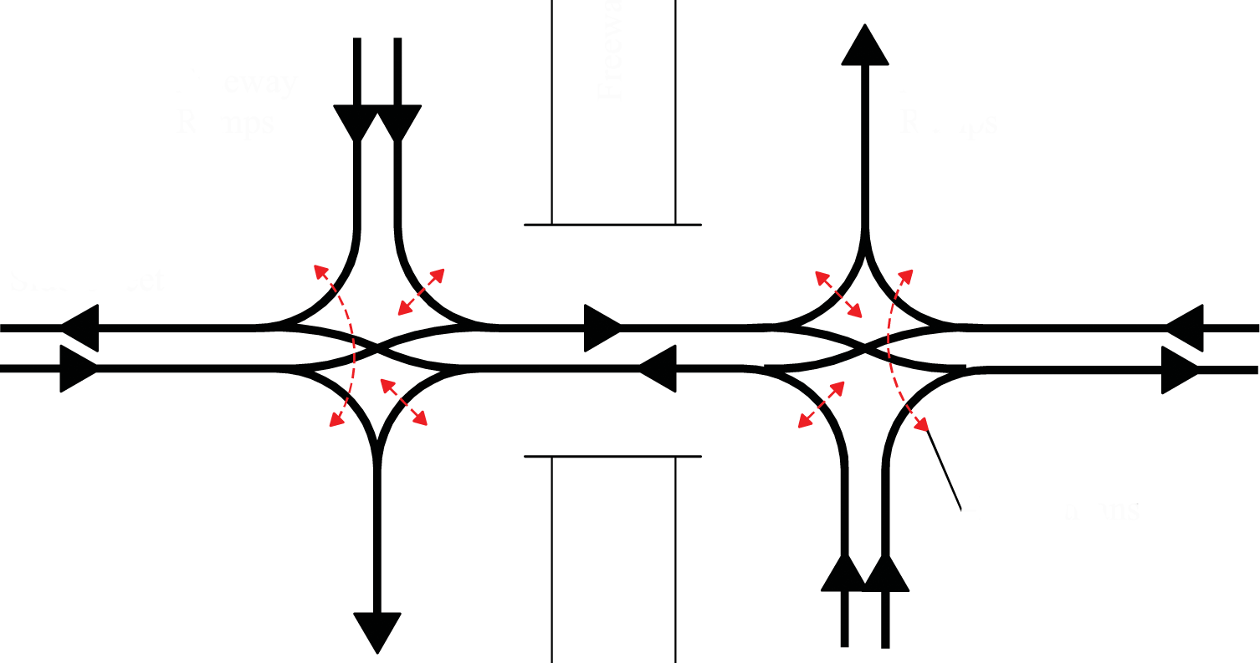
Freeway Ramps
Freeway Ramps
Side Street
Pedestrians
FIGURE 2: TYPICAL DDI MOVEMENTS

TRAFFIC SIGNAL CONTROL
The Diverging Diamond Interchange typically has two signalized junctions or nodes at the points of left-turn crossovers. The signals operate with just two phases, with each phase dedicated to the alternative opposing movements. The two-phase operation of the DDI allows for shorter cycle lengths and reduced lost time per cycle compared to the three or four phase operation at conventional diamond interchanges. Signals on the DDI may be fully actuated to minimize delay and both signalized junctions can be operated using either one or two controllers.

7
OPERATIONAL PERFORMANCE
The traffic simulation software VISSIM was used to compare the operational performance of a Diverging Diamond Interchange to conventional diamond interchanges. Two DDI designs and two conventional diamond interchange designs were simulated under high and low traffic volumes.
At the higher traffic volume simulations, the DDI demonstrated overall better performance. It had less delays, fewer stops, reduced stop times, and shorter queue lengths compared to the conventional design. Delays were reduced by 15 to 60 percent, and throughput was increased by 10 to 30 percent. However, at lower volumes the performance of the DDI and conventional diamond interchanges were similar.
The simulation showed that service volumes of the left-turn movements (650 vehicles per hour per lane (yeh/h/lane)) could be twice that of the corresponding left-turn service volumes of a conventional diamond. Another advantage is that exclusive left-turn lanes are not necessary for DDI’s.

BENEFITS
The main advantages to choosing the Diverging Diamond Interchange design instead of a conventional interchange design includes traffic operational benefits, potential safety benefits, right-of-way benefits, and reduced construction costs. DDI’s are especially suitable in suburban/urban settings where limited and costly right-of-way and reduced duration of construction are critical issues. Environmental benefits have not yet been estimated, but it is clear that the reduced congestion and possible safety benefits will result in reduced fuel consumption and pollution. Some situations where DDI’s are most applicable are as follows:
- Heavy volumes of left turns onto freeway ramps.
- Moderate and unbalanced through volumes on bridge approaches on the arterial road.
- Moderate to very heavy off-ramp left-turn volumes.
- Limited bridge deck width availability.

8
The DDI offers benefits over conventional interchange designs with its efficient two-phase operation, narrower bridge structure width, lower costs, fewer conflict points, expected increase in throughput, reduced vehicular delay, decreased speeds, and reduced environmental impact.
The DDI in Elk City in particular was constructed at basically the same cost that it would have been for the conventional interchange design. The benefits of the DDI have also been borne out in this project by significantly reducing delays, eliminating the stacking within I-40, and has so far, eliminated crashes.
Prior to construction, the Elk City Police Department had reported from 2011 through 2015, that 31 collisions occurred on SH-6, with 45% of those being classified as rear end, 32% right angle, and 19% angle turning. Since the DDI was fully opened to traffic in September 2020 (6 months), there have not been any reported crashes.
The existing bridge provided no access for pedestrians to traverse back and forth across to either side of I-40. The DDI now provides signalized control at the crossover points and provides a protective barrier with a lighted handrail through the centerline of the DDI for pedestrians to safely migrate across the interstate.

OKLAHOMA AND EVERY DAY COUNTS (EDC)
Oklahoma Transportation has been very proactive when it comes to participation in Every Day Counts (EDC) Initiatives. Oklahoma has been involved with EDC since the first round of EDC Initiatives or EDC-1, when Oklahoma began utilizing Safety Edge in paving projects and has participated up to the latest round or EDC-6.
The Diverging Diamond Interchange was introduced as an innovation in the 2013-2014 EDC-2 round in the Intersection and Interchange Geometrics category. DDI’s are just one design that was included in the category. Other designs included Roundabouts, Displaced Left Turns (DLT’s), or Variations on U-Turns.
When Oklahoma began considering DDI’s, there were a few locations that were considered for this innovation and now there are future plans to utilize the innovation at some other locations in Oklahoma. This will be expanded upon later in the report.

9
TECHNOLOGY AND INNOVATION DEPLOYMENT PROGRAM (TIPD)
The AID Program is a funding mechanism of the Technology and Innovation Deployment Program. The AID Program that was utilized in the construction of this Diverging Diamond Interchange innovation, provided funding and other resources to offset the risk of trying the innovation. There are goals that must be met in utilizing these funds and the improvement in highway efficiency, safety, and mobility that was achieved in the construction of the DDI in Elk City satisfies these goals. The innovation reduces delays, crashes, vehicle idle times, and improves turning movement efficiencies. It also improves the safety and mobility of pedestrian traffic.

LESSONS LEARNED
- One of the greatest lessons that Oklahoma Transportation has learned is the tremendous benefits that have been gained from the implementation of Every Day Counts (EDC) initiatives and the innovations in project delivery, savings in time and money, and improvements in the quality of our infrastructure.
- Oklahoma took advantage of another EDC Initiative, Project Bundling, and tied another bridge construction project to this one. The other project is also located in Beckham County. The price bid for Staking, SWPPP, and Mobilization were included in the Pay Items for Project No. STP-205B (076) PM, Job Piece No. 30329(04). We are learning the value of combining these EDC innovations to realize even further benefit. Perhaps one day entire projects will be constructed based entirely on a conglomeration of these beneficial ideas.
- The sequencing of the construction of the bridge in the interchange allowed it to remain fully operational at all times throughout the duration of the project. During Phase I, traffic was able to utilize the existing bridge that was slated for the Phase II construction. During Phase II construction, traffic was shifted over to

10
the newly constructed Phase I portion of the bridge. The sequencing proved very beneficial in maintaining mobility throughout the project.
- There were several articles of artwork incorporated into this project. There was a lot of planning and close coordination with the City of Elk City in the design and incorporation of these items that highlights the history and the culture of the citizens of this community. It was a great demonstration of the cooperation of the citizens and government to accomplish a work that is functional, innovative, and aesthetically pleasing, while keeping the community’s safety first and foremost.

PRE-WORK MEETING
A pre-work meeting was held at the District 5 Headquarters in Clinton, Oklahoma on April 25, 2019. Representatives from the City of Elk City, the Contractor, Frontier Bridge, various Consultants, and Oklahoma Transportation were in attendance. Some of the points that were addressed in the meeting were:
- The project was bundled with another bridge project in Sayre, Oklahoma
- All of the bridges were structurally deficient
- Design was performed in-house at Oklahoma Transportation
- Signing and Traffic Control were set to begin on May 20, 2019
- Construction start date was slated for May 28, 2019
- The City of Elk City commissioned the fabrication of artwork for the project consisting of:
- Oil Derricks
- Elk Statues
- Form Liner Artwork
- Removals and Demolition were to be performed at night
- Oklahoma Transportation Video Production was to produce drone footage and time lapse video of project
- Portable signals and message boards were to be deployed to project

11
PRE-CONSTRUCTION
Once it was decided that the Elk City, Oklahoma location would be the site of Oklahoma’s first Diverging Diamond Interchange, a trip was made to the location to photograph the existing bridges and location on September 27, 2017.
The existing facility on SH-6 over I-40 was two bridges on a four-lane divided highway. They were originally constructed in 1969. The existing interchange at I-40 and SH-6 handled an average AADT of 7,800 vehicles with 15% trucks. In the forecast year 2037, the AADT is expected to be 10,900 vehicles. See FIGURES 3 and 4

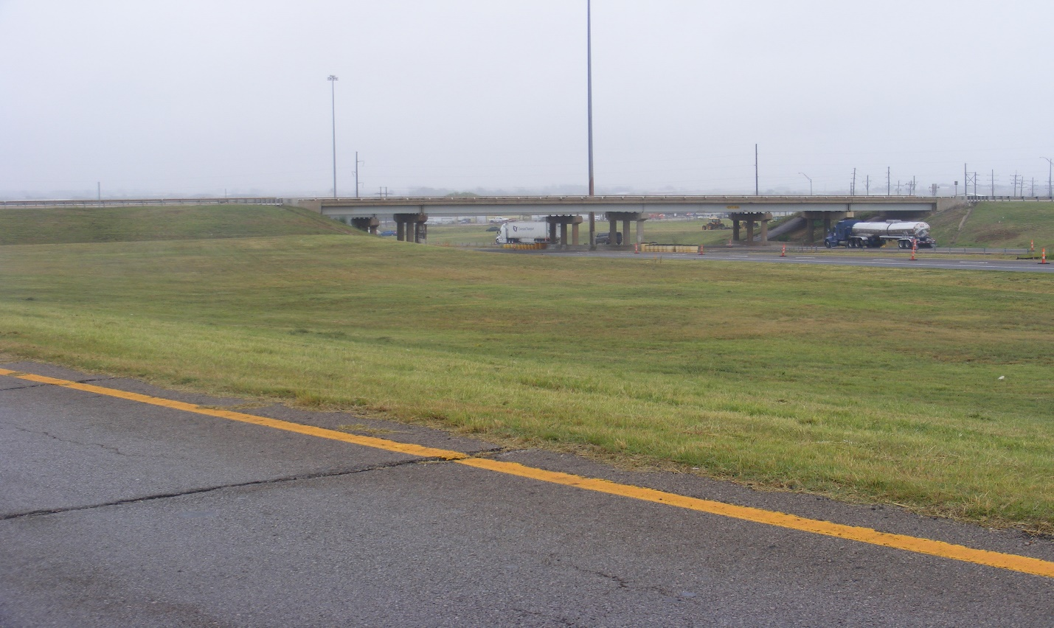
FIGURE 3: Existing Bridges in 2017 over I-40 EB

12
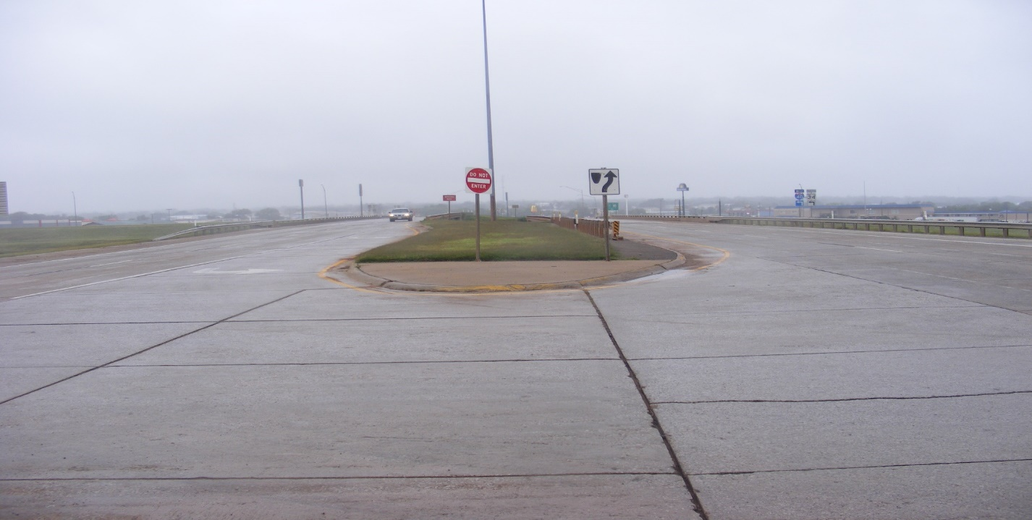

FIGURE 4: Existing Bridges in 2017 on SH-6

13
TRAFFIC CONTROL AND WORK ZONE SET-UP
Work on the project officially began on May 28, 2019. Direct Traffic Control, the contractor for the traffic control within the work zone on the project, began placing the construction traffic control at the project. Concrete barrier walls were placed on the I-40 Mainline and the exit ramp “C” from I-40 WB to SH-6. This was also the beginning of the Phase I Traffic Control Plan. See FIGURE 5.

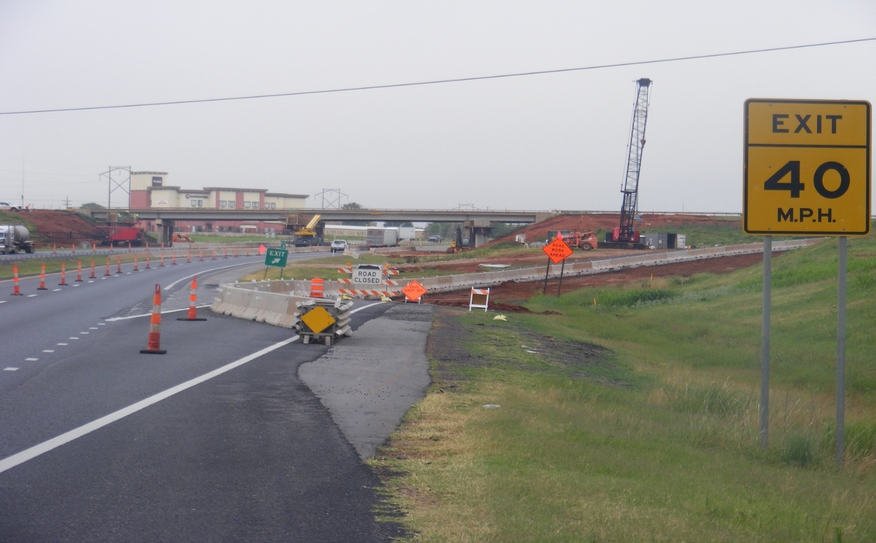FIGURE 5: Traffic Control at I-40 WB, Ramp “C”

14
CONSTRUCTION HIGHLIGHTS TIMELIME
The direction of travel for SH-6 is situated in a northerly and southerly direction and I-40 travel is east and west. This timeline was supplied by the inspector, Mr. Stan Hinds, from the District 5 Construction Residency in Clinton, Oklahoma.
- May 28, 2019: Switching of Traffic to begin Phase I
- May 31, 2019: Demolition began with the SH-6 Northbound Bridge on the East Side of I-40, Phase I
- June 17, 2019: Drilled Shafts, East Side of I-40, Began drilling and pouring concrete, Phase I, See Figure 6
- July 8, 2018: Closing of Ramp “D” in SE Quadrant of Interchange
- July 17, 2019: Placement of Unclassified Borrow
- August 12, 2019: Placement of Conduit System for Lighting
- August 19, 2019: Delivery of Steel Beams: W 40 x 277, W 33 x 118, and
W 33 x 130, Phase I
- August 22, 2019: Placement of Steel Beams, Phase I, See Figure 7
- August 29, 2019: Placement of Stabilized Subgrade on Approaches, Phase I
- September 16, 2019: Asphalt Paving on Approach Bases, Phase I
- September 19, 2019: Drilling and Placement of Concrete for Monotubes, Phase I
- October 1, 2019: Pouring of Concrete Bridge Deck, Phase I
- October 2, 2019: Pouring of Dowel Jointed Concrete, See Figure 8
- October 31, 2019: Placement of Concrete Reinforcement for PCC Pavement, Phase I
- December 11, 2019: Forming for Monotubes, Phase I
- January 20, 2020: Placement of Light Pole Footings
15
CONSTRUCTION HIGHLIGHTS TIMELIME (cont.)
- January 30, 2020: Began Demolition of SB Bridge, Phase II, See Figure 9
- February 3, 2020: Forming for Sidewalks
- February 10, 2020: Drilled Shafts, West side of I-40, began drilling and pouring concrete, Phase II
- February 26, 2020: Placement of Stabilized Subgrade, Phase II
- March 6, 2020: Placement of Stamped Concrete Divider
- March 23, 2020: Delivery of Steel Beams: W 40 x 277, W 33 x 118, and W 33 x 130, Phase II
- April 1, 2020: Placement of Steel Beams, Phase II
- May 5, 2020: Pouring of Concrete Bridge Deck, Phase II
- May 12, 2020: Drilled Shafts for Monotubes, Phase II
- May 26, 2020: Placement of Phase III concrete
- June 2, 2020: Forming and Placement of Concrete for Artwork Elements, Oil Derrick Bases
- July 8, 2020: Forming of Stamped Concrete Islands, Phase II
- July 21, 2020: Painting of Test Strip for Traffic Rail
- July 23, 2020: Placement of Signal and Light Poles, See Figure 10
- August 4, 2020: Switched Traffic to Phase II Bridge for Island Construction
- August 20, 2020: Placement of Antler Artwork Elements into Slope walls
- August 20, 2020: Placement of Oil Derrick Artwork Elements onto their Bases
- September 1, 2020: Installation of Monotubes, Phase II
- September 10, 2020: Installation of Lighted Handrails, Phase III
16
CONSTRUCTION HIGHLIGHTS TIMELIME (cont.)
- September 14, 2020: Placement of Traffic Striping
- September 15, 2020: Installation of Traffic Signs
- September 16, 2020: Installation of Artwork Elements Medallions, See Figure 17
- September 17, 2020: Project Substantially Complete and Fully Opened to Traffic
- October 7, 2020: Installation of Artwork Elements, Elk Statues
- October 2020: Project Complete

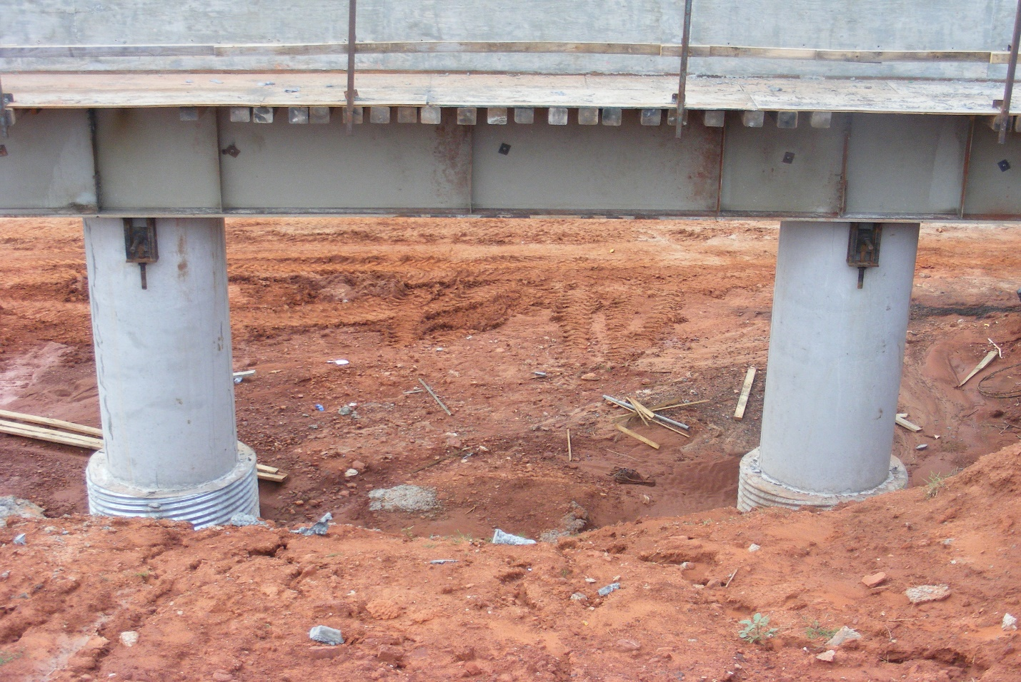
FIGURE 6: Drilled Shafts and Pier Columns, Phase I

17
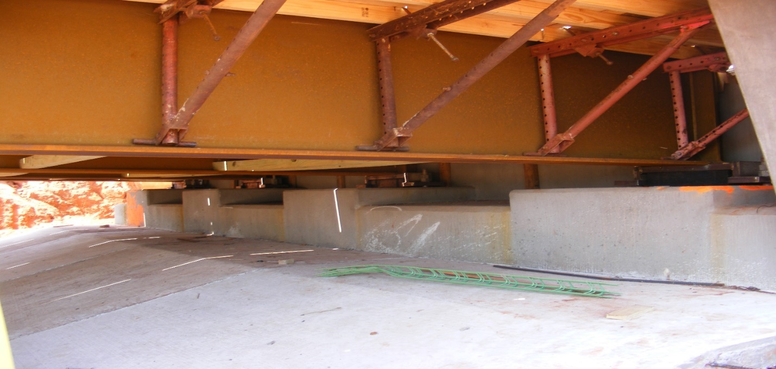

FIGURE 7: W 33 x 130 Steel Beams, Phase I

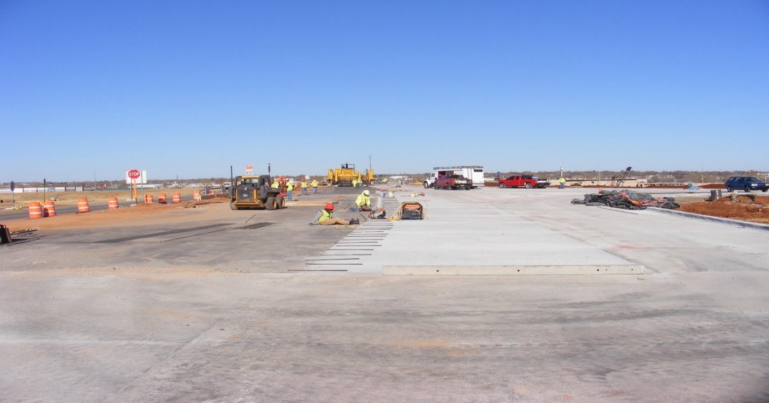
FIGURE 8: Placement of Dowel Bars and Reinforcement

18
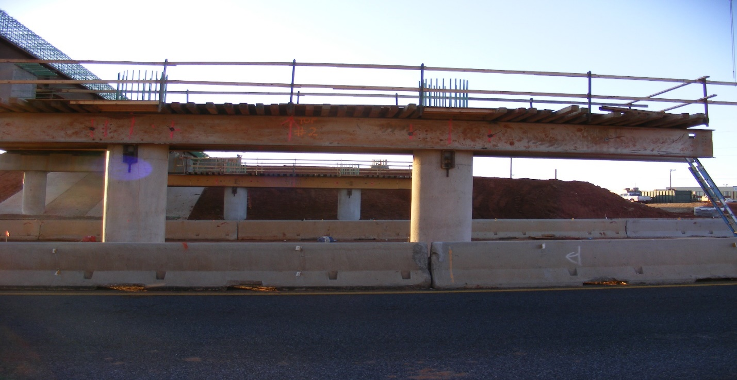
FIGURE 9: Phase II - Bridge Removed

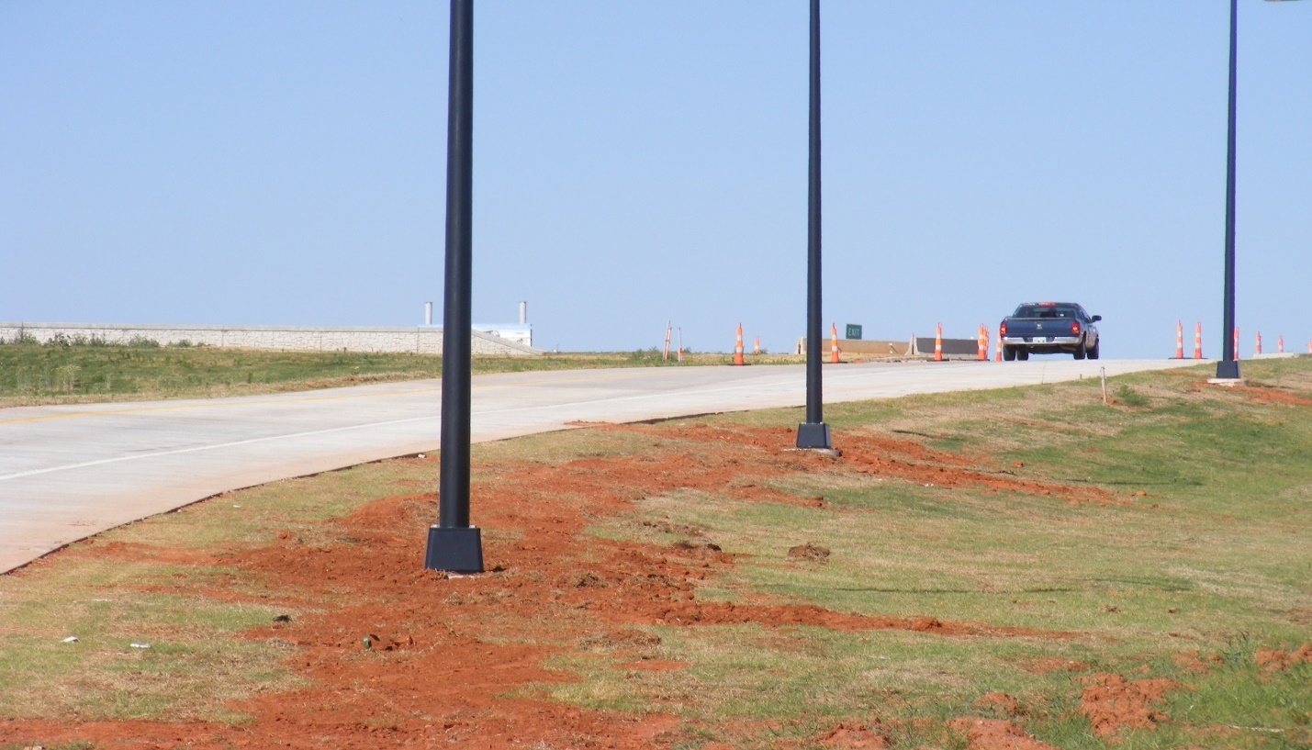
FIGURE 10: Light Poles Installed

19
ARTWORK ELEMENTS
There were several features that were introduced into the construction of the project that exhibit the heritage and culture of the city of Elk City through artwork elements. One of the first features introduced into the project was the use of form liners with a stone masonry pattern that was applied to the wing walls on the abutments and the traffic rails on the bridge. Concrete stain was later applied to the patterns to give a realistic stone masonry look. See Figures 11 and 12.
Another feature that was constructed was the monuments on each side of the road and at each approach to the bridge to support the monotubes that bears directional and destination signage. These also were fabricated with the stone masonry patterned form liners and displays large medallions with antlered elk heads. See Figure 13.
The next item of note that was built into the project was the antler pattern that was incorporated into the slope walls at all four quadrants of the bridge. See Figure 14.
One of the more prominent features to be added to the project was the oil derrick replicas. These were constructed on bases with the stained stone masonry pattern and erected on all four corners of the bridge at the intersection of the wing walls and the top of the slope walls. See Figures 15 and 16.
Another element of artwork that was built into the project were medallions depicting an elk head. This feature was constructed using form liners and the medallions were placed on both sides of the bridge, centered over I-40, and they were also constructed on each side of the monotubes holding the directional and destination signs at each approach to the bridge. See Figures 13 and 17.
And finally; probably the most prominent and iconic pieces of artwork that are exhibited on the project; the city of Elk City commissioned the creation of two large bronze elk statues. They too are mounted on bases with the stone masonry pattern and are situated on both directions of I-40 as you approach the diverging diamond interchange. They are stationed approximately 100’ away from the shoulder of I-40 and approximately 200 yards away from the bridge. See Figures 18 and 19.

20
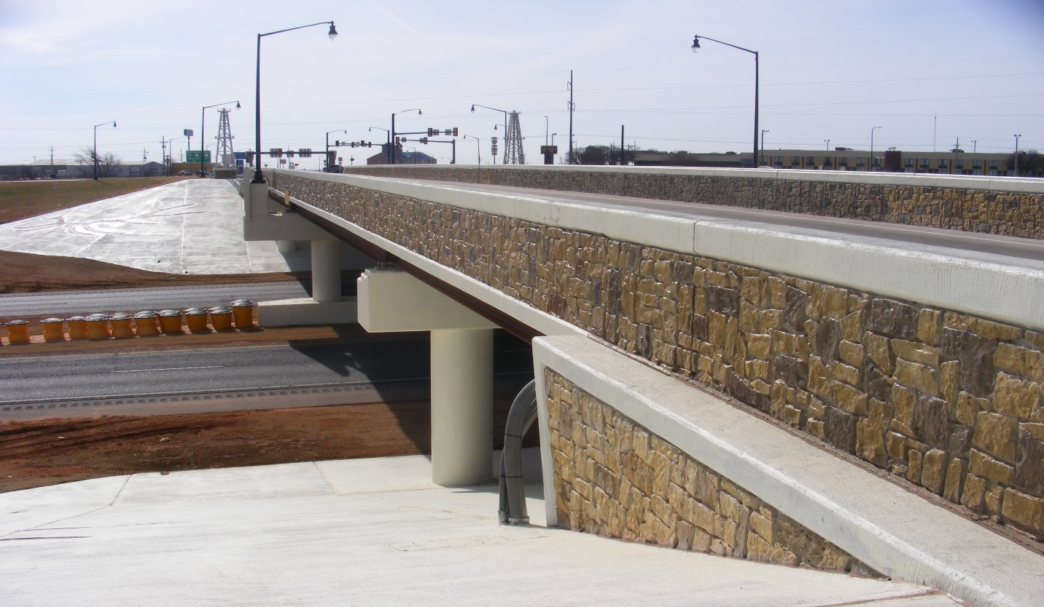
FIGURE 11: Artwork, Stone Masonry Pattern at Wing Wall

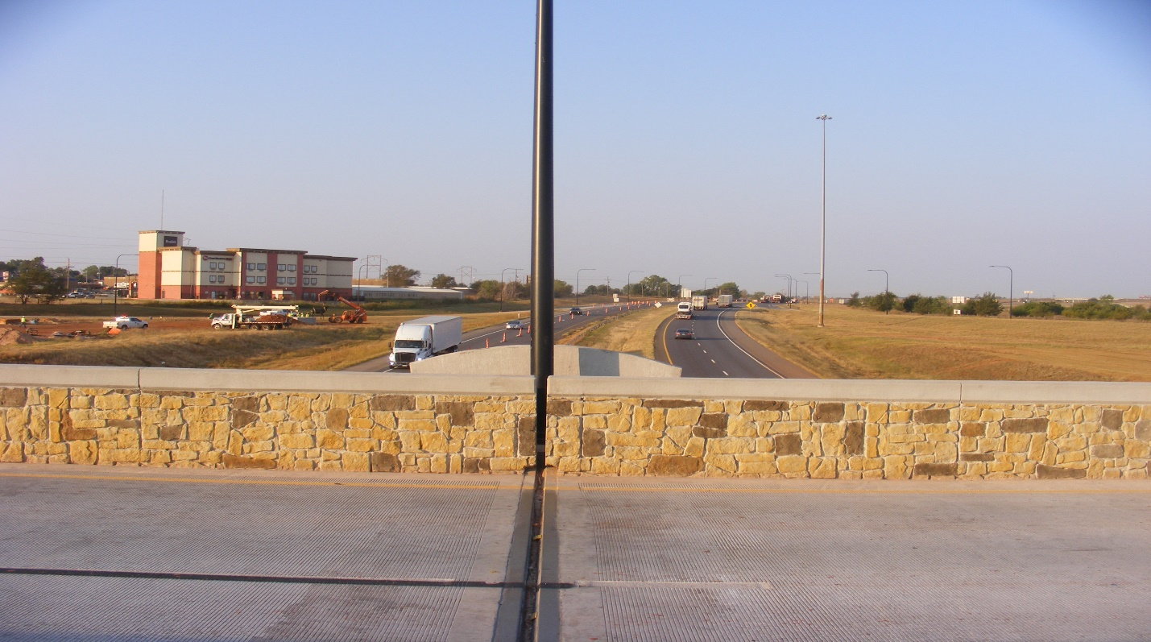
FIGURE 12: Artwork, Stone Masonry Pattern on Traffic Rail

21
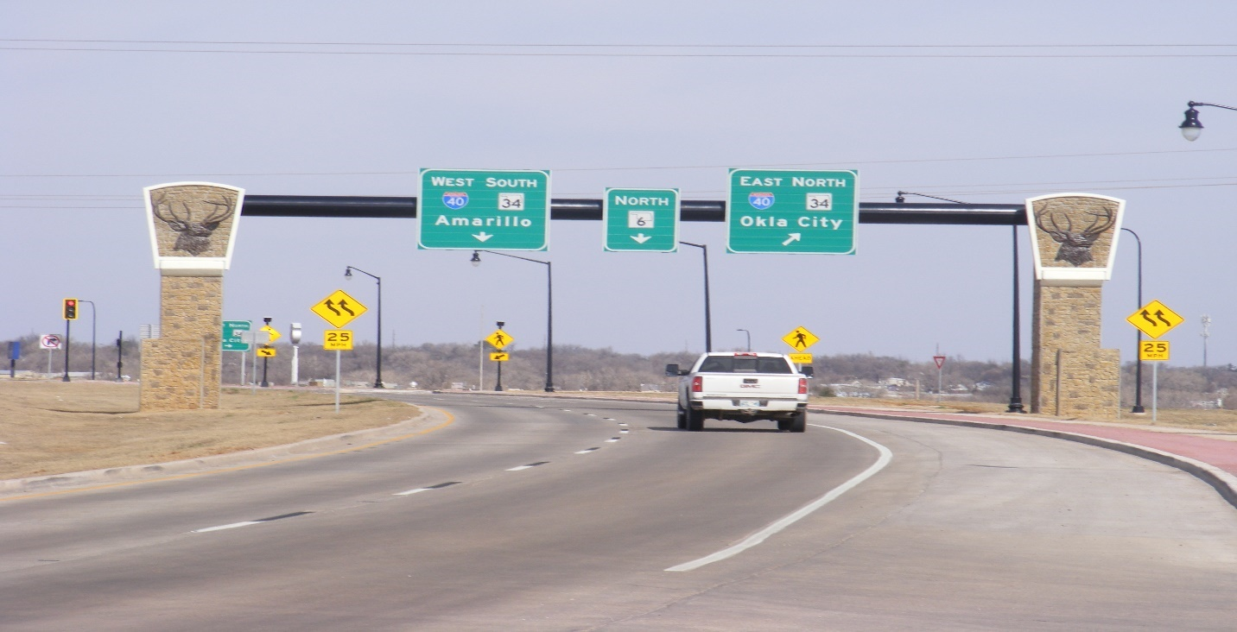
FIGURE 13: Artwork, Monotube Monument for Directional and Destination Signage

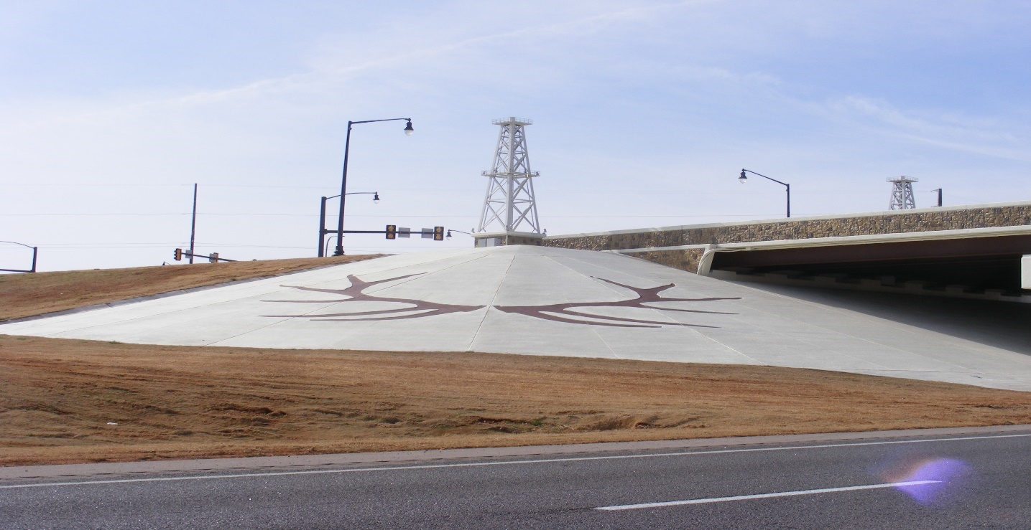
FIGURE 14: Artwork, Slope Wall with Antler Pattern

22
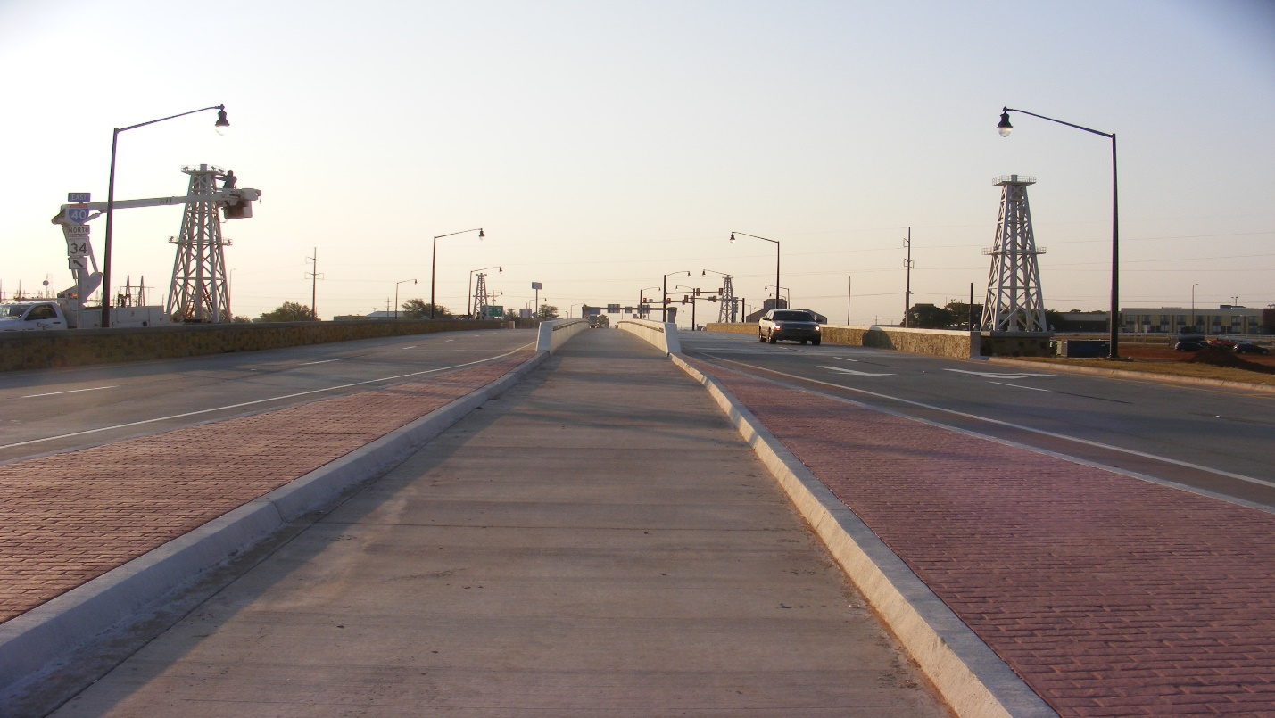
FIGURE 15: Artwork, Oil Derricks

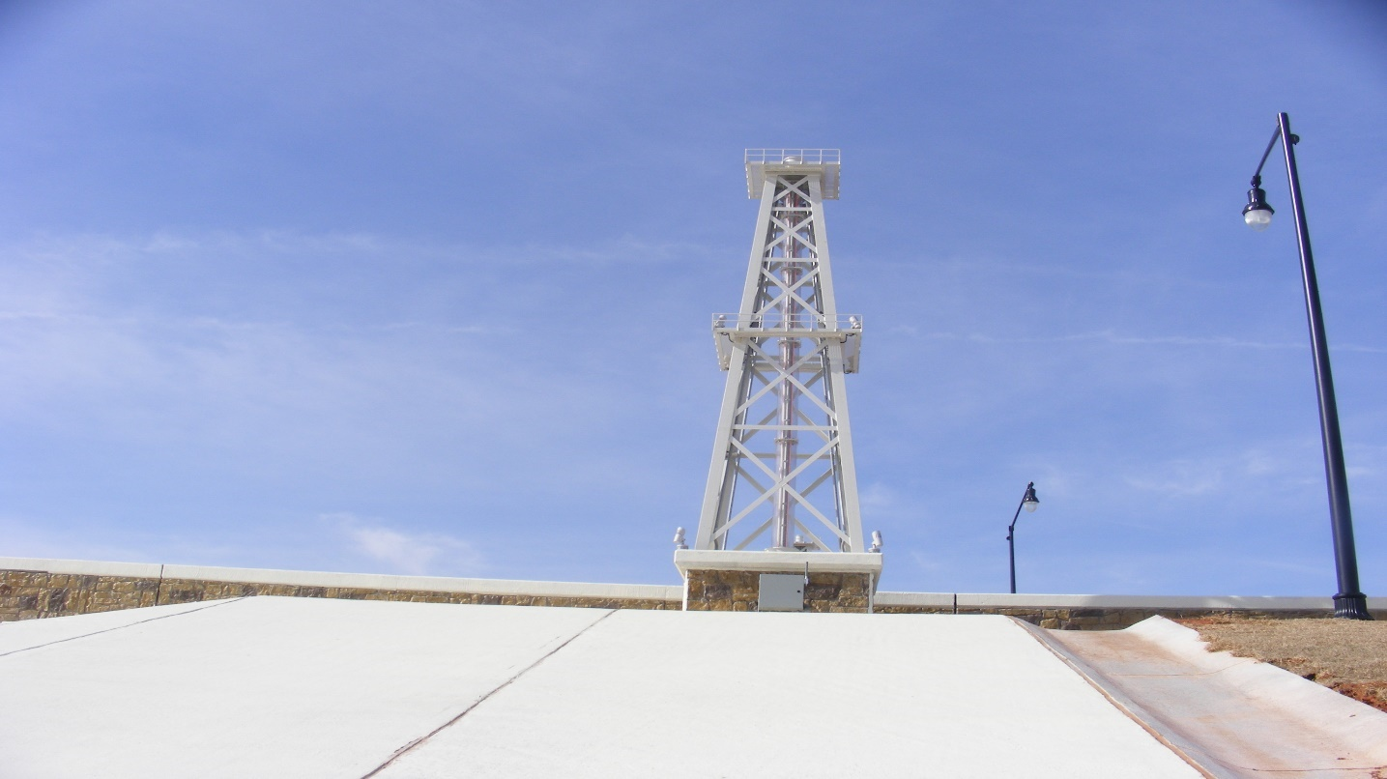
FIGURE 16: Artwork, Oil Derricks
23
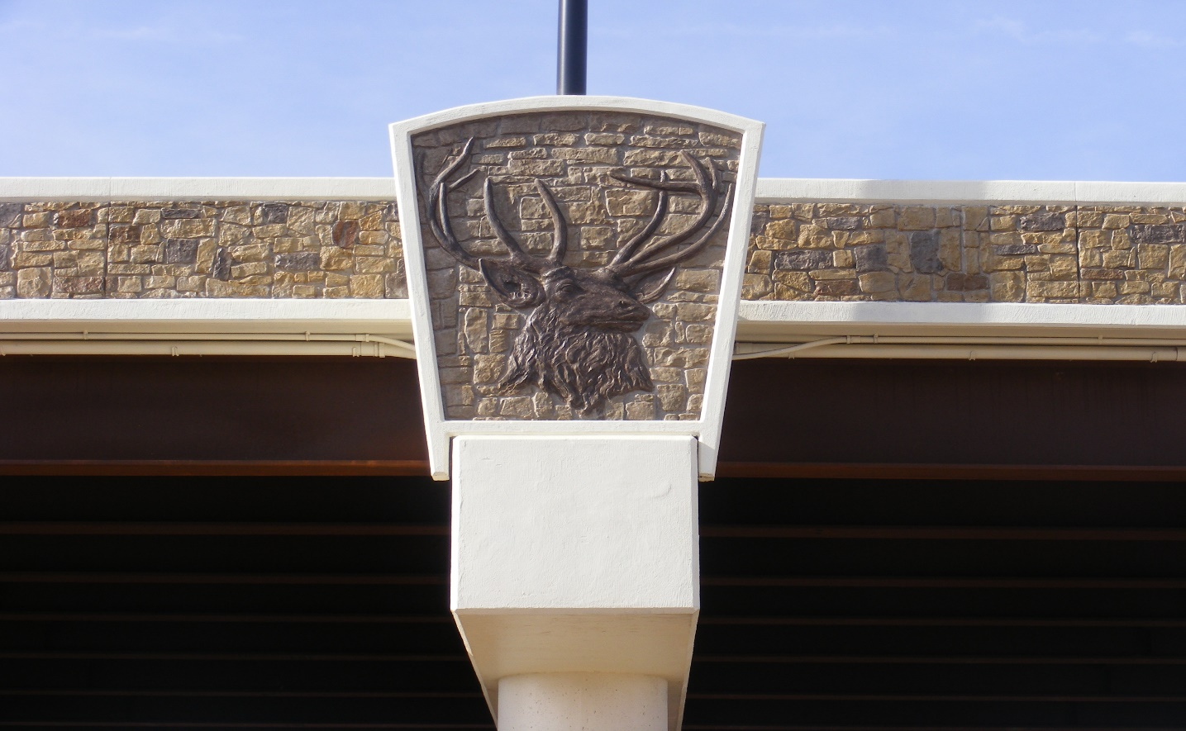
FIGURE 17: Artwork, Medallions

24
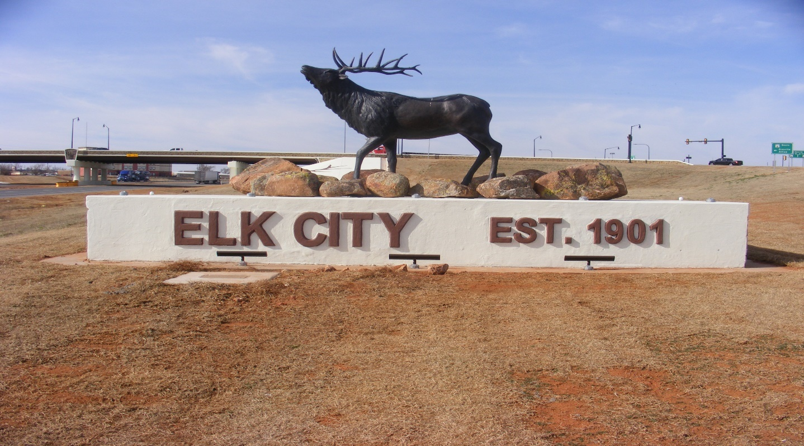
FIGURE 18: I-40 West Bound Elk Statue

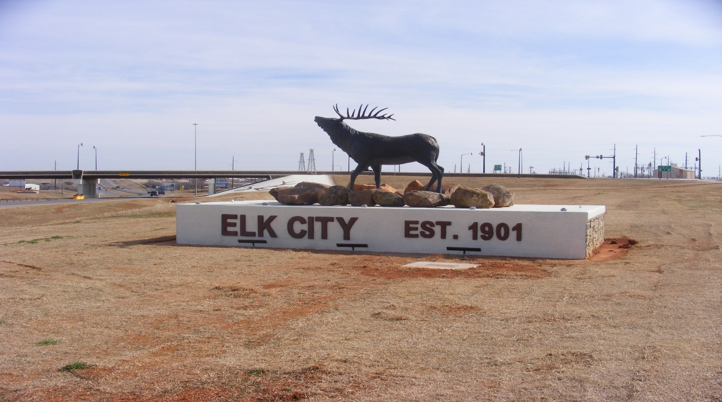
FIGURE 19: I-40 East Bound Elk Statue
25
COST
ODOT requested the maximum $1,000,000 of AID Demonstration funds. The estimated cost of replacing both bridges as well as installing all the necessary roadway items was $8.2 million. Due to plans only being at 60% completion at the time of the application, the estimate did not include the cost of installing traffic signals or the temporary traffic control needed during construction. The cost of replacing the structurally deficient bridges alone was estimated to be $3.5 million, regardless if the interchange was constructed as a standard diamond, or installing the new innovative design.
Since the Diverging Diamond Interchange project was bundled with another bridge project in Beckham County, the entire bid price for the bundle was $28,621,809.83. The DDI bid price alone came to $16,398,898. As of the last progressive estimate that went through February 28, 2021, the contractor had earned $17,030,900.62, just on the DDI portion. As of that date on both projects combined, they had earned 99.61% of the funds available and used 63.57% on the current time allowed. The final cost of the project is not known at the time of the submission of this report.

CONCLUSION
Elk City is a relatively large city for this sparsely populated region of western Oklahoma and it is the largest city that traffic will first encounter on east bound I-40 leaving Texas. It is located approximately 50 miles from the Texas state line and it accommodates quite a lot of semi-truck traffic traveling both directions.
Due to the fact that a lot of traffic exits into Elk City, there was a problem with traffic backing up on to I-40. The existing bridge was classified as structurally deficient and there was an inadequate amount of storage capacity at this interchange.

26

CONCLUSION (cont.)

The semi-truck traffic also had great difficulty in navigating the turning movements at the interchange due to the deficiencies.
Communication between the Elk City officials and the construction residency at the Oklahoma Transportation District V Headquarters, has indicated that the public and the
city officials are very pleased with the results of the construction of this innovative and aesthetically pleasing project. They are pleased with the new efficiency that comes with navigating the interchange and the mobility and safety that it provides. Photographs of the completed projected can be found in Figures 20 and 21.
Oklahoma Transportation is looking forward to deploying this innovation to alleviate problems at other locations where we have traffic backing up on mainline thoroughfares.
There are plans to construct a Diverging Diamond Interchange at I-35 and Waterloo Road in northern Oklahoma County near Edmond, Oklahoma and there are also plans to construct one at US-64 under US-169 in Tulsa County in Bixby, Oklahoma.
Oklahoma Transportation has now fully adopted the Diverging Diamond Interchange as standard practice. Like any design, conditions must be met in order to design and construct one. Oklahoma Transportation Roadway Design Engineers are now trained to apply the DDI model to each interchange scenario to see if it is the right fit for that situation.
The Diverging Diamond Interchange is one more tool that has come from the Every Day Counts toolbox that has helped improve transportation in Oklahoma.

27
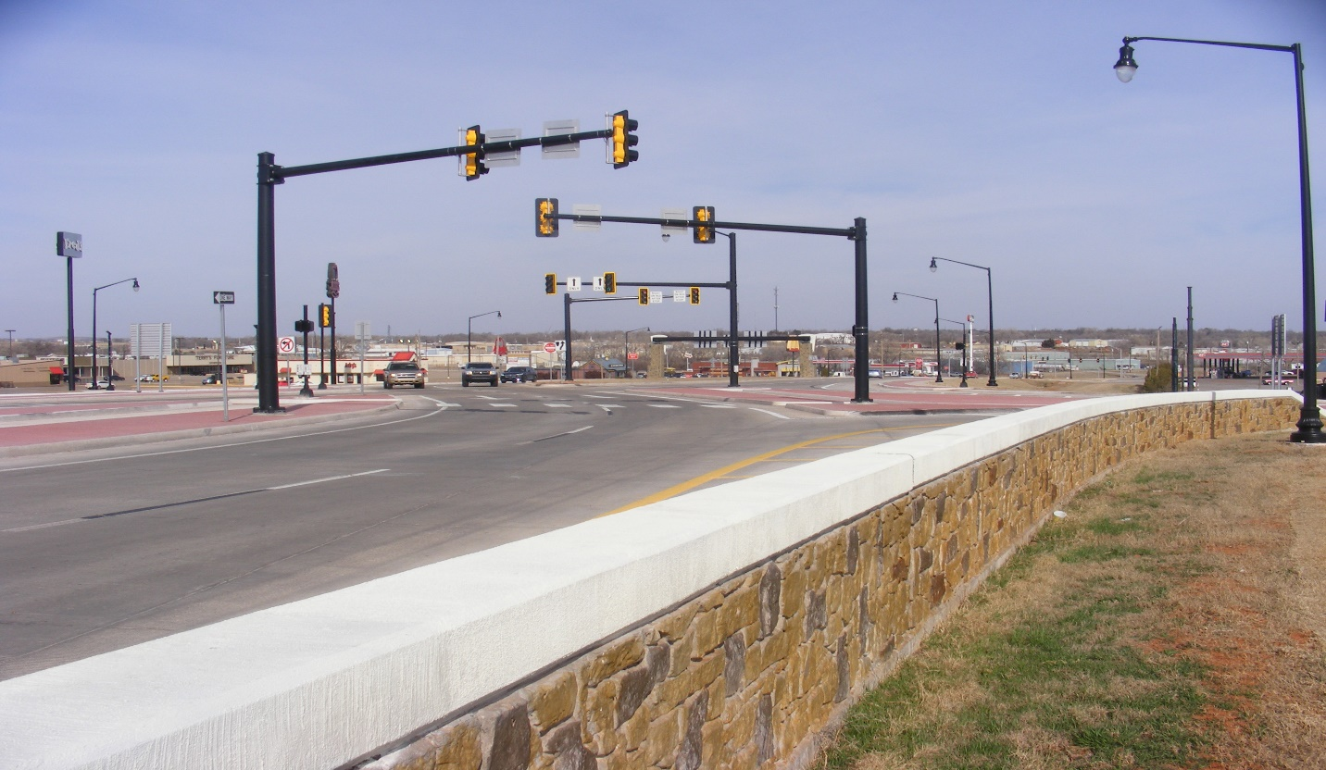
FIGURE 20: Completed Project, North Bound SH-6

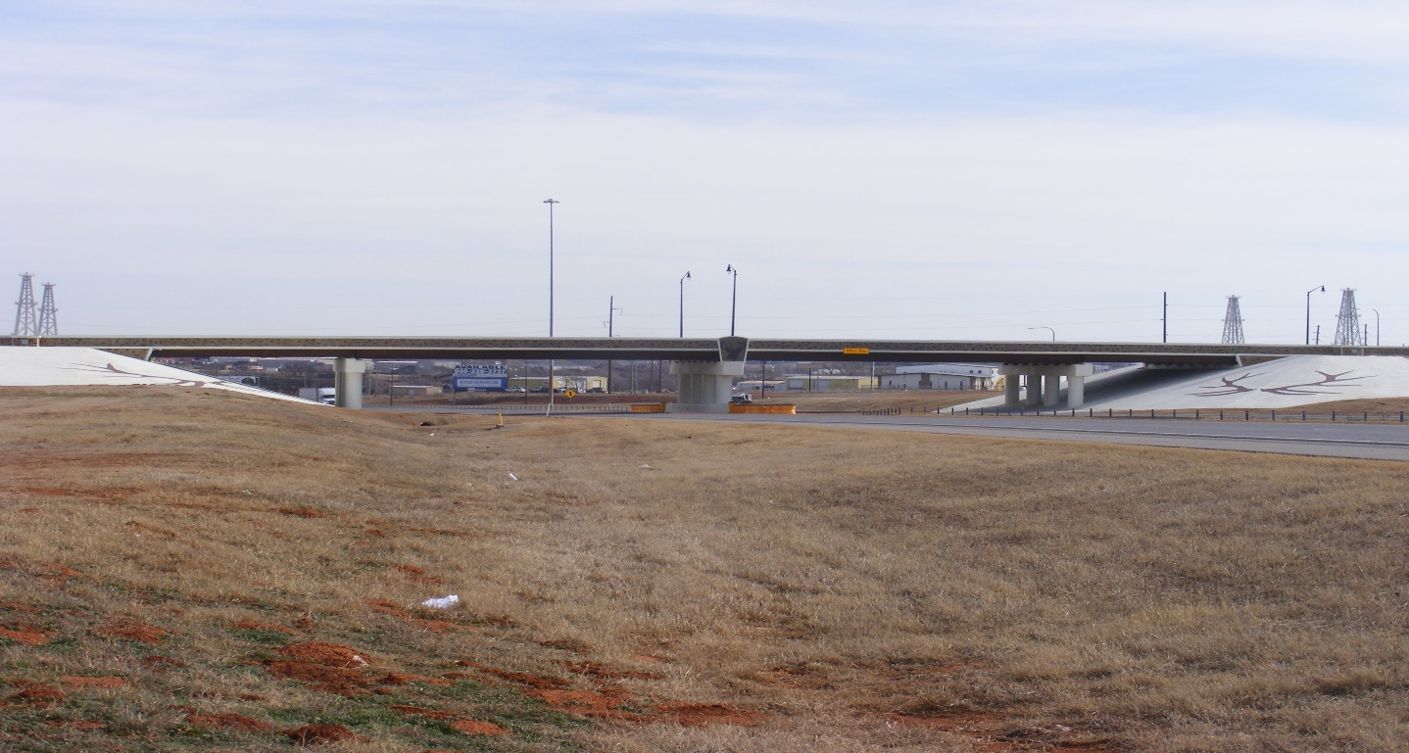
FIGURE 21: Completed Project, East Bound I-40
28

