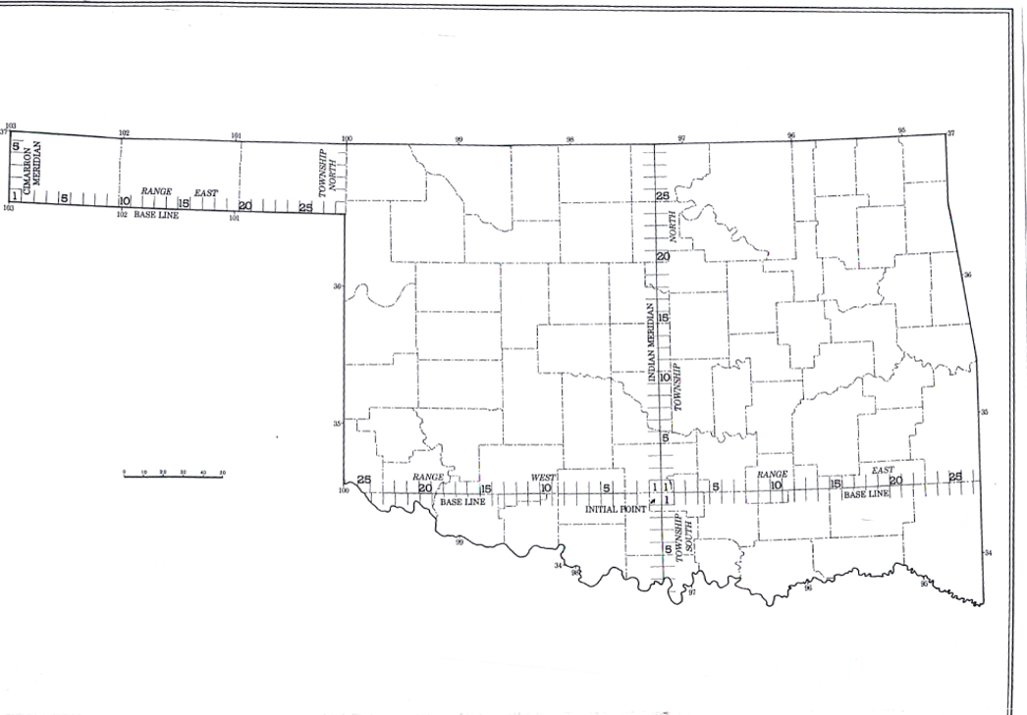
NOTICE
To Those Preparing to the Take the
Oklahoma State Specific Exam for Licensure
as a Professional Land Surveyor

The Oklahoma State specific examination for land surveyors was created to fill the gap between the surveying knowledges examined on the NCEES exams and the knowledge that is specific to Oklahoma. Applicants must complete and pass two state specific exams. One exam is a two-hour closed book exam which covers knowledge of the principles and practice of surveying within the United States Public Land Survey System, the Corner Perpetuation and Filing Act, and the Oklahoma Minimum Standards for the Practice of Surveying. The other exam is a take home exam that covers the Oklahoma state licensing statute and Board Rules, and other state specific statutes which directly affect the practice of land surveying.
Exam specifications, study references, applicable state laws and rules and the Certified Corner Record Manual of Instructions, and the Oklahoma Minimum Standards for the Practice of Land Surveying can be found on the Board website: pels.ok.gov. They are located in the Professional Land Surveyors Application section under the Applicants tab.

The Board presumes that the applicant has taken at least one college level course in surveying within the United States Public Land Surveying System and has a working knowledge of its principles listed in the Exam Specifications. Candidates must perform calculations necessary for both single and double proportion, will be tested on their knowledge of the procedures used by the General Land office when the original surveys were performed, and be able to know how to properly establish and restore lost and obliterated corners.

Examinees will also be tested on the requirements found in the Certified Corner Record Manual of Instructions. Topics like BLM definition of corner classification, what corners need to be filed, and what needs to be on the CCR form will be included on the exam. Knowledge of this Manual and knowledge of surveying within the Public Land Surveying System accounts for 80% of the Oklahoma state specific exam.

The remaining 20% of the exam includes topics from Section245: 15-13-2 (b), (c) and (f) in the Oklahoma Minimum Standards for the Practice of Surveying. It should be noted by our comity applicants that these Oklahoma standards are NOT the same as the standards in your state or the ALTA/NSPS Land Title Survey Standards. Our standards can be either more or less stringent than the ones in your state, and that is why it is mandatory that you read and be familiar with Oklahoma standards.

Applicants are expected to know the basic information about riparian boundaries in Oklahoma, but will not be required to perform a riparian boundary calculation.

The Oklahoma Law and Surveying exam is not an easy or intuitive exam. The Oklahoma Board strongly recommends taking the necessary classwork and studying the reference manuals prior to being examined.

Please contact Bruce Pitts, PLS, at bpitts@pels.ok.gov if you have any questions about the Oklahoma examinations.

