Table of Contents
The West Central Planning Region 1
Section 1.1: Watershed Introduction 1
Section 1.2: Socioeconomic and Geographic Characteristics 3
Section 1.3: Floodplain Management and Mitigation Capabilities 7
Section 1.4: Flood Hazard Assessment 16
Section 1.5: Flood Mitigation Needs 22
Section 1.6: Conclusion 23

The West Central Planning Region

Watershed Introduction
The West Central Planning Region (Region) spans an area of 5,262 square miles across western Oklahoma and encompasses all or parts of 12 counties -- Beckham, Blaine, Caddo, Canadian, Comanche, Custer, Dewey, Ellis, Kiowa, Roger Mills, Washita, and Woodward. There are 48 communities located within the West Central Watershed within the Planning Region . This area also coincides with three tribal Nations – the Cheyenne and Arapaho Nation, Caddo-Wichita-Delaware Nation, and Kiowa-Comanche-Apache-Fort Sill Apache Nation. Major waterways include the Washita and Canadian Rivers, the Upper Canadian River, the Washita Headwaters and three Upper Washita Basins. Also included are Foss and Fort Cobb Reservoirs, which are used primarily for flood risk control, and collect water from two different basins. Figure 1 highlights the geographic boundaries of the planning area for this region of the State.
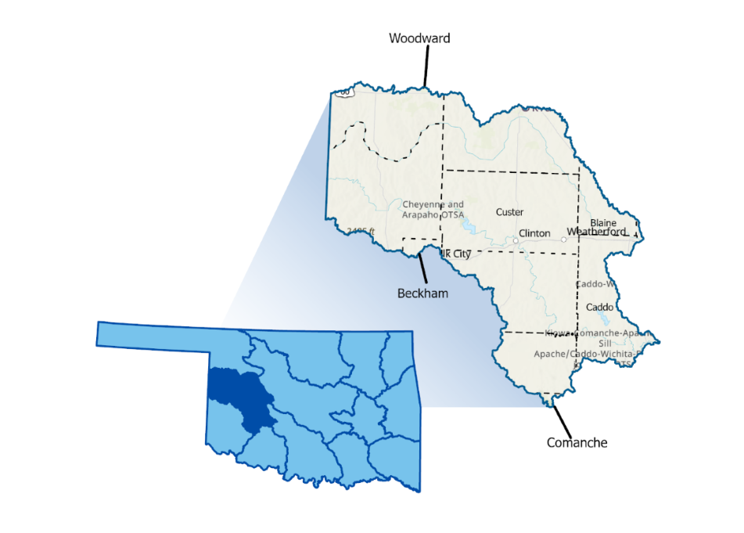
Figure 1: West Central Planning Region Boundary, Population, and Flood History
Land use data from United States Geological Survey (USGS) shows the eastern/southeastern half of the Planning Region is comprised of cultivated crops, while land in the western/northwestern half is primarily shrubs and grassland. Agriculture is predominant in this Region. Since 1950, 74 FEMA disaster declarations have been granted including 48 major disaster declarations (DR), 9 Emergency declarations (EM), and 17 Fire declarations (FM). 31 declarations are attributed to flooding, either partially or entirely.
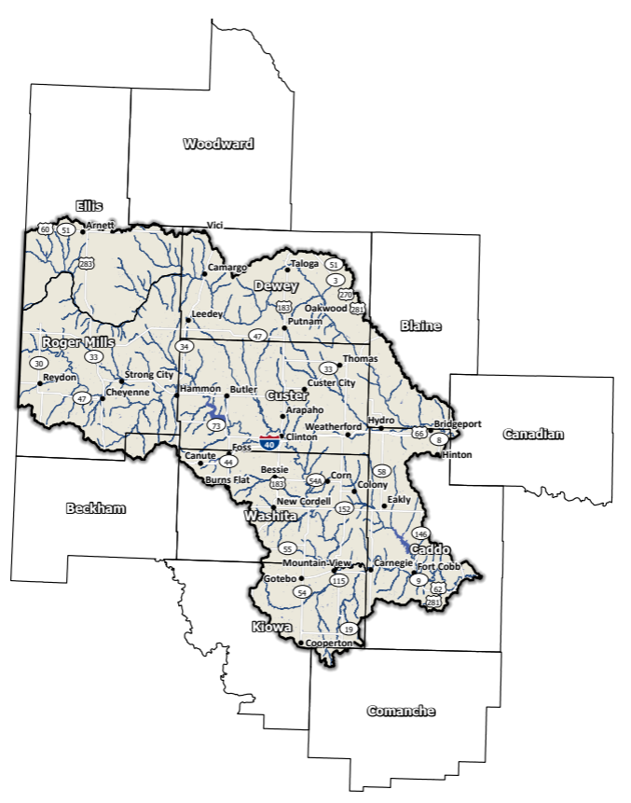
Figure 2: West Central Planning Region Base Map

Socioeconomic and Geographic Characteristics

Demographic Profile
According to the 2020 U.S. Census, 109,000 people call the West Central Planning Region home, which equates to approximately 2.7% of the total Oklahoma population. Of the 12 counties, only Custer County is completely contained within the West Central Planning Region, as shown in Figure 2.
Table 1: Population Breakdown in the West Central Planning Region
County | Total Population
Beckham | 22,410
Blaine | 8,735
Caddo | 26,945
Canadian | 154,405
Comanche | 121,125
Custer | 28,513
Dewey | 4,484
Ellis | 3,749
Kiowa | 8,509
Roger Mills | 3,442
Washita | 10,924
Woodward | 20,470

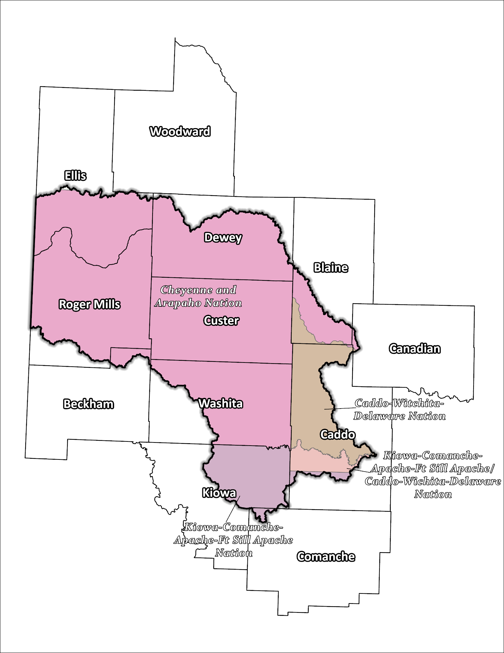
Figure 3: Tribal Jurisdictions Base Map for West Central Planning Region

Economic Profile
The West Central Planning Region has significant economic importance in the state and the nation. Ranked #2 in the nation for beef cattle production, and in the top 10 for crops such as wheat, cotton, soybeans, and sorghum, billions of dollars in Oklahoma agricultural products are exported to outside markets annually pumping valuable dollars into Oklahoma’s economy. Located in Comanche County, Fort Sill is another economic contributor. A study conducted by Fort Sill and local partners published in 2018 noted a $1.7B economic impact in Southwestern Oklahoma in FY2015. Other major contributors to the economic health of the Planning Region and the State include state parks, historical sites, and wildlife refuges that attract visitors to the area annually. Oil and gas as well as transportation, especially in relation to the exportation of crop yield and livestock, play key roles in the west central economic profile. Primary employment industries are agriculture, health care, and education. Tribal casinos and gaming revenue are also economic drivers in the 12-county Region with casinos located in Blaine, Caddo, Canadian, Comanche, and Custer counties.

Floodplain Management and Mitigation Capabilities

National Flood Insurance Program Participation
Participation in Federal Emergency Management Agency’s (FEMA) National Flood Insurance Program (NFIP) is widespread across the Planning Region boundary. A total of 10 of the 12 counties are participating communities. Municipalities within these counties also have a high level of participation, as seen in Figure 4 below. Tribal entities are invited to participate in the NFIP; however, FEMA does not list any of the four tribal nations in this Planning Region as participants.
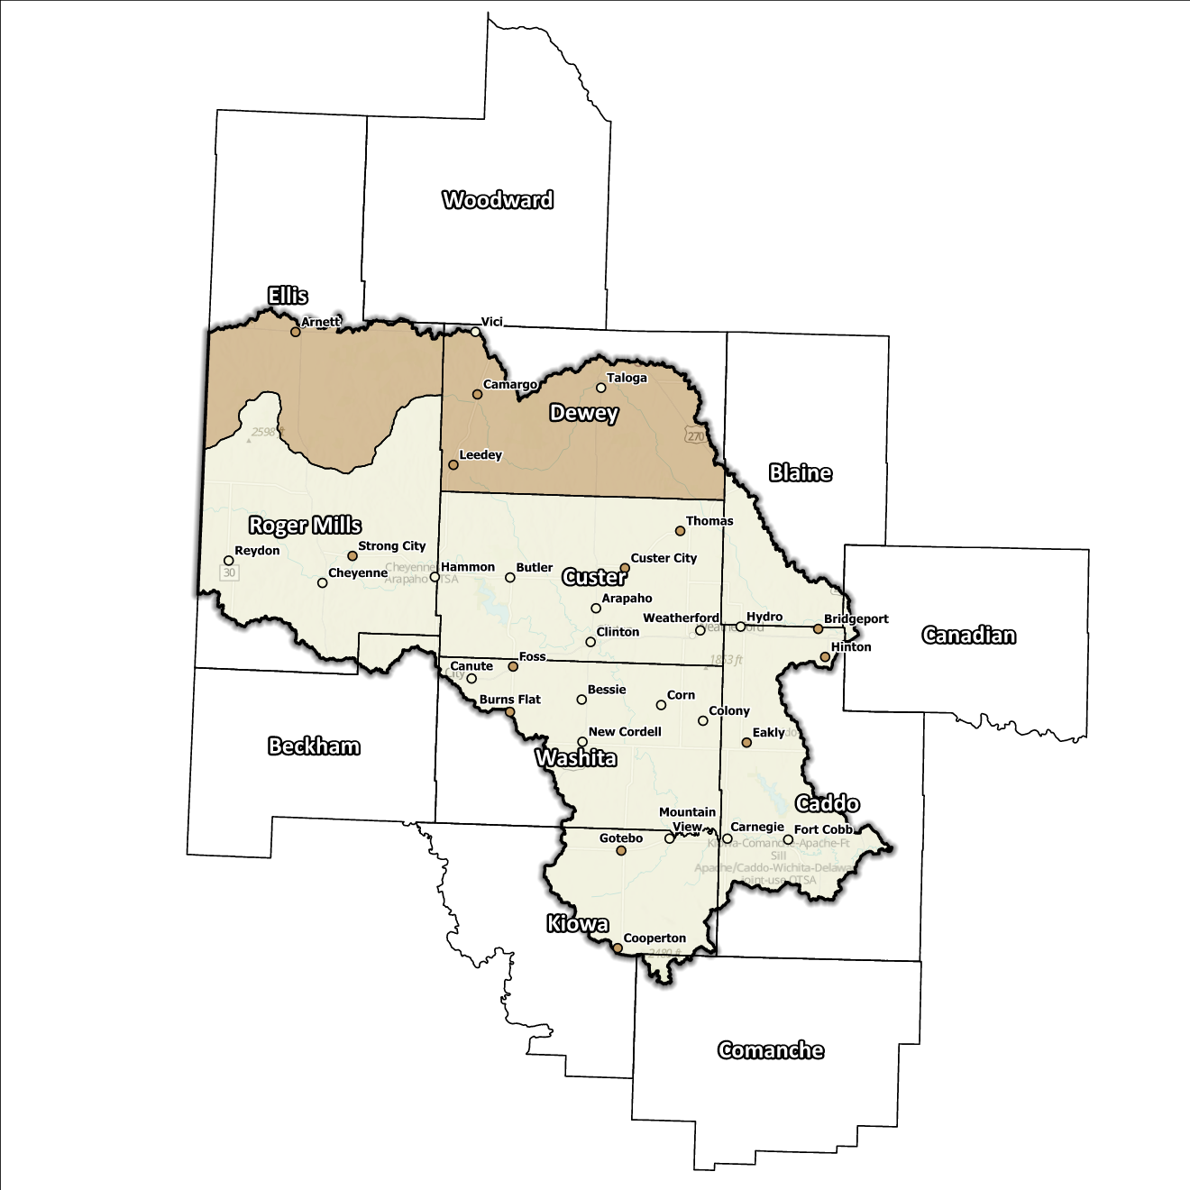
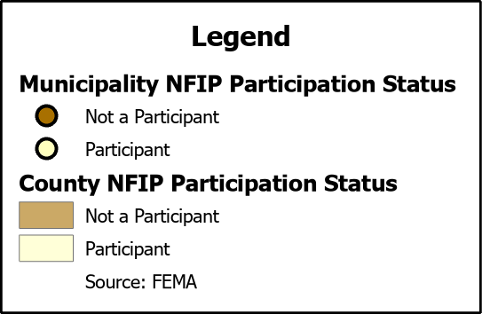
Figure 4: Status of NFIP Participation in the West Central Planning Region

Flood Insurance Coverage
Across all 12 counties, a total of 57 active NFIP policies are currently in place and a total of 31 NFIP claims have been filed resulting in approximately $393k being paid out to policyholders. Additionally, there are 3 structures classified as repetitive loss (RL) within this Region. Repetitive loss, in the context of the NFIP, refers to properties that have experienced multiple flood-related insurance claims over a specific time period. Severe repetitive loss, on the other hand, pertains to properties with an extensive history of recurrent flood damage and a high number of insurance claims, making them particularly vulnerable and costly for the NFIP.
Subsequent graphics provide a range of information about NFIP policies as well as total claims filed and paid in the Planning Region. Although these figures are insightful, it's crucial to recognize they may not accurately reflect the true extent of losses in the area due to an underrepresentation of flood insurance. Not every claim filed or paid is linked to an active policy. To address concerns of those in the Region who may be impacted by flooding but have never had flood insurance, it is essential to increase awareness about flood risk and the importance of obtaining flood insurance coverage.

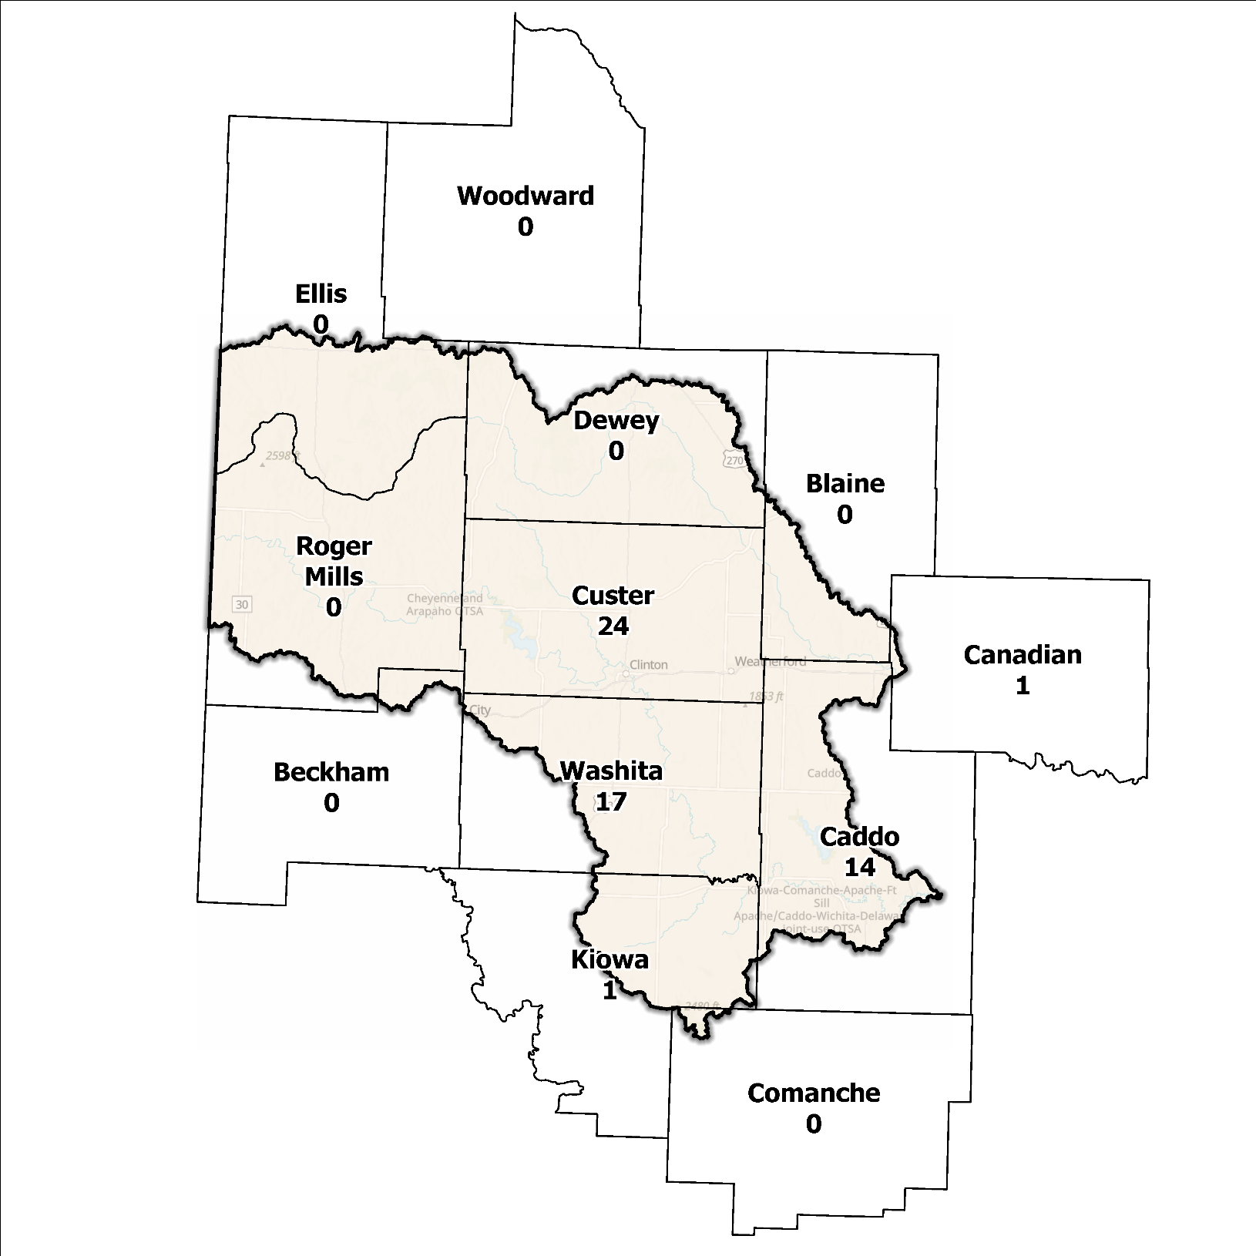
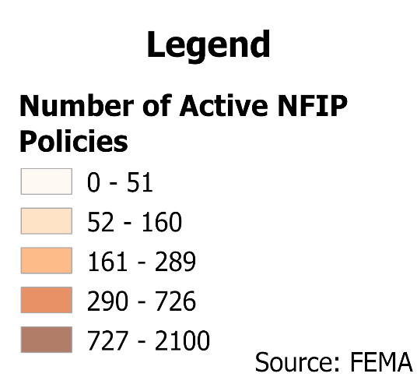
Figure 5: Number of Active NFIP Policies in the 100-Year Floodplain in the West Central Planning Region

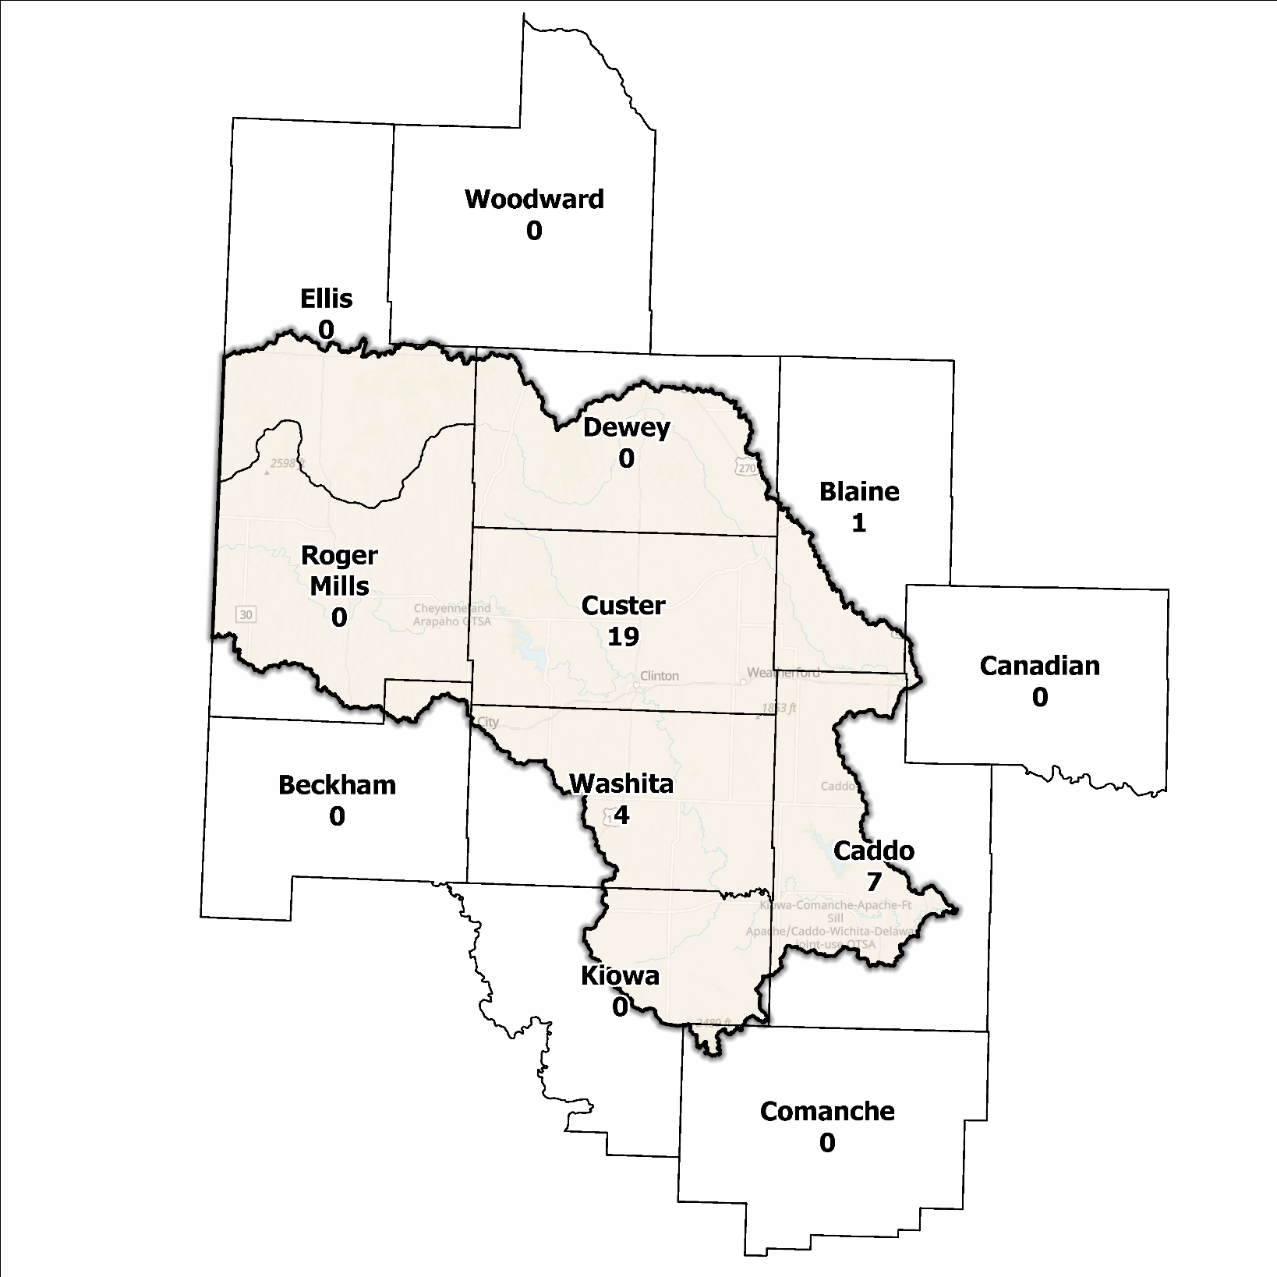
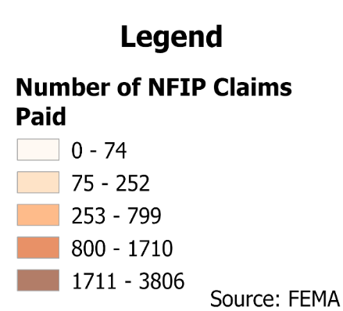
Figure 6: Total NFIP Claims Paid in the West Central Planning Region

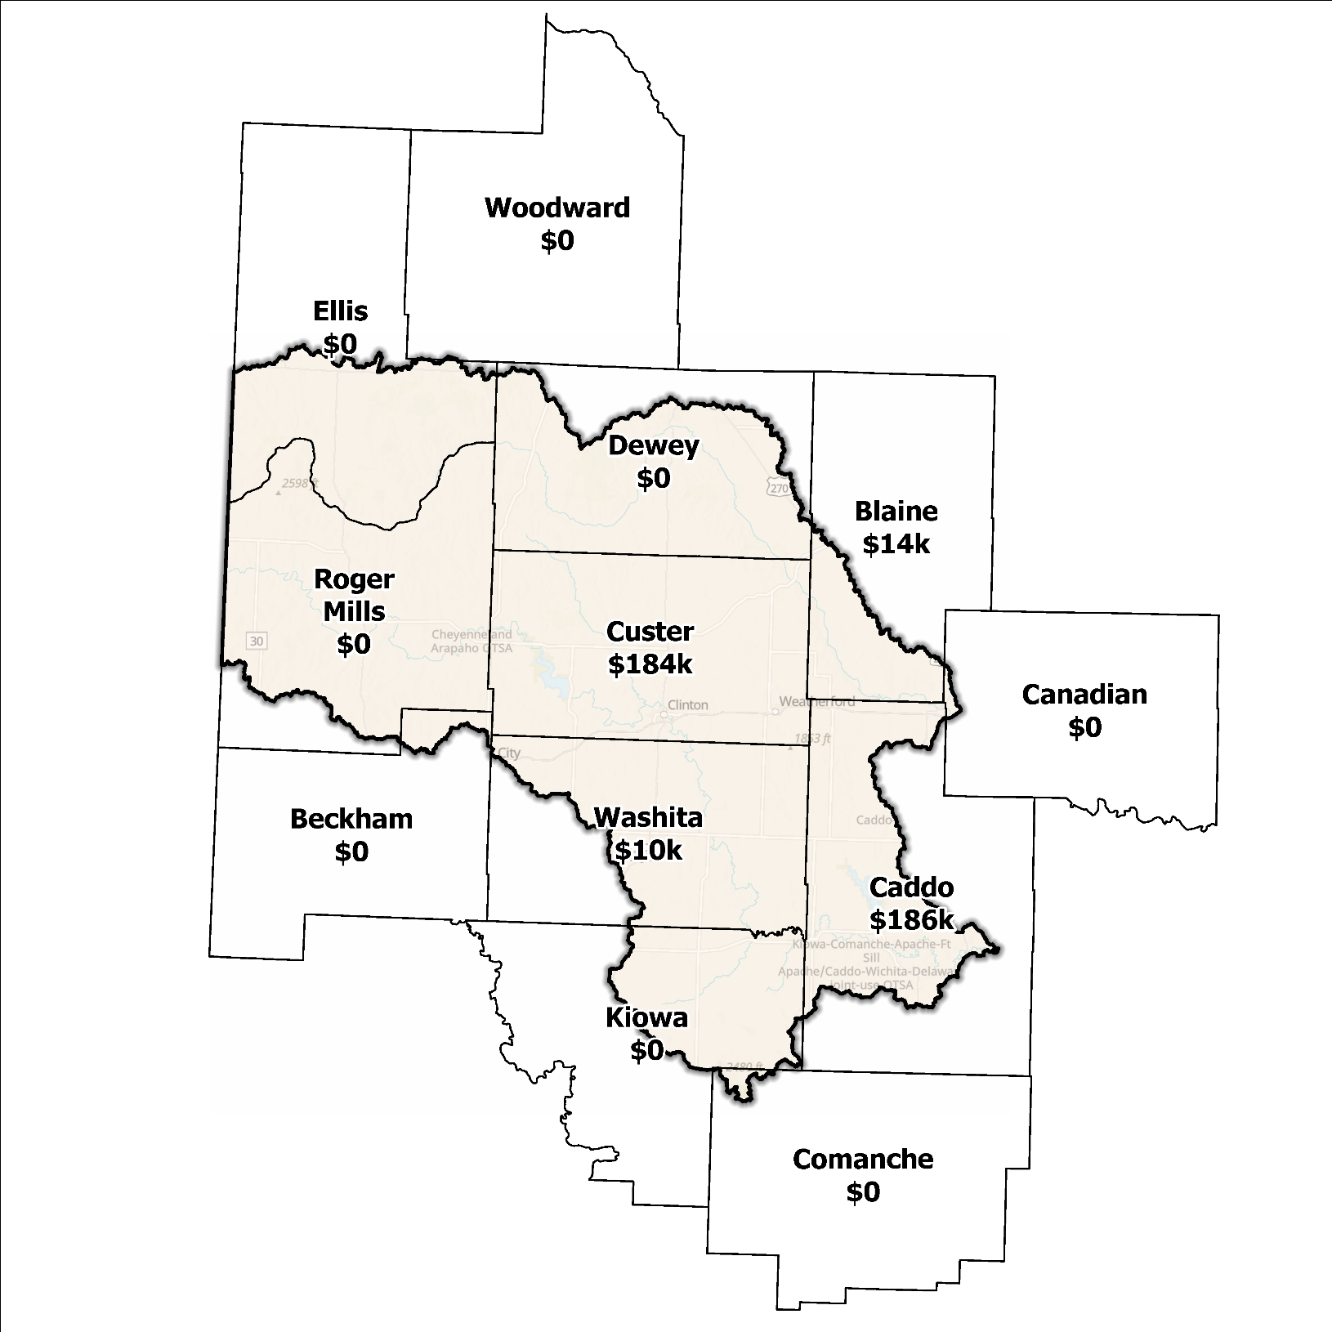
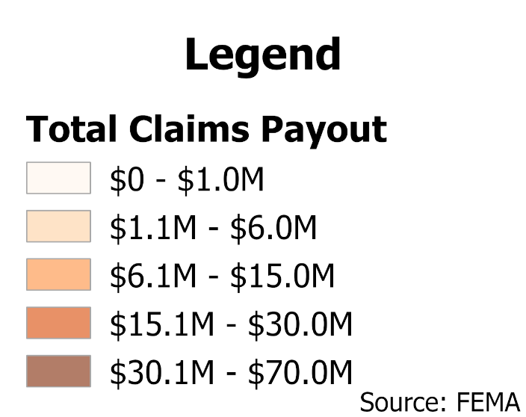
Figure 7: Total Value NFIP Claims Paid Out in the West Central Planning Region

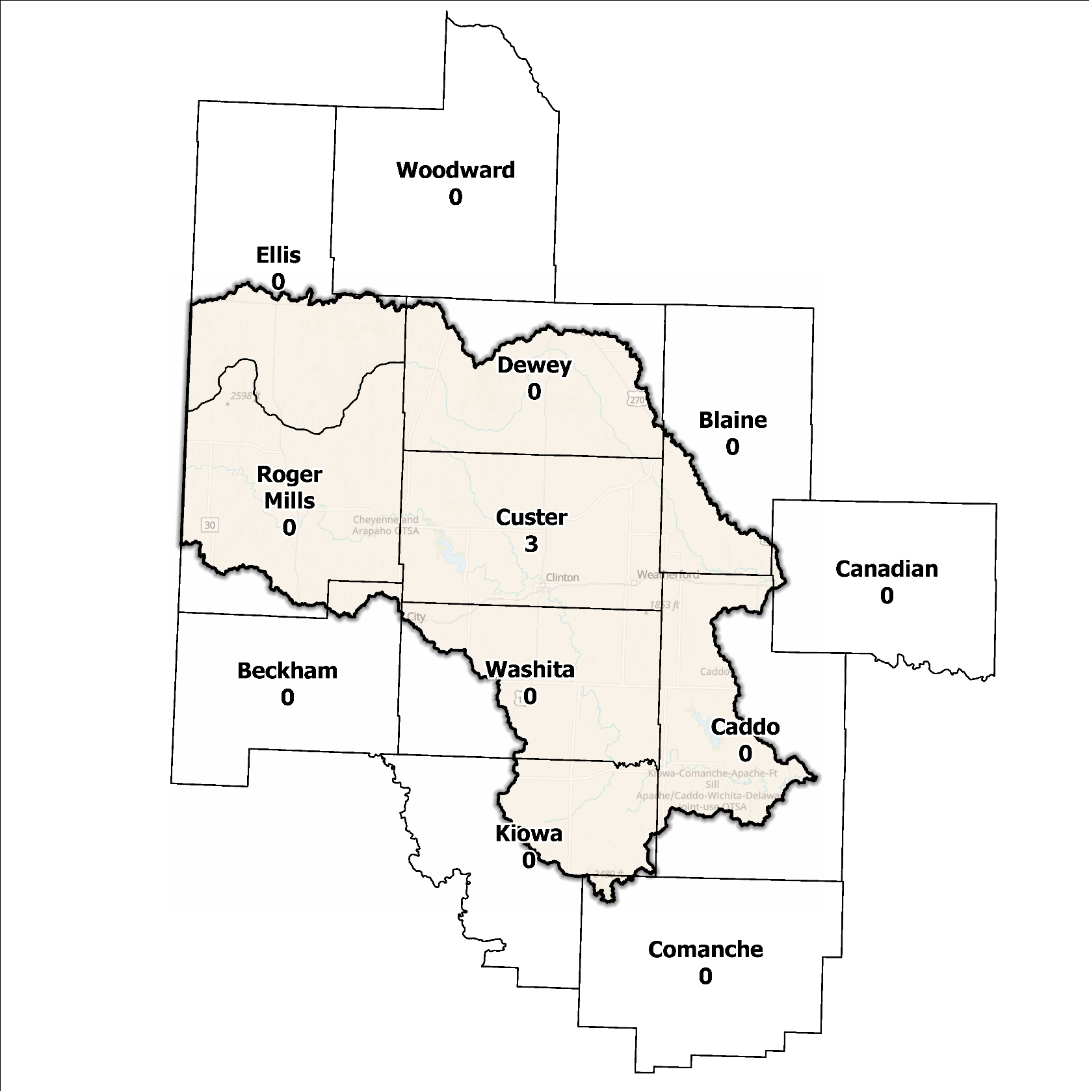
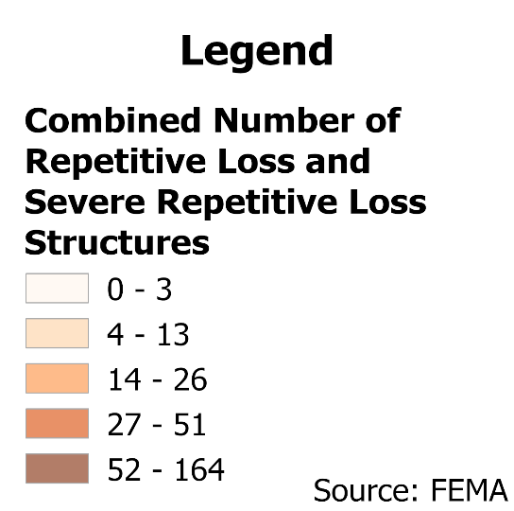
Figure 8: Repetitive Loss and Severe Repetitive Loss Structures in the West Central Planning Region

Flood Funding Mechanisms
Larger urban areas within the state have effectively adopted stormwater utility fees to finance flood mitigation initiatives, however, the acceptance of such programs is challenging in regions with infrequent flooding events. In rural areas where flooding occurrences are less common, funding for flood mitigation projects is often sought through grant programs. An analysis conducted by the planning team to determine the nature of funding for stormwater and floodplain management in the West Central Planning Region revealed that in addition to local and state sources of funding, external sources include Hazard Mitigation Grant Programs (HMGP) along with other similar programs. Regular budget allocations are primarily reserved for routine expenses like road repairs and other everyday necessities.

Hazard Mitigation Plan Status
Among the 12 counties in this Region, eight have FEMA-approved Hazard Mitigation Plans (HMPs) that outline various mitigation actions tailored to each jurisdiction. These actions encompass a range of activities including planning, public education, outreach efforts, and acquiring essential equipment. Some of the proposed action items focus on specific projects such as participating in the National Flood Insurance Program (NFIP), implementing road and drainage improvements, and undertaking engineering projects. Other HMP mitigation strategies revolve around activities tailored to planning, public education, and outreach efforts or activities like acquiring essential equipment. One example of a specific action item can be found in Washita County, where their plan includes construction of a reservoir to divert water from the East Fork of North Cavalry Creek to safeguard structures in New Cordell from potential flooding. County-level HMP information is provided in Table 2, however, some local municipalities have their own HMPs in place. Typically, communities within a county will fall under the purview of the county plan, but there are instances where towns/cities have a separate HMP in place. For example, the town of Sweetwater, which straddles Beckham and Roger Mills counties, has their own approved plan independent of the two county-level plans. Plans listed in the table below are a summary of county-level HMPs only and do not account for any local HMP that may also be active. Additional information on a community's HMP status can be found on the FEMA Hazard Mitigation Plan Status webpage.

Table 2: Hazard Mitigation Planning Status for Counties in the West Central Planning Region
Name | Type | Approval Date | Expiration | Current Action Status of this Plan
Beckham | County | 09/14/2022 | 09/13/2027 | Approved
Blaine | County | 03/23/2023 | 03/22/2028 | Approved
Caddo | County | - | - | In Progress
Canadian | County | 11/17/2021 | 11/16/2026 | Approved
Geary | City | 03/22/2023 | 03/21/2028 | Amending
Comanche | County | 09/13/2024 | 09/12/2029 | Approved
Custer | County | - | - | In Progress
Dewey | County | 09/23/2020 | 09/22/2025 | Approved
Ellis | County | 10/30/2024 | 10/29/2029 | Approved
Kiowa | County | 10/17/2022 | 10/16/2027 | Approved
Roger Mills | County | - | - | In Progress
Washita | County | 02/20/2020 | 02/19/2025 | Approved
Woodward | County | 07/29/2008 | 07/29/2013 | Expired
Caddo | Tribal  Nation | 01/19/2023 | 01/18/2028 | Approved
Anadarko | City | 10/25/2010 | 10/25/2015 | Expired
Cheyenne and Arapaho | Tribal  Nation | 01/27/2022 | 01/26/2027 | Approved
Comanche | Tribal  Nation | 07/21/2011 | 07/21/2016 | Expired
Delaware | Tribal  Nation | 09/23/2015 | 09/23/2020 | Expired

Flood Mapping Assessment
In the West Central Planning Region, the floodplain quilt consolidates the best available data on flood risk and flood extent. Some more rural areas in the Region still lack access to FEMA flood maps providing base flood engineering levels. This can limit the ability of local authorities such as floodplain managers to regulate development in flood-prone areas. As such, the best data available affords a broad understanding of flood risk, but precise assessments cannot be made based on these studies. Figure 9 displays FEMA-mapped areas in the Planning Region.
While in areas with A zones, Base Level Engineering (BLE) data might provide a more accurate indication of flood risk, but it is essential to note that not all areas of the Planning Region have BLE coverage. Thus, there is a pressing need for in-depth studies to be conducted to enhance the precision and reliability of flood risk information in specific areas.
A significant factor contributing to a lack of floodplain mapping is funding. For communities where funding is limited, mapping may be overlooked in favor of providing different essential services.
While Flood Insurance Rate Maps (FIRMs) are beneficial for regulatory uses and flood insurance assessments, they only represent potential risks associated with a flood event under certain specific conditions. The threat of stormwater flooding is only included on FIRMs if the community opts to carry out the required studies to integrate such data into their hazard map.

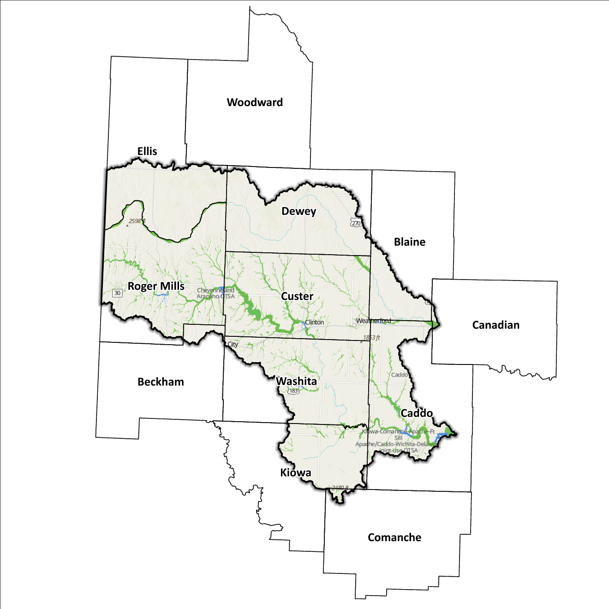
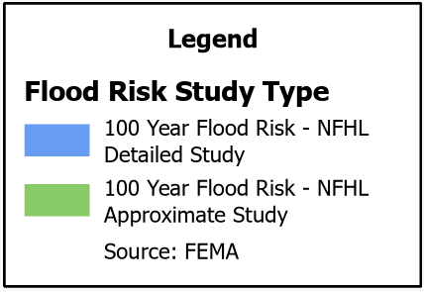
Figure 9: FEMA Mapped Special Flood Hazard Area Comparison in the West Central Planning Region

Flood Hazard Assessment
Flood hazards in this Region encompass flash, river, and urban flooding. Prominent waterways within the West Central Planning Region are the Washita and Canadian Rivers, as well as their numerous tributaries. These rivers play a significant role in shaping the flood patterns and risks within the area.

Location of Flood Hazards
The West Central Planning Region is characterized by a flood hazard that encompasses various significant aspects. The flood location in the West Central Planning Region exhibits the following characteristics:
- Flooding along major waterways with extensive drainage basins, including the Washita and Canadian Rivers.
- Flash floods along smaller tributaries that ultimately flow into the major waterways.
- Drainage issues in specific areas result from inadequate infrastructure. Insufficient drainage systems can exacerbate flood risks, leading to localized flooding in vulnerable locations.
- Downstream areas located below high-hazard potential dams are exposed to heightened risks.
Figure 10 illustrates mapped flood risk areas in the Region. This map integrates data from various sources, including the National Flood Hazard Layer and BLE to present a comprehensive and cohesive view. The map prioritizes layer types and displays crucial information available for each specific area.
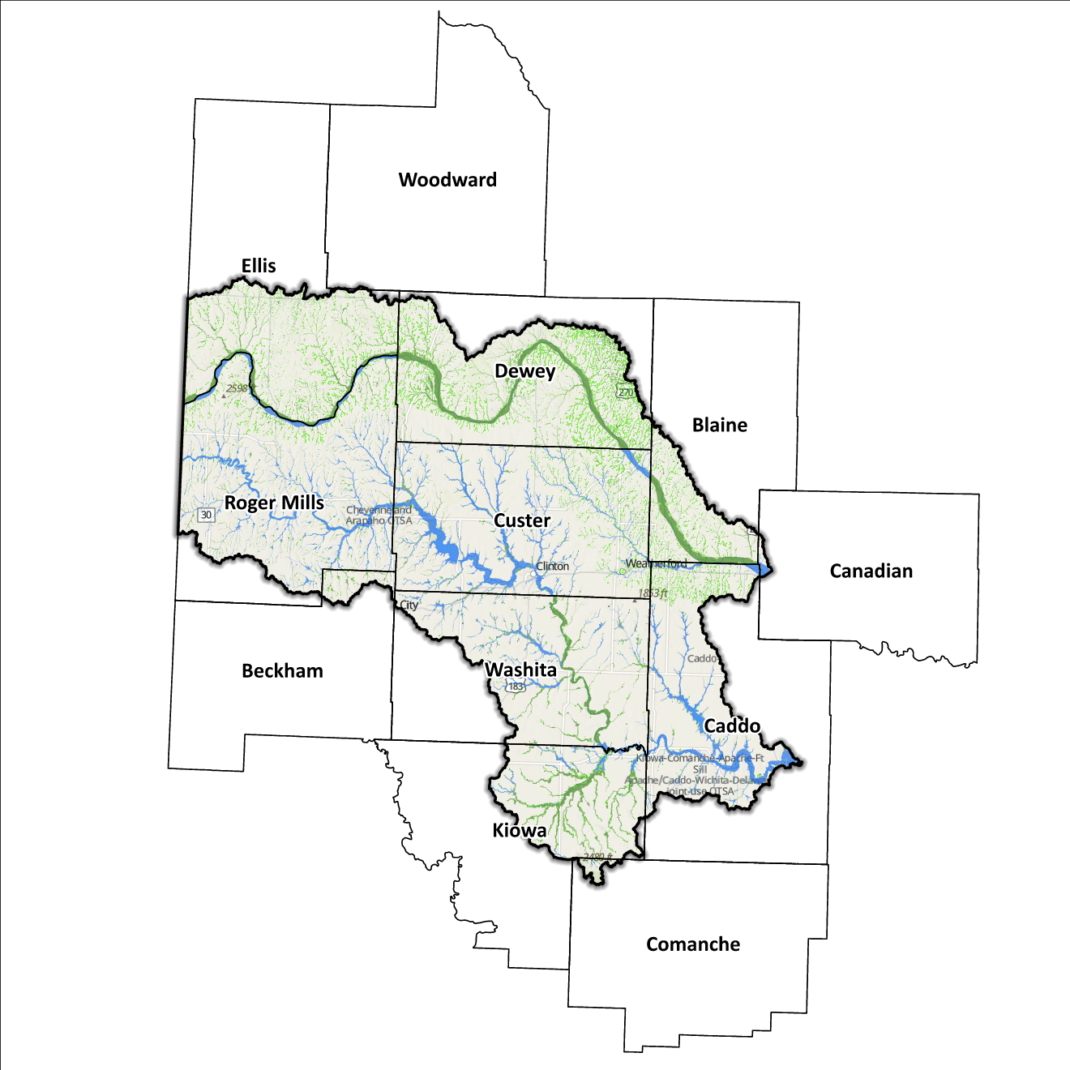
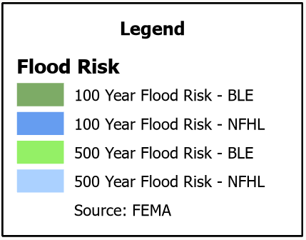
Figure 10: Flood Quilt in the West Central Planning Region

Dam and Levee Infrastructure
Numerous dams designed to prevent flooding are located within this Region, however, aging infrastructure raises concerns about potential downstream consequences in the case of a breach or failure. This is especially true of the 47 high-hazard dams located in the Planning Region. The potential outcome of dam failures can be catastrophic, leading to the devastation of communities and significant loss of life. A sudden release of vast amounts of water with tremendous force can inundate floodplains, posing a grave threat. Therefore, it is crucial to carefully assess the risk of flooding resulting from a dam incident while evaluating each Planning Region. The Oklahoma Water Resources Board (OWRB) designates hazard ratings for dams across the state when determining risk. Figure 11 maps the locations of all dams in the Planning Region. In addition to dams within the state of Oklahoma, those located to the west in the Texas Panhandle must also be considered, as flooding due to dam breaches does not stop at state boundaries. Sanford Dam, located on the Canadian River eight miles west of Borger, TX would impact areas within this Planning Region. It is rated as high-hazard and remains relevant to this Region due to potential for floodwaters reaching Camargo, in Dewey County.

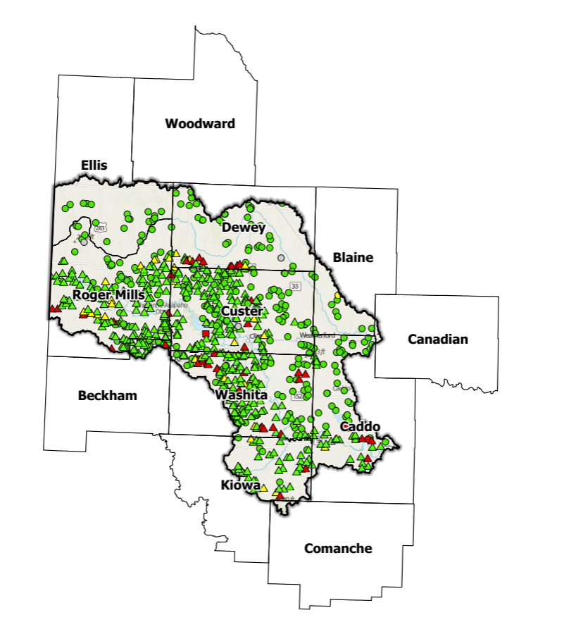
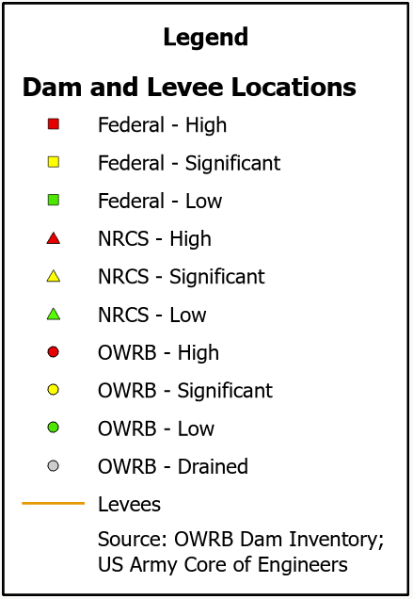
Figure 11: Dam and Levee Locations in the West Central Planning Region

Extent of Flooding
Extent pertains to the predicted magnitude of flooding, and due to diverse topography across the planning area, it differs among various communities. Within the FEMA-mapped Special Flood Hazard Area, the average depth of flooding can vary significantly, ranging from a few inches to several feet. This variation is influenced by factors such as local topography, distance to water bodies, drainage patterns, and the intensity of a flood event.

Previous Occurrences
According to records maintained by the National Center of Environmental Information (NCEI), from January 1996 to December 2022, a total of 382 flood events have been documented in the Planning Region ’s 12 county boundary. Nearly 24% of these occurred in Comanche County. Since NCEI data does not contain tract-level details, it is unclear how many flooding events occurred within the West Central Planning Region. Regardless, event summaries show how costly these events can be. Cumulatively, flooding has caused property damage amounting to $13,119,000 and crop damage amounting to $40,000. County-level disaster declarations, as maintained by FEMA, are summarized in Table 3 below. Total declaration numbers are county-level summaries that differentiate all disasters, and those caused by flooding (either partially or entirely). Caddo County has been included in more flood-related disaster declarations (twenty-three) than any other county in the Region, while Woodward County has seen the least (seven).
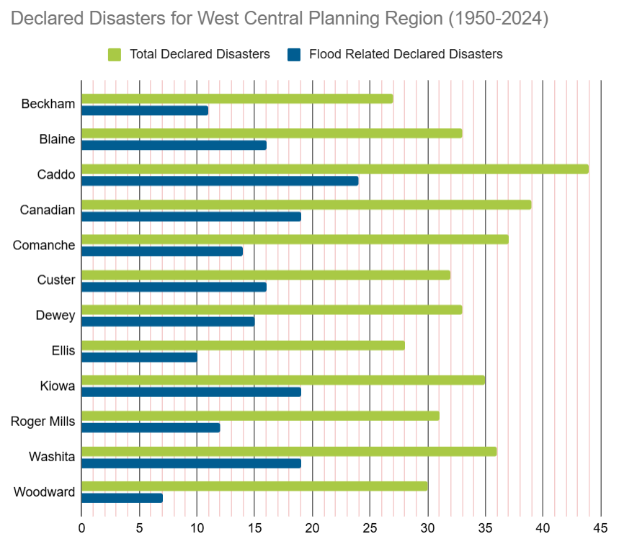
Table 3: FEMA Flood Related Disaster Declarations (1950-2024) in the West Central Planning Region

Vulnerability and Impacts of Flooding

Areas within this Planning Region average less than 35 inches of rainfall per year, with the northwestern extent of the Region averaging less than 25 inches of precipitation annually. While above the threshold for qualification as an arid climate, rainfall amounts are still much lower than other areas of the state. A common perception is that areas with higher average annual rainfall are at greater risk for flooding, but drier areas can also face significant risk. Soils in drier areas harden during dry spells, which can emulate impervious surfaces found in developed areas. If a heavy rainfall event occurs after a long dry spell, flooding and flash flooding can be an immediate concern. Additionally, since the terrain in this area slopes gently downward toward the east/southeast, it can lead to flooding threats in areas downstream.

Summary of Flood Exposure
Flood exposure encompasses the level of vulnerability an area or its population faces in the event of a flood. Table 4 offers a comprehensive summary of essential factors, such as total count of housing units, population figures, job statistics, land area measurements, and the number of parcels/blocks located within the designated FEMA-mapped flood area. Data in this section was generated using UrbanFootprint. This module evaluates flood risk by conducting a spatial join of parcels or census blocks with the FEMA National Flood Hazard Layer to assess the potential risks associated with hazards. The data presented in the table below is focused on three different FEMA SFHA flood zones that represent areas within the 100-yr floodplain with a 1% annual chance of experiencing a flood event. Zone AE is the most detailed, providing base flood elevations, Zone AO represents areas subject to shallow flooding of depths between one to three feet, and Zone A being an approximation of the 100-yr floodplain for areas where detailed hydraulic analyses have not been performed.
Table 4: Flood Exposure in the West Central Planning Region
West Central Planning Region Flood Risk Report
Housing in Flood Hazard Zones (Dwelling Units)
Dwelling Units in SFHL Zone AE | 136
Dwelling Units in SFHL Zone A | 702
Dwelling Units in SFHL Zone AO | N/A
Total | 838
Population in Flood Hazard Zones (Persons)
Population in SFHL Zone AE | 258
Population in SFHL Zone A | 1,407
Population in SFHL Zone AO | N/A
Total | 1,665
Jobs in Flood Hazard Zones (Employees)
Jobs in SFHL Zone AE | N/A
Jobs in SFHL Zone A | N/A
Jobs in SFHL Zone AO | N/A
Total | N/A
Land Area in Flood Hazard Zones (Acres)
Area in SFHL Zone AE | 4,167
Area in SFHL Zone A | 223,524
Area in SFHL Zone AO | N/A
Total | 227,691
Parcels or Blocks in Flood Hazard Zones
Parcels or Blocks in SFHL Zone AE | N/A
Parcels or Blocks in SFHL Zone A | N/A
Parcels or Blocks in SFHL Zone AO | N/A
Total | N/A

Flood Mitigation Needs
Flood mitigation projects for the Region have been identified at a county level through the analysis of hazard mitigation plans, master drainage plans at the community level, and prioritized lists provided by jurisdictions. The following stormwater project types were considered:
- Channel
- Storm Drain
- Infrastructure
- Detention Pond
- Dam-Reservoir
- Floodwalls and Levees
- Acquisition
According to OWRB data, only one stormwater project has been identified within the West Central Planning Region: a storm drain system for Riverview Drive in Clinton (Custer County) funded in 2022 at a cost of $250,000. Table 5 below shows stormwater projects by type, with details on the number of each, the percentage of total projects, and cumulative dollar amounts for each type.
Table 5: Stormwater Projects Identified in the West Central Planning Region
Stormwater Project Types Per County | Number | Percentage | $ Amount
Custer County
Storm Drain | 1 | 100% | $350k
Total | 1 | - | $350k

Despite the Planning Region having a relatively low risk of flooding, developed areas within towns and communities face a higher risk compared to surrounding Planning Regions. To enhance resilience to flooding, it is essential for communities within the West Central Planning Region to actively seek external funding sources to implement flood mitigation measures. This proactive approach will enable the development of strategies which provide resilience to potential flood events.

Conclusion
The West Central Planning Region report highlights this Region’s vulnerability to flood events and emphasizes an urgent need for funding to support engineering efforts in flood projects within the Planning Region. Adequate funding is essential for conducting detailed engineering assessments, implementing effective flood control measures, and enhancing community resilience. The lack of project submissions underscores the importance of assisting communities in identifying and developing flood mitigation projects.
By allocating resources and support for project identification and development, communities can better understand their flood exposure and proactively protect lives and infrastructure. Investing in engineering and flood mitigation projects in the West Central Planning Region will contribute to creating safer, more resilient communities better equipped to handle future flood events.
During the planning process, the data generated was incorporated into an interactive OWRB State Flood Plan Dashboard (DRAFT). The dashboard serves as a valuable tool for conducting flood assessments at the community level. It is important to note that this report should not substitute locally generated data specific to each community.

NFIP Community Status Report
Blaine County’s HMP includes the City of Geary.
Caddo County’s HMP includes the Towns of Carnegie, Eakly, Fort Cobb, Hinton, Hydro, and the City of Bridgeport.
Custer County’s HMP includes the Towns of Arapaho, Butler, Custer City, and the Cities of Clinton, Thomas, and Weatherford.
Dewey County’s HMP includes the Towns of Camargo, Leedy, Oakwood, Taloga, and Vici.
Ellis County’s HMP includes the Town of Arnett.
Kiowa County’s HMP includes the Towns of Cooperton, Gotebo, Mountain View, and the City of Hobart.
Washita County’s HMP includes the Towns of Bessie, Burns Flats, Canute, Colony, Corn, and Foss.
https://www.usbr.gov/projects/index.php?id=270
https://climate.ok.gov/index.php/climate/map/normal_annual_precipitation/oklahoma_climate
The Urban Intelligence Platform | UrbanFootprint
Any counties that do not appear in the table do not have any identified projects.

