Table of Contents
The Upper Arkansas Planning Region 1
Section 1.1: Watershed Introduction 1
Section 1.2: Socioeconomic and Geographic Characteristics 2
Section 1.3: Floodplain Management and Mitigation Capabilities 4
Section 1.4: Flood Hazard Assessment 13
Section 1.5: Flood Mitigation Needs 17
Section 1.6: Conclusion 18

The Upper Arkansas Planning Region

Watershed Introduction
The Upper Arkansas Watershed Planning Region (Region) covers a total area of approximately 7,452 square miles in Northern Oklahoma. The Region extends from the northeastern segment of Woods County to the northwestern part of Creek County, encompassing all or certain portions of Alfalfa, Grant, Kay, Osage, Garfield, Noble, Pawnee, Kingfisher, Logan, Payne, Tulsa, and Lincoln Counties. There are approximately 79 municipalities and 11 tribal nations encompassed by the Upper Arkansas Watershed, though this number may vary slightly in accordance with the specific watershed boundaries. Among these communities, some of the most populated areas include Enid, Stillwater, Ponca City, Blackwell, and Cushing. The region is primarily located in an area known as the Central Lowland. The land here is mostly flat with some gentle hills, especially in the south. As you go further east, the land changes to rolling hills and valleys that are a part of the Flint Hills. In the Upper Arkansas Region, there is a mix of farmland and open space. In some areas, there are grassy fields, while others have more trees. Moving towards the east, the land becomes more forested and hillier. The Arkansas, Cimarron, and Salt Fork of the Arkansas Rivers, along with their various tributaries, are the major waterways in the Planning Region.
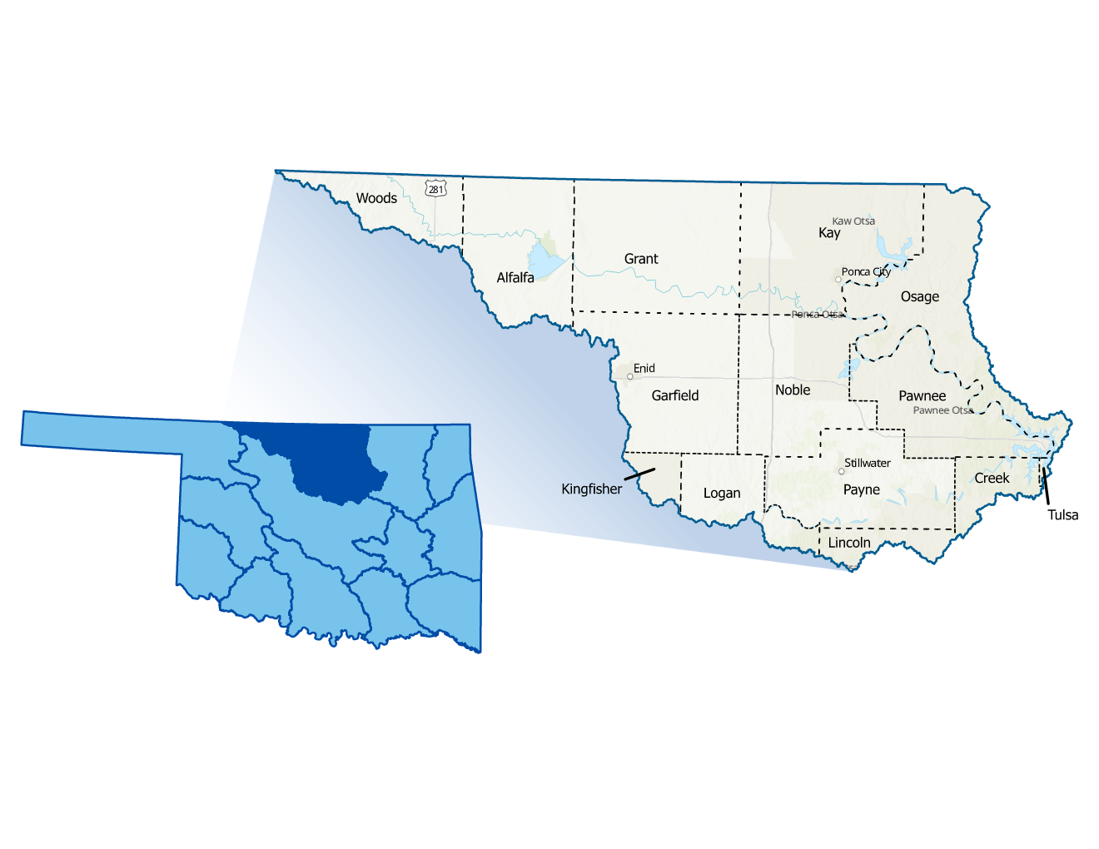
Figure 1 highlights the geographic boundaries of the planning area for this Region of the State.
Figure 1: Upper Arkansas Planning Region Boundary
The Planning Region exhibits diverse population densities throughout its 14 counties. Urban centers in Tulsa, Payne and Garfield Counties have higher densities due to their major cities, while surrounding areas feature suburban zones with mixed residential and commercial development. Counties farther from urban cores, such as Woods, Alfalfa and Grant, are predominantly rural with lower population densities, characterized by open landscapes and agricultural activities. This mixture of urban, suburban, and rural areas creates a varied demographic makeup within the Region. All counties in the planning area have experienced multiple federally declared flood disasters since 1970.
A base map displaying incorporated jurisdictions within the Planning Region is displayed in Figure 2.
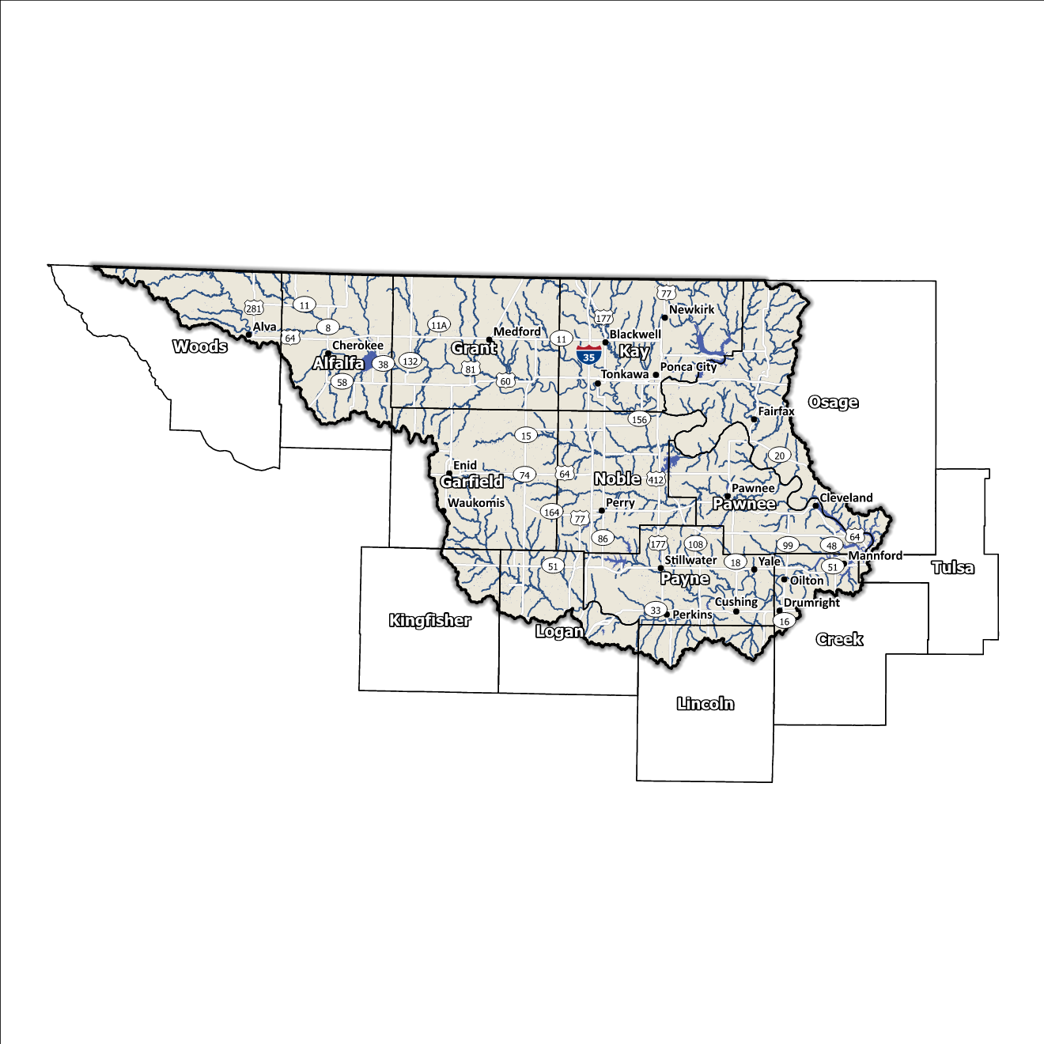
Figure 2: Upper Arkansas Planning Region Base Map

Socioeconomic and Geographic Characteristics
A mix of industries, including agriculture and livestock, oil and gas and wind farms, among others, brings economic variety to this Region. Adding another level of diversity is the geography of the area. This section will examine some of these socioeconomic and geographic factors and how they contribute to and affect this watershed.

Demographic Profile
The Upper Arkansas Watershed Planning Region encompasses over 1,100,000 people with a mix of urban, suburban, and rural areas. This Region represents approximately 10.8% of Oklahoma's land area, and around 28% of Oklahoma residents call this area home according to the 2020 U.S. Census. A population breakdown in the Region is found in Table 1.
Provided by the 2020 U.S. Census, these statistics represent county-level populations, not those within the watershed boundary. Grant, Kay, Noble, Pawnee, and Payne Counties are the only five in the group that are completely contained within the Upper Arkansas Watershed Region.
Table 1: Population Breakdown by County in the Upper Arkansas Planning Region
County | Total Population
Alfalfa | 5,699
Creek | 71,754
Garfield | 62,846
Grant | 4,169
Kay | 43,700
Kingfisher | 15,184
Lincoln | 33,458
Logan | 49,555
Noble | 10,924
Osage | 45,818
Pawnee | 15,553
Payne | 81,646
Tulsa | 669,279
Woods | 8,624

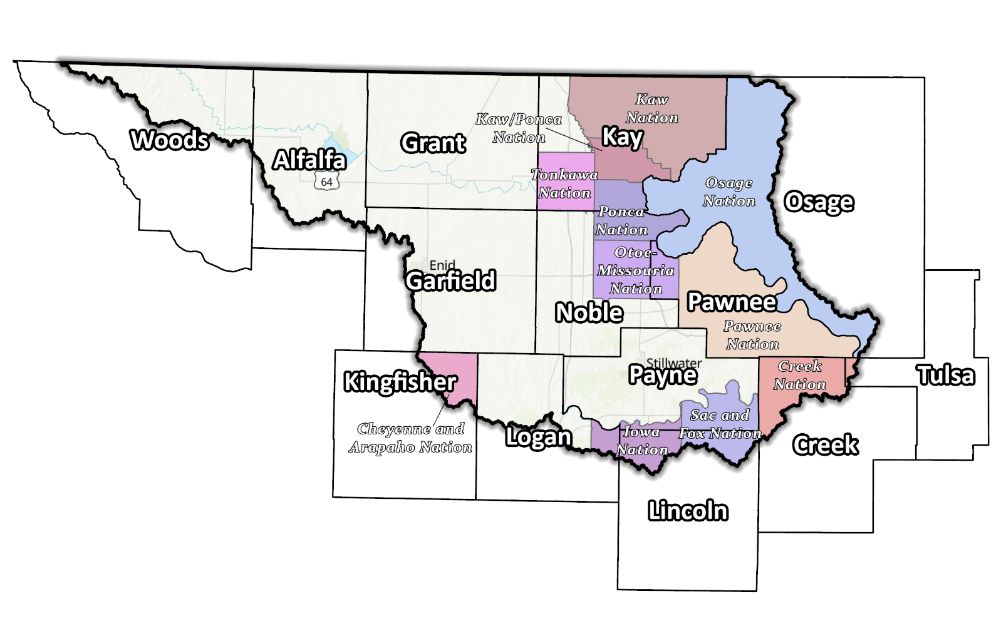
Figure 3: Tribal Jurisdictions Base Map for the Upper Arkansas Planning Region

The Region is home to several tribal nations, including the Cheyenne and Arapaho, Iowa, Kaw, Kaw/Ponca, Muscogee (Creek), Osage, Otoe-Missouria, Pawnee, Ponca, Sac and Fox, and Tonkawa Nations. It is also home to the now closed Historic Chilocco Native American Boarding School. They have a long-standing history of inhabiting the Region and have significantly shaped the area's cultural and economic development.

Economic Profile
The Upper Arkansas Planning Region has significant economic importance in the state and the country. The western half of the area is flat and doesn’t have many trees or many large populations, making it suitable for wind energy farms. The tribal nations in northern Oklahoma are significant employers in the Region. They operate in various industries, including gaming, hospitality, and retail. Additionally, the tribal nations support growth and development in the area through investments in infrastructure, education, and healthcare.

Floodplain Management and Mitigation Capabilities
This section provides a broad summary of floodplain management capabilities and community engagement within the overall Upper Arkansas Planning Region.

National Flood Insurance Program Participation
Within the Planning Region, all counties have been mapped by Federal Emergency Management Agency (FEMA) and participate in the National Flood Insurance Program (NFIP). There are few communities within the fourteen counties, however, that do not currently participate in the NFIP program, as shown in Figure 4, below.
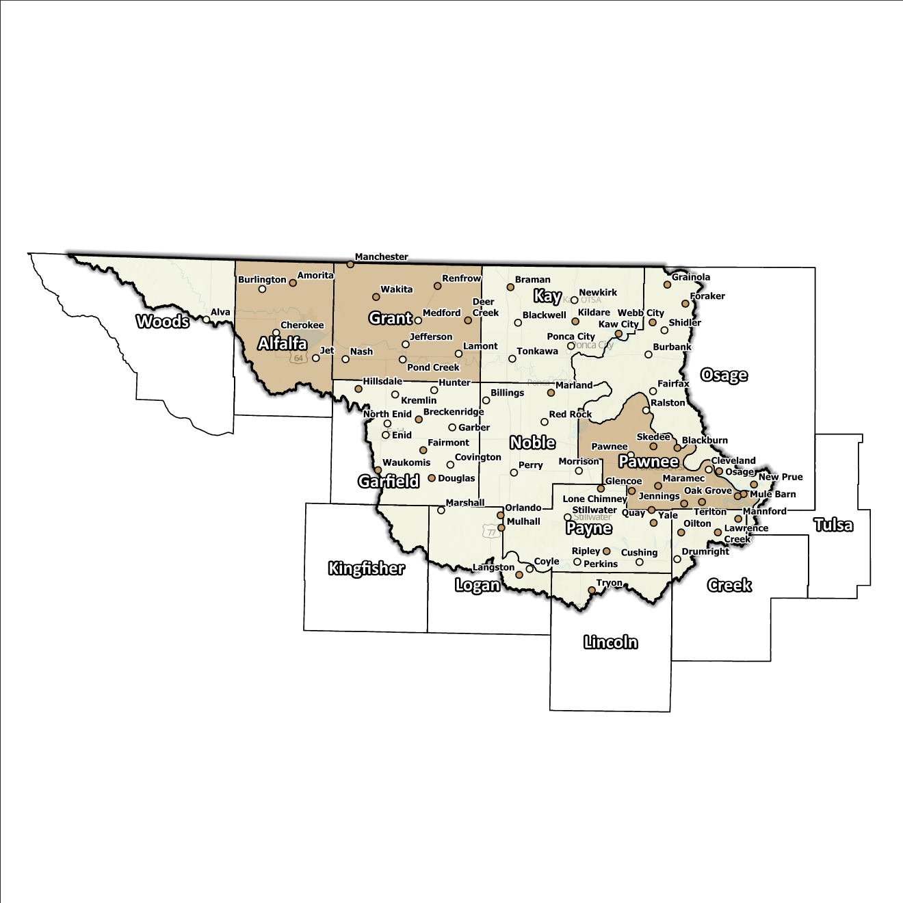
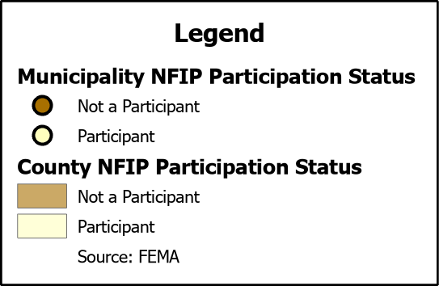
Figure 4: Status of NFIP Participation in the Upper Arkansas Planning Region
The dedication to floodplain management by jurisdictions in this Planning Region is well demonstrated by a majority participation in the NFIP as well as two cities, Blackwell and Ponca City in Kay County, and Enid in Garfield County participating in CRS (Community Rating System). Several communities in this Region go above and beyond the minimum NFIP requirements and could be used as an example for best practices and knowledge sharing in other portions of the State.

Flood Insurance Coverage
As of the latest update, there are currently 463 active NFIP policies in effect within the planning area. These policies cover approximately 6.9% of the total structures located in the FEMA mapped Special Flood Hazard Area (SFHA). It should be noted that not all active policies are situated within the SFHA, while Tulsa County is within the Planning Region, no cities from the County are in the watershed. A total of 596 NFIP claims have been filed, resulting in approximately $5 million being paid out to policyholders. In the Region, there are 45 structures classified as repetitive loss (RL) and/or classified as severe repetitive loss (SRL), with a significant concentration of both types in Tulsa County and Logan County. Repetitive loss, in the context of the National Flood Insurance Program (NFIP), refers to properties that have experienced multiple flood-related insurance claims over a specific time period. Severe repetitive loss, on the other hand, pertains to properties with an extensive history of recurrent flood damage and a high number of insurance claims, making them particularly vulnerable and costly for the NFIP.
The subsequent displays provide a range of information about NFIP policies, as well as the total claims filed and paid in the Planning Region. Although these figures are insightful, it's crucial to recognize they may not accurately reflect the true extent of losses in the area due to an underrepresentation of flood insurance. Not every claim filed or paid is linked to an active policy.
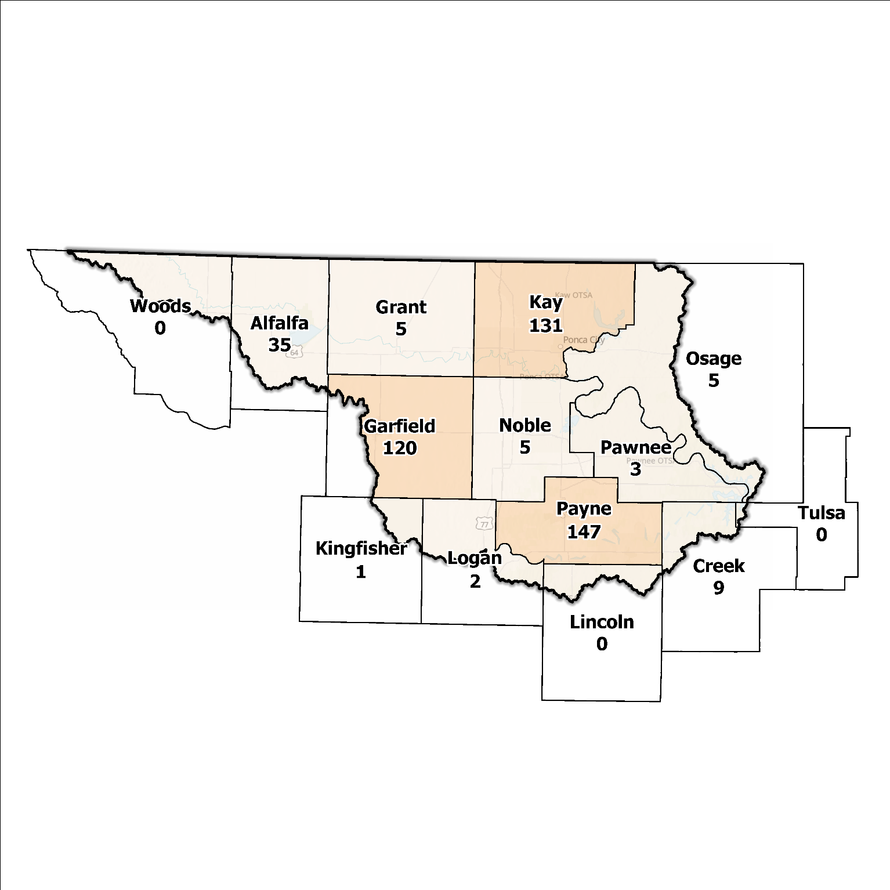
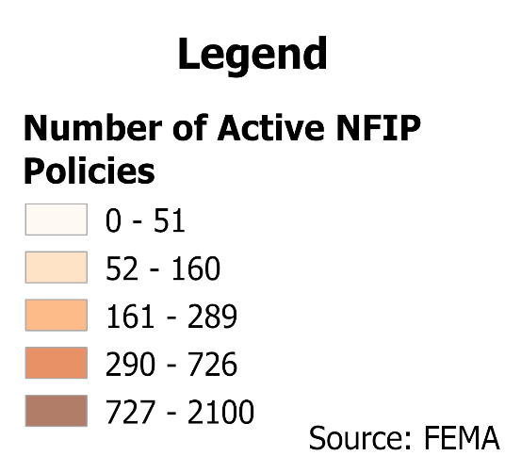
Source: FEMA
Figure 5: Number of Active NFIP Policies in the 100-Year Floodplain in the Upper Arkansas Planning Region

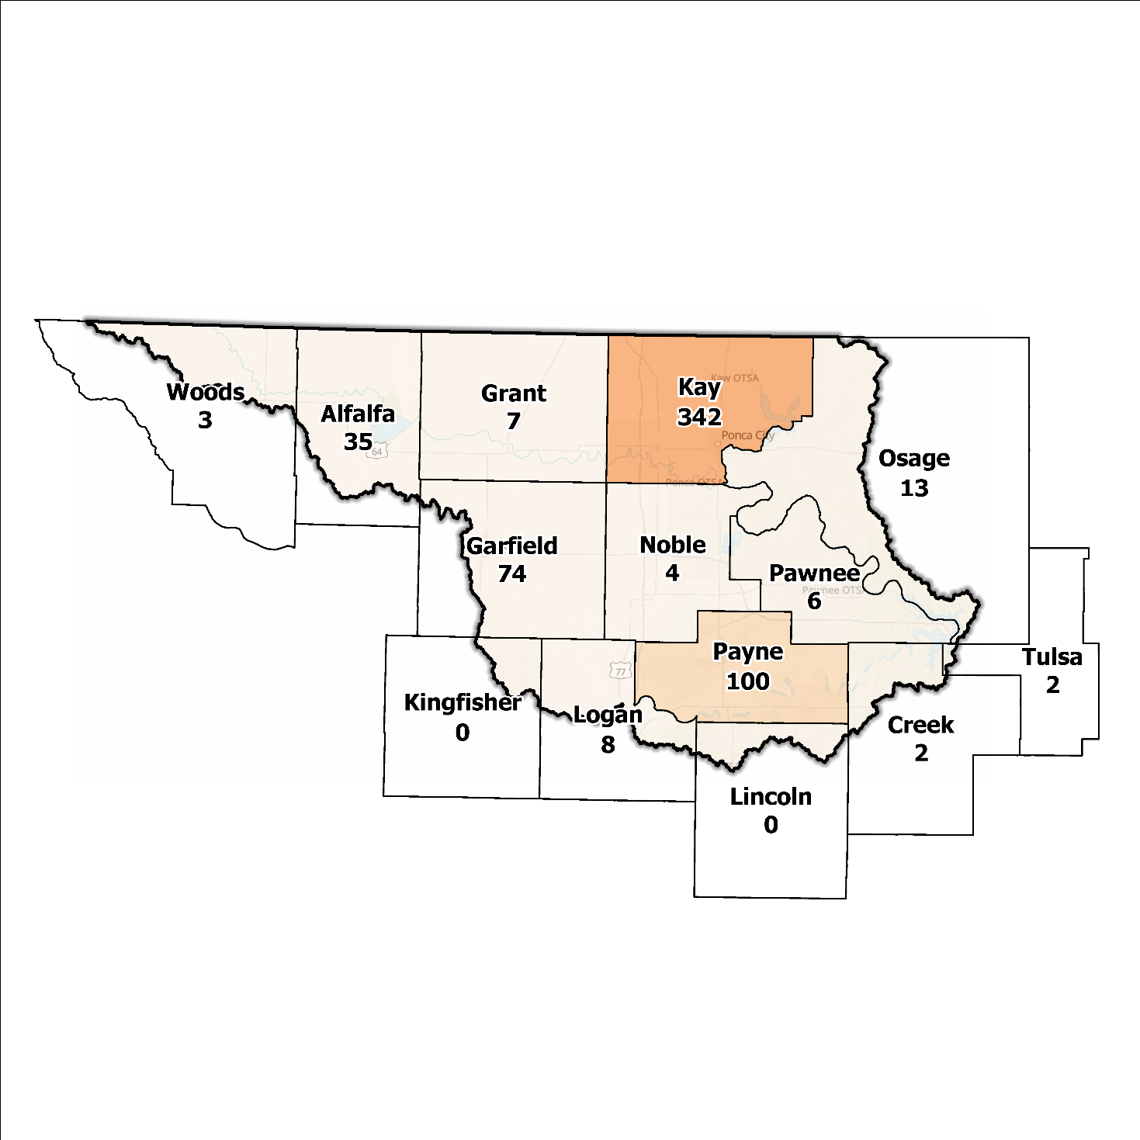
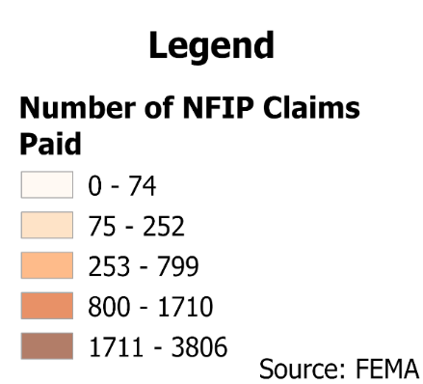
Source: FEMA
Figure 6: Total NFIP Claims Paid in the Upper Arkansas Planning Region

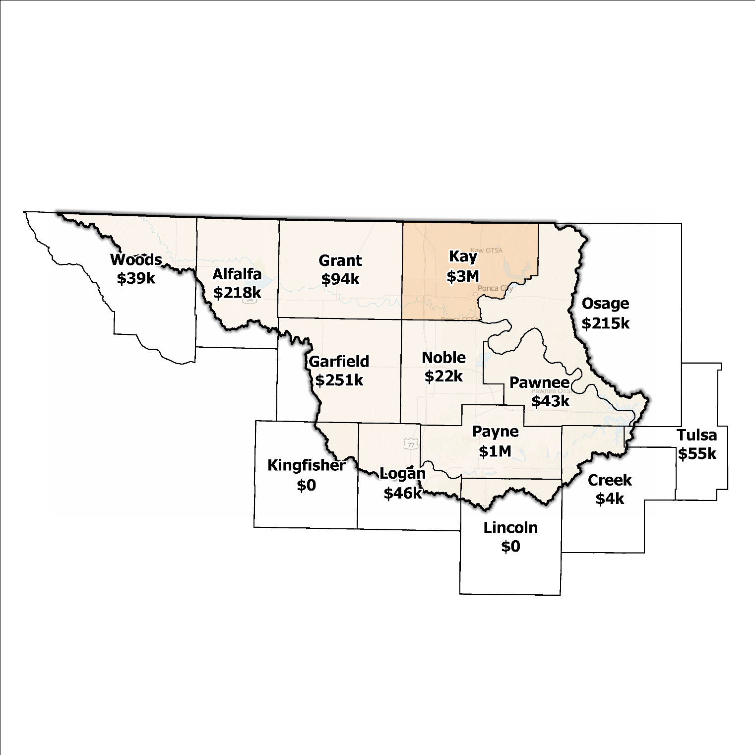
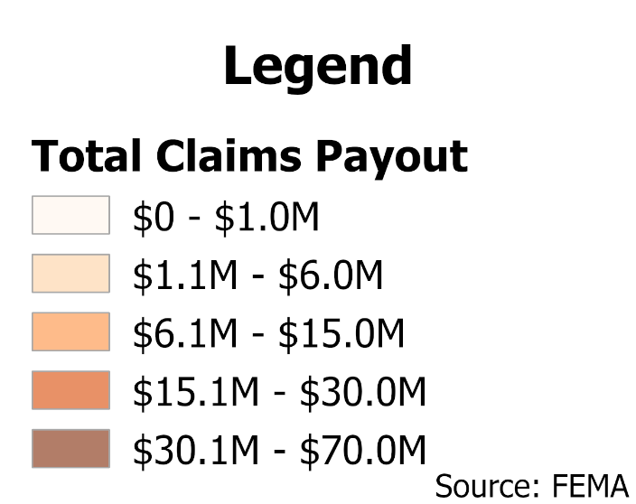
Source: FEMA
Figure 7: Total Value NFIP Claims Paid Out in the Upper Arkansas Planning Region

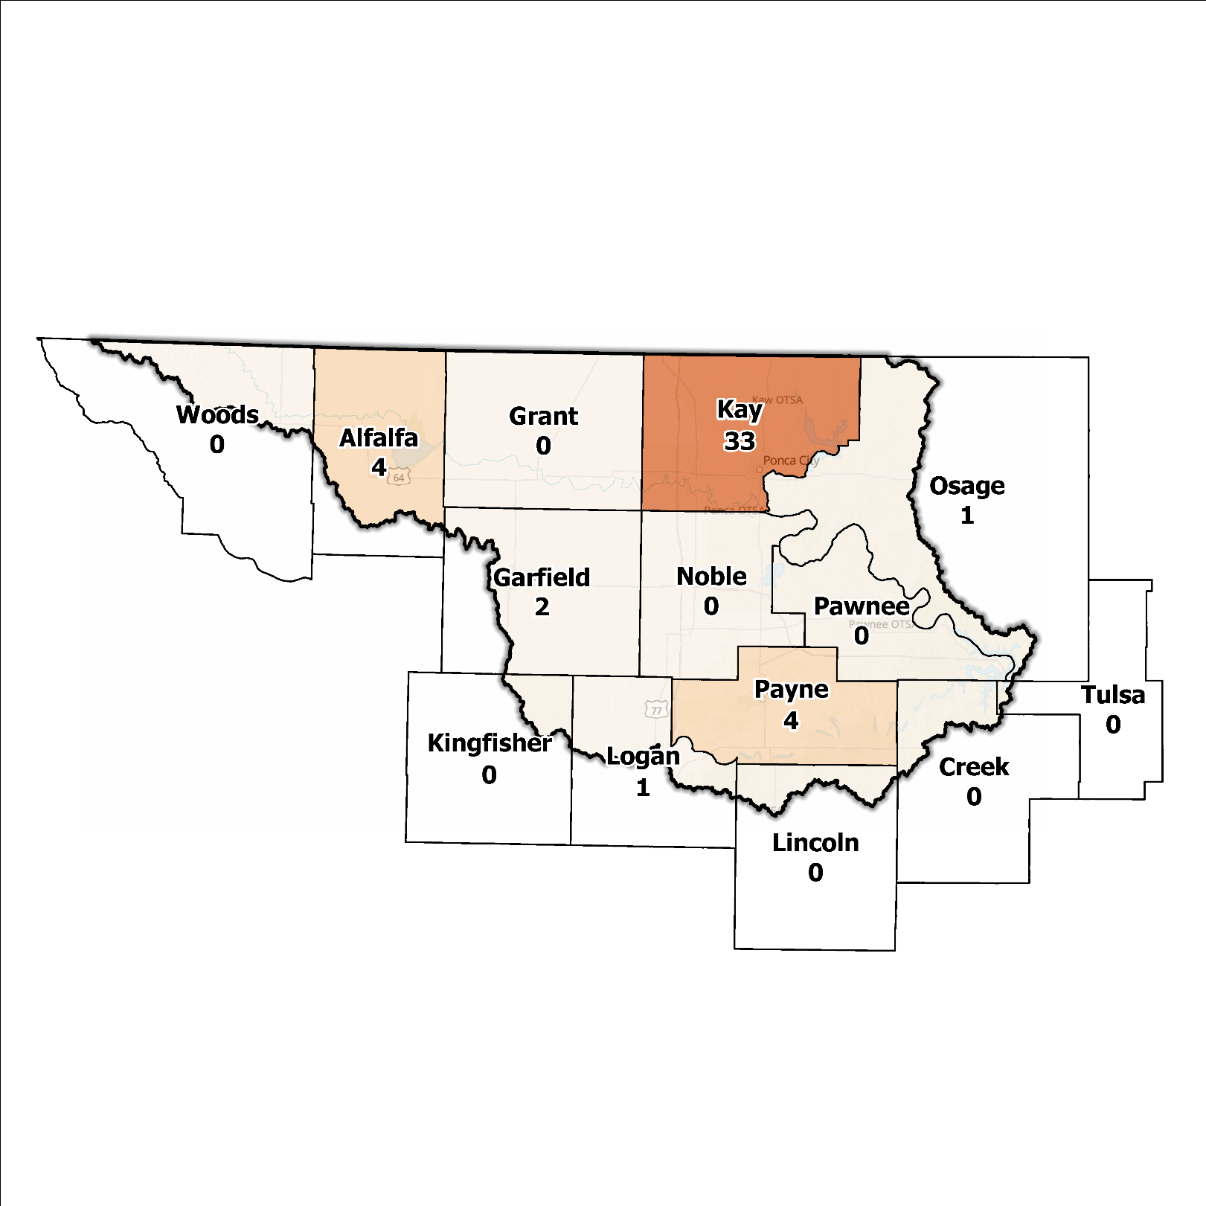
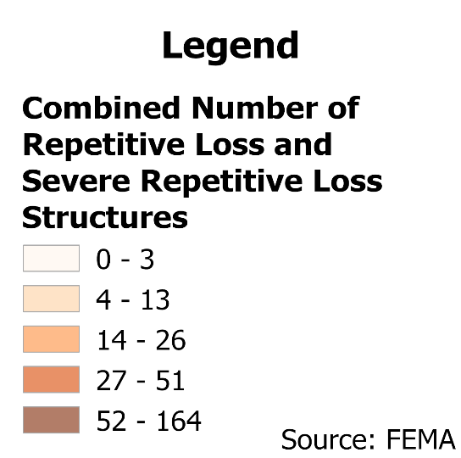
Source: FEMA
Figure 8: Repetitive Loss and Severe Repetitive Loss Structures in the Upper Arkansas Planning Region

Flood Funding Mechanisms
A survey conducted by the planning team to determine the level of funding for stormwater and floodplain management in the Upper Arkansas Planning Region revealed that most communities have limited local funding. Some larger, more urban jurisdictions, such as the City of Enid and Stillwater, could successfully implement stormwater utility fees enabling them to fund departments for facilitating management activities. In contrast, other jurisdictions have found marginal results in the utilization of local taxes, fees, and funds.

Hazard Mitigation Plan Status
Eight out of fourteen counties in this Region possess a FEMA-approved Hazard Mitigation Plan (HMP) and identified mitigation actions vary in jurisdictions. Several identify basic programmatic and administrative activities, such as planning, education, acquiring or implementing warning systems, participating in the NFIP, etc. In contrast, others intentionally list flood mitigation projects such as property buyouts, road and drainage improvements, floodplain restoration, and other flood-specific activities. Road flooding and dams overtopping are the most frequently reported problems across the planning area. Several communities and some tribal entities in the Region have individual HMPs separate from their respective counties. The cities of Blackwell and Ponca City use their FEMA-approved HMPs to gain points under activity 510 of the Community Rating System (CRS).
Table 2: Hazard Mitigation Planning Status in the Upper Arkansas Planning Region
Name | Type | Approval Date | Expiration | Current Action Status of this Plan
Alfalfa | County | 04/11/2022 | 04/10/2027 | Approved
Creek | County | 04/04/2023 | 04/03/2028 | Approved
Garfield | County | - | - | In Progress
Grant | County | 03/21/2023 | 03/20/2028 | Approved
Kay | County | - | - | In Progress
Tonkawa | City | - | - | In Progress
Kingfisher | County | 07/24/2024 | 07/23/2029 | Approved
Lincoln | County | - | - | In Progress
Logan | County | 02/24/2023 | 02/23/2028 | Approved
Noble | County | 09/25/2024 | 09/24/2029 | Approved
Osage | County | - | - | In Progress
Pawnee | County | - | - | In Progress
Payne | County | 10/17/2016 | 10/17/2021 | Expired
Stillwater | City | 09/21/2020 | 09/20/2025 | Approved
Tulsa | County | 06/14/2021 | 06/13/2026 | Approved
Sand Springs | City | 10/20/2014 | 10/20/2019 | Expired
Woods | County | 04/04/2023 | 04/03/2028 | Approved
Cheyenne and Arapaho | Tribal Nations | 01/27/2022 | 01/26/2027 | Approved
Creek | Tribal Nation | 12/01/2021 | 11/30/2026 | Approved
Kaw | Tribal Nation | 10/21/2024 | 10/20/2029 | Approved
Otoe-Missouria | Tribal Nation | 12/11/2023 | 12/10/2028 | Approved
Pawnee | Tribal Nation | - | - | In Progress
Ponca | Tribal Nation | - | - | In Progress
Sac & Fox | Tribal Nation | 07/25/2012 | 07/25/2017 | Expired
Osage | Tribal Nation | - | - | Expired
Tonkawa | Tribal Nation | 01/13/2017 | 01/12/2022 | Expired

Flood Mapping Assessment
In the Upper Arkansas Planning Region, the floodplain quilt consolidates the best available data on flood risk. However, some areas in the Region still need to be mapped by FEMA, including Grant and Pawnee Counties, limiting the ability of local authorities to regulate development in flood-prone areas.
A notable aspect in the Region is most of the effective FEMA maps still need detailed studies. This leaves floodplain managers relying on Approximate A Zones, which offer a broad understanding of flood risk but do not have determined Base Flood Elevations (BFE). Figure 9 displays FEMA-mapped areas in the Planning Region.
While in areas with A zones, Base Level Engineering (BLE) data might provide a more accurate indication of flood risk, it is important to note that the Upper Arkansas Planning Region lacks BLE coverage in East Alfalfa, Grant, and Pawnee County. BLE assists in determining areas that are expected to flood and therefore are not reasonably safe from flooding. Thus, there is a need for in-depth studies to enhance the precision and reliability of flood risk information in specific areas.
Kay, Noble, and Payne Counties, along with the cities of Enid, Ponca City, and Stillwater, stand out among areas in the Planning Region for having the most extensive flood risk assessment information. Investment in floodplain mapping has been higher in these areas than in others in the Region.
While Flood Insurance Rate Maps (FIRMs) are beneficial for regulatory uses and flood insurance assessments, they only represent potential risks associated with a flood event under certain specific conditions. The threat of flooding beyond the FEMA mapped SFHA is only included on FIRMs if the community opts to carry out the required studies to integrate such data into their hazard map.
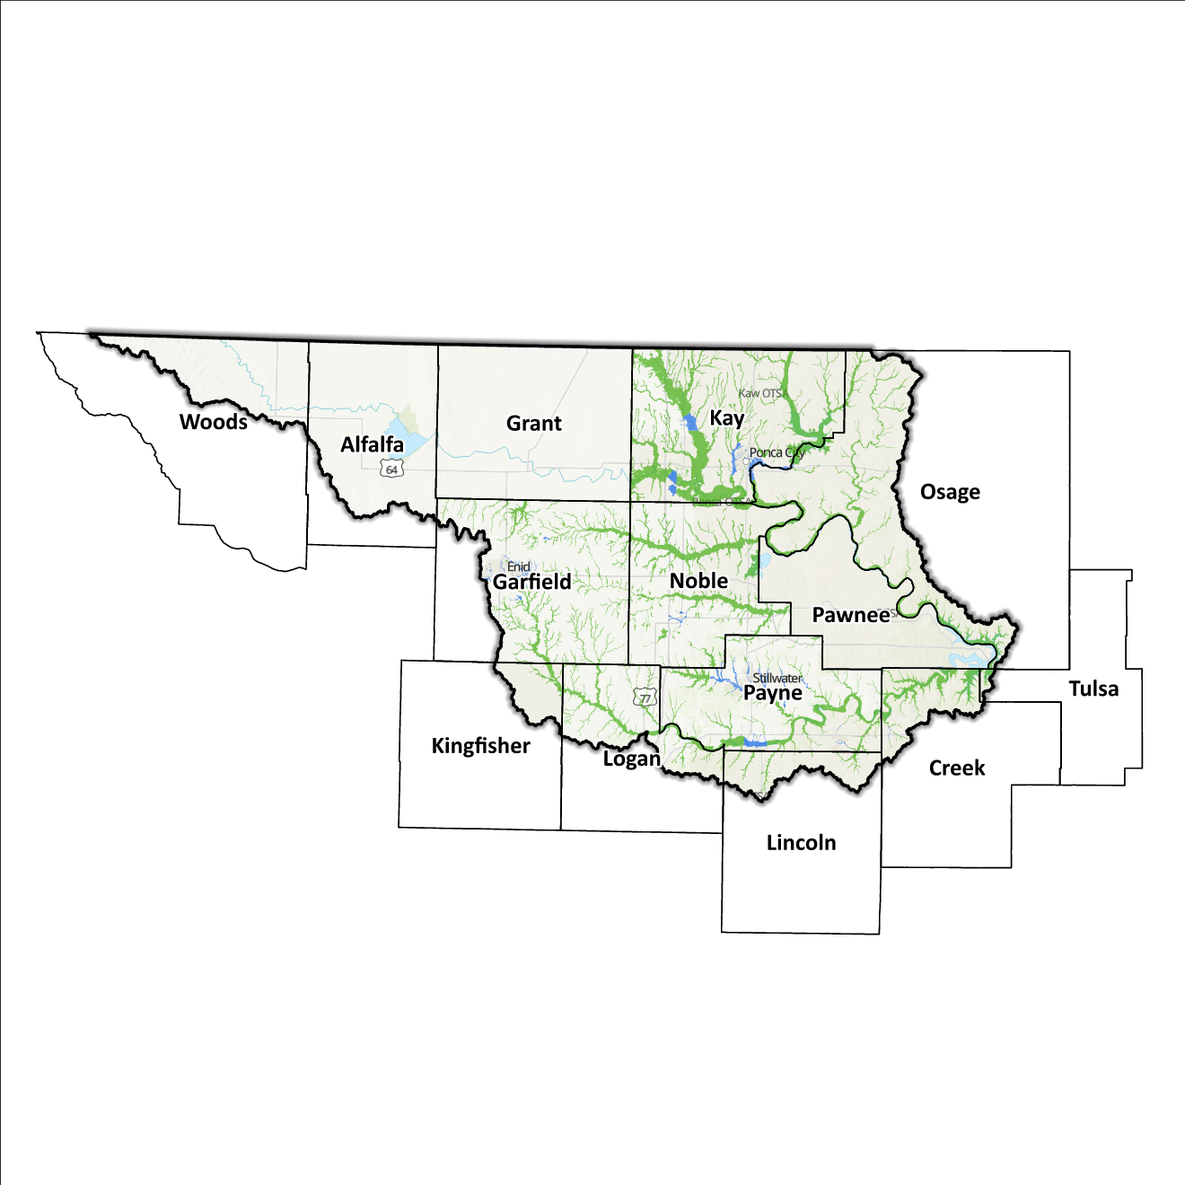
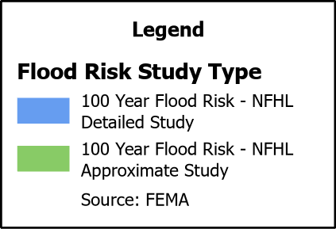
Figure 9: FEMA Mapped Special Flood Hazard Area Comparison in the Upper Arkansas Planning Region

2020 USGS Stream Gauge Report
In the wake of the 2019 flooding event across the Arkansas River Watershed, the United States Geological Survey (USGS) released a comprehensive report documenting peak streamflow data collected by stream gages across the Arkansas River Basin. It was determined that analytical methods for calculating annual exceedance probabilities (AEPs) for streams such as the Arkansas River, which is heavily regulated by United States Army Corps of Engineers (USACE) flood-control dams, is not usually appropriate. Developed by the USACE Tulsa District, the 2020 RiverWare model allows for more accurate Base Flood Elevation (BFE) metrics to be determined, and following the 2019 event, a comparison was made between the results of the USGS/USACE report and the Flood Insurance Study (FIS) which examined new computations for BFE levels. Also examined was the question of what designates a 1% Annual Exceedance Probability.

Increases in BFE heights were noted at both Kaw Dam and Keystone Dam gauges which correlate with an increase in BFE (ft) of 3.21 ft and 2.84 ft respectively. Increases in BFE and flow rates signal a potential for cascading impacts in Ponca City as well as some of the more heavily populated communities downstream of Keystone Dam. While these statistics provide a potentially more accurate representation of flooding risk, additional studies are needed to understand the full range of potential changes in the Upper Arkansas Watershed.

Flood Hazard Assessment
Flood hazards in this Region include flash, river, and urban flooding. The Arkansas, Cimarron, and Salt Fork of the Arkansas River, along with their various tributaries, are the major waterways found in the Upper Arkansas Watershed.

Location of Flood Hazards
The Upper Arkansas Planning Region is characterized by a flood hazard that encompasses various significant aspects. The flood location in the Upper Arkansas Planning Region exhibits the following characteristics:
- Flooding along major waterways with extensive drainage basins, including the Arkansas, Cimarron, and Salt Fork of the Arkansas River.
- Flash floods along smaller tributaries that ultimately flow into the major waterways.
- Drainage issues in specific areas result from inadequate infrastructure. Insufficient drainage systems can exacerbate flood risks, leading to localized flooding in vulnerable locations.
- Downstream areas located below high-hazard potential dams, including those situated north of the Kansas and Oklahoma state line are exposed to a heightened risk.
Figure 10 shows mapped areas of flood risk in the Region. The map brings together data from different sources, like the National Flood Hazard Layer and BLE, to create a unified view. It prioritizes layer types and shows the most important layer available for a specific area.

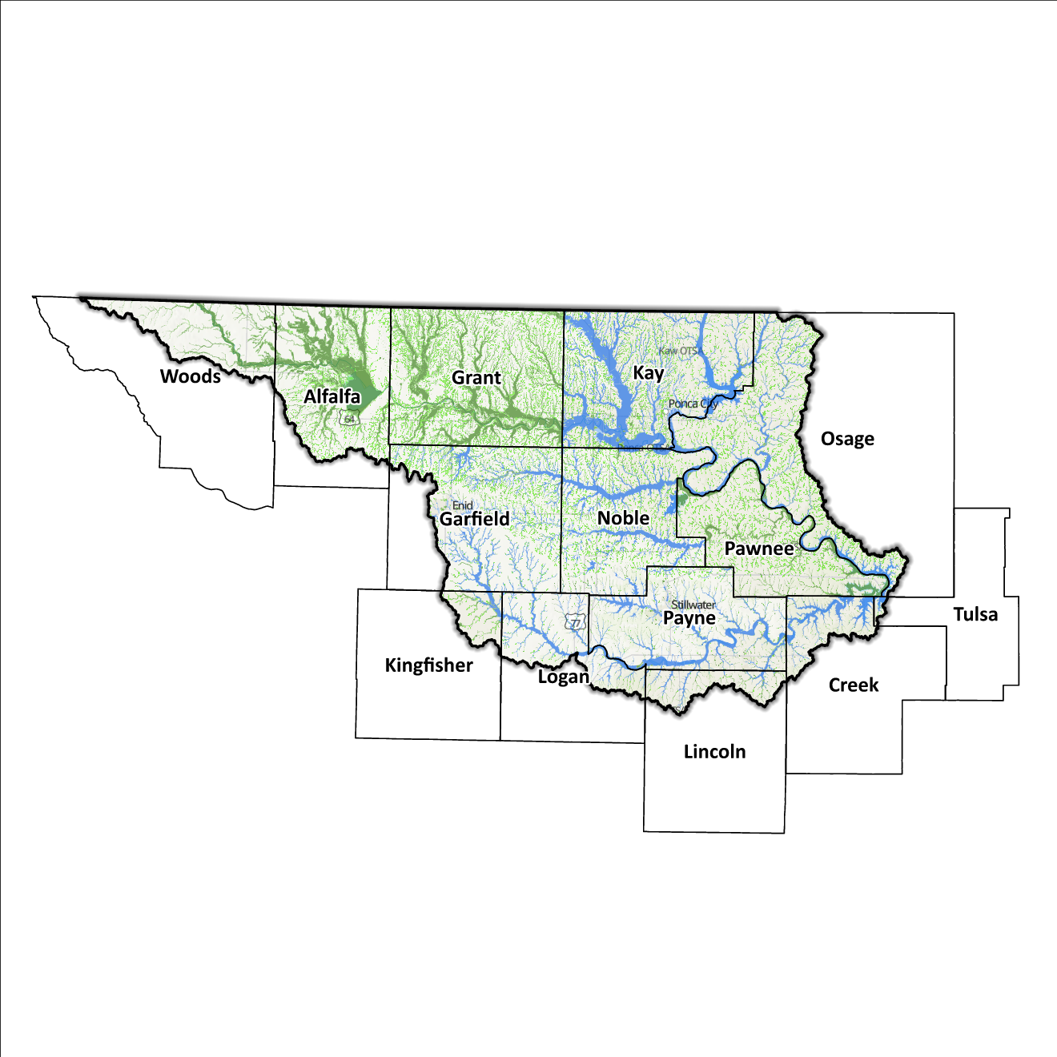
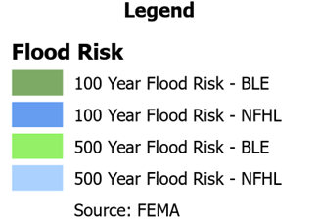
Figure 10: Flood Quilt in the Upper Arkansas Planning Region

Dam and Levee Infrastructure
The Region has multiple dams and levees aimed at preventing flooding. However, aging infrastructure increases the risk of downstream impacts if a breach or failure occurs, especially for high-hazard dams classified by the Oklahoma Water Resources Board (OWRB). The 14 counties have 68 high-hazard dams, with 36 located in the Upper Arkansas Watershed. A map of dam and levee locations within the Region is shown in Figure 11. While there are several high-hazard dams with the potential for downstream impacts, it's worth noting that no significant dam breaches or failures have occurred in the area.
The largest dam in the area is the Great Salt Plains Reservoir Dam, situated in Alfalfa County. An embankment dam managed by the USACE, the Great Salt Plains Reservoir Dam controls the Salt Fork of the Arkansas River, mitigating downstream flood risks and maintaining water levels during heavy rainfall and snowmelt. The dam creates the Great Salt Plains Reservoir, offering recreational activities like fishing, boating, and camping, while also supporting diverse wildlife. The dam is integral to water resource management and recreation in the Region. According to calculations by the USACE of Tulsa based on current dam failure data, a flood could traverse Alfalfa County in under two hours.
Additionally, the Upper Arkansas Watershed Region has two levee systems located in Garfield and Pawnee Counties. Garfield County has a legacy of levee systems primarily positioned along the Cimarron River and its tributaries while Pawnee County’s levee system mitigates flooding along the Arkansas River and its associated tributaries. These engineered structures are crafted to safeguard communities, agricultural areas, and nearby infrastructure from the impacts of river-related flooding. State and local officials can find information on these systems on the USACE National Levee Database website.
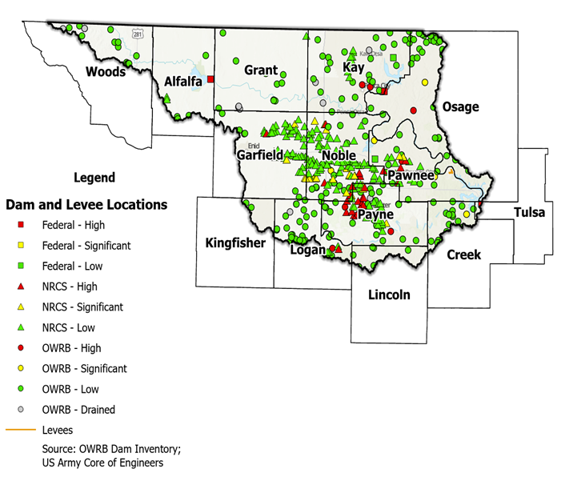
Figure 11: Dam and Levee Locations in the Upper Arkansas Planning Region

Although the Upper Arkansas Watershed Region concludes at the Kansas/Oklahoma state line, the flood risks associated with dams and levees transcend its boundaries.

Extent of Flooding
Extent refers to the expected severity of flooding, and because not all areas within the planning area share the same topography, the extent varies between individual communities. The average depth of flooding within the FEMA-mapped SFHA can range from a few inches to several feet, depending on factors such as topography, proximity to water bodies, local drainage characteristics, and the intensity of the flood event.

Previous Occurrences
According to the records maintained by the National Center of Environmental Information (NCEI), from January 1996 to December 2022, a total of 860 flood events have been documented in the fourteen counties encompassing this Planning Region. Cumulatively, these flooding incidents have caused property damage amounting to $19,871,700.
The NCEI initiated the tracking of flood events only from 1996, hence this data represents the most comprehensive information available. Flooding has frequently escalated to the point of necessitating a Presidential Disaster Declaration. A breakdown of flood-related disasters by county is shown in Table 3.
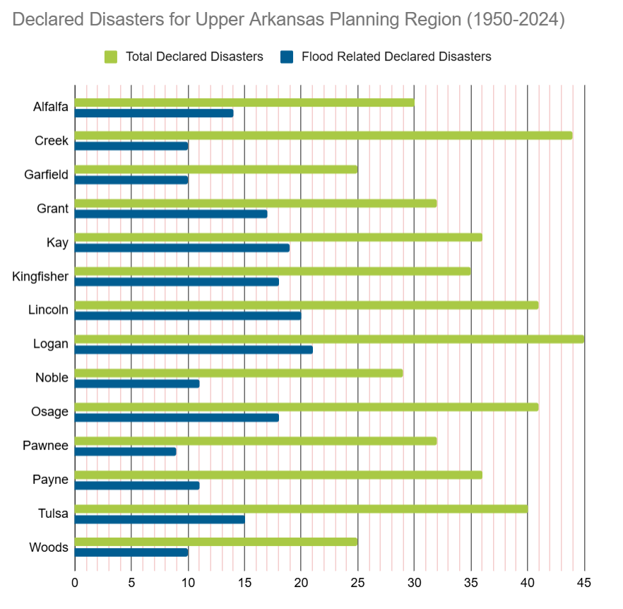
Table 3: FEMA Flood Related Disaster Declarations (1950-2024) in the Upper Arkansas Planning Region

Of all the counties in the Region, Logan County has most frequently been declared a disaster area due to flooding. However, it's important to note that disaster declarations are issued on a county-wide basis and not all declarations may have directly impacted this specific Region.

Vulnerability and Impacts of Flooding
According to FEMA’s National Risk Index (NRI), the Upper Arkansas Planning Region demonstrates a range of risk levels for river flooding and flash flooding, varying from very low to relatively moderate risk at the county level, when compared to the rest of the United States. However, when examined at a more granular scale by census tract, the NRI highlights specific areas along the Arkansas River, particularly in Kay and Logan Counties, as being at moderate risk of flooding.

Summary of Flood Exposure
Flood exposure refers to the degree to which an area or population is at risk of being affected by a flood event. Table 4 provides a comprehensive overview of key factors, including the total count of housing units, population figures, job statistics, land area measurements, and the number of parcels/blocks within the designated FEMA-mapped flood area. This information aims to facilitate a thorough understanding of the flood-affected area's characteristics and implications.
The data in this section was generated using UrbanFootprint. This module evaluates flood risk by conducting a spatial join of parcels or census blocks with the FEMA National Flood Hazard Layer to assess the potential risks associated with hazards. The data presented in the table below is focused on three different FEMA SFHA flood zones that represent areas within the 100-yr floodplain with a 1% annual chance of experiencing a flood event. Zone AE is the most detailed, providing base flood elevations, Zone AO represents areas subject to shallow flooding of depths between one to three feet, and Zone A being an approximation of the 100-yr floodplain for areas where detailed hydraulic analyses have not been performed.
Table 4: Flood Exposure in the Upper Arkansas Region
Upper Arkansas Planning Region Flood Risk Report
Housing in Flood Hazard Zones (Dwelling Units)
Dwelling Units in SFHL Zone AE | 2,846
Dwelling Units in SFHL Zone A | 1,248
Dwelling Units in SFHL Zone AO | N/A
Total | 4,094
Population in Flood Hazard Zones (Persons)
Population in SFHL Zone AE | 5,700
Population in SFHL Zone A | 2,680
Population in SFHL Zone AO | N/A
Total | 8,380
Jobs in Flood Hazard Zones (Employees)
Jobs in SFHL Zone AE | N/A
Jobs in SFHL Zone A | N/A
Jobs in SFHL Zone AO | N/A
Total | N/A
Land Area in Flood Hazard Zones (Acres)
Area in SFHL Zone AE | N/A
Area in SFHL Zone A | N/A
Area in SFHL Zone AO | N/A
Total | N/A
Parcels or Blocks in Flood Hazard Zones
Parcels or Blocks in SFHL Zone AE | N/A
Parcels or Blocks in SFHL Zone A | N/A
Parcels or Blocks in SFHL Zone AO | N/A
Total | N/A

Flood Mitigation Needs
Flood mitigation projects for the Region have been identified at a county level through the analysis of hazard mitigation plans, master drainage plans at the community level, and prioritized lists provided by jurisdictions. The following stormwater project types were considered:
- Channel
- Storm Drain
- Infrastructure
- Detention Pond
- Dam-Reservoir
- Floodwalls and Levees
- Acquisition
The largest project type identified in this Region is in relation to storm sewer/ pipe improvements and inlet additions, with two projects identified. Other projects include the addition of detention ponds, the regrading of streets and ditches, the addition of culverts, and general city-wide stormwater improvements.
The stormwater projects pinpointed in the Upper Arkansas Watershed are found in Kay County, collectively making up close to 2% of all planned projects across the state. These four projects, estimated to exceed $18.8 million in cost, account for 2.7% of all statewide projects identified. A detailed representation of project requirements by category and approximate cost can be found in Table 5.
Table 5: Stormwater Projects Identified in the Upper Arkansas Planning Region
Stormwater Project Types Per County | Number | Percentage | $ Amount
Kay County
Channel | 1 | 25% | $4.7M
Infrastructure | 2 | 50% | $10.3M
Detention Pond | 1 | 25% | $3.9M
Total | 4 |  | $18.8M

Conclusion
The Upper Arkansas Watershed report highlights the significance of this Region and its vulnerability to flood events. The report's findings emphasize the urgent need for funding to support engineering efforts in flood projects within the watershed. Adequate funding is essential for conducting detailed engineering assessments, implementing effective flood control measures, and enhancing community resilience. The lack of project submissions underscores the importance of assisting communities in identifying and developing flood mitigation projects.
By allocating resources and support for project identification and development, communities can better understand their flood exposure and proactively protect lives and infrastructure. Investing in engineering and flood mitigation projects in the Upper Arkansas Watershed will contribute to creating safer, more resilient communities better equipped to handle future flood events.
During the planning process, the data generated was developed into an interactive flood planning dashboard. The dashboard serves as a valuable tool for conducting flood assessments at the community level. It is important to note that this report should not substitute locally generated data specific to each community.

Census Bureau Data – 2020 Decennial Census
Alfalfa County’s HMP includes the Towns of Amorita, Burlington, Byron, Goltry, Jet, Lambert, and the City of Cherokee.
Creek County’s HMP includes the Town of Mannford and the City of Drumright.
Grant County’s HMP includes the Towns of Deer Creek, Jefferson, Lamont, Manchester, Nash, Renfrow, Wakita, and the Cities of Medford and Pond Creek.
Kay County’s HMP includes the Towns of Braman, Kildare. And the Cities of Blackwell, Kaw City, Newkirk, and Ponca City.
Lincoln County’s HMP includes the Town of Agra.
Logan County’s HMP includes the Towns of Coyle, Cresent, Langston, Mulhall, and Orlando.
Noble County’s HMP includes the Towns of Billings, Marland, Morrison, Red Rock, and the City of Perry.
Osage County’s HMP includes the Towns of Burbank, Fairfax, Prue, and the City of Shidler.
Pawnee County’s HMP includes the Cities of Cleveland and Pawnee.
Payne County’s HMP includes the Towns of Glencoe, Ripley, and the Cities of Cushing, Perkins, and Yale.
Woods County’s HMP includes the Town of Capron and the City of Alva.
FEMA’s National Risk Index (NRI) is a tool used to calculate a community’s potential for negative impacts due to natural hazards and community risk factors. The three components used in the NRI equation that generates the Risk Index Score are expected annual loss due to natural hazards, social vulnerability, and community resilience.
The Urban Intelligence Platform | UrbanFootprint
Any counties that do not appear in the table do not have any identified projects.

