Table of Contents
The Southwest Planning Region 1
Section 1.1: Watershed Introduction 1
Section 1.2: Socioeconomic and Geographic Characteristics 3
Section 1.3: Floodplain Management and Mitigation Capabilities 5
Section 1.4: Flood Hazard Assessment 16
Section 1.5: Flood Mitigation Needs 22
Section 1.6: Conclusion 23

The Southwest Planning Region

Watershed Introduction
Southwestern Oklahoma is home to three of the four tributaries that feed the Red River; Elm Fork, North Fork, and Salt Fork as it makes its trip out of the vast Texas panhandle and into the Southwest Watershed Planning Region (Region). These sources and their associated tributaries constitute all primary waterways in this Planning Region. Encompassing 12 basins, this Region covers a total area of 4,045 square miles and spans all or parts of nine Oklahoma counties, including Harmon, Jackson, Greer, Tillman, Kiowa, Beckham, Roger Mills, Comanche, and Washita. The population of this area is approximately 83,100 people and includes 39 communities along with various tribal nations.
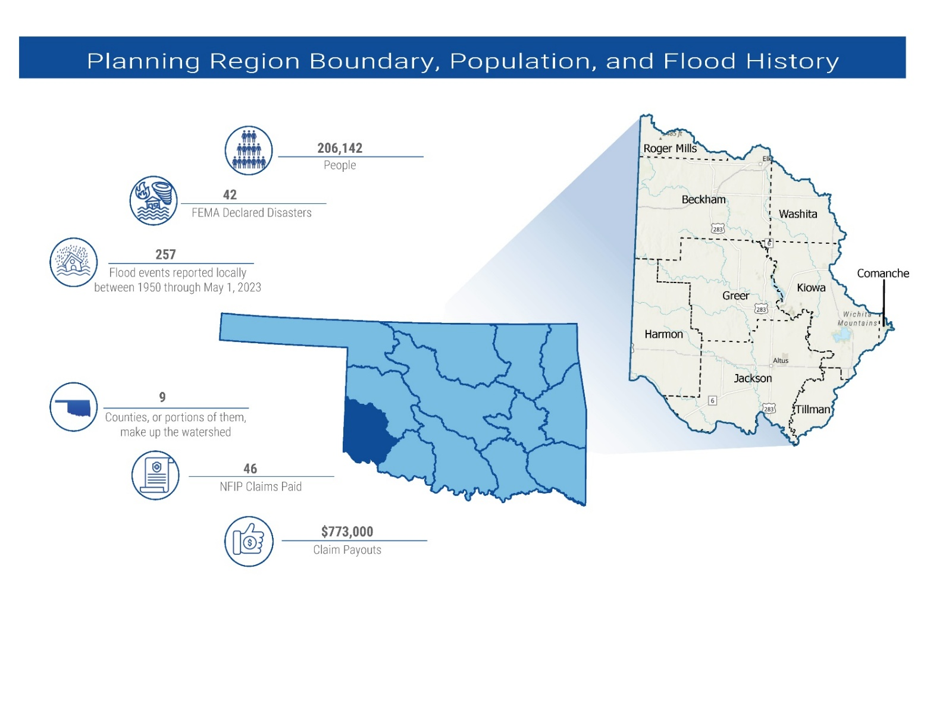
Figure 1: Southwest Planning Region Boundary, Population, and Flood History

The Southwest Planning Region is predominantly rural, accented by pockets of urbanization. The City of Altus, situated in Jackson County, is home to approximately 18,729 residents, and Elk City, located in northeastern Beckham County, sustains a population of around 11,406. In contrast to these cities, the rest of the Planning Region comprises a blend of smaller towns and communities, each with populations below 5,000. Like other regions, pockets of vulnerable populations exist here.
Displayed in Figure 2 is a base map depicting incorporated jurisdictions within the Region.
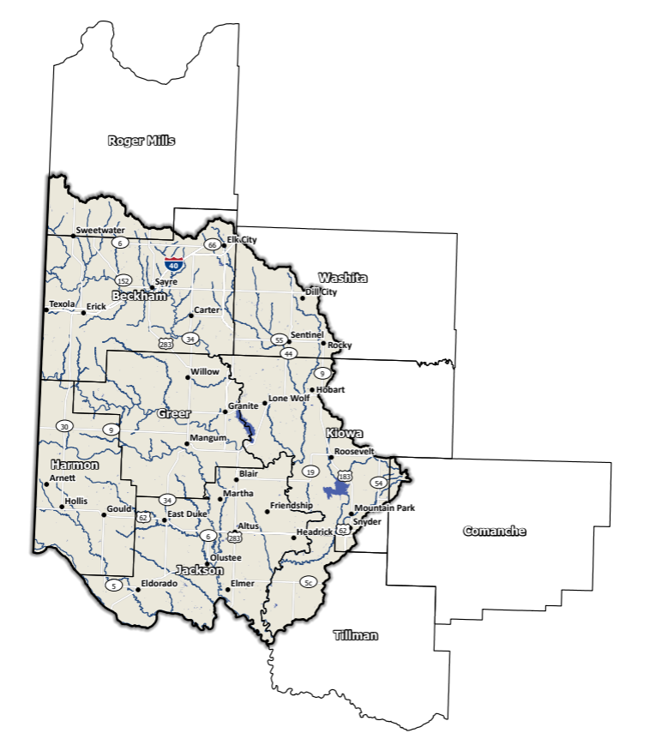
Figure 2: Southwest Planning Region Base Map

Socioeconomic and Geographic Characteristics
The Southwest Planning Region derives its diversity from a blend of agricultural and manufacturing industries. These narratives shed light on the individual roles and impacts of these factors within the Region. In the following section, we will examine socioeconomic and geographic aspects and how they contribute to and impact this Planning Region.

Demographic Profile
Scattered across the Planning Region is a mix of urban and rural areas. This Region represents approximately 5.8% of Oklahoma's total land area, and around 5% of Oklahoma residents call this area home according to the 2020 U.S. Census.
Detailed in Table 1 is an overview of the Region’s population composition and demographic distribution. These figures, sourced from the 2020 U.S. Census, pertain to populations at the county level, extending beyond the watershed’s boundaries. Notably among the counties, Greer, Harmon, and Jackson are the only counties fully encompassed within the Southwest Watershed.
Table 1: Population Breakdown by County in the Southwest Planning Region
County | Total Population
Beckham | 22,410
Comanche | 121,125
Greer | 5,491
Harmon | 2,488
Jackson | 24,785
Kiowa | 8,509
Roger Mills | 3,442
Tillman | 6,968
Washita | 10,924
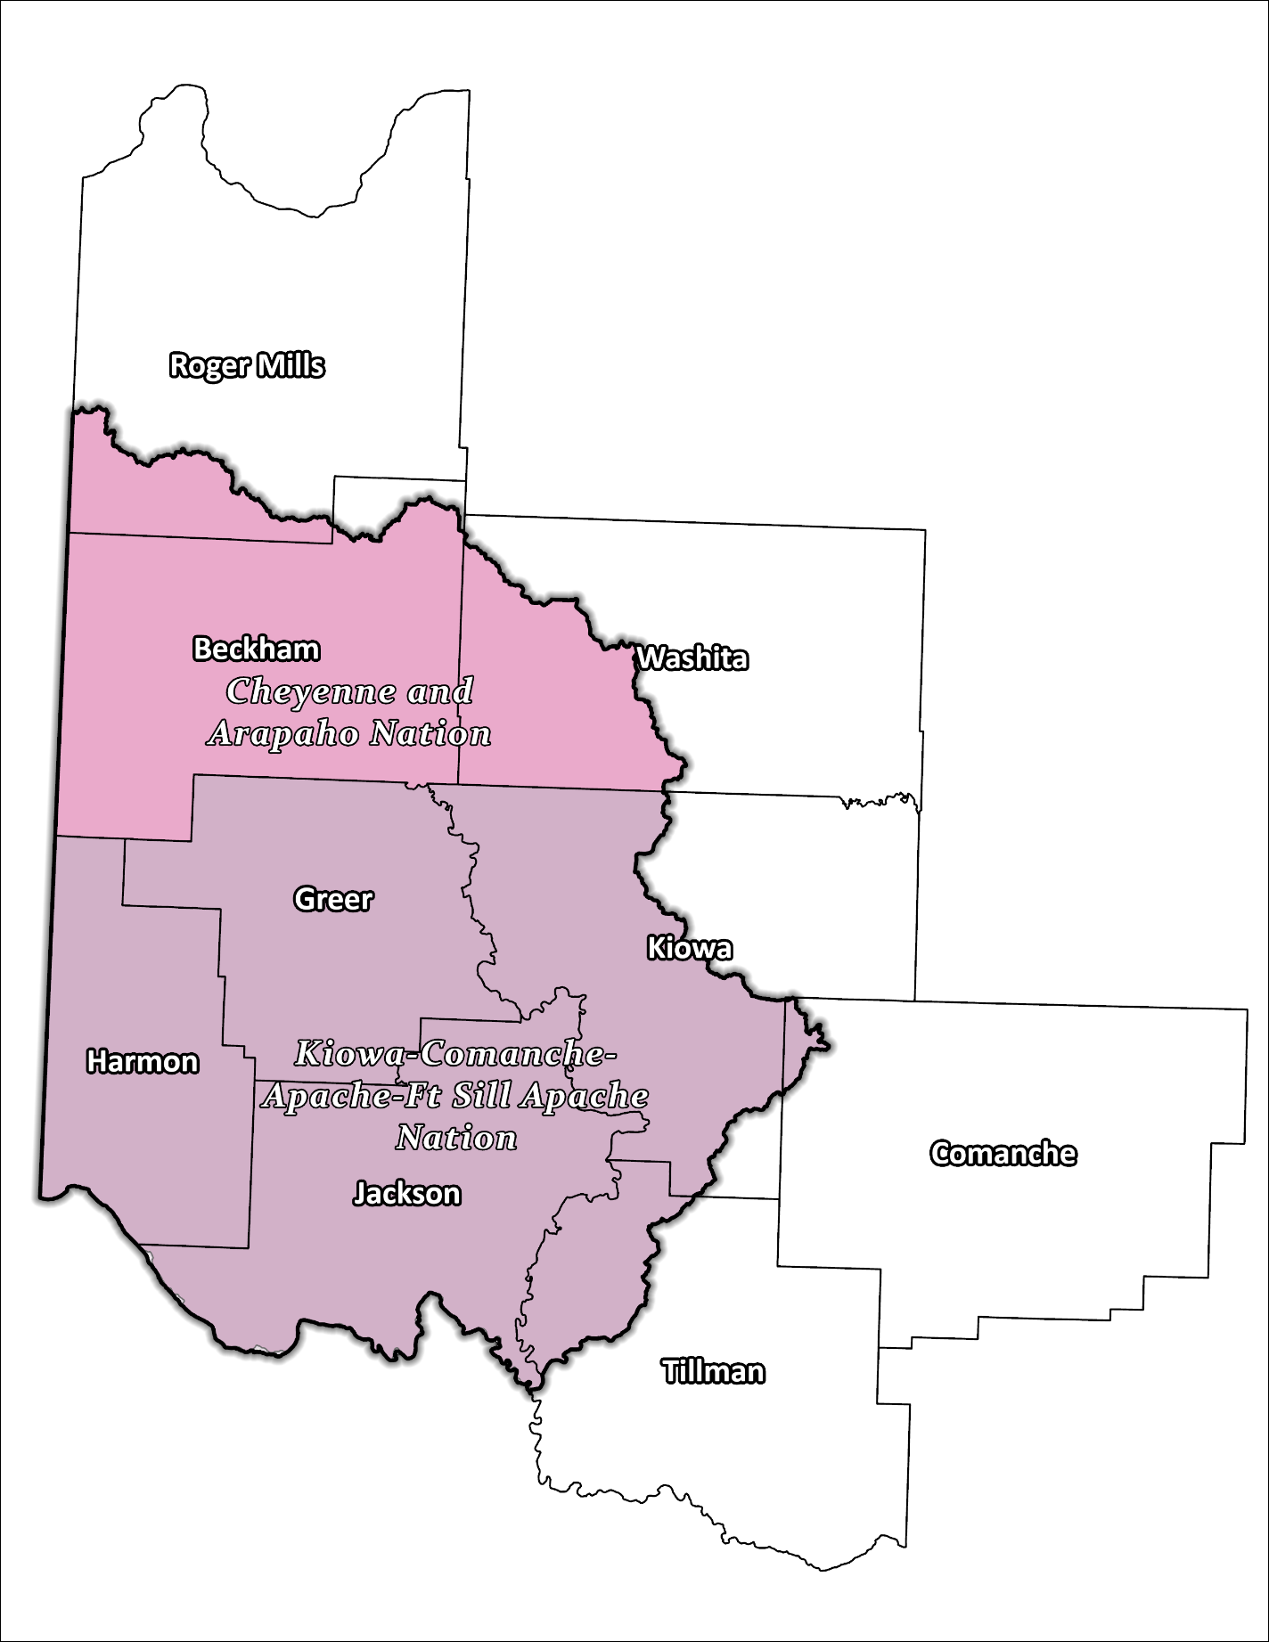
Figure 3: Tribal Jurisdictions Base Map for Southwest Planning Region

The Native American tribes that reside within the Region are the Cheyenne and Arapaho and Kiowa-Comanche-Apache-Ft. Sill Apache Nations. These tribes have a rich historical presence in the area and have played a substantial role in influencing both its cultural and economic evolution.

Economic Profile
This Planning Region carries substantial economic significance for both the state and the country. Situated on the eastern outskirts of Altus, Altus Air Force Base contributes to the local economy through its stationed service members. Agriculture emerges as the predominant economic sector across the entire Planning Region, with key crops like cotton and wheat, alongside a significant presence of livestock. Beyond agriculture, manufacturing stands as the subsequent major economic sector within this Planning Region.

Floodplain Management and Mitigation Capabilities
This segment offers a general overview of floodplain management capabilities and community involvement within the broader Southwest Planning Region.

National Flood Insurance Program Participation
Most counties within the Planning Region have undergone preliminary floodplain mapping by Federal Emergency Management Agency (FEMA) and are actively engaged in the National Flood Insurance Program (NFIP). Unfortunately, there remains a small number of communities within the nine counties who are presently not part of the NFIP program as depicted in Figure 4 below.
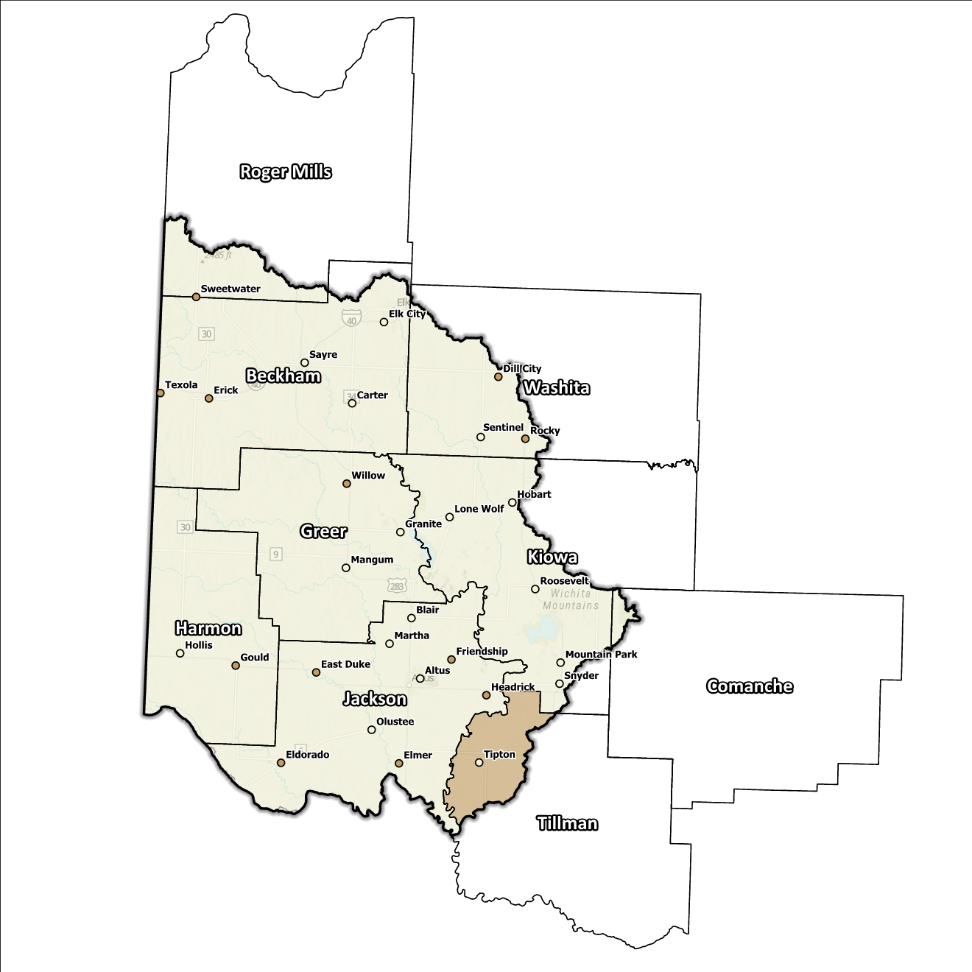
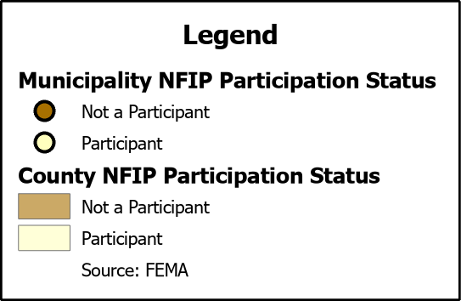
Figure 4: Status of NFIP Participation in the Southwest Planning Region

While multiple governing bodies in the Planning Region participate in the NFIP, none are engaged in the Community Rating System (CRS). This absence represents an overlooked chance for these communities to offer not only secure and cost-effective flood insurance options to property owners, but also to bolster their capacity to withstand the impact of flooding. Further discussion of this matter is found in Section 1.4: Vulnerability and Impacts of Flooding.

Flood Insurance Coverage
As of the most recent update, there are currently 74 active NFIP policies in effect across this Region. These policies offer coverage for approximately 4.7% of the total structures located within the FEMA mapped Special Flood Hazard Area (SFHA). However, it is worth noting that not all active policies are situated within this SFHA. Over the course of time, a total of 66 NFIP claims have been logged, resulting in a disbursement of $557k to policyholders.
Within the Region, there are a total of three structures designated as repetitive loss (RL) structures, and/or classified as severe repetitive loss (SRL) structures. Repetitive loss, in the context of the NFIP, refers to properties that have experienced multiple flood-related insurance claims over a specific time period. Severe repetitive loss, on the other hand, pertains to properties with an extensive history of recurrent flood damage and a high number of insurance claims, making them particularly vulnerable and costly for the NFIP.
Presented below are visual representations that encompass a variety of details pertaining to NFIP policies, in addition to the overall count of claims submitted and the financial disbursements made within the Planning Region. While these figures provide valuable insights, it is important to acknowledge that they may not completely capture the actual scale of losses in the Region due to an underrepresentation of flood insurance. It is noteworthy that not all claims filed or settled directly are tied to current active policies.

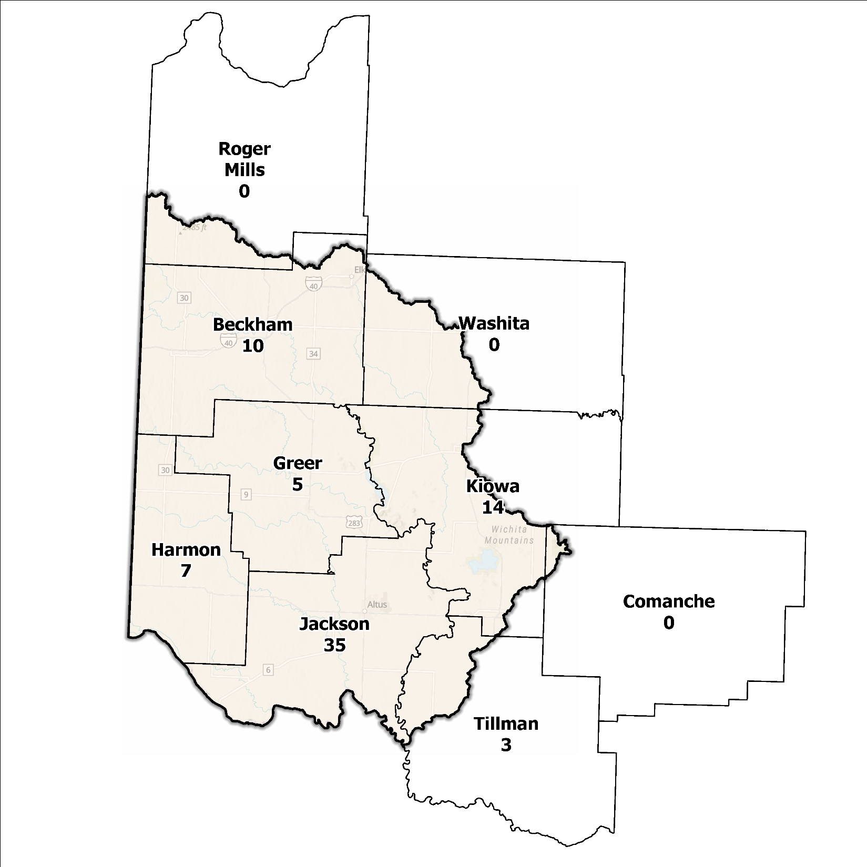
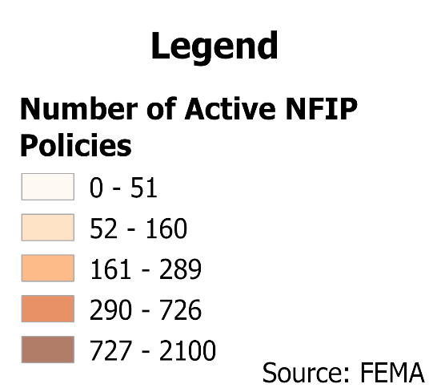
Figure 5: Number of Active NFIP Policies in the 100-Year Floodplain in the Southwest Planning Region

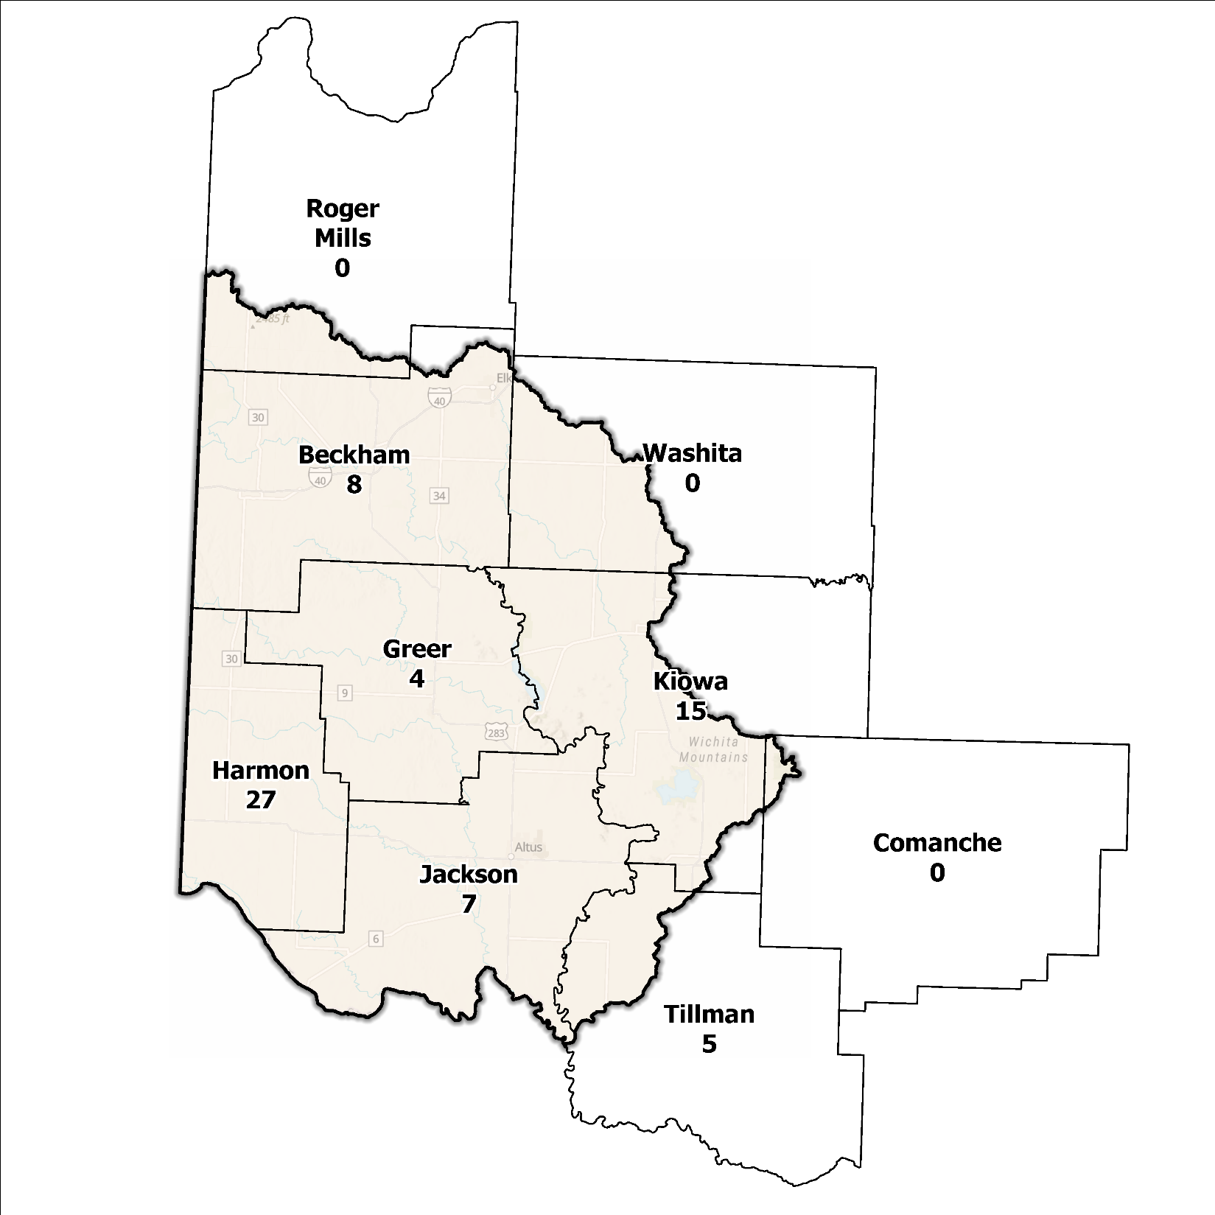
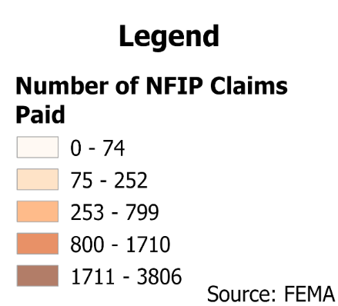
Figure 6: Total NFIP Claims Paid in the Southwest Planning Region

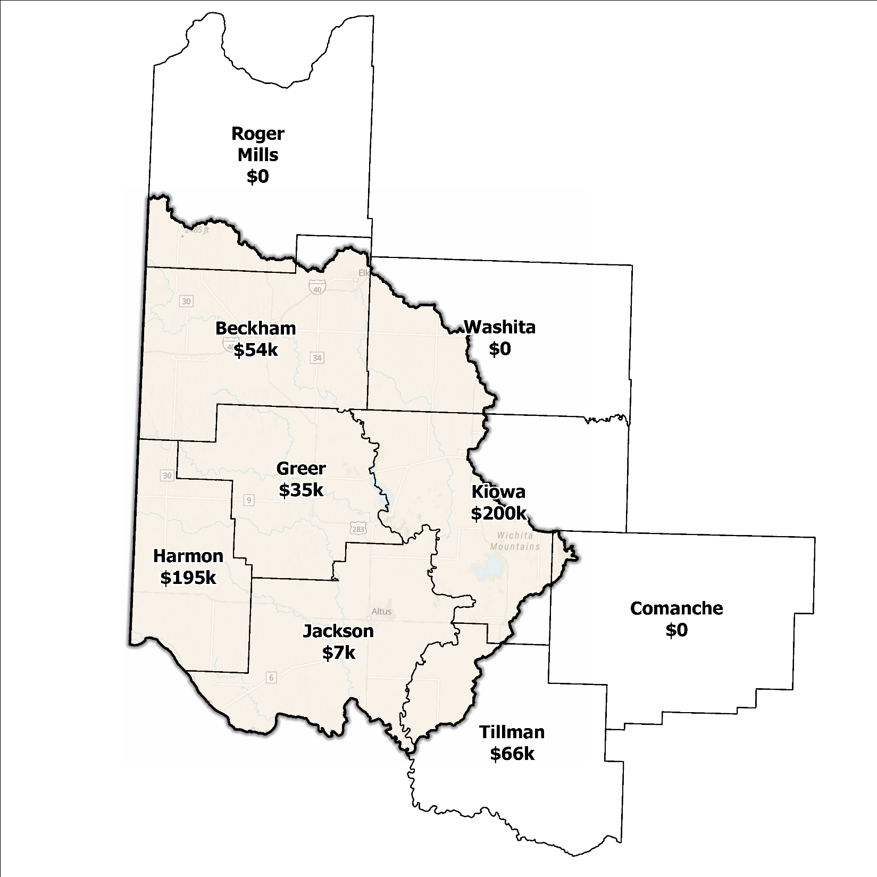
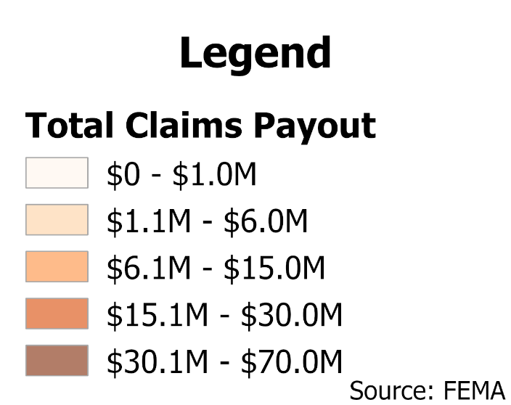
Figure 7: Total Value NFIP Claims Paid Out in the Southwest Planning Region

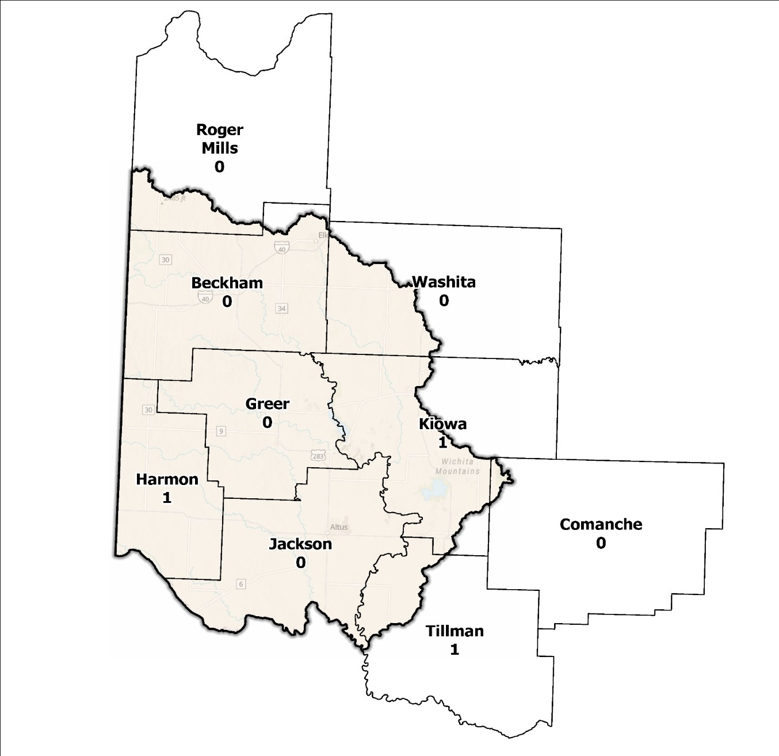
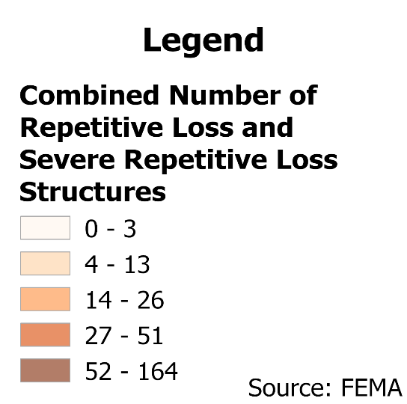
Figure 8: Repetitive Loss and Severe Repetitive Loss Structures in the Southwest Planning Region

Flood Funding Mechanisms
An analysis undertaken by the planning team to ascertain the funding landscape for stormwater and floodplain management within the Southwest Planning Region unveiled a combination of funding options. Alongside local and state funding channels, external sources encompass the Hazard Mitigation Grant Program, Community Development Block Grants, and Homeland Security grants. Notable rural areas, which constitute a sizable portion of the Planning Region, depend heavily on external funding sources for initiatives related to flood mitigation. Federal funding specific to flood mitigation, such as the Flood Mitigation Assistance program, favors more urban or metropolitan areas due to cost benefits and remains out of reach for more rural and smaller jurisdictions.
While some regions may employ local funding mechanisms like stormwater utility fees, their presence is not universal, and local taxes alone may prove insufficient to fully support flood mitigation and prevention projects due to the limited tax base.

Hazard Mitigation Plan Status
Among nine counties within this Region, six possess an approved Hazard Mitigation Plan from FEMA (HMP). Both the Cheyenne-Arapaho and Caddo Nations also have current plans. Mitigation actions outlined within these plans vary across jurisdictions, shaped by their distinct prioritization of vulnerabilities and needs. Some jurisdictions emphasize fundamental programmatic and administrative endeavors, including planning, education and outreach initiatives, engagement with the NFIP and the implementation of warning systems.
In contrast, other jurisdictions intentionally specify flood-focused projects like raising structures and roadways, enhancing road and drainage systems, and restoring floodplains and executing flood-related activities. A prevalent concern across the Planning Region is road flooding, which is prominently addressed through action items in these plans.

Table 2: Hazard Mitigation Planning Status in the Southwest Planning Region
Name | Type | Approval Date | Expiration | Current Action Status of this Plan
Beckham | County | 09/14/2022 | 09/13/2027 | Approved
Comanche | County | 09/13/2024 | 09/12/2029 | Approved
Greer | County | - | - | In Review
Harmon | County | 01/29/2014 | 01/29/2019 | Expired
Jackson | County | 05/16/2024 | 05/15/2029 | Approved
Kiowa | County | 10/17/2022 | 10/16/2027 | Approved
Roger Mills | County | - | - | N/A
Tillman | County | 04/17/2024 | 04/16/2029 | Approved
Washita | County | 02/20/2020 | 02/19/2025 | Approved*
Cheyenne and Arapaho | Tribal Nation | 01/27/2022 | 01/26/2027 | Approved
Comanche | Tribal Nation | 07/21/2011 | 07/21/2016 | Expired

Flood Mapping Assessment
Within the Southwest Planning Region, the floodplain quilt (depicted in Figure 10) serves as a compilation of the most reliable data pertaining to flood risk and the extent of flooding in the Region. However, certain rural sectors within the Region continue to face challenges in accessing FEMA flood maps that provide essential information about base flood engineering levels. This limitation constrains the capacity of local authorities, including floodplain managers, to effectively regulate development within flood-prone zones. Consequently, while the available data offers a comprehensive overview of flood risk, it falls short of enabling precise evaluations based on these analyses. To gain a visual understanding of FEMA-mapped areas in the Planning Region, refer to Figure 9.
Due to the unavailability of BLE coverage in the majority of the Southwest Planning Region, there exists a significant need to conduct comprehensive studies aimed at refining the accuracy and dependability of the flood risk assessments within specific locations. These studies entail the thorough compilation and analysis of historical flood occurrences, topographical data, hydrological patterns, and land usage information. Leveraging advanced hydraulic modeling techniques, these efforts facilitate the precise mapping of flood extents and hazard zones, while incorporating specific Base Flood Elevations (BFEs). Such data-driven insights play a vital role in guiding land-use planning and fostering effective flood mitigation strategies.
A notable element contributing to the absence of comprehensive floodplain mapping is the issue of funding. Enforcing regulations related to floodplains demands various resources, including personnel, transportation, and equipment, all of which necessitate financial support. In communities with constrained funding, this can pose a challenge, and such initiatives might be deprioritized in favor of more essential services, such as first responder services.
Although Flood Insurance Rate Maps (FIRMs) serve as valuable tools for regulatory purposes and evaluating flood insurance, they only depict potential risks associated with a flood event under certain specific predetermined conditions. The inclusion of stormwater flooding threats on a FIRM is contingent upon the community’s choice to conduct the necessary studies to integrate such data into their hazard map.

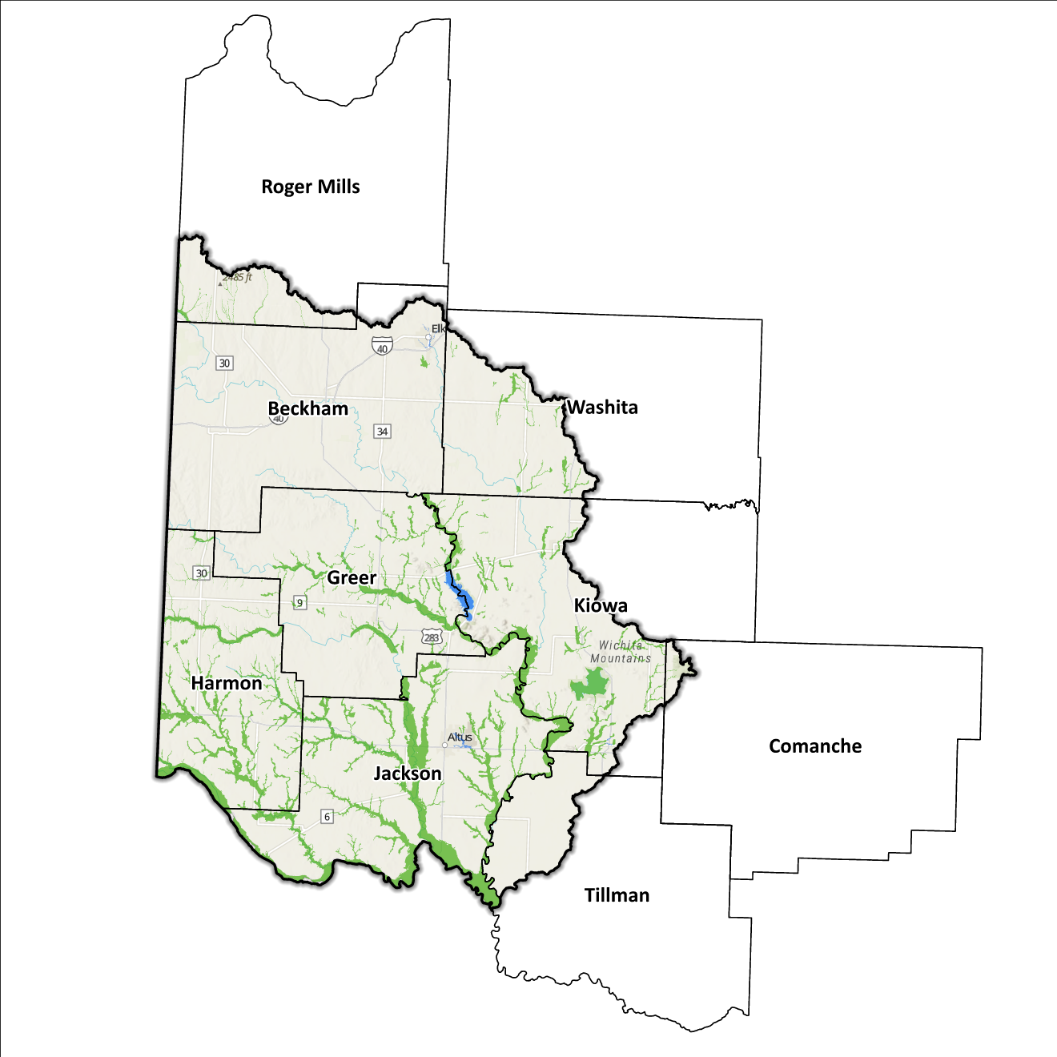
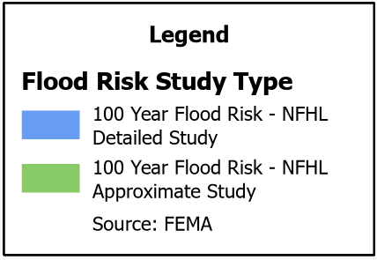
Figure 9: FEMA Mapped Special Flood Hazard Area Comparison in the Southwest Planning Region

Flood Hazard Assessment
Flood hazards in this Region include flash, river, and urban flooding. The Elm Fork, North Fork, and Salt Fork of the Red River, along with their various tributaries, make up the major waterways found in the Southwest Planning Region.

Location of Flood Hazards
Characterized by a range of significant flood hazards, the flood profile within this Region marks the following notable features:
- Flooding occurs along major waterways encompassing expansive drainage basins including the Elm Fork, North Fork, and Salt Fork of the Red River.
- Flash floods arise along smaller tributaries that eventually flow into the above-mentioned major waterways.
- Specific areas experience drainage challenges due to insufficient infrastructure. Inadequate drainage systems can amplify flood vulnerabilities, resulting in localized flooding in susceptible areas.
- Downstream areas situated beneath high-hazard potential dams face heightened risks.
Figure 10 displays data from diverse sources, such as the National Flood Hazard Layer and Base Level Engineering to establish a comprehensive view. This map prioritizes layer types and shows the most crucial layer available for a particular area.
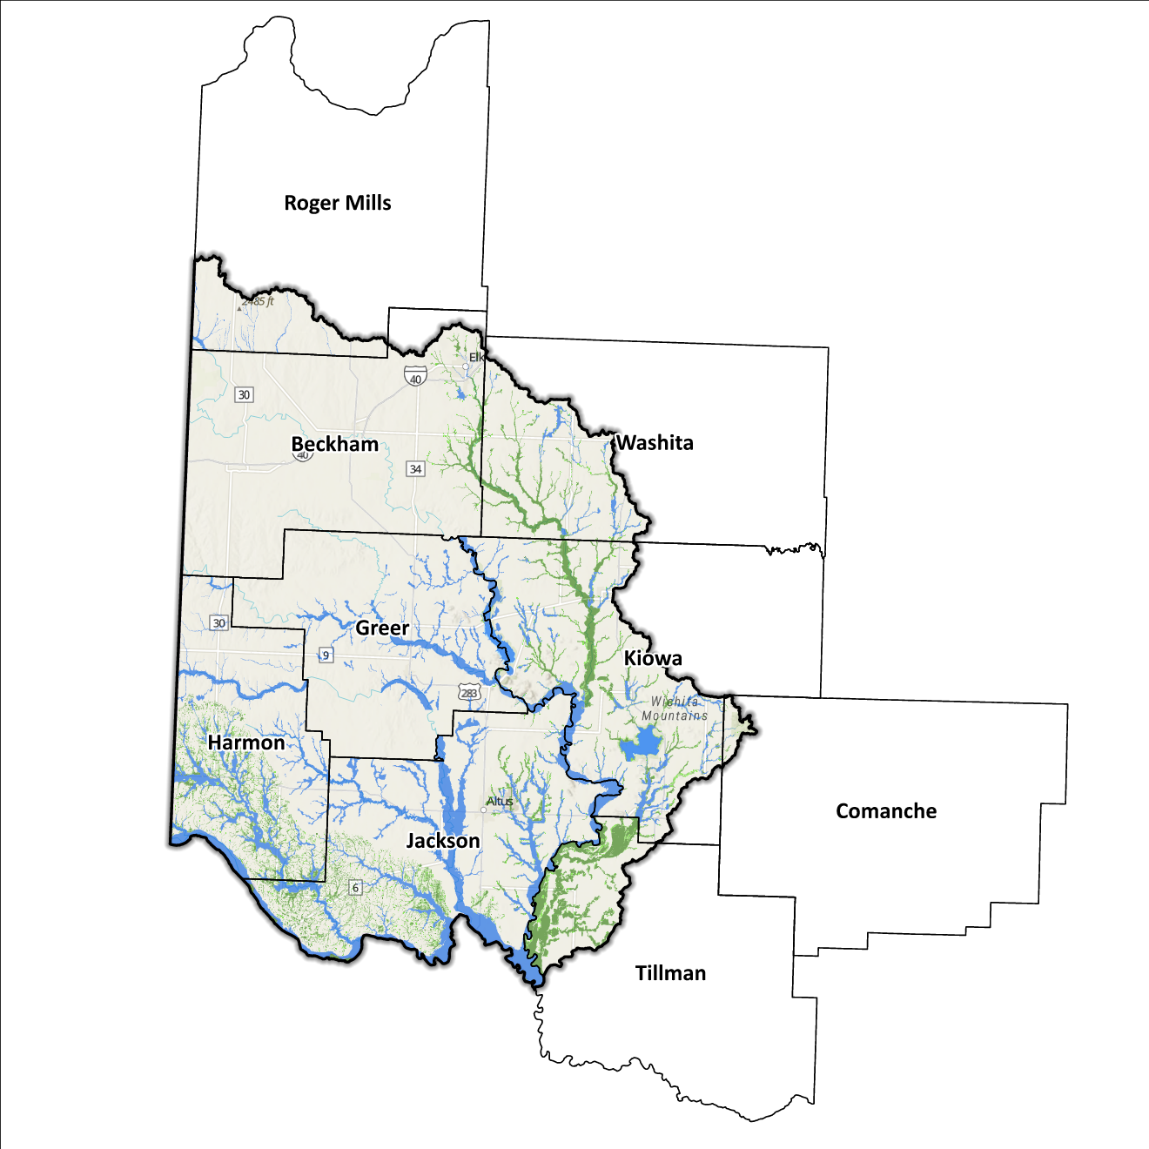
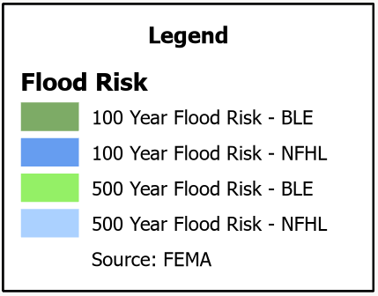
Figure 10: Flood Quilt in the Southwest Planning Region

Dam and Levee Infrastructure
Numerous dams and levees designed to mitigate flooding are situated within the Planning Region. Nonetheless, the aging state of infrastructure elevates the potential for adverse downstream effects in the event of breaches or failures, particularly for high-hazard dams. Within this Planning Region, there are a total of 162 dams, with 15 of them categorized as high-hazard dams. Figure 11 is a map of these locations.
Dam failure has the potential to result in catastrophic consequences for downstream areas, causing significant harm to communities and posing a serious risk to human life. The sudden discharge of large volumes of water with immense force has the capacity to flood, creating a dire hazard. Consequently, it is of utmost importance to conduct a meticulous evaluation of the flood risk stemming from potential dam incidents while analyzing each Planning Region. The Oklahoma Water Resources Board (OWRB) assigns hazard ratings to dams throughout the state as a critical determinant of the level of risk they pose.
In addition to dams in the state of Oklahoma within the Planning Region, those located in the Texas Panhandle upstream of these waterways must also be considered. Flooding due to dam breaches does not stop at state boundaries and can produce adverse effects well in Oklahoma and the Southwest Planning Region. Dams at Lake McClellan (NID ID TX02130), and Greenbelt Reservoir (TX03698) in Texas are classified as high-hazard and hold the potential to produce adverse effects in the event of a dam failure at either facility.
McClellan Dam is in Gray County, TX, approximately seven miles west of the town of Alanreed, or approximately 47 miles east of Amarillo. This dam creates Lake McClellan on McClellan Creek, which drains into North Fork Red River.
Greenbelt Dam is in Donley County, TX, on the southern edge of the town of Howardwick, or approximately 50 miles east-southeast of Amarillo. This dam creates Greenbelt Reservoir on Salt Fork Red River.
These two dams would produce increased flows on North Fork Red River and Salt Fork Red River, though the extent of flooding within the Southwest Planning Region cannot be determined without further analysis on the details of inundation of areas downstream of these facilities. Although the Southwest Planning Region stops at the Oklahoma/Texas state line to the west and the south, the flood risks associated with dams and levees transcend its boundaries.

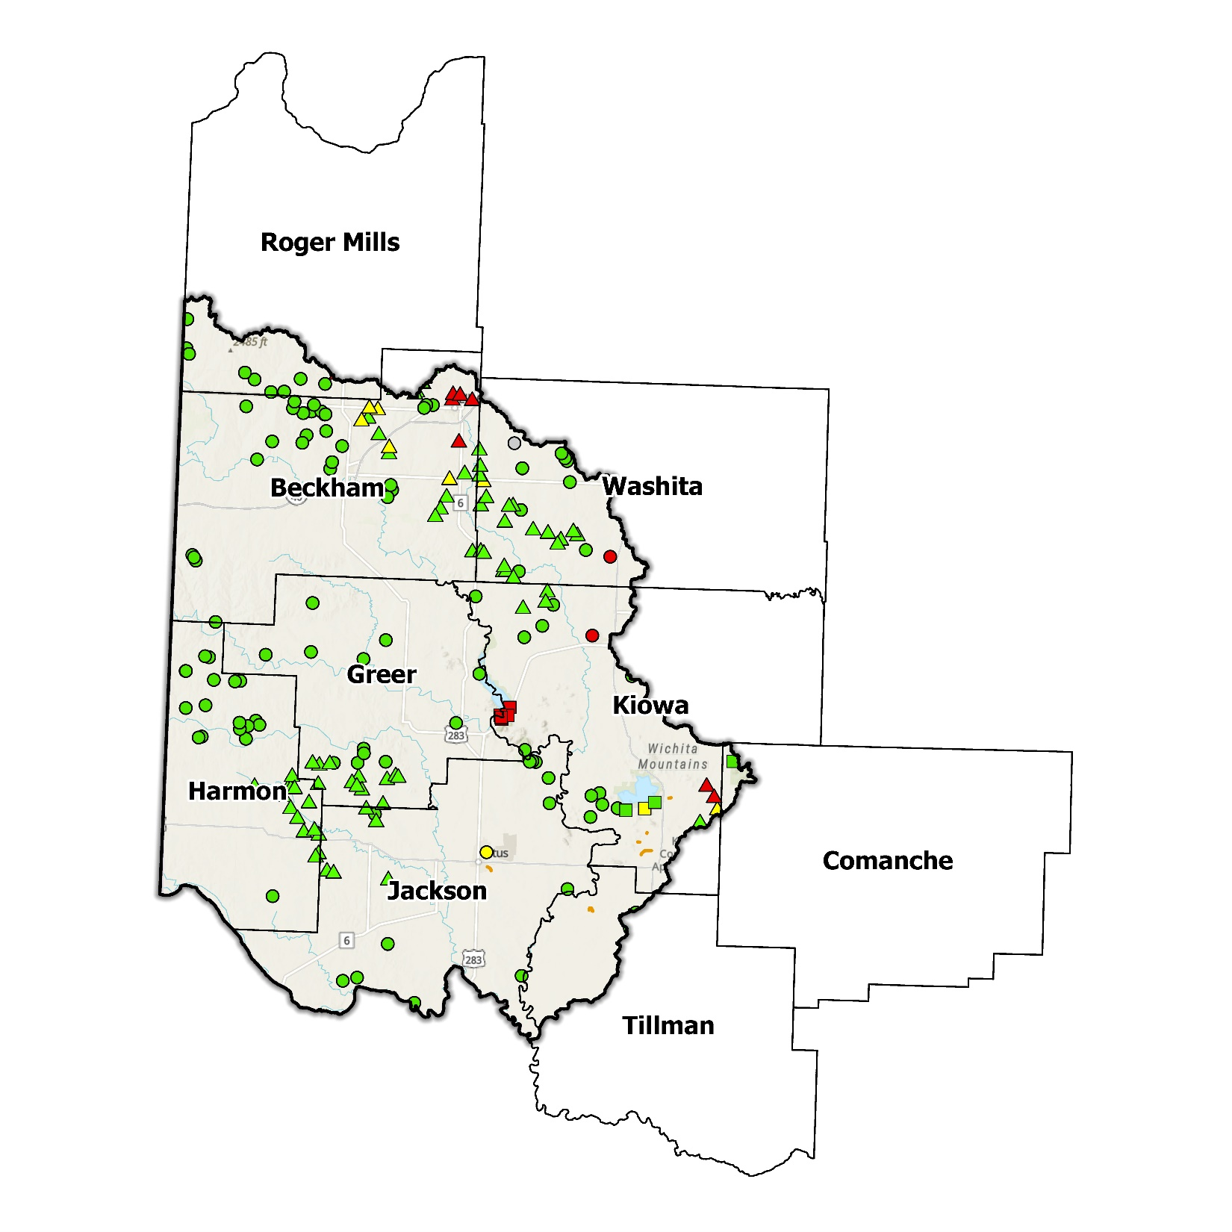
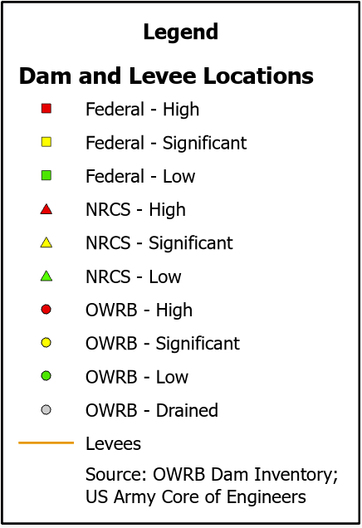
Figure 11: Dam and Levee Locations in the Southwest Planning Region

Extent of Flooding
The extent signifies the projected magnitude of flooding, and due to the divergent topographical features across the Planning Region, the extent varies across its diverse communities. Within the FEMA-mapped SFHA, the typical depth of flooding can fluctuate from a shallow accumulation of inches to a substantial inundation of several feet. This variability hinges on factors including the local topography, proximity to water sources, drainage patterns, and the intensity of the flooding event.

Previous Occurrences
According to the records maintained by the National Center of Environmental Information (NCEI), from January 1996 to December 2022, a total of 257 flood events have been documented in the counties which comprise this Planning Region. Cumulatively, these flooding incidents have caused property damage amounting to $4,009,000 and crop damage amounting to $40,000.
The NCEI initiated the tracking of flood events only from 1996, hence this data represents the most comprehensive information available. Flooding here has frequently escalated to the point of necessitating a Presidential Disaster Declaration. All counties in the planning area have experienced multiple federally declared flood disasters since 1970. A breakdown of flood-related disasters by county is in Table 3.
Table 3: FEMA Flood Related Disaster Declarations (1950-2024) in the Southwest Planning Region
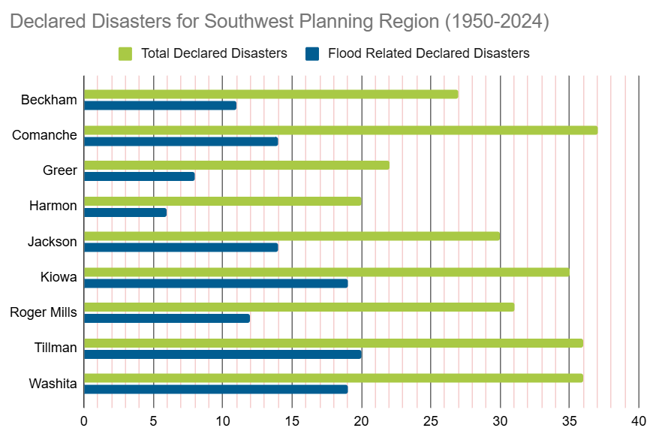
Of all the counties in the Region, Kiowa and Tillman Counties have most frequently been declared disaster areas due to flooding, with Washita County running a close third. However, it is important to note that disaster declarations are issued on a county-wide basis and not all declarations may have directly impacted this specific Region.

Vulnerability and Impacts of Flooding
According to FEMA’s National Risk Index (NRI), the Southwest Planning Region demonstrates a range of risk levels for riverine flooding and flash flooding on the lower to moderate end of the spectrum, from exceptionally low to moderate risk, when analyzed at the county level and compared to the rest of the United States.
Except for the Wichita Mountains, the terrain within this Planning Region slopes downward from the northwest to the southeast. The terrain mostly features many areas of flat lands to gently rolling hills, with some rural areas featuring hills and canyons of more notable geographic relief. Areas near Lake Altus and Tom Steed Reservoir, near the town of Mountain Park, in the eastern portions of this Region prove the exception to this rule, as terrain becomes more rugged near the Wichita Mountains. These areas where terrain is more rugged are at greater risk of flash flooding during periods of intense rainfall due to the nature of runoff flowing down those slopes. Quartz Mountain State Park, which is adjacent to Lake Altus, and Great Plains State Park, which is adjacent to Tom Steed, attract tourists and visitors in search of recreation, particularly during warmer weather. This increases risk to those visitors, particularly if heavy rainfall occurs during busy periods, such as holiday weekends.

Summary of Flood Exposure
Flood exposure pertains to the extent of vulnerability an area or its population faces in relation to potential flood incidents. Table 4 offers a comprehensive summary of essential variables, encompassing total housing units, population numbers, employment data, land area measurements, and the count of parcels/blocks situated within the designated flood-prone zone mapped by FEMA. Data in this section was generated using UrbanFootprint. The objective of presenting this information is to enable a comprehensive grasp of the distinctive traits and consequences associated with the Region susceptible to flooding.
Annual average precipitation amounts across the Planning Region vary from about 26 inches in the western portions of the Region, to about 32 inches per year in the east. While above the threshold for qualification as an arid climate, rainfall amounts are still much lower than many other areas of the state. A common perception is that areas with higher average annual rainfall are at greater risk for flooding, but drier areas can also be at risk. Soils in drier areas harden during dry spells, which can emulate impervious surfaces found in developed areas. If a heavy rainfall event occurs after a long dry spell, flooding and flash flooding can be an immediate concern. Additionally, since the terrain in this area slopes gently downward toward the east/southeast, this can lead to flooding threats in lower-lying areas downstream.
This module evaluates flood risk by conducting a spatial join of parcels or census blocks with the FEMA National Flood Hazard Layer to assess the potential risks associated with hazards. The data presented in the table below is focused on three different FEMA SFHA flood zones that represent areas within the 100-yr floodplain with a 1% annual chance of experiencing a flood event. Zone AE is the most detailed, providing base flood elevations, Zone AO represents areas subject to shallow flooding of depths between one to three feet, and Zone A is an approximation of the 100-yr floodplain for areas where detailed hydraulic analyses have not been performed.

Table 4: Flood Exposure in the Southwest Region
Southwest Planning Region Flood Risk Report
Housing in Flood Hazard Zones (Dwelling Units)
Dwelling Units in SFHL Zone AE | 201
Dwelling Units in SFHL Zone A | 1,036
Dwelling Units in SFHL Zone AO | N/A
Total | 1,237
Population in Flood Hazard Zones (Persons)
Population in SFHL Zone AE | 352
Population in SFHL Zone A | 2,394
Population in SFHL Zone AO | N/A
Total | 2,746
Jobs in Flood Hazard Zones (Employees)
Jobs in SFHL Zone AE | N/A
Jobs in SFHL Zone A | N/A
Jobs in SFHL Zone AO | N/A
Total | N/A
Land Area in Flood Hazard Zones (Acres)
Area in SFHL Zone AE | 5,581
Area in SFHL Zone A | 304,868
Area in SFHL Zone AO | N/A
Total | 310,449
Parcels or Blocks in Flood Hazard Zones
Parcels or Blocks in SFHL Zone AE | N/A
Parcels or Blocks in SFHL Zone A | N/A
Parcels or Blocks in SFHL Zone AO | N/A
Total | N/A

Flood Mitigation Needs
Flood mitigation projects for the Region have been identified at a county level through the analysis of HMPs, master drainage plans at the community level, and prioritized lists provided by jurisdictions. The following stormwater project types were considered:
- Channel
- Storm Drain
- Infrastructure
- Detention Pond
- Dam-Reservoir
- Floodwalls and Levees
- Acquisition
The stormwater projects in this Planning Region are two channel projects and two dam/reservoir projects. Undertaken by the City of Altus, all three projects total approximately $12.6 million.
Both flood channels contain a 1% annual probability of flooding. One is to mitigate flooding to existing structures and new development near North Broadway Street and East Veterans Drive and the other is to mitigate flood potential for Altus Air Force Base and an adjacent proposed development. The dam will be used as a regional detention facility to reduce flooding on Carver Road.
Table 5: Stormwater Projects Identified in the Southwest Planning Region
Stormwater Project Types Per County | Number | Percentage | $ Amount
Jackson County
Channel | 2 | 66.7% | $9.8M
Dam-Reservoir | 1 | 33.3% | $2.8M
Total | 3 |  | $12.6M

Jackson County has also indicated a goal to acquire properties in high hazard areas at risk of flooding due to dam failure in an unofficial hazard mitigation plan on their website. While it is unusual for communities to strategize for flood acquisitions ahead of a flooding event, such planning becomes invaluable in a post-disaster context to facilitate the relocation of citizens out of hazard-prone areas. External funding sources can, and should, be pursued by communities within the Southwest Planning Region to develop flood mitigation methods to allow these communities to become more resilient to flooding.

Conclusion
This report on the Southwest Planning Region underscores the Region's importance and its susceptibility to flooding. The findings from this report underscore the critical and immediate necessity for funding to support engineering initiatives aimed at flood projects within the Planning Region. Adequate financial support is pivotal for conducting comprehensive engineering evaluations, executing effective flood control measures, and augmenting the overall resilience of communities. The limited number of project submissions underscores the significance of guiding communities in recognizing and developing flood mitigation projects.
Through the allocation of resources and the provision of support for the identification and development of projects, communities can enhance their grasp of flood risks and take proactive measures to safeguard both lives and critical infrastructure. Investing in engineering and flood mitigation initiatives within the Southwest Planning Region will play a pivotal role in fostering the creation of safer, more resilient communities that possess improved capabilities to effectively manage and respond to future flood occurrences.
Throughout the planning phase, data collected was implemented into an interactive flood planning dashboard. This dashboard serves as a valuable resource for conducting flood assessments on a community level. However, it is imperative to emphasize that this report should not be seen as a replacement for locally generated data that is tailored to the unique characteristics of each individual community.

Oklahoma’s total surface land area is 69,899 sq mi.
This calculation was performed by summing the populations of the counties within this region, as indicated in Table 1, then divided by the entire population of the State of Oklahoma using the same data source (2020 U.S. Decennial Census).
Census Bureau Data – 2020 Decennial Census
Beckham County’s HMP includes the Towns of Carter, Sweetwater, Texola, and the Cities of Elk City, Erick, and Sayre.
Greer County’s HMP will include the Towns of Granite, Willow, and the City of Magnum.
Harmon County’s HMP includes the Town of Gould and the City of Hollis.
Jackson County’s HMP includes the Towns of Blair, East Duke, Eldorado, Elmer, Headrick, Martha, Olustee, and the City of Altus.
Kiowa County’s HMP includes the Towns of Cooperton, Hobart, Lone Wolf, Mountain Park, Roosevelt, and the City of Snyder.
Tillman County’s HMP includes the Towns of Davidson, Manitou and the Cities of Frederick, and Grandfield.
FEMA’s National Risk Index (NRI) is a tool used to calculate a community’s potential for negative impacts due to natural hazards and community risk factors. The three components used in the NRI equation that generates the Risk Index Score include annual loss due to natural hazards, social vulnerability, and community resilience.
The Urban Intelligence Platform | UrbanFootprint
http://climate.ok.gov/index.php/climate/map/normal_annual_precipitation/oklahoma_climate
Any counties that do not appear in the table do not have any identified projects.
As indicated in Table 3, Jackson County does not have a hazard mitigation plan which has received approval from FEMA. The HMP found on their website serves as a good-faith measure which documents the county’s efforts to independently address their impacts and vulnerabilities to hazards, but is not recognized as an official, FEMA-approved plan adopted by local jurisdictions within the county.

