Table of Contents
The Southeast Planning Region 1
Section 1.1: Watershed Introduction 1
Section 1.2: Socioeconomic and Geographic Characteristics 3
Section 1.3: Floodplain Management and Mitigation Capabilities 5
Section 1.4: Flood Hazard Assessment 15
Section 1.5: Flood Mitigation Needs 20
Section 1.6: Conclusion 21

The Southeast Planning Region

Watershed Introduction
Encompassing over 4,445 square miles, the Southeast Watershed Planning Region (Region) spans across seven counties in southeastern Oklahoma, engulfing all of McCurtain and Pushmataha counties, and parts of Atoka, Choctaw, Latimer, Le Flore, and Pittsburg counties. 16 municipalities and one tribal nation are located within the Region. The Kiamichi, Little, and Red Rivers, along with their various tributaries, are the major waterways in the Southeast Watershed. Major lakes include Broken Bow, Hugo, and Sardis Lakes, as well as smaller lakes Clayton, Nanih Waiyah, Ozzie Cobb, and Pine Creek. The Southeast Region is also far more mountainous than the rest of the state, being home to the Boktuklo, Cedar, Kiamichi Mountain ranges. Figure 1 highlights the geographic boundaries of the planning area for this Region of the State.
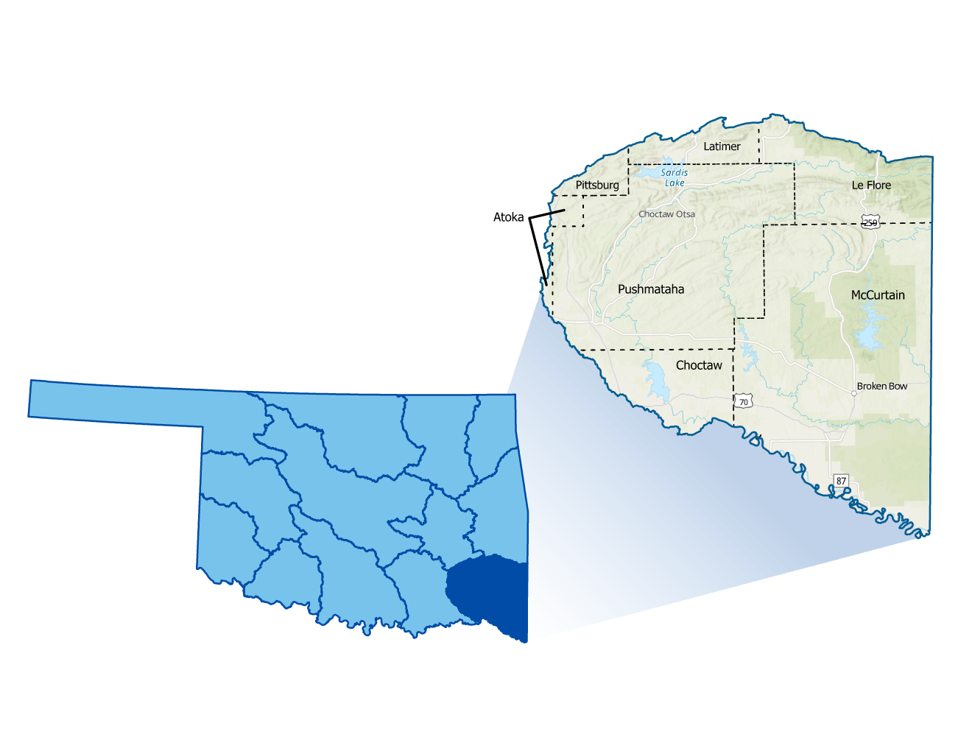
Figure 1: Southeast Planning Region Boundary

The area is filled with mountainous regions with minimal road infrastructure due to the difficulty of construction, because of this the Southeast Watershed Region is sparsely populated. Additionally, many rural areas, small towns and vulnerable populations are located within the watershed. With the Region having so many rivers and lakes, a few towns and many roads flood more frequently. Broken Bow and Idabel, serving as the population centers, have a history of dealing with floods. All counties in the planning area have experienced multiple federally declared flood disasters since 1970.
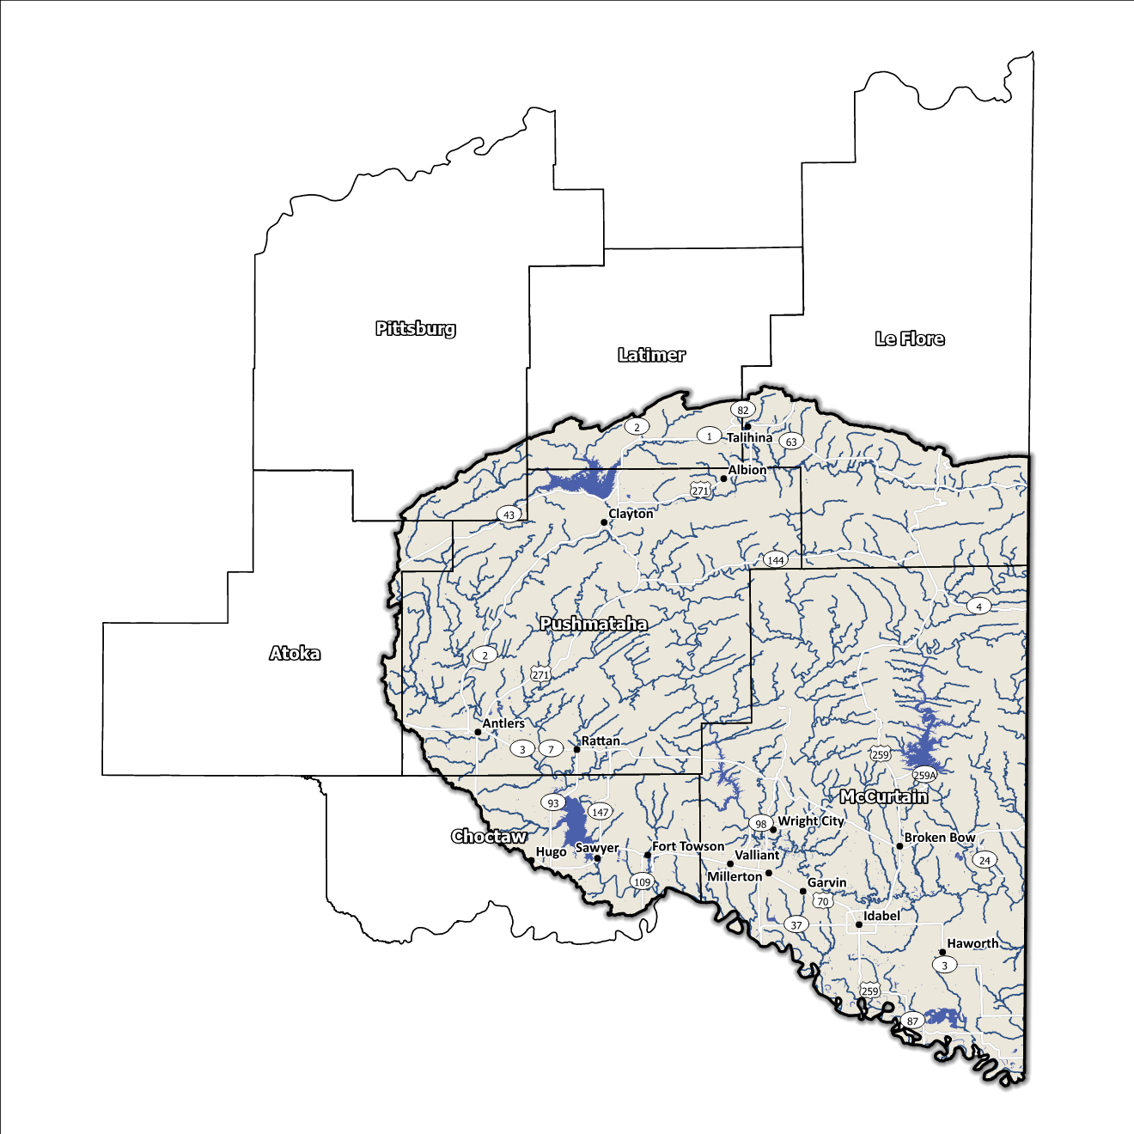
A base map displaying incorporated jurisdictions within the Planning Region is displayed in Figure 2.
Figure 2: Southeast Planning Region Base Map

Socioeconomic and Geographic Characteristics
A mix of industries, including agriculture and forestry, among others, brings economic diversity to this Region. The Region is also well known for its high yield deer hunting. Adding another level of variety is the geography of the area. This section will examine some of these socioeconomic and geographic factors and how they contribute to and affect this watershed.

Demographic Profile
The Southeast Watershed Planning Region encompasses over 171,000 people with a mix of urban, suburban, and rural areas. This Region represents approximately 6.4% of Oklahoma's land area, and around 4% of Oklahoma residents call this area home according to the 2020 U.S. Census. A population breakdown in the Region is found in Table 1.
Provided by the 2020 U.S. Census, these statistics represent county-level populations, not those within the watershed boundary. McCurtain and Pushmataha Counties are the only two in the group that are completely contained within the Southeast Watershed Region.
Table 1: Population Breakdown by County in the Southeast Planning Region
County | Total Population
Atoka | 14,143
Choctaw | 14,204
Latimer | 9,444
Le Flore | 48,129
McCurtain | 30,814
Pittsburg | 43,773
Pushmataha | 10,812

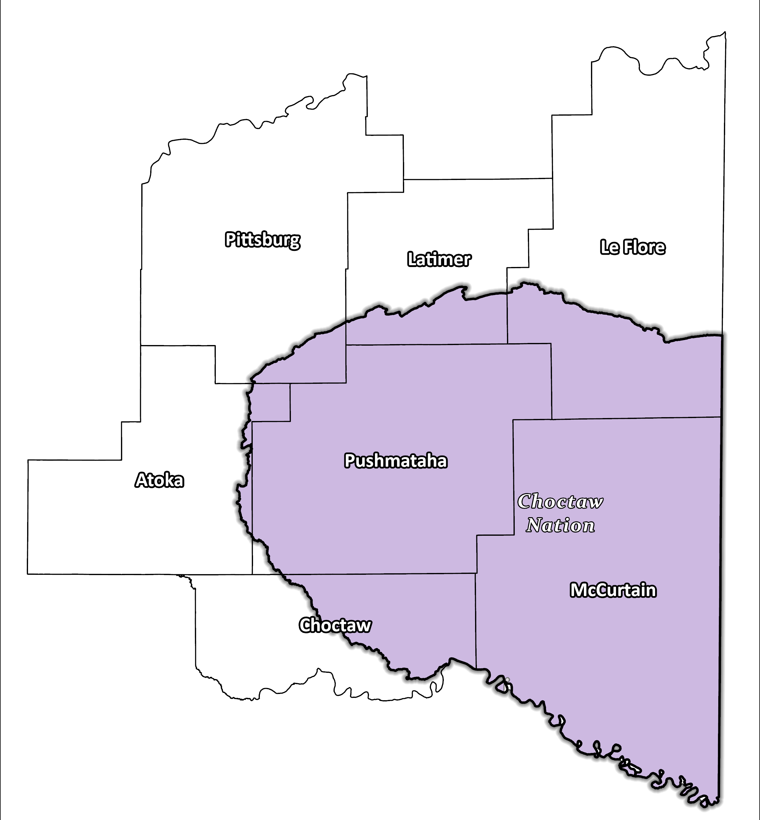
Figure 3: Tribal Jurisdictions Base Map for Southeast Planning Region

The Region was inhabited by the Choctaw Nation in the 19th century and today still has a large population of the Choctaw Nation, as well as small populations from the Cherokee, the Muscogee (Creek), and the Chickasaw Nations. They have a long history of inhabiting the Region and have significantly shaped the area's cultural and economic development. High-risk areas include nursing homes, which are highly populated in the area, or special education facilities. The Region overall is lacking in storm shelters and generators, and many areas are at risk due to low elevation such as the City of Antlers, the county seat for Pushmataha. Road closures due to riverine flooding are very common, flash flooding and urban flooding are also major concerns, especially because of the lack of storm sirens in the Region.

Economic Profile
The Southeast Planning Region has significant economic importance in the state and the country. The Region is home to the Boktuklo and Cedar Mountains, and the Kiamichi Mountains are a sub-range of the Ouachita Mountains. The area also harbors Broken Bow, Hugo, and Sardis Lakes and the Kiamichi, Little, and Red Rivers, along with their various tributaries. Sardis Lake is a flood control facility that impounds the water of Jack Fork Creek, while Hugo Lake backs up the water flow of the Kiamichi River. The Choctaw Nation in southeast Oklahoma are significant employers and contributors in the Region. Additionally, the Choctaw Nation supports growth and development in the area through investments in infrastructure, education, and healthcare.

Floodplain Management and Mitigation Capabilities
This section provides a broad summary of floodplain management capabilities and community engagement within the overall Southeast Planning Region.

National Flood Insurance Program Participation
Within the Planning Region, all counties have been mapped by the Federal Emergency Management Agency (FEMA) and a majority participate in the National Flood Insurance Program (NFIP). There are two major counties within the seven counties, however, that do not currently participate in the NFIP program, as shown in Figure 4, below.
Despite the Southeast Region being known for heavy rainfall and many water bodies, a majority of the Region does not participate in the NFIP, none of the communities in the watershed participate in FEMA’s Community Rating System (CRS).

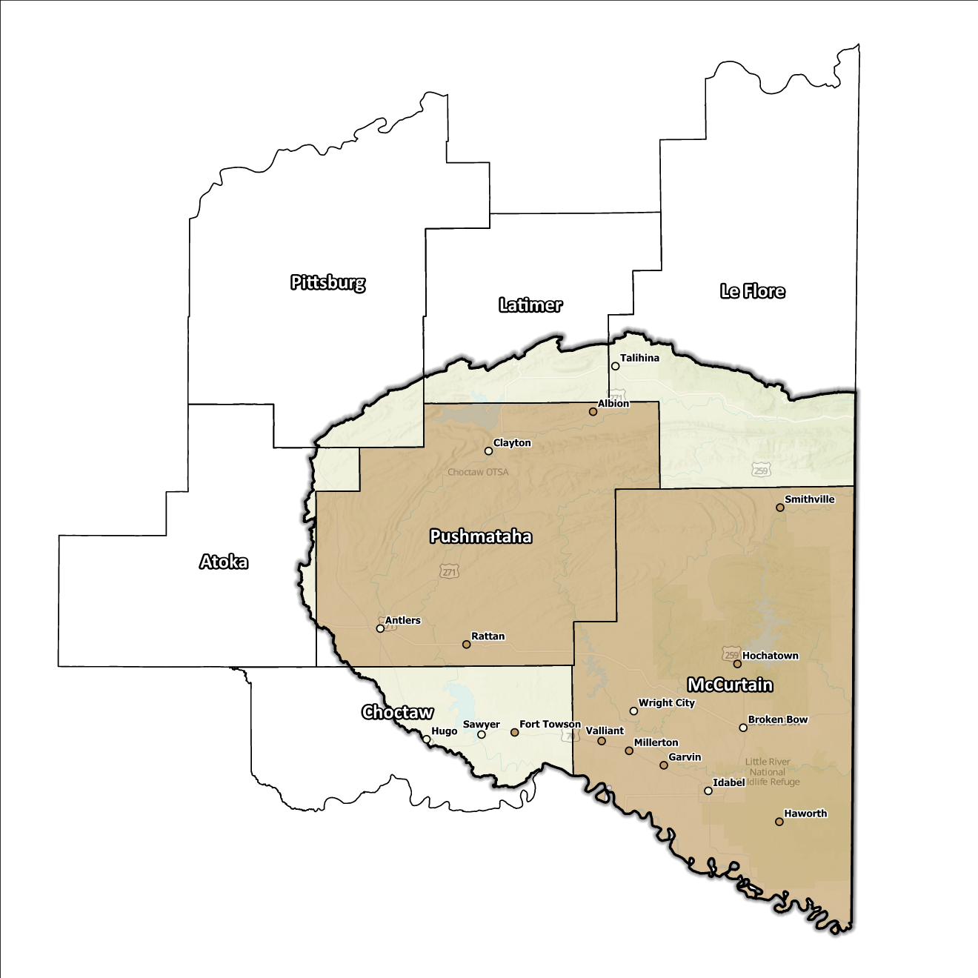
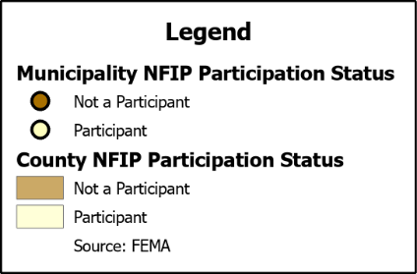
Figure 4: Status of NFIP Participation in the Southeast Planning Region

Flood Insurance Coverage
As of the latest update, there are currently 91 active NFIP policies in effect within the planning area. These policies cover approximately 3.3% of the total structures located in the FEMA mapped Special Flood Hazard Area (SFHA). It should be noted that not all active policies are situated within the SFHA. A total of 55 NFIP claims have been filed, resulting in approximately $963k being paid out to policyholders. There are eight structures classified as repetitive loss (RL) or as severe repetitive loss (SRL), with a significant concentration of both types in McCurtain County. Repetitive loss, in the context of the NFIP, refers to properties that have experienced multiple flood-related insurance claims over a specific time period. Severe repetitive loss, on the other hand, pertains to properties with an extensive history of recurrent flood damage and a high number of insurance claims, making them particularly vulnerable and costly for the NFIP.
The subsequent displays provide a range of information about NFIP policies, as well as the total claims filed and paid in the Planning Region. Although these figures are insightful, it's crucial to recognize they may not accurately reflect the true extent of losses in the area due to an underrepresentation of flood insurance. Not every claim filed or paid is linked to an active policy.

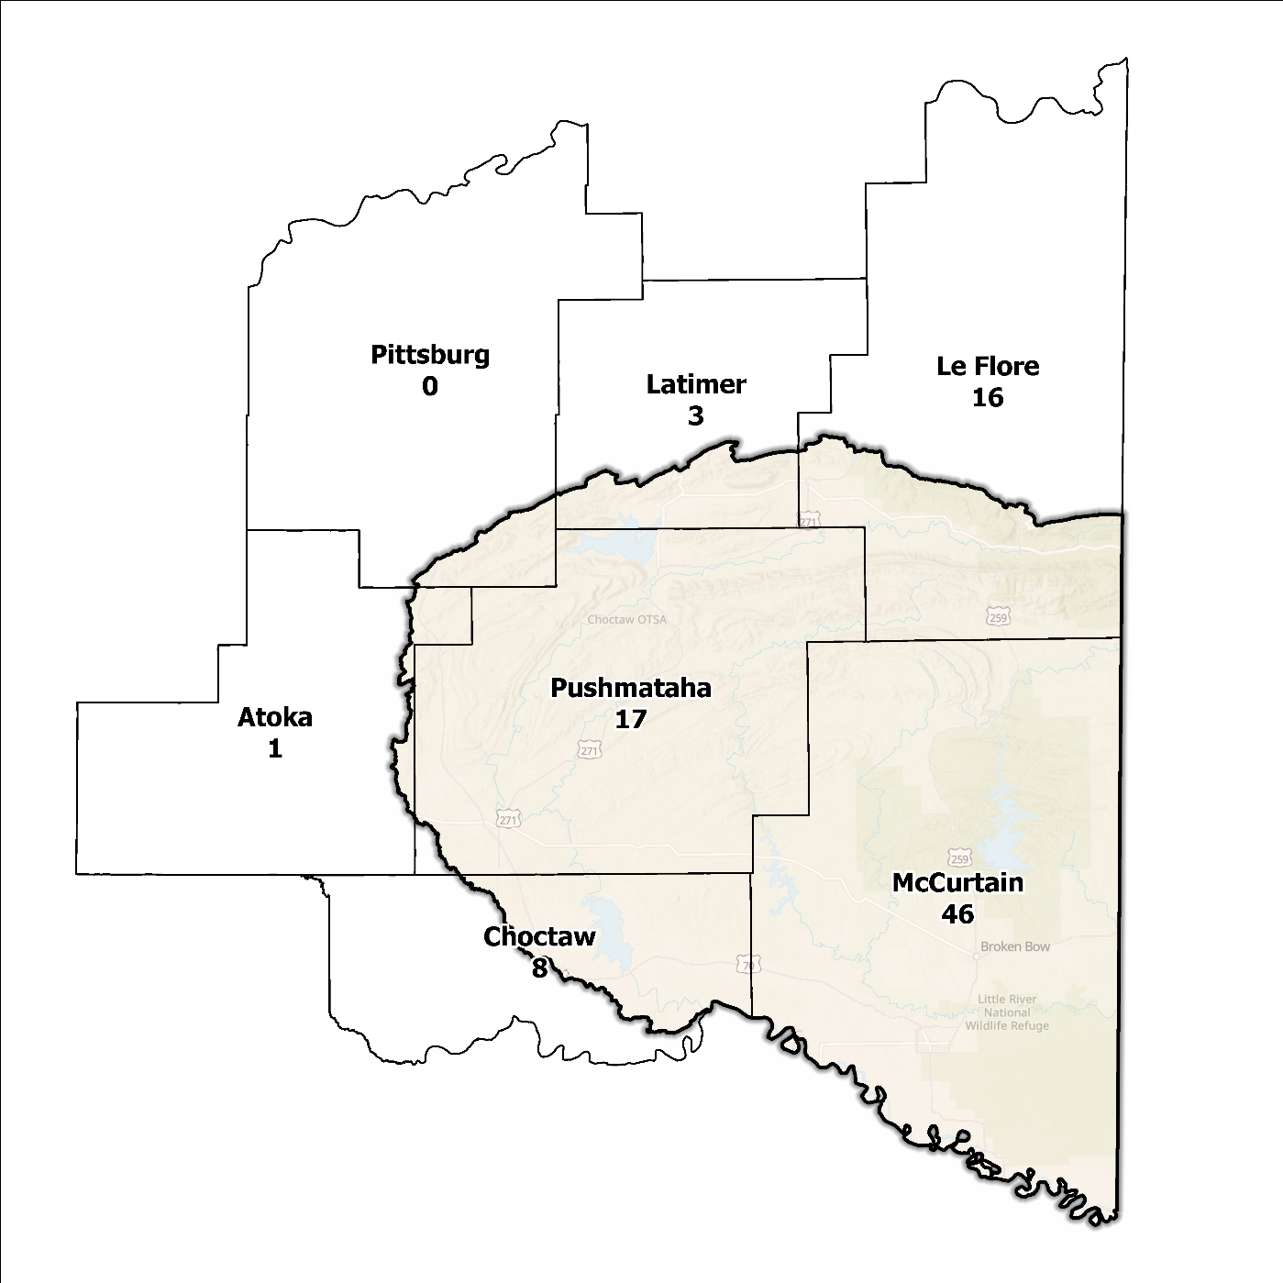
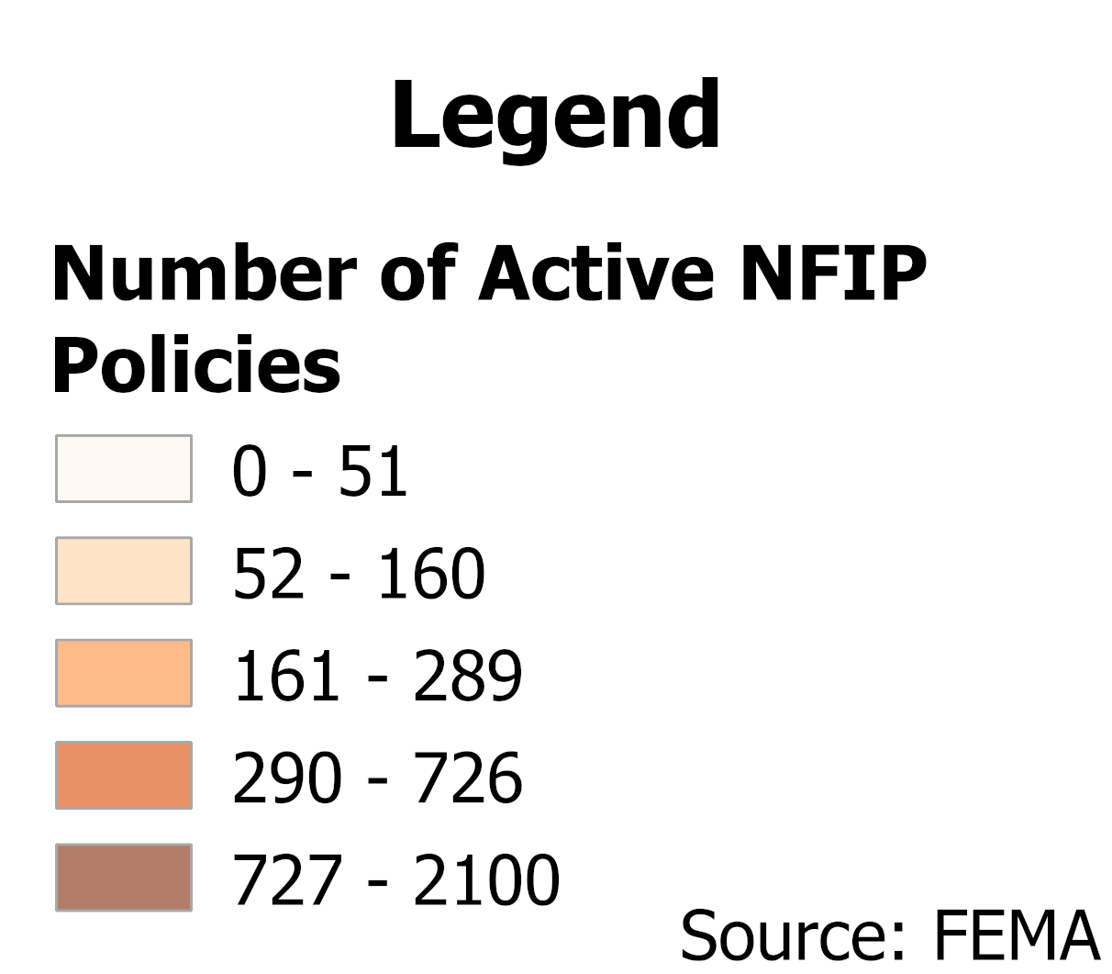

Figure 5: Number of Active NFIP Policies in the 100-Year Floodplain in the Southeast Planning Region

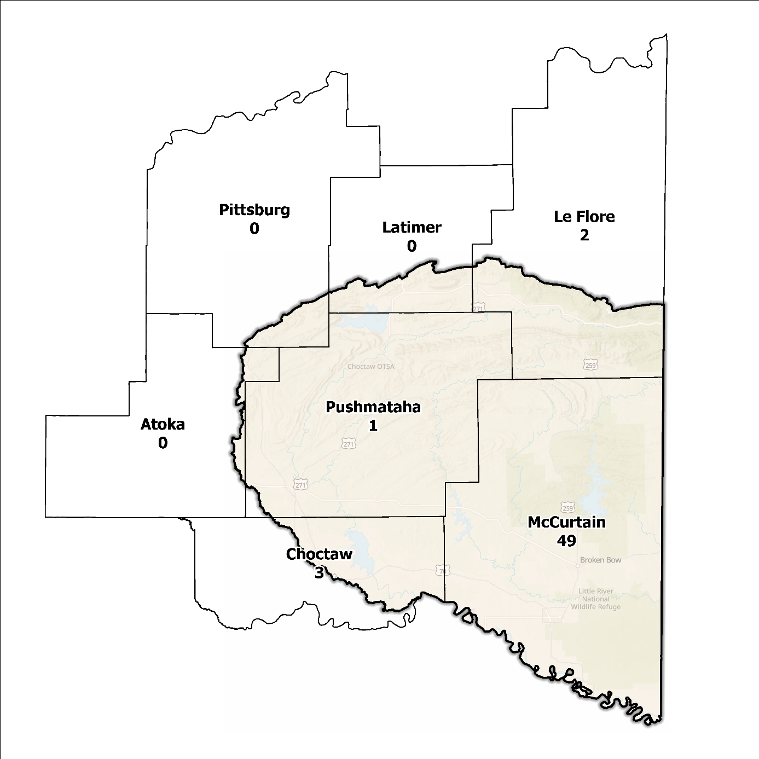
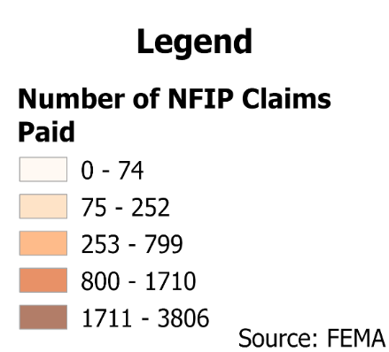
Figure 6: Total NFIP Claims Paid in the Southeast Planning Region

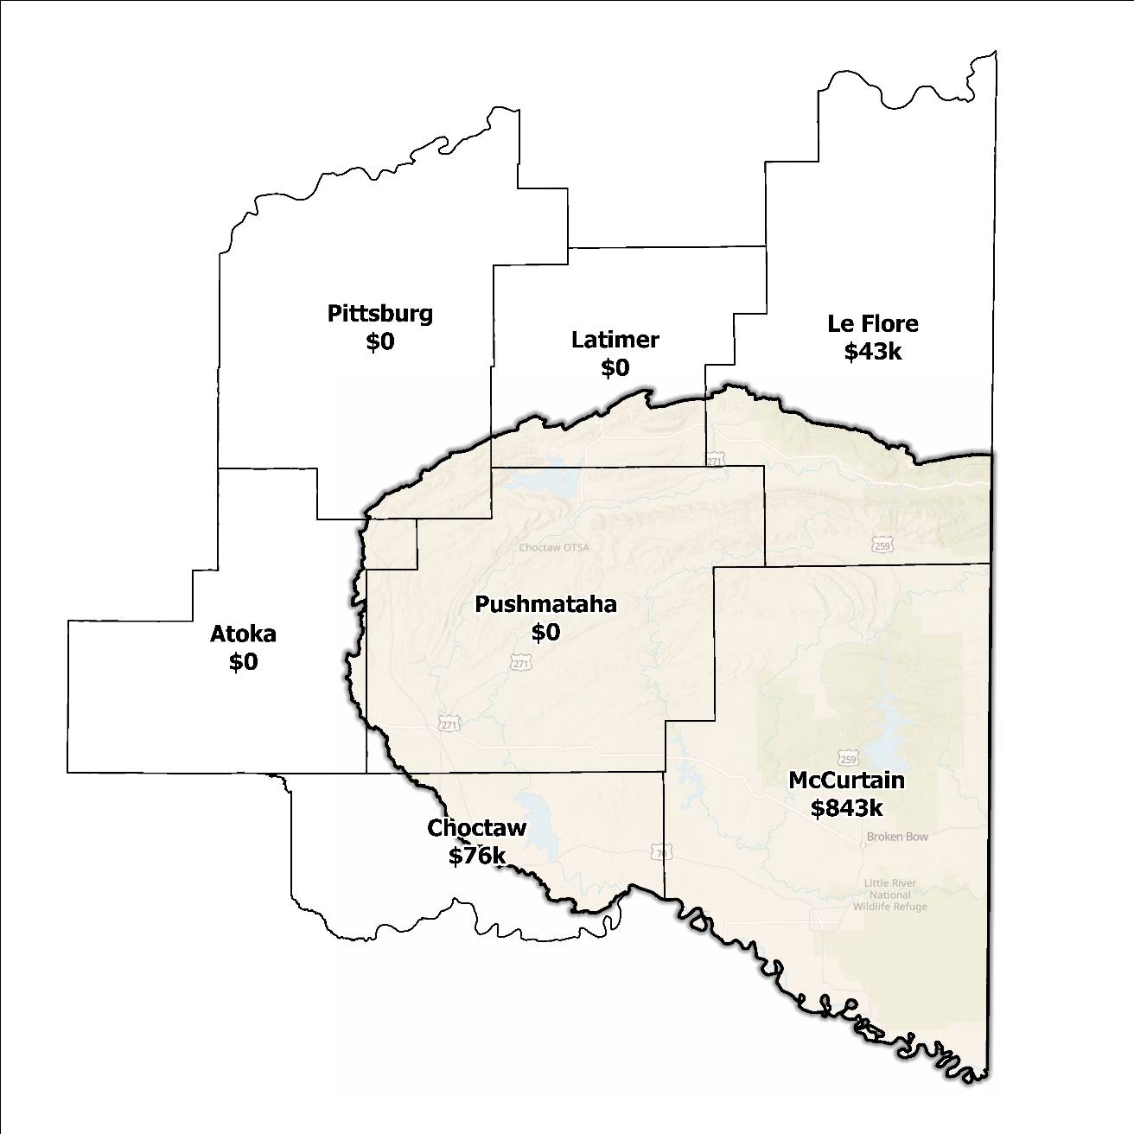
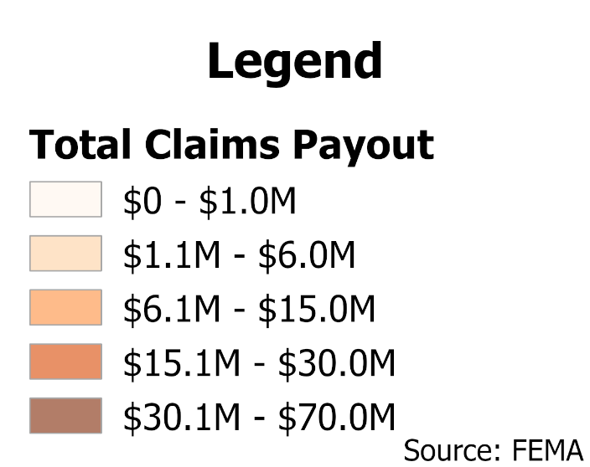
Figure 7: Total Value NFIP Claims Paid Out in the Southeast Planning Region

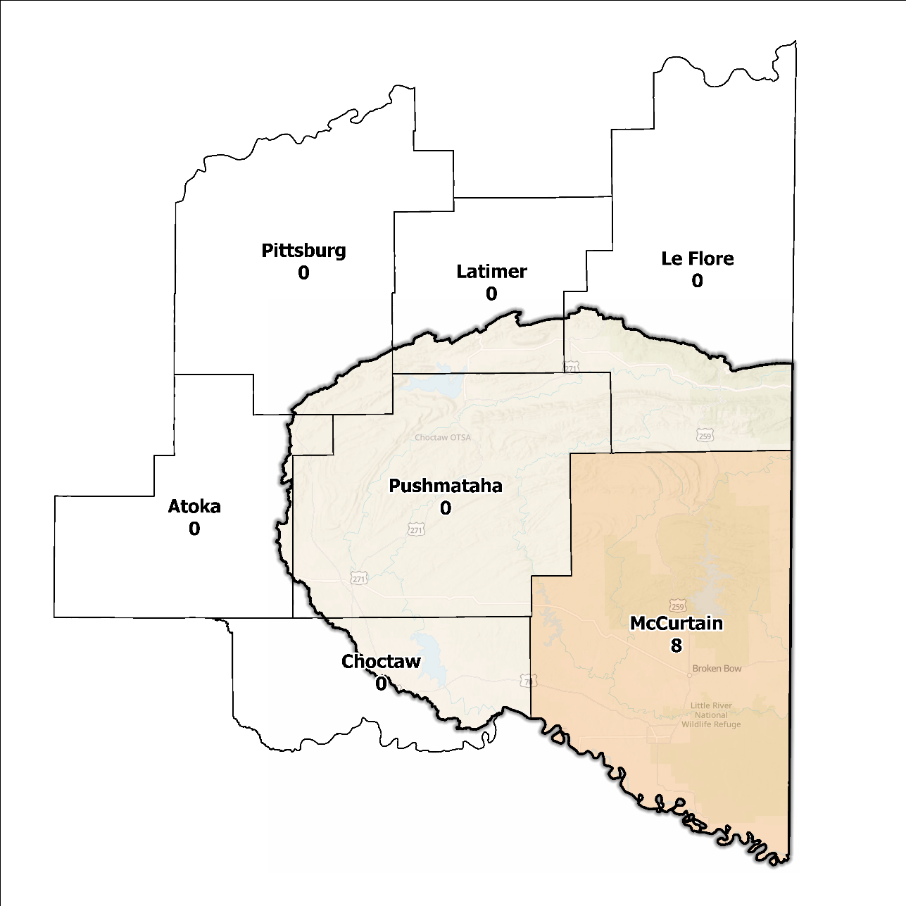
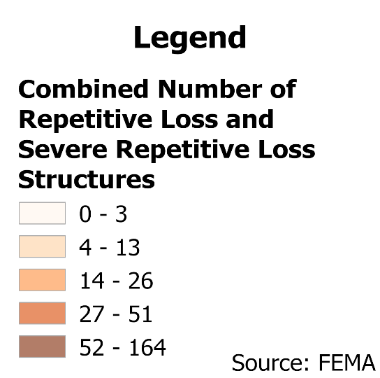
Figure 8: Repetitive Loss and Severe Repetitive Loss Structures in the Southeast Planning Region

Flood Funding Mechanisms
A survey conducted by the planning team to determine the level of funding for stormwater and floodplain management in the Southeast Planning Region revealed that most communities have limited local funding. Some larger, more urban jurisdictions, such as the City of Broken Bow, are more likely to be able to implement stormwater management fees.

Hazard Mitigation Plan Status
Five out of seven counties in this Region possess a FEMA-approved Hazard Mitigation Plan (HMP) and the identified mitigation actions vary in jurisdictions. Several identify basic programmatic and administrative activities, such as planning, education, acquiring or implementing warning systems, participating in the NFIP, etc. In contrast, others intentionally list flood mitigation projects such as property buyouts, road and drainage improvements, floodplain restoration, and other flood-specific activities. Road flooding is the most frequently reported problem across the planning area. Several communities and tribal nations in the Region have individual HMPs separate from their respective counties.
Table 2: Hazard Mitigation Planning Status in the Southeast Planning Region
Name | Type | Approval Date | Expiration | Current Action Status of this Plan
Atoka | County | 12/16/2009 | 12/16/2014 | Expired
Choctaw | County | 09/11/2019 | 09/10/2024 | Expired
Latimer | County | 08/08/2018 | 08/07/2023 | Approved
Le Flore | County | 09/15/2022 | 09/14/2027 | Approved
McCurtain | County | 03/22/2023 | 03/21/2028 | Approved
Valliant | Town | 06/15/2010 | 06/15/2015 | Expired
Wright City | Town | 06/15/2010 | 06/15/2015 | Expired
Pittsburg | County | 03/09/2022 | 03/08/2027 | Approved
Pushmataha | County | 06/28/2022 | 06/27/2027 | Approved
Choctaw | Tribal  Nation | 05/21/2020 | 05/21/2025 | Approved

Flood Mapping Assessment
In the Southeast Planning Region, the floodplain quilt consolidates the best available data on flood risk. However, some areas in the Region still need to be mapped by FEMA, limiting the ability of local authorities to regulate development in flood-prone areas.
A notable aspect of the Region is that most of the effective FEMA maps still lack detailed studies. This leaves floodplain managers to rely on Approximate A Zones, which offer a broad understanding of flood risk but do not have determined Base Flood Elevations (BFE). Figure 9 displays FEMA-mapped areas in the Planning Region.
While in areas with A zones, Base Level Engineering (BLE) data might provide a more accurate indication of flood risk, it is noted that most of the Southeast Planning Region contains ample BLE coverage. BLE assists in determining areas that are expected to flood and therefore are not reasonably safe from flooding. Although there is good coverage of data between the effective FEMA maps and BLE data, there is still a need for in-depth studies to enhance the precision and reliability of flood risk information in this Region.
McCurtain County, along with the City of Broken Bow, stand out among areas in the Planning Region for having the most extensive flood risk assessment information. Investment in floodplain mapping has been higher in these areas than in others in the Region.
While Flood Insurance Rate Maps (FIRMs) are beneficial for regulatory uses and flood insurance assessments, they only represent potential risks associated with a flood event under certain specific conditions. The threat of flooding beyond the FEMA mapped SFHA is only included on FIRMs if the community opts to carry out the required studies to integrate such data into their hazard map.

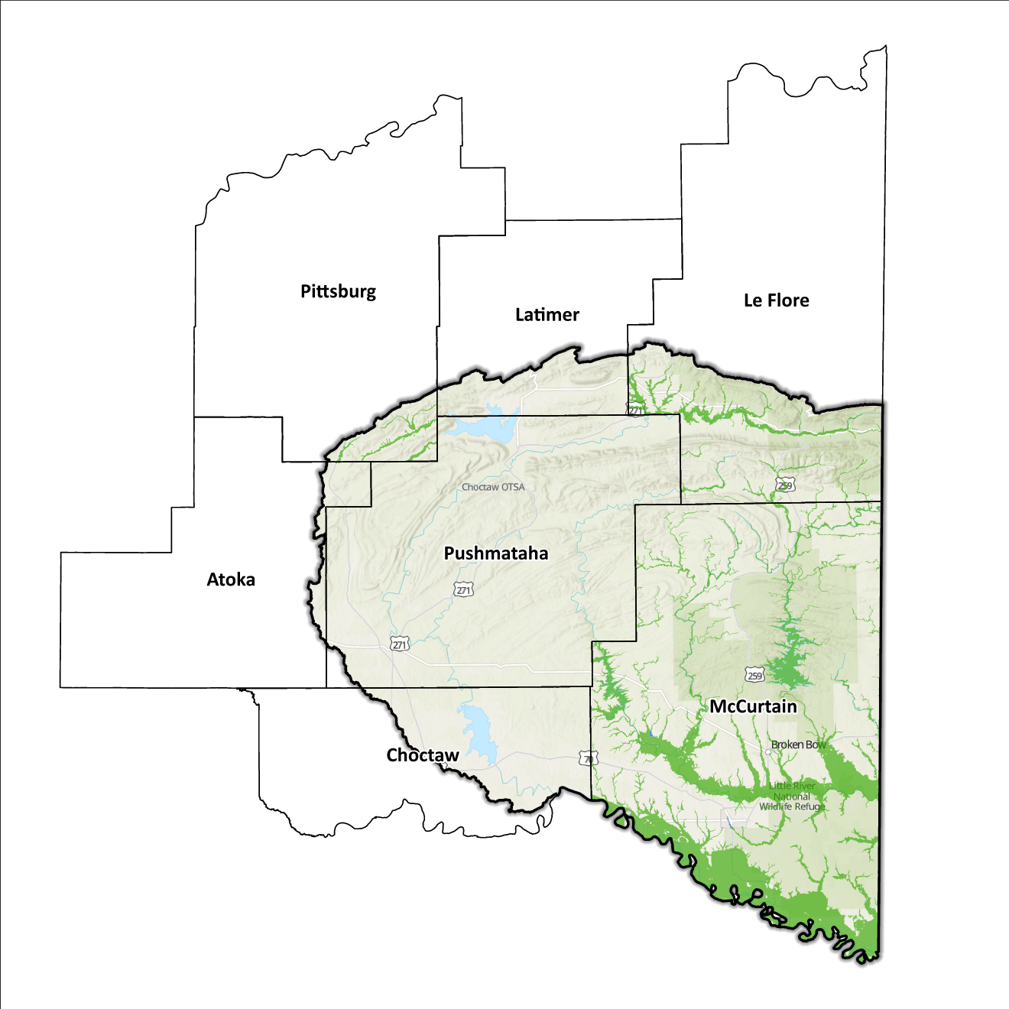
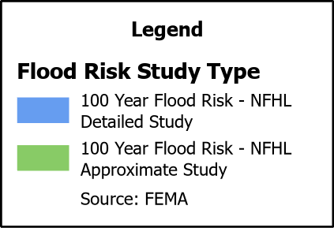
Figure 9: FEMA Mapped Special Flood Hazard Area Comparison in the Southeast Planning Region

Flood Hazard Assessment
Flood hazards in this Region include flash, river, and urban flooding. The Kiamichi, Little, and Red Rivers, along with their various tributaries, are the major waterways found in the Southeast Watershed.

Location of Flood Hazards
The Southeast Planning Region is characterized by a flood hazard that encompasses various significant aspects. The flood location in the Southeast Planning Region exhibits the following characteristics:
- Flooding along major waterways with extensive drainage basins, including the Little River, Red River, Kiamichi River, Mountain Fork River, Big Eagle Creek, and Rock Creek.
- Flash floods along smaller tributaries that ultimately flow into the major waterways.
- Drainage issues in specific areas result from inadequate infrastructure. Insufficient drainage systems can exacerbate flood risks, leading to localized flooding in vulnerable locations.
- Downstream areas located below high-hazard potential dams, including those situated south of the Texas and Oklahoma state line, are exposed to heightened risks.
Figure 10 shows mapped areas of flood risk in the Region. The map brings together data from different sources, like the National Flood Hazard Layer and BLE, to create a unified view. It prioritizes layer types and shows the most important layer available for a specific area.
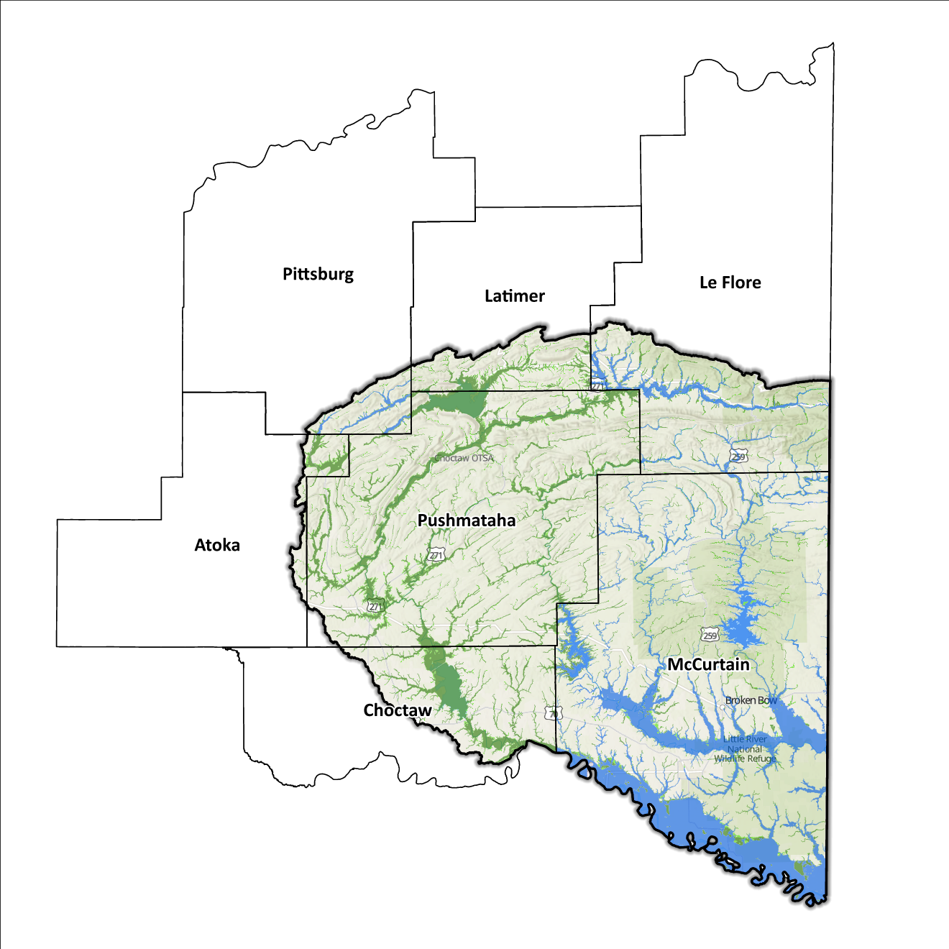
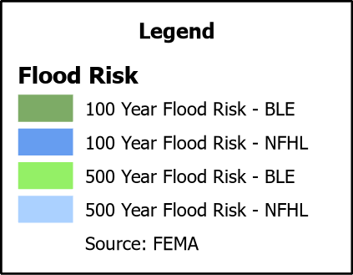
Figure 10: Flood Quilt in the Southeast Planning Region

Dam and Levee Infrastructure
The Region has multiple dams aimed at preventing flooding. However, aging infrastructure increases the risk of downstream impacts if a breach or failure occurs, especially for high-hazard dams classified by the Oklahoma Water Resources Board (OWRB). The seven counties have 33 high-hazard dams, with 10 located in the Southeast Watershed. The Region has no levee systems across its counties. A map of dam and levee locations within the Region is shown in Figure 11.
Although the Southeast Watershed Region concludes at the Arkansas/Oklahoma state line, the flood risks associated with dams and levees transcend its boundaries.

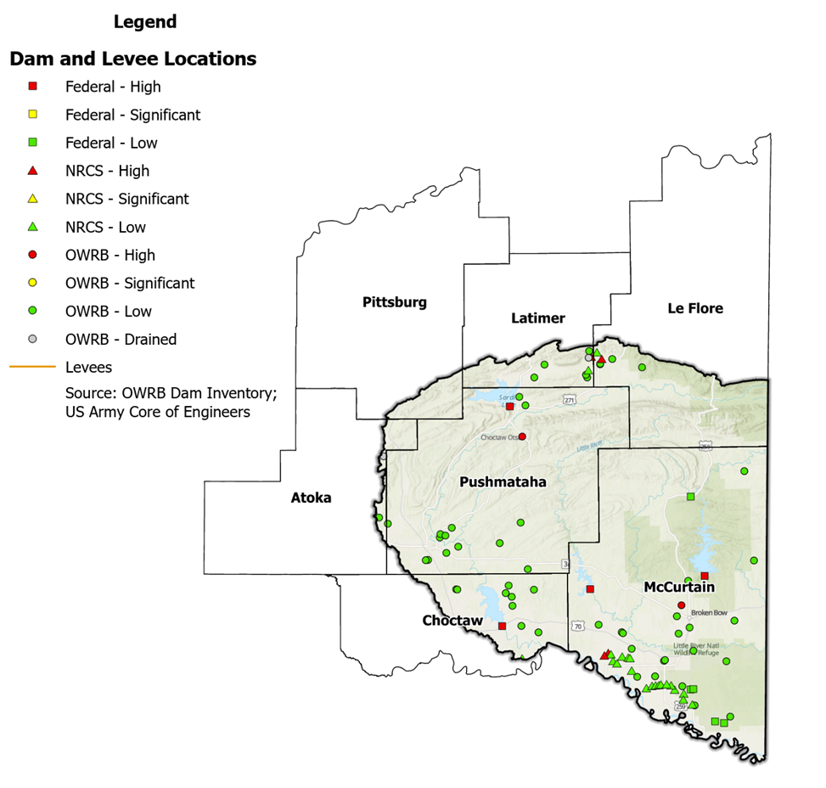
Figure 11: Dam and Levee Locations in the Southeast Planning Region

Extent of Flooding
Extent refers to the expected severity of flooding, and because not all areas within the planning area share the same topography, the extent varies between individual communities. The average depth of flooding within the FEMA-mapped SFHA can range from a few inches to several feet, depending on factors such as topography, proximity to water bodies, local drainage characteristics, and the intensity of the flood event.

Previous Occurrences
According to the records maintained by the National Center of Environmental Information (NCEI), from January 1996 to December 2022, a total of 531 flood events have been documented in the seven counties encompassing this Planning Region. Cumulatively, these flooding incidents have caused property damage amounting to $2,630,000.
The NCEI initiated the tracking of flood events only from 1996, hence this data represents the most comprehensive information available. Flooding has frequently escalated to the point of necessitating a Presidential Disaster Declaration. A breakdown of flood-related disasters by county is shown in Table 3.

Table 3: FEMA Flood Related Disaster Declarations (1950-2024) in the Southeast Planning Region
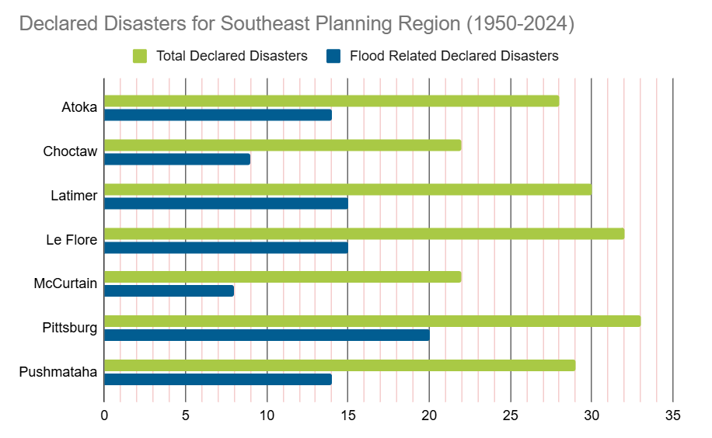

Of all the counties in the Region, Pittsburg County has most frequently been declared a disaster area due to flooding. However, it's important to note that disaster declarations are issued on a county-wide basis and not all declarations may have directly impacted this specific Region.

Vulnerability and Impacts of Flooding
According to FEMA’s National Risk Index (NRI), the Southeast Planning Region demonstrates a range of risk levels for river flooding and flash flooding, varying from relatively low to relatively moderate risk at the county level, when compared to the rest of the United States. However, when examined at a more granular scale by census tract, the NRI highlights specific areas along the Little River and Hugo Lake, particularly in Choctaw and McCurtain counties, as being at a moderate risk of flooding.
Compared to other regions in Oklahoma, the Southeast Planning Region is at a higher risk of flooding due to multiple factors including high annual precipitation, a large number of waterways and drainage areas, development in flood-prone locations, and aging infrastructure.

Summary of Flood Exposure
Flood exposure refers to the degree to which an area or population is at risk of being affected by a flood event. Table 4 provides a comprehensive overview of key factors, including the total count of housing units, population figures, job statistics, land area measurements, and the number of parcels/blocks within the designated FEMA-mapped flood area. This information aims to facilitate a thorough understanding of the flood-affected area's characteristics and implications.
The data in this section was generated using UrbanFootprint. This module evaluates flood risk by conducting a spatial join of parcels or census blocks with the FEMA National Flood Hazard Layer to assess the potential risks associated with hazards. The data presented in the table below is focused on three different FEMA SFHA flood zones that represent areas within the 100-yr floodplain with a 1% annual chance of experiencing a flood event. Zone AE is the most detailed, providing BFE, Zone AO represents areas subject to shallow flooding of depths between one to three feet, and Zone A is an approximation of the 100-yr floodplain for areas where detailed hydraulic analyses have not been performed.

Table 4: Flood Exposure in the Southeast Region
Southeast Planning Region Flood Risk Report
Housing in Flood Hazard Zones (Dwelling Units)
Dwelling Units in SFHL Zone AE | 84
Dwelling Units in SFHL Zone A | 8
Dwelling Units in SFHL Zone AO | N/A
Total | 92
Population in Flood Hazard Zones (Persons)
Population in SFHL Zone AE | 180
Population in SFHL Zone A | 17
Population in SFHL Zone AO | N/A
Total | 197
Jobs in Flood Hazard Zones (Employees)
Jobs in SFHL Zone AE | N/A
Jobs in SFHL Zone A | N/A
Jobs in SFHL Zone AO | N/A
Total | N/A
Land Area in Flood Hazard Zones (Acres)
Area in SFHL Zone AE | N/A
Area in SFHL Zone A | N/A
Area in SFHL Zone AO | N/A
Total | N/A
Parcels or Blocks in Flood Hazard Zones
Parcels or Blocks in SFHL Zone AE | N/A
Parcels or Blocks in SFHL Zone A | N/A
Parcels or Blocks in SFHL Zone AO | N/A
Total | N/A

Flood Mitigation Needs
While most floodplains within this Region are in rural areas, the following communities have at least one structure located within floodplain: the cities of Broken Bow, Fort Townson, and Hugo, the towns of Talihina, Haworth, and Hochatown, and the unincorporated communities of Goodlake and Farmers Hill. Despite this, the Southeast Planning Region has not reported any data on the use of acquisition as a mitigation method. The following stormwater project types were considered:
- Channel
- Storm Drain
- Infrastructure
- Detention Pond
- Dam-Reservoir
- Floodwalls and Levees
- Acquisition

Smaller communities face challenges in funding acquisitions and other stormwater and mitigation projects. In numerous cases, the local tax base proves insufficient to finance property acquisition, necessitating these jurisdictions to seek external sources, such as state and federal grant funding. Such sources can be highly competitive in nature and favor more populated urban areas due to the cost benefits and can depend on a variety of factors.

Conclusion
The Southeast Watershed report highlights the significance of this Region and its vulnerability to flood events. The report's findings emphasize the urgent need for funding to support engineering efforts in flood projects within the watershed. Adequate funding is essential for conducting detailed engineering assessments, implementing effective flood control measures, and enhancing community resilience. The lack of project submissions underscores the importance of assisting communities in identifying and developing flood mitigation projects.
By allocating resources and support for project identification and development, communities can better understand their flood exposure and proactively protect lives and infrastructure. Investing in engineering and flood mitigation projects in the Southeast Watershed will contribute to creating safer, more resilient communities better equipped to handle future flood events.
During the planning process, the data generated was developed into an interactive flood planning dashboard. The dashboard serves as a valuable tool for conducting flood assessments at the community level. It is important to note that this report should not substitute locally generated data specific to each community.

This calculation was performed by summing the populations of the counties within this region, as indicated in Table 1, then divided by the entire population of the State of Oklahoma using the same data source (2020 U.S. Decennial Census).
Census Bureau Data – 2020 Decennial Census
Choctaw County’s HMP includes the Towns of Fort Townson, Sawyer, and the City of Hugo.
Le Flore County’s HMP includes the Towns of Talihina.
McCurtain County’s HMP includes the Towns of Garvin, Haworth, Millerton, Smithville, and the Cities of Broken Bow, and Idabel.
Pushmataha County’s HMP includes the Towns of Albion, Clayton, Rattan, and the City of Antlers.

