Table of Contents
The Panhandle Planning Region 1
Section 1.1: Watershed Introduction 1
Section 1.2: Socioeconomic and Geographic Characteristics 2
Section 1.3: Floodplain Management and Mitigation Capabilities 4
Section 1.4: Flood Hazard Assessment 10
Section 1.5: Flood Mitigation Needs 14
Section 1.6: Conclusion 15

The Panhandle Planning Region

Watershed Introduction
Stretching over 9,360 square miles of what was once No Man's Land, the Panhandle Watershed Planning Region (Region) spans 10 counties in northwestern Oklahoma, and encompasses all or part of Blaine, Beaver, Cimarron, Dewey, Ellis, Harper, Major, Texas, Woods, and Woodward counties. There are 17 municipalities located here. The Beaver/North Canadian, and Cimarron Rivers, along with their various tributaries, are the major waterways in the Panhandle Watershed.
Figure 1 highlights the geographic boundaries of the planning area for this Region of the State.
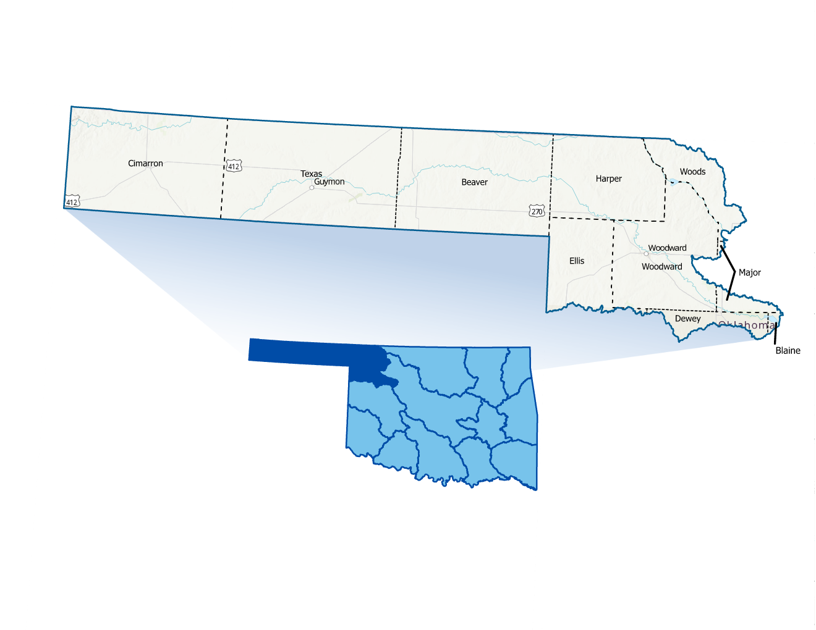
Figure 1: Panhandle Planning Region Boundary

The Panhandle Watershed stands out due to its low amounts of precipitation and location above the Ogallala Aquifer. The Region is primarily farmland and feedlots and is sparsely populated with several small cities and towns with many rural areas within the watershed. Guymon and Woodward serve as the main population centers. There are many outdoor activities in the area, such as Beaver Dunes Park, fishing, hiking, and camping. All counties in the planning area have experienced multiple federally declared flood disasters since 1970.
A base map displaying incorporated jurisdictions within the Planning Region is shown in Figure 2.
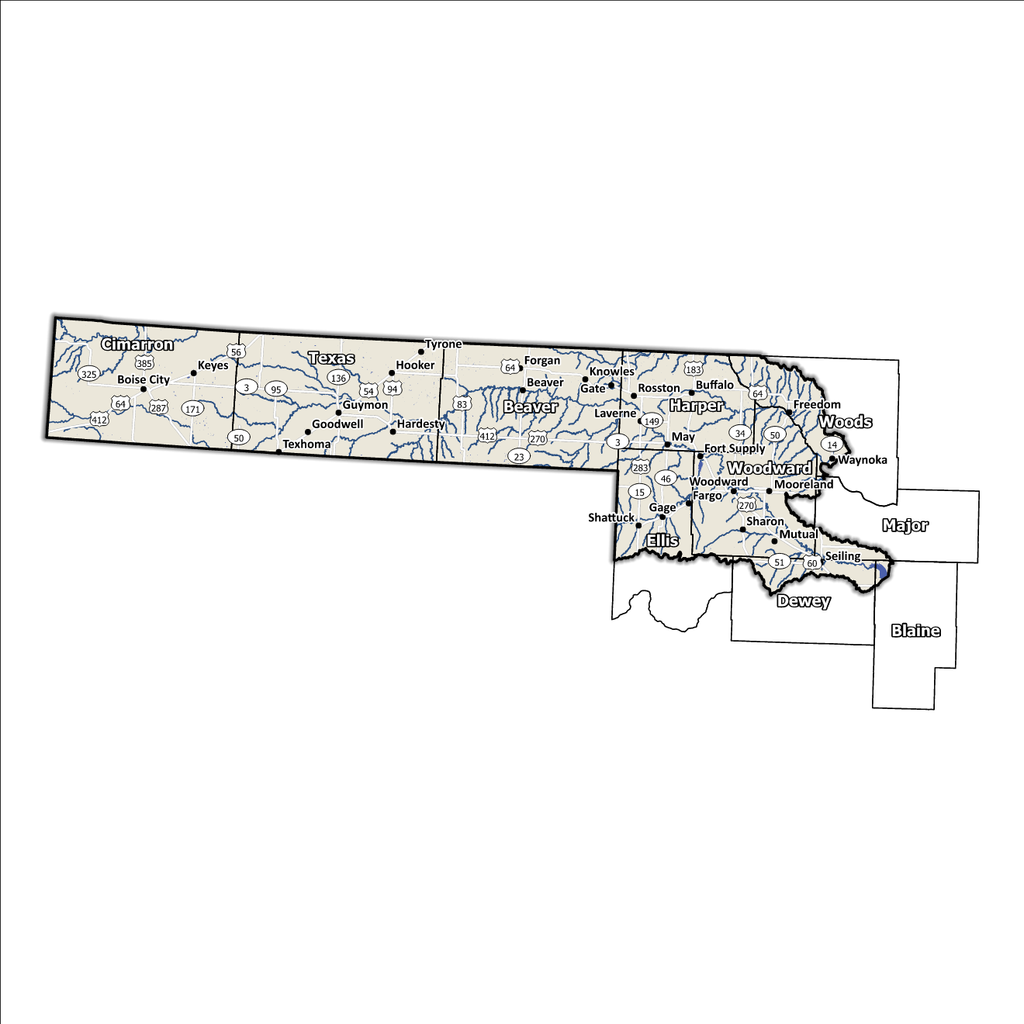
Figure 2: Panhandle Planning Region Base Map

Socioeconomic and Geographic Characteristics

Demographic Profile
The Panhandle Watershed Planning Region encompasses over 80,000 people with a mix of urban, suburban, and rural areas. This Region represents approximately 13.6% of Oklahoma's land area, and around 2% of Oklahoma residents call this area home, according to the 2020 U.S. Census. The Region is home to the Cheyenne and Arapaho Nation in the south. A view of the Region's population breakdown is provided in Table 1. Provided by the 2020 U.S. Census, these statistics represent county-level populations, not those within the watershed boundary. Beaver, Cimarron, Harper, and Texas counties are the only four counties in the group that are completely contained within the Panhandle Watershed Region.

Table 1: Population Breakdown by County in the Panhandle Planning Region
County | Total Population
Beaver | 5,049
Blaine | 8,735
Cimarron | 2,296
Dewey | 4,484
Ellis | 3,749
Harper | 3,272
Major | 7,782
Texas | 21,384
Woods | 8,624
Woodward | 20,470

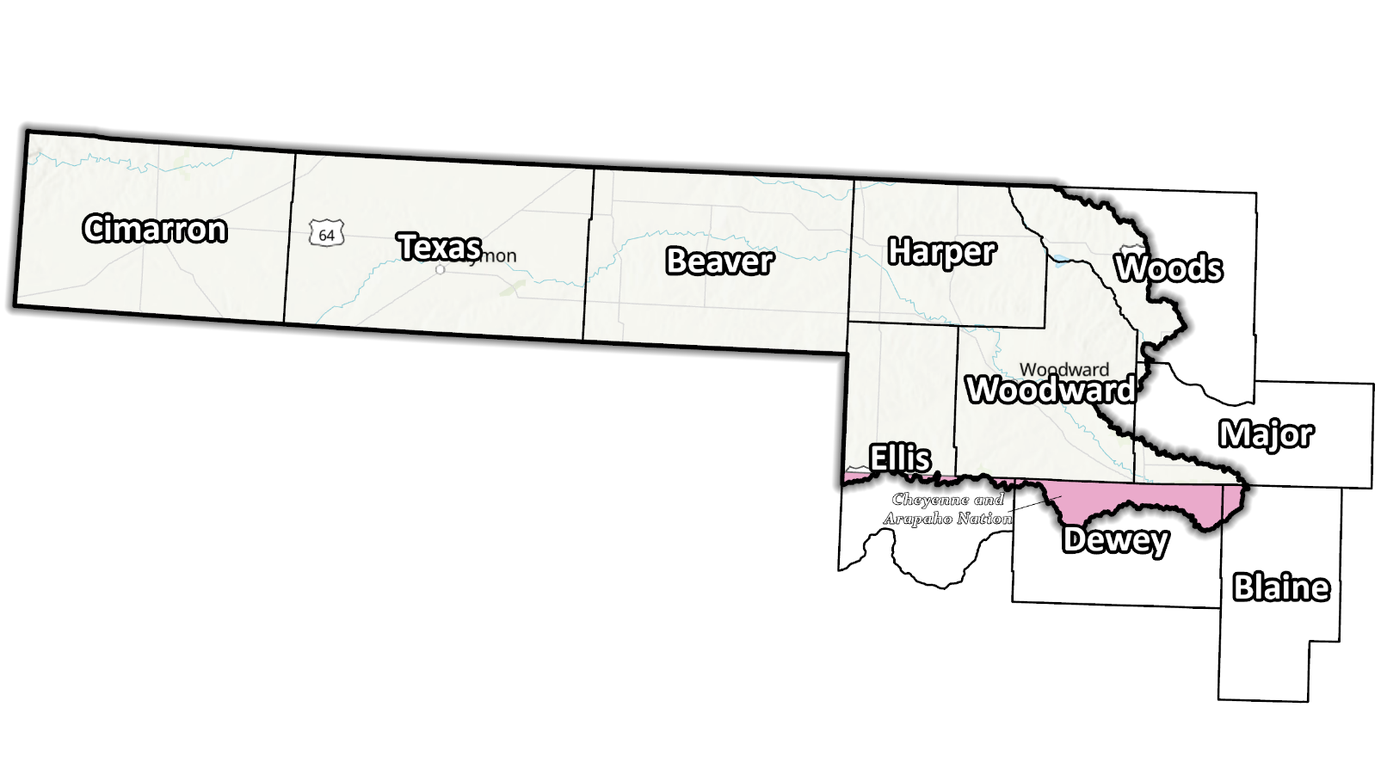
Figure 3: Tribal Jurisdictions Base Map for Panhandle Planning Region

Economic Profile
The Panhandle Planning Region has significant economic importance in the state and the country. The Region is home to the Hugoton Gas Field, one of the nation’s largest deposits of natural gas. The tribal nation in the southeast of the Panhandle Region of Oklahoma is a significant employer in the Region. They operate in various industries, including hospitality and retail. Additionally, the tribal nation supports growth and development in the area through investments in infrastructure, education, and healthcare.

Floodplain Management and Mitigation Capabilities

National Flood Insurance Program Participation
Within the Planning Region, all counties have been mapped by the Federal Emergency Management Agency (FEMA) and participate in the National Flood Insurance Program (NFIP). There are some communities within the ten counties, however, that do not currently participate in the NFIP program, as shown in Figure 4.
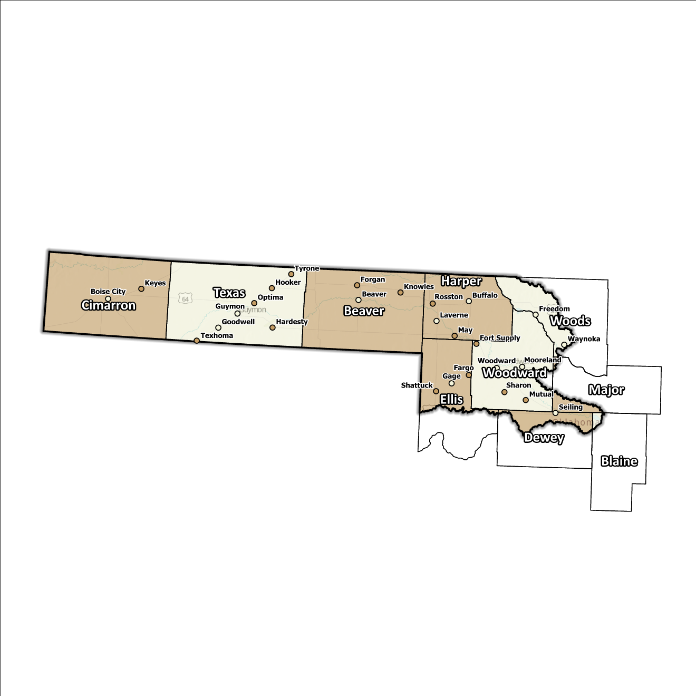
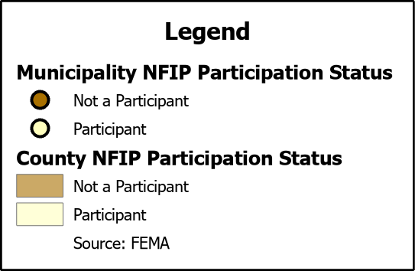
Figure 4: Status of NFIP Participation in the Panhandle Planning Region
The dedication to floodplain management by jurisdictions in this Planning Region is well demonstrated by participation in the NFIP, although none of the communities in the Region participate in FEMA’s Community Rating System (CRS). The Region does experience flash floods from time to time, which can be especially dangerous to people, crops, livestock, and roads.

Flood Insurance Coverage
As of the latest update, there are currently 109 active NFIP policies in effect within the planning area. These policies cover approximately 6.1% of the total structures located in the FEMA mapped Special Flood Hazard Area (SFHA). It should be noted that not all active policies are situated within the SFHA. A total of 56 NFIP claims have been filed, resulting in approximately $255K being paid out to policyholders. In the Region, there are three structures classified as repetitive loss (RL) or severe repetitive loss (SRL), with a significant concentration of both types in Woodward County. Repetitive loss, in the context of the NFIP, refers to properties that have experienced multiple flood-related insurance claims over a specific time period. Severe repetitive loss, on the other hand, pertains to properties with an extensive history of recurrent flood damage and a high number of insurance claims, making them particularly vulnerable and costly for the NFIP.
The subsequent displays provide a range of information about NFIP policies, as well as the total claims filed and paid in the Planning Region. Although these figures are insightful, it's crucial to recognize they may not accurately reflect the true extent of losses in the area due to an underrepresentation of flood insurance. Not every claim filed or paid is linked to an active policy.
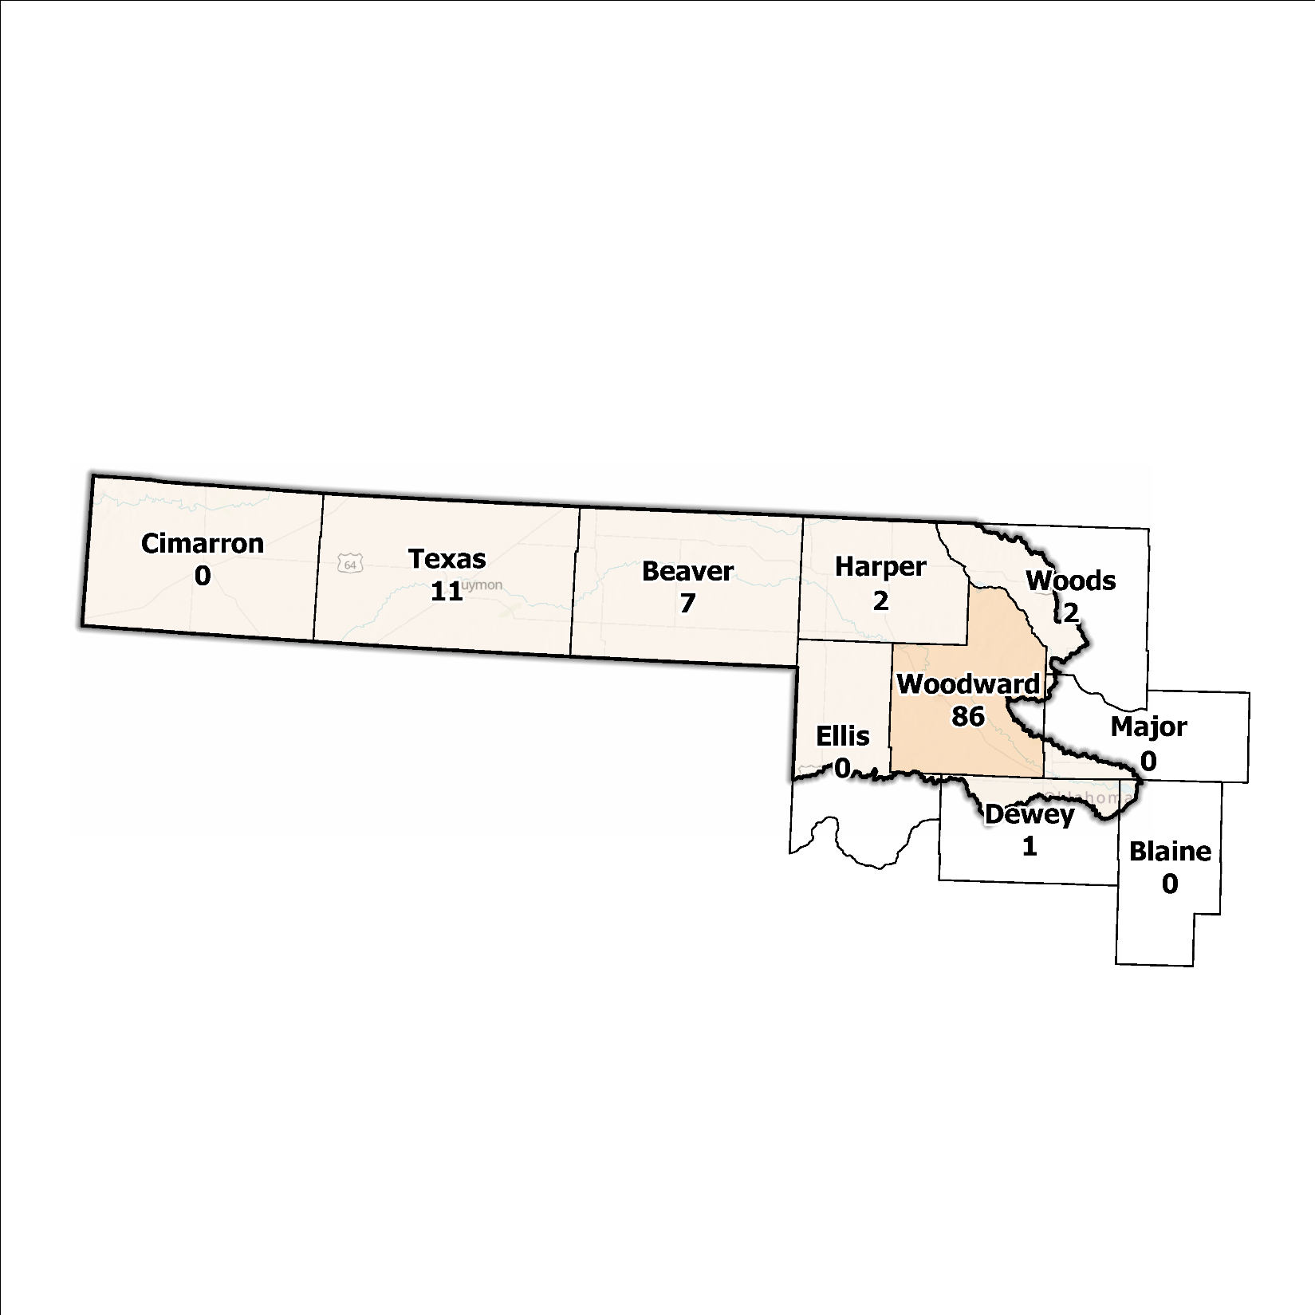
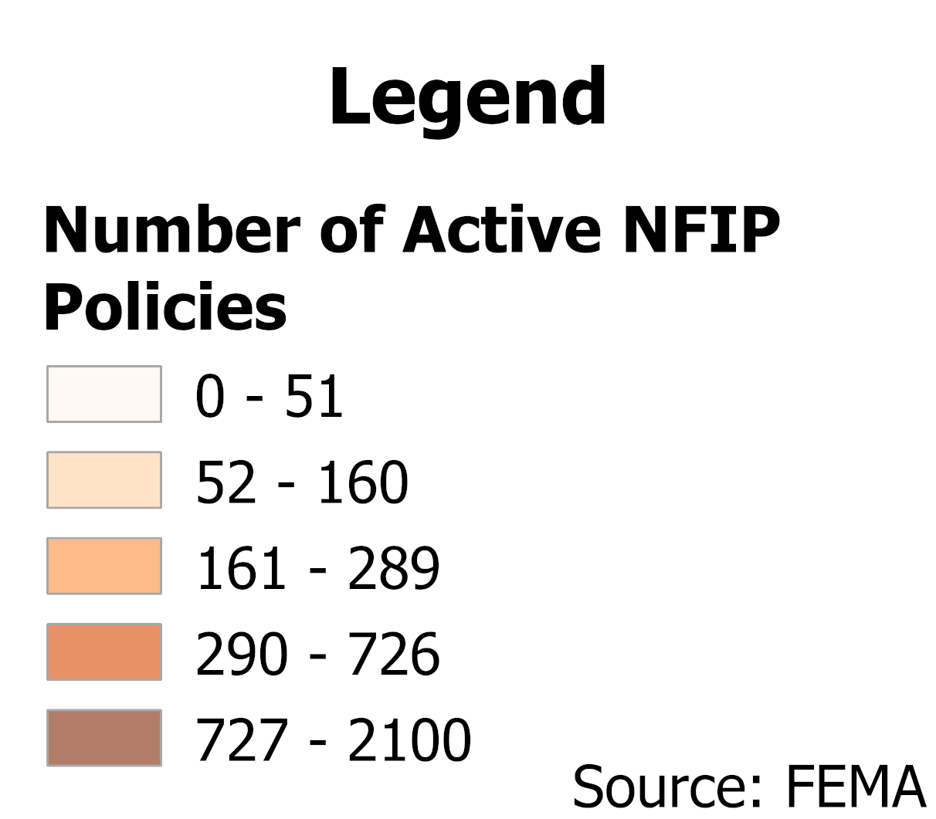
Figure 5: Number of Active NFIP Policies in the 100-Year Floodplain in the Panhandle Planning Region

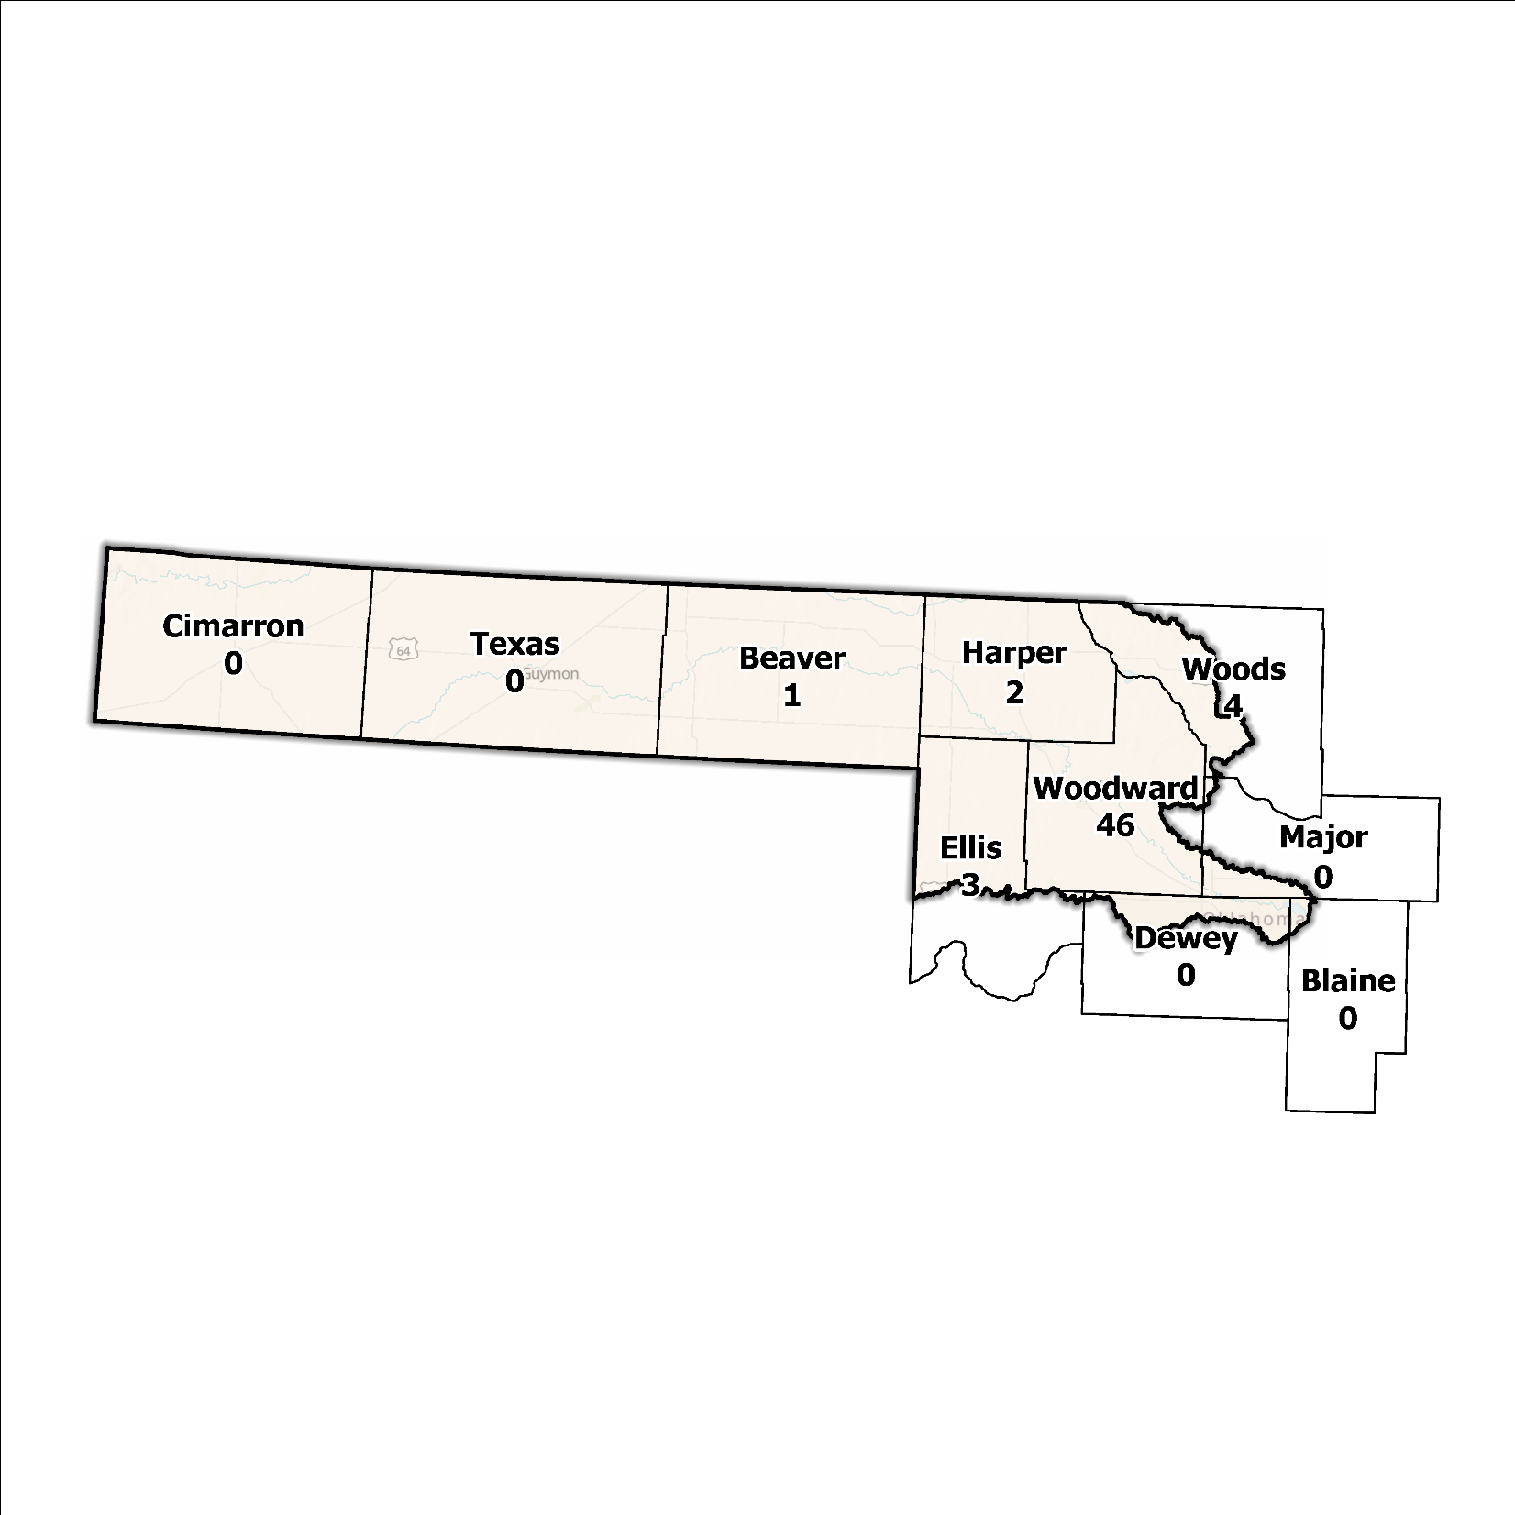
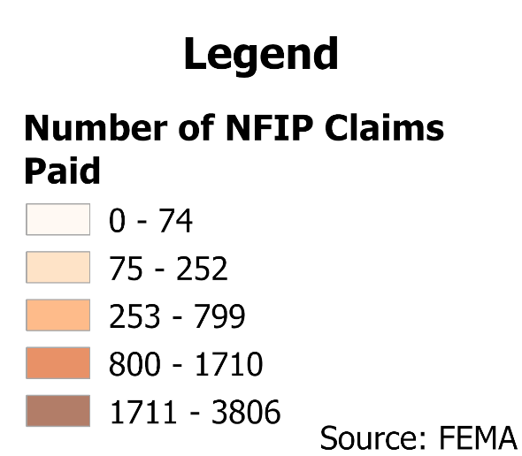
Figure 6: Total NFIP Claims Paid in the Panhandle Planning Region

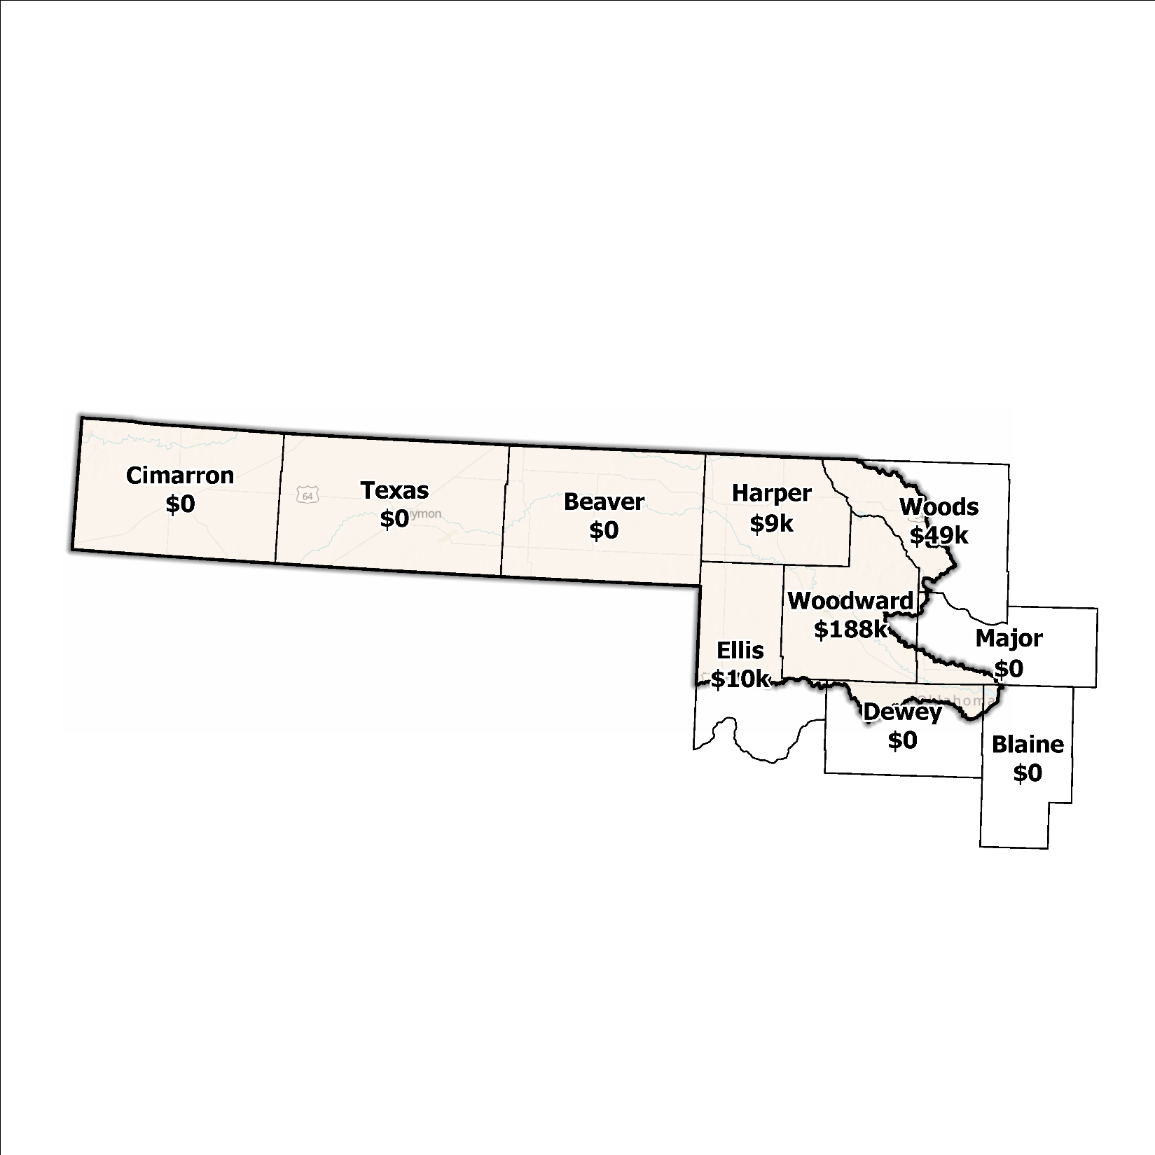
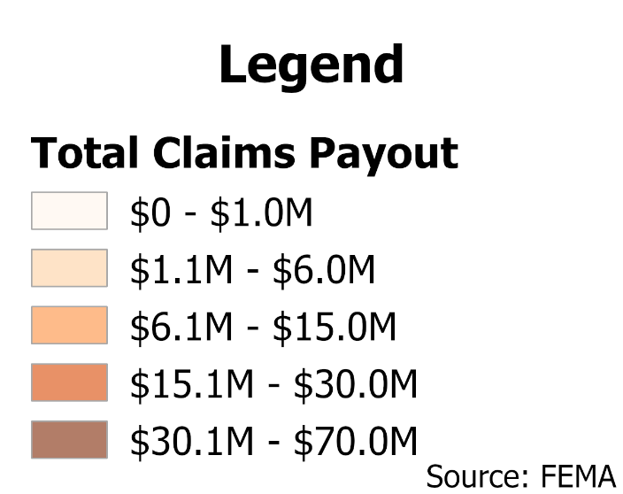
Figure 7: Total Value NFIP Claims Paid Out in the Panhandle Planning Region

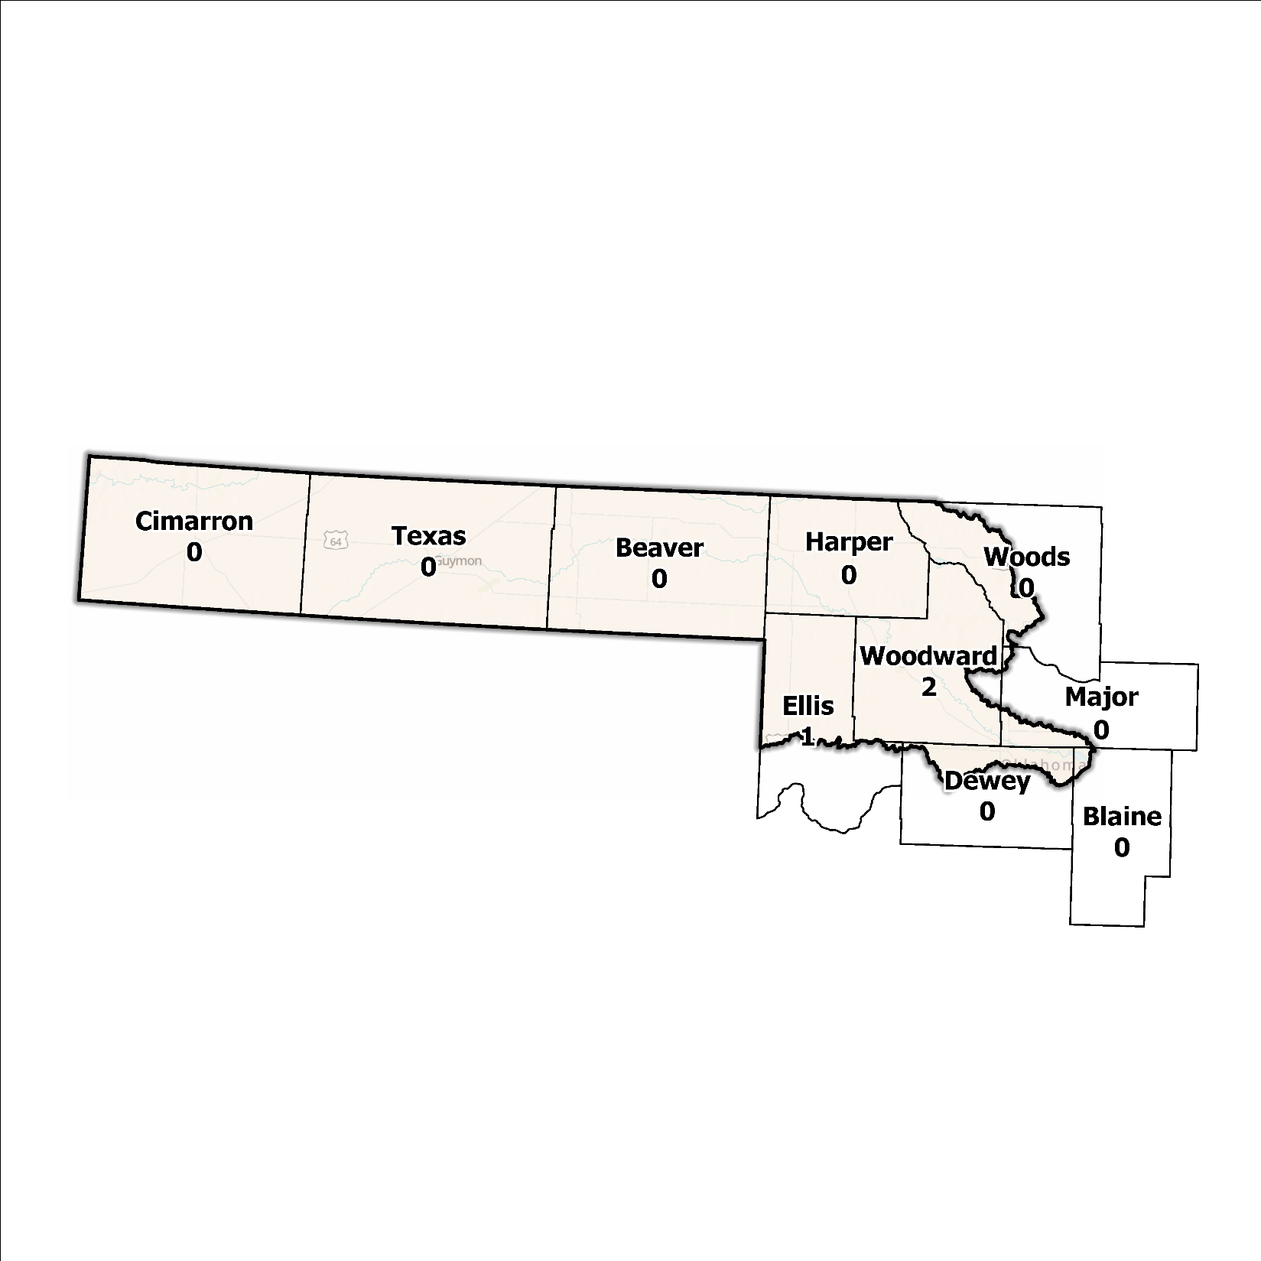
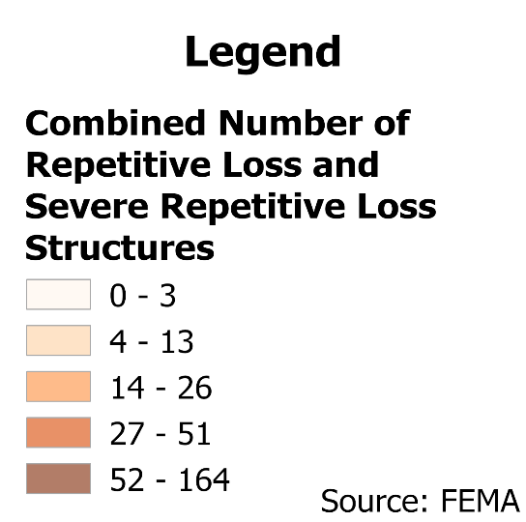
Figure 8: Repetitive Loss and Severe Repetitive Loss Structures in the Panhandle Planning Region

Flood Funding Mechanisms
The Panhandle Planning Region is sparsely populated and therefore most communities have limited local funding. Some larger, more urban jurisdictions, such as the City of Woodward, could successfully implement stormwater utility fees enabling them to fund departments for facilitating management activities. In contrast, other jurisdictions have achieved marginal results in the utilization of local taxes, fees, and funds.

Hazard Mitigation Plan Status
Seven out of ten counties in this Region possess a FEMA-approved Hazard Mitigation Plan (HMP) and the identified mitigation actions vary in jurisdictions. Several identify basic programmatic and administrative activities, such as planning, education, acquiring or implementing warning systems, participating in the NFIP, etc. In contrast, others intentionally list flood mitigation projects such as property buyouts, road and drainage improvements, floodplain restoration, and other flood-specific activities. Road flooding is the most frequently reported problem across the planning area. Several communities and some tribal nations in the Region have individual HMPs separate from their respective counties.
Table 2: Hazard Mitigation Planning Status in the Panhandle Planning Region
Name | Type | Approval Date | Expiration | Current Action Status of this Plan
Beaver | County | 03/07/2022 | 03/06/2027 | Approved
Blaine | County | 03/23/2023 | 03/22/2028 | Approved
Cimarron | County | 07/03/2007 | 07/02/2012 | Expired
Dewey | County | 09/23/2020 | 09/22/2025 | Approved
Ellis | County | 10/30/2024 | 10/29/2029 | Approved
Harper | County | 02/18/2024 | 02/17/2026 | Approved
Major | County | 05/13/2024 | 05/12/2029 | Approved
Texas | County | 03/19/2015 | 03/19/2020 | Expired
Woods | County | 04/04/2023 | 04/03/2028 | Approved
Woodward | County | 07/29/2008 | 07/29/2013 | Expired
Cheyenne and Arapaho | Tribal Nations | 01/27/2022 | 01/26/2027 | Approved

Flood Mapping Assessment
In the Panhandle Planning Region, the floodplain quilt consolidates the best available data on flood risk. However, some areas in the region still need to be mapped by FEMA, including Cimarron and Ellis Counties, limiting the ability of local authorities to regulate development in flood-prone areas.
A notable aspect in the Region is that all of the effective FEMA maps still need detailed studies. This leaves floodplain managers to rely on limited Approximate A Zones, which offer a broad understanding of flood risk but do not have determined Base Flood Elevations (BFE). Figure 9 displays FEMA-mapped areas in the Planning Region.
While in areas with A zones, Base Level Engineering (BLE) data might provide a more accurate indication of flood risk, it is essential to note that most of the Panhandle Planning Region lacks BLE coverage. BLE assists in determining areas that are expected to flood and therefore are not reasonably safe from flooding. Thus, there is a pressing need for in-depth studies to enhance the precision and reliability of flood risk information in specific areas.
Woodward County stands out among areas in the Planning Region for having the most extensive flood risk assessment information. Investment in floodplain mapping has been higher in this area than in others in the Region.
While Flood Insurance Rate Maps (FIRMs) are beneficial for regulatory uses and flood insurance assessments, they only represent potential risks associated with a flood event under certain specific conditions. The threat of flooding beyond the FEMA mapped SFHA is only included on FIRMs if the community opts to carry out the required studies to integrate such data into their hazard map.
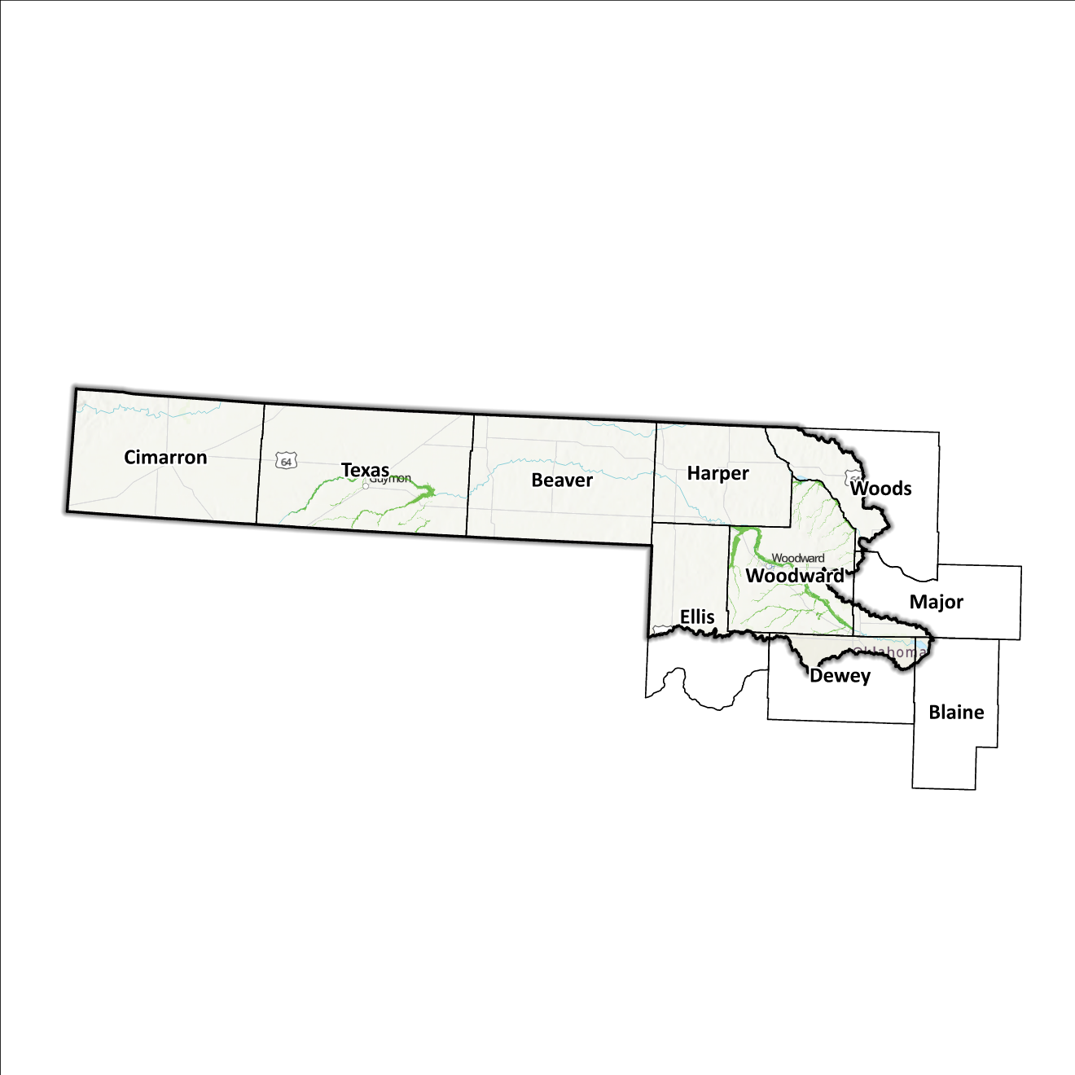
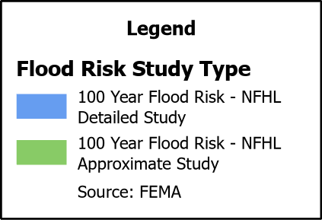
Figure 9: FEMA Mapped Special Flood Hazard Area Comparison in the Panhandle Planning Region

Flood Hazard Assessment
Flood hazards in this Region include flash, river, and urban flooding. The Beaver/North Canadian, and Cimarron Rivers, along with their various tributaries, are the major waterways found in the Panhandle Watershed. High winds are also common in the area and with little cover from trees and large open spaces such as windmill farms, agriculture farms, and salt flats, erosion is imminent, often causing a larger issue especially with roads during a flash flood event.

Location of Flood Hazards
The Panhandle Planning Region is characterized by a flood hazard that encompasses various significant aspects. The flood location in the Panhandle Planning Region exhibits the following characteristics:
- Flooding along major waterways with extensive drainage basins, including the Beaver/North Canadian and Cimarron Rivers.
- Flash floods along smaller tributaries that ultimately flow into the major waterways.
- Drainage issues in specific areas result from inadequate infrastructure. Insufficient drainage systems can exacerbate flood risks, leading to localized flooding in vulnerable locations.
- Downstream areas located below high-hazard potential dams, including those situated north of the Kansas–Oklahoma state line, are exposed to heightened risks.
Figure 10 shows mapped areas of flood risk in the Region. The map brings together data from different sources, like the National Flood Hazard Layer and Base Level Engineering, to create a unified view. It prioritizes layer types and shows the most important layer available for a specific area.
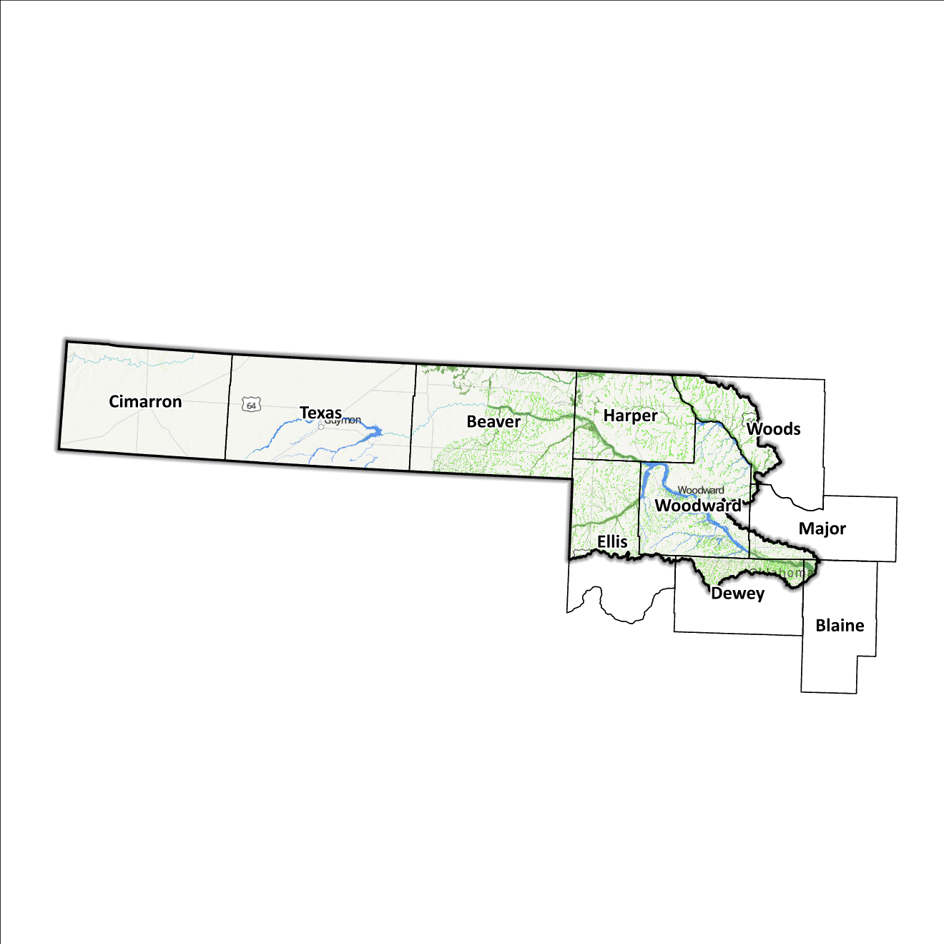
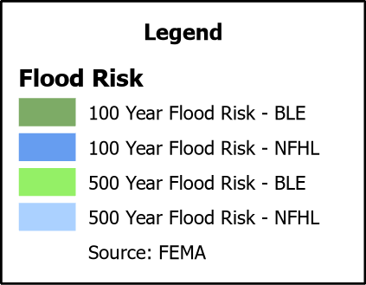
Figure 10: Flood Quilt in the Panhandle Planning Region

Dam and Levee Infrastructure
The Region has multiple dams and levees aimed at preventing flooding. However, aging infrastructure increases the risk of downstream impacts if a breach or failure occurs, especially for high-hazard dams classified by the Oklahoma Water Resources Board (OWRB). The 10 counties have 13 high-hazard dams, with four located in the Panhandle Watershed. A map of dam and levee locations within the Region is shown in Figure 11.
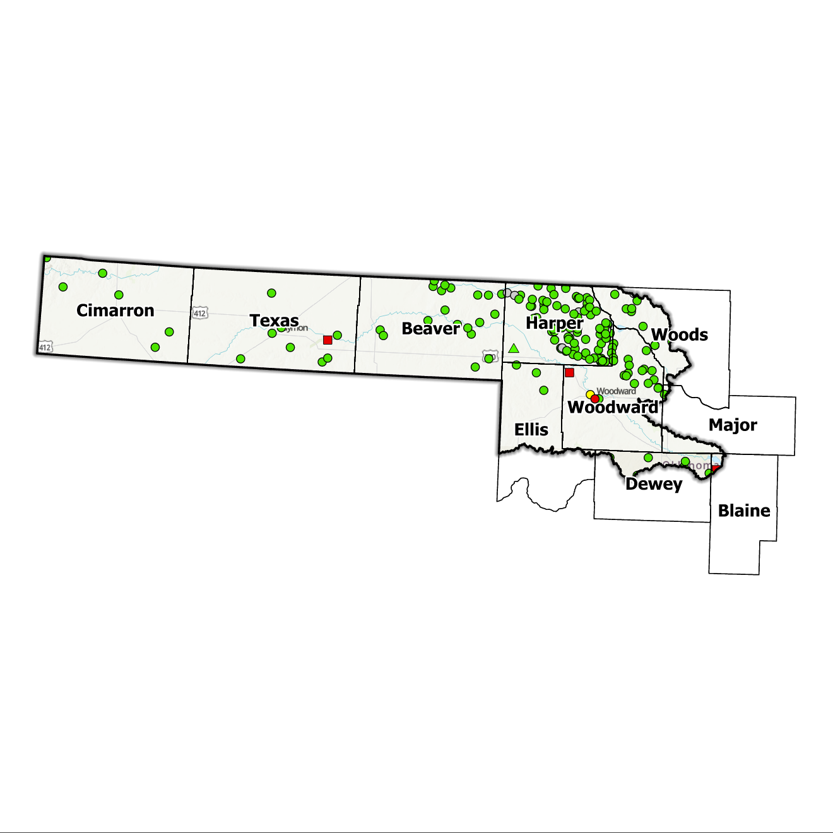
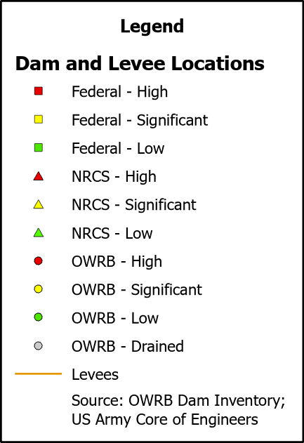
Figure 11: Dam and Levee Locations in the Panhandle Planning Region
Although the Panhandle Watershed Region concludes at the Colorado/Oklahoma, Kansas/Oklahoma, New Mexico/Oklahoma, and Oklahoma/Texas state lines, the flood risks associated with dams transcend its boundaries.

Extent of Flooding
Extent refers to the expected severity of flooding, and because not all areas within the planning area share the same topography, the extent varies between individual communities. The average depth of flooding within the FEMA-mapped Special Flood Hazard Area (SFHA) can range from a few inches to several feet, depending on factors such as topography, proximity to water bodies, local drainage characteristics, and the intensity of the flood event.

Previous Occurrences
According to the records maintained by the National Center of Environmental Information (NCEI), from January 1996 to December 2022, a total of 176 flood events have been documented in the ten counties encompassing this Planning Region. Cumulatively, these flooding incidents have caused property damage amounting to $2,790,700 and crop damage amounting to $250,000.
The NCEI initiated the tracking of flood events only from 1996, hence this data represents the most comprehensive information available. Flooding has frequently escalated to the point of necessitating a Presidential Disaster Declaration. A breakdown of flood-related disasters by county is shown in Table 3.
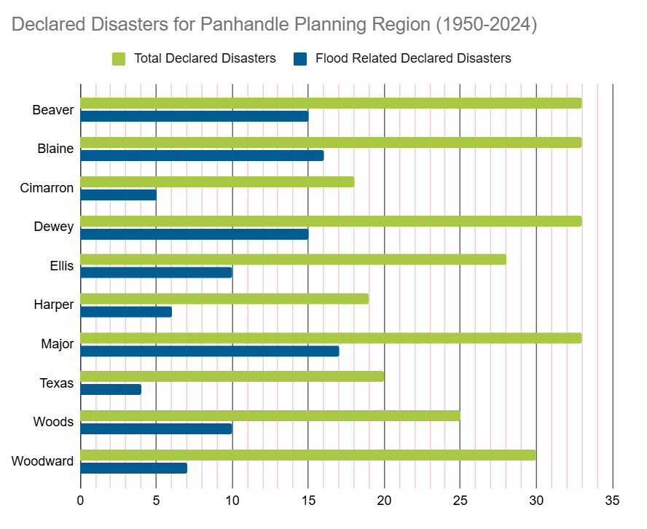
Table 3: FEMA Flood Related Disaster Declarations (1950-2024) in the Panhandle Planning Region

Of all the counties in the Region, Major County has most frequently declared disaster areas due to flooding. However, it's important to note that disaster declarations are issued on a county-wide basis and not all declarations may have directly impacted this specific Region.

Vulnerability and Impacts of Flooding
According to FEMA’s National Risk Index (NRI), the Panhandle Planning Region demonstrates a range of risk levels for river flooding and flash flooding, varying from very low to relatively low risk at the county level, when compared to the rest of the United States. However, when examined at a more granular scale by census tract, the NRI highlights specific areas along the Cimarron and North Canadian Rivers, particularly in Woodward and Woods Counties, as being at a moderate risk of flooding.
Compared to other regions in Oklahoma, the Panhandle Planning Region is at a lower risk of flooding due to multiple factors including low annual precipitation, and a fewer number of waterways and drainage areas.

Summary of Flood Exposure
Flood exposure refers to the degree to which an area or population is at risk of being affected by a flood event. Table 4 provides a comprehensive overview of key factors, including the total count of housing units, population figures, job statistics, land area measurements, and the number of parcels/blocks within the designated FEMA-mapped flood area. This information aims to facilitate a thorough understanding of the flood-affected area's characteristics and implications.
The data in this section was generated using UrbanFootprint. This module evaluates flood risk by conducting a spatial join of parcels or census blocks with the FEMA National Flood Hazard Layer to assess the potential risks associated with hazards. The data presented in the table below is focused on three different FEMA SFHA flood zones that represent areas within the 100-yr floodplain with a 1% annual chance of experiencing a flood event. Zone AE is the most detailed, providing base flood elevations, Zone AO represents areas subject to shallow flooding of depths between one to three feet, and Zone A is an approximation of the 100-yr floodplain for areas where detailed hydraulic analyses have not been performed.
Table 4: Flood Exposure in the Panhandle Region
Panhandle Planning Region Flood Risk Report
Housing in Flood Hazard Zones (Dwelling Units)
Dwelling Units in SFHL Zone AE | 86
Dwelling Units in SFHL Zone A | 537
Dwelling Units in SFHL Zone AO | 22
Dwelling Units in SFHL Zone AH | 154
Total | 799
Population in Flood Hazard Zones (Persons)
Population in SFHL Zone AE | 177
Population in SFHL Zone A | 1,569
Population in SFHL Zone AO | 37
Population in SFHL Zone AH | 293
Total | 2,076
Jobs in Flood Hazard Zones (Employees)
Jobs in SFHL Zone AE | N/A
Jobs in SFHL Zone A | N/A
Jobs in SFHL Zone AO | N/A
Total | N/A
Land Area in Flood Hazard Zones (Acres)
Area in SFHL Zone AE | N/A
Area in SFHL Zone A | N/A
Area in SFHL Zone AO | N/A
Total | N/A
Parcels or Blocks in Flood Hazard Zones
Parcels or Blocks in SFHL Zone AE | N/A
Parcels or Blocks in SFHL Zone A | N/A
Parcels or Blocks in SFHL Zone AO | N/A
Total | N/A

Flood Mitigation Needs
While most floodplains within this Region are in rural areas, the following communities have at least one structure located within floodplain: the cities of Alva, Buffalo, and Fairview, the towns of Waynoka and Freedom. Despite this, the Panhandle Planning Region has not reported any data on the use of acquisition as a mitigation method.
The following stormwater project types were considered:
- Channel
- Storm Drain
- Infrastructure
- Detention Pond
- Dam-Reservoir
- Floodwalls and Levees
- Acquisition

Smaller communities face challenges in funding acquisitions and other stormwater and mitigation projects. In numerous cases, the local tax base proves insufficient to finance property acquisition, necessitating these jurisdictions to seek external sources, such as state and federal grant funding. Such sources can be highly competitive in nature and favor more populated urban areas due to cost benefits, can be unpredictable, and can depend on a variety of factors.

Conclusion
The Panhandle Watershed report highlights the significance of this Region and its vulnerability to flood events. The report's findings emphasize the urgent need for funding to support engineering efforts in flood projects within the watershed. Adequate funding is essential for conducting detailed engineering assessments, implementing effective flash flood control measures, and enhancing community resilience. The lack of project submissions underscores the importance of assisting communities in identifying and developing flood mitigation projects.
By allocating resources and support for project identification and development, communities can better understand their flood exposure and proactively protect lives and infrastructure. Investing in engineering and flood mitigation projects in the Panhandle Watershed will contribute to creating safer, more resilient communities better equipped to handle future flood events.
During the planning process, the data generated was developed into an interactive flood planning dashboard. The dashboard serves as a valuable tool for conducting flood assessments at the community level. It is important to note that this report should not substitute locally generated data specific to each community.

Census Bureau Data – 2020 Decennial Census
Beaver County’s HMP includes the Towns of Beaver, Gate, and Knowles.
Cimarron County’s HMP includes the Town of Keyes and the City of Boise City.
Dewey County’s HMP includes the Town of Vici and the City of Seiling.
Ellis County’s HMP includes the Towns of Fargo, Gage, Shattuck.
Harper County’s HMP includes the Towns of Buffalo, Laverne, May, Rosston.
Texas County’s HMP includes the Towns of Goodwell, Hardesty, Optima, Texhoma, and the Cities of Guymon, and Hooker.
Woods County’s HMP includes the Town of Freedom and the City of Waynoka.
Woodward County’s HMP includes the Towns of Fort Supply, Mooreland, Mutual, Sharon, and the City of Woodward.

