Table of Contents
The Middle Arkansas Planning Region 1
Section 1.1: Watershed Introduction 1
Section 1.2: Socioeconomic and Geographic Characteristics 3
Section 1.3: Floodplain Management and Mitigation Capabilities 5
Section 1.4: Flood Hazard Assessment 16
Section 1.5: Flood Mitigation Needs 22
Section 1.6: Conclusion 23

The Middle Arkansas Planning Region

Watershed Introduction
The Middle Arkansas Planning Region (the Region) spans 5,173 square miles across northeastern Oklahoma encompassing all or part of Craig, Creek, Mayes, Muskogee, Nowata, Okmulgee, Osage, Rogers, Tulsa, Wagoner, and Washington counties. 64 municipalities and three tribal nations are located in the Region. Major waterways in the Region include the Arkansas, Verdigris, Caney, and Little Caney Rivers along with their various tributaries.
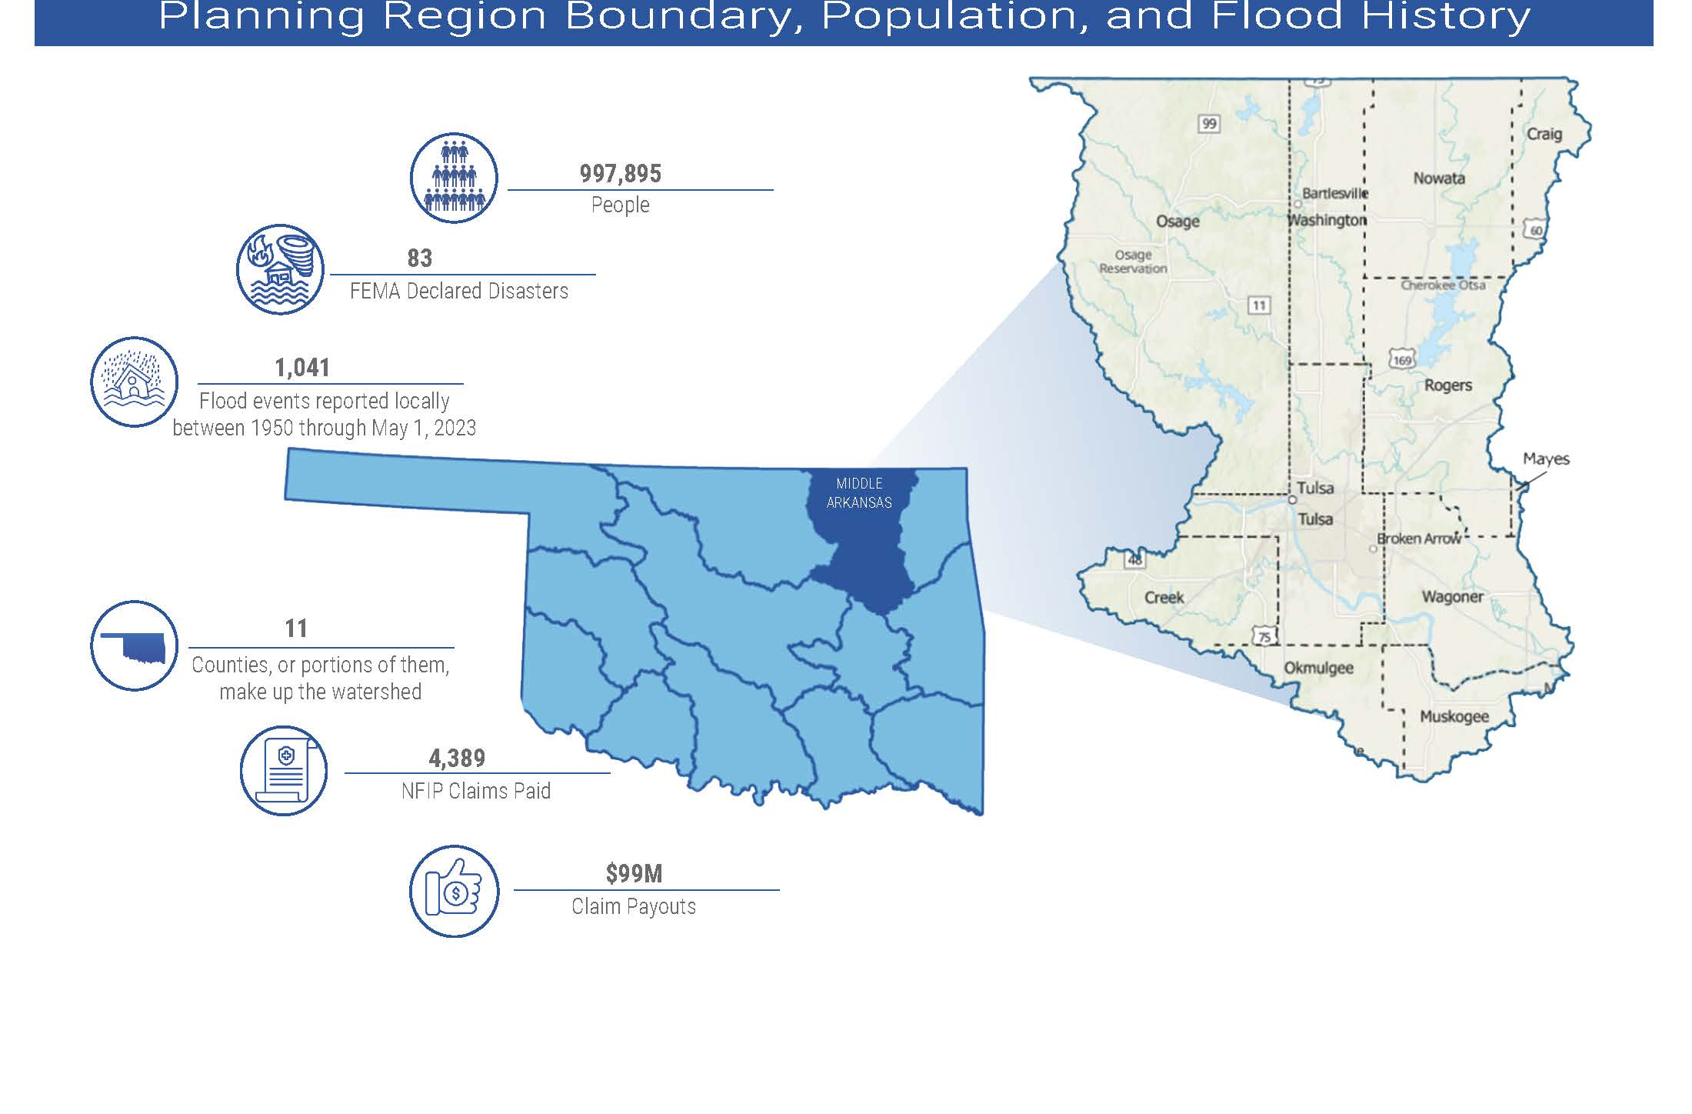
Figure 1 highlights the geographic boundaries, demographics, and flood history of the Middle Arkansas Planning Region.
Figure 1: Middle Arkansas Planning Region Boundary, Population, and Flood History.
Source: FEMA, U.S. Census 2020
The Middle Arkansas Planning Region has a unique drainage system centered around the Arkansas River and its tributaries, making it one of Oklahoma's most flood-prone areas. This Region is densely populated with several large cities, further increasing its flood vulnerability. Additionally, many rural areas and small towns are located within the Region. The City of Tulsa, serving as the population center of the Region, has a long history of major flooding events and was once considered the most disaster-prone city in the country. All counties in the planning area have experienced multiple federally declared flood disasters since 1970.
A base map displaying incorporated jurisdictions within the Planning Region is displayed in Figure 2.
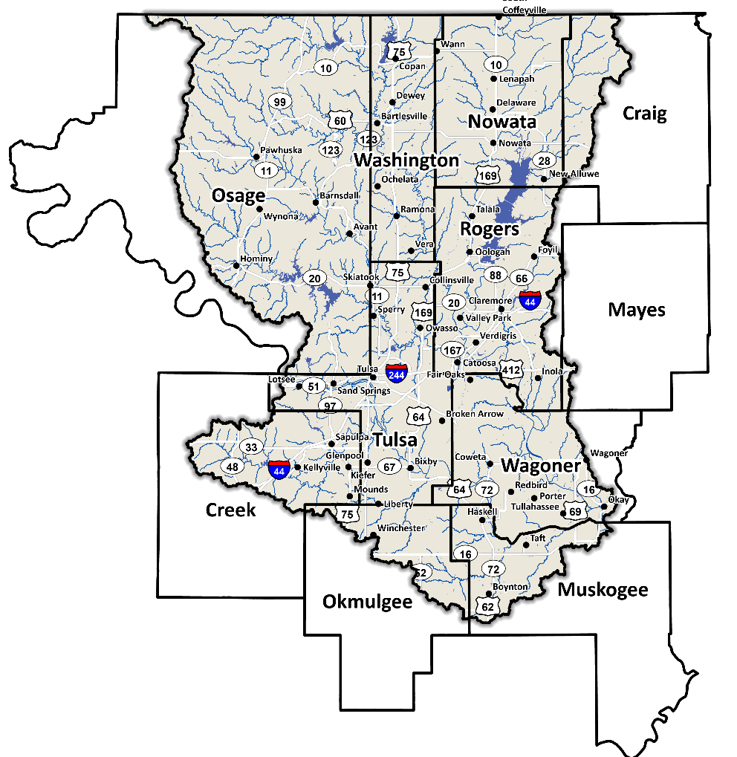
Figure 2: Middle Arkansas Planning Region Base Map

Socioeconomic and Geographic Characteristics

Demographic Profile
Nearly one million Oklahomans live in the Middle Arkansas Planning Region according to the 2020 U.S. Census, which is nearly 30% of the state’s population. The Region has a mix of urban, suburban, and rural areas.
A view of the Region's population breakdown is provided in Table 1. The 2020 U.S. Census statistics represent county-level populations, not those within the watershed boundary. Washington County is the only county which is completely contained within the Region.
Table 1: Population Breakdown by County in the Middle Arkansas Planning Region
County | Total Population
Craig | 14,107
Creek | 71,754
Mayes | 39,046
Muskogee | 66,339
Nowata | 9,320
Okmulgee | 36,706
Osage | 45,818
Rogers | 95,240
Tulsa | 669,279
Wagoner | 80,981
Washington | 52,455

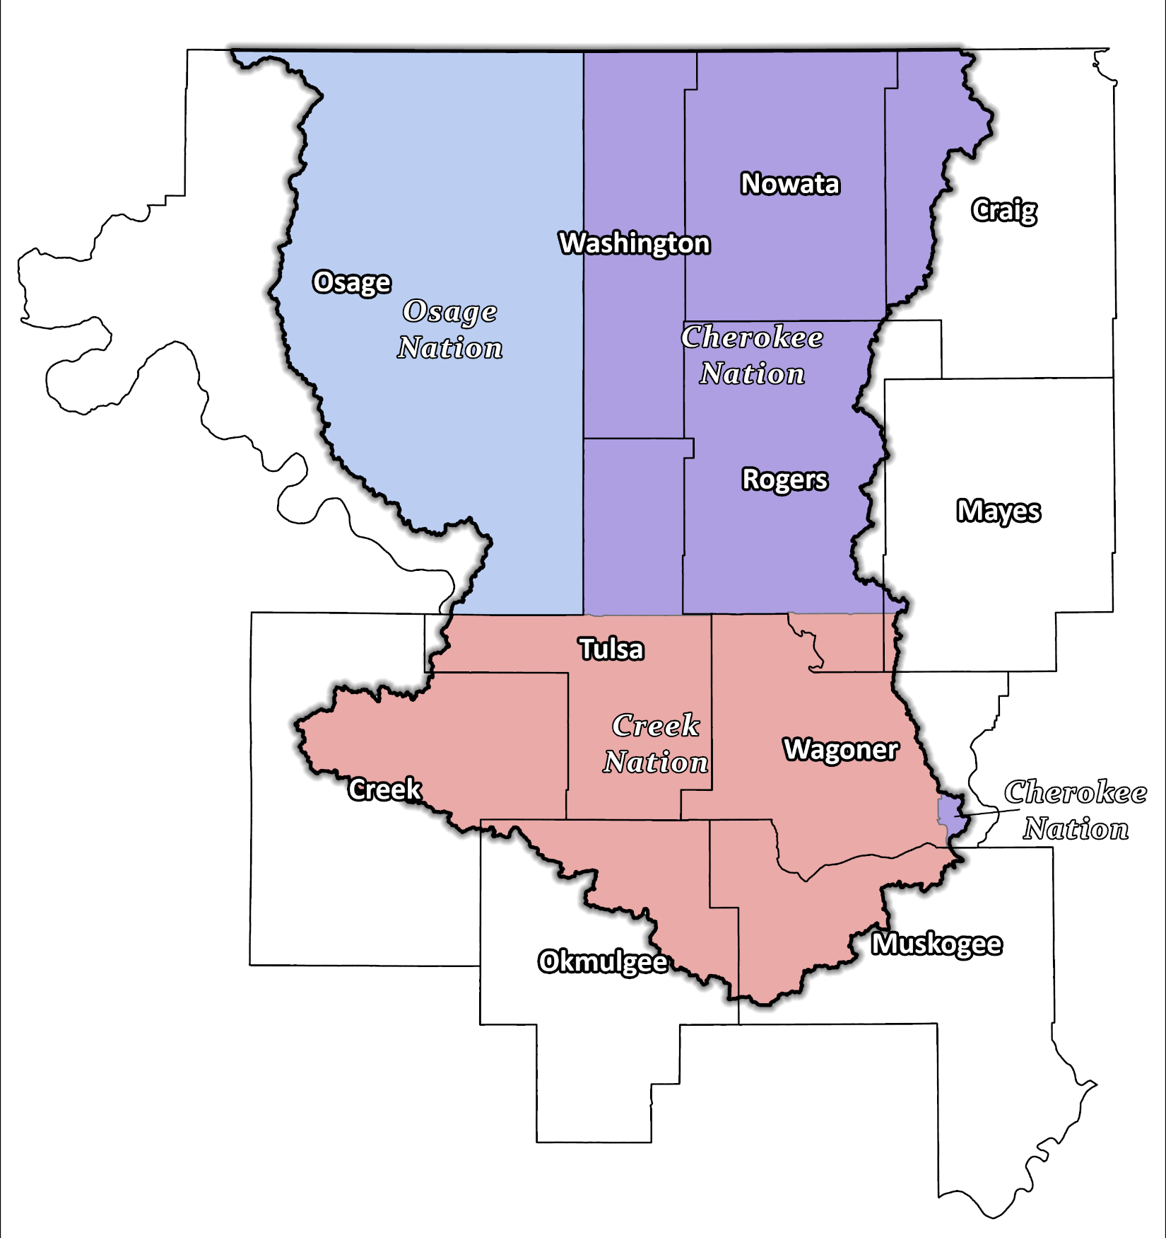
Figure 3: Tribal Jurisdictions Base Map for Middle Arkansas Planning Region

The Region is home to many minority groups, including three Tribal Nations, the Cherokee, Muscogee (Creek), and Osage.

Economic Profile
The Middle Arkansas Planning Region has significant economic importance to the state and nation. Tulsa is the 2nd largest city in Oklahoma, serving as a hub for oil, gas, and energy industries. The Region is also home to two of the nation’s most inland ports, the Port of Catoosa and Port of Muskogee, and several large healthcare and aerospace corporations. Tribal Nations in northeast Oklahoma are significant employers, operating various industries, including gaming, hospitality, and retail. Additionally, the tribes support growth and development in the area through investments in infrastructure, education, and healthcare.

Floodplain Management and Mitigation Capabilities

National Flood Insurance Program Participation
Within the Planning Region, all counties have been mapped by the Federal Emergency Management Agency (FEMA) and participate in the National Flood Insurance Program (NFIP). There are a few communities within the 11 counties, however, that do not currently participate in the NFIP program, as shown in Figure 4, below.
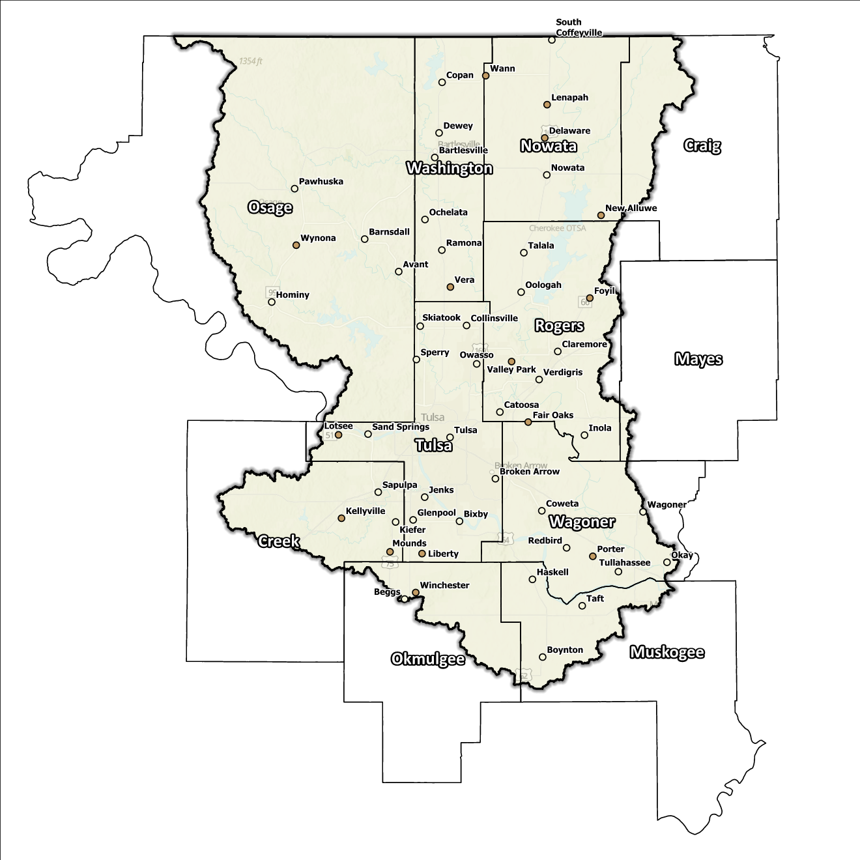
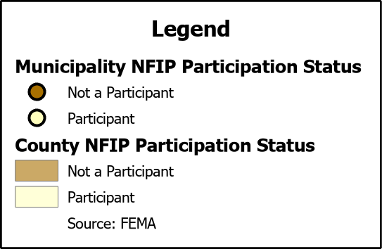
Figure 4: Status of NFIP Participation in the Middle Arkansas Planning Region

Dedication to floodplain management by jurisdictions in this Planning Region is well demonstrated not only by participation in the NFIP, but also by FEMA’s Community Rating System (CRS). The CRS is a voluntary program administered by FEMA that encourages communities to take proactive measures to reduce flood risks and enhance floodplain management. CRS provides a rating system for communities based on the flood mitigation measures they have implemented. These ratings range from Class 10 to Class 1, with Class 10 being the lowest and Class 1 being the highest. Ratings are determined based on the number of points a community earns from implementing various floodplain management activities.
Approximately 39% of Oklahoma CRS communities are in the Middle Arkansas Planning Region, including the City of Tulsa, which is one of only two in the nation to attain class 1 CRS status. Several communities in this Region go above and beyond the minimum NFIP requirements and can be used as an example for best practices and knowledge sharing in other parts of the State.

Flood Insurance Coverage
As of the latest update, there are currently 3,123 active NFIP policies in effect within the planning area. These policies cover approximately 21.6% of the total structures located in the FEMA mapped Special Flood Hazard Area (SFHA). It should be noted that not all active policies are situated within the SFHA. A total of 5,125 NFIP claims have been filed, resulting in approximately $99 million being paid out to policyholders. In the Region, there are 298 structures classified as repetitive loss (RL) and/or structures classified as severe repetitive loss (SRL), with a significant concentration of both types in Tulsa County. Repetitive loss, in the context of the National Flood Insurance Program (NFIP), refers to properties that have experienced multiple flood-related insurance claims over a specific time period. Severe repetitive loss, on the other hand, pertains to properties with an extensive history of recurrent flood damage and a high number of insurance claims, making them particularly vulnerable and costly for the NFIP.
Subsequent graphics provide a range of information about NFIP policies as well as total claims filed and paid in the Planning Region. Although these figures are insightful, it is important to note that they may not accurately reflect the true extent of losses in the area due to an underrepresentation of flood insurance. Not every claim filed or paid is linked to an active policy. Data indicates a significant number of structures in the planning area lack active NFIP policies, potentially leaving them uninsured for flood-related losses. To address concerns of those in the Region who may be impacted by flooding but have never had flood insurance, it is essential to increase awareness about flood risks and the importance of obtaining flood insurance coverage.

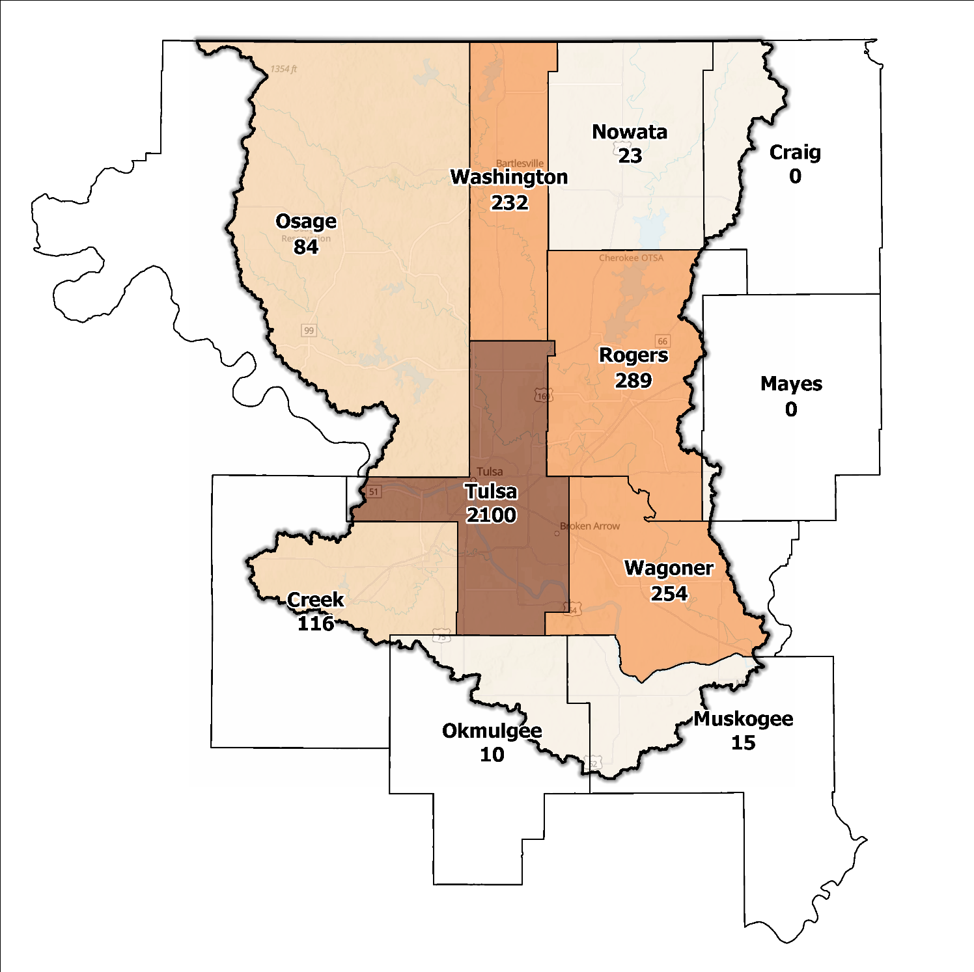
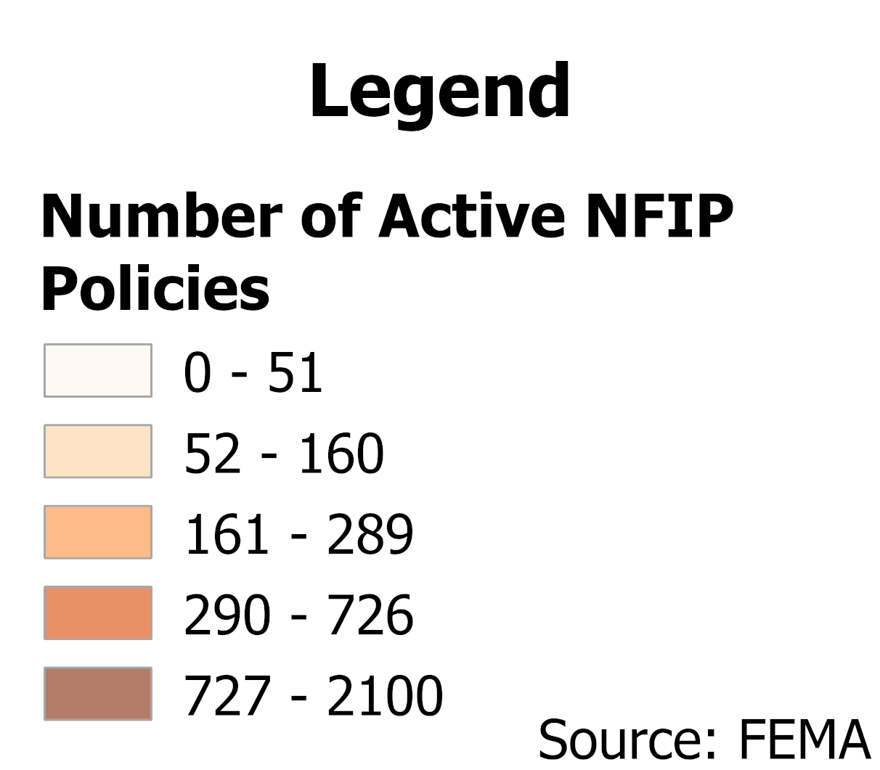
Figure 5: Number of Active NFIP Policies in the 100-Year Floodplain in the Middle Arkansas Planning Region

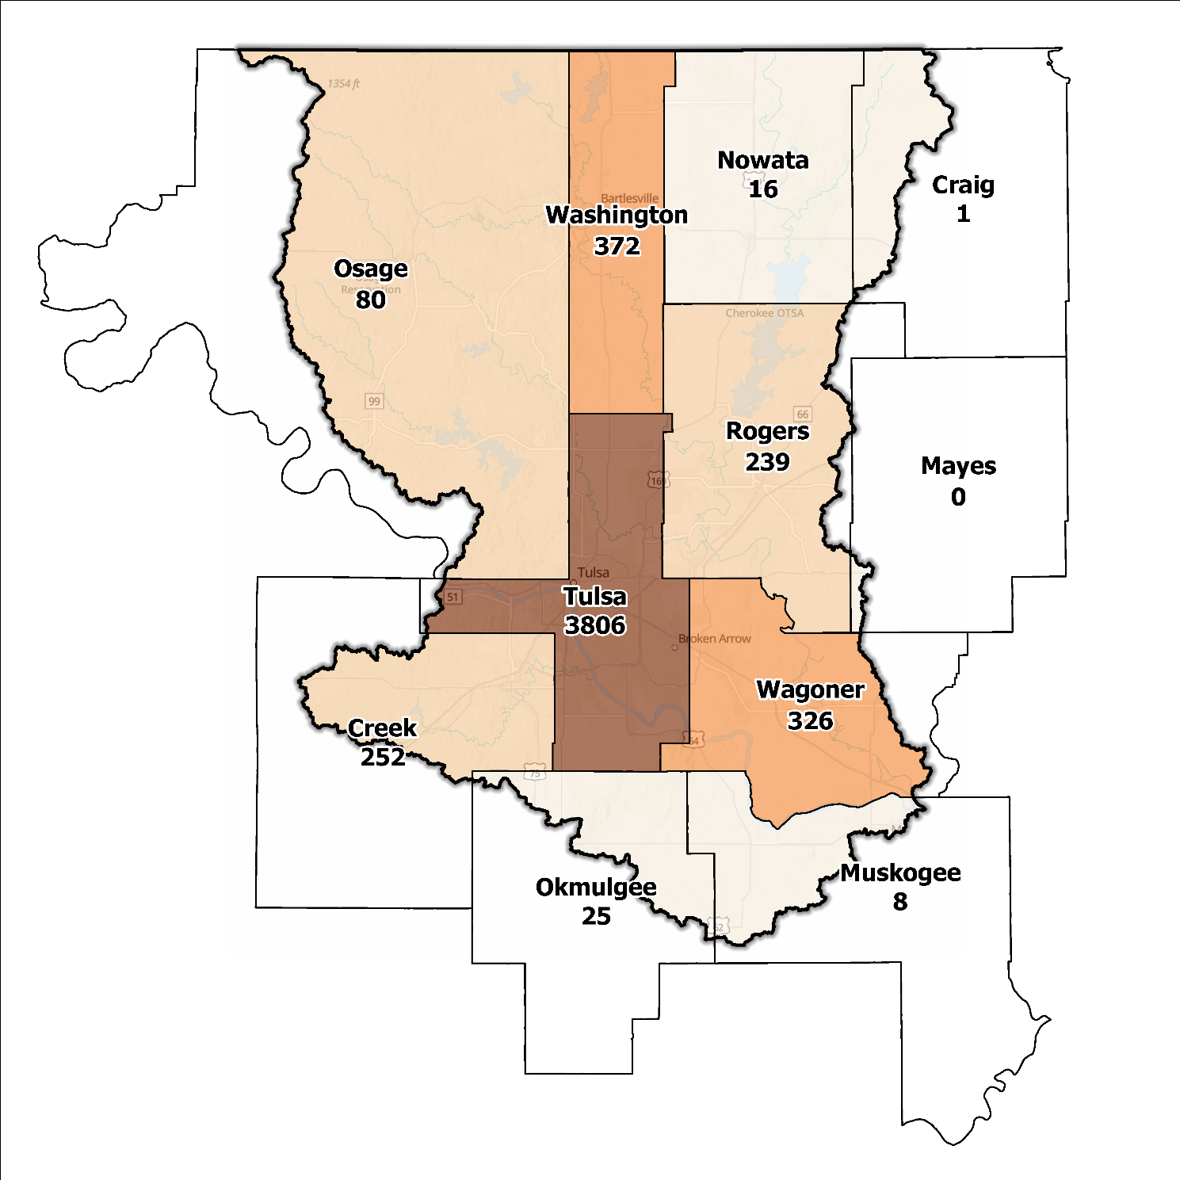
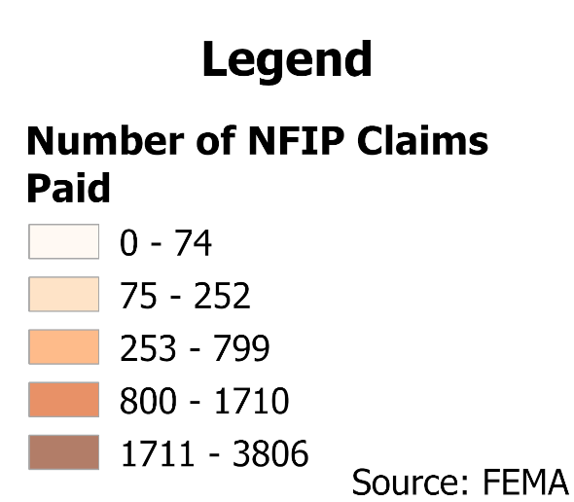
Figure 6: Total NFIP Claims Paid in the Middle Arkansas Planning Region

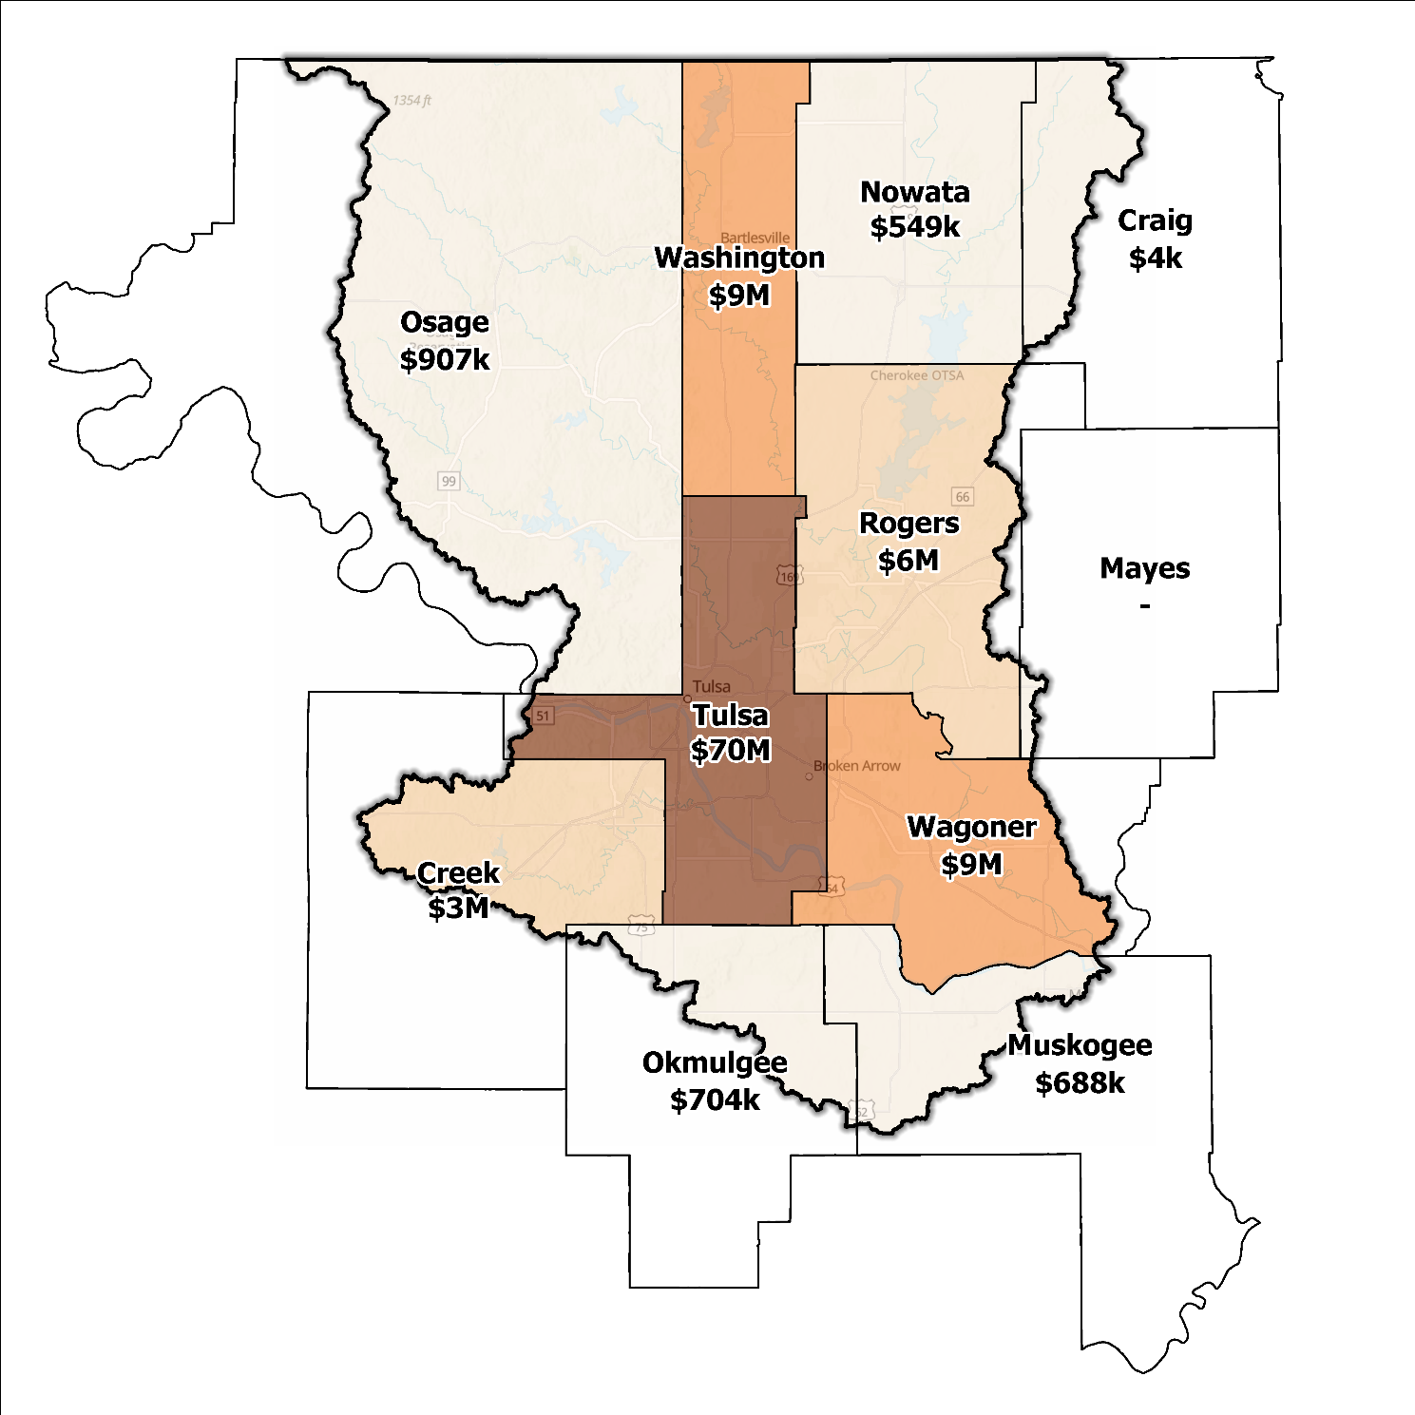
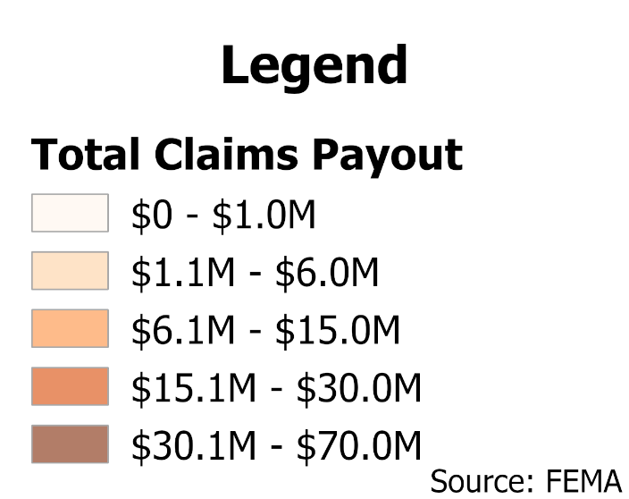
Figure 7: Total Value NFIP Claims Paid Out in the Middle Arkansas Planning Region

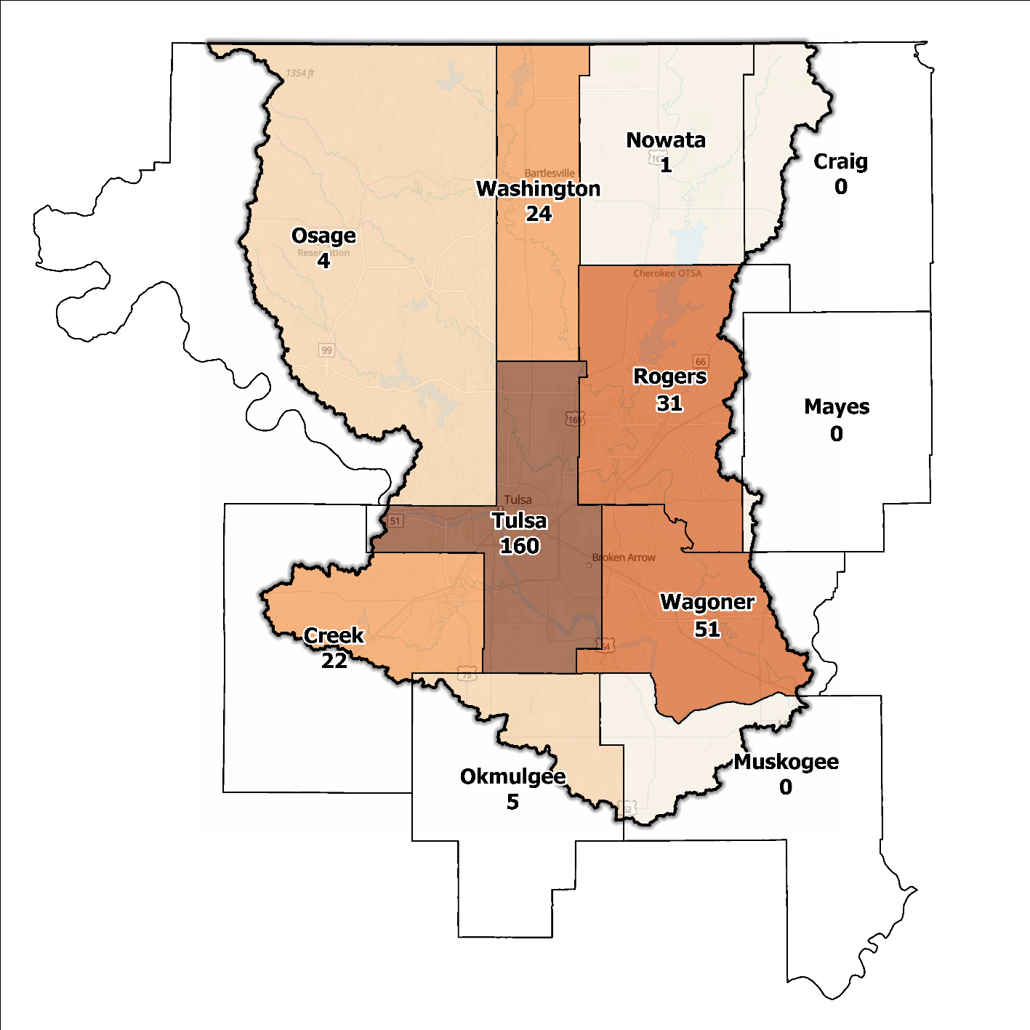
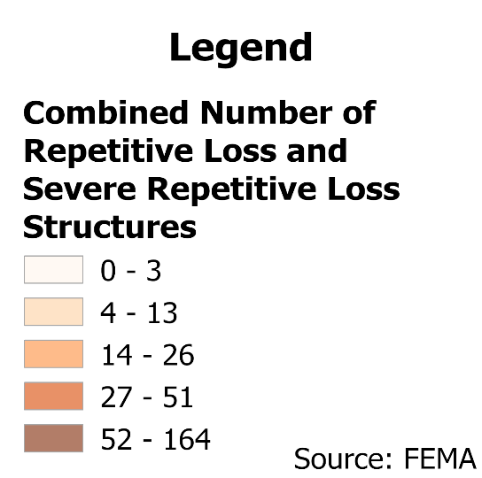
Figure 8: Repetitive Loss and Severe Repetitive Loss Structures in the Middle Arkansas Planning Region

Flood Funding Mechanisms
A survey conducted by the planning team to determine the level of funding for stormwater and floodplain management in the Middle Arkansas Planning Region revealed that most communities have limited local funding. Some larger, more urban jurisdictions, such as the City of Tulsa, could successfully implement stormwater utility fees enabling them to fund departments for facilitating management activities. In contrast, other jurisdictions have achieved moderate results in the utilization of local taxes, fees, and funds. Marginal success in funding stormwater and floodplain management in the Middle Arkansas Planning Region is attributed to restricted local funding in most communities and disparities among jurisdictions.

Hazard Mitigation Plan Status
A FEMA-approved hazard mitigation plan (HMP) is a comprehensive document developed by communities to identify and assess potential natural and human-made hazards that may affect them. The plan outlines mitigation strategies and actions to guide communities in making informed decisions and implementing measures to enhance resilience and minimize damage in the face of future disasters. In this Region, eight out of eleven counties have HMPs, and the identified mitigation actions and projects differ among jurisdictions. Several identify basic programmatic and administrative activities, such as planning, education, acquiring or implementing warning systems, participating in the NFIP, etc. In contrast, others intentionally list flood mitigation projects, such as property buyouts, road and drainage improvements, floodplain restoration, and other flood-specific activities. Road flooding is the most frequently reported problem across the planning area. Several communities and Tribal Nations in the Region have individual HMPs separate from their respective counties. The cities of Tulsa and Broken Arrow use their HMPs to gain points under activity 510 of the Community Rating System.
Activity 510 is a component of the CRS program, a voluntary initiative managed by FEMA. Its aim is to encourage communities to adopt floodplain management practices that go beyond the basic NFIP requirements. In this activity, communities work on creating and implementing extensive stormwater management plans. These plans are designed to handle stormwater runoff efficiently, minimize flood risks, and safeguard water quality in the area. By implementing such plans, communities demonstrate their dedication to proactive flood mitigation and, in return, earn CRS credits that can result in lower flood insurance premiums for their residents.
Table 2: Hazard Mitigation Planning Status in the Middle Arkansas Planning Region
Name | Type | Approval Date | Expiration | Current Action Status of this Plan
Craig | County | 01/17/2023 | 01/16/2028 | Approved
Creek | County | 04/04/2023 | 04/04/2028 | Approved
Sapulpa | City | 09/17/2012 | 09/17/2017 | Expired
Mayes | County | 04/23/2020 | 04/22/2025 | Approved
Muskogee | County | 04/17/2024 | 04/16/2029 | Approved
Nowata | County | - | - | N/A
Okmulgee | County | 08/02/2023 | 08/01/2028 | Approved
Beggs | City | 10/01/2008 | 10/01/2013 | Expired
Osage | County | - | - | N/A
Rogers | County | 04/22/2020 | 04/21/2025 | Approved
Claremore | City | 01/03/2022 | 01/03/2027 | Approved
Tulsa | County | 06/14/2021 | 06/13/2026 | Approved
Broken Arrow | City | 03/06/2023 | 03/05/2028 | Approved
Glenpool | City | - | - | In Progress
Owasso | City | 08/04/2014 | 08/04/2019 | Expired
Sand Springs | City | 10/20/2014 | 10/20/2019 | Expired
Skiatook | Town | 10/01/2014 | 10/01/2019 | Expired
Tulsa | City | 12/12/2024 | 12/11/2029 | Approved
Wagoner | County | 04/06/2022 | 04/05/2027 | Approved
Wagoner | City | 08/03/2022 | 08/02/2027 | Approved
Washington | County | 03/16/2022 | 03/15/2027 | Approved
Cherokee | Tribal Nation | 02/08/2023 | 02/07/2028 | Approved
Creek | Tribal Nation | 12/01/2021 | 11/30/2026 | Approved
Osage | Tribal Nation | 12/16/2015 | 12/16/2020 | Expired

Flood Mapping Assessment
In the Middle Arkansas Planning Region, the floodplain quilt consolidates the best available data on flood risk. However, some areas in the Planning Region still need to be mapped more comprehensively by FEMA, limiting the ability of local authorities to regulate development in flood-prone areas.
Most effective FEMA maps in the Region lack comprehensive floodplain information and require detailed studies. As a result, floodplain managers often rely on Approximate A Zones, which offer a broad understanding of flood risk but lack specific Base Flood Elevations (BFEs) crucial for accurate management.

Approximate A Zones have imprecise flood elevation information due to the absence of detailed hydraulic analysis. Although they provide general flood hazard information, they may not be as accurate as thoroughly studied areas. Detailed floodplain mapping studies are preferred for better flood risk assessments and management decisions.
These studies involve collecting and analyzing past floods, topography, hydrology, and land use data. Advanced hydraulic modeling accurately maps flood extents and hazard zones, incorporating specific BFEs to inform land-use planning and flood mitigation. Figure 9 displays the FEMA-mapped areas in the Planning Region, providing a visual representation of the flood hazard zones and floodplain extents in the area.
While Base Level Engineering (BLE) data might offer a more accurate indication of flood risk in areas with A zones, it is crucial to highlight that most of the Middle Arkansas Planning Region does not have BLE coverage. Thus, there is a pressing need for in-depth studies to enhance the precision and reliability of flood risk information in specific areas.
Tulsa, Rogers, and Wagoner Counties, along with the cities of Bartlesville, Broken Arrow, Pryor, Sand Springs, and Tulsa have the most extensive flood risk assessment information. Investment in floodplain mapping has been higher in these areas than in others in the Region. FEMA plays a significant role in floodplain mapping and risk assessment, partnering with state or local agencies, engineering firms, or contractors for BLE studies in specific areas. Local government agencies may also conduct BLE studies with support from state or federal grants. The goal is to provide accurate flood risk information for effective floodplain management and mitigation strategies in different regions.
Flood Insurance Rate Maps (FIRMs) are valuable for regulatory uses and flood insurance assessments, representing potential flood risks under specific conditions. The threat of flooding beyond the FEMA-mapped Special Flood Hazard Area (SFHA) is only included on FIRMs if the community conducts the required studies to integrate such data. For instance, the City of Tulsa Regulatory Floodplain is an example of a hazard map that includes additional flood risk information beyond the SFHA. Following historic flooding in 2019, a collaborative report titled "Peak Streamflow and Stages at Selected Stream gages on the Arkansas River in Oklahoma and Arkansas, May to June 2019" was prepared in cooperation with FEMA and the United States Army Corps of Engineers (USACE). The report revealed that the 1% flood elevation in certain areas exceeded the existing FEMA mappings. This highlights the importance and need for ongoing and accurate mapping efforts to assess flood risks in the Region.

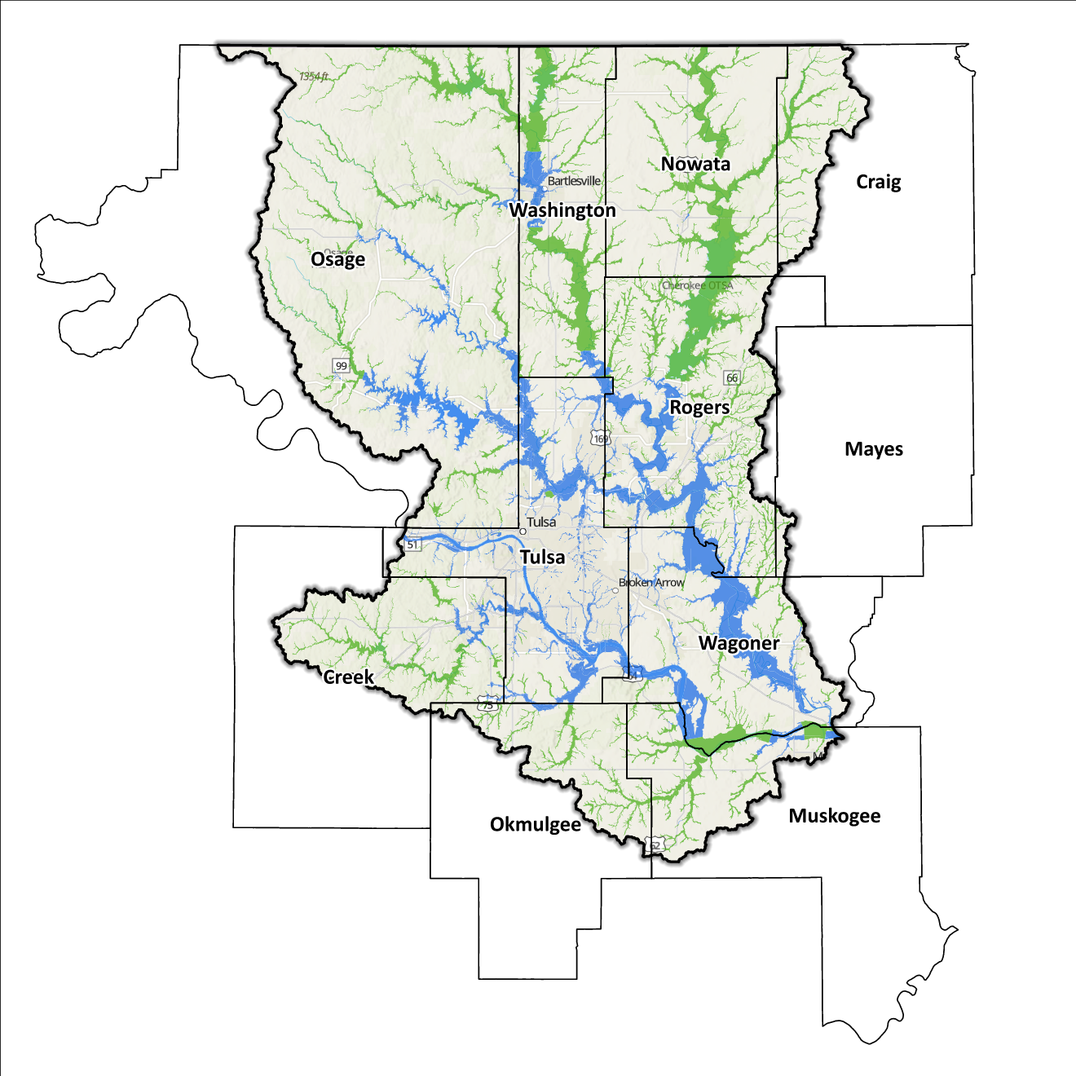
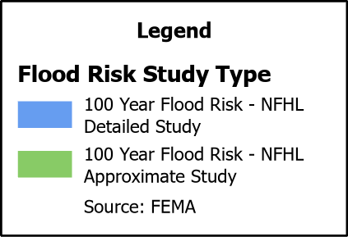
Figure 9: FEMA Mapped Special Flood Hazard Area Comparison in the Middle Arkansas Planning Region

2020 USGS Stream Gage Report
Following the 2019 flooding across the Arkansas River Watershed, a comprehensive report was released that documented peak streamflow data collected by United States Geological Survey (USGS) and USACE stream gages in the Arkansas River Basin. It was determined that analytical methods for calculating annual exceedance probabilities (AEPs) for streams such as the Arkansas River, which is heavily regulated by USACE flood-control dams, is not usually appropriate. Developed by the USACE Tulsa District, the 2020 RiverWare model allows for more accurate Base Flood Elevation (BFE) metrics to be determined, and following the 2019 event, a comparison was made between the results of the USGS/USACE report and the Flood Insurance Study (FIS) which examined new computations for BFE levels. Also examined was the question of what designates a 1% Annual Exceedance Probability.

Significant changes can be noted at multiple gage locations across the Middle Arkansas Watershed, like at the gauge near the Port of Catoosa and Haskell where an increase in 73% and 32% respectively is shown. These changes correlate with an increase in BFE (ft) of 5.37 ft and 1.66 ft each. Such large changes would imply substantial ramifications for downstream communities that have suffered great losses from past flooding events. While this report provides a modern analysis of what could be used to model new floodplain maps, not all gage locations provided these statistics. For this reason, further studies and floodplain mapping efforts should be considered before making a broader statement across the Middle Arkansas Planning Region.

Flood Hazard Assessment

Location of Flood Hazards
The Middle Arkansas Planning Region is characterized by a flood hazard that encompasses various significant aspects. The flood location in the Region exhibits the following characteristics:
- Flooding along major waterways with extensive drainage basins, including the Arkansas, Caney, Deep Fork, and Verdigris.
- Flash floods along smaller tributaries that ultimately flow into the major waterways.
- Drainage issues in specific areas result from inadequate infrastructure. Insufficient drainage systems can exacerbate flood risks, leading to localized flooding in vulnerable locations.
- Downstream areas located below high-hazard potential dams, including those situated north of the Kansas–Oklahoma state line, are exposed to heightened risks.
Figure 10 shows mapped areas of flood risk in the Region. The map brings together data from different sources, such as the National Flood Hazard Layer and BLE to create a unified view. It prioritizes layer types and shows the most important layer available for a specific area.

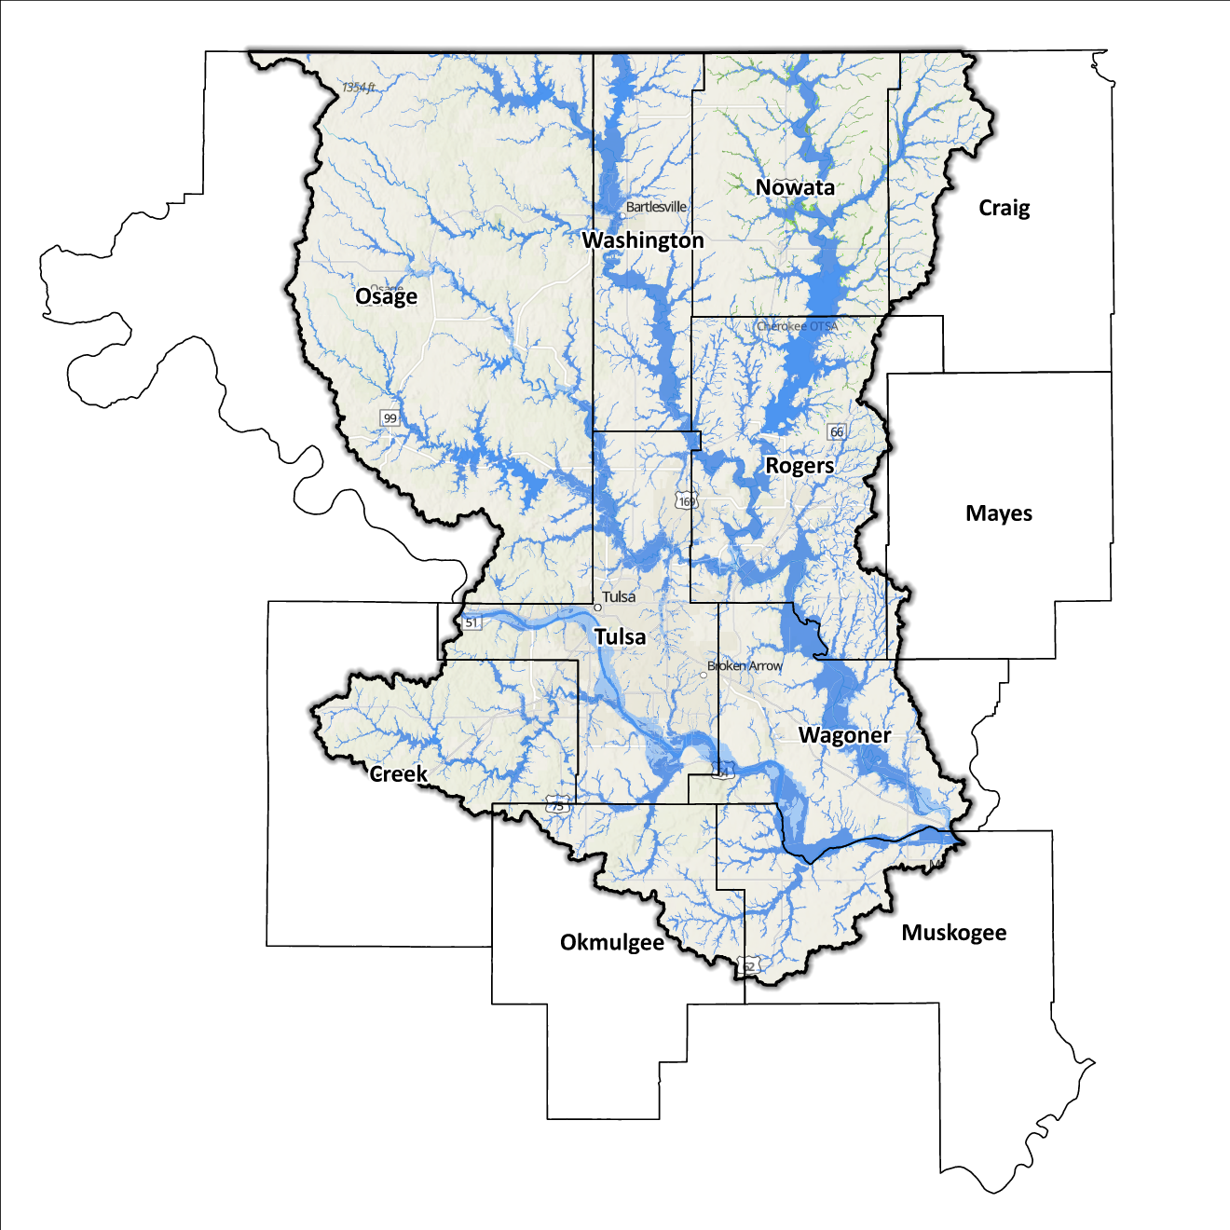
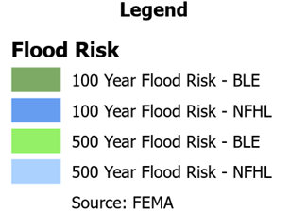
Figure 10: Flood Quilt in the Middle Arkansas Planning Region

Dam and Levee Infrastructure
The Region has multiple dams and levees aimed at preventing flooding. However, aging infrastructure increases the risk of downstream impacts if a breach or failure occurs, especially for high-hazard dams classified by the Oklahoma Water Resources Board (OWRB). There are 56 high-hazard dams in the 11 counties, with 39 located in the Middle Arkansas Planning Region. Figure 11 is a map of dam and levee locations within the Region.
Dam failures have had significant consequences in the past. Heavy rainfall in 1986 and 2019 resulted in high releases from Keystone Dam and Oologah Lake causing substantial damage downstream. Tulsa County and Muskogee County were particularly affected during the 2019 flood, identified by the Department of Housing and Urban Development (HUD) as distressed areas. Additionally, eight USACE projects upstream in this Planning Region may pose flood-related issues.
The Region has 14 levee systems across Mayes, Muskogee, Tulsa, and Wagoner counties. State and local officials can find information for these systems on the USACE National Levee Database website. Most notably, the Tulsa West Tulsa Levee System protects 10,000 people and critical infrastructure worth around $2 billion in the City of Tulsa and Sand Springs.
Levee A, B, and C, safeguard residential neighborhoods, industrial refineries, and commercial establishments in West Tulsa.
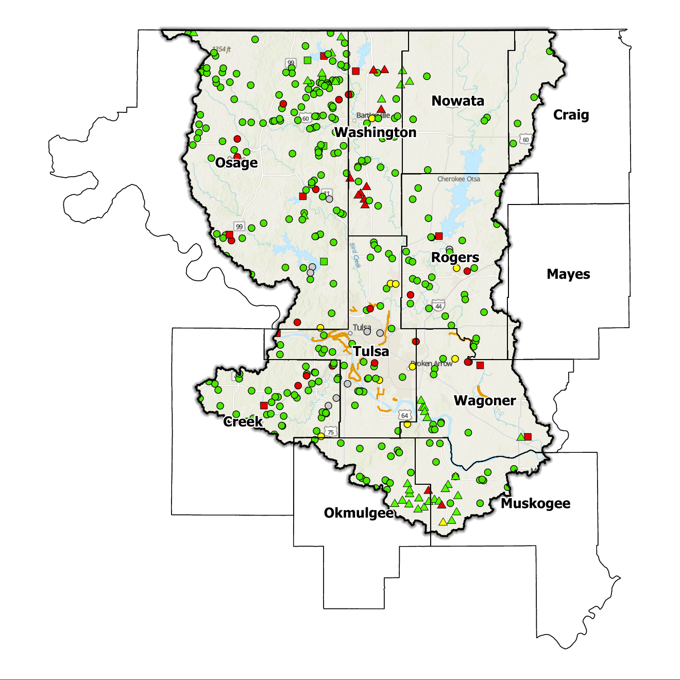
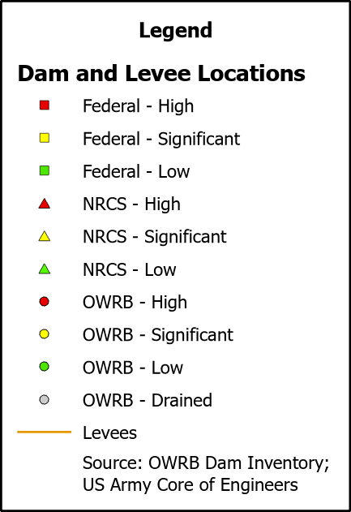
Figure 11: Dam and Levee Locations in the Middle Arkansas Planning Region

Although the Middle Arkansas Planning Region ends at the Kansas/Oklahoma state line, the flood risks associated with the Region’s dams and levees transcend its boundaries.

Extent of Flooding
Extent refers to the expected severity of flooding, and because not all areas within the planning area share the same topography, the extent varies between individual communities. The average depth of flooding within the FEMA-mapped SFHA can range from a few inches to several feet, depending on factors such as topography, proximity to water bodies, local drainage characteristics, and the intensity of the flood event.

Previous Occurrences
According to records maintained by the National Center of Environmental Information (NCEI), from January 1996 to December 2022, a total of 1,041 flood events have been documented in the 11 counties in the Region. Cumulatively, these flooding incidents have caused property damage amounting to $25,009,000.
The NCEI initiated tracking flood events beginning in 1996. Flooding has frequently escalated to the point of necessitating a Presidential Disaster Declaration. A breakdown of flood-related disasters by county since 1996 is shown in Table 3.
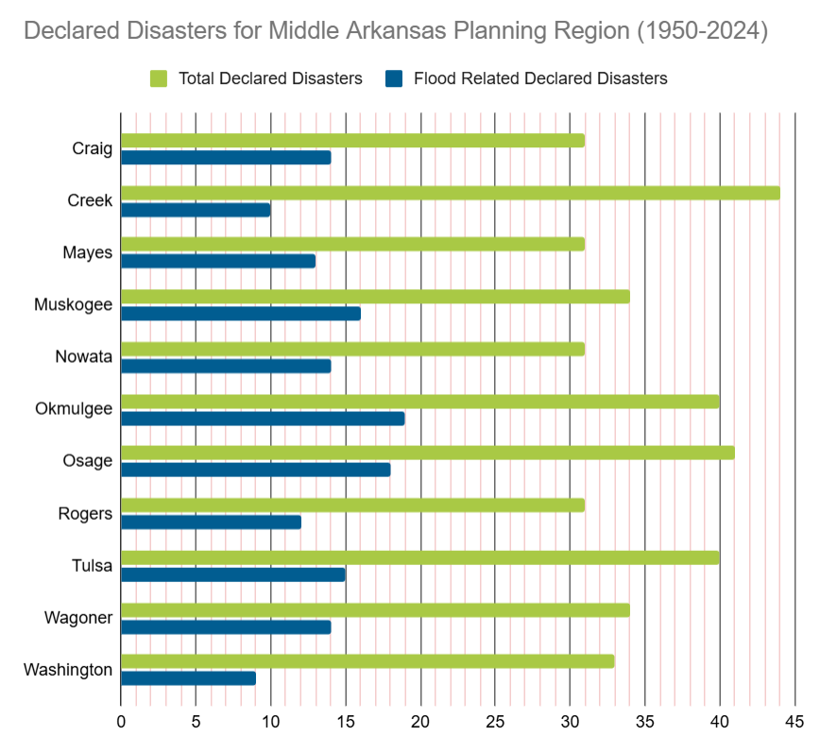
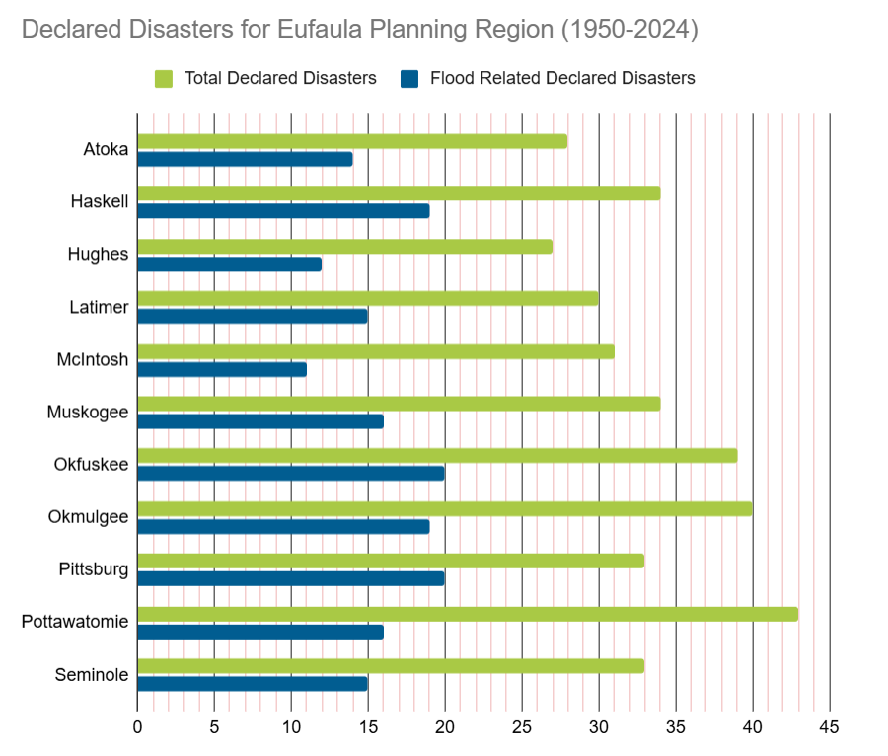
Table 3: FEMA Flood Related Disaster Declarations (1950-2024) in the Middle Arkansas Planning Region

Of all the counties in the Middle Arkansas Planning Region, Okmulgee County has most frequently been declared a disaster area due to flooding. However, it's important to note that disaster declarations are issued on a county-wide basis and not all declarations may have directly impacted this specific Planning Region.

Vulnerability and Impacts of Flooding
According to FEMA’s National Risk Index (NRI), the Middle Arkansas Planning Region demonstrates a range of risk levels for river flooding and flash flooding that varies from relatively low to relatively moderate risk at the county level compared to the rest of the U.S. However, when examined at a more granular scale by census tract, the NRI highlights specific areas along the Arkansas River, particularly in Tulsa, Muskogee, and Creek counties, as being at a moderate risk of flooding.
Compared to other regions in Oklahoma, the Middle Arkansas Planning Region is at a higher risk of flooding due to multiple factors including higher annual precipitation, a larger number of waterways and drainage areas, more development in flood-prone locations, and more aging infrastructure.

Summary of Flood Exposure
Flood exposure refers to the degree to which an area or population is at risk of being affected by a flood event. Table 4 provides a comprehensive overview of key factors, including the total count of housing units, population figures, job statistics, land area measurements, and the number of parcels/blocks within the designated FEMA-mapped flood area. This information aims to facilitate a thorough understanding of the flood-affected area's characteristics and implications.
Data in this section was generated using UrbanFootprint. This module evaluates flood risk by conducting a spatial join of parcels or census blocks with the FEMA National Flood Hazard Layer to assess the potential risks associated with hazards. The data presented in the table below is focused on three different FEMA SFHA flood zones that represent areas within the 100-yr floodplain with a 1% annual chance of experiencing a flood event. Zone AE is the most detailed, providing base flood elevations, Zone AO represents areas subject to shallow flooding of depths between one to three feet, and Zone A is an approximation of the 100-yr floodplain for areas where detailed hydraulic analyses have not been performed.

Table 4: Flood Exposure in the Middle Arkansas Planning Region
Middle Arkansas Planning Region Flood Risk Report
Housing in Flood Hazard Zones (Dwelling Units)
Dwelling Units in SFHL Zone AE | 12,174.00
Dwelling Units in SFHL Zone A | 3,985.00
Dwelling Units in SFHL Zone AO | 85.00
Total | 16,244.00
Population in Flood Hazard Zones (Persons)
Population in SFHL Zone AE | 27,570.00
Population in SFHL Zone A | 9,371.00
Population in SFHL Zone AO | 175.00
Total | 37,116.00
Jobs in Flood Hazard Zones (Employees)
Jobs in SFHL Zone AE | 17,273.00
Jobs in SFHL Zone A | 2,263.00
Jobs in SFHL Zone AO | 8.00
Total | 19,544.00
Land Area in Flood Hazard Zones (Acres)
Area in SFHL Zone AE | 232,302.47
Area in SFHL Zone A | 327,249.30
Area in SFHL Zone AO | 853.45
Total | 560,405.22
Parcels or Block in Flood Hazard Zones
Parcels or Blocks in SFHL Zone AE | 15,901.00
Parcels or Blocks in SFHL Zone A | 7,424.00
Parcels or Blocks in SFHL Zone AO | 78.00
Total | 23,403.00

Flood Mitigation Needs
Flood mitigation projects for the Region have been identified at a county level through the analysis of HMPs, master drainage plans at the community level, and prioritized lists provided by jurisdictions. The following stormwater project types were considered:
- Channel
- Storm Drain
- Infrastructure
- Detention Pond
- Dam-Reservoir
- Floodwalls and Levees
- Acquisition
The largest project type identified in this Region is storm sewer/ pipe extension and inlet additions with approximately 31 projects identified. Inlet enlargements, street and ditch repair, cul-de-sac repairs, and the replacement of reinforced concrete box culverts also make up a significant portion of the project list. Other notable projects include channel improvements, the addition of detention ponds, regrading of streets and ditches, addition of culverts, and general city-wide stormwater improvements.
Most stormwater projects pinpointed in the Middle Arkansas Watershed are found in Tulsa County, collectively making up close to 42% of all planned projects across the state. These 87 projects, estimated to exceed $463.4 million in cost, account for over 65% of all identified statewide projects. A detailed representation of project requirements by category and approximate cost can be found in Table 5.
Table 5: Stormwater Projects Identified in the Middle Arkansas Planning Region
Stormwater Project Types Per County | Number |  |  | Percentage | $ Amount
Osage County
Dam-Reservoir |  | 1 | 1.1% |  | $2.1M
Rogers County
Channel |  | 7 | 8% |  | $20.3M
Storm Drain |  | 5 | 5.7% |  | $5.5M
Infrastructure |  | 4 | 4.6% |  | $4.3M
Detention Pond |  | 3 | 3.4% |  | $5.5M
Tulsa County
Channel |  | 22 | 25.3% |  | $99.7M
Storm Drain |  | 26 | 29.9% |  | $220.7M
Infrastructure |  | 6 | 6.9% |  | $19.5M
Detention Pond |  | 11 | 12.6% |  | $69.3M
Floodwalls and Levees |  | 1 | 1.1% |  | $3.9M
Acquisition |  | 1 | 1.1% |  | $12.6M
Total | 87 |  |  | - | $463.4M

In the Planning Region, there has only been one project identified for flood acquisition, but nearly all hazard mitigation strategies in this area include flood acquisition as a crucial action point. While it is unusual for communities to strategize for flood acquisitions ahead of a flooding event, such planning becomes invaluable in a post-disaster context to facilitate the relocation of citizens out of hazard-prone areas. The City of Tulsa and Tulsa County are engaged in flood acquisition initiatives. Nevertheless, Tulsa County still requires additional funding to help residents of the Town and Country Neighborhood, an area that bore the worst impact of the 2019 flood along the Arkansas River, to move to safer locations.

Conclusion
The Middle Arkansas Planning Region’s report highlights the Region’s vulnerability to flood events and emphasizes the urgent need for funding to support engineering efforts in flood projects within the watershed. Adequate funding is essential for conducting detailed engineering assessments, implementing effective flood control measures, and enhancing community resilience. The lack of project submissions underscores the importance of assisting communities in identifying and developing flood mitigation projects.
By allocating resources and support for project identification and development, communities can better understand their flood exposure and proactively protect lives and infrastructure. Investing in engineering and flood mitigation projects in the Middle Arkansas Planning Region will contribute to creating safer, more resilient communities better equipped to handle future flood events.
During the planning process, the data generated was developed into an interactive flood planning dashboard. The dashboard serves as a valuable tool for conducting flood assessments at the community level. It is important to note that this report should not substitute locally generated data specific to each community.

Census Bureau Data – 2020 Decennial Census
Creek County’s HMP includes the Towns of Kellyville, Kiefer, and Mannford.
Muskogee County’s HMP includes the Towns of Boynton, Haskell, Taft, and the City of Muskogee.
Nowata County’s HMP includes the Towns of Delaware, Lenapah, New Alluwe, South Coffeyville, Wann, and the City of Nowata.
Okmulgee County’s HMP includes the Town of Winchester.
Osage County’s HMP includes the Towns of Avant, Wynona, and the Cities of Barnsdall, Hominy, and Pawhuska.
Rogers County’s HMP includes the Towns of Foyil, Oologah, Talala, Verdigris, and the City of Catoosa.
Tulsa County’s HMP includes the Town of Sperry, and the Cities of Bixby, Collinsville, and Jenks.
Wagoner County’s HMP includes the Towns of Porter, Redbird, Tullahassee, and the City of Coweta.
Washington County’s HMP includes the Towns of Copan, Ochelata, Ramona, Vera, and the Cities of Bartlesville, and Dewey.
U.S. Geological Survey and Federal Emergency Management Agency, "Peak Streamflow and Stages at Selected Stream gages on the Arkansas River in Oklahoma and Arkansas, May to June 2019.
Any counties that do not appear in the table do not have any identified projects.

