Table of Contents
The Lower Washita Planning Region 1
Section 1.1: Watershed Introduction 1
Section 1.2: Socioeconomic and Geographic Characteristics 2
Section 1.3: Floodplain Management and Mitigation Capabilities 5
Section 1.4: Flood Hazard Assessment 15
Section 1.5: Flood Mitigation Needs 21
Section 1.6: Conclusion 22

The Lower Washita Planning Region

Watershed Introduction
Spanning 6,192 square miles, the Lower Washita Watershed Planning Region (Region) extends across 15 counties in central and southern regions of Oklahoma. It encompasses all or part of Bryan, Canadian, Carter, Caddo, Comanche, Garvin, Grady, Jefferson, Johnston, Love, Marshall, McClain, Murray, Pontotoc, and Stephens counties. This area is home to 84 communities and four tribal nations. The Red and Washita Rivers, as well as Mud Creek, Walnut Bayou, and their various tributaries, are the major waterways in the Lower Washita Planning Region. These prominent waterways shape the landscape. Figure 1 highlights the geographic boundaries of the planning area supplemented by key details about this Region.
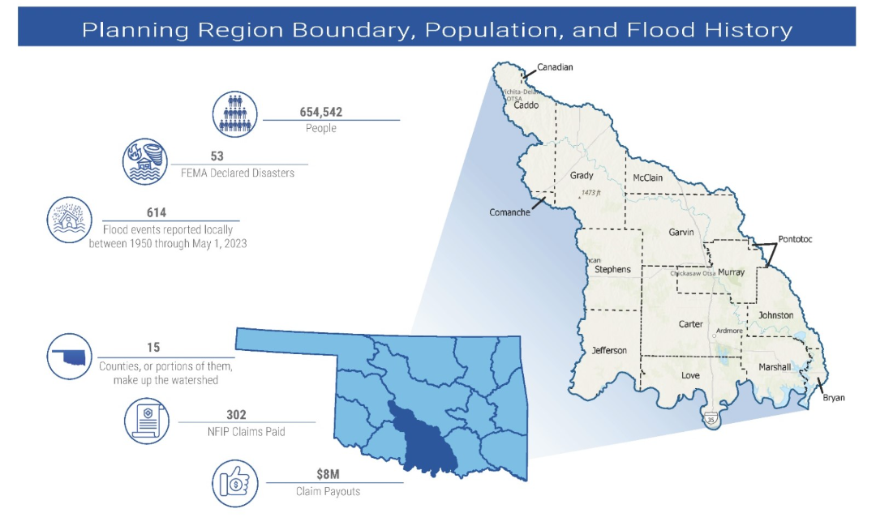
Figure 1: Lower Washita Planning Region Boundary, Population, and Flood History
The Lower Washita Planning Region features the Washita River and its accompanying tributaries, which ultimately converge with the Red River at Lake Texoma near the Oklahoma/Texas border. This Region hosts several population centers and is traversed by two significant transportation arteries, Interstates 35 to the east and 44 to the west. Each county in this Region has experienced numerous flood-related disasters resulting in federal declarations since 1970. Figure 2 is a base map displaying incorporated jurisdictions.
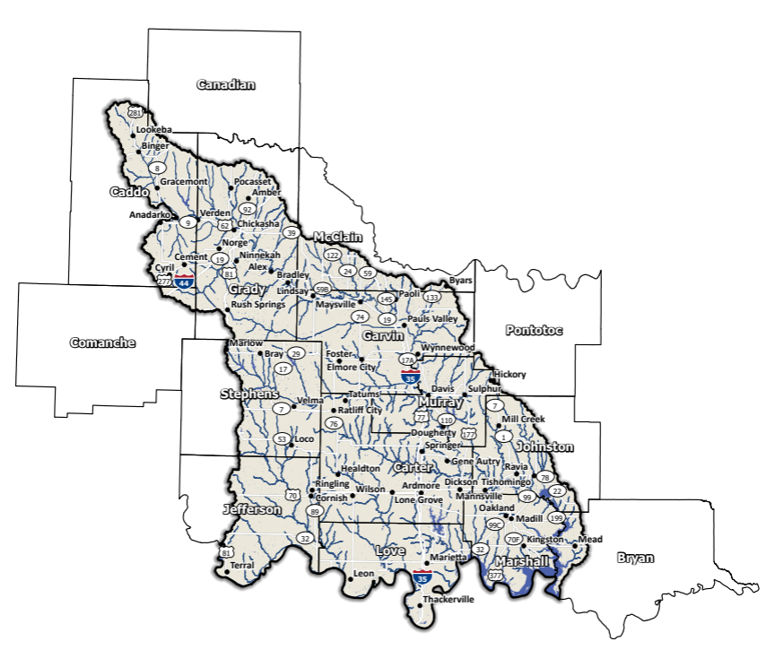
Figure 2: Lower Washita Planning Region Base Map
Geographical makeup of the Lower Washita Planning Region exhibits a diverse topography, ranging from expansive plains and gentle rolling hills in the northwest to the rugged and elevated terrain of the Arbuckle Mountains situated in northern Carter County, extending the distance of Lake Texoma, and spanning across Marshall and Bryan Counties in the southeastern corner of the state. Notable population centers within this Region include Ardmore (24,725), Chickasha (16,051), Pauls Valley (5,992), and Anadarko (5,745).

Socioeconomic and Geographic Characteristics
The Lower Washita Planning Region is diverse in demographics, geography, and the economy. This section will examine some of these socioeconomic and geographic factors and how they contribute to and affect this Planning Region.

Demographic Profile
Ranked among the more densely populated Planning Regions within the state, the Lower Washita harbors a resident population exceeding 650,000. This community embodies a blend of urban, suburban, and rural localities. Constituting approximately 8.9% of Oklahoma's land area, this Region accommodates around 17% of the state’s population according to the 2020 U.S. Census.
It is essential to emphasize that the data provided in this section pertains to the populations at the county level, rather than specifically within the confines of the watershed. Among the group of counties, only Love and Marshall counties are entirely situated within the boundaries of the Lower Washita watershed.
Table 1: Population Breakdown by County in the Lower Washita Planning Region
County | Total Population
Bryan | 46,067
Caddo | 26,945
Canadian | 154,405
Carter | 48,003
Comanche | 121,125
Garvin | 25,656
Grady | 54,795
Jefferson | 5,337
Johnston | 10,272
Love | 10,146
Marshall | 15,312
McClain | 41,662
Murray | 13,904
Pontotoc | 38,065
Stephens | 42,848

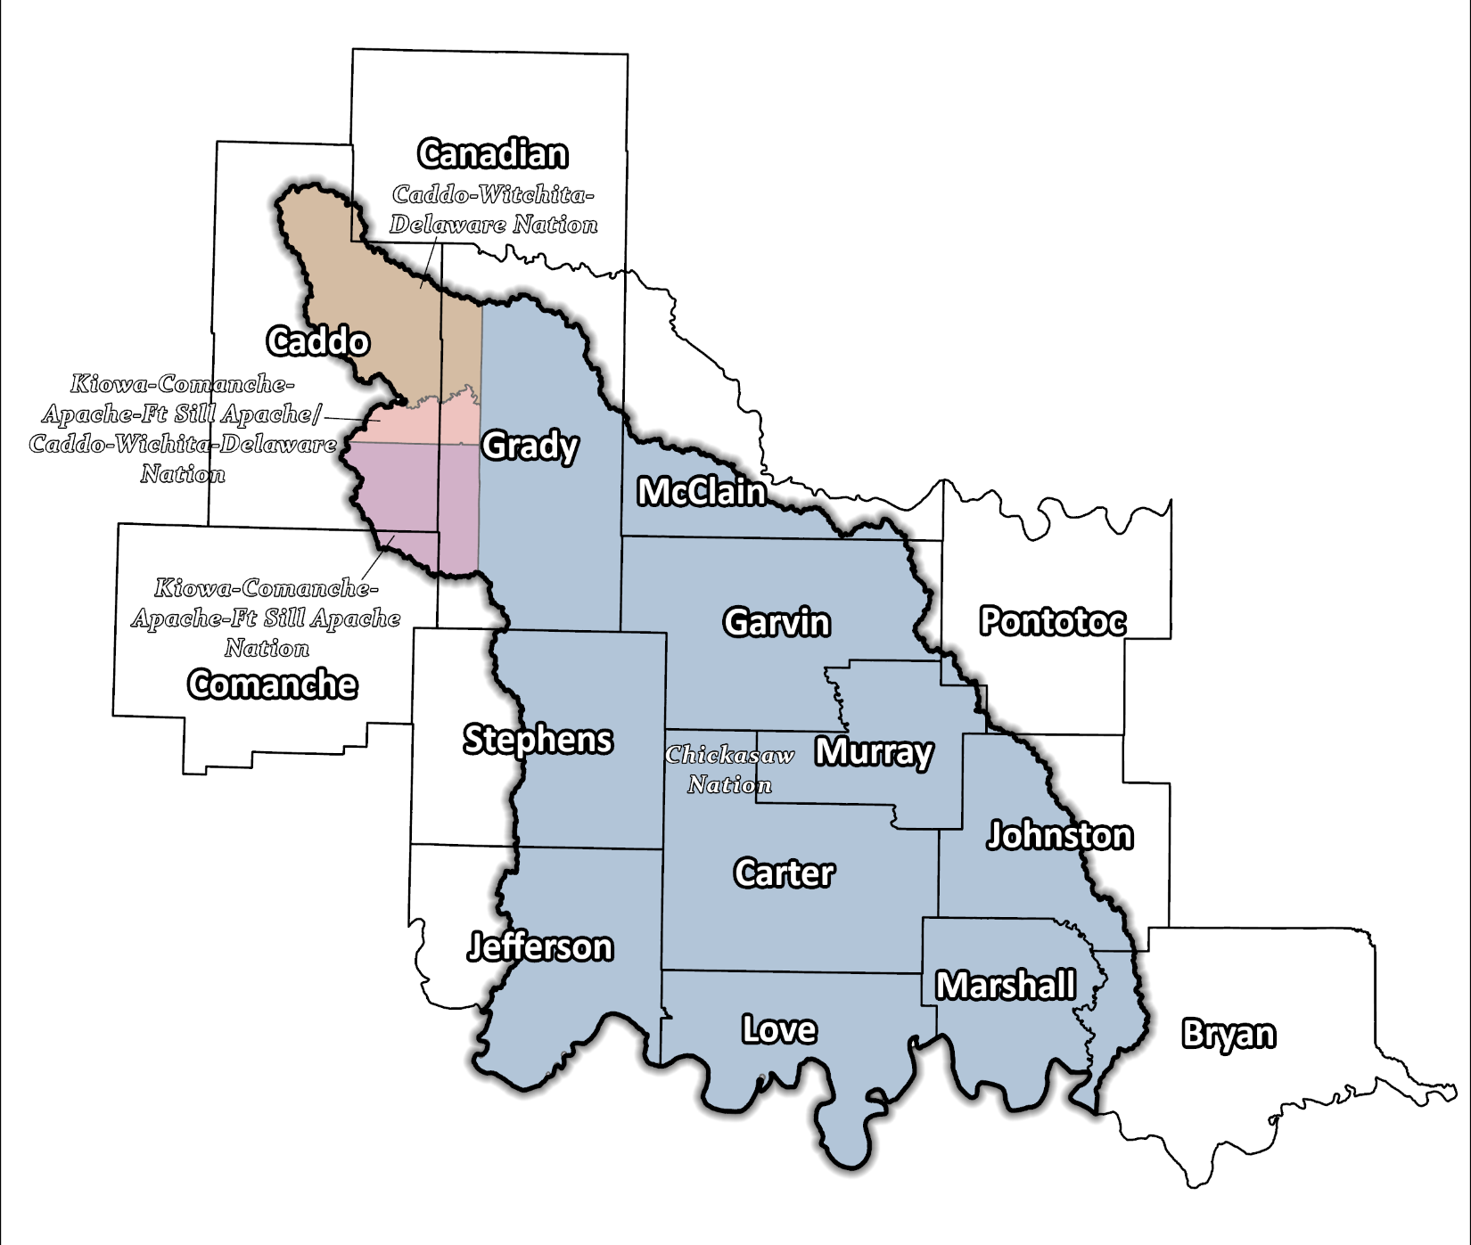
Figure 3: Tribal Jurisdictions Base Map for Lower Washita Planning Region

A multitude of Native American tribes have established their presence in this vicinity, encompassing the Chickasaw, Kiowa-Comanche-Apache-Ft. Sill Apache/Caddo-Wichita-Delaware, Kiowa-Comanche-Apache-Ft. Sill Apache, and Caddo-Wichita-Delaware Nations. These tribes boast an enduring legacy in the Region, profoundly influencing both its cultural tapestry and economic progression.

Economic Profile
Encompassing a spectrum of industries including agriculture, manufacturing, retail, and gaming, among others, the Lower Washita Planning Region showcases a profound diversity within its economy. Positioned along I-35, Ardmore has emerged as a pivotal nexus for retail distribution serving major corporations and functioning as a manufacturing center for Michelin Tires. In the southern part of the Region, Love County houses the popular WinStar World Casino, the largest in the state, driving interstate tourism. Operated by the Chickasaw Nation, this complex complements the Treasure Valley Casino situated along I-35 in Garvin County, near Davis. Agriculture remains another vital economic pillar within this Region, with livestock, corn, wheat, soybeans, and hay constituting key components of a thriving agricultural sector.

Floodplain Management and Mitigation Capabilities
This section provides a comprehensive overview of floodplain management capabilities and the extent of community engagement across the entirety of the Lower Washita Planning Region.

National Flood Insurance Program Participation
Apart from Garvin and Grady counties, along with certain Tribal Nations, all counties within the Planning Region have undergone mapping by the Federal Emergency Management Agency (FEMA) and are actively engaged in the National Flood Insurance Program (NFIP). Nonetheless, it is important to note that a small number of communities within the 15 counties are not presently participating in the NFIP initiative, as depicted in Figure 4 below.
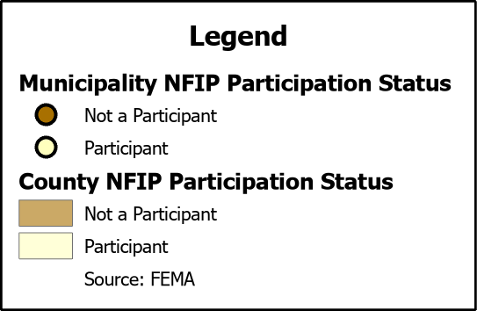
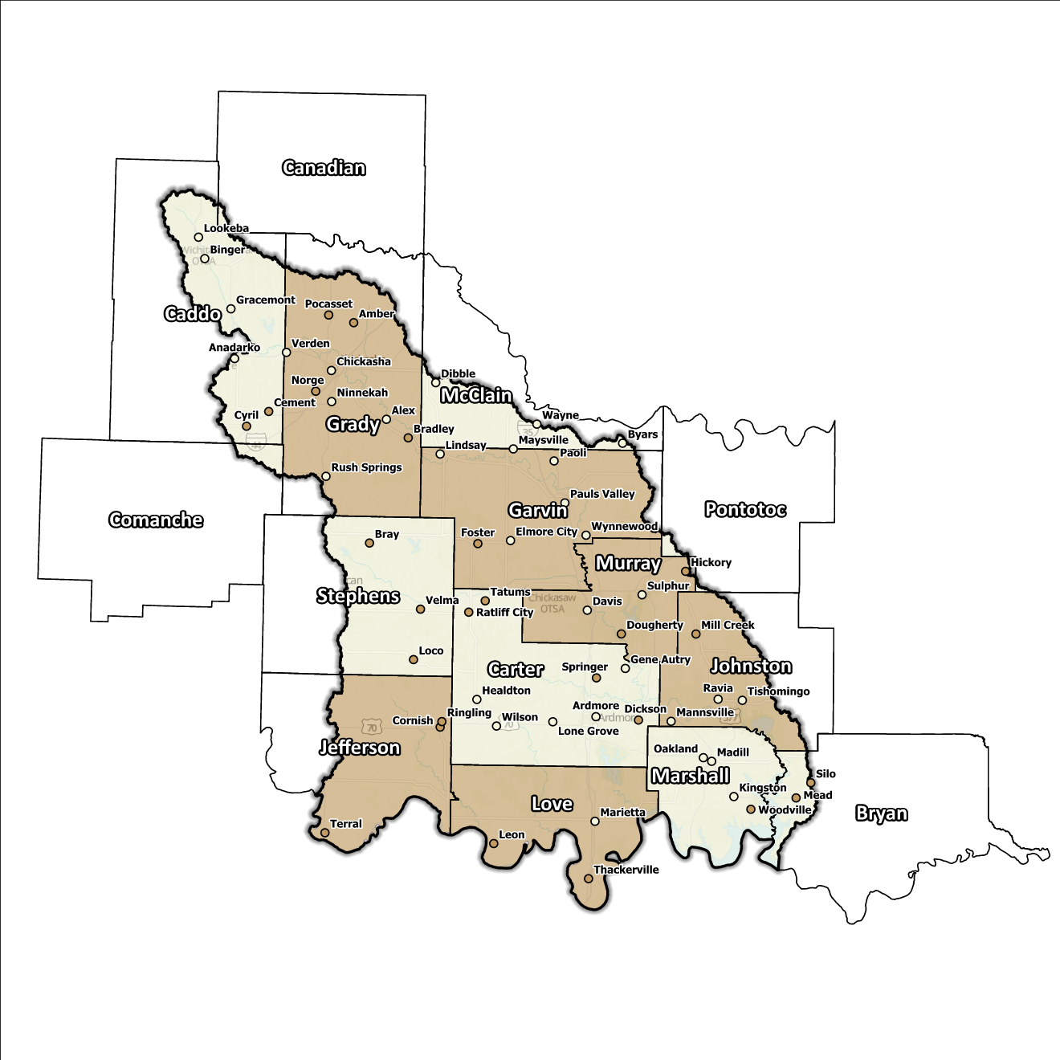
Figure 4: Status of NFIP Participation in the Lower Washita Planning Region
Engaging in NFIP can bolster a community's ability to withstand flooding as can active involvement in the Community Rating System (CRS) program. Within the Planning Region, Chickasha and Lindsay are active in the CRS initiative.

Flood Insurance Coverage
Presently, the 15 counties within the Planning Region have 357 active NFIP policies, offering protection to approximately 5.8% of the total structures within the delineated Special Flood Hazard Area (SFHA). It is important to highlight that while NFIP provides coverage for structures within floodplains, not all active policies are confined to the SFHA. Over time, policyholders in the Lower Washita Region have been reimbursed with a total of $9 million via 389 NFIP claims. Among them are 33 structures designated as Repetitive Loss (RL), and/or classified as Severe Repetitive Loss (SRL). Repetitive loss, in the context of the National Flood Insurance Program (NFIP), refers to properties that have experienced multiple flood-related insurance claims over a specific time period. Severe repetitive loss, on the other hand, pertains to properties with an extensive history of recurrent flood damage and a high number of insurance claims, making them particularly vulnerable and costly for the NFIP.
Figures on the following pages offer insight into NFIP policies, including details on total claims submitted and settled within the Planning Region. It is important to acknowledge, however, that while these figures provide valuable information, they may not entirely capture the complete scope of losses in the Region given the potential underrepresentation of flood insurance. It is also worth noting that not every filed or settled claim corresponds to an active policy.

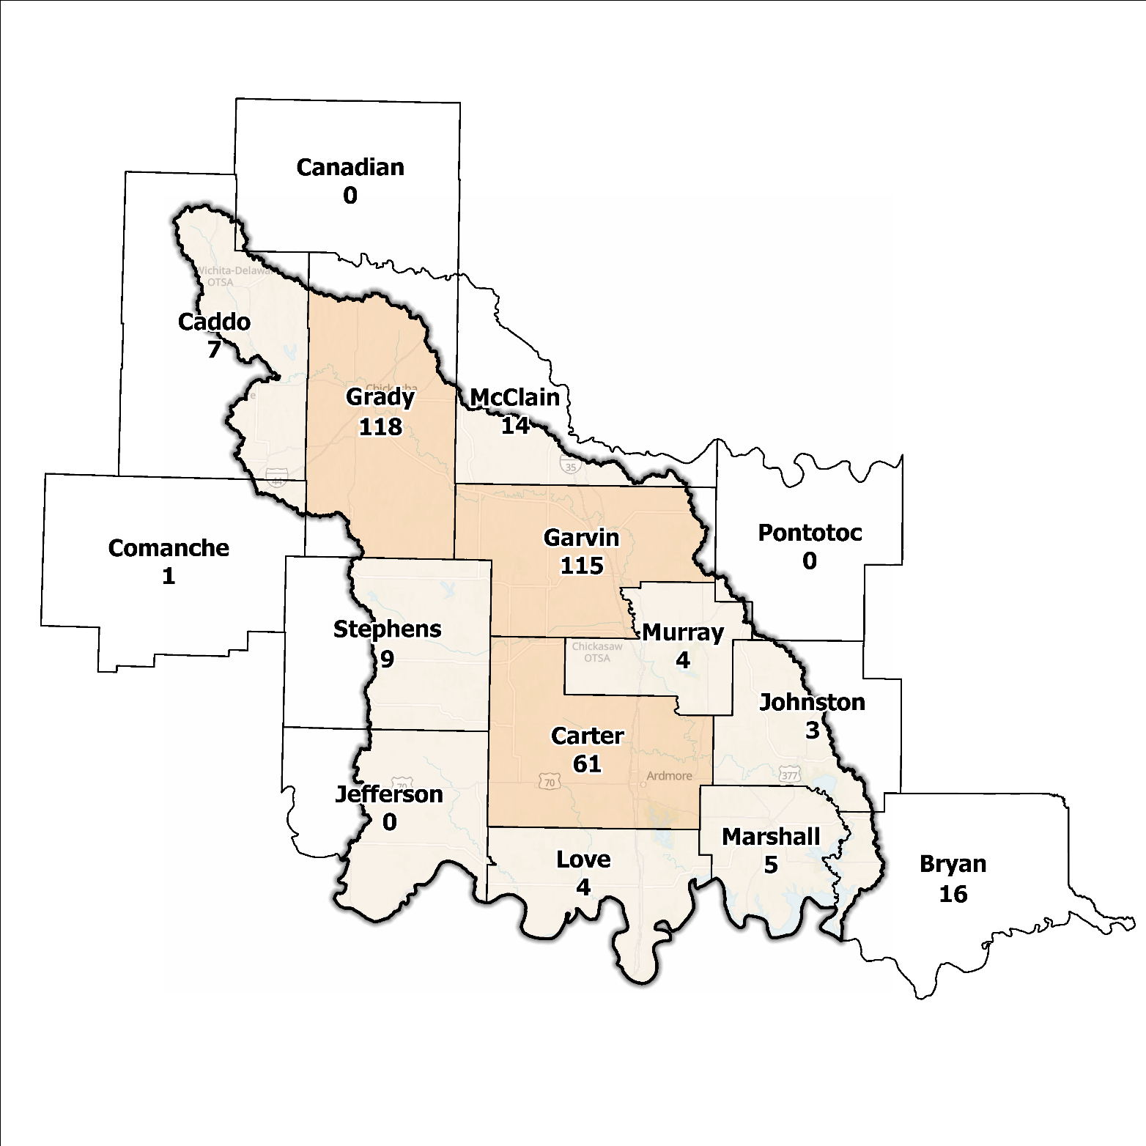
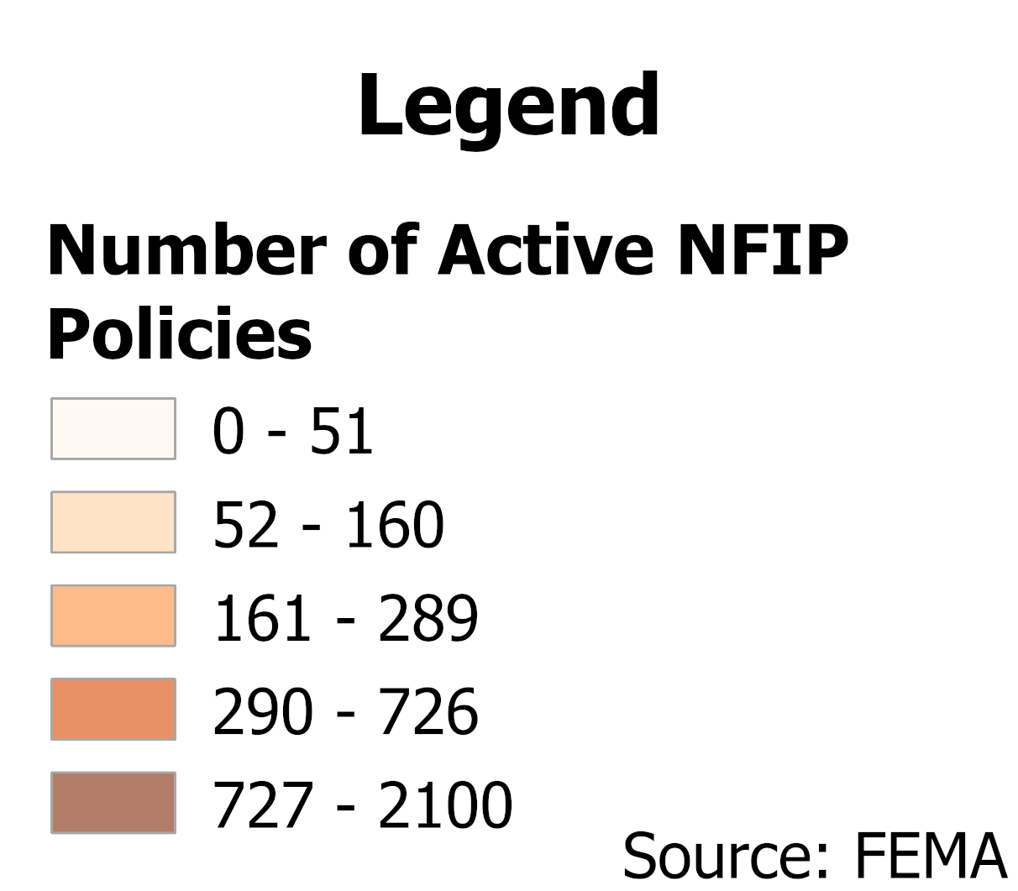
Figure 5: Number of Active NFIP Policies in the 100-Year Floodplain in the Lower Washita Planning Region

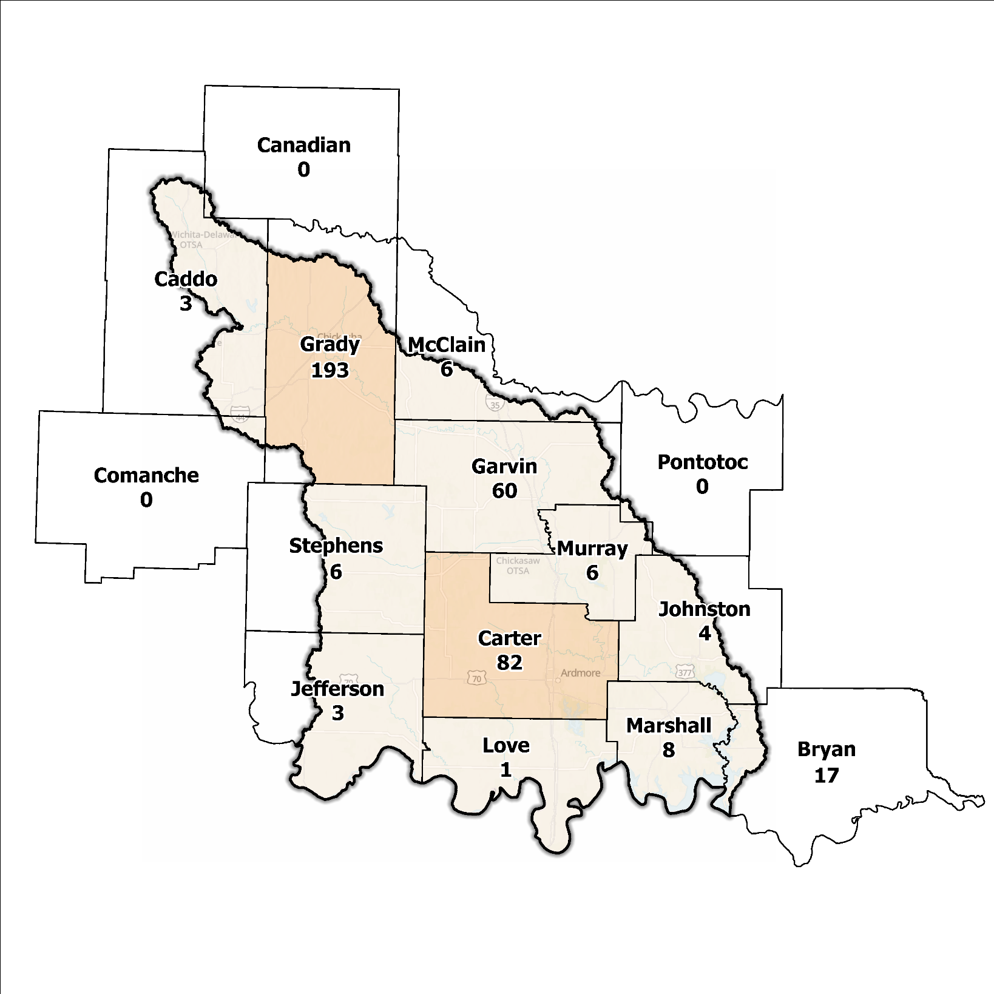
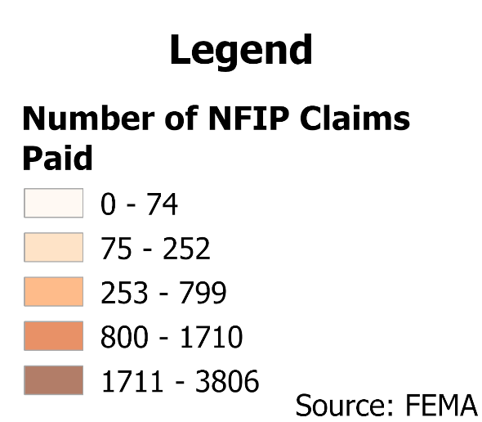
Figure 6: Total NFIP Claims Paid in the Lower Washita Planning Region

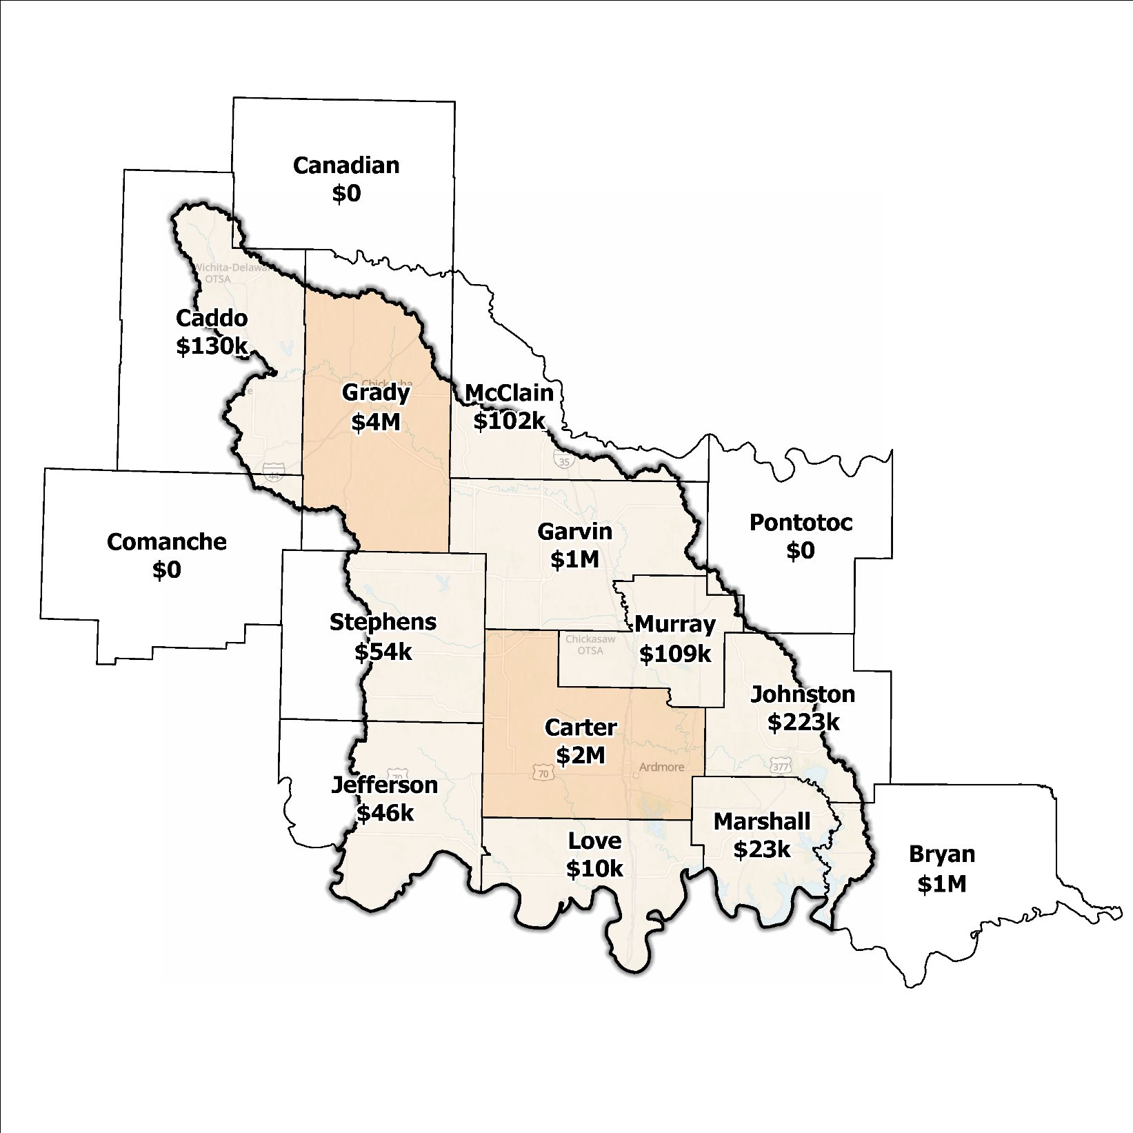
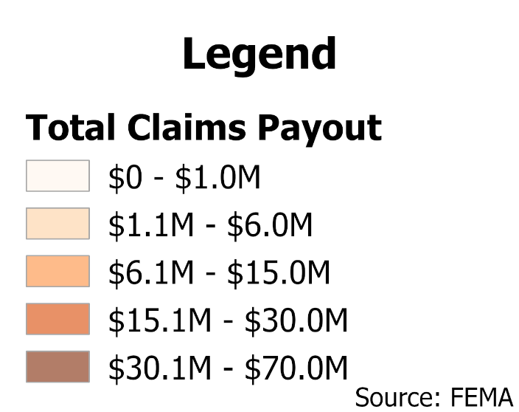
Figure 7: Total Value NFIP Claims Paid Out in the Lower Washita Planning Region

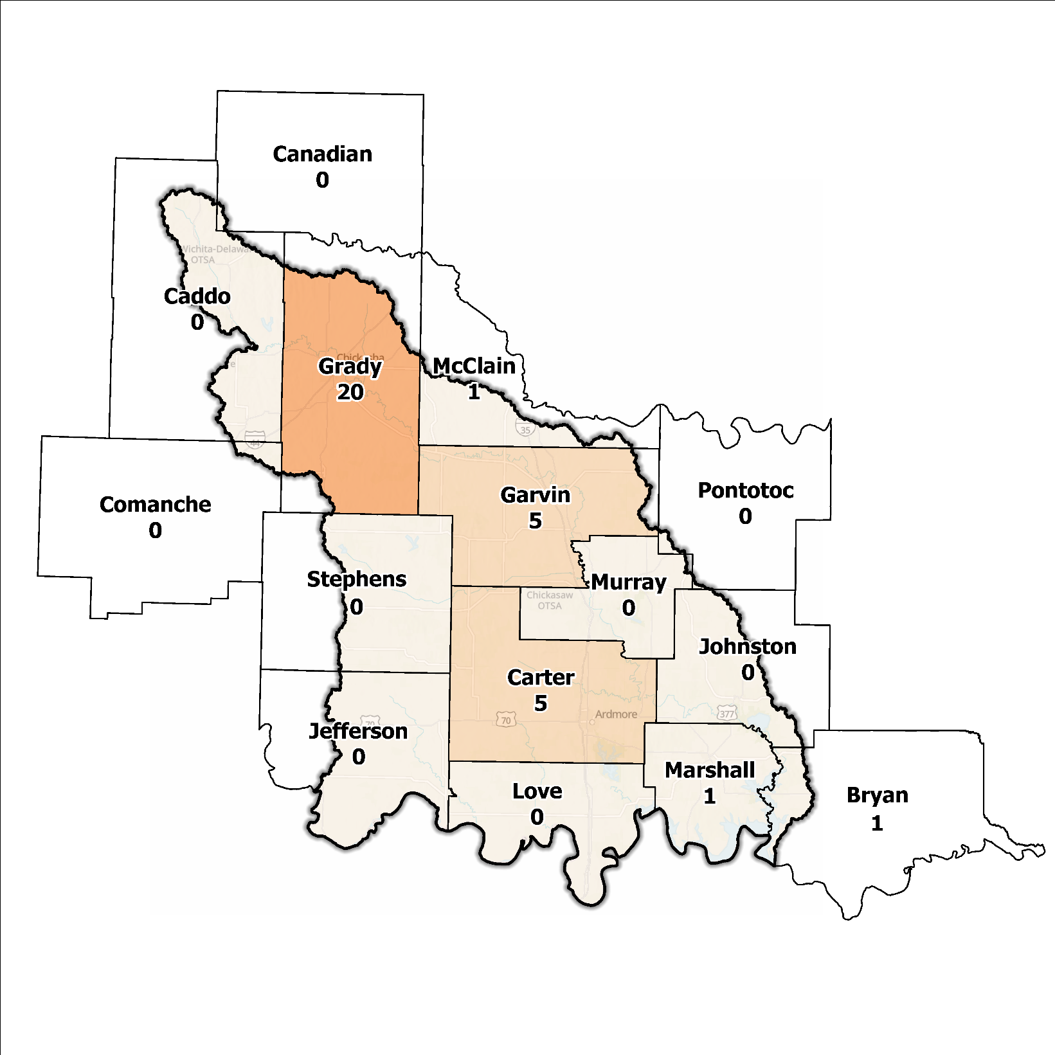
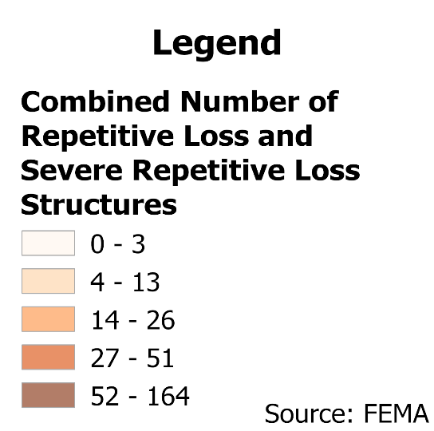
Figure 8: Repetitive Loss and Severe Repetitive Loss Structures in the Lower Washita Planning Region

Flood Funding Mechanisms
Assessments of funding levels and origins for stormwater and floodplain management activities in the Lower Washita Planning Region, follow a trend. Numerous smaller communities contend with restricted local funding resources, while larger jurisdictions, fortified by a broader tax base, wield greater financial means to undertake comprehensive management endeavors. Beyond local and state channels, external funding for stormwater management initiatives frequently stems from programs like Hazard Mitigation Grant Program (HMGP) and Pre-Disaster Mitigation Grants. Programs such as these may be cost-prohibitive to smaller jurisdictions due to local match dollars required to participate.

Hazard Mitigation Plan Status
Of the 15 counties in this Region, 11 currently possess a FEMA-approved Hazard Mitigation Plan (HMP). Stephens County’s HMP is still pending approval from FEMA. Mitigation strategies outlined in these plans span a diverse spectrum and encompass a variety of approaches. These include administrative endeavors like educational initiatives, outreach programs, and heightened awareness efforts, along with other actions such as property acquisition in flood-prone areas and enhancements to drainage systems.
Beyond county-level engagement, Ardmore has formulated a local HMP tailored to tackle hazards directly impactful to its community members. Municipalities equipped with a FEMA-approved HMP and actively partaking in the CRS stand to accumulate points within Activity 510. These points serve a dual purpose: they augment the community's overall flood resilience while concurrently enabling property owners in these municipalities to enjoy deeper discounts on their flood insurance premiums.
Table 2: Hazard Mitigation Plan Status in the Lower Washita Planning Region
Name | Type | Approval Date | Expiration | Current Action Status of this Plan
Bryan | County | 03/11/2023 | 03/10/2028 | Approved
Caddo | County | - | - | In Progress
Anadarko | City | 10/25/2010 | 10/25/2015 | Approved
Canadian | County | 11/17/2021 | 11/16/2026 | Approved
Carter | County | 04/18/2021 | 04/17/2028 | Approved
Ardmore | City | 05/24/2017 | 05/23/2022 | Expired
Comanche | County | 09/23/2024 | 09/12/2029 | Approved
Garvin | County | 06/10/2024 | 06/09/2029 | Approved
Elmore City | Town | 12/09/2009 | 12/09/2014 | Expired
Lindsay | City | 12/15/2009 | 12/15/2014 | Expired
Maysville | Town | 10/27/2009 | 01/27/2014 | Expired
Paoli | Town | 12/15/2009 | 12/15/2014 | Expired
Pauls Valley | City | 06/19/2014 | 06/19/2019 | Expired
Wynnewood | City | 10/27/2009 | 10/27/2014 | Expired
Grady | County | 08/29/2024 | 08/28/2029 | Approved
Jefferson | County | 10/05/2009 | 10/05/2014 | Expired
Johnston | County | 12/24/2008 | 12/24/2013 | Expired
Love | County | 05/07/2020 | 05/06/2025 | Approved
Marshall | County | 04/04/2023 | 04/03/2028 | Approved
McClain | County | 09/15/2021 | 09/14/2026 | Approved
Murray | County | 05/08/2024 | 05/07/2029 | Approved
Davis | City | 01/08/2025 | 01/07/2030 | Approved
Sulphur | City | 11/22/2009 | 11/22/2014 | Expired
Pontotoc | County | 02/24/2023 | 02/23/2028 | Approved
Stephens | County | 12/20/2024 | 12/19/2029 | Pending Approval
Caddo | Tribal Nation | 01/19/2023 | 01/18/2028 | Approved
Cheyenne and Arapaho | Tribal Nation | 01/27/2022 | 01/26/2027 | Approved
Chickasaw | Tribal Nation | 10/20/2021 | 10/19/2026 | Approved
Choctaw | Tribal Nation | 05/21/2015 | 05/20/2020 | Expired
Comanche | Tribal Nation | 07/21/2011 | 07/21/2016 | Expired
Delaware | Tribal Nation | 09/23/2015 | 09/23/2020 | Expired

Flood Mapping Assessment
Within the Lower Washita Planning Region, the floodplain quilt merges the most reliable and up-to-date data concerning flood risk. Nonetheless, there are areas within the Region that lack forms of advanced floodplain mapping by FEMA. This situation constrains the capacity of the local authorities to effectively oversee and manage development within flood-prone areas.
Mapping efforts in this Region provide a general grasp of flood risk and the locations of floodplains. However, to acquire a comprehensive understanding of flood risks within the Planning Region, more intricate examinations employing Base Level Engineering (BLE) are essential. As a result, there is an urgent demand for these thorough investigations to augment the accuracy and dependability of flood risk data within specific locales.
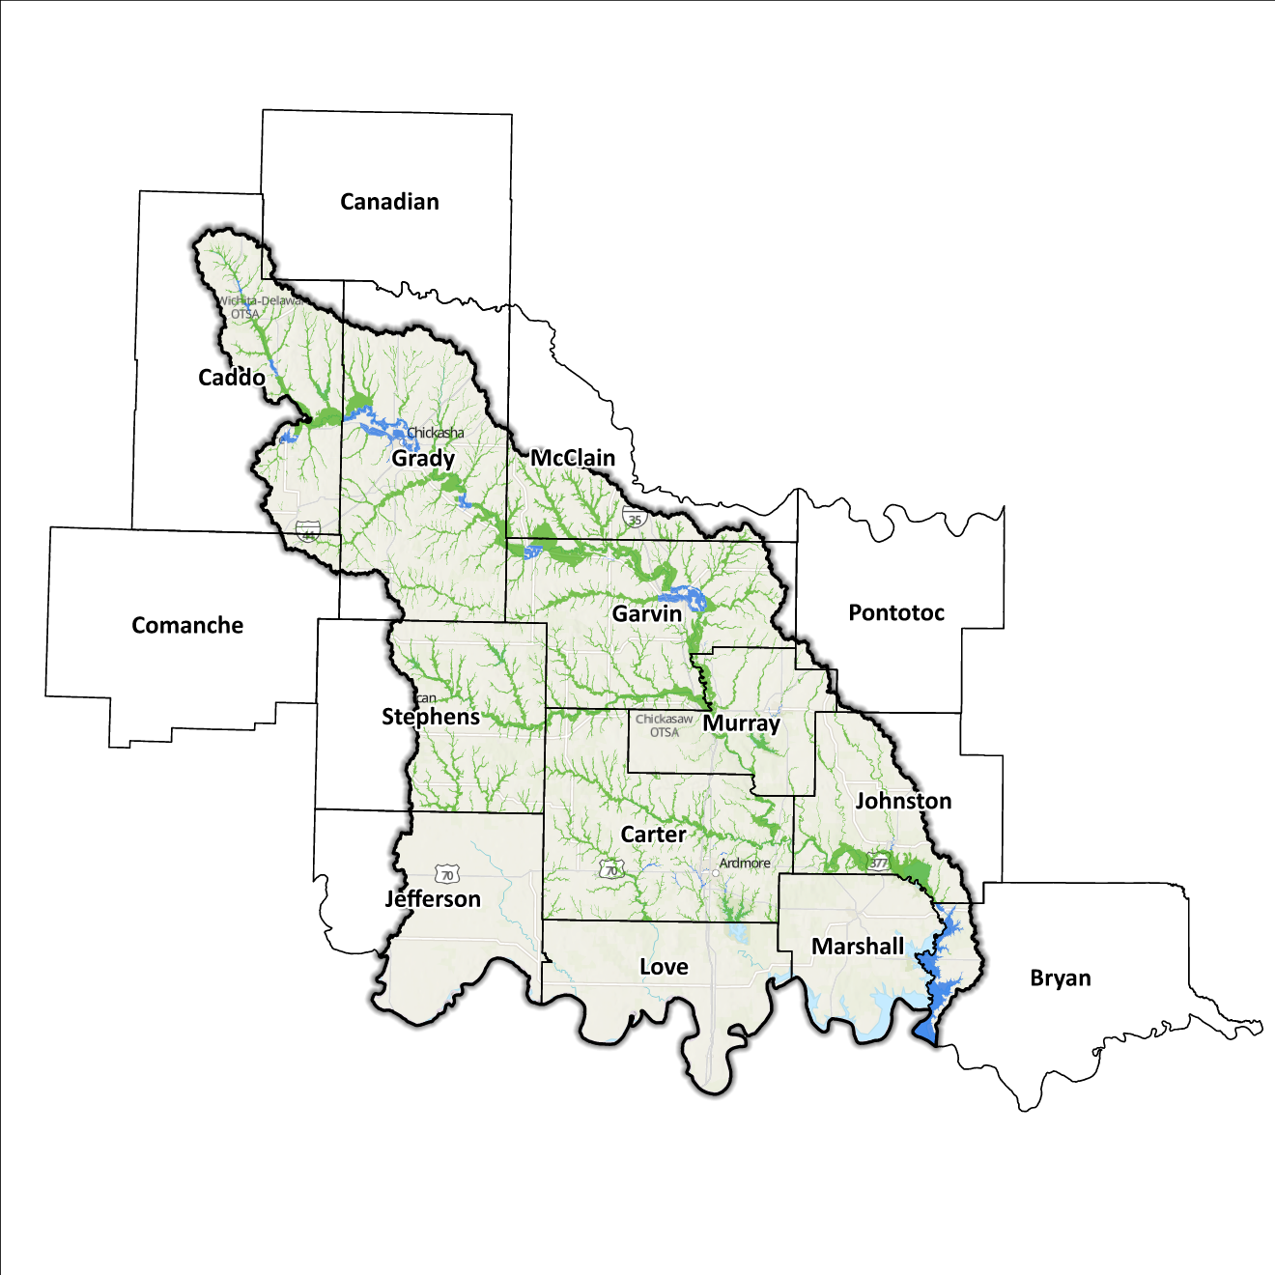
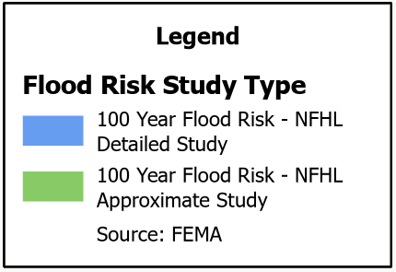
Although Flood Insurance Rate Maps (FIRMs) are valuable for regulatory purposes and assessing flood insurance needs, they exclusively illustrate potential flood risks tied to conditions of a flood event. The possibility of flooding beyond the boundaries of the FEMA-mapped SFHA is incorporated in FIRMs solely if the community chooses to undertake the necessary studies to incorporate this data into their hazard map.

Figure 9: FEMA Mapped Special Flood Hazard Areas in the Lower Washita Planning Region

Flood Hazard Assessment
The Lower Washita Region is susceptible to a range of flood hazards including flash floods, river floods, and urban flooding. Prominent watercourses shaping this area are the Red and Washita Rivers, in addition to Mud Creek and Walnut Bayou, accompanied by their diverse network of tributaries.

Location of Flood Hazards
The Lower Washita Planning Region is distinguished by a comprehensive flood hazard, which covers several noteworthy features. Flood dynamics within the Lower Washita Planning Region showcase these subsequent traits:
- Major waterways with vast drainage basins, including the Washita, Little Washita, and Red Rivers, as well as various creeks such as Rush, Wildhorse, Caddo, Mud, Negro, Hickory, Pennington, Mill, Wilson, Glasses, and Caney, are prone to flooding in the Region. This flooding risk extends to include Walnut Bayou as well.
- Rapid-onset floods occur along minor tributaries and within valleys that ultimately feed into major watercourses.
- Localized drainage problems stem from inadequate infrastructure, which, in turn, can escalate flood vulnerabilities. Insufficient drainage systems have the potential to worsen flood risks, particularly in susceptible areas.
- Downstream areas positioned beneath high-hazard potential dams, including those situated along the Red River like Denison Dam in Bryan County, are of particular concern.
Illustrated in Figure 10 are mapped areas of the Region displaying flood risk. This map brings together data from various sources including the National Flood Hazard Layer and BLE, to present a consolidated perspective. It gives precedence to various layer categories and underscores the most critical layer that pertains to a particular area.
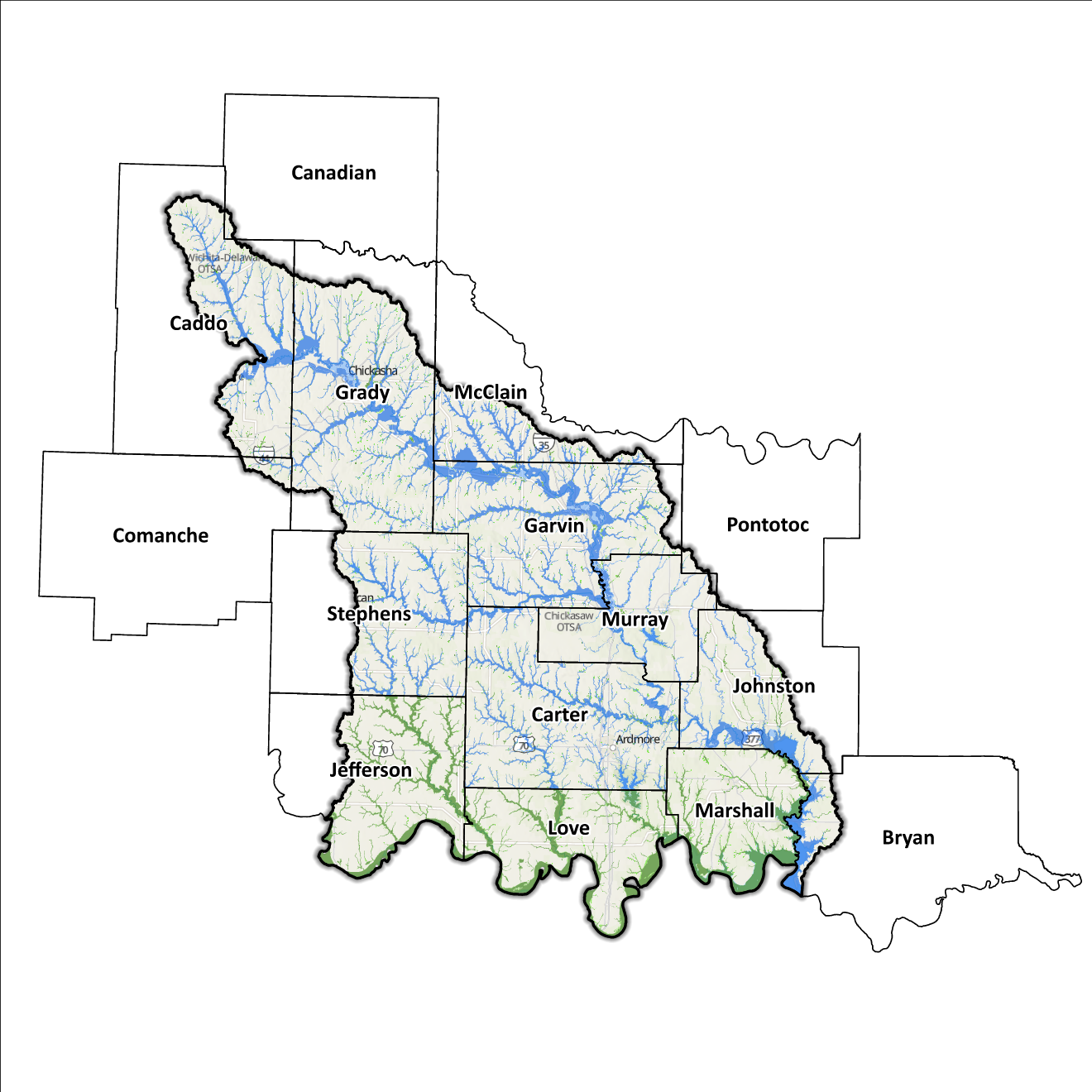
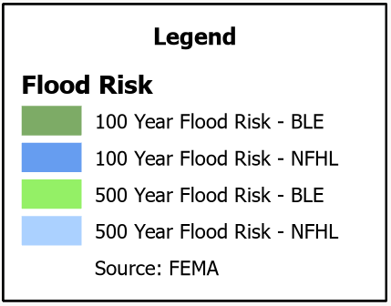
Figure 10: Flood Quilt in the Lower Washita Planning Region

Dam and Levee Infrastructure
The Planning Region hosts numerous dams and levees strategically designed to counteract flooding. Nonetheless, this aging infrastructure heightens the likelihood of downstream consequences in the event of a breach or malfunction, particularly concerning dams categorized as high hazard by the Oklahoma Water Resources Board (OWRB). Across the 15 counties within this Planning Region, a total of 161 high-hazard dams are present, with 80 situated in the confines of the Lower Washita Watershed. A visual representation of the distribution of dam and levee locations in the Region is in Figure 11.
Although there have been no recorded instances of dam incidents in this area, potential consequences of failure at any of these structures could be profound and tragic. These inherent risks underscore the critical significance of consistently conducting thorough inspections, maintenance activities, and necessary repairs for these facilities.
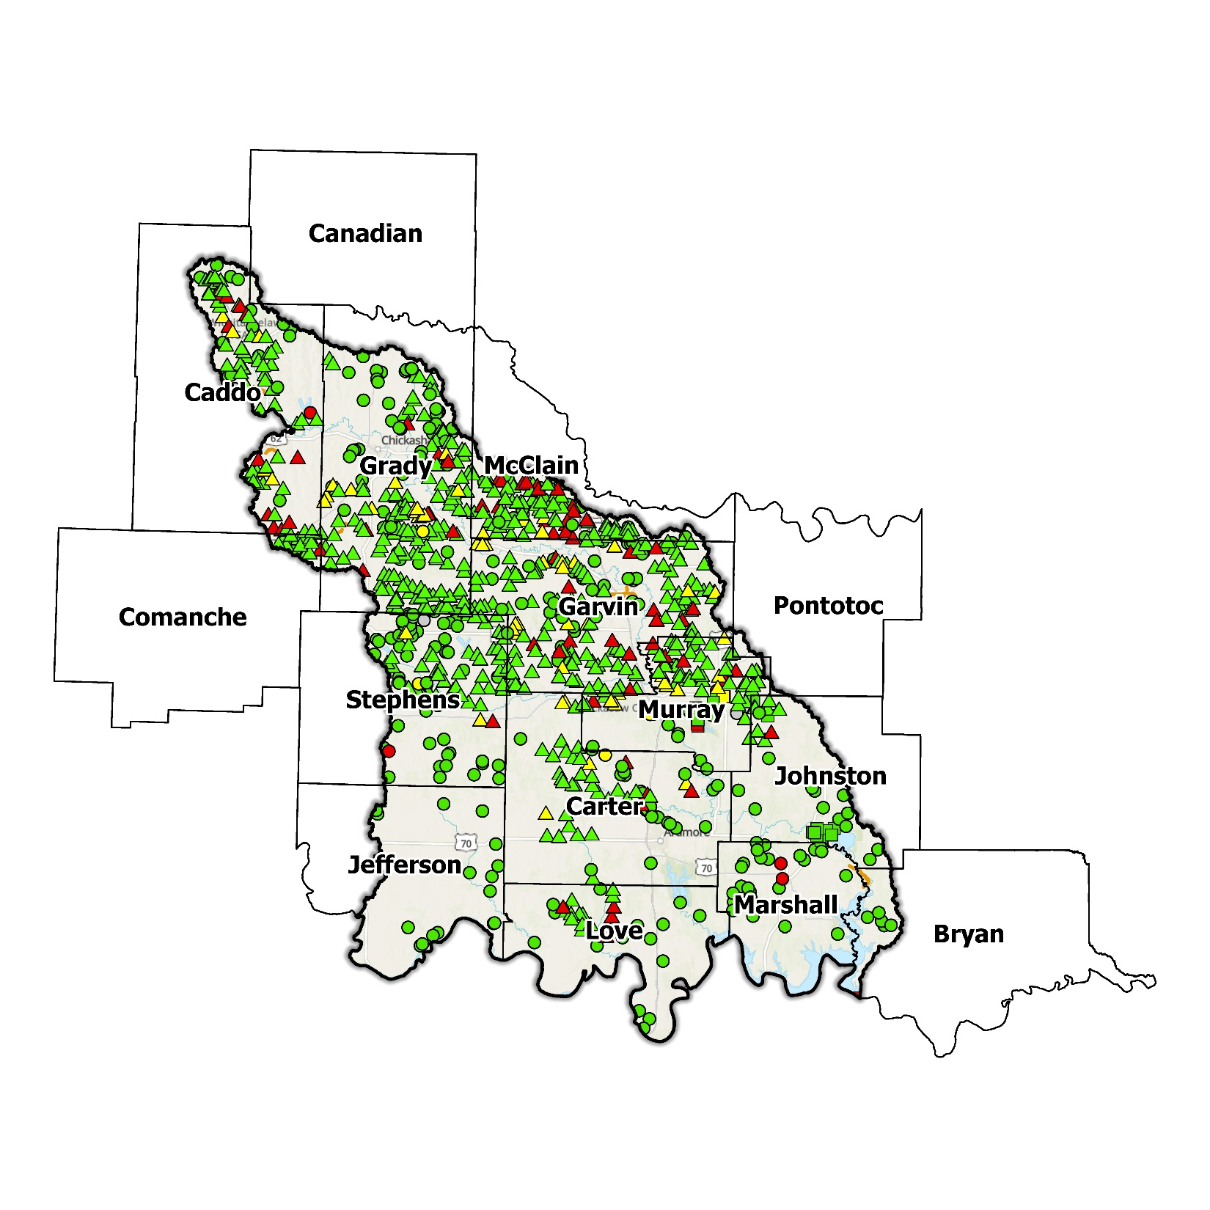
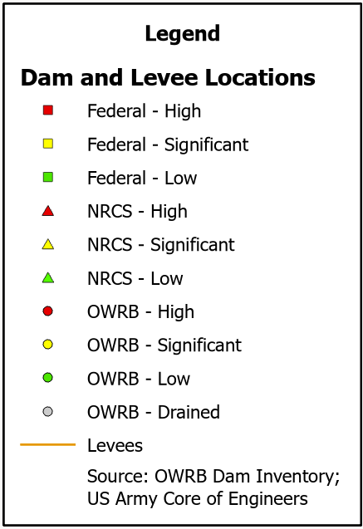
Furthermore, there are 10 levee systems strategically established within this Planning Region. State and local authorities can access information pertaining to these systems via the United States Army Corps of Engineers National Levee Database website. These structures are of paramount importance in safeguarding both residents and property within developed zones. For instance, the levees near Anadarko and Pauls Valley provide protection for more than 10,000 individuals residing in those communities against the potential hazards posed by flooding.
Figure 11: Dam and Levee Locations in the Lower Washita Planning Region

While the southern extent of the Lower Washita Planning Region is confined by the Red River, which concurrently functions as the Oklahoma/Texas state boundary, the flood hazards linked with dams and levees extend beyond these confines. Notably, Denison Dam, situated along the Red River at the juncture of the Texas/Oklahoma State Line, holds the potential to trigger inundation in both states if an incident were to transpire at this structure. It is noteworthy that this dam is under the ownership of the United States Army Corps of Engineers (USACE).

Extent of Flooding
"Extent" denotes the projected intensity of flooding, a variable that diverges across different communities due to variations in the local topography within the planning area. The typical depth of floodwater within the FEMA-identified SFHA can vary from shallow inches to significant feet, influenced by factors such as landscape characteristics, proximity to water sources, local drainage conditions, and intensity of a flooding event.

Previous Occurrences
The National Oceanic and Atmospheric Administration (NOAA) initiated the recording of flood events in 1996. Data spanning from January 1996 to December 2022 reveals a cumulative count of 614 flood occurrences across this Planning Region. These floods resulted in property damage exceeding $21 million. This dataset represents the most comprehensive and extensive information accessible for the Region.
In numerous instances, flooding has reached a severity that warranted a Presidential Disaster Declaration. A detailed breakdown of flood-related disasters, categorized by county, is in Table 3. This table illustrates close to 190 declarations related to floods, encompassing the counties within the Planning Region.
Table 3: FEMA Disaster Declarations from 1950-2024 for the Lower Washita Planning Region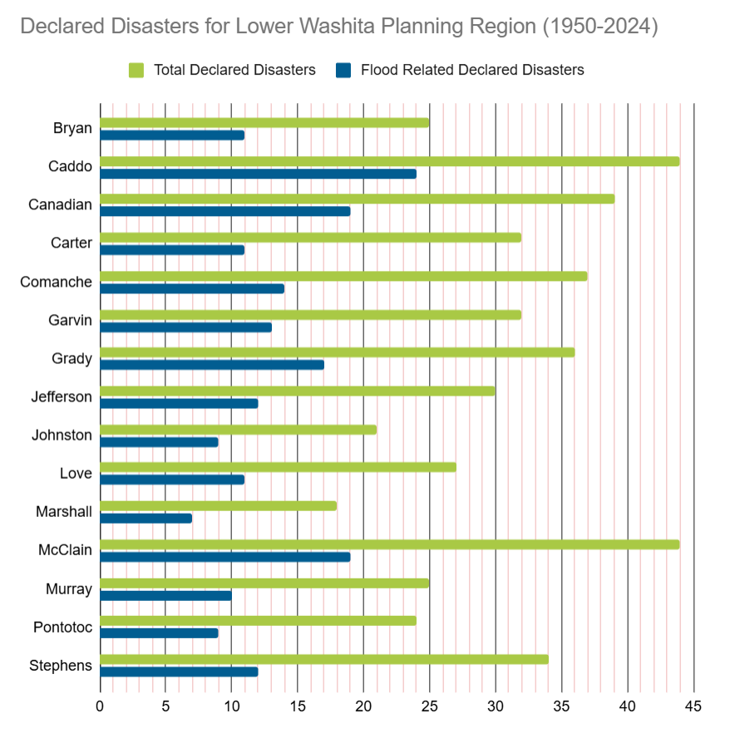

Among the counties within the Planning Region, Caddo County has experienced a higher frequency of disaster declarations due to flooding. It is important to acknowledge that disaster declarations are granted on a county-wide scale, and not all may have a direct impact on this watershed.

Vulnerability and Impacts of Flooding
In FEMA’s National Risk Index (NRI), a majority of the Lower Washita Planning Region has been evaluated as having a very low to relatively low risk at the county level for both river and flash flooding compared to the broader United States. This general trend holds true for most parts of the Region, except for a specific section in Comanche County's northeastern corner. However, when subjected to a more detailed analysis at the census tract level, the NRI indicates a sizable portion of these tracts have a relatively moderate risk rating. Certain localized areas, such as the east-central parts of Grady County and Caddo County, the southern region of Stephens County, and specific sections of Garvin County encompassing Lindsay and Pauls Valley, receive relatively higher risk ratings.
Annual precipitation varies from 32 inches in the western parts to 42 inches in the eastern areas. Typically, areas receiving lower rainfall correspond with higher elevations, except for the Arbuckle Mountains. Consequently, the prevailing pattern of drainage across the Planning Region is oriented eastward and southeastward, except for the immediate vicinity of the Washita River valley. Interestingly, certain zones alongside the Washita River correspond with those evaluated with an increased NRI rating.
Examining the NRI, it is apparent that the Lower Washita Planning Region exhibits a heightened risk of flooding in comparison to some other regions in Oklahoma. It is important to note that certain areas with an elevated overall risk can be found in various parts of the state, particularly in the eastern sections. This is a broad observation and should be interpreted alongside several contributing factors, including localized annual precipitation, the density of waterways and drainage areas, the presence of development in flood-prone locales, terrain incline, and the condition of aging infrastructure. It is worth mentioning that a more comprehensive analysis that encompasses these factors is not within the scope of this discussion.

Summary of Flood Exposure
Flood exposure pertains to the extent of vulnerability that an area or its population faces in the event of a flood occurrence. Table 4 furnishes a comprehensive snapshot of pivotal variables, encompassing the total quantity of housing units, population metrics, employment data, land area measurements, and the count of parcels/blocks located within the delineated FEMA-mapped flood zone.
Data in this section was generated using UrbanFootprint. The purpose of this data is to enable a comprehensive comprehension of the attributes and consequences associated with the flood-affected area. This module evaluates flood risk by conducting a spatial join of parcels or census blocks with the FEMA National Flood Hazard Layer to assess the potential risks associated with hazards. The data presented in the table below is focused on three different FEMA SFHA flood zones that represent areas within the 100-yr floodplain with a 1% annual chance of experiencing a flood event. Zone AE is the most detailed, providing base flood elevations, Zone AO represents areas subject to shallow flooding of depths between one to three feet, and Zone A is an approximation of the 100-yr floodplain for areas where detailed hydraulic analyses have not been performed.

Table 4: Flood Exposure in the Lower Washita Planning Region
Lower Washita Planning Region Flood Risk Report
Housing in Flood Hazard Zones (Dwelling Units)
Dwelling Units in SFHL Zone AE | 2,705
Dwelling Units in SFHL Zone A | 4,377
Dwelling Units in SFHL Zone AO | 214
Total | 7,296
Population in Flood Hazard Zones (Persons)
Population in SFHL Zone AE | 5,037
Population in SFHL Zone A | 9,333
Population in SFHL Zone AO | 965
Total | 15,335
Jobs in Flood Hazard Zones (Employees)
Jobs in SFHL Zone AE | N/A
Jobs in SFHL Zone A | N/A
Jobs in SFHL Zone AO | N/A
Total | N/A
Land Area in Flood Hazard Zones (Acres)
Area in SFHL Zone AE | 40,705
Area in SFHL Zone A | 535,455
Area in SFHL Zone AO | 299
Total | 576,459
Parcels or Block in Flood Hazard Zones
Parcels or Blocks in SFHL Zone AE | N/A
Parcels or Blocks in SFHL Zone A | N/A
Parcels or Blocks in SFHL Zone AO | N/A
Total | N/A

Flood Mitigation Needs
Flood mitigation projects for the Region have been identified at a county level through the analysis of HMPs, master drainage plans at the community level, and prioritized lists provided by jurisdictions. The following stormwater project types were considered:

- Channel
- Storm Drain
- Infrastructure
- Detention Pond
- Dam-Reservoir
- Floodwalls and Levees
- Acquisition

Flood mitigation initiatives within the Region are identified through various channels, including a county-level assessment of HMPs and online Geographical Information System (GIS) resources. Similarly, at the community level, projects are identified through master drainage plans while prioritized lists furnished by respective jurisdictions have also contributed to this endeavor.
Within the Region, a total of three stormwater projects were reported. Significant endeavors entail the repair of dams at Clear Creek Lake in Stephens County and Paul’s Valley Lake in Garvin County, with a cumulative investment of $23.1 million. An additional project, totaling $620,200, pertains to drainage enhancements near Marietta in Love County. Table 5 provides a comparative breakdown of these projects in relation to one another and in the context of various other types of stormwater initiatives.
Table 5: Stormwater Projects Identified in the Lower Washita Planning Region
Stormwater Project Types Per County | Number |  |  | Percentage | $ Amount
Garvin County
Dam-Reservoir |  | 1 | 33.3% |  | $16.8M
Love County
Storm Drain |  | 1 | 33.3% |  | $620.2k
Stephens County
Dam-Reservoir |  | 1 | 33.3% |  | $6.3M
Total | 3 |  |  | - | $23.8M

An alternative approach to mitigate the detrimental impacts of stormwater on a community involves acquiring properties or structures situated within flood-prone regions for subsequent demolition and return to green space. Property acquisition aimed at structures within flood-prone areas has been identified as a course of action in the HMPs of Canadian, Bryan, and McClain Counties, along with the City of Ardmore.

Conclusion
Although the overall flood risk within the Lower Washita Planning Region is relatively low to moderate, there remain opportunities to elevate the Region's resilience. Communities can bolster their preparedness by engaging in hazard mitigation activities, such as joining NFIP and participating in CRS, while also formulating and executing stormwater projects that align with engineering initiatives, ultimately diminishing the overall risk to the area.

Through the allocation of resources and supportive measures for project identification and development, communities stand to enhance their comprehension of flood exposure, enabling proactive safeguarding of lives and infrastructure. The investment of engineering and flood mitigation within the Lower Washita Planning Region will contribute significantly to the creation of more secure and resilient communities, better equipped to effectively manage forthcoming flood incidents.

During the planning process, the data was used to create an interactive online GIS flood planning dashboard. This dashboard facilitates comprehensive flood assessments at the community level. It is crucial to emphasize that while this report offers a comprehensive overview, it should not replace locally tailored data unique to each individual community.

This calculation was performed by summing the populations of the counties within this region, as indicated in Table 1, then divided by the entire population of the State of Oklahoma using the same data source (2020 U.S. Decennial Census).
Bryan County’s HMP includes the Towns of Mead, Silo, and the City of Durant.
Caddo County’s HMP will include the Towns of Binger, Cement, Cyril, Gracemont, Hinton, Lookeba.
Carter County’s HMP includes the Towns of Dickson, Gene Autry, Ratliff City, Springer, Tatums, and the Cities of Healdton, Lone Grove, and Wilson.
Comanche County’s HMP includes the Town of Fletcher.
Garvin County’s HMP includes the Town of Foster.
Grady County’s HMP includes the Town of Alex, Amber, Bradley, Bridge Creek, Ninnekah, Norge, Pocasset, Rush Springs, Verden and the City of Chickasaw.
Johnston County’s HMP includes the Town of Ravia and the City of Tishomingo.
Love County’s HMP includes the Towns of Leon, Thackerville, and the City of Marietta.
Marshall County’s HMP includes the Town of Kingston and the City of Madill.
McClain County’s HMP includes the Towns of Byars, Dibble, Wayne, and the Cities of Blanchard, and Purcell.
Murray County’s HMP includes the Towns of Dougherty and Hickory.
Stephens County’s HMP includes the Towns of Bray, Loco, Velma, and the Cities of Comanche, Duncan, and Marlow.
FEMA’s National Risk Index (NRI) is a tool used to calculate a community’s potential for negative impacts due to natural hazards and community risk factors. The three components used in the NRI equation that generates the Risk Index Score are expected annual loss due to natural hazards, social vulnerability, and community resilience.
Any counties that do not appear in the table do not have any identified projects.

