Table of Contents
The Lower Arkansas Planning Region 1
Section 1.1: Watershed Introduction 1
Section 1.2: Socioeconomic and Geographic Characteristics 2
Section 1.3: Floodplain Management and Mitigation Capabilities 5
Section 1.4: Flood Hazard Assessment 10
Section 1.5: Flood Mitigation Needs 14
Section 1.6: Conclusion 15

The Lower Arkansas Planning Region

Watershed Introduction
Stretching over 4,675 square miles, the Lower Arkansas Watershed Planning Region (Region) spans across 10 counties in eastern Oklahoma, and encompasses all or part of Adair, Cherokee, Delaware, Haskell, McIntosh, Muskogee, Latimer, Le Flore, Pittsburg, and Sequoyah counties. 52 municipalities and three tribal nations are located here. The Arkansas, Canadian, Illinois, and Poteau Rivers, along with their various tributaries, are the major waterways in the Lower Arkansas Watershed.
Figure 1 highlights the geographic boundaries of the planning area for this Region of the State.
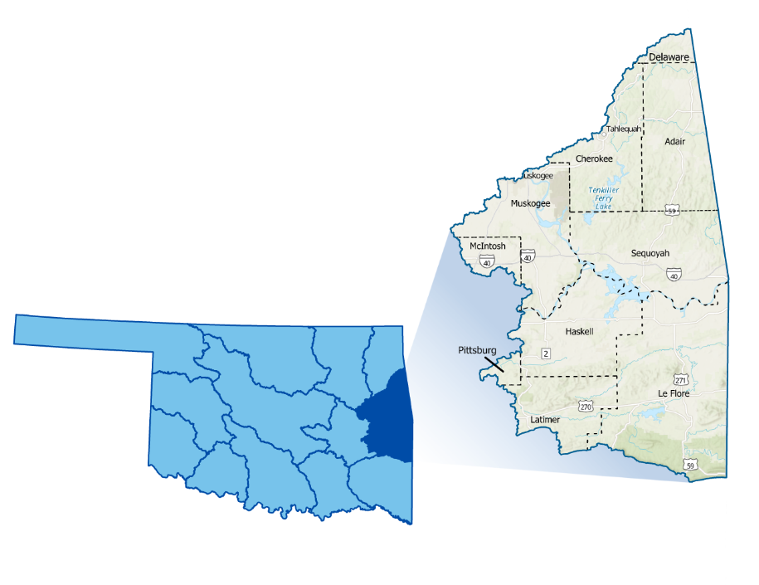
Figure 1: Lower Arkansas Boundary

The Lower Arkansas watershed stands out due to its unique drainage system centered around the Arkansas River and its tributaries, making it one of Oklahoma's most flood-prone areas. While the Region is not as densely populated as the Middle Arkansas Region, it still has a considerable number of larger cities and many rural ones, increasing its flood vulnerability. Additionally, many rural areas, small towns, and at-risk populations are located within the watershed. Muskogee, serving as the population center, has a history of grappling with floods. All counties in the planning area have experienced multiple federally declared flood disasters since 1970.
A base map displaying incorporated jurisdictions within the Planning Region is shown in Figure 2.
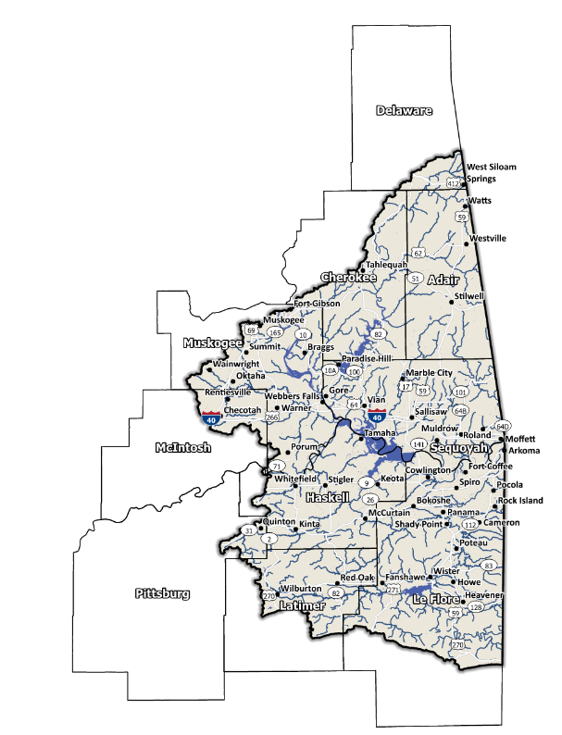
Figure 2: Lower Arkansas Planning Region Base Map

Socioeconomic and Geographic Characteristics
The area's population is one of the most diversified in Oklahoma with minorities being the majority in two counties. A mix of industries, including livestock, agriculture, and oil and gas, bring economic variety to this Region. This section will examine some of these socioeconomic and geographic factors and how they contribute to and affect this watershed.

Demographic Profile
The Lower Arkansas Watershed Planning Region encompasses over 340,000 people with a mix of urban, suburban, and rural areas. This Region represents approximately 6.8% of Oklahoma's land area, and around 9% of Oklahoma residents call this area home according to the 2020 U.S. Census.
Provided by the 2020 U.S. Census, these statistics represent county-level populations, not those within the watershed boundary. Adair and Sequoyah Counties are the only two in the group that are completely contained within the Lower Arkansas Watershed Region.
Table 1: Population Breakdown by County in the Lower Arkansas Planning Region
County | Total Population
Adair | 19,495
Cherokee | 47,078
Delaware | 40,397
Haskell | 11,561
Latimer | 9,444
Le Flore | 48,129
McIntosh | 18,941
Muskogee | 66,339
Pittsburg | 43,773
Sequoyah | 39,281

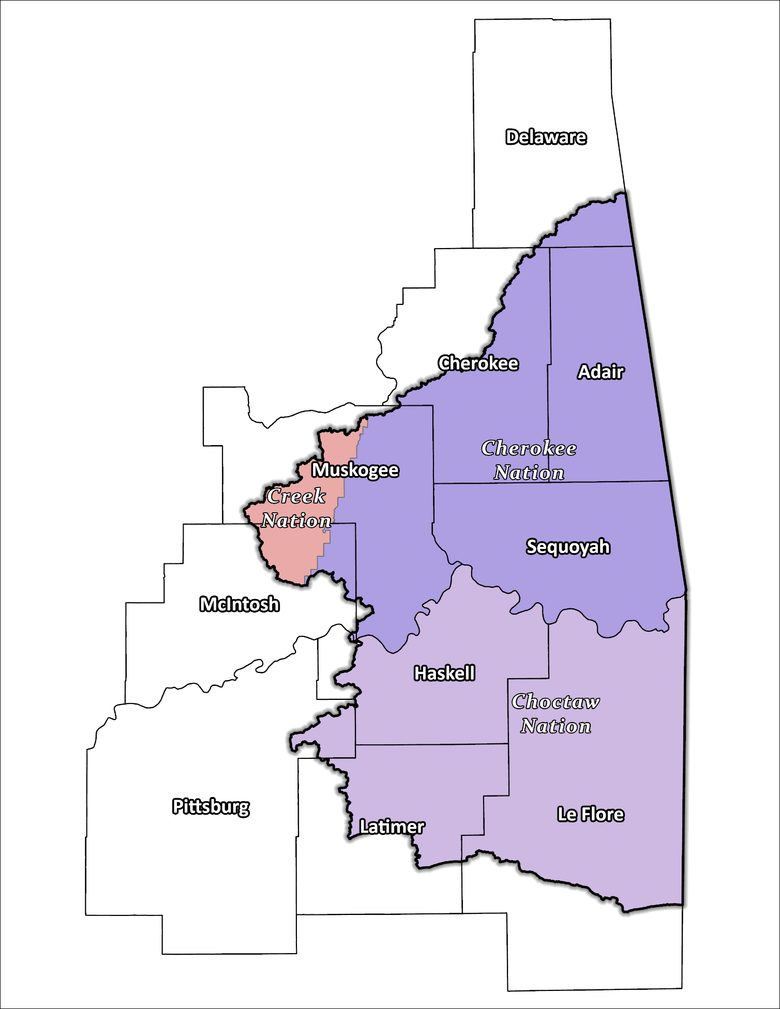
Figure 3: Tribal Jurisdiction Base Map for Lower Arkansas Planning Region

The Region is home to three Native American tribes, the Cherokee, Choctaw and Muscogee (Creek) Nations. These tribes have a long-standing history of inhabiting the Region and have significantly shaped the area's cultural and economic development.

Economic Profile
The Lower Arkansas Planning Region has significant economic importance in the state and the country. Muskogee is a large city with many medical and support facilities especially for veterans, as well as numerous manufacturing plants that employ hundreds of workers in the area. The tribal nations in east central Oklahoma are significant employers in the Region. They operate in various industries, including gaming, hospitality, and retail. Additionally, the tribal nations support growth and development in the area through investments in infrastructure, education, and healthcare.

Floodplain Management and Mitigation Capabilities
This section provides a broad summary of floodplain management capabilities and community engagement within the overall Lower Arkansas Planning Region.

National Flood Insurance Program Participation
Within the Planning Region, all counties except Haskell have been mapped by Federal Emergency Management Agency (FEMA) and participate in the National Flood Insurance Program (NFIP). There are few communities within the 10 counties, however, that do not currently participate in the NFIP program, as shown in Figure 4, below.

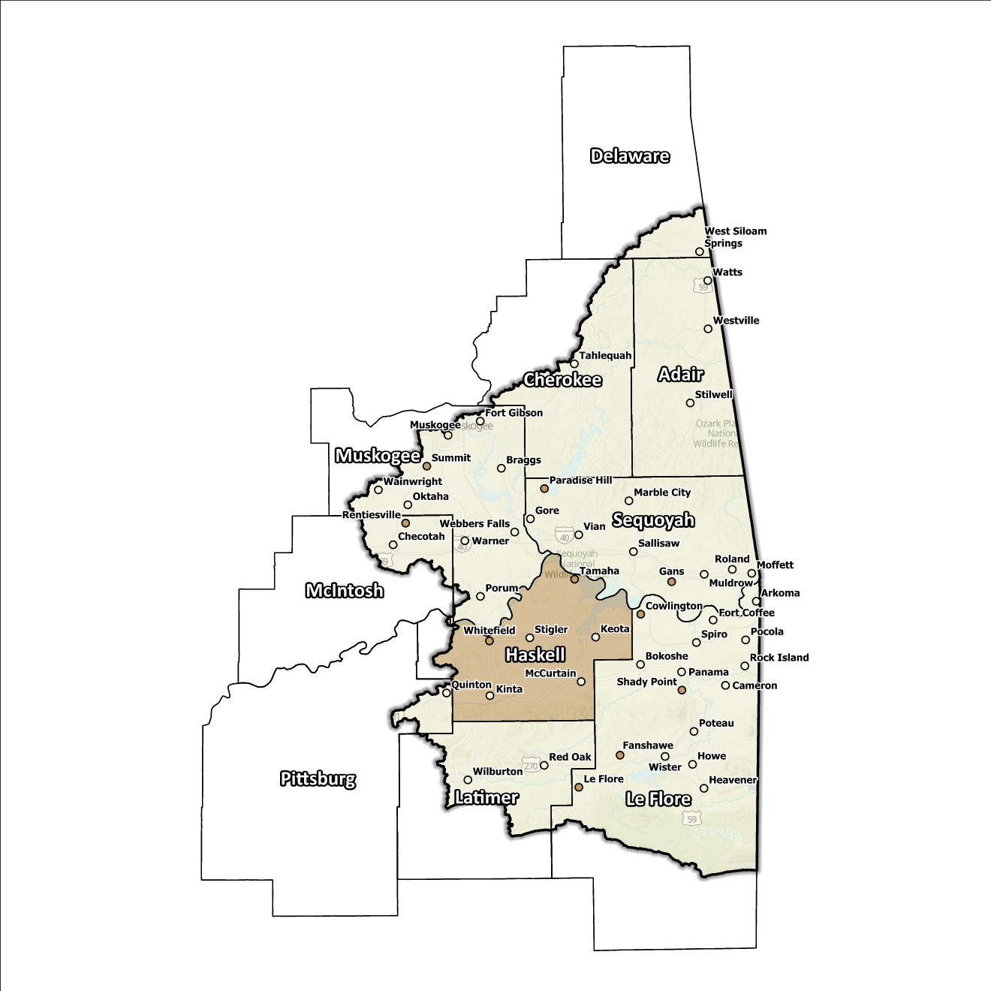
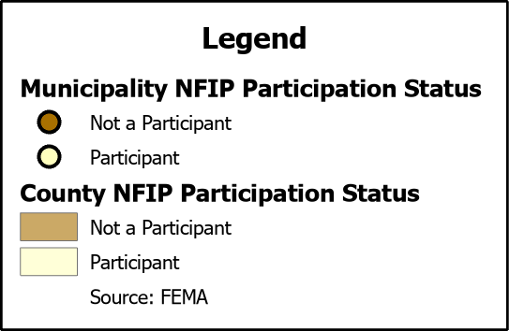
Figure 4: Status of NFIP Participation in the Lower Arkansas Planning Region

The dedication to floodplain management by jurisdictions in this Planning Region is well demonstrated by participation in the NFIP which includes all but one of the ten counties. Even though none of the counties in the Region participate in FEMA’s Community Rating System (CRS), select communities go above and beyond the minimum NFIP requirements and could be used as an example for best practices and knowledge sharing in other portions of the State.

Flood Insurance Coverage
As of the latest update, there are currently 455 active NFIP policies in effect within the planning area. These policies cover approximately 7.3% of the total structures located in the FEMA mapped Special Flood Hazard Area (SFHA). It should be noted that not all active policies are situated within the SFHA. A total of 494 NFIP claims have been filed, resulting in approximately $21 million being paid out to policyholders. In the Region, there are 53 structures classified as repetitive loss (RL) and/or classified as severe repetitive loss (SRL), with a significant concentration of both types in Muskogee County. Repetitive loss, in the context of the NFIP, refers to properties that have experienced multiple flood-related insurance claims over a specific time period. Severe repetitive loss, on the other hand, pertains to properties with an extensive history of recurrent flood damage and a high number of insurance claims, making them particularly vulnerable and costly for the NFIP.
The subsequent displays provide a range of information about NFIP policies, as well as the total claims filed and paid in the Planning Region. Although these figures are insightful, it's crucial to recognize they may not accurately reflect the true extent of losses in the area due to an underrepresentation of flood insurance. Not every claim filed or paid is linked to an active policy.

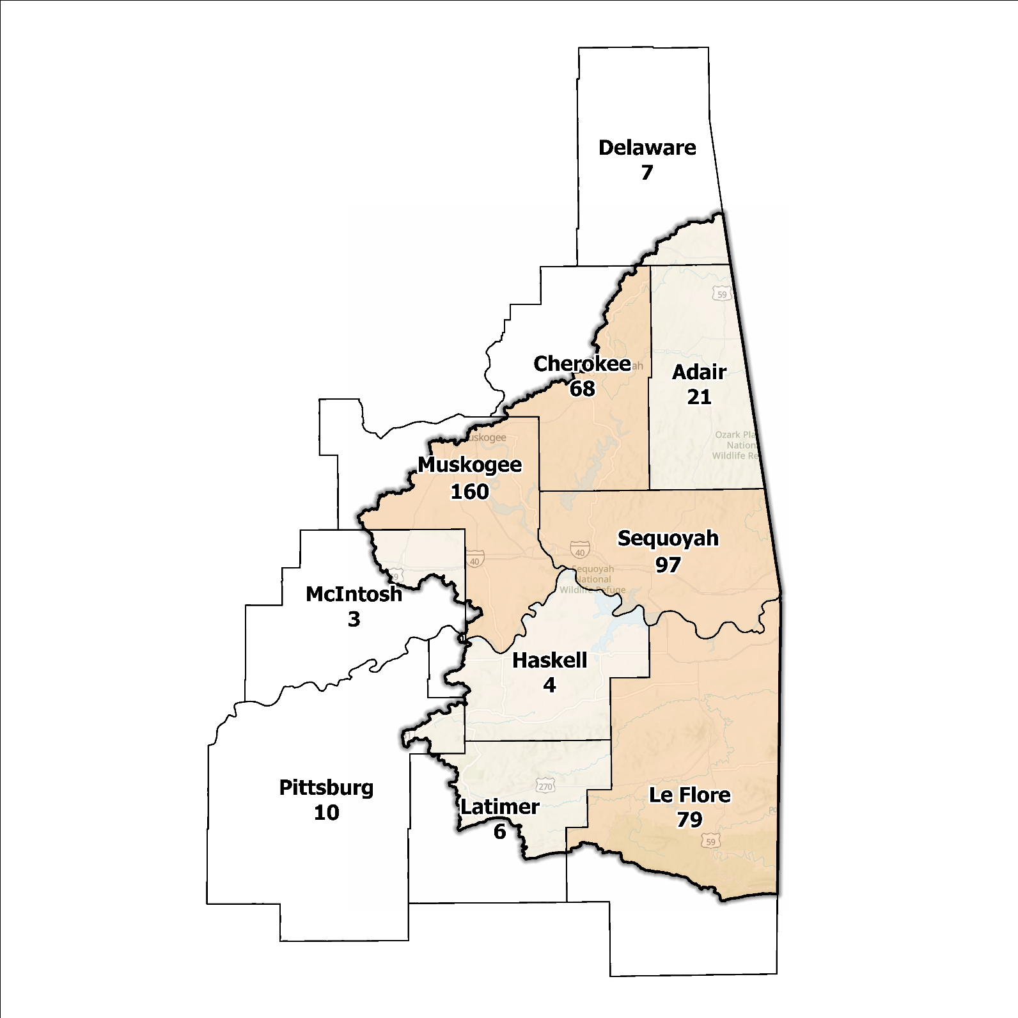
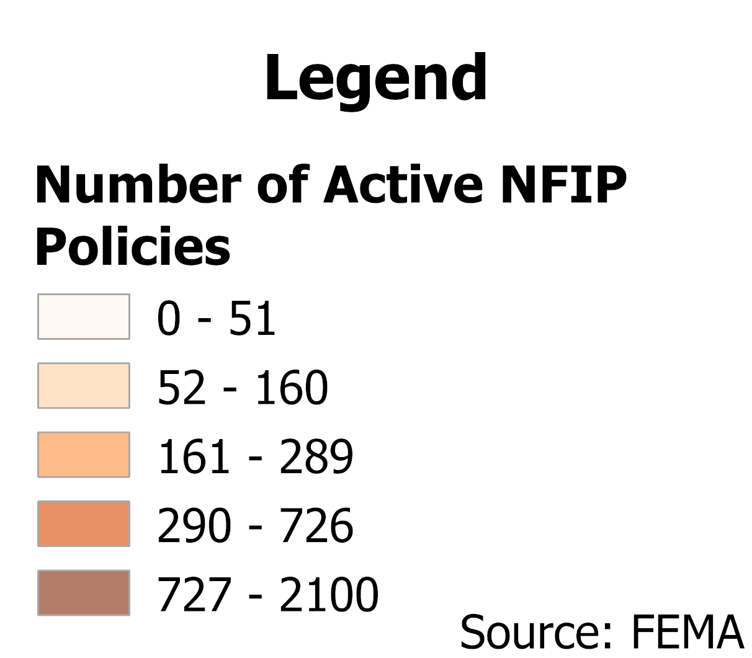
Figure 5: Number of Active NFIP Policies in the 100-Year Floodplain in the Lower Arkansas Planning Region

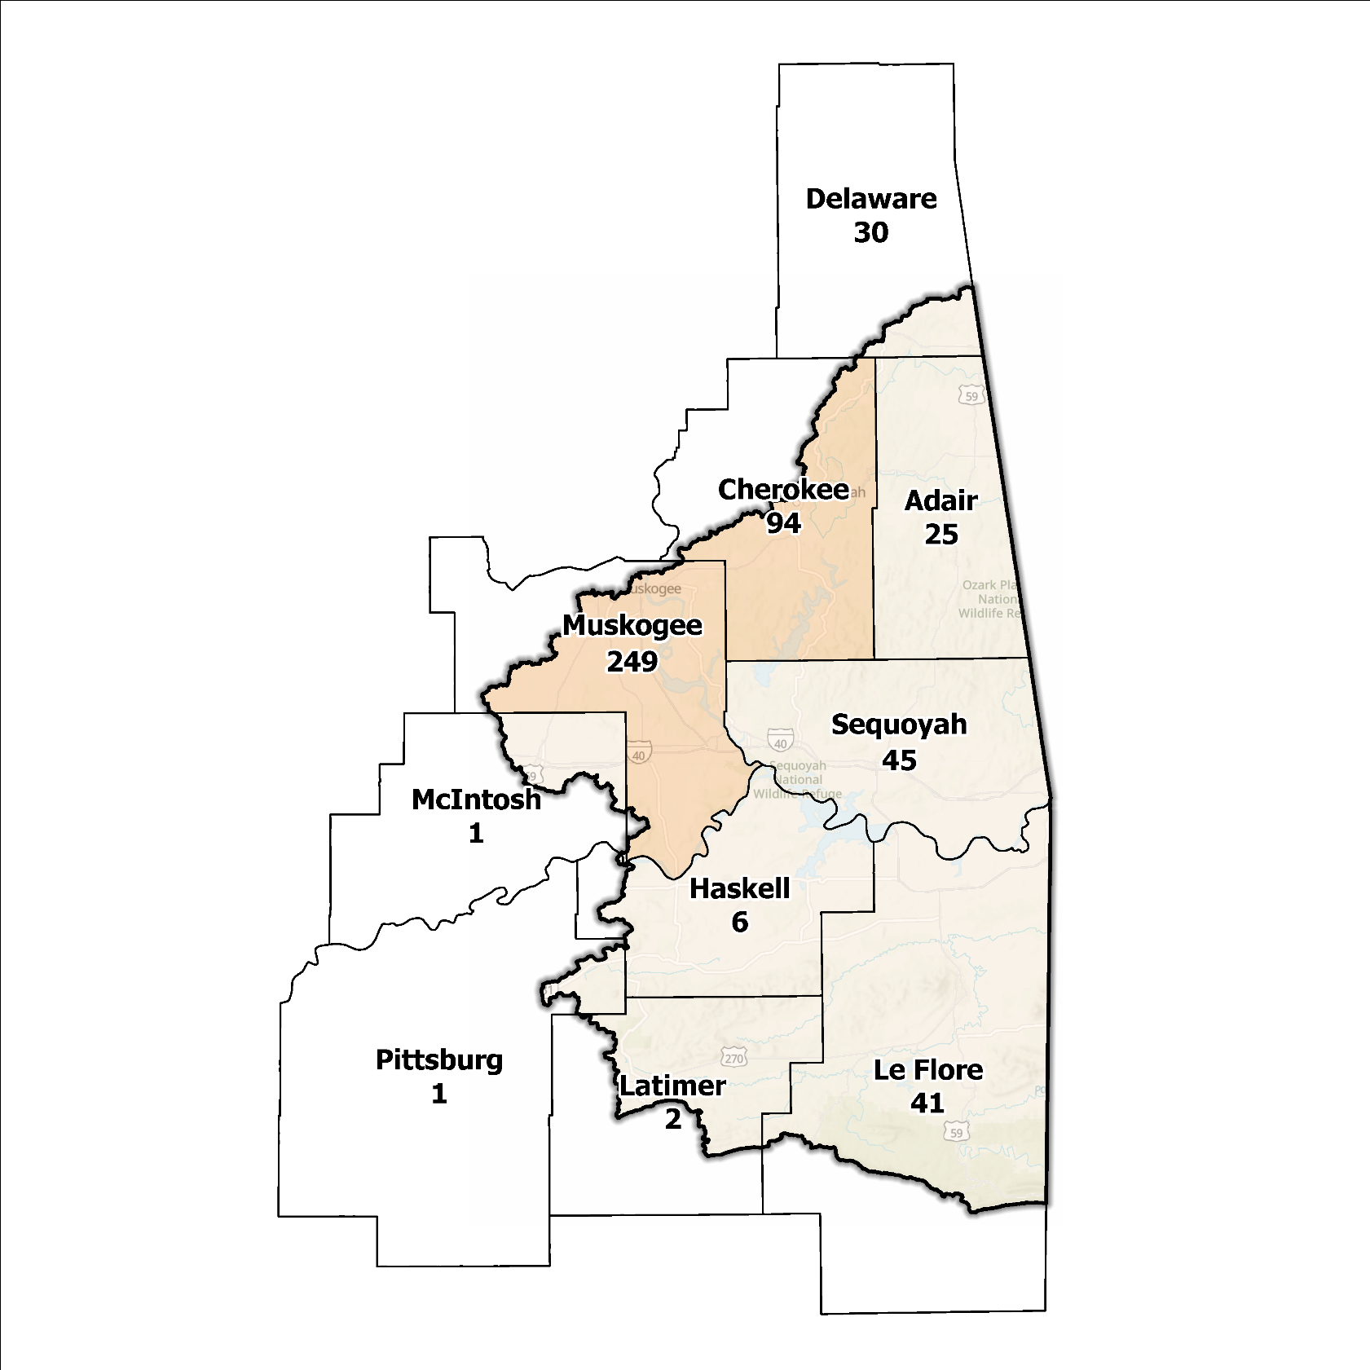
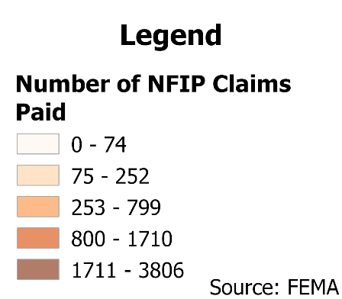
Figure 6: Total NFIP Claims Paid in the Lower Arkansas Planning Region

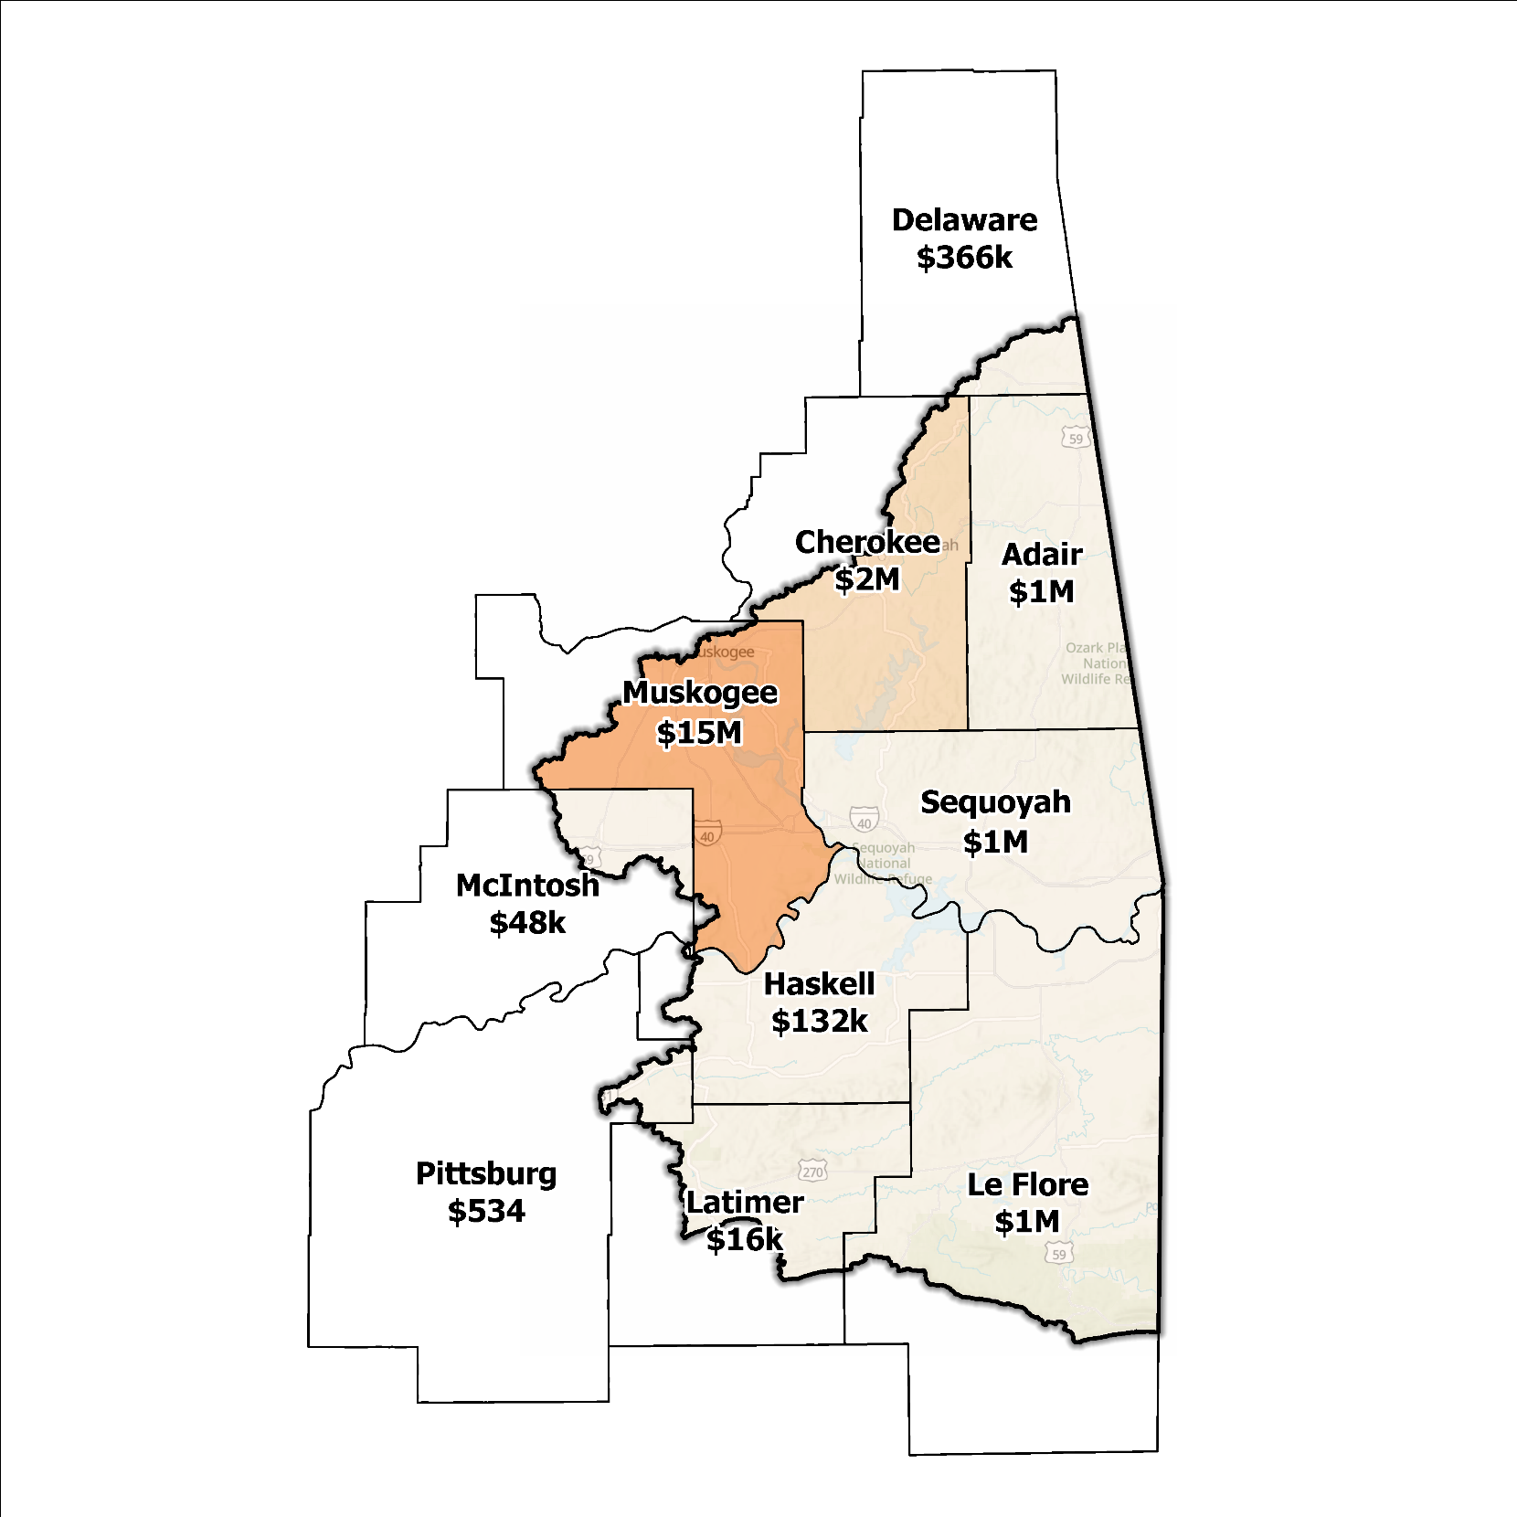
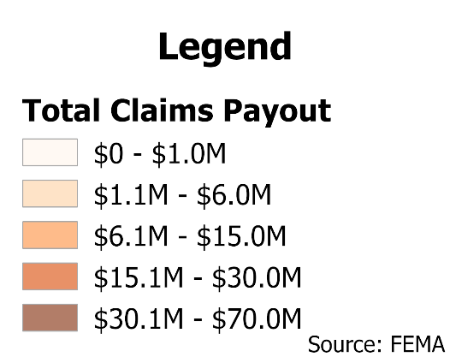
Figure 7: Total Value NFIP Claims Paid Out in the Lower Arkansas Planning Region

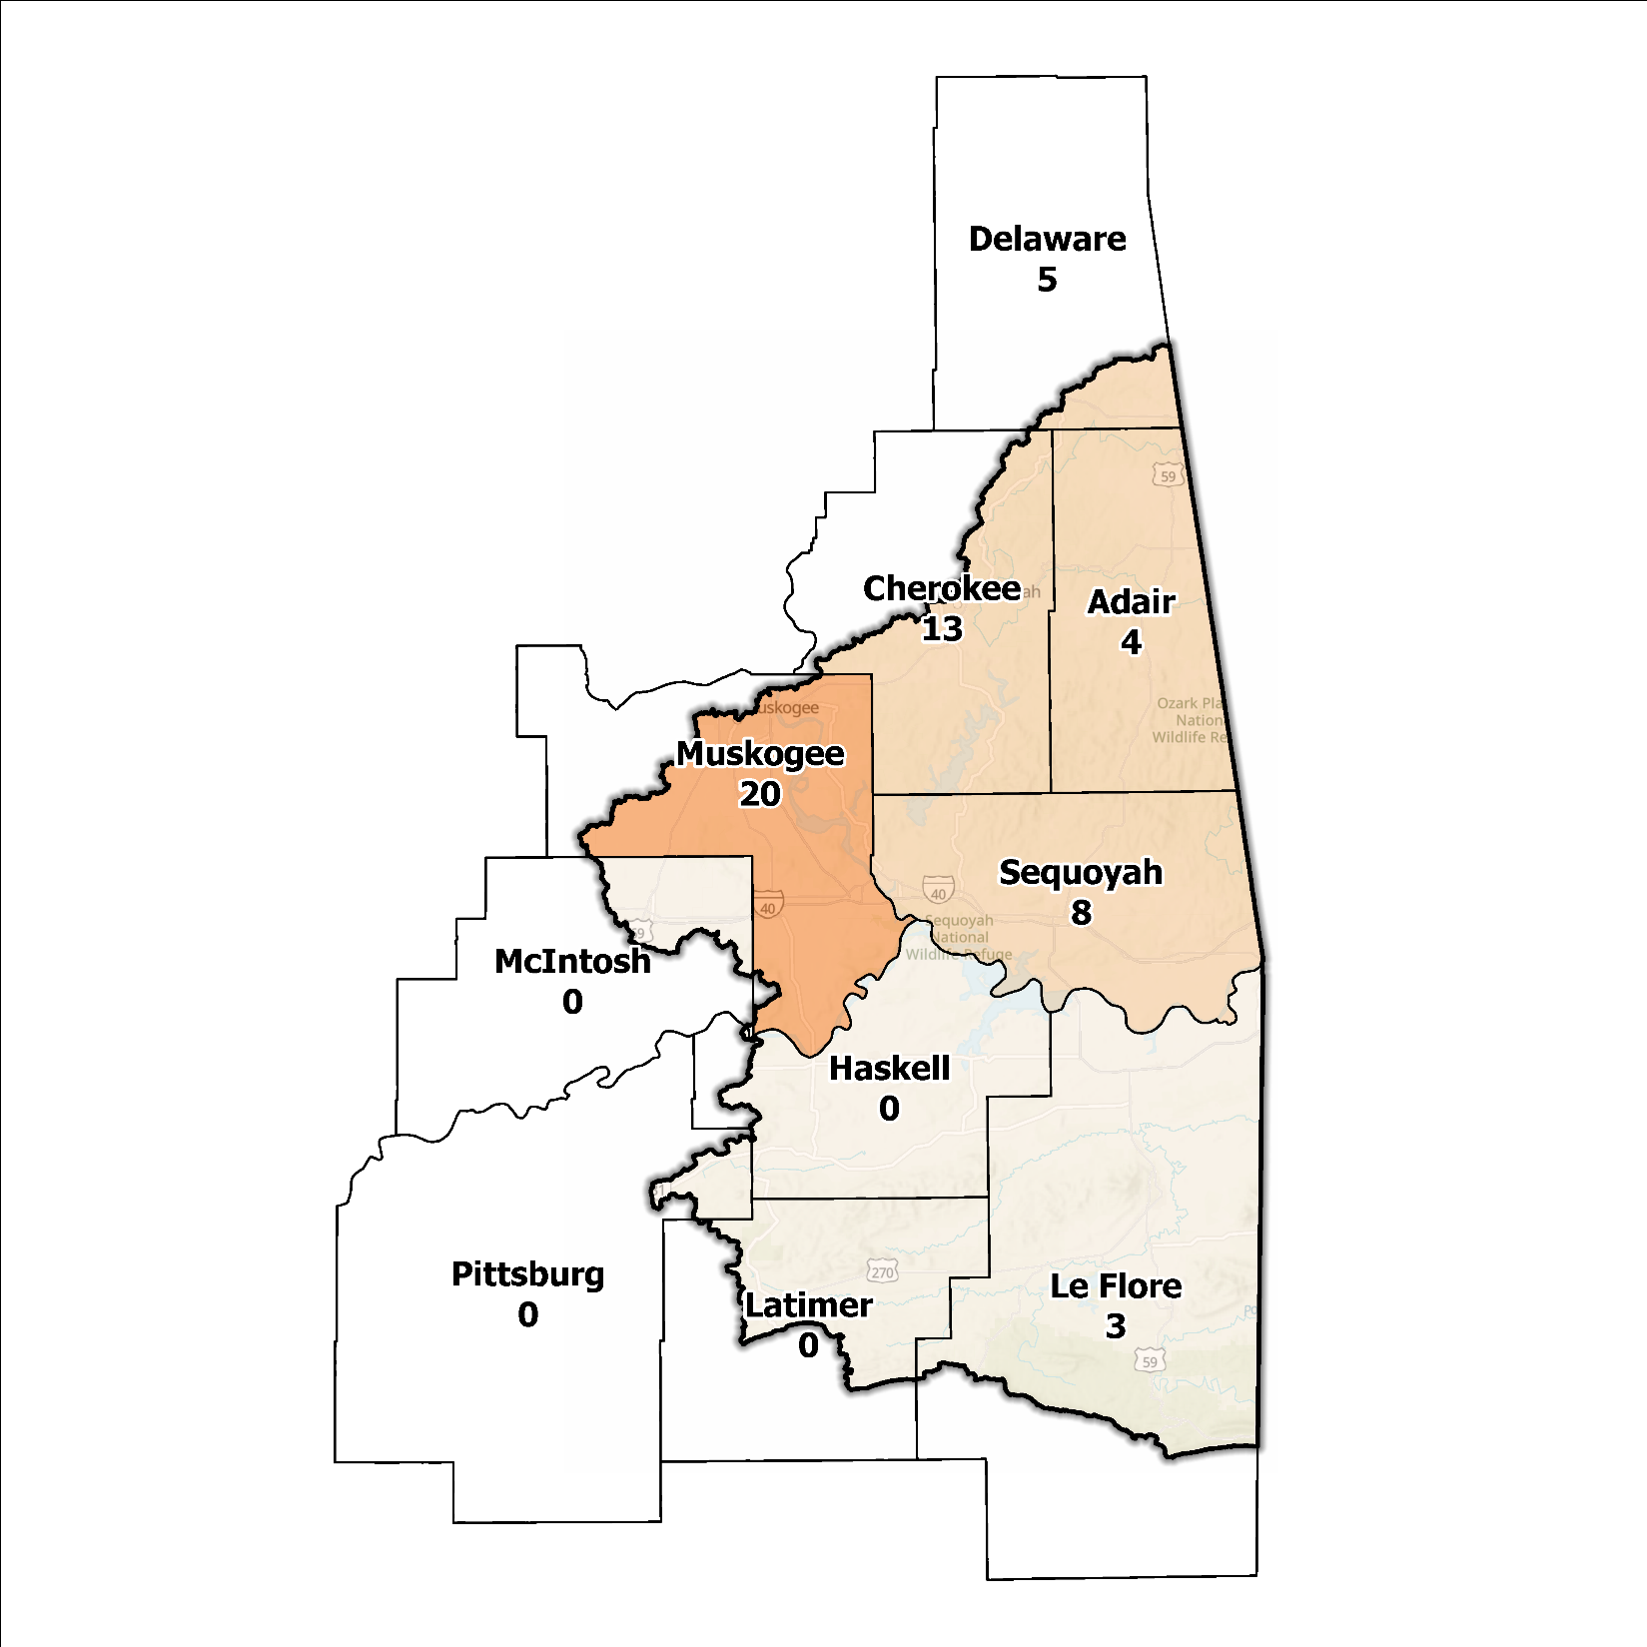
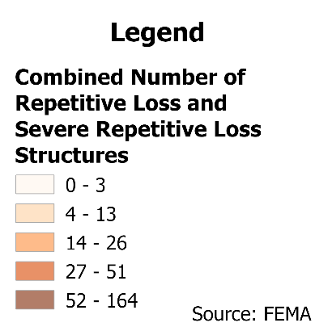
Figure 8: Repetitive Loss and Severe Repetitive Loss Structures in the Lower Arkansas Planning Region

Flood Funding Mechanisms
A survey conducted by the planning team to determine the level of funding for stormwater and floodplain management in the Lower Arkansas Planning Region revealed that most of the smaller rural communities have limited local funding. Some larger, more urban jurisdictions, such as the City of Muskogee, are more likely to be effective when implementing stormwater utility fees and have success in funding departments for facilitating management activities. In contrast, other jurisdictions have achieved marginal results in the utilization of local taxes, fees, and funds.

Hazard Mitigation Plan Status
Six out of ten counties in this Region possess a FEMA-approved Hazard Mitigation Plan (HMP) and the identified mitigation actions vary in jurisdictions. Several identify basic programmatic and administrative activities, such as planning, education, acquiring or implementing warning systems, and participating in the NFIP. In contrast, others intentionally list flood mitigation projects such as property buyouts, dam repair, road and drainage improvements, floodplain restoration, and other flood-specific activities. Flash, riverine, and urban flooding are the most frequently reported problems across the planning area. Several communities and some Tribal Nations in the Region have individual HMPs separate from their respective counties.

Table 2: Hazard Mitigation Planning Status in the Lower Arkansas Planning Region
Name | Type | Approval Date | Expiration | Current Action Status of this Plan
Adair | County | 03/30/2022 | 03/29/2027 | Approved
Cherokee | County | 09/19/2022 | 09/18/2027 | Approved
Tahlequah | City | 09/19/2022 | 09/18/2027 | Approved
Delaware | County | 12/11/2023 | 12/10/2028 | Approved
Haskell | County | 01/23/2017 | 01/23/2022 | Expired
Latimer | County | 08/08/2018 | 08/07/2023 | Expired
Le Flore | County | 09/15/2022 | 09/14/2027 | Approved
McIntosh | County | - | - | N/A
Muskogee | County | 04/17/2024 | 04/16/2029 | Approved
Pittsburg | County | 03/09/2022 | 03/08/2027 | Approved
Sequoyah | County | - | - | N/A
Cherokee | Tribal Nation | 02/08/2023 | 02/07/2028 | Approved
Choctaw | Tribal Nation | 05/21/2020 | 05/20/2025 | Approved
Creek | Tribal Nation | 12/01/2021 | 11/30/2026 | Approved

Flood Mapping Assessment
In the Lower Arkansas Planning Region, the floodplain quilt consolidates the best available data on flood risk. However, some areas in the Region still need to be mapped by FEMA, limiting the ability of local authorities to regulate development in flood-prone areas.
A notable aspect in the Region is almost all of the effective FEMA maps still need detailed studies. This leaves floodplain managers relying on Approximate A Zones, which offer a broad understanding of flood risk but do not have determined Base Flood Elevations (BFE). Figure 9 displays FEMA-mapped areas in the Planning Region.
While in areas with A zones, Base Level Engineering (BLE) data might provide a more accurate indication of flood risk, it is of note that most of the Lower Arkansas Planning Region has ample BLE coverage. BLE assists in determining areas that are expected to flood and therefore are not reasonably safe from flooding. The need for in-depth studies is still needed for precision and reliability of flood risk information.
Le Flore, Muskogee, and Sequoyah Counties stand out among areas in the Planning Region for having the most extensive flood risk assessment information. Investment in floodplain mapping has been higher in these areas than in others in the Region.
While Flood Insurance Rate Maps (FIRMs) are beneficial for regulatory uses and flood insurance assessments, they only represent potential risks associated with a flood event under certain specific conditions. The threat of flooding beyond the FEMA mapped SFHA is only included on FIRMs if the community opts to carry out the required studies to integrate such data into their hazard map.
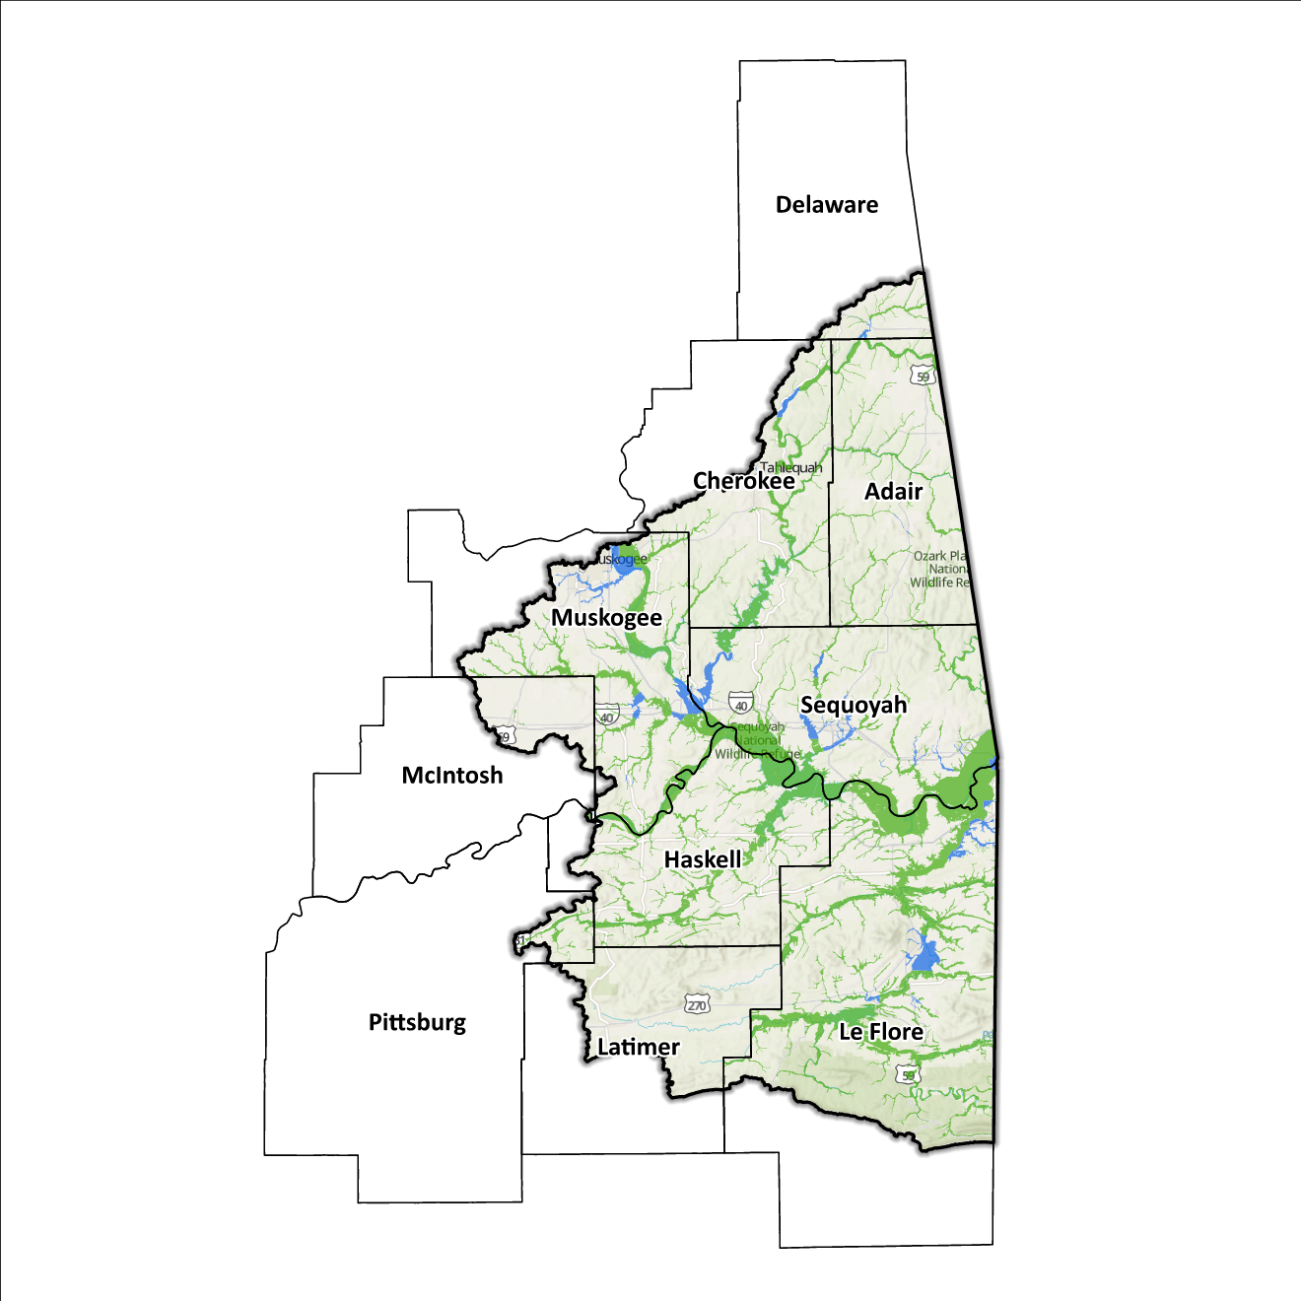
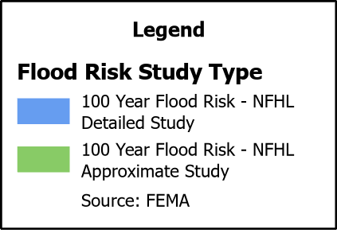
Figure 9: FEMA Mapped Special Flood Hazard Area Comparison in the Lower Arkansas Planning Region

2020 USGS Stream Gage Report
Following the 2019 Arkansas River flooding event, the United States Geological Survey (USGS) released a stream gauge report in conjunction with a series of United States Army Corps of Engineers (USACE) to examine whether the documented peak streamflow data collected at USACE sites accurately represented flood risk during these types of flood events. Findings suggested that analytical methods for calculating annual exceedance probabilities (AEPs) for streams (such as the Arkansas River) that are heavily regulated by USACE flood-control dams are not appropriate. Instead, a new model called 2020 RiverWare was developed by the USACE Tulsa District which allows for more accurate BFE metrics to be determined. Most notably are dramatic reductions in flow rates at the Tenkiller Ferry Dam, while the Port of Muskogee gauge showed an increase. Relating these to BFE changes, results were inconclusive, and further studies are recommended before any flood risk mapping changes take effect.

Flood Hazard Assessment
Flood hazards in this Region include flash, river, and urban flooding. The Arkansas, Canadian, Illinois, and Poteau Rivers, along with their various tributaries, are the major waterways found in the Lower Arkansas Watershed.

Location of Flood Hazards
The Lower Arkansas Planning Region is characterized by a flood hazard that encompasses various significant aspects. The flood location in the Lower Arkansas Planning Region exhibits the following characteristics:
- Flooding along major waterways with extensive drainage basins, including the Arkansas, Canadian, Illinois and Poteau Rivers.
- Flash floods along smaller tributaries that ultimately flow into the major waterways.
- Drainage issues in specific areas result from inadequate infrastructure. Insufficient drainage systems can exacerbate flood risks, leading to localized flooding in vulnerable locations.
- Downstream areas located below high-hazard potential dams are exposed to heightened risks.
Figure 10 shows mapped areas of flood risk in the Region. The map brings together data from different sources, like the National Flood Hazard Layer and BLE, to create a unified view. It prioritizes layer types and shows the most important layer available for a specific area.
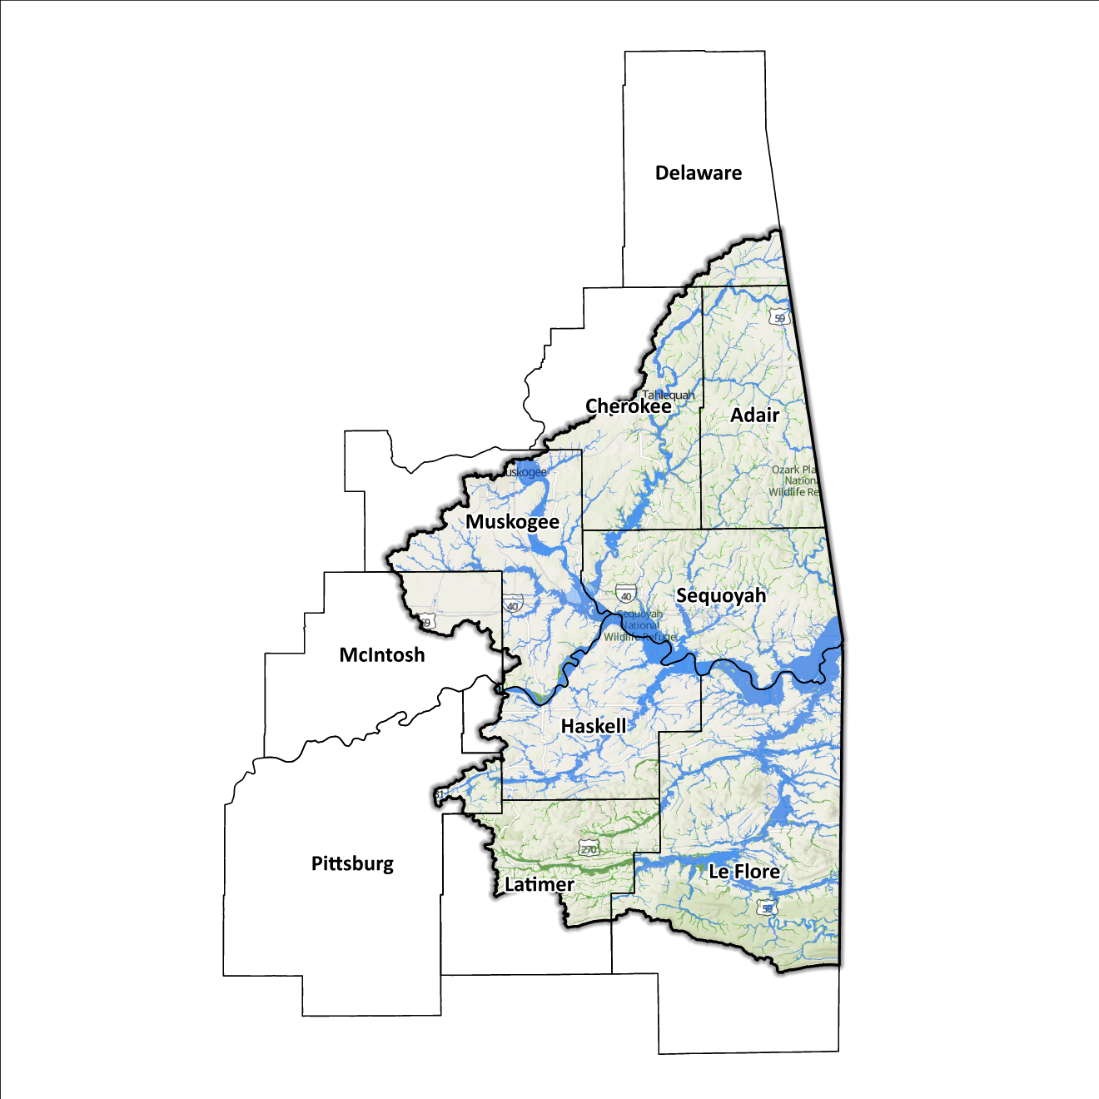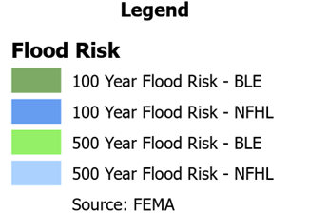
Figure 10: Flood Quilt in the Lower Arkansas Planning Region

Dam and Levee Infrastructure
The Region has multiple dams and levees aimed at preventing flooding. However, aging infrastructure increases the risk of downstream impacts if a breach or failure occurs, especially for high-hazard dams classified by the Oklahoma Water Resources Board (OWRB). The 10 counties have 60 high-hazard dams, with 47 located in the Lower Arkansas Watershed. A map of dam and levee locations within the Region is shown in Figure 11.
The Lower Arkansas Watershed Region has a single levee system in Muskogee county along Coody Creek. State and local officials can find information on these systems on the USACE National Levee Database website. Although the Lower Arkansas Watershed Region concludes at the Arkansas/Oklahoma state line, the flood risks associated with dams and levees transcend its boundaries.
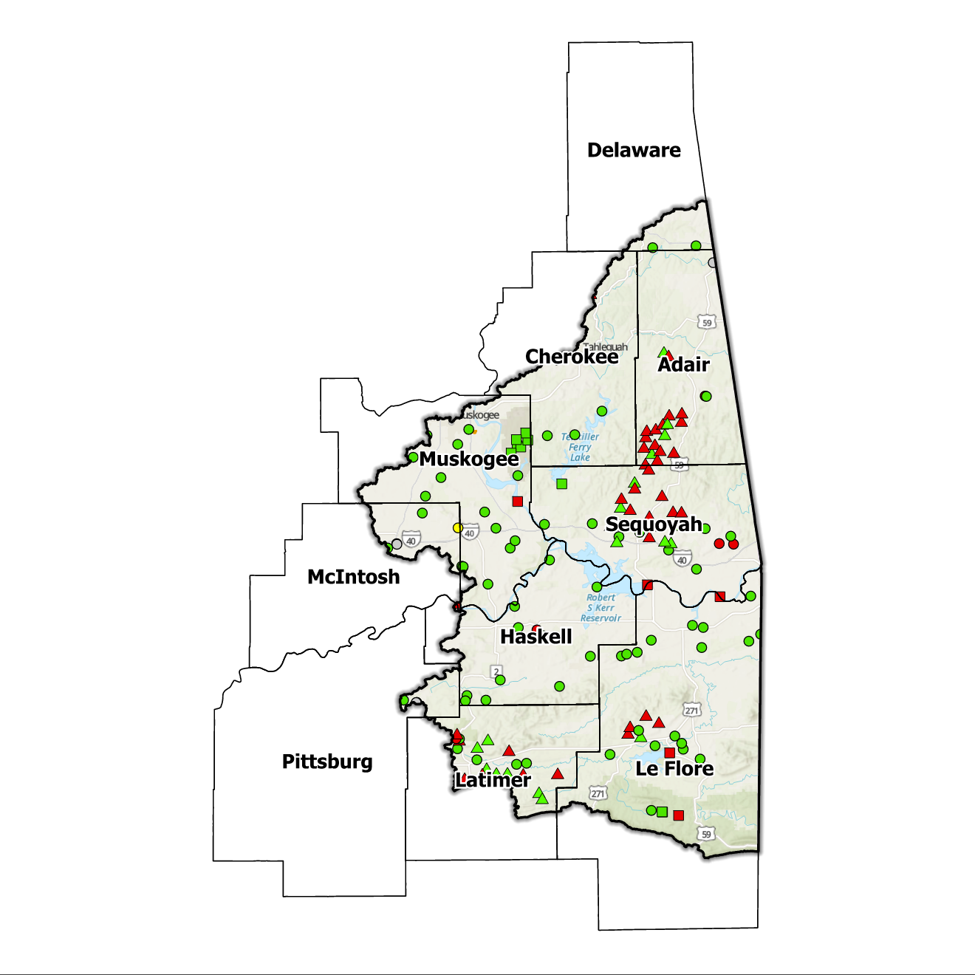
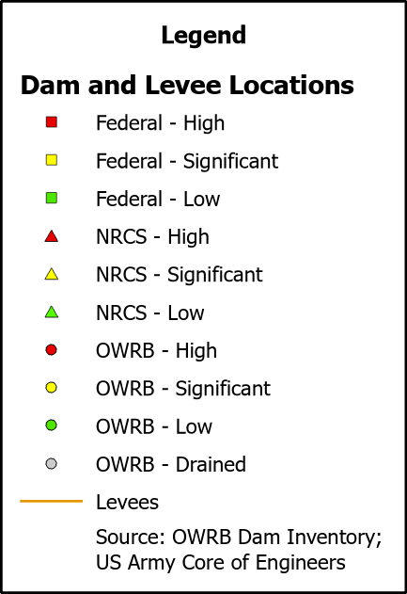
Figure 11: Dam and Levee Locations in the Lower Arkansas Planning Region

Extent of Flooding
Extent refers to the expected severity of flooding, and because not all areas within the planning area share the same topography, the extent varies between individual communities. The average depth of flooding within the FEMA-mapped SFHA can range from a few inches to several feet, depending on factors such as topography, proximity to water bodies, local drainage characteristics, and the intensity of the flood event.

Previous Occurrences
According to the records maintained by the National Center of Environmental Information (NCEI), from January 1996 to December 2022, a total of 849 flood events have been documented in the 10 counties encompassing this Planning Region. Cumulatively, these flooding incidents have caused property damage amounting to $8,652,000.
The NCEI initiated the tracking of flood events only from 1996, hence this data represents the most comprehensive information available. Flooding has frequently escalated to the point of necessitating a Presidential Disaster Declaration. A breakdown of flood-related disasters by county is shown in Table 3.
Table 3: FEMA Flood Related Disaster Declarations (1950-2024) in the Lower Arkansas Planning Region
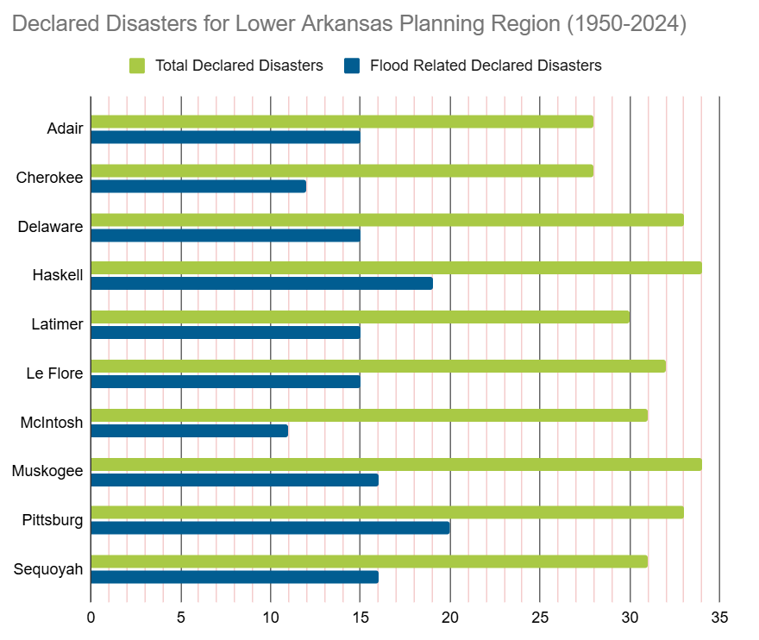
Of all the counties in the Region, Pittsburg County has most frequently been declared a disaster area due to flooding. However, it's important to note that disaster declarations are issued on a county-wide basis and not all declarations may have directly impacted this specific Region.

Vulnerability and Impacts of Flooding
According to FEMA’s National Risk Index (NRI), the Lower Arkansas Planning Region demonstrates a range of risk levels for river flooding and flash flooding, varying from very low to relatively moderate risk at the county level, when compared to the rest of the United States. However, when examined at a more granular scale by census tract, the NRI highlights specific areas along the Arkansas River, particularly in Adair, Cherokee, and Sequoyah counties, as being at a moderate risk of flooding.
Compared to other regions in Oklahoma, the Lower Arkansas Planning Region is at a higher risk of flooding due to multiple factors including high annual precipitation, a large number of waterways and drainage areas, development in flood-prone locations, poverty levels, and aging infrastructure.

Summary of Flood Exposure
Flood exposure refers to the degree to which an area or population is at risk of being affected by a flood event. Table 4 provides a comprehensive overview of key factors, including the total count of housing units, population figures, job statistics, land area measurements, and the number of parcels/blocks within the designated FEMA-mapped flood area. This information aims to facilitate a thorough understanding of the flood-affected area's characteristics and implications.
The data in this section was generated using UrbanFootprint. This module evaluates flood risk by conducting a spatial join of parcels or census blocks with the FEMA National Flood Hazard Layer to assess the potential risks associated with hazards. The data presented in the table below is focused on three different FEMA SFHA flood zones that represent areas within the 100-yr floodplain with a 1% annual chance of experiencing a flood event. Zone AE is the most detailed, providing BFE, Zone AO represents areas subject to shallow flooding of depths between one to three feet, and Zone A is an approximation of the 100-yr floodplain for areas where detailed hydraulic analyses have not been performed.

Table 4: Flood Exposure in the Lower Arkansas Region
Lower Arkansas Planning Region Flood Risk Report
Housing in Flood Hazard Zones (Dwelling Units)
Dwelling Units in SFHL Zone AE | 1,594
Dwelling Units in SFHL Zone A | 880
Dwelling Units in SFHL Zone AO | N/A
Total | 2,474
Population in Flood Hazard Zones (Persons)
Population in SFHL Zone AE | 3,630
Population in SFHL Zone A | 1,940
Population in SFHL Zone AO | N/A
Total | 5,571
Jobs in Flood Hazard Zones (Employees)
Jobs in SFHL Zone AE | N/A
Jobs in SFHL Zone A | N/A
Jobs in SFHL Zone AO | N/A
Total | N/A
Land Area in Flood Hazard Zones (Acres)
Area in SFHL Zone AE | N/A
Area in SFHL Zone A | N/A
Area in SFHL Zone AO | N/A
Total | N/A
Parcels or Blocks in Flood Hazard Zones
Parcels or Blocks in SFHL Zone AE | N/A
Parcels or Blocks in SFHL Zone A | N/A
Parcels or Blocks in SFHL Zone AO | N/A
Total | N/A

Flood Mitigation Needs
Flood mitigation projects for the Region have been identified at a county level through the analysis of HMPs, master drainage plans at the community level, and prioritized lists provided by jurisdictions. The following stormwater project types were considered:
  - Channel
  - Storm Drain
  - Infrastructure
  - Detention Pond
  - Dam-Reservoir
  - Floodwalls and Levees
  - Acquisition
The largest project type identified in this Region is in relation to the replacement of culverts. The other project on the list for the Region is the construction of a dam in Haskell County, although the cost has not yet been projected. Most stormwater projects pinpointed in the Lower Arkansas Watershed are found in Muskogee County, collectively making up under 2% of all planned projects across the state. These three projects, estimated to exceed $5 million in cost, account for under 1% of all identified statewide projects. A detailed representation of project requirements by category and approximate cost can be found in Table 5.
Table 5: Stormwater Projects Identified in the Lower Arkansas Planning Region
Stormwater Project Types Per County | Number | Percentage |  | $ Amount
Haskell County
Dam-Reservoir | 1 | 33.3% |  | $0
Muskogee County
Infrastructure | 2 |  | 66.7% | $5M
Total | 3 | - |  | $5M

Conclusion
The Lower Arkansas Watershed report highlights the significance of this Region and its vulnerability to flood events. The report's findings emphasize the urgent need for funding to support engineering efforts in flood projects within the watershed. Adequate funding is essential for conducting detailed engineering assessments, implementing effective flood control measures, and enhancing community resilience. The lack of project submissions underscores the importance of assisting communities in identifying and developing flood mitigation projects.
By allocating resources and support for project identification and development, communities can better understand their flood exposure and proactively protect lives and infrastructure. Investing in engineering and flood mitigation projects in the Lower Arkansas Watershed will contribute to creating safer, more resilient communities better equipped to handle future flood events.
During the planning process, the data generated was developed into an interactive flood planning dashboard. The dashboard serves as a valuable tool for conducting flood assessments at the community level. It is important to note that this report should not substitute locally generated data specific to each community.

This calculation was performed by summing the populations of the counties within this region, as indicated in Table 1, then divided by the entire population of the State of Oklahoma using the same data source (2020 U.S. Decennial Census).
Census Bureau Data – 2020 Decennial Census
Adair County’s HMP includes the Towns of Watts, Westville, and the City of Stilwell.
Delaware County’s HMP includes the Towns of Colcord, Kansas, Oaks, and Siloam Springs.
Haskell County’s HMP includes the Towns of Keota, Kinta, McCurtain, Tamaha, Whitefield, and the City of Stigler.
Latimer County’s HMP includes the Town of Red Oak and the City of Wilburton.
Le Flore County’s HMP includes the Towns of Arkoma, Bokoshe, Cameron, Cowlington, Fanshawe, Fort Coffee, Howe, Le Flore, Panama, Pocola, Rock Island, Shady Point, Spiro, Wister, and the City of Heavener and Poteau.
McIntosh County’s HMP includes the Town of Rentiesville and the City of Checotah.
Muskogee County’s HMP includes the Towns of Braggs, Fort Gibson, Oktaha, Porum, Summit, Wainwright, Warner, Webbers Falls, and the City of Muskogee.
Pittsburg County’s HMP includes the Town of Quinton.
Sequoyah County’s HMP includes the Towns of Gans, Gore, Marble City, Moffett, Muldrow, Paradise Hill, Roland, Vian, and the City of Sallisaw.
FEMA’s National Risk Index (NRI) is a tool used to calculate a community’s potential for negative impacts due to natural hazards and community risk factors. The three components used in the NRI equation that generates the Risk Index Score are expected annual loss due to natural hazards, social vulnerability, and community resilience.
Any counties that do not appear in the table do not have any identified projects.

