Table of Contents
The Grand Planning Region 1
Section 1.1: Watershed Introduction 1
Section 1.2: Socioeconomic and Geographic Characteristics 3
Section 1.3: Floodplain Management and Mitigation Capabilities 5
Section 1.4: Flood Hazard Assessment 16
Section 1.5: Flood Mitigation Needs 21
Section 1.6: Conclusion 22

The Grand Planning Region

Watershed Introduction
Encompassing over 2,965 square miles, the Grand Watershed Planning Region (Region) spans across nine counties in northeastern Oklahoma, and encompasses all or part of Cherokee, Craig, Delaware, Mayes, Muskogee, Nowata, Ottawa, Rogers, and Wagoner counties. A total of 35 municipalities and 10 tribal nations are located here. Grand Lake O’ the Cherokees, the Grand River, and the Neosho River, along with various tributaries, are the major waterways in the Grand Watershed.
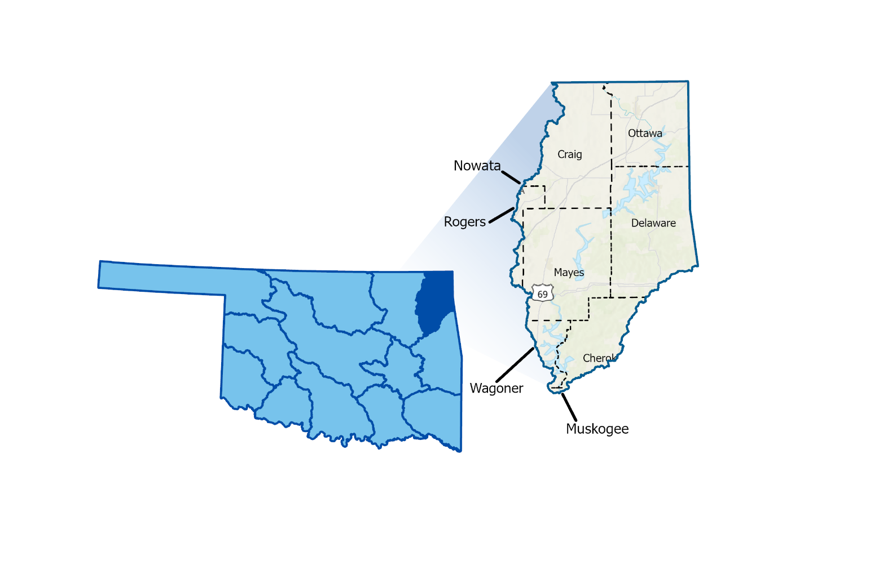
Figure 1 highlights the geographic boundaries of the planning area for this Region of the State.
Figure 1: Grand Planning Region Boundary
The Grand Watershed is unique because Grand Lake O’ the Cherokees (the Lake) is a very popular vacation spot for people living nearby. The many lake houses, restaurants, stores and entertainment, built up along the shores of the Lake make it susceptible to flooding. The Region is fairly rural with several cities, and many resorts and hotels along the Lake, increasing its flood vulnerability, especially because of the shape of the Lake. The Lake has many peninsulas and sharp cuts of water inland. Additionally, many rural areas, small towns, and vulnerable populations are located within the watershed. Miami, serving as the population center, has a history of grappling with floods and is situated right on the Neosho River. Grove is another city that often deals with flooding, being right along the Grand Lake O’ the Cherokees. All counties in the planning area have experienced multiple federally declared flood disasters since 1970.
A base map displaying incorporated jurisdictions within the Planning Region is shown in Figure 2.
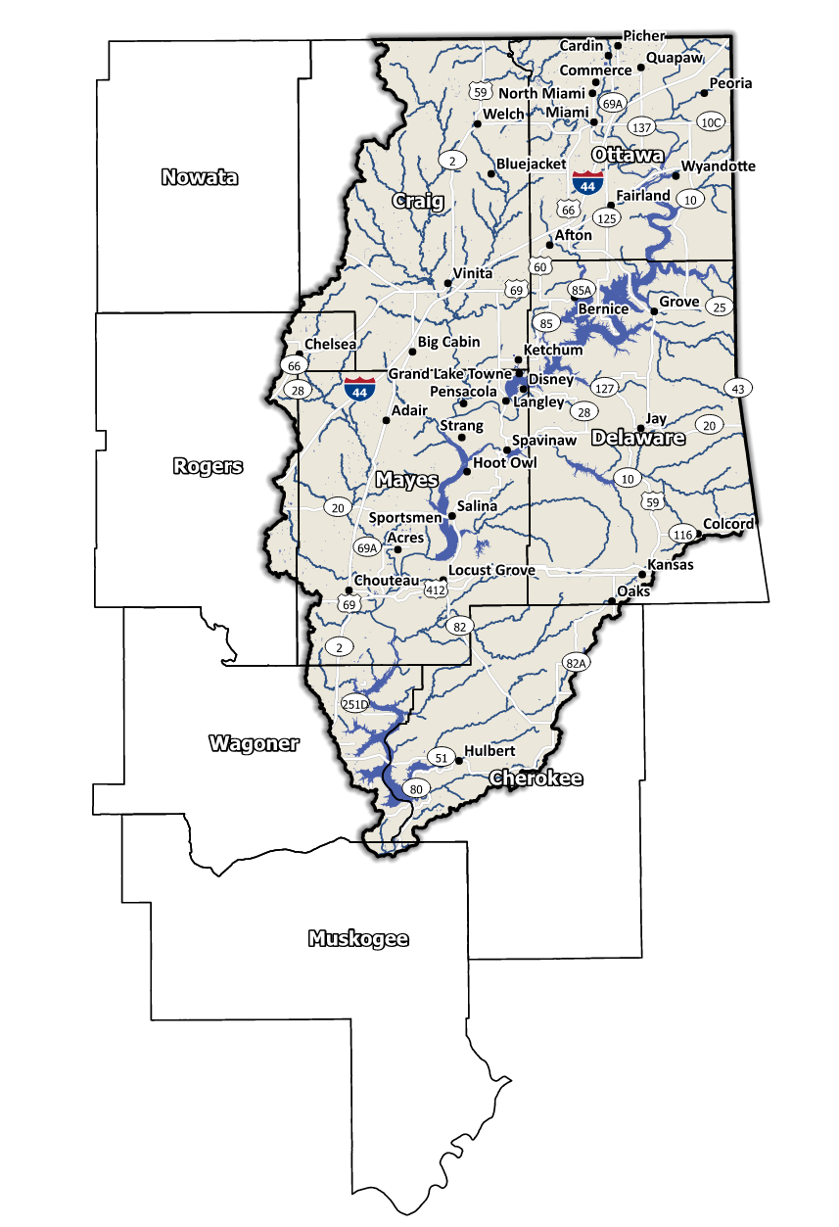
Figure 2: Grand Planning Region Base Map

Socioeconomic and Geographic Characteristics
A mix of industries, including tourism and entertainment, among a variety of others, brings economic diversity to this Region. This section will examine some of these socioeconomic and geographic factors and how they contribute to and affect this watershed.

Demographic Profile
The Grand Watershed Planning Region encompasses over 420,000 people with a mix of urban, suburban, and rural areas. This Region represents approximately 4.3% of Oklahoma's land area, and around 11% of Oklahoma residents call this area home according to the 2020 U.S. Census. Table 1 provides a population breakdown for each county in the Region. Provided by the 2020 U.S. Census, these statistics represent county-level populations, not those within the watershed boundary. Ottawa County is the only county in the group that is completely contained within the Grand Watershed Region.
Table 1: Population Breakdown by County in the Grand Planning Region
County | Total Population
Cherokee | 47,078
Craig | 14,107
Delaware | 40,397
Mayes | 39,046
Muskogee | 66,339
Nowata | 9,320
Ottawa | 30,285
Rogers | 95,240
Wagoner | 80,981

The Region is home to several Native American Tribal Nations, including the Cherokee, Eastern Shawnee, Miami, Modoc, Muscogee (Creek), Ottawa, Peoria, Quapaw, Seneca-Cayuga, and Wyandotte Nations. They have a long history of inhabiting the Region and have significantly shaped the area's cultural and economic development. A map displaying areas of tribal jurisdiction within the Planning Region is shown in Figure 3.

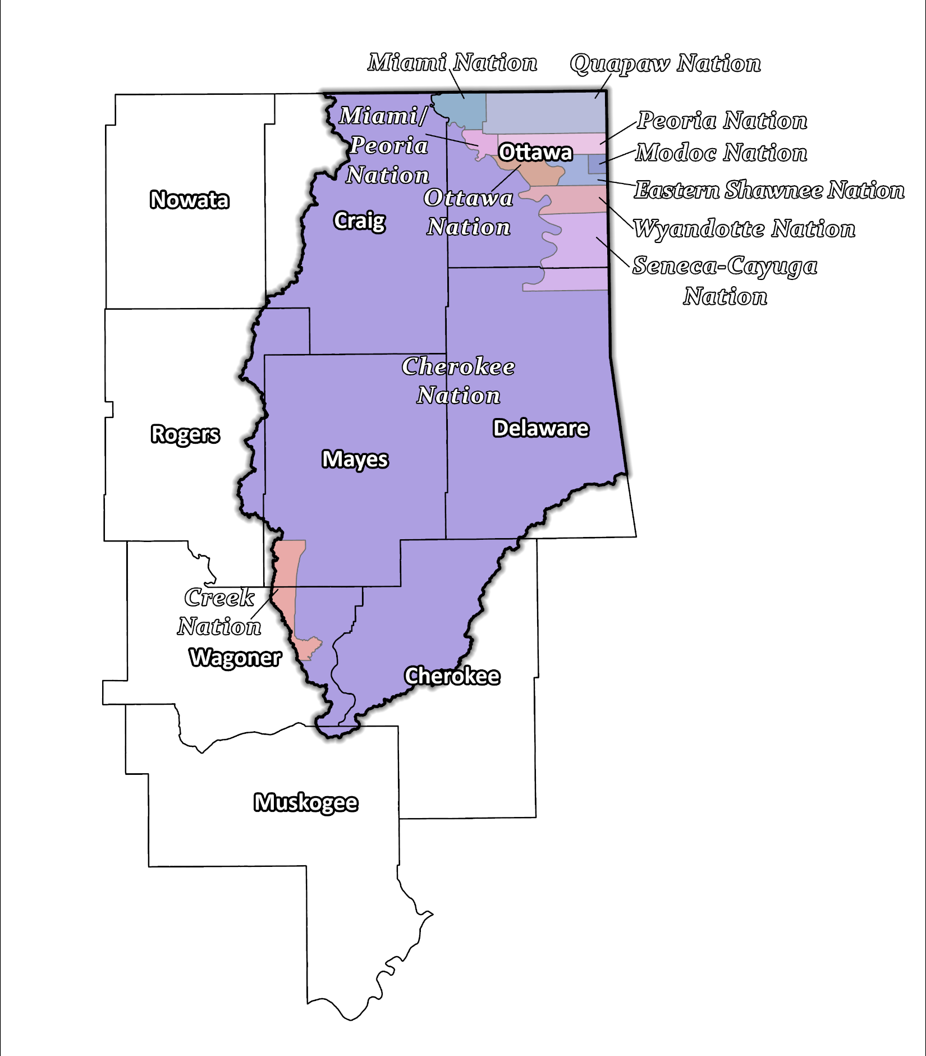
Figure 3: Tribal Jurisdictions Base Map for the Grand Planning Region

Economic Profile
The Grand Planning Region has significant economic importance in the state and the country. Grand Lake O’ the Cherokees is the 3rd largest lake in Oklahoma and is a top spot for fishing tournaments in the United States. The Lake is at the base of the Ozark foothills and brings tourism from the surrounding states as well as from within Oklahoma. The tribal nations in northeast Oklahoma are significant employers in the Region. They operate in various industries, including gaming, hospitality, and retail. Additionally, the tribal nations support growth and development in the area through investments in infrastructure, education, and healthcare.

Floodplain Management and Mitigation Capabilities
This section provides a broad summary of floodplain management capabilities and community engagement within the overall Grand Planning Region.

National Flood Insurance Program Participation
Within the Planning Region, all counties have been mapped by the Federal Emergency Management Agency (FEMA) and participate in the National Flood Insurance Program (NFIP). There are few communities within the nine counties, however, that do not currently participate in the NFIP, as shown in Figure 4, below.
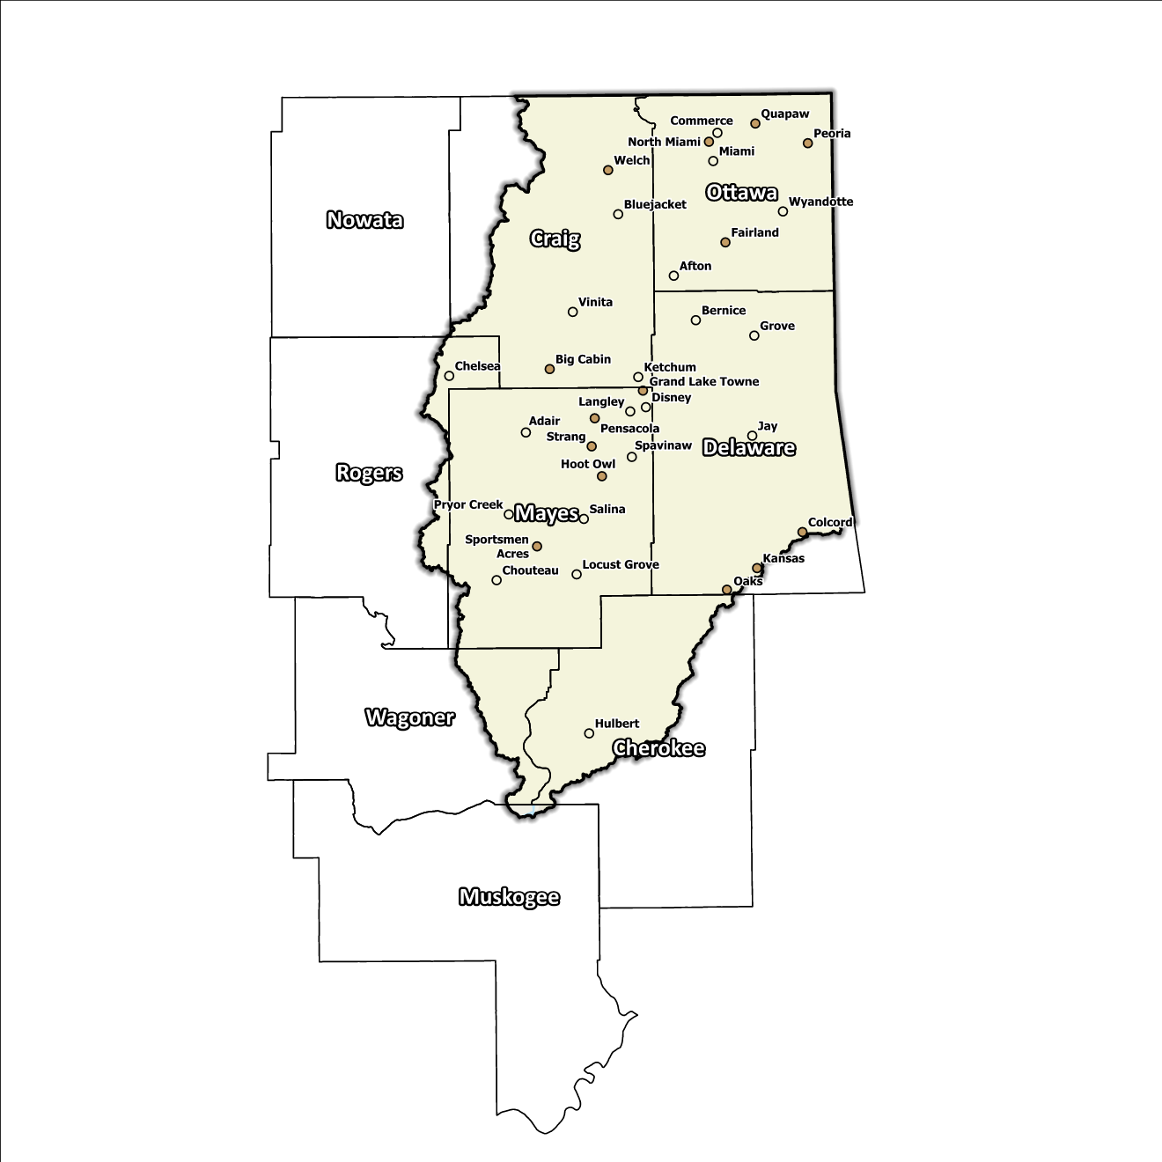
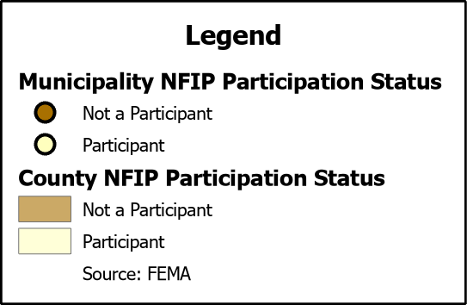
Figure 4: Status of NFIP Participation in the Grand Planning Region

The dedication to floodplain management by jurisdictions in this Planning Region is well demonstrated by participation in the NFIP from all counties. While no counties participate in FEMA’s Community Rating System (CRS), several communities in this Region go above and beyond the minimum NFIP requirements and could be used as an example for best practices and knowledge sharing in other portions of the State.

Flood Insurance Coverage
As of the latest update, there are currently 603 active NFIP policies in effect within the planning area. These policies cover approximately 6.6% of the total structures located in the FEMA mapped Special Flood Hazard Area (SFHA). It should be noted that not all active policies are situated within the SFHA. A total of 1,436 NFIP claims have been filed, resulting in approximately $37 million being paid out to policyholders. In the Region, there are 141 structures classified as repetitive loss (RL) and/or classified as severe repetitive loss (SRL), with a significant concentration of both types in Ottawa County. Repetitive loss, in the context of the NFIP, refers to properties that have experienced multiple flood-related insurance claims over a specific time period. Severe repetitive loss, on the other hand, pertains to properties with an extensive history of recurrent flood damage and a high number of insurance claims, making them particularly vulnerable and costly for the NFIP.
The following figures (Figure 5 through Figure 8) provide a range of information about NFIP policies, as well as the total claims filed and paid in the Planning Region. Although these figures are insightful, it's crucial to recognize they may not accurately reflect the true extent of losses in the area due to an underrepresentation of flood insurance. Not every claim filed or paid is linked to an active policy.
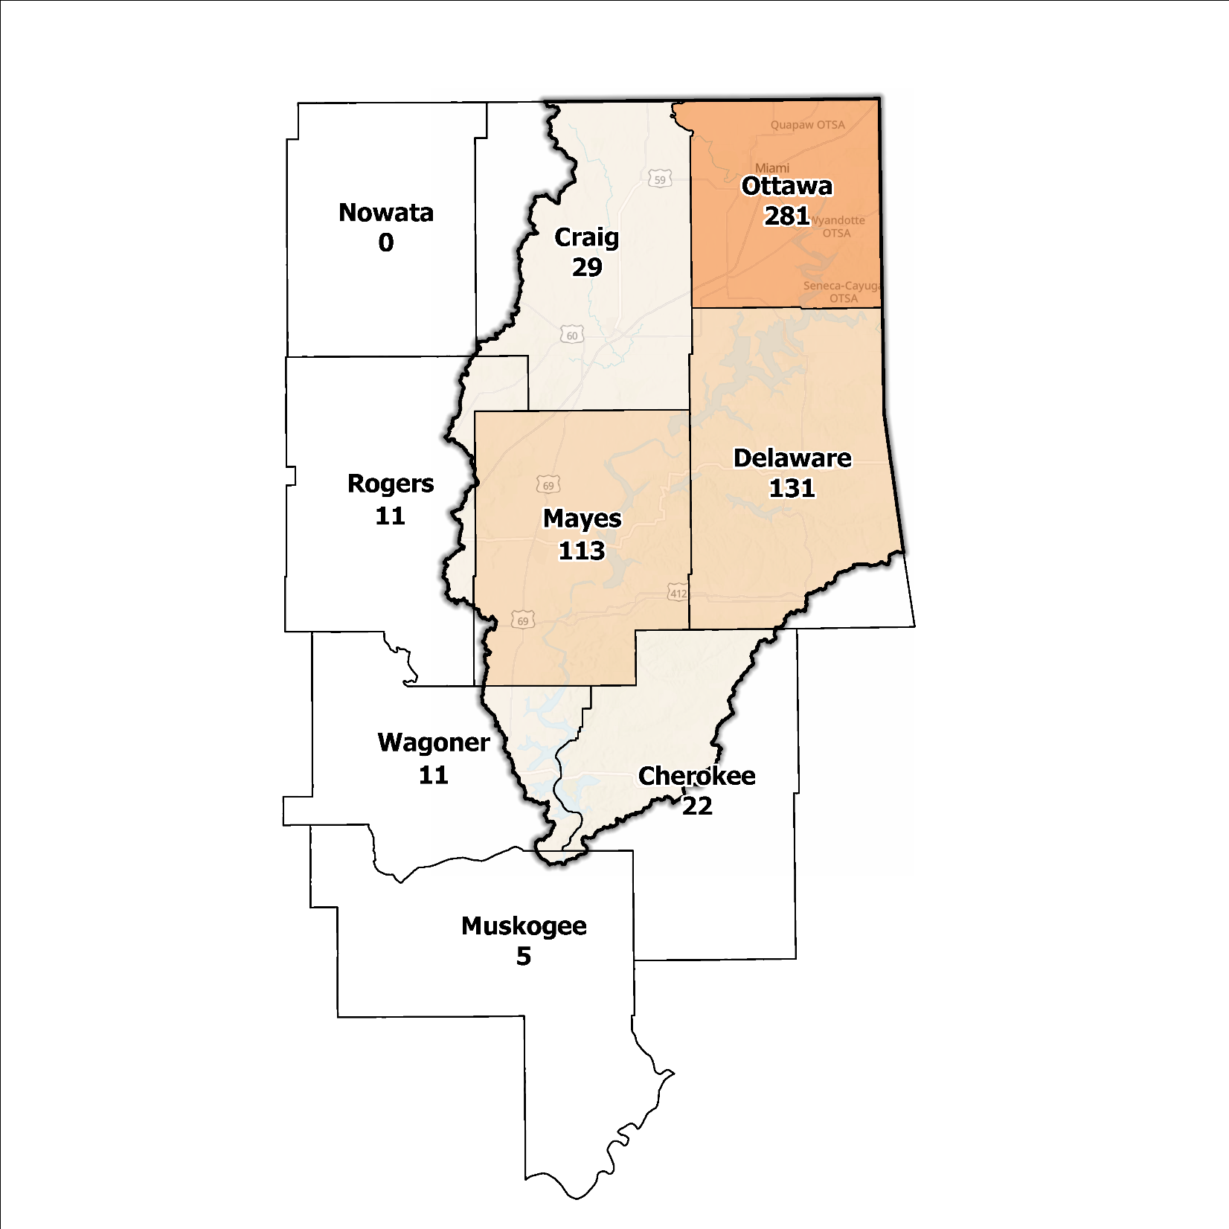
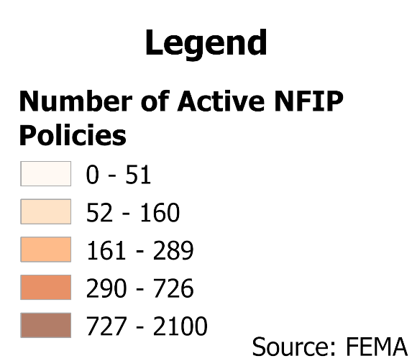
Figure 5: Number of Active NFIP Policies in the 100-Year Floodplain in the Grand Planning Region

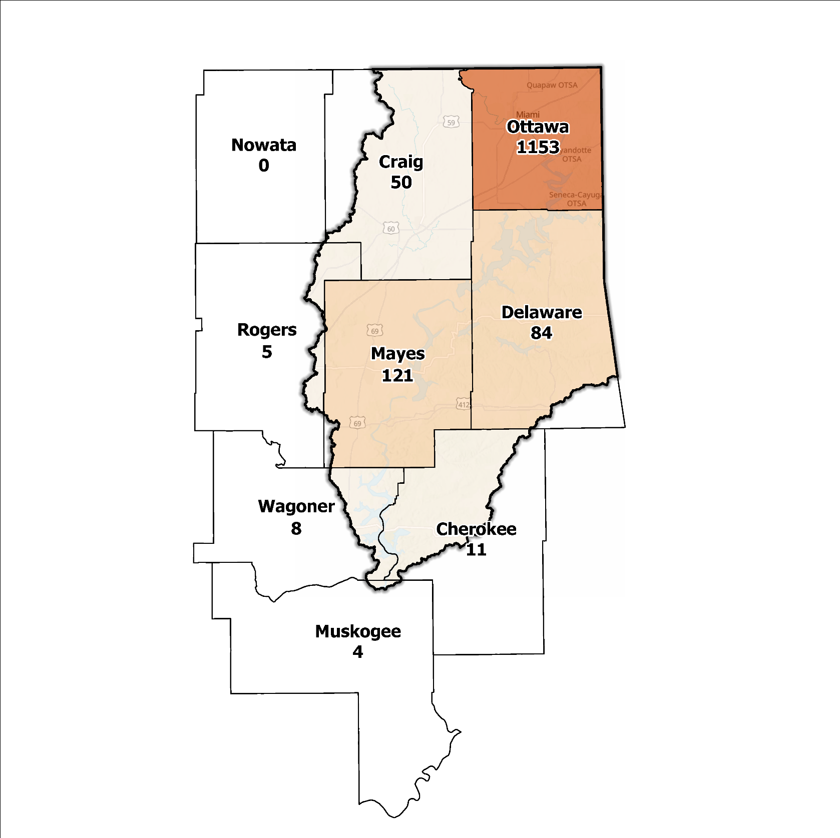
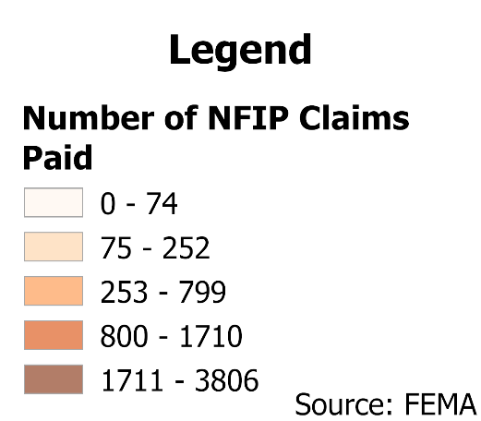
Figure 6: Total NFIP Claims Paid in the Grand Planning Region

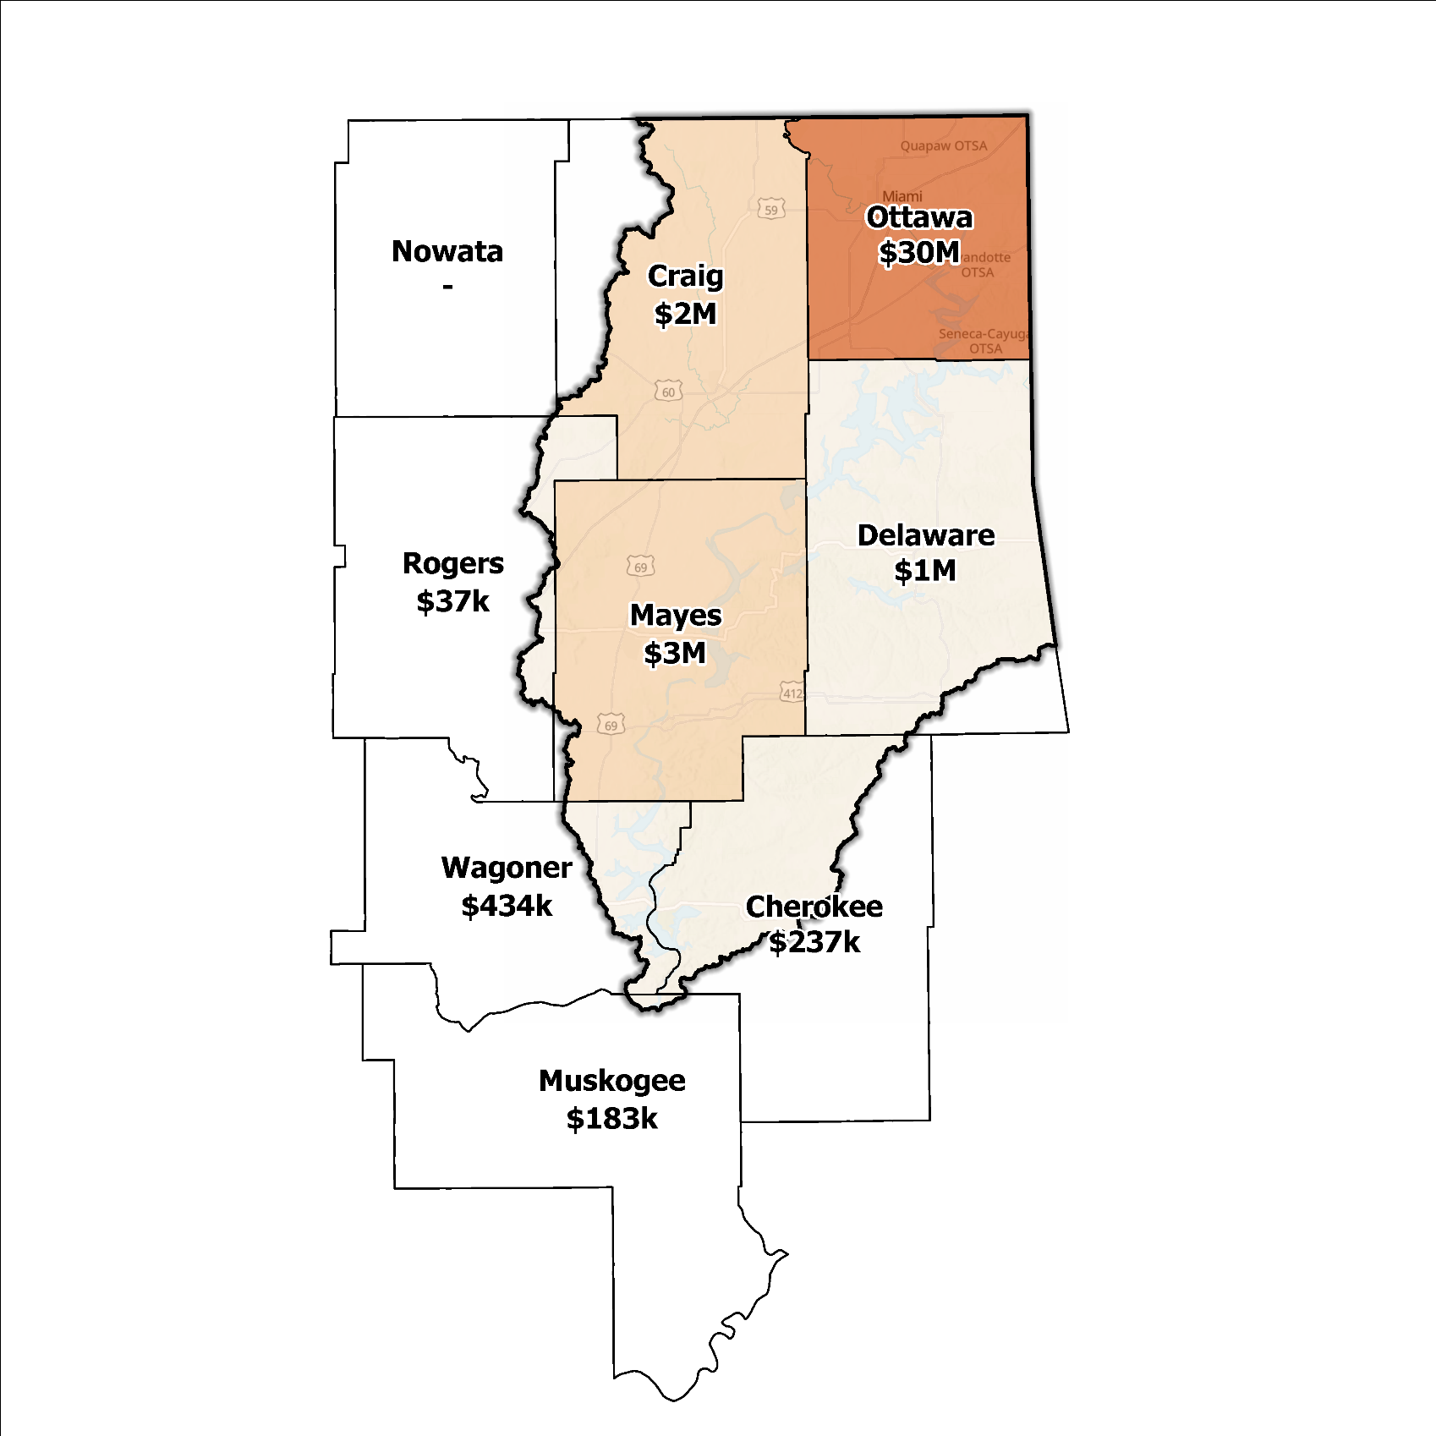
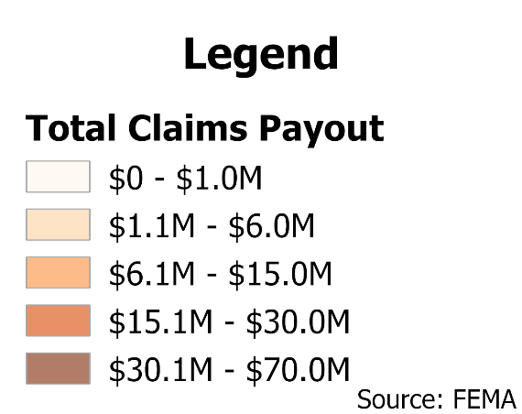
Figure 7: Total Value NFIP Claims Paid Out in the Grand Planning Region

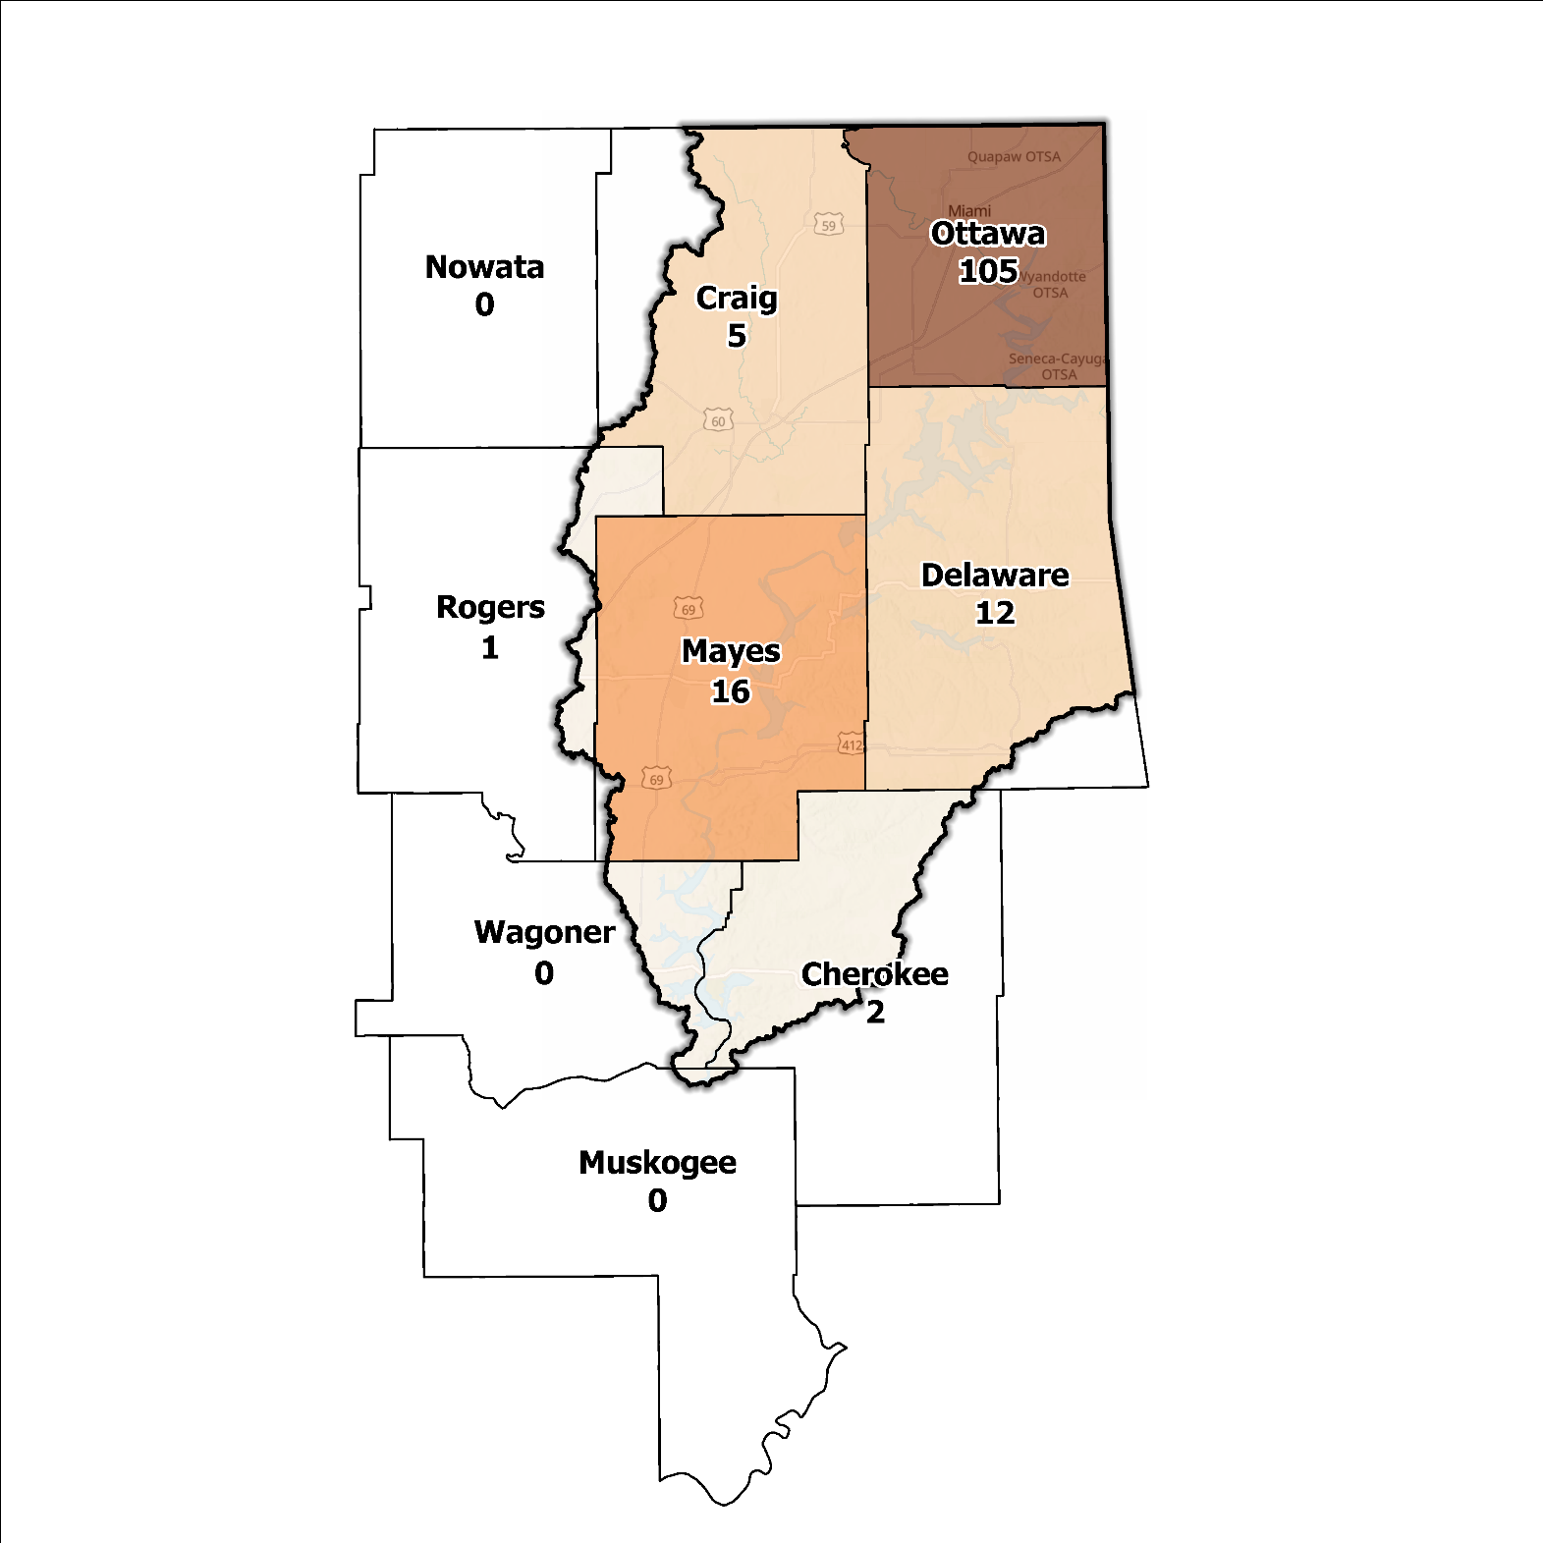
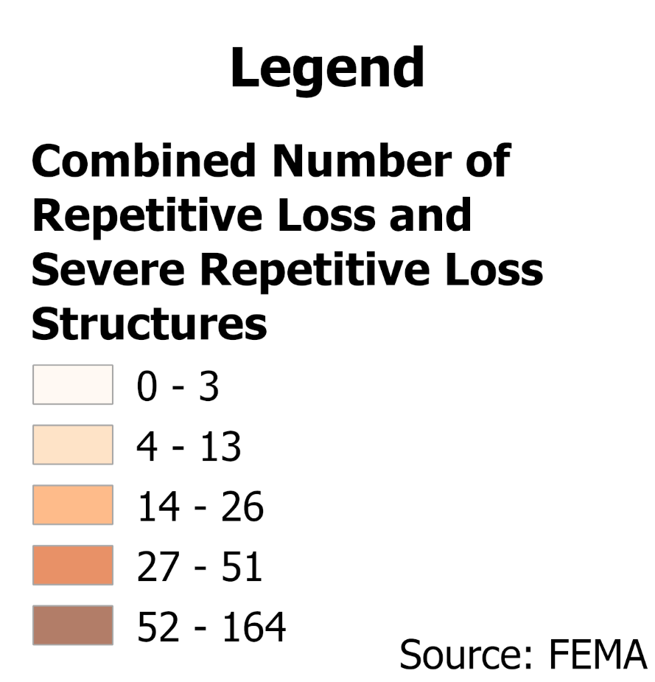
Figure 8: Repetitive Loss and Severe Repetitive Loss Structures in the Grand Planning Region

Flood Funding Mechanisms
A survey conducted by the planning team to determine the level of funding for stormwater and floodplain management in the Grand Planning Region revealed that most smaller communities have limited local funding. Some larger, more urban jurisdictions, such as the City of Grove, Miami, and Pryor are more likely to be effective when implementing stormwater utility fees and have success in funding departments for facilitating management activities. In contrast, other jurisdictions have achieved marginal results in the utilization of local taxes, fees, and funds.

Hazard Mitigation Plan Status
Eight out of nine counties in this Region possess a FEMA-approved Hazard Mitigation Plan (HMP) and the identified mitigation actions vary in jurisdictions. Several identify basic programmatic and administrative activities, such as planning, education, acquiring or implementing warning systems, participating in the NFIP, etc. In contrast, others intentionally list flood mitigation projects such as property buyouts, road and drainage improvements, floodplain restoration, dam repair, and other flood-specific activities. Riverine flooding is the most frequently reported problem across the planning area. Several communities and Tribal Nations such as the Creek, Eastern Shawnee, Modoc, Ottawa, Quapaw, and Wyandotte, in the Region have individual HMPs separate from their respective counties. Table 2 shows all previous, current, or pending HMPs in the Region.

Table 2: Hazard Mitigation Planning Status for the Grand Planning Region
Name | Type | Approval Date | Expiration | Current Action Status of this Plan
Cherokee | County | 09/19/2022 | 09/18/2027 | Approved
Craig | County | 01/17/2023 | 01/16/2028 | Approved
Delaware | County | 12/11/2023 | 12/10/2028 | Approved
Grove | City | 07/25/2023 | 07/24/2028 | Approved
Mayes | County | 04/23/2020 | 04/22/2025 | Approved
Pryor Creek | City | 07/05/2011 | 07/05/2016 | Expired
Muskogee | County | 04/17/2024 | 04/16/2029 | Approved
Nowata | County | - | - | In Progress
Ottawa | County | 03/13/2023 | 03/12/2028 | Approved
Miami | City | 09/30/2020 | 09/29/2025 | Approved
Rogers | County | 04/22/2020 | 08/21/2025 | Approved
Claremore | City | 01/03/2022 | 01/02/2027 | Approved
Wagoner | County | 04/06/2022 | 04/05/2027 | Approved
Wagoner | City | 08/03/2022 | 08/03/2027 | Approved
Cherokee | Tribal Nation | 02/08/2023 | 02/07/2028 | Approved
Creek | Tribal Nation | 12/01/2021 | 11/30/2026 | Approved
Eastern Shawnee | Tribal Nation | 02/16/2012 | 02/16/2017 | Expired
Modoc | Tribal Nation | 11/18/2014 | 11/18/2019 | Expired
Ottawa | Tribal Nation | 07/14/2014 | 07/14/2019 | Expired
Quapaw | Tribal Nation | 03/08/2023 | 03/07/2028 | Approved
Wyandotte | Tribal Nation | 08/14/2024 | 08/13/2029 | Approved

Flood Mapping Assessment
In the Grand Planning Region, the floodplain quilt consolidates the best available data on flood risk. A notable aspect in the Region is most of the effective FEMA maps still need detailed studies. This leaves floodplain managers to rely on Approximate A Zones, which offer a broad understanding of flood risk but do not have determined Base Flood Elevations (BFE). Figure 9 displays FEMA-mapped areas in the Planning Region.
While in areas with A zones, Base Level Engineering (BLE) data might provide a more accurate indication of flood risk, it is important to note that the Grand Planning Region lacks BLE coverage entirely. However, effective FEMA maps have sufficient coverage of the entire Region whether it be a detailed or approximate study. There is a pressing need for in-depth studies to enhance the precision and reliability of flood risk information in specific areas, specifically along the downstream end of the Lower Neosho River in Mayes and Wagoner County.
Ottawa and Mayes Counties, along with the cities of Pryor, Miami, and the Grand Lake area, stand out among areas in the Planning Region for having the most extensive flood risk assessment information. Investment in floodplain mapping has been higher in these areas than in others in the Region.
While Flood Insurance Rate Maps (FIRMs) are beneficial for regulatory uses and flood insurance assessments, they only represent potential risks associated with a flood event under certain specific conditions. The threat of flooding beyond the FEMA mapped SFHA is only included on FIRMs if the community opts to carry out the required studies to integrate such data into their hazard map.
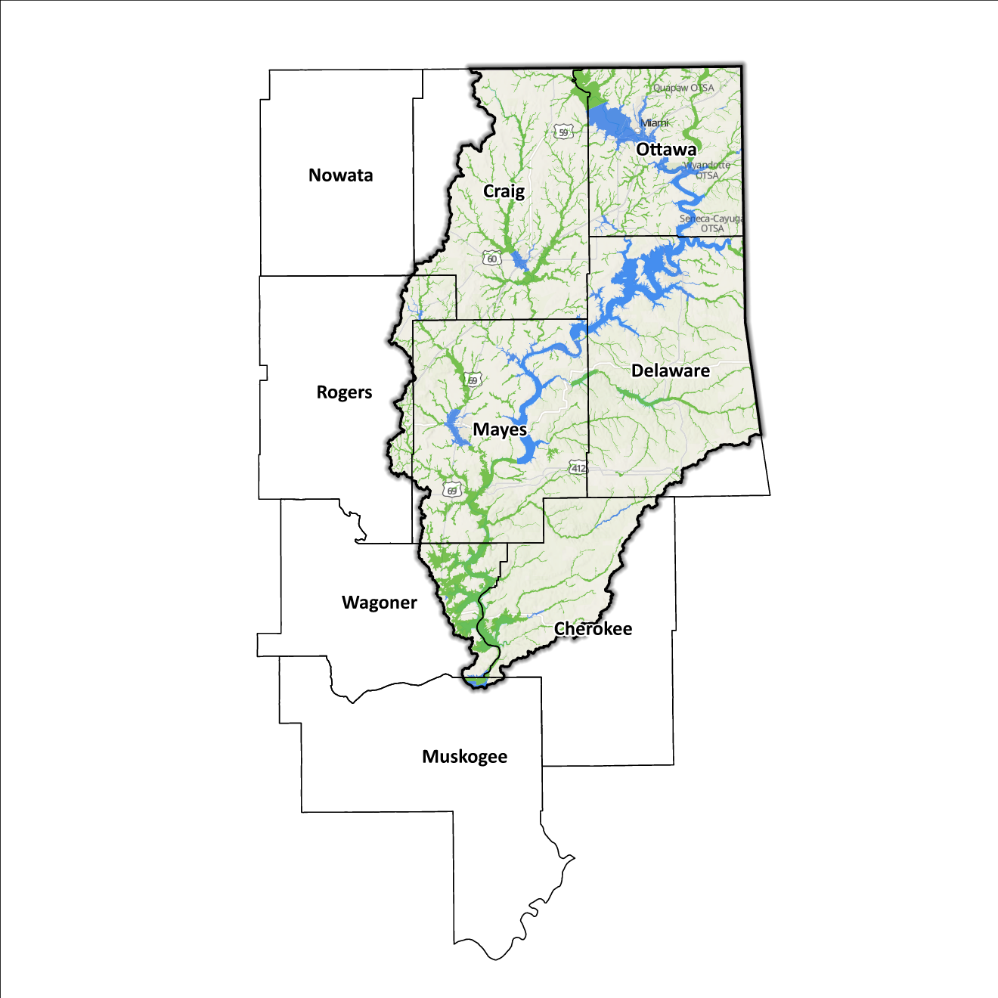
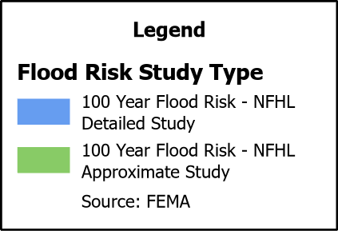
Figure 9: FEMA Mapped Special Flood Hazard Area Comparison in the Grand Planning Region

2020 USGS Stream Gage Report
Following the 2019 flooding across the Arkansas River Watershed, a comprehensive report was released that documented peak streamflow data collected by the United States Geological Survey (USGS) and the United States Army Corps of Engineers (USACE) stream gages in the Arkansas River Basin. It was determined that analytical methods for calculating annual exceedance probabilities (AEPs) for streams such as the Arkansas River, which is heavily regulated by USACE flood-control dams, are not usually appropriate. Developed by the USACE Tulsa District, the 2020 RiverWare model allows for more accurate Base Flood Elevation (BFE) metrics to be determined.

The USGS/USACE report compares existing flood risk mapping to those calculated by USGS at various gage sites in the Grand Watershed. BFE levels as well as flow rate differences underscore a reason to potentially revise flood risk mapping. Downstream of Pensacola Dam, there were significant jumps in measured flow rate. BFE comparisons similarly saw a sharp increase which corroborates the USGS idea that heavily controlled waterways are not being accurately represented by current flood risk maps. Such large changes would imply that river flood events (like the one experienced in 2019) has much more serious ramifications for downstream communities like Muskogee and Webbers Falls, who both experienced devastating flooding. While this report provides a modern analysis of what could be used to model new floodplain maps, not all gage locations provided these statistics. For this reason, further studies and floodplain mapping efforts should be considered before making a broader statement across the Grand Watershed Planning Region.

Flood Hazard Assessment
Flood hazards in this Region include flash, river, and urban flooding. The Grand River, along with its various tributaries, are the major waterways found in the Grand Watershed.

Location of Flood Hazards
The Grand Planning Region is characterized by a flood hazard that encompasses various significant aspects. The flood dynamics in the Grand Planning Region exhibit the following characteristics:
- Flooding along major waterways with extensive drainage basins, including the Grand River/Lower Neosho River.
- Flash floods along smaller tributaries that ultimately flow into the major waterways.
- Drainage issues in specific areas result from inadequate infrastructure. Insufficient drainage systems can exacerbate flood risks, leading to localized flooding in vulnerable locations.
- Downstream areas located below high-hazard potential dams, including those situated north of the Kansas and Oklahoma state line, are exposed to heightened risks.
Figure 10 shows mapped areas of flood risk in the Region. The map brings together data from different sources, like the National Flood Hazard Layer and BLE, to create a unified view. It prioritizes layer types and shows the most important layer available for a specific area.
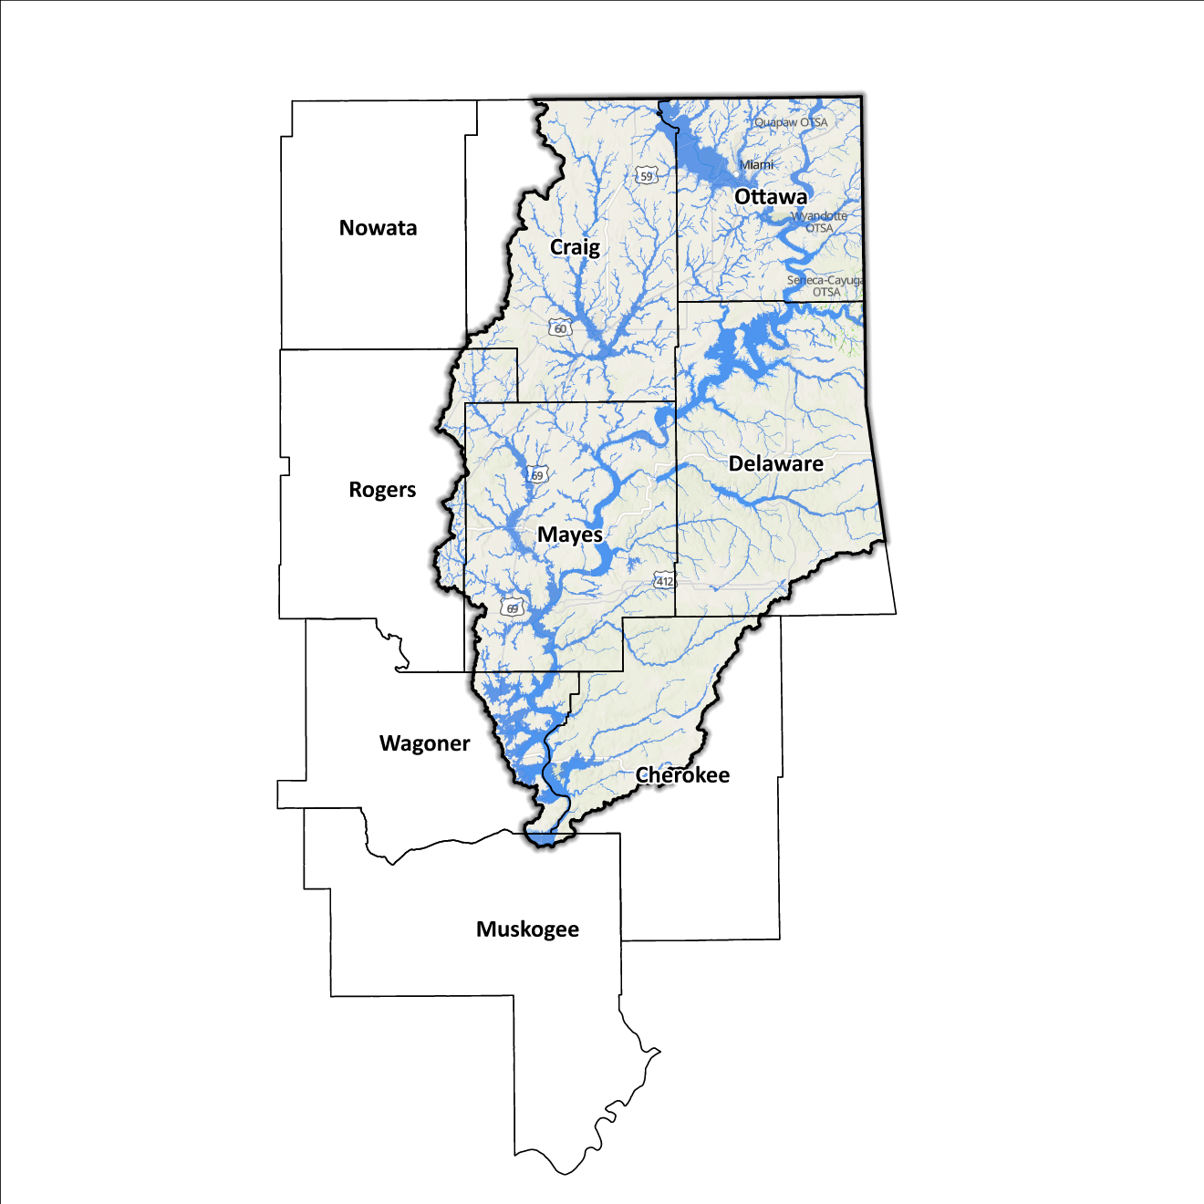
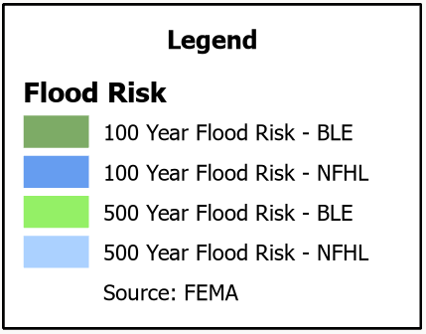
Figure 10: Flood Quilt in the Grand Planning Region

Dam and Levee Infrastructure
The Region has multiple dams and levees aimed at preventing flooding. However, aging infrastructure increases the risk of downstream impacts if a breach or failure occurs, especially for high-hazard dams classified by the Oklahoma Water Resources Board (OWRB). Across the nine counties, there are 14 high-hazard dams, with seven located in the Grand Watershed. A map of dam and levee locations within the Region is shown in Figure 11. Although the Grand Watershed Region concludes at the Arkansas/Oklahoma and Kansas/Oklahoma state lines, the flood risks associated with dams and levees transcend its boundaries.
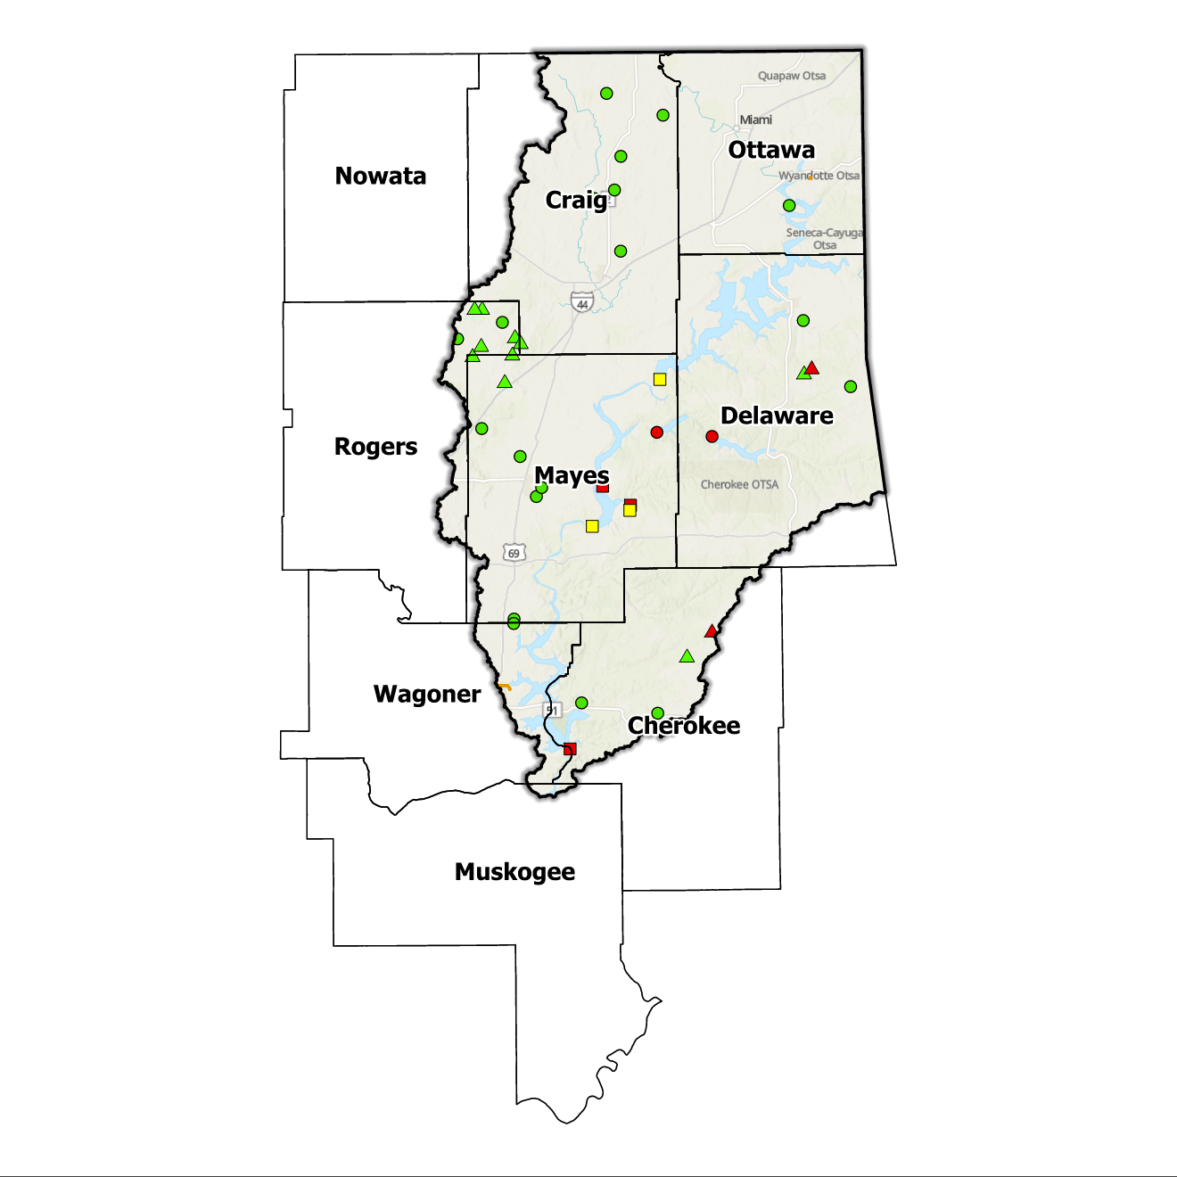
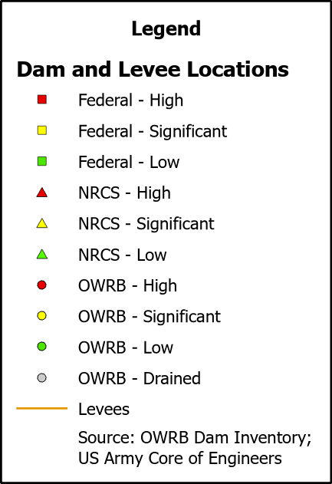
The Grand Watershed Region has three levee systems in Ottawa, Mayes, and Wagoner counties. State and local officials can find information on these systems on the USACE National Levee Database website.
Figure 11: Dam and Levee Locations in the Grand Planning Region

Extent of Flooding
Extent refers to the expected severity of flooding, and because not all areas within the planning area share the same topography, the extent varies between individual communities. The average depth of flooding within the FEMA-mapped SFHA can range from a few inches to several feet, depending on factors such as topography, proximity to water bodies, local drainage characteristics, and the intensity of the flood event.

Previous Occurrences
According to the records maintained by the National Center of Environmental Information (NCEI), from January 1996 to December 2022, a total of 752 flood events have been documented in the nine counties encompassing this Planning Region. Cumulatively, these flooding incidents have caused property damage amounting to $32,614,000.
The NCEI initiated the tracking of flood events only from 1996, hence this data represents the most comprehensive information available. Flooding has frequently escalated to the point of necessitating a Presidential Disaster Declaration. A breakdown of flood-related disasters by county is shown in Figure 12.
Of all the counties in the Region, Ottawa County has most frequently been declared a disaster area due to flooding. However, it's important to note that disaster declarations are issued on a county-wide basis and not all declarations may have directly impacted this specific region.
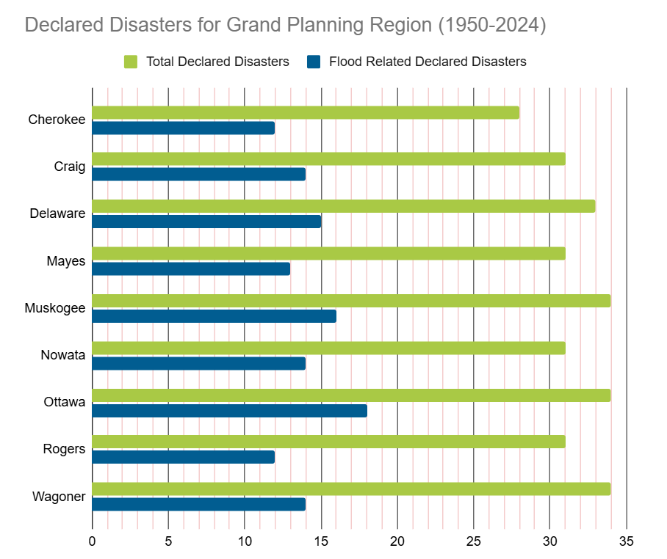
Table 3: FEMA Disaster Declarations from 1950-2024 in the Grand Planning Region

Vulnerability and Impacts of Flooding
According to FEMA’s National Risk Index (NRI), the Grand Planning Region demonstrates a range of risk levels for river flooding and flash flooding, varying from relatively low to relatively moderate risk at the county level, when compared to the rest of the United States. However, when examined at a more granular scale by census tract, the NRI highlights specific areas along the Grand River, particularly in Cherokee, and Ottawa counties, as being at a moderate risk of flooding.
Compared to other regions in Oklahoma, the Grand Planning Region is at a higher risk of flooding due to multiple factors including high annual precipitation, a large number of waterways and drainage areas, development in flood-prone locations, and aging infrastructure.

Summary of Flood Exposure
Flood exposure refers to the degree to which an area or population is at risk of being affected by a flood event. Table 4 provides a comprehensive overview of key factors, including the total count of housing units, population figures, job statistics, land area measurements, and the number of parcels/blocks within the designated FEMA-mapped flood area. This information aims to facilitate a thorough understanding of the flood-affected area's characteristics and implications.
The data in this section was generated using UrbanFootprint. This module evaluates flood risk by conducting a spatial join of parcels or census blocks with the FEMA National Flood Hazard Layer to assess the potential risks associated with hazards. The data presented in the table below is focused on three different FEMA SFHA flood zones that represent areas within the 100-yr floodplain with a 1% annual chance of experiencing a flood event. Zone AE is the most detailed, providing BFE, Zone AO represents areas subject to shallow flooding of depths between one to three feet, and Zone A being an approximation of the 100-yr floodplain for areas where detailed hydraulic analyses have not been performed.

Table 4: Flood Exposure in the Grand Planning Region
Grand Planning Region Flood Risk Report
Housing in Flood Hazard Zones (Dwelling Units)
Dwelling Units in SFHA Zone AE | 4,086.00
Dwelling Units in SFHA Zone A | 3,498
Dwelling Units in SFHA Zone AO | N/A
Total | 7,583.00
Population in Flood Hazard Zones (Persons)
Population in SFHA Zone AE | 7,210.00
Population in SFHA Zone A | 7,808.00
Population in SFHA Zone AO | N/A
Total | 15,018.00
Jobs in Flood Hazard Zones (Employees)
Jobs in SFHA Zone AE | N/A
Jobs in SFHA Zone A | N/A
Jobs in SFHA Zone AO | N/A
Total | N/A
Land Area in Flood Hazard Zones (Acres)
Area in SFHA Zone AE | N/A
Area in SFHA Zone A | N/A
Area in SFHA Zone AO | N/A
Total | N/A
Parcels or Blocks in Flood Hazard Zones
Parcels or Blocks in SFHA Zone AE | N/A
Parcels or Blocks in SFHA Zone A | N/A
Parcels or Blocks in SFHA Zone AO | N/A
Total | N/A

Flood Mitigation Needs
Flood mitigation projects for the Region have been identified at a county level through the analysis of HMPs, the community level through projects identified in master drainage plans, and prioritized lists provided by jurisdictions. The following stormwater project types were considered:
- Channel
- Storm Drain
- Infrastructure
- Detention Pond
- Dam-Reservoir
- Floodwalls and Levees
- Acquisition
Although the OWRB State Flood Plan Dashboard does not list any stormwater projects in the Grand Planning Region at the time of this writing, the City of Tahlequah has made noteworthy progress in planning projects citywide.
While most floodplains within this Region are in rural areas, the following communities have at least one structure located within floodplain: the cities of Tahlequah, Vinita, Grove, and Locust Grove, the towns of Big Cabin, Ketchum, Welch, Bernice, Kansas, Disney, and Salina, and the unincorporated communities of Patmos, and Boatman. Despite this, the Grand Planning Region has not reported any data on the use of acquisition as a mitigation method.
Smaller communities face challenges in funding acquisitions and other stormwater and mitigation projects. In numerous cases, the local tax base proves insufficient to finance property acquisition, necessitating these jurisdictions to seek external sources, such as state and federal grant funding. Such sources can be highly competitive in nature and favor more populated urban areas due to the cost benefits and can depend on a variety of factors.

Conclusion
The Grand Watershed report highlights the significance of this Region and its vulnerability to flood events. The report's findings emphasize the urgent need for funding to support engineering efforts in flood projects within the watershed. Identification of projects is needed, and planning or technical assistance may be needed to help communities even identify projects. Adequate funding is essential for conducting detailed engineering assessments, implementing effective flood control measures, and enhancing community resilience. The lack of project submissions underscores the importance of assisting communities in identifying and developing flood mitigation projects.
By allocating resources and support for project identification and development, communities can better understand their flood exposure and proactively protect lives and infrastructure. Investing in engineering and flood mitigation projects in the Grand Watershed will contribute to creating safer, more resilient communities better equipped to handle future flood events.
During the planning process, the data generated was developed into an interactive flood planning dashboard. The dashboard serves as a valuable tool for conducting flood assessments at the community level. It is important to note that this report should not substitute locally generated data specific to each community.

This calculation was performed by summing the populations of the counties within this region, as indicated in Table 1, then divided by the entire population of the State of Oklahoma using the same data source (2020 U.S. Decennial Census).
Census Bureau Data – 2020 Decennial Census
Cherokee County’s HMP includes the Town of Hulbert and the City of Tahlequah.
Craig County’s HMP includes the Towns of Big Cabin, Bluejacket, Ketchum, Welch, and the City of Vinita.
Delaware County’s HMP includes the Towns of Bernice, Colcord, Kansas, Oaks, and the City of Jay.
Mayes County’s HMP includes the Towns of Adair, Chouteau, Disney, Grand Lake Towne, Langley, Locust Grove, Pensacola, Salina, Spavinaw, Sportsman Acres, and Strang.
Muskogee County’s HMP includes the Town of Fort Gibson and the City of Muskogee.
Ottawa County’s HMP includes the Town of Afton, Commerce, Fairland, North Miami, Peoria, Quapaw, and Wyandotte.
Rogers County’s HMP includes the Town of Chelsea.
FEMA’s National Risk Index (NRI) is a tool used to calculate a community’s potential for negative impacts due to natural hazards and community risk factors. The three components used in the NRI equation that generates the Risk Index Score are expected annual loss due to natural hazards, social vulnerability, and community resilience.
The Urban Intelligence Platform | UrbanFootprint

