Table of Contents
The Eufaula Planning Region 1
Section 1.1: Watershed Introduction 1
Section 1.2: Socioeconomic and Geographic Characteristics 2
Section 1.3: Floodplain Management and Mitigation Capabilities 5
Section 1.4: Flood Hazard Assessment 14
Section 1.5: Flood Mitigation Needs 19
Section 1.6: Conclusion 20

The Eufaula Planning Region

Watershed Introduction
Spanning 3,223 square miles, the Eufaula Watershed Planning Region (Region) spans 10 counties in eastern Oklahoma, and encompasses all or part of Atoka, Haskell, Hughes, Latimer, McIntosh, Okfuskee, Okmulgee, Pittsburg, Pottawatomie, and Seminole counties. A total of 92 municipalities and six tribal nations are located here. The Red and Washita Rivers with Mud Creek and Walnut Bayou, along with their various tributaries, are the major waterways in the Eufaula Watershed.
Figure 1 highlights the geographic boundaries of the planning area for the Region of the State.
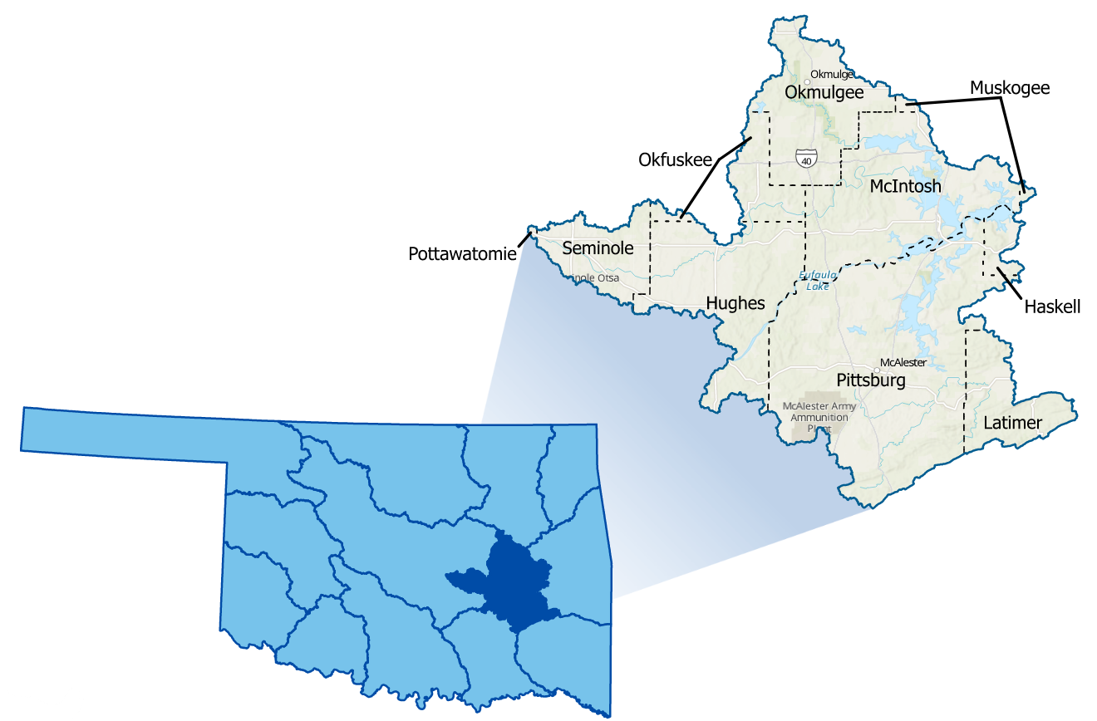
Figure 1: Eufaula Planning Region Boundary

The Eufaula Watershed Planning Region includes one basin (Basin 48). The region includes portions of the Central Lowland and Ouachita physiography provinces. The region’s terrain ranges from the hills and ridges of the Northern Cross Timbers in the north, transitioning southward to the diverse plains, terraces, and wooded hills of the Arkansas Valley, then to the Fourche Mountains at the far southern border. A significant area of the watershed is located with a Special Flood Hazard Area (SFHA) due to the Canadian River, Eufaula Lake, and its tributaries. All counties in the planning area have experienced multiple flood-related disasters since 1970.
A base map displaying incorporated jurisdictions within the Planning Region is displayed in Figure 2.
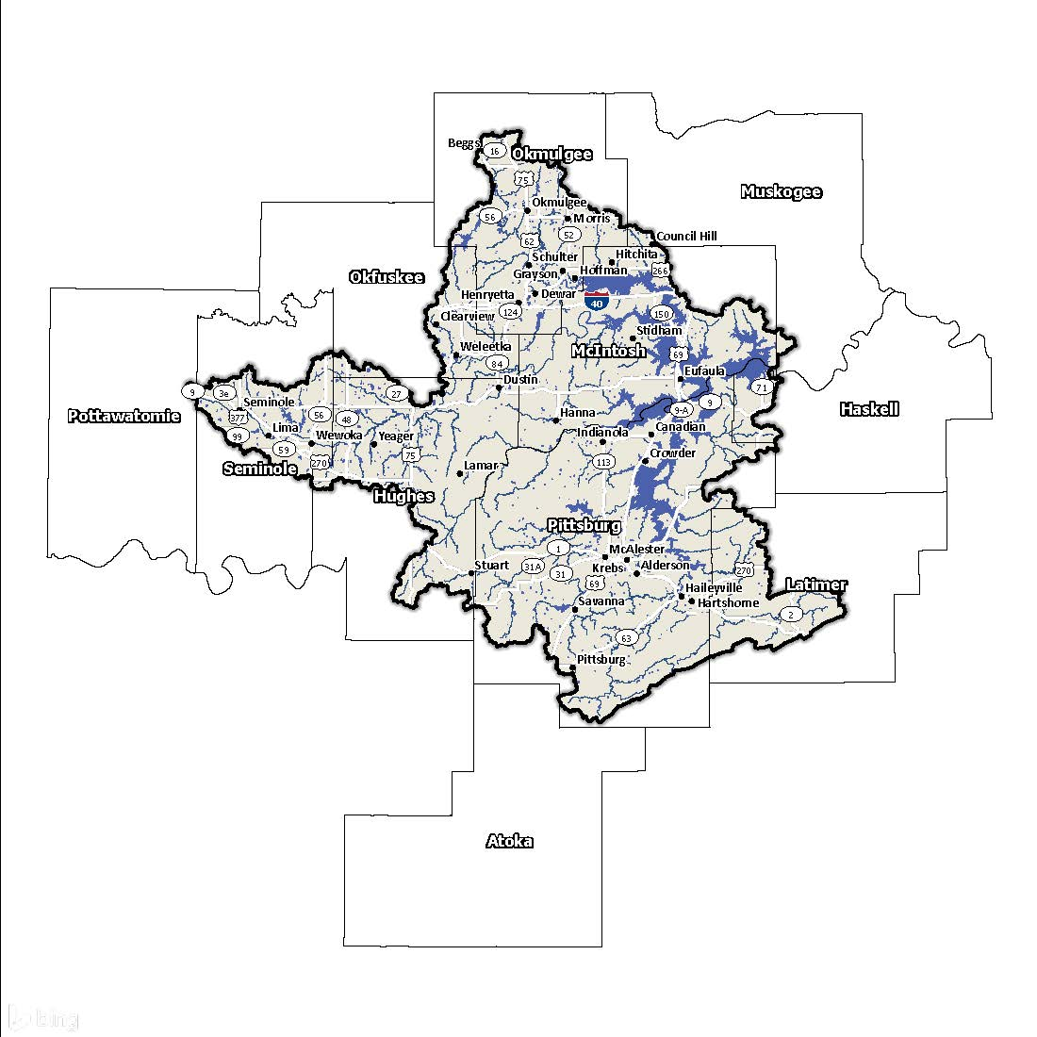
Figure 2: Eufaula Planning Region Base Map

Socioeconomic and Geographic Characteristics
A mix of industries, including oil and gas, among a variety of agricultural resources, bring economic diversity to this Region. This section will examine some of these socioeconomic and geographic factors and how they contribute to and affect this watershed.

Demographic Profile
The Eufaula Watershed Planning Region encompasses over 250,000 people with a mix of urban, suburban, and rural areas. This Region represents approximately 4.7% of Oklahoma's land area, and around 6% of Oklahoma residents call this area home according to the 2020 U.S. Census. A population breakdown in the Region is found in Table 1.
Provided by the 2020 U.S. Census, these statistics represent county-level populations, not those within the watershed boundary. None of the counties in the group are completely contained within the Eufaula Watershed Region.
Table 1: Population Breakdown by County in the Eufaula Planning Region
County | Total Population
Atoka | 14,143
Haskell | 11,561
Hughes | 13,367
Latimer | 9,444
McIntosh | 18,941
Okfuskee | 11,310
Okmulgee | 36,706
Pittsburg | 43,773
Pottawatomie | 72,454
Seminole | 23,556

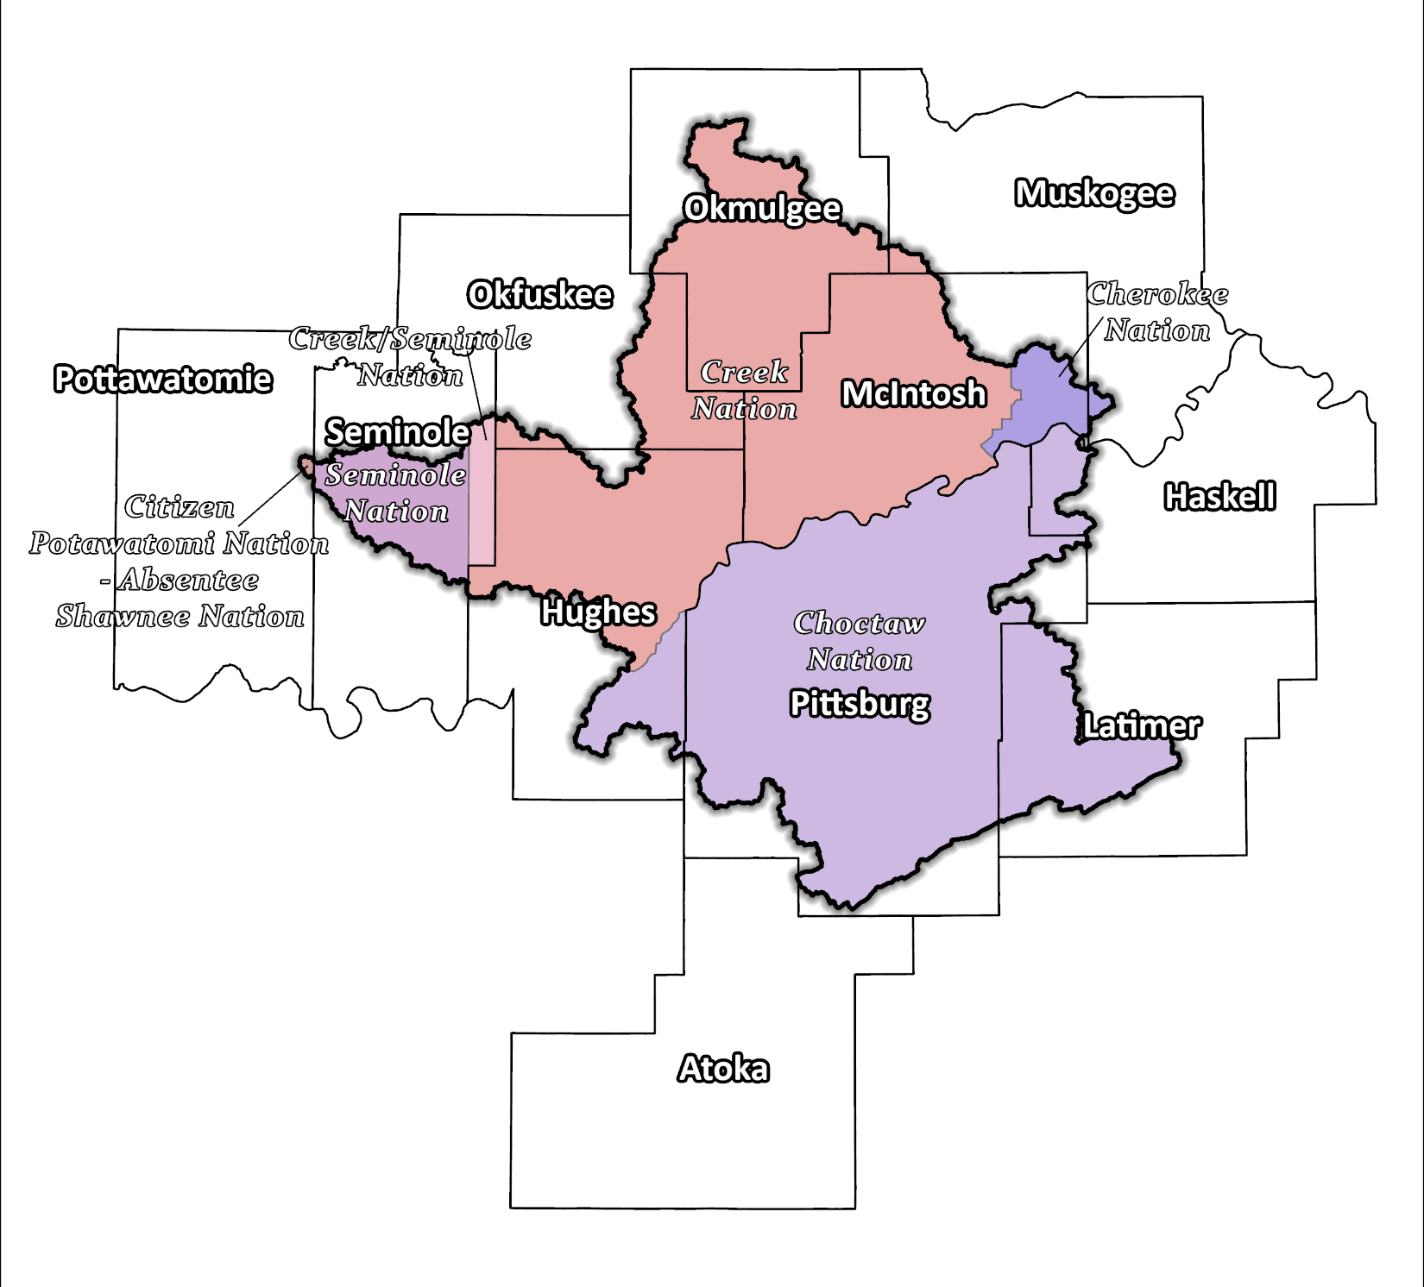
Figure 3: Tribal Jurisdiction Base Map for Eufaula Planning Region

The region is home to six Native American tribes, including the Cherokee, Choctaw, Citizen Potawatomi-Absentee Shawnee, Muscogee (Creek), Creek/Seminole, and Seminole Nations. These tribes have a long-standing history of inhabiting the region and have significantly shaped the area's cultural and economic development.

Economic Profile
The Eufaula Planning Region includes communities that rank in the lower half of Oklahoma counties based on per capita income. The production of hydroelectric power by the Eufaula Dam, which impounds Lake Eufaula, is important to the Region. This is also Oklahoma’s largest lake, bringing tourism to the area. Additionally, the presence of Tyson Foods and agriculture activity adds to the modest economy. The tribes in east central Oklahoma are significant employers in the Region. They operate in various industries, including gaming, hospitality, and retail. Additionally, the tribes support growth and development in the area through investments in infrastructure, education, and healthcare.

Floodplain Management and Mitigation Capabilities
This section provides a broad summary of floodplain management capabilities and community engagement within the overall Eufaula Planning Region.

National Flood Insurance Program Participation
Within the Planning Region, all counties except Haskell and Okfuskee, have been mapped by the Federal Emergency Management Agency (FEMA) and participate in the National Flood Insurance Program (NFIP). There are few communities within the 10 counties, however, that do not currently participate in the NFIP program, as shown in Figure 4, below.

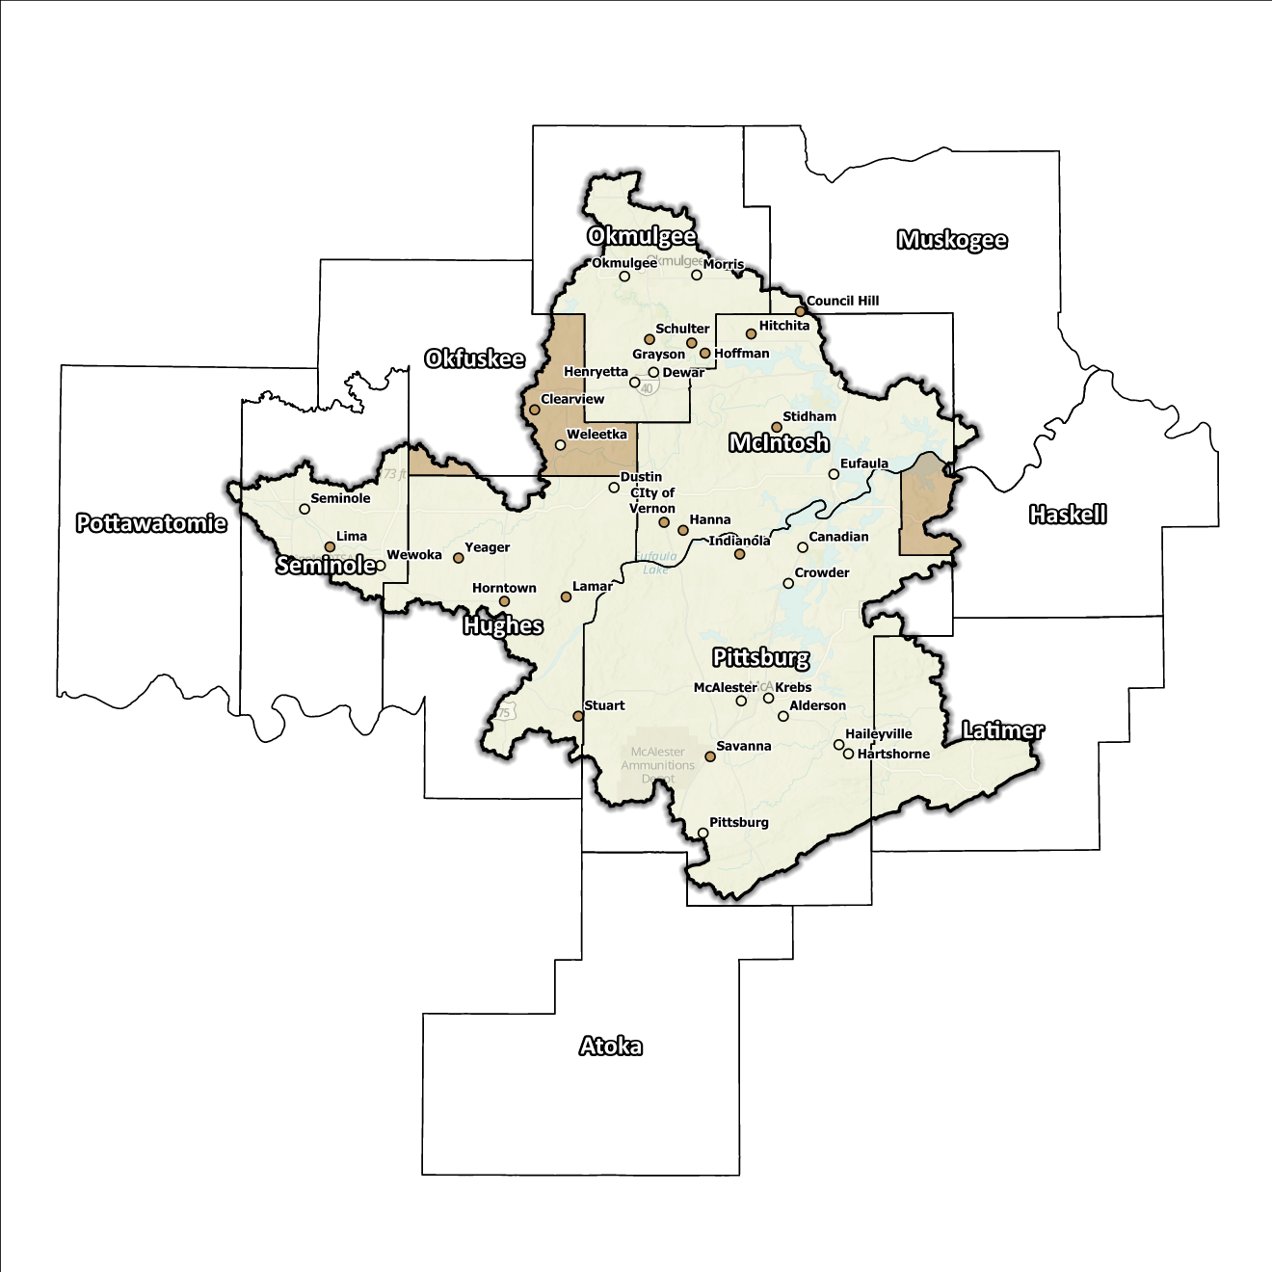
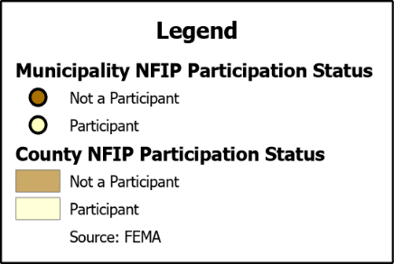
Figure 4: Status of NFIP Participation in the Eufaula Planning Region
As of April 4, 2023, none of the communities in the Eufaula Watershed are eligible to participate in FEMA’s Community Rating System (CRS). Continued outreach to these communities to enhance NFIP standards will support the desire to reduce insurance rates and the need for large payouts.

Flood Insurance Coverage
As of the latest update, there are currently 204 active NFIP policies in effect within the planning area.
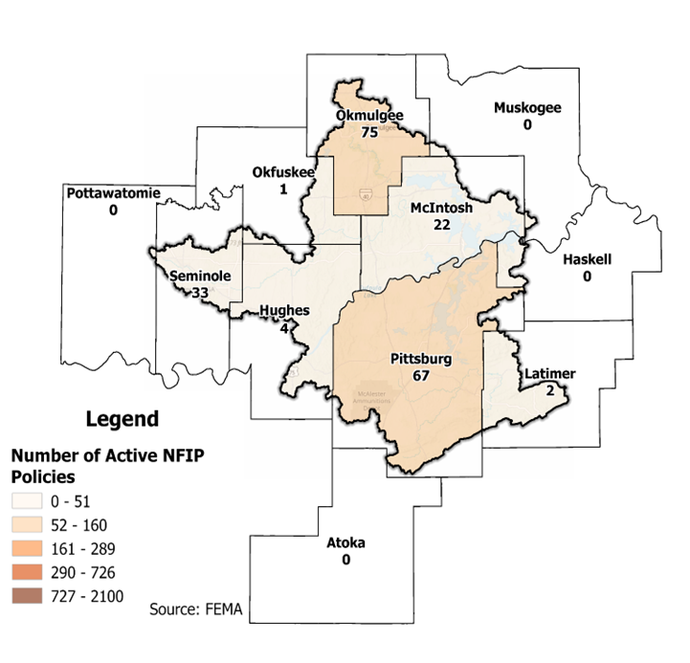
The subsequent displays provide a range of information about NFIP policies, as well as the total claims filed and paid in the Planning Region. Although these figures are insightful, it's crucial to recognize they may not accurately reflect the true extent of losses in the area due to an underrepresentation of flood insurance. Not every claim filed or paid is linked to an active policy.
Figure 5: Number of Active NFIP Policies in the 100- Year Floodplain in the Eufaula Planning Region
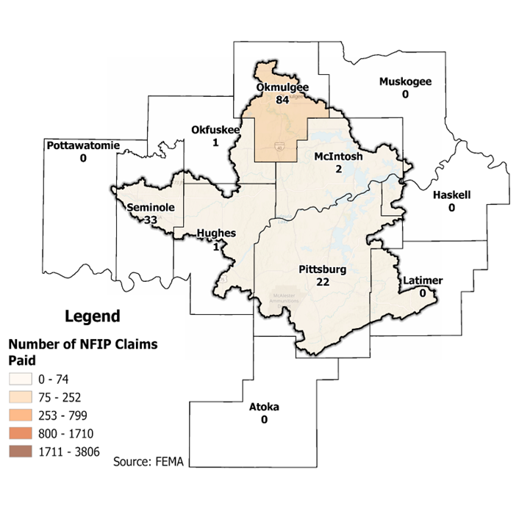
Figure 6: Total NFIP Claims Paid in the Eufaula Planning Region
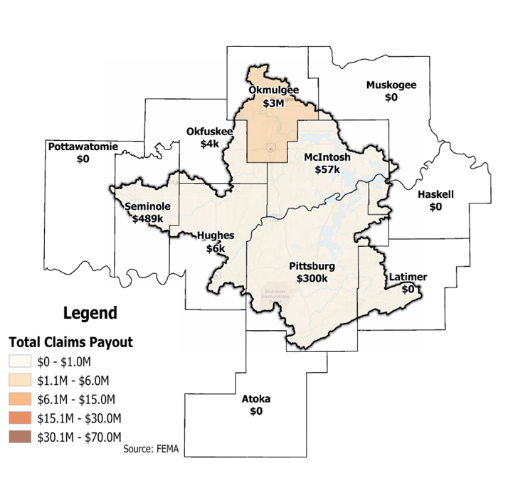
Figure 7: Total Value NFIP Claims Paid Out in the Eufaula Planning Region
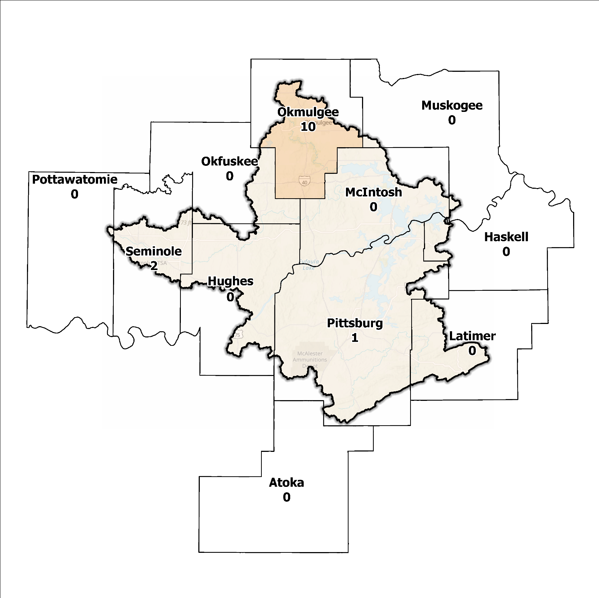
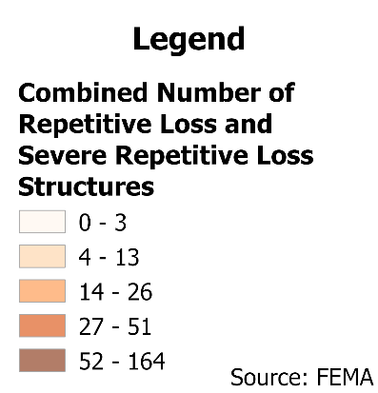

Figure 8: Repetitive Loss and Severe Repetitive Loss Structures in the Eufaula Planning Region

Flood Funding Mechanisms
The majority of communities in the Eufaula Watershed Region are rural and have limited local funding. Regional cooperative flood reduction projects may be helpful in bridging the funding gap for these smaller communities.

Hazard Mitigation Plan Status
Five out of ten counties in this Region possess a current FEMA-approved Hazard Mitigation Plan (HMP) and identified mitigation actions vary in jurisdictions. Commonalities include improvement to drainage systems and stormwater management, installation of warning systems, and public education on NFIP participation. County roads and bridges are considered the highest risk with riverine flooding being the primary cause.
Table 2: Hazard Mitigation Planning Status in the Eufaula Planning Region
Name | Type | Approval Date | Expiration | Current Action Status of this Plan
Atoka | County | 12/15/2009 | 12/15/2014 | Expired
Haskell | County | 01/22/2017 | 01/22/2022 | Expired
Hughes | County | 08/05/2024 | 08/04/2029 | Approved
Wetumka | City | 09/24/2012 | 09/24/2017 | Expired
Latimer | County | 08/07/2018 | 08/06/2023 | Expired
McIntosh | County | - | - | In Progress
Muskogee | County | 04/17/2024 | 04/16/2026 | Approved
Okfuskee | County | 07/30/2013 | 07/30/2018 | Expired
Okmulgee | County | 08/02/2023 | 08/01/2028 | Approved
Beggs | City | 10/01/2008 | 10/01/2013 | Expired
Okmulgee | City | 12/04/2024 | 12/03/2029 | Approved
Pittsburg | County | 03/09/2022 | 03/08/2027 | Approved
Pottawatomi | County | 01/07/2022 | 01/06/2027 | Approved
Seminole | County | 04/24/2024 | 04/23/2029 | Approved
Seminole | City | 06/06/2024 | 06/05/2029 | Approved
Absentee-Shawnee | Tribal Nation | - | - | In Progress
Cherokee | Tribal Nation | 02/08/2023 | 02/07/2028 | Approved
Choctaw | Tribal Nation | 05/21/2020 | 05/20/2025 | Approved
Citizen Potawatomi | Tribal Nation | 01/19/2023 | 01/18/2028 | Approved
Creek | Tribal Nation | 12/01/2021 | 11/30/2026 | Approved
Seminole | Tribal Nation | - | - | In Progress

Flood Mapping Assessment
In the Eufaula Planning Region, the floodplain quilt consolidates the best available data on flood risk. However, some areas in the Region still need to be mapped by FEMA, like Okfuskee and Latimer County, limiting the ability of local authorities to regulate development in flood-prone areas.
A notable aspect in the Region is most of the effective FEMA maps still need detailed studies. This leaves floodplain managers to rely on Approximate A Zones, which offer a broad understanding of flood risk but do not have determined Base Flood Elevations (BFE). Figure 9 displays FEMA-mapped areas in the Planning Region.
While in areas with A zones, Base Level Engineering (BLE) data might provide a more accurate indication of flood risk, it is noted that most of the Eufaula Planning Region has comprehensive BLE coverage. BLE assists in determining areas that are expected to flood and therefore are not reasonably safe from flooding. The need for in-depth studies is required to augment the precision and reliability of flood risk information in this Region.
McIntosh, Seminole, and Okmulgee Counties, along with the cities of Henryetta, Seminole, and Wewoka, stand out among areas in the Planning Region for having the most extensive flood risk assessment information. Investment in floodplain mapping has been higher in these areas than in others in the Region.
While Flood Insurance Rate Maps (FIRMs) are beneficial for regulatory uses and flood insurance assessments, they only represent potential risks associated with a flood event under certain specific conditions. The threat of flooding beyond the FEMA mapped SFHA is only included on FIRMs if the community opts to carry out the required studies to integrate such data into their hazard map.
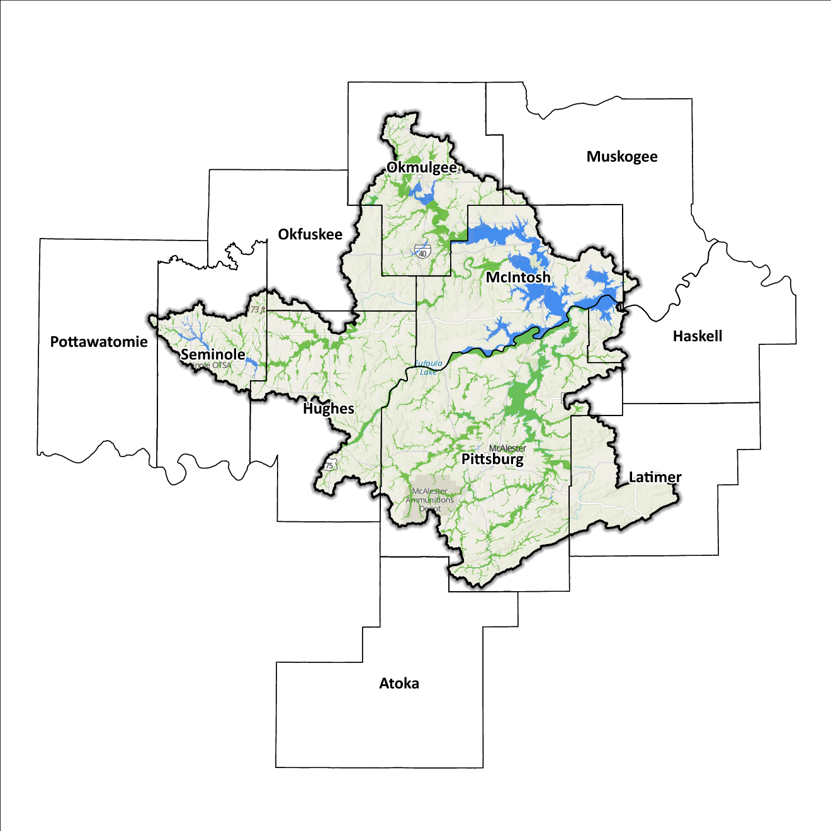
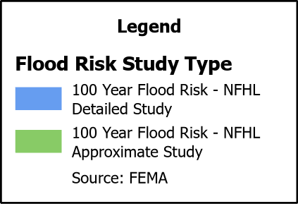
Figure 9: FEMA Mapped Special Flood Hazard Area Comparison in the Eufaula Planning Region

Flood Hazard Assessment
Flood hazards in this Region include flash, riverine, and urban flooding. The Red and Washita Rivers, Mud Creek, and Walnut Bayou, along with their various tributaries, are the major waterways found in the Eufaula Watershed.

Location of Flood Hazards
The Eufaula Planning Region is characterized by a flood hazard that encompasses various significant aspects. The flood location in the Eufaula Planning Region exhibits the following characteristics:
- Flooding along major waterways with extensive drainage basins, including the Canadian River, Deep Fork, Coal Creek, and Wewoka Creek.
- Flash floods along smaller tributaries that ultimately flow into the major waterways.
- Drainage issues in specific areas result from inadequate infrastructure. Insufficient drainage systems can exacerbate flood risks, leading to localized flooding in vulnerable locations.
- Downstream areas located below high-hazard potential dams are exposed to heightened risks.
Figure 10 shows mapped areas of flood risk in the Region. The map brings together data from different sources, like the National Flood Hazard Layer and BLE, to create a unified view. It prioritizes layer types and shows the most important layer available for a specific area.
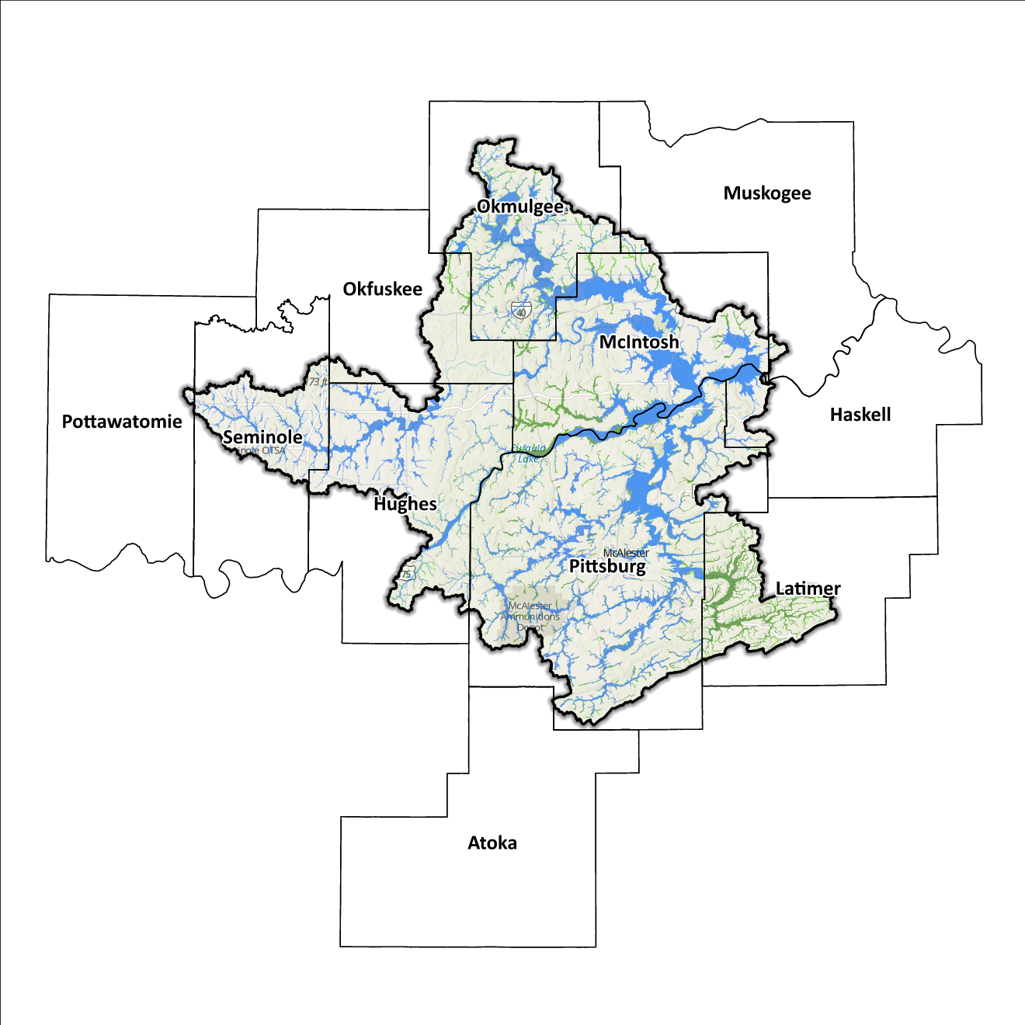
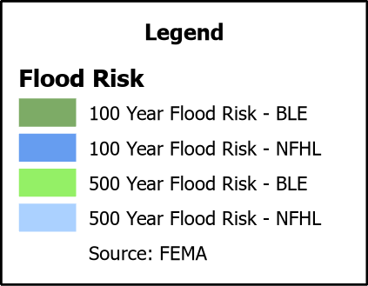
Figure 10: Flood Quilt in the Eufaula Planning Region

Dam and Levee Infrastructure
The Region has multiple dams and levees aimed at preventing flooding. However, aging infrastructure increases the risk of downstream impacts if a breach or failure occurs, especially for high-hazard dams classified by the Oklahoma Water Resources Board (OWRB). The 10 counties have 48 high-hazard dams, with 23 located in the Eufaula Watershed. The Eufaula Watershed Region has no levee systems across any of its counties. A map of dam and levee locations within the Region is shown in Figure 11.
Dam failure has not been significant through much of the past; however, heavy rainfall in the spring of 2015 forced the United States Army Corps of Engineers (USACE) to open the flood gates causing rapid flooding greatly affecting the residents and their land downstream of the flood gates.
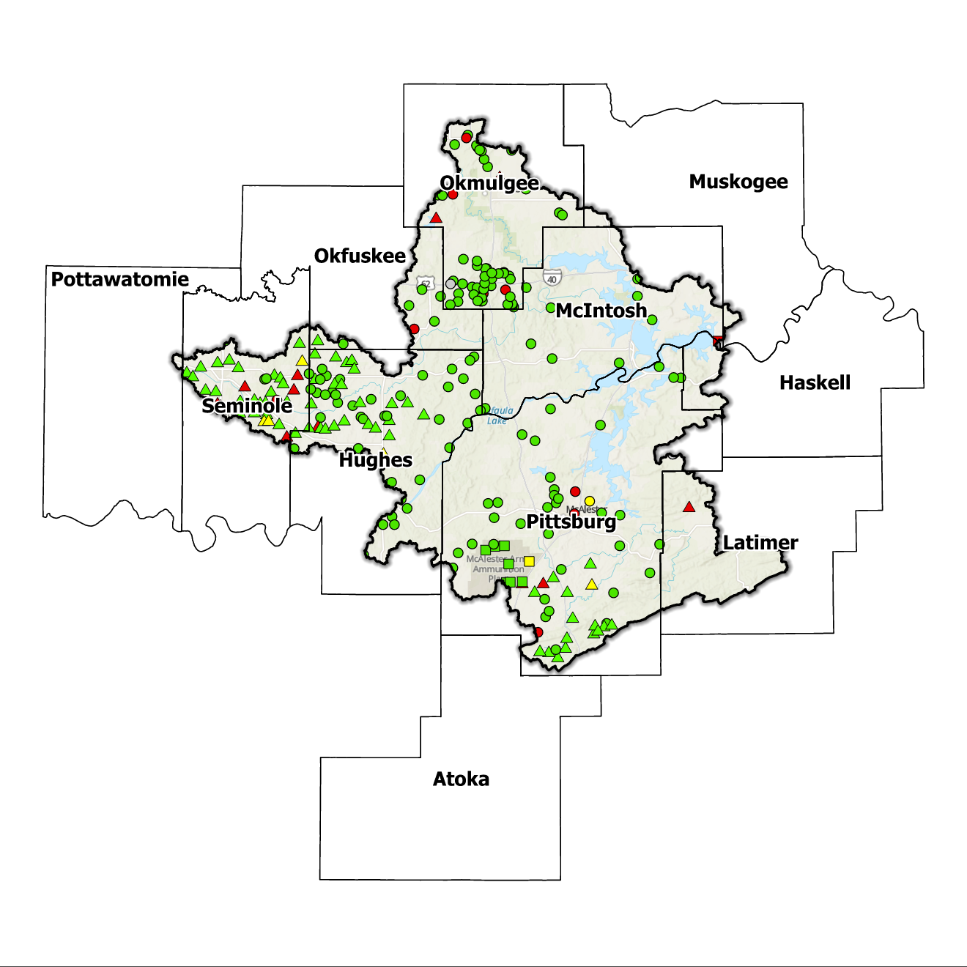
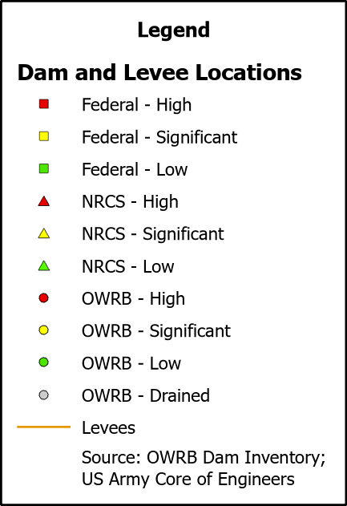
Figure 11: Dam and Levee Locations in the Eufaula Planning Region

Extent of Flooding
Extent refers to the expected severity of flooding, and because not all areas within the planning area share the same topography, the extent varies between individual communities. The average depth of flooding within the FEMA-mapped SFHA can range from a few inches to several feet, depending on factors such as topography, proximity to water bodies, local drainage characteristics, and the intensity of the flood event.

Previous Occurrences
According to the records maintained by the National Center of Environmental Information (NCEI), from January 1996 to December 2022, a total of 496 flood events have been documented in the 10 counties encompassing this Planning Region. Cumulatively, these flooding incidents have caused property damage amounting to $6,183,000.
The NCEI initiated the tracking of flood events only from 1996, hence this data represents the most comprehensive information available. Flooding has frequently escalated to the point of necessitating a Presidential Disaster Declaration. A breakdown of flood-related disasters by county is shown in Table 3.

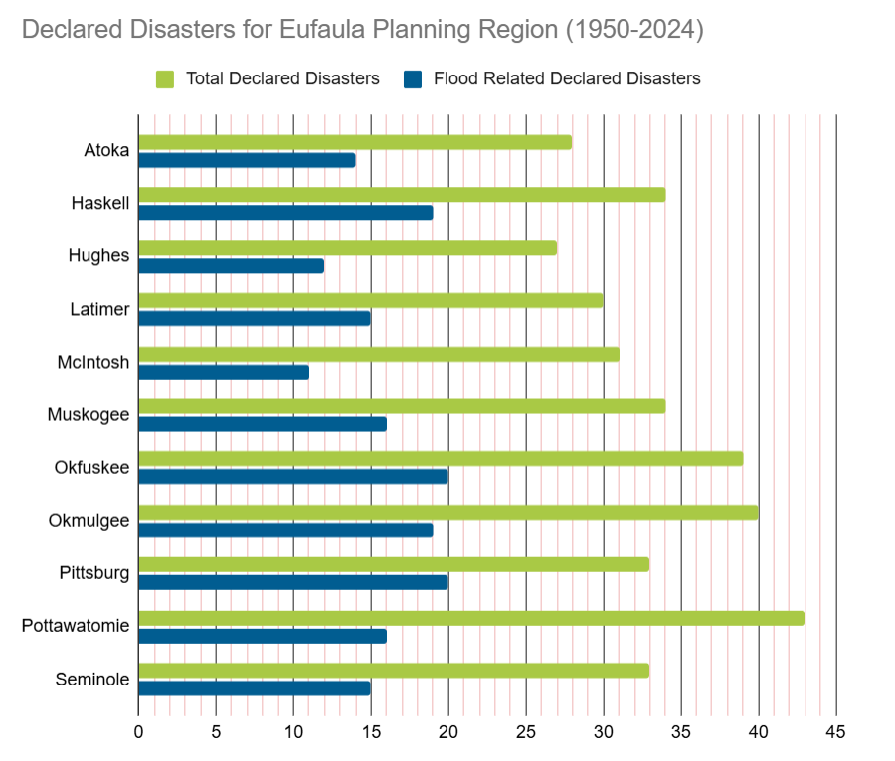
Table 3: FEMA Flood Related Disaster Declarations (1950-2024) in the Eufaula Planning Region

Of all the counties in the Region, Okfuskee and Pittsburg Counties have most frequently been declared disaster areas due to flooding. However, it's important to note that disaster declarations are issued on a county-wide basis and not all declarations may have directly impacted this specific Region.

Vulnerability and Impacts of Flooding
According to FEMA’s National Risk Index (NRI), the Eufaula Planning Region demonstrates a range of risk levels for riverine flooding and flash flooding, varying from very low to relatively moderate risk at the county level, when compared to the rest of the United States. However, when examined at a more granular scale by census tract, the NRI highlights specific areas along the Canadian River, particularly in Okmulgee County, as being at a moderate risk of flooding.
Compared to other regions in Oklahoma, the Eufaula Planning Region is at a moderate risk of flooding due to multiple factors including inconsistent medium to high annual precipitation, a large number of waterways and drainage areas, development in flood-prone locations, and aging infrastructure.

Summary of Flood Exposure
Flood exposure refers to the degree to which an area or population is at risk of being affected by a flood event. Table 4 provides a comprehensive overview of key factors, including the total count of housing units, population figures, job statistics, land area measurements, and the number of parcels/blocks within the designated FEMA-mapped flood area. This information aims to facilitate a thorough understanding of the flood-affected area's characteristics and implications.
The data in this section was generated using UrbanFootprint. This module evaluates flood risk by conducting a spatial join of parcels or census blocks with the FEMA National Flood Hazard Layer to assess the potential risks associated with hazards. The data presented in the table below is focused on three different FEMA SFHA flood zones that represent areas within the 100-yr floodplain with a 1% annual chance of experiencing a flood event. Zone AE is the most detailed, providing base flood elevations, Zone AO represents areas subject to shallow flooding of depths between one to three feet, and Zone A being an approximation of the 100-yr floodplain for areas where detailed hydraulic analyses have not been performed.

Table 4: Flood Exposure in the Eufaula Region
Eufaula Planning Region Flood Risk Report
Housing in Flood Hazard Zones (Dwelling Units)
Dwelling Units in SFHL Zone AE | 1,469
Dwelling Units in SFHL Zone A | 412
Dwelling Units in SFHL Zone AO | N/A
Total | 1,881
Population in Flood Hazard Zones (Persons)
Population in SFHL Zone AE | 2,519
Population in SFHL Zone A | 845
Population in SFHL Zone AO | N/A
Total | 3,364
Jobs in Flood Hazard Zones (Employees)
Jobs in SFHL Zone AE | N/A
Jobs in SFHL Zone A | N/A
Jobs in SFHL Zone AO | N/A
Total | N/A
Land Area in Flood Hazard Zones (Acres)
Area in SFHL Zone AE | N/A
Area in SFHL Zone A | N/A
Area in SFHL Zone AO | N/A
Total | N/A
Parcels or Blocks in Flood Hazard Zones
Parcels or Blocks in SFHL Zone AE | N/A
Parcels or Blocks in SFHL Zone A | N/A
Parcels or Blocks in SFHL Zone AO | N/A
Total | N/A

Flood Mitigation Needs
Flood mitigation projects for the Region have been identified at a county level through the analysis of HMPs, the community level through projects identified in master drainage plans, and prioritized lists provided by jurisdictions. The type and number of projects identified in this Region are limited with two dam upgrades, one reservoir improvement, and one city-level stormwater improvement project. Additional projects are possible across the Region with a renewed emphasis on hazard mitigation planning.
A detailed representation of project requirements by category and approximate cost can be found in Table 5.

Table 5: Stormwater Projects Identified in the Eufaula Planning Region
Stormwater Project Types Per County | Number |  | Percentage |  | $ Amount
Okfuskee County
Dam-Reservoir |  | 1 |  | 25% | $927.9k
Okmulgee County
Dam-Reservoir |  | 1 |  | 25% | $3M
Pittsburg County
Infrastructure |  | 1 |  | 25% | $27.8M
Seminole County
Dam-Reservoir |  | 1 |  | 25% | $1.4M
Total | 4 |  | - |  | $33.1M

Conclusion
The Eufaula Watershed report highlights the significance of this Region and its vulnerability to flood events. The report's findings emphasize the urgent need for funding to support engineering efforts in flood projects within the watershed. Adequate funding is essential for conducting detailed engineering assessments, implementing effective flood control measures, and enhancing community resilience. The lack of project submissions underscores the importance of assisting communities in identifying and developing flood mitigation projects.
By allocating resources and support for project identification and development, communities can better understand their flood exposure and proactively protect lives and infrastructure. Investing in engineering and flood mitigation projects in the Eufaula Watershed will contribute to creating safer, more resilient communities better equipped to handle future flood events.
During the planning process, the data generated was developed into an interactive flood planning dashboard. The dashboard serves as a valuable tool for conducting flood assessments at the community level. It is important to note that this report should not substitute locally generated data specific to each community.

This calculation was performed by summing the populations of the counties within this region, as indicated in Table 1, then divided by the entire population of the State of Oklahoma using the same data source (2020 U.S. Decennial Census).
Census Bureau Data – 2020 Decennial Census
Hughes County’s HMP includes the Towns of Dustin, Horntown, Lamar, Stuart, Yeager, and the City of Holdenville.
McIntosh County’s HMP includes the Towns of Hanna, Hitchita, and the City of Eufaula.
Muskogee County’s HMP includes the Town of Council Hill.
Okfuskee County’s HMP includes the Towns of Clearview, Weleetka.
Okmulgee County’s HMP includes the Towns of Dewar, Grayson, Hoffman, Schulter, Winchester, and the Cities of Henryetta, and Morris.
Pittsburg County’s HMP includes the Towns of Alderson, Canadian, Carlton Landing, Crowder, Indianola, Kiowa, Pittsburg, Savanna, and the Cities of Haileyville, Hartshorne, Krebs, and McAlester.
Pottawatomie County’s HMP includes the Town of Earlsboro.
Seminole County’s HMP includes the Towns of Bowlegs, Cromwell, Lima, and the City of Wewoka.
FEMA’s National Risk Index (NRI) is a tool used to calculate a community’s potential for negative impacts due to natural hazards and community risk factors. The three components used in the NRI equation that generates the Risk Index Score are expected annual loss due to natural hazards, social vulnerability, and community resilience.
Any counties that do not appear in the table do not have any identified projects.

