Table of Contents
The Central Planning Region 1
Section 1.1: Watershed Introduction 1
Section 1.2: Socioeconomic and Geographic Characteristics 2
Section 1.3: Floodplain Management and Mitigation Capabilities 5
Section 1.4: Flood Hazard Assessment 16
Section 1.5: Flood Mitigation Needs 22
Section 1.6: Conclusion 23

The Central Planning Region

Watershed Introduction
Encompassing over 10,145 square miles, the Central Watershed Planning Region (the Region) spans across 24 counties in central Oklahoma, and encompasses all or part of Alfalfa, Blaine, Caddo, Canadian, Cleveland, Creek, Dewey, Garfield, Garvin, Grady, Hughes, Kingfisher, Lincoln, Logan, Major, McClain, Okfuskee, Oklahoma, Okmulgee, Pontotoc, Pottawatomie, Seminole, Woods and Woodward counties. A total of 122 municipalities and 11 tribal nations are located here. The Canadian, Cimarron, Little, Deep Fork, and North Canadian Rivers, along with their various tributaries, are the major waterways in the Central Watershed.
Figure 1 highlights the geographic boundaries of the planning area, as well as some quick facts about this Region of the State.
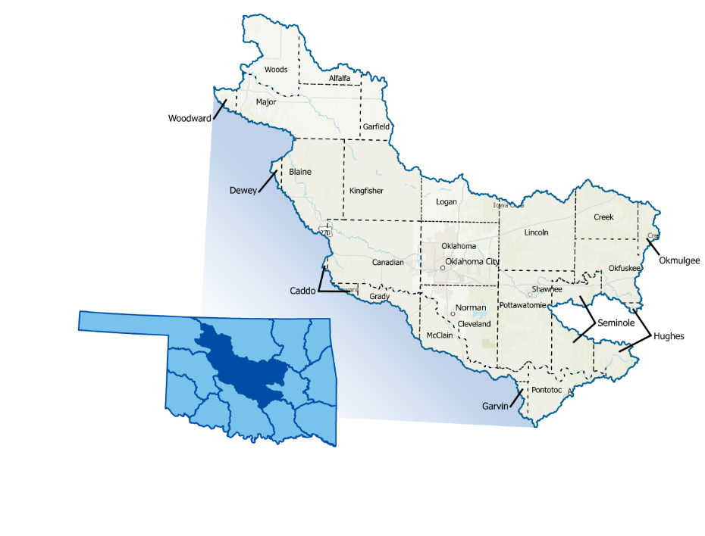
Figure 1: Central Planning Region Boundary

The Central Watershed stands out due to the sheer number of urban areas with little infiltration, making it one of Oklahoma's most flash flood-prone areas. The Region is densely populated with several large cities, increasing its flood vulnerability. Additionally, many rural areas, small towns, and at-risk populations are located within the watershed. Oklahoma City, serving as the population center, has a history of flooding. All counties in the planning area have experienced multiple federally declared flood disasters since 1970. A base map displaying incorporated jurisdictions within the Planning Region is displayed in Figure 2.
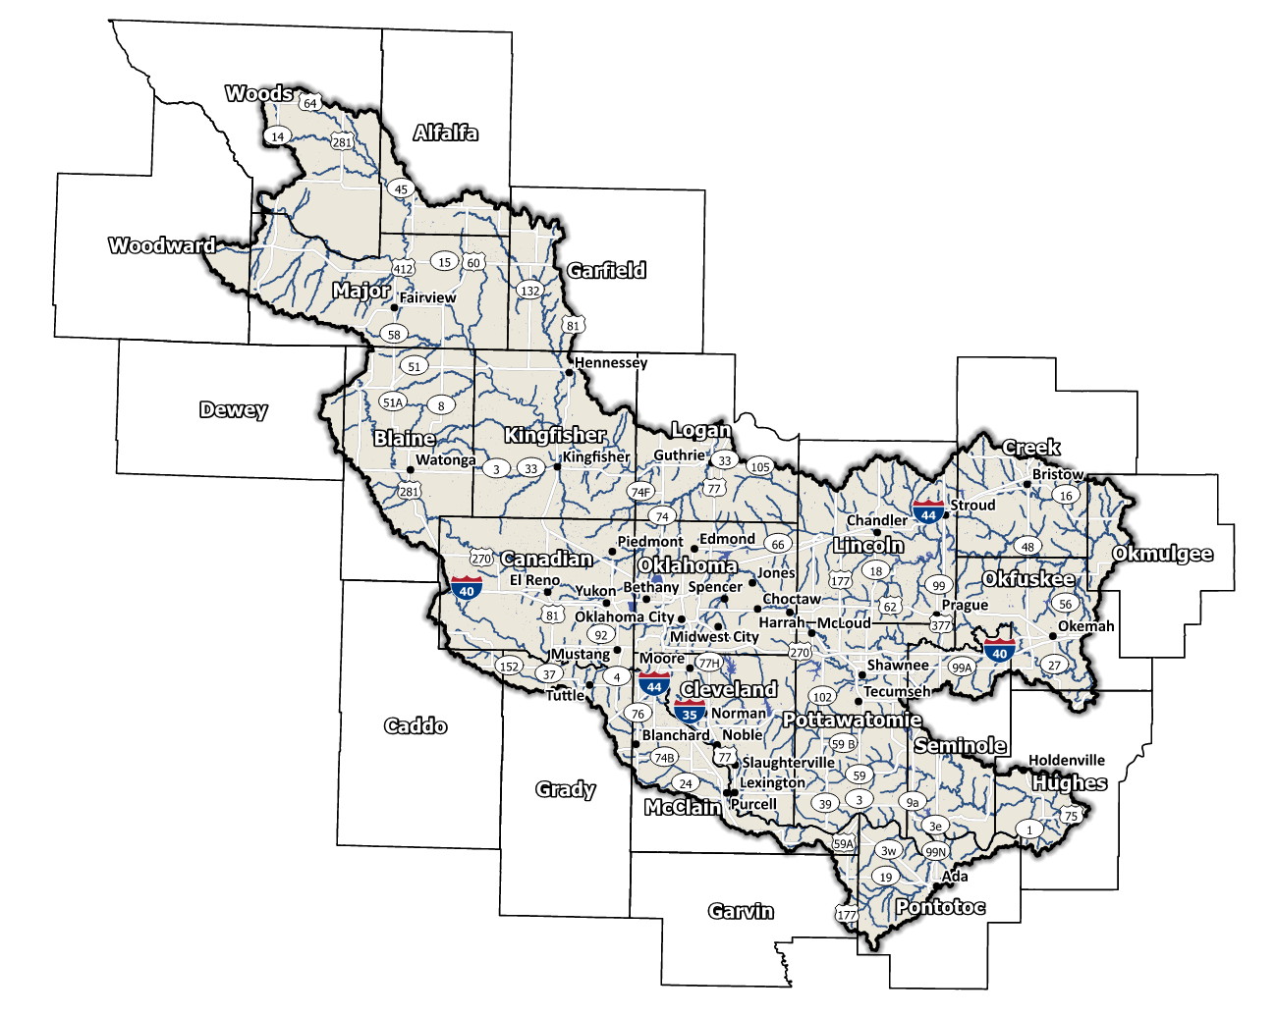
Figure 2: Central Planning Region Base Map

Socioeconomic and Geographic Characteristics
As the largest Planning Region in the state, the Central Planning Region’s population is well diversified. A mix of industries, including oil, gas and aerospace, among a variety of others, bring economic diversity to this Region. Adding another level of variety is the geography of the area. This section will examine some of these socioeconomic and geographic factors and how they contribute to and affect this watershed.

Demographic Profile
The Central Watershed Planning Region encompasses over 800,000 people with a mix of urban, suburban, and rural areas. This Region represents approximately 14.7% of Oklahoma's land area, and around 47% of Oklahoma residents call this area home according to the 2020 U.S. Census. Table 1 provides a population breakdown for each county in the region. Provided by the 2020 U.S. Census, these statistics represent county-level populations, not those within the watershed boundary. Cleveland and Oklahoma Counties are the only 2 in the group that are completely contained within the Central Planning Region.
Table 1: Population Breakdown by County in the Central Planning Region
County |  | Total Population
Alfalfa | 5,699
Blaine | 8,735
Caddo | 26,945
Canadian | 154,405
Cleveland | 295,528
Creek | 71,754
Dewey | 4,484
Garfield | 62,846
Garvin | 25,656
Grady | 54,795
Hughes | 13,367
Kingfisher | 15,184
Lincoln | 33,458
Logan | 49,555
Major | 7,782
McClain | 41,662
Okfuskee | 11,310
Oklahoma | 796,292
Okmulgee | 36,706
Pontotoc | 38,065
Pottawatomie | 72,454
Seminole | 23,556
Woods | 8,624
Woodward | 20,470

The region is home to several Tribal Nations, including the Arapaho, Caddo, Cheyenne, Chickasaw, Choctaw, Delaware, Iowa, Kickapoo, Muscogee (Creek), Potawatomi, Sac and Fox, Seminole, Shawnee, and Wichita Nations. They have a long history of inhabiting the Region and have significantly shaped the area's cultural and economic development. A map displaying areas of tribal jurisdiction within the Planning Region is shown in Figure 3.

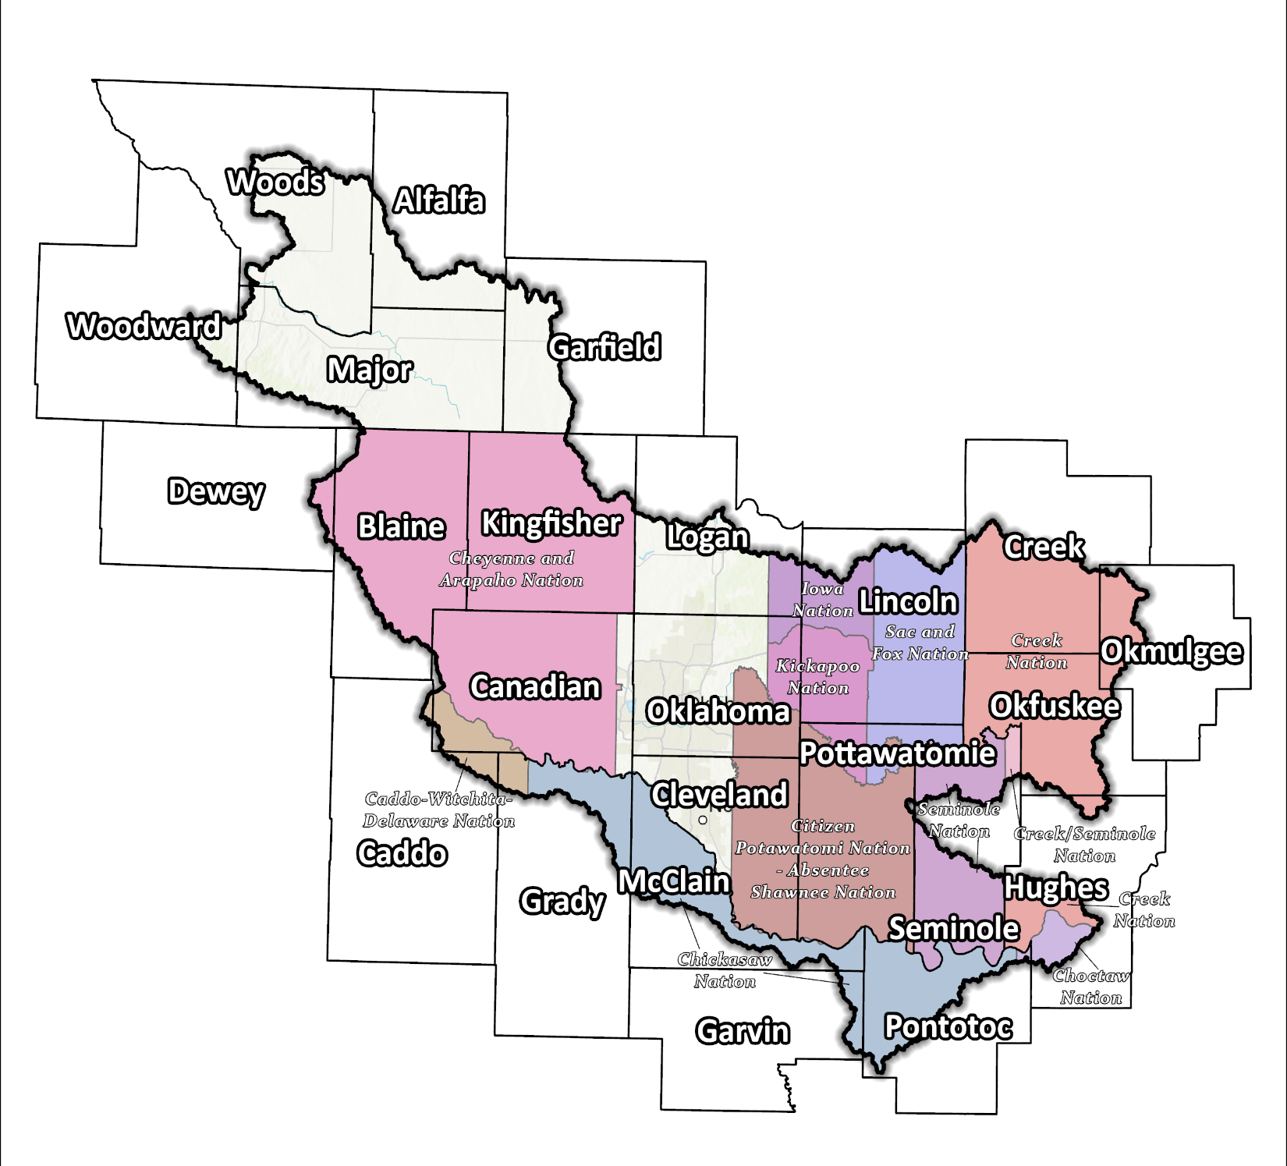
Figure 3: Tribal Jurisdiction Base Map for Central Planning Region

Economic Profile
The Central Planning Region has significant economic importance in the state and the country. Oklahoma City is the largest city in Oklahoma and serves as a hub for oil, gas, and energy industries. The Region is also home to Tinker Air Force Base, Oklahoma’s largest air force base, and several large healthcare and aerospace corporations. The tribal nations in central Oklahoma are significant employers in the Region. They operate in various industries, including gaming, hospitality, and retail. Additionally, the tribal nations support growth and development in the area through investments in infrastructure, education, and healthcare.

Floodplain Management and Mitigation Capabilities
This section provides a broad summary of floodplain management capabilities and community engagement within the overall Central Planning Region.

National Flood Insurance Program Participation
Within the Planning Region, all counties except Garvin and Grady have been mapped by FEMA and participate in the National Flood Insurance Program (NFIP). There are a few communities within the 24 counties, however, that do not currently participate in the NFIP program, as shown in Figure 4, below.
The dedication to floodplain management by jurisdictions in this Planning Region is well demonstrated not only by participation in the NFIP but also in FEMA’s Community Rating System (CRS). 28.5% of Oklahoma CRS communities are in the Central Planning Region. Stretching across four counties the CRS participants include the Cities of Oklahoma City, Del City, Edmond, and part of Enid. Several communities in the Region go above and beyond the minimum NFIP requirements and could be used as an example for best practices and knowledge sharing in other portions of the State.
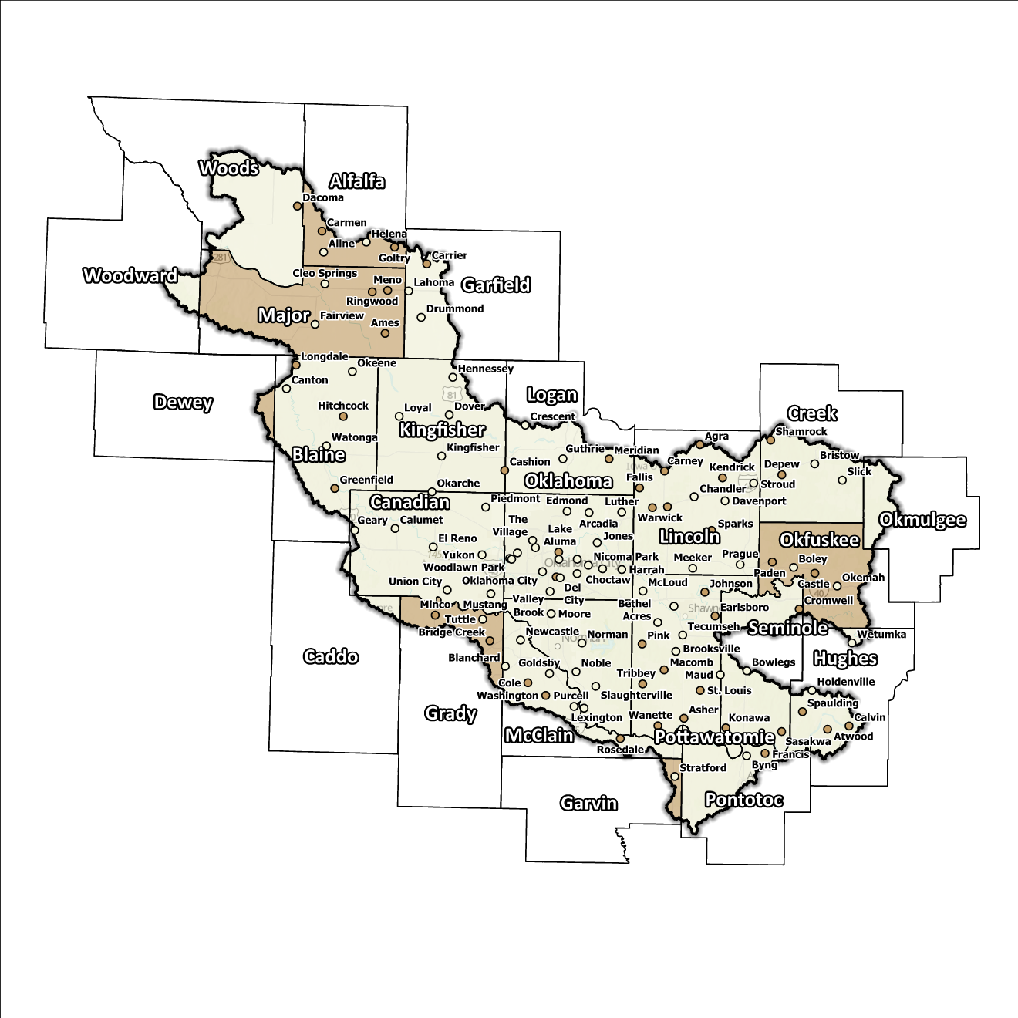
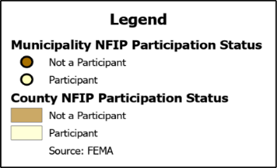
Figure 4: Status of NFIP Participation in the Central Planning Region

Flood Insurance Coverage
As of the latest update, there are currently 3,133 active NFIP policies in effect within the planning area. These policies cover approximately 17.9% of the total structures located in the FEMA mapped Special Flood Hazard Area (SFHA). It should be noted that not all active policies are situated within the SFHA. A total of 3,373 NFIP claims have been filed, resulting in approximately $49 million being paid out to policyholders. In the Region, there are 17,431 structures classified as repetitive loss (RL) and/or classified as severe repetitive loss (SRL), with a significant concentration of both types in Oklahoma County. Repetitive loss, in the context of the NFIP, refers to properties that have experienced multiple flood-related insurance claims over a specific time period. Severe repetitive loss, on the other hand, pertains to properties with an extensive history of recurrent flood damage and a high number of insurance claims, making them particularly vulnerable and costly for the NFIP.
The following figures (Figure 5 through Figure 8) provide a range of information about NFIP policies, as well as the total claims filed and paid in the Planning Region. While these figures offer valuable insights, it is crucial to acknowledge they may not accurately reflect the true extent of losses within the area due to potential underrepresentation of flood insurance. It is important to note that not every claim submitted or paid can be directly associated with an active policy.

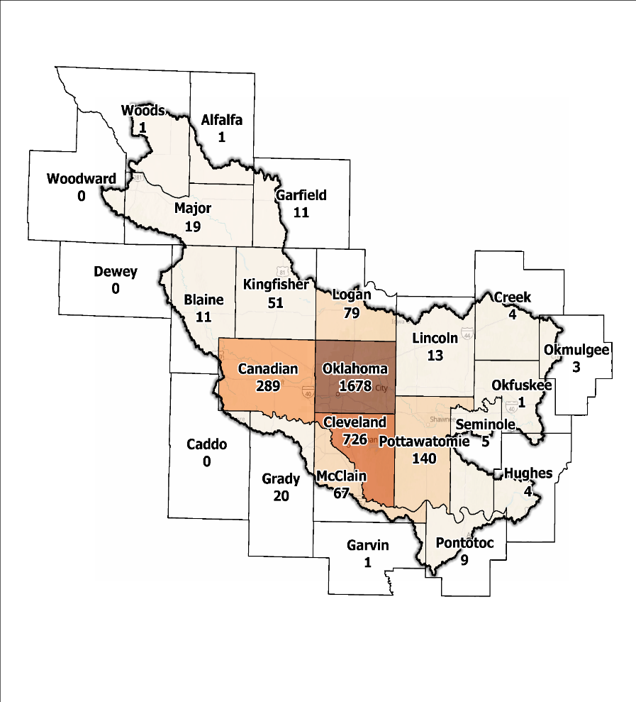
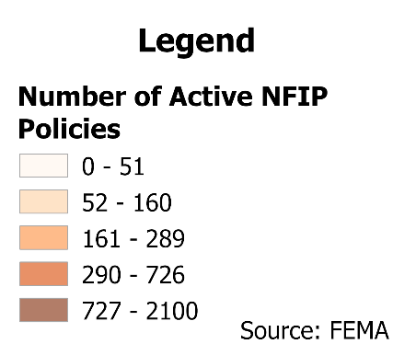
Figure 5: Number of Active NFIP Policies in the 100-Year Floodplain Central Planning Region

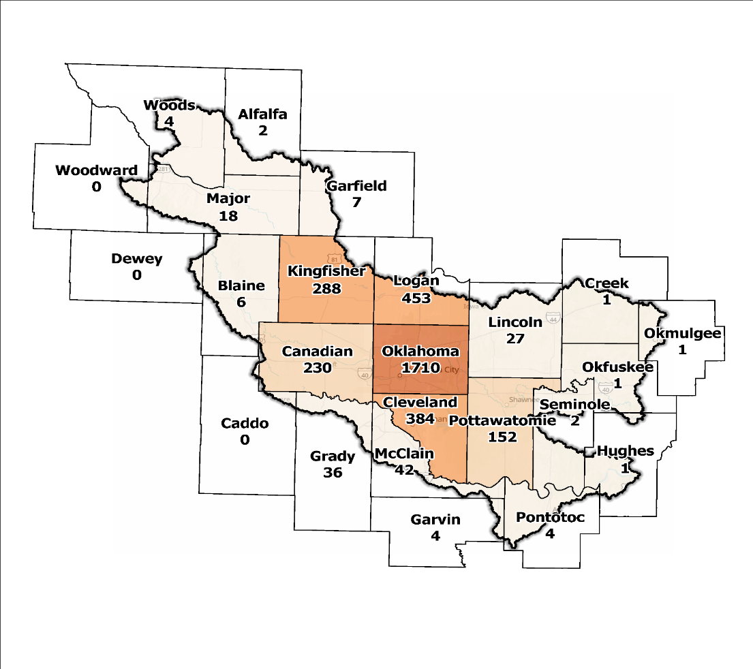
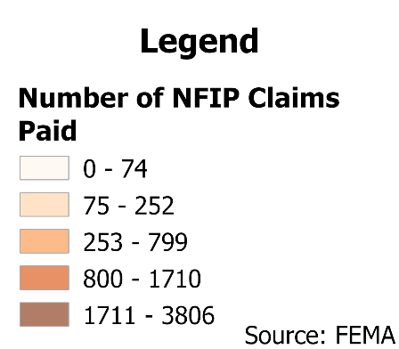
Figure 6: Total NFIP Claims Paid Central Planning Region

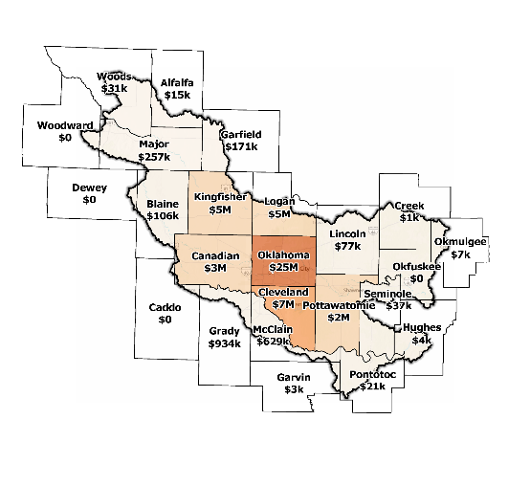
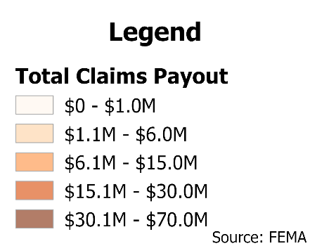
Figure 7: Total Value NFIP Claims Paid Out in the Central Planning Region

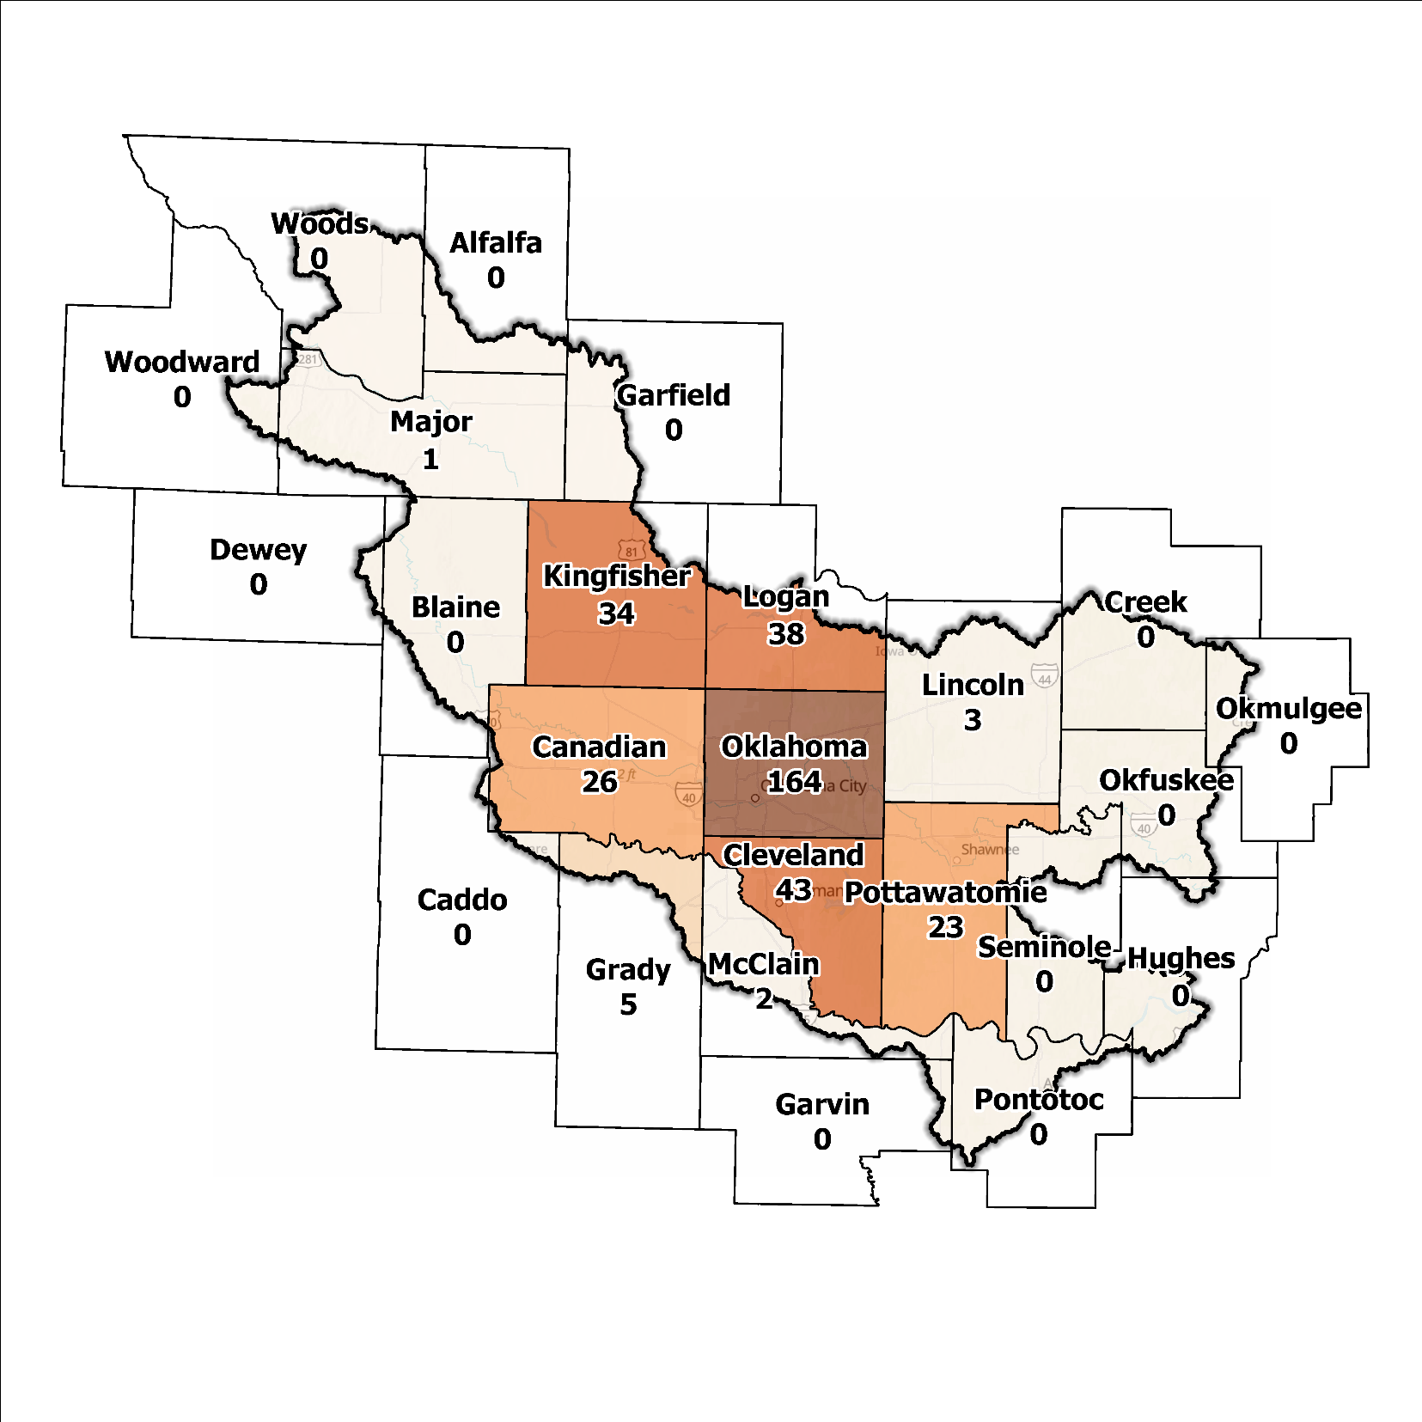
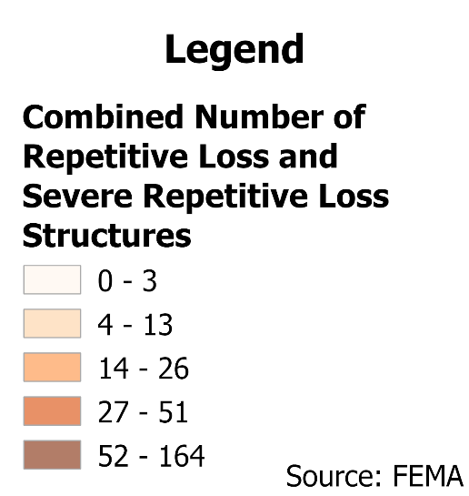
Figure 8: Repetitive Loss and Severe Repetitive Loss Structures in the Central Planning Region

Flood Funding Mechanisms
A survey conducted by the planning team to determine the level of funding for stormwater and floodplain management in the Central Planning Region revealed that some smaller communities have limited local funding. Some larger, more urban jurisdictions, such as Oklahoma City, Del City, Edmond, and Enid could successfully implement stormwater utility fees enabling them to fund departments for facilitating management activities. In contrast, other jurisdictions have found marginal results in the utilization of local taxes, fees, and funds.

Hazard Mitigation Plan Status
A total of 18 out of 24 counties in the Region possess a FEMA-approved Hazard Mitigation Plan (HMP), and identified mitigation actions vary by jurisdiction. Several identify basic programmatic and administrative activities, such as planning, education, acquiring or implementing warning systems, participating in the NFIP and/or CRS, etc. In contrast, others intentionally list flood mitigation projects such as property buyouts, road and drainage improvements, floodplain restoration, and other flood-specific activities. Flash flooding and road flooding are the most frequently reported problems across the planning area. Several communities and tribal entities in the Region have individual HMPs separate from their respective counties. The cities of Edmond, Norman, Del City, and Oklahoma City use their HMPs to gain points under activity 510 of the CRS. Table 2 shows all previous, current, or pending HMPs in the Region.

Table 2: Hazard Mitigation Planning Status for the Central Planning Region
Name | Type | Approval Date | Expiration | Current Action Status of this Plan
Alfalfa | County | 04/10/2022 | 04/09/2027 | Approved
Blaine | County | 03/21/2023 | 03/20/2028 | Approved
Caddo | County | - | - | N/A
Canadian | County | 11/16/2021 | 1/15/2026 | Approved
Yukon | City | 09/12/2024 | 09/11/2029 | Approved
Cleveland | County | 09/22/2020 | 09/21/2025 | Approved
Moore | City | 06/11/2020 | 06/10/2025 | Approved
Creek | County | 04/03/2023 | 04/02/2028 | Approved
Dewey | County | 09/22/2020 | 09/21/2025 | Approved
Garfield | County | - | - | N/A
Garvin | County | 06/10/2024 | 06/09/2029 | Approved
Grady | County | 08/29/2024 | 08/28/2029 | Approved
Hughes | County | 08/05/2024 | 08/04/2029 | Approved
Wetumka | City | 09/24/2012 | 09/24/2017 | Expired
Kingfisher | County | 07/24/2024 | 07/23/2029 | Approved
Lincoln | County | - | - | N/A
Logan | County | 02/23/2023 | 02/22/2028 | Approved
Major | County | 05/13/2024 | 05/12/2029 | Approved
McClain | County | 09/14/2021 | 09/13/2026 | Approved
Newcastle | City | 10/28/2024 | 10/27/2029 | Approved
Okfuskee | County | 07/29/2013 | 07/29/2018 | Expired
Oklahoma | County | - | - | N/A
Jones | Town | 03/19/2020 | 03/18/2025 | Approved*
Oklahoma City | City | 12/30/2022 | 12/29/2027 | Approved
Okmulgee | County | 08/02/2023 | 08/01/2028 | Approved
Beggs | City | 10/01/2008 | 10/01/2013 | Expired
Pontotoc | County | 02/23/2023 | 02/22/2028 | Approved
Pottawatomie | County | 01/06/2022 | 01/05/2027 | Approved
Seminole | County | 04/24/2024 | 04/23/2029 | Approved
Woods | County | 04/04/2023 | 04/03/2028 | Approved
Woodward | County | 07/28/2008 | 07/28/2013 | Expired
Absentee-Shawnee | Tribal Nation | - | - | In Progress
Caddo | Tribal Nation | 01/19/2023 | 01/18/2028 | Approved
Cheyenne and Arapaho | Tribal Nation | 01/27/2022 | 01/26/2027 | Approved
Chickasaw | Tribal Nation | 10/20/2021 | 10/19/2026 | Approved
Choctaw | Tribal Nation | 05/21/2020 | 05/20/2025 | Approved*
Citizen Potawatomi | Tribal Nation | 01/19/2023 | 01/18/2028 | Approved
Creek | Tribal Nation | 12/01/2021 | 11/30/2026 | Approved
Kickapoo | Tribal Nation | 05/23/2019 | 05/22/2024 | Expired
Sac & Fox | Tribal Nation | 07/25/2012 | 07/25/2017 | Expired

Flood Mapping Assessment
In the Central Planning Region, the floodplain quilt consolidates the best available data on flood risk. However, some areas in the Region still need to be mapped by FEMA, limiting the ability of local authorities to regulate development in flood-prone areas.
A notable aspect in the Region is most of the effective FEMA maps still need detailed studies, including Lincoln and Creek Counties, leaving floodplain managers to rely on limited Approximate A Zones, which offer a broad understanding of flood risk but do not have determined Base Flood Elevations (BFE). Figure 9 displays FEMA-mapped areas in the Planning Region.
While in areas with A zones, Base Level Engineering (BLE) data might provide a more accurate indication of flood risk, it is noted that the Central Planning Region has comprehensive coverage in this regard. BLE assists in determining areas that are expected to flood and therefore are not reasonably safe from flooding. The need for in-depth studies is required to augment the precision and reliability of flood risk information in this Region.
Oklahoma and Cleveland Counties, along with the cities of Oklahoma City, Norman and Shawnee stand out among areas in the Planning Region for having the most extensive flood risk assessment information. Investment in floodplain mapping has been higher in these areas than in others in the Region.
While FIRMs are beneficial for regulatory uses and flood insurance assessments, they only represent potential risks associated with a flood event under certain specific conditions. The threat of flooding beyond the FEMA mapped SFHA is only included on FIRMs if the community opts to carry out the required studies to integrate such data into their hazard map.

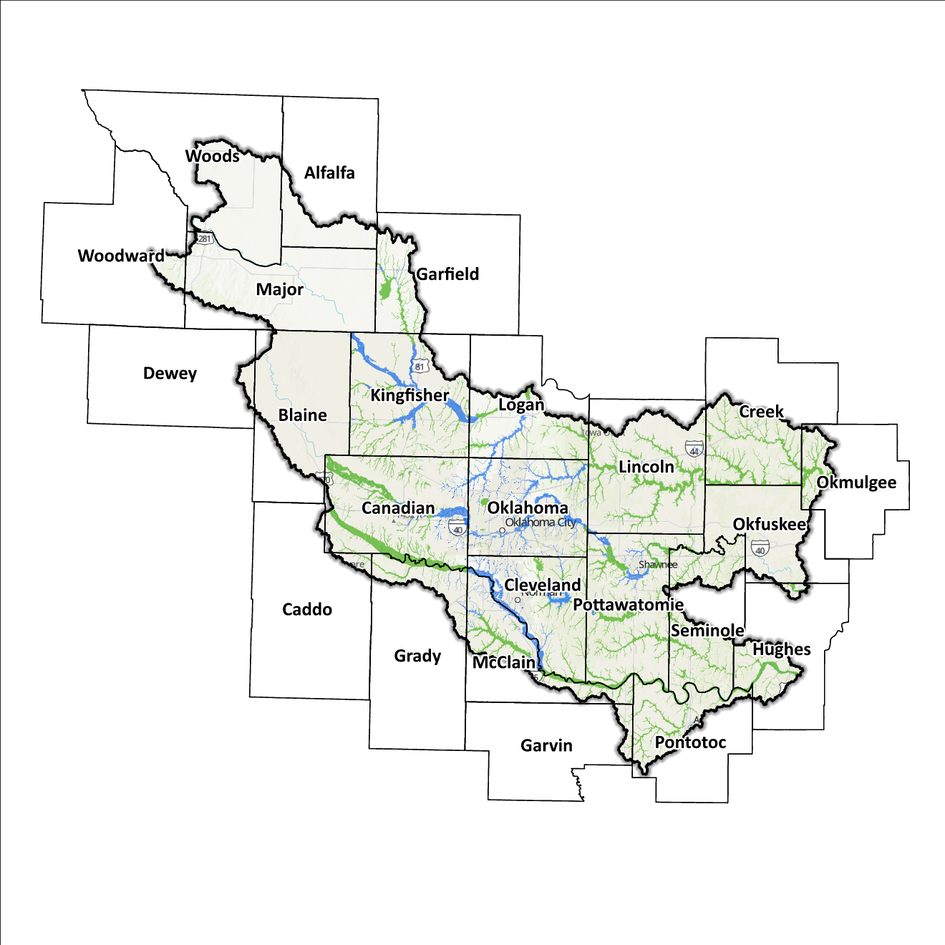
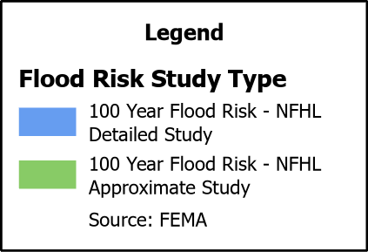
Figure 9: FEMA Mapped Special Flood Hazard Area Comparison in the Central Planning Region

Flood Hazard Assessment
Flood hazards in the Region include flash, river, and urban flooding. The Canadian, Cimarron, Little, Deep Fork, and North Canadian Rivers, along with their various tributaries, are the major waterways found in the Central Planning Region.

Location of Flood Hazards
The Central Planning Region is characterized by a flood hazard that encompasses various significant aspects. The flood location in the Central Planning Region exhibits the following characteristics:
- Flooding along major waterways with extensive drainage basins, including the Canadian, Cimarron, Little, Deep Fork, and North Canadian Rivers.
- Flash floods along smaller tributaries that ultimately flow into the major waterways.
- Drainage issues in specific areas result from inadequate infrastructure. Insufficient drainage systems can exacerbate flood risks, leading to localized flooding in vulnerable locations.
- Downstream areas located below high-hazard potential dams are exposed to heightened risks.
Figure 10 shows mapped areas of flood risk in the Region. The map brings together data from different sources, like the National Flood Hazard Layer and Base Level Engineering, to create a unified view. It prioritizes layer types and shows the most important layer available for a specific area.

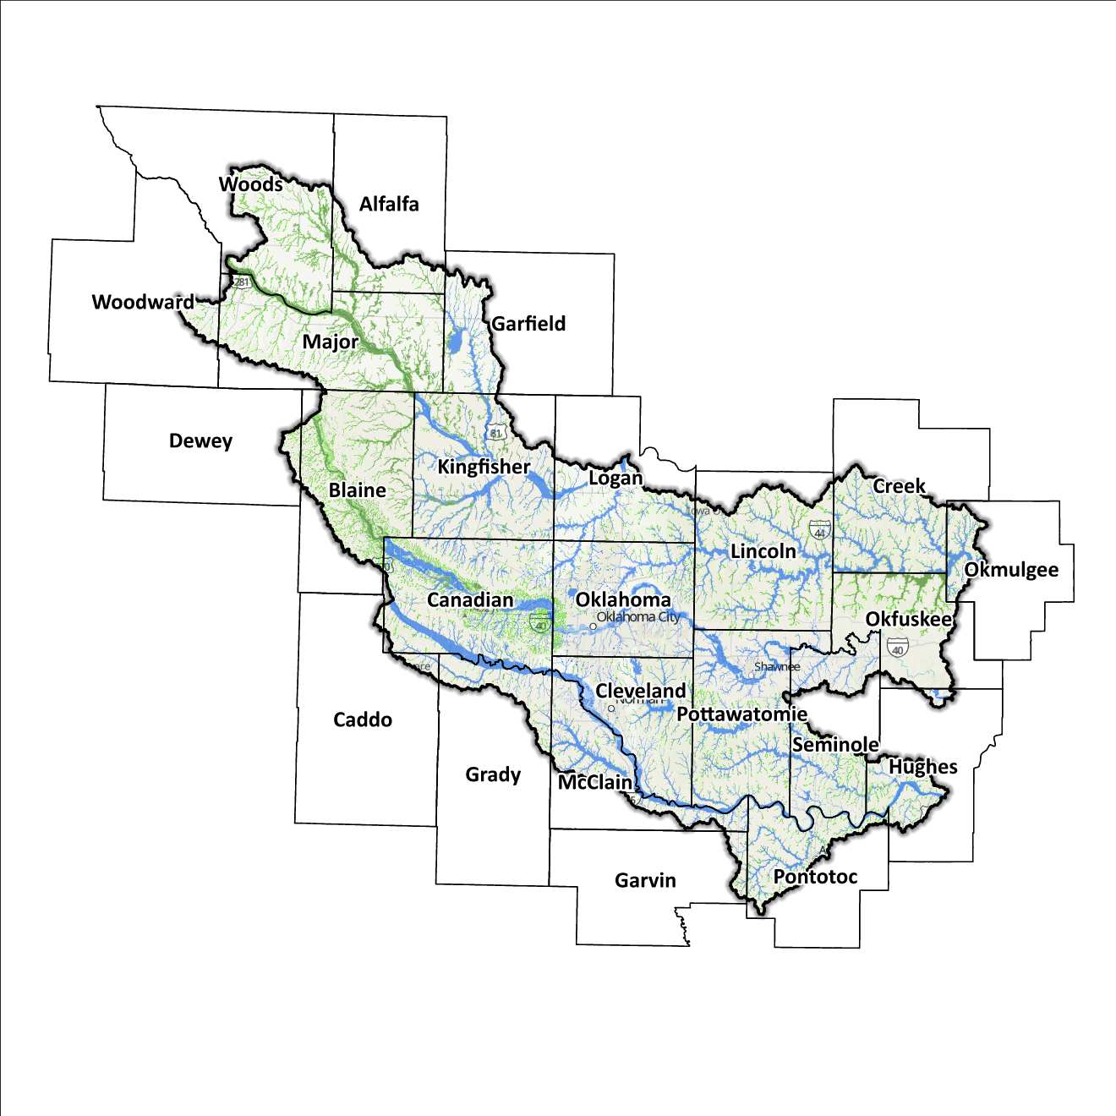
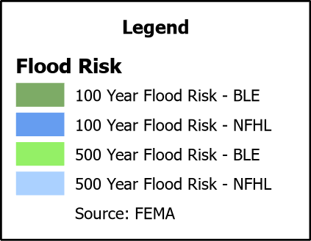
Figure 10: Flood Quilt for the Central Planning Region

Dam and Levee Infrastructure
The Region has multiple dams and levees aimed at preventing flooding. However, aging infrastructure increases the risk of downstream impacts if a breach or failure occurs, especially for high-hazard dams classified by the Oklahoma Water Resources Board (OWRB). The 24 counties in the Region have 179 high-hazard dams, with 81 located in the Central Planning Region. A map of dam and levee locations within the Region is shown in Figure 11.
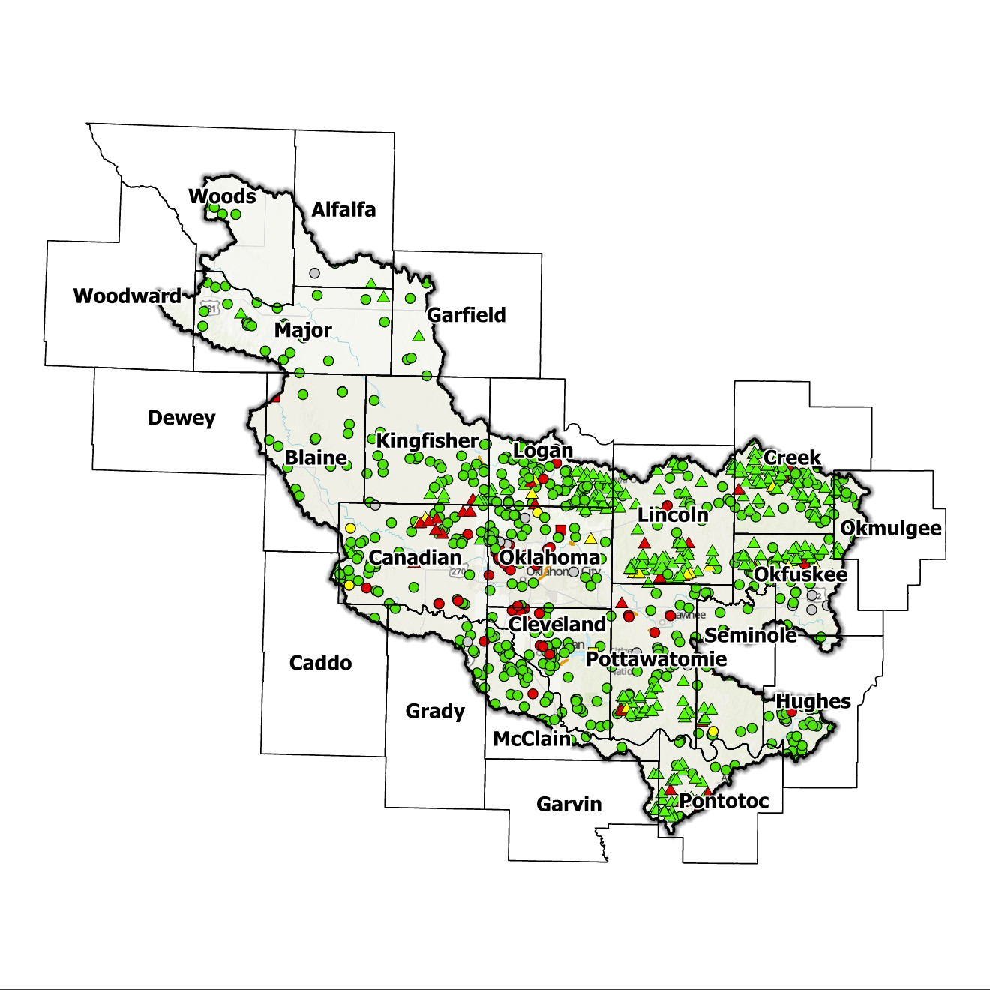
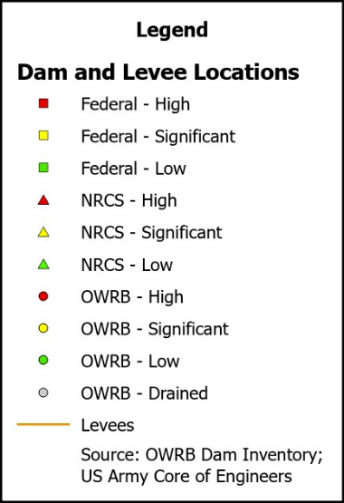
The Central Planning Region has 7 levee systems across Cleveland, Kingfisher, Logan, Oklahoma, and Pottawatomie counties. State and local officials can find information on these systems on the USACE National Levee Database website.

Figure 11: Dam and Levee Locations in the Central Planning Region

Extent of Flooding
Extent refers to the expected severity of flooding, and because not all areas within the planning area share the same topography, the extent varies between individual communities. The average depth of flooding within the FEMA-mapped SFHA can range from a few inches to several feet, depending on factors such as topography, proximity to water bodies, local drainage characteristics, and the intensity of the flood event.

Previous Occurrences
According to the records maintained by the National Center of Environmental Information (NCEI), from January 1996 to December 2022, a total of 1,111 flood events have been documented in the eleven counties encompassing this Planning Region. Cumulatively, these flooding incidents have caused property damage amounting to $39,008,700.
The NCEI initiated the tracking of flood events only from 1996, hence this data represents the most comprehensive information available. Flooding has frequently escalated to the point of necessitating a Presidential Disaster Declaration. A breakdown of flood-related disasters by county is shown in Figure 12.
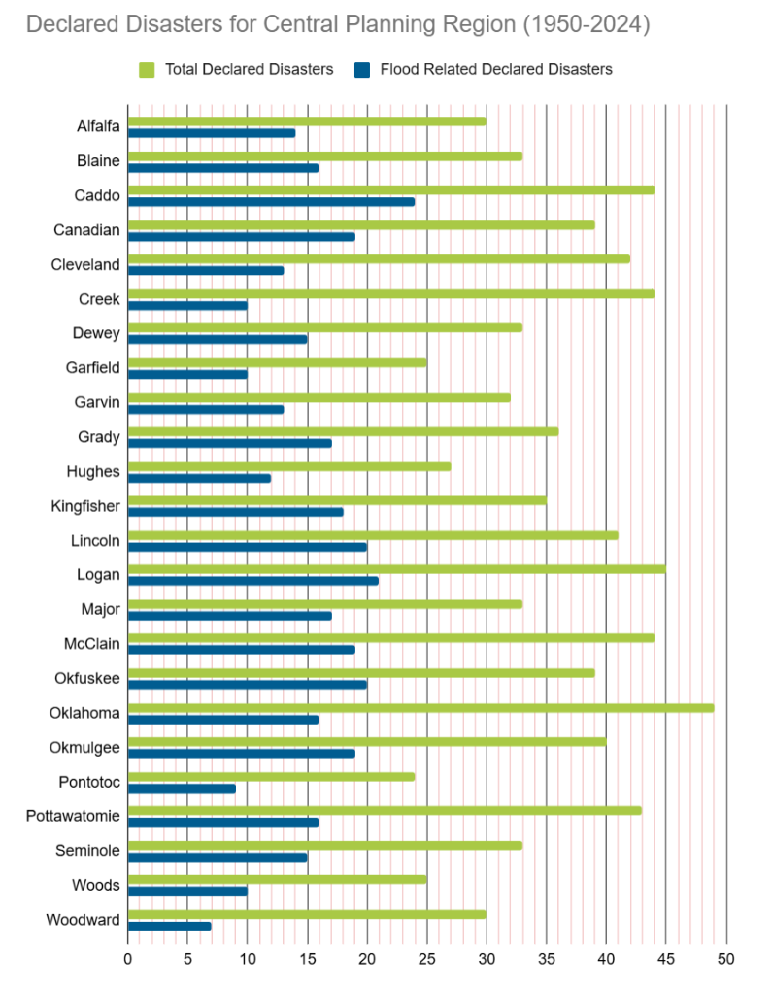
Table 3: FEMA Disaster Declarations from 1950-2024 in the Central Planning Region

Of all the counties in the Region, Caddo County has been declared a disaster area due to flooding more frequently. However, it's important to note that disaster declarations are issued on a county-wide basis and not all declarations may have directly impacted this specific Region.

Vulnerability and Impacts of Flooding
According to FEMA’s National Risk Index (NRI), the Central Planning Region demonstrates a range of risk levels for river flooding and flash flooding, varying from very low to relatively high risk at the county level, when compared to the rest of the United States. However, when examined at a more granular scale by census tract, the NRI highlights specific areas along the North Canadian River, particularly in Oklahoma county, as being at a high risk of flooding.
Compared to other regions in Oklahoma, the Central Planning Region has areas at a higher risk of flooding due to multiple factors including high annual precipitation, numerous waterways and drainage areas, development in flood-prone locations, and aging infrastructure.

Summary of Flood Exposure
Flood exposure refers to the degree to which an area or population is at risk of being affected by a flood event. Table 4 provides a comprehensive overview of key factors, including the total count of housing units, population figures, job statistics, land area measurements, and the number of parcels/blocks within the designated FEMA-mapped flood area. This information aims to facilitate a thorough understanding of the flood-affected area's characteristics and implications.
The data in this section was generated using UrbanFootprint. This module evaluates flood risk by conducting a spatial join of parcels or census blocks with the FEMA National Flood Hazard Layer to assess the potential risks associated with hazards. The data presented in the table below is focused on three different FEMA SFHA flood zones that represent areas within the 100-yr floodplain with a 1% annual chance of experiencing a flood event. Zone AE is the most detailed, providing base flood elevations, Zone AO represents areas subject to shallow flooding of depths between 1 to 3 feet, and Zone A is an approximation of the 100-yr floodplain for areas where detailed hydraulic analyses have not been performed.

Table 4: Flood Exposure in the Central Region
Central Planning Region Flood Risk Report
Housing in Flood Hazard Zones (Dwelling Units)
Dwelling Units in SFHL Zone AE | 12,315
Dwelling Units in SFHL Zone A | 2,388
Dwelling Units in SFHL Zone AO | 23
Total | 14,726
Population in Flood Hazard Zones (Persons)
Population in SFHL Zone AE | 28,364
Population in SFHL Zone A | 5,807
Population in SFHL Zone AO | 69
Total | 34,240
Jobs in Flood Hazard Zones (Employees)
Jobs in SFHA Zone AE | N/A
Jobs in SFHA Zone A | N/A
Jobs in SFHA Zone AO | N/A
Total | N/A
Land Area in Flood Hazard Zones (Acres)
Area in SFHL Zone AE | N/A
Area in SFHL Zone A | N/A
Area in SFHL Zone AO | N/A
Total | N/A
Parcels or Blocks in Flood Hazard Zones
Parcels or Blocks in SFHA Zone AE | N/A
Parcels or Blocks in SFHA Zone A | N/A
Parcels or Blocks in SFHA Zone AO | N/A
Total | N/A

Flood Mitigation Needs
Flood mitigation projects for the Region have been identified at a county level through the analysis of HMPs, the community level through projects identified in master drainage plans, and prioritized lists provided by jurisdictions. The following stormwater project types were considered:
- Channel
- Storm Drain
- Infrastructure
- Detention Pond
- Dam-Reservoir
- Floodwalls and Levees
- Acquisition
The largest project type identified in the Region is in relation to stormwater infrastructure, with approximately 105 projects. Inlet enlargements, channel repair, and the replacement of Reinforced Concrete Box (RCB) culverts also make up a significant portion of the project list. Other notable projects include the addition of detention ponds, berm construction, the addition of culverts, and general city-wide stormwater improvements.
Most stormwater projects pinpointed in the Central Watershed are found in Cleveland County, collectively making up 99% of all planned projects across the state. These 105 projects, estimated to exceed $139.5 million in cost, account for over 49% of all identified statewide projects. A detailed representation of project requirements by category and approximate cost can be found in Table 5.
Table 5: Stormwater Projects Identified in the Central Planning Region
Stormwater Project Types Per County | Number | Percentage | $ Amount
Alfalfa County
Infrastructure | 1 | 0.95% | $6.4M
Cleveland County
Channel | 30 | 28.6% | $16.9M
Storm Drain | 20 | 19% | $39.2M
Infrastructure | 41 | 39% | $72.4M
Detention Pond | 9 | 8.6% | $13.5M
Floodwalls and Levees | 2 | 1.9% | $836.6k
Acquisition | 2 | 1.9% | $3.1M
Total | 105 | - | $152.3M

In the Region, there's been just two projects concerning acquisition requested, but nearly all hazard mitigation strategies in this area include flood acquisition as a crucial action point. While it's unusual for communities to strategize for flood acquisitions ahead of a flooding event, such planning becomes invaluable in a post-disaster context to facilitate the relocation of citizens out of hazard-prone areas.

Conclusion
The Central Planning Region report highlights the significance of this Region and its vulnerability to flooding events. The report's findings emphasize the urgent need for funding to support engineering efforts in flood projects within the watershed. Adequate funding is essential for conducting detailed engineering assessments, implementing effective flood control measures, and enhancing community resilience. The lack of project submissions underscores the importance of assisting communities in identifying and developing flood mitigation projects.
By allocating resources and support for project identification and development, communities can better understand their flood exposure and proactively protect lives and infrastructure. Investing in engineering and flood mitigation projects in the Central Planning Region will contribute to creating safer, more resilient communities better equipped to handle future flood events.
During the planning process, the data generated was developed into an interactive flood planning dashboard. The dashboard serves as a valuable tool for conducting flood assessments at the community level. It is important to note that this report should not substitute locally generated data specific to each community.

This calculation was performed by summing the populations of the counties within the Region, as indicated in Table 1, then divided by the entire population of the State of Oklahoma using the same data source (2020 U.S. Decennial Census).
Census Bureau Data – 2020 Decennial Census
Alfalfa County’s HMP includes the Towns of Aline, Carmen, Goltry, and Helena.
Blaine County’s HMP includes the Towns of Canton, Greenfield, Hitchcock, Longdale, Okeene, and the Cities of Geary and Watonga.
Canadian County’s HMP includes the Towns of Calumet, Union City, and the Cities of El Reno, Mustang, and Piedmont.
Cleveland County’s HMP includes the Town of Slaughterville, and the Cities of Lexington, Noble, and Norman.
Creek County’s HMP includes the City of Bristow.
Garvin County’s HMP includes the Town of Stratford.
Grady County’s HMP includes the Town of Bridge Creek, and the Cities of Minco, and Tuttle.
Hughes County’s HMP includes the Towns of Atwood, Calvin, Spaulding, and the City of Holdenville.
Kingfisher County’s HMP includes the Towns of Cashion, Dover, Hennessey, Loyal, and the City of Kingfisher.
Lincoln County’s HMP includes the Towns of Agra, Davenport, Kendrick, Meeker, Sparks, Warwick, Wellston, and the Cities of Chandler, Prague, and Stroud.
Logan County’s HMP includes the Towns of Cimarron City, Crescent City, and the City of Guthrie.
Major County’s HMP includes the Towns of Ames, Cleo Springs, Meno, Ringwood, and the City of Fairview.
McClain County’s HMP includes the Towns of Byars, Cole, Dibble, Goldsby, Rosedale, Washington, Wayne, and the Cities of Blanchard, and Purcell.
Okfuskee County’s HMP includes the Towns of Bearden, Boley, Castle, IXL, Paden, and the City of Okemah.
Oklahoma County’s HMP includes the Towns of Arcadia, Bethany, Forest Park, Luther, and the Cities of Choctaw, Del City, Edmond, Harrah, Midwest City, Nichols Hills, Nicoma Park, Spencer, The Village, and Warr Acres.
Pontotoc County’s HMP includes the Towns of Allen, Byng, Fitzhugh, and Francis.
Pottawatomie County’s HMP includes the Towns of Asher, Bethel Acres, Brooksville, Earlsboro, Johnson, Macomb, Pink, St. Louis, Tribbey, Wanette, and the Cities of Maud, McLoud, Shawnee, and Tecumseh.
Seminole County’s HMP includes the Towns of Bowlegs, Cromwell, Sasakwa, and the City of Konawa.
Woods County’s HMP includes the Town of Dacoma, and the Cities of Alva and Waynoka.
FEMA’s National Risk Index (NRI) is a tool used to calculate a community’s potential for negative impacts due to natural hazards and community risk factors. The three components used in the NRI equation that generates the Risk Index Score are expected annual loss due to natural hazards, social vulnerability, and community resilience.
Any counties that do not appear in the table do not have any identified projects.

