Table of Contents
The Blue-Boggy Planning Region 1
Section 1.1: Watershed Introduction 1
Section 1.2: Socioeconomic and Geographic Characteristics 3
Section 1.3: Floodplain Management and Mitigation Capabilities 5
Section 1.4: Flood Hazard Assessment 16
Section 1.5: Flood Mitigation Needs 21
Section 1.6: Conclusion 22

The Blue-Boggy Planning Region

Watershed Introduction
Encompassing over 3,670 square miles, the Blue-Boggy Watershed Planning Region (Region) spans across 10 counties in southern Oklahoma, and encompasses all or part of Atoka, Bryan, Choctaw, Coal, Hughes, Johnston, Murray, Pittsburg, Pontotoc and Pushmataha counties. A total of 35 municipalities and two tribal nations are located here. Clear Boggy and Muddy Boggy Creeks and the Red and Blue Rivers, along with their various tributaries, are the major waterways in the Blue-Boggy Watershed.
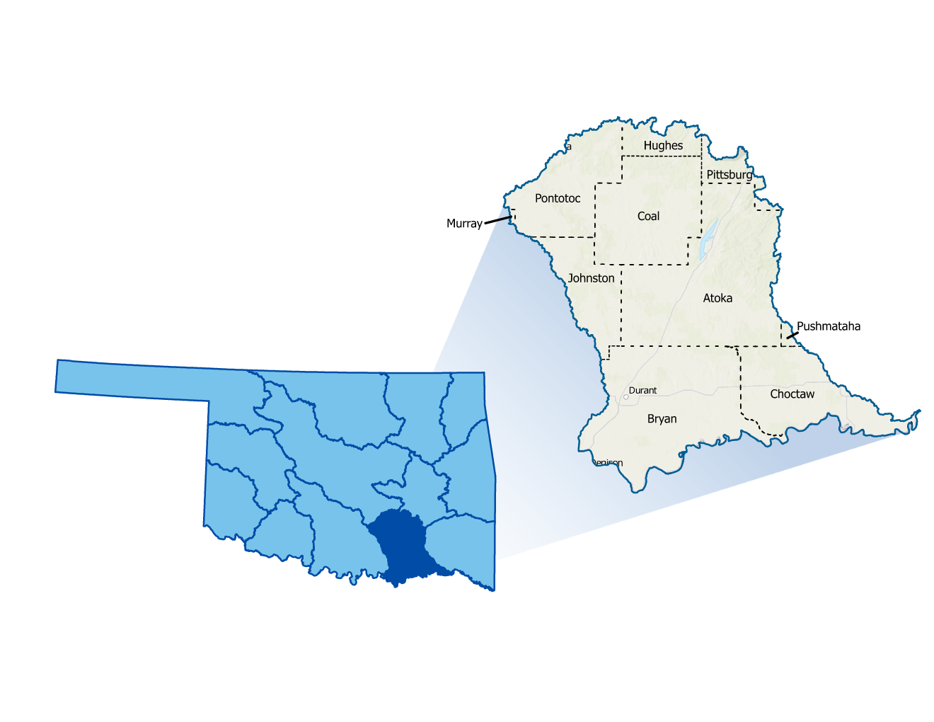
Figure 1 highlights the geographic boundaries of the planning area for this Region of the State.
Figure 1: Blue-Boggy Planning Region Boundary

The Blue-Boggy Watershed Region relies primarily on surface water supplies, including reservoirs, as well as groundwater sourced from bedrock. The Region is populated with a few large cities, increasing its flood vulnerability. Additionally, many rural areas, small towns and at-risk populations are located within the watershed. Durant, in Bryan County, serves as the population center. It and many others have a history of grappling with floods. All counties in the planning area have experienced multiple federally declared flood disasters since 1970.
A base map displaying incorporated jurisdictions within the Planning Region is displayed in Figure 2.
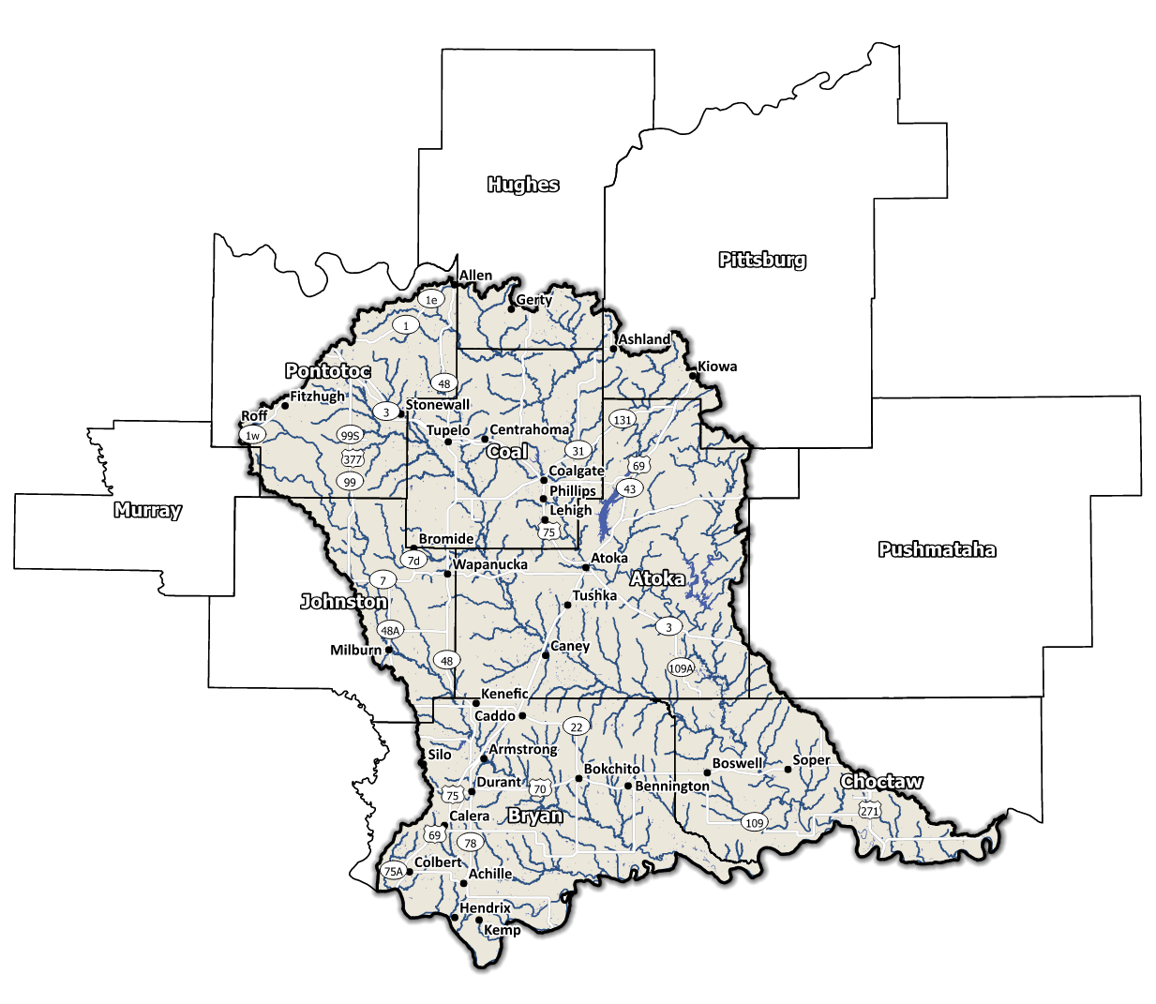
Figure 2: Blue-Boggy Planning Region Base Map

Socioeconomic and Geographic Characteristics
The majority population of the Region is spread across three counties, Bryan, Pittsburg, and Pontotoc. A mix of industries, including oil and gas, among a variety of others, bring economic diversity to this Region. This section will examine some of these socioeconomic and geographic factors and how they contribute to and affect this watershed.

Demographic Profile
The Blue-Boggy Watershed Planning Region encompasses over 220,000 people with a mix of urban, suburban, and rural areas. This Region represents approximately 5.3% of Oklahoma's land area, and around 5% of Oklahoma residents call this area home according to the 2020 U.S. Census. Table 1 provides a population breakdown for each county in the Region. These figures pertain to county-level populations rather than those confined within the watershed’s boundaries. Coal County is the only county in the group that is completely contained within the Blue-Boggy Planning Region.
Table 1: Population Breakdown by County in the Blue-Boggy Planning Region
County | Total Population
Atoka | 14,262
Bryan | 46,067
Choctaw | 14,204
Coal | 5,266
Hughes | 13,367
Johnston | 10,272
Murray | 13,904
Pittsburg | 43,773
Pontotoc | 38,065
Pushmataha | 10,812

The Region is home to two Tribal Nations, the Choctaw and Chickasaw Nations. These nations have a long-standing history of inhabiting the Region and have significantly shaped the area's cultural and economic development. A map displaying areas of tribal jurisdiction within the Planning Region is shown in Figure 3.

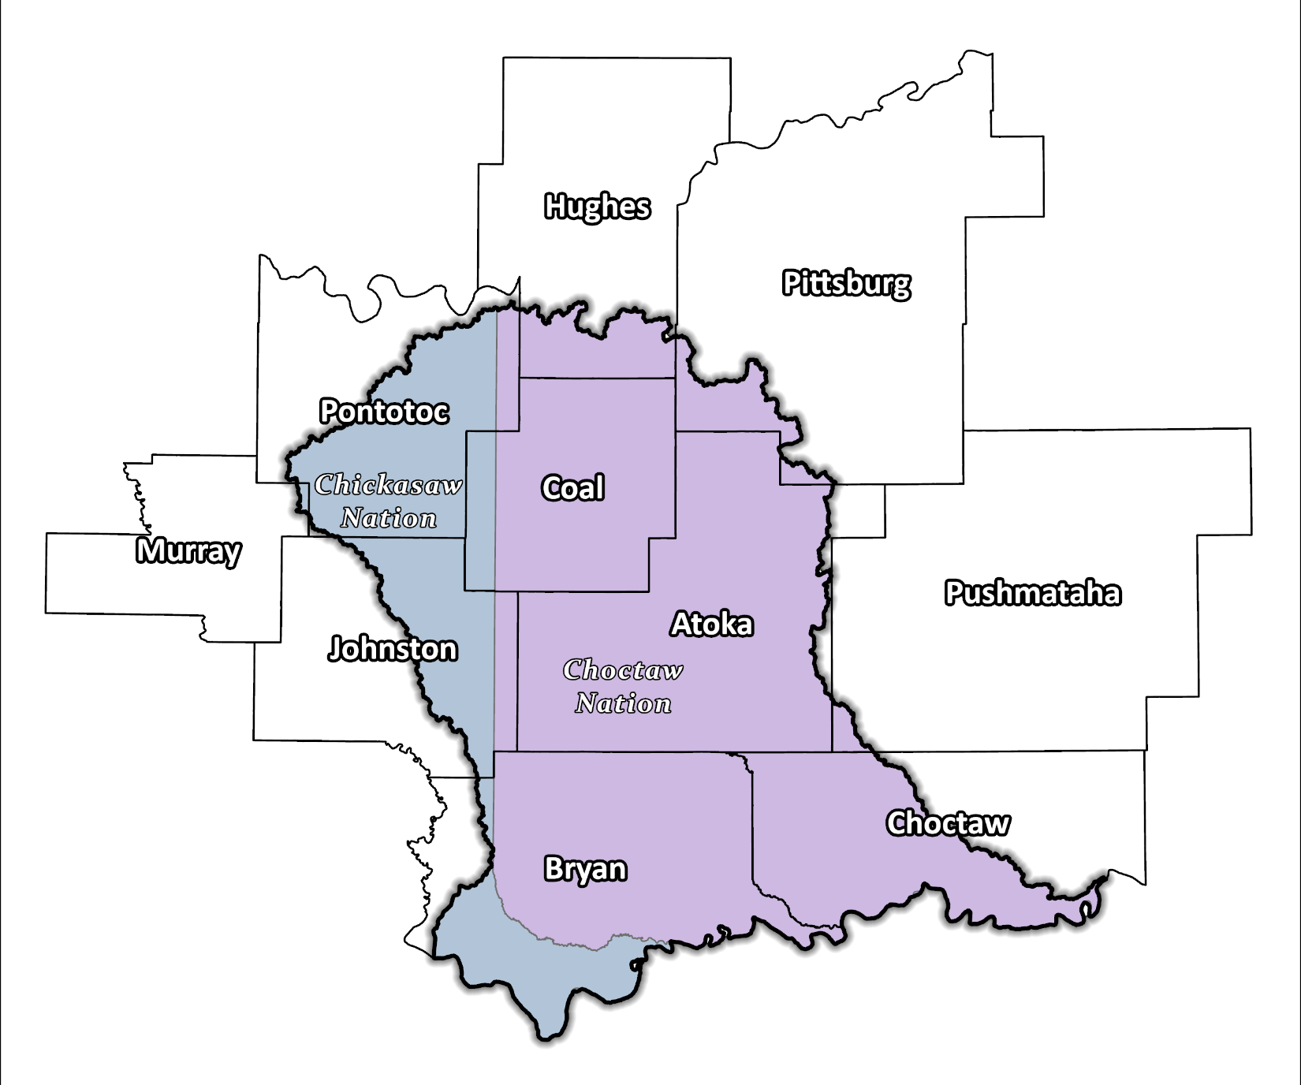
Figure 3: Tribal Jurisdictions Base Map for the Blue-Boggy Planning Region

Economic Profile
The Blue-Boggy Planning Region has significant economic importance in the state and the country. The largest city in the watershed is Durant, a fast-growing rural city with a population of 18,589. Durant is the county seat of Bryan County. While Durant is not the official capital of the Choctaw Nation, it does serve as a hub of industry for the tribe. Durant is home to the Choctaw Nation Headquarters, the Choctaw Casino Resort, two Choctaw Casinos, two Choctaw Travel Plazas, and the Choctaw Inn. The Choctaw Nation of Oklahoma is the largest employer in Durant. The city has various tourist attractions including Lake Texoma, the Choctaw Casino Resort, and Fort Washita. Southeastern Oklahoma State University is located in Durant and admits up to 5,800 students each year.
The southeast portion of the City of Ada is also within the Blue-Boggy Watershed. Ada is a major manufacturing center, producing a diverse array of products. Oil and natural gas are also a large part of the local economy. The Robert S. Kerr Environmental Research Center as well as LegalShield headquarters are both located in Ada. The city is also home to the Chickasaw Nation headquarters.

Floodplain Management and Mitigation Capabilities
This section provides a broad summary of floodplain management capabilities and community engagement within the overall Blue-Boggy Planning Region.

National Flood Insurance Program Participation
Within the Planning Region, all counties have been mapped by Federal Emergency Management Agency (FEMA) and participate in the National Flood Insurance Program (NFIP). There are few communities within the 10 counties, however, that do not currently participate in the NFIP program, as shown in Figure 4 below.
The dedication to floodplain management by jurisdictions in this Planning Region is well demonstrated as evidenced by the active participation in the NFIP. Several communities in this Region go above and beyond the minimum NFIP requirements and could be used as examples for best practices and knowledge sharing in other portions of the State.
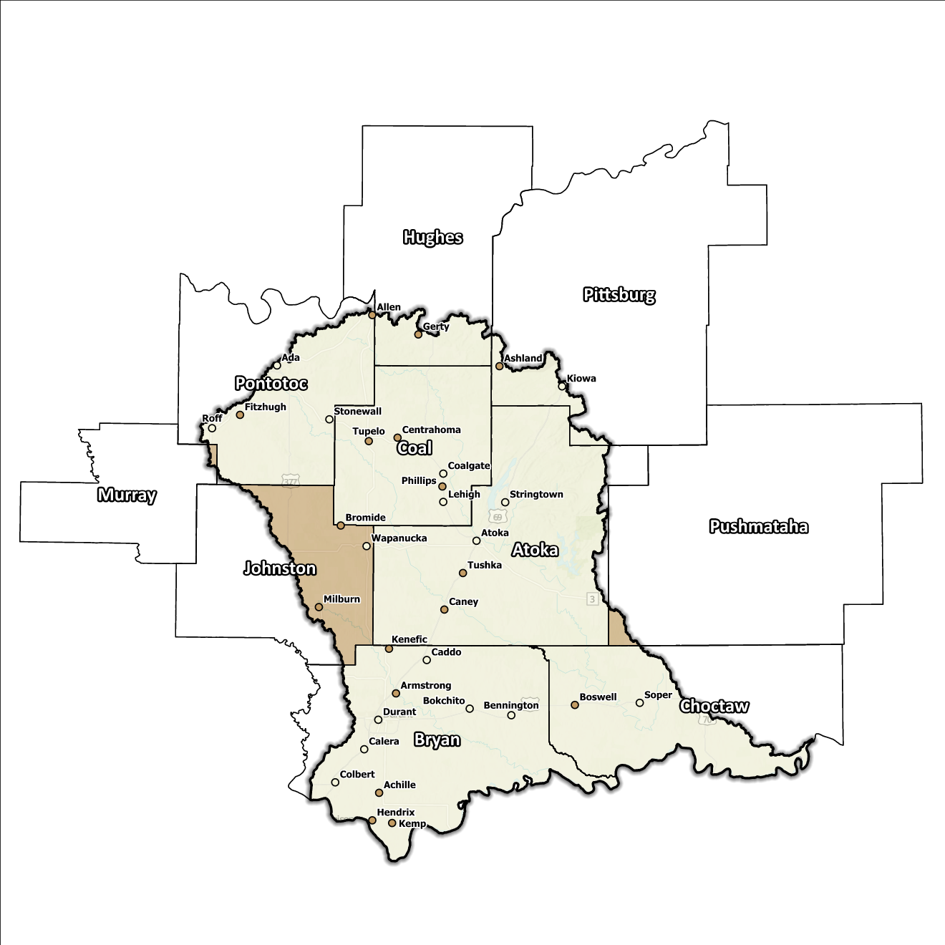
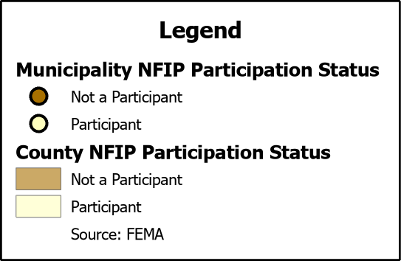
Figure 4: Status of NFIP Participation in the Blue-Boggy Planning Region

Flood Insurance Coverage
As of the latest update, there are currently 72 active NFIP policies in effect within the planning area. These policies cover approximately 3.4% of the total structures located in the FEMA mapped Special Flood Hazard Area (SFHA). It should be noted that not all active policies are situated within the SFHA. A total of 33 NFIP claims have been filed, resulting in approximately $782,000 being paid out to policyholders. In the Region, there are two structures that fall into the categories of repetitive loss (RL) or severe repetitive loss (SRL). Repetitive loss, in the context of the NFIP, refers to properties that have experienced multiple flood-related insurance claims over a specific time period. Severe repetitive loss, on the other hand, pertains to properties with an extensive history of recurrent flood damage and a high number of insurance claims, making them particularly vulnerable and costly for the NFIP.
The following figures (Figure 5 through Figure 8) provide a range of information about NFIP policies, along with a comprehensive overview of total claims filed and corresponding payouts within the Planning Region. While these figures offer valuable insights, it is crucial to acknowledge they may not accurately reflect the true extent of losses within the area due to the underrepresentation of flood insurance. It is important to note that not every claim submitted or paid can be directly associated with an active policy.

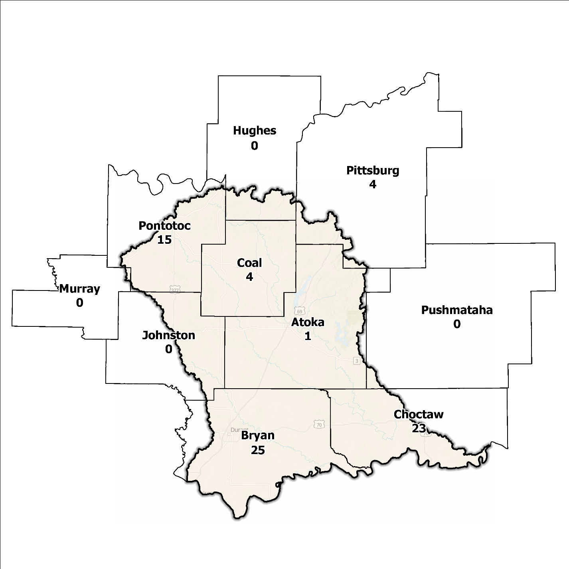
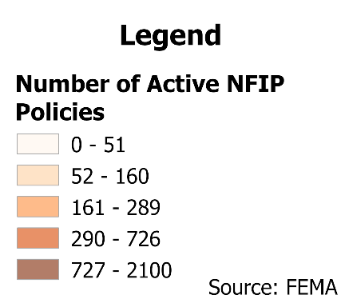
Figure 5: Number of Active NFIP Policies in the 100-Year Floodplain in the Blue-Boggy Planning Region

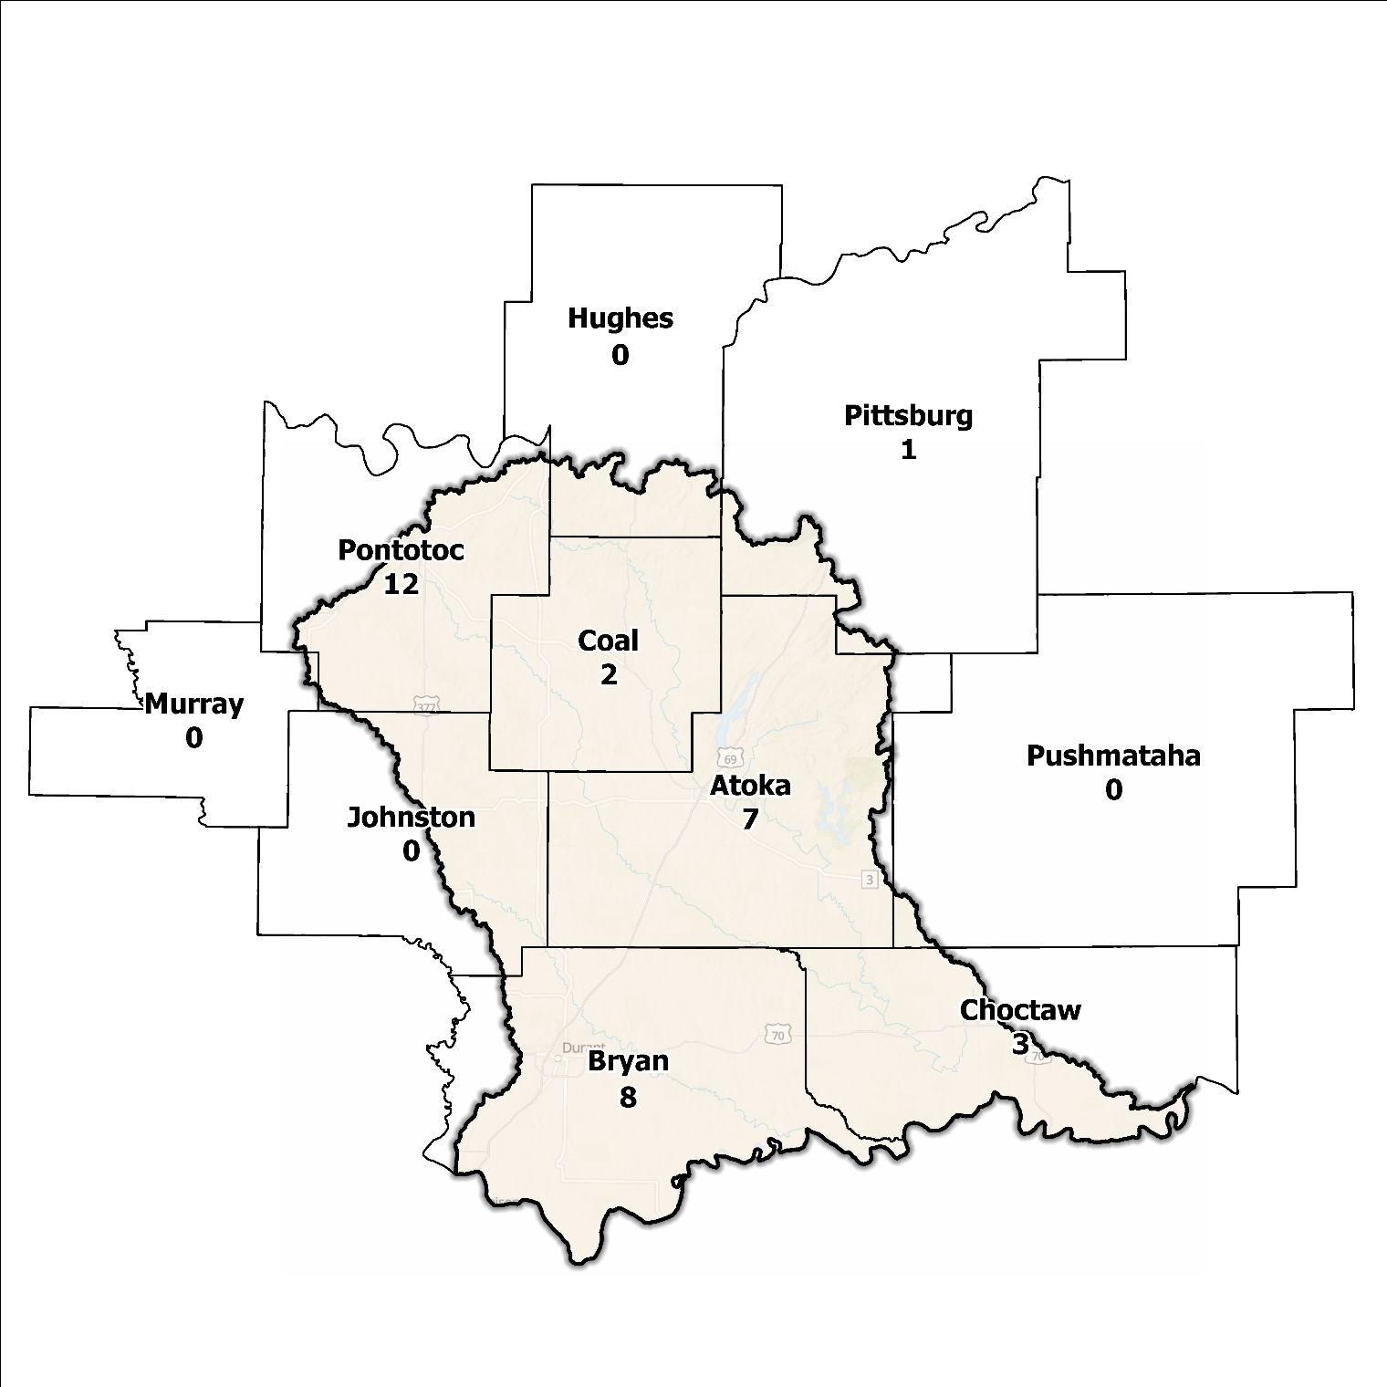
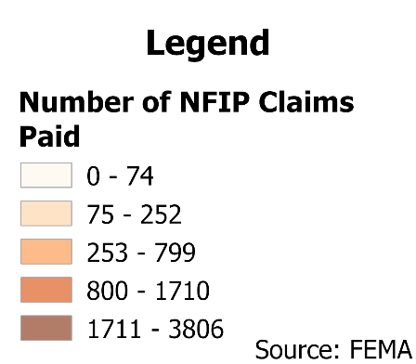
Figure 6: Total NFIP Claims Paid in the Blue-Boggy Planning Region

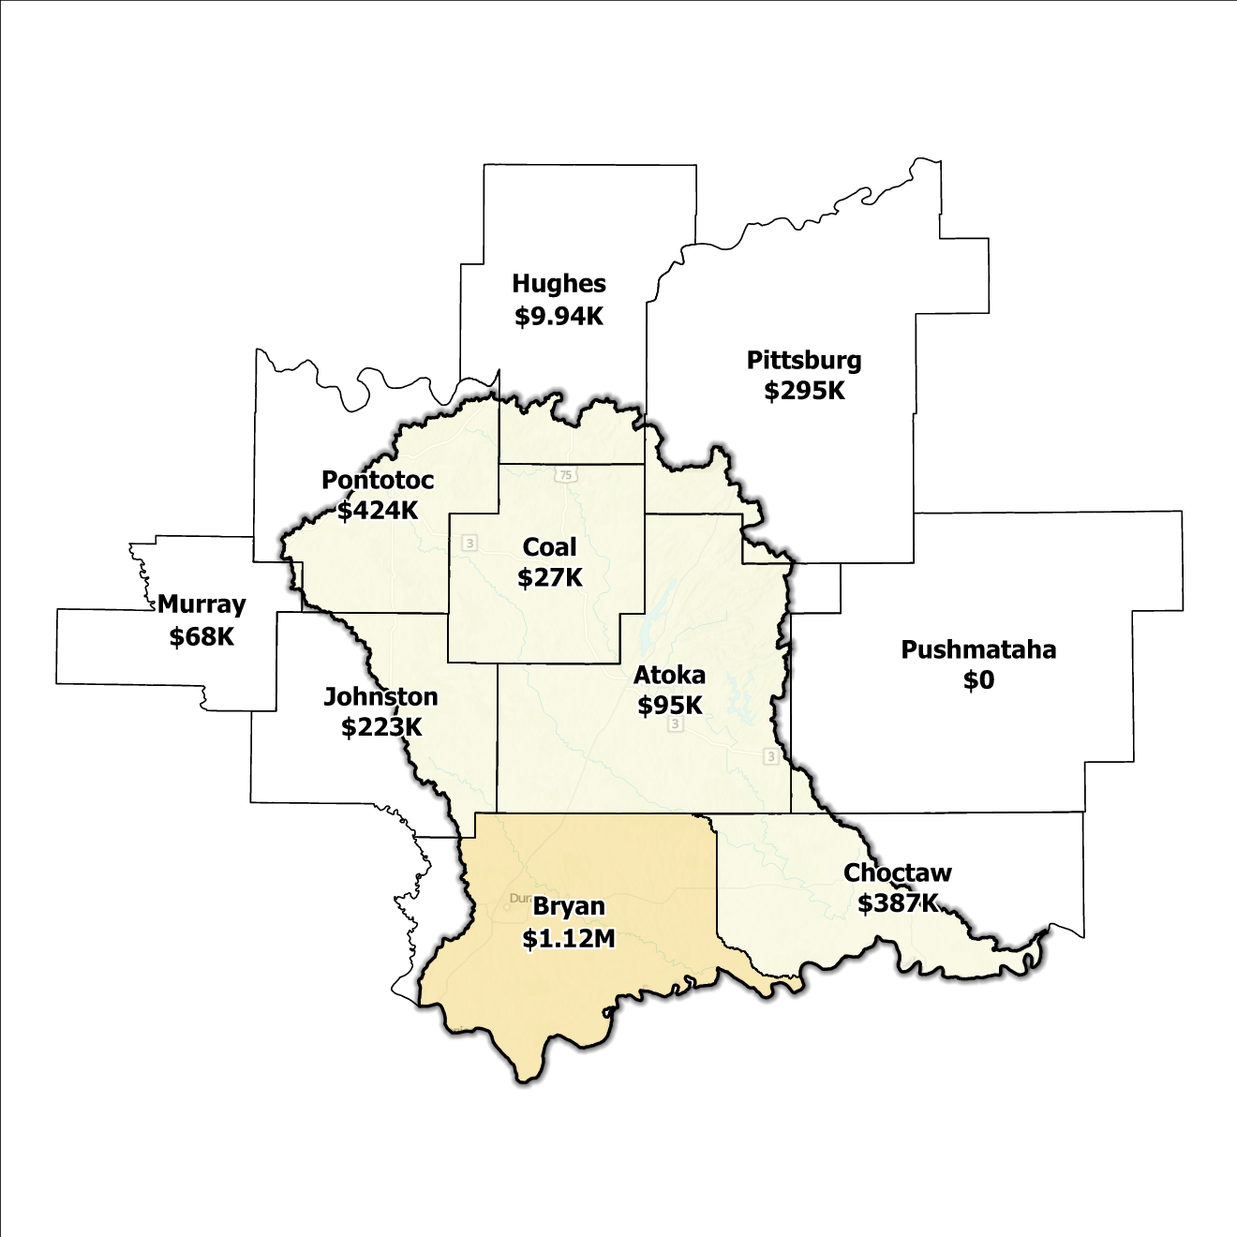
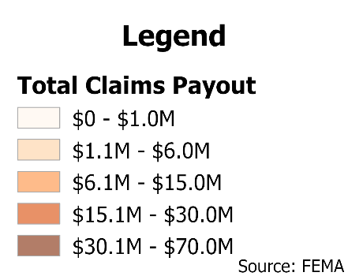
Figure 7: Total Value NFIP Claims Paid Out in the Blue-Boggy Planning Region

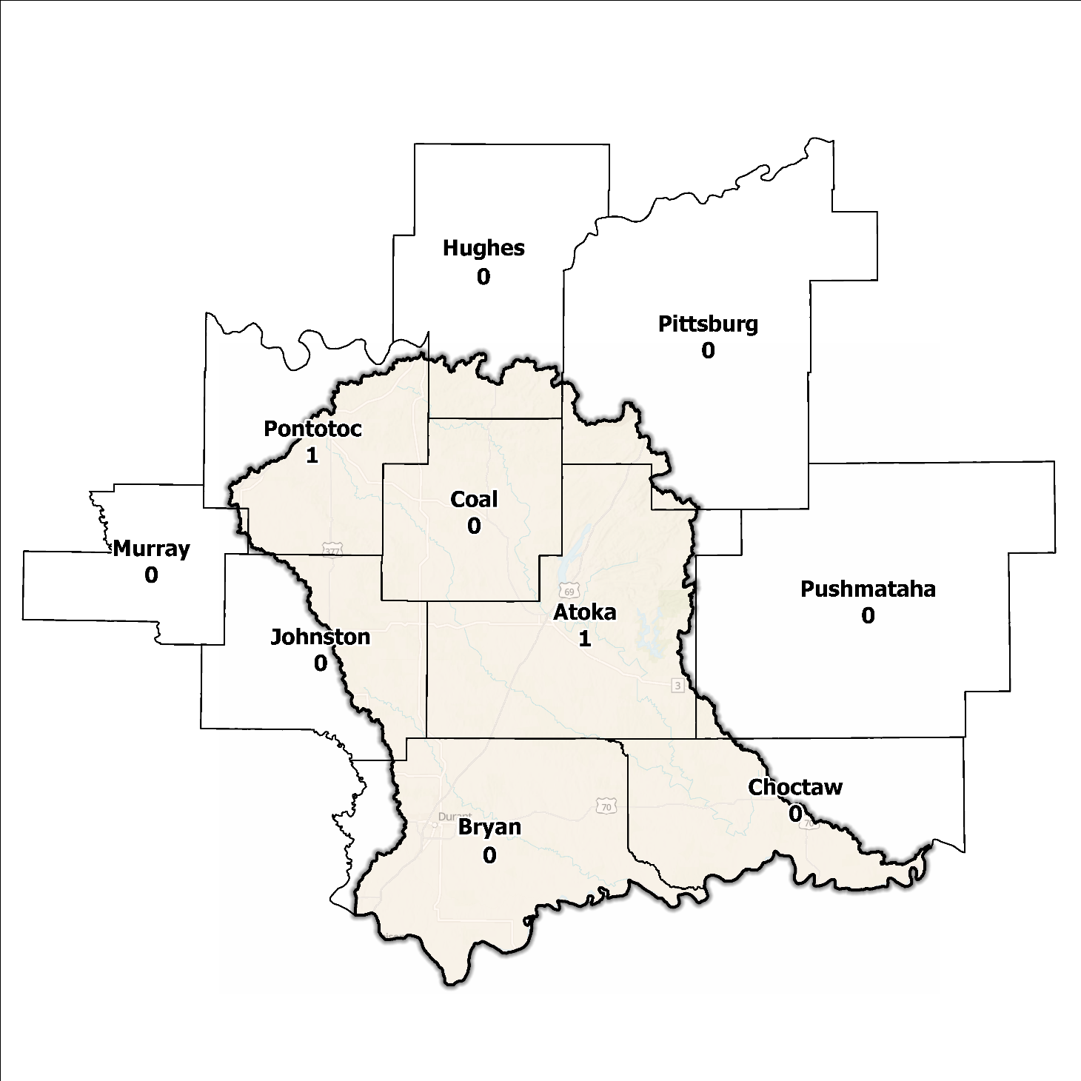
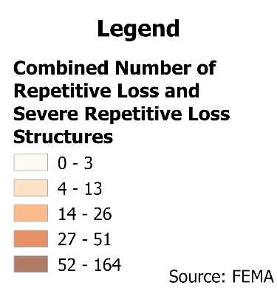
Figure 8: Repetitive Loss and Severe Repetitive Loss Structures in the Blue-Boggy Planning Region

Flood Funding Mechanisms
A survey conducted by the planning team to determine the level of funding for stormwater and floodplain management in the Blue-Boggy Planning Region revealed that most communities have limited local funding. Some larger, more urban jurisdictions, such as the City of Durant, have successfully implemented stormwater utility fees enabling them to fund departments for facilitating management activities. In contrast, other jurisdictions have achieved marginal results in the utilization of local taxes, fees, and funds.

Hazard Mitigation Plan Status
Seven out of ten counties in this Region possess a FEMA-approved Hazard Mitigation Plan (HMP) and the identified mitigation actions vary in jurisdictions. Several identify basic programmatic and administrative activities, such as planning, education, acquiring or implementing warning systems, participating in the NFIP, etc. In contrast, others intentionally list flood mitigation projects such as property buyouts, road and drainage improvements, floodplain restoration, and other flood-specific activities. Road flooding is the most frequently reported problem across the planning area. Several communities and some Tribal entities in the Region have individual HMPs separate from their respective counties. Table 2 shows all previous, current, and pending HMPs in the Region.

Table 2: Hazard Mitigation Planning Status for the Blue-Boggy Planning Region
Name | Type | Approval Date | Expiration | Current Action Status of this Plan
Atoka | County | 12/15/2009 | 12/15/2014 | Expired
Atoka | City | 12/09/2009 | 12/09/2014 | Expired
Stringtown | Town | 11/15/2009 | 11/15/2014 | Expired
Tushka | Town | 11/18/2009 | 11/18/2014 | Expired
Bryan | County | 03/09/2023 | 03/08/2028 | Approved
Bennington | Town | 03/08/2010 | 03/08/2015 | Expired
Kemp | Town | 12/16/2009 | 12/16/2014 | Expired
Choctaw | County | 09/10/2019 | 09/09/2024 | Expired
Coal | County | 06/27/2022 | 06/26/2027 | Approved
Centrahoma | City | - | - | In Progress
Hughes | County | 08/05/2024 | 08/04/2029 | Approved
Johnston | County | 12/23/2008 | 12/23/2013 | Expired
Murray | County | 05/08/2024 | 05/07/2029 | Approved
Pittsburg | County | 03/08/2022 | 03/07/2027 | Approved
Pontotoc | County | 02/23/2023 | 02/22/2028 | Approved
Ada | City | 11/04/2015 | 11/04/2020 | Expired
Pushmataha | County | 06/27/2022 | 06/26/2027 | Approved
Chickasaw | Tribal Nation | 10/20/2021 | 10/19/2026 | Approved
Choctaw | Tribal Nation | 05/21/2020 | 05/20/2026 | Approved

Flood Mapping Assessment
In the Blue-Boggy Planning Region, the floodplain quilt consolidates the best available data on flood risk. However, some areas in the Region still need to be mapped by FEMA, like Atoka, Coal, Johnston, and Choctaw Counties, limiting the ability of local authorities to regulate development in flood-prone areas.
A notable aspect in the Region is that most of the effective FEMA maps still need detailed studies. This leaves floodplain managers to rely on limited Approximate A Zones, which offer a broad understanding of flood risk but do not have determined Base Flood Elevations (BFE). Figure 9 displays FEMA-mapped areas in the Planning Region.
While in areas with A zones, Base Level Engineering (BLE) data might provide a more accurate indication of flood risk, it is important to note that most of the Blue-Boggy Planning Region has adequate BLE coverage. BLE assists in determining areas that are expected to flood and therefore are not reasonably safe from flooding. There is still a need for in-depth studies to augment the precision and reliability of flood risk information in specific areas.
Bryan and Pontotoc Counties, along with the cities of Durant and Kiowa, stand out among areas in the Planning Region for having the most extensive flood risk assessment information. Investment in floodplain mapping has been higher in these areas than in others in the Region.
While Flood Insurance Rate Maps (FIRMs) are beneficial for regulatory uses and flood insurance assessments, they only represent potential risks associated with a flood event under certain specific conditions. The threat of flooding beyond the FEMA mapped SFHA is only included on FIRMs if the community opts to carry out the required studies to integrate such data into their hazard map.
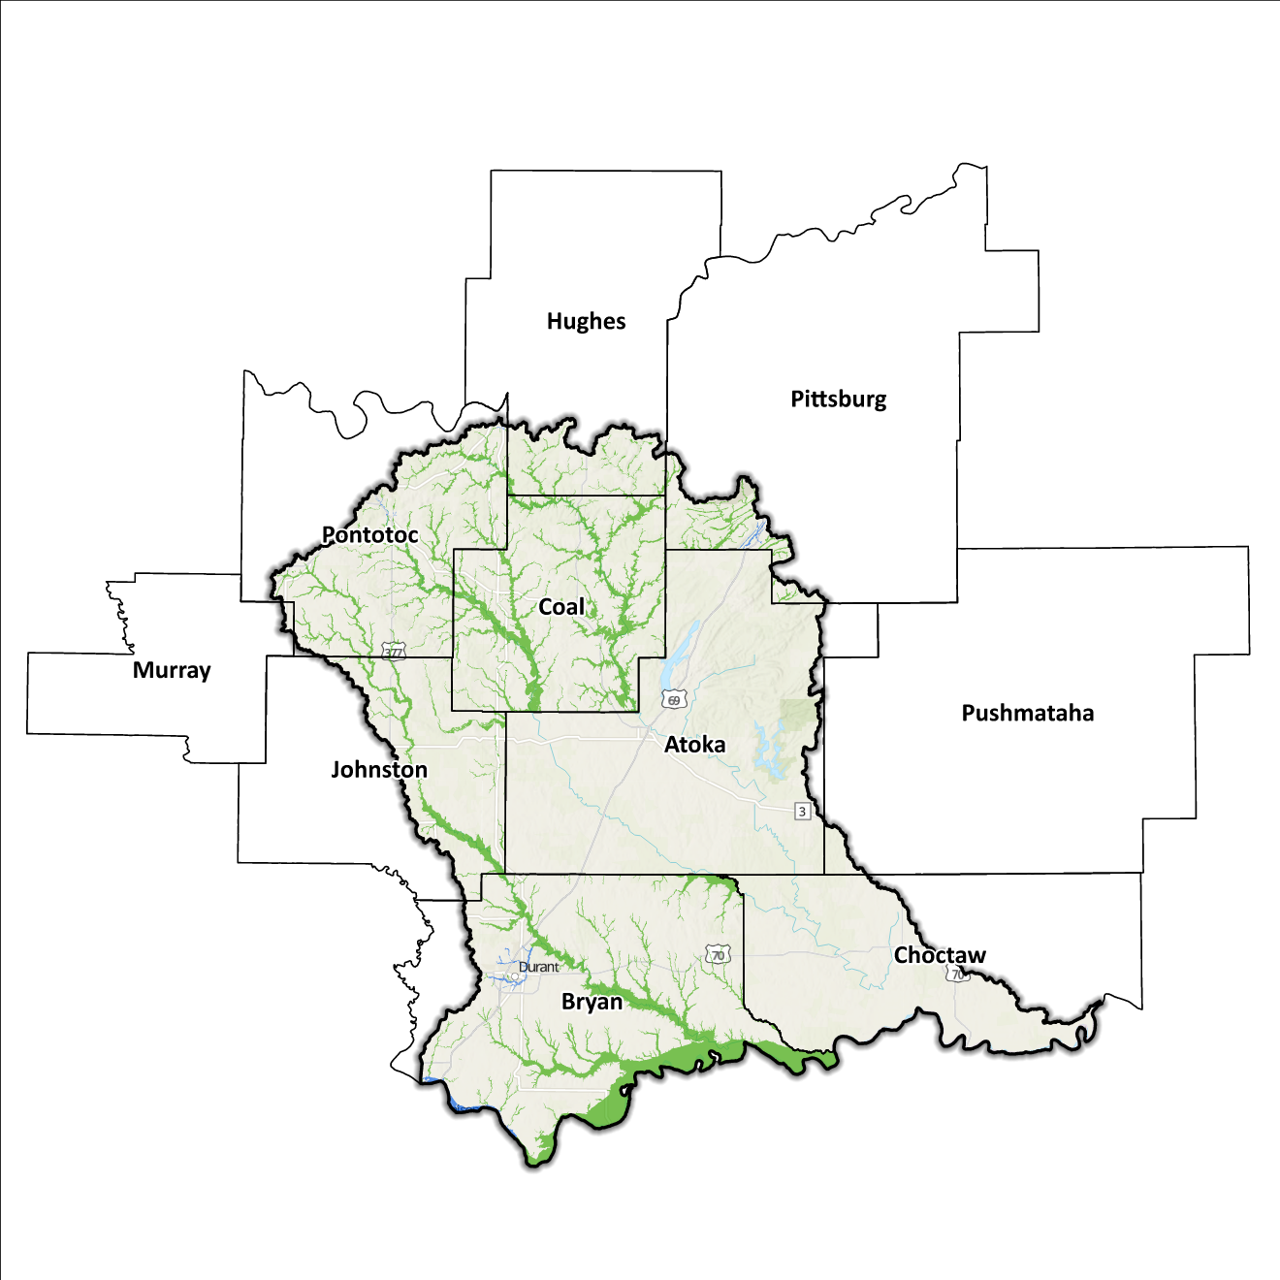
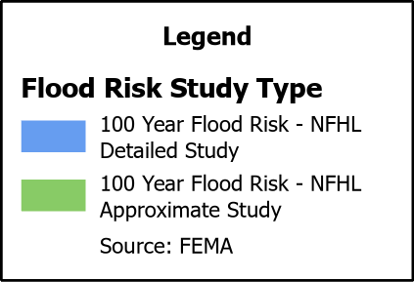
Figure 9: FEMA Mapped Special Flood Hazard Area Comparison in the Blue-Boggy Planning Region

Flood Hazard Assessment
Flood hazards in this Region include flash, river, and urban flooding. The Blue River, Red River, Clear Boggy Creek, and Muddy Boggy Creek, along with their various tributaries, are the major waterways found in the Blue-Boggy Watershed.

Location of Flood Hazards
The Blue-Boggy Planning Region is characterized by a flood hazard that encompasses various significant aspects. The flood location in the Blue-Boggy Planning Region exhibits the following characteristics:
- Flooding along major waterways with extensive drainage basins, including the Blue River, Red River, Clear Boggy Creek, and Muddy Boggy Creek.
- Flash floods along smaller tributaries that ultimately flow into the major waterways.
- Drainage issues in specific areas result from inadequate infrastructure. Insufficient drainage systems can exacerbate flood risks, leading to localized flooding in vulnerable locations.
- Downstream areas located below high-hazard potential dams are exposed to heightened risks.
Figure 10 shows mapped areas of flood risk in the Region. The map brings together data from different sources, like the National Flood Hazard Layer and BLE, to create a unified view. It prioritizes layer types and shows the most important layer available for a specific area.
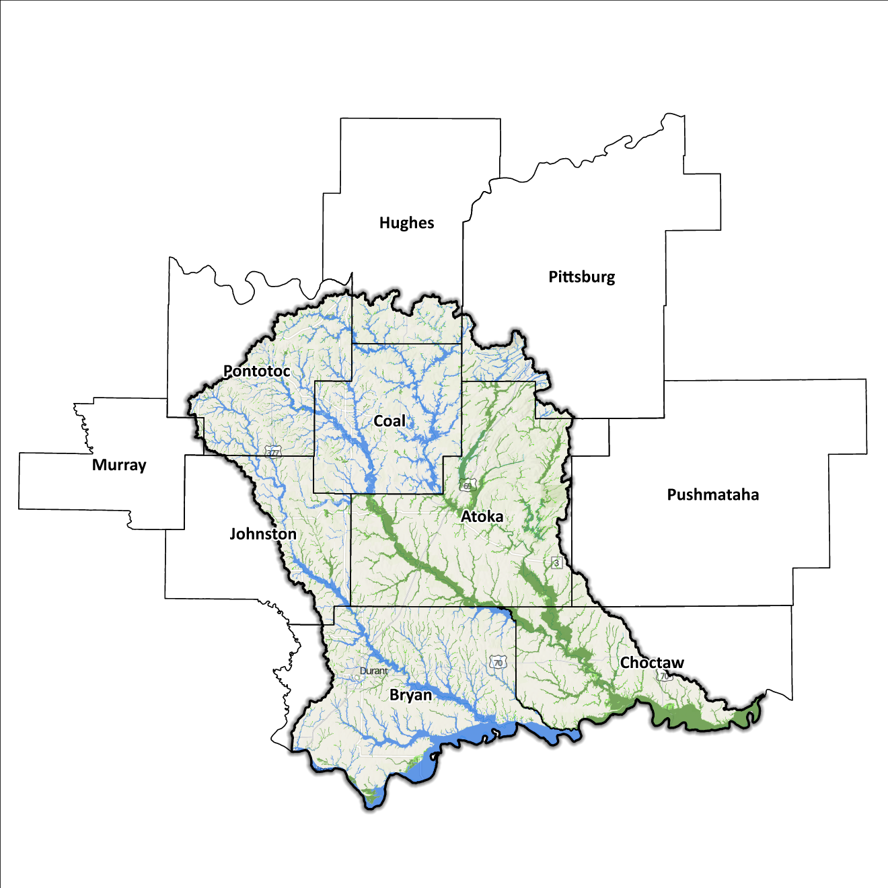
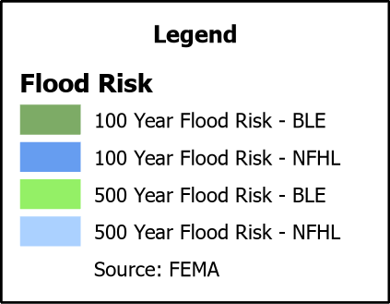
Figure 10: Flood Quilt in the Blue-Boggy Planning Region

Dam and Levee Infrastructure
The Region has multiple dams and levees aimed at preventing flooding. However, aging infrastructure increases the risk of downstream impacts if a breach or failure occurs, especially for high-hazard dams classified by the Oklahoma Water Resources Board (OWRB). The ten counties have 40 high-hazard dams, with 13 located in the Blue-Boggy Watershed. A map of dam and levee locations within the Region is shown in Figure 11.
The Blue-Boggy Watershed Region has three levee systems across Pontotoc County. State and local officials can find information on these systems on the United States Army Corps of Engineers National Levee Database website. Although the Blue-Boggy Watershed Region concludes at the Oklahoma/Texas state line, the flood risks associated with dams and levees transcend its boundaries.
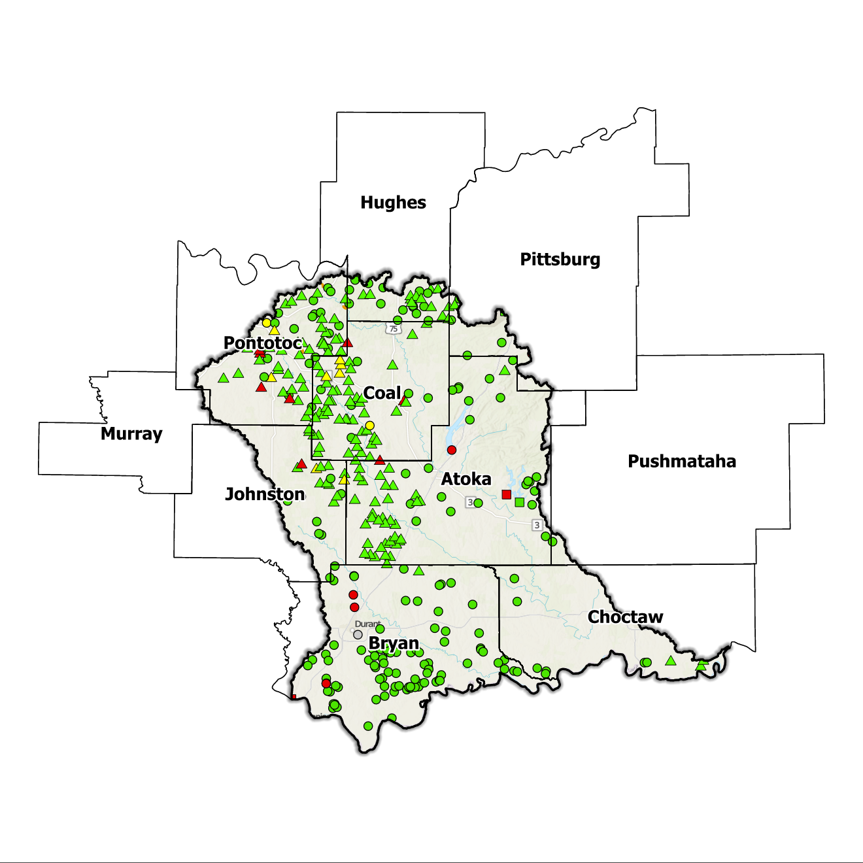
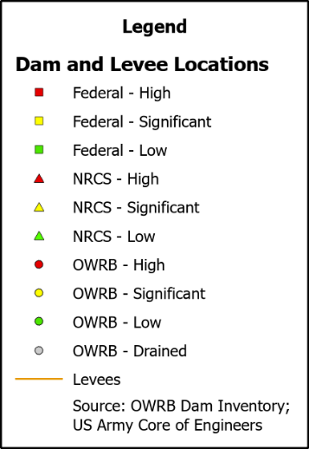
Figure 11: Dam and Levee Locations in the Blue-Boggy Planning Region

Extent of Flooding
Extent refers to the expected severity of flooding, and because not all areas within the planning area share the same topography, the extent varies between individual communities. The average depth of flooding within the FEMA-mapped Special Flood Hazard Area can range from a few inches to several feet, depending on factors such as topography, proximity to water bodies, local drainage characteristics, and the intensity of the flood event.

Previous Occurrences
According to the records maintained by the National Center of Environmental Information (NCEI), from January 1996 to December 2022, a total of 14 flood events have been documented in the 10 counties encompassing this Planning Region. Cumulatively, these flooding incidents have caused property damage amounting to $25,009,000.
The NCEI initiated the tracking of flood events only from 1996, hence this data represents the most comprehensive information available. Flooding has frequently escalated to the point of necessitating a Presidential Disaster Declaration. A breakdown of flood-related disasters by county is shown in Figure 12. Of all the counties in the Region, Pittsburg County has most frequently been declared a disaster area due to flooding. However, it's important to note that disaster declarations are issued on a county-wide basis and not all declarations may have directly impacted this specific Region.
Table 3: FEMA Disaster Declarations from 1950-2024 in the Blue-Boggy Planning Region
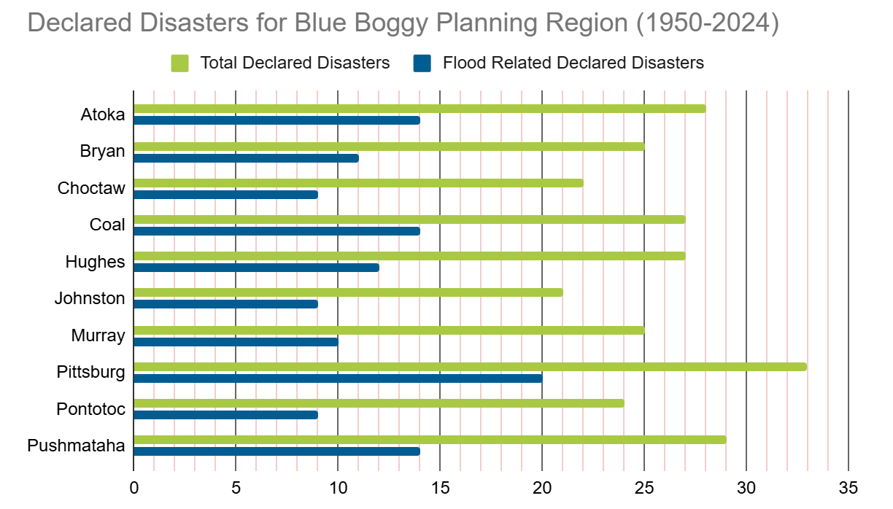

Vulnerability and Impacts of Flooding
According to FEMA’s National Risk Index (NRI), the Blue-Boggy Planning Region demonstrates a range of risk levels for river flooding and flash flooding, varying from relatively low to very low risk at the county level, when compared to the rest of the United States. However, when examined at a more granular scale by census tract, the NRI highlights specific areas in Pittsburg, Pushmataha, Atoka, and Coal counties, as being at moderate risk of flooding.
Compared to other regions in Oklahoma, the Blue-Boggy Planning Region is at a lower risk of flooding due to multiple factors including fewer number of waterways and drainage areas.

Summary of Flood Exposure
Flood exposure refers to the degree to which an area or population is at risk of being affected by a flood event. Table 4 provides a comprehensive overview of key factors, including the total count of housing units, population figures, job statistics, land area measurements, and the number of parcels/blocks within the designated FEMA-mapped flood area. This information aims to facilitate a thorough understanding of the flood-affected area's characteristics and implications.
The data in this section was generated using UrbanFootprint. This module evaluates flood risk by conducting a spatial join of parcels or census blocks with the FEMA National Flood Hazard Layer to assess the potential risks associated with hazards. The data presented in the table below is focused on three different FEMA SFHA flood zones that represent areas within the 100-yr floodplain with a 1% annual chance of experiencing a flood event. Zone AE is the most detailed, providing base flood elevations, Zone AO represents areas subject to shallow flooding of depths between one to three feet, and Zone A is an approximation of the 100-yr floodplain for areas where detailed hydraulic analyses have not been performed.
Table 4: Flood Exposure in the Blue-Boggy Planning Region
Blue-Boggy Planning Region Flood Risk Report
Housing in Flood Hazard Zones (Dwelling Units)
Dwelling Units in SFHA Zone AE | 330
Dwelling Units in SFHA Zone A | 3,216
Dwelling Units in SFHA Zone AO | N/A
Total | 3,546
Population in Flood Hazard Zones (Persons)
Population in SFHA Zone AE | 734
Population in SFHA Zone A | 7,108
Population in SFHA Zone AO | N/A
Total | 7,843
Jobs in Flood Hazard Zones (Employees)
Jobs in SFHA Zone AE | N/A
Jobs in SFHA Zone A | N/A
Jobs in SFHA Zone AO | N/A
Total | N/A
Land Area in Flood Hazard Zones (Acres)
Area in SFHA Zone AE | N/A
Area in SFHA Zone A | N/A
Area in SFHA Zone AO | N/A
Total | N/A
Parcels or Block in Flood Hazard Zones
Parcels or Blocks in SFHA Zone AE | N/A
Parcels or Blocks in SFHA Zone A | N/A
Parcels or Blocks in SFHA Zone AO | N/A
Total | N/A

Flood Mitigation Needs
Flood mitigation projects for the Region have been identified at a county level through the analysis of HMPs, master drainage plans at the community level, and prioritized lists provided by jurisdictions. The following stormwater project types were considered:
- Channel
- Storm Drain
- Infrastructure
- Detention Pond
- Dam-Reservoir
- Floodwalls and Levees
- Acquisition

Although the OWRB State Flood Plan Dashboard does not list any stormwater projects in the Blue-Boggy Planning Region at the time of this writing, the City of Durant has made noteworthy progress.
While most floodplains within this Region are in rural areas, the following communities have at least one structure located within floodplain: the cities of Atoka, Stringtown, Hugo, Holdenville, and Durant, the towns of Butler, Caney, Achille, Armstrong, Bokchito, Caddo, Calera, Colbert, Silo, Boswell, Coalgate, Lehigh, Phillips, and the unincorporated communities of Farris and Lane. Despite this, the Blue-Boggy Planning Region has not reported any data on the use of acquisition as a mitigation method.
Smaller communities face challenges in funding acquisitions and other stormwater and mitigation projects. In numerous cases, the local tax base proves insufficient to finance property acquisition, necessitating these jurisdictions to seek external sources, such as state and federal grant funding. Such sources can be highly competitive in nature and favor more populated urban areas due to the cost benefits and can depend on a variety of factors.

Conclusion
The Blue-Boggy Planning Region report highlights the significance of this Region and its vulnerability to flood events. The report's findings emphasize the urgent need for funding to support engineering efforts in flood projects within the watershed. Adequate funding is essential for conducting detailed engineering assessments, implementing effective flood control measures, and enhancing community resilience. The lack of project submissions underscores the importance of assisting communities in identifying and developing flood mitigation projects.
By allocating resources and support for project identification and development, communities can better understand their flood exposure and proactively protect lives and infrastructure. Investing in engineering and flood mitigation projects in the Blue-Boggy Planning Region will contribute to creating safer, more resilient communities better equipped to handle future flood events.
During the planning process, the data generated was developed into an interactive flood planning dashboard. The dashboard serves as a valuable tool for conducting flood assessments at the community level. It is important to note that this report should not substitute locally generated data specific to each community.

Census Bureau Data – 2020 Decennial Census
Atoka County’s HMP includes the Town of Caney.
Bryan County’s HMP includes the Towns of Achille, Bokchito, Caddo, Calera, Colbert, Silo, and the City of Durant.
Choctaw County’s HMP includes the Towns of Boswell, Soper, and the City of Hugo.
Coal County’s HMP includes the Town of Phillips and the Cities of Coalgate, Lehigh, and Tupelo.
Hughes County’s HMP includes the Town of Gerty.
Johnston County’s HMP includes the Town of Wapanucka.
Murray County’s HMP includes the Town of Hickory.
Pittsburg County’s HMP includes the Towns of Ashland and Kiowa.
Pontotoc County’s HMP includes the Towns of Allen, Fitzhugh, Roff, and Stonewall.
FEMA’s National Risk Index (NRI) is a tool used to calculate a community’s potential for negative impacts due to natural hazards and community risk factors. The three components used in the NRI equation that generates the Risk Index Score are expected annual loss due to natural hazards, social vulnerability, and community resilience.

