Table of Contents
The Beaver-Cache Planning Region 1
Section 1.1: Watershed Introduction 1
Section 1.2: Socioeconomic and Geographic Characteristics 3
Section 1.3: Floodplain Management and Mitigation Capabilities 5
Section 1.4: Flood Hazard Assessment 14
Section 1.5: Flood Mitigation Needs 20
Section 1.6: Conclusion 21

The Beaver-Cache Planning Region

Watershed Introduction
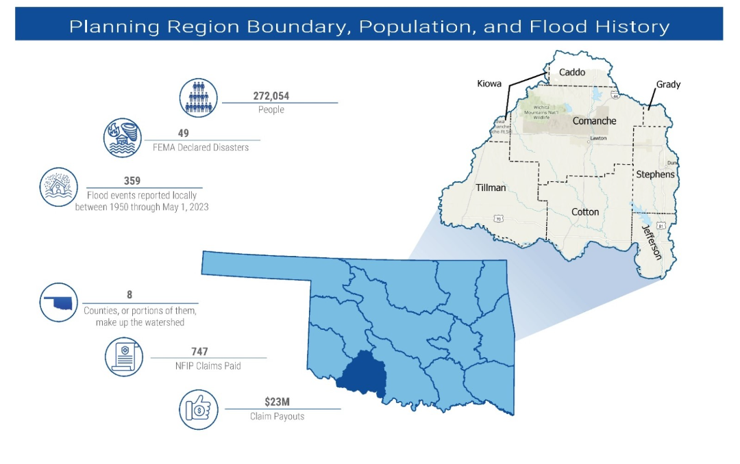 Figure 1: Beaver-Cache Planning Region Boundary, Population, and Flood History

Encompassing 3,288 square miles, the Beaver-Cache Watershed Planning Region (Region) spans across eight counties in southwestern Oklahoma. The Region encompasses all or part of Caddo, Comanche, Cotton, Grady, Jefferson, Kiowa, Stephens, and Tillman Counties. A total of 39 communities and two tribal nations including the Kiowa-Comanche-Apache and Chickasaw are located here. The Beaver, Cache, and Deep Red Creeks, accompanied by their respective tributaries, are the major waterways in the Beaver-Cache Planning Region. Figure 1 highlights the geographic boundaries of the planning area, as well as some quick facts about this Region of the State.

This area stands out due to expansive floodplains that connect the creeks and their tributaries. Apart from the Red River which forms its southern border, the Beaver-Cache Planning Region lacks any significant rivers. The central population hubs within this region, each with more than 5,000 inhabitants, are Lawton (90,381) and Duncan (22,692). It is worth noting that all counties within the planning area have encountered several instances of federally declared flood disasters since the year 1970. A base map displaying incorporated jurisdictions within the Planning Region is shown in Figure 2.
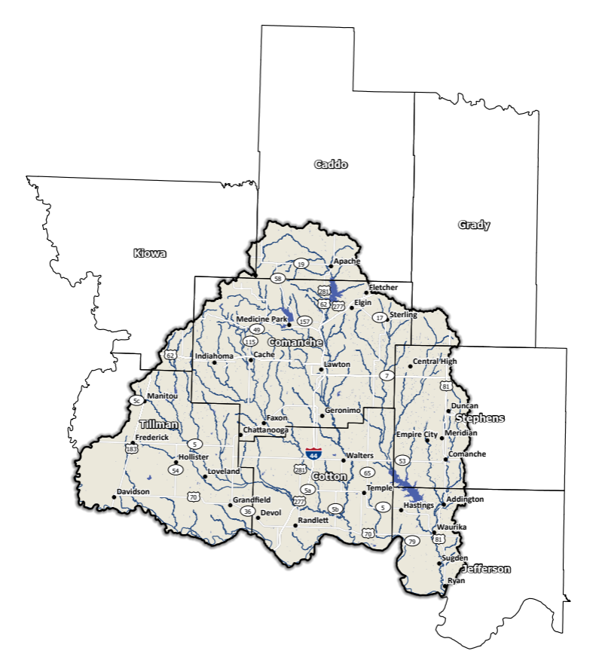
Figure 2: Beaver-Cache Planning Region Base Map

Socioeconomic and Geographic Characteristics
Comanche County is the most populous in the Region. Industries here encompass a wide spectrum, ranging from agriculture activities in rural areas, to manufacturing, and military presence in Lawton. A notable economic stimulator is Fort Sill, situated just north of Lawton, contributing to almost 43% of the GDP in Comanche County,. In the following section, we will examine socioeconomic and geographic aspects and how they contribute to and impact this Region.

Demographic Profile
The Beaver-Cache Planning Region encompasses 272,000 people with a mix of urban, suburban, and rural areas. This region represents approximately 4.7% of Oklahoma's land space and around 11% of Oklahoma residents call this area home according to the 2020 U.S. Census. Table 1 provides a population breakdown for each county in the Region. These figures pertain to county-level populations rather than those confined within the watershed’s boundaries. Cotton County is the only county situated entirely within the confines of the Beaver-Cache Planning Region.
Table 1: Population Breakdown by County in the Beaver-Cache Planning Region
County | Total Population
Caddo | 26,945
Comanche | 121,125
Cotton | 5,527
Grady | 54,795
Jefferson | 5,337
Kiowa | 8,509
Stephens | 42,848
Tillman | 6,968
The region is home to two Native American Tribal Nations, the Kiowa-Comanche-Apache-Fort Sill Apache, and Chickasaw Nations. These tribes have a long-standing history of inhabiting the region and have significantly shaped the area's cultural and economic development. A map displaying areas of tribal jurisdiction within the Planning Region is shown in Figure 3.
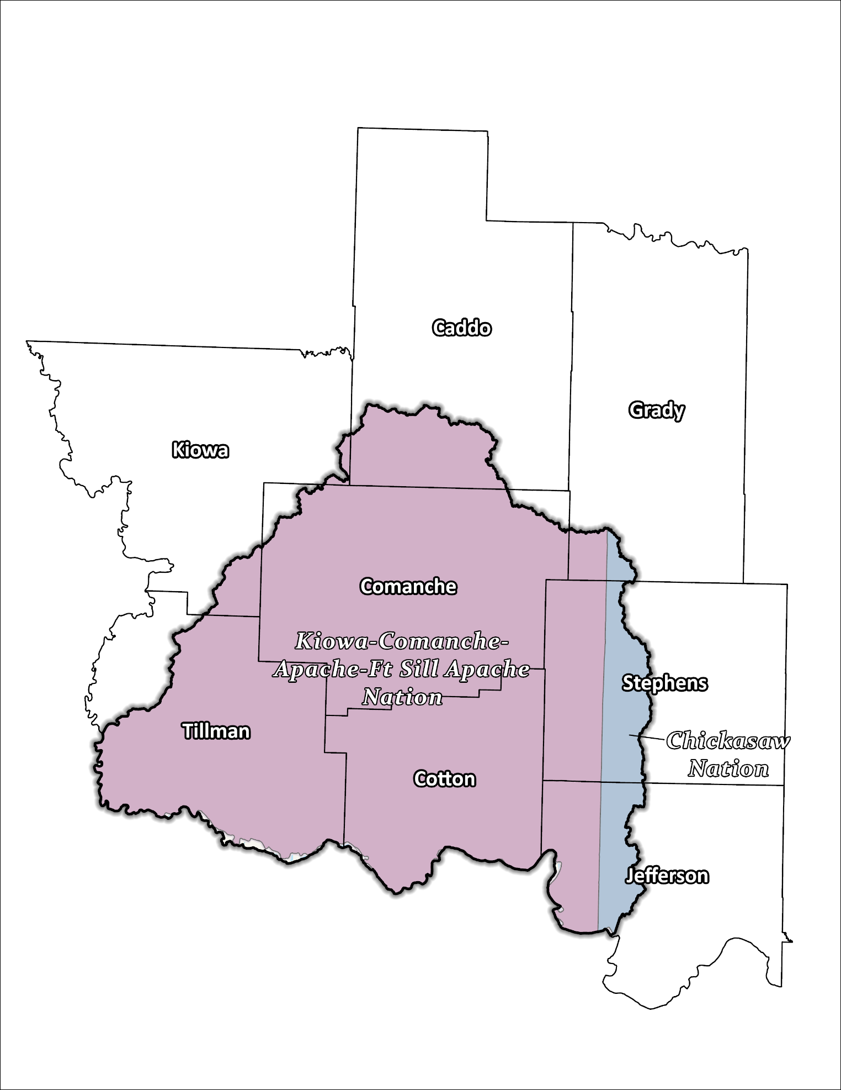
Figure 3: Tribal Jurisdictions Base Map for the Beaver-Cache Planning Region

Economic Profile
The Beaver-Cache Planning Region has significant economic importance in the state and the country with a total GDP of $8.8 billion in 2021. From the casinos operated by tribal nations in each county, to agriculture in rural areas, and Fort Sill and manufacturing in Lawton, the economy is widely varied.

Floodplain Management and Mitigation Capabilities
This section provides a broad summary of floodplain management capabilities and community engagement within the overall Beaver-Cache Planning Region.

National Flood Insurance Program Participation
Figure 4 below depicts the National Flood Insurance Program (NFIP) participation level within the Beaver-Cache Planning Region. Although stormwater projects are not prevalent here, a large majority of counties and communities are engaged in the NFIP. Tillman, Grady, and Jefferson counties, however, are not engaged in NFIP. Alongside county participation, several individual communities are also involved, these include Tipton, Manitou, Frederick, and Davidson in Tillman County, as well as Waurika and Ryan in Jefferson County. Lawton goes beyond NFIP participation through involvement in the Federal Emergency Management Agency's (FEMA) Community Rating System (CRS). This approach enables Lawton's residents to benefit from reduced rates on flood insurance policies. Lawton is rated at six out of ten in the CRS, giving its residents a 20% discount.

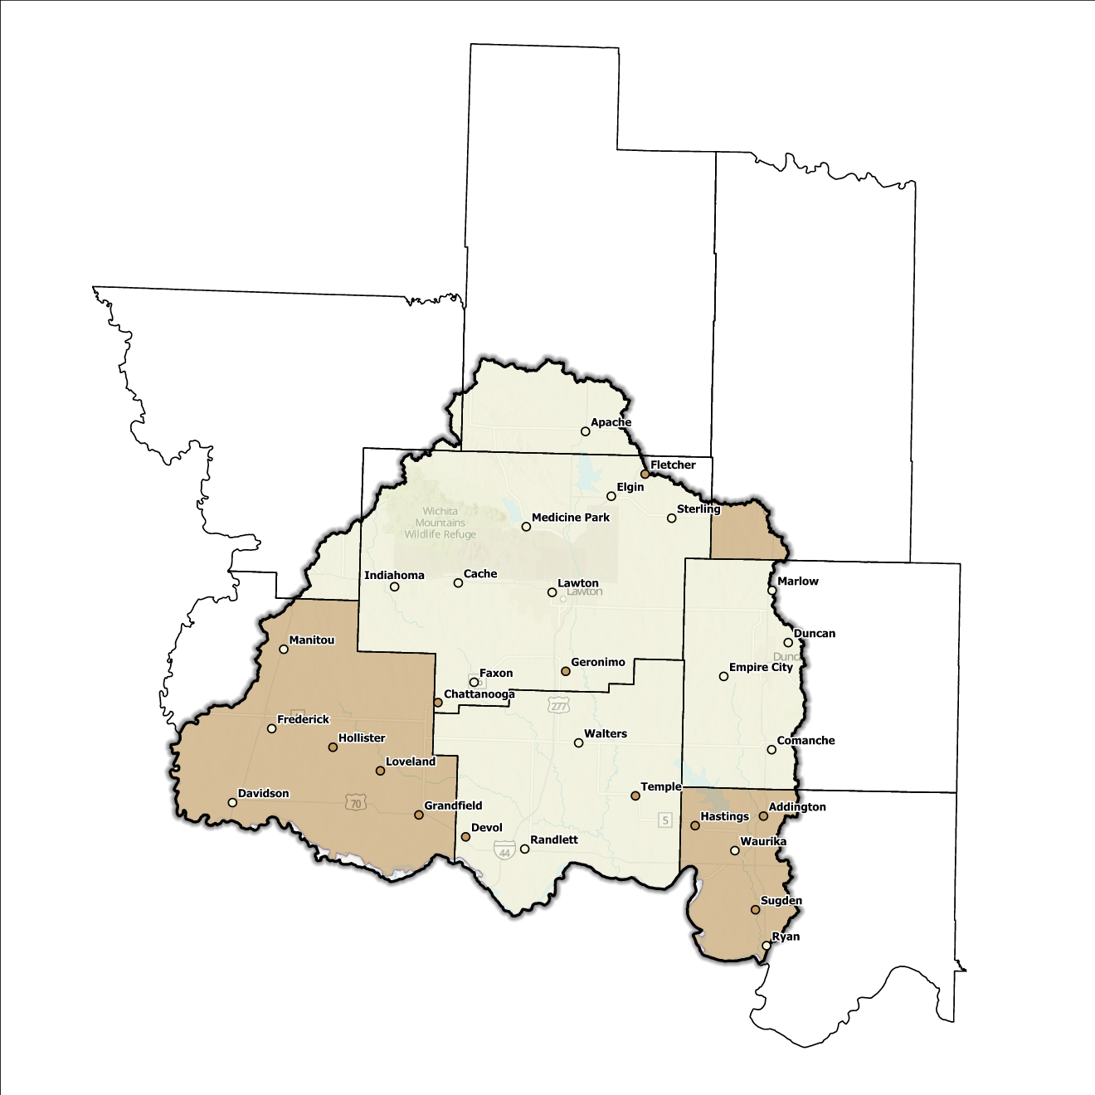
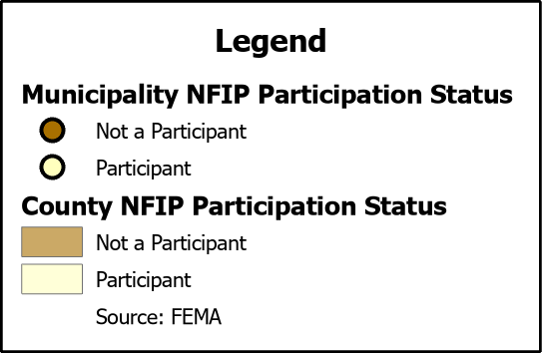
Figure 4: Status of NFIP Participation in the Beaver-Cache Planning Region

Flood Insurance Coverage
As of the latest update, there are currently 647 active NFIP policies within the Region. These policies cover approximately 18% of the total structures located in the FEMA mapped Special Flood Hazard Area (SFHA). It should be noted that not all active policies are situated within the SFHA. A total of 934 NFIP claims have been filed, resulting in approximately $24 million being paid out to policyholders. In the Region, there are 100 structures classified as repetitive loss (RL) and/or classified as severe repetitive loss (SRL), with a significant concentration of both types in Comanche County. Repetitive loss, in the context of the NFIP, refers to properties that have experienced multiple flood-related insurance claims over a specific time period. Severe repetitive loss, on the other hand, pertains to properties with an extensive history of recurrent flood damage and a high number of insurance claims, making them particularly vulnerable and costly for the NFIP.
The following Figures (Figure 5 through Figure 8) provide a range of information about NFIP policies, along with a comprehensive overview of total claims filed and corresponding payouts within the Region. While these figures offer valuable insights, it is crucial to acknowledge they may not accurately reflect the true extent of losses within the area due to potential underrepresentation of flood insurance. It is important to note that not every claim submitted or paid can be directly associated with an active policy.
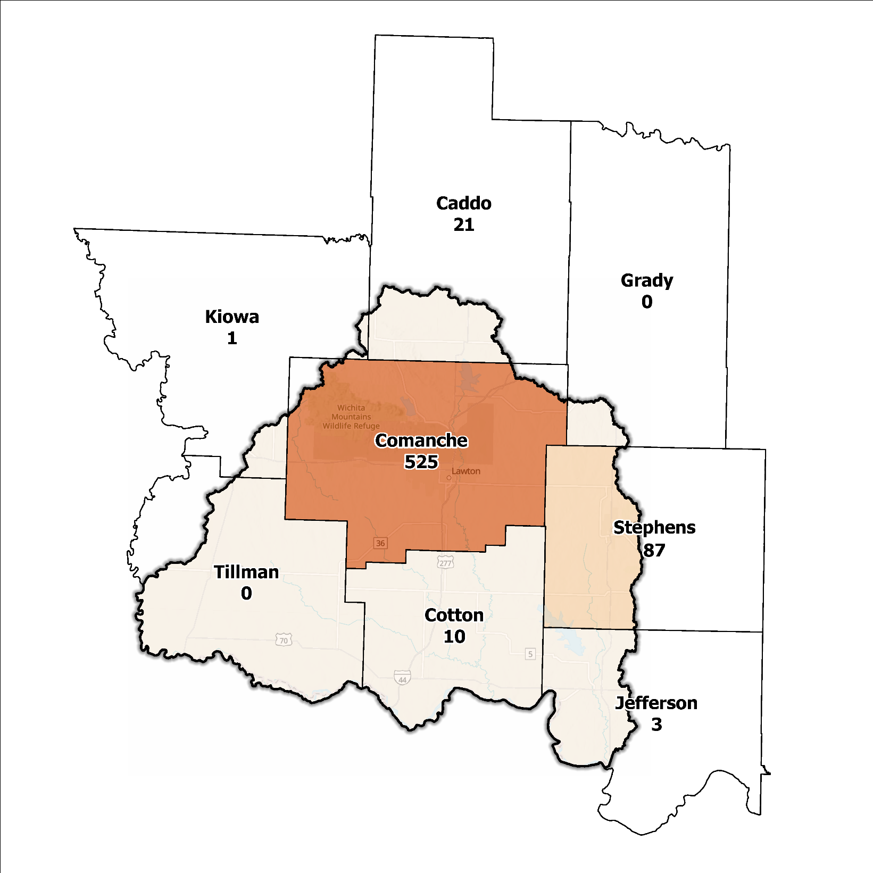
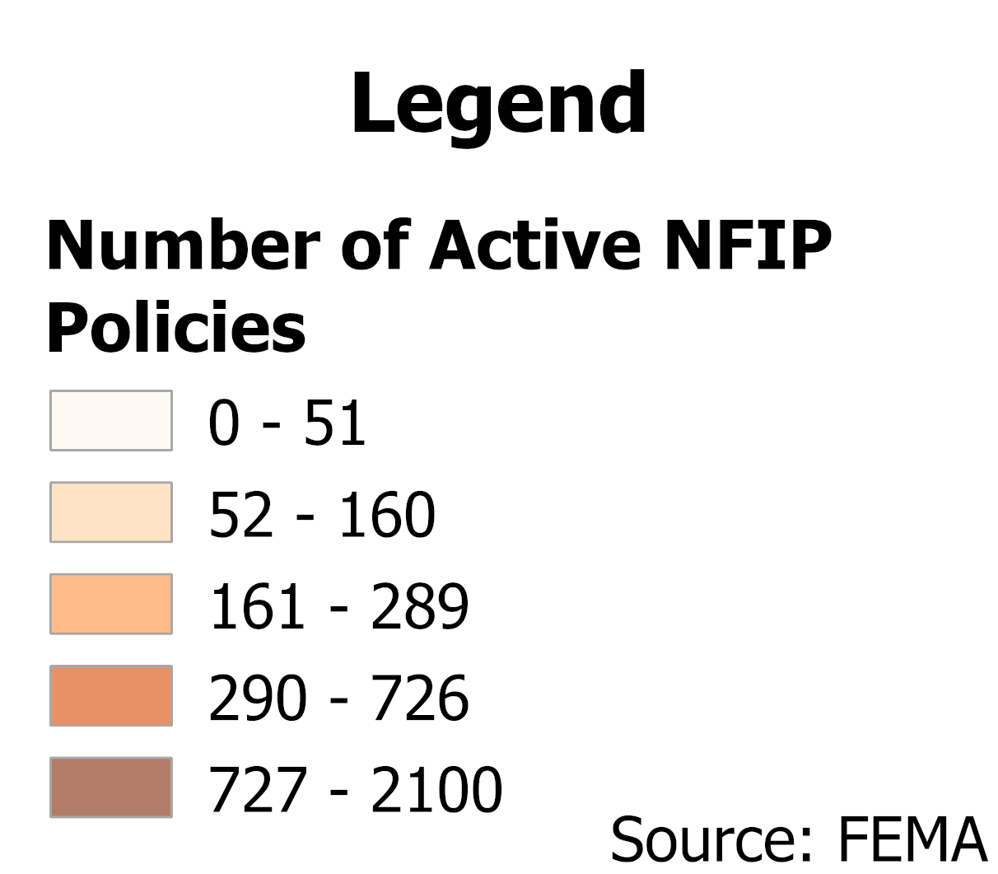
Figure 5: Number of Active NFIP Policies in the 100-Year Floodplain in the Beaver-Cache Planning Region

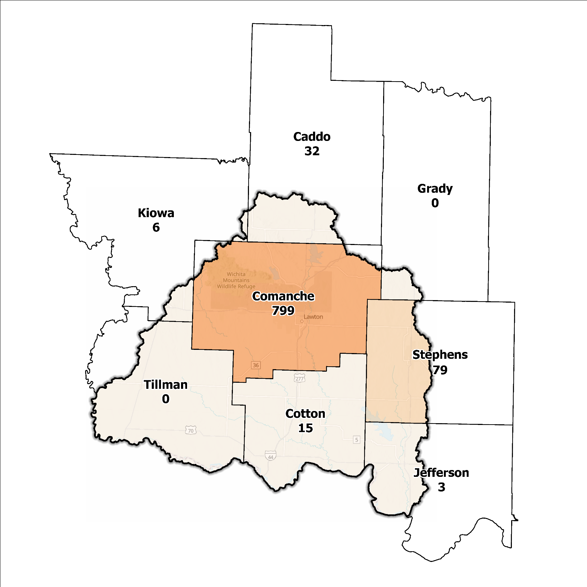
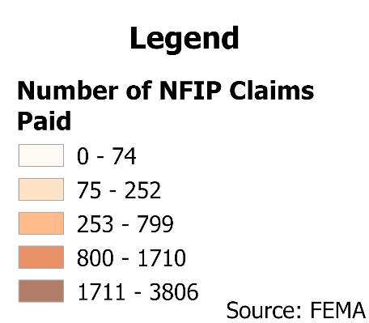
Figure 6: Total NFIP Claims Paid in the Beaver-Cache Planning Region

Source: FEMA
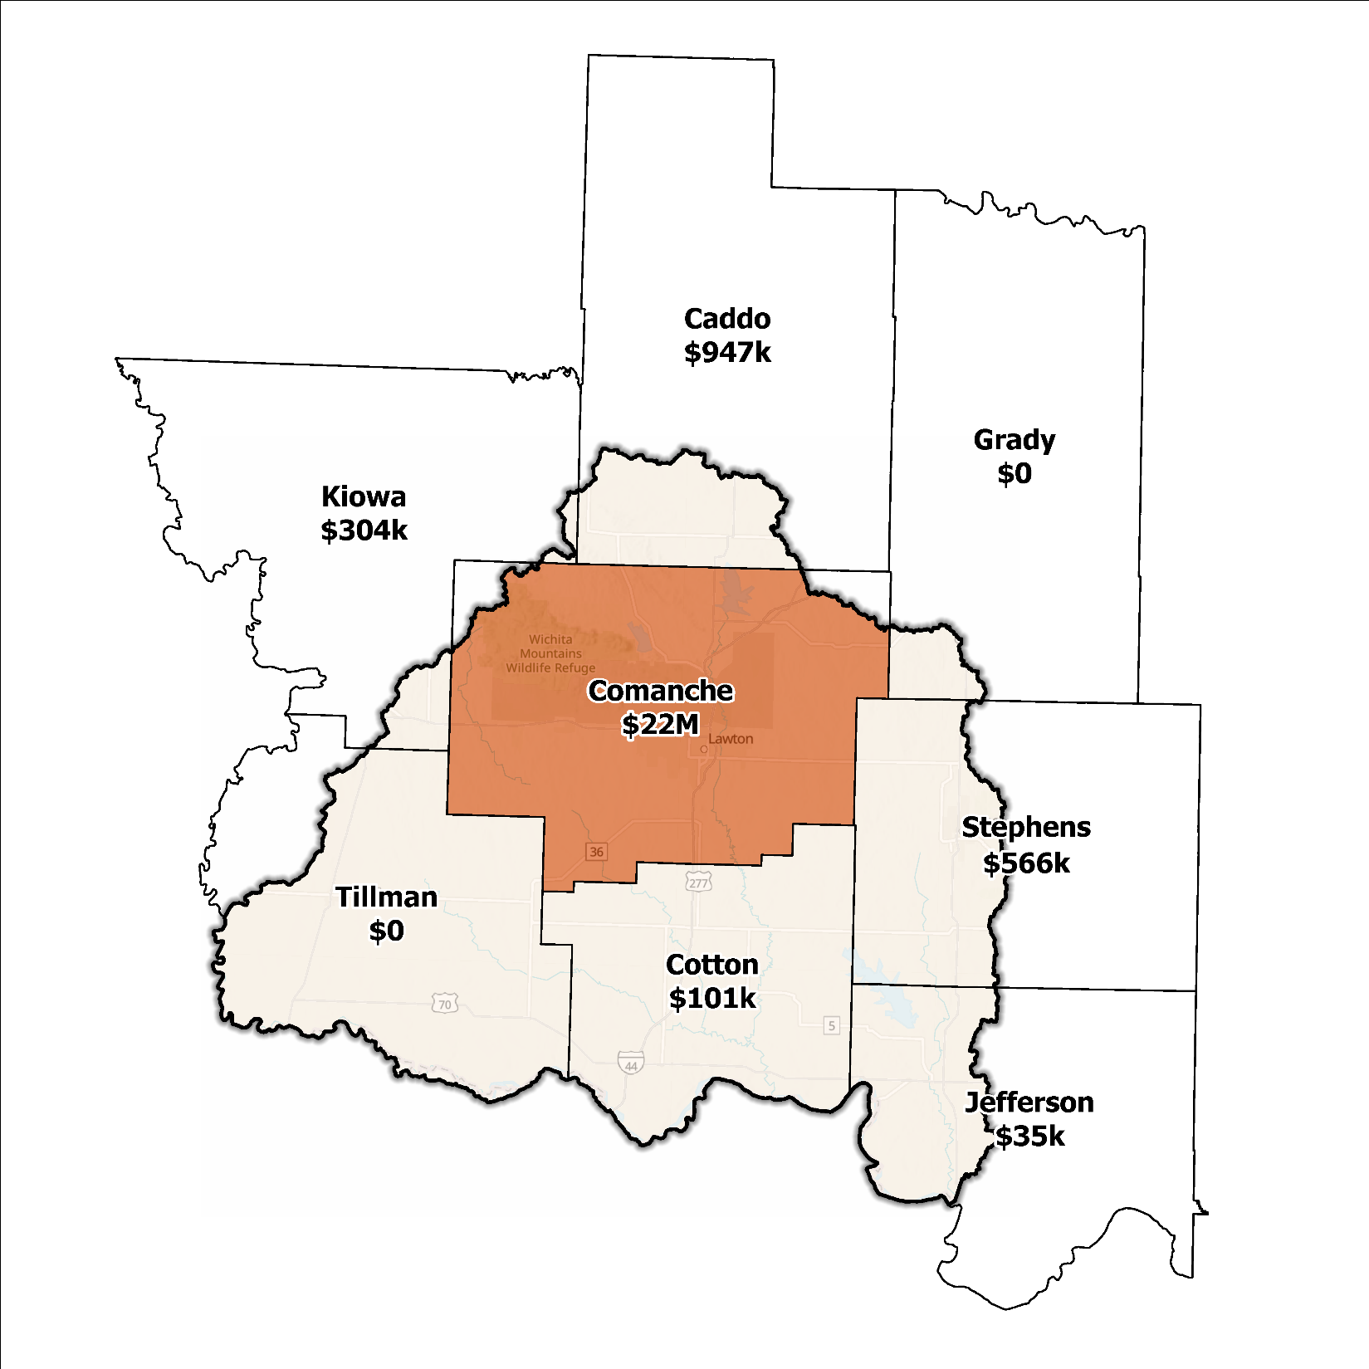
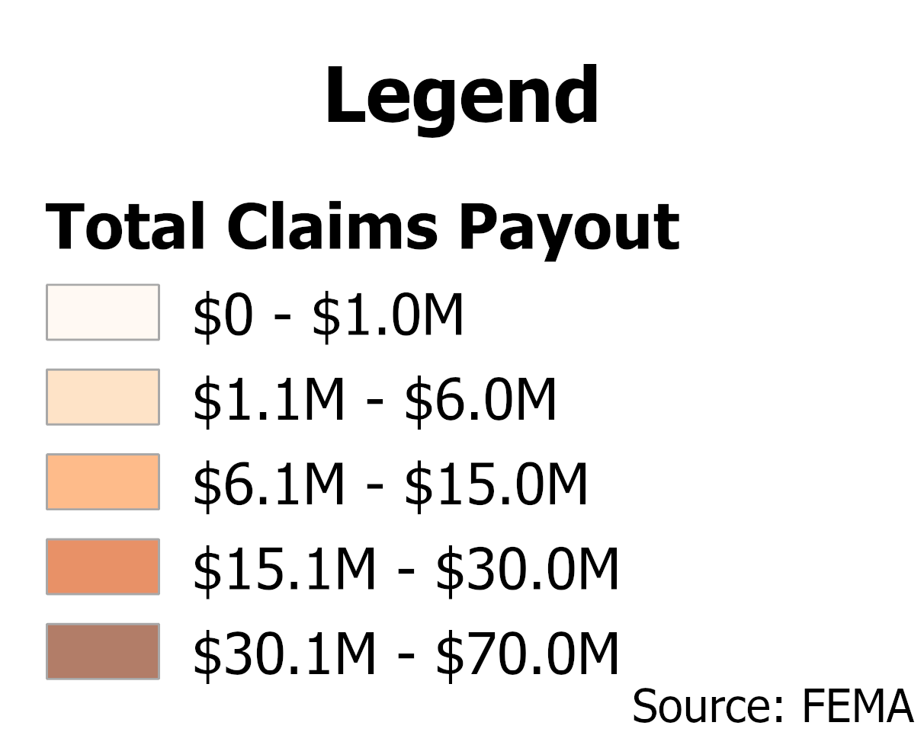
Figure 7: Total Value NFIP Claims Paid Out in the Beaver-Cache Planning Region

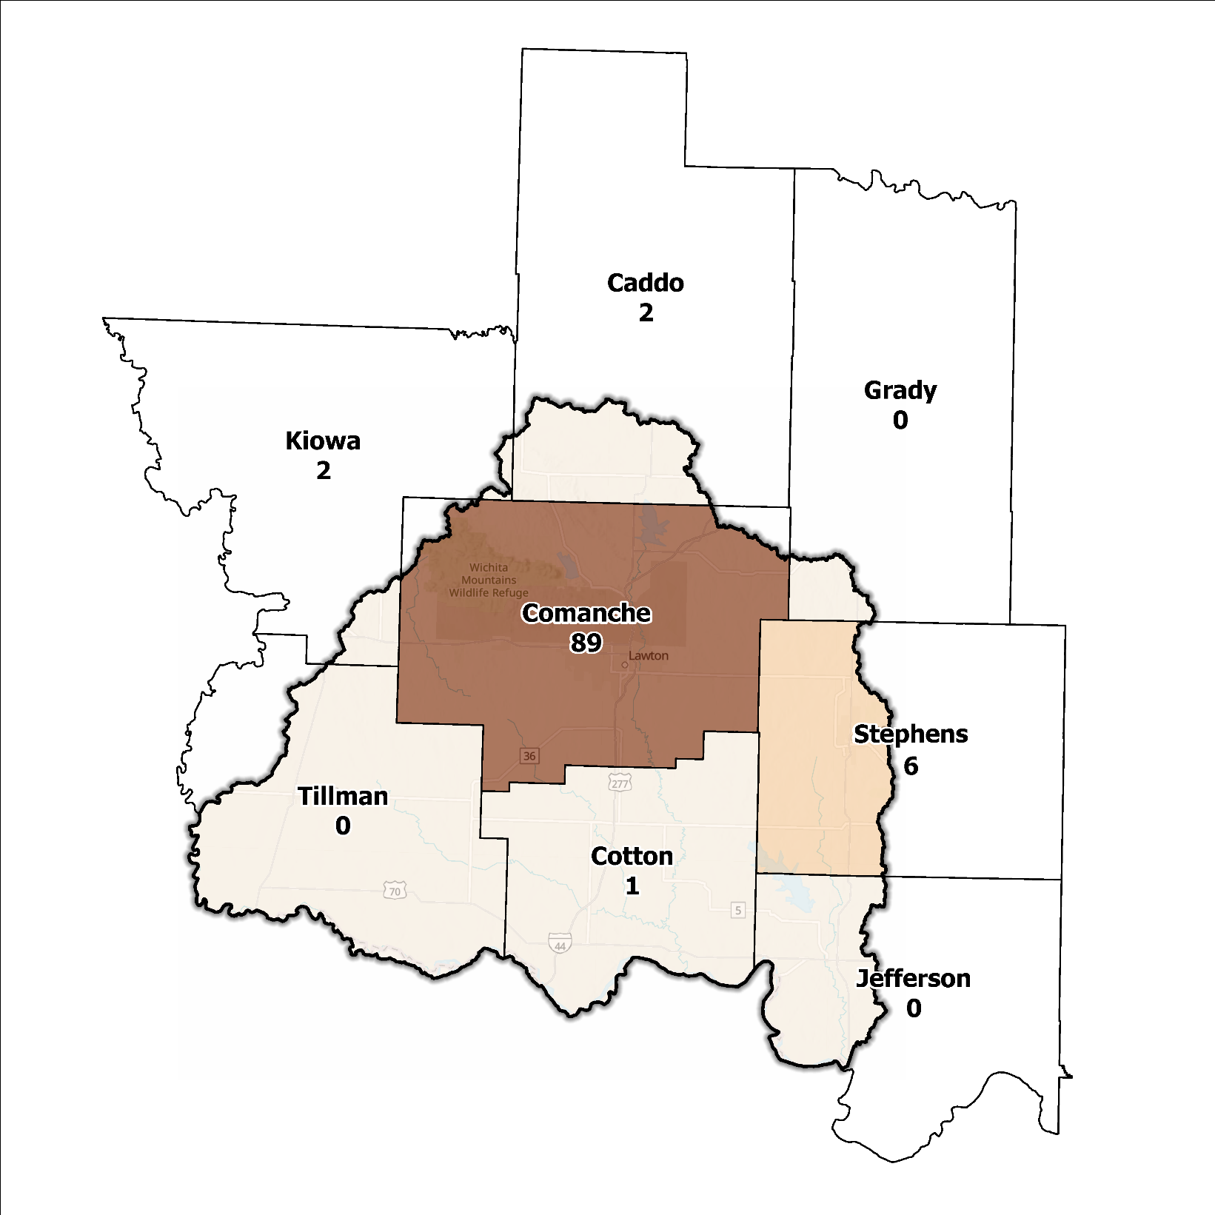
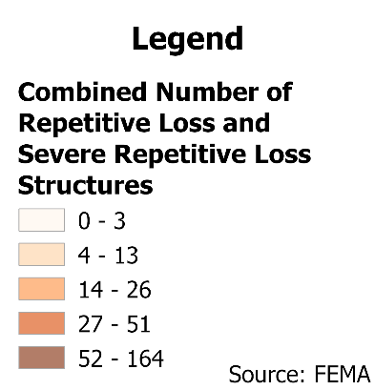
Figure 8: Repetitive Loss and Severe Repetitive Loss Structures in the Beaver-Cache Planning Region

Flood Funding Mechanisms
A survey conducted by the planning team to determine the level of funding for stormwater and floodplain management in the Beaver-Cache Planning Region revealed that numerous communities have limited local funding. The tax base in many of these areas is restricted, impeding the capacity to finance projects aimed at reducing flood risk. Even state and federal grant programs that are available to assist with such projects require communities to provide match dollars, sometimes up to 50% of the award amount, which can put assistance out of reach for communities with tight operating budgets.
Communities and counties of greater size, such as Lawton or Comanche County, possess greater financial leeway in supporting flood mitigation activities, courtesy of their larger tax bases. Projects previously implemented or are in progress have utilized local funding channels augmented by allocations from the Hazard Mitigation Grant Program (HMGP) and other federal and state grant programs.

Hazard Mitigation Plan Status
In this Region five out of eight counties, and the Chickasaw Nation, have FEMA-approved Hazard Mitigation Plans (HMP) and the identified mitigation actions vary among the jurisdictions. Stephens County’s HMP is still pending approval from FEMA. Alongside these participants’ independent HMPs, the municipalities of Lawton and Duncan possess their own FEMA approved plans. Notably, Lawton leverages its HMP to accrue points for engagement in Activity 510 of FEMA’s CRS. Table 2 shows all previous, current, or pending HMPs in the Region.
Table 2: Hazard Mitigation Plan Status for the Beaver-Cache Planning Region
Name | Type | Approval Date | Expiration | Current Action Status of this Plan
Caddo | County | - | - | In Progress
Comanche | County | 09/13/2024 | 09/12/2029 | Approved
Lawton | City | 08/15/2019 | 08/14/2024 | Expired
Cotton | County | 09/25/2024 | 09/24/2029 | Approved
Grady | County | 08/29/2024 | 08/28/2029 | Approved
Jefferson | County | 10/04/2009 | 10/04/2014 | Expired
Kiowa | County | 10/16/2022 | 10/15/2027 | Approved
Stephens | County | 12/20/2024 | 12/19/2029 | Pending Approval
Tillman | County | 04/17/2024 | 04/16/2029 | Approved
Chickasaw | Tribal Nation | 10/20/2021 | 10/19/2026 | Approved

Flood Mapping Assessment
Within the Beaver-Cache Planning Region, the floodplain quilt consolidates the best available data on flood risk. Still, certain communities within this Region lack advanced floodplain mapping by FEMA that would provide useful Base Level Engineering (BLE) information. The absence of this information restricts the capacity of local authorities to manage developmental activities in areas prone to flooding.
A notable aspect in the Region is most of the effective FEMA maps still need detailed studies. This leaves floodplain managers to rely on Approximate A Zones, which offer a broad understanding of flood risk but do not have determined Base Flood Elevations (BFE). Figure 9 displays FEMA-mapped areas in the Region.
While in areas with Zone A coverage, BLE data could potentially offer a more precise assessment of flood risk, it is important to note that the entire Planning Region may not have complete BLE coverage. There is a need for in-depth studies to enhance the precision and reliability of flood risk information in specific areas.
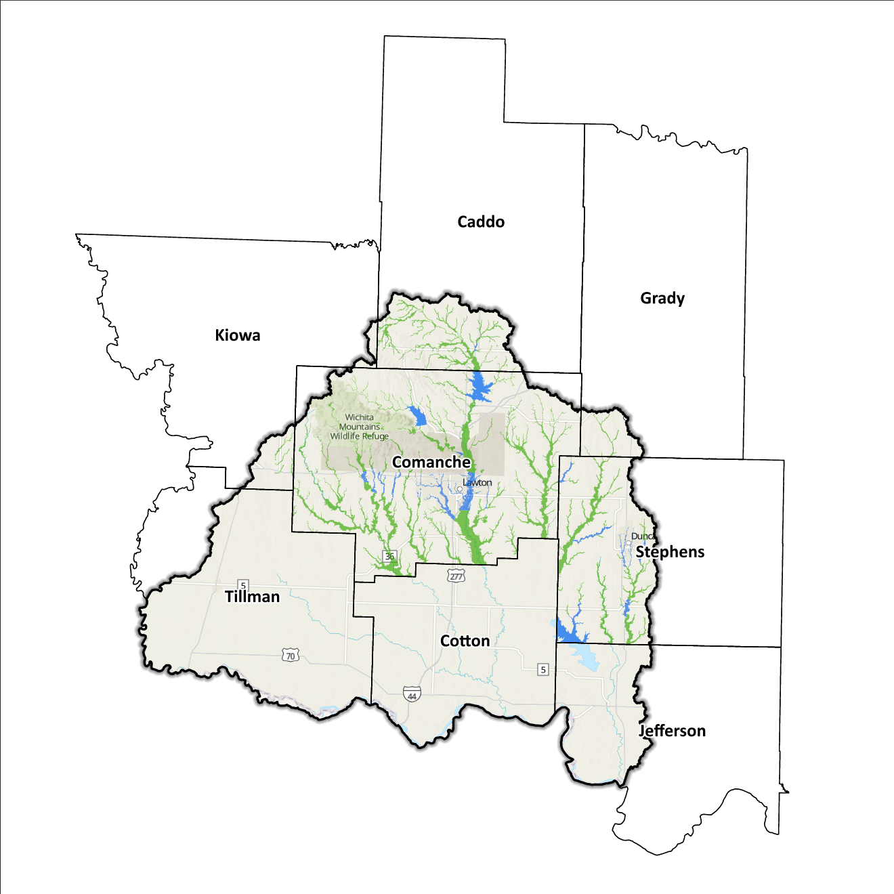
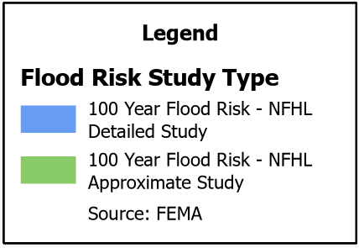
Although Flood Insurance Rate Maps (FIRMs) offer advantages for regulatory purposes and evaluating flood insurance, they solely portray potential hazards linked to flood occurrences within specific conditions. The inclusion of flooding threats beyond the FEMA-mapped SFHA is contingent upon the community's decision to conduct necessary studies for integrating such data into their hazard map.
Figure 9: FEMA Mapped Special Flood Hazard Areas in the Beaver-Cache Planning Region

Flood Hazard Assessment
Flood hazards in this Region include flash, river, and urban flooding. The Beaver, Cache, and Deep Red Creeks, along with their respective tributaries, are the major waterways found in the Beaver-Cache Planning Region.

Location of Flood Hazards
The Beaver-Cache Planning Region is characterized by a flood hazard that encompasses various significant aspects. The flood dynamics in this Region exhibit the following characteristics:
- Flooding along major waterways with extensive drainage basins, including the Beaver, Cache, and Deep Red Creeks.
- Flash floods along smaller tributaries that ultimately flow into the major waterways.
- Drainage issues in specific areas result from inadequate infrastructure. Insufficient drainage systems can exacerbate flood risks, leading to localized flooding in vulnerable locations.
- Downstream areas located below high-hazard potential dams are exposed to heightened risks.
Figure 10 shows mapped areas of flood risk in the Region. The map brings together data from different sources, like the National Flood Hazard Layer and BLE, to create a unified view. It prioritizes layer types and shows the most important layer available for a specific area.

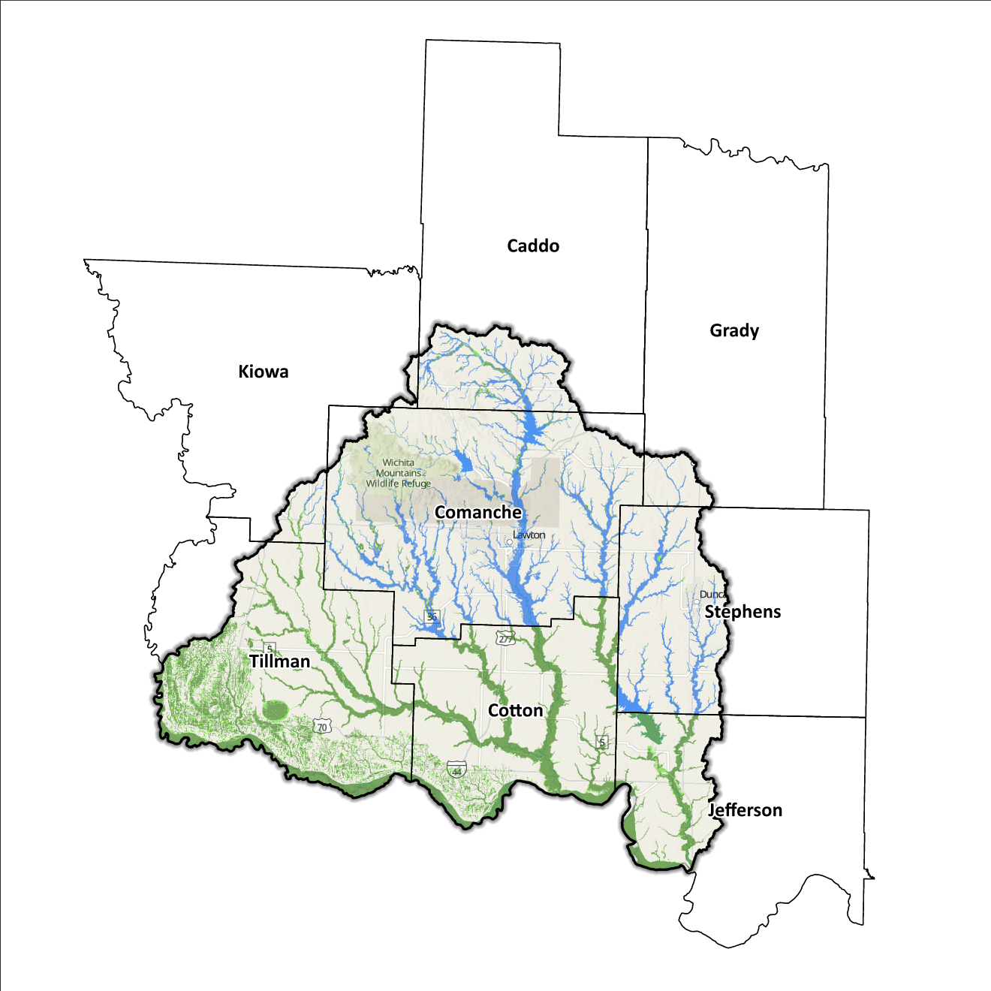
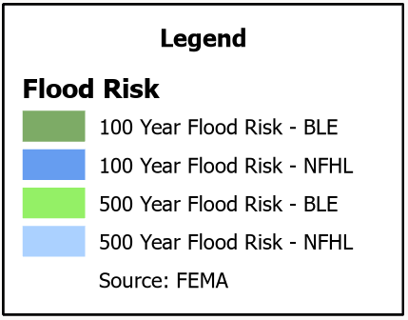
Figure 10: Flood Quilt for the Beaver-Cache Planning Region

Dam and Levee Infrastructure
The Region has multiple dams aimed at preventing flooding. However, aging infrastructure increases the risk of downstream impacts if a breach or failure occurs, especially for high-hazard dams classified by the Oklahoma Water Resources Board (OWRB). Across the eight counties, there are 183 total dams, 15 of which are high hazard. A map of dam and levee sites within the Region is shown in Figure 11. In the event of an incident, seven of these high-hazard dams could potentially impact sections of Lawton, while two could negatively impact Waurika.
There are 18 levee systems in the Region, spanning Tillman, far southern Kiowa, Comanche, and Cotton counties. Among these, four levees exist along Jack Creek in the eastern region of Tillman County, while nine are situated along Beaver and Little Beaver Creek in the eastern portions of Comanche and Cotton counties, four are positioned across Comanche County, and the final one is in the southeastern portion of Kiowa County. State and local officials can find information on these systems on the United States Army Corps of Engineers National Levee Database website.

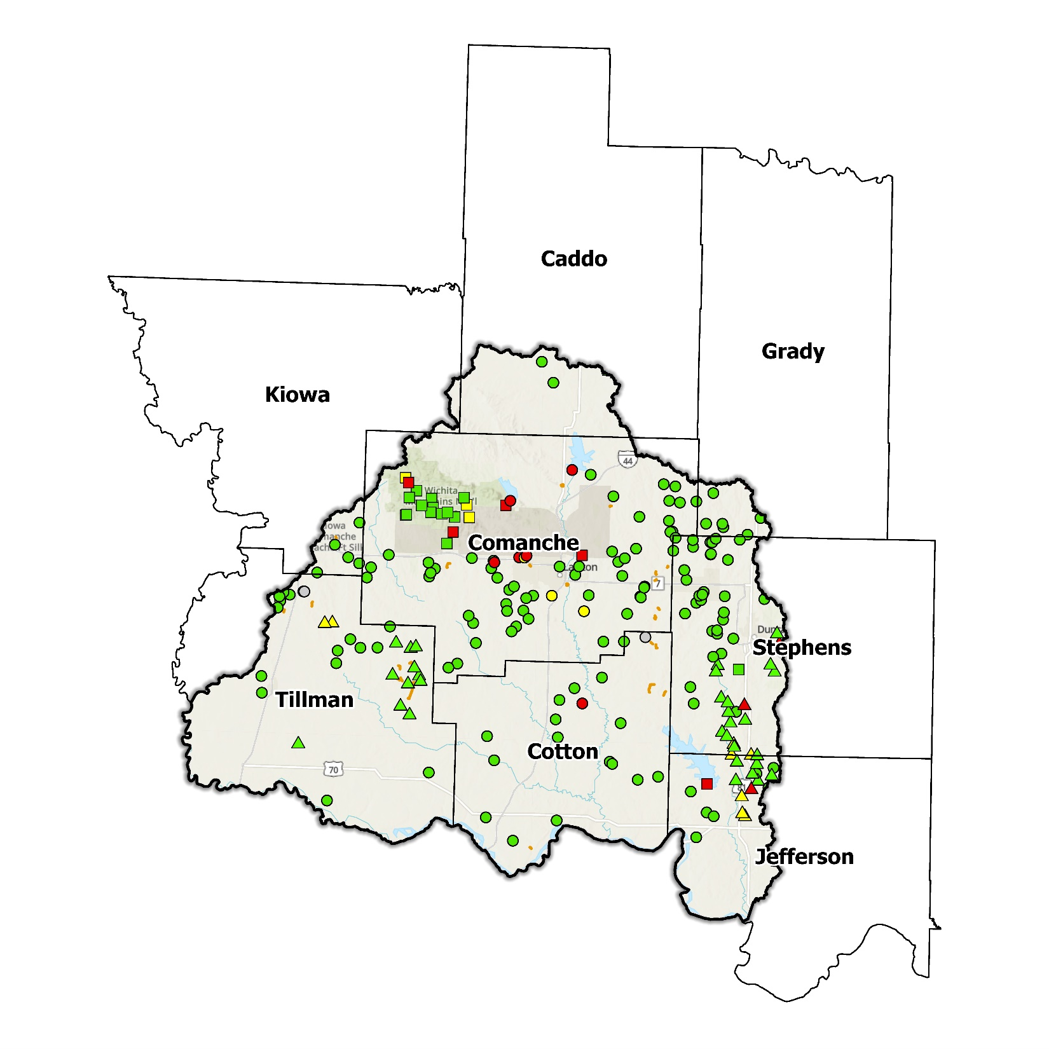
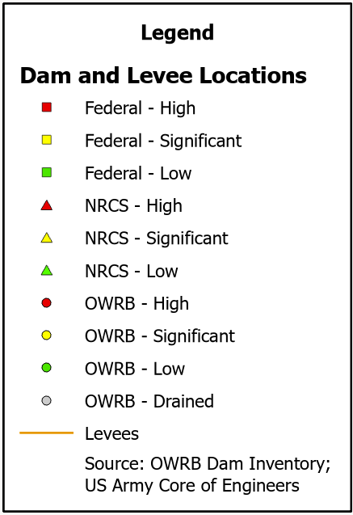
Figure 11: Dam and Levee Locations in the Beaver-Cache Planning Region

Extent of Flooding
Extent refers to the expected severity of flooding, and because not all areas within the planning area share the same topography, the extent varies between individual communities. The average depth of flooding within the FEMA-mapped SFHA can range from a few inches to several feet, depending on factors such as topography, proximity to water bodies, local drainage characteristics, and the intensity of the flood event.

Previous Occurrences
According to the records maintained by the National Center of Environmental Information (NCEI), from January 1996 to December 2022, a total of 139 flood events have been documented in the eight counties encompassing this Planning Region. Cumulatively, these flooding incidents have caused property damage amounting to $12,555,500 and crop damage amounting to $10,000.
The NCEI initiated the tracking of flood events only from 1996, hence this data represents the most comprehensive information available. Flooding has frequently escalated to the point of necessitating a Presidential Disaster Declaration. A breakdown of flood-related disasters by county is shown in Table 3.
Of all the counties in the Region, Caddo County has most frequently been declared a disaster area due to flooding. However, it's important to note that disaster declarations are issued on a county-wide basis and not all declarations may have directly impacted this specific Region.

Table 3: FEMA Disaster Declarations from 1950-2024 in the Beaver-Cache Planning Region
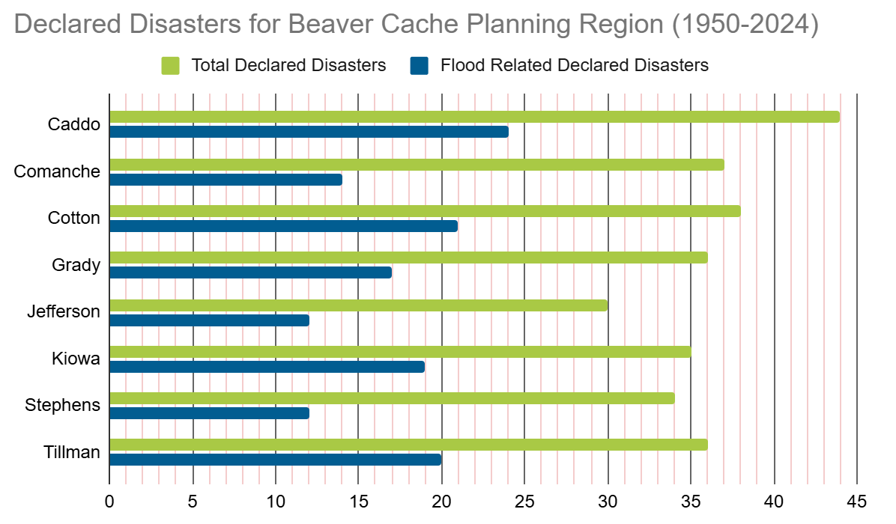

Vulnerability and Impacts of Flooding
According to FEMA’s National Risk Index (NRI), the Beaver-Cache Planning Region demonstrates a range of risk levels for river flooding and flash flooding, varying from extremely low to moderately low risk at the county level, when compared to the rest of the United States. However, when examined at a more granular scale by census tract, the NRI highlights two zones within the Region characterized by an elevated likelihood of flooding. These areas are situated northeast of Lawton within Comanche County, and in the southern part of Stephens County.
Average annual precipitation across the Region ranges from about 28 inches in Tillman County, to 37 inches in Stephens County. A cursory examination of drainage basins within the Region in combination with average annual precipitation supports the assessment of the area in southern Stephens County. The assessment of the area northeast of Lawton can be attributed to the potential areas of inundation in the event of a dam incident at Lake Ellsworth.

Summary of Flood Exposure
Flood exposure refers to the degree to which an area or population is at risk of being affected by a flood event. Table 4 provides a comprehensive overview of key factors, including the total count of housing units, population figures, job statistics, land area measurements, and the number of parcels/blocks within the designated FEMA-mapped flood area. This information aims to facilitate a thorough understanding of the flood-affected area's characteristics and implications.
The data in this section was generated using UrbanFootprint. This module evaluates flood risk by conducting a spatial join of parcels or census blocks with the FEMA National Flood Hazard Layer to assess the potential risks associated with hazards. The data presented in the table below is focused on three different FEMA SFHA flood zones that represent areas within the 100-yr floodplain with a 1% annual chance of experiencing a flood event. Zone AE is the most detailed, providing BFE, Zone AO represents areas subject to shallow flooding of depths between one to three feet, and Zone A is an approximation of the 100-yr floodplain for areas where detailed hydraulic analyses have not been performed.

Table 4: Flood Exposure in the Beaver-Cache Planning Region
Beaver-Cache Planning Region Flood Risk Report
Housing in Flood Hazard Zones (Dwelling Units)
Dwelling Units in SFHA Zone AE | 2,526
Dwelling Units in SFHA Zone A | 23
Dwelling Units in SFHA Zone AO | 5
Total | 2,554
Population in Flood Hazard Zones (Persons)
Population in SFHA Zone AE | 4,859
Population in SFHA Zone A | 167
Population in SFHA Zone AO | 12
Total | 5,038
Jobs in Flood Hazard Zones (Employees)
Jobs in SFHA Zone AE | N/A
Jobs in SFHA Zone A | N/A
Jobs in SFHA Zone AO | N/A
Total | N/A
Land Area in Flood Hazard Zones (Acres)
Area in SFHA Zone AE | 21,736
Area in SFHA Zone A | 84.33
Area in SFHA Zone AO | 5,049
Total | 26,869
Parcels or Blocks in Flood Hazard Zones
Parcels or Blocks in SFHA Zone AE | N/A
Parcels or Blocks in SFHA Zone A | N/A
Parcels or Blocks in SFHA Zone AO | N/A
Total | N/A

Flood Mitigation Needs
Flood mitigation projects for the Region have been identified at a county level through the analysis of HMPs, master drainage plans at the community level, and prioritized lists provided by jurisdictions. The following stormwater project types were considered:
- Channel
- Storm Drain
- Infrastructure
- Detention Pond
- Dam-Reservoir
- Floodwalls and Levees
- Acquisition

Although the OWRB State Flood Plan Dashboard does not list any stormwater projects in the Beaver-Cache Planning Region at the time of this writing, the City of Lawton has made noteworthy progress. It has recently secured $1 million in grants earmarked for improvements to Lake Ellsworth dam, a high-hazard structure in Comanche County posing a risk of inundation to parts of the city should a dam-related incident occur. This project is shown in Table 5 as the sole stormwater project identified for the Beaver-Cache Planning Region.

Comanche County, the most populous in this region, has outlined direct mitigation actions targeting flood hazards in its latest accessible HMP, which dates to 2015. These measures span various fronts, encompassing the elevation of vulnerable structures, roads, and bridges. Administrative endeavors, such as public outreach to foster flooding hazard awareness and sustained participation in the National Flood Insurance Program (NFIP), are also included within these action items. Mitigation plans for other counties in the Planning Region concentrate on strategies to mitigate erosion and enhancement of stormwater drainage systems.

Table 5: Stormwater Projects Identified in the Beaver-Cache Planning Region
Stormwater Project Types Per County | Number | Percentage | $ Amount
Comanche County
Dam-Reservoir | 1 | 100% | $1M
Total | 1 | - | $1M

While most floodplains within this region are in rural areas, the following communities have at least one structure located within floodplains: the cities of Lawton, Waurika, and Duncan, the towns of Manitou, Cache, Apache, Elgin, Faxon, Walters, Comanche, Sugden, Temple and the unincorporated communities of Boone and Hooper. Despite this, the Beaver-Cache Planning Region has not reported any data on the use of acquisition as a mitigation method.
Smaller communities face challenges in funding acquisitions and other stormwater and mitigation projects. In numerous cases, the local tax base proves insufficient to finance property acquisition, necessitating these jurisdictions to seek external sources, such as state and federal grant funding. Such sources can be highly competitive in nature and favor more populated urban areas due to the cost benefits and can depend on a variety of factors.

Conclusion
The Beaver-Cache Planning Region report highlights the significance of this Region and its vulnerability to flooding events. The report's findings emphasize the urgent need for funding to support engineering efforts in flood projects within the watershed. Identification of projects is needed, and planning or technical assistance may be needed to help communities even identify projects. Adequate funding is essential for conducting detailed engineering assessments, implementing effective flood control measures, and enhancing community resilience. The lack of project submissions underscores the importance of assisting communities in identifying and developing flood mitigation projects.
By allocating resources and support for project identification and development, communities can better understand their flood exposure and proactively protect lives and infrastructure. Investing in engineering and flood mitigation projects in the Beaver-Cache Planning Region will contribute to creating safer, more resilient communities better equipped to handle future flood events.
During the planning process, the data generated was developed into an interactive flood planning dashboard. The dashboard serves as a valuable tool for conducting flood assessments at the community level. It is important to note that this report should not substitute locally generated data specific to each community.

https://lawtonfortsillchamber.com/chamber/economic-development/
https://www.bea.gov/tools
This calculation was performed by summing the populations of the counties within this region, as indicated in Table 1, then divided by the entire population of the State of Oklahoma using the same data source (2020 U.S. Decennial Census).
Census Bureau Data – 2020 Decennial Census
U.S. Bureau of Economic Analysis
Caddo County’s HMP includes the Town of Apache.
Comanche County’s HMP includes the Towns of Chattanooga, Faxon, Fletcher, Geronimo, Indiahoma, Medicine Park, Sterling and the Cities of Cache, and Elgin.
Cotton County’s HMP includes the Towns of Devol, Randlett, Temple, and the City of Walters City.
Stephens County’s HMP includes the Towns of Central High, Empire City, and the Cities of Comanche, Duncan, and Marlow.
Tillman County’s HMP includes the Towns of Davidson, Manitou, and the Cities of Frederick, and Grandfield.
FEMA’s National Risk Index (NRI) is a tool used to calculate a community’s potential for negative impacts due to natural hazards and community risk factors. The three components used in the NRI equation that generates the Risk Index Score are expected annual loss due to natural hazards, social vulnerability, and community resilience.
Any counties that do not appear in the table do not have any identified projects.

