Other Documents in CARS
All resources, documents, forms, and the Manual are located in Other Documents

Website: https://cnp.sde.ok.gov/oknslp/PrintDocuments.aspx
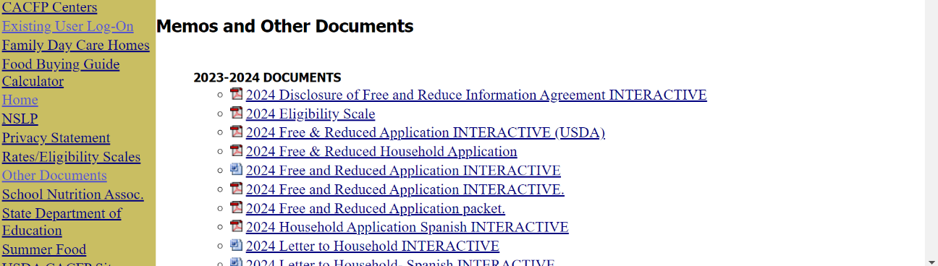
To Search, Click Ctrl + F

Sections:

- 20XX-20XX DOCUMENTS
- AGREEMENT PROVISIONS
- AFTERSCHOOL SNACK (ASSP)
- AT-RISK CACFP
- CEP AND PROVISION INFORMATION
- CHILD NUTRITION MANUAL
- CIVIL RIGHTS
- CHARGE POLICY/UNPAID MEALS
- CNP DOCUMENTS
- COMPETITIVE FOODS/SMART SNACKS
- COOKING FOR KIDS: TRAINING AND RESOURCES
- EQUIPMENT GRANT
- ESPANOL RECURSOS
- FARM TO SCHOOL RESOURCES
- FINANCIAL MANAGEMENT
- FOOD BUYING GUIDE
- FOOD SAFETY
- FOOD SERVICE MANAGEMENT COMPANY
- FRESH FRUIT AND VEGETABLE PROGRAM (FFVP)
- HOW TO INSERT A NEW APPLICATION
- INTERACTIVE FORMS
- MEAL PATTERN DOCUMENTS
- MEAL PATTERN REQUIREMENTS
- MENU PLANNING RESOURCES
- NEW FINAL RULE GUIDELINES FOR FY2026
- PAID LUNCH EQUITY (PLE)
- PROCUREMENT
- PROFESSIONAL STANDARDS
- RCCIs
- RESOURCES
- SCHOOL CALLS, Q&AS, & WALKTHROUGHS
- SEAMLESS SUMMER OPTION (SSO)
- SPECIAL DIETARY NEEDS
- TRAINING INFORMATION
- TRAINING SLIDES & HANDOUTS
- WELLNESS POLICY

