COR251 Strategic Sourcing – Electronic Solicitations

Authorized by: [_CORE_] Original Issue: [07/01/2003]
Maintained by: [____Purchasing Lead___] Current Version: [12/01/2011]
Review Date: [12/01/2012]

Table of Contents

Table of Contents 3
Document History 4
Create the Sourcing Event (RFx) 5
Create Vendor User ID’s 21
Update Vendor (optional) 23
Bid on Behalf of Vendor 25
Analyze and Award Bid Responses 30
Create a Bidder 36
Creating New Rounds (Counters) 46
Creating New Versions (Amendments) 50
Event Workbench and History Review 54

Document History

Document Revision | Date | Description
1.0 | 07/01/2003 | Initial Document
1.1 | 06/01/2010 | ADA compliant and update to the process
1.2 | 12/01/2011 | Review and update screen shots

Create the Sourcing Event (RFx)

Navigation: Sourcing > Create Events > Event Details > Add a New Value

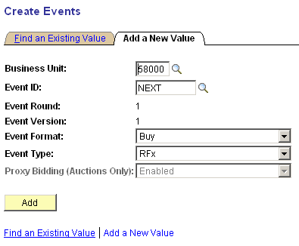

Event ID – leave as NEXT.

Event Format – Buy

Event Type - RFx

Click .
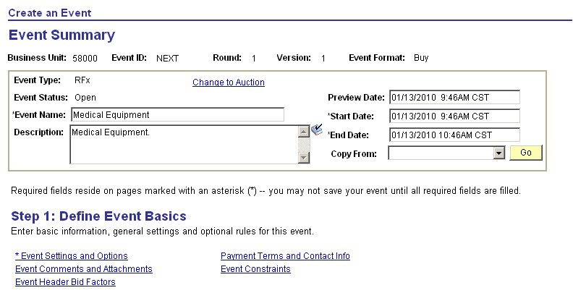

Event Name – required field should hold the general Name of the Event. This will print at the top of the paper bid document and be visible at the top of the page when suppliers are bidding electronically.

Description – a comment field holding 256 characters. Populate with general comments, specific directions, etc. Use to communicate with the suppliers anything important or unusual about this Event. . This will print at the top of the paper bid document and be visible at the top of the page when suppliers are bidding electronically.

Start Date – solicitation open date

End Date – solicitation close date

Use the drop down list to select a transaction to copy into this Event. Typically this will be Requisition.

Click to initiate the Copy function.
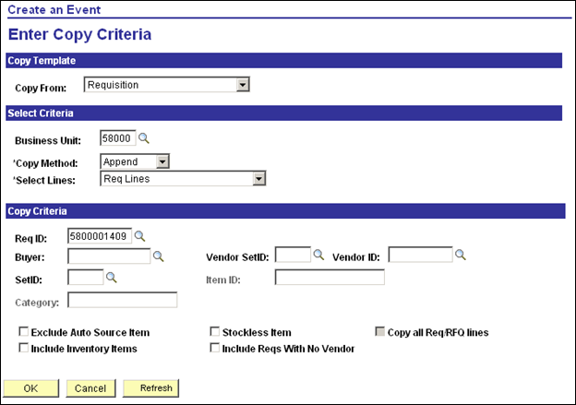

Business Unit – populate with the Agency Business Unit in which the Event is being created.

Copy Method – Append

Select Lines – Req Lines

Requisition ID – select the Requisition ID (or other document if copying from PO, Template, etc.)

Click to initiate the copy of Requisition Lines into the Sourcing Event.

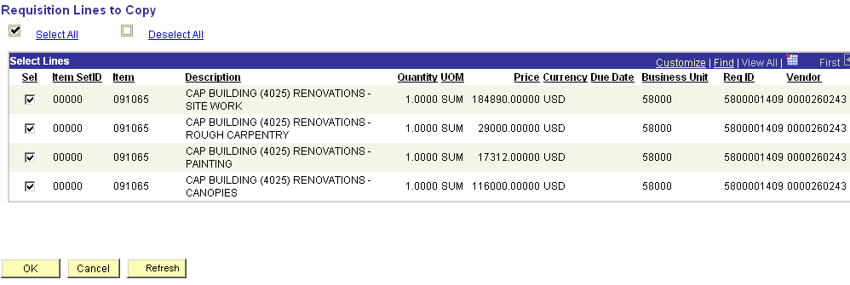

Select – use the Select checkboxes to select the requisition lines that you want to copy into the Event. Alternatively, use the Select All link option.

Click to copy the requisition lines into the Event.
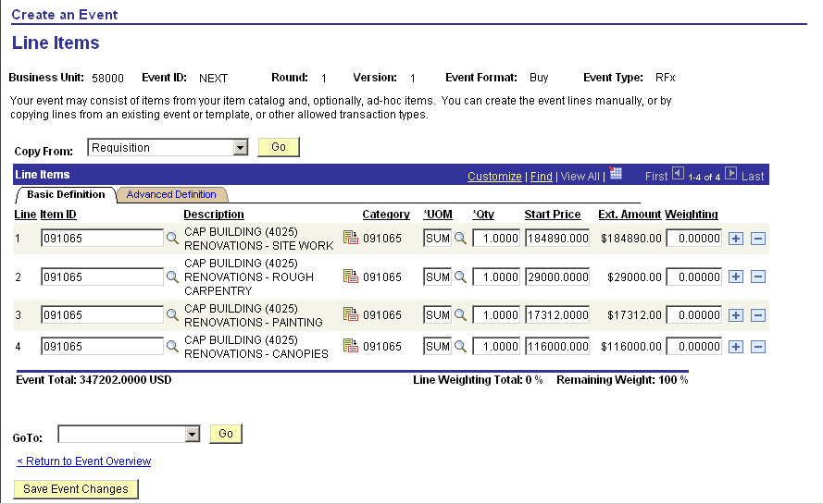

The copied requisition lines will be displayed on the Line Items page. If any adjustments to the Event Lines are necessary (Quantity, Price, Weightings, etc.) need to be made, they can be done here.

Optionally, use the Advanced Definition Tab to access Bid Factors and attach documents or line comments to the Event Lines.

NOTE: Generally, it is not necessary to visit the Advanced Definition Tab if Bid Factors are set (Price is the only default Bid Factor) and no additional line attachments are necessary.

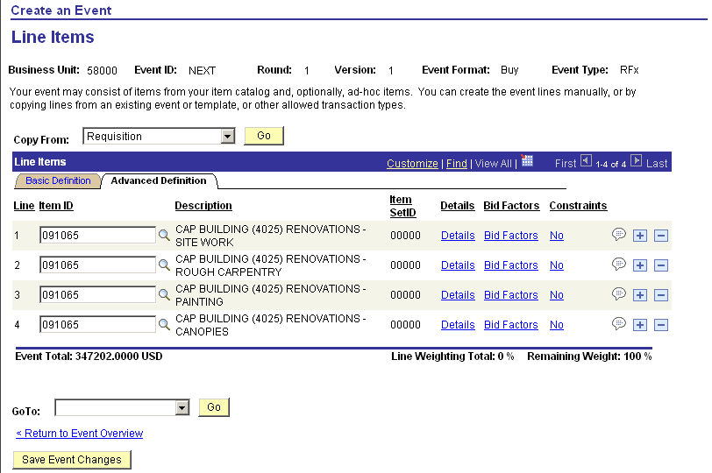

Use the Advanced Definition Tab to add additional Bid Factors to the Event Lines or to add more line comments or file attachments.

Click to view the Line Comments and Attachments page.
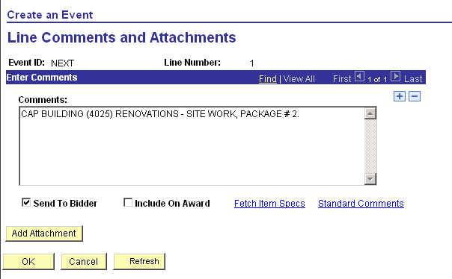

Use the Line Comments and Attachments page to insert additional line comments or add file attachments to the Event Lines.

NOTE: This page attaches files and comments to the Event Line.

Click to return to the Event Lines page after all comments and file attachments are added.
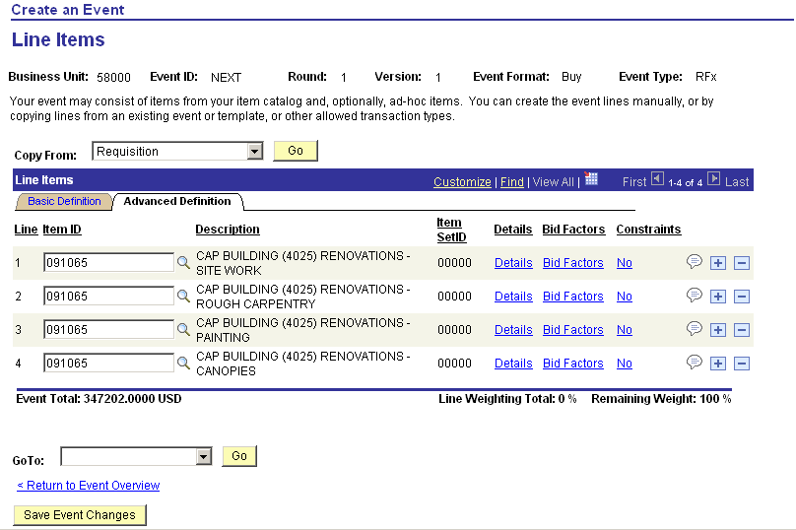

From the Event Lines Page, select the < Return to Event Overview link to return to the main Event Summary page.

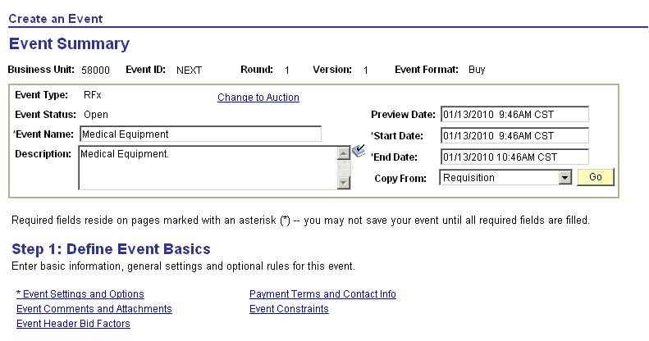

Once the Requisition (or other document) has been copied into the Event, and you are back to the Event Summary page, you can continue to define the Event Header information, and invite Bidders (Vendors) to the solicitation Event.

Use the Event Comments and Attachments link to attach documents to the Event Header.

NOTE: This link attaches documents to the Event Header.

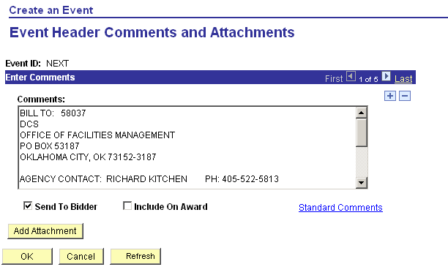

Use the Event Header Comments and Attachments page to insert additional header comments or add file attachments to the Event Header.

NOTE: This page attaches files and comments to the Event Line.

Click to return to the Event Summary page after all comments and file attachments are added.

On the Event Summary page, use the Payment Terms and Contact Info link to define more general Event properties.

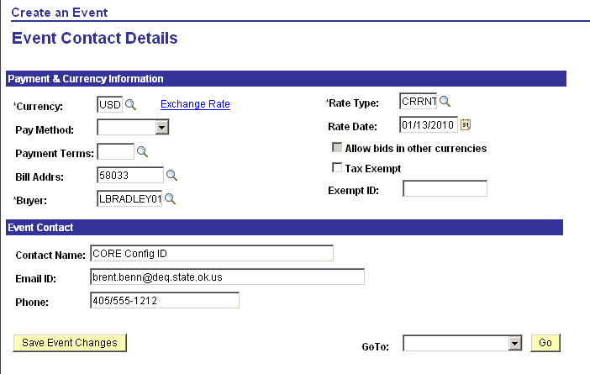

Pay Method – optionally populate the payment method for the PO that will be generated from the Event Award.

Payment Terms - optionally populate the payment terms for the PO that will be generated from the Event Award.

Buyer – defaults to Buyer creating Event.

Contact Name – this is generally the Buyer name. This will print at the top of the paper bid document and be visible at the top of the page when suppliers are bidding electronically.

Email ID – this should hold the Email of the Event Creator (Buyer). System generated emails will be sent to the address including undelivered emails to invited bidders. This email will be visible to bidders when responding electronically and allow them to send emails directly to this email address with questions, etc.

Phone – generally the buyer phone number. This will print at the top of the paper bid document and be visible at the top of the page when suppliers are bidding electronically.

Select the < Return to Event Overview link to return to the main Event Summary page.

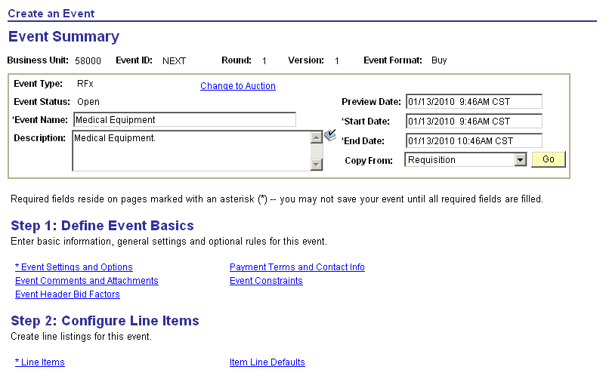

Use the Line Items link to make any necessary changes to the Event Lines.

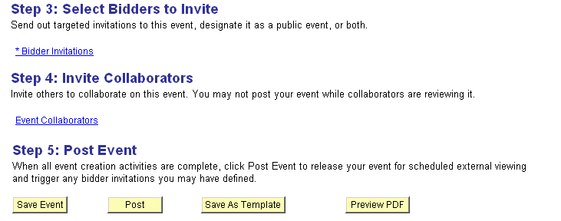

Use the * Bidder Invitations link to initiate the Vendor Invitation process.

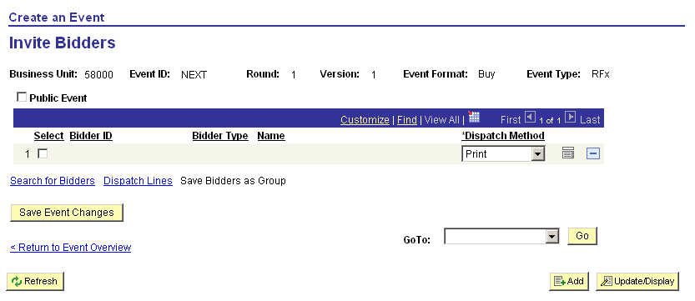

The Invite Bidders page shows the list of all Vendors that have been invited to bid on the Event. At this point in the Event creation, no Vendors have been invited.

Select the Search for Bidders link to initiate the invitation process.

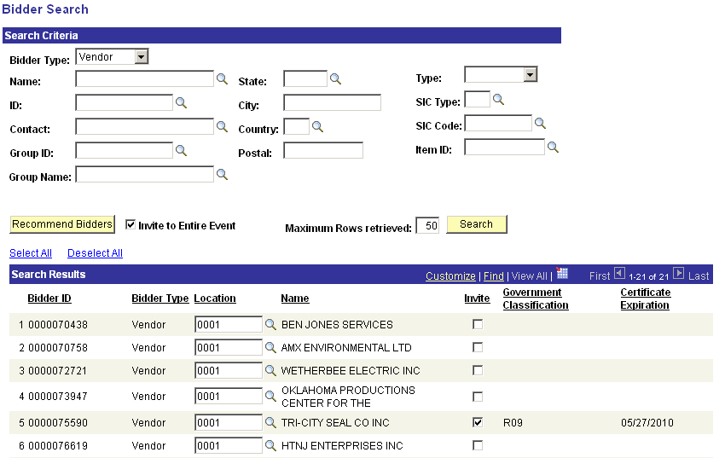

The button will retrieve all the Vendors that are registered for the Category (commodity) that is on the Event Lines (copied from the requisition generally).

The button retrieves all Vendors that match the Search Criteria defined in the top of the page.

NOTE: These two (2) buttons cannot be used in combination together. Vendors are either retrieved using the Recommended Bidder button or the Search button but not both at the same time.

Bidder ID – this is the Vendor ID for Vendors in retrieved.

Maximum Rows retrieved – increase the number of vendors displayed in the Search Results section.

Invite – use this checkbox to invite Vendors to this Event. Optionally, use the Select All and/or Deselect All hyperlinks to invite bidders.

Government Classification – this column holds the registration code indicating the year of registration.

Certificate Expiration – displays the date that the Vendor registration expires.

NOTE: If the Certificate Expiration date is greater than or equal to today’s date, the Invite checkbox will automatically be selected.

Once the desired Vendors have been selected to invite, click , located in the lower left of the screen, to return to the Invite Bidders page.

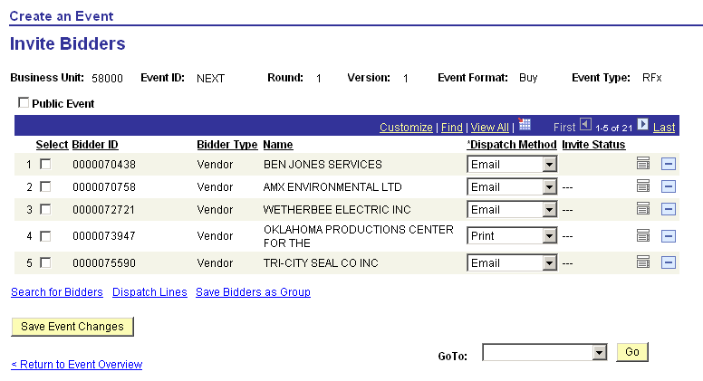

Dispatch Method – for those vendors that you want to receive automatic email notification, set this field to Email.

Click , contact details icon, next to each Bidder (Vendor) to view the Contact information including the Email address that will receive automatic Event Notification.
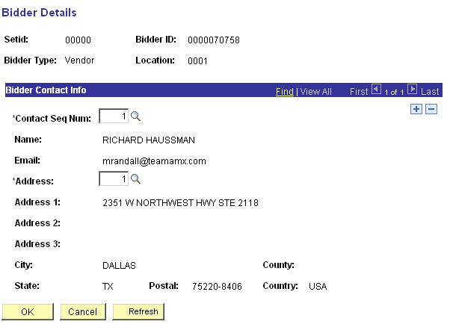

If necessary, change the Contact Sequence Number to the desired contact that contains the email address that you want automatic Event Notifications sent to.

Click to return to the Invite Bidders page.

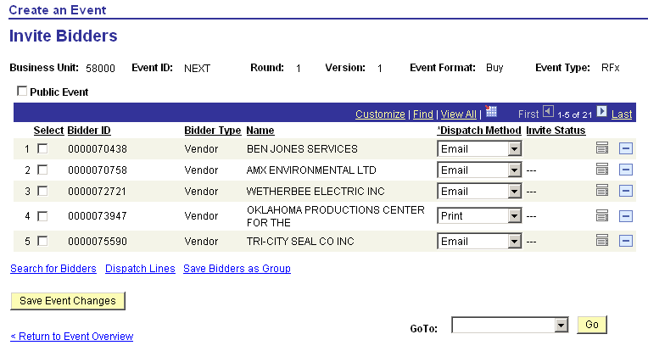

Once all Bidders (Vendors) have been invited to the Event and the Contact information (email addresses) are complete, select the < Return to Event Overview link to return to the Event Summary page.
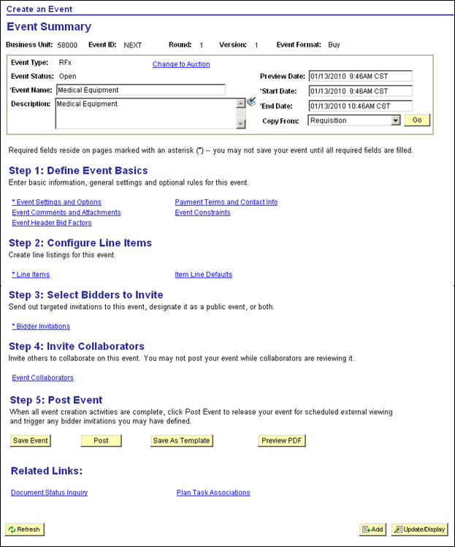

When all Event information is complete, click to save your work. If the Event is ready to Post, click . If not, posting can be done at a later time.

NOTE: If any vendor changes or communication need to happen before the email notifications go out – setup Vendor User ID’s, change Contact Email address, etc., do those before you Post the Event. Once you hit the POST button, all automatic email invitations will be sent to the Vendor Contact email addresses defined in the system at that time.

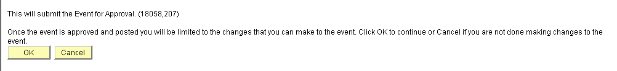

When the Post button is clicked, a warning message indicating the Event will be posted is displayed. Click to post the Event.

Create Vendor User ID’s

If any of the Vendors that have been invited to a Strategic Sourcing Event do not have a User ID and Password to the system, they will not be able to log into the system and respond to solicitation opportunities. The following steps describe that setup.

Navigation: Vendors > Vendor Information > Add/Update > Define Vendor User > Add a New Value

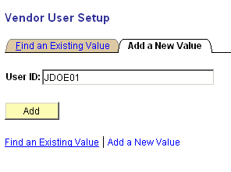

User ID – populate with the individual in the Vendor organization that will be logging into the system to respond to Events. This will be First Initial of First Name, followed by Last Name For example John Doe would be assigned a User ID of JDOE. If the User ID already exists, use a numeric suffix to differentiate from the existing user id. For John Doe this could be JDOE01.

NOTE: Before the Vendor User ID’s can be setup, an email to the vendor should be sent asking the Vendor to identify by name their users that will be logging into the system to respond to solicitation opportunities. These users will also be able to see PO, Receiving and Payment information in the system.

NOTE: Once Vendor User ID’s have been configured, the User ID and Password will need to be emailed back to the Vendor.

Click to enter the Vendor User page.

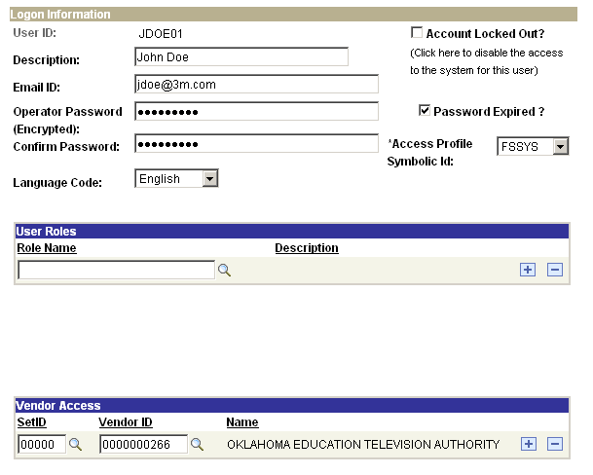

Description – add the Vendor User Name.

Email – email address of the Vendor User.

NOTE: Automatic Email correspondence from the Sourcing Event does not go to this email address, but rather the Contact Email address defined on the Event.

Password – password should be UPPER CASE with a numeric value on the end. Passwords must be eight (8) characters in length.

Access Profile Symbolic ID – FSSYS

Role Name – populate with the correct roles for the Vendor User access. Both roles available in the prompt list should be selected. These are:
- All Non EE’s State of OK
- Registered Vendor_OK

SetID – 0000

Vendor ID – populate with the Vendor ID for this User.

Click when the Vendor User has been defined.

Update Vendor (optional)

Under the current system the Automatic Email notifications are sent to the Vendor Contact that is Sequence Number 1. At the time of this manual, the option to change the Vendor Contact Sequence to which the automatic email notification is being sent is not available in the Sourcing Event. Therefore, it may be necessary to visit the Vendor file to make the Vendor Contact Sequence Number 1, contain the email address to which you want automatic email notification sent.

Navigation: Vendors > Vendor Information > Add/Update > Vendor > Find an Existing Value

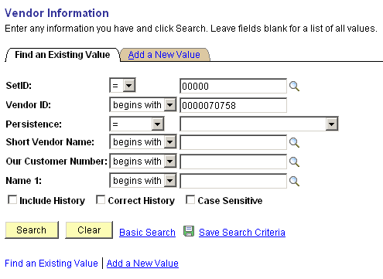

Vendor ID – populate with the Vendor ID that requires a Vendor Contact update.

Click to pull up the vendor.
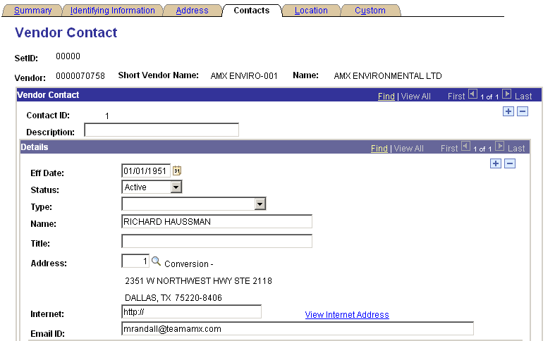

On the Contacts Tab, verify that the Email ID is the correct email address to which automatic Event Notification should be sent for this vendor. If this value is not correct, use the button to insert a new Effective Dated row for the new email value.

When your work is completed, click to save the new Contact Email Address.

Bid on Behalf of Vendor

When Vendors do not submit bids electronically but do respond thru paper, those bids can be added to the system by the buyer.

Navigation: Sourcing > Create Events > Event Responses > Create Bidder Response

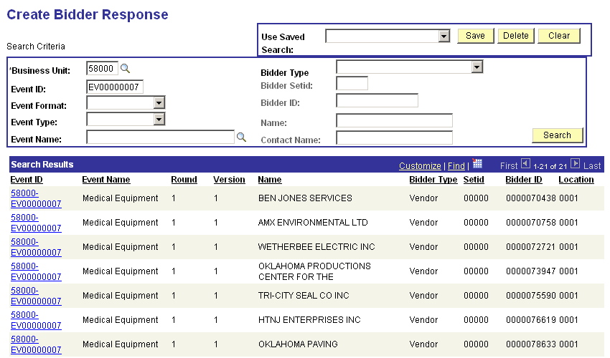

Use the Search Criteria to retrieve the Event on which you would like to submit a response on behalf of the Vendor.

Event ID - click the Event ID link next to the Vendor you would like to respond for.
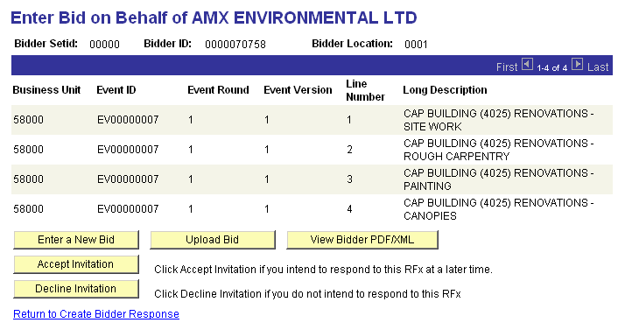

Click to enter the pages for bid responses.

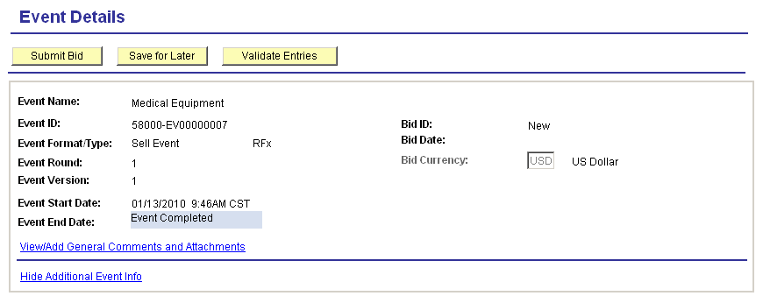

The Event Details page holds all the Event information necessary to bid on behalf of the Vendor. Scroll further down in the page to answer Event Questions and enter the Bid Response.

NOTE: This page is identical in functionality to the page that the Vendors see on the Supplier Portal when they are responding electronically.

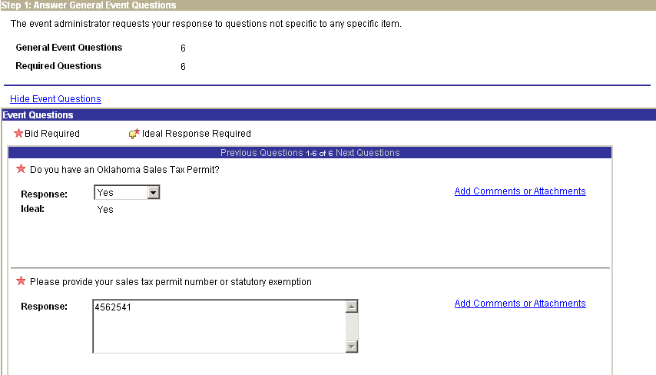

The middle section of the page (Step 1: Answer General Event Questions) allows the buyer to respond on behalf of the Vendor for general questions. Respond to the Event Questions on behalf of the bidder.

NOTE: A response is required for all Event Questions.

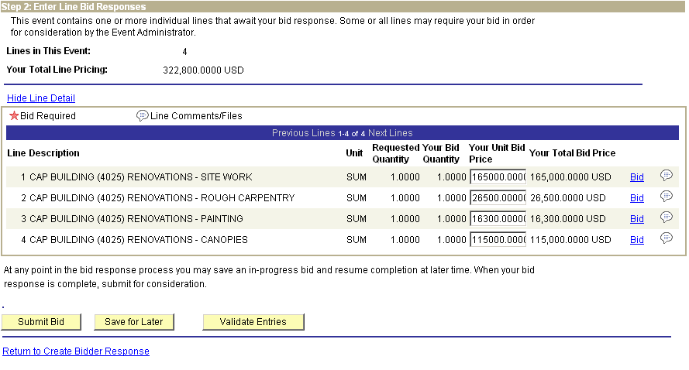

The bottom section of the page (Step 2 Enter Line Bid Responses) allows the buyer to enter bid responses to all Event Lines on behalf of the Vendor.

Alternatively, use the Bid link to see more detail about the Event Lines.

Use the button to view Line comments and file attachments.

When all responses are entered for desired lines, click to validate that the information entered passes system edits.

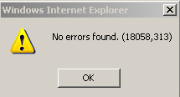

If no errors are found, you will receive this message. If errors are found, follow the instructions on correcting the errors and re-validate the entries.

When all Event Questions have been answered and all Event Lines populated with the desired bid response amounts, click to submit this Bid Response.
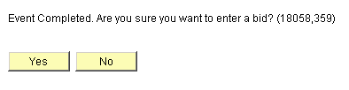

Click , if you are finished with the Bid Response.

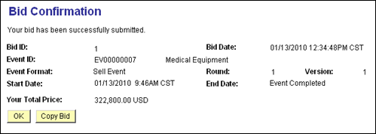

Once the Bid has been submitted the Bid Confirmation page will provide details of the bid including time, Round, Version and Total Price.

Click .

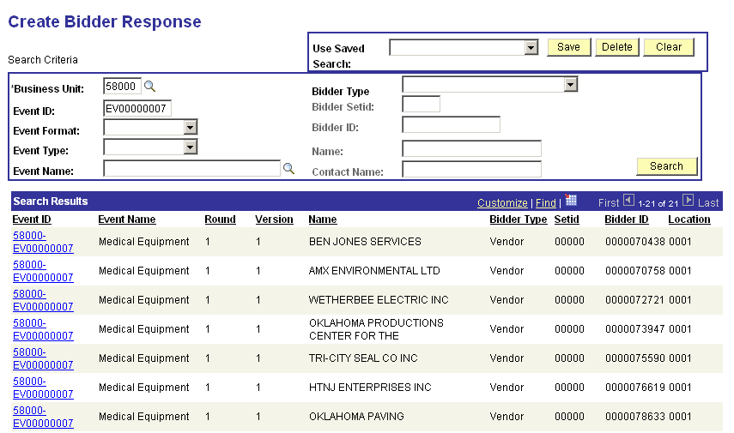

The Create Bidder Response page will appear for the next response to be entered.

NOTE: When bidding “On Behalf” of a bidder for a new Version (Amendment) and a bid has already been entered, the buyer must simply confirm or re-submit the bid that is copied to the new Version. See New Version section in this manual.

Analyze and Award Bid Responses

Bid Analysis is the process of viewing supplier responses, analyzing and awarding the Event. Award can be done to Purchase Order or Contract.

Navigation: Sourcing > Maintain Events > Event Workbench

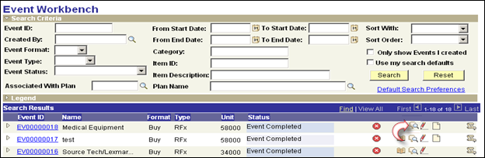

Select the Analyze Bids icon from the Workbench.

OR

Navigation: Sourcing > Maintain Events > Analyze Events > Find an Existing Value

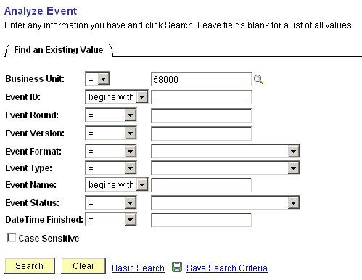

Use the Search Criteria to find the desired Event to analyze.

Click to retrieve the Event.
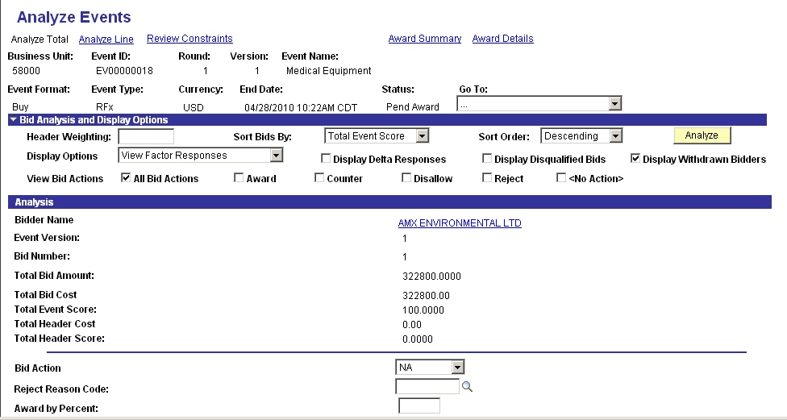

Use the Analyze Events – Total page to view each suppliers bid response and award the entire event to a single supplier.

Sort Bids By – sort the supplier bids by Score, Amount or Name.

Sort Order – use this sort option to view results in ascending or descending order.

View Bid Action – determine which types of Bid Responses to view.

Total Bid Amount – this field displays the sum of all Event Line response amounts.

Bid Action – to award the entire Event (all Event Lines) to a supplier, select the Award action.

NOTE: The user may Disallow, Reject or Counter the Bid. A Counter action will initiate a new Round for the Event.

Award by Percent – to award the entire Event to a single supplier use ‘100’ percent.

Factors – view supplier Event Header responses to Bid Factor questions.

Click the Analyze Line link to award by the Line.
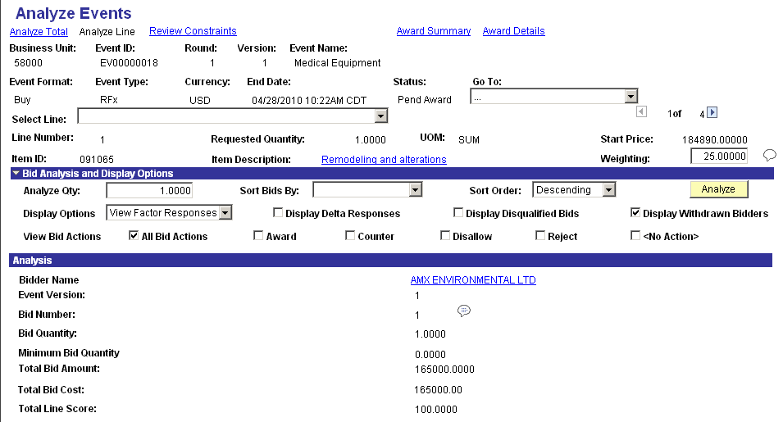

Use the Analyze Events – Line page to award events by Line.

Use the line scroll arrows to view all Lines on the Event.

Sort Bids By – sort the supplier bids by Line Score, Line Amount or Name.

Sort Order – use this sort option to view results in ascending or descending order.

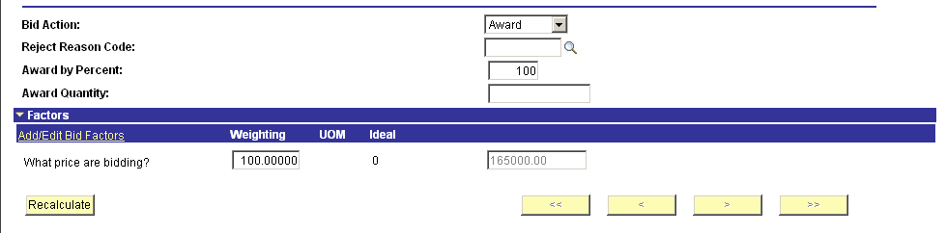

To Award by Line, use the Bid Action option and either the ‘Award by Percent’ or ‘Award by Quantity’ options.

NOTE: Event lines may be split awarded to multiple vendors by Line.

When multiple supplier bid responses exist use the chunking arrows, located in the lower right of the screen, to scroll thru all responses.

Factors - view supplier Line Responses to Bid Factor questions.

Using the drop-down menu, select Analyze Export to print and email a Bid Tab worksheet.

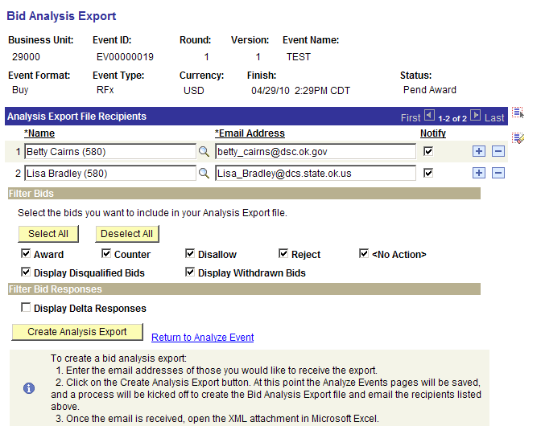

Use the Bid Analysis Export page to define who will receive the email containing the Bid Export package.

Name – select from a pre-defined list of Names or key a new name into this field.

Email Address – if the name selected is a pre-defined name in the system, the email will default into this field. Otherwise, key the email address into this field.

Filter Bids – alternatively, select which types of bids will be displayed on the Bid Export package.

Click to execute a batch process that will create the Bid Export package and email the results to the users listed.

NOTE: The three (3) steps at the bottom of the page MUST be followed for the email attachment (Bid Export package) to be viewed properly.

Click the Return to Analyze Events link.

Click the Award Summary link.

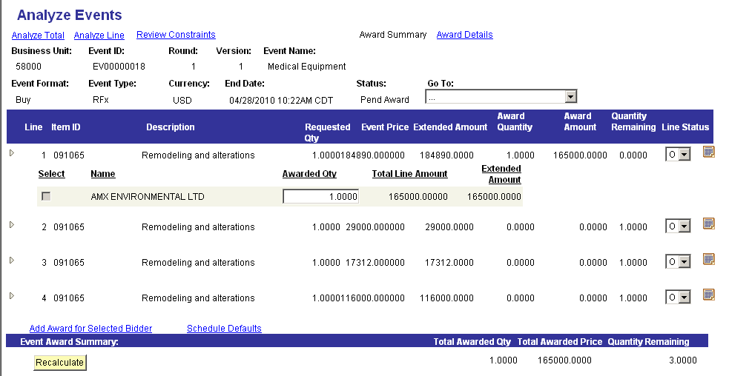

Use the Award Summary page to view all Event Lines and supplier award details.

Award Quantity – displays the quantity that has been awarded the supplier for each line.

Total Line Amount – displays the amount awarded by line.

Use the Line Status icon to view shipping information that will be used on the Purchase Order.

Use the Schedule Defaults link to view schedule information that will be populated on the Purchase Order.

NOTE: No updates or edits are required on the Award Summary page. However, this page provides a summary of the award.

NOTE: For the Department of Central Services buyers creating Events WITHOUT a Requisition for an agency, the agency Ship To value must be populated using the Schedule Defaults page.

Click the Award Details link.

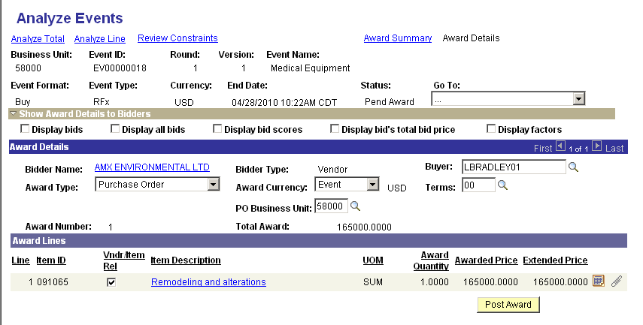

Use the Analyze Events – Details page to award to the selected suppliers.

Award Type – select to award to ‘Purchase Order’ or ‘PO Contract’

Buyer – define the buyer that will be used on the award (PO or Contract). This value will default from the Event.

Terms – optionally define the terms for the PO.

PO Business Unit – define the agency business unit.

Click to save the Award information before Posting the Event.

Click to award the Event to PO or Contract.

Create a Bidder

The Bidder Registration process is a multi-step process that a potential supplier would initiate to be registered to do business with the State. A Bidder is a new supplier that has not yet been awarded a PO or Contract by the state but is registering to be notified of such solicitation opportunities.

A Supplier that is registering may define multiple Users during the registration process.

NOTE: The terms Bidder and Supplier will be used interchangeably in this section.

The Bidder Registration process is done thru the SUPPLIER Portal. The URL is:

https://corefp.ok.gov/psp/mrfsi/SUPPLIER/ERP/?cmd=logout

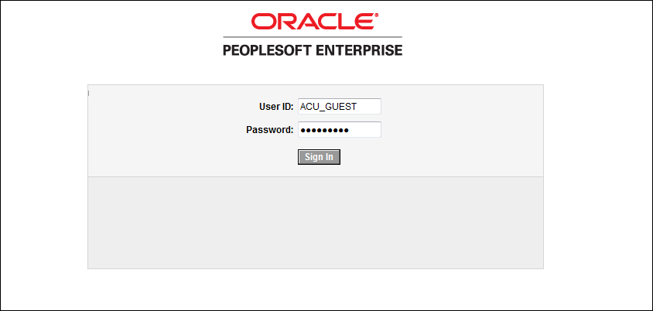

To create a new Bidder a user must log in using the Bidder Registration User ID. This example uses the delivered User ID of AUC_GUEST.

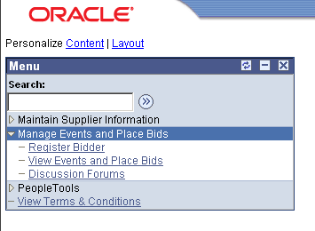

Navigate to the Register Bidder menu.

Navigation: Manage Events and Place Bids > Register Bidder

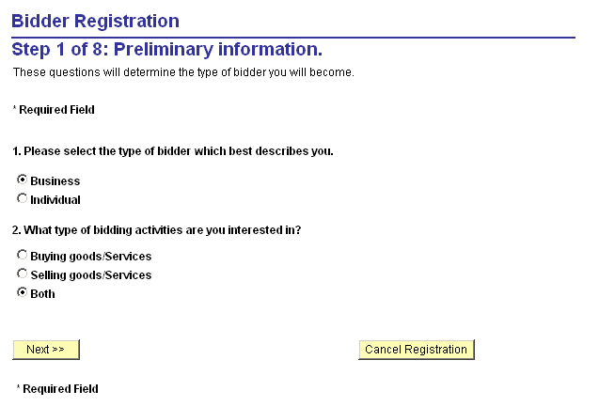

Indicate whether the Bidder is a Business or Individual.

Select whether the Bidder will Buy, Sell or Both when doing business with the State.

Click to continue the Bidder Registration process.

Click to cancel the Bidder Registration process at any time.
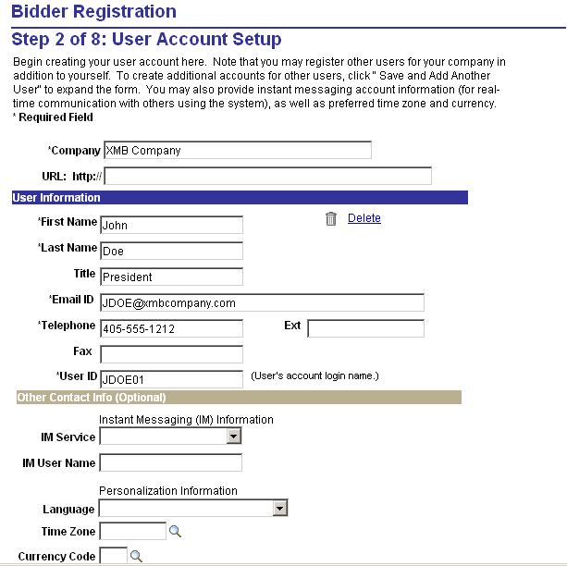

Company – populate the Company name for the Bidder.

User Information – provide Name, Title, Email and Telephone information.

User ID – this will be the system assigned User ID for the Bidder.

Click to continue the Bidder Registration process.

Click to create another User for this Supplier.
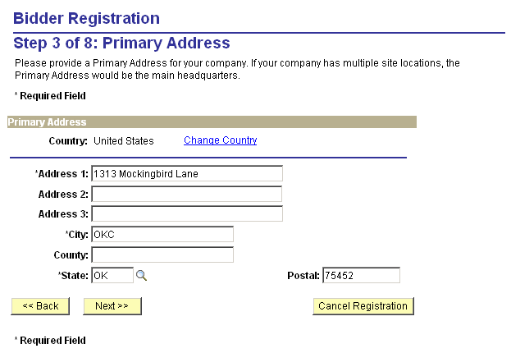

Primary Address – populate the Address of the Supplier.

Click to continue the Bidder Registration process.
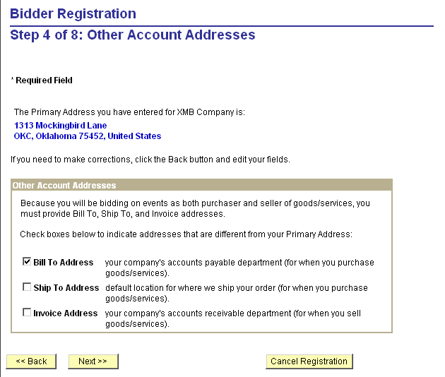

Other Account Addresses – if the Primary address defined in the previous step is not the Bill To, Ship To or Invoicing Address for the supplier, select to change one of these to a different address.

Click to continue the Bidder Registration process.
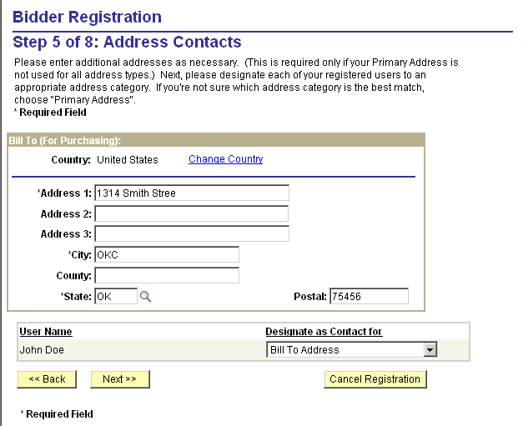

If the supplier has indicated that the Bill To, Ship To or Invoicing Address is different than the Primary Address, they will be able to define that different address here.

User Name – link one of the defined User ID’s to this new Address value.

Click to continue the Bidder Registration process.
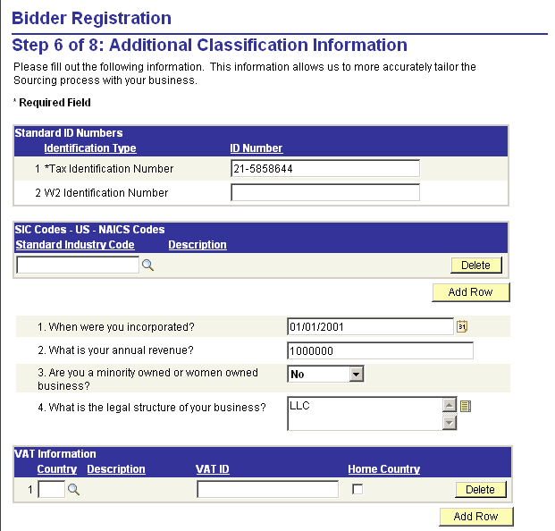

Answer the Bidder Registration Questions that identify the Supplier and indicate the type of Business that the supplier has.

Click to continue the Bidder Registration process.
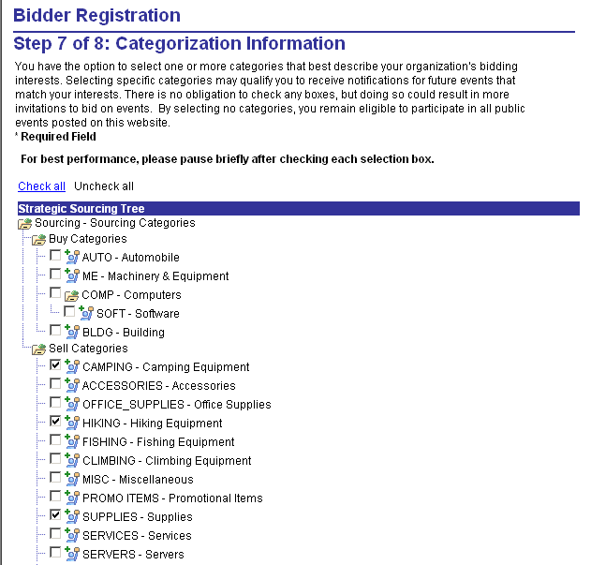

Populate the Bidder Self Categorization Tree that indicated which commodities the Supplier will Buy or Sell when transacting with the State. The commodities selected here will be user to invite the Supplier to solicitation opportunities.

NOTE: Sell/Buy Category values are from the Supplier perspective. For example, if the Supplier sells Farming Tools, that commodity code would be selected under the ‘Sell Categories’ on this tree.

Click to continue the Bidder Registration process.
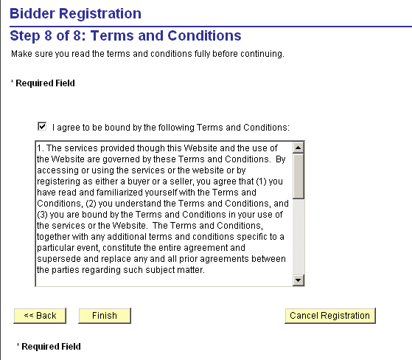

The Bidder must agree to the Terms and Conditions of the Registration Process.

Click to complete the registration process.

NOTE: The Users defined for the Bidder will receive an email indicating User ID and password for access to the system.

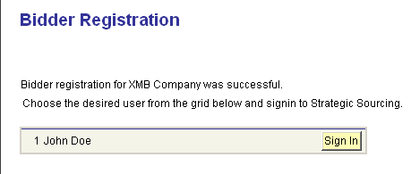

The Bidder that has registered will have an opportunity to log into the system immediately if the Bidder Registration is not subject to approval.

NOTE: The Users defined for the Bidder will receive an email indicating User ID and password for access to the system.

Creating New Rounds (Counters)

Create new Rounds for RFx events to negotiate with bidders after initial bids are received. This is useful when either substantive change to the event (requiring additional input from the bidders) are made or when you evaluate and narrow bids to a select group for further negotiation.

You can select to counter one or more bidders for the overall event or for individual lines. The system creates the new Round by copying the previous Round/Version. Countered bidders are the only invited bidders for the new round. Only countered lines are included in the new round. You can add additional bidders if necessary.

The new round is posted out to the invited bidders. The bidders receive a new invitation along with a new counter PDF version of the event. When a bidder bids on the new round, the bidder can view his or her initial bid and the countered offer.

Navigation: Sourcing > Maintain Events > Event Workbench

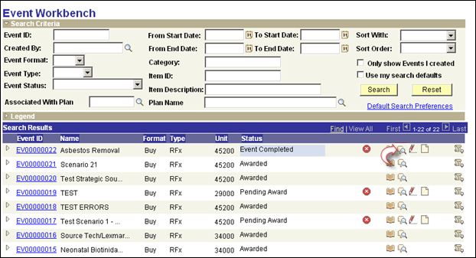

Select the Analyze Bids icon from the Workbench. The Analyze Bids page allows the user to counter the bids to create a new Round.

NOTE: New Rounds can only be created for Events in Pending Award or Event Completed status.

OR
Navigation: Sourcing > Maintain Events > Analyze Events > Find an Existing Value

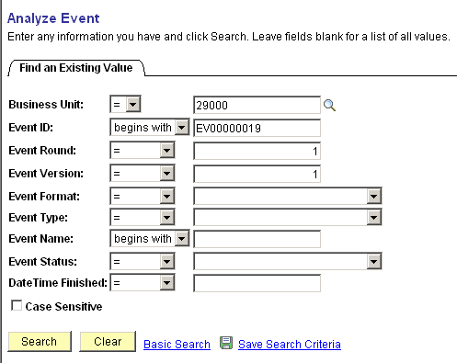

Use the Search Criteria to find the desired Event to Counter.

Click to retrieve the Event.
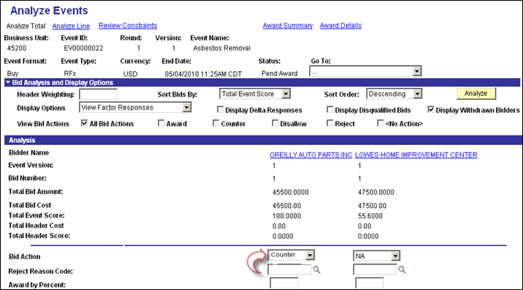

Bid Action – select the bid action of ‘Counter’ to counter a particular bidder.

NOTE: If you want to counter all lines on an Event, you select the Counter action on the Analyze Total page (displayed) for the selected bidders. If you want to counter only selected lines from the event, select the Counter action on the Analyze Lines page for the selected lines and bidders.

Go To – select 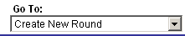 from the drop down menu.

NOTE: All the details from the previous Round are copied into the new Round.

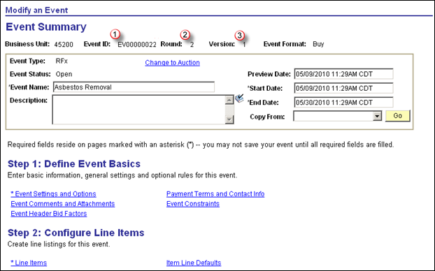

The new Event Round will be displayed.

Event ID – the new Round will have the same Event ID as the previous.

Round – the Round number will be incremented by 1.

Version – this new round will have Version number 1 initially.

NOTE: New Rounds can have subsequent Versions in which case the Version number can also increment from the original Version 1.

NOTE: Normal Bidder Invitation, Bids and related actions can be take on the new Round.

Creating New Versions (Amendments)

Create new Versions for Events when you need to make changes to a posted event. Once a new version is created, you can't delete lines or bid factors because bids to the previous version would include those lines and bid factors.

You can create and edit Versions of multi-version events. When viewing a multi-version event in the Event Workbench component, the system displays the most recent version of the event. The new version of the event must be Posted to be available for bidding.

When a new Version of an Event is created:

- Thy system will create a new Version of the event.
- The system Increments the Version number by one.
- The previous current Version of the event becomes read-only upon posting the new version, and additional changes to that version cannot be made.
- The user cannot add or delete line items, change bid factors, or change the start price or line quantity for a new version.
- If any scoring-related changes are required, you must create a new round.

Navigation: Sourcing > Maintain Events > Event Workbench

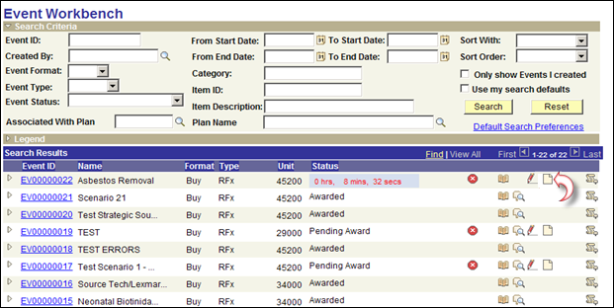

Select Create New Version icon from the Workbench.

NOTE: New Versions can be created either before or after the Event End date.

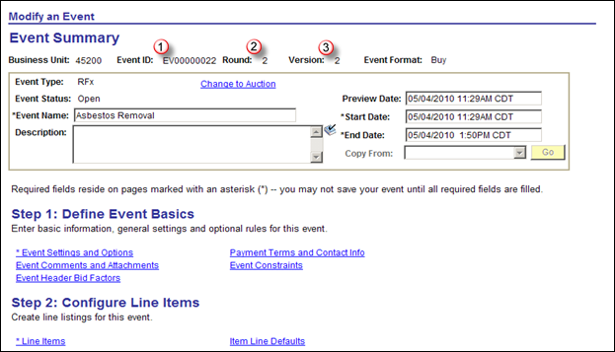

The New Version of the Event will use the same Event ID number but increase the Version count.

Event ID – this is same as the previous version.

Round – for Version changes only think number remains the same.

Version – the Version number will be incremented by one for the new version.

Description – for new Versions, the buyer may want to indicate in this field the reason for the Amendment. This field is visible at the top of the bidder email and Event Package.

End Date – to extend the Event End Date to accommodate amendment requirements, change this field as would be done with a new Event.

Use the Event Comments and Attachments link to add any amendment attachments that are required.

NOTE: The new Versions will have the same invited bidders as the previous version. If those bidders have submitted a bid previously, they will need to “Confirm” that their previous bid is ok for the new version. An email will indicate this requirement to the bidder.

NOTE: When bidding “On Behalf” of a bidder, the buyer will also need to “Confirm” that the bid entered before the new Version was created, is still ok for the new version. This is done by retrieving (use icon on the Enter Bid on Behalf pages_ the previous bid and resubmitting the bid that is copied to the new version.

NOTE: The new Version can be edited, saved and re-posted just as a new Event.

Click the Event Header Bid Factors link.

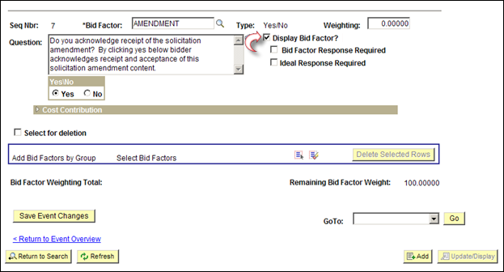

For new Versions, a special Amendment Header Bid Factor question has been created to verify that the bidder has indeed read and accepted the terms of the new Version (amendment).

Display Bid Factor – select this checkbox for the special Amendment question to display this question to the bidder when they enter for the first time or confirm a previously entered bid for this Event. The bidder must answer ‘Yes’ to this question for their bid to be accepted.

Click the < Return to Event Overview link.
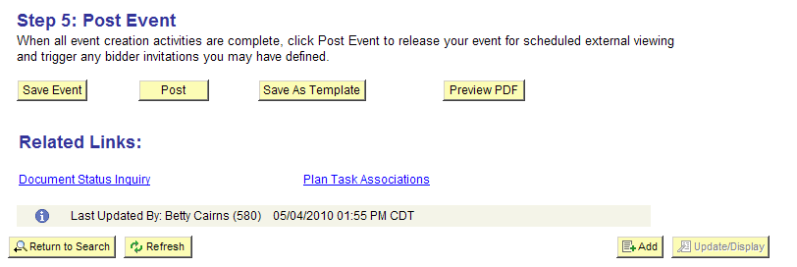

Save, Edit or Post the Event as would be done with a first time Event.

NOTE: New Version should be used to make the following changes:
- Additional information that needs to be communicated to bidders (questions, etc.).
- Any Event Line changes such as Item or Quantity.
- Event Name
- Extension of Event End Date/Time
- Payment and Currency Information (For PO Award)

Event Workbench and History Review
The Event Workbench is an area that buyers can use to manage Events thru their lifecycle. The Event Workbench can be used to access Event Details, view Event Lines, create new Versions, Cancel an Event or research History of an Event.

From the Event Workbench the user can navigate to other pages to do Analyze Events, Edit Events or see Bid Response history.

Navigation: Sourcing > Maintain Events > Event Workbench

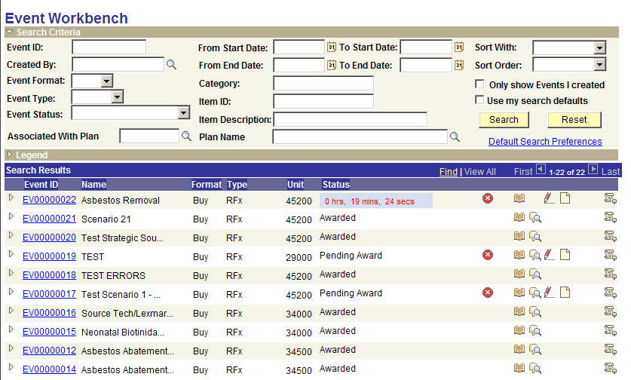

Use the Search Criteria section of the page to retrieve only desired Events.
- Create By – use this field to display only those Event created by a particular User.
- Event Format/Type – display only those Events that are of a particular format or type.
- Event Status – select only Events in a particular event status.
- Category/Item ID – display only those Events who’s Event Lines contain a particular purchasing Category or Item.

Only show Events I created – select this checkbox to view only Events created by the user.

Click to retrieve Events matching the Search Criteria.

Click the Default Search Preferences link.
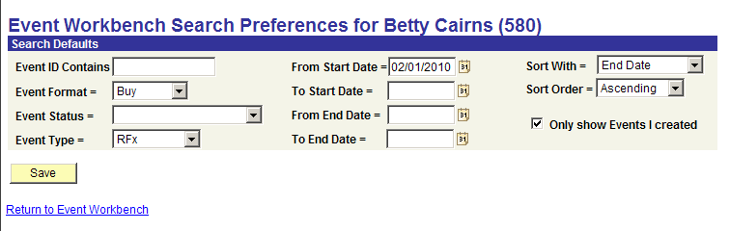

Use the Search Preferences page to set default search criteria that will be used each time the user enters the Workbench.

Sort With – select how the Events will be sorted.

Sort Order – select the order in which the Events will be sorted based on the ‘Sort With’ field.

Only Show Events I Created – select this checkbox to view only those Events created by the User each time the Workbench is used.

Click to store the Search Default values.

Click the Return to Event Workbench link.

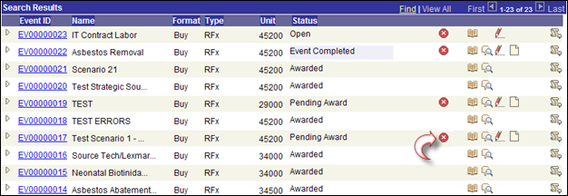

Use the Cancel Event icon to cancel an Event.

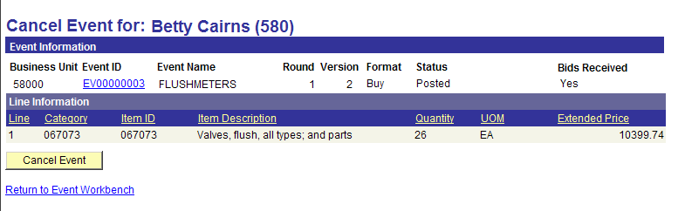

To confirm the Event Cancelation click .

Click the Return to Event Workbench link to stop the Event Cancelation.

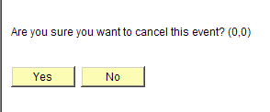

The user will be prompted to verify the Cancel.
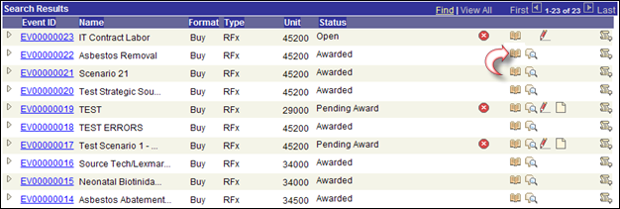

Use the Event History icon to view history for an Event.

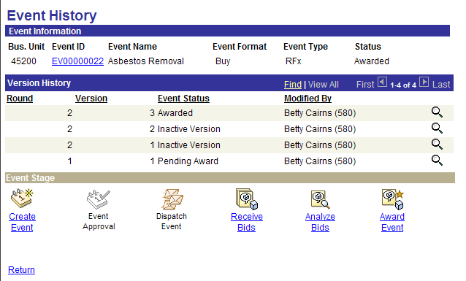

The Event History page shows the history of the Event as it has progressed through the Event Lifecycle.

Version History – this section of the page shows the ‘Round’ and ‘Version’ history for an Event.

Use the icon to navigate directly to a particular Round or Version of the Event.

Event Stage – this section of the page allows the user to navigate directly to the Event, Bid Responses or Award Transaction (PO or Contract).

Click the Return link to go back to the Workbench.
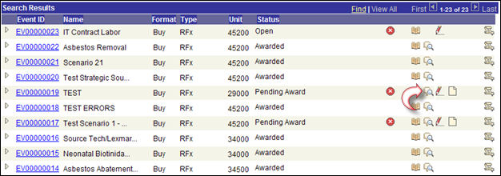

Use the Analyze Bids icon to transfer to the Analyze Bids pages to evaluate and award an Event.

NOTE: The Analyze Bids page allows the user to view bid responses, bid questions, comments, etc. The Event is awarded from these pages as well.

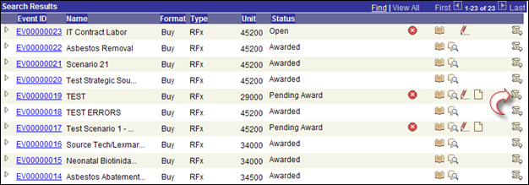

Use the Bid History icon to view bid response history by Event.
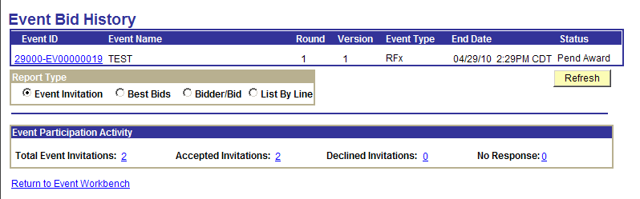

The Event Bid History page displays Event bid history and related reporting.

Report Type – define the type of display that will be visible at the bottom of the page.

Event Participation Activity – displays the invited bidders, bidders who have accepted, declined or not responded.

Use to retrieve new results based on selection criteria.

Click Best Bids radio button.

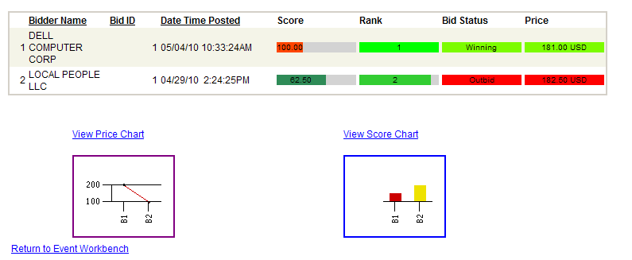

The Best Bids option shows the bid results by in chart format by Price and Score.

The List by Line option shows each bid response by Event Line.

Click Return to Event Workbench link.

