COR151 Receiving Manual

Authorized by: [_EBS_] Original Issue: [05/01/2014]
Maintained by: [____Purchasing Lead___] Current Version: [07/21/2015]
Review Date: [07/01/2016]

Table of Contents

Document History 5
Receiving Overview 6
Procure To Pay Process 6
Receiving with a Purchase Order 8
Step 1 – Select PO to Receive Against 8
Select Purchase Order Page 9
Selected Rows Tab 10
Step 2 – Receive Shipment Quantities 11
Maintain Receipts – Receiving Page 11
Receipt Lines Tab 13
More Details Tab 14
Links and Status Tab 15
Optional Input Tab 17
Step 3 – Receive “Amount Only” PO 18
Source Information Tab 18
Receipt Lines Tab 19
Step 4 – Reject Items in a Shipment 20
More Details Tab 21
Receipt Lines Tab 22
Asset Receiving 23
Step 1 – Select PO to Receive Against 23
Select Purchase Order Page 24
Step 2 - Receive Asset Shipment 26
Step 3A – Scenario #1 – Single Funded Assets 27
Distribution Information 27
Asset Information Tab 28
Apply to Details 29
More Details Tab 31
Interface Receipt 33
Step 3B – Scenario #2 – Split Funded Asset 34
Maintain Receipts 35
Distribution Information 36
Asset Information Tab 39
More Details 43
Physical Transaction A Page in Asset Management 45
Step 4 – Review Receipt after the Receiver Interface Push 46
Canceling Receipts 48
Receiving Page 49
Reviewing Receipt Information 51
Receipts Tab 52
More Line Data Tab 53
Receiving an Inventory Item by PO Number 54
Step 1 – Select PO to Receive Against 54
Select Purchase Order Page 55
Selected Rows Tab 56
Step 2 – Receive Shipment Quantities 59
Maintain Receipts – Receiving Page 59
Receipts Lines Tab 60
Step 3 – Inventory Putaway 63
Putaway Information Tab 63
Putaway Location Tab 65
Step 4 – Interface Receipt 67
Step 5 – Review Transaction History 68

Document History
Document Revision | Date | Description
1.0 | 11/01/2003 | Initial Document
1.1 | 08/30/2007 | Updated
1.2 | 08/01/2008 | ADA Compliance
1.3  2.0  2.1 | 01/10/2011  05/01/2014  07/21/2015 | Assets and Inventory Added  Upgrade Update  Updated

Receiving Overview
The PeopleSoft Purchasing Receiving business process enables you to receive, inspect, return and put away goods. Receiving rules are defined in the business processes leading up to actual receipt. These processes include creating requisitions and purchase orders as illustrated in the simplified diagram of the procure-to-pay process.

Procure To Pay Process
Purchasing Supplier Receiving Payables

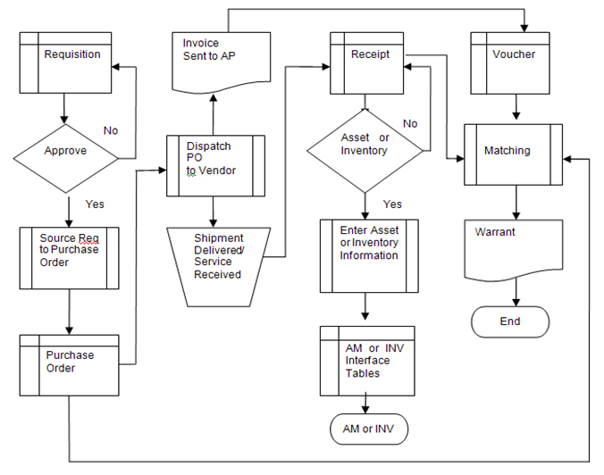
Procure-to-Pay

Begin

Purchasing creates a requisition.
If the requisition is not approved, no further action.
If approved, the requisition is sourced to a purchase order.
The purchase order is dispatched to the supplier.
The supplier delivers the product or executes the service and sends an invoice.
The receiver creates a receipt for the product received or service executed.
If the receipt is an asset or inventory item, information is entered on the receipt and the data is integrated to the Asset or Inventory modules.
The payer creates a voucher to pay the invoice.
The matching process is run to ensure the PO, receipt, and voucher match.
A warrant is created to pay the supplier.

End

When services are executed or goods purchased arrive at the receiving locations, receive them using the PeopleSoft Purchasing Receiving component. Use the online Receiving page to receive, accept, and reject shipment quantities. You can receive full or partial shipments.

Receiving with a Purchase Order
The PeopleSoft system enables receipts to be created for items or services received from Suppliers. It is the preferred method to acknowledge acceptance of goods or services and a good way to create documentation that is accessible online. One (full) or many (partial) receipts can be used to record shipments for a single PO. Receiving can be performed against a PO once it has been dispatched.

Step 1 – Select PO to Receive Against
To retrieve a PO for receiving shipments, use the following navigation:

Navigation: Purchasing > Receipts > Add/Update Receipts

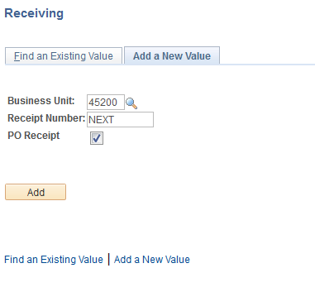

Add a New Value Tab will default.

Business Unit – Defaults to specific agency for each User.

Receipt Number – Defaults to NEXT. DO NOT CHANGE. The system will auto number each receipt.

PO Receipt – Leave the PO Receipt option checked when creating a receipt from a PO.

Click to take you to the Select Purchase Order page.

Select Purchase Order Page
This page allows the User to define selection criteria for locating ordered items to be received.

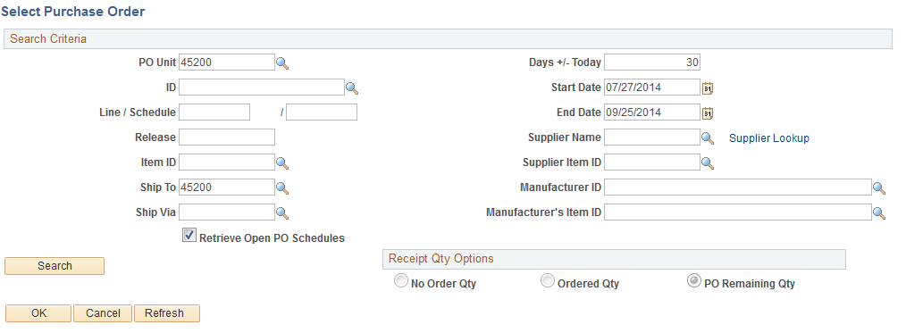

The PO Unit, Days +/-Today, Start and End Dates and Ship To will default into the page based on the defaults set for the User. (Please note that the PO Unit is required). The user can change the defaults and enter criteria into the remaining fields to narrow the search or leave the fields blank to list all of the purchase orders associated with the Business Unit available for receiving between the specified start and end dates.

PO ID – A specific PO ID can be entered if it is identified on the receiving documentation. If a Ship To value defaulted into the page, it must match the purchase order Ship To or the purchase order will not be retrieved. The Ship To can be changed or the field can be cleared.

Receipt Qty Options – The No Order Qty (no order quantity), Ordered Qty (ordered quantity), or PO Remaining Qty (purchase order remaining quantity) will be set based on the particular requirements of each State agency. The PO Remaining Qty is recommended, since it will display the PO remaining receipt quantity/amount. These options can be changed as long as the default is not blind receiving.

Click to display the PO schedules available to receive against. Receiving with a PO is done by schedule, so if a single Line has multiple schedules, each schedule will appear on the Select Purchase Order page.

Selected Rows Tab
Purchase order lines/schedules display based on the search criteria. The receiver will need to locate the PO lines in the search results that match the service or contents of the shipment.

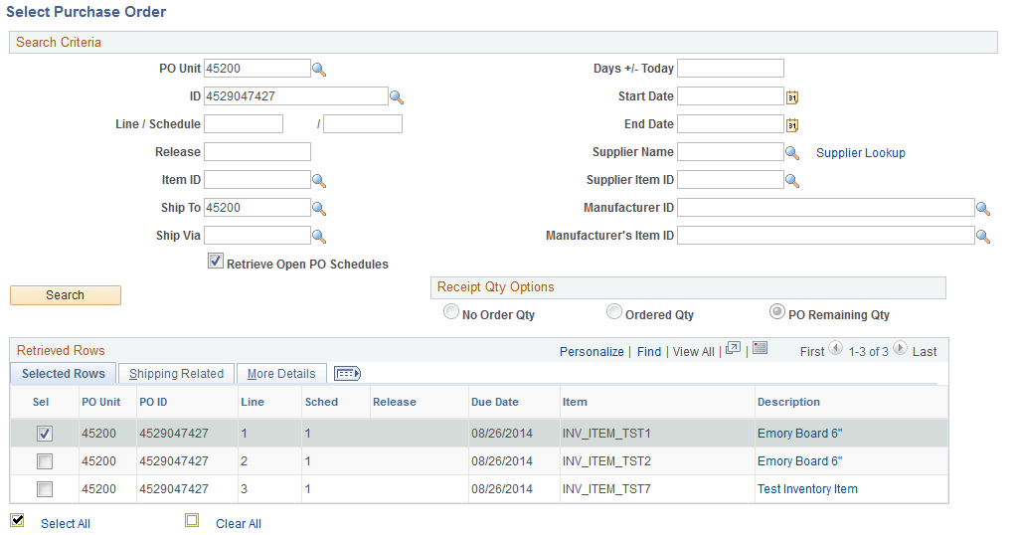

Sel – Select a check box to work with a particular line. Multiple schedules can be selected.

Due Date – Date which the shipment is due for this schedule.

Description – Description from the purchase order that receiver will use to match the PO lines to service or contents of shipment.

Click button (not shown, but placed in the lower left corner of the screen) will transfer you to the Receiving page.

Step 2 – Receive Shipment Quantities
Once you have selected the PO line(s) to receive, click to enter the Receiving Page.

Maintain Receipts – Receiving Page

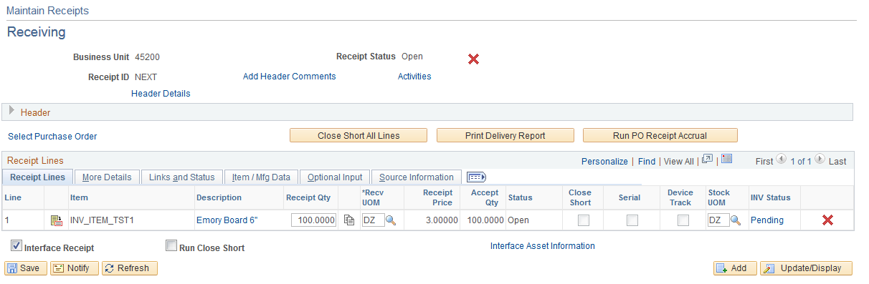

In the header information on the Receiving page, the following information is available.

Receipt Status – Displays the status of the receipt header. Values are:
O – Open
C – Closed
M – Moved to destination
R – Received
H – Hold
X – Canceled

- Cancels the entire receipt. This action cannot be reversed.

Header Details – Use to view and enter receipt header information including shipment information. This is the link that is used to access the Hold Receipts check box if a receipt needs to be held from further processing.

Add Header Comments – Use to add header level comments that will be associated with this receiver ID. Once the comments are added, the link will be displayed as Edit Comments. Click the link to add additional header level comments or to review existing ones.

Activities – Use this page to add or review activities associated with the receipt header.

Receipt Lines Tab
Receipt Qty – Edit the field to record the number of items received. In our example, the receipt quantity populated with the remaining quantity of 100 (see print screen on previous page) because the Receipt Qty Option was PO Remaining Qty. If the PO Remaining Qty exceeded 100 and only a partial amount was received, the received quantity would be changed to the actual quantity received.

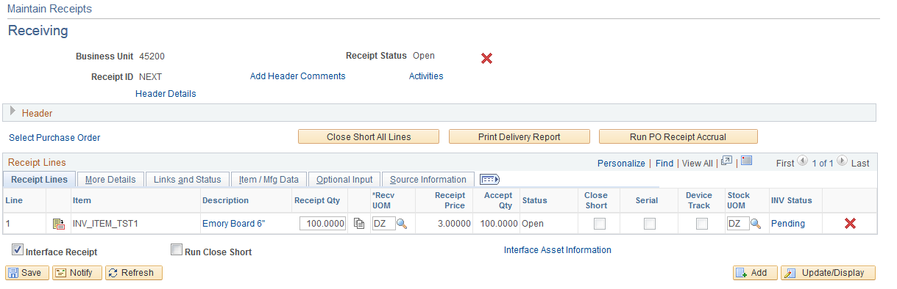

NOTE: The Receipt Qty field will be filled in with the PO scheduled quantity if Ordered Qty is the Receipt Qty option, and with the remaining scheduled quantity from the PO if PO Remaining Qty is the Receipt Qty option. When receiving a partial shipment, change the quantity to the amount received. The Receipt Qty will be blank if the agency’s default is blind receiving. Enter the amount you are actually receiving.

Accept Qty – The quantity of items accepted. This display field defaults as a calculated value (subtracts the rejected quantity from the receipt quantity). If received and accepted quantities exceed the quantity open for that schedule, the User will receive a warning message. Items may not be added to the receiving document if they do not already exist on the PO. These items must be added via change order.

Status – Displays the status of the receipt line. Initially, the status will be Open. Values are:
O – Open schedule
C – Closed schedule
R – Received schedule
H – Hold schedule
X – Canceled schedule

– View Details about the receipt including the Source PO information.

- Copy Quantity Down button to copy the Receipt Qty value on the selected line to all Receipt Qty fields below.

- Cancels the selected receipt line. This action cannot be reversed.

More Details Tab
The More Details Tab is used to record rejected quantities and provide reject reasons and codes. See Step 4 – Reject Items in a Shipment for additional information on rejecting delivered items.

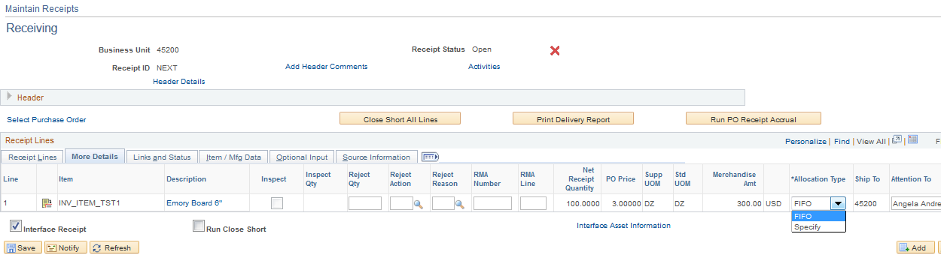

Allocation Type – The method selected is used when the receipt quantity is less than the quantity ordered. The allocation type determines the quantities and amounts that will populate the voucher distribution lines from the purchase order distribution lines when the receipt is copied to the voucher. The default is FIFO. Values are:

• FIFO (first-in-first-out) – Allocations to the distribution quantities are fulfilled based on the sequence in which they are added to the purchase order.
• Prorate – The receipt amount is prorated across the distributions for the schedule based on what percentage the receipt amount is to the total purchase order schedule’s distribution amount.
• Specify – The user will specify the quantity received for each distribution line.

The allocation type can be changed through the Links and Status Tab.

Ship To – Identifies the location to which the supplier delivered the product.

Links and Status Tab
The Links and Status Tab displays several statuses, allows receipt line comments to be added using the message icon. Distribution Line icon accesses the Receipts Distributions Line page where the Allocation Type can be changed.

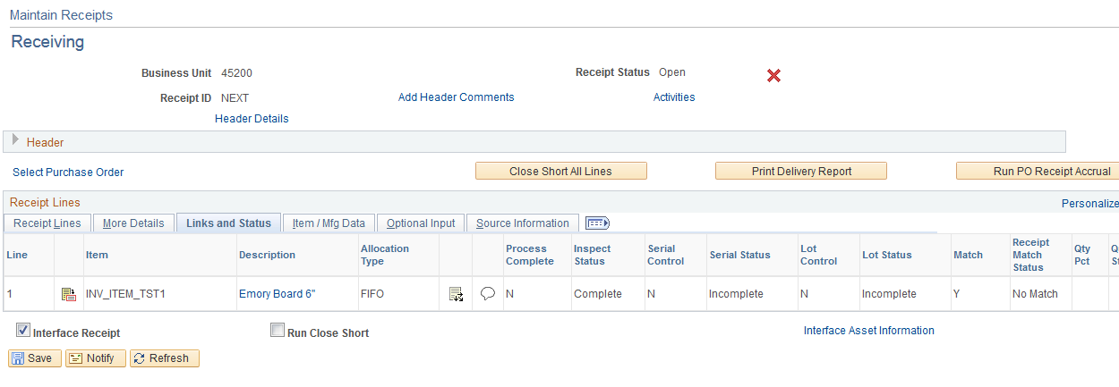

FIFO (first-in-first-out): Allocations to the receipt distributions are fulfilled based on the sequence in which they are added to the purchase order schedule. In the example, the first distribution line has not been totally fulfilled so the received quantity of 13 is allocated to distribution line 1. Only the quantity and amount from the first distribution line will have an amount and quantity populated in the voucher, but all subsequent purchase order distribution lines from this schedule will copy from the receipt to the voucher so the payer can correct the voucher if the expenditure should have been allocated using another allocation type.

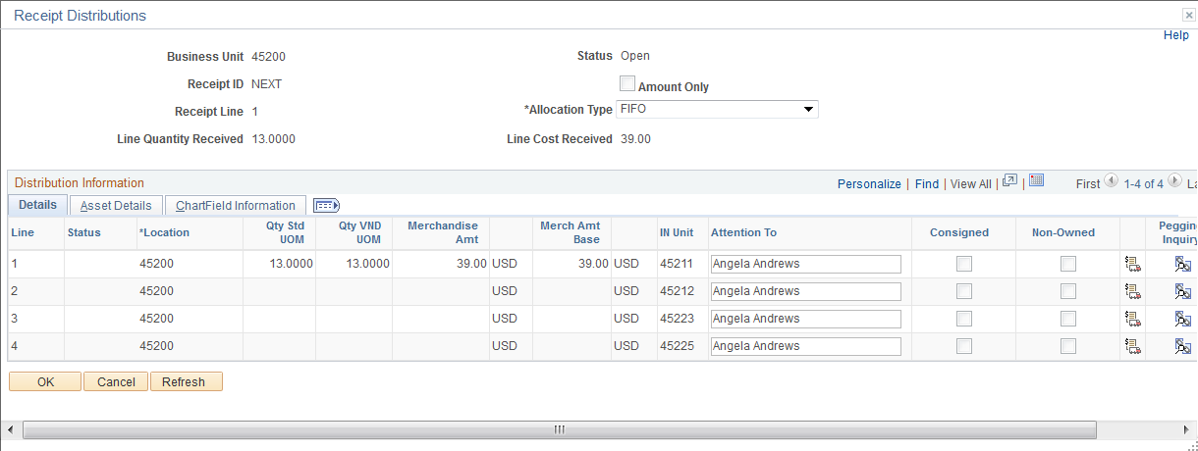
Prorate: Allocation to the receipt amount is across the distributions for the schedule based on what percentage the receipt amount is to the total purchase order schedule’s distribution amount. In the example, the expenditure has been allocated to all purchase order distribution lines for this schedule. These are the quantities and amounts that will copy from the receipt to the voucher.

Specify: The user will specify the quantity received for each distribution line. When this value is selected, the Qty Std UOM or the Amount field becomes available for entry, depending on whether the transaction line is received by quantity or amount.

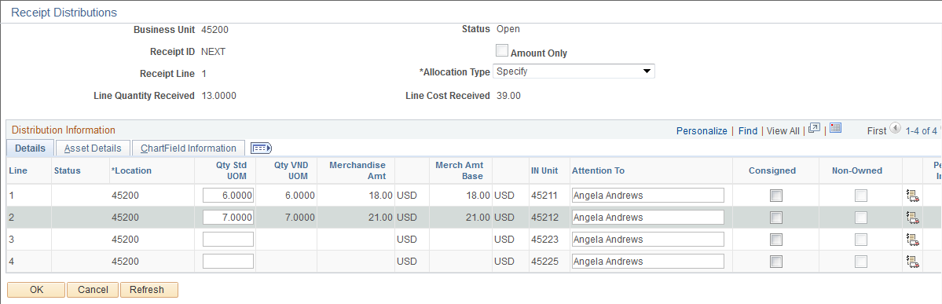
Optional Input Tab
The option to put a receipt line on hold is on the Optional Input Tab.

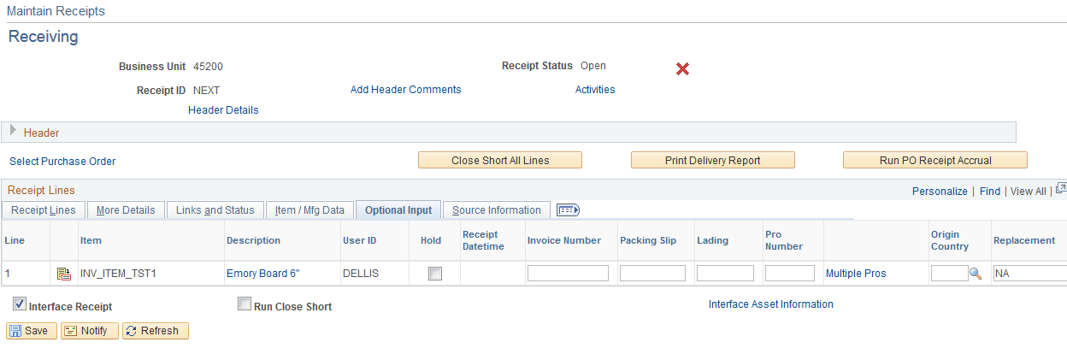

Once the information has been entered, click . Note the Receipt ID.

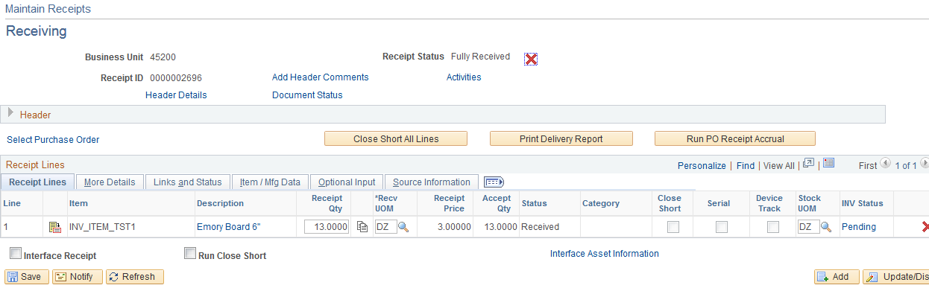

Step 3 – Receive “Amount Only” PO
In some cases, receipt quantities for goods or services may be difficult to calculate. Such items can be received by amount rather than quantity.

Source Information Tab
When the Amount Only check box is selected on the associated PO, the quantity field for the transaction is set to 1 and made unavailable for entry. The Source Information Tab for the purchase order schedule selected in the example illustrates that this PO is set to match by “Amount Only”. It also displays the purchase order amount.

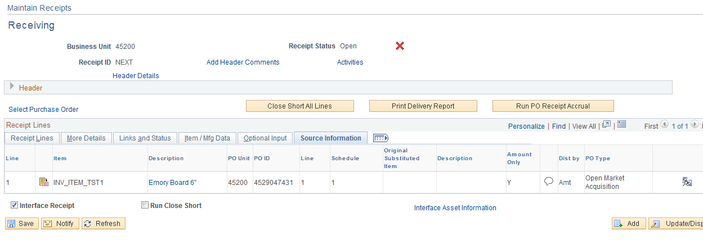
Receipt Lines Tab
Receipt Qty – Edit the Price field to record the amount received. For amount-only transaction lines, the open amount and prior received amount are calculated instead of the open quantity and prior received quantity. In our example, the receipt price is populated with the remaining dollar amount because the PO Remaining QTY option was selected on the Select Purchase Order page. If this is a partial receipt, change the received price to the actual dollar amount of the expenditure.

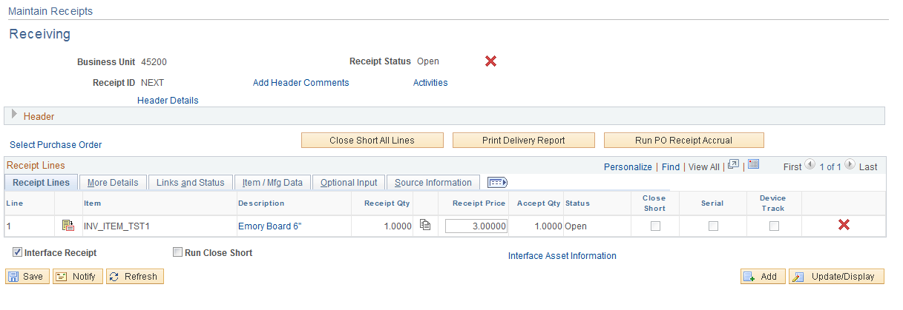

The steps to allocate the cost and create the receipt are the same as those explained in Step 2 – Receive Shipment Quantities.

NOTE: Amount Only transactions cannot be used for an inventory-related or an asset-related transaction.

Step 4 – Reject Items in a Shipment
If items in a shipment are damaged, shipped incorrectly, or refused, this information can be recorded on the More Details Tab of the Receiving page before the Receipt is saved.

Navigation: Purchasing>Receipts>Add/Update Receipts

In the example, receipt quantities are entered for the selected PO lines. All items, including reject items, are included in the Receipt Qty.

Note that the Receipt Qty and Accept Qty values are the same before the rejected items are recorded on the More Details Tab.

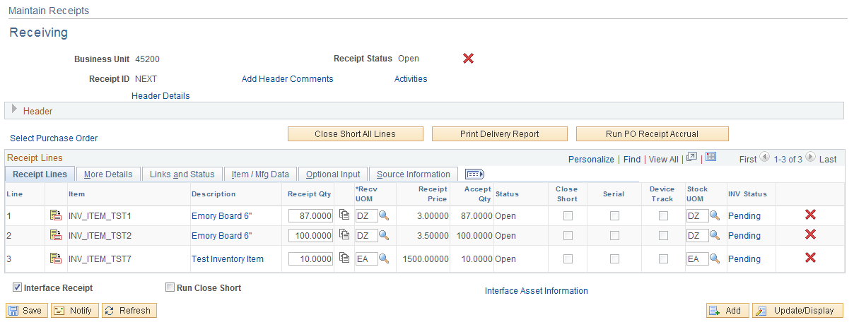

Click on the More Details Tab on the Receiving page.

More Details Tab
Use the More Details Tab to record rejected quantities and provide reject reasons and code.

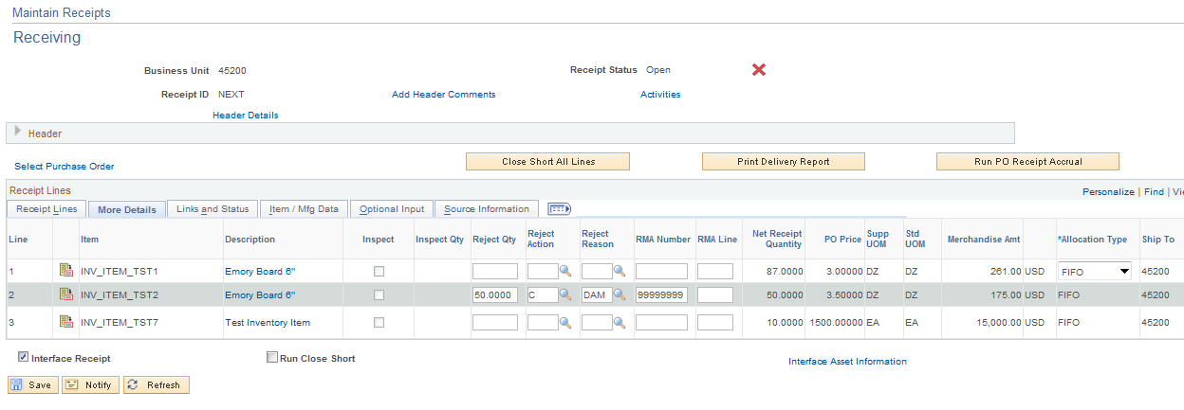

Reject Qty – Enter the quantity of items rejected.

Reject Action – Select the Action for the rejects.

Reject Reason – Select the reason for the rejection.

RMA Number – Enter the Return Merchandise Amount (RMA) number ID if provided by the supplier, otherwise leave blank.

RMA Line – Enter the RMA line number if provided by the supplier, otherwise leave blank.

Net Receipt Quantity - Displays the net number of items received (Actual quantity received minus the quantity rejected).

Click .

Receipt Lines Tab
Note where the Receipt and Accept Qty’s differ. This display field defaults as a calculated value (subtracts the rejected quantity from the receipt quantity). Only Accept Qty’s will copy from the receipt onto the voucher.

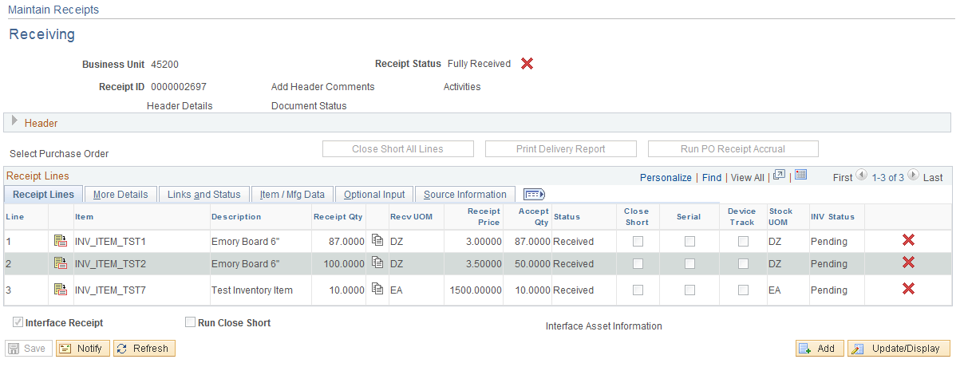

Asset Receiving
If a Purchase Order Distribution Line specifies an Asset Profile ID, the Receipt is identified as an asset purchase and provides an Asset Management Information page to record physical data, including serial ID, tag ID, custodian, etc. The receipt passes the information to Asset Management so the asset can be added with its Physical Information.

Step 1 – Select PO to Receive Against

To retrieve an asset PO for receiving shipments, use the following navigation:

Navigation: Purchasing > Receipts > Add/Update Receipts

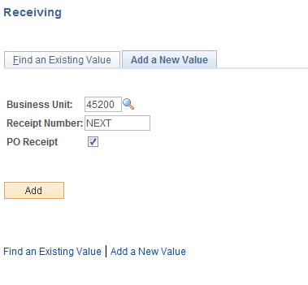

Add a New Value” Tab will default.

Business Unit – Defaults to specific agency for each User.

Receipt Number – Defaults to NEXT. DO NOT CHANGE. The system will auto number each receipt.

PO Receipt – Leave the PO Receipt option checked when creating a receipt from a PO.

Click to take you to the Select Purchase Order page.

Select Purchase Order Page

This page allows the User to define selection criteria for locating ordered items to be received.

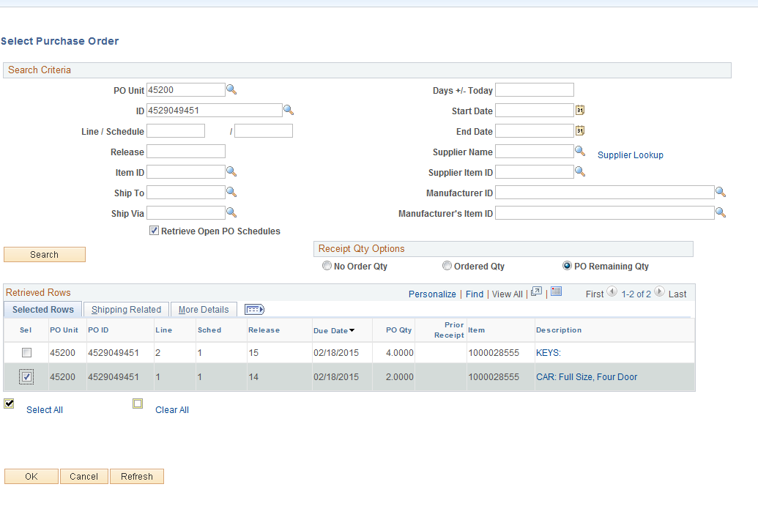

The PO Unit, Days +/-Today, Start and End Dates and Ship To will default into the page based on the defaults set for the User. (Please note that the PO Unit is required). The user can change the defaults and enter criteria into the remaining fields to narrow the search or leave the fields blank to list all of the purchase orders associated with the Business Unit available for receiving between the specified start and end dates. In this example, the Short Supplier Name was used to narrow the search.

PO ID – A specific PO ID can be entered if it is identified on the receiving documentation. If a Ship To value defaulted into the page, it must match the purchase order Ship To or the purchase order will not be retrieved. The Ship To can be changed or the field can be cleared.

Receipt Qty Options – The No Order Qty (no order quantity), Ordered Qty (ordered quantity), or PO Remaining Qty (purchase order remaining quantity) will be set based on the particular requirements of each State agency. The PO Remaining Qty is recommended since it will display the PO remaining receipt quantity/amount. These options can be changed as long as the default is not blind receiving.

Click to display the PO schedules available to receive against. Receiving with a PO is done by schedule, so if a single Line has multiple schedules, each schedule will appear on the Select Purchase Order page.

Selected Rows Tab – Purchase order lines/schedules display based on the search criteria. The receiver will need to locate the PO lines in the search results that match the service or contents of the shipment.

Step 2 - Receive Asset Shipment
If the purchase order distribution has a PeopleSoft Asset Management business unit and asset profile ID specified, the receipt items are identified as asset purchases.

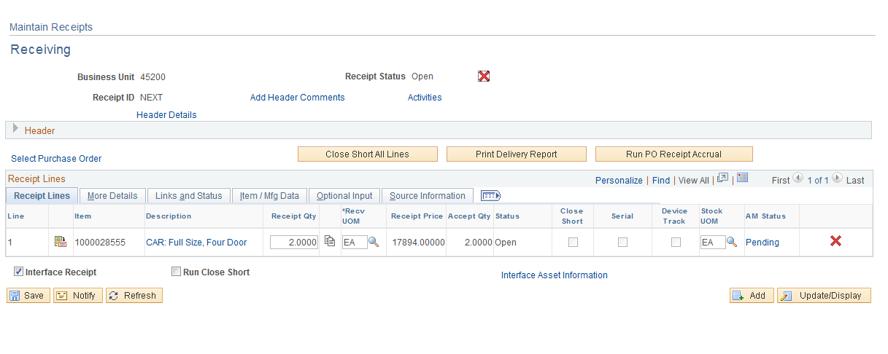

Receipt Qty – Once you have selected the PO line(s) to receive, enter the quantity received.

Serial – Identifies if the receipt line is serial controlled, meaning the item(s) require(s) a serial ID at the time of receipt; otherwise, the receipt line status stays in the Open status and is not eligible for interfacing to assets. If you are receiving a description-only purchase order line (no item ID) and the line is asset-related, the serial check box can be selected. The advantage of a serial controlled receipt line is that it separates multiple Items on one Receiver Line so that the system can treat each Item as a unique asset.

AM Status – Column designates whether the receipt line is an asset-related line. The status values are:

- Moved – The receipt line has been interfaced to PeopleSoft Asset Management.
- N/A (not applicable) – The AM Status will not be displayed because it is not asset-related.
- Pending – The receipt line is an asset item that has not been moved to the assets staging area and is pending interface with PeopleSoft Asset Management.

Click the Pending link in the AM Status column to access the Asset Management Information for the Line.

Step 3A – Scenario #1 – Single Funded Assets
The receipt line associated with the Asset Management Information for Line page is identified under Maintain Receipts. Use this page to enter the asset physical information to be sent to PeopleSoft Asset Management.

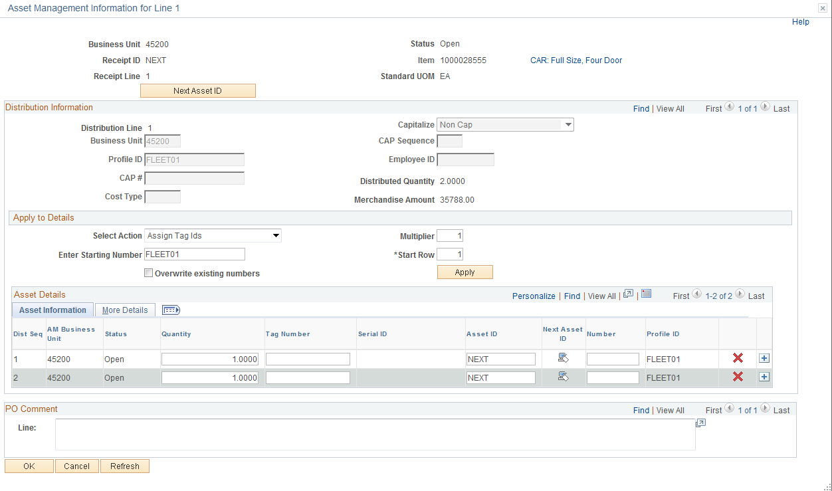

Distribution Information
Distribution Line – The PO distribution line associated with the PO line and schedule selected. When only one distribution line is associated with a receipt line, the asset is single funded.

Profile ID – The Profile ID defaults onto the Distribution Line based on the Item ID selected on the Purchase Order Line and cannot be overridden on the receipt.

NOTE: If the Profile ID appears to be incorrect, exit the receipt without saving it and ask the CPO to change the Profile ID on the PO.

Cost Type – This field should populate with a ‘C’ for CAFR assets (assets with a unit price greater than or equal to $25,000.00.)

Capitalize – The value should be ‘Non Cap’. Assets will be capitalized from the Accounts Payable voucher.

Distributed Quantity – The quantity on the PO distribution line.

Merchandise Amt – The cost on the PO distribution line.

Asset Information Tab
Dist Seq – Distribution sequence number associated with the selected asset. These numbers are assigned to detail rows on the asset. These values can be greater than 1 if multiple serial IDs or tag numbers exist.

Quantity – If the item does not require serialization, then one row is generated with a quantity equal to the distribution quantity. If the item being received requires serialization, the number of rows generated is equal to the distribution quantity converted to the standard unit of measure.

Tag Number – Enter the asset tag number for asset row. The system checks the tag number that you entered on the receipt to make sure it is not already assigned to an asset. If the tag number has already been assigned to another asset the system gives a warning message.

Serial ID – This field is available for entry only when the Serial option is selected for the selected line on the Maintain Receipts - Receiving page. Enter the Serial ID for the distribution sequence.

NOTE: If the receipt line is serial controlled, but there is no Serial ID, the field can be populated with the tag number. If a Serial ID is not available at the time of receipt, enter a value that will alert the agency Asset Manager that this ID must be obtained and entered correctly in Asset Management after the physical information is passed to Asset Management.

Asset ID – The default value is ‘NEXT” allowing the system to assign the next asset ID. Do not override.

The plus icon will allow additional distribution sequence numbers to be added. In this example, the receipt line could not be serialized because the Item ID was not specified as serialized. The quantity field for each row must be changed to 1.

Apply to Details
Use the "Apply to Details" options to populate similar Tag or Serial IDs quickly when there are multiple distribution sequence rows.

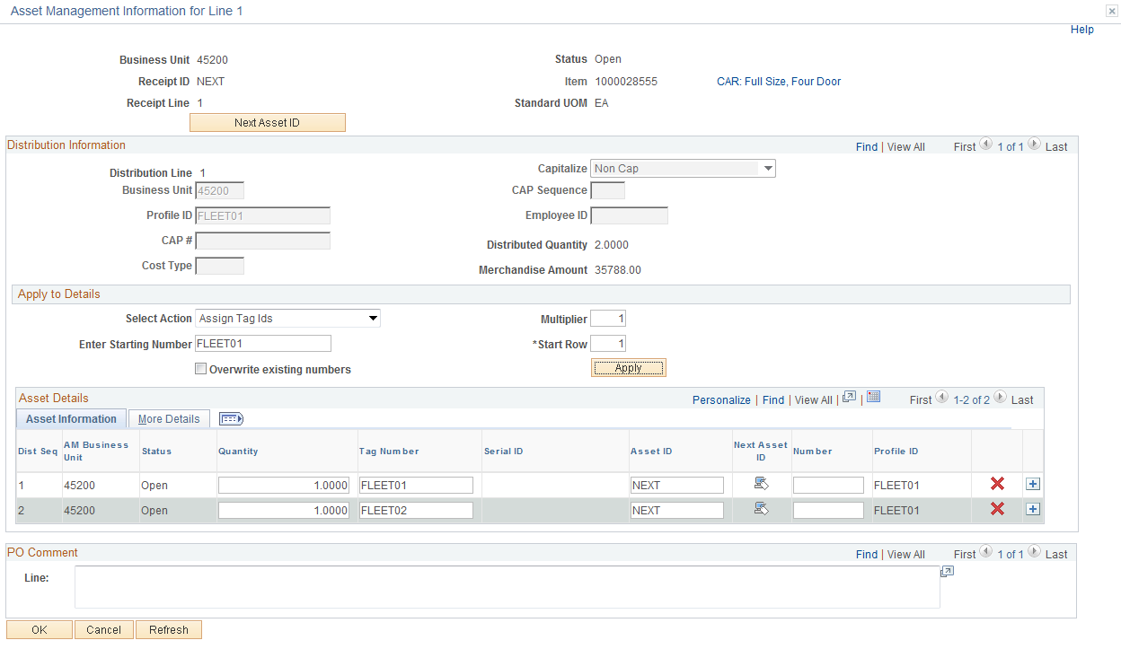

Assign Tag IDs and Assign Serial IDs – If the receipt line is serial controlled, both the Asset Serial IDs and Assign Tag IDs options are available. If the receipt line is not serial controlled, only the ‘Assign Tag IDs’ is available.

Enter Starting Number – If you assign serial IDs, this represents the starting serial ID, which is assigned to the first detail row and is indicated by the Start Row field. If you assign tag IDs, this represents the starting tag ID, which is assigned to the first detail row and is indicated by the Start Row field.

Start Row – This is a required field and automatically changes to a value of 1. Indicate the detail row to use as the starting point for assigning values that are determined by the starting number and multiplier.

Overwrite existing numbers – Select to override existing values in the detail grid rows for either the tag ID or serial ID, depending on which action is selected (Assign Tag IDs or Assign Serial IDs).

Click to assign the tag ID (or serial ID) values to the detail rows in the grid based on the starting number and the start row values.

Note the Quantity, Tag Number and Asset ID fields on the Asset Information Tab after clicking . Thomas,Dan
More Details Tab
The More Details Tab holds additional Asset Physical Information.

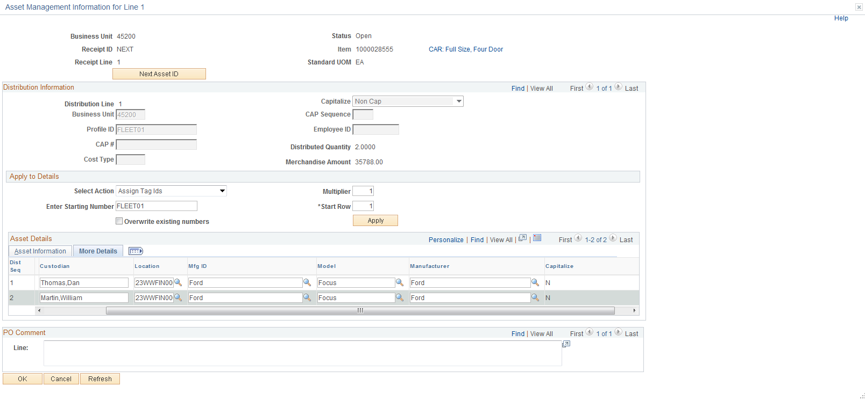

VIN – Enter the VIN if applicable. The VIN number will be available if the Asset Type defaulted from the Profile ID is set to allow this value to be stored on the Asset. This field is available for distribution sequence lines added with Add icon.

Custodian – Enter the custodian name if know.

NOTE: Names must be entered into the system as Last, First with no spaces.

Location – Enter the Agency’s internal location where the Asset will be located. Use the prompt feature to look-up all valid locations values for the agency.

Mfg ID – Mfg ID can be assigned at time of receipt as part of the Asset Physical information. If the manufacturer is not pre-defined, submit a help desk case to request it be added. DCS requires manufacturer ID for machinery and equipment per OAC 580:70-3-1 (c) (4).

Model – Enter the model name or number. DCS requires the model for machinery and equipment per OAC 580:70-3-1 (c) (3).

Click to return to the Maintain Receipts page.

Interface Receipt

Interface Receipt – Executes a Receiver Interface Push batch process to move the receipt to Asset Management in real time when saving the Receipt if the Interface Receipt box is checked on the Receiving page. The box default can be to check the box automatically based on the user preference setup.

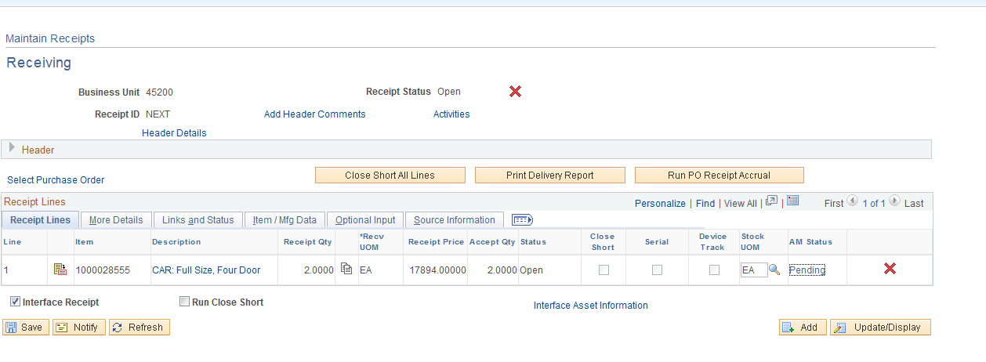

– Upon clicking the following message displays and identifies the receipt number, the receipt integration RECV_02 process, and the process instance number of the job.

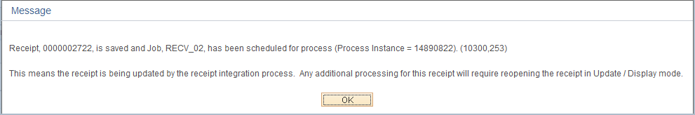

Step 3B – Scenario #2 – Split Funded Asset
The Asset Management Information for Line page accommodates split-funded purchase orders. An asset may be funded by multiple classes or it may be shared among departments or operating units. The Use One Asset ID feature assigns one asset ID to all the PO distribution lines associated with the receipt line and retains the split-funding in Asset Management.

If the receipt line is serial controlled, the system verifies the following for the selected receipt line:

• The sum of interface record quantities for any given serial ID is 1.
• Only one asset ID is assigned to any given serial ID on the receipt line.
• Only one tag number is assigned to any given serial ID on the receipt line.

In this example, a single asset has been split-funded 50% to each of two operating units.

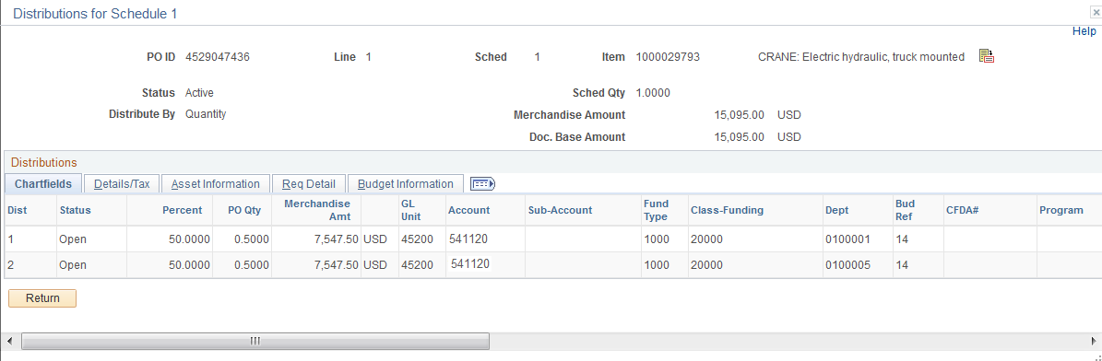

NOTE: If more than one asset on a PO line has split-funding, each asset must be entered on a separate PO schedule.

Maintain Receipts
The Maintain Receipts page reflects the receipt quantity on the PO schedule. Always click the Pending link in the AM status column to access the Asset Management Information for Line page and view the distribution information.

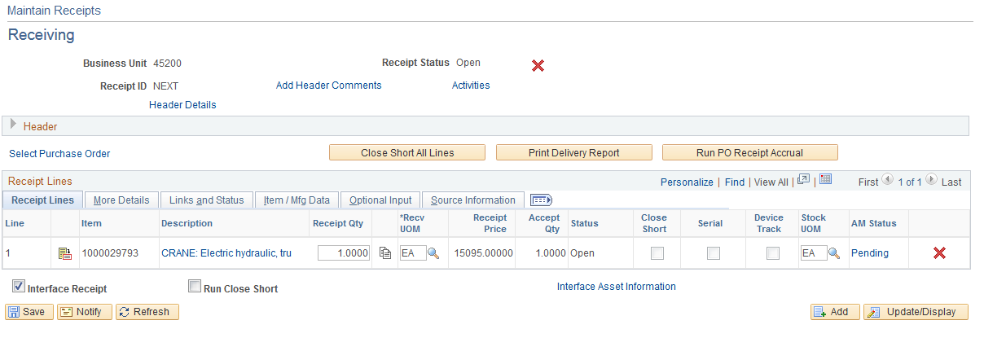

Distribution Information

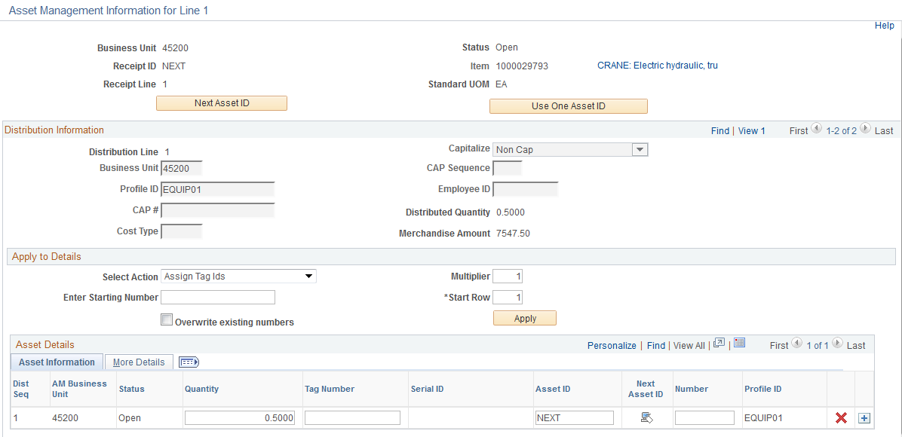
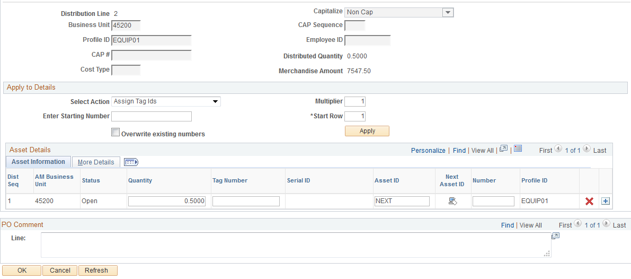
Distribution Line – The PO distribution line associated with the PO line and schedule selected. When more than one distribution line is associated with a receipt line, the asset is split funded.

Profile ID – The Profile ID defaults onto the Distribution Line based on the Item ID selected on the Purchase Order Line and cannot be overridden on the receipt.

NOTE: If the Profile ID appears to be incorrect, exit the receipt without saving it and ask the CPO to change the Profile ID on the PO.

Cost Type – This field should populate with a ‘C’ for CAFR assets (assets with a unit price greater than or equal to $25,000.00.)

Capitalize – The value should be ‘Non Cap’. Assets will be capitalized from the Accounts Payable voucher.

Distributed Quantity – The quantity on the PO distribution line.

Merchandise Amt – The cost on the PO distribution line.

Asset Information Tab

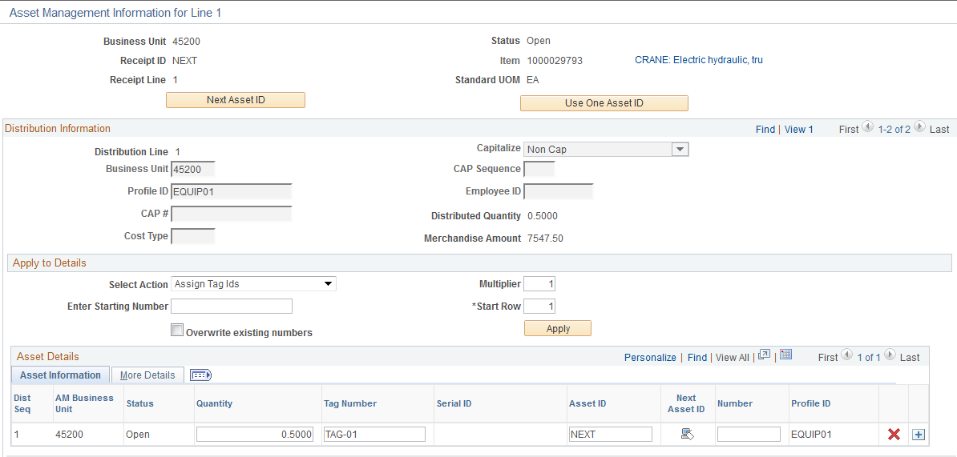
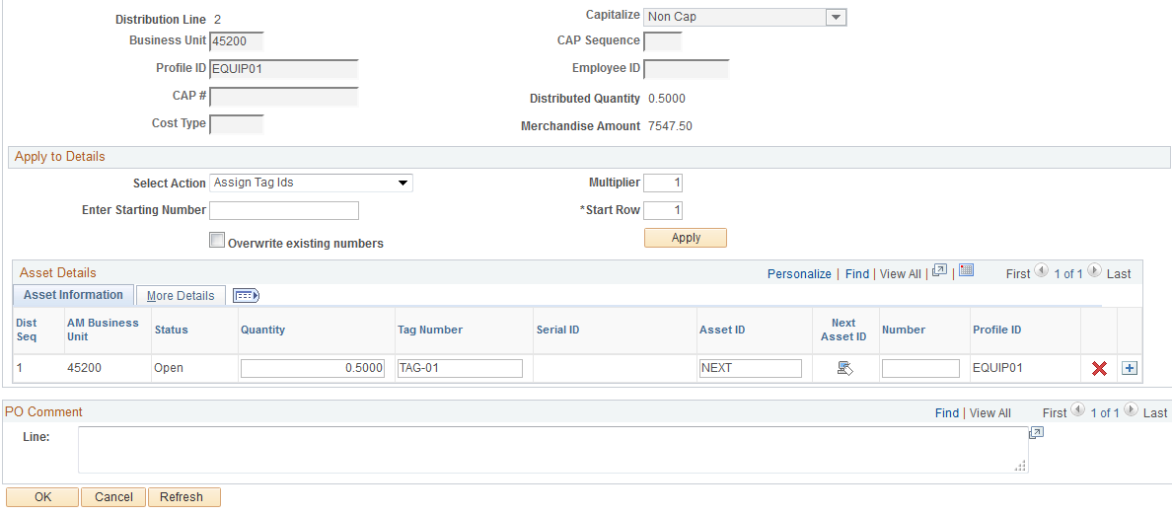

Dist Seq – Distribution sequence number associated with the selected asset. These numbers are assigned to detail rows on the asset. The value will be 1 for each of the distribution lines associated with a split funded assets on the PO line and schedule selected.

Quantity – If the item is split funded, then the sum of the amounts on the Distribution Sequence rows must equal 1.
Tag Number – Enter the same asset tag number on each Distribution Sequence row. The system checks the tag number that you entered on the receipt to make sure it is not already assigned to an asset. If the tag number has already been assigned to another asset the system gives a warning message.

NOTE: The same tag number must be entered on all Distribution Sequence rows in order for all the rows to be assigned the same Asset ID. If one of the tag numbers is omitted, the Asset does not interface properly to Asset Management.

Serial ID – This field is available for entry only when the Serial option is selected for the selected line on the Maintain Receipts - Receiving page. Enter the Serial ID for the distribution sequence.

NOTE: The same serial ID must be entered on all Distribution Sequence rows in order for all the rows to be assigned the same Asset ID. If the receipt line is serial controlled, but there is no Serial ID, the field can be populated with the tag number. If a Serial ID is not available at the time of receipt, enter a value that will alert the agency Asset Manager that this ID must be obtained and entered correctly in Asset Management after the physical information is passed to Asset Management.

Asset ID – The default value is ‘NEXT” allowing the system to assign the next asset ID. Do not override.

Click to combine split asset distribution lines into a single asset ID when the receipt is interfaced to Asset Management.

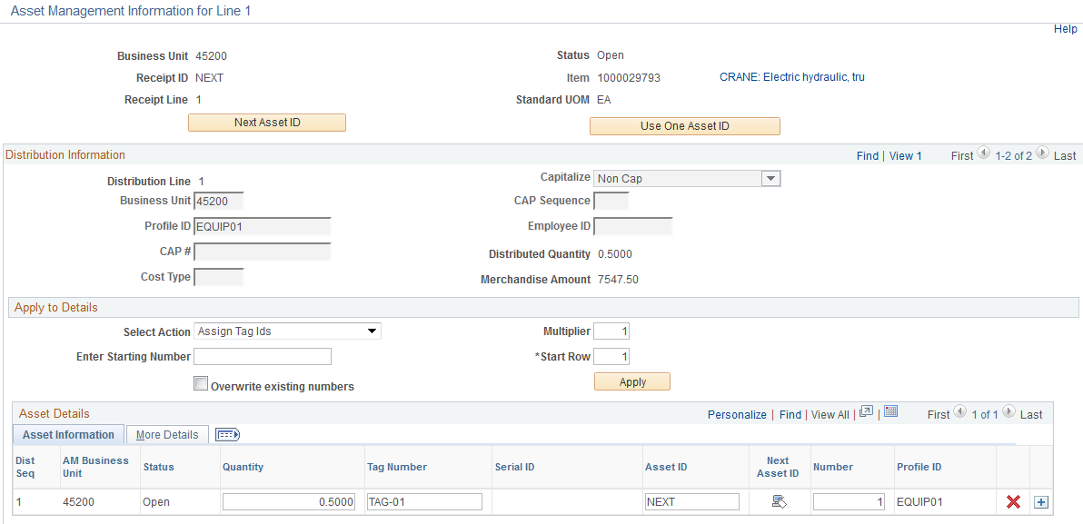
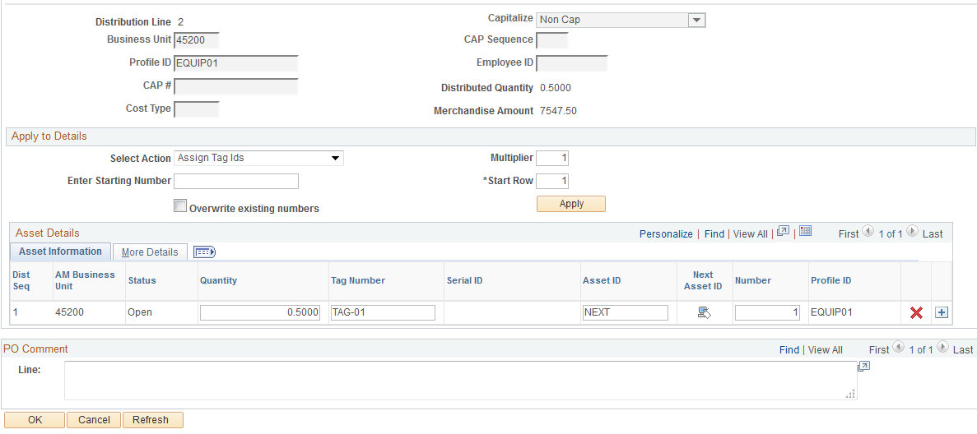

Number – Upon using the Use One Asset ID functionality, the system combines split asset distribution lines into a single asset ID by assigning a value of 1 to the Seq Nbr (sequence number) field on each of the receipt asset row for each distribution row of the receipt line that appears.

More Details
Enter the additional physical information in the More Details Tab (see the prior chapter).

Click to return to the Maintain Receipts page.

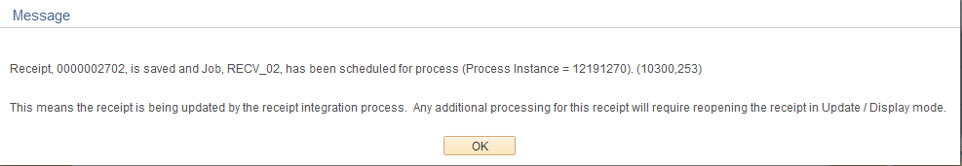

Physical Transaction A Page in Asset Management
The Asset IDs are assigned to each distribution row at the time the receipt is interfaced to Asset Management. The ChartField distribution will be retained in Asset Management.

Navigation: Asset Management > Send/Receive Information > Approve Physical Information> Review A

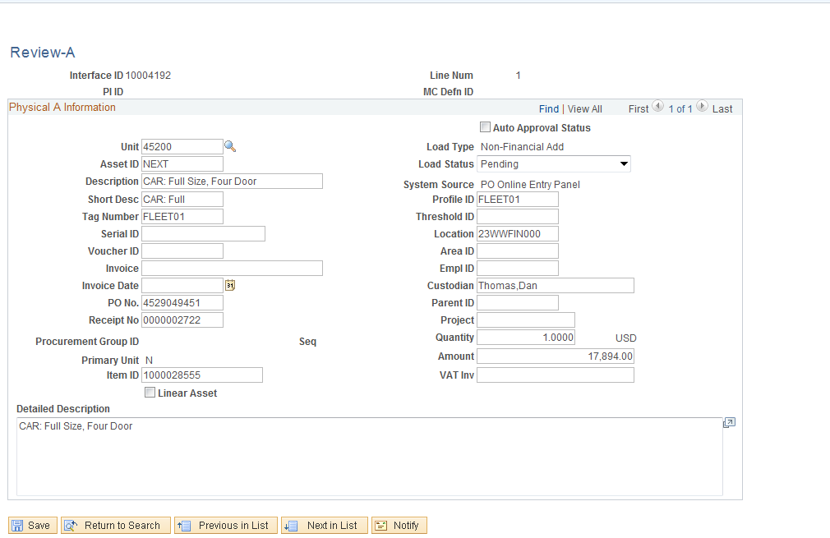

Step 4 – Review Receipt after the Receiver Interface Push
To review the receipt information after the Receiver Interface Push, follow the navigation below.

Navigation: Purchasing > Receipts > Review Receipt Information > Receipts

To narrow your search, enter a combination of search criteria including Receipt Number, PO Number, Receipt Status, etc

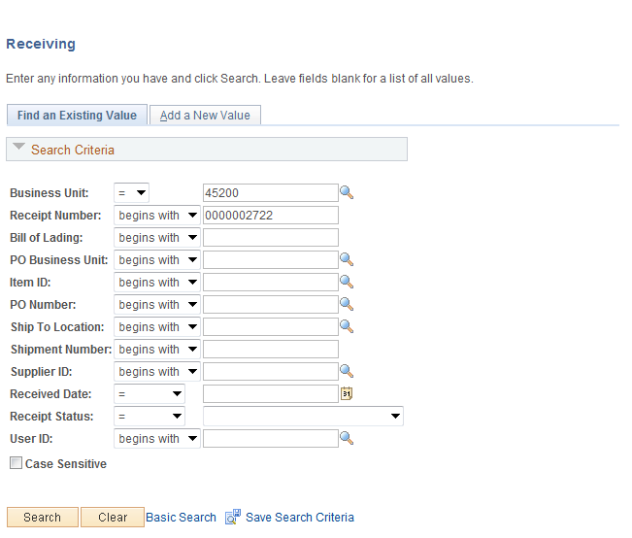

.
Click to retreive the receipt information.
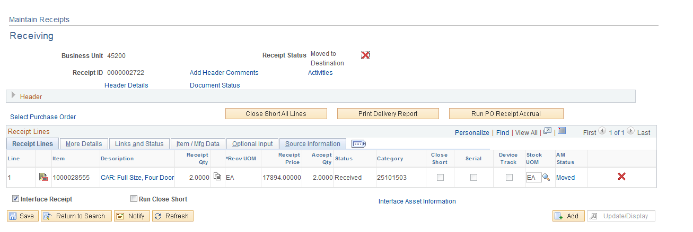

The Receipt Status and AM Status is Moved indicating the receipt has been interfaced to Asset Management.

Canceling Receipts
If you need to cancel a receipt or cancel a line on a receipt after it has been entered and saved, you must first select the Receipt Number.

Navigation: Purchasing > Receipts > Add/Update Receipts > Find an Existing Value

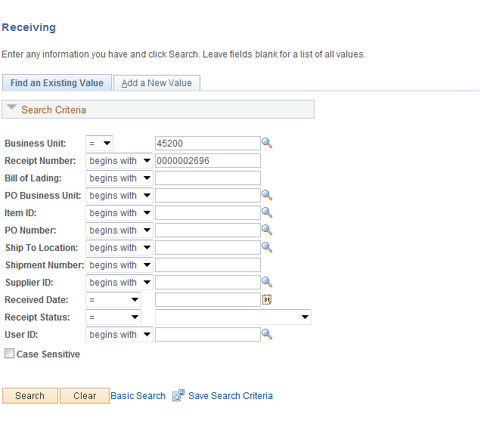

Business Unit – Defaults to specific agency for each User.

Receipt Number – Enter the receipt number that you wish to cancel. If you leave the field blank, a list of receipts will be available when you click .

Click to transfer you to the Receiving page.

Receiving Page
Click at the header level to cancel the entire receipt. Click at the line level to cancel a line on the receipt. In the example, the receipt is canceled at the header level since there is only one receipt line.

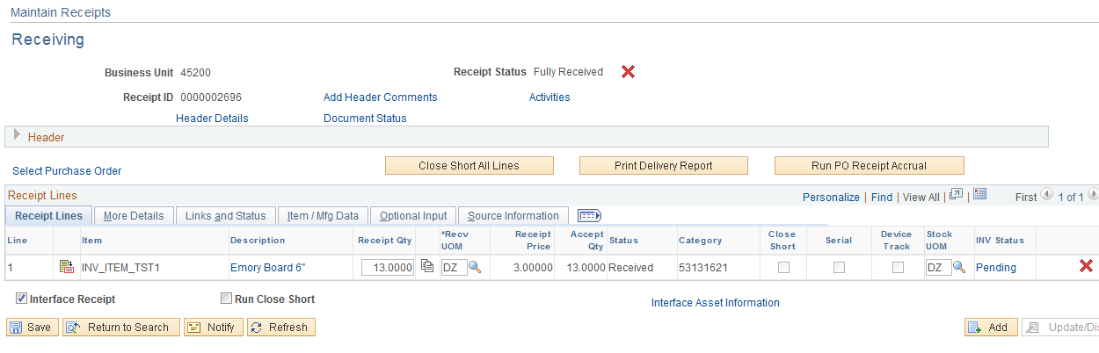

This cancel action cannot be reversed. You will receive the following message:

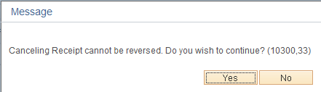

Click and.

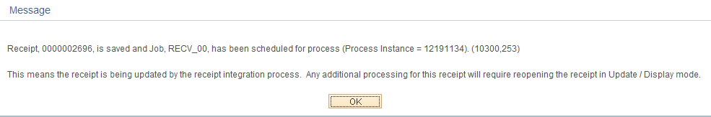

Receipt Status of receipts canceled at the header level changes to Canceled at the Header and Line levels.

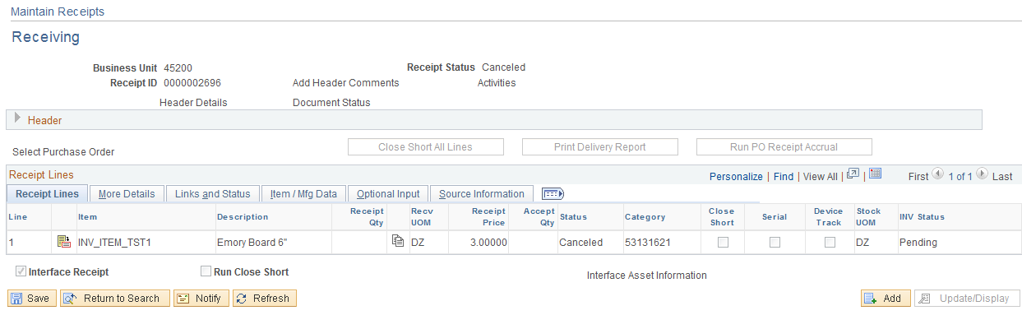

NOTE: When receipt line(s) are cancelled but at least receipt line has a Received Status, the Receipt Status remains Received, but the Status of the canceled lines will change to Canceled.

Reviewing Receipt Information
To review receipt information, follow the navigation below.

Navigation: Purchasing > Receipts > Review Receipt Information > Receipts

To narrow your search, enter a combination of search criteria including Receipt Number, PO Number, Receipt Status, etc.

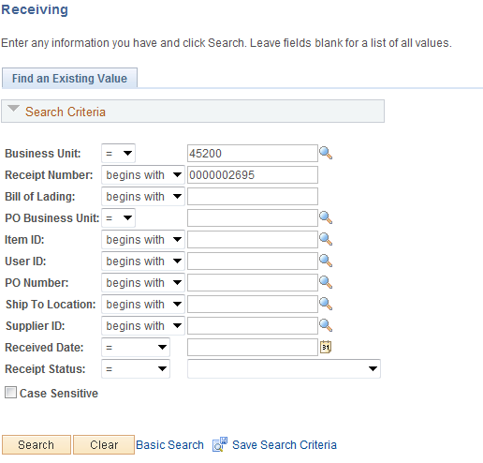

Click to transfer to the Receipts Page.

Receipts Tab

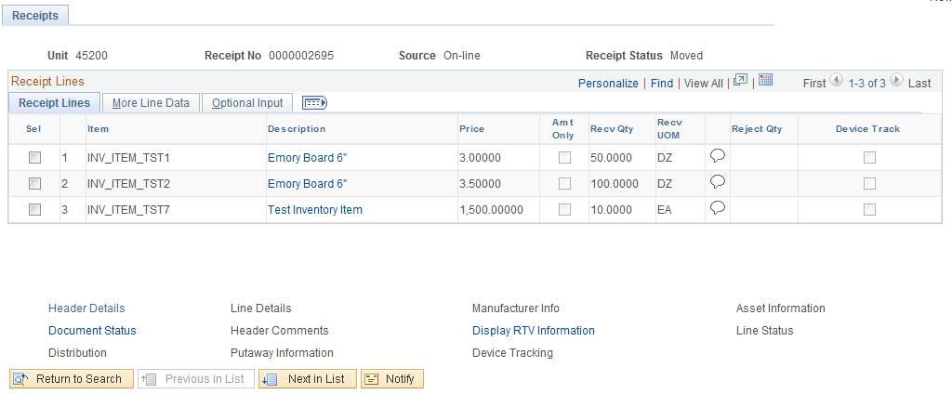

Receipt Status – Displays the current status of the Receipt. The values are:

O Open
C Closed
R Received
H Hold
X Canceled
M Moved to Destination
C Closed
N PO Not Received

Recv Qty – The actual quantity received.

Reject Qty – The quantity rejected.

Sel – Selecting a receipt line activates hyperlinks at bottom of page to view additional information related to the selected receipt line.

More Line Data Tab
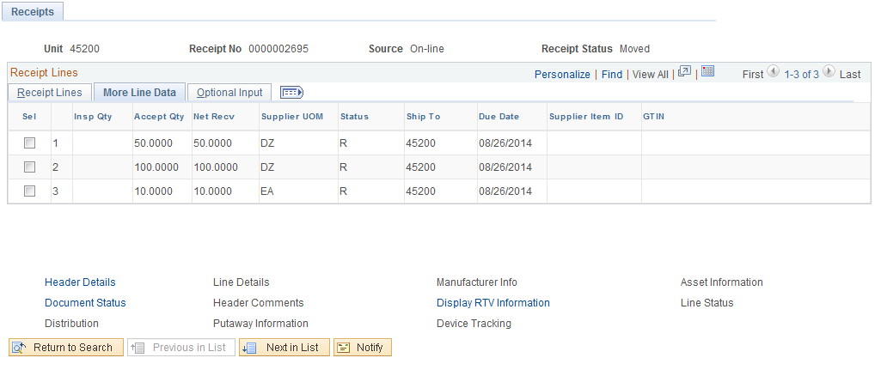

Line Status – Displays the current status of the line. The values are:

O – Open schedule
C – Closed schedule
R – Received schedule
H – Hold schedule
X – Canceled schedule

Accept Qty – The quantity received less the quantity rejected.

Net Recv – The net quantity received that will copy from the receipt to the voucher.

Sel – Selecting a receipt line activates hyperlinks at bottom of page to view additional information related to the selected receipt line.

Receiving an Inventory Item by PO Number
If a Purchase Order Distribution Line specifies an Inventory Item, the Receipt is identified as an inventory purchase and provides an Inventory Putaway page to record quantities by inventory business unit, area and, storage locations. The receipt passes the information to the Inventory Module.

Step 1 – Select PO to Receive Against
To retrieve an inventory PO for receiving inventory shipments, use the following navigation:

Navigation: Purchasing > Receipts > Add/Update Receipts

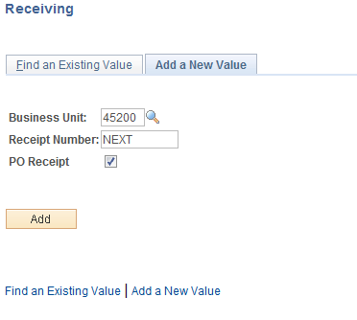

“Add a New Value” Tab will default.

Business Unit – Defaults to specific agency for each User.

Receipt Number – Defaults to NEXT. DO NOT CHANGE. The system will auto number each receipt.

PO Receipt – Leave the PO Receipt option checked when creating a receipt from a PO.

Click to take you to the Select Purchase Order page.

Select Purchase Order Page
This page allows the User to define selection criteria for locating ordered items to be received.

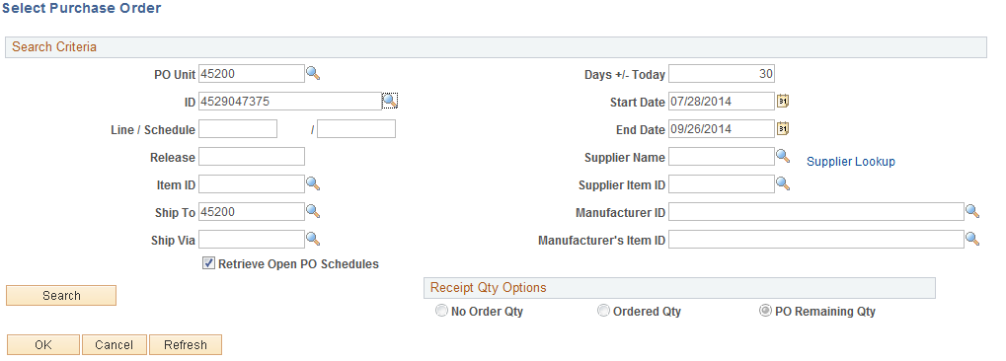

The PO Unit, Days +/-Today, Start and End Dates and Ship To will default into the page based on the defaults set for the User. (Please note that the PO Unit is required). The user can change the defaults and enter criteria into the remaining fields to narrow the search or leave the fields blank to list all of the purchase orders associated with the Business Unit available for receiving between the specified start and end dates. In this example, the dates were removed and the search is conducted on the PO and Ship To ID.

PO ID – A specific PO ID can be entered if it is identified on the receiving documentation.

Ship To ID – The Ship To will default with your Warehouse Ship To ID. It must match the purchase order Ship To or the purchase order will not be retrieved. The Ship To can be changed or the field can be cleared.

Receipt Qty Options – The No Order Qty (no order quantity), Ordered Qty (ordered quantity), or PO Remaining Qty (purchase order remaining quantity) will be set based on the particular requirements of each State agency. The PO Remaining Qty is recommended since it will display the PO remaining receipt quantity/amount. These options can be changed as long as the default is not blind receiving.

Click to display the PO schedules available to receive against. Receiving with a PO is done by schedule, so if a single Line has multiple schedules, each schedule will appear on the Select Purchase Order page.

Selected Rows Tab
Purchase order lines/schedules display based on the search criteria. The receiver will need to locate the PO lines in the search results that match the service or contents of the shipment.

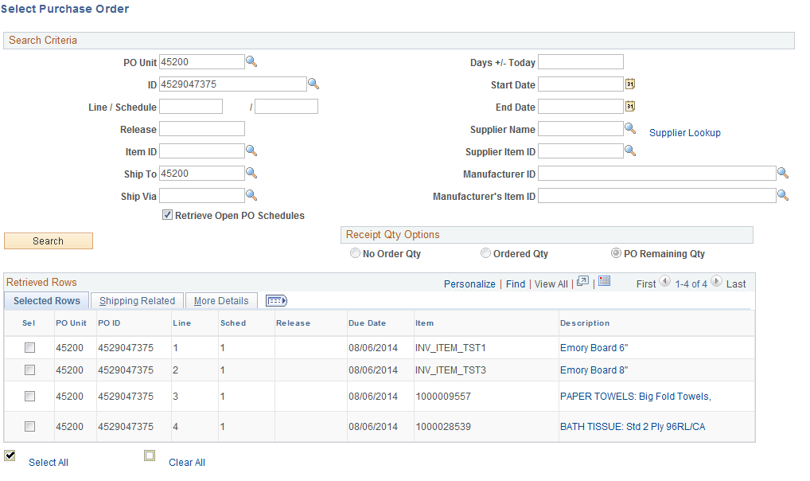

Description – Review the full item description by clicking the description link to ensure the item(s) match the contents of the shipment.

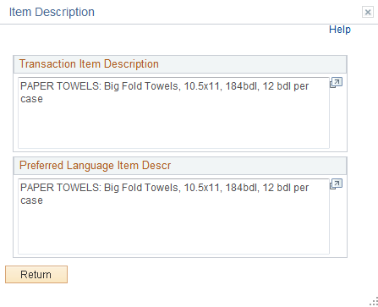

Click to return to the Select Purchase Order page.

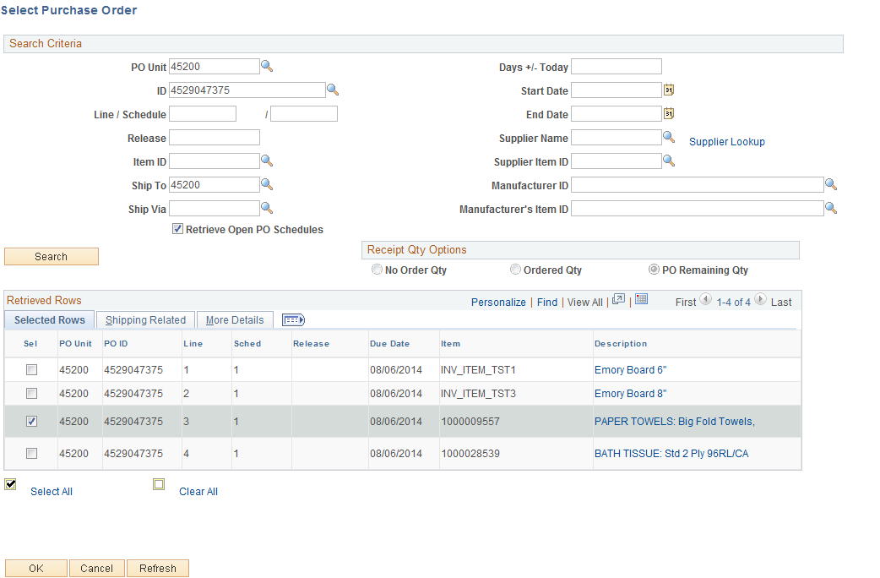

Sel – Select a check box to work with a particular line. Multiple schedules can be selected.

Due Date – Date which the shipment is due for this schedule.

PO Quantity – Quantity ordered on the PO for this schedule.

Prior Receipt – Quantity previously received for this schedule.

Description – Description from the purchase order that receiver will use to match the PO lines to service or contents of shipment.

Clicking will transfer you to the Receiving page.

Step 2 – Receive Shipment Quantities
Once you have selected the PO line(s) to receive, enter the receiving information.

Maintain Receipts – Receiving Page
In the header information on the Receiving page, the following information is available.

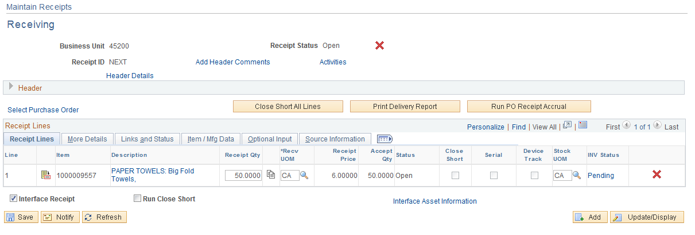

Receipt Status – Displays the status of the receipt header. Values are:

O Open
C Closed
R Received
H Hold
X Canceled
M Moved to Destination
C Closed
N PO Not Received

– Cancels the entire receipt. This action cannot be reversed.

Header Details – Use this link to view and enter receipt header information including shipment information. This is the link that is used to access the Hold Receipts check box if a receipt needs to be held from further processing.

Add Comments – Use this link to add header level comments that will be associated with this receiver ID. Once the comments are added, the link will be displayed as Edit Comments. Click the link to add additional header level comments or to review existing ones.

Activities – Use this link to add or review activities associated with the receipt header.

Receipts Lines Tab
Receipt Qty – Edit the field to record the number of items received. In our example, the receipt quantity populated with the remaining quantity of 5 because the Receipt Qty Option was PO Remaining Qty (see print screen before Step 2). If the PO Remaining Qty exceeded the quantity received, the received quantity would be changed to the actual quantity received. The system will perform a quantity and cost conversion between the receiving and stocking UOM when being interfaced to Inventory.

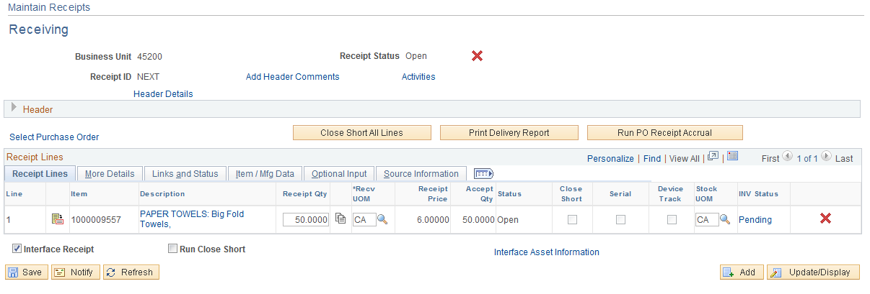

NOTE: The Receipt Qty field will be filled in with the PO scheduled quantity if Ordered Qty is the Receipt Qty option, and with the remaining scheduled quantity from the PO if PO Remaining Qty is the Receipt Qty option. When receiving a partial shipment, change the quantity to the amount received. The Receipt Qty will be blank if the agency’s default is blind receiving. Enter the amount you are actually receiving.

Recv UOM – Defaults from the unit of measure ordered on the PO.

Stock UOM - Defaults from the item ID. Change, if necessary, by clicking to select from a list of valid values.

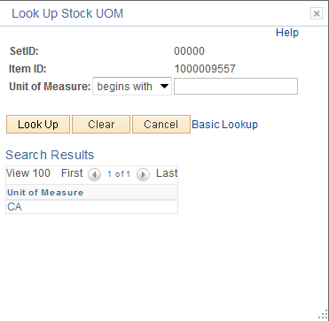

Click the UOM link to select the Unit of Measure.

NOTE: If the correct stocking UOM is not available, contact the helpdesk at 521-2144 and provide the following information: 1. an Explanation of the Issue; 2. the UOM; and 3. the conversion between the Ordering UOM and the Stocking UOM.

INV Status – Displays the item status in relation to PeopleSoft Inventory. The status values are:

- Moved – The receipt line has been interfaced to PeopleSoft Inventory.
- Pending – The receipt line is an inventory item and is pending interface with PeopleSoft Inventory.
- Blank – Receipt line is not inventory related.

Click the Pending link to access the Inventory Putaway Information for the Line page where storage location information can be reviewed or entered.

NOTE: If the defaults for the inventory purchases are set up in a way that you do not need to override them during the receiving process. It is not necessary to access the Putaway pages. These rows are generated and populated with defaults at save time. However, if the receipt line is serial controlled or lot controlled, you must supply the appropriate required information.

NOTE: If the item is an inventory item but the field in the INV Status is blank, contact the purchasing department to add it the PO. Express Putaway will be used for P-Card inventory purchases.

Step 3 – Inventory Putaway
In PeopleSoft Purchasing, items are staged until you initiate Material Putaway. The Putaway process assigns the items to appropriate inventory business unit storage locations.

Click on the Inventory Status hyperlink Moved .

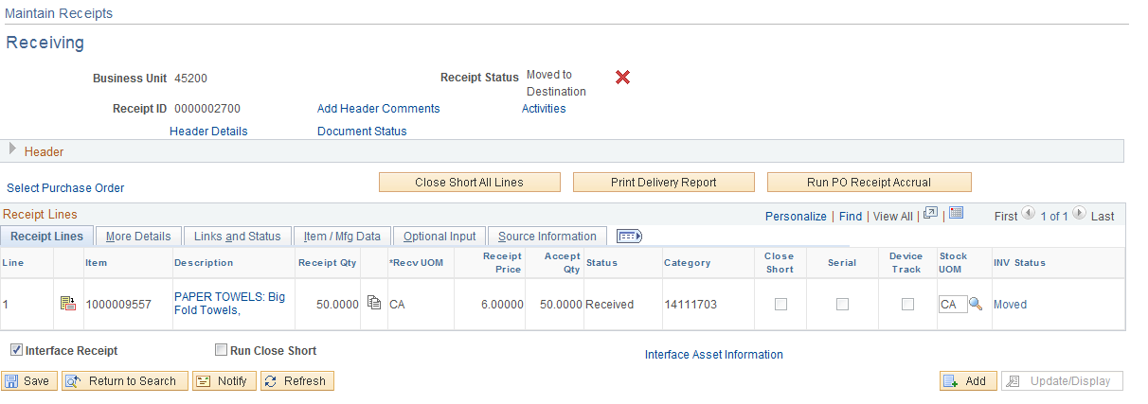

Putaway Information Tab
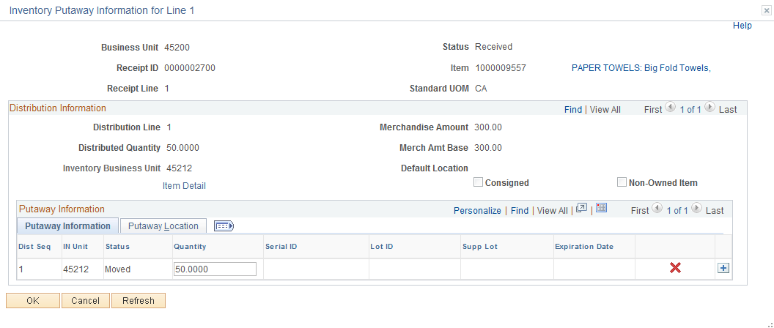

NOTE: The system will convert the Receiving UOM to the Stocking UOM if they are different. If the Standard UOM is incorrect on the Inventory Putaway Information for Line page, contact the helpdesk at 521-2144 and provide the following information: 1) An Explanation of the Issue; 2) The Item ID; 3) The Stocking UOM; and 4)The correct conversion.

Status – Displays the receipt putaway row status. It identifies whether the specific putaway row has passed to the PeopleSoft Inventory system. One putaway row can have a status of Moved, while another row on the same distribution can have a status of Open.

Quantity – Enter the number of items being received. The value in this field determines the values that appear in the Distributed Quantity, Merchandise Amt, and Base Amt fields. If the receipt line is serial controlled, the quantity is not available for change.

NOTE: The sum of the quantities on the putaway rows must equal the distributed quantity on the receipt distribution.

Click to cancel the putaway row. If the receipt has not been interfaced, this putaway row is not to be interfaced and is deleted during receipt interface processing. If the receipt has been interfaced, the putaway rows are removed from inventory at receipt save time.

If the default location has not been setup for the item, click the Putaway Location Tab.

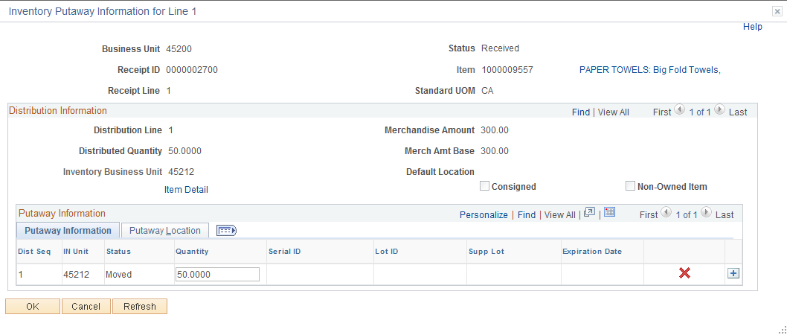
Putaway Location Tab
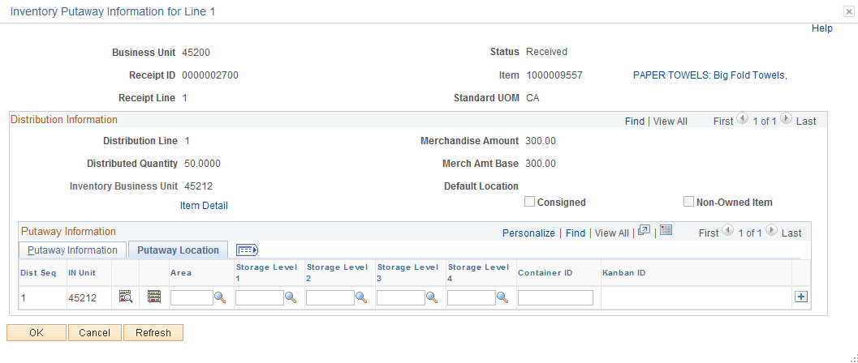

In Unit – Identifies the PeopleSoft Inventory business unit for the distribution and defaults from the PO distribution.

Area – Select an Area to putaway the item. Click for a list of valid values and select the correct Area. If an Inventory Business Unit has Putaway locations setup for Inventory Items, you do not need to populate the Putaway Location.

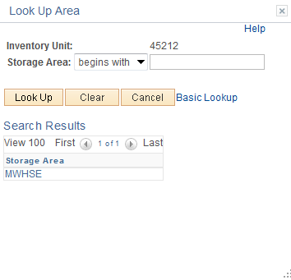

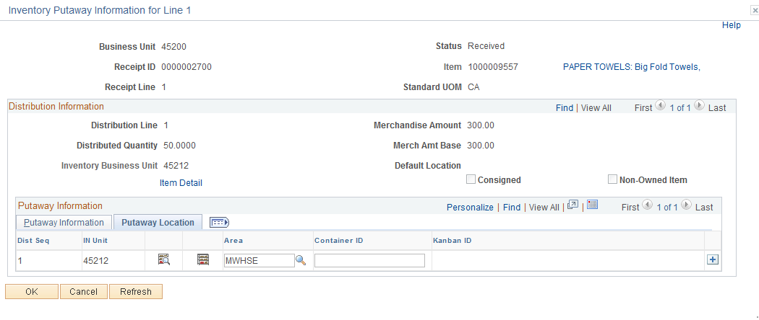

NOTE: Depending on your individual setup, you may need to select a Level 1, 2, or 3.

Click to return to the Maintain Receipts page.

Step 4 – Interface Receipt

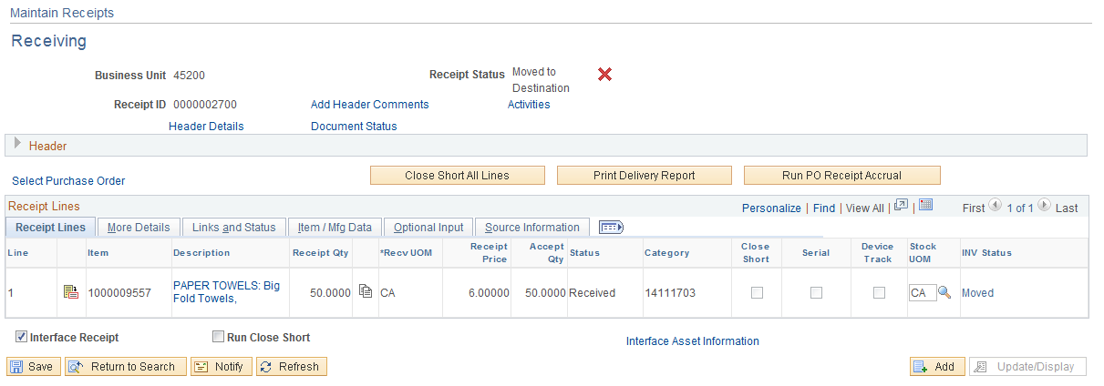

Interface Receipt – Executes a Receiver Interface Push batch process to move the receipt and putaway the item(s) in PeopleSoft Inventory if the Interface Receipt box is checked on the Receiving page. The box default can be to check the box automatically based on the user preference setup. This default should not be changed.

Click and the following message will displays and identify the receipt number, the receipt integration RECV_01 process, and the process instance number of the job.

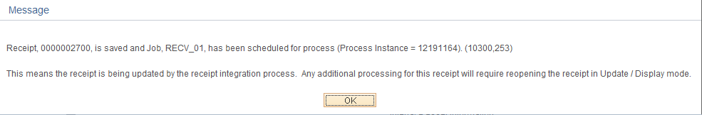

Step 5 – Review Transaction History
To review Transaction History, use the following navigation:

Navigation: Inventory > Manage Inventory > Analyze Inventory > Review Transaction History

The inventory BU defaults.

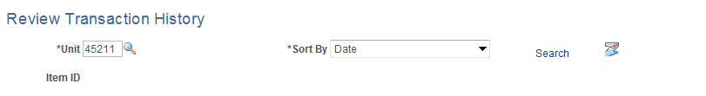

Click Search link.

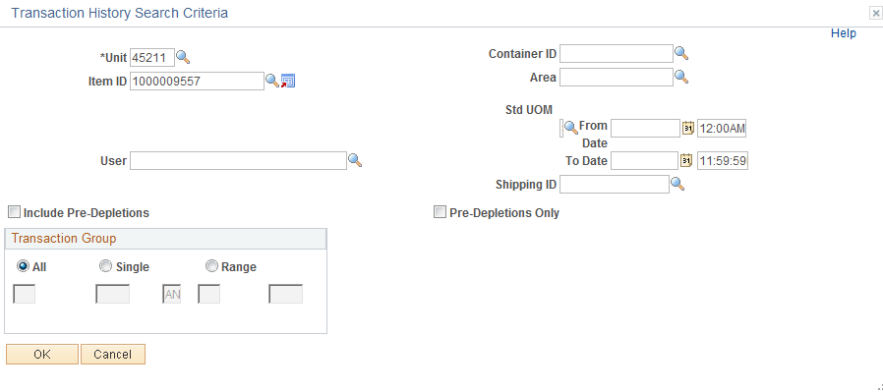

Item ID – Enter the item ID that you will search the Transaction History and click .

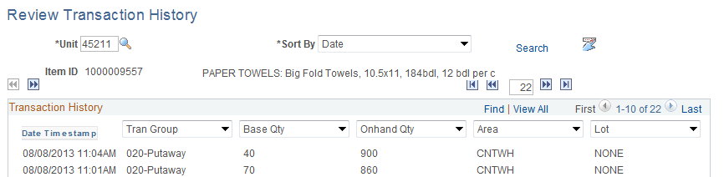

You can review additional data by selecting different fields using the drop down arrows. Use on the last field to change Lot to Recv ID to view the Receipt ID number.

