COR131 PO/Req Closing Manual

Table of Contents
Document History 4
Close Requisition through WorkBench 5
Overview 5
Close a Requisition (s) 6
Filter Option Page 7
Filter Option Definitions 8
Reconciliation WorkBench 8
Reconciliation Definitions 10
Budget Check Requisition (s) 12
Criteria for Closing Requisition 16
Requisition Not Qualified Messages 16
Close Purchase Order through WorkBench 17
Overview 17
Close a Single Purchase Order 18
Filter Option Page 19
Filter Option Definitions 20
Reconciliation WorkBench 21
Reconciliation Definitions 21
Update Purchase Order-Maintain POs 22
Edit the PO 23
Close the Purchase Order 25
Close a Multiple Purchase Orders-Canceled POs 28
Filter Option Page 29
Reconciliation WorkBench 31
Steps to Close a Purchase Order 35
Review Purchase Order 35
Document Status 35
Review PO Lines 37
Review PO Schedules 38
Review PO Distributions 39
Review PO Results 41
Review the Not Qualified PO 41
Override Not Qualified PO 43
Delete Qualified PO 44
Budget Check Close PO 45
Criteria for Closing PO 50
Appendix A 50
Purchase Orders Not Qualified Messages 51
Close a Purchase Order Line 53
Error Messages 59

Authorized by: [_EBS_] Original Issue: [05/01/2014]
Maintained by: [____Purchasing Lead___]
Review Date: [05/01/2014]

Document History

Document Revision | Date | Description
1.0 | 02/01/2006 | Initial Document
1.1 | 06/12/2008 | Upgrade Revision
1.2  2.0 | 05/12/2011  05/01/2014 | ADA compliance  Upgrade Update

Close Requisition through WorkBench

Overview
The Purchase Order, (PO) must be closed and budget checked before the Requisition.

Closing the Requisition will complete the PO process and release available Pre-encumbrances. Once a Requisition has been closed it cannot be opened again. [DO NOT CLOSE A Requisition IF YOU EVER INTEND TO USE IT AGAIN].

If the Requisition is associated with a Purchase Order, the Purchase Order will need to be closed first. If the Purchase Order is not finalized any available encumbrance will be reinstated on the Requisition (pre-encumbrance). This is not a problem, as long as you intend to close the Requisition.

Closing the Requisition resets your Requisition Header status to Complete, your line status to complete and your budget status to ‘Not Checked’. The benefit of this status change is that completed requisitions no longer appear in your list of available requisitions when you access requisition pages in update or display mode. These completed requisitions are also removed from the view in many other situations in which the available options have been set to exclude completed or canceled requisitions. Removing these requisitions from these prompts improves system performance and decreases the time required to find requisitions that you must modify.

Close a Requisition (s)
Navigation: Purchasing > Requisitions > Requester’s WorkBench

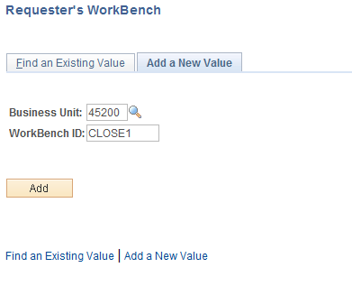

Enter the BU, WorkBench ID, and click . If it is the first time the user has run this process, a Run Control ID must be created.

Filter Option Page

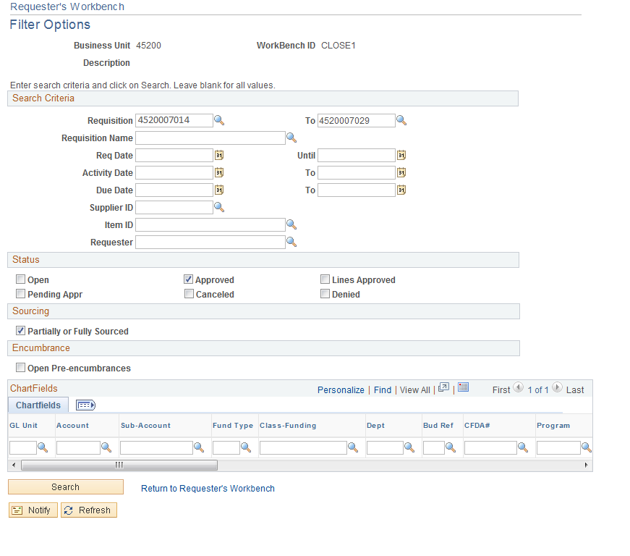

Above is the Filter Option Page. This page allows the user to enter selection criteria for the Requisitions to display on the Requisitions Reconciliation WorkBench Page. One Requisition can be selected by entering the Requisition number in the Requisition ID fields.

Enter the selection criteria.

Filter Option Definitions
- Requisition Name: Range of requisitions to close
- Req Date: The date on the Requisition.
- Activity Date: The system updates this date on the requisition when you last save your requisition
- Due Date: Date product is due
- Supplier ID: Supplier on the Requisition
- Item ID: Item ID on the Requisition
- Requester: User who created the Requisition
- Status: Requisition Status
- Sourcing: The sourcing status of the requisition. This status can be found on the Requisition’s sourcing control tab. If the status is sourcing complete then the “Radio Box” must be checked.
- Open Pre-encumbrances: This check box enables you to search for requisitions that are tied to purchase orders with an open balance.
- Chartfields: Enter multiple Chartfield combinations as search criteria

Once you have selected your criteria, click located in the bottom left hand corner of the page.

Requestor’s WorkBench

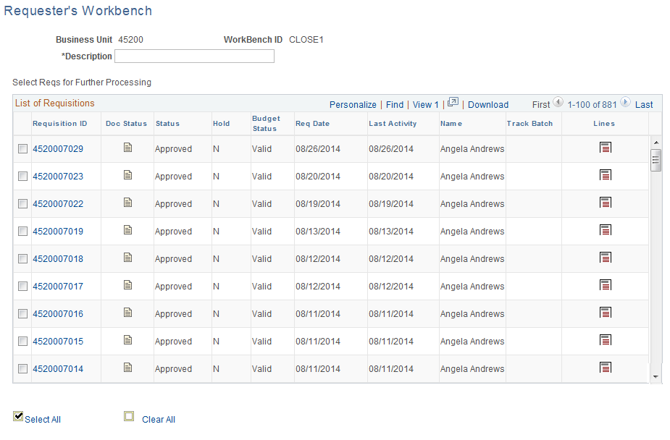

To review all requisitions, if you have multiple, in your results click View All Link.

Review the Doc Status by clicking the Doc Status icon .

Review the Requisition Line by clicking the Requisition Line icon .

To select the individual Requisition to be closed, click the check box left of the PO.

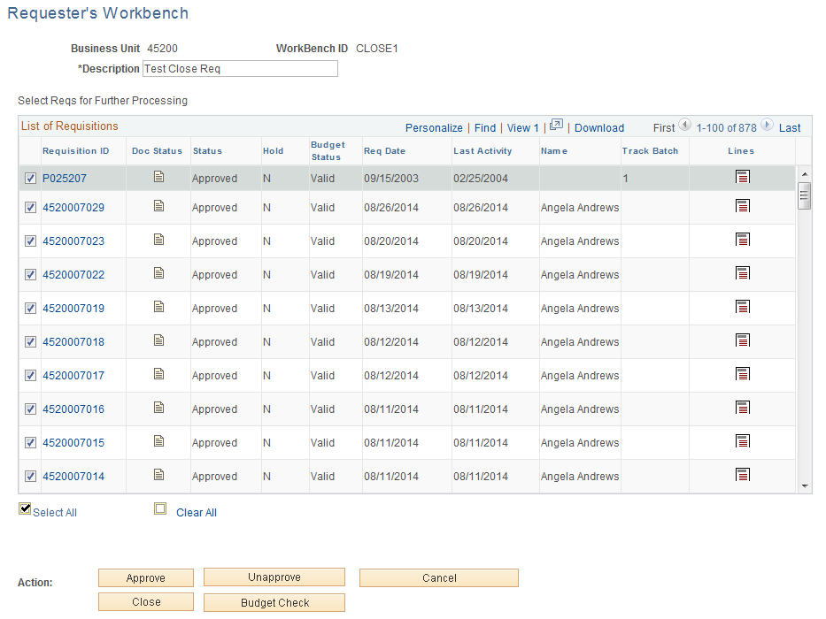

To select all the Requisitions, click the Select All Link.

After the requisitions have been selected, click .

Reconciliation Definitions
- Approve: Not available. Workflow is used to approve Requisitions

- Un-Approve: Click to put the requisition in a pending status. Requisition will need to be approved again

- Cancel: Click to cancel the selected requisitions and all lines

- Close: Click to close the selected requisitions to further processing. Requisitions that are associated with purchase orders which have not yet been closed will be available to close.

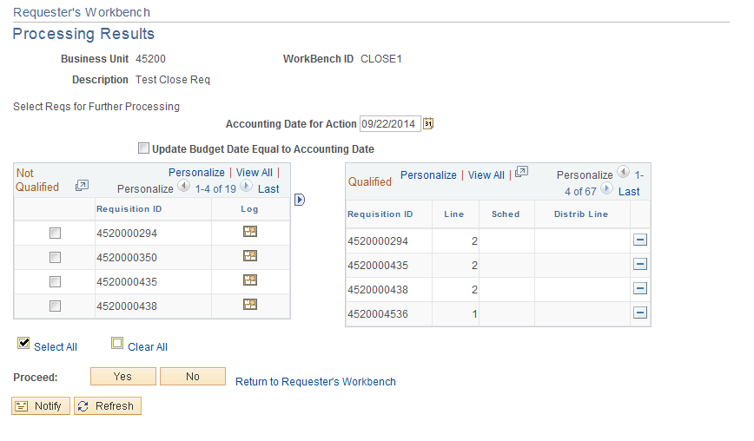

If the Requisition is Qualified, click . (If not qualified, go to page 51)

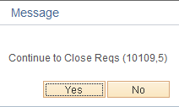

To continue, click .

NOTE: The Requisition is now being closed.

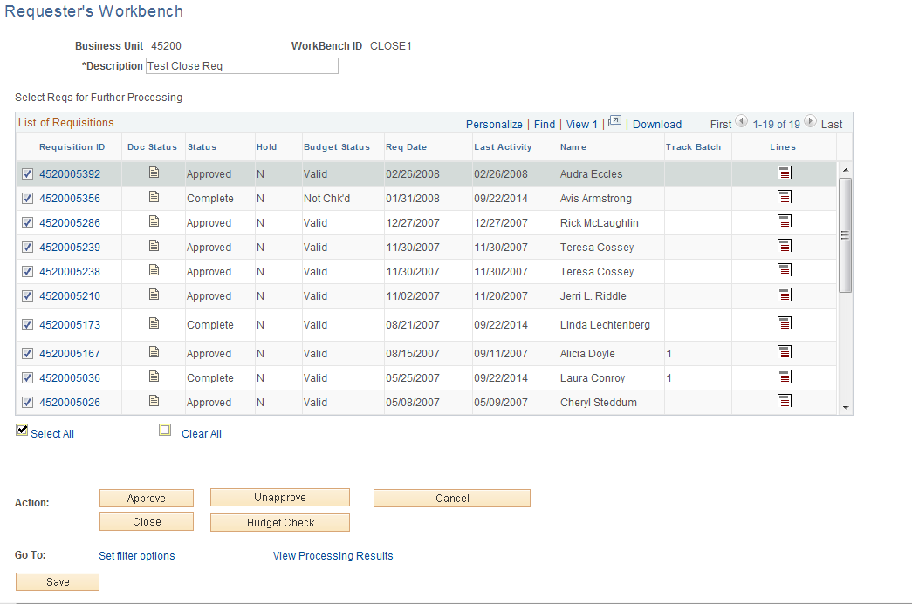

The status changed from Approved to Complete on the Requisitions that were qualified.

NOTE: If the Requisition has an available Pre-encumbrance the Budget Status will change to not checked and will need to be budget checked.

Budget Check Requisition (s)
Navigation: Purchasing > Requisitions > Budget Check

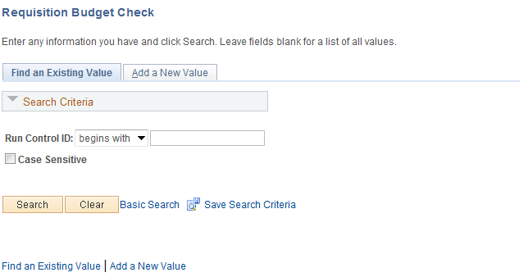

Enter Run control and click .

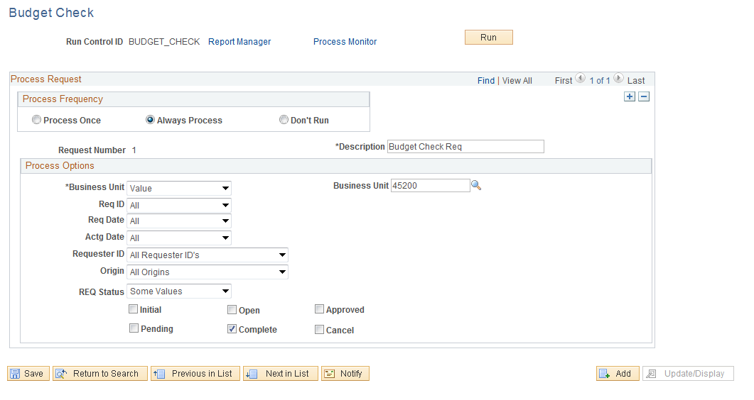

- Description: Enter a description if needed
- Process Frequency: Select Always
- Req Status: Select Some
- Select: Complete Status

Click.
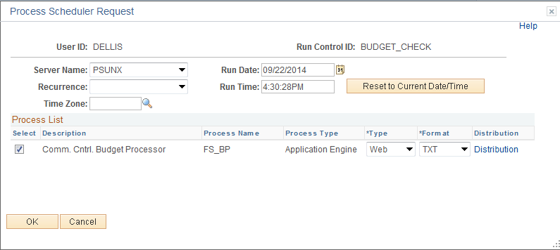

- Server = PSUNX

Click .

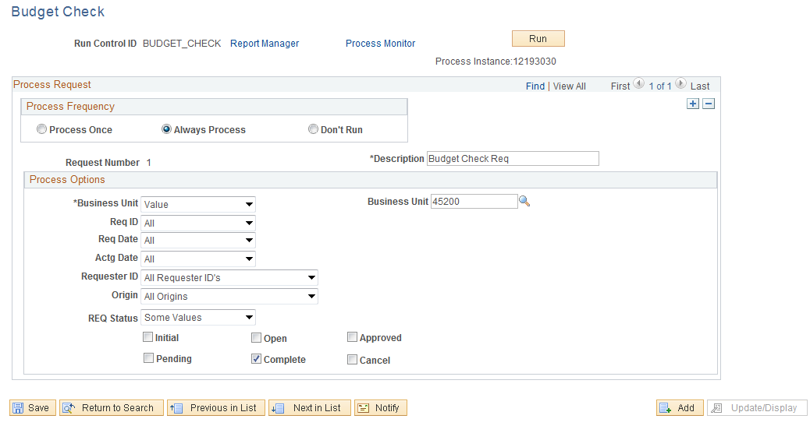

Click the Process Monitor link to review the budget checking process.

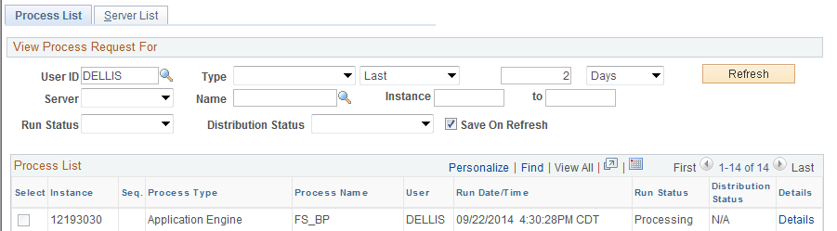

Click to update the Run Status.

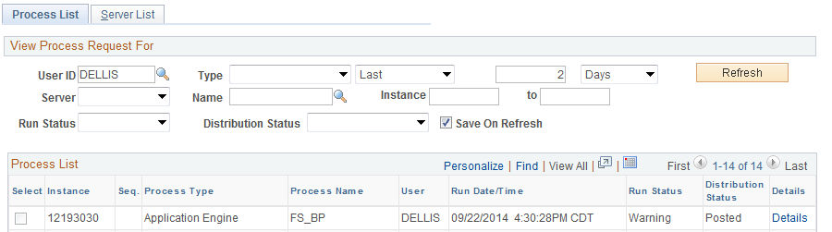

Click the Details link.

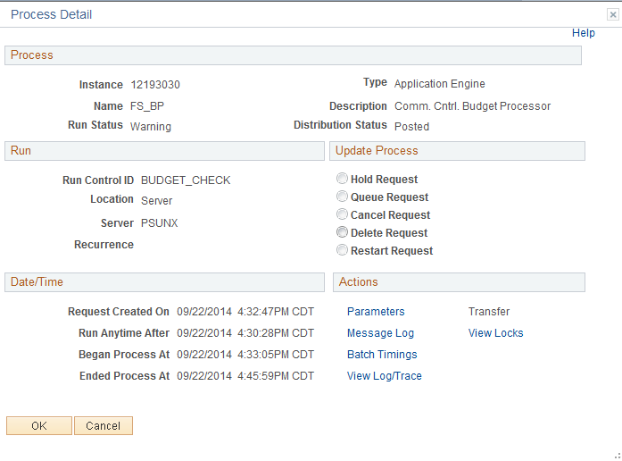

Click Message Log Link.

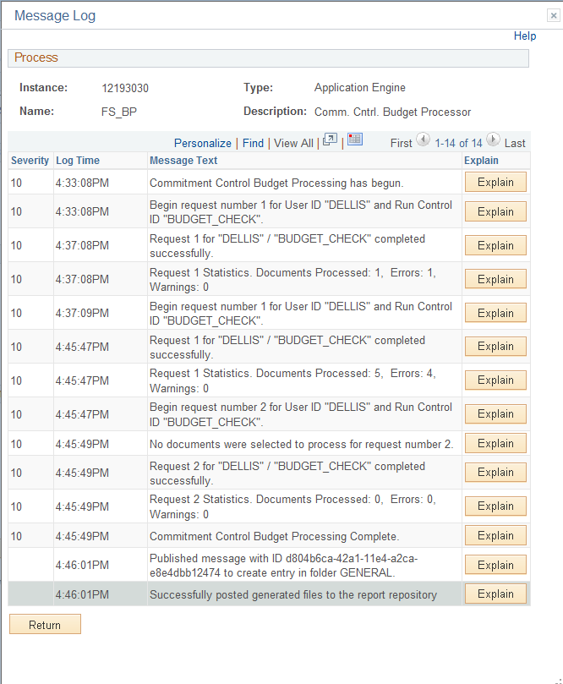

To identify the errors, run the Requisition Budget Checking Report.

Criteria for Closing Requisition
- Purchase Order must be closed and budget checked first
- Requisition must have a valid budget checking status

Additional Notes

- Do not close Requisition if you will need to use the Requisition again.
- Closing the Requisition will remove it from the Maintain Requisition list.

Requisition Not Qualified Messages
MESSAGE | DEFFINITION | RESOLUTION | OVERRIDE
The Requisition is associated with a Purchase Order that has not been closed. | The requisition has been sourced/copied to a PO and the PO has not been closed. | Close PO  Final the PO to reduce pre-encumbrance  Process a change order to amount of PO. | No
Cannot close line with unchecked or error budget line status | The requisition budget status is in a not checked or error status. | Fix the requisition if needed and budget check it. | No
Cannot unapprove a Req that has been Canceled. | The requisition has been canceled so it cannot be unapproved. | Once the Requisition has been canceled nothing can be done to it. | No
Cannot unapprove Requisition that has status of Pending Approval. | The requisition is in a Pending Approval status so it cannot be unapproved, | Since the requisition is in a pending approval status it has not been approved. | No
Can't unapprove a Req that has a status of Open. | The requisition is in an Open status so it cannot be unapproved. | Since the requisition is in an open status it has not been approved. | No
Cannot use WorkBench to approve Pending Approval Requisitions when Approval Workflow enabled. | Cannot use the Reconciliation WorkBench to approve requisition when workflow is enabled. | Must use workflow to approve requisitions | No

Close Purchase Order through WorkBench

Overview
The Purchase Order, (PO) must be closed before the Requisition. This rule was introduced in the 8.9 release.

Closing the PO will complete the PO process and release available encumbrances. Once a PO has been closed it cannot be opened again. [DO NOT CLOSE A PURCHASE ORDER IF YOU EVER INTEND TO USE IT AGAIN].

If the PO is associated with a Requisition and is not finalized, any available encumbrance will be reinstated on the Requisition (pre-encumbrance). This is not a problem, as long as you intend to close the Requisition. If for some reason you are not going to close the Requisition then Final the Purchase Order.

The PO status will change to complete, line status will change to complete and the budget status will change to not checked. The benefit of this status change is that completed purchase orders no longer appear in your list of available purchase orders when you access purchase order pages in update and display mode. These completed purchase orders are also removed from the view in many of the other situations in which the available options have been set to exclude completed or canceled purchase orders. Removing these purchase orders improves system performance and decreases the time required to find purchase orders that you need to modify.

NOTE: Prior to closing a PO, the PO Accounting Page should be reconciled to the PO Activity Page. This will help ensure that all vouchers associated with the PO have been budget checked and matched. However, this action will not identify outstanding invoices that have not been entered into People Soft.

Close a Single Purchase Order
Navigation: Purchasing > Purchase Orders > Buyer’s WorkBench

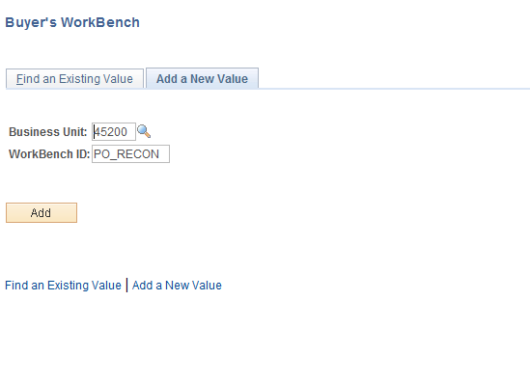

Enter the BU, WorkBench ID and click . If it is the first time the user has run this process, a Run Control ID must be created.

Filter Option Page

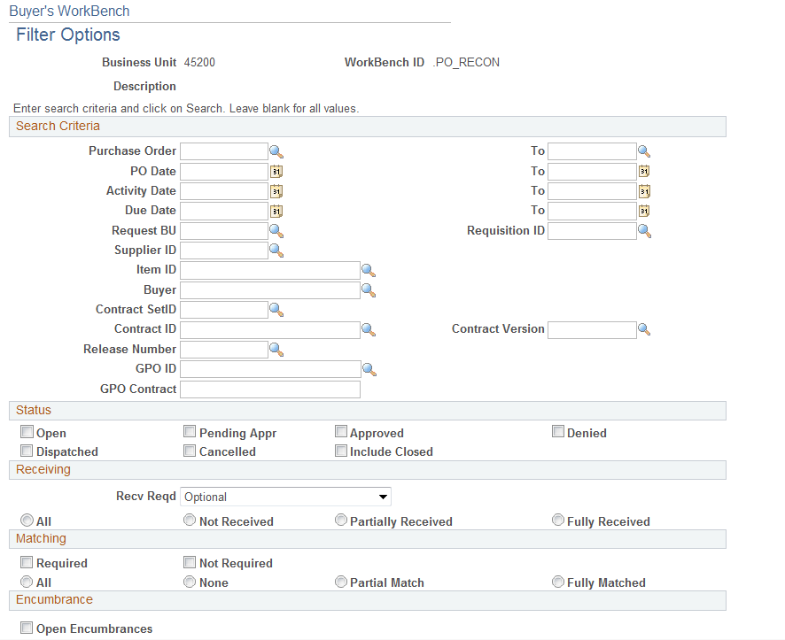
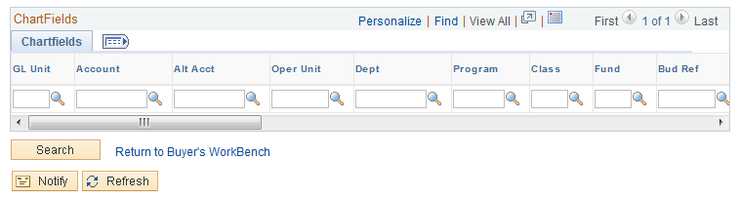

Above is the Filter Option Page. This page allows the user to enter selection criteria for the PO to display on the Purchase Order Reconciliation WorkBench Page. One PO can be selected by entering the PO number in the PO ID fields.

Enter the selection criteria.

Filter Option Definitions
- Purchase Order ID: Range or Purchase Orders to close
- PO Date: Date on the Purchase Order
- Activity Date: The system updates this date on the purchase order when you create a change order and save your work, and also when you cancel a purchase order through the PO WorkBench page.
- Due Date: Date product is due
- Request BU: Business Unit on the Purchase Order
- Requisition ID: Requisition number Purchase Order was created from
- Supplier ID: Supplier on the Purchase Order
- Item ID: Item ID on the Purchase Order
- Buyer: Select the buyer you want to filter the purchase orders by.
- Contract SetID: 00000
- Contract ID: Contract the Purchase Order was created from
- Release Number: Release number against the contract
- GPO ID: Select a group purchasing organization ID.
- GPO Contract: Select a group purchasing organization contract number
- Status: Purchase Order Status
- Receiving: Receiving selection made on the Purchase Order.
- Matching: Match status on the Purchase Order
- Chartfields: Enter multiple ChartField combinations as search criteria

Once you have selected your criteria, click .

Buyer’s WorkBench

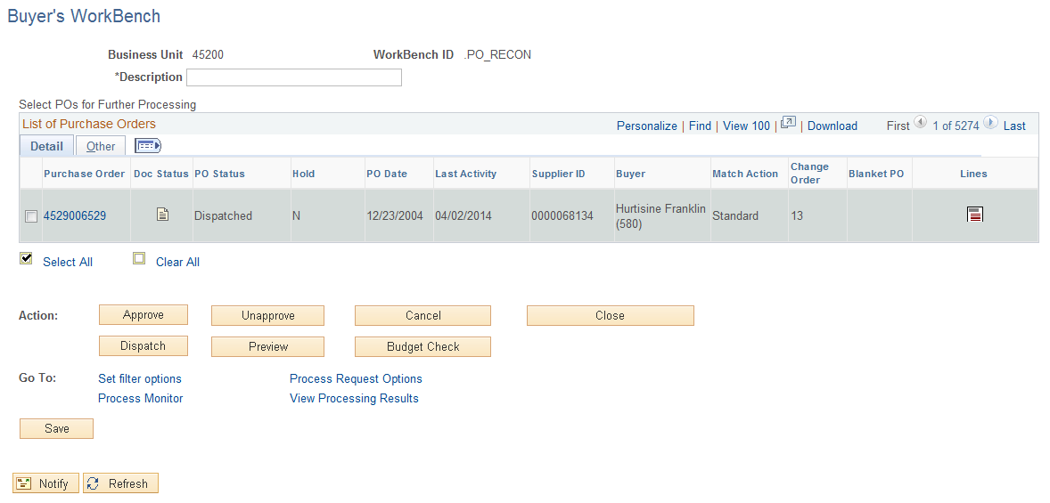

To select the individual PO to be closed, click the check box located to the left of the Purchase Order.

Reconciliation Definitions
- Approve: Not available. Requisition must be approved in workflow.
- Un-Approve: Click this button to change the status of the selected purchase orders to Open
- Cancel: Cancels the selected purchase orders. When you cancel a purchase order that is in a Dispatched status, the status changes to Pend Cncl (pending cancel).
- Close: Closes the selected purchase orders to further processing
- Dispatch: Dispatches the selected purchase orders, including all lines on the purchase order. Only purchase orders with approved or pending cancel statuses can be dispatched. If commitment control is enabled, the purchase order must also have a valid budget check status before it can be dispatched.
- Preview: Previews the selected purchase orders
- Process Request Options: Click this link to access the Reconciliation WorkBench - Process Request Options page. Use this page to define process request options for use by the dispatch process.

Update Purchase Order-Maintain POs

Click the Tab

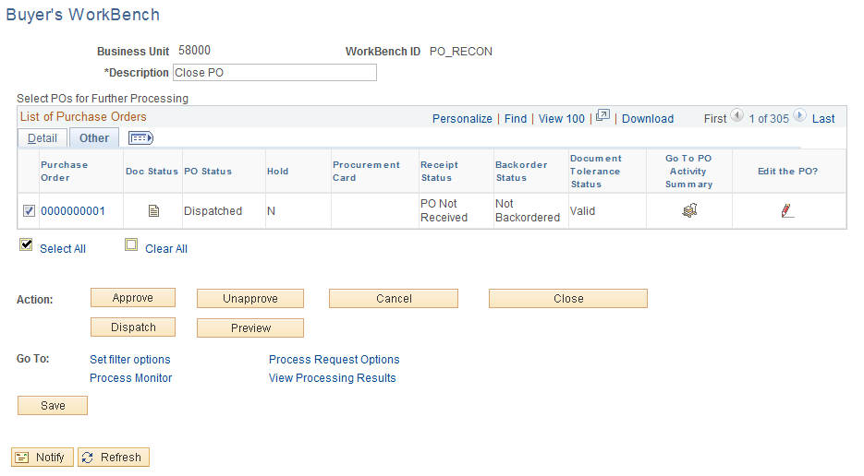

To close the PO, the Budget Status and Document Tolerance Status must equal valid. To review the Purchase Order activity, click Activity Summary icon .

Edit the PO
To go to Maintain PO’s, click the Edit the PO Icon . This will pull up a new window.

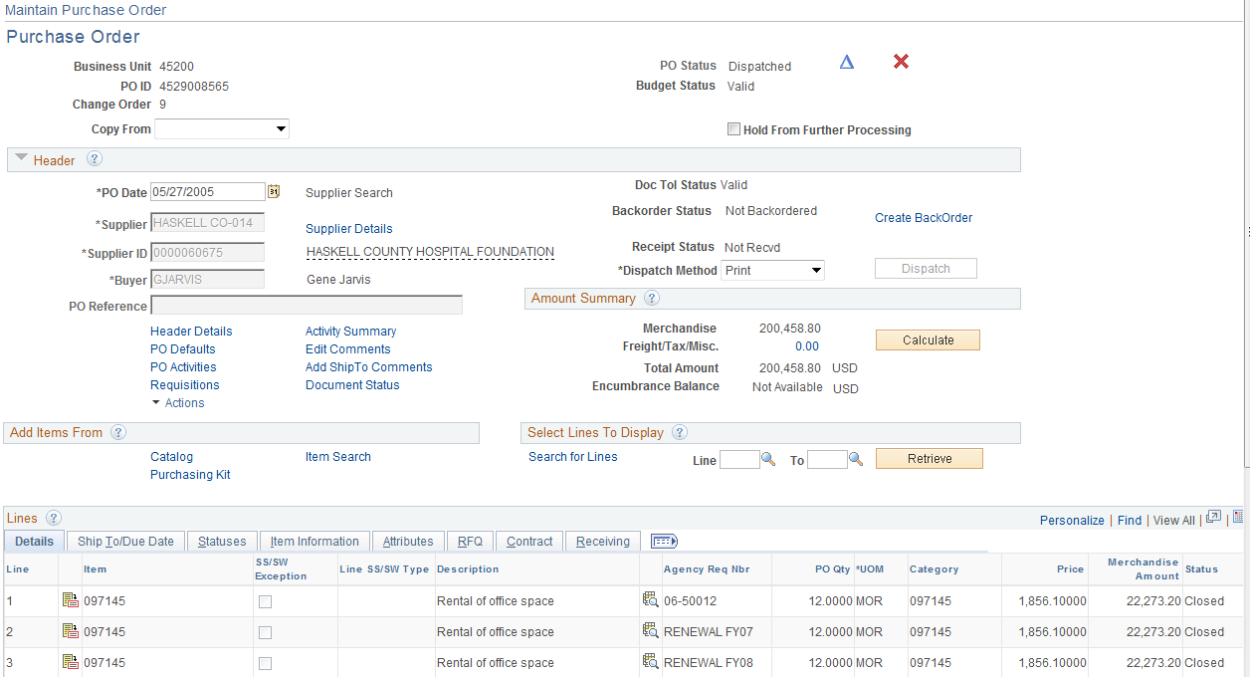
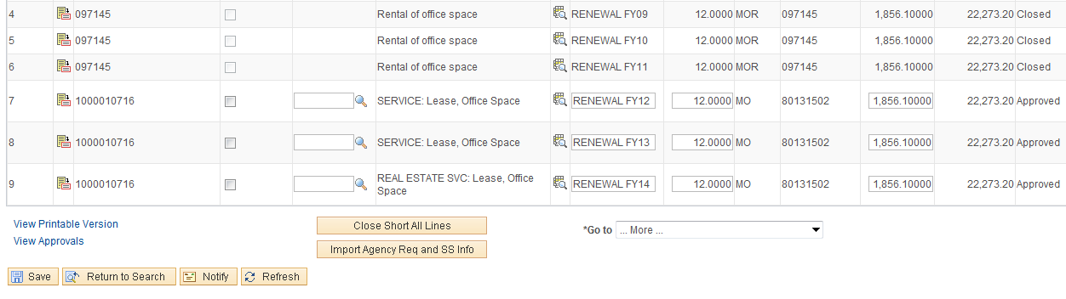

From this screen, the PO can be reviewed. Click PO Activities link.

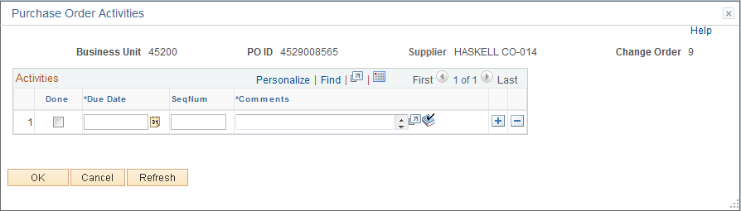

Enter the Date and Comment. It is useful for future viewing to include your name or initials in the Comment.

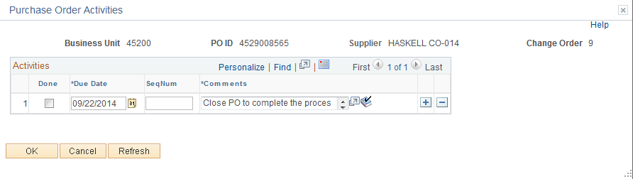

Click .

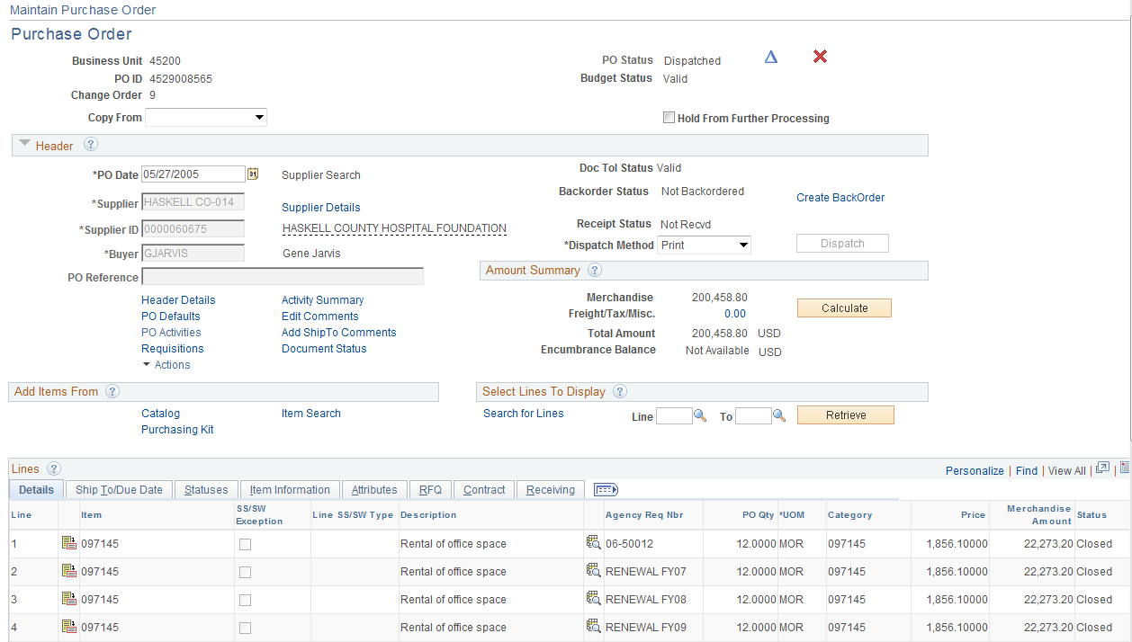

Click and close the new Window Do not use the red “X”. This cancels the PO at the Maintain Purchase Order level. You need to close the screen using the black “x” at the top right of the screen. Then you can go back to the Buyers WorkBench and close the PO there. It will not take you there if you use the red x.

Close the Purchase Order

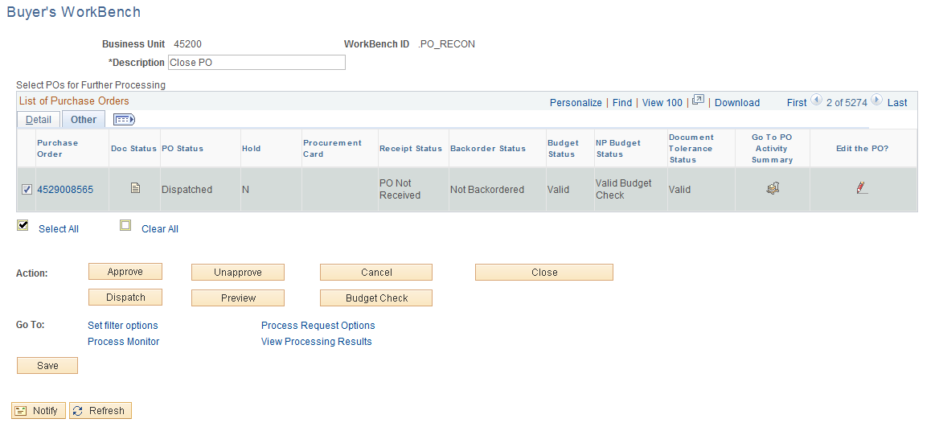

Click .

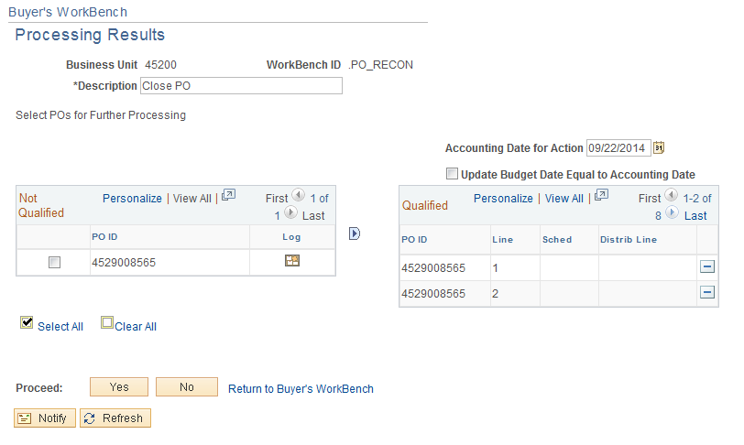

If the PO is Qualified, click .

NOTE: If not qualified, go to page 51 of this manual.

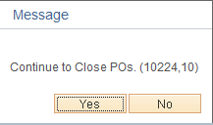

To continue click .

NOTE: The PO is now being closed.

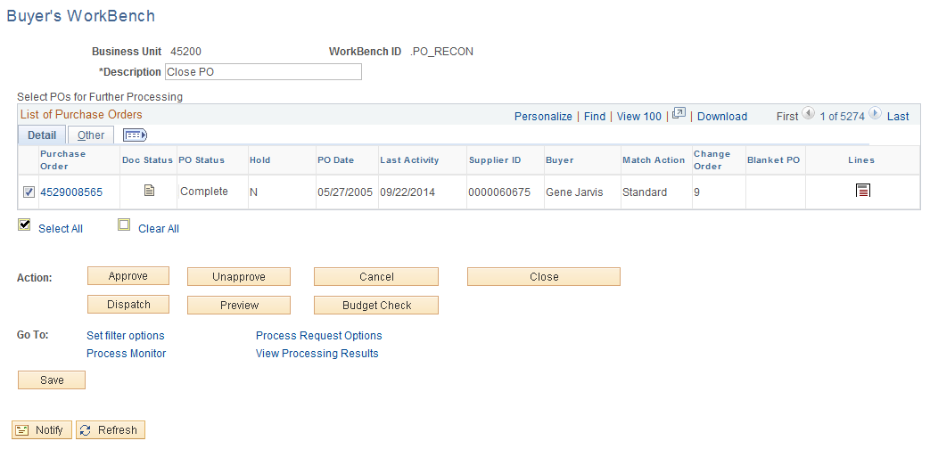

The status changed from Dispatched to Complete. Click Tab.

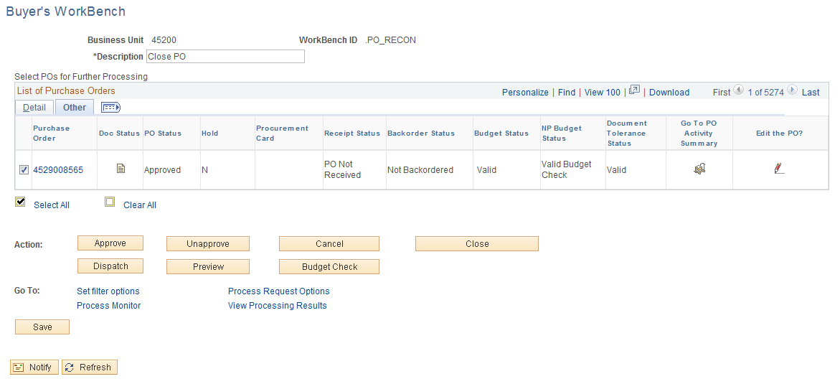

If the PO has an available encumbrance the Budget Status will change to not checked. If you click “Edit the PO” icon you will get “No Matching Values Found”. Once the PO has been closed, the PO will no longer be available from the Maintain Purchase Order Page.

Close Multiple Purchase Orders-Canceled POs
Navigation: Purchasing > Purchase Orders > Reconcile POs > Reconciliation WorkBench

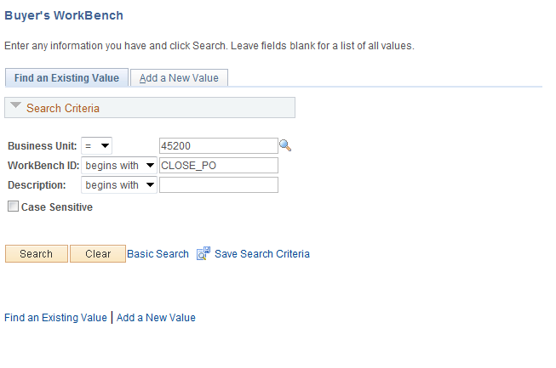

Enter BU, WorkBench ID and click . If it is the first time the user has run this process, a Run Control ID must be created.

Filter Option Page

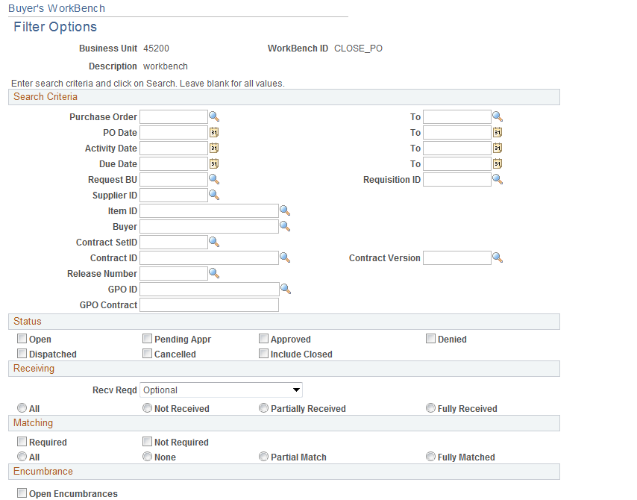
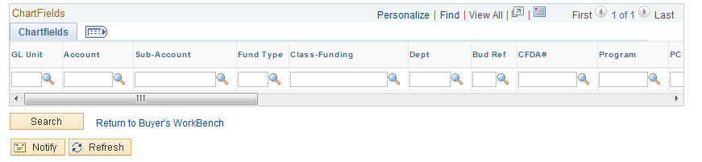

Above is the Filter Option Page. This page allows the user to enter selection criteria for the PO to display on the Purchase Order Buyer’s WorkBench Page. One PO can be selected by entering the PO number in the PO ID fields, or multiple PO(s) can be selected by using other fields such as PO status, Matching status, Receiving status, etc.

Enter the selection criteria and click .

In this example all Canceled POs will be closed, click the “Cancelled” radio box located in the “Status” section and click on the All radio button located in the Receiving section.

NOTE: Be sure to clear unwanted criteria.

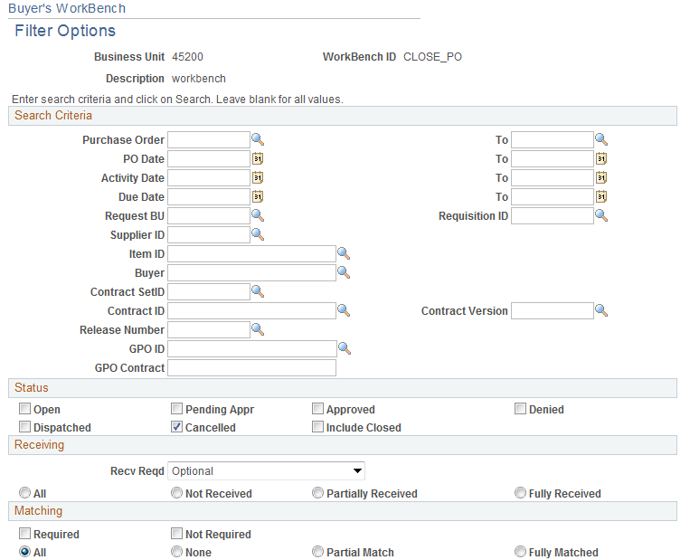

Buyer’s WorkBench
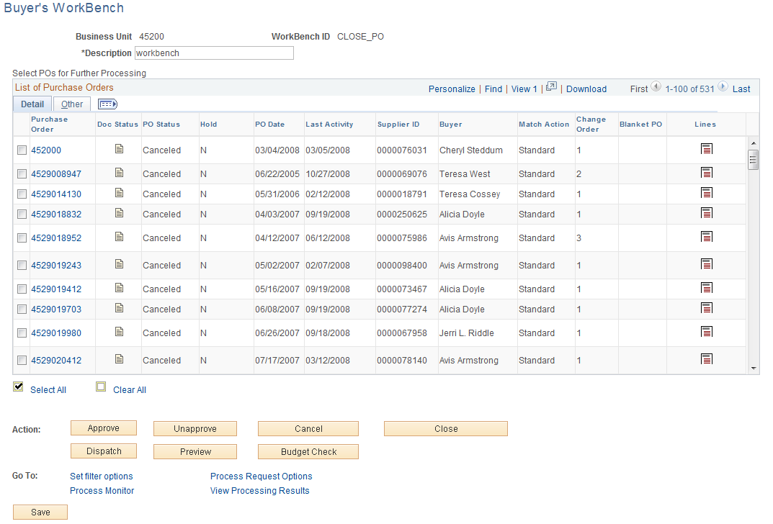

Select the View All link to view all the Purchase Orders selected.

NOTE: The PO status is Canceled.

To select individual PO(s) to be closed, click the check box located to the left of the PO or to select all PO(s) click Select All link and all PO(s) will be selected.

In this example the Select All link was selected.

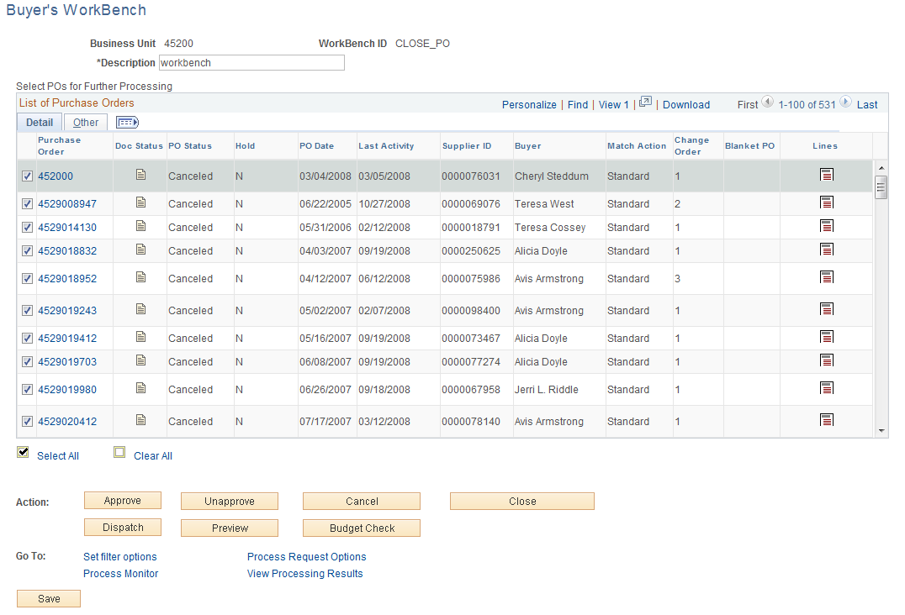

NOTE: All have been selected for closing.

Click .

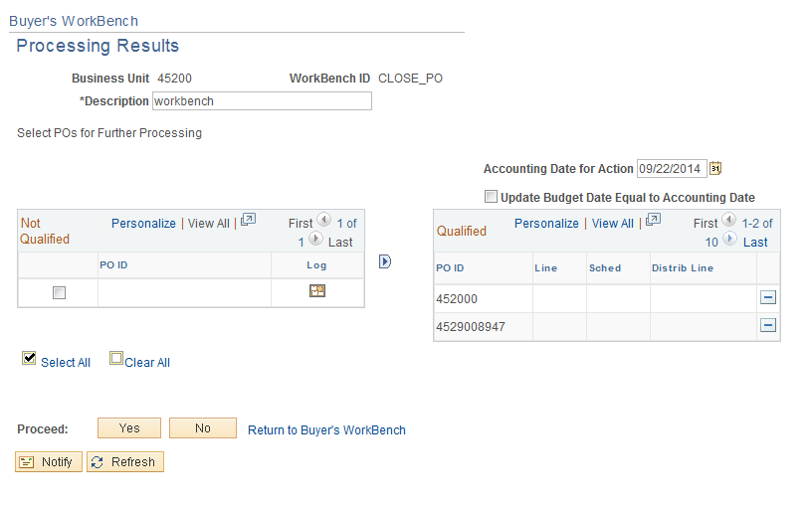

If the entire PO is Qualified, click .

NOTE: If PO does not qualify, go to page 51 of this manual.

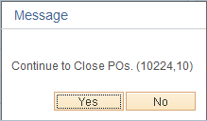

To continue, click .

NOTE: The PO is now being closed.

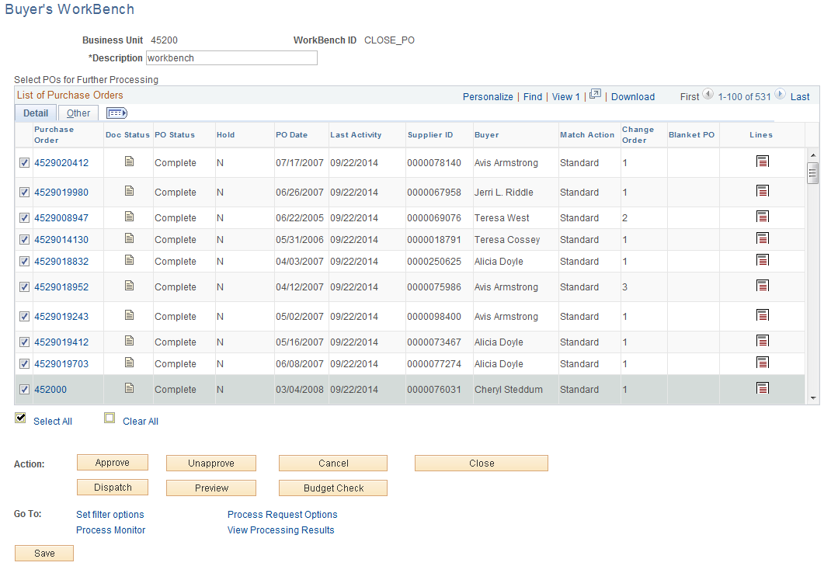

The status changed from canceled to Complete. Click Tab.

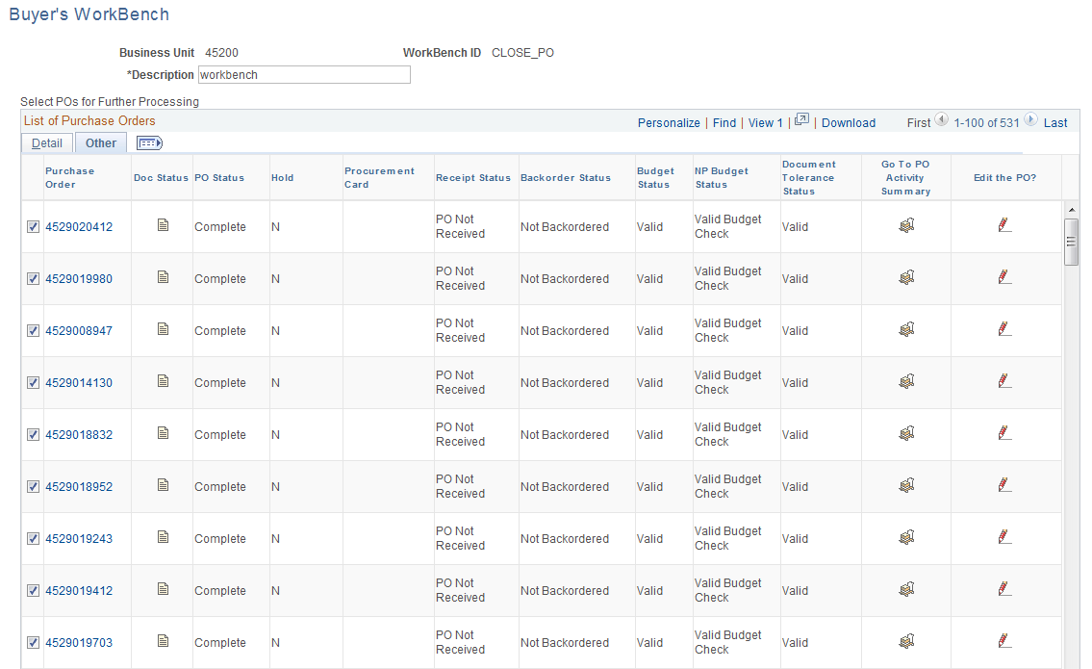

NOTE: The Budget Status and Document Tolerance Status did not change to “Not checked” because the PO(s) already had a zero encumbrance balance. Budget checking will not need to be completed.

Steps to Close a Purchase Order
- Reconcile the Purchase Order Activity Page to the Purchase Order Accounting Page.
- The Purchase Order Status must be Dispatched or Cancelled.
- The Budget Status must be “Valid”.
- The Document Tolerance Status must be Valid.

If the Purchase Order does meet any of the above criteria, de-select the check box located to the left of the Purchase Order line. This action will clear the check mark.

Review Purchase Order

Document Status
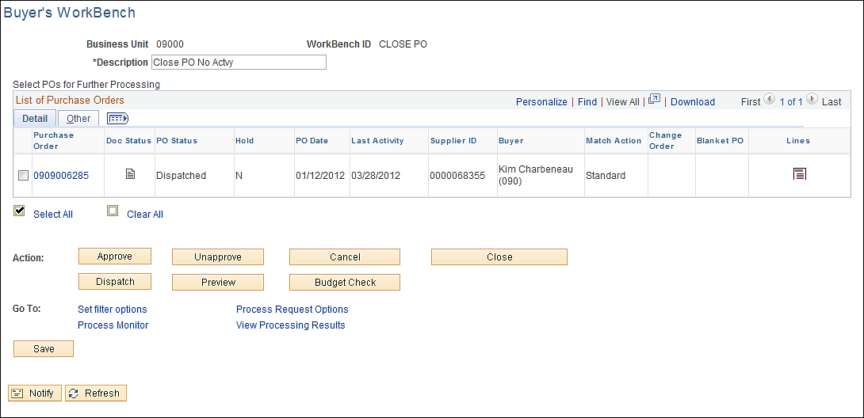

To review the PO’s associated documents, click Document Status Icon located to the left of the PO. A new window will display containing all documents associated with the PO.

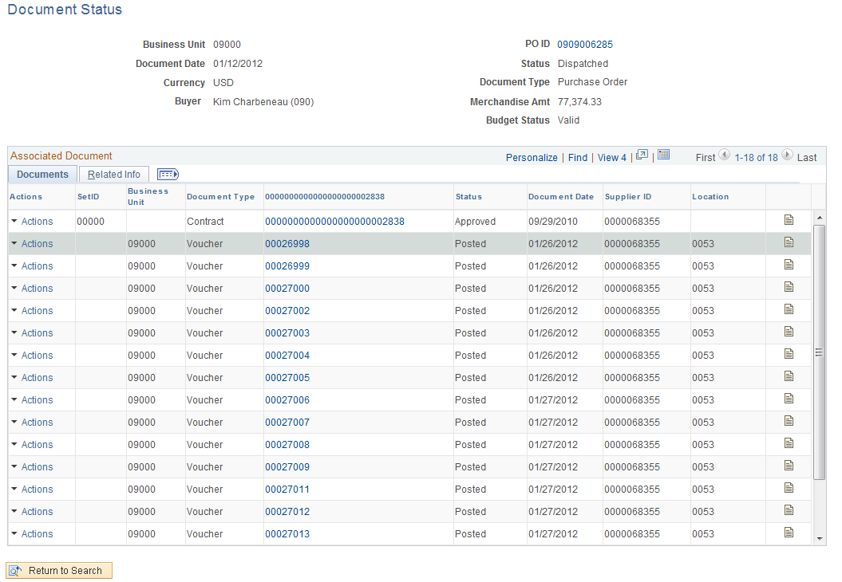

- Click View 100 link to view 100 documents at a time.
- To download this data, click Download Icon .
- To review the documents associated with the Purchase Order, click Document Status Icon located to the right of the document line.

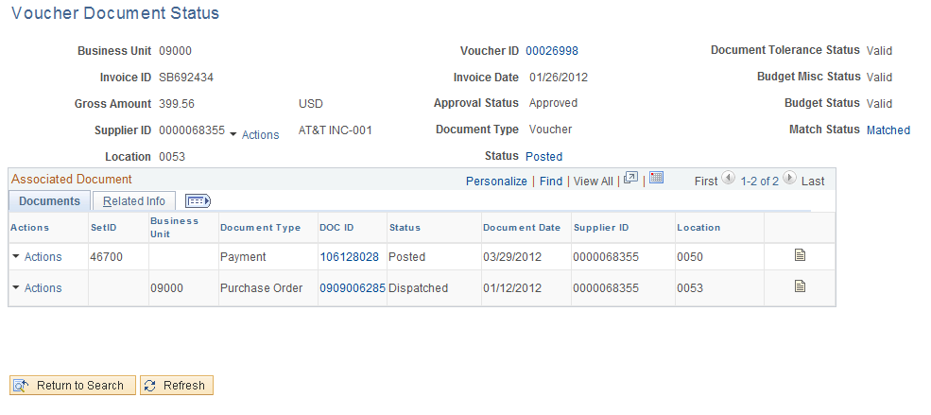

From this page you can review additional information using the DOC ID Link. To close, click the X in the top right corner.

Review PO Lines
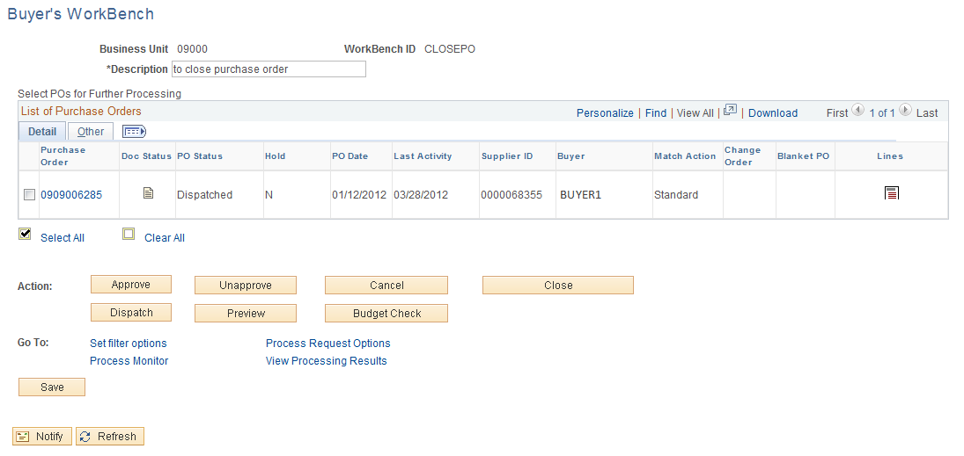

To review the PO lines, click Lines Icon located to the right of the PO.

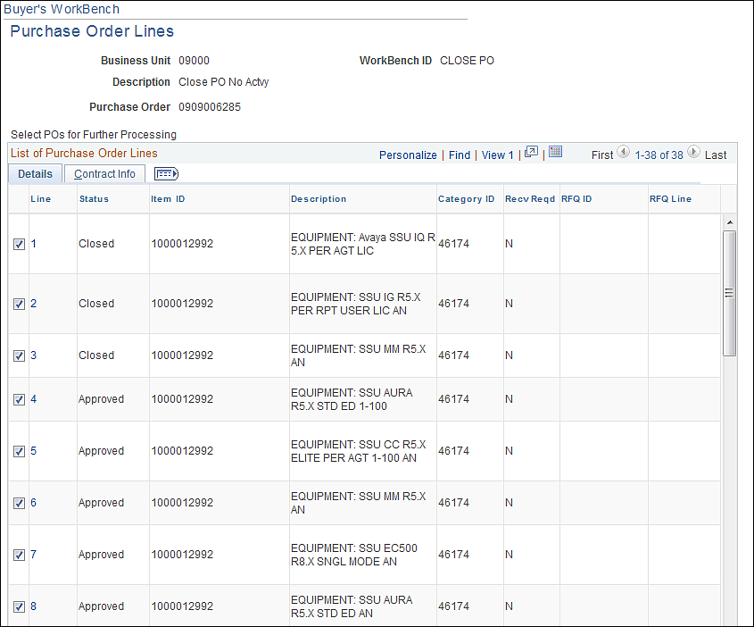

Be sure to click View All link to review all the PO lines.

Review PO Schedules
Select the link number located under the line heading. This will open the Schedule Page as seen on the page below. From here you can go to the Receiver or Maintain Distribution.

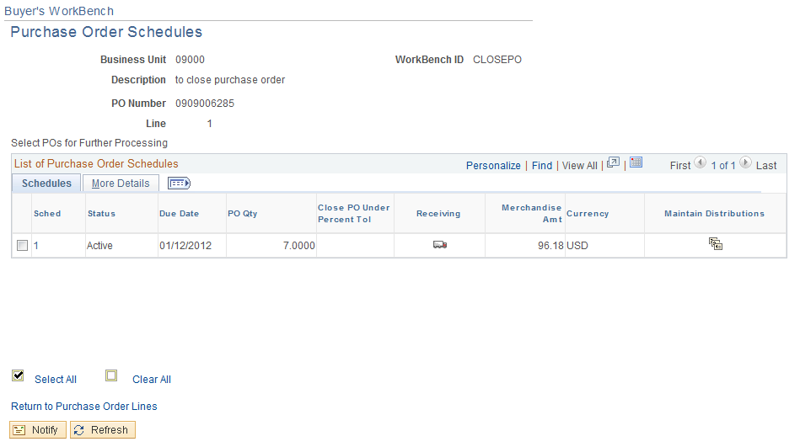

To review receivers, click ‘Receiving’ Icon. To go to Maintain Distribution and click Maintain Distribution Icon .

Click the Tab.

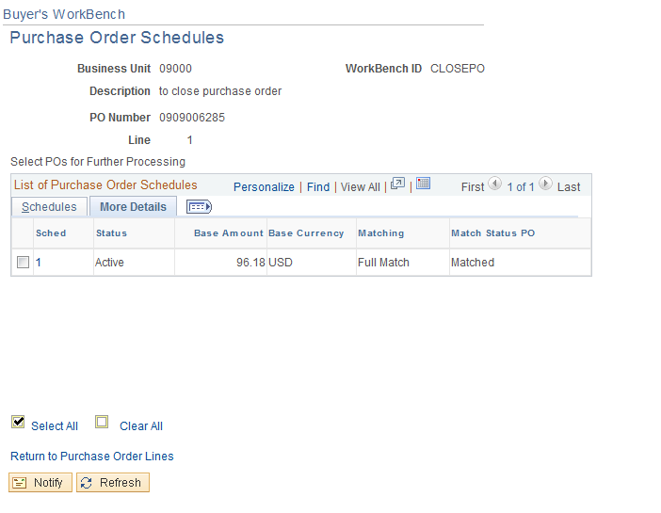

NOTE: The Match Status; if matching is required, the Purchase Order must be fully matched or an exception will be received.

Review PO Distributions
Select the number link located under the Schedule Heading. This link will open the Distribution Page as seen on the next page.

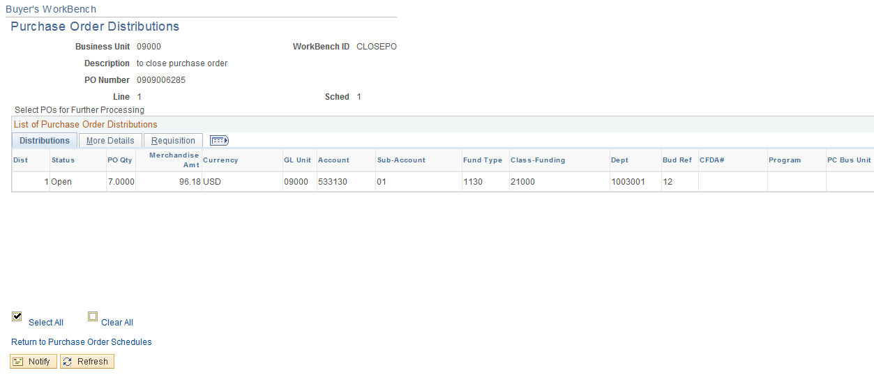

Select the Return to Purchase Order Schedules link to return to the schedule page.

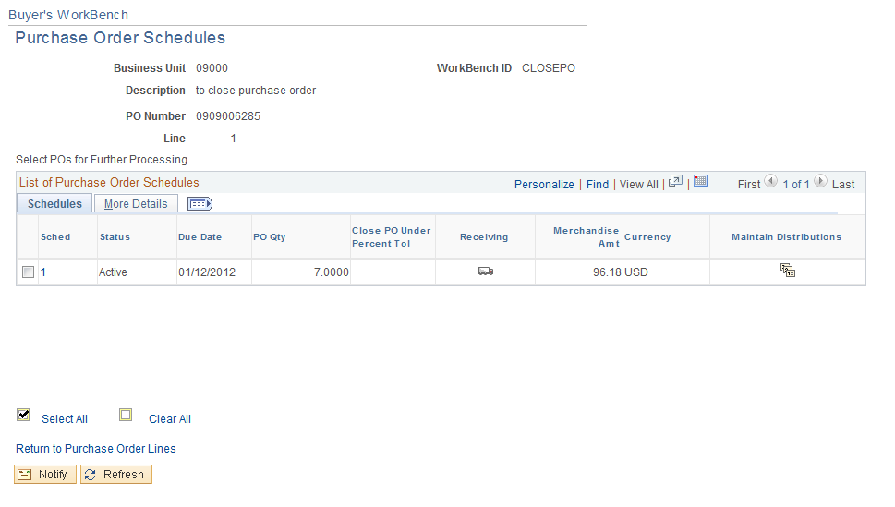

Select the Return to Purchase Order Lines link to return to the Purchase Order Line page.

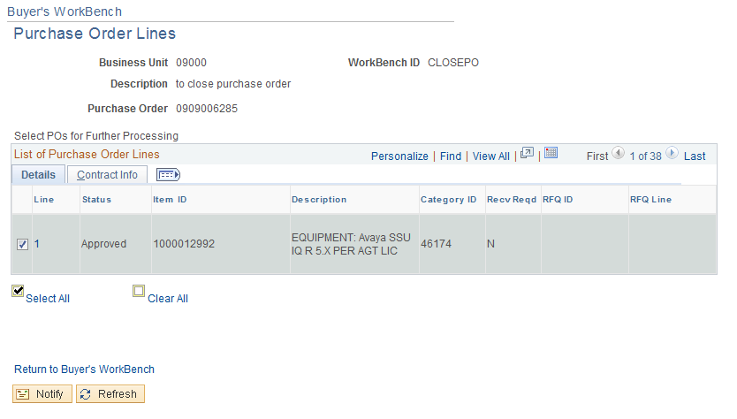

Select the Return to Buyer’s WorkBench link to return to the PO WorkBench page.

Review PO Results

Review the Not Qualified PO

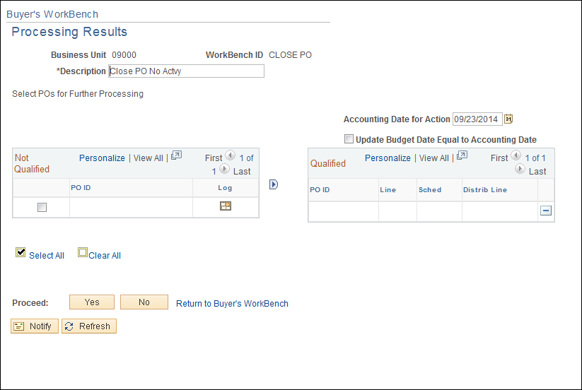

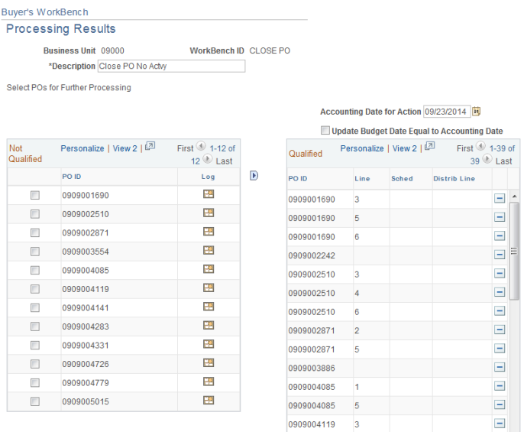

This page is the Results section and in it there is a Not Qualified and a Qualified section. The Not Qualified section is a list of PO’s with some lines that are not eligible to be closed. The Qualified section is a list of PO’s showing lines eligible to be closed.

Click Exception Log Icon .

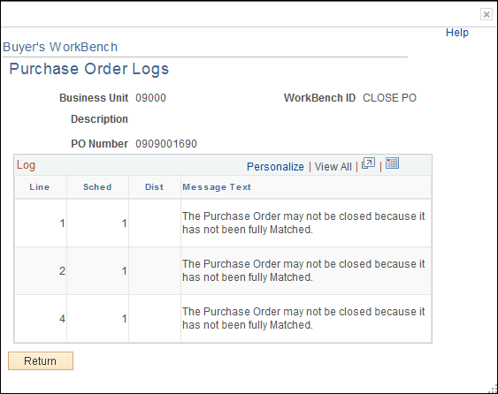

Determine if the message has any bearing as to whether the PO should be closed.

Click .

Override Not Qualified PO

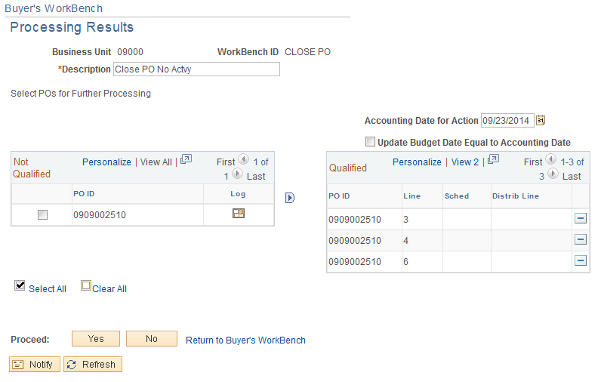

The PO can be moved from the Not Qualified column to Qualified column by clicking the empty radio box located to the left of the PO number and then the button.

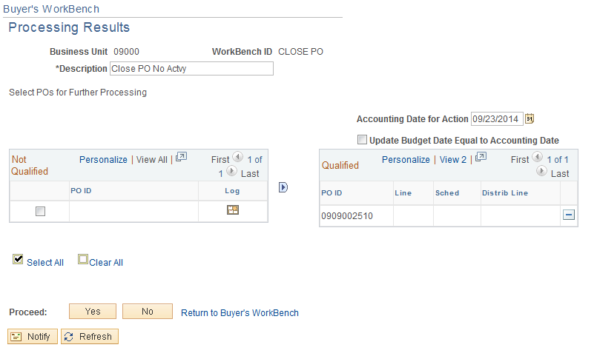

Go to page 29 of this manual, (Close a Multiple Purchase Orders-Canceled Po’s), to continue Closing PO.

Delete Qualified PO

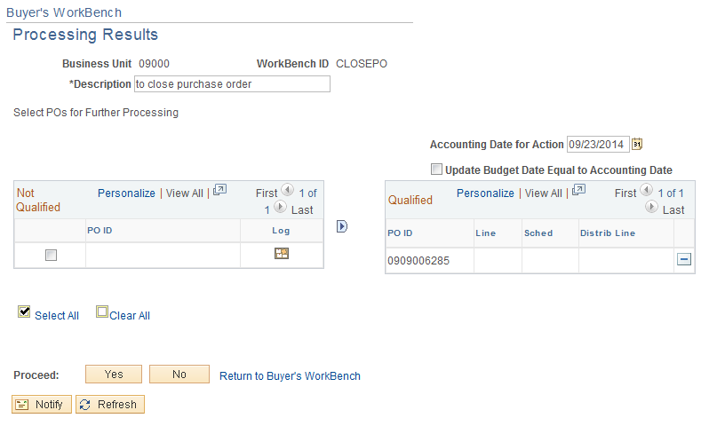

The user can delete a Qualified Purchase Order by selecting the icon located to the right of the Purchase Order number.

Budget Check Close PO
The PO budget checking process is run at Noon and in the evening. If the user does not want to wait for the PO to budget check during those times, the PO can budget check from the Batch Budget Check process page.

Navigation: Purchasing > Purchase Orders > Budget Check

Enter the Run Control ID and select .

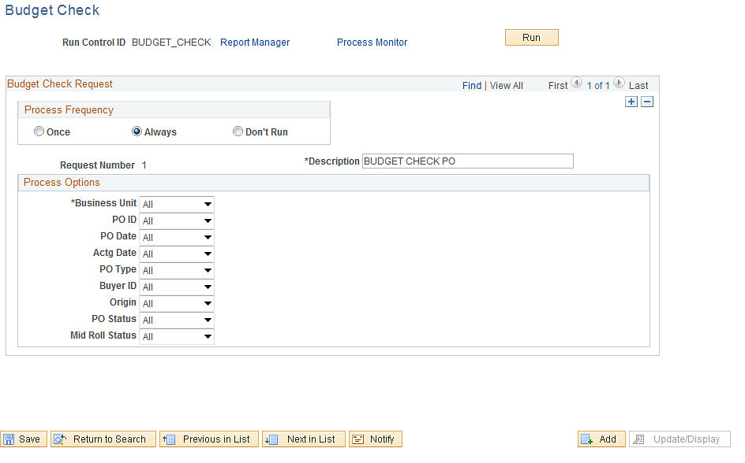

- Select Process Frequency of ‘Always’, by clicking on the ‘Radio Box’ located to the left.
- Enter a description.
- Select a value for the Business Unit option.
- Enter Business Unit ID
- Select Some for the PO Status.
- Click arrow key located to the right.
- Click Complete radio box located to the left.

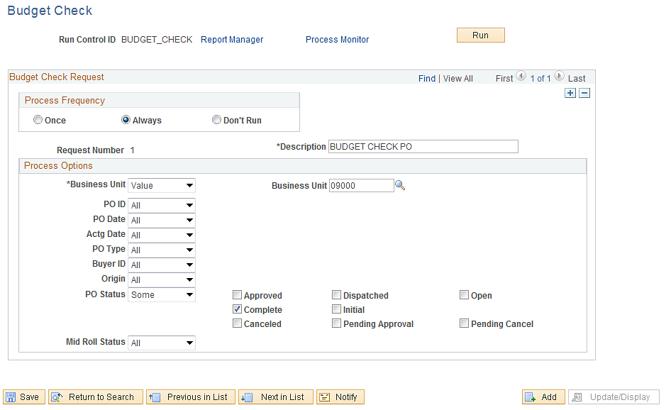

Click .

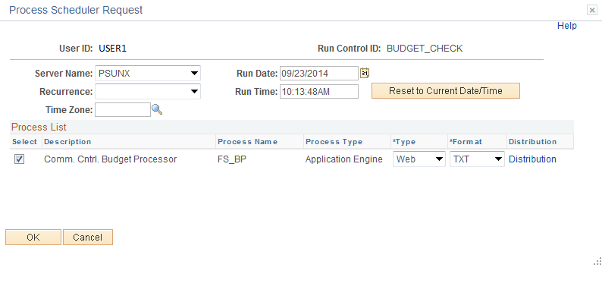

Server Name: PSUNX

Select .

NOTE: Any encumbrance balance on the Closed PO will be returned to your budget.

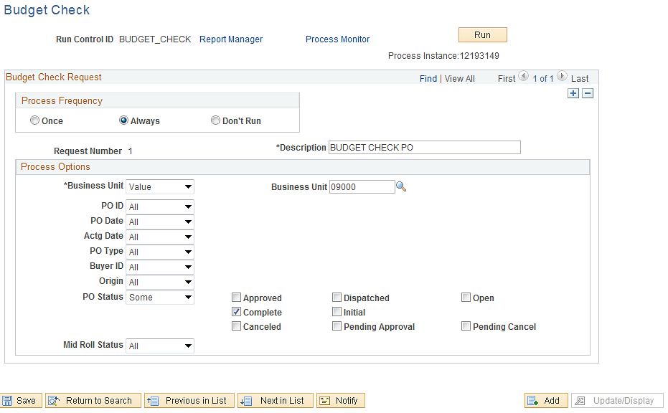

Select Process Monitor link to review the process.

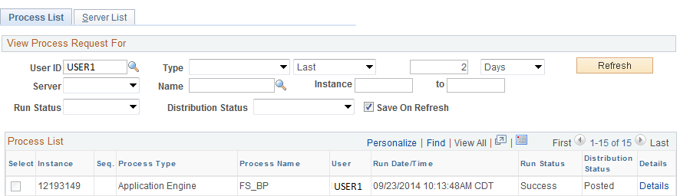

When the job is complete, click Details Link.

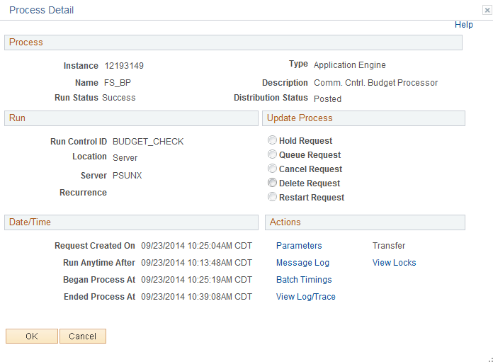

Click Message Log link.

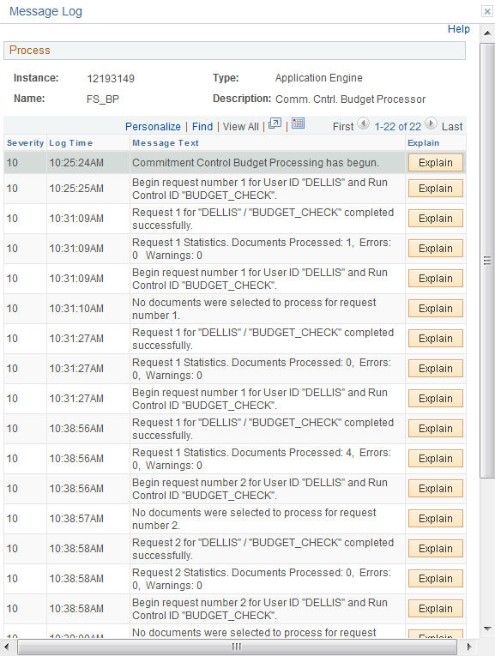

Criteria for Closing PO

Appendix A
- All vouchers associated with the Purchase Order must be posted.
- The Purchase Order must be fully matched.
- Fully Matched means:
- The quantity ordered for each line on the PO is equal to the total quantity received and matched.
- The quantity ordered is within the specified Close PO Under Quantity Percent Tolerance.
- The PO is distributed by quantity and all quantities have been matched.
- The PO is distributed by amount and the extended dollar amount has all been matched.
- If a line item has been canceled and all other lines are fully matched, the Matching link on the PO header will never update to Fully Matched but the PO will be eligible to close.
- If the Purchase Order is set up as No Match but Receiving is required, the receiving must either be turned off or the product must be received.

Purchase Orders Not Qualified Messages
MESSAGE | DEFFINITION | RESOLUTION | OVERRIDE
The PO Line is tied to an active Voucher; therefore it may not be closed. | There is a voucher that has not been posted. Therefore it may not be matched or budget checked. | The voucher needs to be fully processed. (Budget check, matched and posted and if possible paid.) | No
POs with Receiving Required On though not received | The PO is usually an AO set up as No Match but the PO was set up as Receiving Required. Receiving was not done. When the voucher was created it was not required to go through matching so the voucher did not fail match. | You can either process a receiver or turn receiving off.  We prefer agencies begin using the receiving. | Yes
The Purchase Order may not be closed because it has not been fully Matched. | 1. The PO was not fully received and/or paid and will not be.  2. The PO will not fully match because the “Distribute By” selection (PO distribution page) was not fully utilized. If the “Distribute By” is AMOUNT then you must fully match on amount. If the “Distribute By” is QUANTITY then you must fully match on quantity. | If you are sure you will not be using this PO again then you can override the criteria. If you are not sure then you need to process a change order  On #1 you may want to process a Change Order.  On #2, if you have received all your quantities and the PO will not fully match it is probably because it is “Distributed By” AMOUNT and you have not fully utilized all of the PO line item(s) amount. You may want to override the criteria. | Yes
The Purchase Order’s Activity Date us greater than the Calculate PO Close Date |  |  | Yes
Cannot close PO with unchecked or error budget status on header. | The PO is in an error status. | The PO is in an error status and must be fixed before the system will close it. | No, if it is in an error status.

Close a Purchase Order Line
Navigation: Purchasing > Purchase Order > Reconcile POs > Reconciliation WorkBench

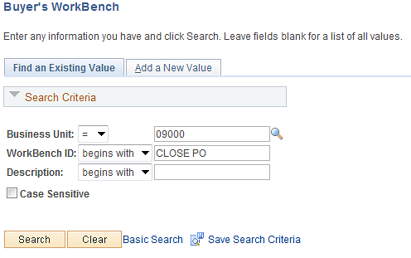

Enter your BU, WorkBench ID, and click . If it is the first time the user has run this process, a Run Control ID must be created.

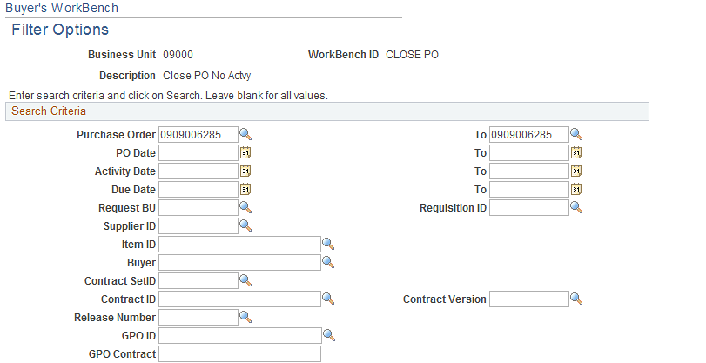
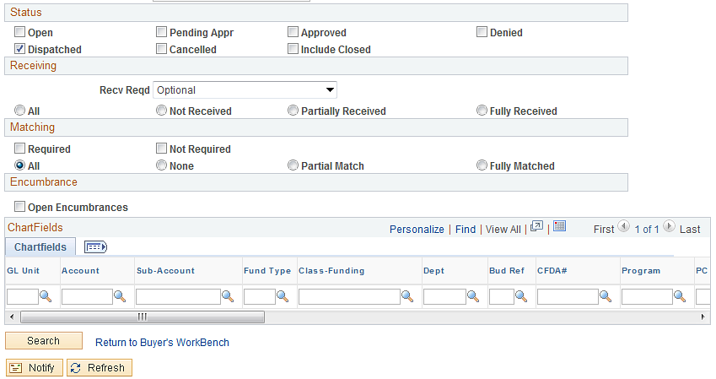

Enter the selection criteria and click .

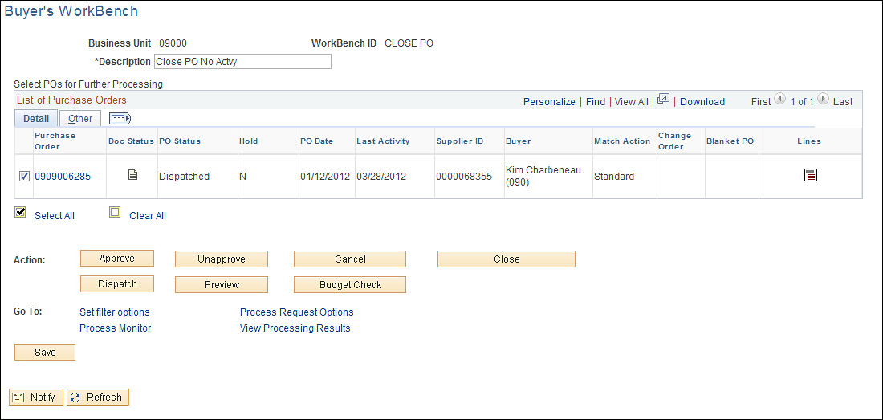

Click the check box located to the left of the Purchase Order number and scroll right.

Click the Lines Icon .

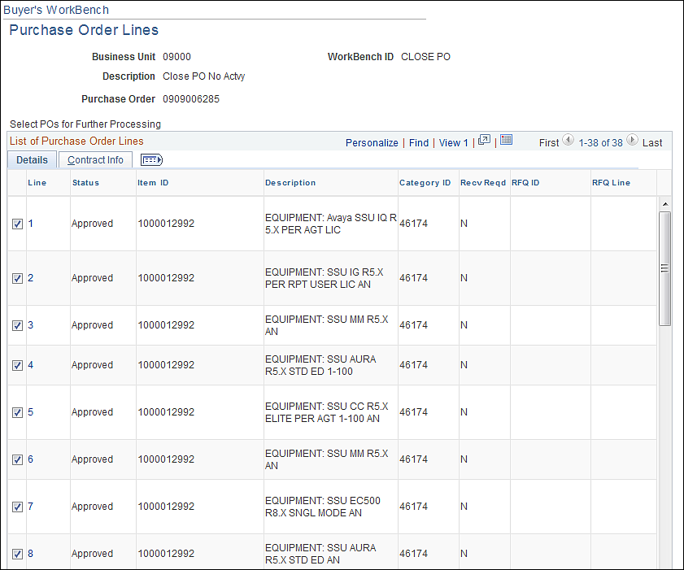

NOTE: All the lines have been selected; deselect the lines you do not want to close.

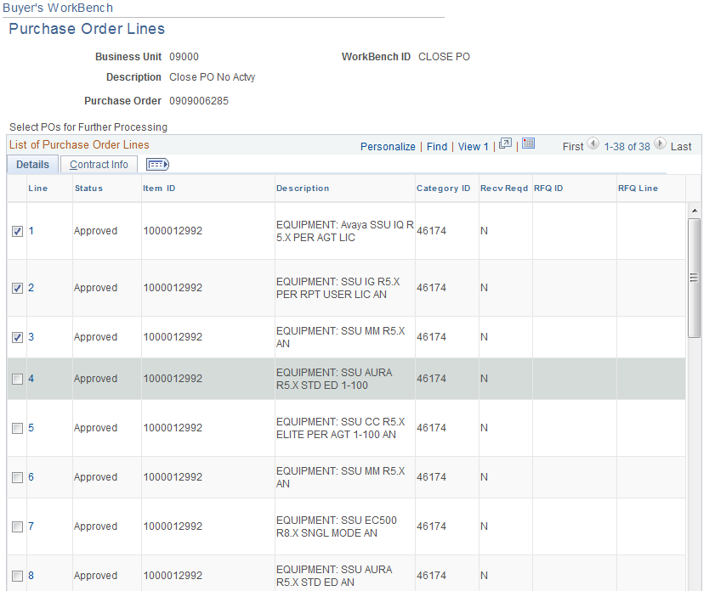

Click Return to Reconciliation WorkBench link.

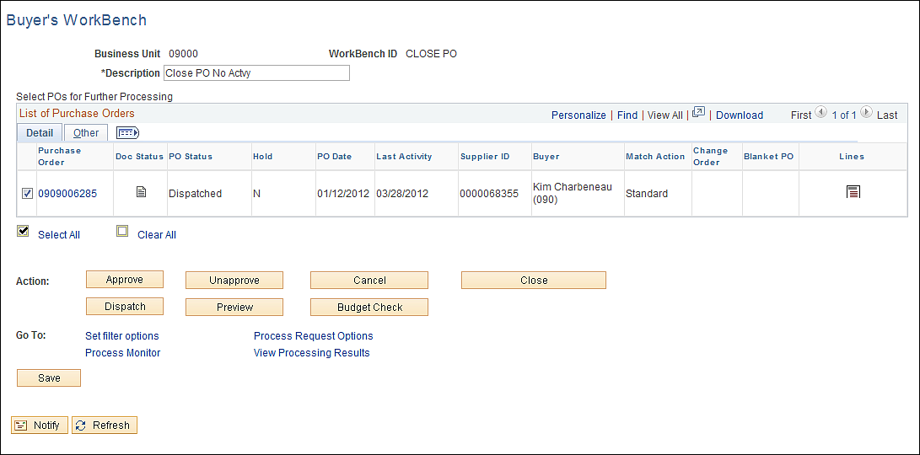

Click . .
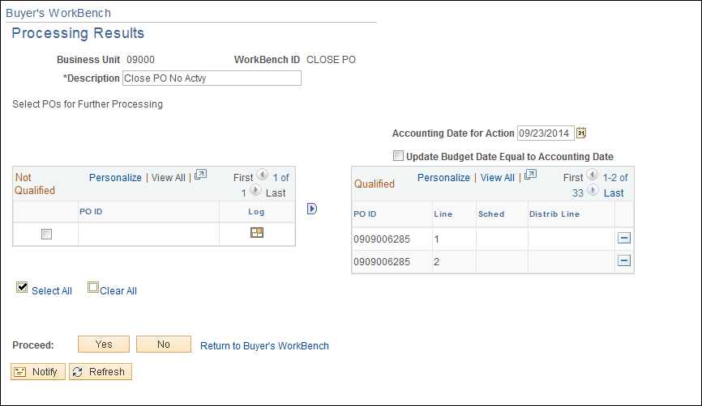

NOTE: NOTE: You must pay close attention to the qualified section. This section will tell you if you are canceling a Purchase Order, Purchase Order Line, or Purchase Order Schedule.
- If it was closing the Purchase Order only, the Purchase Order number will be present.
- If you are closing the Purchase Order line, the Purchase Order number and line will be present.
- If you are closing a Schedule, the Purchase Order number, line and schedule will be present.

Click . To view all lines returned, click the View All link.

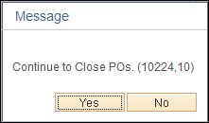

Click .

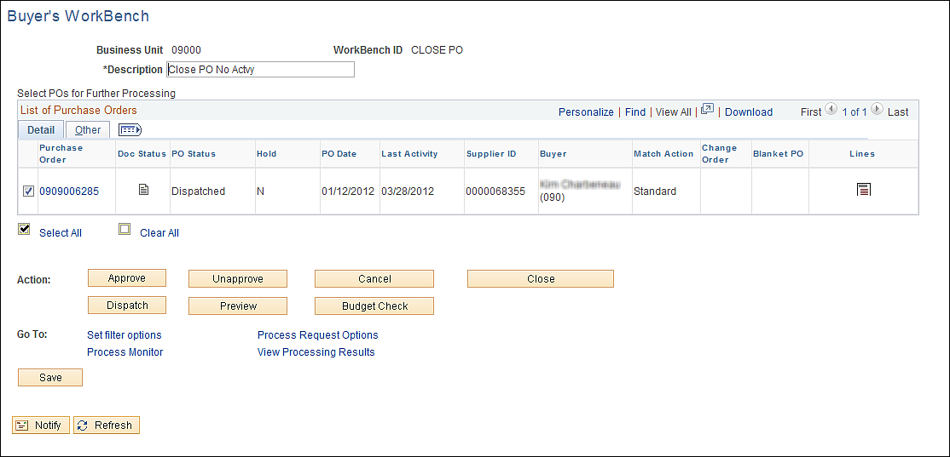

Click the Lines Icon located to the right.

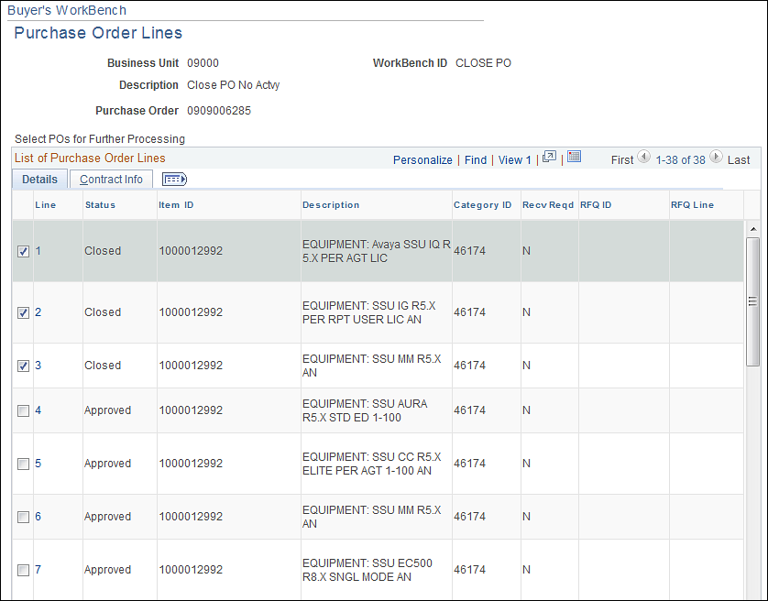

The line has been closed. This can also be closed on the schedule line.

