COR110 – Purchase Order Administration Manual

Table of Contents

Create Direct PO - Single Line 6
Step 1 – Enter Purchase Order Data 6
Step 2 – Update Header Details 10
Step 3 – Enter the Header Comments 11
Field Definitions 12
Standard Comments 14
Step 4 – Input Item ID 18
Step 5 – Verify Line Item Details 22
Details Tab. 22
Ship to Due Date Tab. 23
Status Tab. 23
Item Information Tab. 24
Attributes Tab. 26
RFQ Tab. 26
Contract Tab 27
Receiving Tab. 28
Step 6 – Enter Liner Comments 31
Field Definitions 31
Standard Comments 35
Step 7– Verify Shipping Details and Input Distribution Info. 41
Schedule 41
Details Tab. 42
Statuses Tab. 43
Shipment Tab. 43
Matching Tab. 44
Receiving Tab. 45
Freight Tab 46
RTV Tab. 47
Distribution Information 48
Chartfield Tab. 48
Details/Tax Tab 50
Asset Tab- 51
REQ TAB. 52
Status Tab. 53
Step 8-Pre-Approve PO 56
Step 9-Budget Check PO 58
Overview 58
Budget Checking 58
Step 10-Purchase Order Approval 60
Overview 60
Approving a Purchase Order 60
Amount Approval Page 61
Step 11-Dispatch Purchase Order 63
Step 12-Print Purchase Order 65
Create Direct PO - Multiple Line 67
Step 4 – Input the Item ID 67
Create Multiple Schedule Line PO 71
Step 7– Verify Shipping Details and Input Distribution Info. 71
Schedule 71
Create PO-Copy From Requisition 74
Step 1 – Enter Purchase Order Data 74
Step 2 – Copy Requisition to Purchase Order 77
Step 9 – Finalizing the Requisition from the Purchase Order and Budget Checking. 81
Create PO-Sourcing From Requisition 84
Step 1 – Select the Requisition to Source 84
Review the Sourcing Workbench Page 87
Step 2 –PO Calculation 89
Step 3 –PO Creation 94
Step 4 –Review the Purchase Order 98
Dispatch Purchase Order 101
Dispatch From Batch Process 101
Dispatch from the Reconciliation Workbench. 103
Print Purchase Order 109
Print from Process Monitor 109
Print from Report Manager 114
Print from Purchase Order 115
Purchase Order Inquiry 119
PO Accounting Page 119
Purchase Order Activity Page 124
Purchase Order Inquiry Page 133
Budget Checking 136
Budget Checking from Batch Process 136
Budget Checking Error 147
Purchase Order Header Default 150
Using Header Defaults 150
Supplier Look Up 161
Category 176
Finalizing Po (Requisition) 182
Sole Source/Sole Brand Affidavits 192
Sole Source/Sole Brand Approval Authority 194
Purchase Order Types 195
Purchase Order Type And Origin 197
Messages 198
Price Adjustment Page 205
Customize Distribution Fields 207
PO Activity Link 210

Authorized by: [_EBS_] Original Issue: [11/01/2004]
Maintained by: [____Procurement Lead___] Current Version: [10/1/2014]
Review Date: [10/1/2014]

Document History
Document Revision | Date | Description
1.0  2.0 | 04/30/2010  05/01/2014 | Initial Document  Upgrade Update

Create Direct PO - Single Line

A Purchase Order is a commitment to buy goods or services from a supplier. Upon budget checking the Purchase Orders funds are encumbered (obligated) from a budget to ensure funds are available when the product or service has been received. If a Requisition is processed the pre-encumbrance will be released when the encumbrance is established. Like a Requisition the Purchase Order consist of these basic elements: headers, lines, schedules, and distributions. Each requisition has one header, which can have multiple lines. Each line can have multiple schedules. Each schedule can have multiple distributions.

Step 1 – Enter Purchase Order Data
Follow the following navigation

Navigation: Purchasing > Purchase Orders > Add/Update POs > Add a New Value
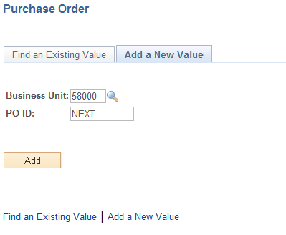

Business Unit - Defaults to specific agency for each User.

Purchase Order Number-Defaults to NEXT. The system will auto number each Purchase Order.

NOTE: Do not change the Purchase Order ID data field. Let the system default NEXT into the data field. The Purchase Order number will be assigned upon saving.

Click the button to take you to the Maintain Purchase Order page.

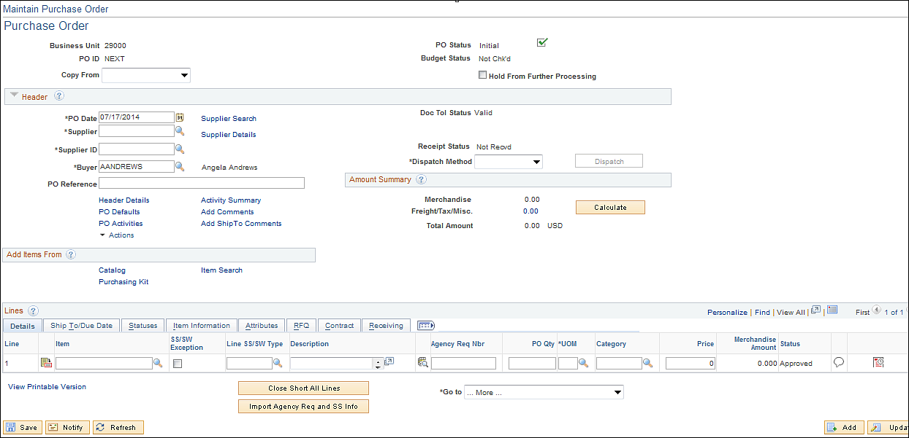

NOTE: The PO date defaulted to today’s date. (Leave this field alone so the PO date will always be the creation date.)

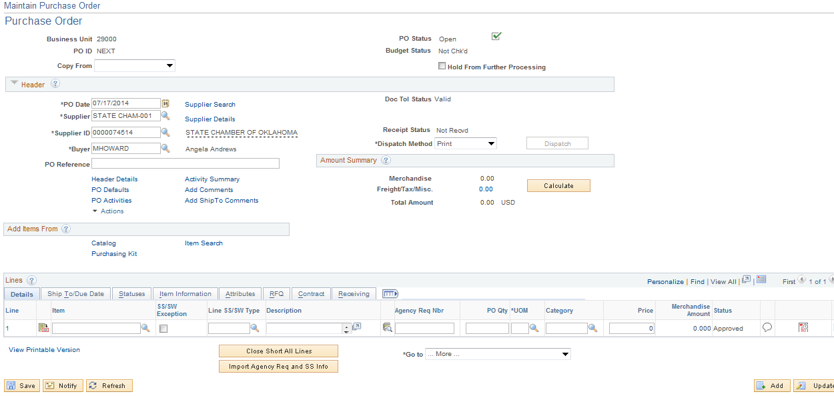

Input the Supplier Id and Buyer. Click the Supplier Details link to review the supplier’s location and address. (See Appendix page 178 for the Supplier Look Up process). Click the button to validate data.

The PO status changed to ‘OPEN”

Hold from Further Processing: Processes will not run against a PO if this box is checked.

PO Reference-Will populate if with the originating document number if using sourcing.

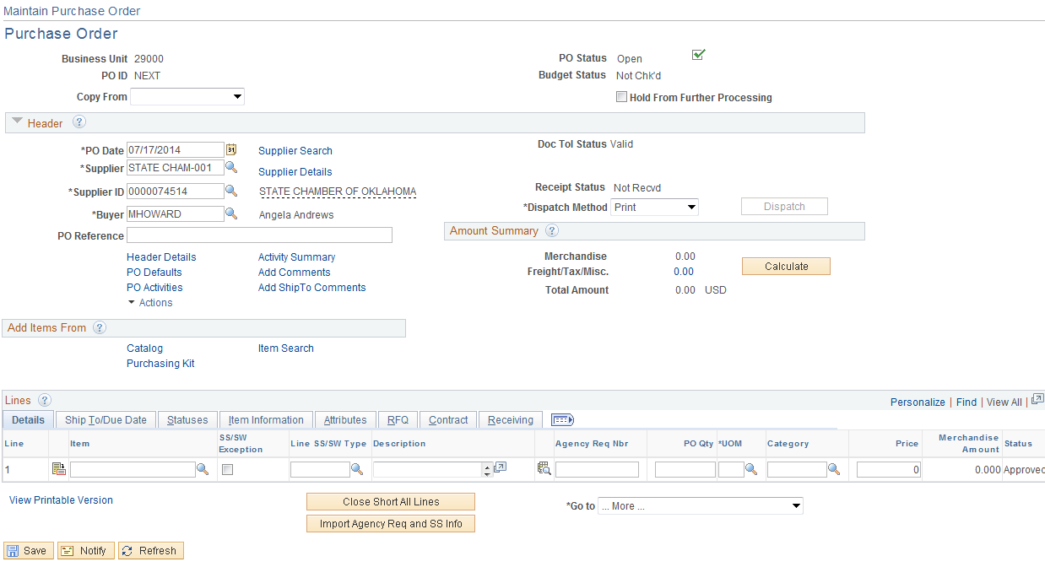
Step 2 – Update Header Details
Information entered on this page is associated with the entire Purchase Order.

Click the Header Details link.

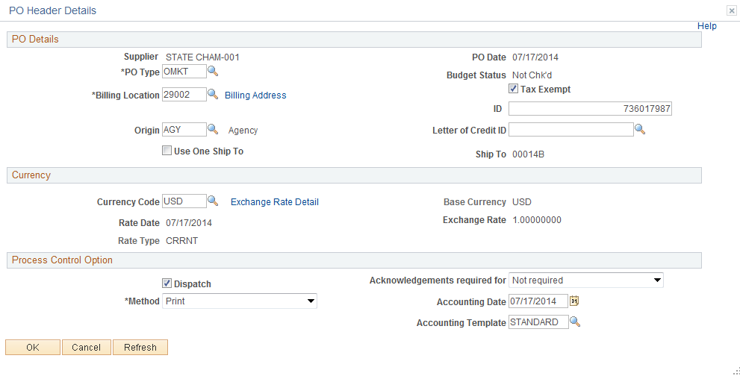

PO Type: This field will establish the type of Purchase being created. (See appendix page 198 for PO Type).

Billing Location: The field identifies where the invoice should be sent, such as the Main Office of a Department within an agency.

Origin: The origin may need to be changed. The origin is used to describe who will complete the Purchase Order. This defaults from your user preference and is normally AGY- Agency. Change the origin to CP= Central Purchasing, CAP = Construction and Properties, LSG = State Leasing, EXC = Exempt (Statewide) (See appendix page 200 for PO Origin).

Dispatched: The default is “on.” This indicates that once the PO has been successfully checked for Document Tolerance and Budget Checking, the PO is scheduled for the next Dispatch process. To prevent de-select the Radio Box located to the left.

Method: Defaults from the Business Unit definition. Method can be overridden with any valid value as needed.

Accounting Date: Defaults to today’s date and should not be changed, this date will determine the FY and Accounting Period assigned in Commitment Control.

Update information on this page and click the button to return to the Maintain Purchase Order page.

Step 3 – Enter the Header Comments
Access the Header Comments page by clicking on the Add Comments Link.

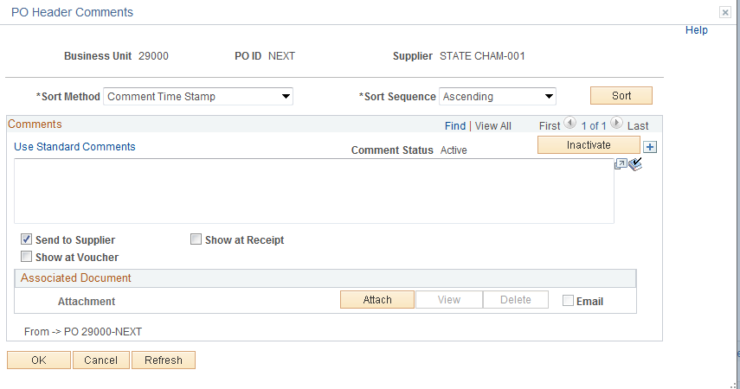

Input any comments to send with the Purchase Order in the Comment Field.

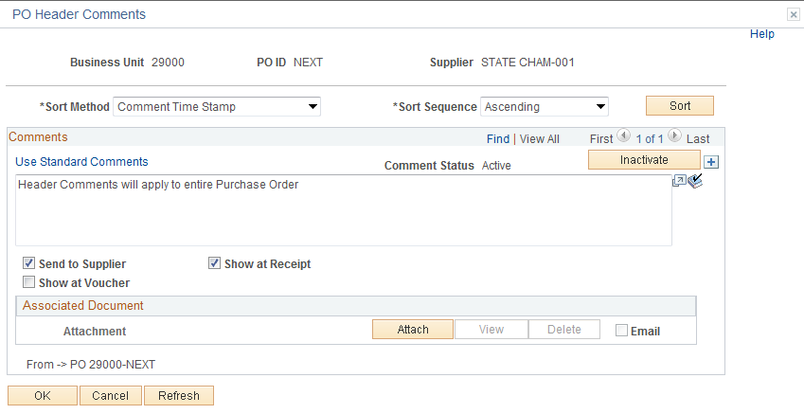

NOTE: The Send to Supplier check () box by default will be checked. If you want this comment to appear on the receipt or voucher check () the appropriate box.

NOTE: When there are multiple comments, the system will display only the most recent comment. The (Find, View All, First, backwards arrow symbol, 1 of 3, forward arrow symbol, and Last) display indicates the number of comments available for viewing. To view the remaining comments, either press the forward arrow symbol to go to the next comment or press View All to see all of the comments in the scroll area. To return to viewing only one line and its associated schedules, press View 1.

Field Definitions

Retrieve Active Comments Only – This field is available after the Purchase Order has been saved. The radio box is selected by default. If you want to select the inactive comments deselect the radio box and click the button.

Inactivate Button - Click this button to inactivate the currently displayed comment. The comment is not actually deleted, but is set to an inactive status.

Sort Method – Select the method that you want to use to sort the comments retrieved:

Comment Time Stamp – Sorts the comments by the time stamp assigned to them when they were created.
Supplier Flag – Sorts the comments flagged to be sent to the supplier.

Sort Seq – Select Ascending or Descending.

Sort Button- Click this button to sort comments according to the selections that you made in the Sort Method and Sort Sequence fields.

To add additional comments, click on the plus button in the upper right corner of the comment page.

PeopleSoft gives you the ability to attach a file to your Purchase Order. Currently this feature is not being utilized.

Standard Comments
The Department of Central Services requires certain Purchase Orders to contain certain comment concerning the purchase. Instead of having to type this information into each Purchase Order, Department of Central Services has come up with a list of Standard Comments when selected will default in. These comments are called STANDARD COMMENTS and must be added to these Purchase Orders. See Department of Central Services rules and regulations.

Click the Use Standard Comments Link.

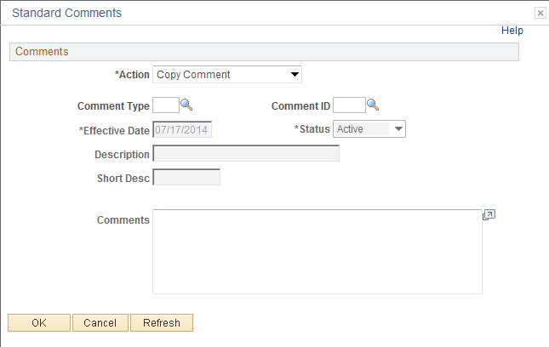

From this page, select the “Standard Comment” by inputting the Comment Type and Comment ID. If you do not know this information then click the Look Up Icon located to the right.

Click the Look Up Iconfor the Std Type.

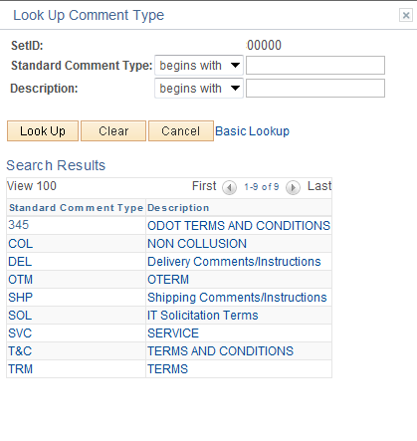

Select the comment by clicking on it. In this example Non-Collusion will be used.

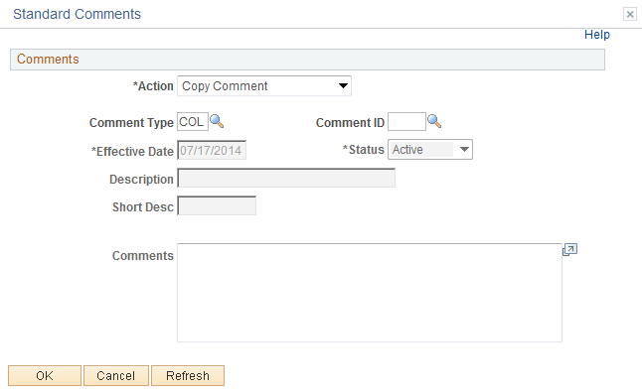

Click the Look Up Iconfor the Comment ID.
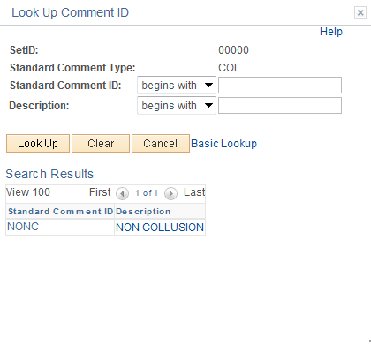

NOTE: The Comment ID is unique to the Comment Type.

Select the comment by clicking on it.

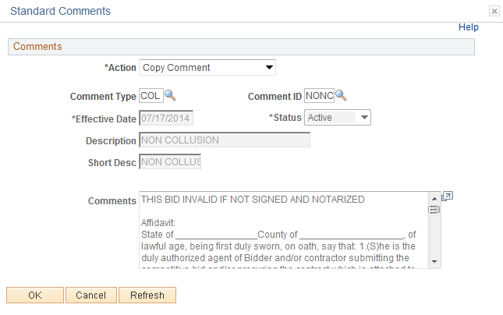

Notice the comments copied in, this saved time.

Click the button.
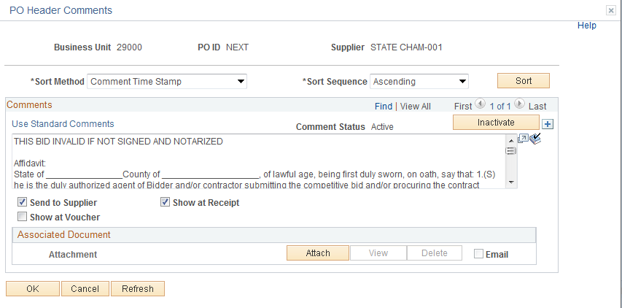

To view all comments click the View All link.

Click the button.

Step 4 – Input Item ID

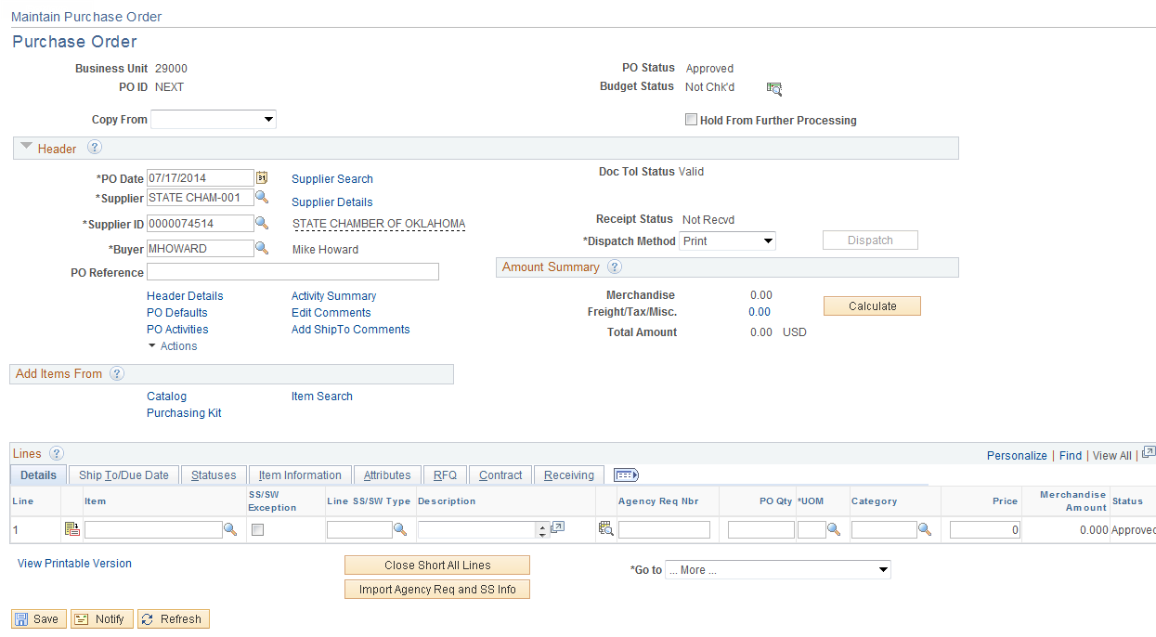

Notice the Add Comments Link changed to Edit Comments.

Input the Item ID and click the button, if the Item ID is not known then click the Look Up Icon located to the right.

Click the Look Up Icon

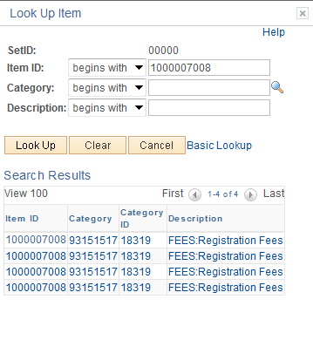

To narrow your results, input an item number, category, o description and click the button. In this example, a description of FEES was used and received the following results.

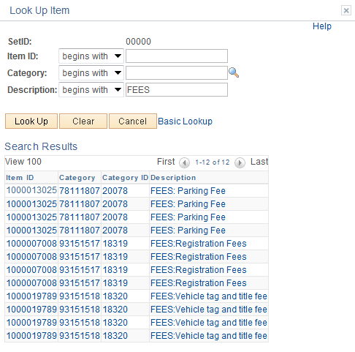

Make your selection by clicking on the link. Choose an item.

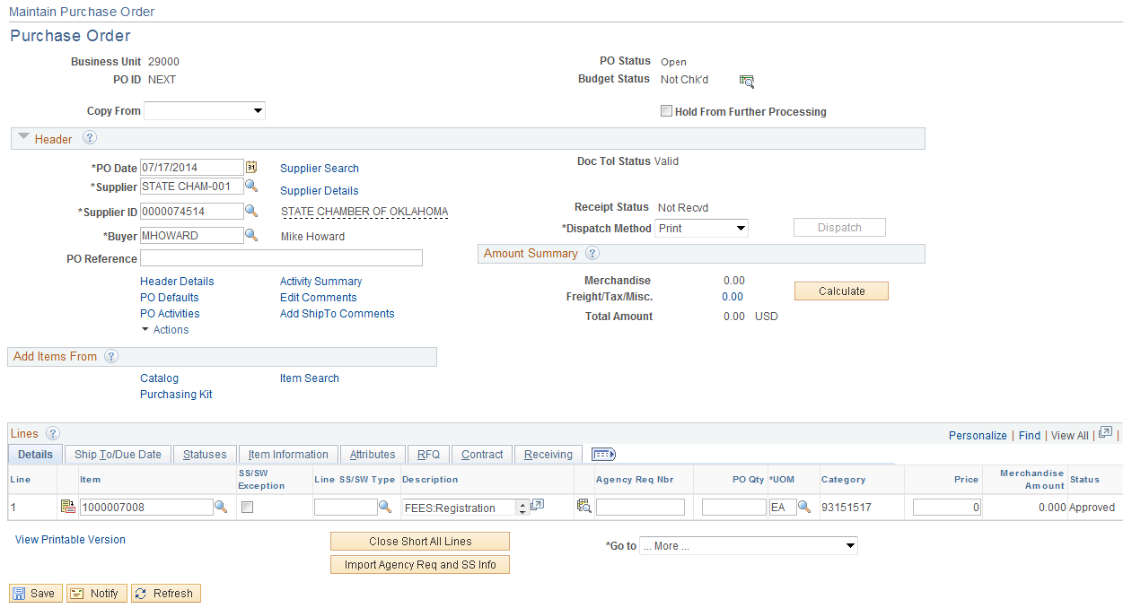

The Description defaulted in from the ITEM ID.

Input the PO QTY and click the button to validate the data.

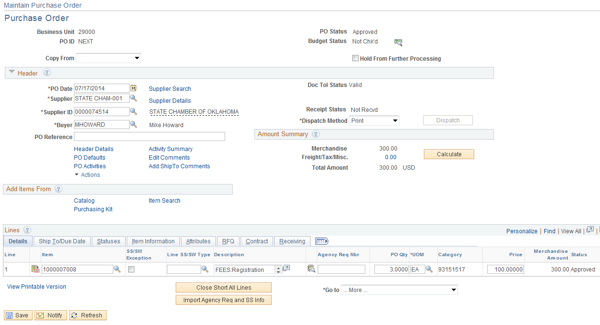

The amount defaulted in from the ITEM ID.

Step 5 – Verify Line Item Details

Use the Line Details page or Line to verify or modify additional details on the line, such as the Receiving Required, Contract Data, and other line specific information. To review the Line Details click the Line Details Icon located to the left of the line or click the Tabs located above the line.

Details Tab
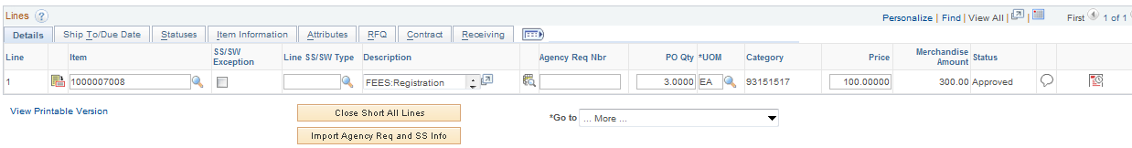

- Item ID-Select the ID of the item that you want to order. If the item that you want to order does not have an item ID, choose to order the item by description only. To do this, enter item information in the Description field. This is not recommended.
- SS Flag and SS Type – This field is used to report Sole Source information.
- Description-If you are ordering an item by description only, enter item information in this field. If you specify an item ID, the description appears from the Purchasing Attributes page and can be changed.
- Agency Req Nbr-Input your Agencies Internal Requisition Number.
- Quantity- Enter the item quantity to order. The quantity is recalculated if you change the unit of measure.
- UOM-The UOM will default from the Item ID. It can be changed by clicking the Look Up Icon .
- Category- Enter the category for the item on the Purchase Order line. If you specify an item ID, the category defaults from the Item ID, and cannot be changed.
- Price-The Price will default from the Item and will need to be change.
- Amount-Quantity X Price.
- Line Comment Icon-Click the Line Comments button to access the Line Comments page. Use this page to maintain line comments.
- Schedule Icon-Click this button to access the Purchase Order - Schedule page, where the view schedule shipment details and distribution information is located.
- Plus or Minus Icon-Add or Delete a Line.

Ship to/Due Date Tab
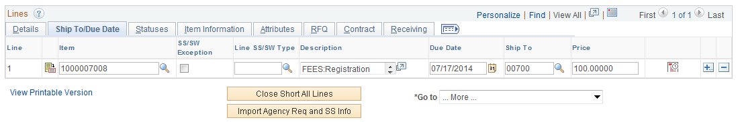

- Due Date-Date shipment is due or service is due.
- Ship To-Location the product will be shipped to or service performed at.

If you input the Due Date and Ship To data on this page, it will default to the Schedule Page.

Statuses Tab

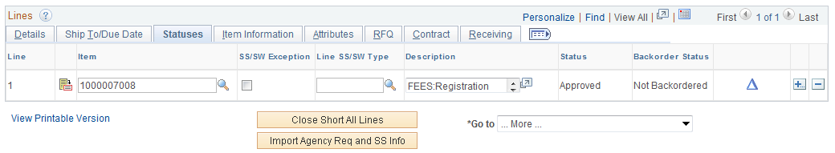
- Line Status-The status of the line appears. Values are: Active, Canceled, or Closed.
- Backorder Status- Backorder status displays. Values include: None, Backorder and BO Received.

Item Information Tab

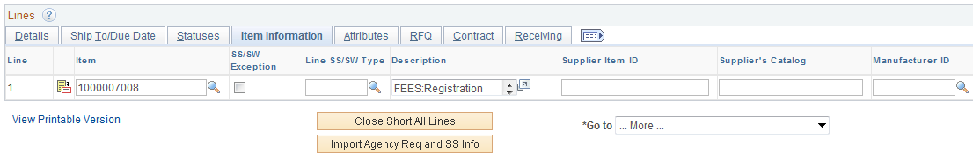

- Device Tracking- Select this check box to indicate whether a line contains a device-tracked item. Currently not using
- Supplier Item ID/Supplier Catalog- The supplier catalog and ID assigned. Values default from the Item ID. (Optional)
- Manufacturer ID- This value is required on all Assets. Select from a list of values by clicking on the Look Up Icon . If the value is not know then leave blank or clear the default value. This data can be updated when receiving the Item.
- Manufacturer’s Item ID-Value defaults from the Item ID. (Optional)
- UPN ID-Universal Production Number ID. Currently not using
- Replenish Code- Displays the replenishment code setup for the line item if it is either a replenishment or stockless item. A purchase order can have either stockless or replenishment items only. You cannot have both types on the same purchase order. Currently not using.
- Stockless- Select this check box if the line item is a stockless item and, therefore, supplied directly from the supplier based on a previously established agreement. If a stockless item purchase order line cannot be fulfilled on the first receipt, the remaining quantity on the line is canceled. You can then run the Close Backorders process (PORC500) to close partially received stockless orders or orders that have not been received within a specified number of days. Currently not using.
- Withholding-Select this check box to indicate that the voucher line that matches this purchase order line may be subject to withholding. Supplier defaults determine whether this option is checked or unchecked.

Attributes Tab

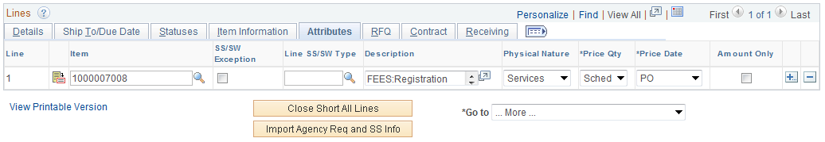

- Physical Nature-Will default to Goods, Select to indicate whether the object is a physical good or service.
- Price QTY-Quantity that the system uses to determine minimum order quantities and price adjustment quantities. Leave as Schedule
- Price Date-Date that the system uses to determine minimum quantity and price adjustment dates. Select PO (purchase order date) or Due (schedule due date). The price date works in conjunction with the value in the Price Qty field. Leave as PO
- AMOUNT ONLY- This option is used to bypass matching on PO QTY and match only on the Extended Amount. Select this check box to designate the line as an amount-only line. If selected, the purchase order quantity value on the line is set to 1 and the field becomes unavailable for entry. The Distribute by will change to Amount and user will receive a message when trying to change it to Quantity.

RFQ Tab

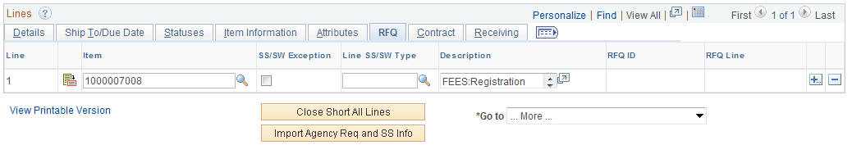

- RFQ ID/RFQ Line-If the PO was created from an RFQ, the RFQ number and line will be displayed.

Contract Tab

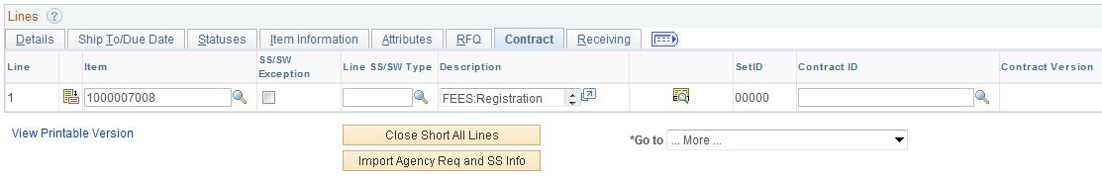

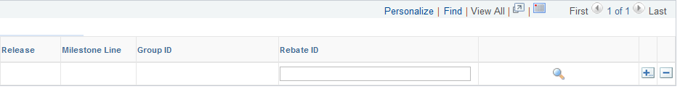

- Contract ID/Contract Line-If the Purchase Order was created from a Contract, the Contract number and line will be displayed.
- Release-If the Purchase Order was created from a Contract, the release number will be displayed.
  - You will no longer be able to copy the contract directly to the Purchase Order. For Additional Information review the Contract Release Manual.
- Milestone Line-Currently not using.
- Rebate ID-Currently not using.

Receiving Tab

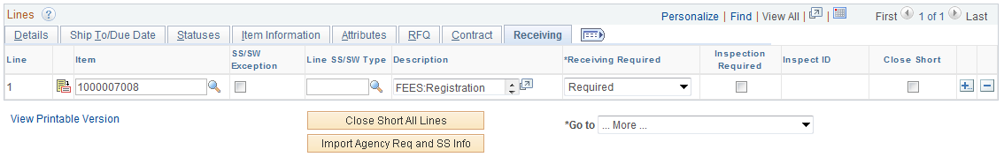

- Receiving Required-This option is used to require the Item Ordered be received and be matched to a payment. This option defaults in from the Item ID as being required and must be changed to Do not Receive if not required or the voucher will fail matching. There is now a third option Receiving Optional - This option will give users the ability to receive the item but not match it.
- Inspection required -Select the Radio box under Inspection required if the product needs to be inspected. This will require the inspection to be matched to a PO and Voucher.
- Inspection ID-Currently no Inspection IDs have been defined. Not using.

Click the Line Details Icon located to the left the line to review the line details vertically.

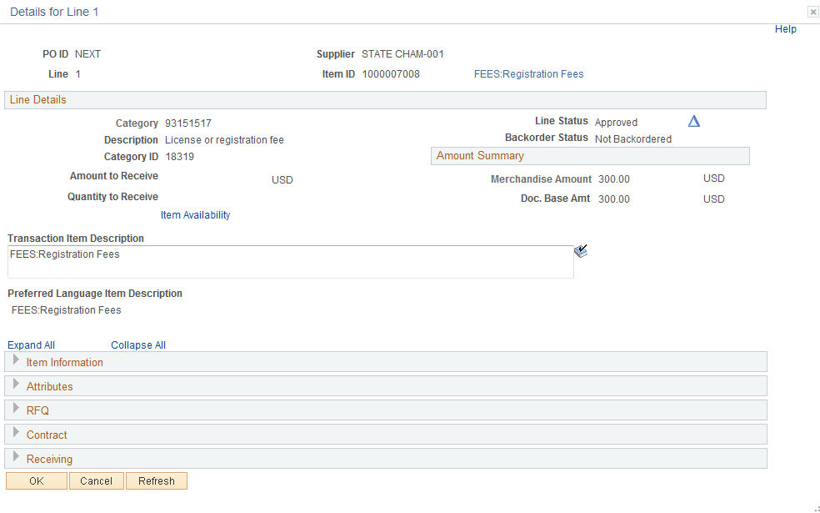

To review the data click the , this will expand the details. The same data will be available as in the TAB.

Click the button.

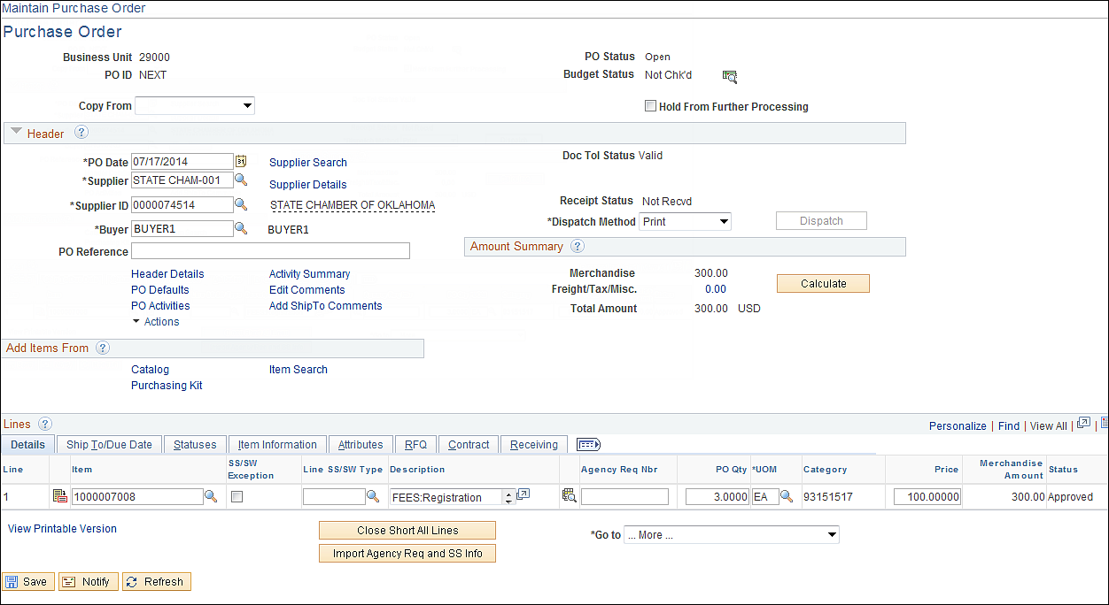

To continue processing click the Details Tab.

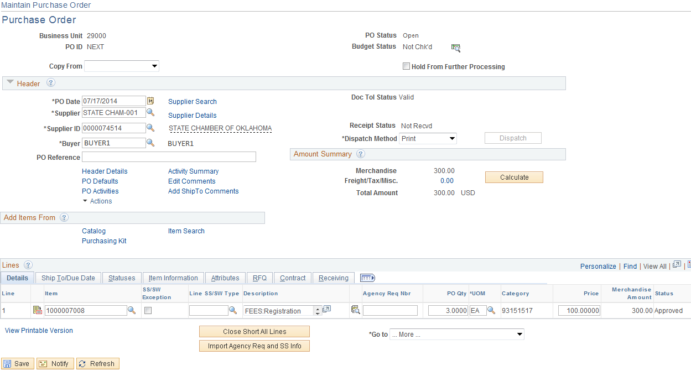

Step 6 – Enter Liner Comments
Click the Line Comments Icon .

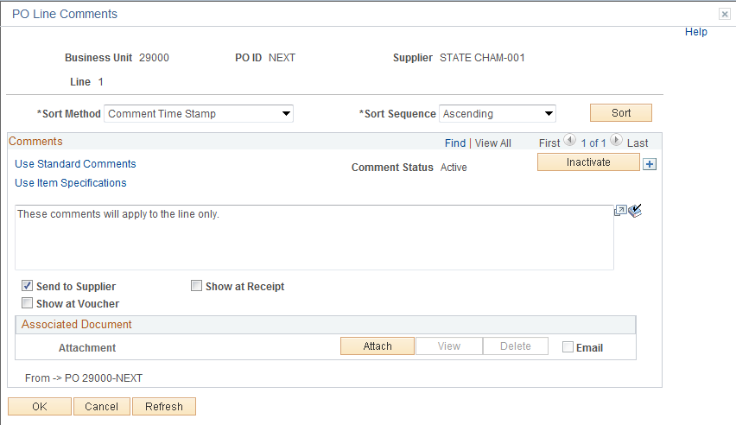

Enter any Line Comments to send with the Purchase Order in the Comment Field.

NOTE: The Send to Supplier checkbox by default will be checked. If you want this comment to appear on the receipt or voucher check the appropriate box.

NOTE: When there are multiple comments, the system will display only the most recent comment. The display indicates the number of comments available for viewing. To view the remaining comments, either press the forward arrow symbol to go to the next comment or press View All to see all of the comments in the scroll area. To return to viewing only one line and its associated schedules, press View 1.

Field Definitions

Retrieve Active Comments Only – This field is available after the Purchase Order has been saved. The radio box is selected by default. If you want to select the inactive comments deselect the radio box and click the button.

Inactivate Button - Click this button to inactivate the currently displayed comment. The comment is not actually deleted, but is set to an inactive status.

Sort Method – Select the method that you want to use to sort the comments retrieved:

Comment Time Stamp – Sorts the comments by the time stamp assigned to them when they were created.
Supplier Flag – Sorts the comments flagged to be sent to the supplier.

Sort Seq – Select Ascending or Descending.

Sort Button- Click this button to sort comments according to the selections that you made in the Sort Method and Sort Sequence fields.
To add additional comments, click on the plus button in the upper right corner of the comment page.

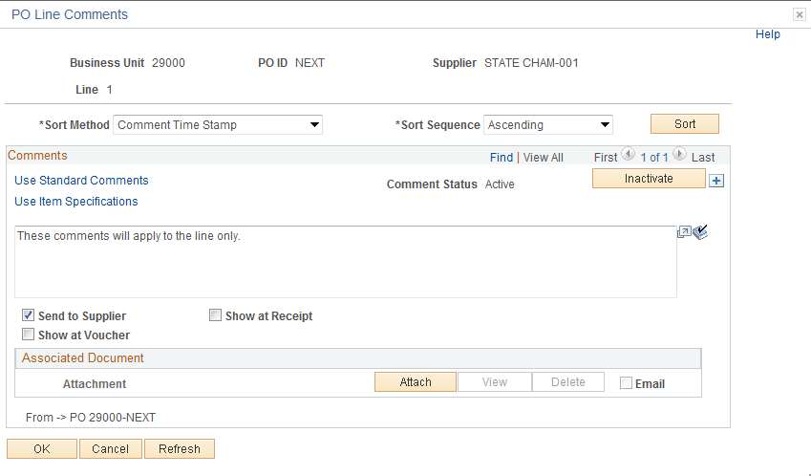

PeopleSoft gives you the ability to attach a file to your Purchase Order. Currently this feature is not being utilized.

Standard Comments
The Department of Central Services requires Purchase Orders to contain certain comment concerning the purchase. Instead of having to type this information into each Purchase Order the Department of Central Services has come up with a list of Standard Comments when selected will default in. These comments are called STANDARD COMMENTS and must be added to every Purchase Order. See the Department of Central Services rules and regulations.

Add a comment section by clicking the button on the right hand side, then click the Use Standard Comments link.

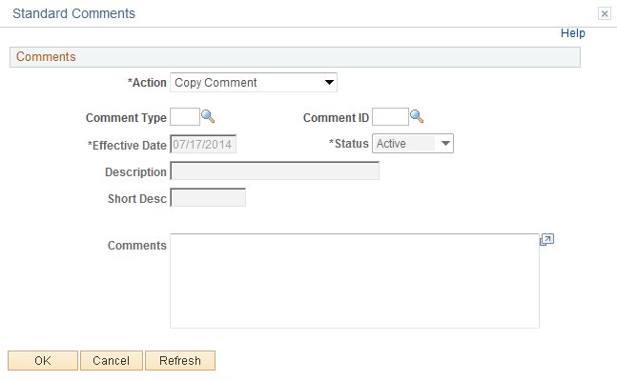

From this page select the “Standard Comment” by inputting the Comment Type and Comment ID. If you do not know this information then click the Look Up Icon located to the right.

Click the Look Up Icon for the Comment Type.

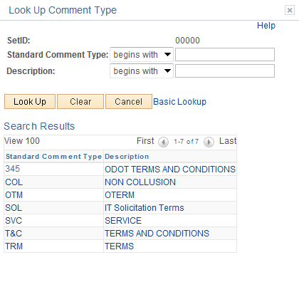

Select the comment by clicking on it. In this example Non-Collusion will be used.

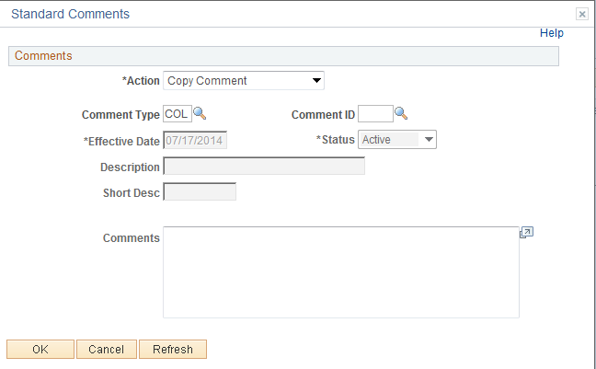

Click the Look Up Icon for the Comment ID.

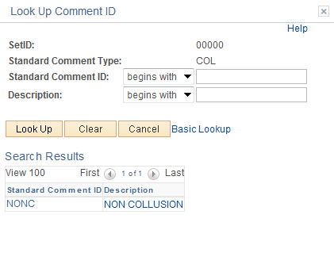

NOTE: The Comment ID is unique to the Comment Type.

Select the comment by clicking on it.

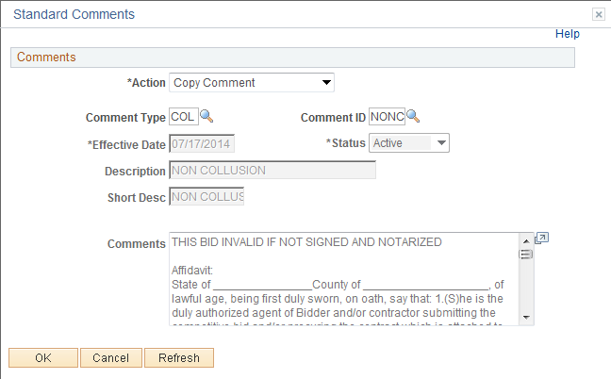

Notice the comments copied in, this saved time.

Click the button.

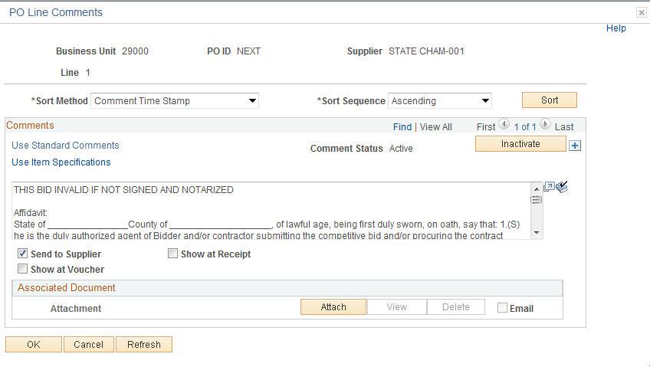

Click the View All link to review all active comments or click the button to transfer between comments.

Click the button

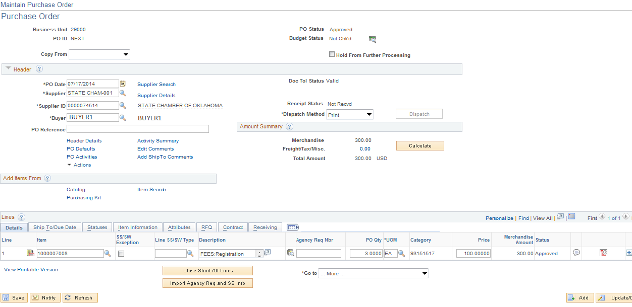

After the Line Comments have been entered, the Line Comment Icon changes to .

Step 7– Verify Shipping Details and Input Distribution Info.

Schedule

Use the Purchase Order Schedule page to specify multiple shipping schedules for each line and to define multiple distributions for each schedule. The Schedule page by default allocates the total by Quantity, but it can also allocate by Dollar amount. To access the Schedule page click on the Schedule Icon .

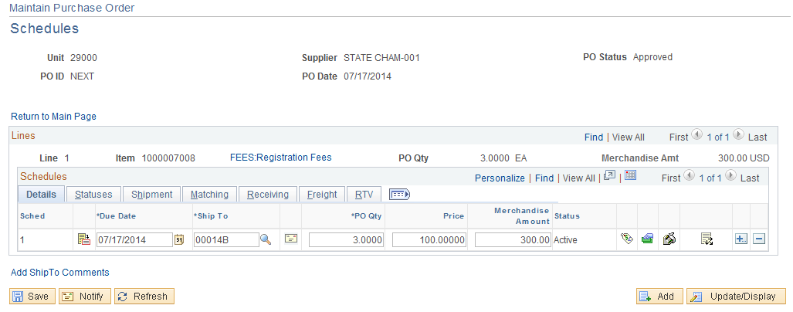

Details Tab

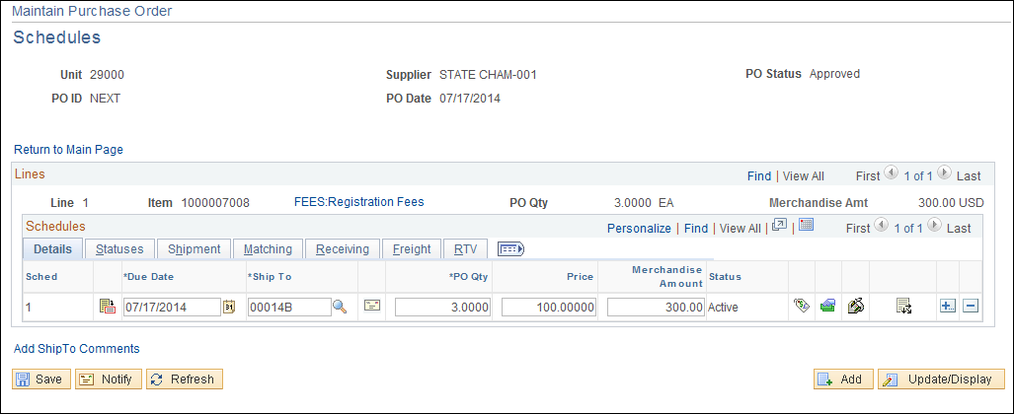

The Due Date, Ship To, PO QTY and PO Price can be changed on the schedule tab and will default back to the Line Page.

- Unit Price-The unit price can be changed by overwriting the price or by using the Value Adjustment. (See appendix page)
- Ship To-A change to the ship to can result in a price change, a sales and use tax recalculation, or a VAT recalculation
- Value Adjustment Icon-This icon allows users to adjust unit price.
- Misc. Charges-Currently not using.
- Sales and User Tax-Currently not using.
- Distribution icon-Enter Distribution data.

Statuses Tab

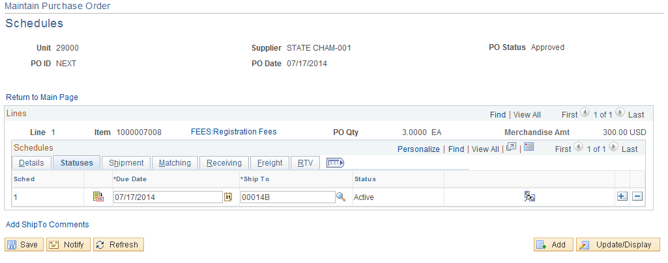

- Status-Purchase order schedule status. Values are: Active, Canceled, or Closed.
- Pegging Inquiry-Currently not using.

Shipment Tab

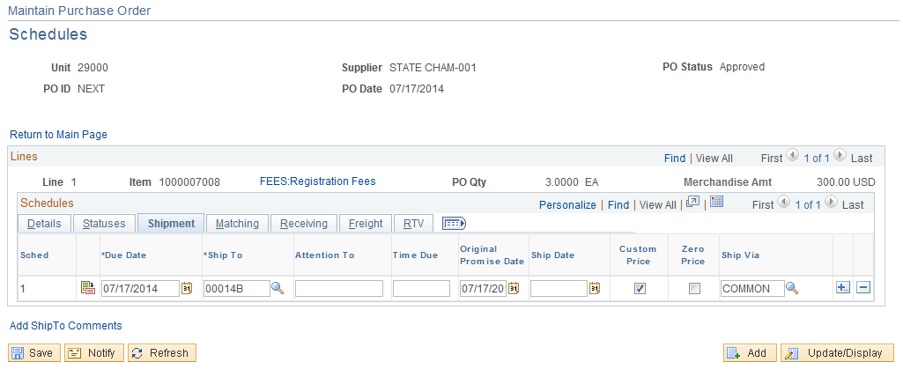

- Time Due-
- Original Promise Date-Displays the supplier's original promised delivery date. Use this field to track when the supplier promised delivery against the date that the goods were actually received.
- Custom Price-Select this check box to indicate that you entered a custom price on the schedule. When the system needs to recalculate a price, it prompts you for approval before automatically recalculating the price.
- Zero Price-Select this check box to indicate that this is a zero-priced line and is considered a no charge item.
- Ship Via- Carrier or method of shipment

Matching Tab
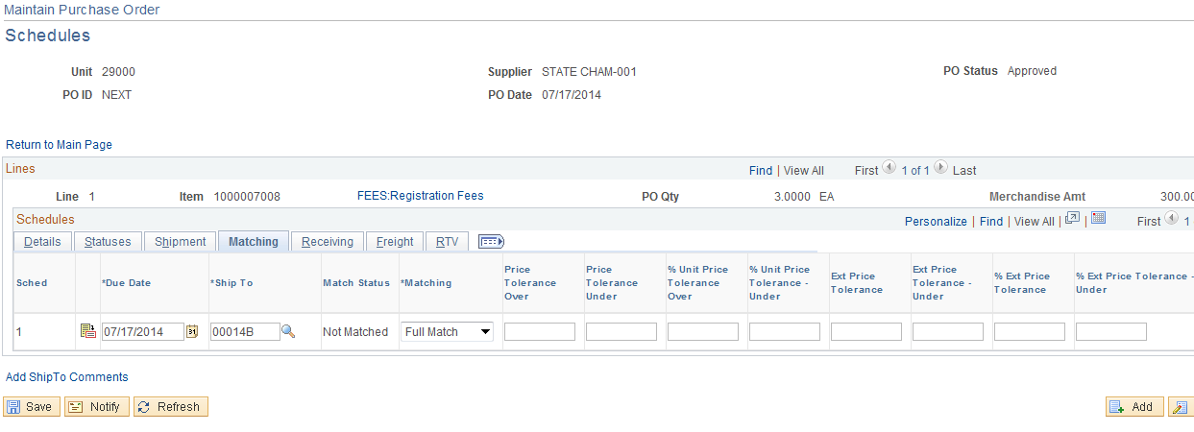

- Match Status-Displays the match status of the schedule. Values are To Match, Part Matched, Fully Matched, and Unmatched. These are set based on the extent to which the matching process has been completed for the schedule.
- Matching-Must state “Full Match” unless the purchase is on an Authority Order.
- Matching Tolerance-When you use matching to verify supplier charges, the system uses price tolerances to determine whether the purchase order and voucher prices are within the tolerances and thus whether the purchase order and purchase order voucher match.

Unit Price Tolerance Over/Tolerance Under | Amount over and under the individual item price that you plan to allow on the voucher and still have the transaction qualify for a match.
% Unit Price Tolerance Over/Tolerance Under | Percent over and under the individual price that you plan to allow on the voucher and still have the transaction qualify for a match.
Ext Price Tolerance Over/Tolerance Under (extended price tolerance over/tolerance under) | Amount over and under the extended item price (price multiplied by quantity) that you plan to allow on the voucher and still have the transaction qualify for a match.
% Ext Price Tolerance Over/Tolerance Under | Percent over and under the extended item price (price multiplied by quantity) that you plan to allow on the voucher and still have the transaction qualify for a match.

Receiving Tab

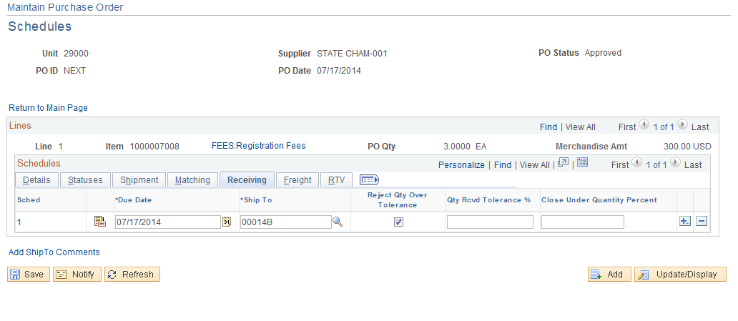

- Reject Qty Over Tolerance-Select this check box to reject a shipment at receiving time if the quantity received is over the tolerance set in the Qty Rcvd Tolerance % (quantity received tolerance percentage) field.
- Qty Received Tolerance-Displays the quantity received tolerance percentage for the item on the purchase order. This field appears by default from the Supplier's UOM and Pricing Info page. “Should not set up a tolerance”

Freight Tab
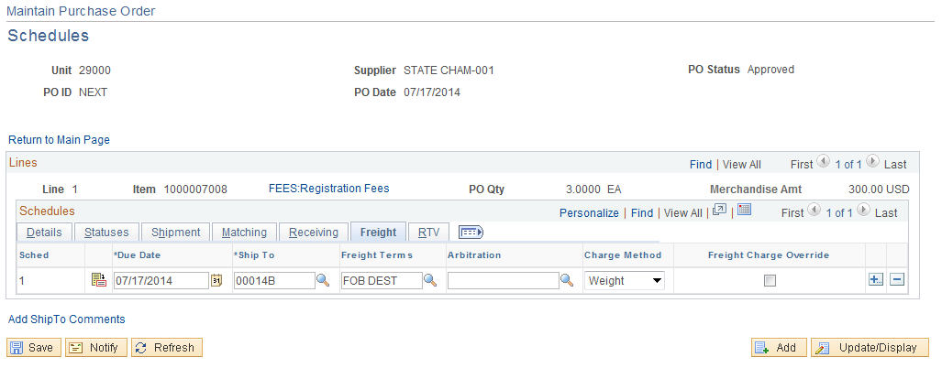

- Freight Term-Normally FOB Dest.

RTV Tab
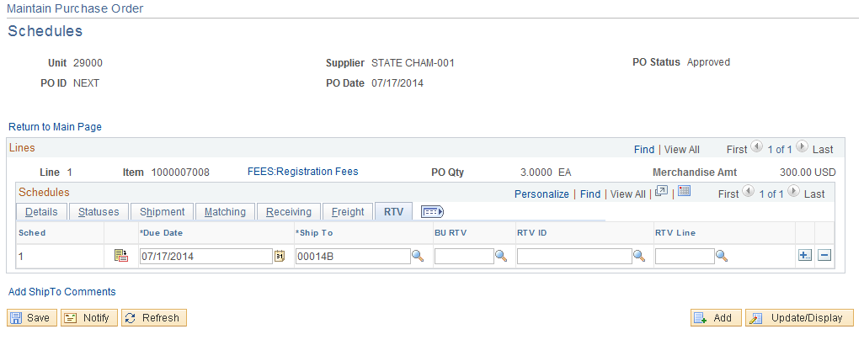

You are able to attach your RTV document on this page.

Distribution Information

Use the Distribution Information page to update and review the distribution data. These line items are transferred to the Purchase Orders, but they do not go out to the supplier. They are a breakdown of accounting distribution and internal delivery locations. This page identifies how the Schedule amounts will be charged within the organization. There can be multiple Distributions for each Schedule. The required Chart Field string is entered for each Distribution, allowing an item to be funded (expensed) from multiple sources. To access the Distribution page, from the Details tab click on the Distribution Icon .

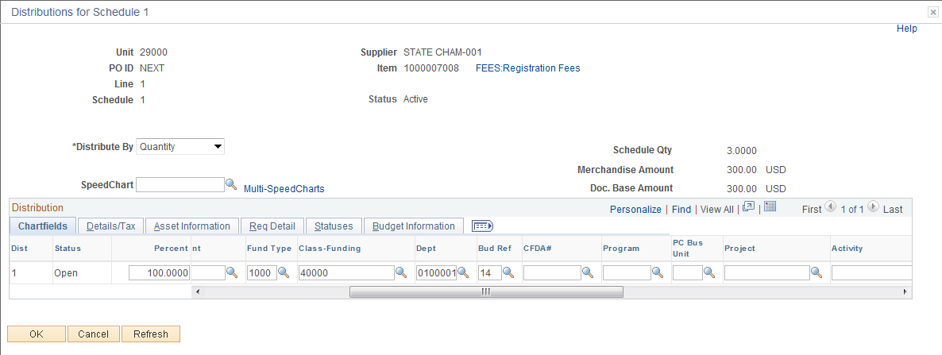

Notice you page does not look like the page displayed in this manual. This page has been customized to display only those fields currently being used.

Chartfields Tab

- Distribute By-Quantity or Amount
- Amount: Select if the sum of all distribution amounts must equal the schedule amount (merchandise amount). Inventory items cannot be distributed by amount
- Quantity: Select if the sum of all distribution quantities must equal the schedule quantity
- Speed Chart-If you charge by amount, define the distributions by using speed charts. Speed charts are templates that contain preset distributions. Select a speed chart and accept or override the default values.
- Status-The default distribution status is Active. This status is updated by the PO RECON process (PO_PORECON) Closed, or when a line is canceled.
- Percent-Enter the distribution percentage for the line. If you distribute by amount or quantity and change either of the values, the percent is adjusted. If you change the percent, the amount or quantity is adjusted. In either case, the percent total must be 100.
- PO Quantity-If you are distributing by quantity, enter a quantity.
- PO Amount-If you are distributing by amount, enter an amount. The transaction currency of the distribution amount appears.
- GL Unit-Defaults from users User Preference and should not need to be changed.
- Account-This field defaults from the Item ID and can be overridden. If the account code is overwritten and a change order is processed the account code can default back from the Item Id.
- Sub-Account-Optional. Input if needed.
- Fund, Class-Funding, Department-Input a valid budget.
- CFDA#-Optional. Input if needed.

Input the funding and click the button to validate the data.

Details/Tax Tab

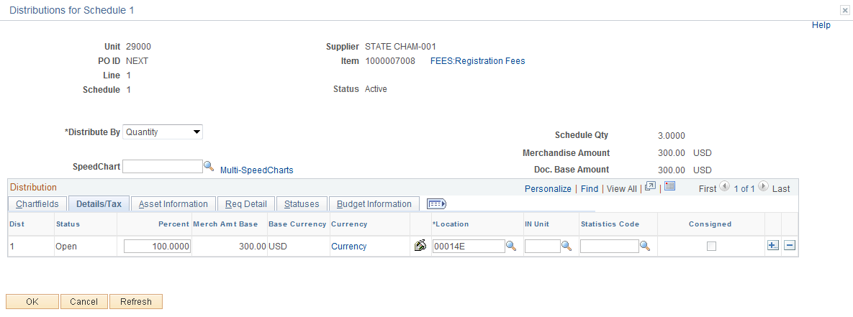

- Location-Internal destination of the item, once it is received. This can be different from the ship to location of the schedule. For instance, the ship to location of the schedule could be corporate headquarters, and the distribution location could be a particular floor's supply room.
- Consignment-If selected, the distribution contains a consignment item. If the inventory business unit is not defined, the consigned check box is clear and cannot be overridden. Currently not using.
- In Unit-Inventory Unit
- Statistics Code- Currently not using.

Asset Information Tab

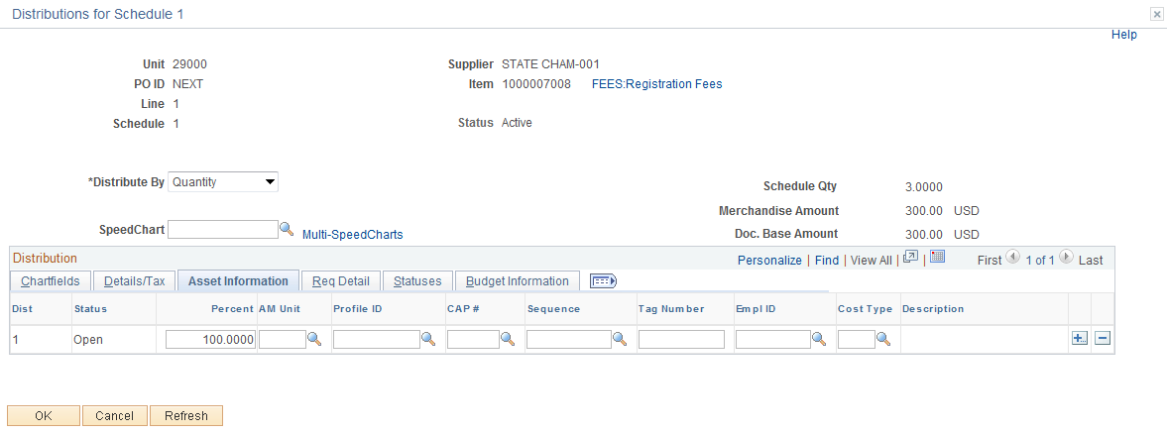

- Once an Agency is live on the Asset Module, the Asset BU and Profile ID will default from the Item ID to the Purchase Order if it meets the following Criteria;
- IT Asset-Account Codes 541120,541130,541140,or 541230 and the unit price is greater then or equal to 500.00
- Non IT Assets-Account Codes 541110,541150-541220,541240-542120,544120,545100-545110, or 546110 and the unit price is greater then or equal to 2,500.00
- If your agency tracks assets under these thresholds it will be the responsibility of the agency to input the AM Business Unit and Asset Profile on the Purchase Order.
- By populating the Asset Information on the Purchase Order, upon receiving, the Asset will interface to the Asset module along with Asset default information.
- If one of the listed accounts are not used, but an AM BU and Profile is used an error message will be received. (Not a valid Asset Account)
- Profile ID- Asset Profile- The Asset profile is the gateway to Asset Management and is a template containing default values for an asset type. Default values include asset category, life (designated by the number in the profile ID), acquisition code, and asset type." Will Default if;
- Cost Type-The Cost Type of "C" designates a CAFR asset and will default to “C” upon saving the Purchase Order if the Item is 25,000.00 or greater. If the item cost is less than $25,000, then the Cost Type field will be blank.
- The Capitalize box has been removed from the Requisition and Purchase Order. The Asset will not be capitalized from the PO, but from the voucher.

NOTE: An average cost is used to determine if an Asset Profile is on the Item ID, if you find an Item should contain an Asset Profile please file an Asset Helpdesk case. If you cannot find an Asset Item and need one added please file an Asset Helpdesk case (one time purchases will not needed an Item ID).

Req Detail Tab

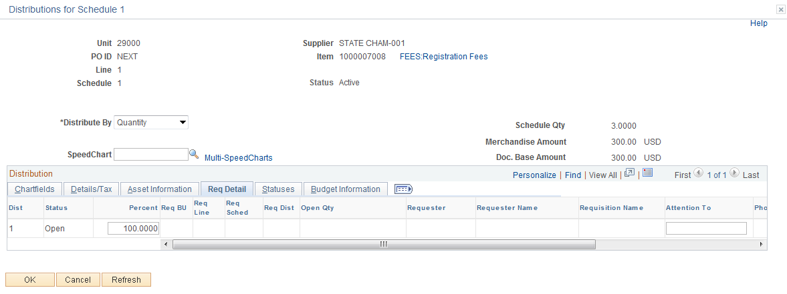

Use this tab to view the details of the requisition from which this purchase order distribution originated. You are able to view the requisition business unit, line, schedule, distribution, as well as other requisition related purchase order distribution information.

Statuses Tab

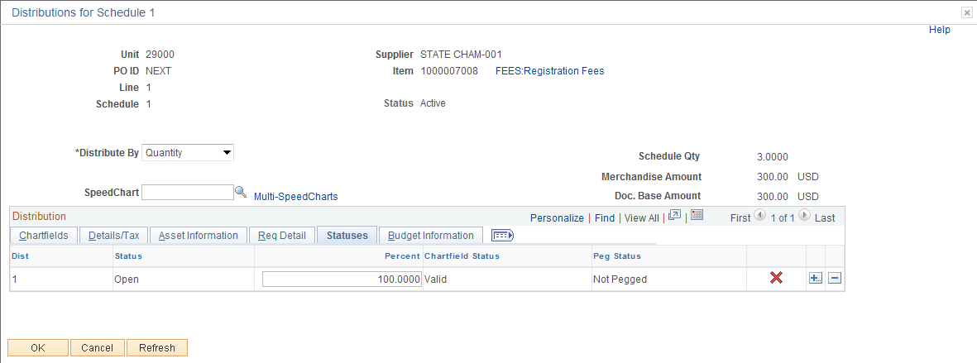

- Chartfield Status-Displays whether the chartfield is valid.
- Final-Will be displayed if copied/sourced from a Requisition. Select this check box to indicate that the purchase order distribution is final and, thus, can be liquidated. The system checks the current purchase order distributions for its predecessor requisition distribution. If the associated requisition has been finalized, the system disassociates the requisition from the purchase order before budget checking so that the pre-encumbrance is not over liquidated
- Peg Status-Currently not using.

Budget Information Tab

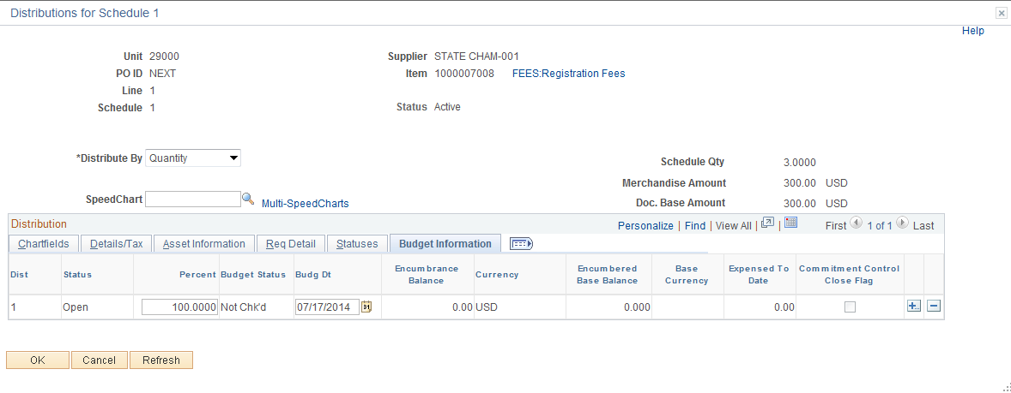

- Distribution Line – line number
- Budget Status - When commitment control is on, the system displays the budget
- status for this distribution line. Statuses include Valid and Not Chk'd.

- Pre-Encumbered Base Balance – displays the beginning pre-encumbered amount.
- Commitment Control Close Flag-If Selected, this check box indicates that the budget processor should fully liquidate the outstanding encumbrance when running budget checking on this purchase order
- Budget Date-Date used here will be used to determine if the budget used on the previous page is active during this time.
- Budget Status- If commitment control is on, the system displays whether or not this distribution has been budget checked and is in a valid or error status.

Click the button.

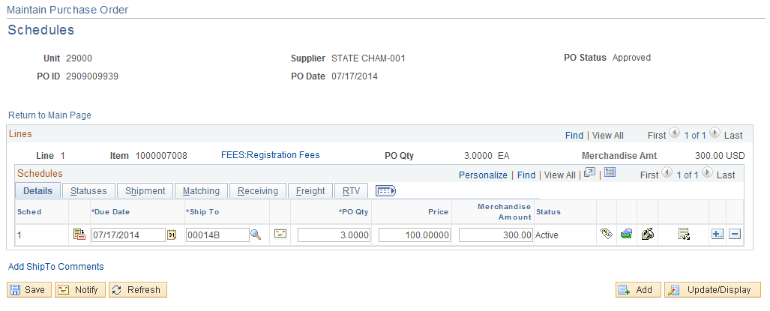

Click the button.

NOTE: The PO number has been assigned. The PO is now ready to be pre-approved, budget checked, approved, dispatched, and printed. Click on the Return to Main Page link.

Step 8-Pre-Approve PO

Pre-approving is completed from the Maintain Purchase Order Page.

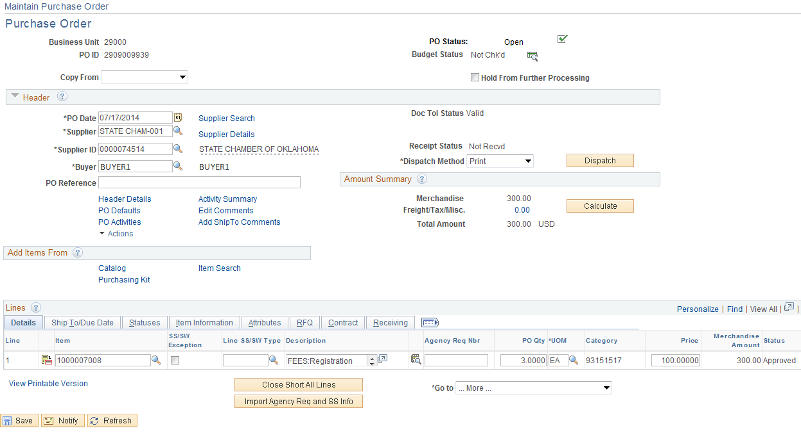

Click the Pre-Approved icon located in the upper right hand corner.

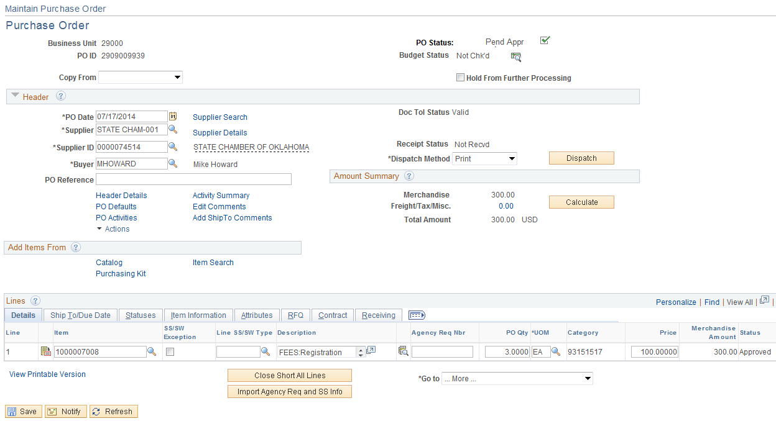

The approval status is now in a pending status. The PO is now ready to be budget checked.

Step 9-Budget Check PO

Overview

Once a Purchase Order is in a pending status, it can be Budget Checked. The PO can be budget checked individually by the user or in a batch process done by OSF. See the Commitment Control Procedure Manual for more information.

Budget Checking

Budget checking individually is done from the Form Page.

Click the Budget Check icon located in the upper right hand corner.

To continue and approve the Purchase Order the budget checking status must equal valid. If it is in an error status, review the Commitment Control Manual for resolving budget checking errors.

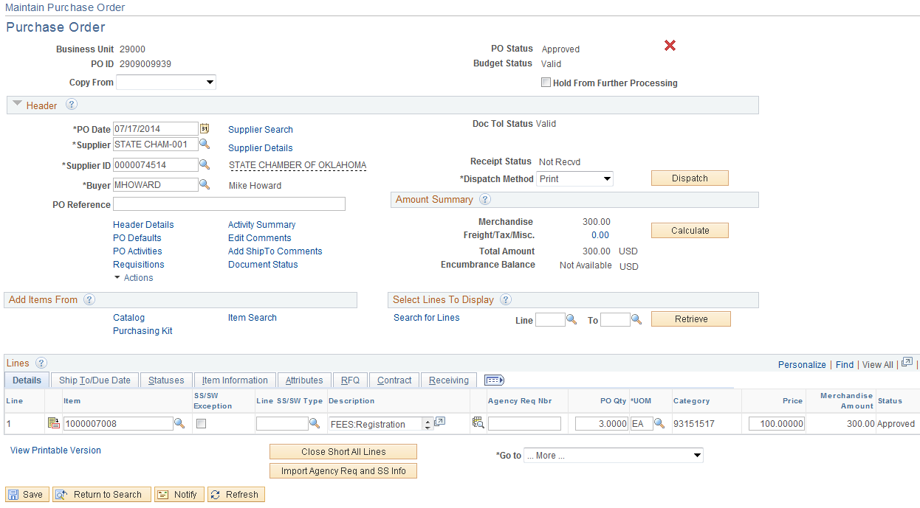

Note: The budget checking status is valid and the document tolerance status is valid. When budget checking from the batch process, document tolerance runs separately.

Step 10-Purchase Order Approval

Overview

Before Dispatching a Purchase Order, the Purchase Order dollar amount must be approved. The State of Oklahoma has chosen approval for amounts only to facilitate the Purchasing process. Once the Purchase Order has successfully passed the budget check and the requestor has pre-approved the Purchase Order, the Purchase Order will be made available for the workflow approval process by the requestor. The requestor will send the Purchase Order to the first approver's work list."

Approving a Purchase Order

Navigation: Purchasing > Purchase Orders > Approve Amounts

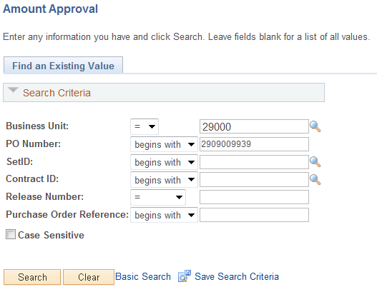

Input the BU and Purchase ID, click the button.

After you retrieve your Purchase Order the Amount Approval page will be displayed.

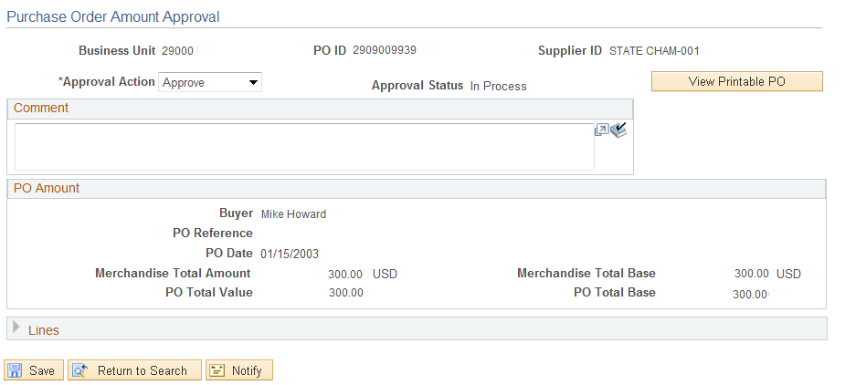

Amount Approval Page

Use the Amount Approval page to approve, deny, or recycle a Purchase Order. If you have a Purchase Order approval role in workflow, the user will have security access to this page when a Purchase Order is selected from the work list.

Approve: Select to approve the Purchase Order amount. If requirements are met, the approval status changes to Complete when you save this page and the PO is made available for dispatch. If workflow is implemented, the system sends an email to the buyer telling him or her that the PO has been approved

Deny: Select to deny the amount for this Purchase Order and deny dispatch. If selected and workflow is enabled, the system generates a worklist entry and an email message to the buyer.

Recycle: Select to send the PO back to the buyer or previous approver. If selected and workflow is enabled, the system generates a worklist entry to the last user who approved the Purchase Order amount.

Comments: The requestor and approver can make comments concerning the approval of the Purchase Order by inputting comments in the Comment Section.

The requestor who created the Purchase Order will click the Approve option and click the button. This will then invoke the workflow process if they do not have approval access.

Warning -- This transaction needs WF_P10_Requestor_(OK) approval. Enter it into workflow? (107,4)
This transaction must be approved. If you click OK, the system will route it to someone who can approve. If you click Cancel, you will be able to change the transaction without forwarding it.
Click the button.

Notice the Approval Status is In_Process. Notice will be sent to the appropriate approver. Once approved the PO status will changed to approve.

Step 11-Dispatch Purchase Order

Once the PO has been approved it can be dispatched from the Purchase Order.

Navigation: Purchasing > Purchase Orders > Add/Update POs > Find an Existing Value

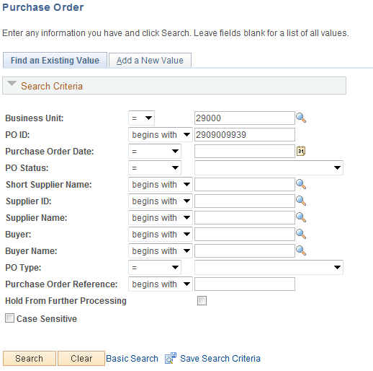

Input the BU and PO ID, and then click the button.

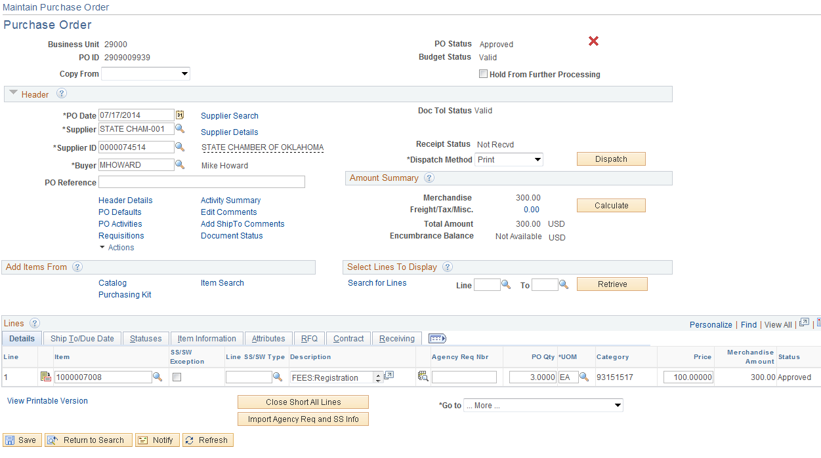

The PO is now approved. To dispatch the PO click the button.

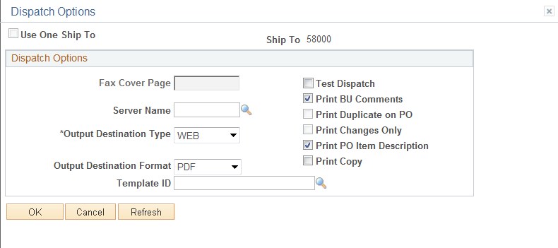

Make sure the Test Dispatch Radio button is not selected. Then click the button.

Would you like to wait for confirmation that the PO Dispatch process has completed? (10208,44)
Your request is currently in process. If you choose to wait, once the process has completed, you will be returned to the updated PO. If you choose not to wait, please check the Process Monitor to verify that the scheduled process has completed before accessing the PO being dispatched. Click the button to wait, click the button to continue working and not wait.

Step 12-Print Purchase Order

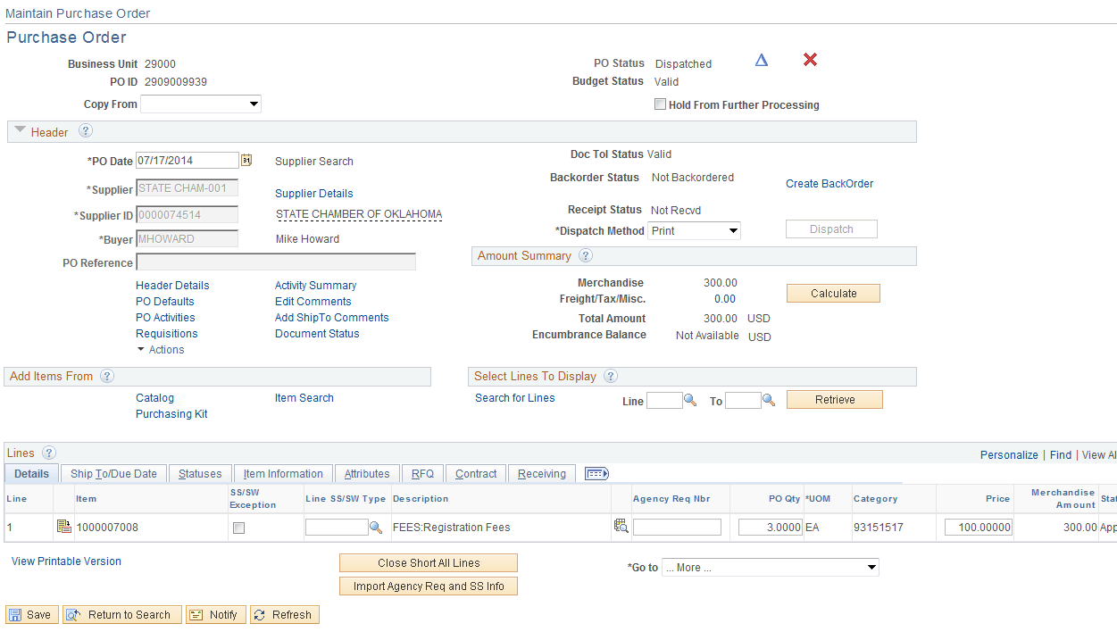

When the PO has been dispatched you also can print the PO from the Report Manager.

Navigation: Reporting Tools>Report Manager>Administration

Click on the Single PO Dispatch/Print link.
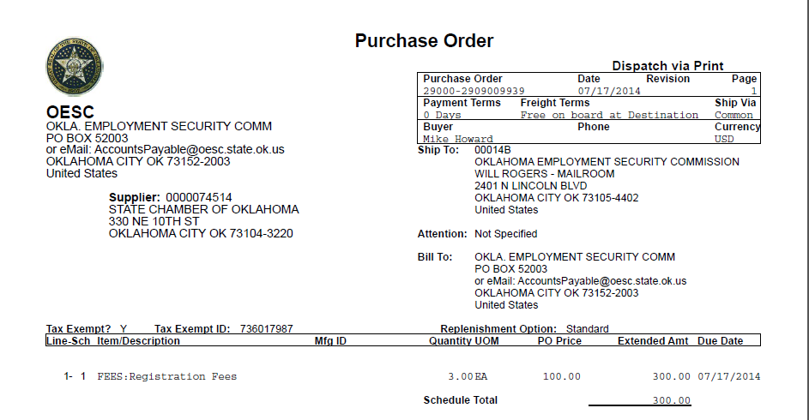
Create Direct PO – Multiple Line

Complete Steps 1 through 3, (Pages 6 - 28).

Step 4 – Input the Item ID

Input the Item ID and click the button, if the Item ID is not known then click the Look Up Icon located to the right.

Input the second Item ID and click the button.

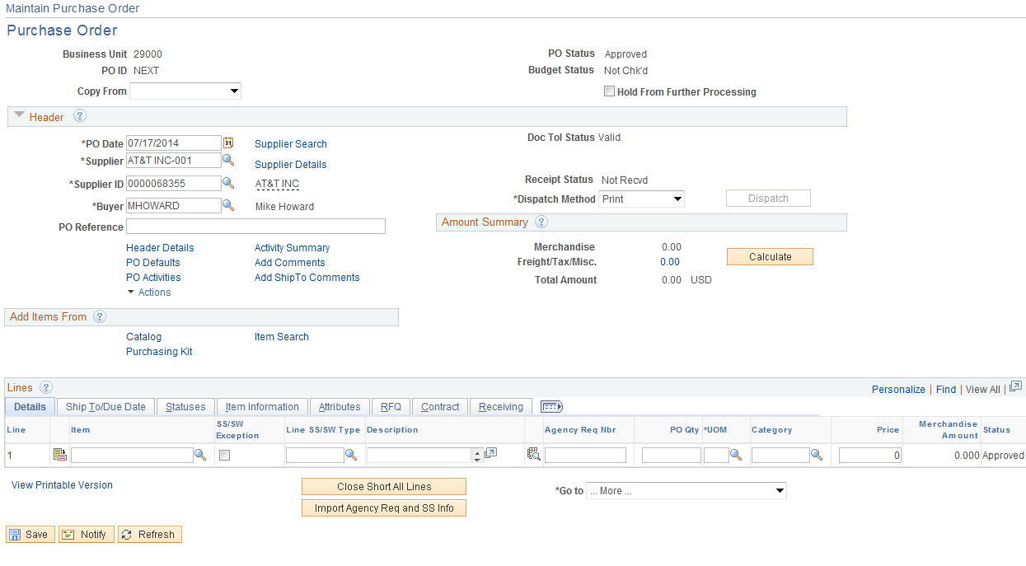

To add an additional line click the button located to the right of the PO line.

Input the number of row(s) to insert and click the button.

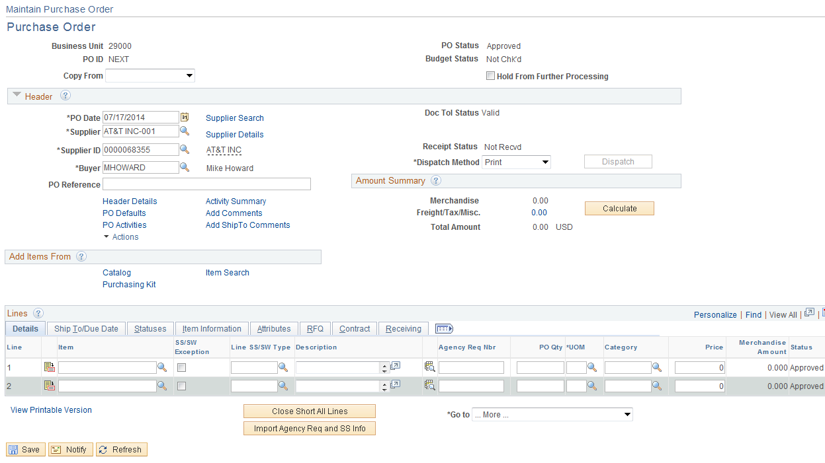

A new line was added, input the second Item ID and click the button.
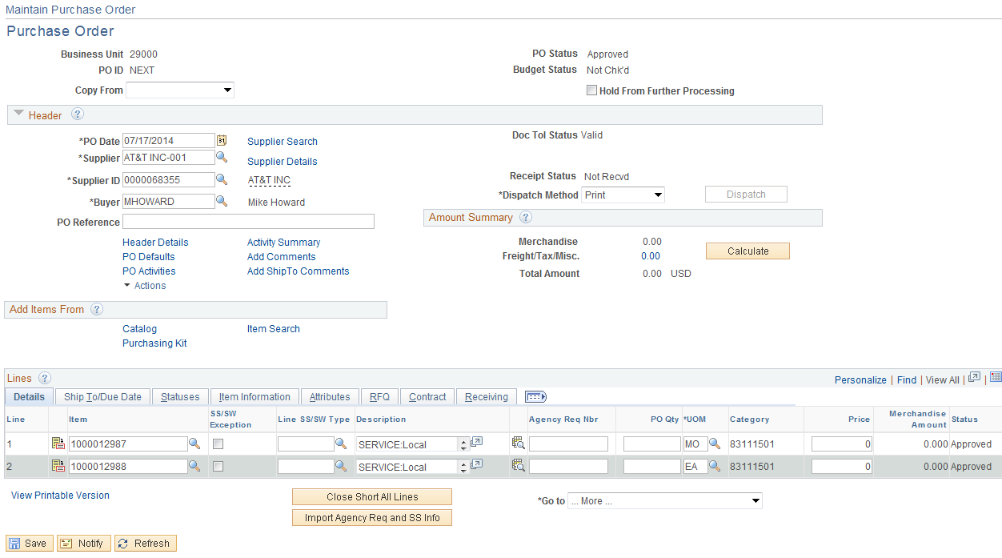

Input the PO QTYs and click the button to validate the data.

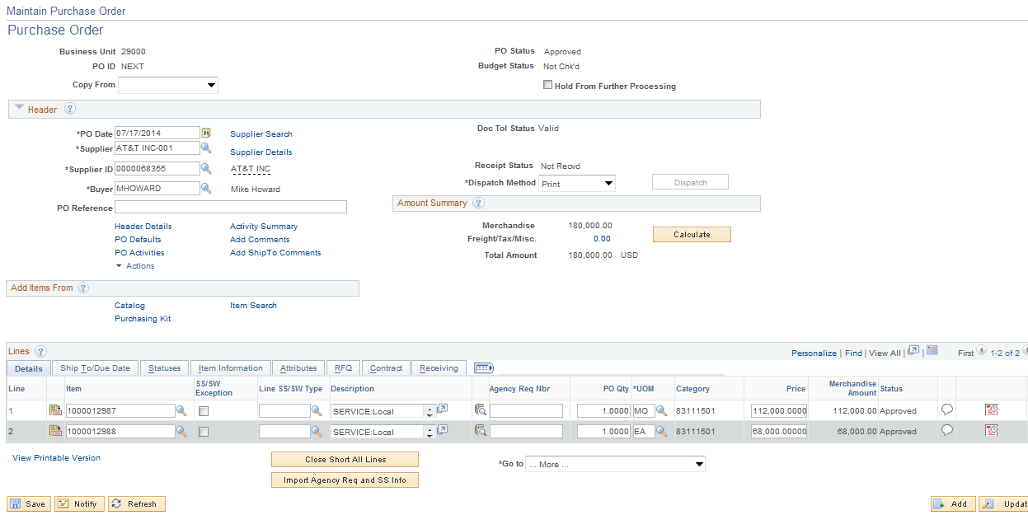

The amounts defaulted in from the Item ID.

Complete Steps 5 through 10, (Pages 22-66).
Create Multiple Schedule Line PO

Complete Steps 1 through 6, (Pages 22-40).

Step 7– Verify Shipping Details and Input Distribution Info.

Schedule

Use the Purchase Order Schedule page to specify multiple shipping schedules for each line and to define multiple distributions for each schedule. The Schedule page by default allocates the total by Quantity, but it can also allocate by Dollar amount. To access the Schedule page click on the Schedule Icon .

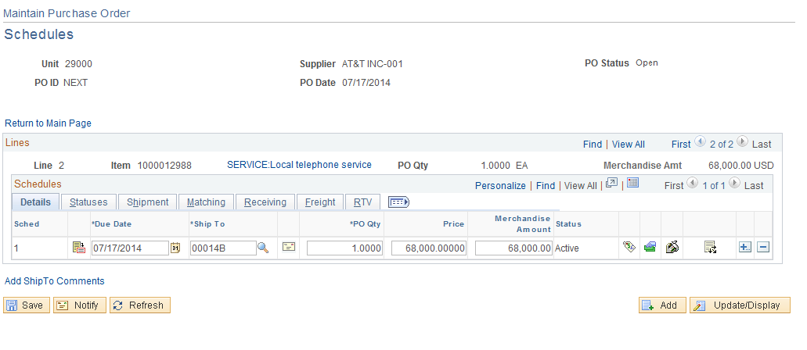

Click the addition button located to right of the Schedule.

Input the number rows needed and click the OK button.

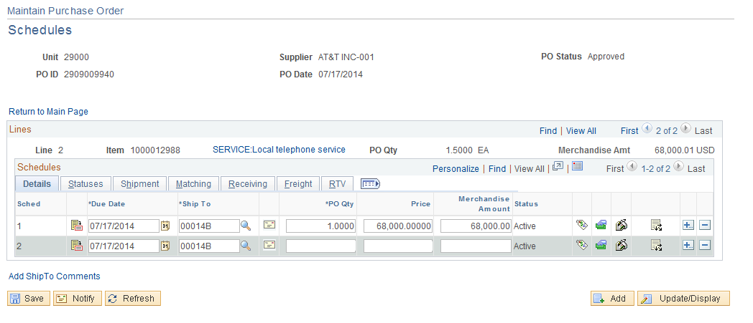

Allocated the PO Qty between the schedules and click the button.

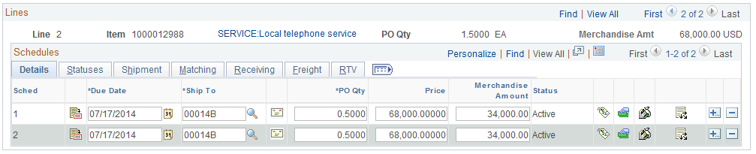

Change the Due Dates and Ship To as needed.

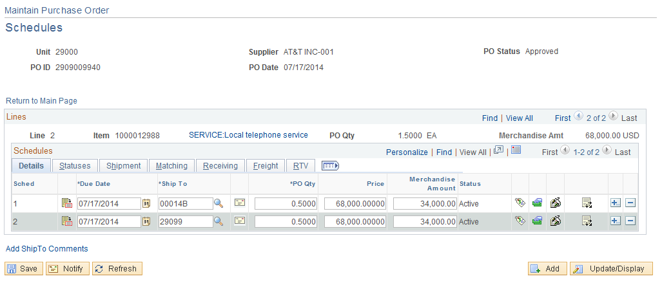

Complete Steps 8 through 10, (Pages 56-62).
Create PO – Copy From Requisition

A Purchase Order is a commitment to buy goods or services from a supplier. Upon budget checking the Purchase Orders funds are encumbered (obligated) from a budget to ensure funds are available when the product or service has been received. If a Requisition is processed the pre-encumbrance will be released when the encumbrance is established. Like a Requisition the Purchase Order consist of these basic elements: headers, lines, schedules, and distributions. Each requisition has one header, which can have multiple lines. Each line can have multiple schedules. Each schedule can have multiple distributions.

Step 1 – Enter Purchase Order Data

Navigation: Purchasing > Purchase Orders > Add/Update POs > Add a New Value

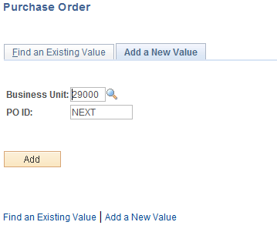

Business Unit-Defaults to specific agency for each User.

Purchase Order Number-Defaults to NEXT. The system will auto number each Purchase Order.

NOTE: Do not change the Purchase Order ID data field. Let the system default NEXT into the data field. The Purchase Order number will be assigned upon saving. The number will begin with the first 3 digits of the BU, followed by a 9, and the last 6 digits be sequentially numbered.

Click the button to take you to the Purchase Order Form page.

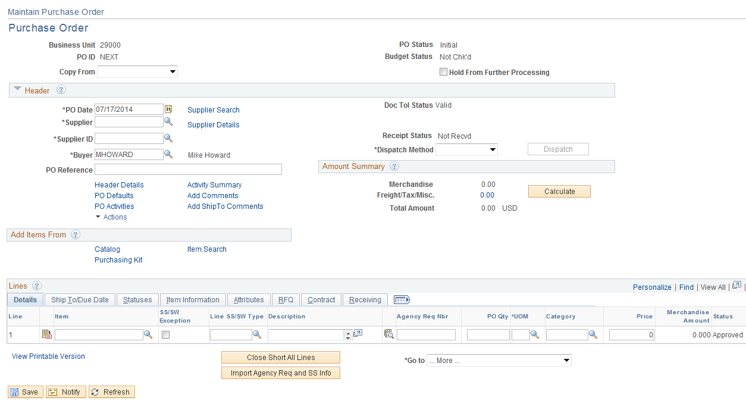
Input the Supplier Id and Buyer’s Name; click the button to validate the data.

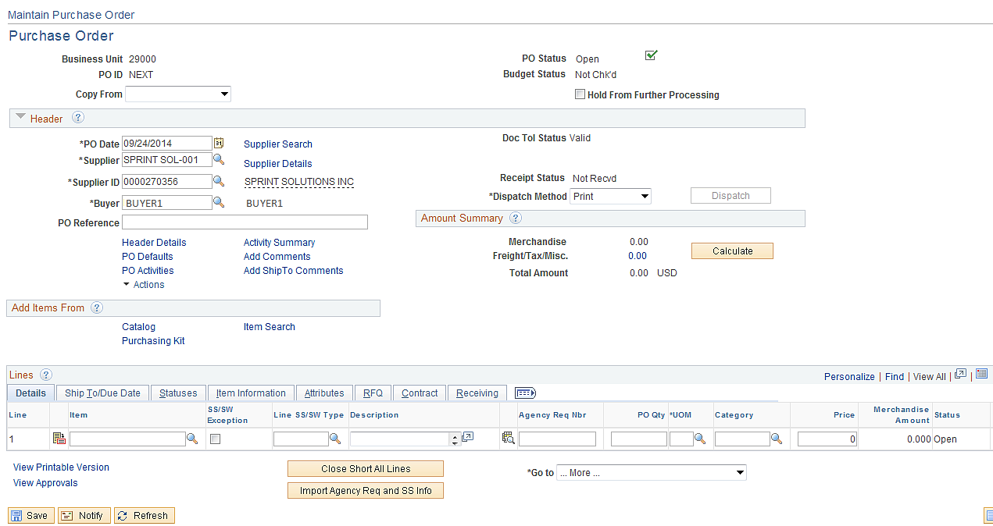

Step 2 – Copy Requisition to Purchase Order
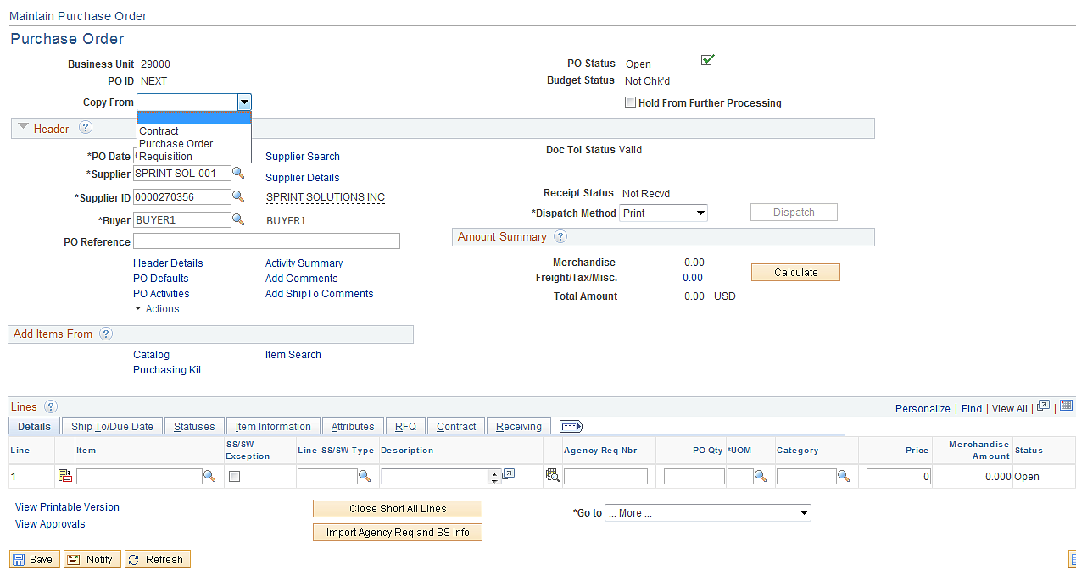

Click the scroll down arrow key located to the left of “Copy From Field”. There are three options:

Contract: Copy the whole Statewide Contract to the Purchase Order-No longer available.
Purchase Order: Copy an existing Purchase Order to a new Purchase Order.
Requisition: Copy a Requisition to a Purchase Order.

Click on Requisition.

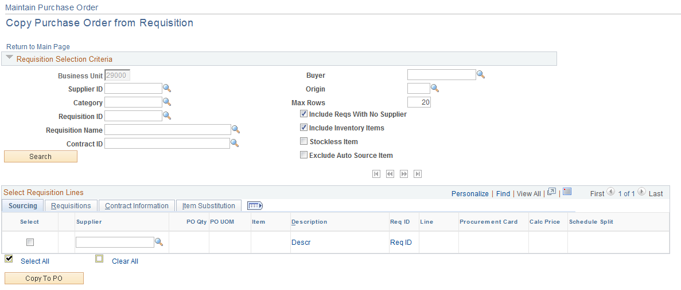

Input the Requisition ID along with any other criteria. Be sure to change Max Rows from 50 if needed, otherwise all the Requisition lines may not copy in.

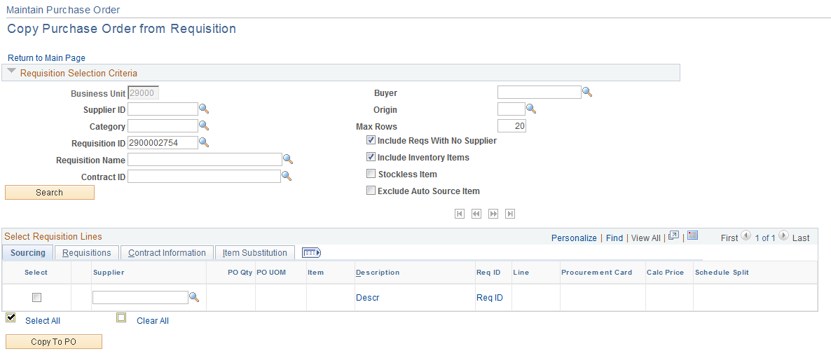

Click the button.

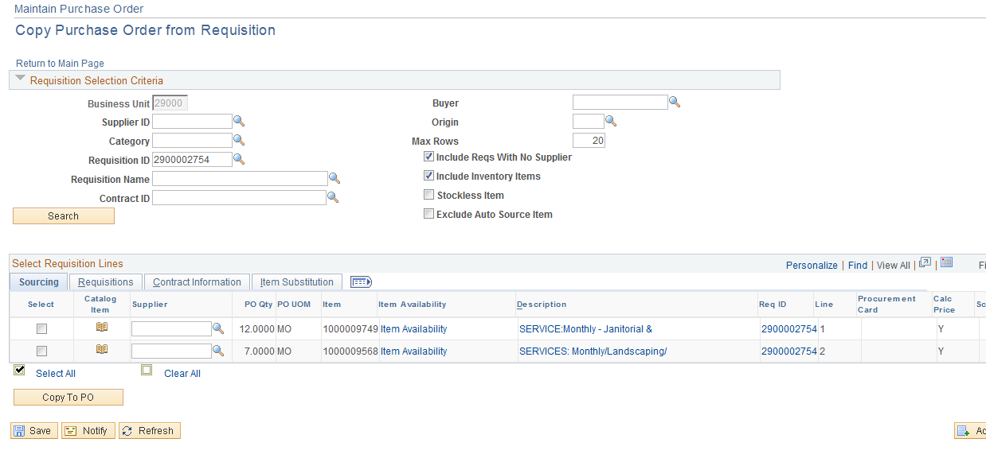

Click the select radio box to the left of the line to copy, click the button.

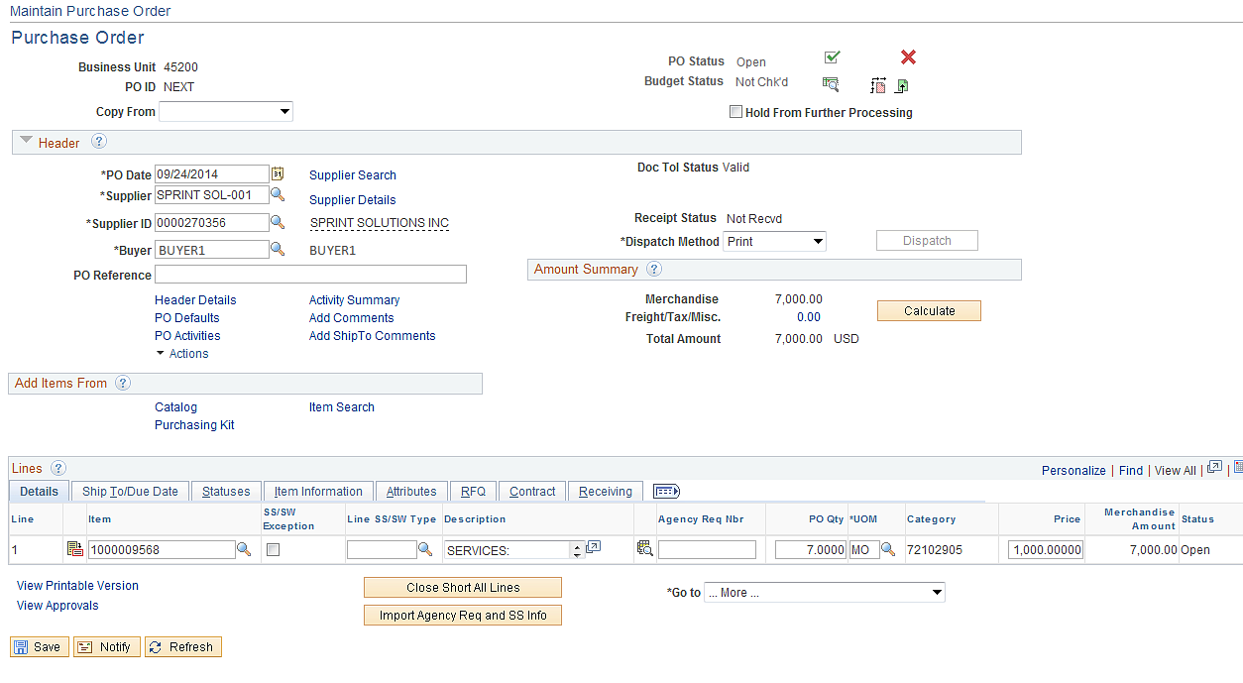

The Unit Price copied from the Item ID price not the Requisition and may need to be changed to reflect the correct amount. This can be avoided by turning off the calculated price on the requisition line and sourcing the Requisition to the Purchase Order. (See PO Sourcing)

If all Requisition Lines are not available then review the following:
Requisition Line Details and make sure the “RFQ Required” is not selected.
The Requisition lines have not already been sourced.
Enough ROWS were selected when selecting the Requisition.

Complete Steps 2-8

Step 2-Update Header Details
Step 3-Add/Update Header Comments
Step 4-Review Item ID
Step 5-Verify Line data
Step 6-Add/Update Line Comments
Step 7-Update Schedule Distribution data.
Step 8-Pre Approve Purchase Order and save.

Step 9 – Finalizing the Requisition from the Purchase Order and Budget Checking

By clicking the Final Icon mark the Purchase Order as Final, prompting the system to liquidate all available pre-encumbrances. This will allow you to make your Purchase Order for less money than you originally authorized with out re-establishing the pre-encumbrance. To also reverse the finalization of the Purchase Order, click the Un-Final Icon .

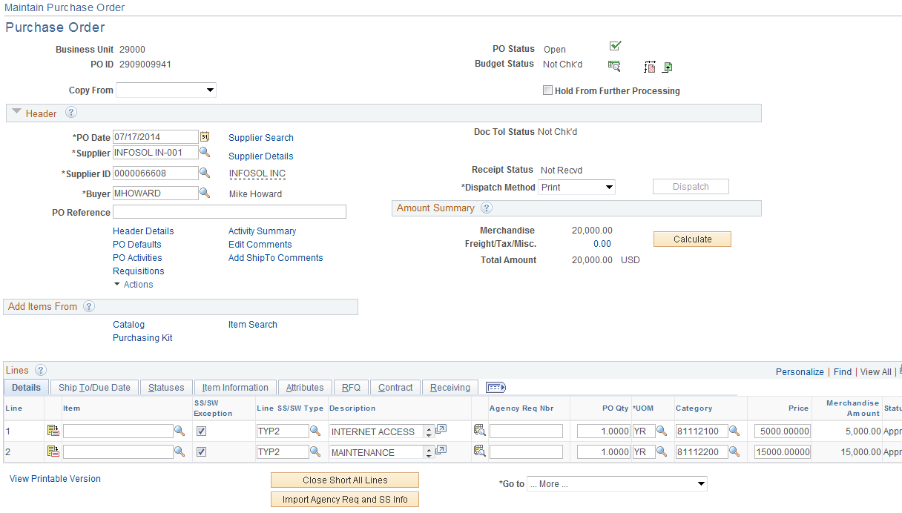

Click the Final Icon .

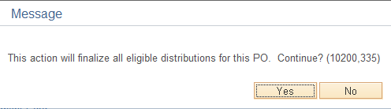

Click the button.

Click the budget checking icon located in the top right hand corner.

Complete Steps 10-12:

Step 10-Approve Purchase Order
Step 11-Dispatch Purchase Order
Create PO – Sourcing from Requisition

Building a PO from a Requisition starts with copying the Requisition to the Staging tables in preparation for sourcing to a PO. There are several more steps than copying from Maintain Purchase Orders but you have more control over the process.

Step 1 – Select the Requisition to Source

Navigation: Purchasing > Purchase Orders > Stage/Source Request > Requisition Selection

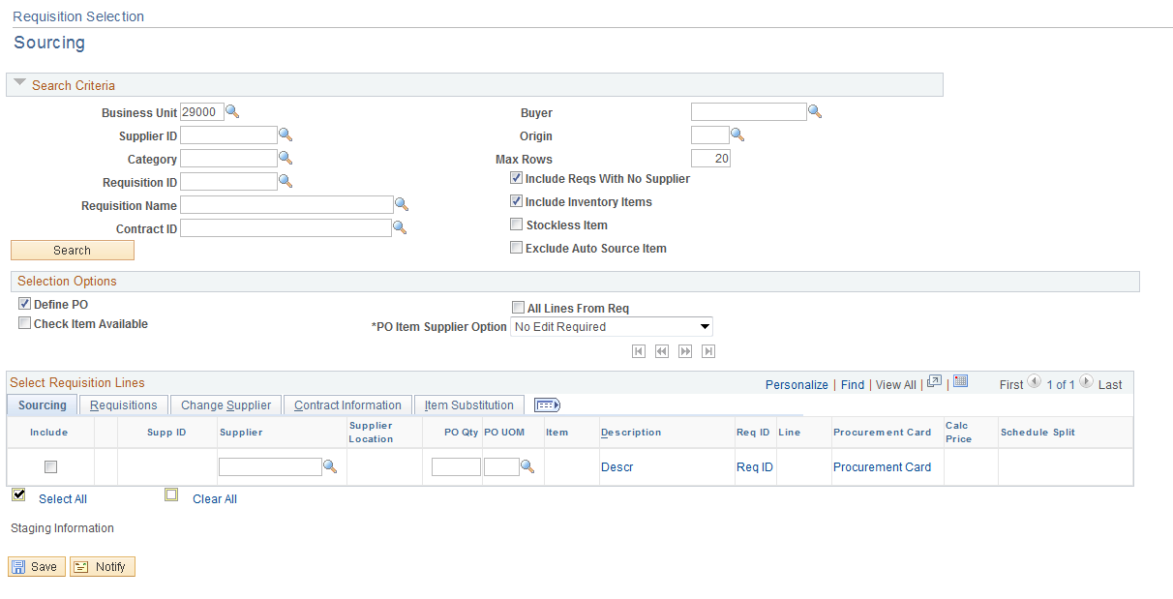

NOTE: To review Requisition available for selection, click the Look Up Icon located to the right of the Requisition Field. In order for a Requisition to be available for sourcing it must be in an approved status, budget checking status must be valid, must not be on hold and not sourced.

Input the Requisition ID and be sure to increase the Max Rows if there are over 50 lines.

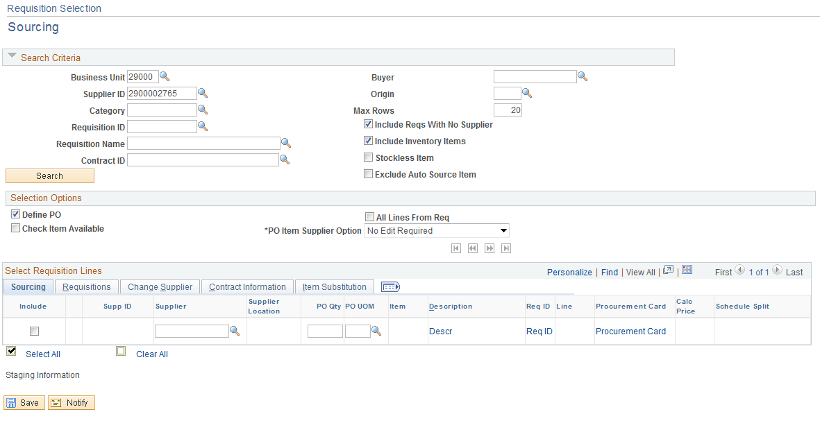

Click the button.

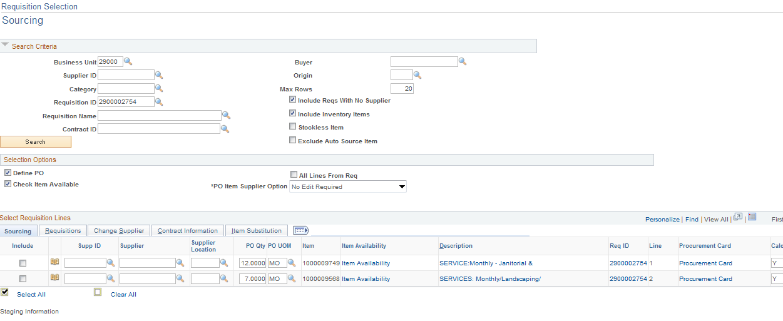

Calc Price (Calculate Price): | Indicates whether the Purchase Order Calculations process should recalculate the price or use the price from the requisition. If set to Y (yes), the PO Calculations process recalculates the price. If set to N (no), the PO Calculations process uses the price from the requisition. This option is set to Y and cannot be changed when using an item ID and a contract is specified. (See P108 Requisition Creation and Processing Manual - Page 40).
Click the radio box located to left of the line to source. Click the button.

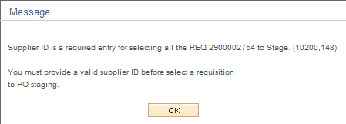

Input a supplier number, select the radio box and click the button. The requisition has been staged. This can be reviewed through the Sourcing Workbench.

Definition

Define PO | Select to define purchase orders using the structure of requisitions as they appear on this page, instead of letting the system create it using the predefined rules.  The PO Calculations process does not overwrite these purchase order configurations, even if the Consolidate with Other Reqs check box on the requisition is selected. In addition, you must specify the supplier for the purchase order, as the PO Calculations process does not select a supplier for you.  If selected, the information that you view on the Requisition Selection - Sourcing page is exactly what will be on the purchase order and each requisition line that you source will be on its own purchase order line, even if others exist for the same item.  If you want to use the Define PO check box, you must select this check box before selecting requisitions for sourcing. Similarly, if you don't want to use the Define PO check box, you must clear the check box before selecting requisitions for sourcing.  If you are sourcing to PeopleSoft Inventory or do not select this check box, the information that you see on this page is either used for creating inventory demand in the Build Inventory Demand process (PO_REQINVS) or is updated in the PO Calculations process.  If a line that you have selected for sourcing on this page has been sourced to a blanket purchase order contract, you will not be able to select the Define PO check box. Instead, you will receive a message that this option is not valid for the selected line. This check box only applies to lines that are selected by the Inc field after you select the Define PO check box.

Review the Sourcing Workbench Page

Navigation: Purchasing > Purchase Orders > Stage/Source Requests > Sourcing Workbench

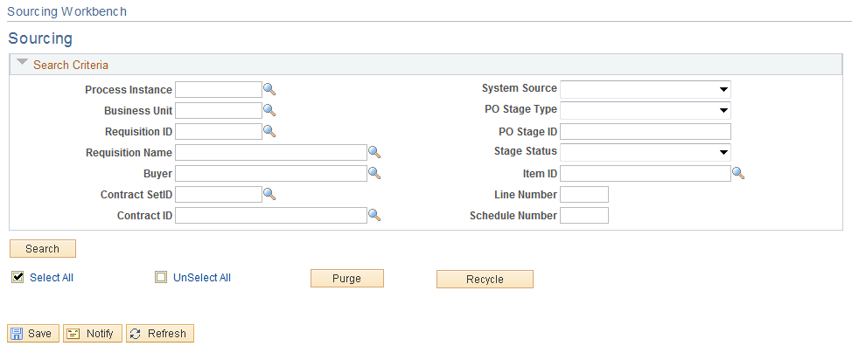

Input your Business Unit and Requisition ID.

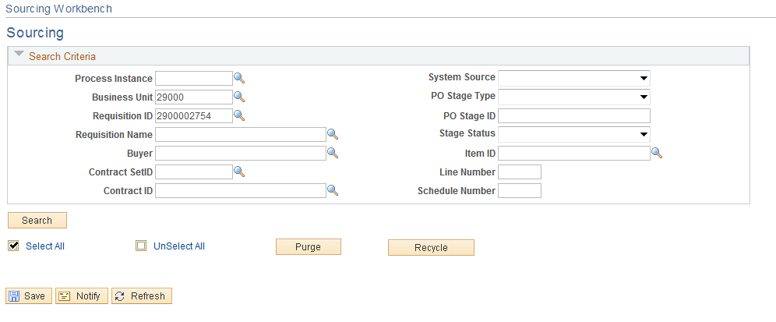

Click the button.

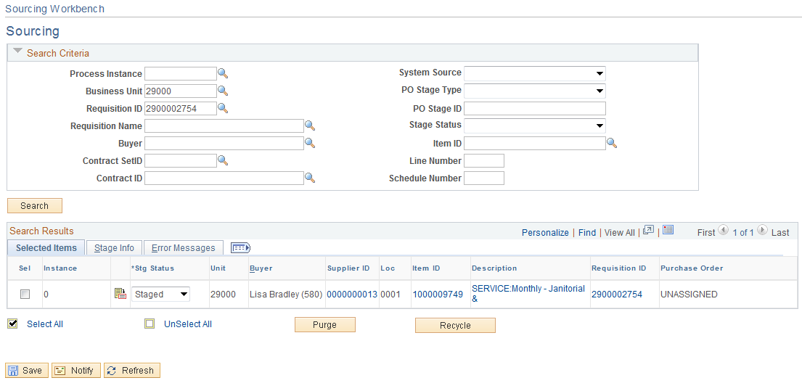

Notice the status is STAGED. The status will change as follows;

Staged-The requisition is in a table waiting to create a Purchase Order.
Calculate PO-The PO Calculation process is running.
Ready-The PO Calculation process has been completed.
Create PO-The PO Creation process is running.
Complete-The PO Creation process has completed running and the PO has been created.

Step 2 –PO Calculation

Once the Requisition has been selected and placed in the staging table the PO Calculation Process is ran. This process actually determines how the information will be copied from the Requisition onto the new PO. The PO Calculations process performs most of the processing necessary to create a PO. After running the PO Calculations process, review results and make changes using the Sourcing Workbench - Selected Items page before the PO is created.

Navigation: Purchasing > Purchase Orders > Stage/Source Requests > PO Calculations

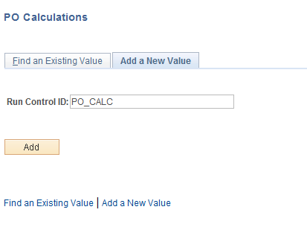

Input your Run Control ID and click the button.

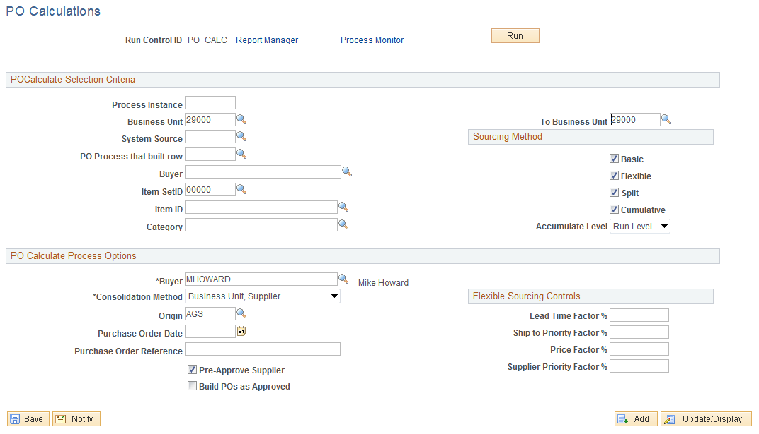

POCalculate Selection Criteria- Selecting field values in this group box limits the selection of staged rows to those that meet the criteria selected. These fields are optional.

- Process Instance-If the PO calculate process was previously ran against the Requisition, an instance number will be assigned and can be used to run the process with no other criteria. This number can be found in the Sourcing Workbench.
- Business Unit-Can limit the process to a certain Business Unit or a Range of Business Units.
- System Source- Currently leave this field blank.
- PO Process that built row-Currently leave this field blank.
- Buyer-The Buyer must match the requisition’s Buyer or it will not be selected. The biggest mistake is not assigning a Buyer to the Requisition, if this happens leave the Buyer field blank, but the problem with that is you could pick up Requisitions you don’t intend on.
- Item SetID-Leave as 00000.
- Item ID-Use if you want to only source requisitions with a certain Item ID.
- Category- Use if you want to only source requisitions with a certain Category
- Sourcing Method-Do not change.

PO Calculate Process Options-Determines what data to use when creating the Purchase Order.

- Buyer- (Required) Select the buyer to be used on the purchase order header in the event that the PO Calculations process cannot determine the buyer.
- The buyer name is carried at the line level on the requisition, so a requisition can have multiple buyers. When the PO Calculations process creates the purchase order header, it must assign a buyer name.
- If all the staged lines that belong on one purchase order have the same buyer name, the PO Calculations process uses that name on the header.
- If the staged lines that belong on the purchase order have different buyer names, or the process that created the staged entry did not specify a buyer name (you have the capability to force a buyer name in online requisition selection), the system uses the supplier buyer name.
- If the supplier buyer name is blank, the system enters the buyer name on the purchase order header.
- Consolidate Method- Determines whether purchase orders are consolidated by business unit, supplier, and buyer or by business unit and supplier only. The consolidation method applies only to staged rows identified for consolidation.
- For example, suppose that you choose to consolidate by business unit and supplier, then all rows with the same supplier and business unit are grouped onto one purchase order.
- Alternately, if you add buyer to the consolidation criteria, all rows that have the same buyer, supplier, and business unit are grouped on a purchase order.
- Origin-Leave blank. The system is not using this origin to create the PO.
- Purchase Order Date- Enter a date to be used on the purchase orders, for purchase orders that do not already have a date assigned. If you leave this field blank, the PO Calculations process uses the current system date.
- Purchase Order Reference Number- (Optional) Enter a purchase order reference to be used on the purchase orders. This is a free-form field.
- Pre-Approve Supplier-Must select. Select this check box to approve the supplier that the PO Calculations process selects.
- If selected, the system automatically approves the supplier recommended by the PO Calculations process, so that the PO Calculations process runs and the Create Purchase Order process without interruption. If you do not select the Pre-Approve Supplier check box, you must approve the supplier manually using the Sourcing Workbench.
- Build POs as Approved-Do not select. Select this check box to have purchase orders created with an Approved status when you run the Create Purchase Orders process. If selected, the process examines auto approval criteria set at the business unit level. If the auto approval criteria are met, the status is set to Approved. If the auto approval criteria are not met, the status is set to Pending Approval, and the purchase order enters the workflow approval business process. If you do not select this check box, the purchase order is created with a status of Open.
- Flexible Sourcing Controls-Do not update.
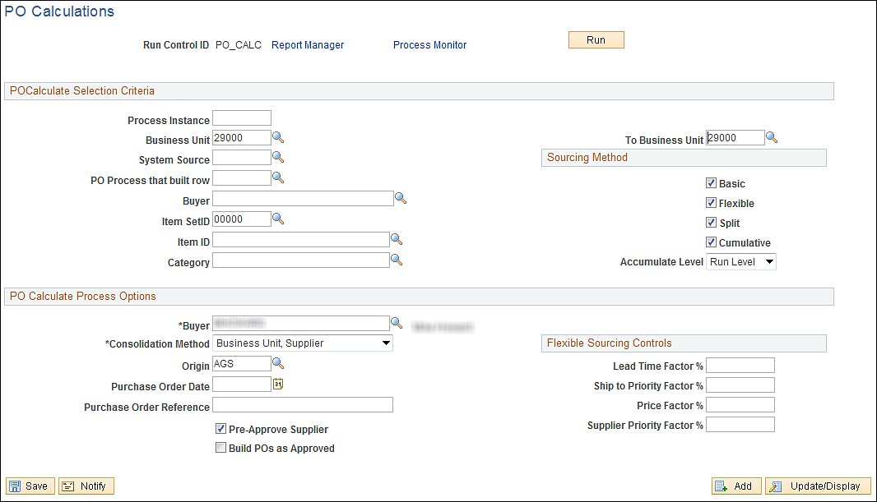

When this process is run it will run the PO Calculation process for every Staged Requisition and RFQ for Buyer MHOWARD and Agency 29000. If the Buyer is left blank on the Requisition then the Buyer will need to be left blank here, but it will pick up all Agencies 580 Buyer’s Requisitions and RFQ that have been staged.

Click the button.

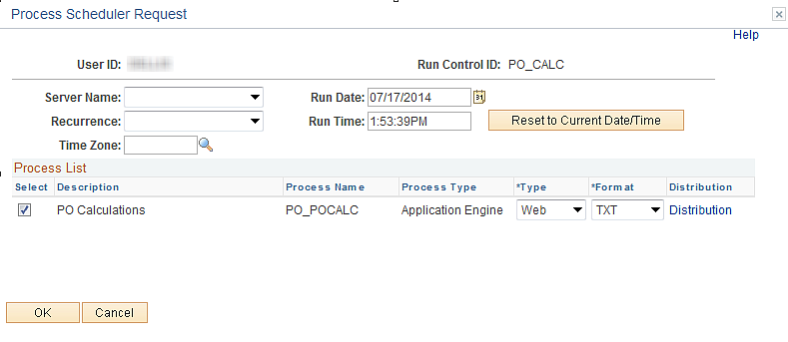

The server Name is “PSUNX”.

Click the button.

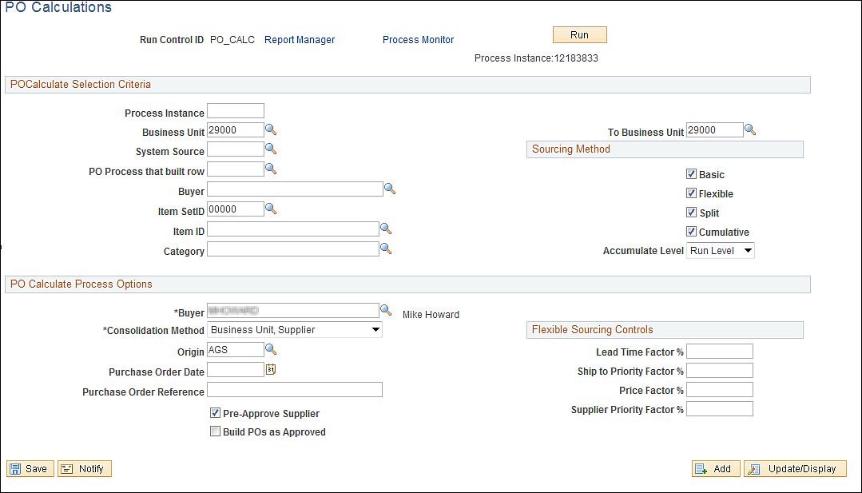

To review the status of your job click the Process Monitor link. Never Cancel or Delete the job while it is running. If there are issues, file a Critical Help Desk case.

Step 3 –PO Creation
The Create Purchase Orders process is the final step in creating the Purchase Order, it calculates the Purchase Order ID, assigns line, schedule, and distribution numbers, and creates contract release information.

Navigation: Purchasing > Purchase Orders > State/Source Request > PO Creation

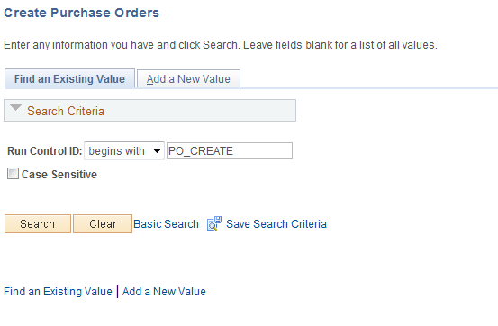

Input the Run Control ID and click the button.
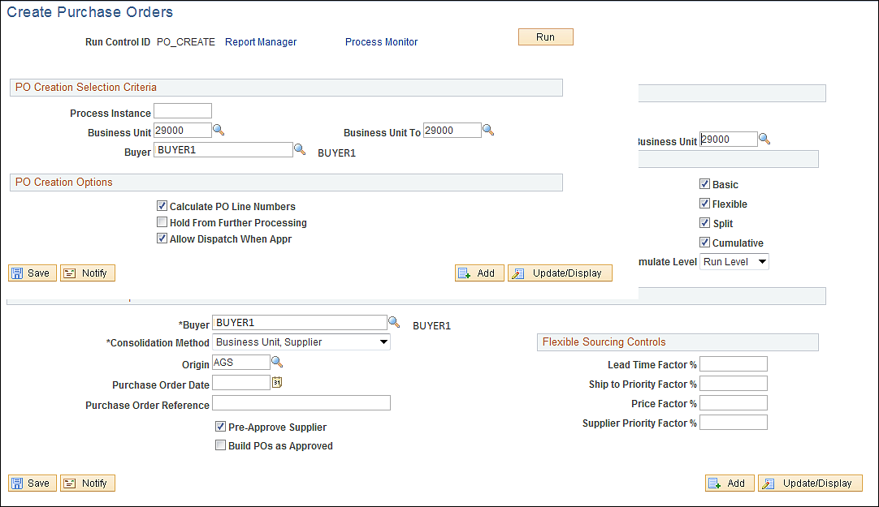

PO Creation Selection Criteria- Selecting field values in this group box limits the selection of staged rows to those that meet the criteria selected. These fields are optional.

- Process Instance- Enter the process instance related to the PO Calculations process. This process instance limits the selection of staged requisitions to those that were put into the PeopleSoft Purchasing stage table.
- Business Unit- Can limit the process to a certain Business Unit or a Range of Business Units.
- Buyer- The buyers name must be the same as the Requisition.)

PO Creation Options- Determines what data to use when creating the Purchase Order.
- Calculate PO Line Numbers- Select to ignore staged entry line numbers when the Create Purchase Orders process creates new POs and assigns sequential line numbers, beginning with one. (Always select)
- Hold From Further Processing- Select to place the resulting purchase orders on hold and prevent further processing of the purchase orders.
- Allow Dispatch When Appr- Select to make the resulting POs eligible for dispatch when you run the PO Dispatch/Print SQR process. Always select.

Input the Business Unit and Buyers Name and click the button.

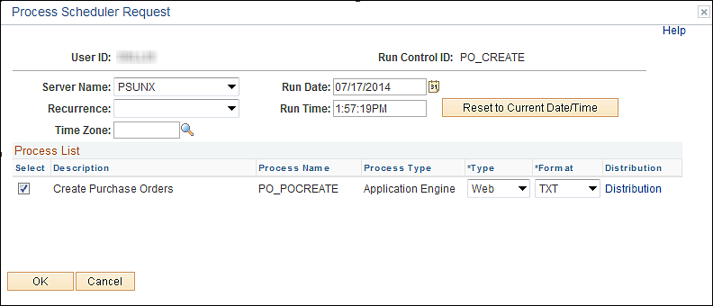

Run on Server “PSUNX”.

Click the button.

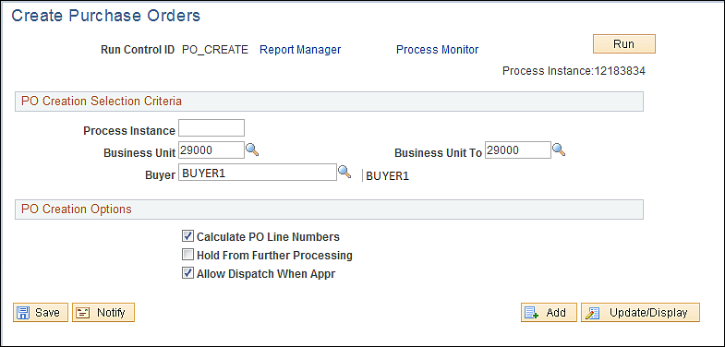

To review the job, click the Process Monitor link. Never Cancel or Delete the job while it is running. If there are issues, file a Critical HelpDesk case.

Note the Run Status is Processing. Click the button until the job has reached
a status of Success.

Review the Sourcing Workbench again.

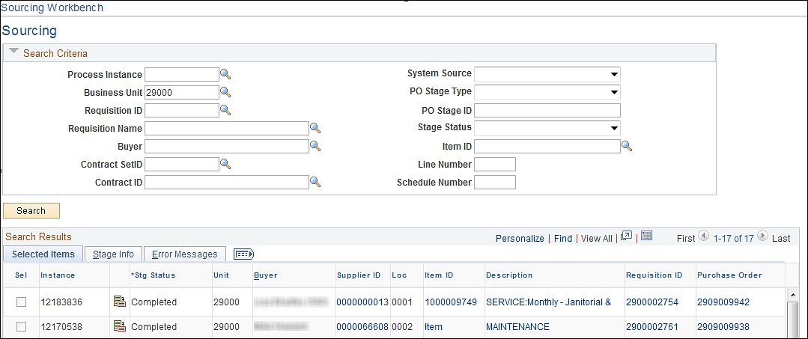

Notice the status is “Complete” and a Purchase Order Number has been assigned.

Clicking the Purchase Order Hyperlink will open a new window and take you to Maintain Purchase Orders.

Step 4 –Review the Purchase Order

Navigation: Purchasing > Purchase Orders > Stage/Source Requests > Sourcing Workbench

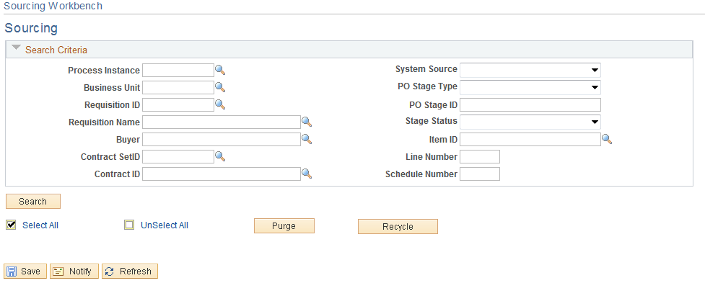

Input your Business Unit and Requisition ID.

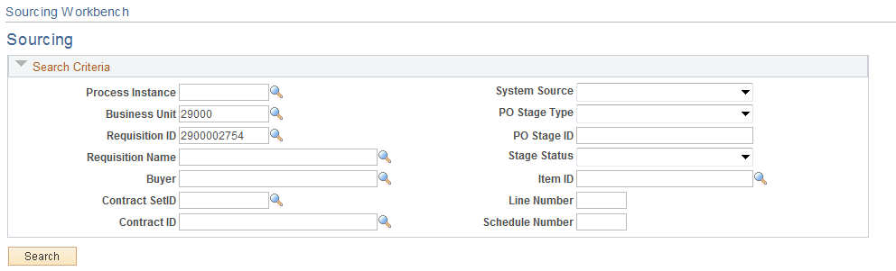

Click the button.

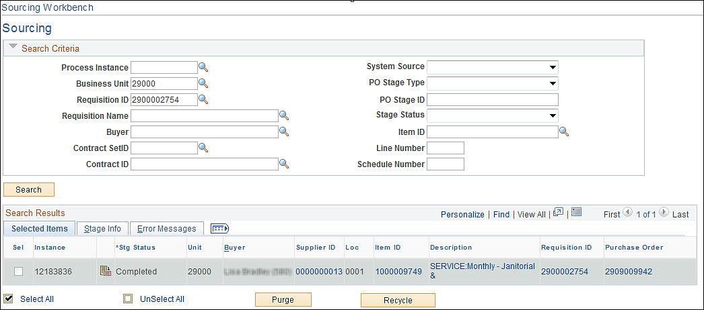

To review and complete the PO click on the link located to the right of the line. A new window will open.

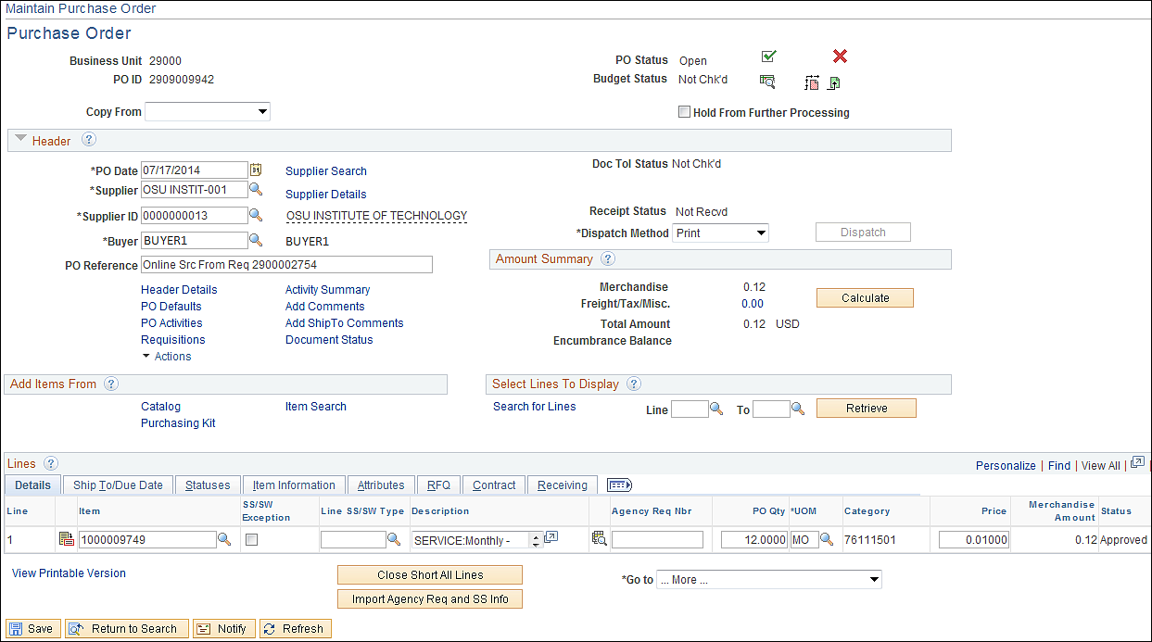

The PO will be in an Open status. Review the PO and make the necessary changes then complete the Purchasing Process. As with the procedures for copying a Requisition you will want to final the PO.

The unit price will be the unit price from the Requisition if Calculate Price was turned off.
Dispatch Purchase Order
Besides dispatching the Purchase Order from Purchase Order From Page, there are several other options.

Dispatch from Batch Process

Navigation: Purchasing > Purchase Order > Dispatch POs

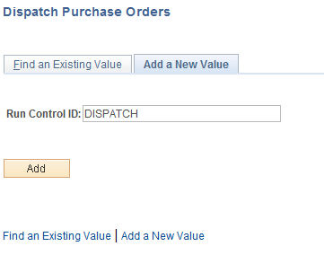

Input a run Control Id and click the button.

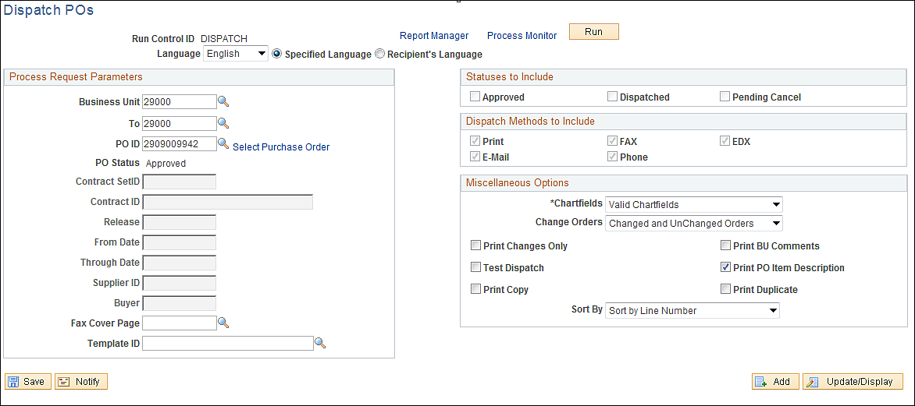

Input criteria to use when determining what Purchase Orders to Dispatch.

Click the button.

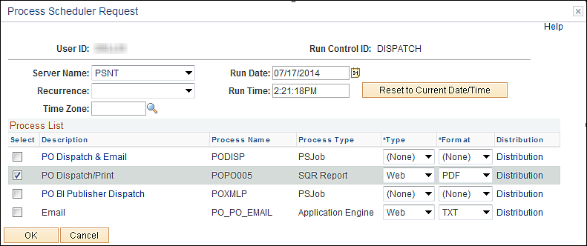

Server Name-PSNT- If the State Seal is not the form then the incorrect server was used.
Click the PO Dispatch/Print Radio box.

Click the button.

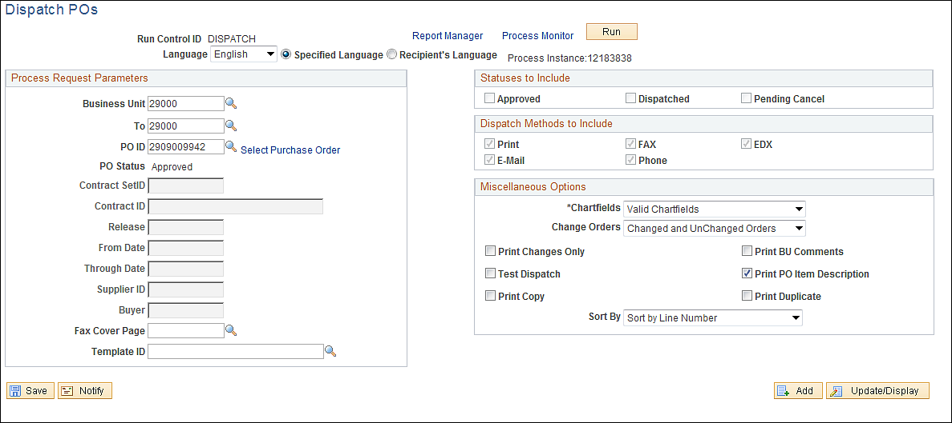

To print the Purchase Order, click on the Process Monitor Link.

Dispatch from the Buyer’s Workbench

Allows users to dispatch Multiple Purchase Orders at once.

Navigation: Purchasing > Purchase Orders > Reconcile POs > Buyer’s Workbench

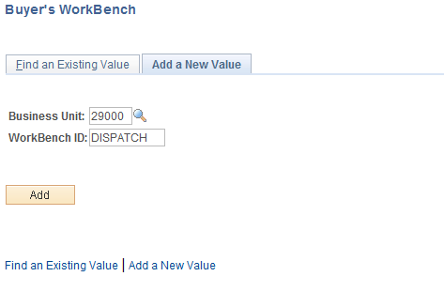

Input WorkBench ID and click the button.

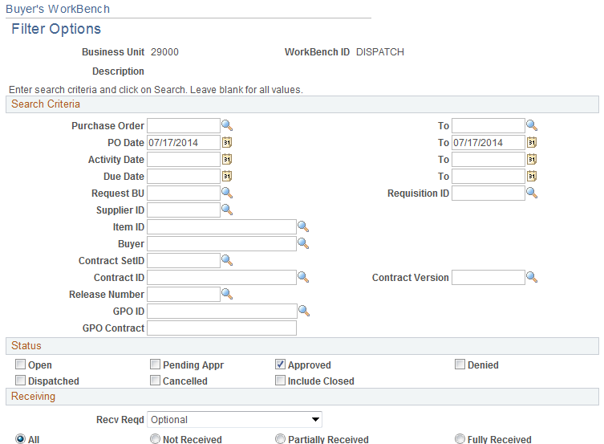
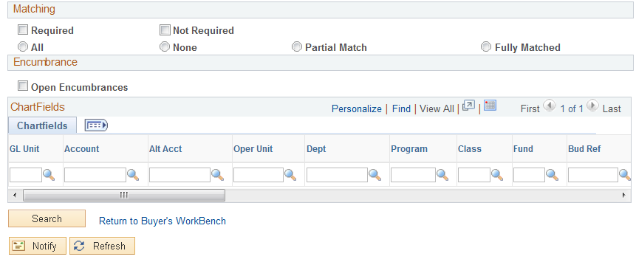

This page is used to define Purchase Order selection criteria. If you do not see expected Purchase Orders then review the Purchase Order.

Click the button located in the bottom left hand corner.

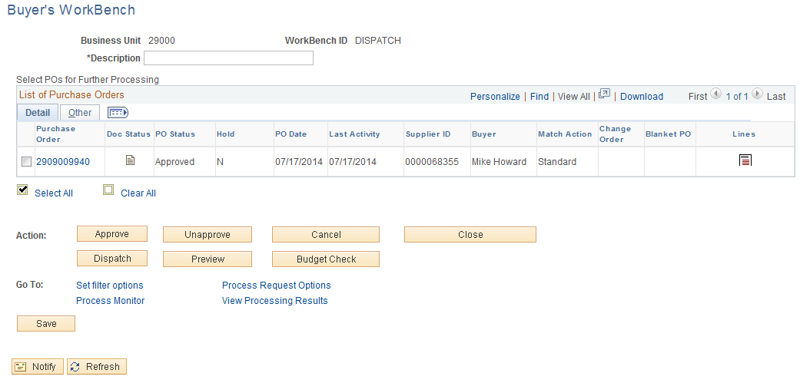

Click the Radio button to the left of the PO to dispatch and click the Process Request Options .

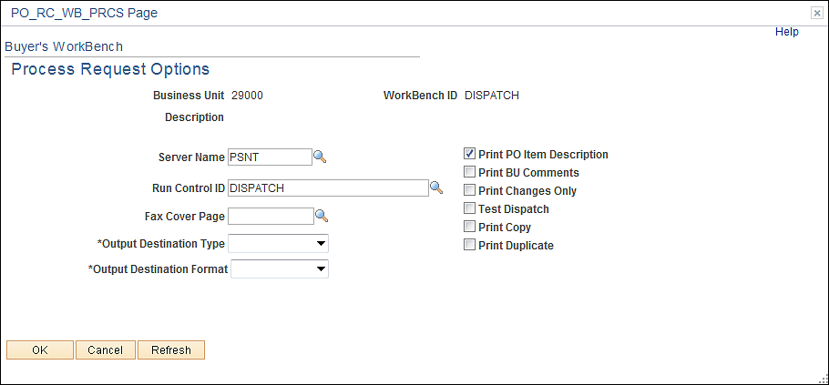

Select a Run Control ID and click the button.

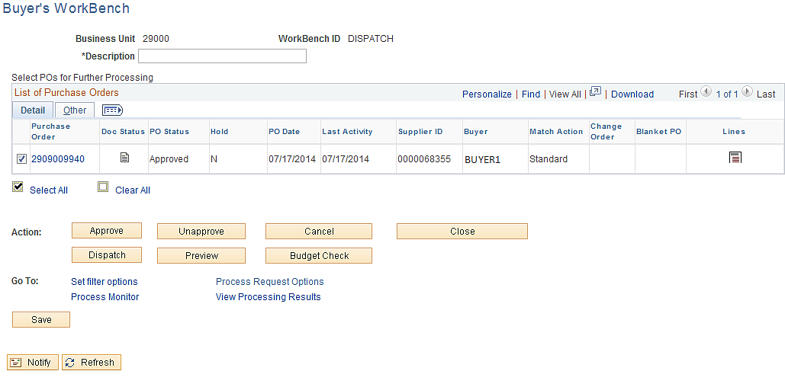

Click the button.

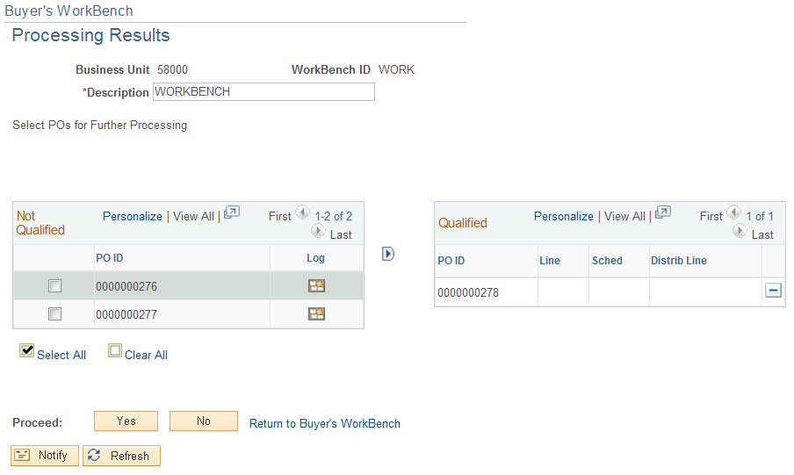

There are two sections:

Not Qualified- If the Purchase Order was not qualified to dispatch it will be displayed in this section. To review the reason click the Log Icon located to the Left of the PO.
Qualified-These Purchase Orders are available for dispatching. Click the button to exclude them.

Click the button.

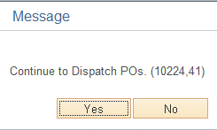

Click the button.
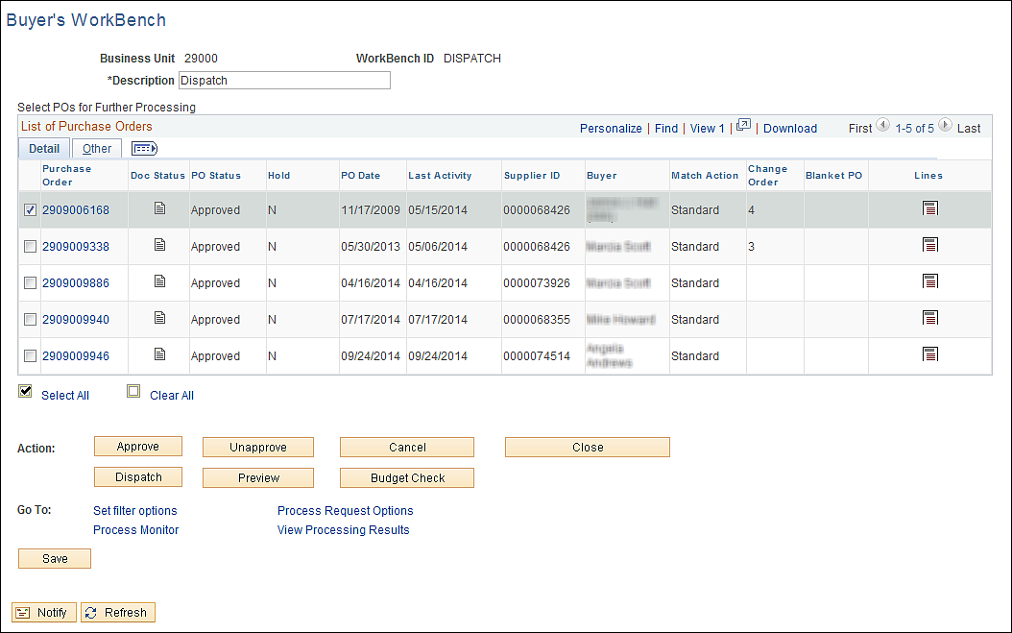

Print Purchase Order

Print from Process Monitor

Navigation: People Tools > Process Scheduler > Process Monitor

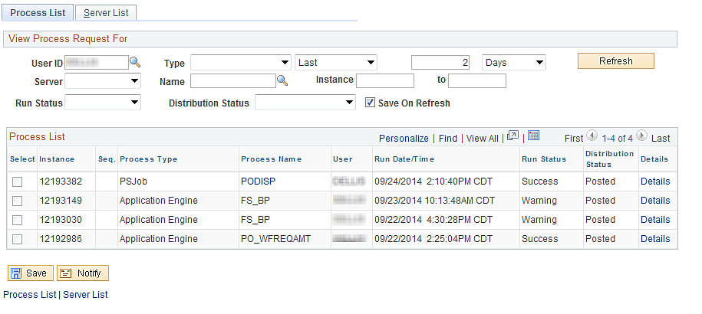

When the process goes to success click the PODISP link.

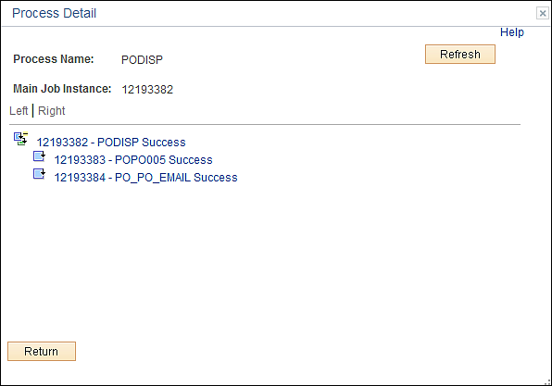

Click the middle link.

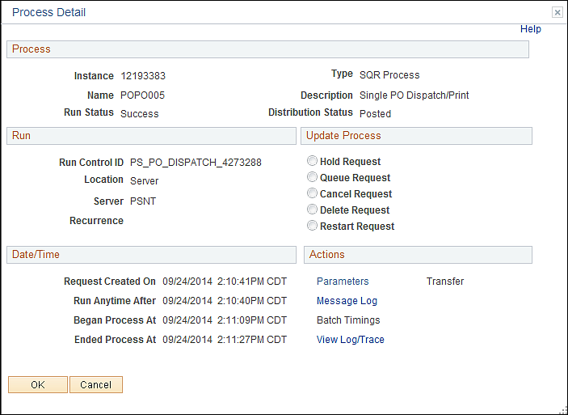

Click the View Log/Trace link.

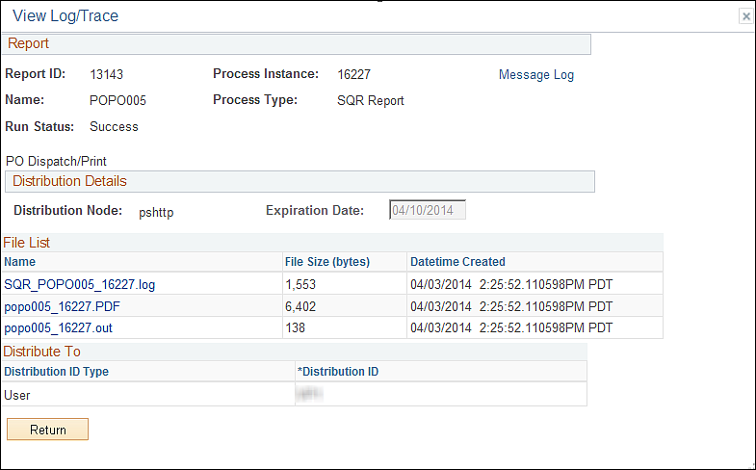

Click the PDF link.

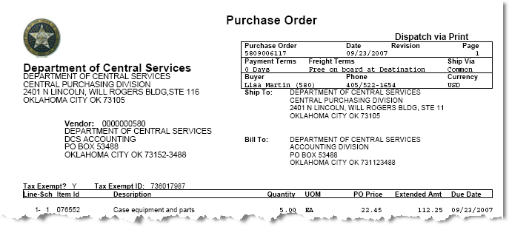

To print the PO click File>Print>OK ( If you receive the box with an X in the upper left hand corner you ran this on PSUNX instead of PSNT.)

Print from Report Manager

Navigation: Reporting Tools > Report Manager

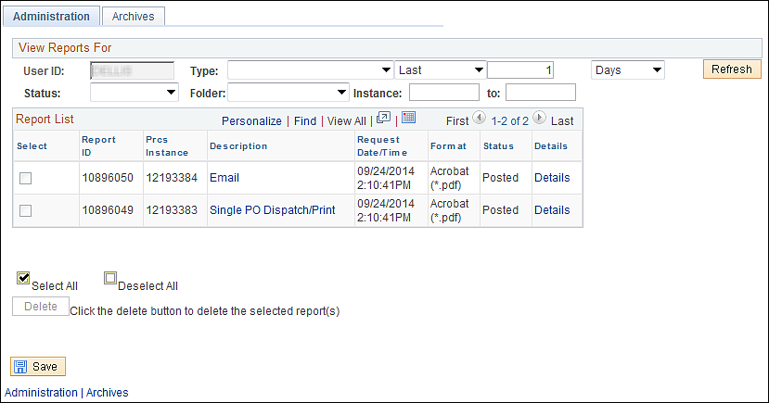

Click on the Single PO Dispatch/Print Link.

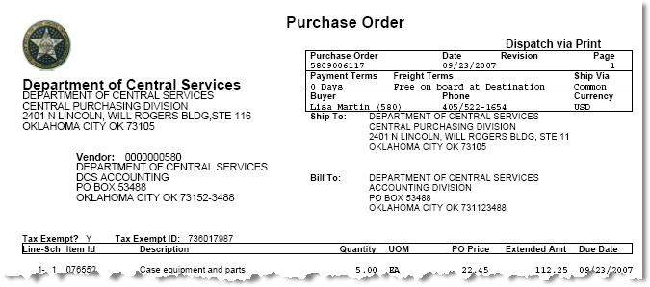

To print the PO click File>Print>OK ( If you receive the box with an X in the upper left hand corner you ran this on PSUNX instead of PSNT.)

Print from Purchase Order

Navigation: Purchasing > Purchase Order > Add/Update POs > Find an Existing Value

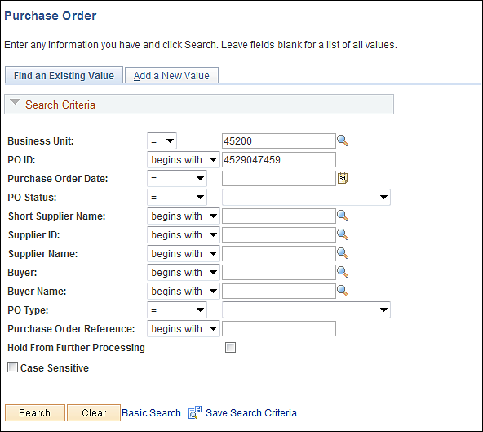

Input Business Unit and PO ID, click the button.

Click the View Printable Version link. After the Purchase Orders has been saved the Purchase Order can be printed in any PO status. This will open a new window displaying the Purchase Order.

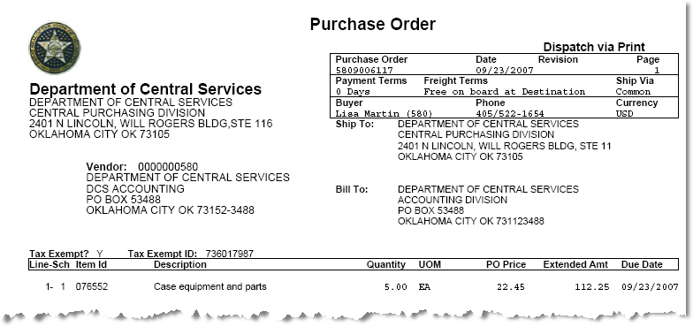

Purchase Order Inquiry

PO Accounting Page
Overview-This screen shows the budget checking entry of the Purchase Order and any reversals against it (Vouchers)

Navigation: Purchasing > Purchase Orders > Review PO Information > PO Accounting Entries

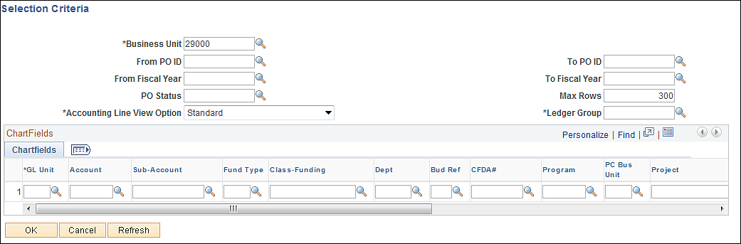

Input PO ID number and Ledger Group ALLOT.

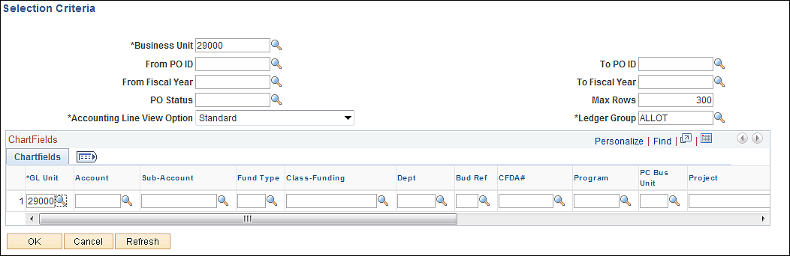

Click the button.

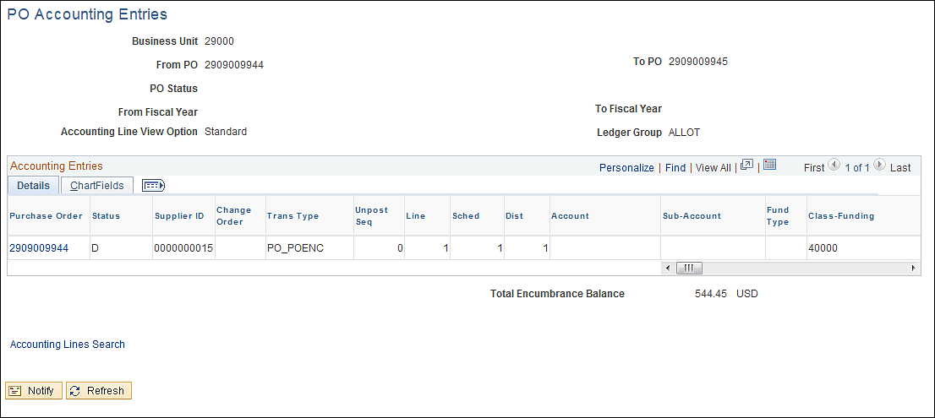

To see all the details click the show all tab.

Closed Value - Y or N. If equal to Y the distribution line has been marked as closed and the available encumbrance should reflect a zero balance.

Finalizing-This process Marks the document as final and will reduce any remaining available encumbrance.

This amount is in the budget as an encumbrance. If the Purchase Order or Voucher was not budget checked or failed budget checking then it would not appear on this screen.

Purchase Order Activity Page

Overview-This screen shows invoices created and matched against a PO Schedule Line.

Navigation: Purchasing > Purchase Orders > Review PO Information > Activity Summary

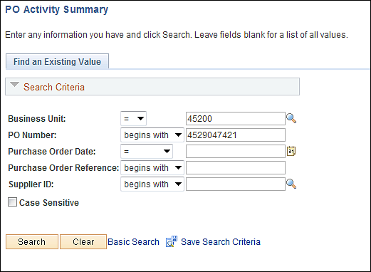

Input the Business Unit and Purchase Order number and click the button.

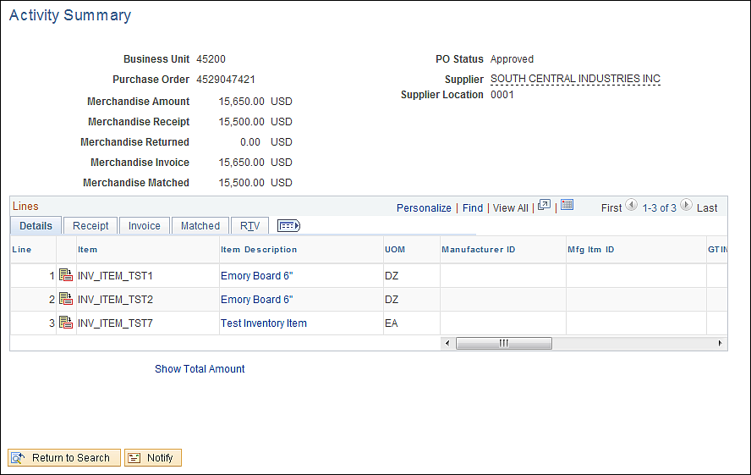
Review receipts created against a PO Line by clicking the receipt tab.

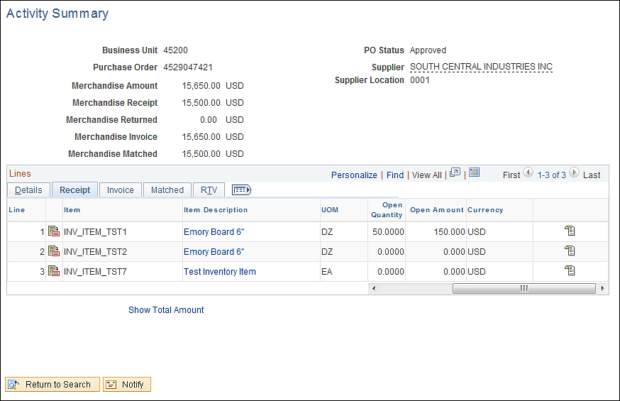

If there were receipts available to review there would be a receipt icon to click on.

Review invoices created against a PO Line by clicking the invoice tab.

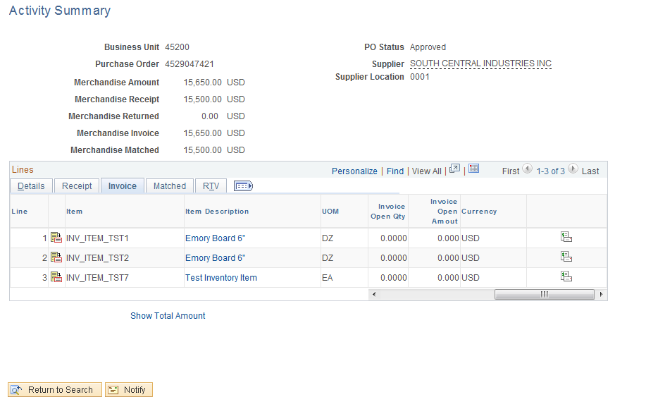

Click on the invoice icon to display all invoices.

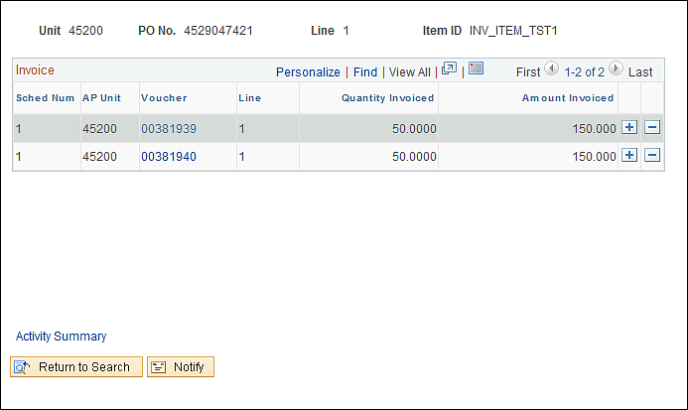

Click on the voucher number link, a new window will be created displaying the voucher inquiry screen (providing user has the security).

To return to the activity page click the Activity Summary Link.

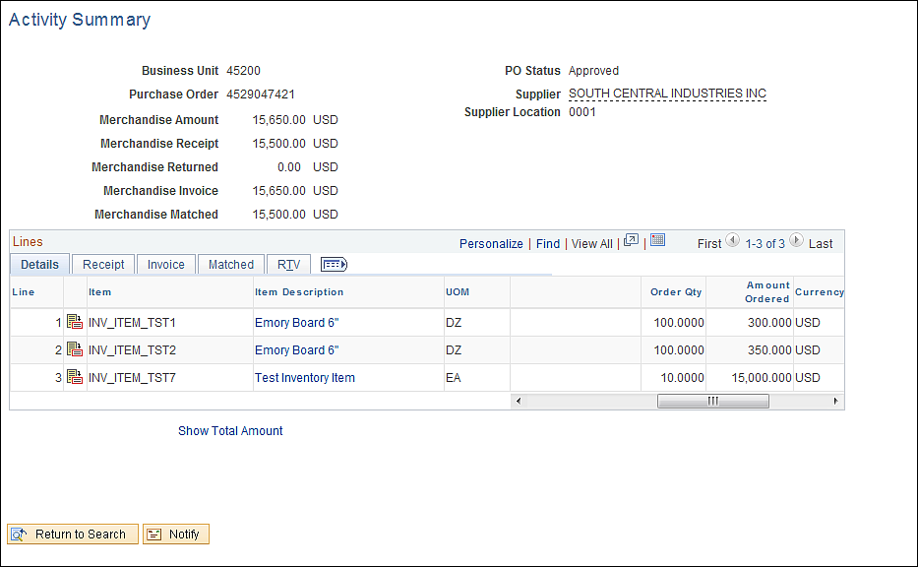

To review voucher matched against a PO line click the Matched Tab.

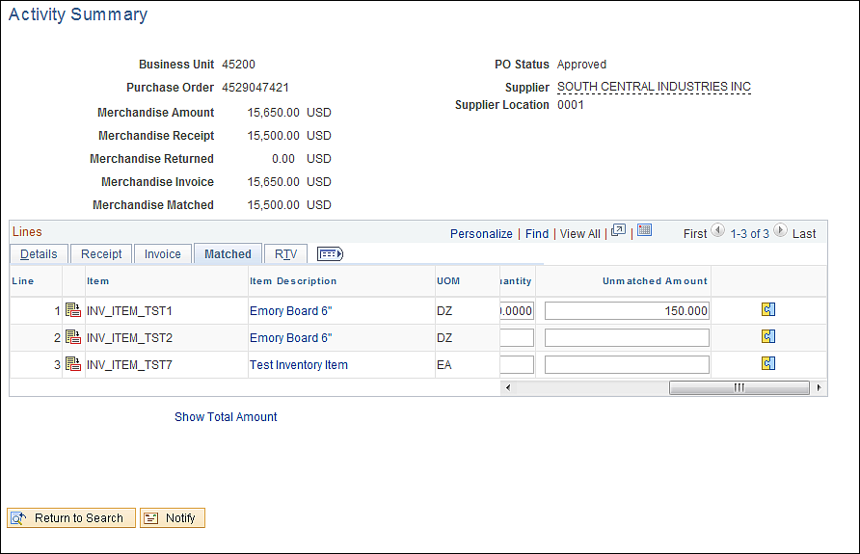

Click on the Match icon to display all invoices Matched.

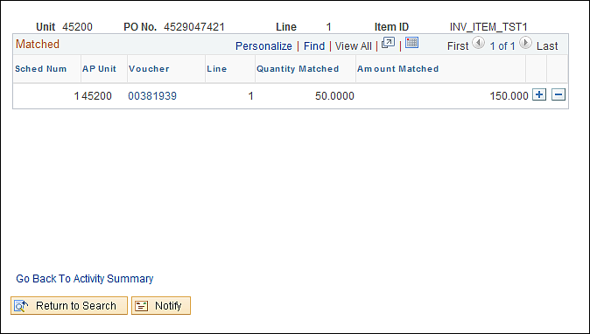

Click on the voucher number link, a new window will be created displaying the voucher inquiry screen (providing user has the security).

To return to the activity page click the Go Back To Activity Summary Link.

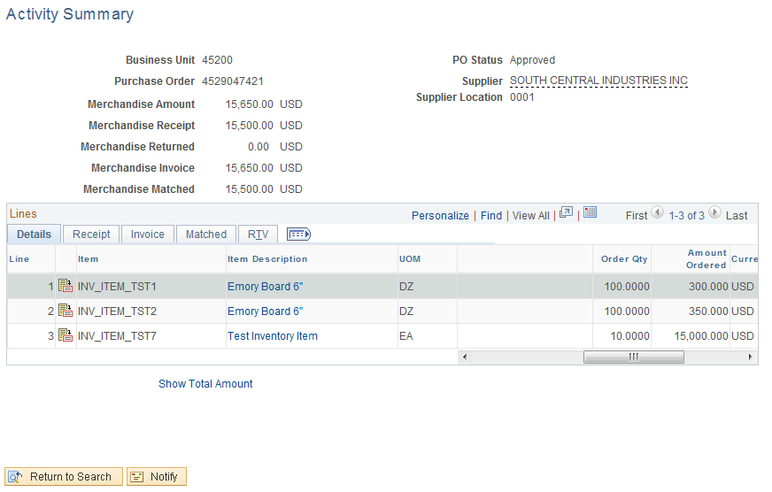

To review the RTV, click the RTV Tab.

Purchase Order Inquiry Page

Overview - This screen allows users to review Purchase Orders with out having Purchase Order update capability.

Navigation: Purchasing > Purchase Orders > Review PO Information > Purchase Orders

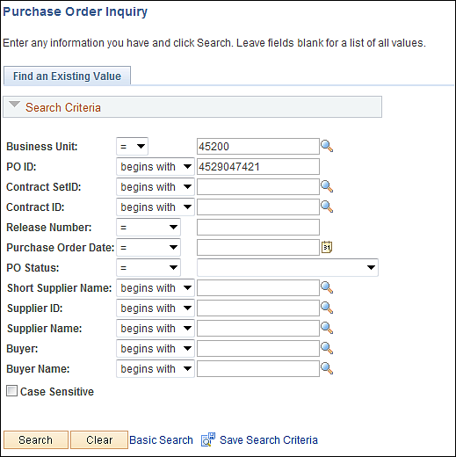

Input Business Unit and Purchase Order ID, click the button.

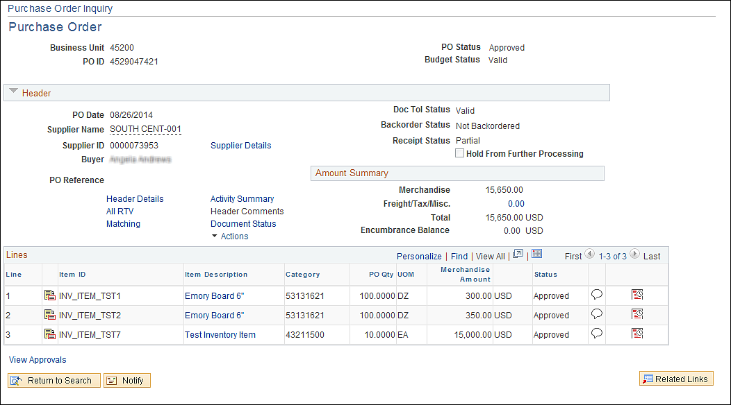

Budget Checking

Budget Checking from Batch Process

Overview-You budget check from the Purchase Order one at a time and you must wait until it has been completed. By using the batch process you have the capability to budget check multiple POs and not have to wait. This allows users to continue working without interruption. The budget checking process is ran at 12:00 noon and every evening.

Navigation: Purchasing > Purchase Orders > Budget Check

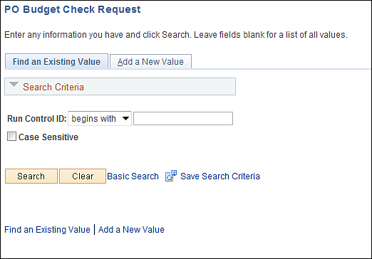

Input a run control and click the button.

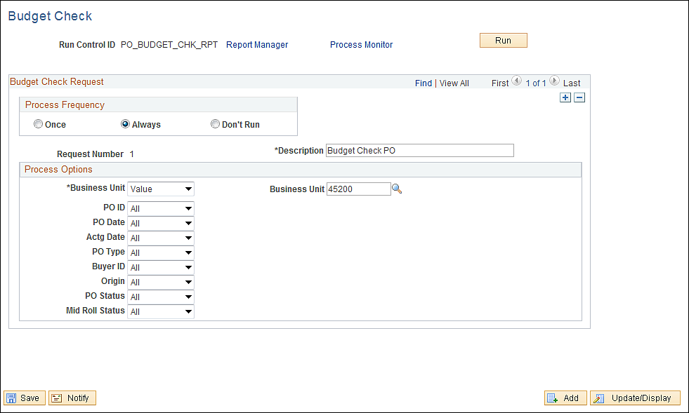

- Process Frequency-Always
- Description-Enter a Description
- Process Options-Select criteria’s to budget check Purchase Orders.
- Business Unit-Select Value and input your Business Unit
- PO ID-To select a certain PO to be budget checked, select value and input your PO ID.
- Other criteria’s can be defined by user.

Input your budget checking criteria’s and click the button.

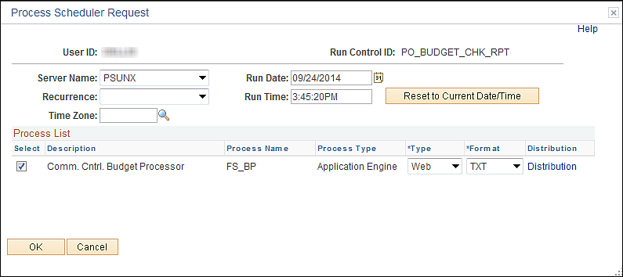

Server Name-PSUNX.

Click the button.

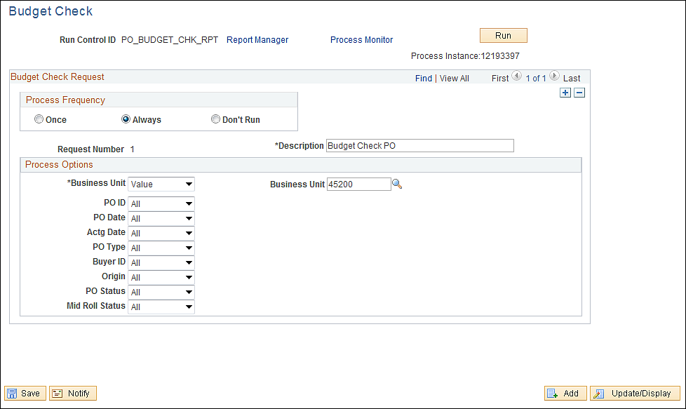

A process instance number will be assigned. Use this if you are have issues with budget checking. To review your job click on the Process Monitor Link.

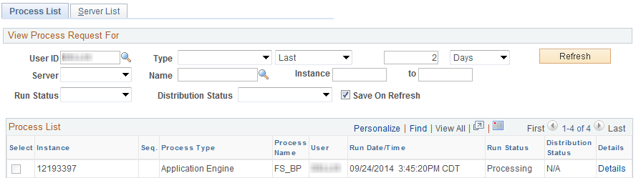

When the job has completed successfully, the run status will change to success or warning. Warning means there was an error in budget checking but the process complete.

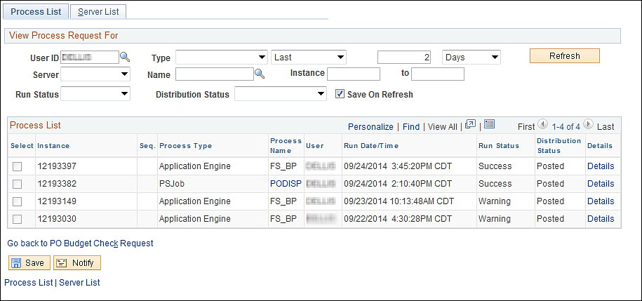

Click on the Details link.
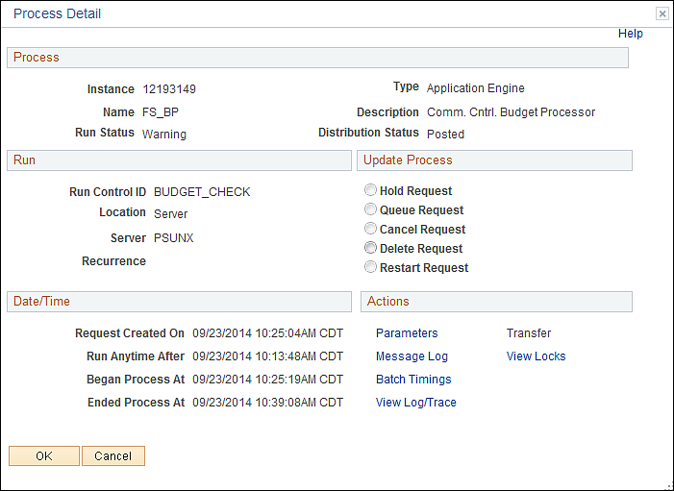

Click on the Message Log link.
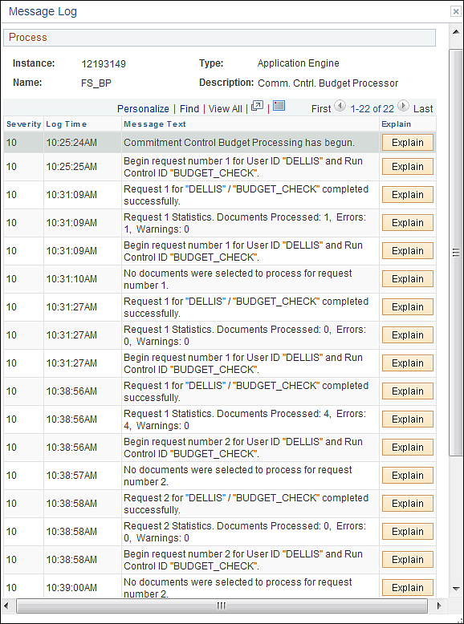

Budget Checking Error
To review the error, from the Maintain Purchase Order Form Page click the Error link.

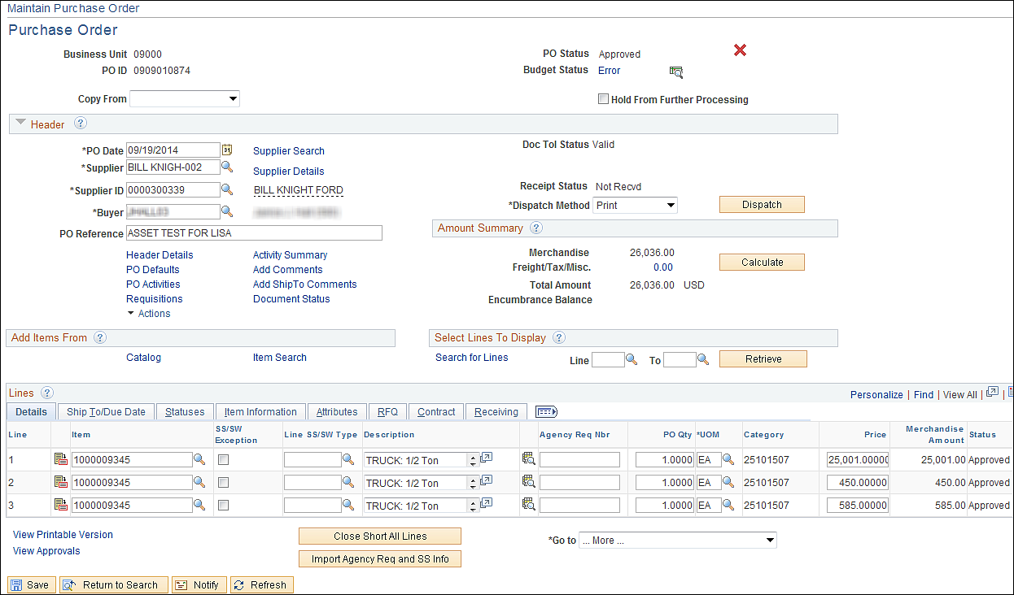

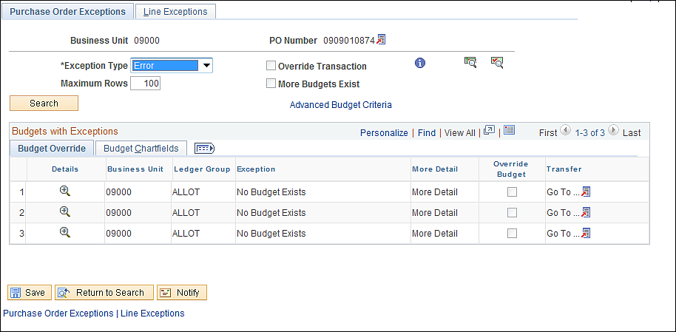

Purchase Order Header Default

Using Header Defaults
Overview-When creating a Purchase Order with multiple lines and multiple schedules, to avoid duplicate entry the header default can be used to enter data that will default to the whole Purchase Order. This data must be the same for each field on the PO otherwise it will not work.

From the Maintain Purchase Order Page click on the PO Defaults Link.

When you create a Purchase Order and use the PO defaults to enter your funding you must fix the budget checking error through the Default Link.

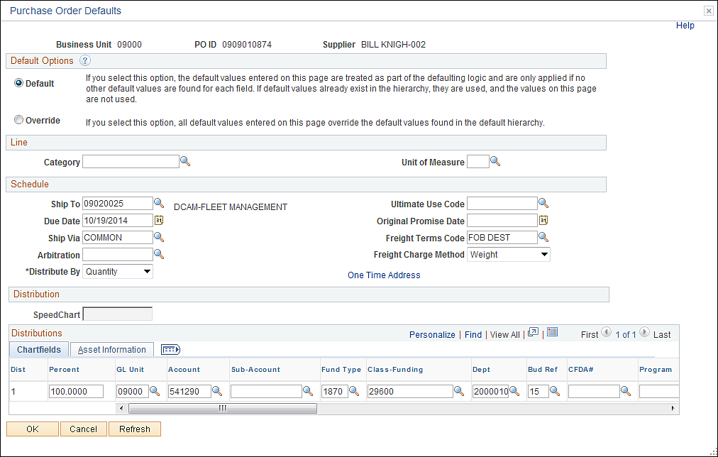

- Default-If you select this option, the default values entered on this page are treated as part of the defaulting logic and are only applied if no other default values are found for each field. If default values already exist in the hierarchy, they are used, and the values on this page are not used.
- Override-If you select this option, all default values entered on this page override the default values found in the default hierarchy.
- Category-Select a default category code for the purchase order. Selecting a default value here enables you to order ad hoc (description-only) items. The category entered here only applies to ad hoc (description only) lines. Do on use if using Item IDs.
- Unit of Measue-Select a default unit of measure (UOM) for the purchase order. Selecting a default value here can facilitate the ability to order ad hoc items. Do not use if using Item IDs.
- Ship To-Displays the default ship to location, which appears on the purchase order schedule as the location to which the supplier ships the order. A change to the ship to location implies sales and use tax and VAT recalculations on the PO Header - VAT Information page. You will receive a message about the change, but since this does not apply to the State of Oklahoma there will be no effect.
- Due Date-Displays the default due date. The due date for each schedule has the default value of the purchase order date, plus the number of lead-time days defined for the item (or item category if an ad hoc item). To override the due date, use the PO Defaults page. If the default option is override, the system uses the override value, and the lead time calculation is ignored. If the default option is default, the system calculates the due date based on the purchase order date plus the number of lead time days. (Currently number of Lead days is not used.)
- Ship Via-Carrier or method of shipment.
- Arbitration-Not being used
- Distribute by-You have the capability to distribute by either amount or quantity. If you select Override on this page, you have the capability to set up multiple distribution lines. You then enter the percentage for each distribution in the distribution details. The sum of the line distribution percentages must equal 100 percent.
- Ultimate Use Code-Not applicable.
- Original Promise Date-Date on which the supplier originally committed to deliver the item. The default due date appears by default in this field and is updated when the item or item category (ad hoc items) changes. If you override the due date on the PO Defaults page, the purchase order date plus the number of lead time days defined for the item or item category (ad hoc items) will be used, not the overridden due date.
- Freight Terms-Freight terms code that applies to the schedules for this purchase order.
- Freight Charge Method-Leave as Weight
- SpeedCharts-Select a speed chart. The SpeedChart field enables you to use a code that contains preset distributions. This speed chart is not itself a defaulting element. Instead use it here to assist you in defining default chart field elements.
- Distribution-
- Chartfields-Agency defined fields to control budgetary requirements.
- Budget Date-If you are using commitment control, this field is available. The default date is the accounting date, but the accounting date can over-ridden. When you save the purchase order, the system confirms that the budget date is within the valid open period date range for the general ledger business unit. (All periods are open for PO).

Input the data to default to the whole Purchase Order. If a field on the Purchase will contain different values then this option should not be used.

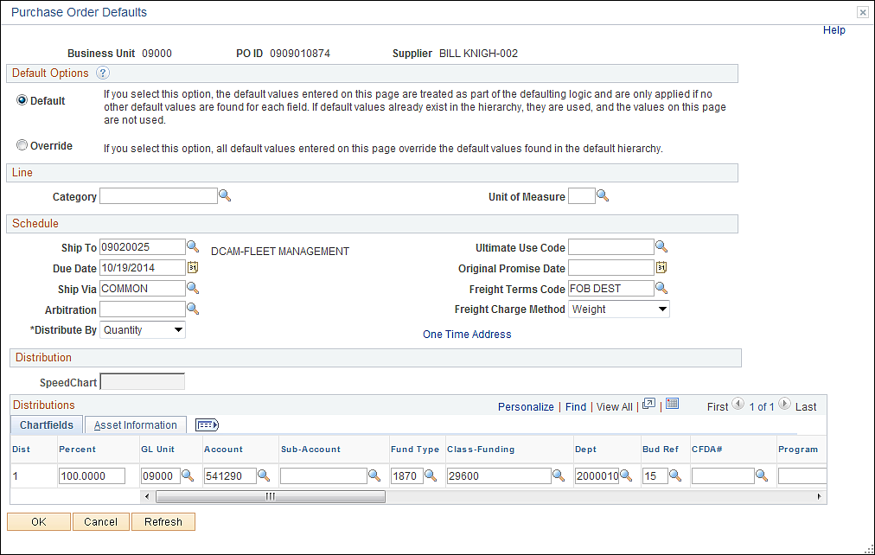

Click the button.

The defined values will be populated on the Purchase Order. If you created the Purchase Order using the default page, any changes or corrections to a defined field on the Purchase Order must take place on this page.

Click on the PO Defaults Link.

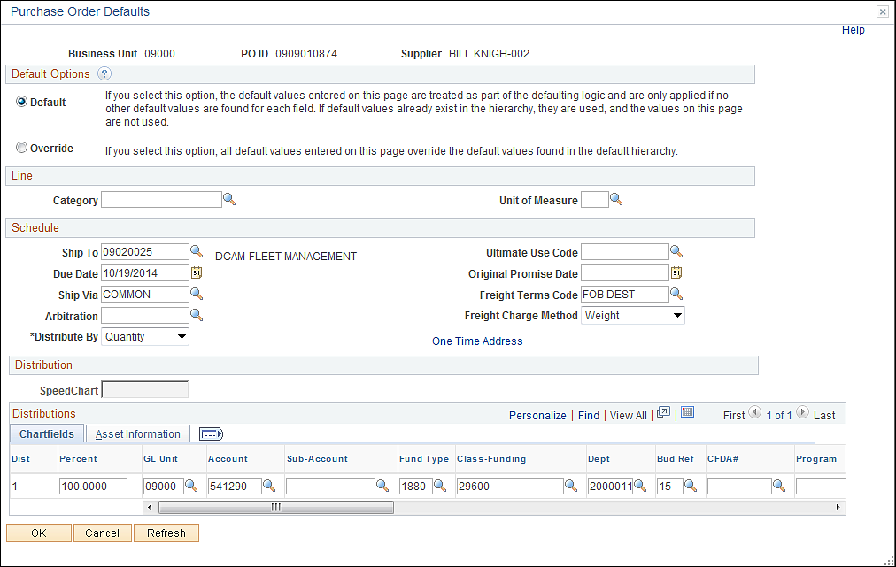

Change the value and click the button.

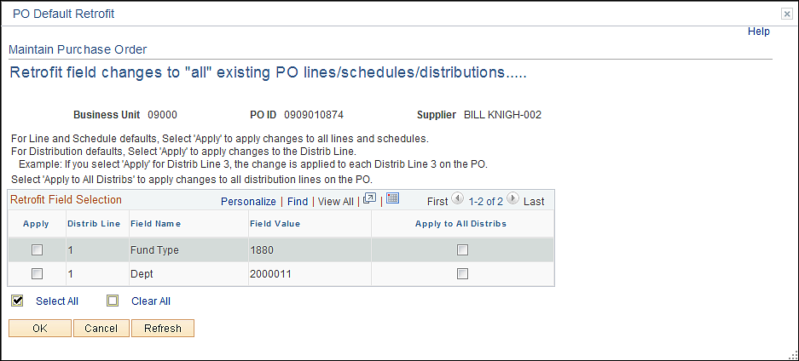

This page is asking for verification of data to change. To review all fields click the View All link.
Click on the radio box to the left of the field to change.

Click the button. Purchase Order fields will be updated.

Supplier Look Up
From the Purchase Order click the Supplier Search Link.

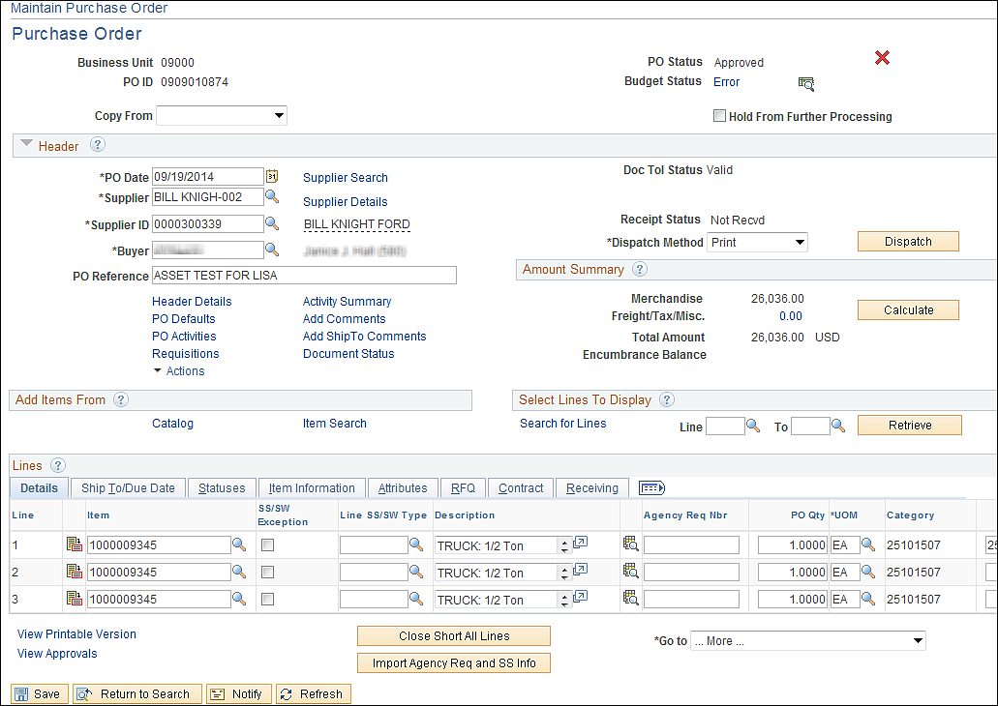

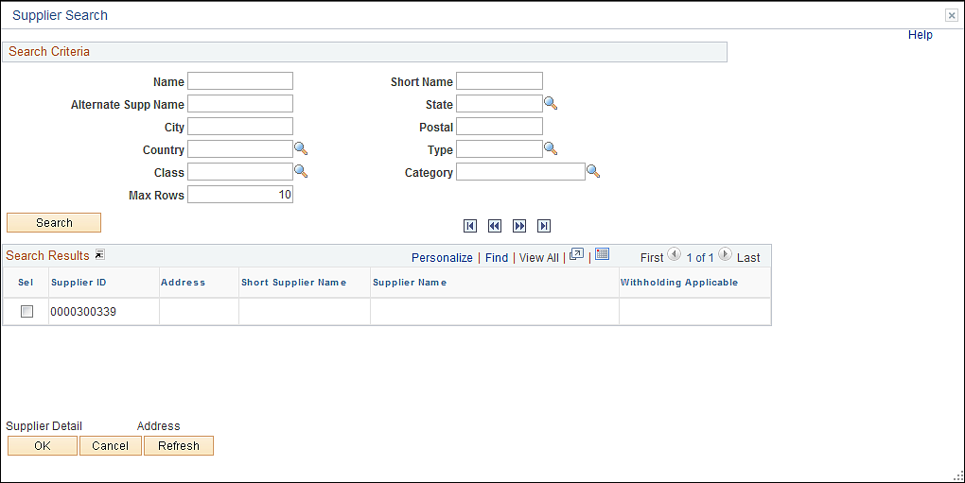

From this page look up a supplier by:

Name
Short Name
City
Class
Category-Locate Registered Suppliers
Others

Name

Input the supplier’s name, if you do not know how to spell the name then input the first few digits and click the button. (If you expect more then 10 results, be sure to change the Max Rows.)

In this example XEROX will be used.

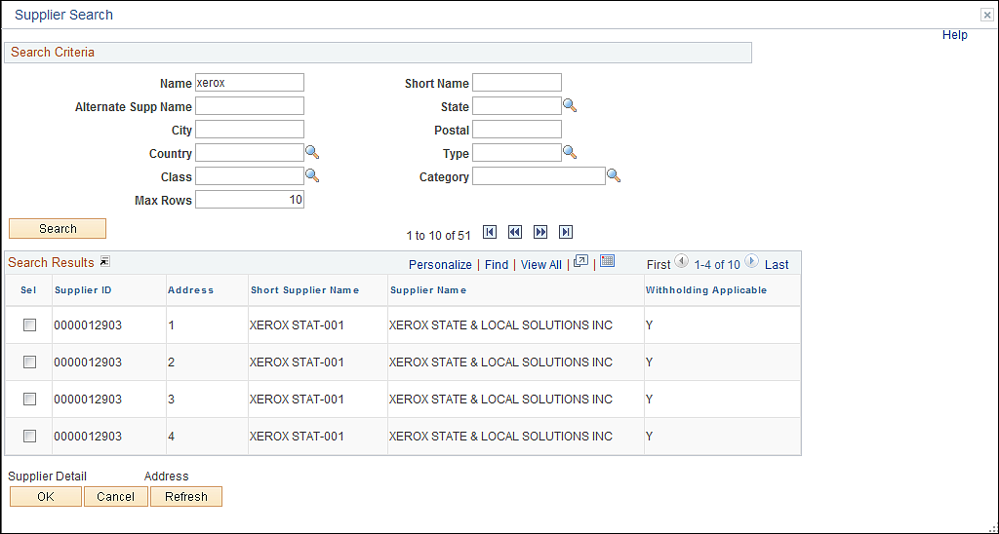

If needed, click the View All link to review all the results.

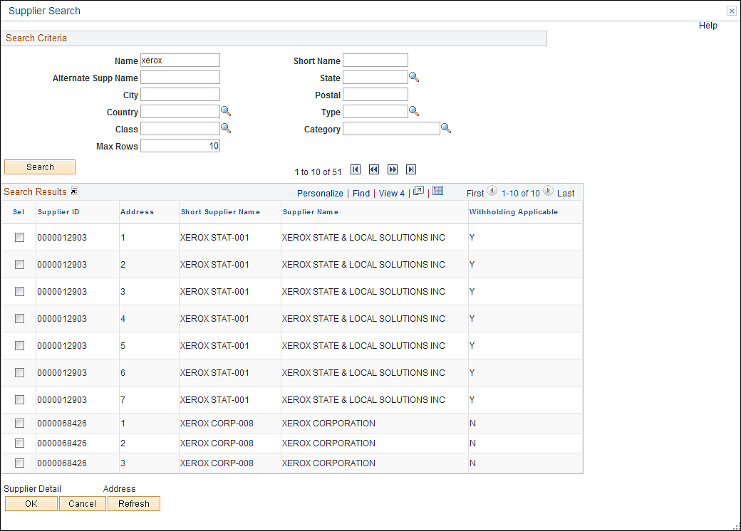

To select a particular supplier click the Radio Box located to the left and click the
button.

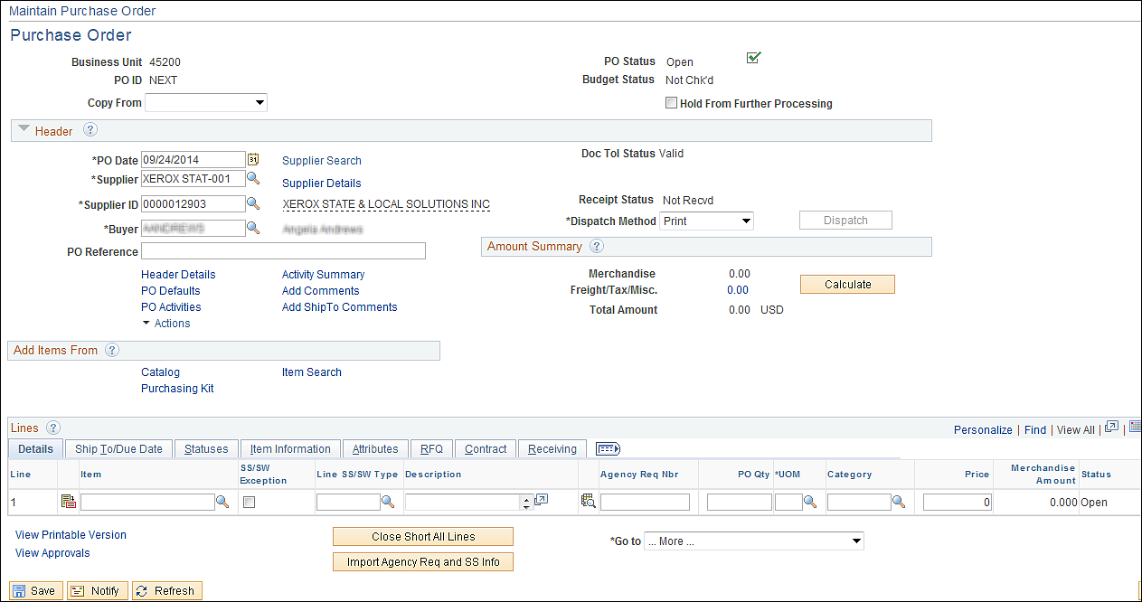

The supplier has now been selected for this Purchase Order. Click the Supplier Details link select the supplier location.

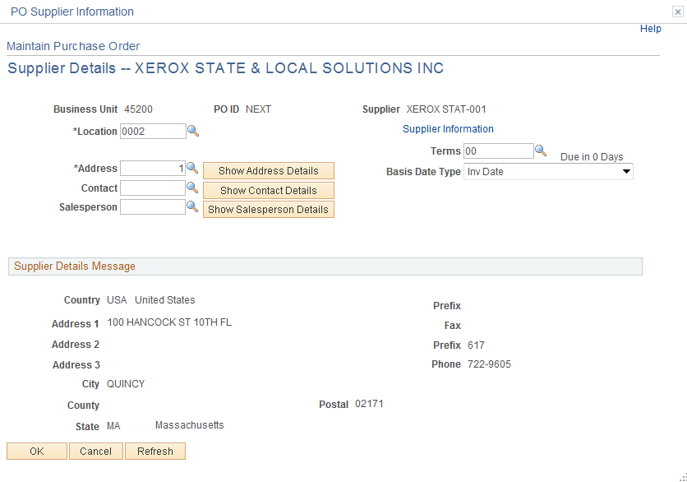
- Location- Defines various locations for a supplier on the Supplier Information - Location page accessed from the Maintain Suppliers menu. Each location you define points to an ordering location and a pricing location.
- Address- View address details for the location.
- Terms-Specifies number of days from invoice date the warrant will be issued. This date should not be changed. The state is currently using immediate pay.
- Contact-View contact address details.
- Sales Person- View salesperson address.
- Basis Dt Type- Defines the date that the system uses as the term basis date for scheduling payment and determining early payment discounts. Values include Acct Date (accounting date), Doc Date (constructive document receipt date), Inv Date (invoice date), Recpt Date (receipt date), Ship Date, and User Date (user specified date)
- Show Button-Click this to display the address in the Supplier Detail section.

Review the Supplier’s Locations by select the Look Up Icon located to the right.

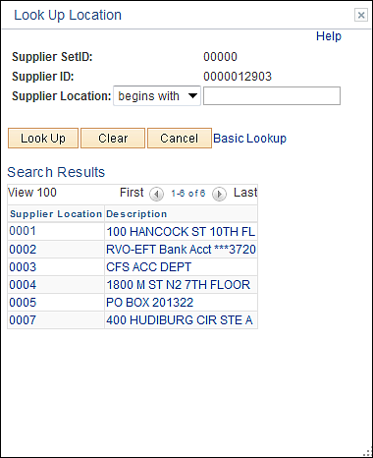

To select the supplier’s location click the link.

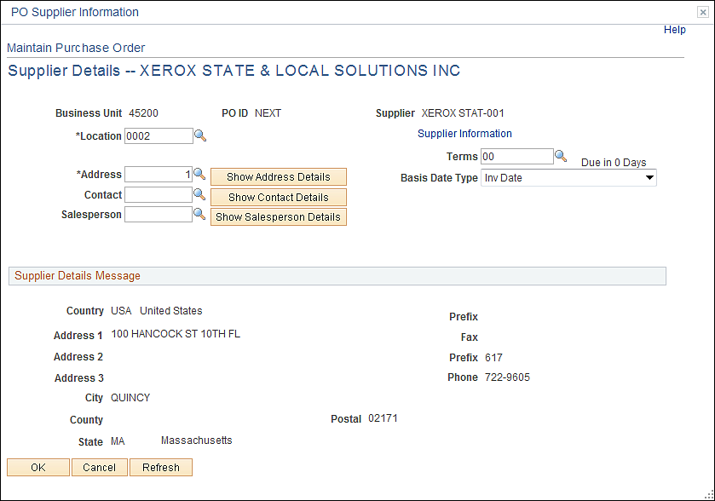

Click the button.

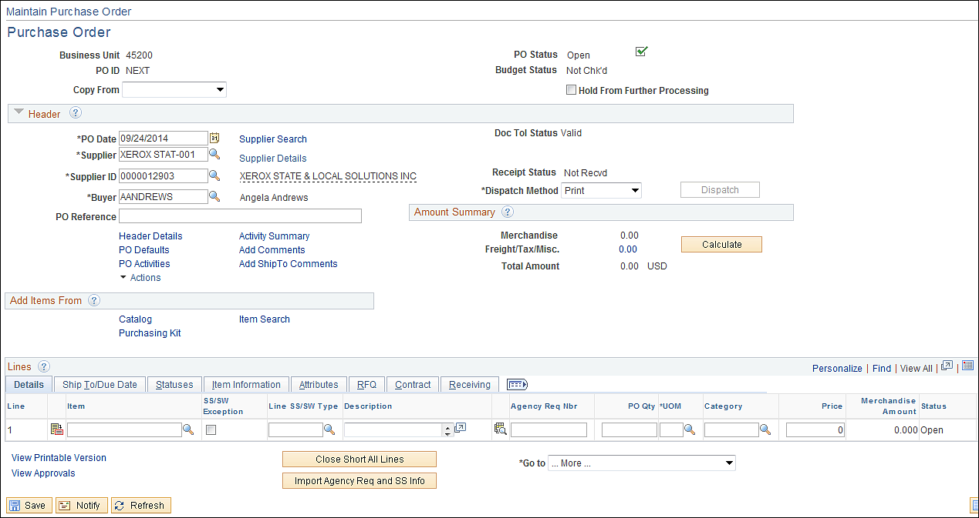

Category

From the Purchase Order click the Supplier Search Link.

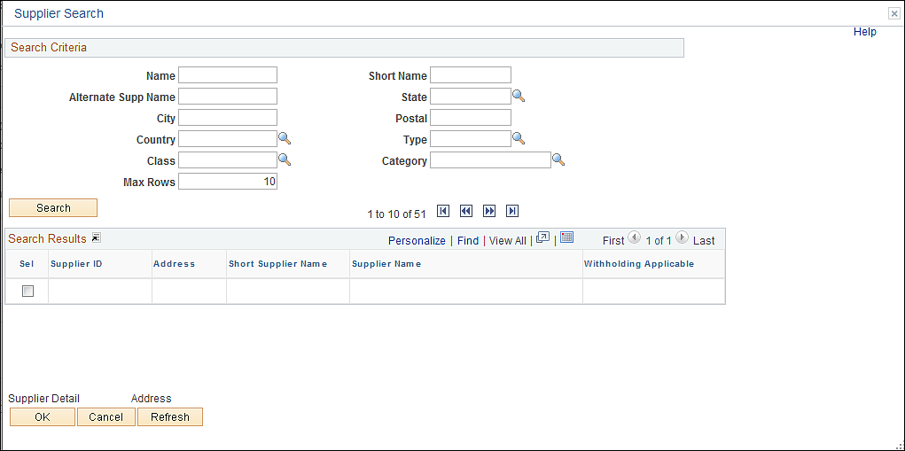

If you know the Category the purchase is for and you want to review all the Registered Suppliers, input the Category Code and Type. The Type will define what year the supplier is registered for. Click the Look Up Icon located to the left of the Type Field.

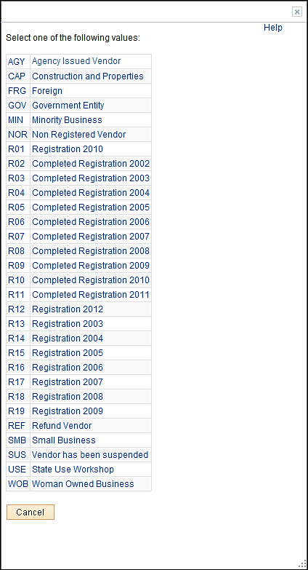

Click the R17 or R18 link.

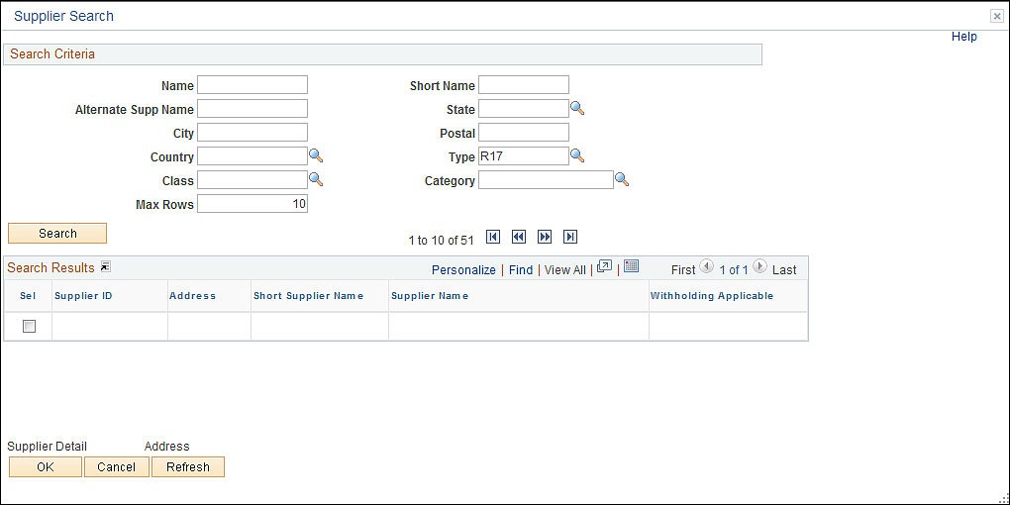

Input Category 0962 and click the button.

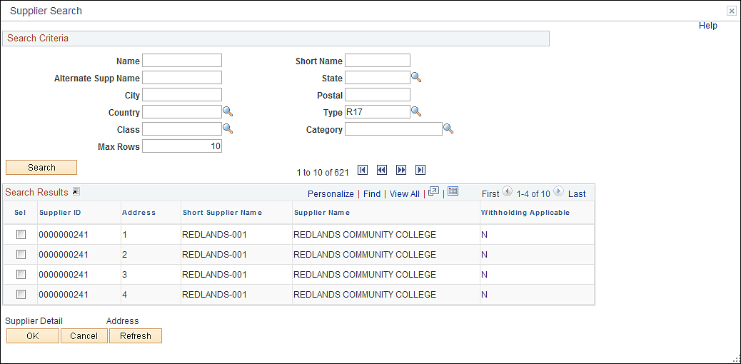

This will display a registered supplier for FY 2007. This can help in identifying supplier to use when making purchases. Click the button to return to the Purchase Order.
Finalizing PO (Requisition)
To specify partial or final liquidation of a requisition when it is copied/sourced to a purchase order directions follow: When you create or modify a purchase order, mark the Purchase Order as Final, prompting the system to liquidate the pre-encumbrance, making your Purchase Order for less money than you originally authorized. Also, reversal of the finalization of the Purchase Order is available.
When you mark the Purchase Order as Final the system will fully liquidate the Requisition lines upon Budget Checking the Purchase Order. The system then creates the appropriate accounting entries to relieve outstanding pre-encumbrances.
If you do not Finalize the Purchase Order then any changes made will directly effect the Requisition. Example: You fully source the Requisition; this will leave a zero pre-encumbrance. If the Purchase Order is not finalized and a Change Order is processed reducing the Purchase Order, the reduction will be reinstated on the Requisition creating a Pre-encumbrance

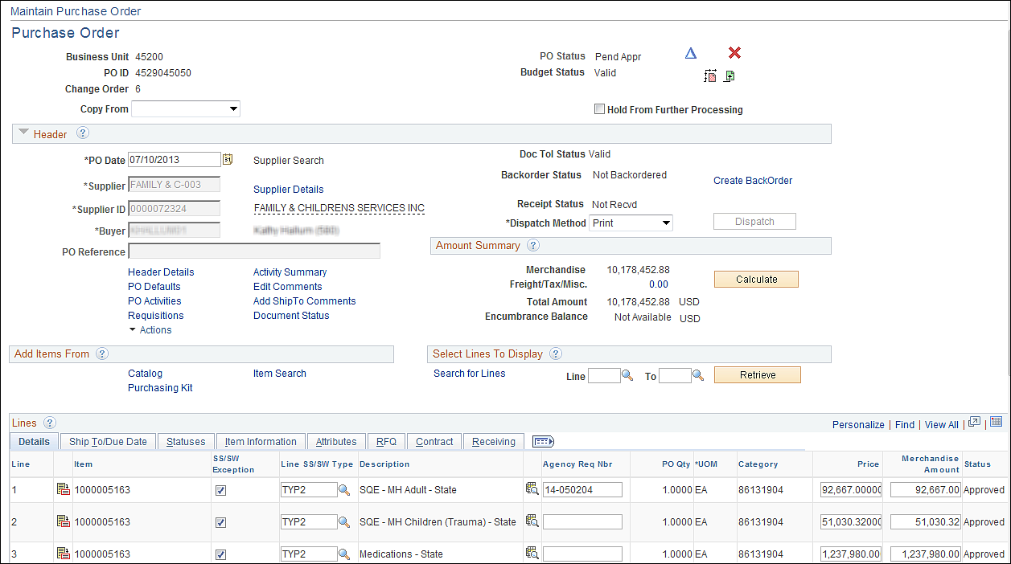

From the Maintain Purchase Order page click the Requisitions link.
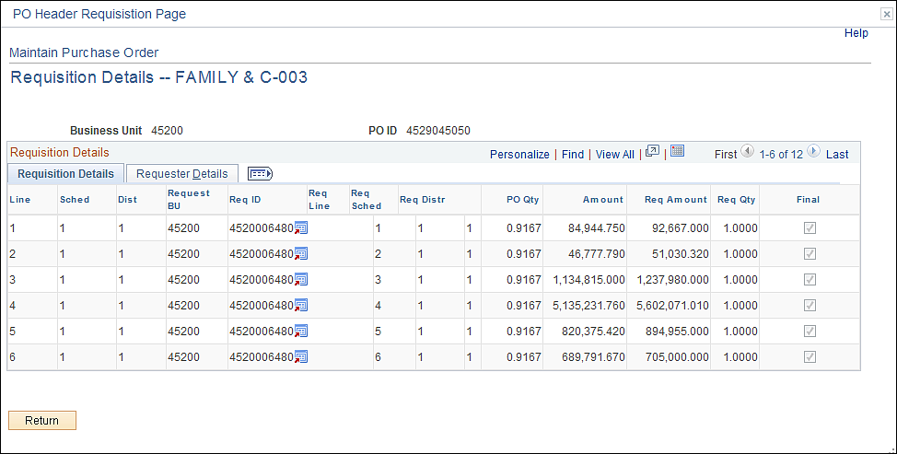

This page identifies the Requisition number and lines copied/sourced to the Purchase Order. If the final Box is not selected then the PO has not been finaled. Review the Requisition by clicking the icon.

Click the button to return to the Purchase Order Form page.

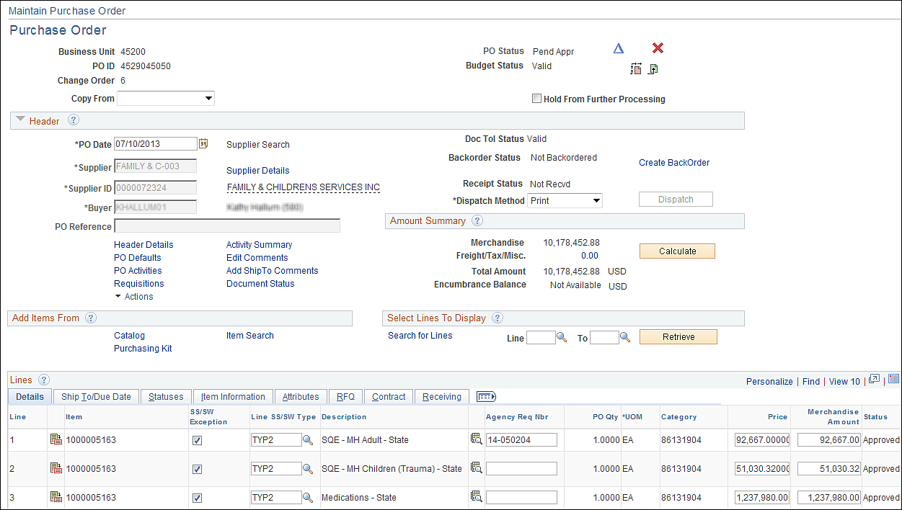

To final the Purchase Order click the Final Icon located in the upper right hand corner.

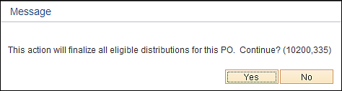

Click the button to final the Purchase Order.

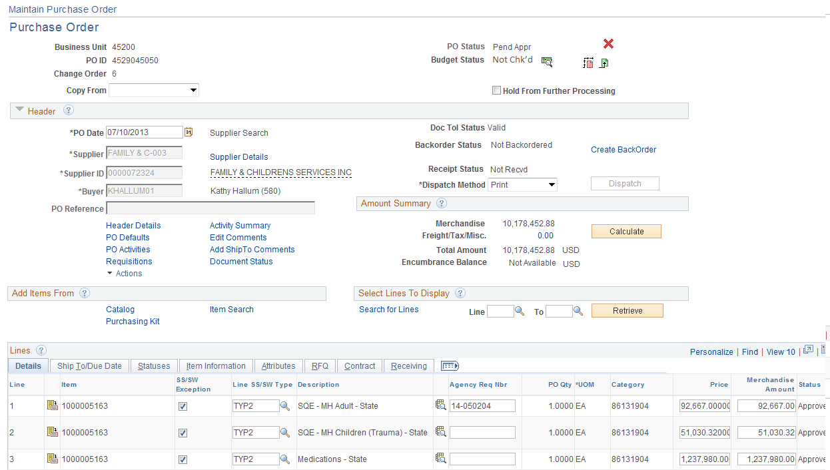

The budget checking status is now Not Chk’d.

Click the Budget Checking Icon.

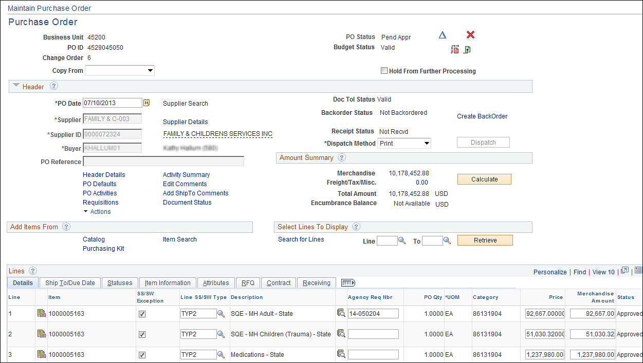

Click the Requisitions link.

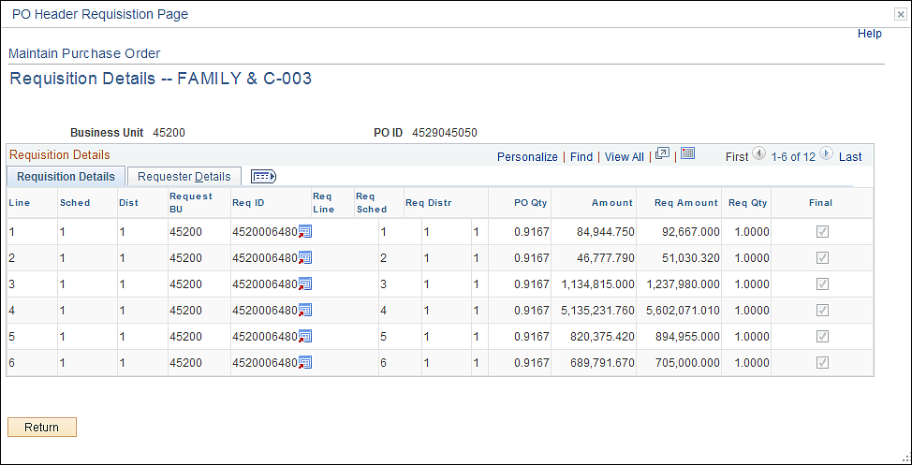

The Final box is updated after the Purchase Order is Budget Checked. To un-final the Purchase Order, select the Undo Final Icon located to the right hand corner.

Click the button to return to the Purchase Order Form page.

Sole Source/Sole Brand Affidavits

TYPE | Reason for Sole Source/Sole Brand | Affidavit must Clearly:
1 | Only a specified make, mode, or brand will meet  Agency needs even though the makes modes or brands are available from multiple suppliers. A brand name description or other purchase description to specify a particular brand name, product, or feature of a product, peculiar to one manufacturer does not provide for full and open competition regardless of the number of suppliers solicited. This restricts competition in that only suppliers able to provide a specified make, model, or brand are permitted to compete. | State why the specified makes, models or unique services are absolutely essential to the ‘State’ requirements.
2 | Market research clearly shows that there is only one responsible supplier and it can be demonstrated that no other suppliers or services will satisfy agency requirements. | State why the specified makes, models, or unique services are absolutely essential to the State’s requirements, and what market research was accomplished to clearly establish that only one supplier can provide the supplies or services.
3 | Requirement is for additional units or replacement parts of specified makes and modes of technical equipment and only one supplier available | State why the specified makes and models are absolutely essential to the State’s requirements and what market research was accomplished to clearly establish that only one supplier can provide the supplies or services.
4 | Agency needs to purchase suppliers or services from the original supplier in the case of a follow-on contract because award to any other supplier would result in substantial duplication of costs to the State that would not be recovered through competition, or in unacceptable delays in fulfilling agency requirements. | Provide data, estimated cost and how those costs were derived extent of delay and impact of delay, and other rationale as to the extent and nature of the harm to the Government.
5 | Purchase of a brand name commercial item that will be used for authorized resale | No additional information needed

TYPE | Reason for Sole Source/Sole Brand | Affidavit must Clearly:
6 | Agency has an unusual and compelling urgency for suppliers or services and the State would be seriously injured unless the agency is permitted to limit the number of suppliers from which it solicits bids/proposals. | Provide data, estimated cost and how those costs were derived and other rational as to the extent and nature of the harm to the Government. Justification may be prepared and approved within a reasonable time after contract award when preparation and approval prior to award would be unreasonably delayed the acquisitions.
7 | Agency needs to acquire services of an expert, such as expert services to support a current or anticipated litigation or dispute, involving the State in any trial, hearing, or proceeding whether or not the expert is expected to testify. Examples of such services include, but are not limited to assisting the State in the Analysis presentation, or defense of any claim or request for adjustment to contract terms and conditions, whether asserted b y a supplier or the State, which is in litigation or dispute, or is anticipated to result in dispute or litigation. | Indicate why the source for expert services is absolutely essential to the State’s requirements, thereby precluding consideration of other sources.
8 | A statute expressly authorizes or requires that the acquisition be made for a specified supplier for Oklahoma Sate Industries, State Use Committee | Attach a copy of the referenced statue.

Sole Source/Sole Brand Approval Authority

Acquisition $ Amount | $ Within Agency DMPA* | $ Exceed Agency DMPA*
Under $2500 | No affidavit or approval required | No affidavit or approval required
$2500-$10,000 | Agency Chief Administrative Officer | State purchasing Director
$10,000-$25,000 | Agency Chief Administrative Officer | State Purchasing Director
Over $25,000 | Not applicable. Agency DMPA limited to 25,000 | State Purchasing Director

- DMPA: Delegated Monetary Procurement Authority

Depending on agencies authority the Delegated Monetary Procurement Amount may vary. These tables are meant as an example only.

Footnote: Data is from the Procurement Information Memorandum (number 99-3 revised).
Issued 09/30/04.
Purchase Order Types

PO TYPE | DESCRIPTION
10 % Waiver | As defined in Title 74 O.S. Section 85.4E 2 (c)
Authority Order | Purchase made are not subject to the Central Purchasing Act
Title 61 | Public Building and Construction Planning Act. (Construction & Properties)
County | Local Governmental entity
Court Ordered | A Court Order requiring the purchase of certain goods or services by state agency – as defined in Title 74 O.S. Section 85.44B
Equipment Lease | Lease of products as defined in Title 74 O.S. Section 85.4L
Emergency 61 | Applies whenever the Construction and Properties Division of the Department of Central Services with concurrence of the chief administrative officer of the public agency affected declares that an emergency exists.  Emergency as used in this section shall be limited to conditions resulting from any of the following:  1. A sudden unexpected happening or unforeseen occurrence if it is impossible for the provisions of Section 62 of this title to be observed because of the time factor and if the public health or safety is endangered.  2. A condition or situation which, if allowed to continue, would lead to economic loss to the state or to further damage of state property.  C. The provisions of Section 62 of this title shall not apply to the process for construction of a correctional facility whenever the Board of Corrections informs the Division that an emergency condition threatens the security of the state correctional system, including inmate population growth, and the condition requires expeditious treatment for the review, approval and bid process as it relates to construction or expansion of correctional facilities. The Division and the Department of Corrections are authorized to implement an expedited competitive bid process for the contracting of consultants and construction of new or expanded correctional facilities that adequately respond to the emergency. The Board of Corrections shall provide written notification to the Governor, the Speaker of the House of Representatives and to the President Pro Tempore of the Senate of the emergency conditions.
Emergency 74 | Acquisition made by the State Purchasing Director or a state agency without seeking competitive bids to relieve unforeseen condition believed to endanger human life, safety poses imminent danger to significant property or is condition certified by the Governor as a serious environmental situation.
Exempt CP | Those orders which are exempt from Central Purchasing Process i.e. interagency orders, releases against statewide contracts, authority orders.
Fixed Rate | Any contract for service for which the Department of Central Services has approved as qualifying for a fixed and uniform rate pursuant to Section 85.7 11 (a thru f) of Title 74 of the Oklahoma Statutes;
GSA | Purchases made from the federal General Services Administration contract as defined in Title 74 O.S. Section 85.5G2; Section 85.9E.B; Section 85.12B.19 and 21 and processed as defined in Procurement Information Memorandum 00-2-revised.
InterAgy | Purchase of goods or services from another governmental entity.
PO TYPE | DESCRIPTION
Land Purchase | Purchase of Land
Lease/Purchase | A lease in which the lease payments are applied, in whole or in part, as installment payments for equity or ownership upon completion of the agreement. (Title 74 Section 85.4)
Open market | A contract for a one-time acquisition not exceeding the acquisition amount requiring competitive bid pursuant to Title 74 Section 85.7.
Property Lease | Space allocation and leasing of real property (Title 74 O.S. Sec. 63 & 94 and Title 73 O.S. Sec. 163)
Professional Bid | Services which are predominantly mental or intellectual in character rather than physical or manual and which do not involve the supplying of products. Professional services include services to support or improve state agency policy development, decision making, management, administration, or the operation of management systems
Professional Non Bid | Services which are predominantly physical or manual in character and may involve the supplying of products
Release | Purchase of goods or services against a State Wide Contract. (A contract for specific acquisitions entered into by state agencies during a specified period with a provision allowing the agencies to place orders as the acquisitions are needed for delivery during the period specified.)
Purchase Order Type and Origin

The origin is directly associated to the workflow path that a specific Purchase Order requires.

Type of Purchase | PO Type | Origin | Approve Amounts | Issued By
Postage<$25,000 | InterAgy | AGY | CPO | Agency
Postage>$25,000 | InterAgy | EXC | CPO | Agency
Utilities | Exempt CP | EXC | CPO | Agency
Release against a Statewide | Release | EXC | CPO | Agency
Other Govt Agency | InterAgy | EXC | CPO | Agency
Fixed Rate <$25,000 | Fixed Rate | AGY | CPO | Agency
Fixed Rate >$25,000 | Fixed Rate | CP | CP | CP
Professional Svc Title 18<$25,000 | Prof No bid | AGY | CPO | Agency
Professional Svc Title 18 >$25,000 | Prof No bid | CP | CP | CP
One Net | Release | EXC | CPO | Agency
Authority Orders | Auth Ord | EXC | CPO | Agency
Lease Purchase | Lease/Purch | CP | CP | CP
Property Lease | Prop Lease | LSG | St Leasing | St leasing
Construction and Properties<$500 | Title 61 | AGY | CPO | Agency
Construction and Properties>$500 | Title 61 | CAP | CAP | CAP
GSA | GSA | CP | CP | CP
Sole Source/Brand<$25,000 | Open Market | AGY | CPO | Agency
Sole Source/Brand>$25,000 | Open Market | CP | CP | CP
State Use <$25,000 | Open Market | AGY | CPO | Agency
State Use>$25,000 | Open Market | CP | CP | CP
Open Market <$25,000 | Open Market | AGY | CPO | Agency
Open market >$25,000 | Open Market | CP | CP | CP

Depending on agencies authority the Delegated Monetary Procurement Amount may vary. These tables are meant as an example only.

Note: If “Use Contract Base Price” is selected then when the Contract is created the PO price cannot be changed. If the “Price Can Be Changed on Order” is selected then when the Contract is created the Price on the PO can be changed. The template’s UOM need to match if not you may need to change it on the PO.

Messages

There are several types of messages: Warning, Error, and Informational. An Error message is the only message that will stop you from saving the document if the issue is not fixed. Some Informational message will require you to make a decision, normally these are Yes or No answers.

ERROR MESSAGES

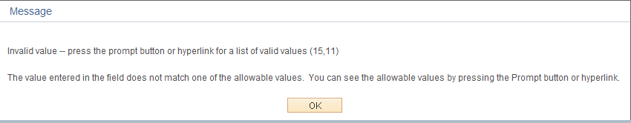

This means the Unit of Measure selected is not in the Unit of Measure table for the Item ID. If it is a valid UOM for this Item ID then DCS will add it or you may need to select a different Item ID.

_____________________________________________________________________________

INFORMATIONAL

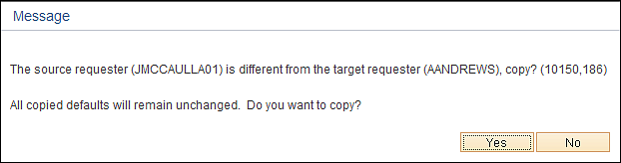

The message, “A default buyer was found” is due to changing the default buyer in the Line Item Detail page. If you want to use the default supplier from the Item ID then click the button. If you want to use the buyer you have selected then click the button. You do not receive this message if you populate the Buyer in the Header Detail page first.

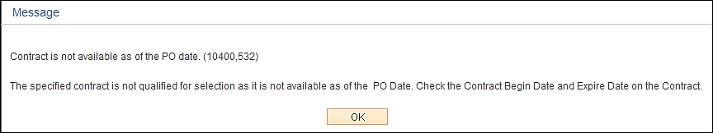

This message is received when a SW contract is being copied into a Requisition or PO that has expired or has not begun.

Receive this message when trying to copy a contract into a PO.

A. Contract date is outside of PO date.

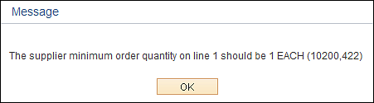

Receive this message when a quantity enter on the Form page does not meet the minimum quantity on the SW Contract

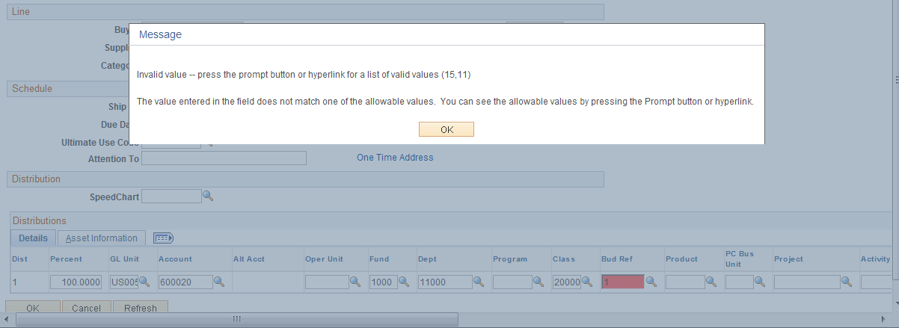

This message mean a value that was inputted is incorrect. The REQ/PO cannot be saved.

Warning -- Distribution AMT Sum on Schedule 1 (2000) is less than Req Distribution AMT Sum (3000). (10200,315)
The open amount of the original distributions on requisition cannot be reopened when distribution is by amounts. The requisition is required to be fully sourced. If you need to make this requisition available for sourcing again you have to Clear Req first .

This message is received when you save a PO connected to a requisition distributed by amount and there is a balance left on the requisition.

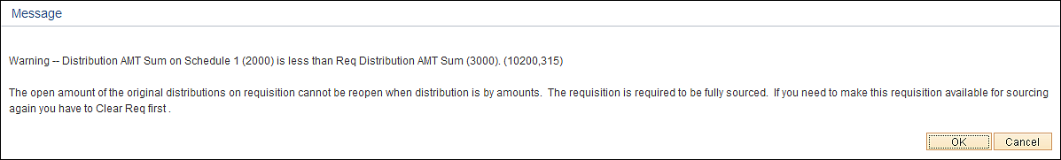
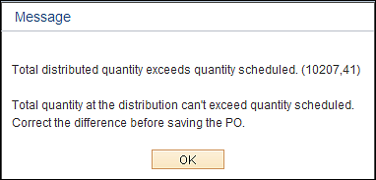

If you have multiple distributions in the Default header and you use the amount only field you receive a message when adding the next schedule and click the refresh button.

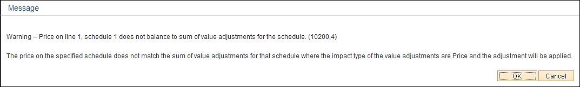

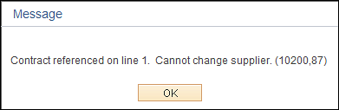

(The price inputted is the Custom Price (your price) , the system calculates a price (standard) based upon Item ID, Priority Suppliers, and Contracts.)

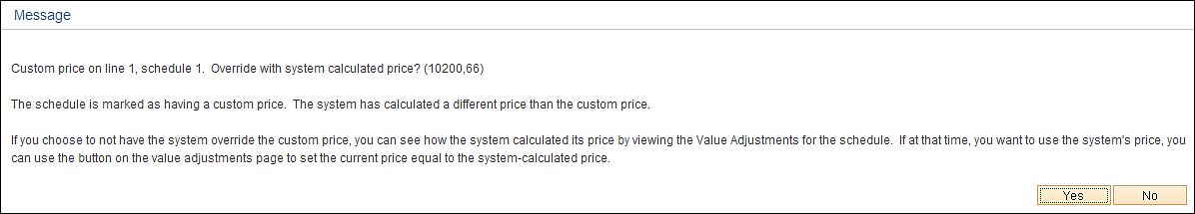
Click the to use your price.

Price Adjustment Page

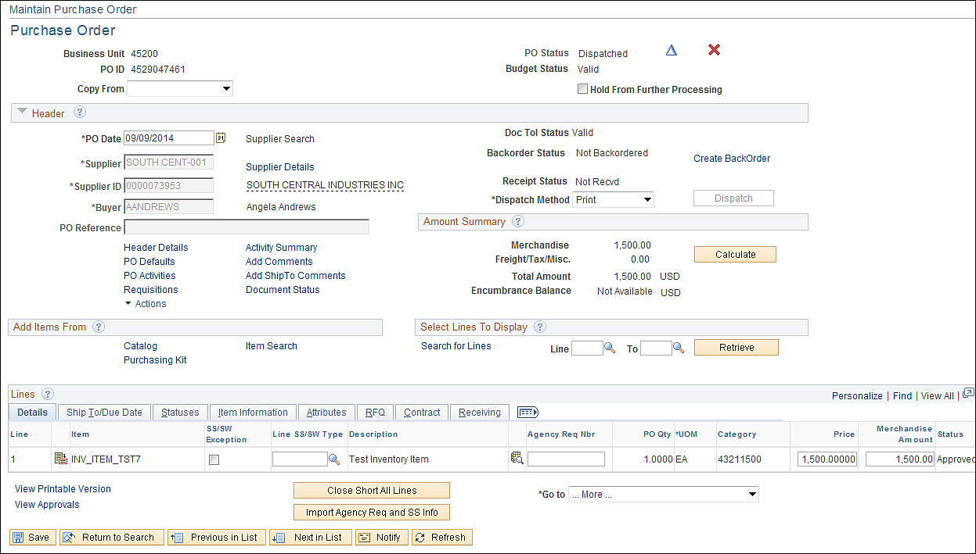

From the Maintain Purchase Order page click the icon.

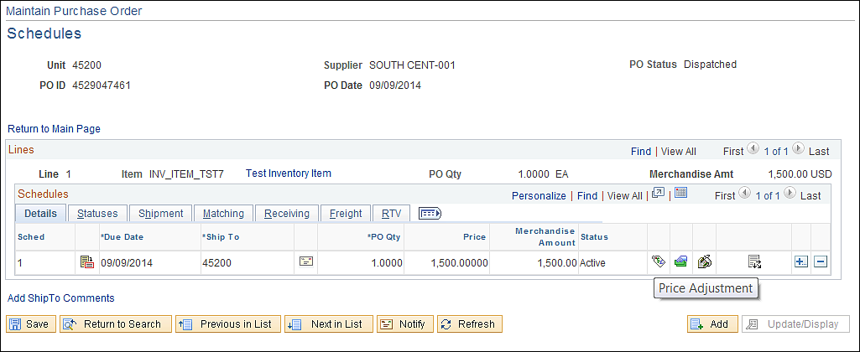

Click the icon.

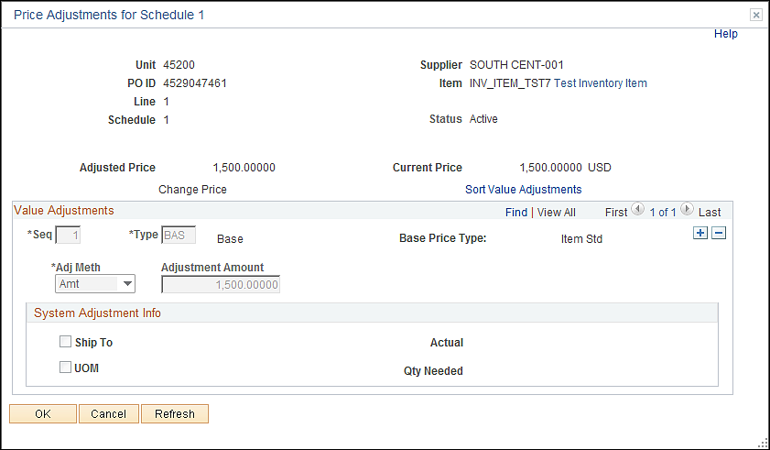

This amount is what was calculated by the system (item id).

Customize Distribution Fields

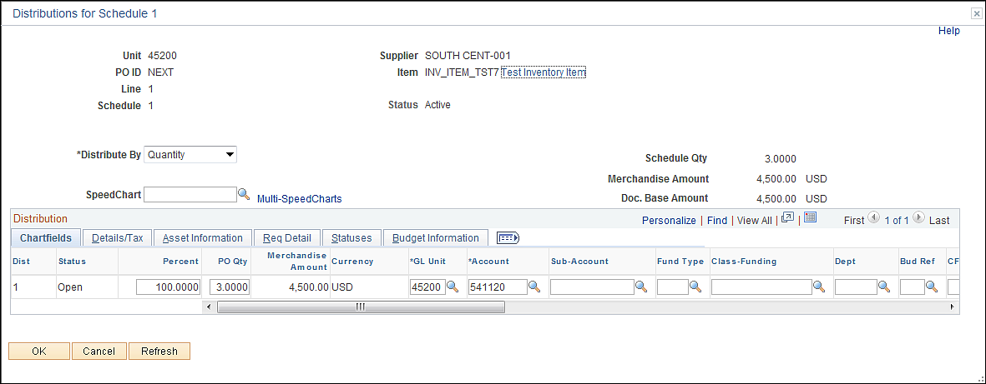

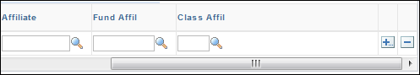

From the distribution page click the Personalize Link.

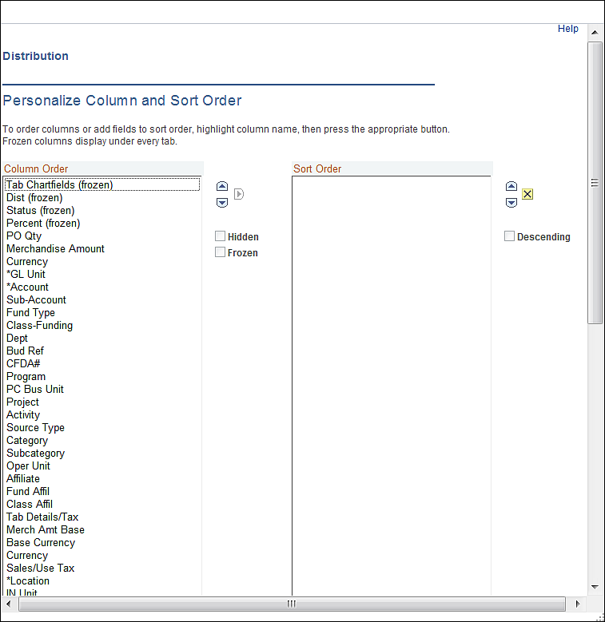

To hide a field click on the field then select the Hidden Radio box.

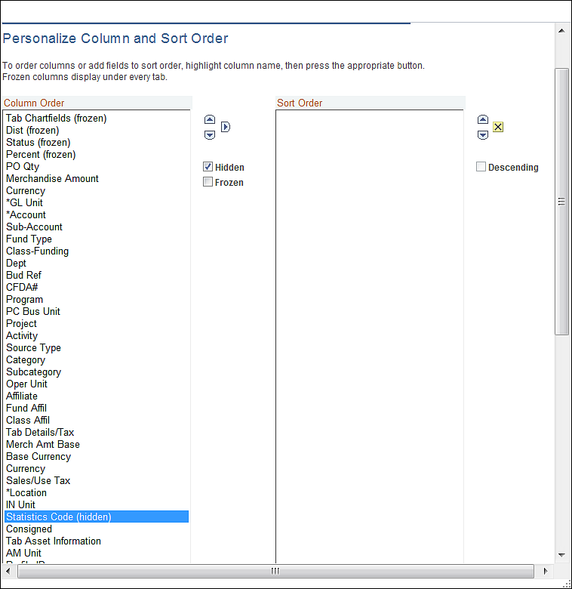

Click the button to return to the Distribution page.

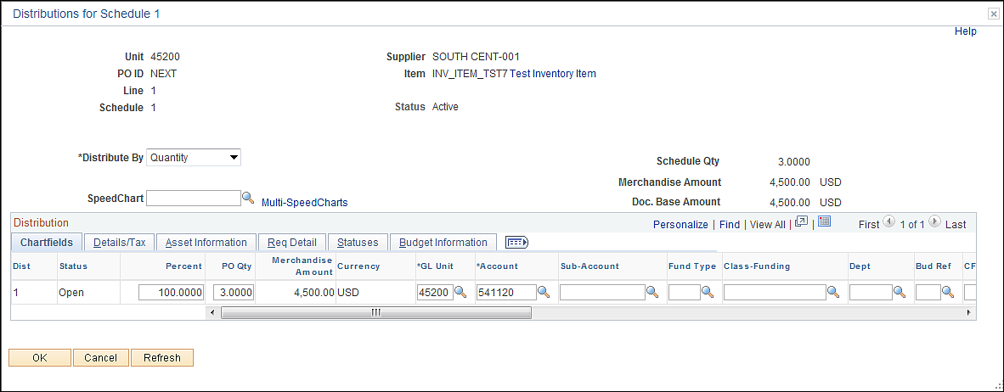

If you decide a field is needed you will need to go back to the Customize page and unhide the field.

PO Activity Link

This link will allow users to track changes and issues on the Purchase Order. This is a good place to store helpdesk issues and resolutions, Change Order request, etc…

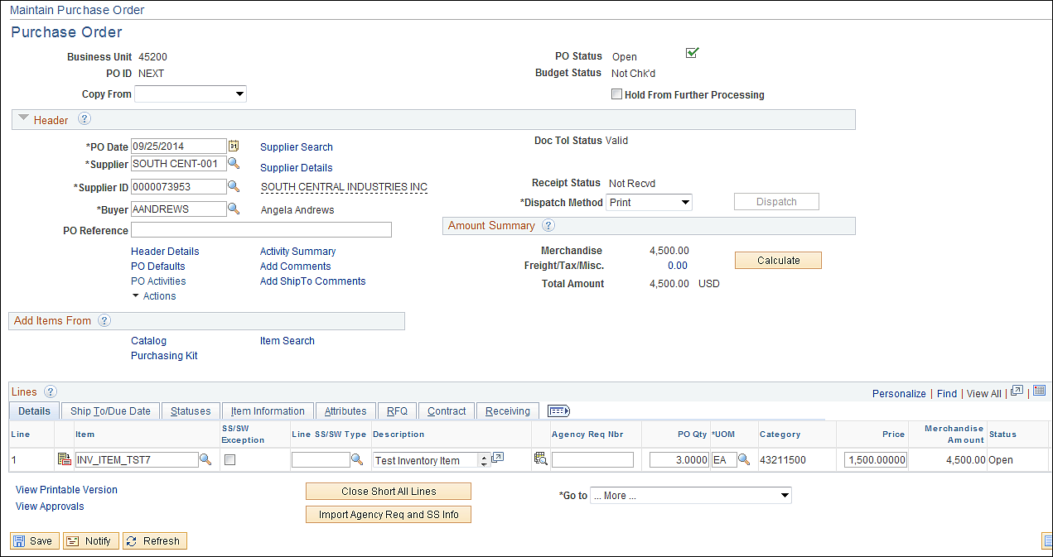

From the Purchase Order page click the PO Activities Link.

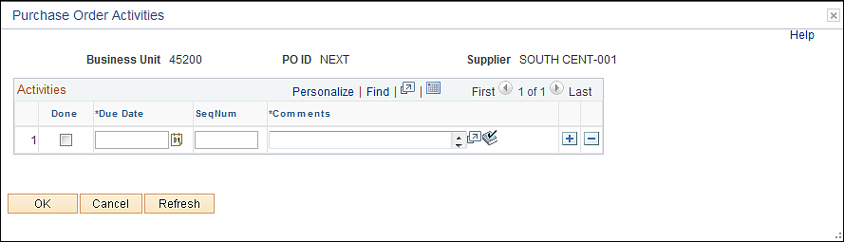

Input data.

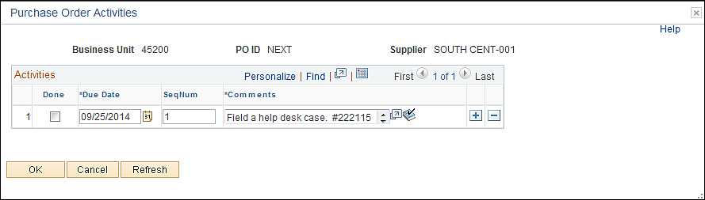

Click the button to return to the Purchase Order Form Page.

