COR108 Requisition Creation and Processing Manual

Authorized by: [_EBS_] Original Issue: [05/01/2014]
Maintained by: [____Purchasing Lead___]
Review Date: [05/01/2014]

Table of Contents

Introduction- Create A Requisition 6
Create Single Line Requistion 6
Step 1 – Enter Requisition 6
Requisition Origin 9
Requisition Origin 9
Step 2 – Enter Header Default Information 10
Header Default Definitions 10
Default Options Page 11
Select Buyer 12
Select Supplier 13
Input Distribution Data 14
Additional Field Definitions 15
One Time Address 16
Step 3 – Enter Item ID 19
Select Item ID 19
Define default data 23
Sole Source 24
Step 4 – Enter Header Comments 26
Field Definitions 27
Standard Comments 30
Step 5 – Verify Line Details 35
Detail Tab 35
Ship To/Due Date Tab 37
Status Tab 37
Supplier Information Tab 37
Item Information Tab 38
Attributes Tab 39
Contract Tab 40
Sourcing Controls 41
Step 6 – Enter Liner Comments 44
Field Definitions 45
Standard Comments 48
Step 7 – Verify Shipping Details and Input Distribution Info. 53
Schedule 53
Distribution Information 54
Step 8 – Save Requisition 55
Step 9 – Pre-Approve Requisition 56
Step 10 – Requisition Budget Check 58
Overview 58
Budget Checking 58
Step 11 – Requisition Approval 60
Overview 60
Approving a Requisition 60
Retrieve Requisition to Review 63
Step 12 – Print Requisition 65
Print from the Requisition 65
Create Multiple Line Requisition 74
Step 5 – Create a Multiple Line Requisition 74
Detail Tab 74
Create A Multiple Schedule Requisition 80
Step 7 – Verify Shipping Details and Input Distribution Info. 80
Schedule 80
Add additional schedule lines 80
Click located to the right of the schedule. 80
Distribution Information 82
Create Multiple Line Distribution 83
Step 7 – Verify Shipping Details and Input Distribution Info. 83
Schedule 83
Distribution Information 84
Create Requisition From Copy Statewide Contract 87
Overview 87
Step 1 – Copy From Statewide Contract 87
Step 2 – Header Default 89
Supplier Selection 89
Step 3 – Verify Line Details and Copy the Statewide Contract 93
Step 4 – Verify Shipping Details and Input Distribution Information 96
Schedule 96
Step 1 – Enter Requisition 97
Retrofit Field Changes 105
MIS Requisition Options 112
Requisition Activity 112
Reviewing Requisition Accounting Entries 113
Overview 113
Reversal 113
Finalizing 113
Review Requisition Inquiry Page 116
Using the Supplier Look Up 122
Look Up by Name 122
Look Up by Category 129
Customize Distribution Page 131
Retrieve documents distribution page 131
Sole Source And Brand Affidavits 136
Sole Source/Sole Brand Approval Authority 138
Purchase Order Type And Origin 139
Requisition Tables 140
Item ID 140
Unit of Measure 140
Item ID (Purchasing Attributes) 143
Standard Price 145
Identify Budget Checking Error. 156
Requisition Correction Process 160
Correcting Requisition Budget Errors through Requisition Defaults 160
Error Messages 166
Invalid UOM 166
Invalid Chartfield 166
Default Buyer Not Found 167
Priority Supplier for Item Does Not Match Default Supplier 167
Contract Selected Out of Contract Data Range 168
Contract Below Minimum Quantity or Exceeds Maximum Quantity 168
Custom Price Override 168
Multiple Distribution in the Default Header 169
UOM Error Message 169
Item ID Message 169

Introduction
Requisitions consist of these basic elements: headers, lines, schedules, and distributions. Each requisition has one header, which can have multiple lines. Each line can have multiple schedules. Each schedule can have multiple distributions. When a Requisition is created and budget checked, funds are obligate in the form of a Pre-Encumbrance, the pre-encumbrance insures funds are available when the Purchase Order is processed. A Requisition is required when approval by the Department of Central Services is needed.

Create a Single Line Requisition

Step 1 – Enter Requisition

Navigation: Purchasing > Requisitions > Add/Update Requisitions > Add a New Value

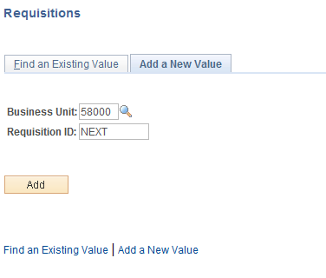

Business Unit - Defaults to specific agency for each User.

Requisition Number - Defaults to NEXT. The system will auto number each Requisitions.

NOTE: Do not change the Requisition ID data field. Let the system default NEXT into the data field. The Requisition number will be assigned upon saving.

Click to take you to the Requisition Form page.

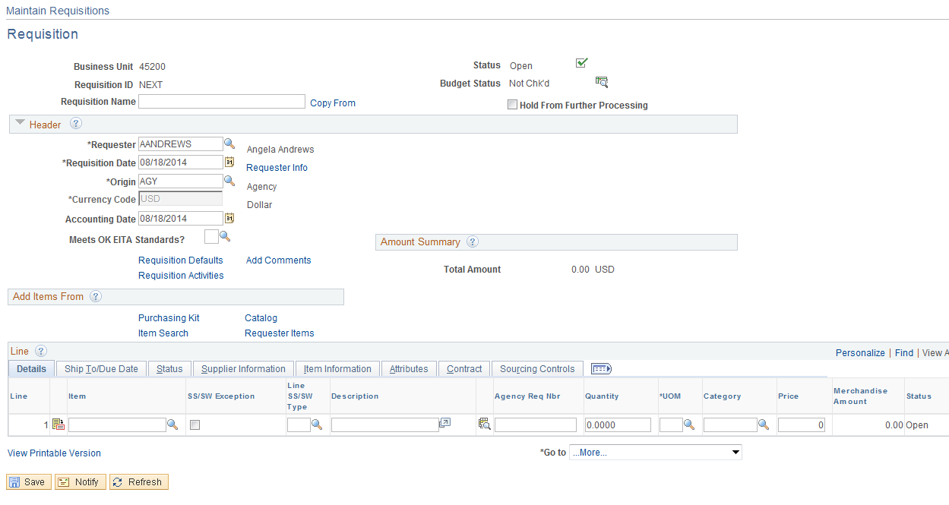

NOTE: Requestor defaulted from your User Preferences; Origin defaulted from your Requestor Setup. If needed, the Origin can be changed by clicking the Look Up Icon located to the right.

Click the Look Up Icon .

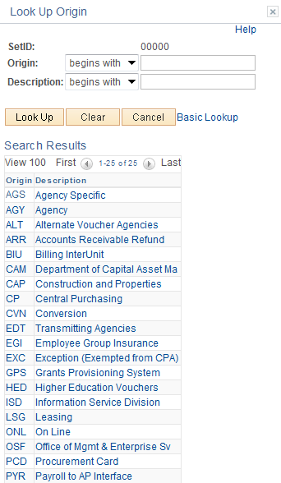

To select the origin, click the link.

Requisition Origin

Origin- The origin may need to be changed. The origin is used to describe who will complete the Requisition and is located at the left side of the header. This defaults from your Requestor Setup and is normally AGY- Agency. Additional origins used; CP= Central Purchasing, CAP = Construction and Properties, LSG = State Leasing, EXC = Exempt (Statewide).

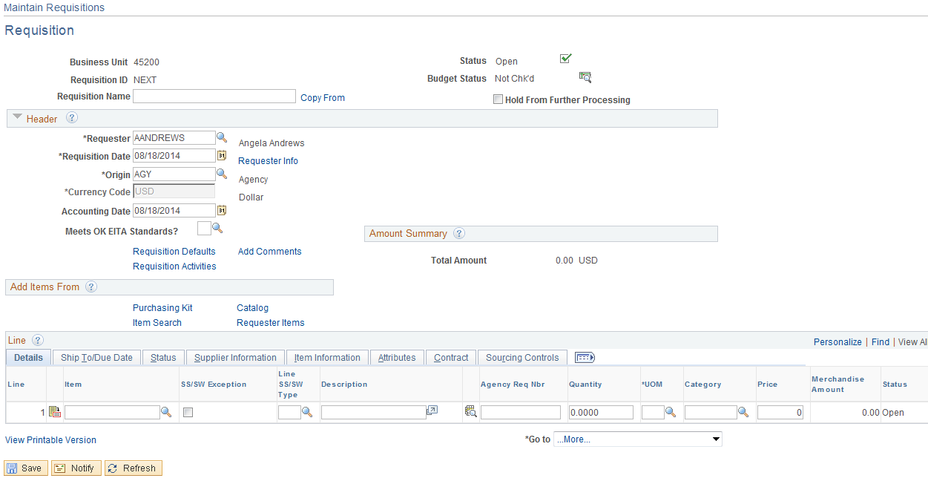

NOTE: The Requisition status is Open and Budget Checking status is Not Checked.

Step 2 – Enter Header Default Information

Header Default Definitions

Use the Header Defaults page to enter default data that will apply to the Requisition Form as a whole. This is used when a field is used multiple times and contains the same data. You can override the defaults at the line, schedule and distribution levels, however you should not do this. The default value will continue to be used for the life of the Requisition and will overwrite existing data. Any changes to the line, schedule and distribution should be made on the default header page or removed from the Default page. Access the page by clicking the Requisition Defaults link.

Default – If this option is selected it will treat the values entered on this page as a part of the default hierarchy. The system will first search for the default hierarchy for existing values. If none are found the system will use the information entered on this page. If existing values are found, the system will use those values and will ignore the values entered on this page. Do not select this option.

Override – Select this option to override existing default information for this Requisition with the values on this page. The system will not search the default hierarchy for the information you have entered. This is the option that will be used.

Click the Requisition Defaults hyperlink.

Default Options Page

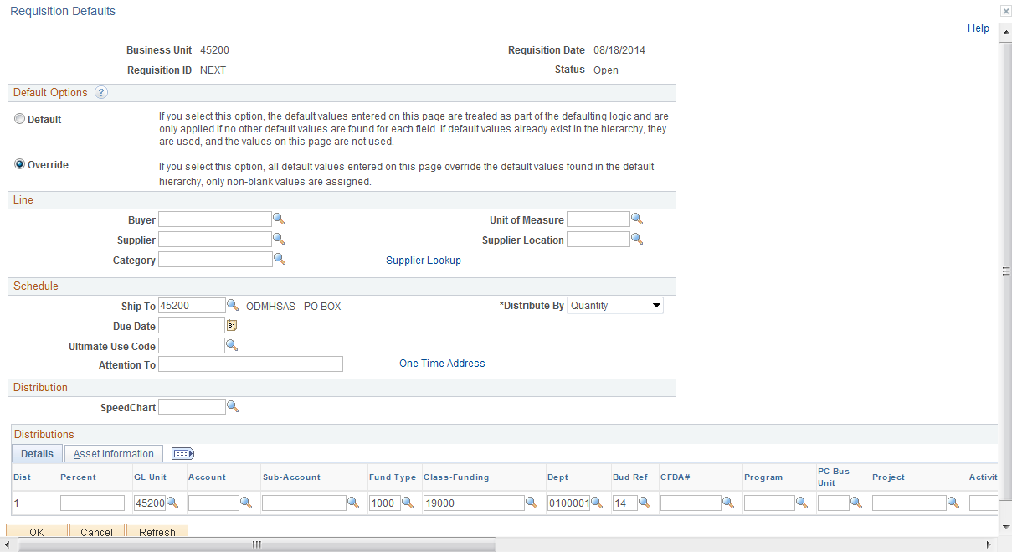

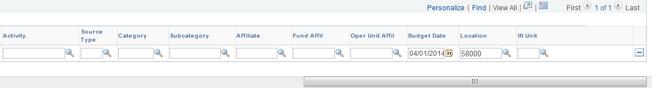

Select Buyer
Input the Buyer’s name, if the name is not known then click the Look Up Icon located to the right.

Click the Look Up Icon .

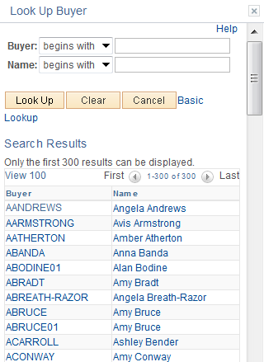
Narrow your results by inputting part of the Buyer’s Name and click .

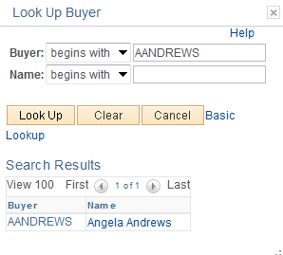

Select the buyer by clicking the link.

Select Supplier

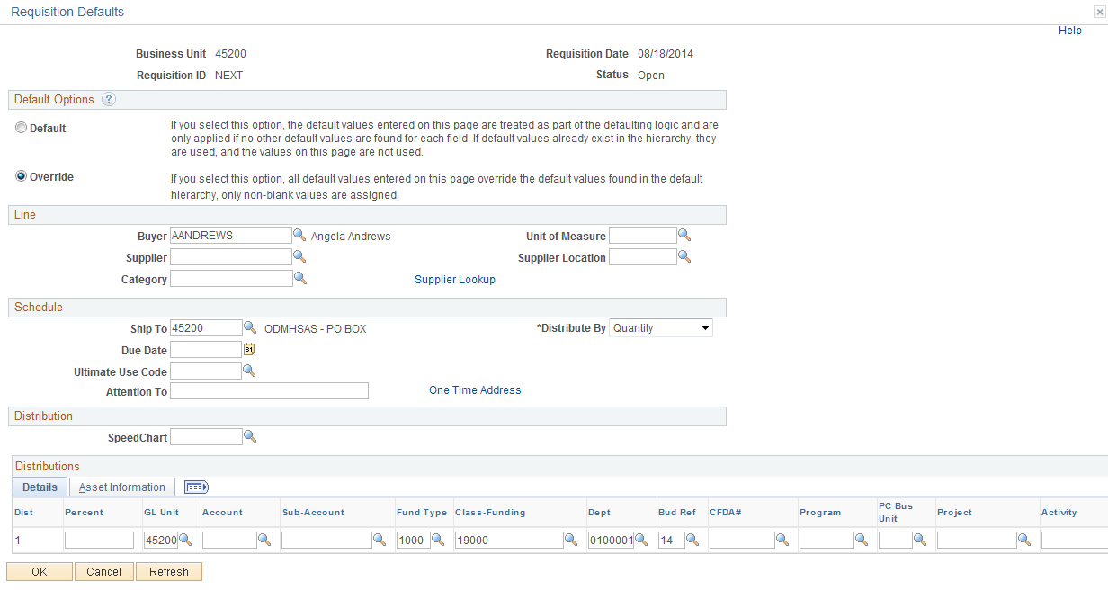

Input the Supplier number and Supplier location, and click . If the Supplier number and location are not known then look up the supplier by clicking the Look Up Icon to the right of the Supplier field/supplier location field or click Supplier Look Up to go to the Supplier Search page. (See APPENDIX page 120 for additional instructions on the Supplier Look Up.) Do not enter a supplier number if you want the priority supplier to default from the Item ID.

For this example supplier # 0000073953 and location STANDARD will be used.

Input Distribution Data

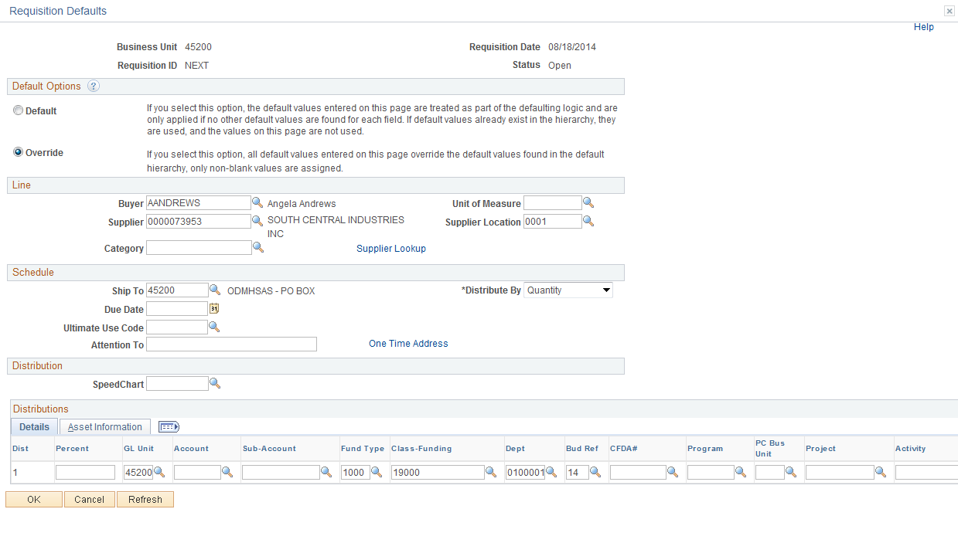

Distribute By – You are able to distribute by Amount or Quantity. This will determine how the funding will be allocated. Quantity will default and if needed will need to be changed to Amount. You cannot partially source REQ to a PO when distributing by Amount.

Chart Fields –Currently the state is using Account, Fund, Class, Department and Bud Ref. Optional fields are Sub-Account, CFDA number, and Operator Id. Input these values and click .

NOTE: If you do not know what the values are then click the Look Up Icon to the right. Click to validate the chart fields.

NOTE: The Account Chart Field should start with 5 (e.g., 531110) when creating Requisitions. An Account starting with 5 denotes an expense account. The account code will also default from the Item ID but the account code enter on the default header will have priority.
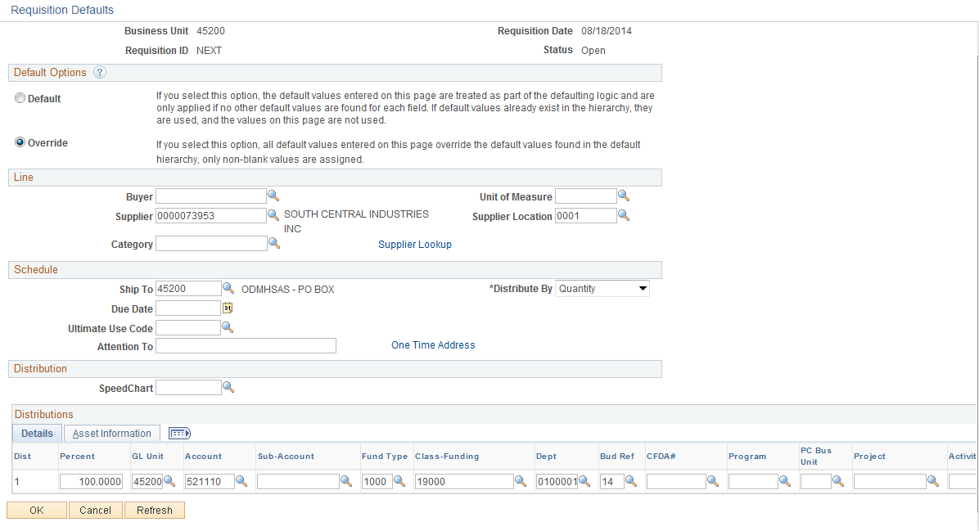

Notice the screen shot may be different then your actual screen. Select only the distribution fields required by clicking the Personalize link. See Appendix page 130.

Additional Field Definitions
Ship To – The location the order will be shipped. This defaults from your Requestor Setup.

Due Date – The Due Date is when the goods or services are required to be delivered.

Category Code – A default value can be entered for the entire Requisition. The default value will auto populate on every line of the Requisition. The Category will also default from the Item ID. Used for description only items.

NOTE: It may, or may not be beneficial to utilize this default value for multiple line Requisitions. The system does allow the user to override the category code values as needed on each line.

UOM – The Unit of Measure entered here will auto populate on every line of the Requisition. The UOM will also default from the Item ID (Example: EA, CASE, TON, BOX, etc.).

One Time Address
One Time Address - PeopleSoft gives you the ability to create a Requisition and have the product shipped to an address that is currently not in the ship to file. This feature is only to be used if you have to ship the product to a special address that will not be used again. Click the One Time Address hyperlink.

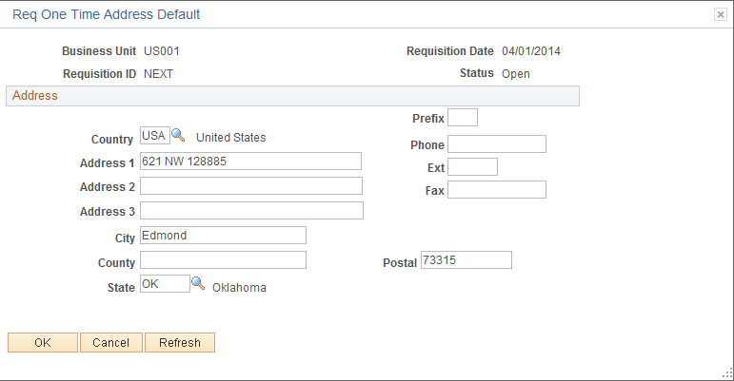
Input the data and click twice.

Step 3 – Enter Item ID

Select Item ID

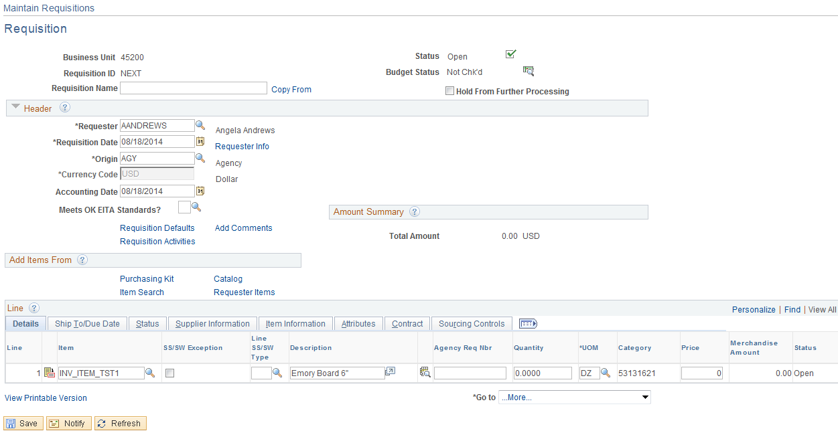

Input the Item ID, if the Item ID is not known then click the Look Up Icon located to the right, if it is known then input the Item ID and click . Click the Look Up Icon .

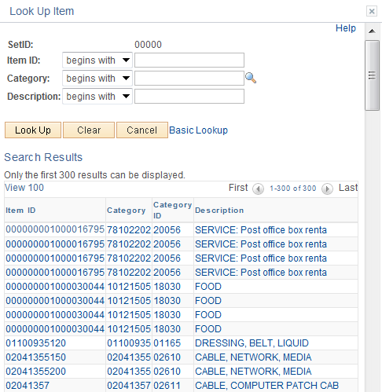
Your results can be narrowed by inputting an item number, category, or description and click . In this example a description of “SHIPPING” was used and received the following results:

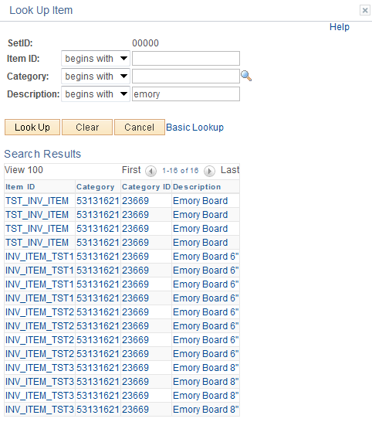

Make your selection by clicking the hyperlink.

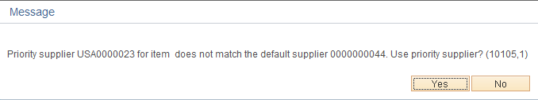

Priority supplier # for item does not match the default supplier #. Use priority supplier? (10105,1).
The priority supplier defined for the item does not match the default supplier as specified on the Requisition Form. Choose Yes to use the priority supplier from the item and override the default supplier. Choose NO to use the default supplier entered on the Requisition Default page.

This message is stating that this Item ID has a priority supplier that is different then the supplier you used in the Header Default. Do you want to use your supplier or the priority supplier? To use your supplier, click . To use the Item ID priority supplier click . Selecting “YES” will override your supplier. For this example the supplier selected (#) will be used, click .

Define default data

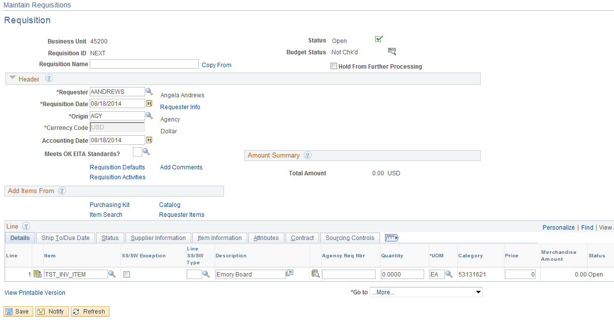

Input the Requisition Quantity and click .

If the Supplier price is not available the system wants to use the standard price of the item.

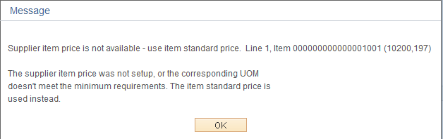

Message means the supplier/supplier location selected does not have a price on the Item ID. The standard price will be used.

Click .

Message

Custom price on line 1, schedule 1. Override with system calculated price (10150,189).
The schedule is having a custom price and the system has calculated a different price than the custom price. Select 'Yes' to Override with system calculated price.

This message is stating that custom price (price entered by you) does not match the system calculated price (price from the Item ID). Click to use your price, click to use the Item Id price. Click at this time since you have not entered a unit price the system will use the Item ID price.

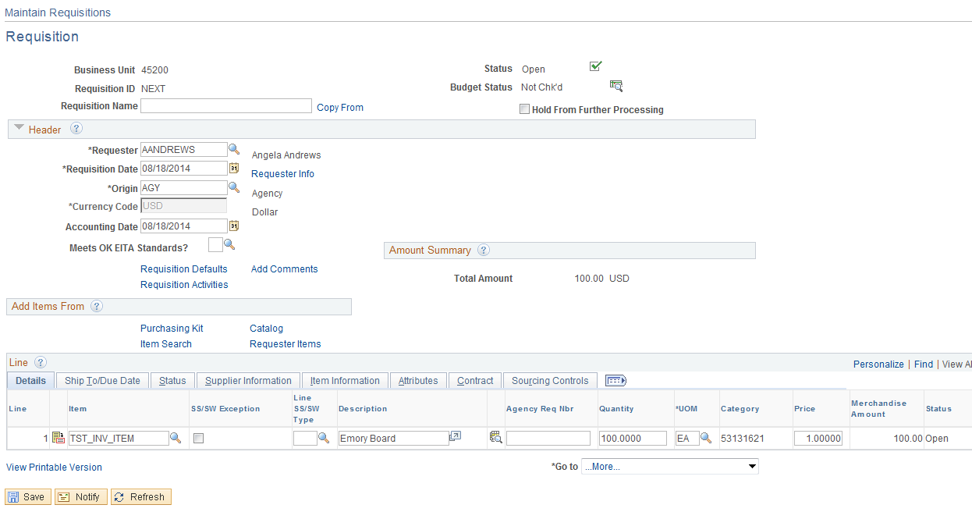

Sole Source

Detail Sole Source Criteria can be found in the APPENDIX section of the manual.

SS Flag – Sole Source checkbox. For Requisitions that require sole source approval this data field is a required field. Please select it by clicking the check box located underneath.

Line SSrc Type – Sole Source Type, orders that are sole sourced need to be flagged for approval. A Requisition over $25K requires approval from the State Purchasing Director; however this amount could vary depending on the agencies Delegated Monetary Procurement Authority. The sole source data field contains eight values. The following values are listed:
- TYP1 – Sole Make/Model/Brand
- TYP2 – Sole Supplier
- TYP3 – Additional/Replacement Parts
- TYP4 – Original Supplier
- TYP5 – Brand Name for Resale
- TYP6 – Compelling Urgency Limit
- TYP7 – Litigation Expert
- TYP8 – Statue Authorization

Input one of these values or click the Look Up Icon on the right.

Agency Req Nbr – Agency Requisition Number is a field used by agencies to cross reference the PS Requisition number to the agency internal Requisition number.

Step 4 – Enter Header Comments

Access the Header Comments page by clicking the Add Comments link.

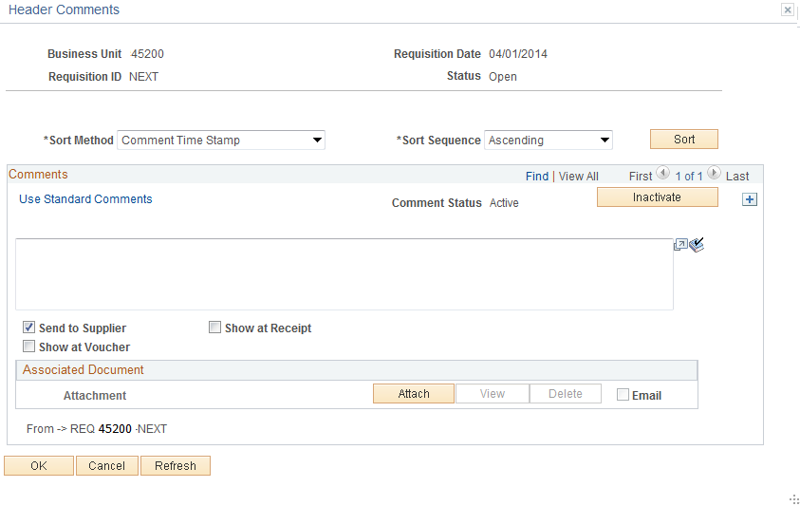

Input any comments to send with the Requisition in the Comment Field.

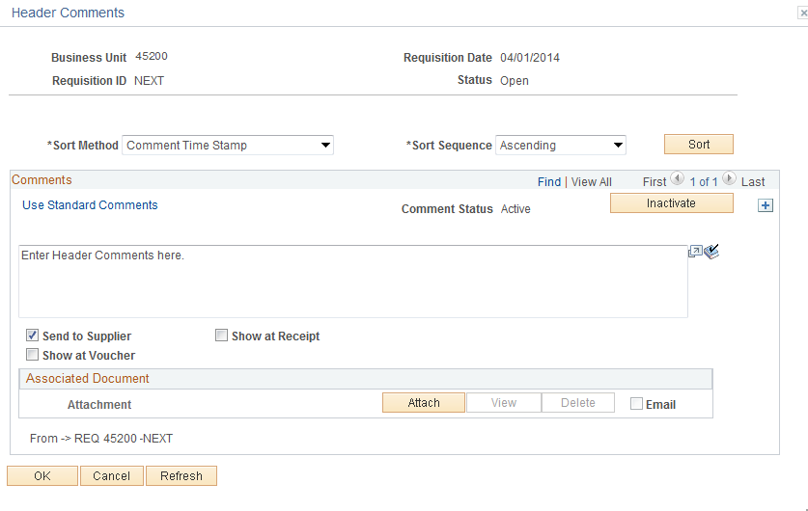

NOTE: The Send to Supplier check () box by default will be checked. If you wish for this comment to appear on the receipt or voucher, then check () the appropriate box.

NOTE: When there are multiple comments, the system will display only the most recent comment. The display indicates the number of comments available for viewing. To view the remaining comments, either press the forward arrow symbol to go to the next comment or press View All to see all of the comments in the scroll area. To return to viewing only one line and its associated schedules, press View 1.

Field Definitions
Undo – This button is available after the comment has been inactivated. Click on the button to reactivate message line.

Click to inactivate the currently displayed comment. The comment is not actually deleted, but is set to an inactive status.
Sort Method – Select the method that you want to use to sort the comments retrieved:

- Comment Time Stamp – Sorts the comments by the time stamp assigned to them when they were created.
- Supplier Flag – Sorts the comments flagged to be sent to the supplier.

Sort Seq – Select Ascending or Descending.

Click to sort comments according to the selections that you made in the Sort Method and Sort Sequence fields.

NOTE: Do not overwrite comments. If comments need to be changed, inactive the old comment and add a new comment section.

To add additional comments, click in the upper right corner of the comment page.

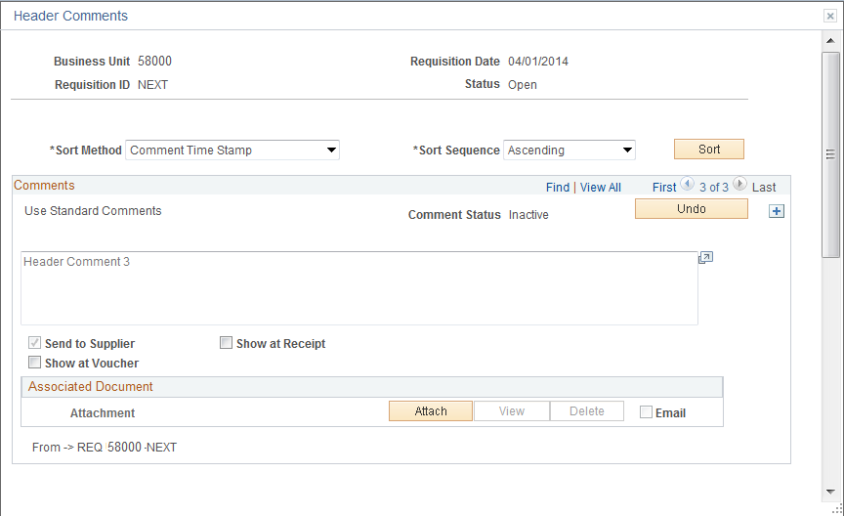

NOTE: PeopleSoft gives you the ability to attach a file to your Requisition. This feature is now being utilized.

Standard Comments

The Department of Central Services requires Requisitions to contain certain comment concerning the purchase. Instead of having to type this information into each Requisition the Department of Central Services has come up with a list of Standard Comments when selected will default in. These comments are called STANDARD COMMENTS and must be added to every Requisition. See the Department of Central Services’ rules and regulations.

Add a comment section by clicking on the right hand side, and then click the Use Standard Comments link.

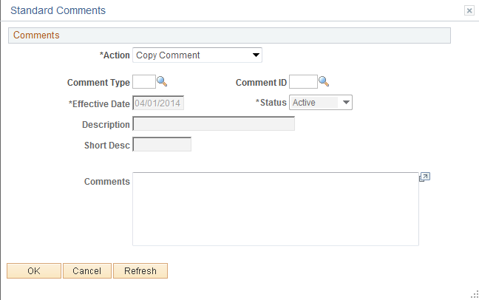

From this page select the “Standard Comment” by inputting the Std Type and Comment ID. If you do not know this information, click the Look Up Icon located to the right.

Click the Look Up Icon for the Std Type.

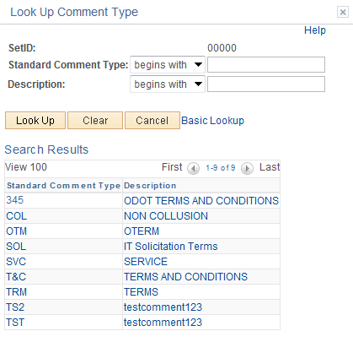

Select the comment by clicking the link. In this example Non-Collusion will be used.

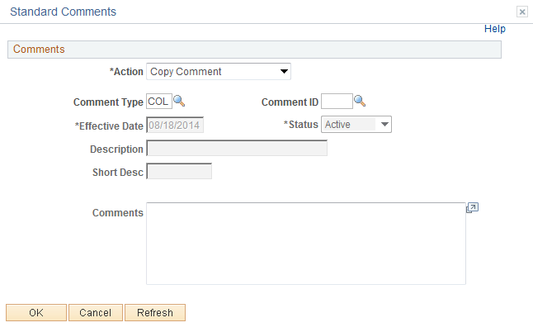

Click the Look Up Icon for the Comment ID.

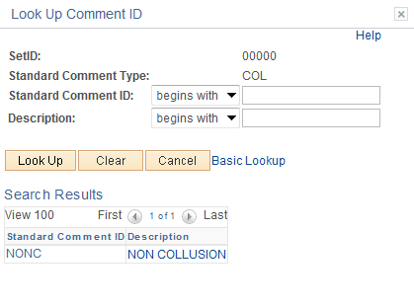

NOTE: The Comment ID is unique to the Std Type.

To select the comment, click the Comment link.

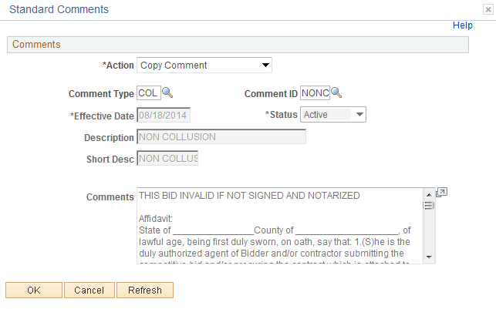

Notice the comments copied into the comments field, saves time.

Click .
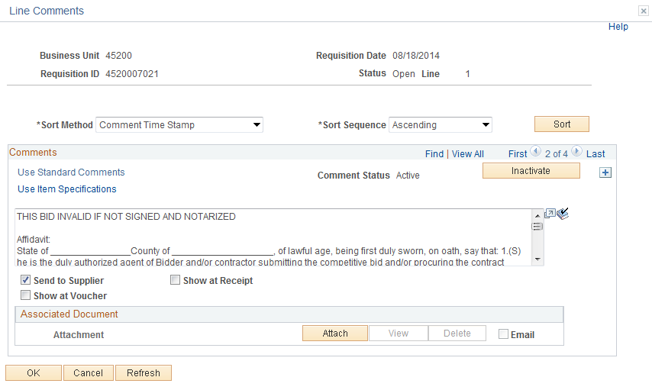

Click the View All link to review all active comments or click to transfer between comments.

Click .

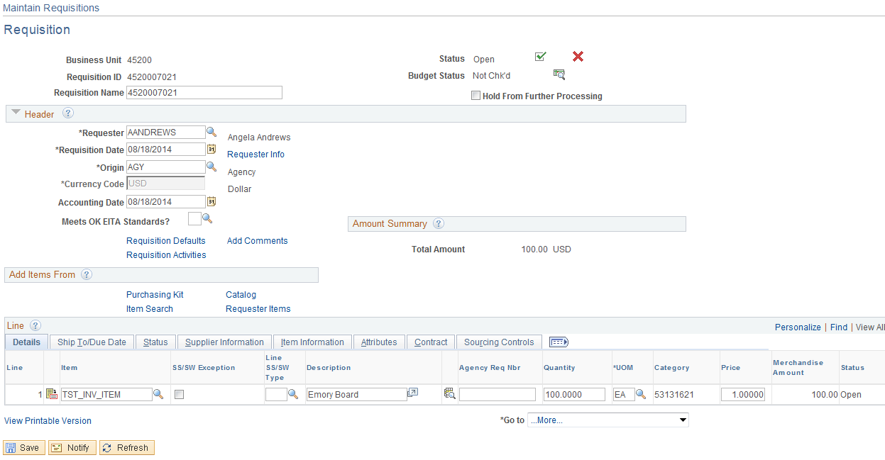

After the Header Comments have been entered, the Header Comments Link becomes Edit Comments.

Step 5 – Verify Line Details

Verify or modify additional details on the line, such as the buyer, supplier, and other line specific information. Select the line item by clicking the details Icon located to the left of the line or click the individual Tab or click the Show All Icon .

Details Tab

- Item ID-Select the ID of the item that you want to order. If the item that you want to order does not have an item ID, choose to order the item by description only. To do this, enter item information in the Description field. This is not recommended.
- SS Flag and SS Type – This field is used to report Sole Source information.
- Description-If you are ordering an item by description only, enter item information in this field. If you specify an item ID, the description appears from the Purchasing Attributes page and can be changed.
- Agency Req Nbr-Input your Agencies Internal Requisition Number.
- Quantity- Enter the item quantity to order. The quantity is recalculated if you change the unit of measure.
- UOM-The UOM will default from the Item ID. The UOM can be changed by clicking the Look Up Icon .
- Category- Enter the category for the item on the requisition line. If you specify an item ID, the category defaults from the Item ID, and cannot be changed.
- Price- The Price will default from the Item and will need to be changed.
- Amount-Quantity X Price.
- Line Comment Icon-Click the Line Comments to access the Line Comments page. Use this page to maintain line comments.
- Line Default Icon-Click icon to access the Details for Line page. Use this page to maintain line defaults. Currently not used.
- Schedule Icon-Click icon to access the Maintain Requisitions - Schedule page, where the view schedule shipment details and distribution information is located.
- Plus or Minus Icon-Add or Delete a Line.

Ship To/Due Date Tab

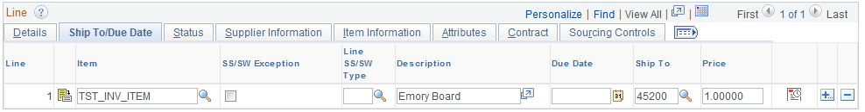

- Due Date-Date shipment is due or service is due.
- Ship To-Location the product will be shipped to or service performed at.

Status Tab

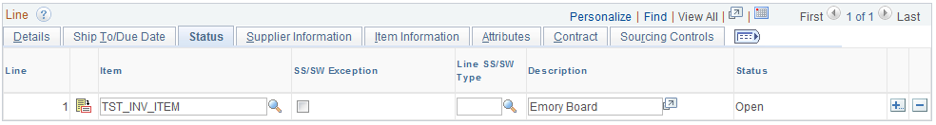

- Line Status-Informational only

Supplier Information Tab

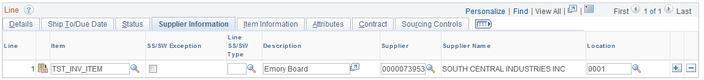

- Supplier Number- Displays by default the Item IDs priority supplier one for the requisition line, along with its default supplier location. To override these values, use the Header Default or enter values in this field.
- Supplier Location-Defaults from the Item ID’s priority supplier location.

Item Information Tab

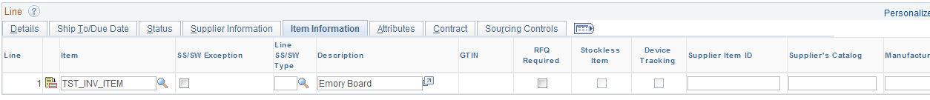

- RFQ Required-Optional. If selected a PO cannot be created unless an RFQ has been processed.
- Device Tracking Currently Not using
- Supplier Item ID/Supplier Catalog- The supplier catalog and ID assigned. Values default from the Purchasing Attributes. Currently not using.
- Manufacturer ID-Currently not using
- Manufacturer’s Item ID-Currently not using.

Attributes Tab

- Buyer - Select a buyer for the requisition line. If you select a new value on the requisition that is tied to a different default buyer (item, supplier, or category, for example) the value in this field will be overridden with the new default buyer value.
- Physical Nature - Will default to Goods, agencies can change it as needed.
- Zero Price Indicator - Select this check box to indicate that the line item is zero-priced. This value is clear and unavailable for entry for ad hoc item orders.
- Inspection Required - Select this field to require Inspection of the product. This will enable 4 way matching.
- Inspect ID - Input the Inspection ID.

Contract Tab

- Contract ID - Select the Contract ID that you want to associate with the requisition line.
- Contract Line - Select the Contract line that you want to associate with the requisition line.

For Additional Information review the Contract Release Manual.

Sourcing Controls

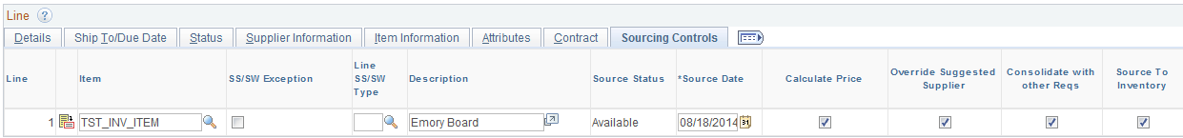

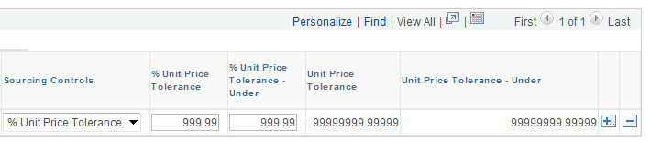

- Source Date - Enter the date when the requisition is available for sourcing. The default value is the current system date. The requisition is available on the Requisition Selection page and AutoSelect Req page only after the source date.
- Calculate Price -Deselect this check box to use Requisition price and not Item Id price when sourcing a Requisition to PO.
- Override Suggested Supplier - Select this check box to enable the sourcing process to override the suggested supplier. If you select this check box, the system overrides any supplier suggested on the requisition line with the supplier selected based on the applicable sourcing method. Check box defaults as selected and should not be changed.
- Consolidate with other Reqs - Select this check box to source the line item to a purchase order line, along with quantities of the same item from other requisitions. If selected, you must also select the Override Suggested Supplier check box. Check box defaults as selected and should not be changed.
- Sourcing Controls - Select the method for sourcing tolerances. Values are:
  - % Unit Price Tolerance
  - Unit Price Tolerance
- Unit Price Tolerances- Enter the upper and lower tolerances. Prices that exceed these tolerances are rejected. Enter an amount or a percentage, depending on the type of unit price tolerance that you choose. A tolerance of 0 means that the requisition price must match the purchase order price. It does not mean that tolerances do not apply. A tolerance of “9s” means ignore any tolerances. The tolerances are between the REQ price and Item ID price.

Click the Line icon located to the left to review the line details vertically.

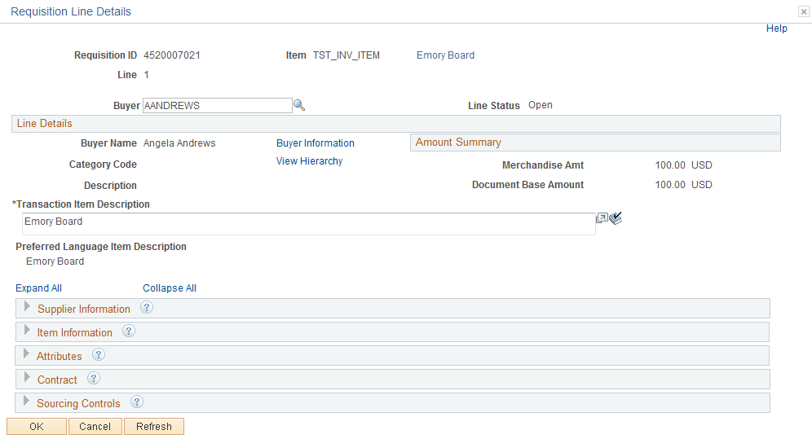

To review the data, click the , this will expand the details. The same data will be available as in the Tab.

Click .

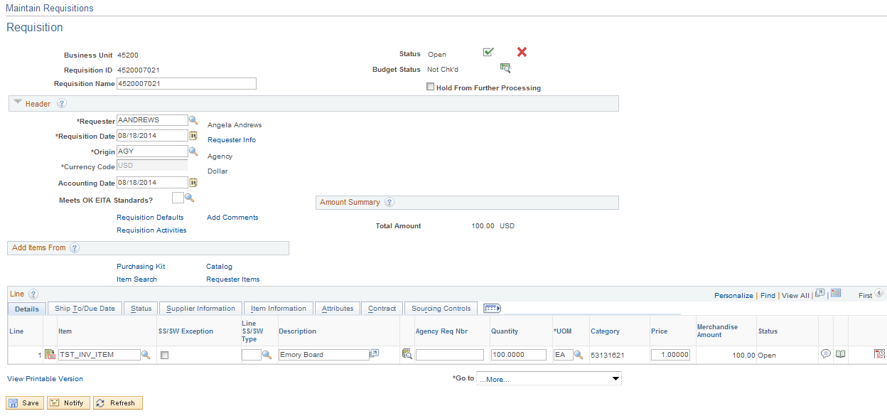
Step 6 – Enter Line Comments

Click the Line Comments Icon .

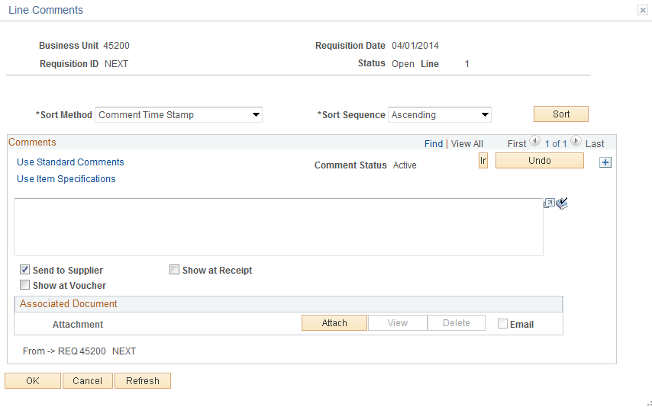

Enter any comments to send with the Requisition in the Comment Field.

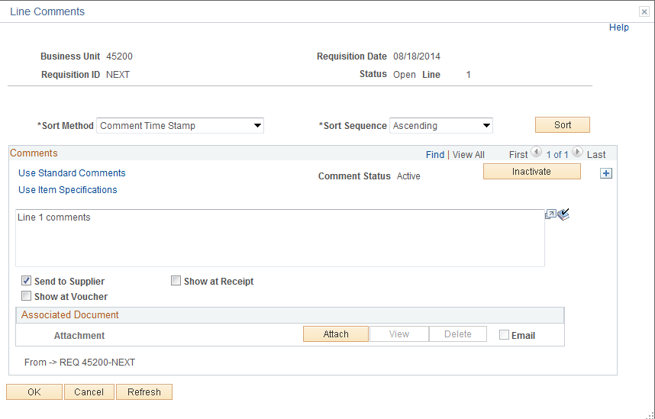

NOTE: The Send to Supplier check () box by default will be checked. If you want this comment to appear on the receipt or voucher check () the appropriate box.

NOTE: When there are multiple comments, the system will display only the most recent comment. The display indicates the number of comments available for viewing. To view the remaining comments, either press the forward arrow symbol to go to the next comment or press View All to see all of the comments in the scroll area. To return to viewing only one line and its associated schedules, press View 1.

Field Definitions
Undo – This button is available after the comment has been inactivated. Click on the button to reactivate message line.

Click to inactivate the currently displayed comment. The comment is not actually deleted, but is set to an inactive status.

Sort Method – Select the method that you want to use to sort the comments retrieved:

- Comment Time Stamp – Sorts the comments by the time stamp assigned to them when they were created.
- Supplier Flag – Sorts the comments flagged to be sent to the supplier.

Sort Seq – Select Ascending or Descending.

Click to sort comments according to the selections that you made in the Sort Method and Sort Sequence fields.

NOTE: Do not overwrite comments. If comments need to be changed, inactive the old comment and add a new comment section.

To add comments, click the in the upper right corner of the comment page.

NOTE: PeopleSoft gives you the ability to attach a file to your Requisition. This feature is now being utilized.

Standard Comments

The Department of Central Services requires Requisitions to contain certain comment concerning the purchase. Instead of having to type this information into each Requisition the Department of Central Services has come up with a list of Standard Comments when selected will default in. These comments are called STANDARD COMMENTS and must be added to every Requisition. See the Department of Central Services' rules and regulations.

Add a comment section by clicking on the right hand side, then click the Use Standard Comments link.

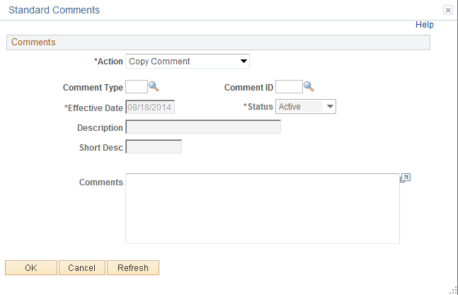

From this page select the “Standard Comment” by inputting the Comment Type and Comment ID. If you do not know this information then click the Look Up Icon located to the right.

Click the Look Up Icon for the Std Type.

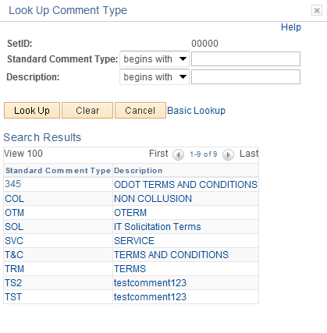

To select the comment, click the comment link.

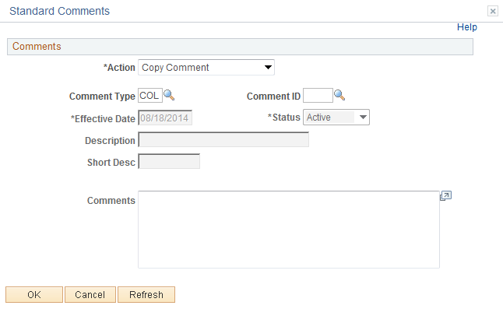

Click the Look Up Icon for the Comment ID.

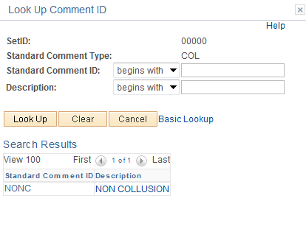

NOTE: The Comment ID is unique to the Comment Type.

To select the comment, click the Comment link.

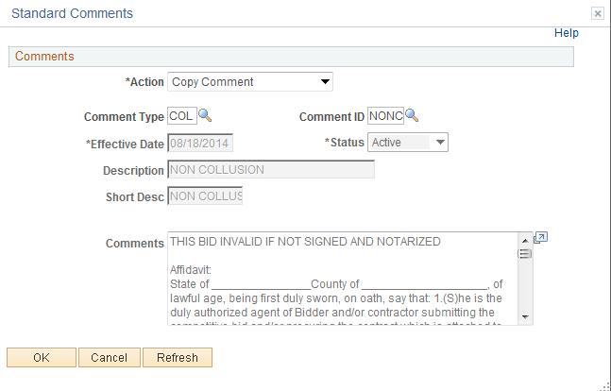
Notice the comments copied in, this saved time.

Click .

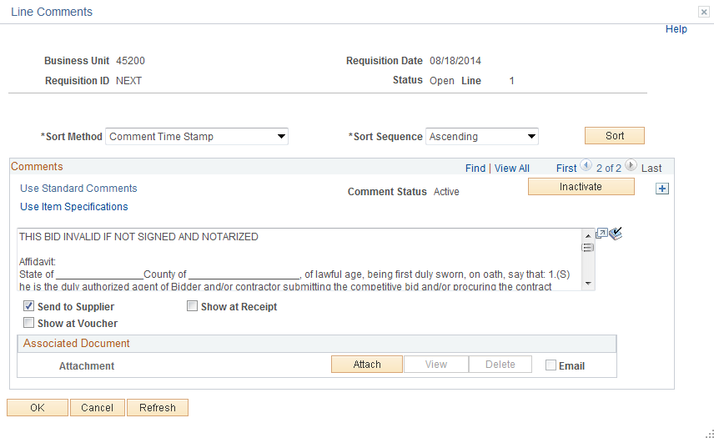

Click the View All link to review all active comments or click to transfer between comments.

Click .

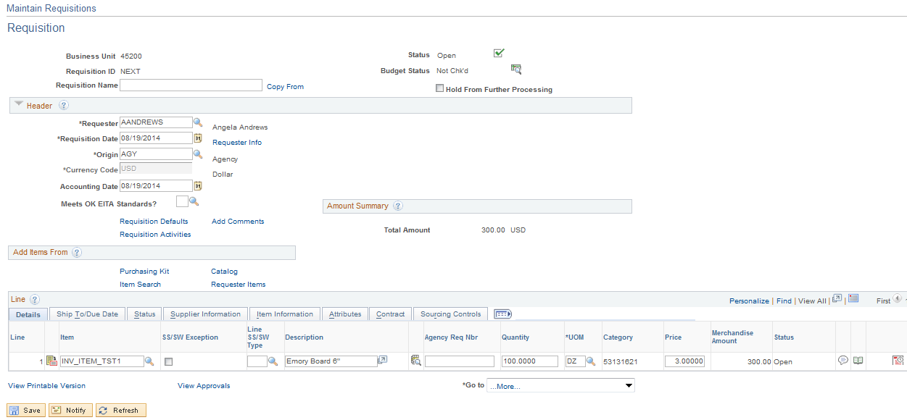

After the Line Comments have been entered, the Line Comment Icon changes to.

Step 7 – Verify Shipping Details and Input Distribution Info.

Schedule

Use the Requisitions Schedule page to specify multiple shipping schedules for each line and to define multiple distributions for each schedule. The Schedule page by default allocates the total by Quantity, but it can also allocate by Dollar amount. To access the Schedule page click the icon.

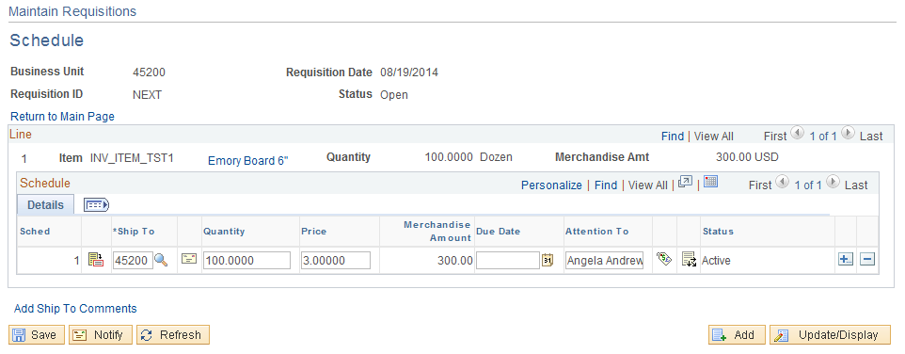

From the schedule page change the Price and click . If needed input a Due Date and Ship to Location. Ship To and Due Date will default from the Form page. If you change the Ship To or Due Date on the Schedule Tab it will default to the line page.

NOTE: If you change the price from the Item ID price, when you copy the Requisition into the PO the Item ID price will copy in, not the Requisition price.

- Unit Price - If you are using commitment control, the price field is unavailable for modification when a requisition schedule that is distributed by quantity, has been partially or fully sourced to a purchase order. This field is also unavailable for modification when creating a change order for a requisition (that is distributed by quantity) that has been partially or fully sourced to a purchase order.
- Schedule Shipment Detail Icon -This page provides Tax and Ultimate Use Code data.
- Ship To Comments- Add comments related to the ship to address by clicking the Add Ship Comments. This comment field is the same as Header and Line Comment with the exception you must select a Ship to ID.

Distribution Information

Use the Distribution Information page to update and review the distribution data. These line items are transferred to the Purchase Orders, but they do not go out to the supplier. They are a breakdown of accounting distribution and internal delivery locations. This page identifies how the Schedule amounts will be charged within the organization. There can be multiple Distributions for each Schedule. The required Chart Field string is entered for each Distribution, allowing an item to be funded (expensed) from multiple sources. To access the Distribution page click Icon.

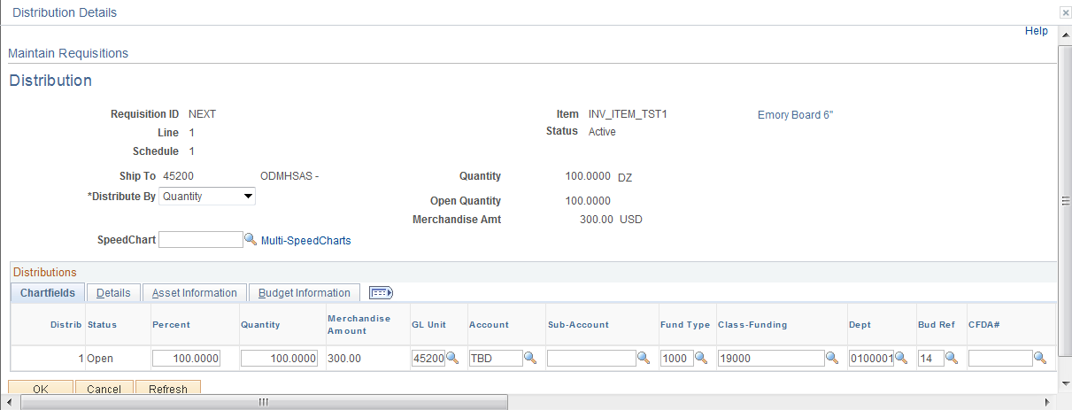

NOTE: The Distribution data defaulted from the Header Default. If changes need to be made, do it in the Default page. This page has also been customized. See Appendix page 130.

NOTE: You cannot partially source a Requisition to a PO when you distribute by Amount.

Click .

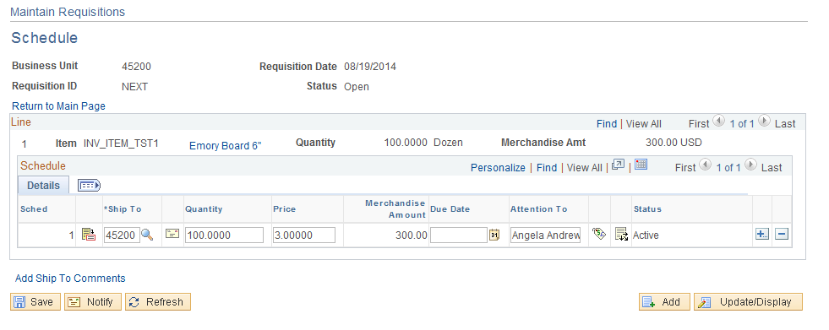

Step 8 – Save Requisition

After a Requisition is completed, it must be saved. Save a Requisition by clicking .

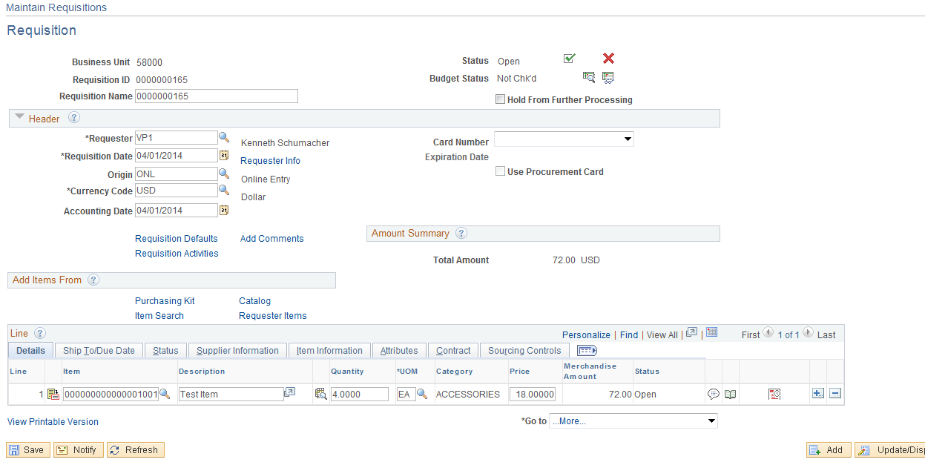

Notice you were transferred to the Requisition Form page and a Requisition Number has been assigned. The Requisition is in an Open Status.

Step 9 – Pre-Approve Requisition

Pre-approving is done from the Form Page.

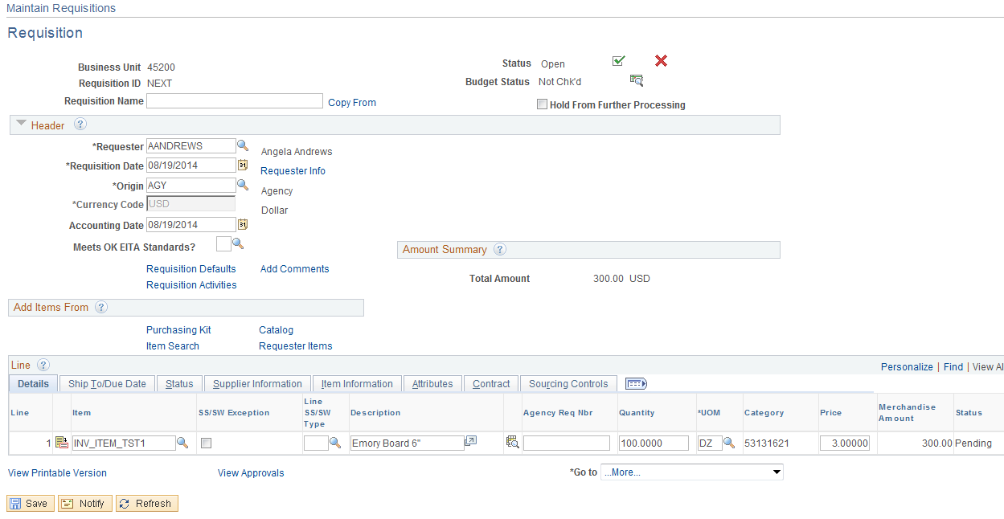

Click the Pre-Approved icon located in the upper right hand corner.

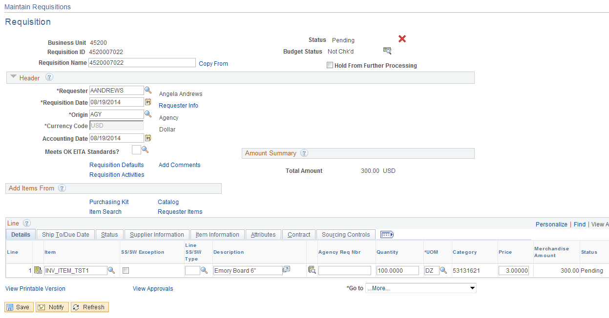

NOTE: The approval status is pending. It is now ready to budget checked.

Step 10 – Requisition Budget Check

Overview

Once a Requisition is in a pending status, it can be Budget Checked. The Requisition can be budget checked individually by the user, or in a batch process done by OSF. See the Commitment Control Procedure Manual for more information.

Budget Checking

Budget checking individually is performed on the Form Page.

Click the Budget Check Icon located in the upper right hand corner.

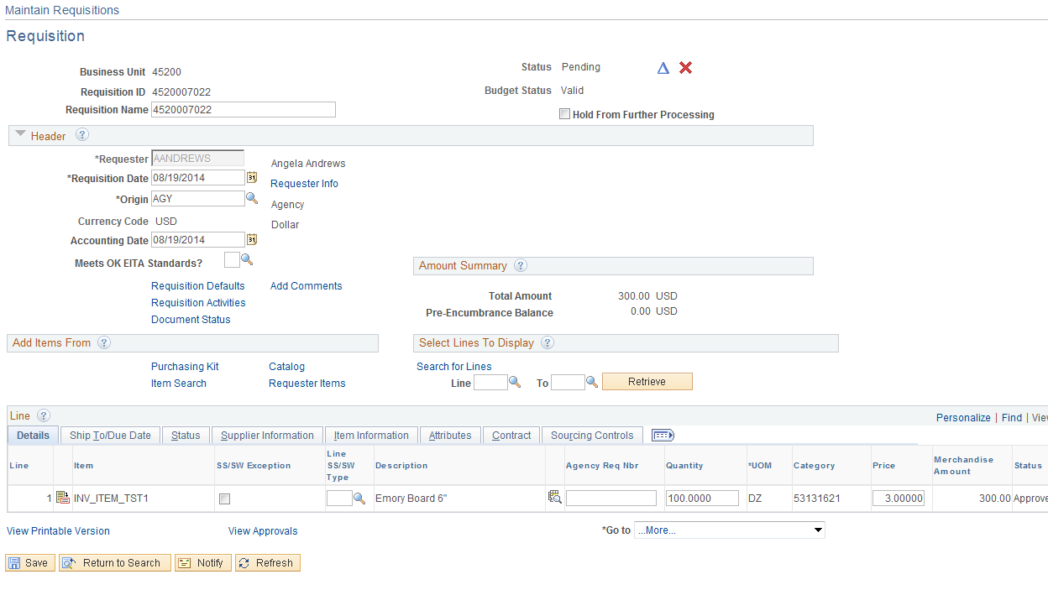

To continue and approve the Requisition the budget checking status must equal valid. If it is in an error, refer to "status review" the P134 Commitment Control Manual for resolving budget checking errors.

Step 11 – Requisition Approval

Overview

Before you source or copy a Requisition to a purchase order, the Requisition dollar amount must be approved. The State of Oklahoma has chosen approval for amounts only to facilitate the Requisition process. Once the Requisition has successfully passed the budget check and the requestor has pre-approved the Requisition, the Requisition will be made available for the workflow approval process and will be sent to the first approver’s work list.

Approving a Requisition

Navigation: Purchasing > Requisitions > Approve Amounts > Find an Existing Value

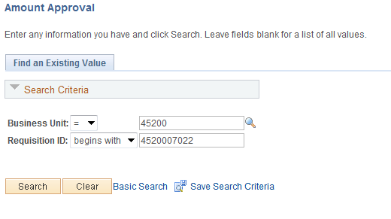

Input the BU and Requisition ID, click . Requisition can also be found by clicking the Look Up Icon .

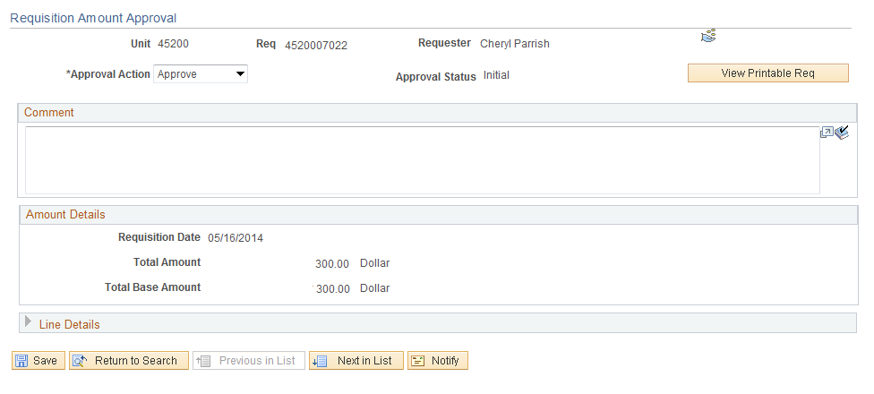

After you retrieve your Requisition the Amount Approval page will be displayed.

The requestor who created the Requisition will click the Approve option and click .
This will then invoke the workflow process if they do not have the proper approval access.

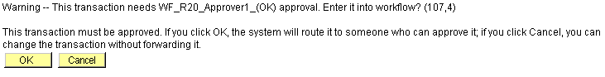

Click .

This action will put the Requisition into the Approvers Worklist. See Procedures for Workflow.

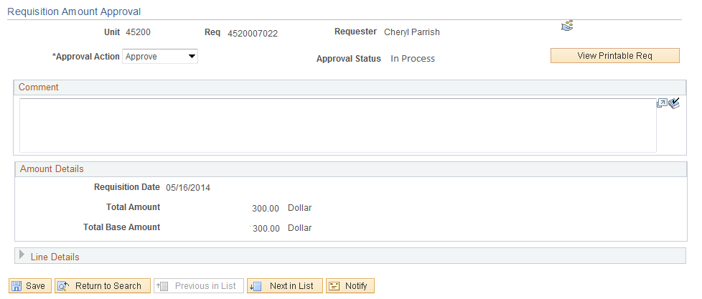

NOTE: The approval status” In Process” and will stay In Process until it has been approved by an authorized user.

After the Requisition has been approved it is ready to be sourced/copied to a RFQ, Contract or PO.
To print the Requisition click .

Retrieve Requisition to Review

Navigation: Purchasing > Requisition > Add Update Requisition > Find an Existing Value

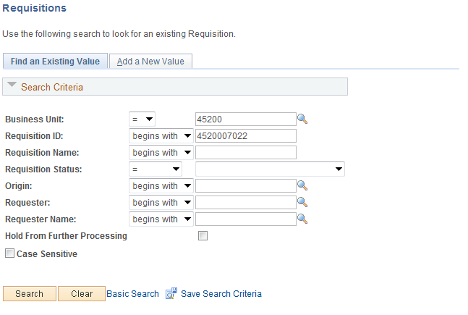

Input the Requisition ID number and click.

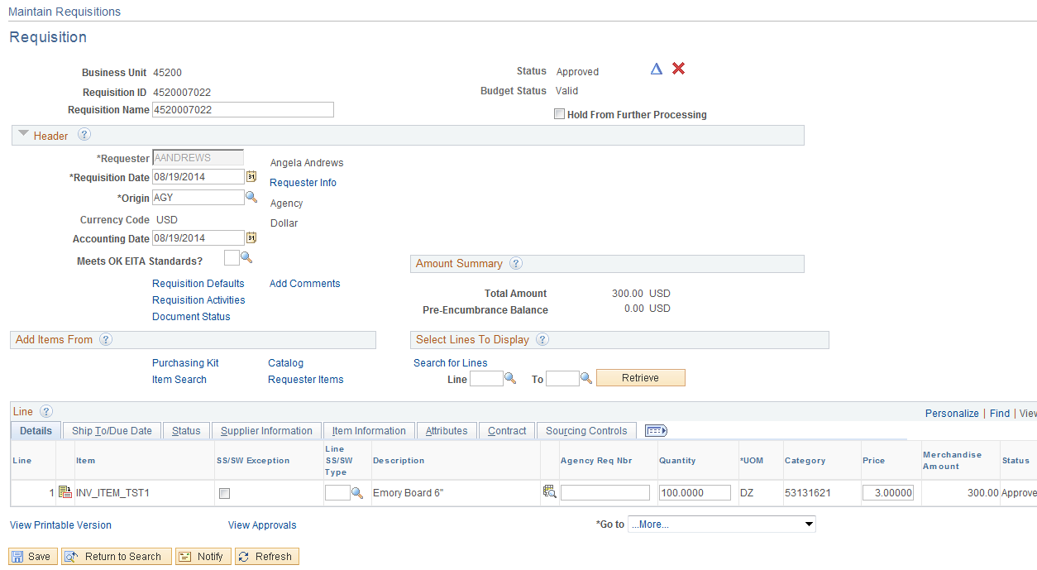

Notice the Requisition is now approved and is available for sourcing or copying to a PO.

Step 12 – Print Requisition

There are two ways to print the requisition. After the requisition has been saved the requisition is available to print.

Print from the Requisition

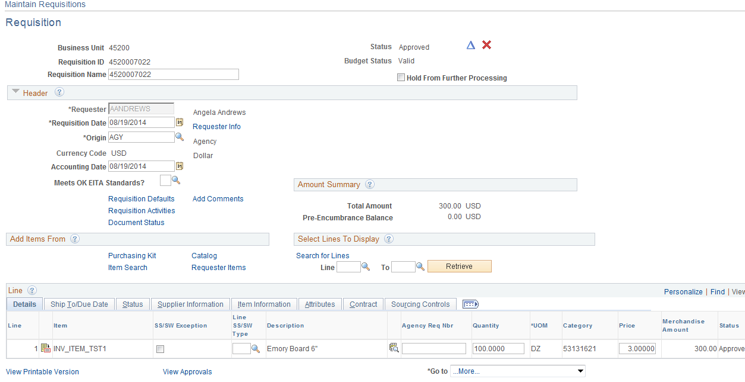

From the Requisition Form page click the View Printable Version link.

Message

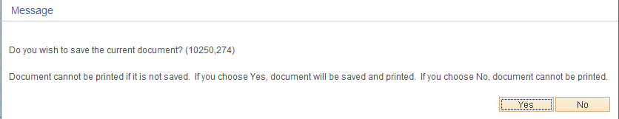

Do you wish to save the current document? (10250,274)
Document cannot be printed if it is not saved. If you choose Yes, document will be saved and printed. If you choose No, document cannot be printed.

Click .

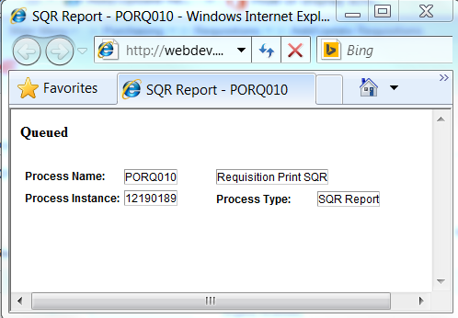

The Queued status will change to Success then the Requisition will be available to print.

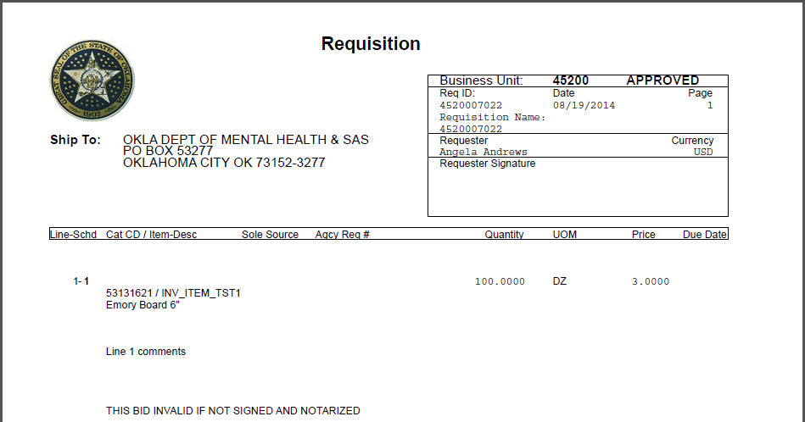

Click, File, Print and .

Navigation: Purchasing>Requisitions>Reports>Print Requisition

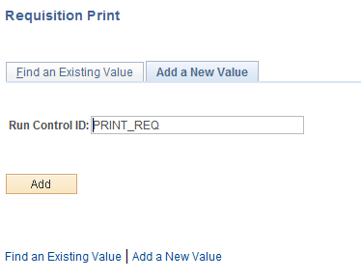

Either input an existing run control ID or create a new run control ID.

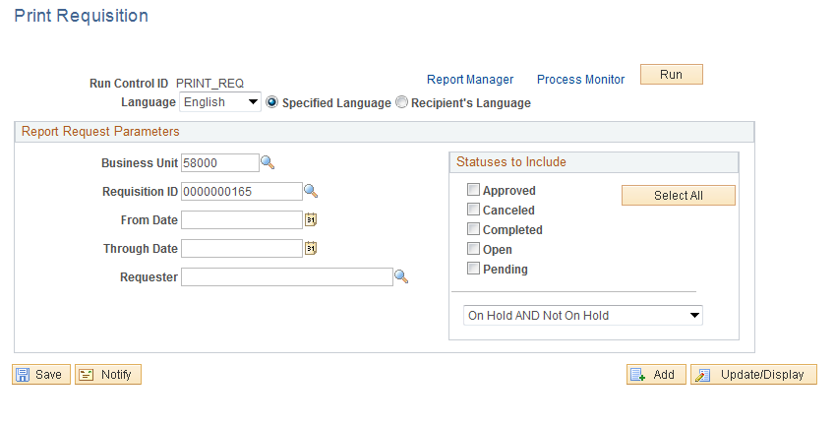

Input the Requisition ID and Requisition Status, click .

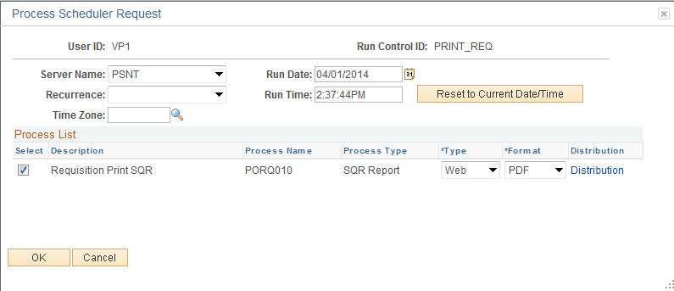

Server - PSNT
Format - PDF

Click .

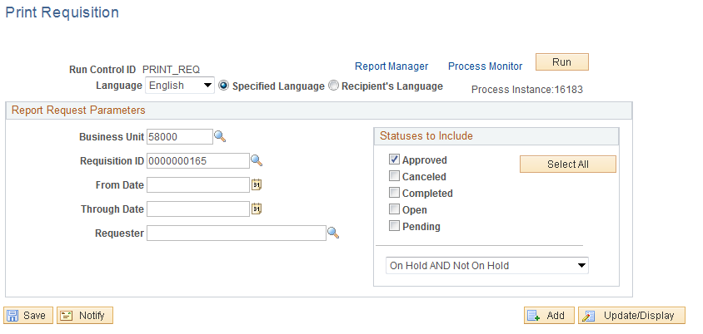

To print your requisition, click the Process Monitor Link.

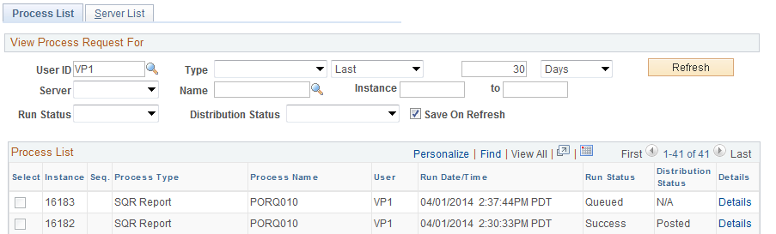

When the Requisition is ready to print the Run Status will be “Success”. If the Run Status is not Success then click , repeatedly until the status changes.

Click the Details link.

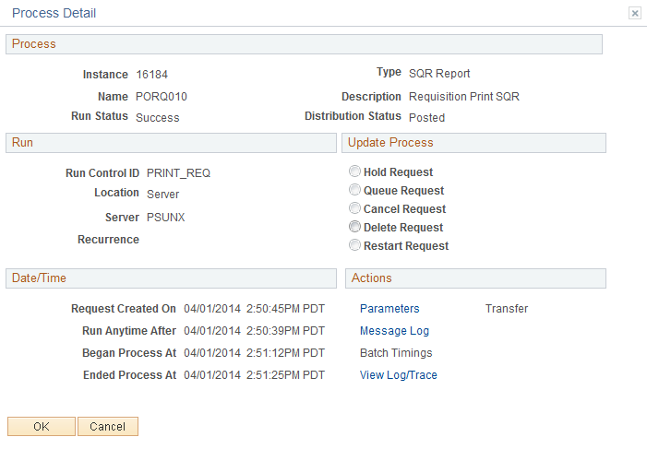

Click the View Log/Trace Link.

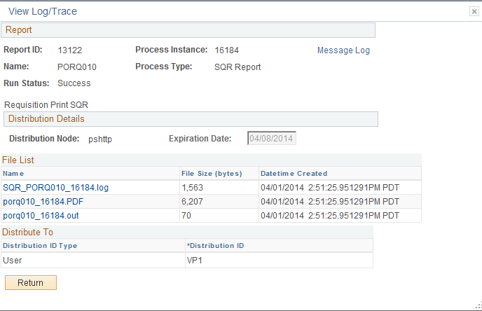

Click the PDF link.

Click, File, Print, and .
Create Multiple Line Requisition

Complete Step 1 through 4, (Pages 6 - 33)

Step 5 – Create a Multiple Line Requisition

Detail Tab

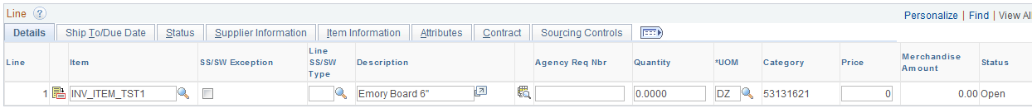

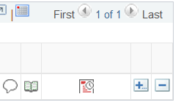

To add an additional line click located to the right of the line.

Input the number of lines to add, click .

You are only able to add up to 100 lines at a time. NOTE: It may be beneficial to add lines in increments of 20 and save the Requisition.

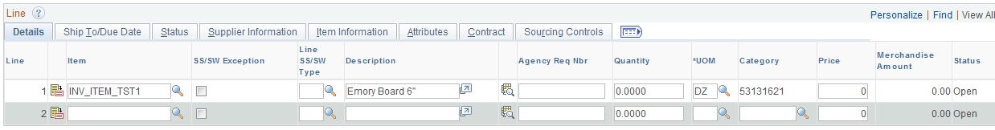

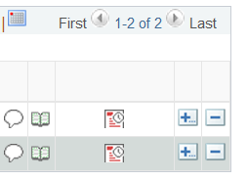

Input the Item ID and click .

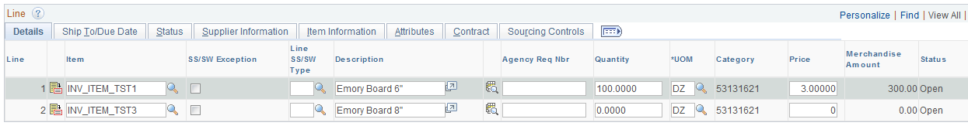

Input a Quantity and click .

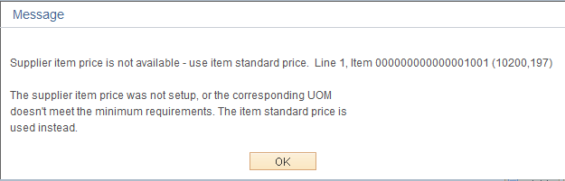

Click .

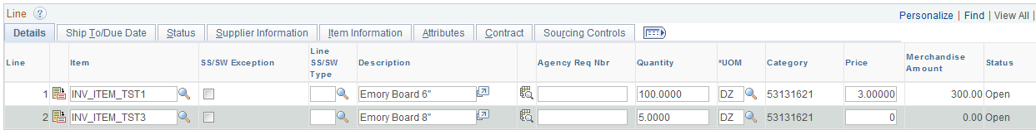

A zero priced defaulted in because the Item Id and the Priority Supplier in the Item ID did not have a price.

Complete steps 6 through 12. (Pages 43-72) Review page 77.
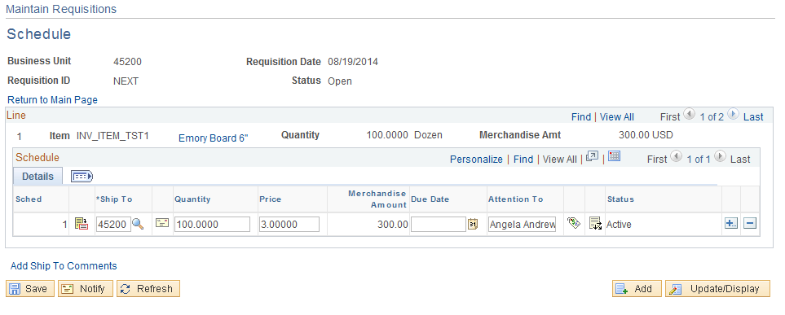

There are two Lines with 1 schedule in each line. Click the View All link to review all the Lines or click the to navigate between the lines.

Click the View All link.
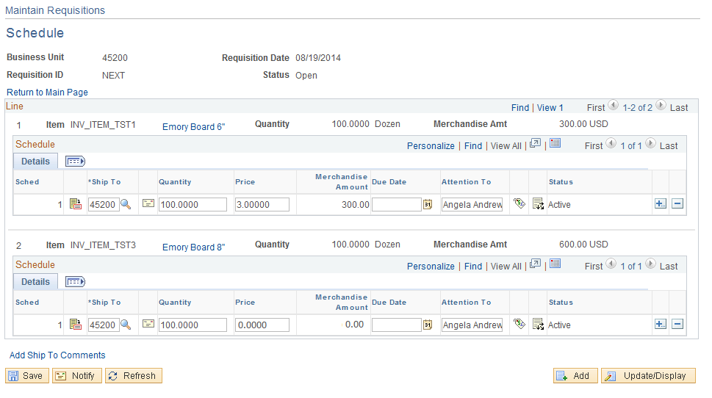

You will need to input a price; to make multiple schedules within a line click located to the right of the line.

To complete the Requisition follow Steps 6-12.
Create a Multiple Schedule Requisition

Complete Step 1 through 6, (Pages 6 – 52)

Step 7 – Verify Shipping Details and Input Distribution Info

Schedule

Use the Requisitions Schedule page to specify multiple shipping schedules for each line and to define multiple distributions for each schedule. The Schedule page by default allocates the total by Quantity, but it can also allocate by Dollar amount. To access the Schedule page, Click the Schedule icon..

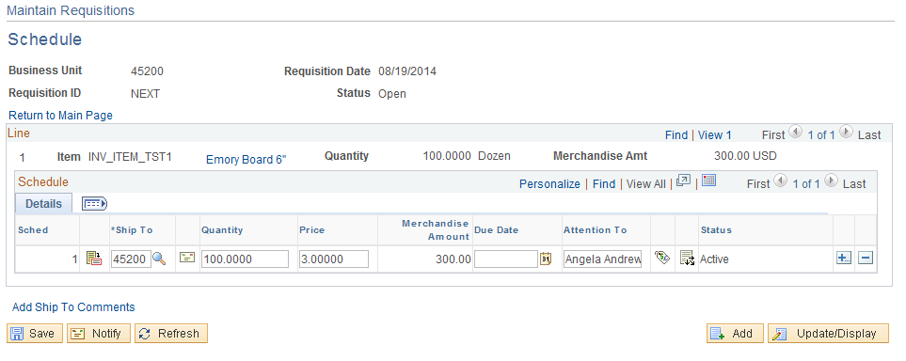

From the schedule page you are able to change the Price, and then click .

To add additional schedule lines, click located to the right of the schedule.

Input the number of rows to add and click .

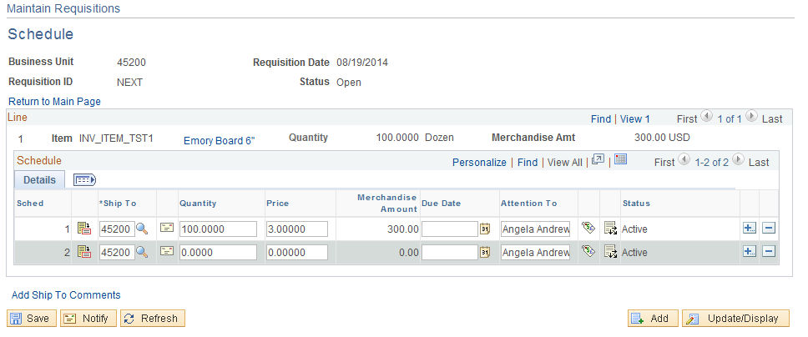

This gives you the ability to ship products at different times to different locations. On schedule two input a different Ship To and distribution the quantities. Click .

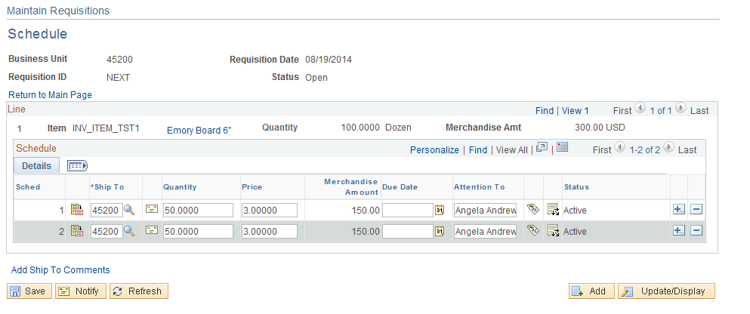

Notice the price defaulted in. There is a distribution link for each schedule.

Distribution Information

Use the Distribution Information page to update and review the distribution data. These line items are transferred to the Purchase Orders, but they do not go out to the supplier. They are a breakdown of accounting distribution and internal delivery locations. This page identifies how the Schedule amounts will be charged within the organization. There can be multiple Distributions for each Schedule. The required Chart Field string is entered for each Distribution, allowing an item to be funded (expensed) from multiple sources. To access the Distribution page click the Distribution Icon .

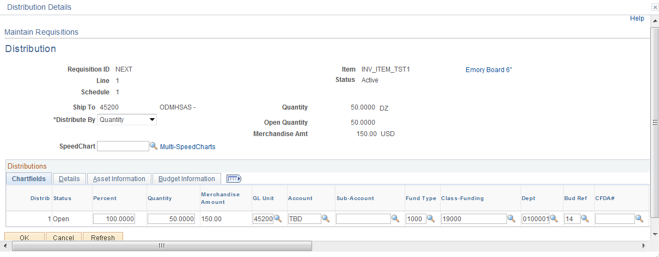

NOTE: The Distribution data defaulted from the Header Default. If changes need to be made, do it in the Default page. This page has also been customized. See Appendix page 130.

Click .

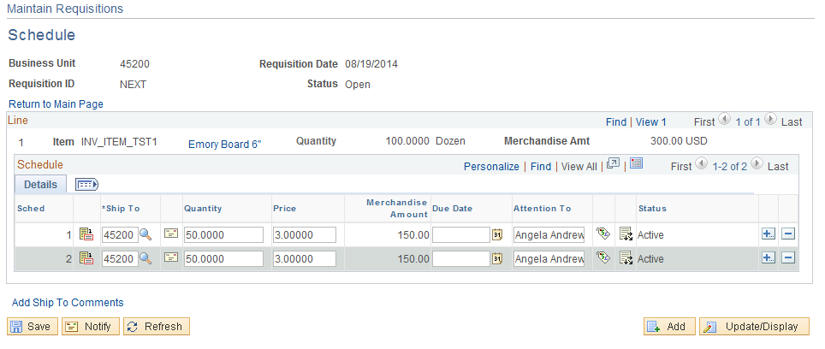

Review the distribution for schedule line 2 by clicking the Distribution Icon .

Complete the Requisition process by completing Steps 8-12, (pages 55-72)

Create Multiple Line Distribution

Complete Step 1 through 6, (Pages 6 - 52)

Step 7 – Verify Shipping Details and Input Distribution Info

Schedule

Use the Requisitions Schedule page to specify multiple shipping schedules for each line and to define multiple distributions for each schedule. The Schedule page by default allocates the total by Quantity, but it can also allocate by Dollar amount. To access the Schedule page, click the Schedule icon..

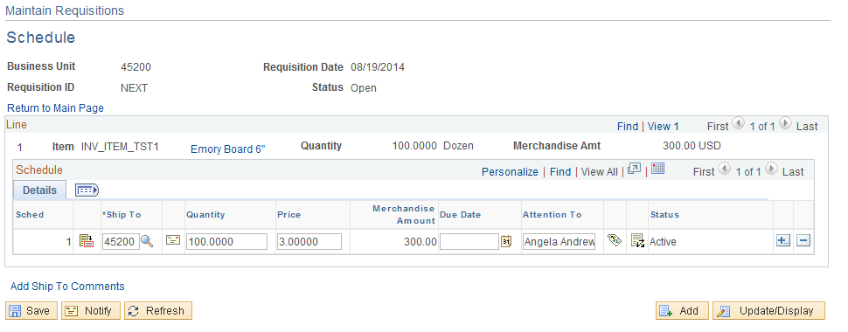

From the schedule page change the Price and click . If needed input a Due Date and Ship to Location. Ship To and Due Date will default from the Form page. If you change the Ship To or Due Date on the Schedule Tab it will default to the line page.

Distribution Information

Use the Distribution Information page to update and review the distribution data. These line items are transferred to the Purchase Orders, but they do not go out to the supplier. They are a breakdown of accounting distribution and internal delivery locations. This page identifies how the Schedule amounts will be charged within the organization. There can be multiple Distributions for each Schedule. The required Chart Field string is entered for each Distribution, allowing an item to be funded (expensed) from multiple sources. To access the Distribution page click the Distribution Icon .

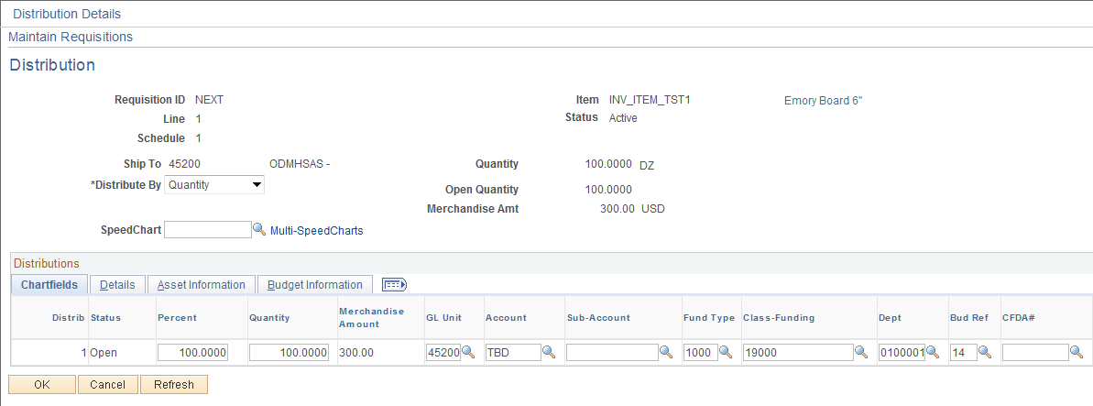

NOTE: The Distribution data defaulted from the Header Default. If changes need to be made, do it in the Default page. This page has also been customized. See Appendix page 130.

To add additional distribution lines click located to the right of the distribution line.

Input the number of rows to and, click .

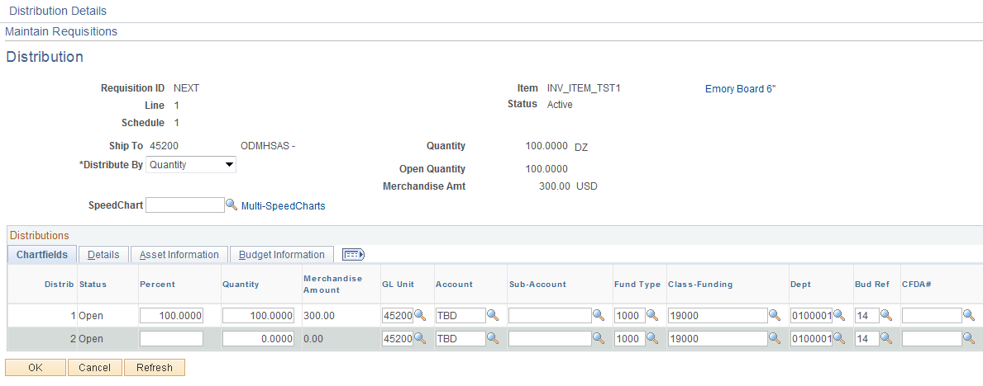

Input the Percent or Quantity to distribute between the distribution lines and click . Notice the funding default from the header default. If any of the values are going to be different then change the distribution line but be sure to go back to the Header Default and clear the value.

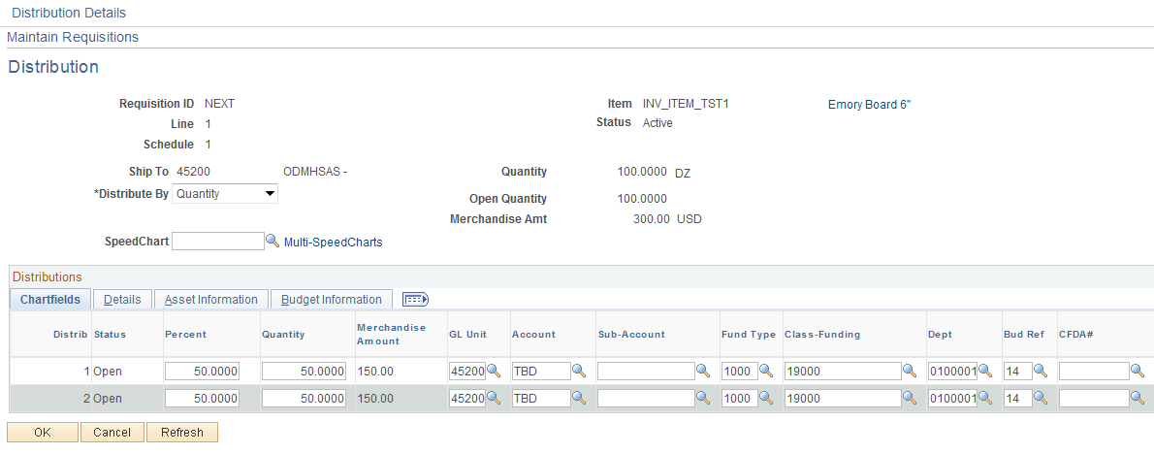

Click .

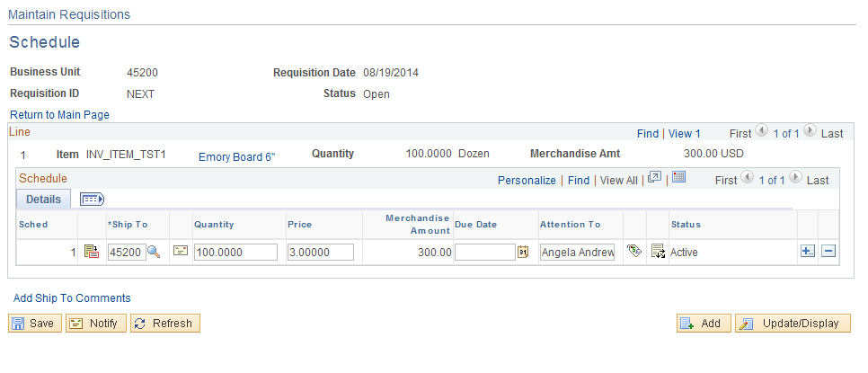

Complete steps 8-12 (Pages 55-72).
Create Requisition from Copy Statewide Contract

Overview

Prior to creating the Requisition you should already have obtained the data needed by reviewing the Department of Central Services website: http://www.ok.gov/DCS/Central_Purchasing/StateWide_Contracts/index.html. This Web Site will give you the Statewide (SW) Contract number, Item Number, Supplier Number and you are able to print a copy of the Statewide Contract.

Step 1 – Copy From Statewide Contract

Navigation: Purchasing > Requisitions > Add/Update Requisitions

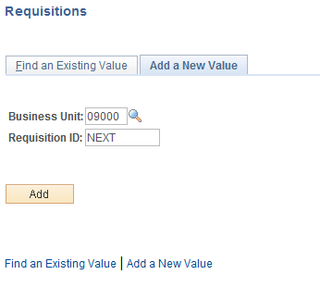

Business Unit-Defaults to specific agency for each User.

Requisition Number-Defaults to NEXT. The system will auto number each Requisition.

NOTE: Do not change the Requisition ID data field. Let the system default NEXT into the data field. The Requisition number will be assigned upon saving.

Click to take you to the Requisition Form page.

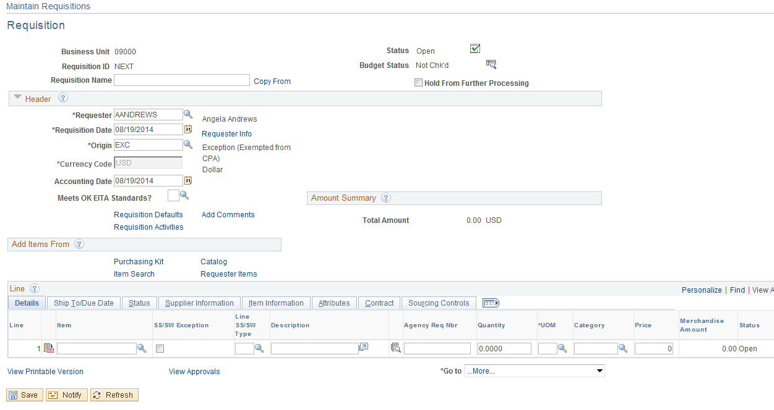

NOTE: Since this is a Statewide the Origin needs to be changed to “EXC”. Click the key located to the right of the Origin to change the origin field.

Step 2 – Header Default

Click the Requisition Default link.

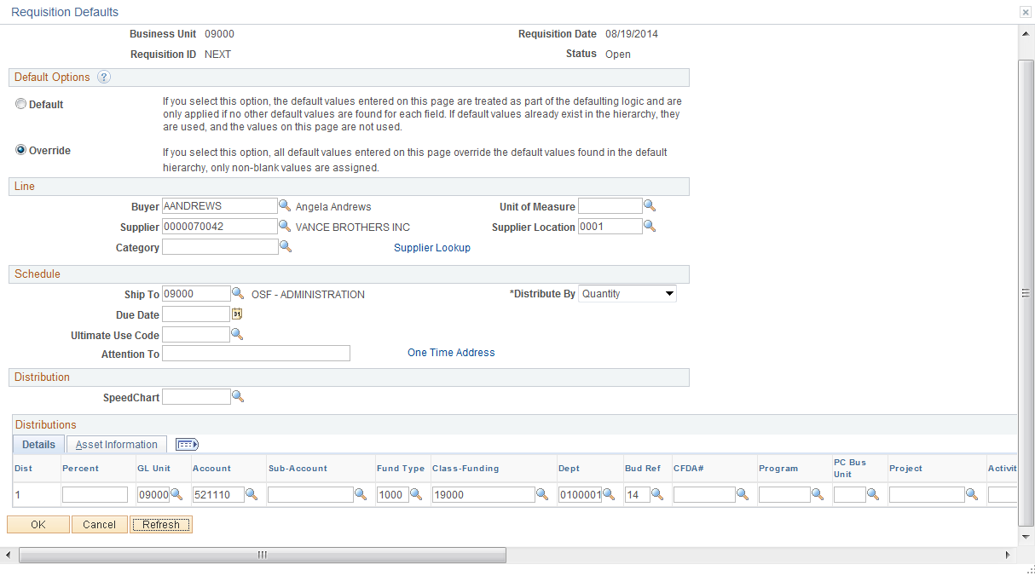

Supplier Selection

Enter the Supplier Number, Supplier Location, Buyer and any other data to default into the Requisition. Make sure the supplier number matches the supplier on the Statewide Contract. If the supplier number does not match, the contact will not be available to copy. You can use the Item IDs priority supplier by not inputting a supplier in the Default page. The priority supplier will copy from the Item ID, this should be the contract supplier.

NOTE: Distribution data (except account) will not default in from the Statewide Contract.

Input default values and distribution data. Click to validate the data.

Click .

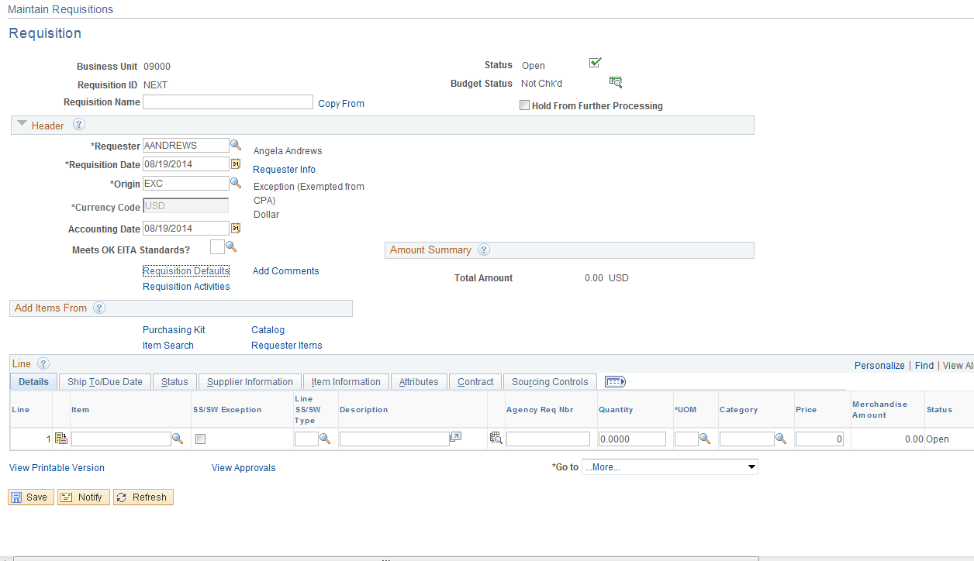

Input the Item ID Number and REQ Qty, click .

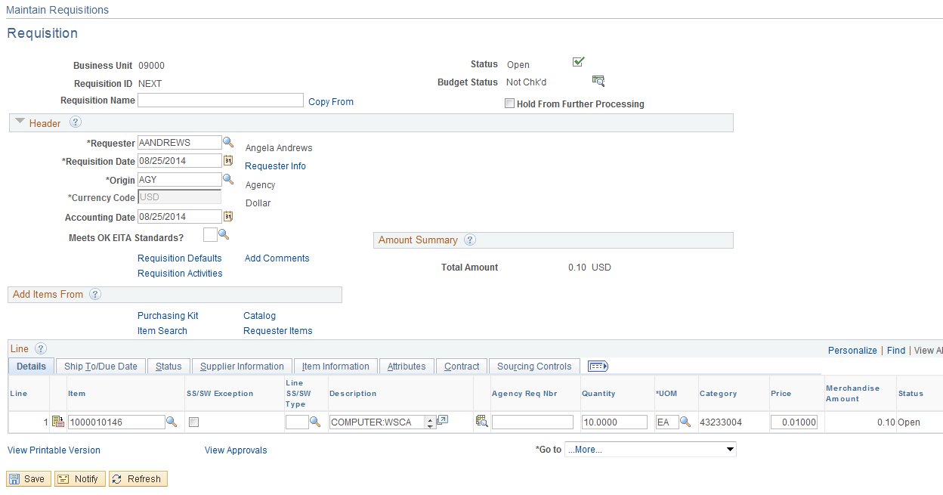

The price defaulted from the ITEM ID Supplier because the correct supplier location was used, this price matches the contract price and will not need to be changed. The UOM on the Requisition must match the UOM on the Contract or an error message will be received.

Step 3 – Verify Line Details and Copy the Statewide Contract

Verification of Line Detail must be completed for EACH Line Item on the Statewide Contract.

Click the Tab.

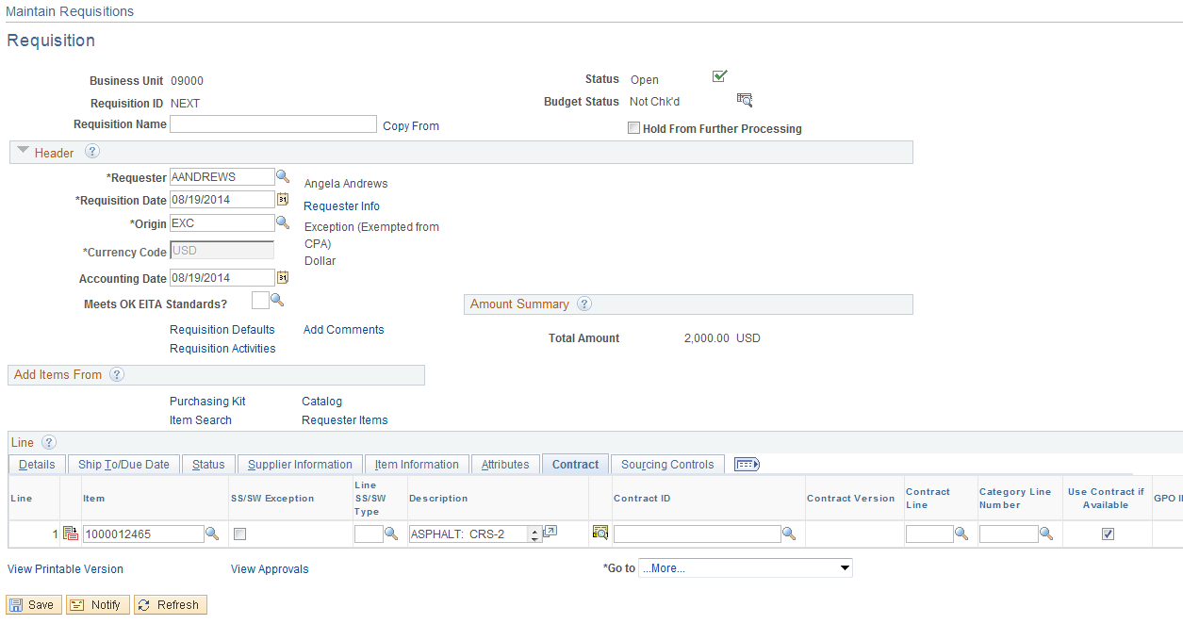

Input the Contract ID and Line number, click the Look Up Icon if the contract number is not known. By populating the Supplier number and location the results will only contain contracts against the supplier. In this example the Look Up Icon will be used for the Contract ID.

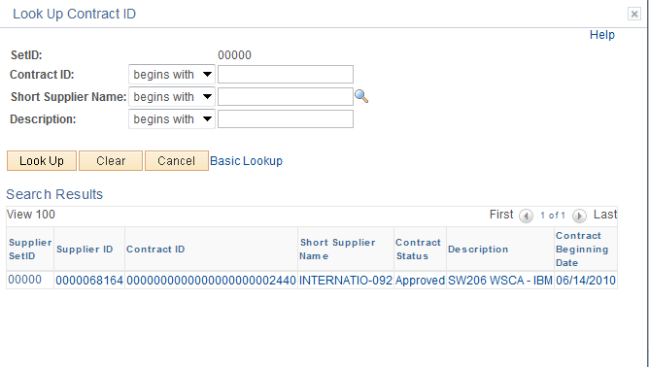

Click the link to select the contract.

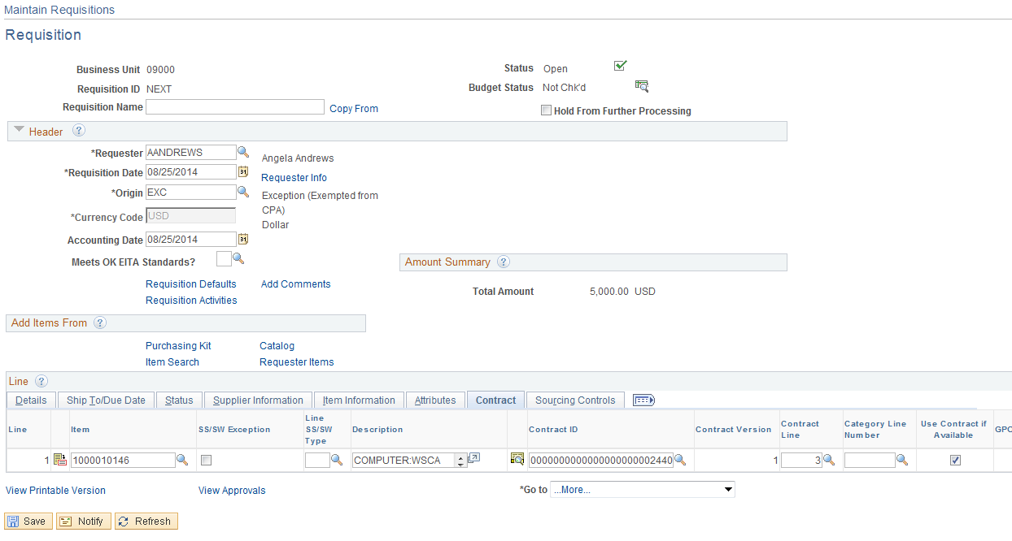

In this example the Look Up Icon will be used for the Contract Line.

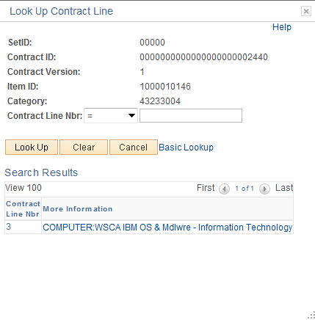

Click the link to copy the line into the Requisition.

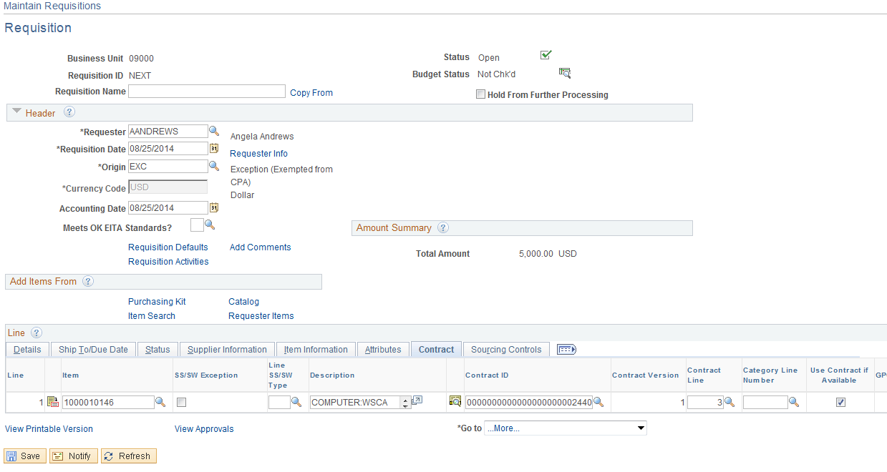
Step 4 – Verify Shipping Details and Input Distribution Information

Schedule

Use the Requisitions Schedule page to specify multiple shipping schedules for each line and to define multiple distributions for each schedule. The Schedule page by default allocates the total by Quantity, but it can also allocate by Dollar amount. To access the Schedule page click the Tab then click the schedule icon located to the right of the line.

Complete Steps 7-12

Troubleshooting

If the Contract number is not available in the selection criteria;
Verify the Supplier number and Supplier location
Verify the contract is in an approved status

If the Contract Line number is not available in the selection criteria;
Verify the Item ID
Verify the UOM
Verify there is a base amount on the contract
Copy a Requisition to a Requisition

Step 1 – Enter Requisition

Navigation: Purchasing > Requisitions > Add/Update Requisitions > Add a New Value

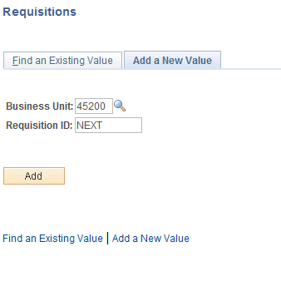

Business Unit - Defaults to specific agency for each User.

Requisition Number-Defaults to NEXT. The system will auto number each Requisitions.

NOTE: Do not change the Requisition ID data field. Let the system default NEXT into the data field. The Requisition number will be assigned upon saving.

Click to take you to the Requisition Form page.

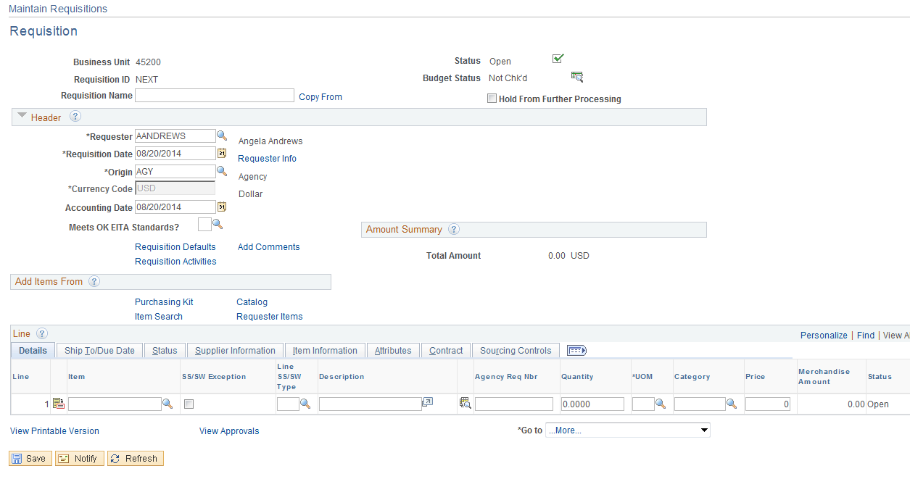

Click the Copy From Link.

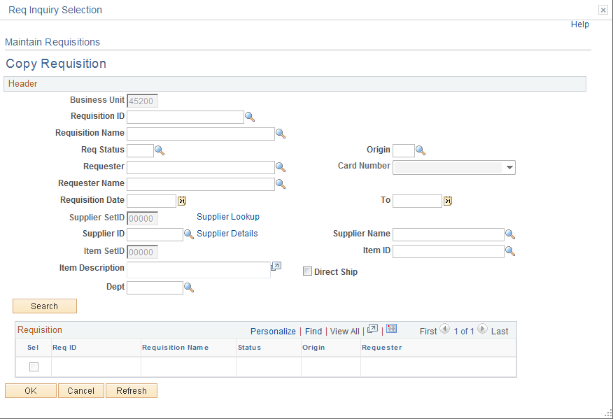

Input the Requisition ID and click .

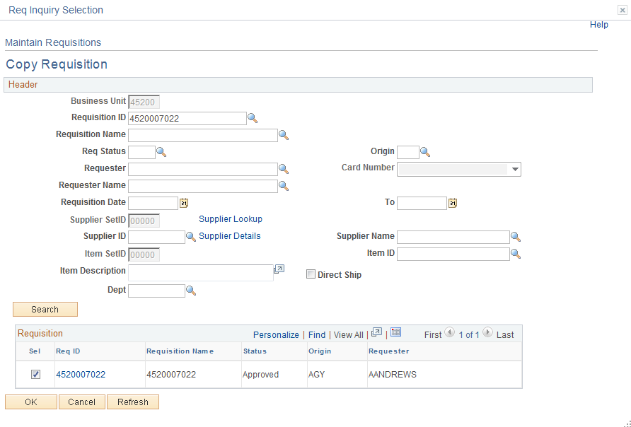

After the Radio box is selected, click .

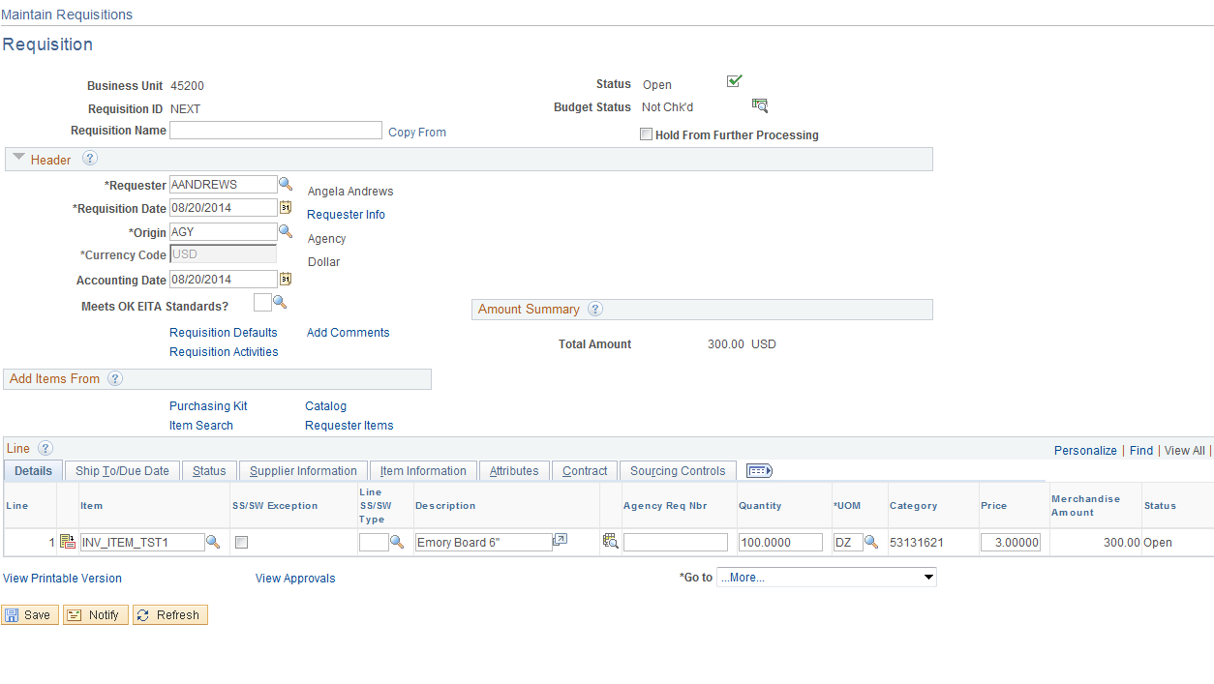

Review and update the data copied in.

Click .

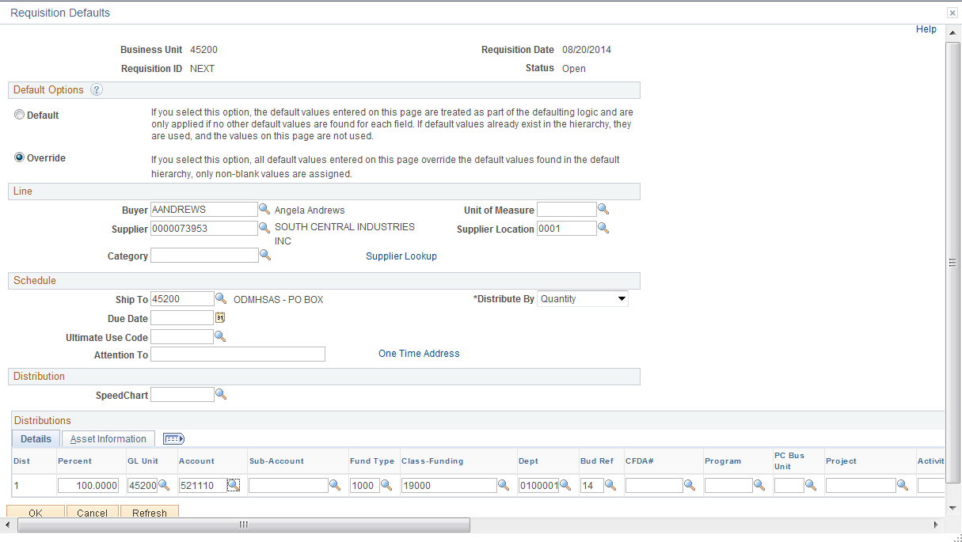

If the default values have been used and they need to be changed, then update the Requisition using the default page.

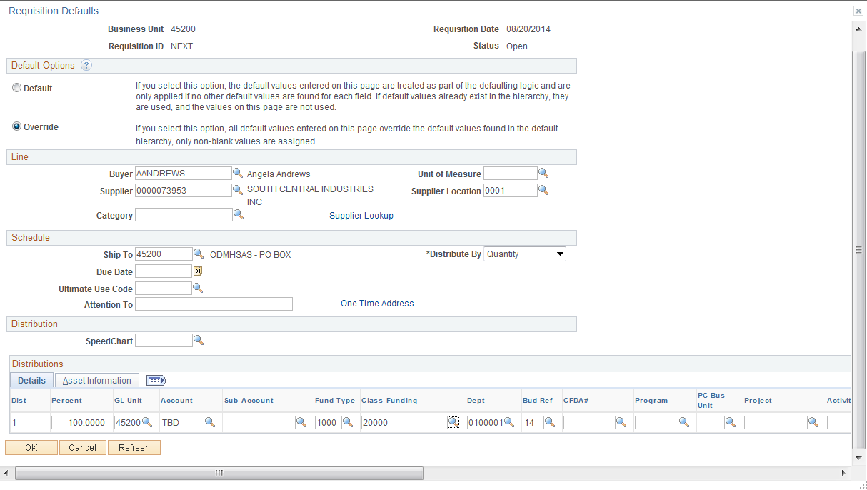

After values have been updated click .

Retrofit Field Changes

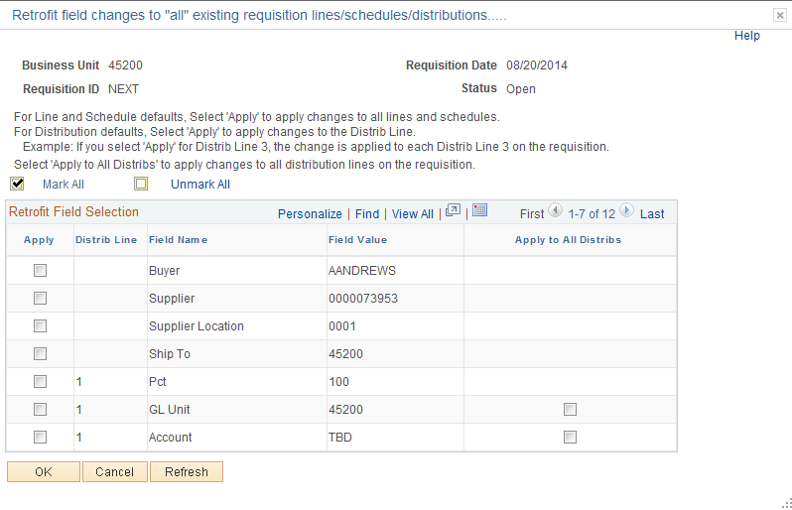

This page allows the user to update defaulted values. Click the radio box next to the value to change, then click .

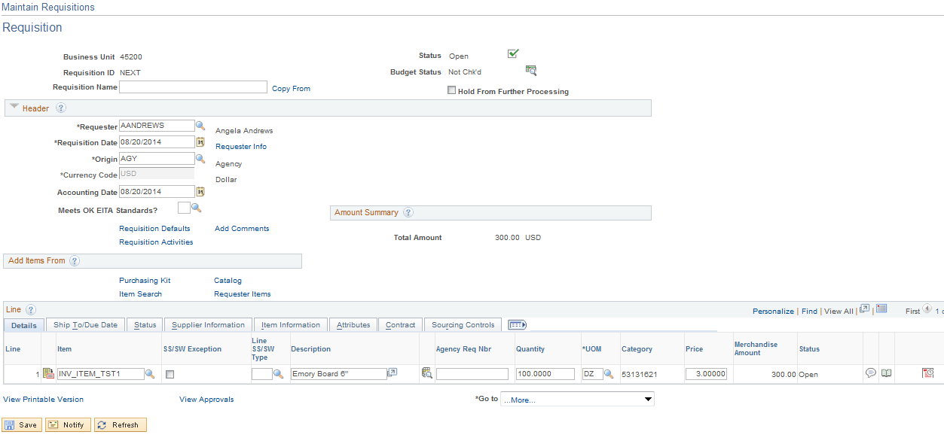

Click the Edit Comments link.

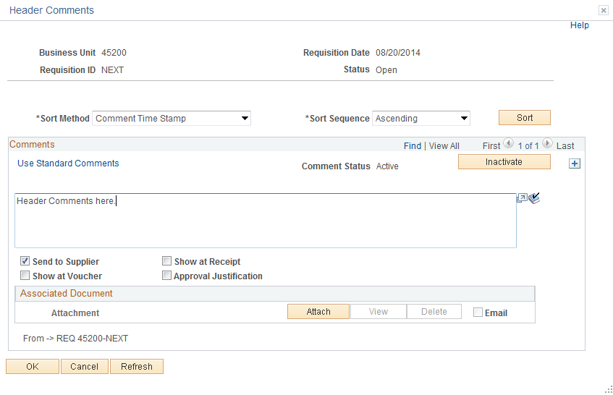

Click the View All link.

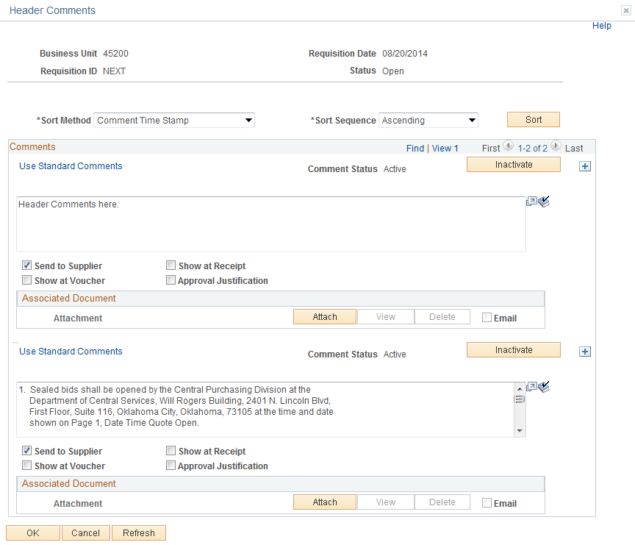

Update comments. The best way to update a comment is to inactivate the comment by selecting .

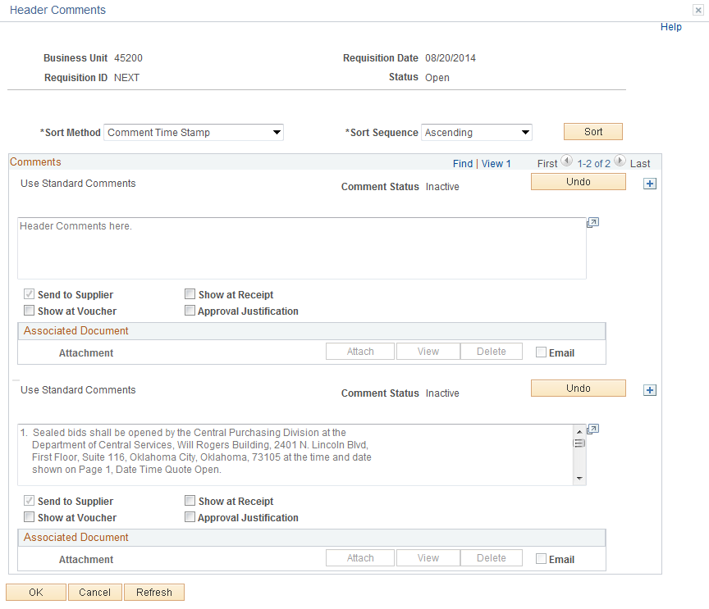

The changed to . To add a comment, click located to the right of the comment.

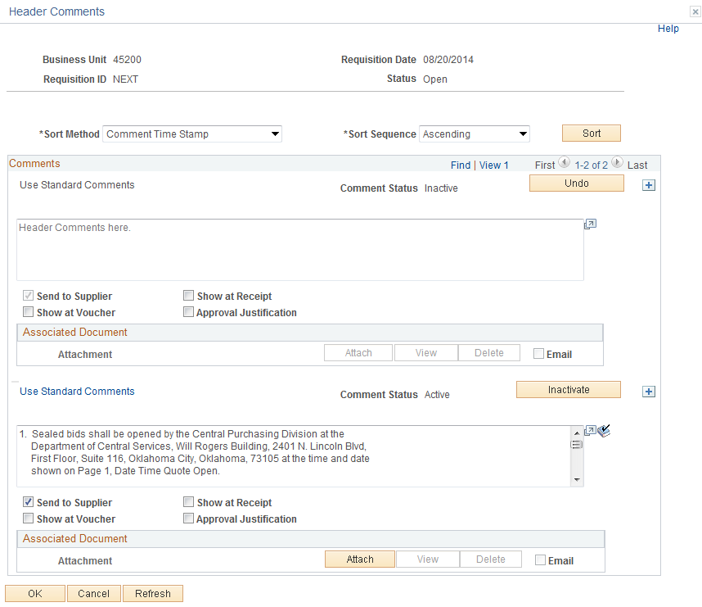
Input your comment and click . If you were to review your comments again the inactive comment will not be available.

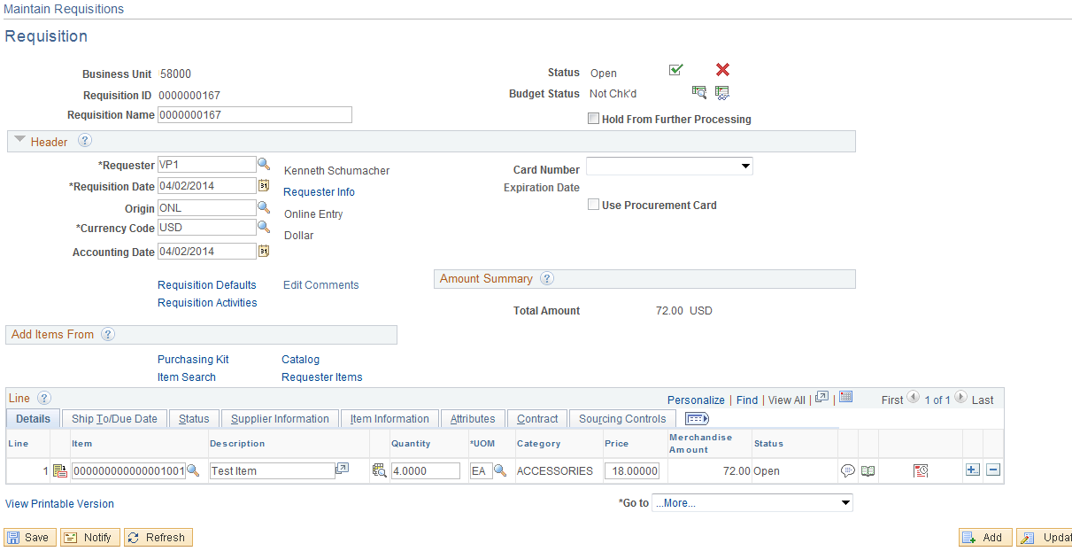

Click .

If needed click the Line Comment Icon and update.

The requisition is ready to be completed. Follow Steps 7-12.
Misc. Requisition Options

Requisition Activity

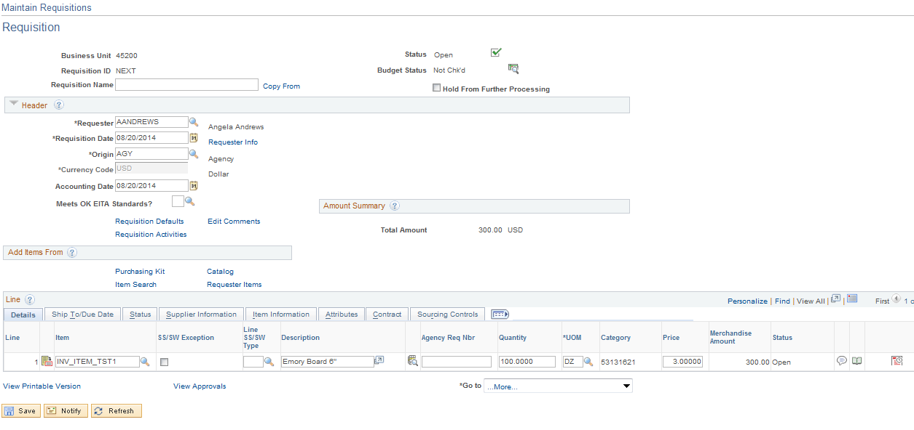

Click the Requisition Activities Link.

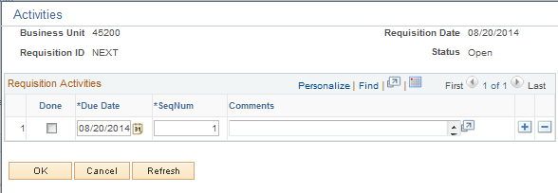

Enter and track activities associated with a particular transaction. Keep the activity comments organized by logging the due date and by selecting the done check box. This is a good place to track CRM cases.

Reviewing Requisition Accounting Entries

Overview

This screen shows the budget checking entry of the Requisition and any reverses against the Requisition, (Purchase Order).

Reversal

The amount reducing the pre-encumbrance

Finalizing

This process Marks the document as finalized and will reduce any remaining pre-encumbrance balance and any changes to the PO will not update the Requisition.

Navigation: Purchasing > Requisitions > Review Requisition Information > Accounting Entries

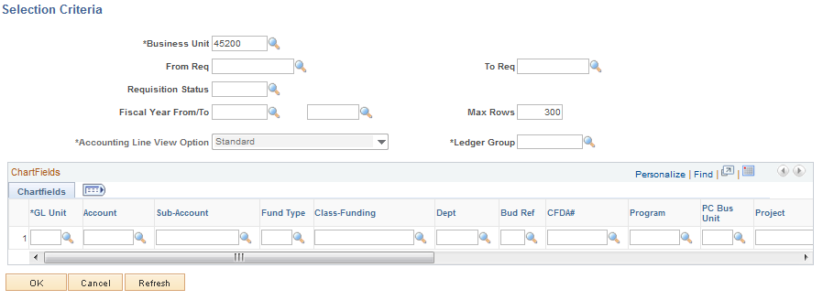

Input the Requisition ID and select a Ledger Group of Allot.

Other ledger available; DEPT and ACCT, CASH. Cash is not used for Encumbrances, DEPT and ACCT are tracking budget. If you use a TBD account, review the entries by using Ledger Group DEPT.

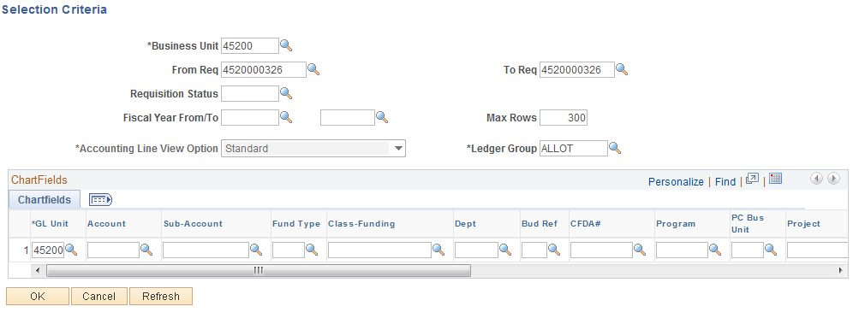

Click .

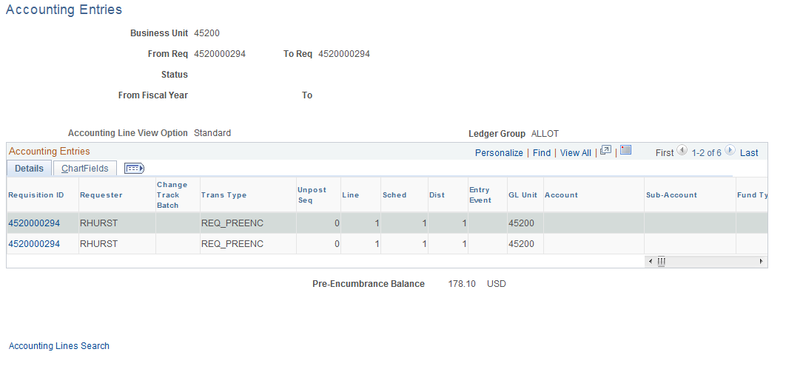

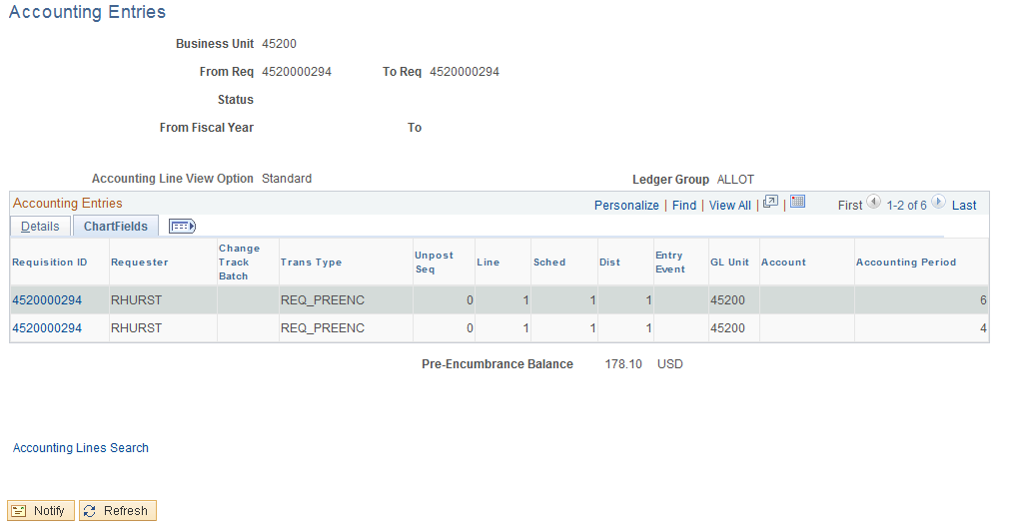

Account Period - Based upon the Requisition’s Accounting Date
Budget Period - Based upon Requisition’s Budget Date
Fiscal Year - Based upon Requisition Accounting Date
Review Requisition Inquiry Page

Navigation: Purchasing > Requisitions > Review Requisition Information > Requisitions

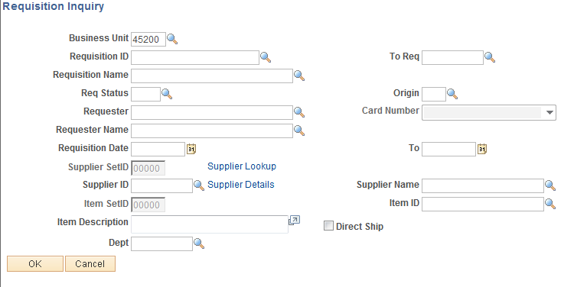

Input the Requisition ID. A From Requisition ID and a To Requisition ID is needed. If only one Requisition is being looked up then the number will be the same. Click the Tab Key to validate the data.

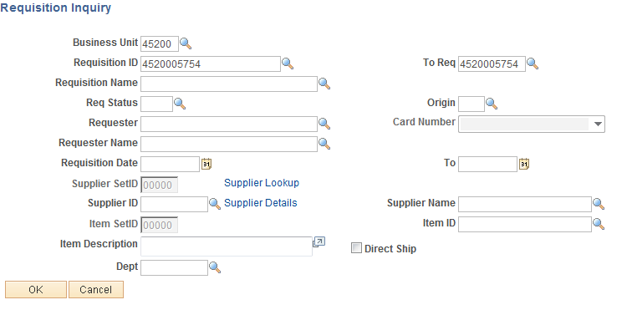

Click .

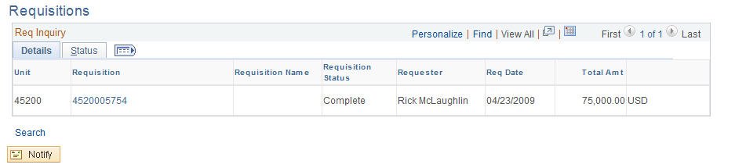

Click the Status Tab.

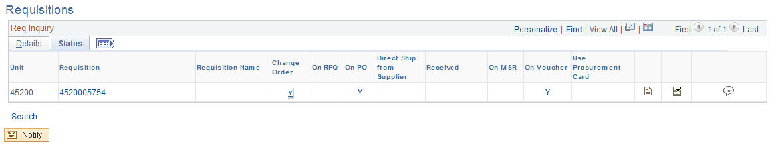
From this screen you are able to see several fields of information.

- A Change Order has been created
- A RFQ has been created
- A Purchase Order has been created
- A Voucher has been created
- Review Document Status and Approval History

Review the Change Order, RFQ, Purchase Order or Voucher by clicking the hyperlink.

Click the hyperlink for the Purchase Order

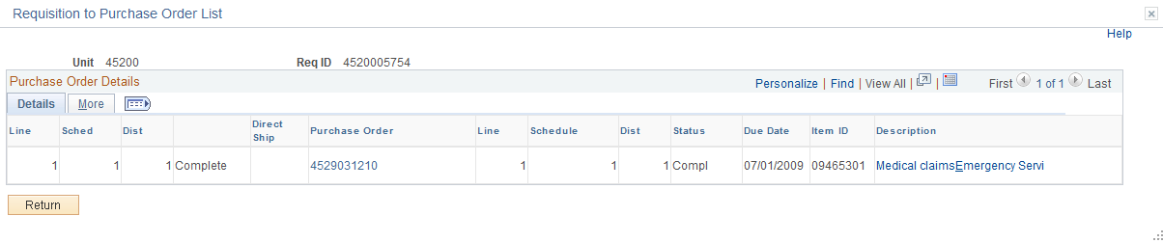

Click the Show All . Tab to review all the data. Click the PO link to create a new window to display the Purchase Order Inquiry Screen.

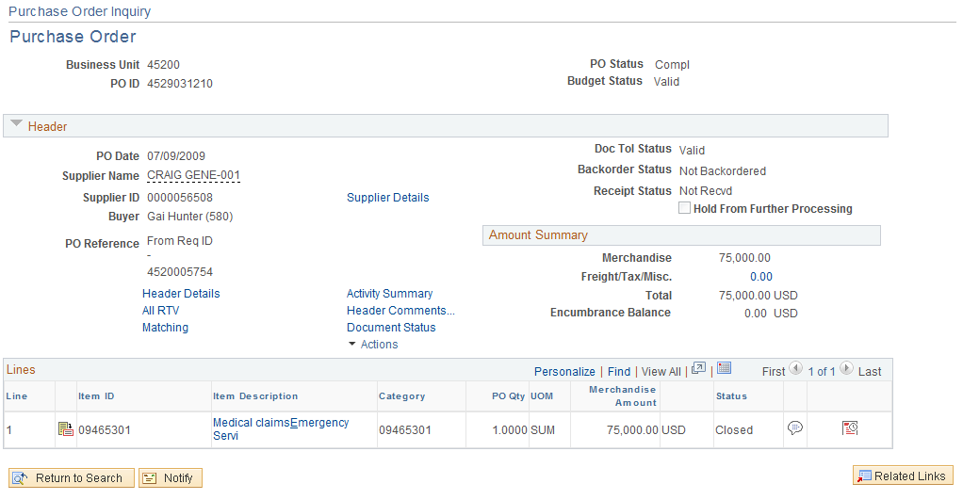

This is a new window and to close click the X in the upper right hand corner.

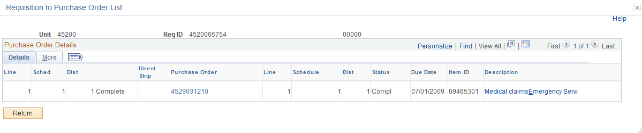

Click to take you back to the Requisition Inquiry Page.

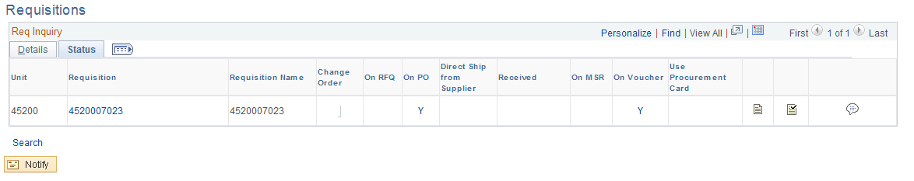

Click the hyperlink for the Voucher.

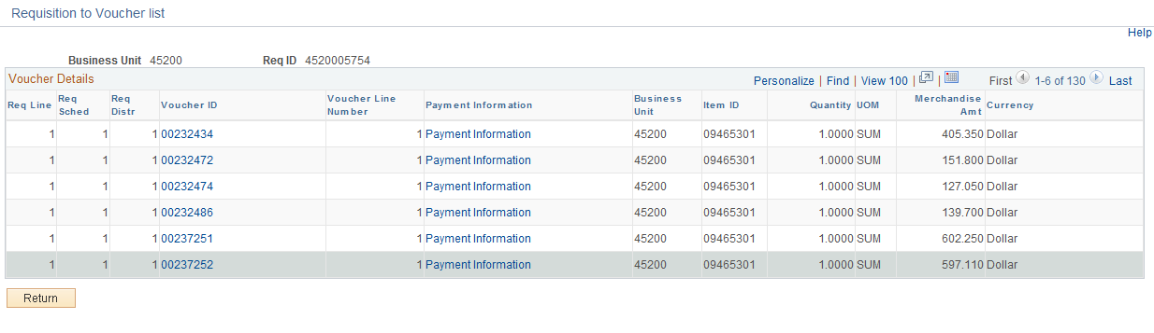

From here use the hyperlink Voucher number to take you to voucher Inquiry or Payment Information link to review payments.

Click the Payment Information Link. This opens a new window displaying voucher payment.

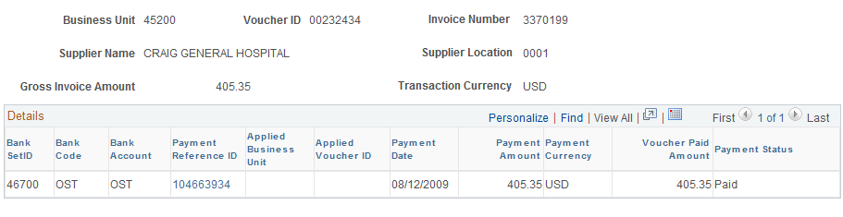

This is a new window. To close the window, click the X in the top right hand corner.

Click .

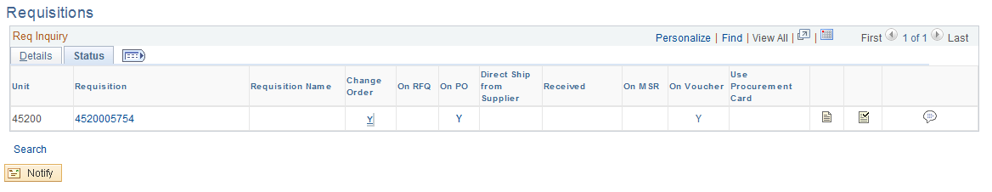

By clicking the Requisition hyperlink you are able to review the detail of the Requisition; Line information, Schedule information, and Distribution information. There are also other hyperlinks available to review, take some time to look at them.

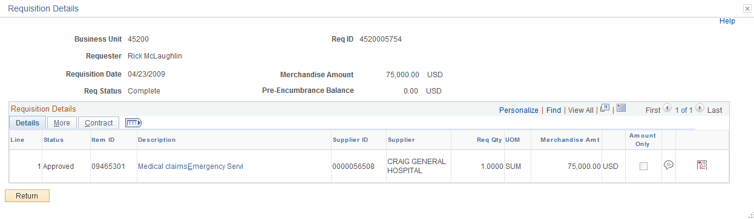
Using the Supplier Look Up

From the Requisition Default click the Supplier Look Up Icon.

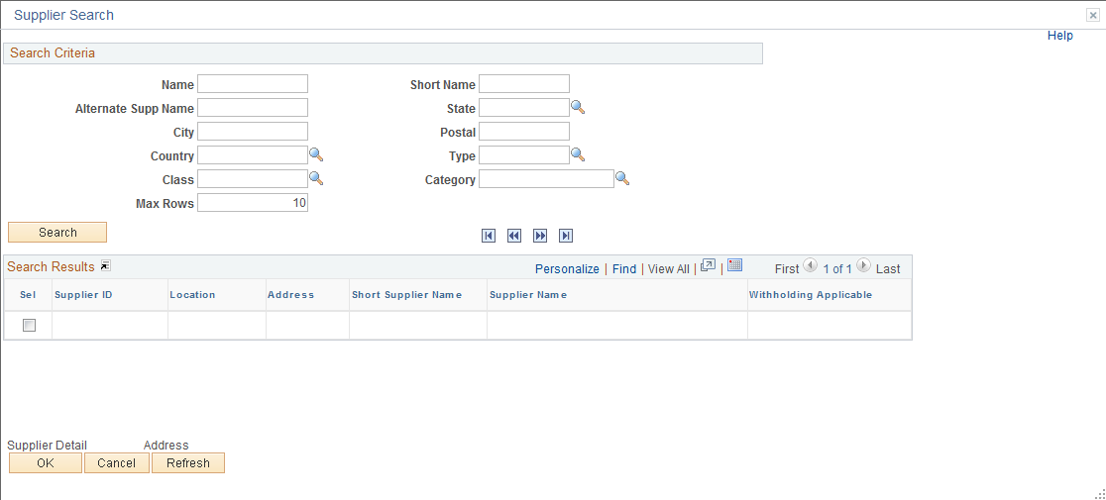

From this page you are able to look up a supplier by several criteria’s.

- Name
- Short name
- City
- Class
- Category-Locate Registered Suppliers
- Others

Look Up by Name

Input the supplier’s name, if you do not know how to spell the name then input the first few digits and click .

NOTE: If you expect more then 10 results, be sure to change the Max Rows.

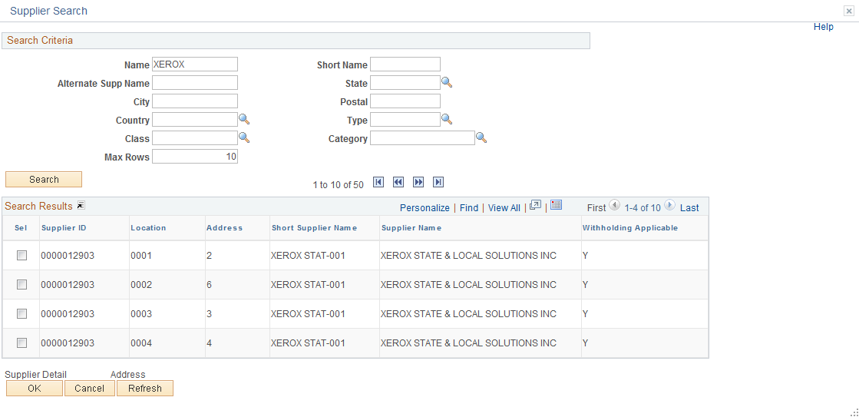

Click the View All link to review all the results, if there are more rows than you specified in Max Rows.

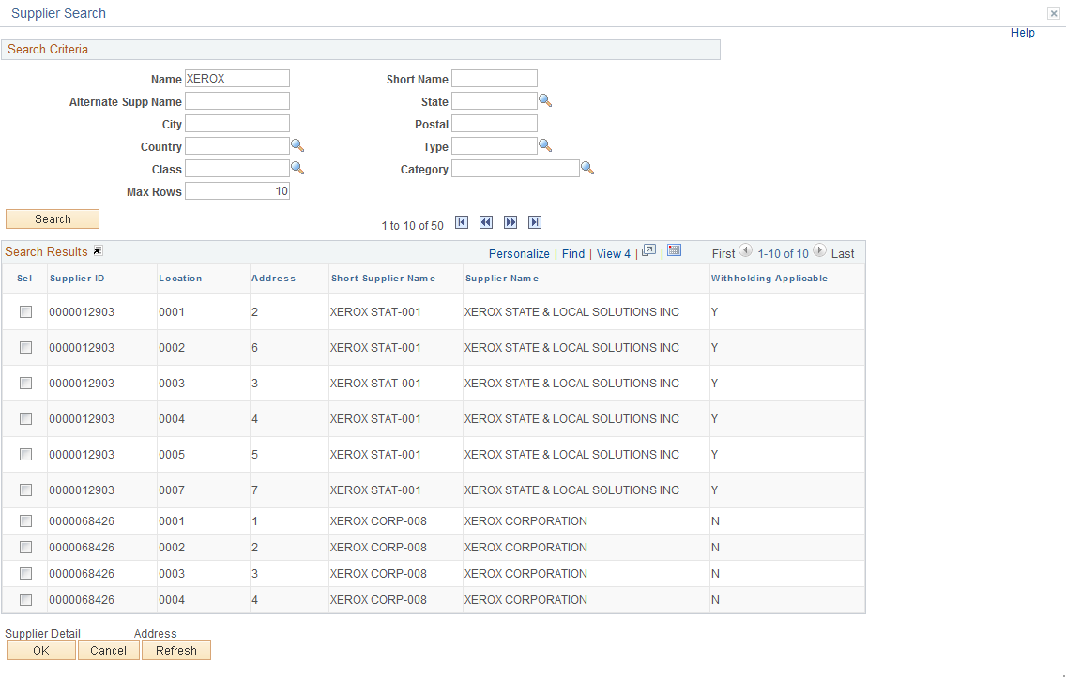

To review a particular supplier click the check box located to the left.

The Supplier Detail and Address becomes available, however, this option is currently not available.

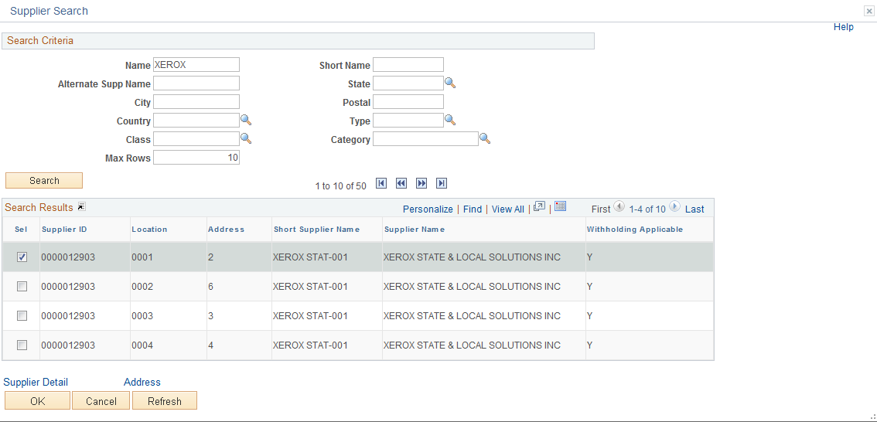

Click the Supplier Detail link.

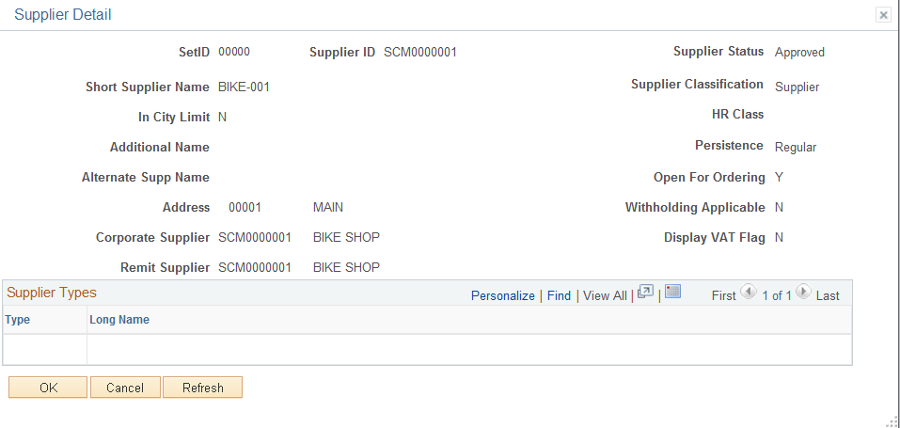

Click .

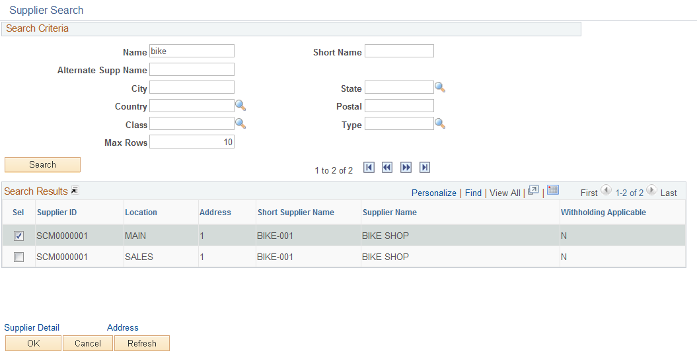

Click the Address link.

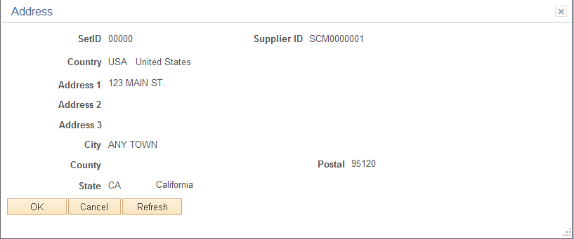

Click .

To review another supplier, click the check box and follow the above steps. To accept the supplier, click . This will take you back to the Requisition Header page.

Look Up by Category

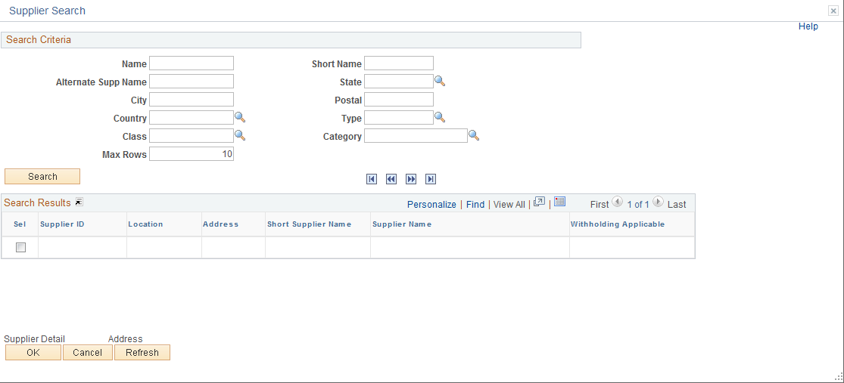

If you know the Category the purchase is for and you want to review all the Registered Suppliers then input the Category Code, Input a Type and click . If there are no results, then there is no Registered Supplier for this Category.
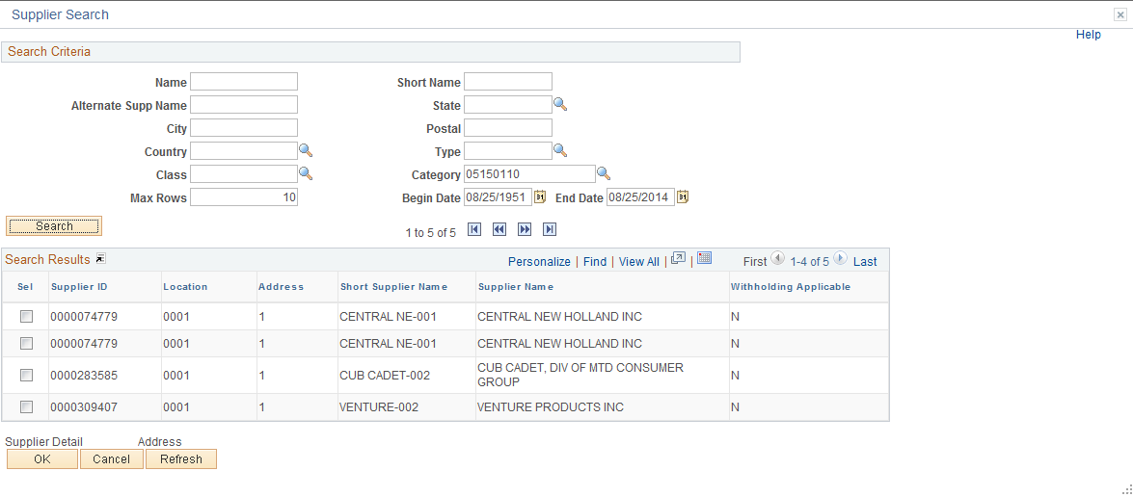

These search criteria gave me all suppliers registered for category 05150120.

To select a supplier click the check box located to the left of the supplier then click . This will take you back to the Requisition Header Page.
Customize Distribution Page

Retrieve documents distribution page

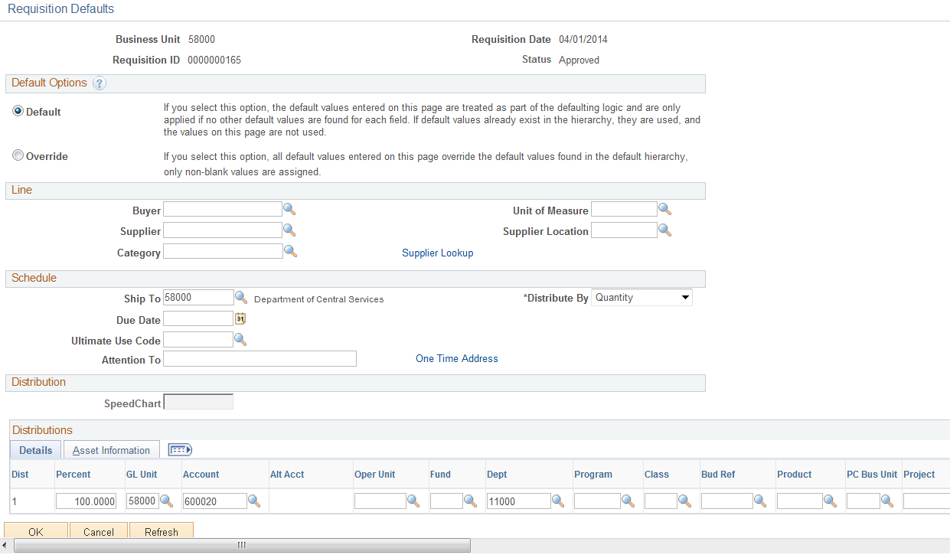

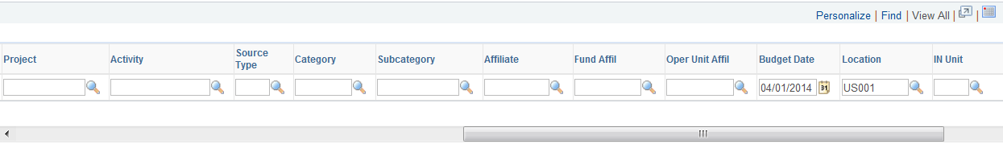

Click the Personalize link.

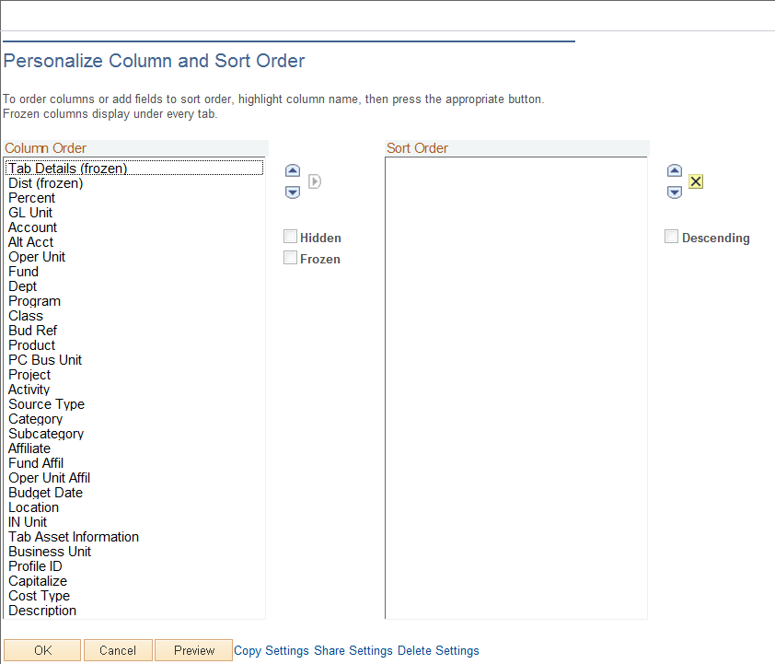

The left hand column shows all fields available on the distribution line. To hide the field, click the field name.
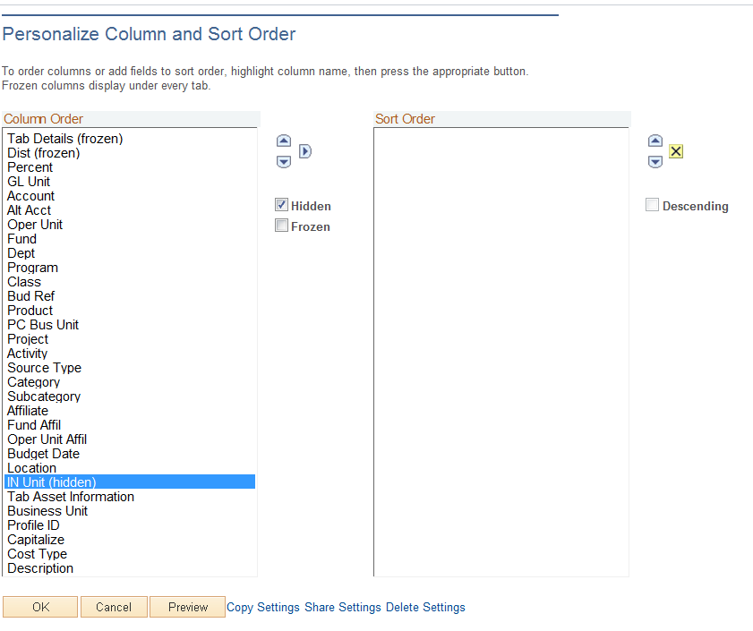

The Hidden radio box becomes available. Click the Radio Box. Repeat this process for each field you want to hide.

NOTE: If you have several fields in a row to hide, click the first field, hold down the shift key, scroll through the fields and then click the Radio Box.

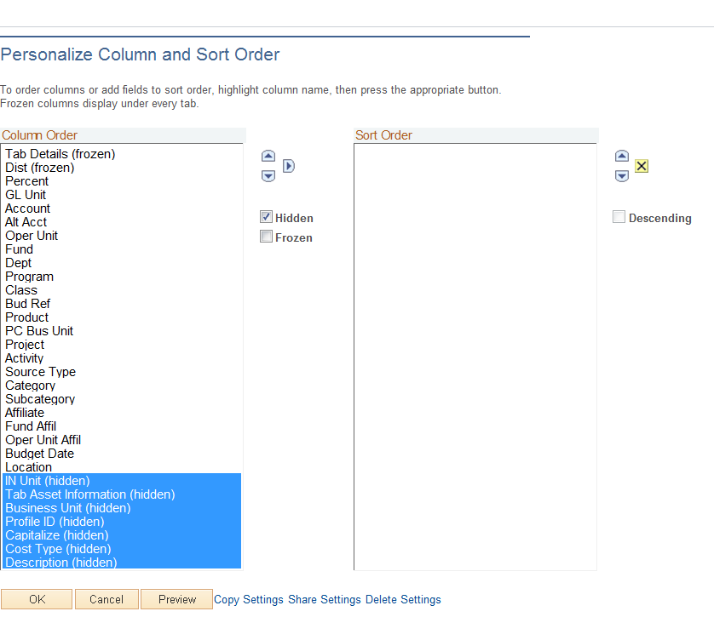

Notice the fields hidden have the word hidden after the field name. To unhide a column, select the field, then deselect the radio box.

Click .

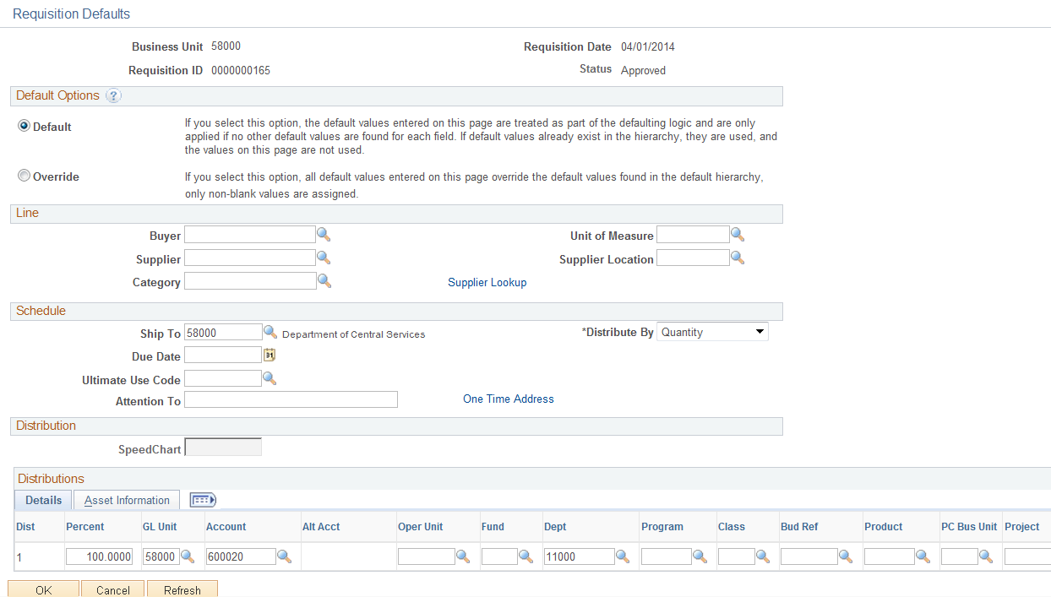
Sole Source and Brand Affidavits

TYPE | Reason for Sole Source/Sole Brand | Affidavit must Clearly:
1 | Only a specified make, mode, or brand will meet  Agency needs even though the makes modes or brands are available from multiple suppliers. A brand name description or other purchase description to specify a particular brand name, product, or feature of a product, peculiar to one manufacturer does not provide for full and open competition regardless of the number of suppliers solicited. This restricts competition in that only suppliers able to provide a specified make, model, or brand are permitted to compete. | State why the specified makes, models or unique services are absolutely essential to the ‘State’ requirements.
2 | Market research clearly shows that there is only one responsible supplier and it can be demonstrated that no other suppliers or services will satisfy agency requirements. | State why the specified makes, models, or unique services are absolutely essential to the State’s requirements, and what market research was accomplished to clearly establish that only one supplier can provide the supplies or services.
3 | Requirement is for additional units or replacement parts of specified makes and modes of technical equipment and only one supplier available | State why the specified makes and models are absolutely essential to the State’s requirements and what market research was accomplished to clearly establish that only one supplier can provide the supplies or services.
4 | Agency needs to purchase suppliers or services from the original supplier in the case of a follow-on contract because award to any other supplier would result in substantial duplication of costs to the State that would not be recovered through competition, or in unacceptable delays in fulfilling agency requirements. | Provide data, estimated cost and how those costs were derived extent of delay and impact of delay, and other rationale as to the extent and nature of the harm to the Government.
5 | Purchase of a brand name commercial item that will be used for authorized resale | No additional information needed
6 | Agency has an unusual and compelling urgency for suppliers or services and the State would be seriously injured unless the agency is permitted to limit the number of suppliers from which it solicits bids/proposals. | Provide data, estimated cost and how those costs were derived and other rational as to the extent and nature of the harm to the Government. Justification may be prepared and approved within a reasonable time after contract award when preparation and approval prior to award would be unreasonably delayed the acquisitions.

TYPE | Reason for Sole Source/Sole Brand | Affidavit must Clearly:
7 | Agency needs to acquire services of an expert, such as expert services to support a current or anticipated litigation or dispute, involving the State in any trial, hearing, or proceeding whether or not the expert is expected to testify. Examples of such services include, but are not limited to assisting the State in the Analysis presentation, or defense of any claim or request for adjustment to contract terms and conditions, whether asserted b y a supplier or the State, which is in litigation or dispute, or is anticipated to result in dispute or litigation. | Indicate why the source for expert services is absolutely essential to the State’s requirements, thereby precluding consideration of other sources.
8 | A statute expressly authorizes or requires that the acquisition be made for a specified supplier for Oklahoma Sate Industries, State Use Committee | Attach a copy of the referenced statue.

Sole Source/Sole Brand Approval Authority

Acquisition $ Amount | $ Within Agency DMPA* | $ Exceed Agency DMPA*
Under $2500 | No affidavit or approval required | No affidavit or approval required
$2500-$10,000 | Agency Chief Administrative Officer | State purchasing Director
$10,000-$25,000 | Agency Chief Administrative Officer | State Purchasing Director
Over $25,000 | Not applicable. Agency DMPA limited to 25,000 | State Purchasing Director

- DMPA: Delegated Monetary Procurement Authority

Depending on an agency’s authority, the Delegated Monetary Procurement Amount may vary. These tables are meant as an example only.

Footnote: Data is from the Procurement Information Memorandum (number 99-3 revised).
Issued 09/30/04.
Purchase Order Type and Origin

The origin is directly associated to the workflow path that a specific Purchase Order requires.

Type of Purchase | PO Type | Origin | Approve Amounts | Issued By
Postage<$25,000 | InterAgy | AGY | CPO | Agency
Postage>$25,000 | InterAgy | EXC | CPO | Agency
Utilities | Exempt CP | EXC | CPO | Agency
Release against a Statewide | Release | EXC | CPO | Agency
Other Govt Agency | InterAgy | EXC | CPO | Agency
Fixed Rate <$25,000 | Fixed Rate | AGY | CPO | Agency
Fixed Rate >$25,000 | Fixed Rate | CP | CP | CP
Professional Svc Title 18<$25,000 | Prof No bid | AGY | CPO | Agency
Professional Svc Title 18 >$25,000 | Prof No bid | CP | CP | CP
One Net | Release | EXC | CPO | Agency
Authority Orders | Auth Ord | EXC | CPO | Agency
Lease Purchase | Lease/Purch | CP | CP | CP
Property Lease | Prop Lease | LSG | St Leasing | St leasing
Construction and Properties<$500 | Title 61 | AGY | CPO | Agency
Construction and Properties>$500 | Title 61 | CAP | CAP | CAP
GSA | GSA | CP | CP | CP
Sole Source/Brand<$25,000 | Open Market | AGY | CPO | Agency
Sole Source/Brand>$25,000 | Open Market | CP | CP | CP
State Use <$25,000 | Open Market | AGY | CPO | Agency
State Use>$25,000 | Open Market | CP | CP | CP
Open Market <$25,000 | Open Market | AGY | CPO | Agency
Open market >$25,000 | Open Market | CP | CP | CP

Depending on the agency’s authority the Delegated Monetary Procurement Amount may vary. These tables are meant as an example only.
Requisition Tables

Item ID

Unit of Measure

Navigation: Items > Define Items and Attributes > Unit of Measure

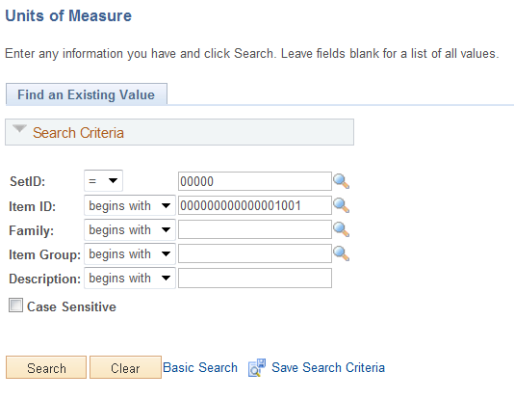

Input the Item ID number and click .

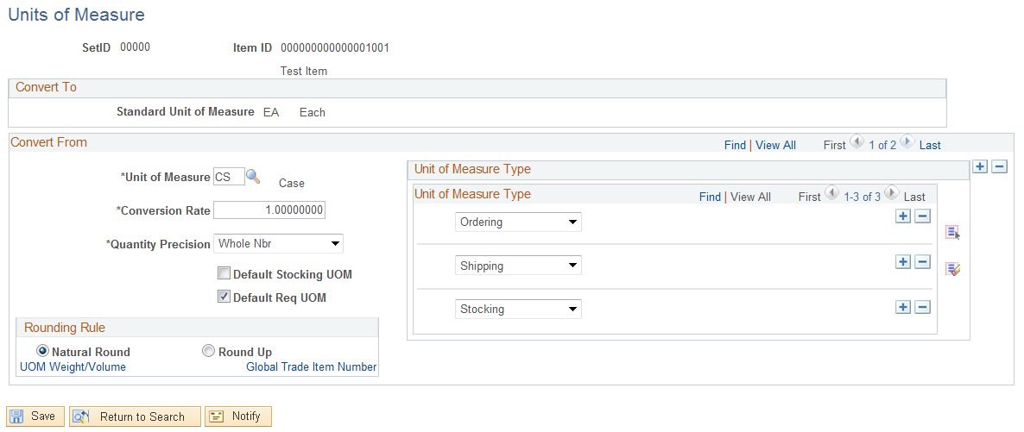

This page will show all the UOM that are available for that Item ID. Click the View All link.

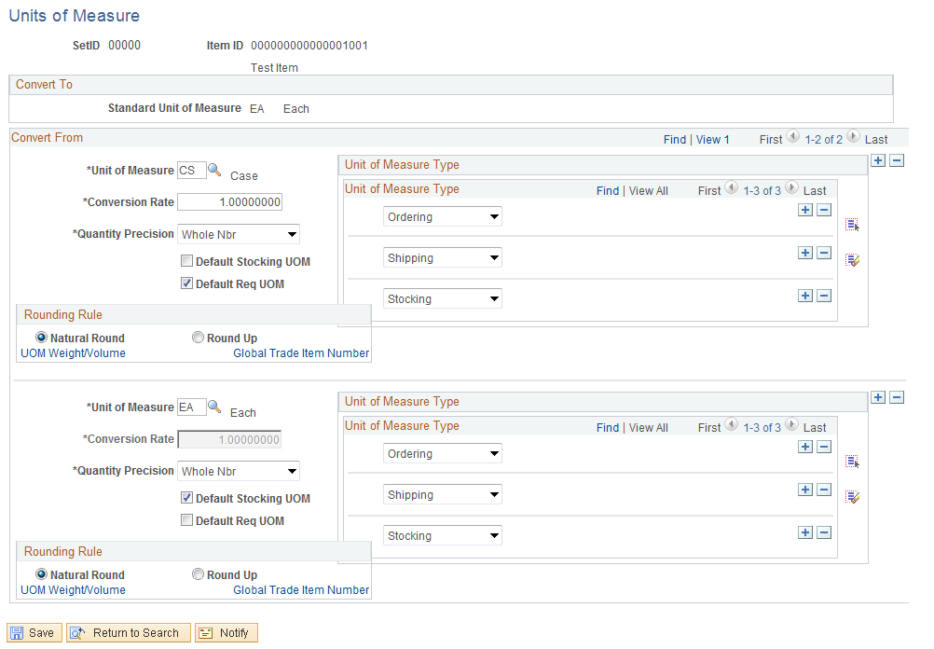

If the UOM is not in this list then review the Item ID’s to determine if there is a different one that should be used, or notify the Department of Central Services a UOM needs to be added.

Item ID (Purchasing Attributes)

Navigation: Items > Define Items and Attributes > Purchasing Attributes

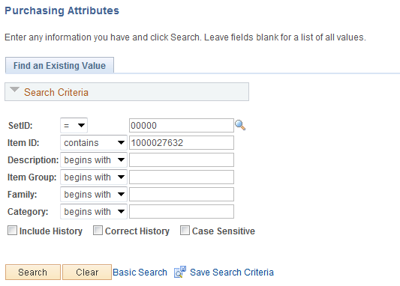

Input the Item ID and click .

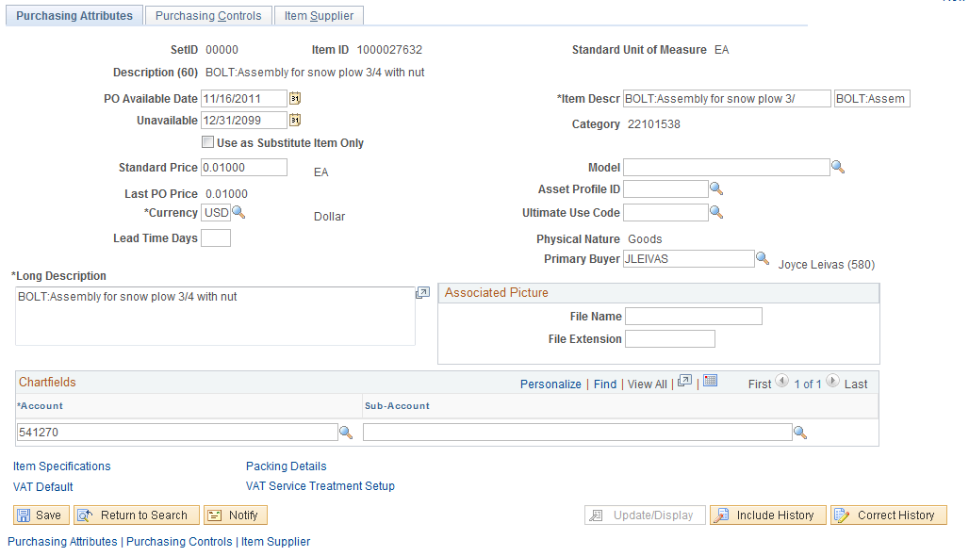

NOTE: Some of the data will default into the Requisition/PO unless there is a Priority Supplier, then that data will default in.

Standard Price

A standard price is required for each item and becomes the default price in transactions where another price, such as a supplier price or a contract price, is not defined for the item.

Click the Purchasing Controls Tab.

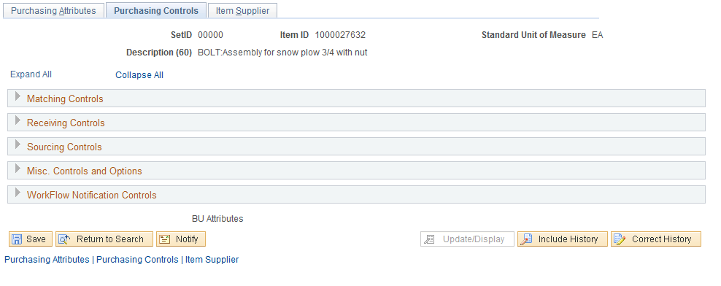

To review a section, click the arrow on the line. Click the Matching Control Section

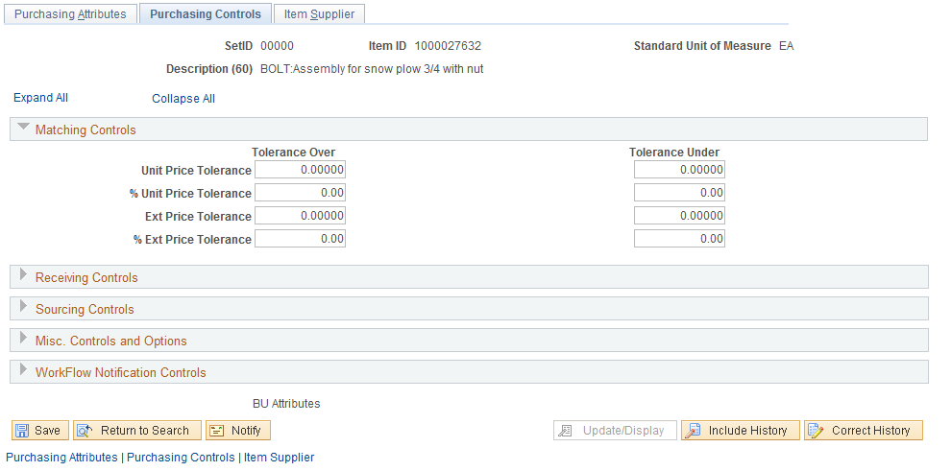

This data will default into the PO Schedule line and can be overwritten. To collapse the section, click the dropdown on the line.

Click the Receiving Control section.

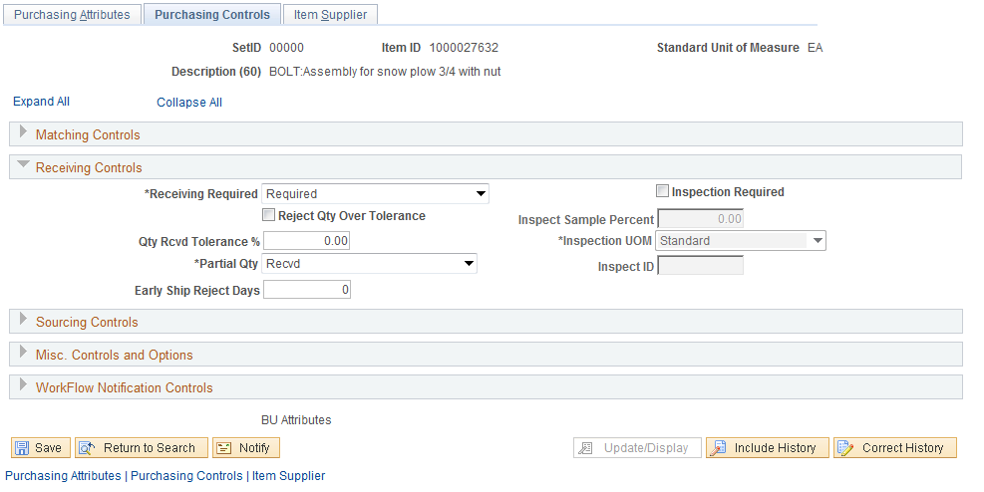

Receiving Required will default into the PO Line and will need to be overwritten if receiving is not being utilized by selecting Do not Receive or Receive Optional.

Click the Sourcing Controls section.

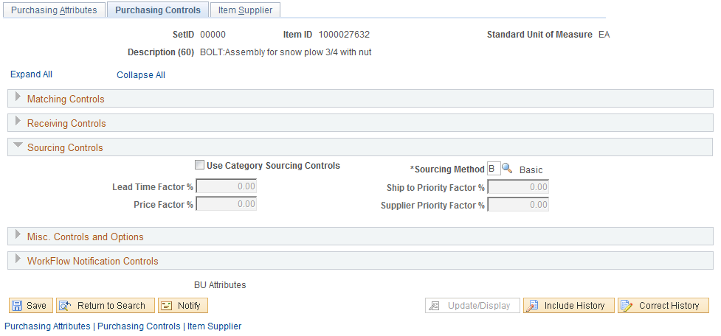

Click the Misc. Controls and Options section.

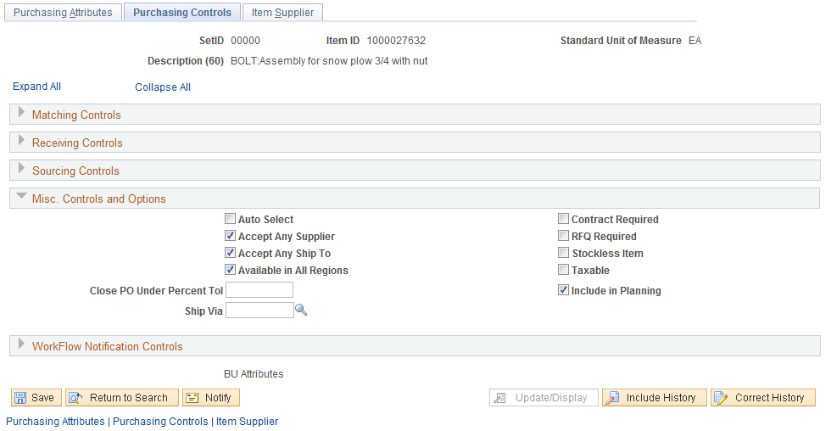
Click the Workflow Notification Controls Section

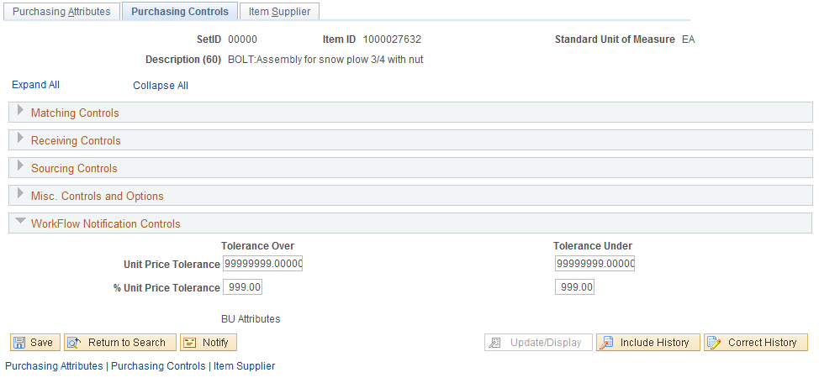

Click the Item Supplier Tab.

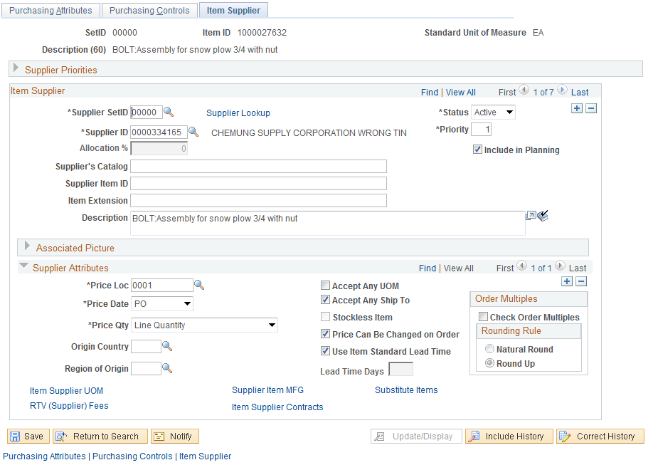

To review all suppliers associated with this Item ID click the View All link.

Supplier data takes priority over the Item ID data. The suppliers Price Location will contain the supplier’s most recent contract price. Click the Item Supplier UOM link.

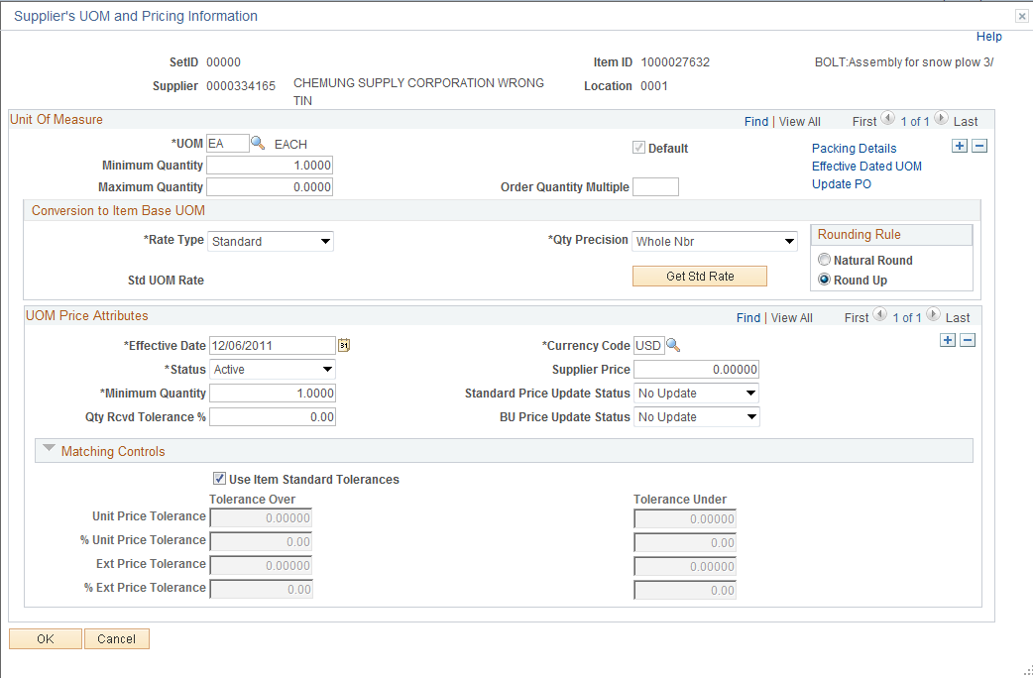

This priority supplier’s data takes priority over the Item Id’s data.

Click .

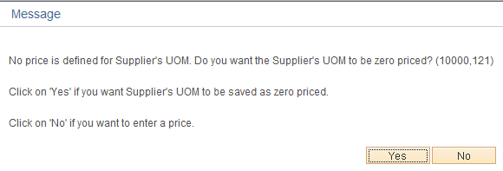

Click .

The supplier with the highest priority will default into the Requisition/PO Header Line.

From the Requisition Form Page, review the Item ID Priority Supplier

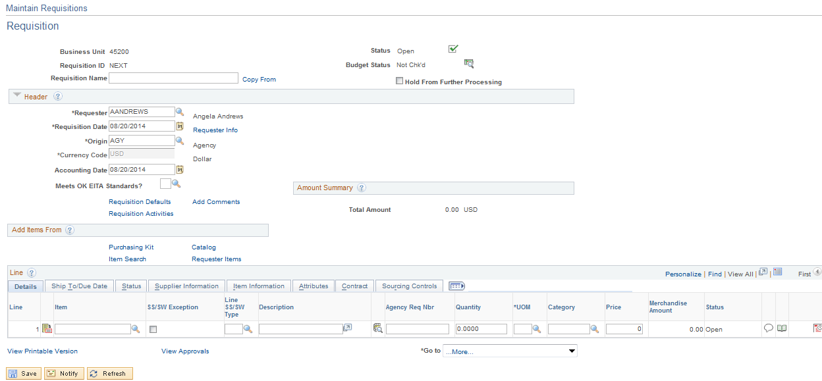

Click the Item Search link.

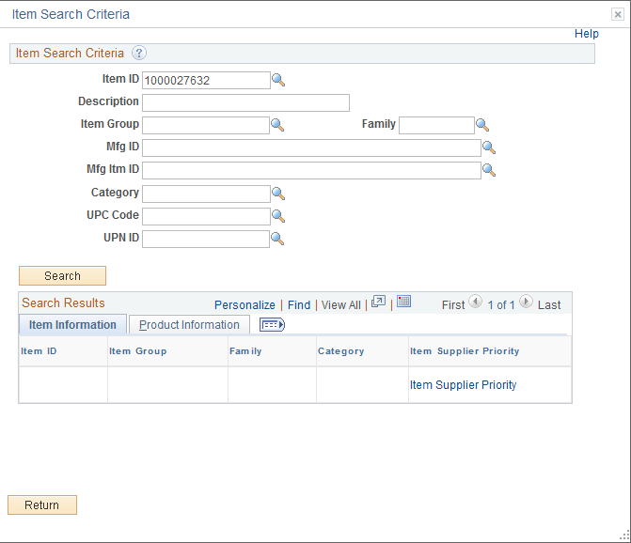

Input the Item ID and click .

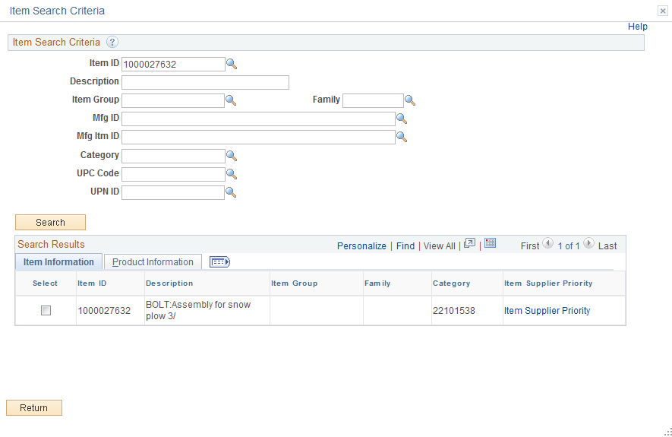

Review more data by clicking the icon. Click the Item Supplier Priority link.

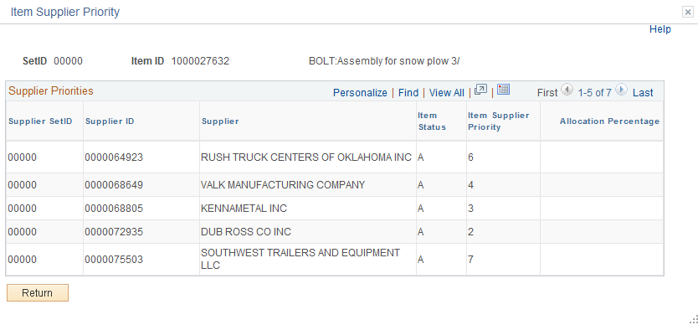

Click .

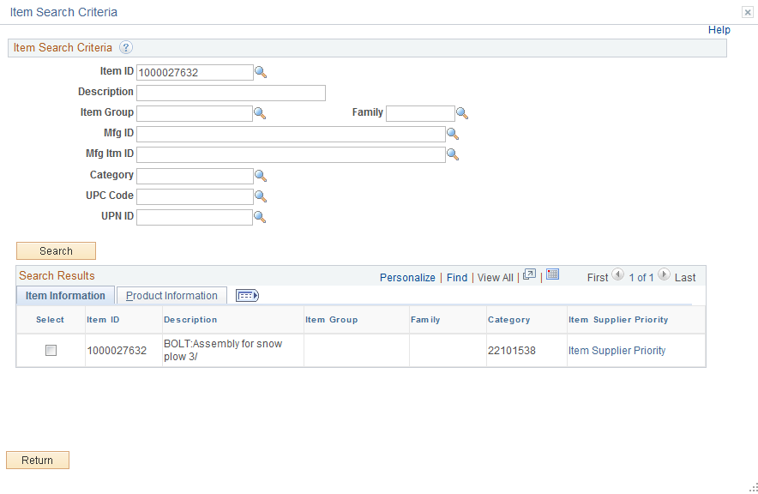

Click .
Identify Budget Checking Error

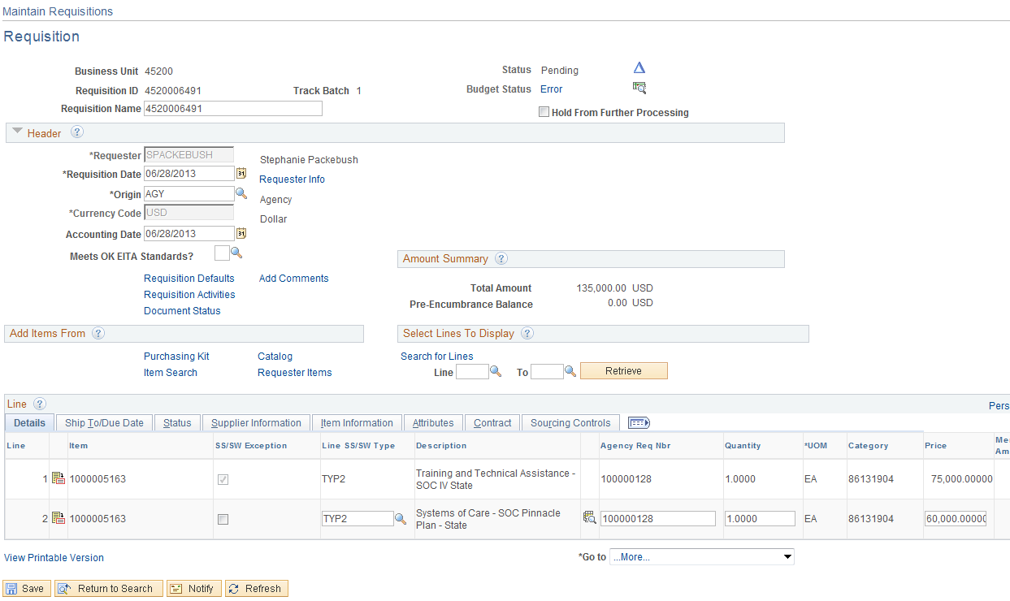

From the Requisition From page click the Error link.

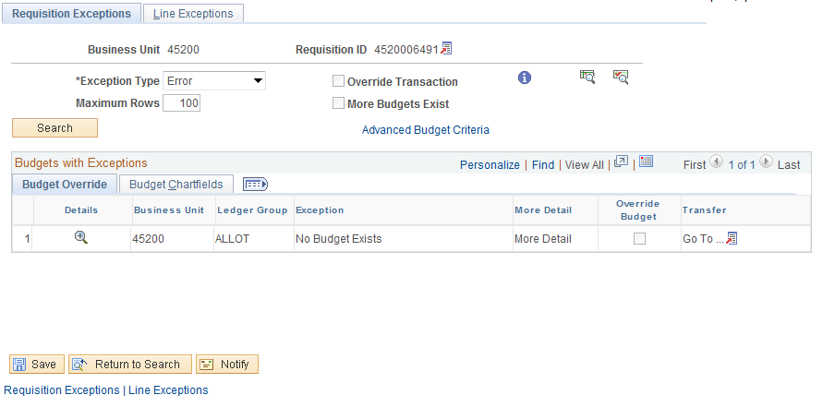

A new window is opened containing the Exception Detail. To review the budget, click the View Related Link Icon .

Review the Requisition Chartfields by clicking the Budget Chartfields Tab.

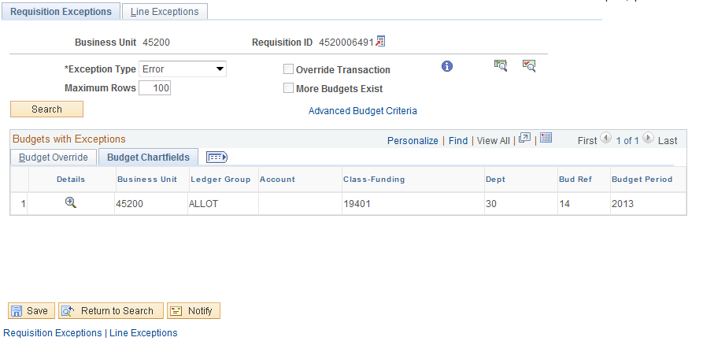

Click the Tab to review the Line, Schedule, and Distribution line containing the error message.

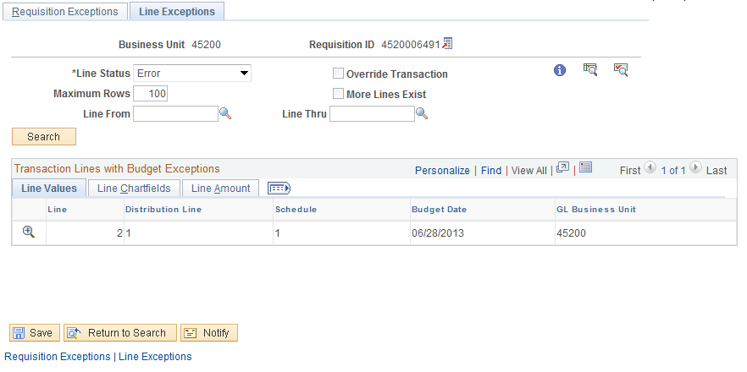

This is a new window, to close it click the X in the upper right hand corner.

Requisition Correction Process

Correcting Requisition Budget Errors through Requisition Defaults

When you use the Requisition Defaults hyperlink to create the Requisition Distribution Line(s) you will need to correct the Requisition Line(s) through the Requisition Defaults hyperlink. PeopleSoft will use these defaults when processing Change Orders and other types of changes so if the incorrect data is in the Default the correct data will be overwritten.

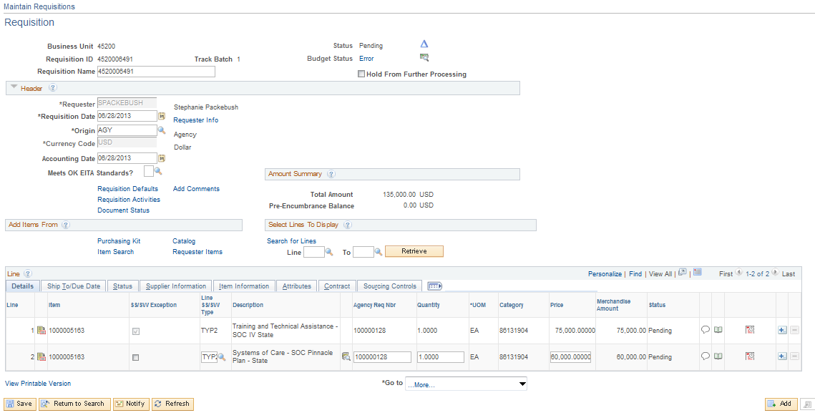

Click the Requisition Defaults hyperlink.

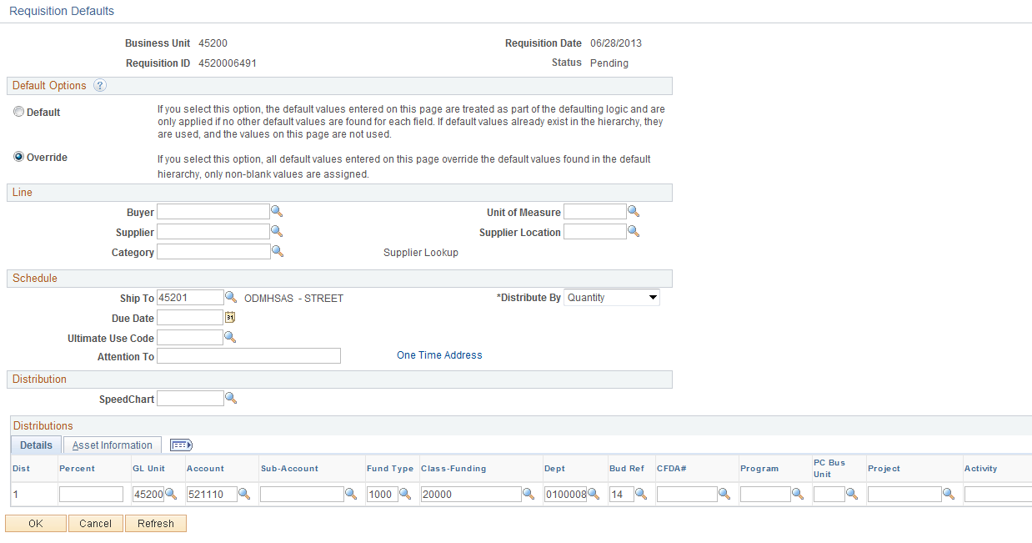

Fix the chartfield stream by correcting or entering values. Click .

Click .

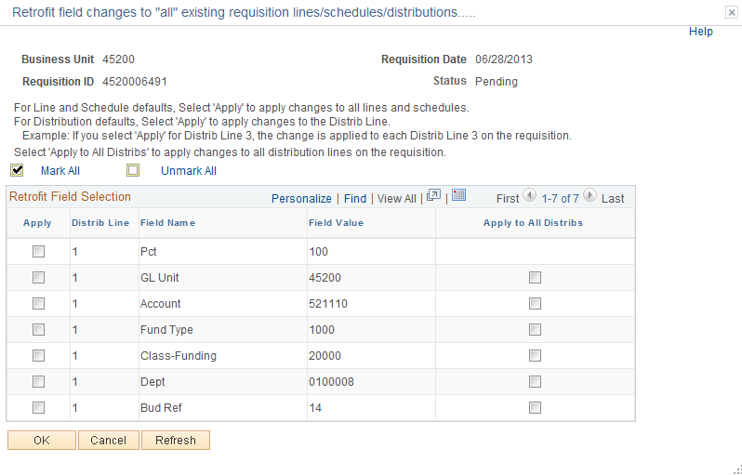
This page is asking which Requisition Distribution lines you want to apply the changes to. Since all the lines are incorrect I will click Apply to All Distribs link by clicking the Radio located on the right.

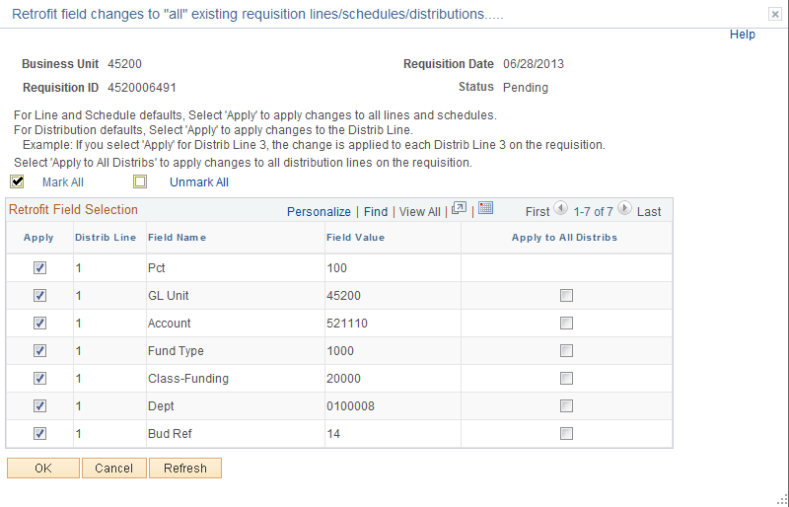

Click .

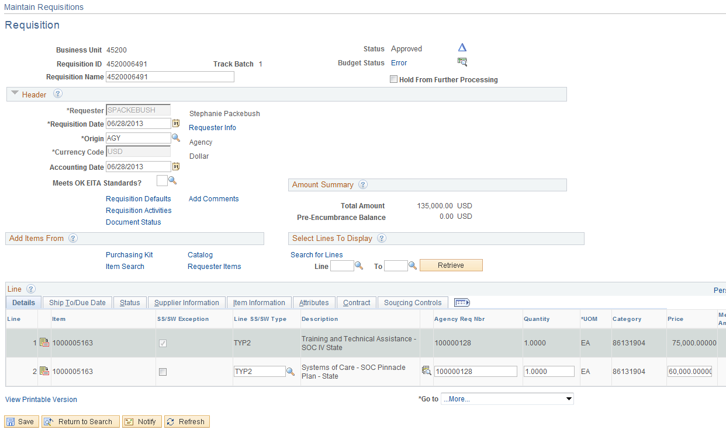

Click .

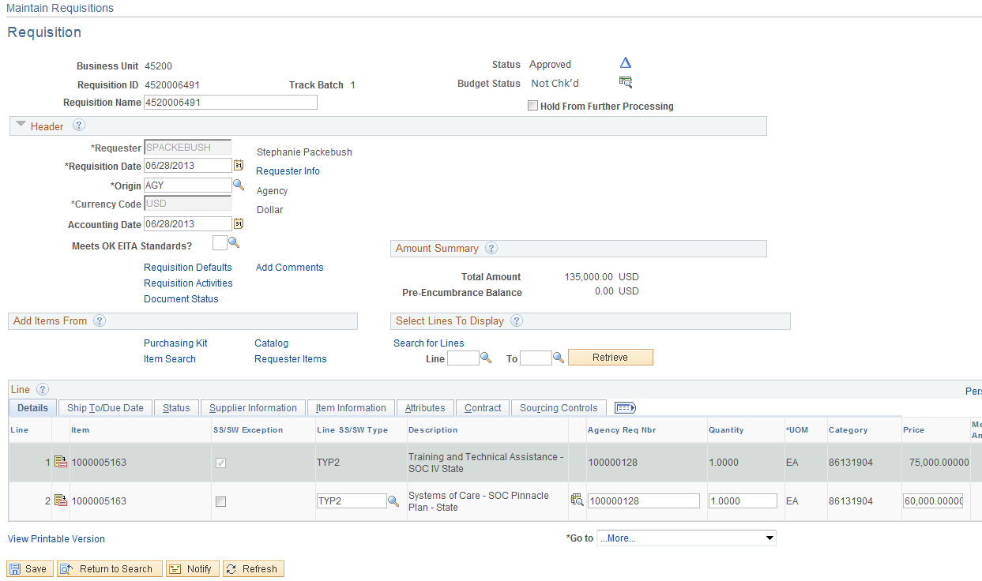
Notice the Requisition is in a Not Checked status. Click the Budget Check Icon.
Error Messages

There are several types of messages: Warning, Error, and Informational. An Error message is the only message that will stop you from saving the document if the issue is not fixed. Informational message will require you to make a decision; normally these are Yes or No answers. Warning are just that WARNINGS, normally you will either select OK or Cancel.

Invalid UOM

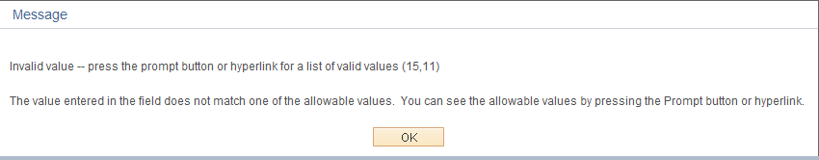

This means the Unit of Measure selected is not in the Unit of Measure table for the Item ID. If it is a valid UOM for this Item ID then the Department of Central Services will need to add it or you may need to select a different Item ID. The Req/PO cannot be saved.

Invalid Chartfield

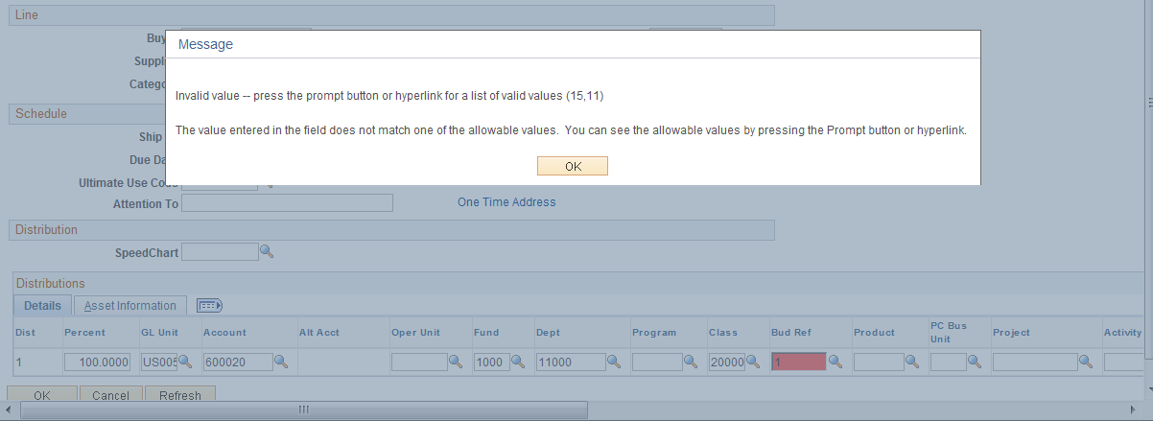

This message means the Chartfield value that was input is incorrect. The REQ/PO cannot be saved.

Default Buyer Not Found

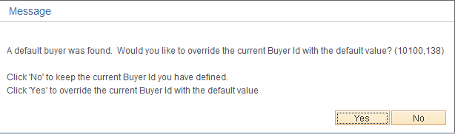

The Message“ A default buyer was found” is due to changing the default buyer in the Line Detail page. If you want to use the default supplier from the Item ID then click . If you want to use the buyer you have selected then click . You do not receive this message if you populate the Buyer in the Header Default page first.

Priority Supplier for Item Does Not Match Default Supplier

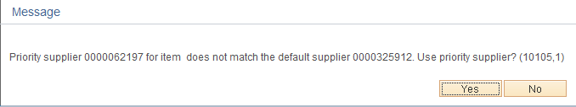

This message is stating that this Item ID has a priority supplier that is different then the supplier you inputted in the Header Default. Do you want to use your supplier or the priority supplier? To use your supplier click . To use the Item ID priority supplier click .

Contract Selected Out of Contract Data Range

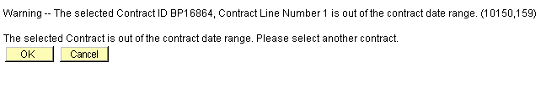

This message is received when a Statewide contract is being copied into a Requisition or PO that has expired or has not begun.

Contract Below Minimum Quantity or Exceeds Maximum Quantity

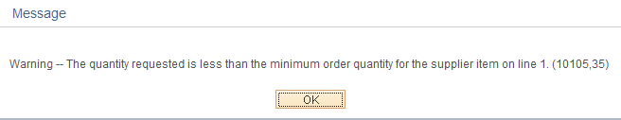

Receive this message when a quantity enter on the Form page does not meet the minimum quantity on the Statewide Contract. To prevent this enter the QYT on the PO Form page first.

Custom Price Override

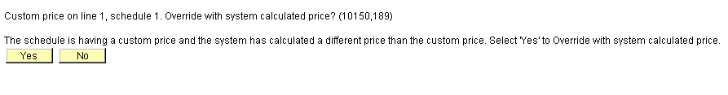

The price inputted is the Custom Price (your price). The system calculates a custom price (standard) based upon Item ID, Priority Suppliers, or Contracts.

Click to use your price.

Multiple Distribution in the Default Header

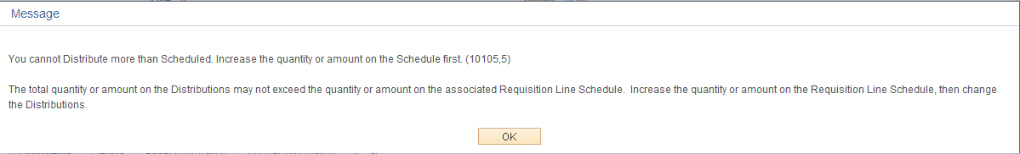

If you have multiple distributions in the Default Header and you use the amount only field you receive a message when adding the next schedule and click .

UOM Error Message

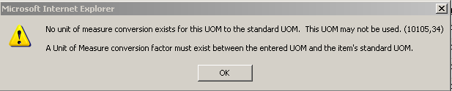

The problem is the Requisition copied contains an Item ID “CPY” which is not in the UOM table. Upon changing the quantity a message was received "No unit of measure conversion exists for this UOM to the standard UOM. This UOM cannot be used." It does allow the user to save it but the data will not update correctly. Tested this in QA by adding the UOM and it copied in correctly. If this is not attached to a contract, change the Item ID to a different one or have the Department of Central Services add the Item ID.

Item ID Message

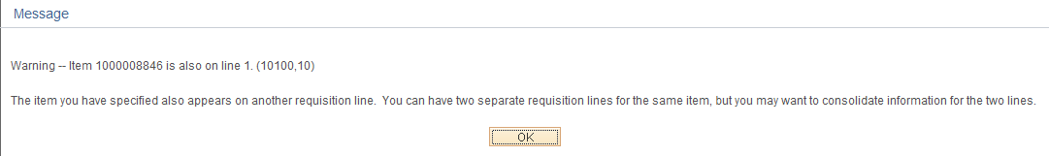

This message is received when you add a second Line Item and use the same Item ID. Click and either accept the duplicate Item ID or combine the two lines into one.
Asset

- Once an Agency is live on the Asset Module, the Asset BU and Profile ID will default from the Item ID to the Requisition if it meets the following Criteria;
  - IT Asset-Account Codes 541120,541130,541140,or 541230 and the unit price is greater then or equal to 500.00
  - Non IT Assets-Account Codes 541110,541150-541220,541240-542120,544120,545100-545110, or 546110 and the unit price is greater then or equal to 2,500.00
  - If your agency tracks assets under these thresholds it will be the responsibility of the agency to input the AM Business Unit and Asset Profile on the Requisition
- By populating the Asset Information on the Requisition, upon creating the PO, the Asset data will default to the PO.
- If one of the listed accounts are not used, but an AM BU and Profile is used an error message will be received. (Not a valid Asset Accounτ)
- Profile ID- Asset Profile- The Asset profile is the gateway to Asset Management and is a template containing default values for an asset type. Default values include asset category, life (designated by the number in the profile ID), acquisition code, and asset type." Will Default if;
- Cost Type-The Cost Type of "C" designates a CAFR asset and will default to “C” upon saving the Requisition if the Item is 25,000.00 or greater. If the item cost is less than $25,000, then the Cost Type field will be blank.
- The Capitalize box has been removed from the Requisition and PO. The Asset will not be capitalized from the PO, but from the voucher.

NOTE: An average cost is used to determine if an Asset Profile is on the Item ID, if you find an Item should contain an Asset Profile please file an Asset Helpdesk case. If you cannot find an Asset Item and need one added please file an Asset Helpdesk case (one time purchases will not needed an Item ID).

