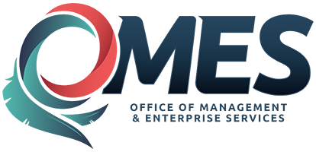 | Learn User Navigation Quick Bit

This quick bit provides quick instruction on accessing the HCM Learn Center and a description of the learner expanded menu. Navigate to State of Oklahoma Learn Center using the link below:
Learn Center Login

User Login
Enter your user name and password. (User name will be your employee ID and a temporary assigned password.) Select Enter.
Note: If this is your first time logging on, you will be required to provide three security questions and change your password. You are now in the State of Oklahoma Learn Center. To view or enroll in HCM courses, you will do that from this page.
To view or enroll in your agency specific courses, select your agency name in Choose Your Learn Center (refer to your agency for more information).

Learner Tab Navigation
On the left side are the navigation tabs. Select the expansion arrow (next to the word Learner) to view all the learner options. Under each area, you have more icons that you can choose to filter the information.
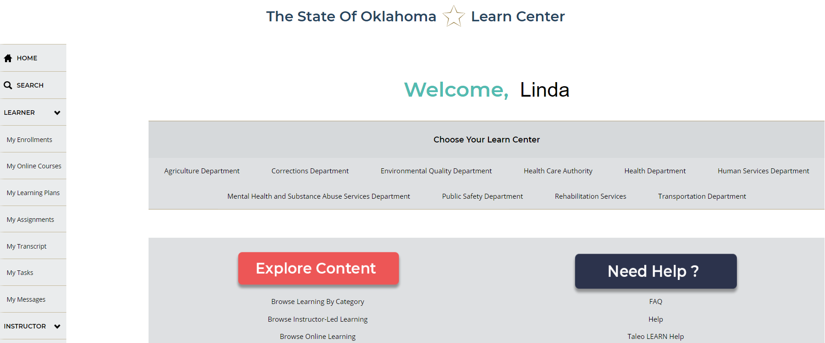

My Enrollments
Here you can view your current or past due instructor-led enrollments. You can change from list view to card view on the right side of the screen. You can select the title of any enrollment to get further details.
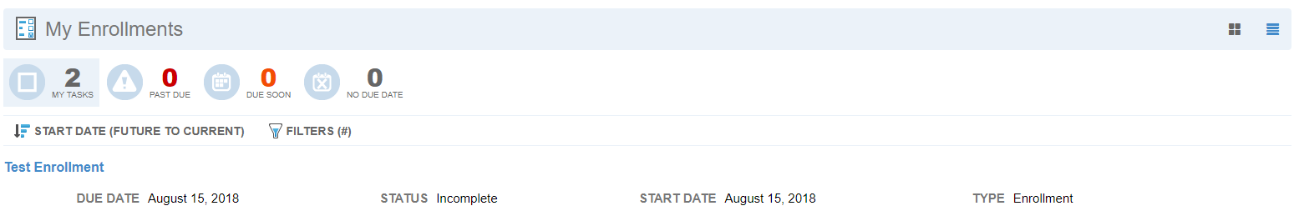

My Online Courses
Here you can see any web-based training in which you are enrolled. Web-based online courses are available anytime through the internet.

My Learning Plans
Here you find a series of assigned class(es) or course(s) that must be completed during a certain period of time, or in a certain order. They are generally assigned by the group you are part of (such as new hire/onboard training) or by a supervisor for prescribed learning. Each learner will still have to enroll in trainings to fit the learning plan.

My Assignments
Here you find any learning task or project assigned to you for completion. Examples of assignments include a test, study material, course or additional training. To view/complete the item, choose the assignment title. The icons below the page title indicate whether the assignment is new, due soon or past due.

My Transcript
Here you can view all completed training. You can select the enrollment title to view more details or to upload files such as certificates of completion. You can also export your transcript by choosing the EXPORT button on the right side of the screen. These files can be exported in a selection of formats or downloaded to your computer.
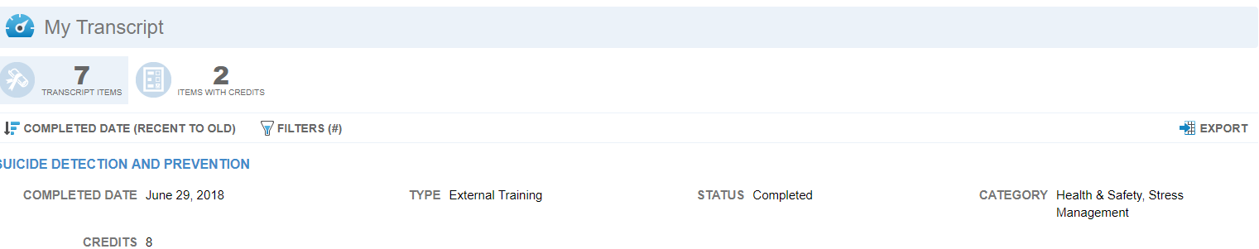

My Tasks
Here you will find all the enrollments, courses and assignments you need to complete. Additionally, you can also add external training here. (See Common Learner Tasks)

My Messages
Here you will find messages regarding your LEARN training. Messages might be notices of completion or approval of training.
To return to the Home Page, select the Home tab on the left tab list. This completes the Learner Login and Tab Navigation.

Related Topics:
Explore Learn Center Navigation
Common Learner Tasks

