Due to a change in the instructions from the Internal Revenue Service on the 2009 Form W-4 which states that on regular wages, withholding must be based on allowances claimed and may not be a flat amount or percentage of wages, Oracle has modified the text on the Employee Tax Data for the Federal Tax Data page. Effective July 20, 2009 on the Federal Tax Data page under the Special Tax Withholding Status, the third radio button for Maintain Taxable Gross (used for exempt status) will have the “FWT zero unless specified in ‘Additional Withholding’ below” language removed. Also to comply with this IRS requirement the employees may not request that their U.S. federal withholding tax be either a flat amount or a percentage of wages, the new warning message shown below is generated on the Federal Tax Data page if the user attempts to save the page when Special Withholding Tax Status = “Maintain Taxable Gross” and a value greater than zero is entered in either the Amount or Percentage fields under FWT Additional Amount.

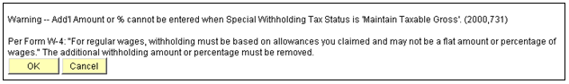

If you have any employees that claim a flat amount or percentage, you must have the employee complete a new 2009 W-4 in order to be in compliance with the IRS. Payroll users may run the query GO_PY_FED_STATE_TAX_WH to verify if any employees are in this category.

****

Also recently, Timekeepers and Time Administrators were given access to the FMLA accumulator. The navigation for this accumulator is Manager Self Service > Time Management > View Time > Accumulators. This accumulator gives a total of the number of FMLA hours that have been posted on the Timesheet and Time Administration has been processed. The instructions for this feature are included in the COR106 Time and Labor Training Manual (page 117) located on the CORE website.

****

In addition, Oracle has completed modifications to support the $5,000 annual limit on U.S. Savings Bond purchases imposed by the U.S. Department of the Treasury. The annual limitation on U.S. Savings Bond purchases is set at $5,000 per Social Security Number, and applies separately to Series EE and Series I savings bonds. This modification will suspend bond purchases for a Bond ID/Owner combination that has reached the annual $5,000 purchase limit (or for a Bond ID/Owner combination that would exceed the limit if an additional bond were purchased), and will automatically refund to the employee any undisbursed funds associated with suspended bond purchases. This will need to be monitored closely on employees that are close to the limit since the full amount of the withholding will show on the Deductions Register which could accidently be processed on the AP voucher when it should not be. The overage of the withholding should remain in the 994 account to await the automatic refund that will be processed through payroll. The automatic refund is triggered when the necessary action to stop future bond deductions is done either by deleting the U.S. Savings Bond Specification record associated with the suspended bond purchase (for employees with multiple bond purchases) or by ending the General Deduction for bond purchases (for employees with only a single bond purchase). This action may generate the following message:

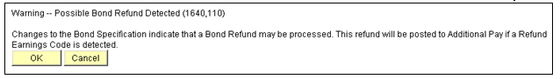

The automatic refund functionality will insert a row in Additional Pay with the earnings code BON along with the proper amount of the refund which will process on the next on-cycle payroll.

If there are any questions regarding these matters, please contact the Help Desk 405 521-2444 or 866 521-2444.

