Supervisor Navigation Quick Bit

This quick bit provides detailed instruction on supervisor navigation of the Team Monitor page, viewing/exporting subordinate transcripts and training approvals/disapprovals.
Learn Center Login

User Login
Enter your user name and password. (User name will be your employee ID and a temporary assigned password.) Select Enter.
Note: If this is your first time logging on, you will be required to provide three security questions and change your password. You are now in the State of Oklahoma Learn Center. To view or enroll in HCM courses, you will do that from this page.
Note: With the exception of the agencies under Choose Your Learn Center, all state training opportunities will be housed in the HCM Learn Center.
Those agencies listed below will be able to enroll in agency-specific training by selecting their agency link. Refer to your agency learning administrators for information regarding agency-specific training.

Supervisor Navigation
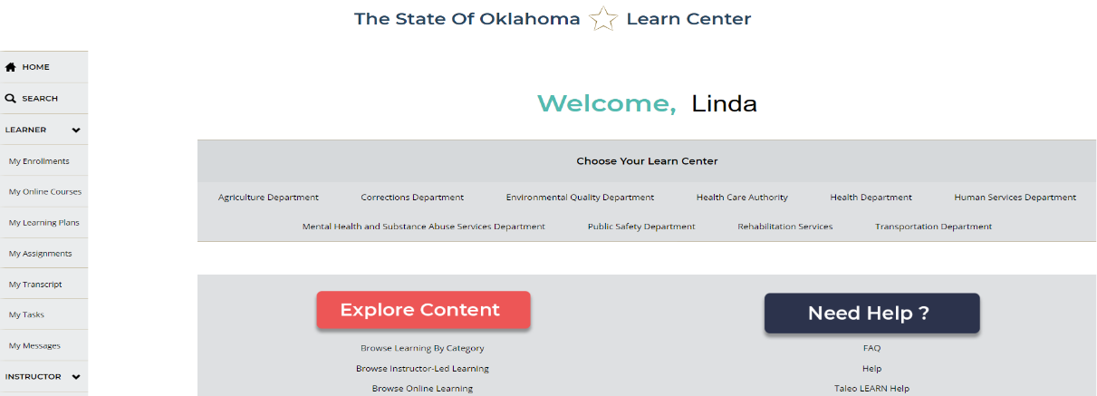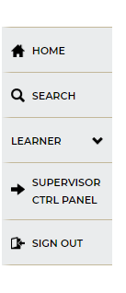
On the left side navigation tabs, select SUPERVISOR CTRL PANEL to navigate to the supervisor page.

Team Monitor
Supervisor page opens to display the Team Monitor page. From here, you can view your subordinates and the status of their training. As a supervisor, you can monitor completions, approve training requests, view transcripts and create reports.
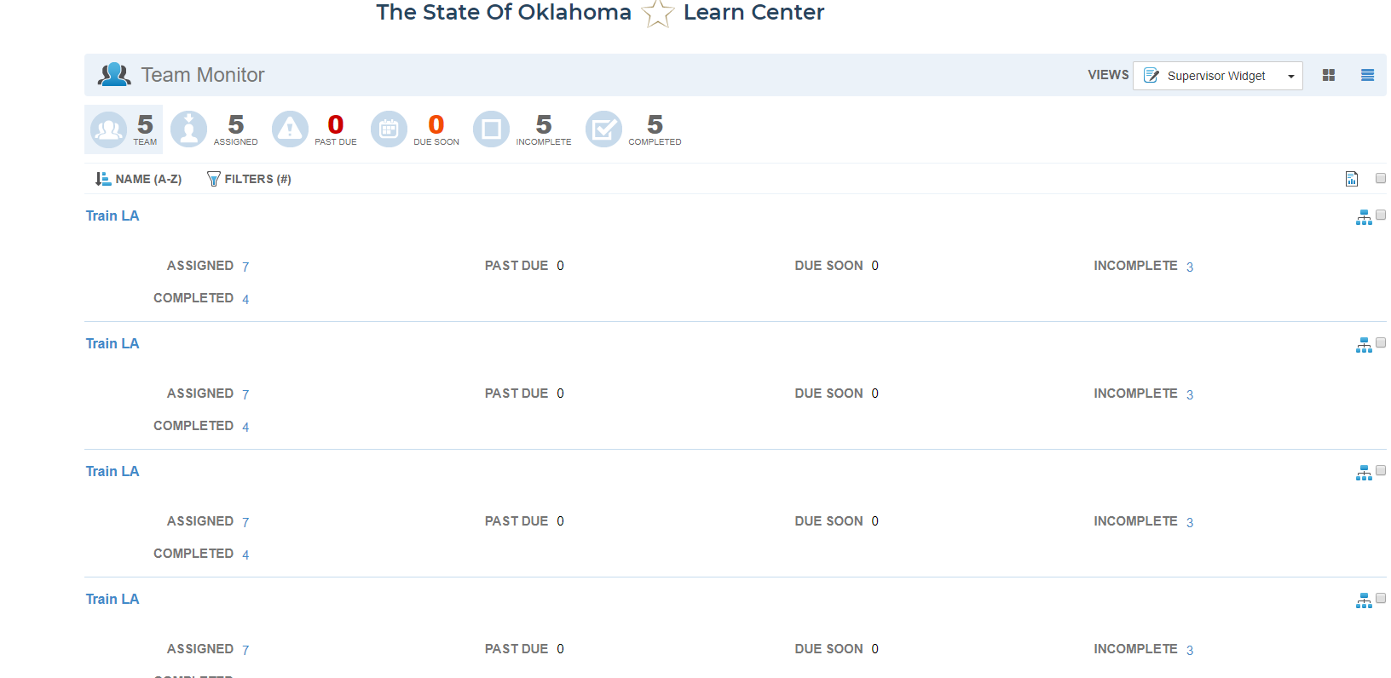

Team Icons
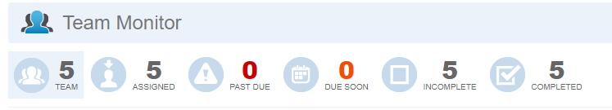
Directly below the name Team Monitor are icons that serve as filters. By selecting the icons, supervisors are able to filter by category for team members, those assigned training, past due, due soon, incomplete and completed training by team members.

My Team
On the Team Monitor page, you can change the view of your subordinates from List to Card view. This is a personal preference, with the same information available in either view. For the purpose of this instruction, card view will be used.
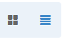
Note: The image below shows the same names seen in card view.
Subordinates are listed in alphabetic order, last name first. You can filter by clicking on the NAME or FILTERS links.
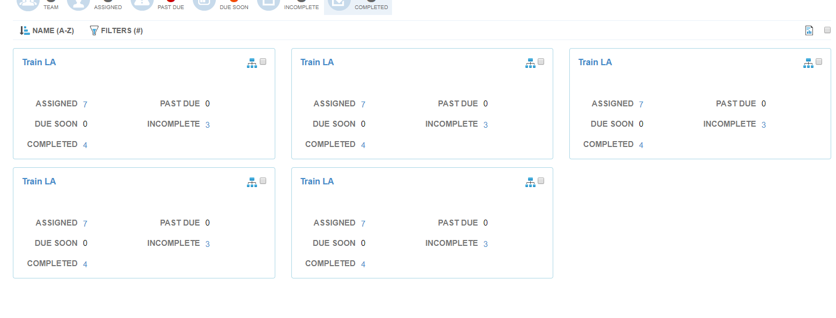

Under the NAME filter, you have several options. Remember, names are Last Name, First order.
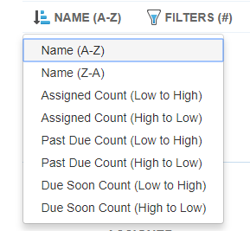
If you use the FILTER option, you can filter to a specific name.
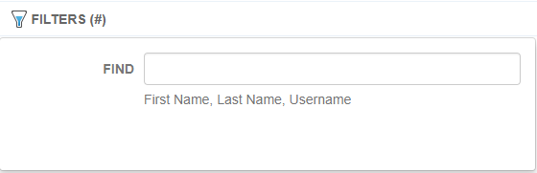

View Subordinate Details
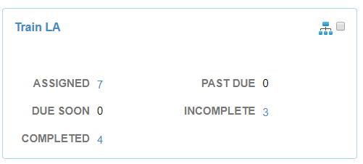
Each subordinate record can be drilled down to more specific information. For example, you can click on the number next to ASSIGNED to view specifics about assigned training.
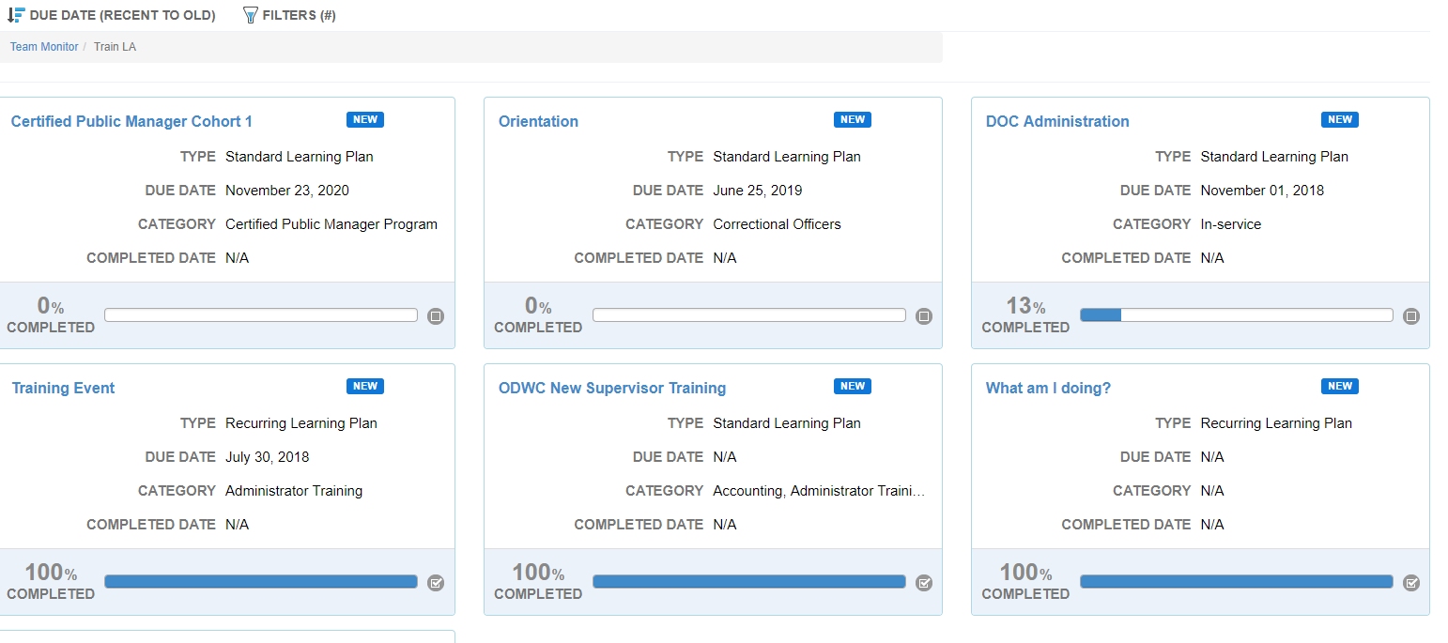
You can also view completed, past due and incomplete training.
Note: When you are done viewing a record, use the Team Monitor link to return to the main Team Monitor page or select the Back button in the upper right corner of the screen.
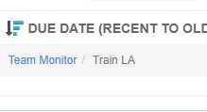
From the main Team Monitor page, you can view indirect subordinates and their training by selecting the hierarchy icon in the upper right corner of the subordinate record.
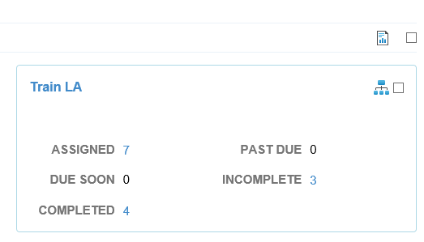

Note: Directly above the hierarchy icon is the management reports icon. (See Supervisor Reporting Quick Bit for more information)

Supervisor Tasks

How do I email my subordinates in the system?
If you need to email members of your team, you can select the check box next to Manage Reports to send an email to all or select subordinates. The email will not include a transcript.
Note: You can individually select recipients by selecting the check box next to each subordinate’s name before selecting the email option.
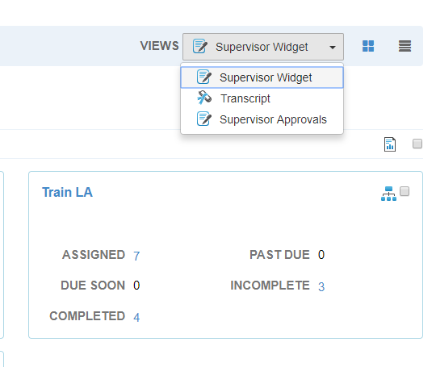

When you choose the check box, an email icon will appear. Select the email icon to open the email message window.
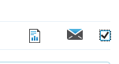
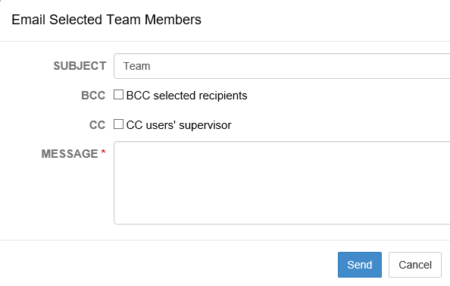
Complete your email options and click send. Message will go to the recipients using the email account associated with the employee in PeopleSoft.

How do I view a subordinate transcript?
From the Supervisor View drop-down menu, choose Transcript. Each subordinate record will appear with new options. You can view transcript items, credits, or items with credits. You can also view indirect subordinate transcripts as well.
When you click on a subordinate TRANSCRIPT ITEMS, the transcript will appear.
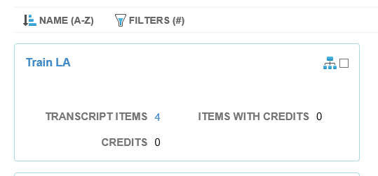
A supervisor can use the filters to view different parts of the transcript, or they can view details of an individual transcript item by selecting the title of training.
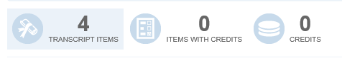
The transcript can be exported as a .pdf, .pdf with credits, or as an Excel file. A supervisor can also choose to download the files.
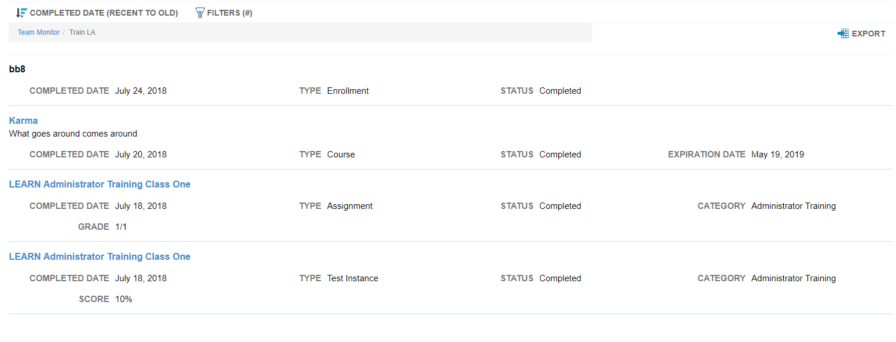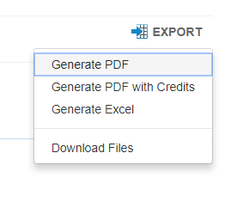

How do I approve training?
Note: All HCM training requires supervisor permission. (See your agency for your agency processes regarding subordinate enrollment).
When a subordinate signs up for a class that requires supervisor approval, a supervisor will get an email and a system message. Follow the prompts to approve training. Supervisors can also view pending approvals by selecting Supervisor Approvals from the view menu in the upper right of the screen.
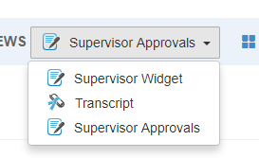
By selecting the icon ALL PENDING, you can filter down to the subordinate records that need approval. Click on the number next to ALL PENDING in the subordinate record.
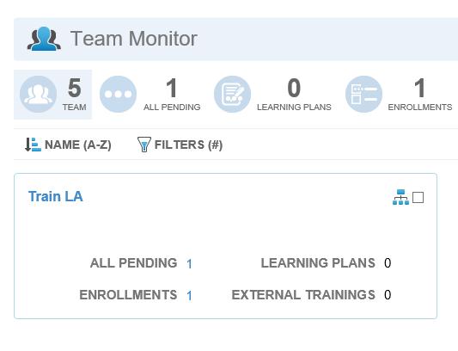

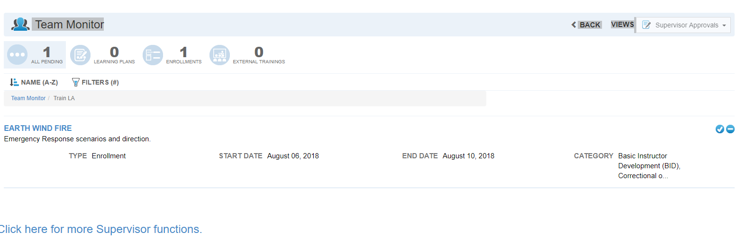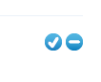
You can choose the title of the training to view more details, or select the checkmark icon or the minus icon to approve or disapprove the training.
If you choose to approve the training, you will be prompted to verify the approval. Choose yes or no to confirm. The employee will receive notification of approval by email and through the system messaging.
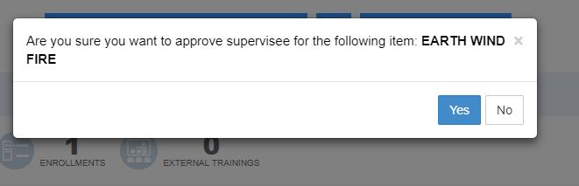
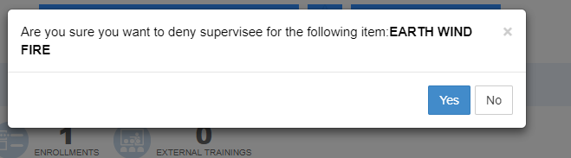
If you disapprove, you will also receive a prompt to confirm. Choose yes or no to confirm. The employee will receive notification of denial through email and system messaging.
Once you are finished, you can select the Back button or use the Supervisor View button and select Supervisor Widget to return to Team Monitor home page.

Related Topics:
Supervisor Reporting Quick Bit
More Supervisor Functions Bit

