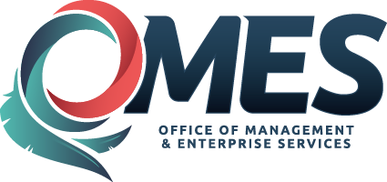

State of Oklahoma
Office of Management and Enterprise Services
Purchasing Division

PROCUREMENT INFORMATION MEMORANDUM

Affected Entities/Personnel:  Executive State Agencies | Subject:  Online Purchasing – Amazon Business Accounts
Effective Date of PIM: 01/05/2018 | Point of Contact: PIM@omes.ok.gov
Prior PIM: N/A | Statutory and Rule Reference:  74 O.S. § 85.5(A) and OAC 260:115-1-4
 | Replaces: N/A
Approved:  Ferris Barger, State Purchasing Director | Approval Date: 01/05/2018

As a means of disseminating relevant state procurement information to state entities, the Office of Management and Enterprise Services, Purchasing Division periodically issues Procurement Information Memoranda. To the extent any information in this Procurement Information Memorandum (“PIM”) conflicts with information in a previously issued memorandum, the information in this PIM controls.

Summary

Pursuant to 74 O.S. § 85.5(A) and OAC 260:115-1-4, the State Purchasing Director has sole and exclusive authority and responsibility for all acquisitions used and consumed by state agencies. Acting under this authority granted to him by the Oklahoma Statute and Oklahoma Administrative Rule, the State Purchasing Director has determined that utilization of Amazon Business accounts are authorized subject to the Central Purchasing Act and Central Purchasing Rules.

- Practitioner Comments
  - Utilization of Amazon Business Accounts are subject to the rules promulgated under OAC 260:115 and Purchase Card (Pcard) Procedures. For the purposes of this PIM only, Purchaser is defined as the Certified Procurement Officer or Pcard holder transacting business with the online retailer, Amazon.
  - It is the sole responsibility of the Purchaser to ensure compliance with the Central Purchasing Act and Rules.
  - Specifically, Amazon purchases do not supersede Mandatory Statewide Contracts. The Purchaser should first determine if the item is available from a SW contract. If the item is on a Mandatory SW contract, the SW contract shall be utilized except when there is a cost savings to the State. CP Form 109 should be completed and submitted to document the savings and transaction.
  - Utilization of on-line retail accounts have potential to create split purchasing issues. It is highly encouraged that the Purchaser determine if same or similar goods have been purchased by the entity and is under the fair and reasonable threshold.
  - Additionally, it is the Purchaser’s responsibility to ensure compliance with State Use, 74 O.S. § 3001 et seq., and Oklahoma Correctional Industries. 57 O.S. § 549.1. IT goods shall be subject to Title 62 requirements.
  - Subject to change, the additional approver functionality within the Amazon Business account is reserved for Central Purchasing. Entities may utilize the functionality internally and yield access upon request by the State Purchasing Director should it be determined the functionality needs to reside with Central Purchasing.
  - Upon request, entities shall provide a list of all account holders.
  - Use of Amazon Business Accounts will be subject to monitoring and audit by OMES.

