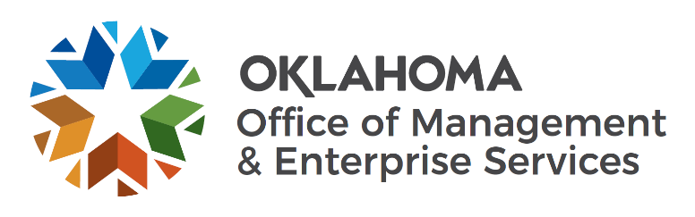
State of Oklahoma
Office of Management and Enterprise Services
Policies and Procedures

Open Records
Effective Date of Policy: 04/01/2019 | Next Scheduled Review: 04/18/2020
Effective Date of Original Policy: 02/13/2013 | Policy Number: OMES-011
Last Reviewed: 02/25/2019 | Replaces Policy Number: Not Numbered
Date Policy Last Revised: 06/06/2018
Approved: Dana Webb, as Designee of OMES Director John Budd | Approval Date: 02/25/2019

Policy
It is the policy of the Office of Management and Enterprise Services (OMES) and its divisions to fully comply with all facets of the State’s Open Records Act found at 51 O.S. §§24A.1-24A.29.

Implementation
The OMES Director of Public Affairs shall handle all news media inquiries and related Open Records requests for all divisions of the agency. Administrators and employees shall expeditiously forward all such requests to that official. When possible, records provided in response to news media inquiries should be delivered electronically by the Director of Public Affairs. Non-media Open Records requests will be handled by division administrators and/or their designees, working with legal counsel. The Director of Public Affairs shall be notified when a non-media Open Records request is filed and when it is fulfilled. The Director of Public Affairs shall keep the Director of OMES informed of pertinent Open Records requests. OMES Legal and the Director of Public Affairs shall be consulted if it is anticipated an Open Records request will clearly cause disruption of essential agency functions, will take longer than one (1) month to fulfill, or if there is a question about whether certain records are exempt from the Open Records Act. All divisions shall ask that Open Records requests be put in writing.
All charges or fees for public records shall be in compliance with the State’s Open Records Act.
All non-media and/or commercial requests will be charged a fee consistent with OMES Open Records Fee Schedule. The direct costs of the record search fee is in accordance with the following methodology:
All searches shall be billed at the rate of $40.00 per documented hour.
OMES Open Records Request Form

