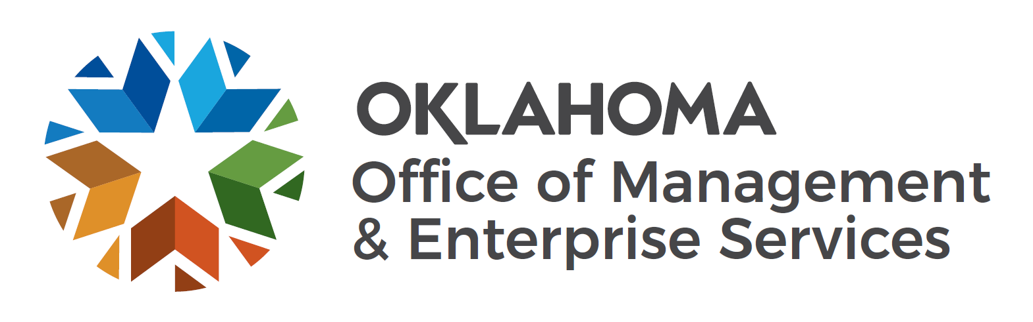 | Tangible Asset Reporting Threshold Evaluation

Pursuant to 74 O.S., §110.1, the Administrator of the Division of Capital Assets Management specifies the tangible asset reporting threshold for state entities based upon consideration of the entity's capability to provide tangible asset records, finance and accounting systems, associated inventory accuracy and other pertinent factors. This 12-point questionnaire provides DCAM with information to assist with the establishment or increase of an entity's reporting threshold. If you have any questions regarding the questionnaire, please contact the State Inventory Control Officer at (405) 522-1164. Please return the form by email to Lisa.Whiteman@omes.ok.gov.
Agency Name |  | Date
Agency Contact |  | Contact Telephone Number
- Does your agency have policies and procedures to ensure all tangible assets are properly coded, tagged or marked in such a manner that they may be readily identified as property of the State of Oklahoma in compliance with OAC 260:110-1-1
YES (Attach a copy of the policies and procedures.) NO
- Is a thorough physical inspection of all property conducted by a person other than the property custodian at least once a year?
YES NO
- Are there proper safeguards on equipment that is portable or easily stolen (i.e., notebook or handheld computers, electronic equipment, etc.), whether reportable or not?
YES NO
- Are Inventory Reports (Ending/Current Inventory) reconciled to prior inventories to ensure proper accounting of all additions, disposals, thefts or other inventory adjustments; and, are all reductions of and additions to inventory supported by appropriate documentation (e.g. purchase order, invoice, receiving report, approved surplus property transfer report, stolen property or police report, etc.)?
YES NO
- Is all missing or stolen property reported to an appropriate law enforcement agency upon discovery and at least annually to the Division of Capital Assets Management as required by 74 O.S. 2001, Section 110.1.?
YES NO
- What inventory or fixed asset system does your agency use?
- What accounting and finance system(s) does your agency use?
- Are there procedures in place within your procurement or accounts payable processes to identify and properly tag acquisitions of capital assets exceeding your current tangible asset reporting?
YES NO
- Do you have query reporting or other data mining tools that would permit your agency to quickly identify all capital asset acquisitions between the minimum (currently $500) and maximum (currently $5,000) tangible asset reporting thresholds?
YES NO
- Does your agency's inventory system include information regarding the physical location of assets, including all equipment located or used "off premises"?
YES NO
- Are agency policies displayed or distributed to clearly advise agency employees that personal use of State of Oklahoma property is prohibited?
YES NO
- Are inventories physically safeguarded from unauthorized access and physical deterioration?
YES NO
Signature of Person Completing Questionnaire |  | Title

