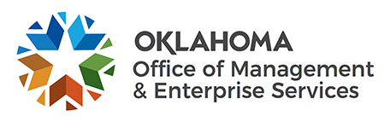 | Agency Acquisition Limitation Exception

In accordance with 74 O.S. § 85.5.N., the acquisition limitations provided in 74 O.S. § 85.5.C. and 85.7.A. shall not apply to agency purchases provided the agency has subject matter experts on staff having the specialized expertise to purchase goods or services, the agency possesses the necessary legal and procurement staff to purchase and monitor the contracts, and provided the purchase does not conflict with consolidated statewide spend initiatives. This exception serves for a single or one-time acquisition and is not intended for multiple acquisitions.

NOTE: By submitting this “Agency Request to Solicit In-House” form to the State Purchasing Director for review, the agency confirms all requirements outlined in 74 O.S. §85.5.N.1. – 3. and OAC 260:115-7-25 are
met. Please submit this form upon completion to: CP.Feedback@omes.ok.gov

Agency Name: |  |  |  |  |  |  |  |  |  |  | Agency #:
Agency Contact: |  |  |  |  |  |  |  | Email address:
Area of agency utilizing service:
The expected contract term is from: |  |  |  | Month | / | Day |  | / | Year | to |  | Month |  | / | Day |  |  | / | Year
Expected or anticipated contract amount (annual spend) $
Describe in detail the agency project:

Does your agency have the required expertise to meet the statutory requirements? Please describe in detail.

Requesting agency:
Chief Administrative Officer of Agency (print) |  | Chief Administrative Officer of Agency (signature)
Date

This request is hereby: Approved Denied - Reason for Denial:

Comment:
State Purchasing Director |  |  |  | Date

