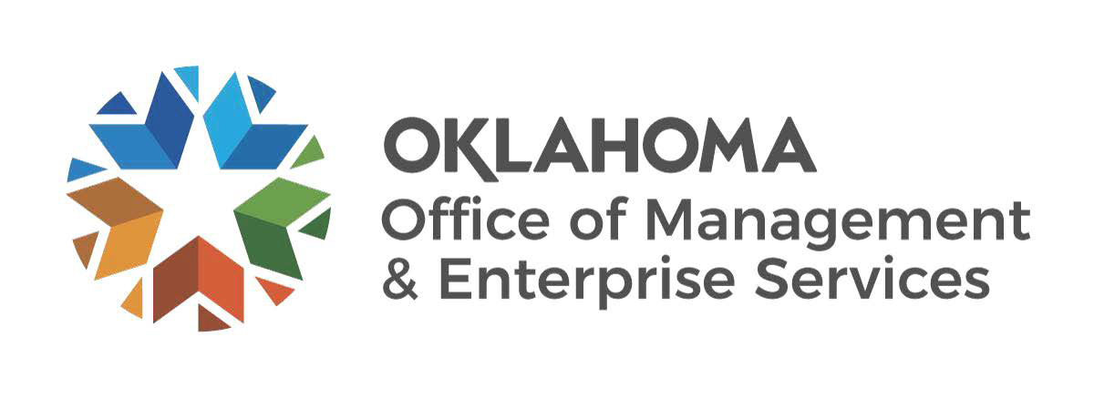 | Request for Exemption from Competitive Bidding

Please submit completed request form to the following: CP.Feedback@omes.ok.gov
1. | Agency Name: |  | Agency Number:
2. | Describe in detail acquisition to be made:

3. Name of Supplier: Cost of Acquisition:
4. Supplier Contact: |  |  |  |  | Email address:
 | 5. Reason for exemption:
6. Benefit to the State of Oklahoma:

7. Comparable items to acquisition item with comparable cost and resultant significant savings to the state:

Supplier A:
Item | Cost: | Savings to the state:
Supplier B:

Item | Cost: | Savings to the state:

(If necessary, please attach additional page(s) to provide justification)

The State Purchasing Director shall take no action under the provisions of this paragraph prior to the publication of a document describing the significant savings realized by the state.

The State Purchasing Director certifies that it is necessary to exempt the above listed procurement from the Central Purchasing Act because the procurement is unusual, time-sensitive, or unique and therefore the exemption of the procurement is in the best and immediate interest of the state as per 74 O.S. §85.7.A.7.

Signature of Requestor |  | Date
This request is hereby: Approved Denied - Reason for Denial:
Comment:

Public Posting Date: Award Date:

State Purchasing Director Date

