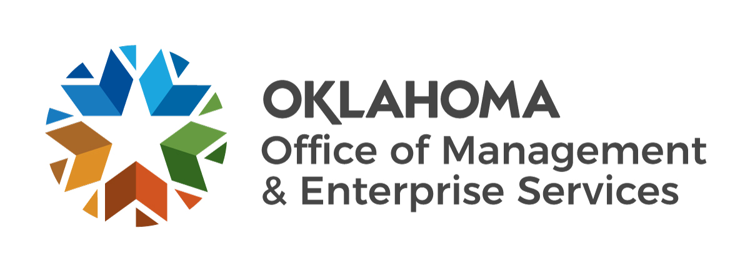 |  | Supplier Contract Certification

Solicitation or Purchase Order #:
Supplier name:
Address:
City: |  |  |  | State: |  |  |  |  |  | Zip Code:
Email address:

- In accordance with 74 O.S. § 85.42, the supplier named herein certifies that no person who has been involved in any manner in the development of this contract while employed by the State of Oklahoma shall be employed by the supplier to fulfill any of the services provided for under said contract.

Supplier Authorized Representative Signature |  | Date
Supplier Authorized Representative Printed Name |  | Title
B. In accordance with 74 O.S. § 85.41, if this contract is for professional services as defined in 74 O.S. § 85.2, and if the final product is a written proposal, report, or study, the supplier named herein further certifies that (s)he has not previously provided the state agency or any other state agency with a final product that is a substantial duplication of the final product of the proposed contract.

