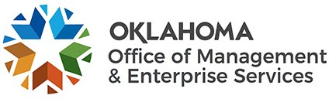 |  |  | Authority Limit Waiver Request
Agency Name: |  |  |  |  |  |  |  | Agency Number:
Agency Requisition #: |  |  |  |  |  |  |  | Purchase Order #:
Supplier Name: |  |  |  |  |  |  |  | Supplier FEI/SSN:
Original Amount ($): |  |  |  |  |  |  |  | Modified Amount ($):
Type or Nature of service or product provided:
Department or division that requested service or product:
Explanation of the inadvertent administrative error or unforeseeable circumstance which caused the acquisition to exceed the agency acquisition authority limit:
I hereby request a waiver of the agency's acquisition authority limit for this specific acquisition made pursuant to its own competitive procedures.
Signature |  |  |  |  |  | Date
Printed Name |  |  |  |  |  | Printed Title
( ) -
Phone Number
Submit this form to the State Purchasing Director for review:
 |  |  | CP.Feedback@omes.ok.gov
(FOR STATE PURCHASING DIRECTOR USE ONLY)
 | The waiver request has been: □ Approved; □ Denied
 | State Purchasing Director |  |  |  |  |  |  |  | Date
 | Comments:
A state agency shall request a limited waiver or increase to perfect an otherwise valid acquisition inadvertently exceeding the agency acquisition authority limit due to an administrative error or unforeseeable circumstance pursuant to 74 O.S. § 85.7.A.5.

