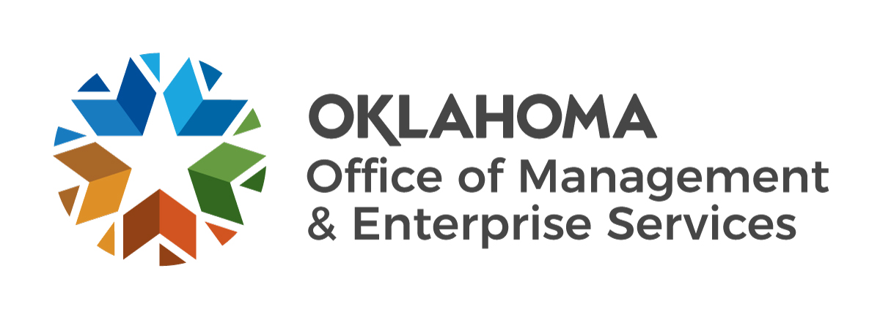 | Fixed Rate Certification

Agency Name: |  |  |  | Agency #:
Agency Requisition #: |  |  |  | OMES Requisition #:
I certify that the attached acquisition is for a service for which this agency has a fixed and uniform rate established in accordance with 74 0. S. § 85.7.A.11.
Signature of Agency Representative |  |  | Date
Printed name of Agency Representative |  |  | Printed Title

