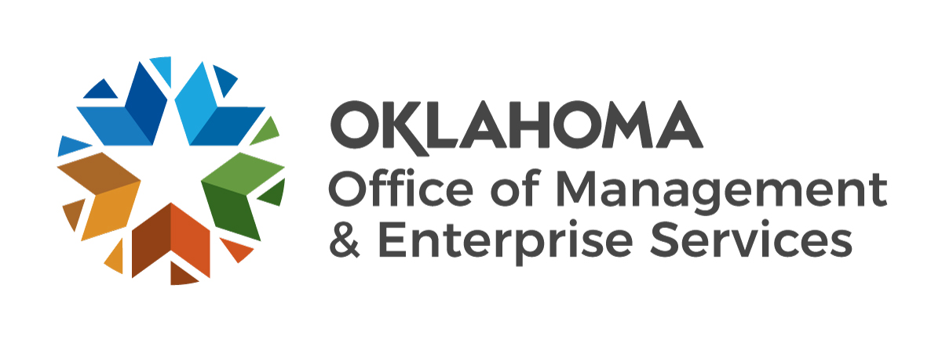 |  |  | Sole Source or Sole Brand Acquisition Certification

Acquisition Type (check one): |  | Sole Source |  | Sole Brand
State Agency:
Supplier Name:
Supplier Address:
Supplier Telephone: |  |  | Supplier e-mail:
In connection with the attached requisition or contract, I hereby affirm that (name of supplier)
 |  |  | is the only business entity singularly qualified to provide the
acquisition, or is the only brand satisfying the acquisition requirements, for the following reasons:

The following is a brief description of all efforts made to verify that the acquisition qualifies as a sole source or sole brand acquisition:

A court order requiring a particular acquisition, but which does not specify a brand or supplier shall not substitute for the certification required by this section or otherwise invalidate the acquisition procedures required by the Oklahoma Central Purchasing Act.

I understand that the signing of this certification knowing such information to be false may result in forfeiture of my position and ineligibility for appointment to or employment in state service for a period of five (5) years following forfeiture of position.

Chief Administrative Officer Signature |  | Date
Chief Administrative Officer Name [PRINT]
Additional Signatures for Requisitioning Agency, if necessary:
Title, Signature and Date |  | Title, Signature and Date
For agency use only:
Signature |  | Name and Title [Print]

