OMES FORM 20R GUIDE

OMES Form 20R is for the replacement of warrants that are ineligible for ‘cashing’ or depositing at a bank and now a reissuance is necessary.

Section 1:

Reissue Selection
If the warrant is less than 90 days from the date of issuance, those warrants are ‘Outstanding’ or ‘Active’. Mark the “Active Lost or Destroyed” box.
- The notary section is required when the warrant is missing or destroyed beyond recognition.
- The notary section is NOT required if the remains of the destroyed warrant can be submitted with the 20R.
- An OST Stop Pay is required when the warrant is lost/destroyed and the destroyed warrant is not available to attach to the 20R. Agencies will be required to submit the OST Stop Pay Confirmation received from OST with the 20R.
If the warrant is Greater than 90 days from the date of issuance, those warrants are ‘Canceled by Statute’, ‘Escheated’, ‘Stat Canceled’, or ‘Stale-dated’.
- If the agency has the original warrant or the official bank copy, mark the “Canceled by Statute (Warrant)” box.
  - Scan the warrant or official bank copy along with the 20R and email to the email address given in the forms submission section. The agency would keep the original as the agency copy and need not to send it in.
- If the stale-dated warrant is missing or damaged beyond recognition, mark the “Canceled by Statute (No Warrant).” The vendor must complete the Vendor Notary section.

Section 2:

Requirements for Reissue
- Title 34.80 is the Oklahoma State Law governing Canceled by Statute warrants.
- Title 34.81 is the Oklahoma State Law governing the replacement of warrants.
- There are special cases, in which, the vendor and amount may need to differ from the original. Prior to reissuance, attain approval by emailing the OMES warrant replacement email. When completing the 20R, fill in the correct vendor and/or amount of the reissue.
- The 20R form does not replace 700 fund, 340 fund, ASA or Special Account, and Clearing Account warrants.
- Note: The 20R form is used to replace warrants on 789, 7925467, and payroll 8905467 accounts.
- Submit an OST Stop Pay on Active Lost warrants. Per Title 62, § 34.81, agencies must submit a Stop Pay request to the Office of the State Treasurer before a replacement can be issued. Get the appropriate form at the OST link: Oklahoma State Treasurer Ken Miller - Stop Pay Processing
- Note: OST communicates with the Banks that a warrant is no longer eligible. OMES only makes changes within People Soft. Not submitting a Stop Pay would run the risk of having two active warrants available for ‘cashing,’ thus the stop pay requirement.
- Oklahoma State Law allows a period of 36 months from the month the warrant stat cancelled for a reissuance of the warrant. After the three years, the funds from the warrant transfers from the Stat Cancel Fund into the State General Revenue Fund. If the vendor is seeking the funds after the three years, please email the warrant replacement email for guidance in the next steps.

Section 3:

Warrant Information
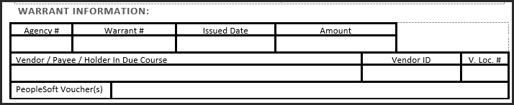
Agency # | The requesting agency’s three-digit business unit number.
Warrant # | The ‘check’ number. This is the number listed on the right top corner of the paper warrant.
Issued Date | The creation date of the warrant.
Amount | The requested reissue amount. *
Vendor/ Payee/ Holder in Due Course | The supplier due the reissued warrant.**
Vendor ID | This is the PeopleSoft ID number for the supplier due the reissued warrant.***
V.Loc. # | This is the location/address of the PS Vendor ID needed for the reissued warrant.****
PS Voucher(s) | This is the PeopleSoft voucher(s) connected to the original warrant. Note: This is not the claim number.

* Agencies may choose to reissue a warrant for a lesser amount if the original warrant amount is incorrect. Agencies should put the CORRECT reissue amount on the form.
** Warrants can only be reissued to the original payee. In the event that this is a payroll withholding voucher that is now due to the employee, or the original company has been acquired by a new company, please contact OMESTPAccountsPayable@omes.ok.gov for further instruction on reissuing the warrant.
*** All payees will need a vendor ID in PeopleSoft in order to reissue the warrant. Below are the situations in which a vendor form will be needed for reissue:
HECLM Agencies
- Lost Higher Ed Payroll: The agency will need to add the payee to the HECLM vendor file if a vendor number does not already exist.
- Stat Cancel: The agency will need to submit a vendor form to have the vendor added to the 00000 vendor file if a vendor number does not already exist in the 00000 vendor file (applies to most replacements).
00000 Converted Higher Ed Agencies
- Lost Higher Ed Payroll: The agency will need to add the payee to the 00000 vendor file if a vendor number does not already exist.
00000 Non-HE Agencies
- Payroll: Agencies will need to submit a vendor form if the employee does not have a vendor number. For former employees, a Vendor/Payee Form (non-employee form) will be needed to update the vendor file.
**** Agencies have the option to reissue the warrant to a different vendor location if the original payment location is incorrect. Agencies should put the CORRECT vendor location on the form.

Section 4:

Vendor Notary
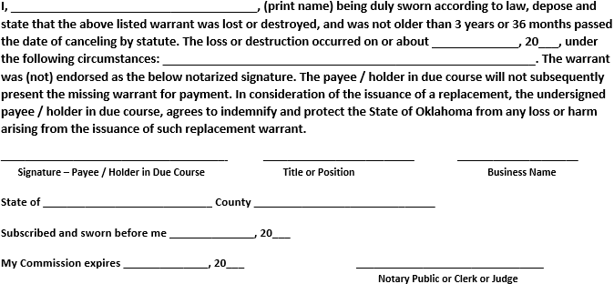
***Required for 20R forms without warrants or the official bank copy.***
The purpose of the notary is to witness the vendor/payee’s signature where he or she is swearing by law the original warrant was lost, and swearing by law that he or she will not attempt to cash the warrant if found. Without the vendor/payee’s signature, the notary is invalid. If notary is incomplete or invalid, the form will return to the agency for correction.

Section 5:

Reserved for State Agency
The State Agency this section is referring to is the requesting agency. Please fill out entirely.
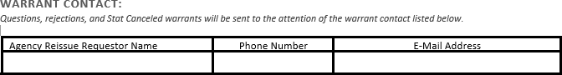
The requestor is the agency contact, whom OMES may contact for issues or requests regarding the replacement and will distribute the stat cancel replacement warrants to their attention. For ease and expedition, please print the requestor’s name and include an email address.
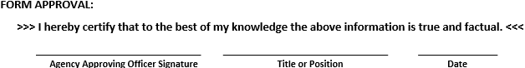
It is the requirement that the officer signing the form approval has an ‘Agency Approving Officer’ signature card on file at OMES-Transaction Processing. Each agency can have up to five Approving Officers. If there are any questions regarding who has a card on file, please email the warrant replacement email.

Section 6:

Form Submission
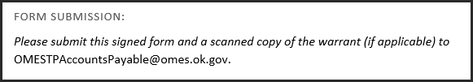
For the convenience of the requesting agencies, the email is included with the 20R form. This separate page is for the convenience only, it is not necessary for the submission of the 20R.
The warrant replacement email link is: OMESTPAccountsPayable@omes.ok.gov .

