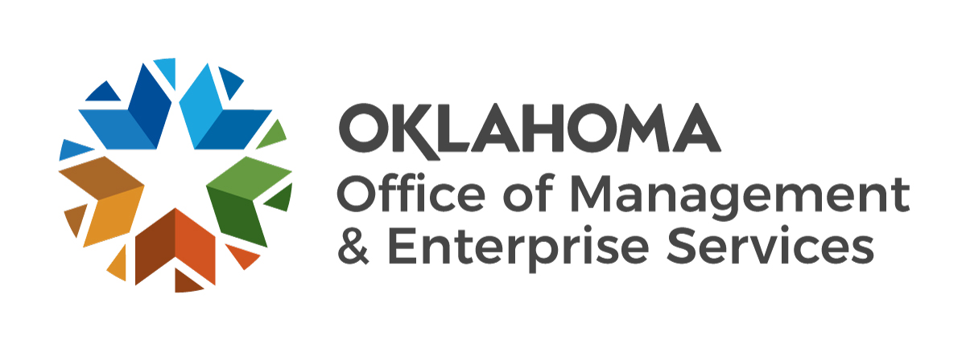 |  | 1033 Law Enforcement Weapon Request Procedures | 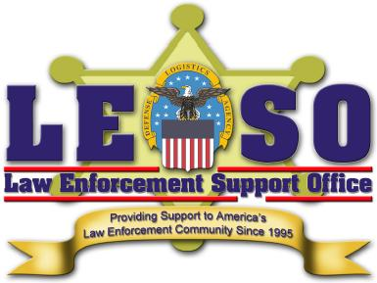
The National Defense Authorization Act of 1997 authorizes the Secretary of Defense to transfer excess military property to state and local law enforcement agencies. The eligible agencies in law enforcement activities are government agencies whose primary function is the enforcement of applicable federal, state and local laws, and whose compensated law enforcement officers have powers of arrest and apprehension. Special emphasis is given to counter-drug and counter-terrorism activities. All requests for weapons must be submitted through the governor-appointed state coordinator for approval. A listing of state coordinators is available upon request from the Defense Logistics Agency's Law Enforcement Support Office. The following procedures must be followed when submitting requests.
On agency letterhead, answer the following questions in narrative form. Please address each question in a separate paragraph.
- Administrative data
  - Name, address, phone and fax numbers of the requesting agency.
  - Full name of the chief executive official of the requesting agency.
  - Any additional points of contact.
  - Number of full-time sworn officers, full-time counter-drug officers, full-time counter-terrorism officers and personnel assigned to a tactical team.
- Written assurance
The LESO must receive written assurance from the chief executive official of the requesting agency that:
  - The chief executive official has read and understands the terms and conditions applicable to weapon transfers as detailed in the Memorandum of Agreement between the Defense Logistics Agency and the governor-appointed state coordinator (contact applicable state coordinator for copy of agreement).
  - The agency has the abilities to maintain, operate, finance and properly store the requested weapons (a description of agency’s plan would best answer this requirement).
  - The chief executive official of the requesting agency is familiar with the Bureau of Alcohol, Tobacco and Firearms regulations governing the registration of the requested weapons.
- Weapons requested
The type and quantity of weapons being requested, their intended use and the impact the resource will have on the requesting agency's jurisdiction and on surrounding jurisdictions.
NOTE – Restrict request types to: M-16 (5.56mm), M-14 (7.62mm), M-21 (7.62mm sniper weapon), M-79 (40mm grenade launcher), and shotgun (12ga). Also, total quantity of weapons requested in excess of the total number of full-time sworn officers will not be honored.
- Agency jurisdiction
The size of the requesting agency’s jurisdiction by population and area.
- Authorization
The signature of the chief executive official of the requesting agency.
The letter must be forwarded to the state coordinator for review. If approved at the state level, the request will be forwarded to the servicing LESO for action. A request approved at the state level is no guarantee that the requesting agency will receive the weapons being requested. Agencies approved to receive weapons will be contacted by their state coordinator. Questions regarding this application should be directed to the applicable state coordinator.
Property Distribution · 304 S. Miller Place · Oklahoma City, OK 73108
Telephone: 405-425-2700 · Fax: 405-425-2713 · www.omes.ok.gov

