Miscellaneous Return and Change Items Processes

- Effective March 1, 2016, OMES will email the Misc Returns Item Report with Return and Change Codes to the Higher Education institutions for payroll transactions.
- Banking information will be blurred
- The names except for the first four characters will be blurred
- Warrant numbers and participant IDs will remain intact so institutions can write a check to the employees from the 79901 clearing account for most return codes without delay (more discussion to follow).
- Institutions should become familiar with the return codes
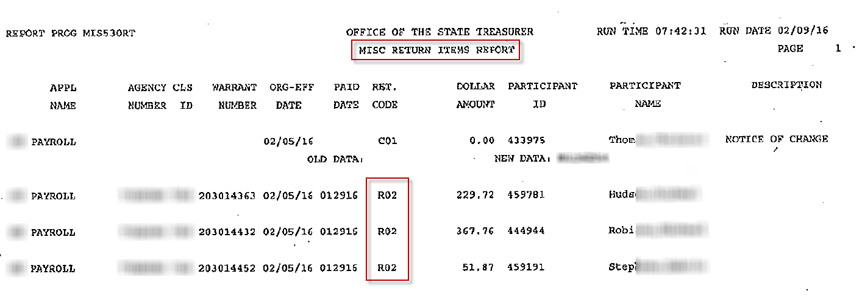
Standard ACH NACHA Format
ACH Standard Return Code Table for Returned Items:
Code | Debit or Credit | Description | Comment
R01 | Debit | Insufficient Funds
R02 | Both | Account Closed
R03 | Both | No Account/Unable to Locate Account
R04 | Both | Invalid Account Number
R05 | Debit | Unauthorized Debit to Consumer Account | Using Corporate SEC Codes
R06 | Both | Returned Per ODFI's Request
R07 | Both | Authorization Revoked by Customer | May not be used for POP, WEB, or TEL Entries.
R08 | Debit | Payment Stopped or Stop Payment
R09 | Debit | Uncollected Funds
R10 | Both | Customer Advises Not Authorized
R11 | Debit | Check Truncation Entry Return | Return based on State Law. Reason should be provided in addenda record.
R12 | Both | Branch Sold to Another DFI
R13 | Both | Invalid ACH Routing Number
R14 | Both | Representative Payee Deceased | Beneficiary is not deceased.
R15 | Both | Beneficiary or Account Holder Deceased
R16 | Both | Account Frozen
R17 | Both | File Recorded Edit Criteria | Field(s) cannot be processed by RDFI
R20 | Both | Non-Transaction Account
R21 | Both | Invalid Company Identification | Normally used on CIE transactions
R22 | Both | Invalid Individual ID Number | CIE and MTE entries
R23 | Credit | Credit Entry Refused by Receiver | Normally applies to credits.
R24 | Both | Duplicate Entry

- Return Codes – OST will place returned funds in each institution’s 79901 clearing account upon return of funds except for the following return codes:
- R01 – Insufficient Funds – This return code occurs when the EWC request cannot be processed by the bank because of insufficient funds in the account. OMES will notify the institution via email and the warrant will not be cancelled. The institution will have to retrieve the funds by other means.
- R08 – Payment Stopped or Stop Payment – OMES will notify the institution via email that the payment was stopped and request a PFT reversal in order to cancel the warrant.
- R14 – Representative Payee Deceased – Representative Payee is a person or institution authorized to accept entries on behalf of one or more other persons. OMES will verify with the institution as discussed in R15 below.
- R15 – Beneficiary or Account Holder Deceased – OMES will verify with the institution that the employee is deceased.
  - If the employee is deceased, OMES will request a EWC form and a PFT Reversal in order to cancel the warrant and also advise the agency to record the payroll expenses using the proper deceased codes and issue a paper warrant to the beneficiary or estate.
  - If the employee is not deceased, OMES will instruct the OST to place the funds in the institution’s 79901 clearing account so the institution can pay the employee from the clearing account. The institution must contact the employee for updated banking information for future payments.
- R23 – Credit Entry Refused by Receiver – OMES will contact the institution to determine the reason the employee refused the payment.
  - If the payment is not due to the employee, OMES will request an EWC and a PFT to cancel the warrant.
  - If the payment is due to the employees, OMES will instruct the OST to place the funds in the institution’s 79901 clearing account so the agency can pay the employee from the clearing account.
- R24 – Duplicate Entry – OMES will contact the agency to determine the reason for the duplicate entry.
  - If the payment is not due to the employee, OMES will request an EWC and a PFT to cancel the warrant.
  - If the payment is due to the employees, OMES will instruct the OST to place the funds in the institution’s 79901 clearing account so the agency can pay the employee from the clearing account.

- Change Codes – The bank has deposited the funds in the employee’s account but is notifying the state that a change was necessary and the employee’s records should be updated.
- An intact copy of the Misc Return Items Report will be mailed to the institution contacts who received payroll reports prior to calendar year 2016.
- A mailed copy provides a secure method to send banking information so employees’ banking data can be updated accordingly.

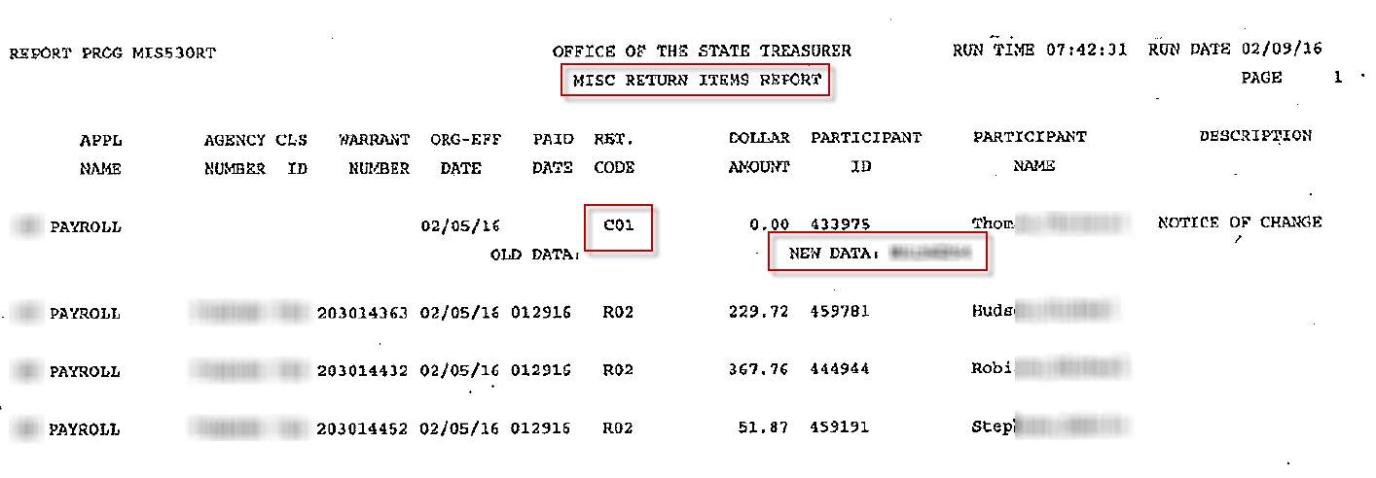

Standard ACH NACHA Format
Correction Codes:
Code | Description | Comment
C01 | Incorrect DFI Account Number
C02 | Incorrect Routing Number
C03 | Incorrected Routing Number and Incorrect DFI Account Number
C04 | Incorrect Individual Name/Receiving Company Name
C05 | Incorrect Transaction Code | Trans Code: 22-Checking or 32-Saving
C06 | Incorrect DFI Account Number & Incorrect Transaction Code | Trans Code: 22-Checking or 32-Saving
C07 | Incorrect Routing Number, DFI Account Number, and Incorrect Transaction Code | Trans Code: 22-Checking or 32-Saving
C08 | Incorrect Foreign Receiving DFI Identification
C09 | Incorrected Individual Identification Number
C10 | Incorrect Company Name
C11 | Incorrect Company Identification
C12 | Incorrected Company Name & Company Identification
C13 | Addenda Format Error
 | Codes C01-C13 are utilized for Bank to Bank Communication

- Per NACHA Rules, originators must respond to Notifications of Change by investigating the incorrect data and making corrections within six banking days of receipt of the NOC information or prior to initiating another entry to the Receiver’s account, whichever is later. Originators should not wait six banking days if the change can be made earlier – they should make the change prior to initiating the next entry.

