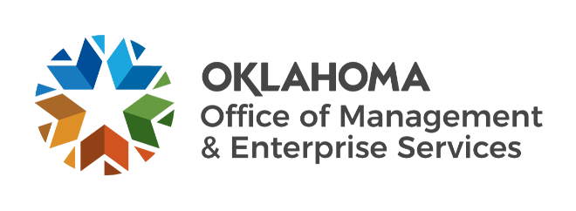

Statewide Contracts team metrics – June 2023

Number of statewide contracts by fiscal year:
FY 2019 – 173.
FY 2020 – 181.
FY 2021 – 192.
FY 2022 – 189.
FY 2023 (as of May 31) – 174.

IT reported spend:
FY 2019 – $208 million.
FY 2020 – $247 million.
FY 2021 – $329 million.
FY 2022 – $357 million.
FY 2023 (as of May 31) – $282 million (10.2% increase since May 1).

Non-IT reported spend:
FY 2019 – $343 million.
FY 2020 – $382 million.
FY 2021 – $388 million.
FY 2022 – $439 million.
FY 2023 (as of May 31) – $348 million (9.8% increase since May 1).

Fiscal year 2023 to date:
936 statewide supplier agreements (0.65% increase since May 1).
35 requests for proposals initiated (9.4% increase since May 1).
51 new supplier agreements entered (24.4% increase since May 1).
1,018 supplier renewals (6.6% increase since May 1).

