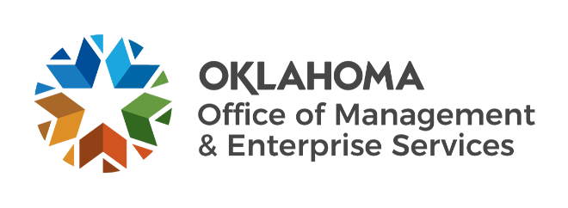

Agency Acquisitions team metrics – June 2023

Number of purchase/change orders processed per fiscal year:
FY 2019 – 452.
FY 2020 – 633.
FY 2021 – 710.
FY 2022 – 785.
FY 2023 (as of May 31) – 713 (7.5% increase since May 1).

Processed purchase/change orders spend:
FY 2019 – $354.4 million.
FY 2020 – $574.3 million.
FY 2021 – $718.1 million.
FY 2022 – $769.5 million.
FY 2023 (as of May 31) – $1,023 million (1.5% increase since May 1).

Fiscal year 2023 to date:
123 requisitions received (11.8% increase since May 1).
117 requests for proposals initiated (11.4% increase since May 1).
80 awarded contracts from solicitations (14.3% increase since May 1).
Contracts processed spend – $183.09 million (90.36%).
Contracts processed savings – $19.54 million (9.64%).

