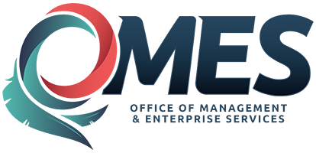 | LEARN Welcome Page Quick Bit Transcript
Linda: Welcome to another learn quick bit video. I'm Linda and [I'm Tom] and we're from OMES. This video is going to show you aspects of the welcome or landing page that we haven't previously covered in other videos.
Tom: In our previous videos, we talked about the navigation area on the left side of the page, choose your learn center options in the middle [of the screen] and the explore content area. Now, we're going to talk about the other sections of the page, starting with need help. We've got some links here, Linda. Do you want to talk about those?
Linda: Absolutely Tom. Just be aware that the need help area is fairly new and this is a new system so these links will have more and more information every time you come here, so visit often. The first link is the FAQ or the frequently asked questions section. This is where you would come to find questions about the system that are asked with their resolution.
Tom: Next we have a help link that will take you to videos like this, job aids and other types of training resources. [This is now called the Learn Information and Training Materials.]
Linda: The next one is the Taleo Learn Help. It is the help website for the learning management system. The good thing about this website is that we have a whole separate video on this area.
Tom: Stay tuned for that one. The next link is called Need Accommodation [Request an Accommodation]. Here you can request resources to assist those that might need a little bit of help in enhancing their classroom experience.
Linda: Excellent Tom, if you scroll further down, we have additional links for you. We've made it convenient for you to access all our training resources for the state of Oklahoma and you'll see that we've divided it up into three areas. The the first area is the Learning and Development Department and this is where you would get your soft skills or supervisory training. Also under here, you'll be able to look at the course catalog and the upcoming course schedule.
Tom: Next is the OMES leadership programs including the certified facilitator program, certified personnel professional, certified public manager or CPM program, and the executive development seminar for state officials.
Linda: The last area, but not the least important because this is the area that Tom and I are part of, is the professional and technical education department. This department is going to provide services and resources for your professional education, vocational skills, and technical and occupational training. Within this area is the certified procurement officer program, the Lean Six Sigma opportunities, and the Microsoft Office and Microsoft Office 365 training.
Tom: Let's scroll down just a little more to talk about these last four links. [At the very bottom of the page.] Of course, at “ok.gov” you'll find the state's official website. The accessibility link is where you can find even more information on accessibility. Policies is where you'll find current copies of the state's official policies; and state agencies will have a list of every single state agency.
Linda: The good thing about the state agencies is that if you click on the links it'll take you to their home pages. That actually concludes the exploring the Welcome page. Tom take it away.
Tom: Until next time, keep on learning.

