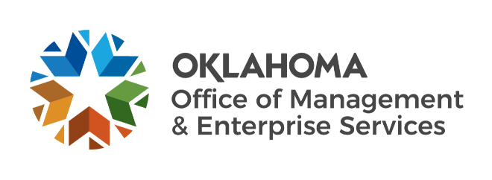

International Women’s Day
  - #BreakTheBias
The International Women's Day 2022 theme, #BreakTheBias, spotlights the challenges that women continue to face in the journey towards equity.

This LinkedIn Learning video-level mapping is a compilation of content about the realities of racism, microaggression, and discrimination. It emphasizes how women can find their voice and how allyship is integral to supporting and elevating underrepresented groups. Most importantly, it shows how to address and break biases that continue to hold women back from reaching their full potential.

