IT Regulatory Reporting Application Tool Guide
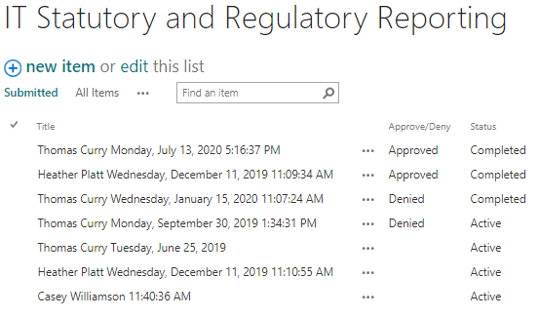

Go to O365 SharePoint application and log in with your O365 email address and password.
If you do not have access to the application, visit the OMES Service Desk and include “Assign this case to the app support-cots-ecm/imaging team” in your request.

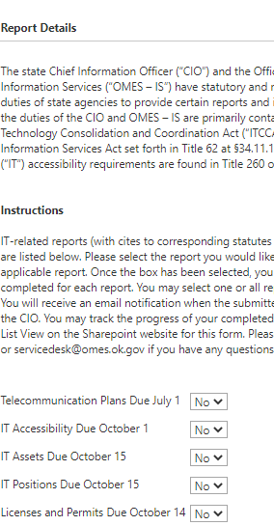

Overview
Once logged in, you will be on the IT Statutory and Regulatory Reporting tab. Select the + new item link to pull up a new form.

Report Details provides background and purpose for submitting reports to OMES IS.

Instructions provides details on how to complete the form.

Select your report
The available IT statutory and regulatory reports for your selection are listed after the Instructions section. Based on your agency/affiliate type, please select Yes or No as your answer for each report in the form.

Selecting Yes will expand that section of the form with instructions on how to finalize your report.

Telecommunication plans, IT assets, IT positions
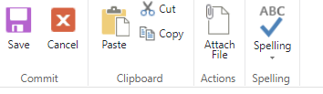
Each report will ask you to download and complete the template then upload your final completed file to the form.

To upload an attachment, use the ribbon at the top to attach a file.

To edit your form once submitted, select ellipsis (. . .) for your report and select edit item. You will be able to delete and reupload an attachment and change your answer for each report. When finished editing, please resubmit. NOTE: If you have previously reported and are reporting again for a new fiscal year, select +new item to start a new form for that fiscal year.

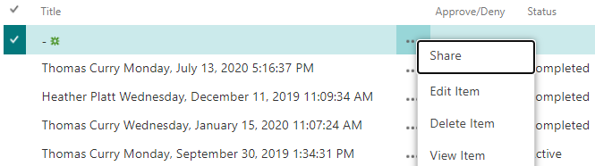

IT accessibility
Fill in the required fields for your accessibility compliance representative. If you received accessibility complaint(s), please include accessibility complaint information in an attachment. No template necessary.
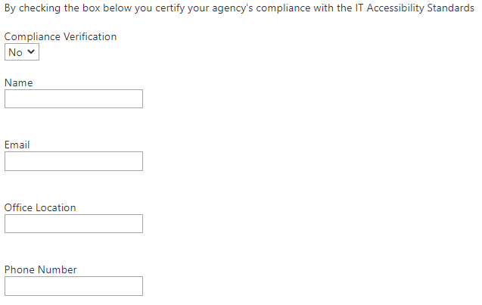

Saving or cancelling your reports
Once you have completed the sections you are reporting, select save. This will submit your form for OMES IS review. Select cancel to cancel your form.
NOTE: If you have previously reported and are reporting again for a new fiscal year, select +new item to start a new form for that fiscal year.

Form status
After submitting your form, you can check the status by going to the Submitted tab. You will see your form and the status should be listed as Approved or Denied.

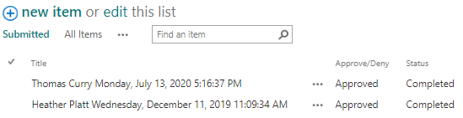

Questions
We are at your service to help with your technology requests. If you experience any issues, please contact the OMES Service Desk.

Tech Desk
ServiceDesk@omes.ok.gov
Local: 405-521-HELP (4357)
Toll-free: 866-521-2444
My Items
View status of current requests or give an update to the technician.

My Items
View status of current requests or give an update to the technician.

