Class 789 Reconciliation Tips
Account numbers used by Higher Ed institutions in Class 78900 were designed to allow for ease of reconciliation. Accounts 485xxx have a corresponding 585xxx account number associated with them. For instance, when the net pay is transferred into Class 789 through the PFT, account 485060 is used for Payroll Payable. When the payment of the warrant is recorded, account 585060 is used. The 485xxx accounts generally increase cash in Class 789 while the 585xxx accounts generally reduce cash when disbursements are created. The exception to the 585xxx account reducing cash would typically be related to a PFT reversal. These accounts need to be reconciled to ensure that all payroll transactions are properly recorded and Class 789 does not maintain a balance.
We have developed 2 public queries to assist in the reconciliation of your 78900 Class.
To locate these queries, the navigation in PeopleSoft is Reporting Tools > Query > Query Viewer. In the ‘Search By’ field, please type ‘OCP_HE’ to find the necessary public queries. There are two reconciliation queries: OCP_HE_789_PR_WH_ACCT_DETL and OCP_HE_789_AP_JRNL_DETL.
Exhibit 1
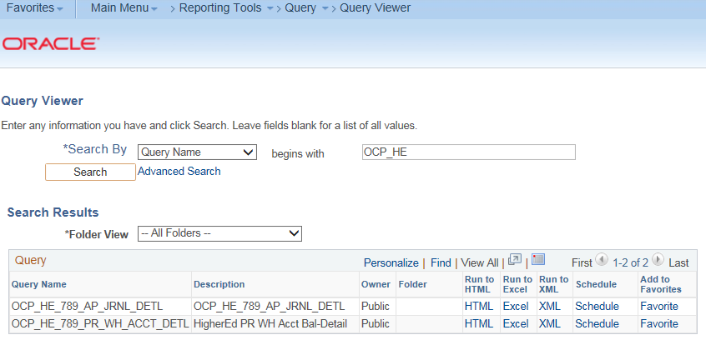

The main query is OCP_HE_789_PR_WH_ACCT_DETL. This query contains information from the Journal Header and Journal Lines tables and contains prompts for Business Unit and From/To Journal Date. The purpose of this query is to ensure that every Recon Account number (defined below) nets to zero.
If any Recon Account does not equal zero, OCP_HE_789_AP_JRNL_DETL, can be used to research any ‘AP’ Journal ID that may be a part of the difference. Keep in mind that PeopleSoft does not contain any detailed transactions for your PFT journal entries. If an account is off for any entry that begins with ‘000’ you will need to research your records to find the details for the PFT or payroll tax payment.
Exhibit 2
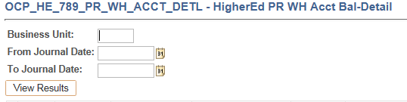

The first time an institution runs this query you will need to run it from 12/1/2015 to current date. For our example, we selected an example from a PROD questions that came to Transaction Processing after a voucher would not budget check.
Exhibit 3
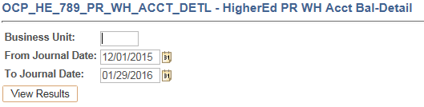

The results are:
Exhibit 4
Ref No | Journal ID | Journal Date | Prd | Jrnl Hdr Status | Budget Status | Original Account | Recon Account | Class  Fund | Amount | Descr | Year
00676 | 0003140436 | 1/5/2016 | 7 | P | V | 485060 | 85060 | 78900 | 7,663,071.20) | Higher Ed PFT | 2016
 | AP03142839 | 1/8/2016 | 7 | P | V | 585060 | 85060 | 78900 | 7,663,071.20 | Accounts Payable | 2016
00676 | 0003140436 | 1/5/2016 | 7 | P | V | 485110 | 85110 | 78900 | 2,630,099.11) | Higher Ed PFT | 2016
PP151231 | 0003143766 | 1/11/2016 | 7 | P | V | 585110 | 85110 | 78900 | 2,630,099.11 | FEDERAL TAX DEPOSIT - PPP15123 | 2016
00676 | 0003140436 | 1/5/2016 | 7 | P | V | 485120 | 85120 | 78900 | (727,494.48) | Higher Ed PFT | 2016
PP151231 | 0003143766 | 1/11/2016 | 7 | P | V | 585120 | 85120 | 78900 | 727,494.48 | FEDERAL TAX DEPOSIT - PPP15123 | 2016
00676 | 0003140436 | 1/5/2016 | 7 | P | V | 485125 | 85125 | 78900 | (727,494.48) | Higher Ed PFT | 2016
PP151231 | 0003143766 | 1/11/2016 | 7 | P | V | 585125 | 85125 | 78900 | 727,494.48 | FEDERAL TAX DEPOSIT - PPP15123 | 2016
00676 | 0003140436 | 1/5/2016 | 7 | P | V | 485130 | 85130 | 78900 | (170,139.92) | Higher Ed PFT | 2016
PP151231 | 0003143766 | 1/11/2016 | 7 | P | V | 585130 | 85130 | 78900 | 170,139.92 | FEDERAL TAX DEPOSIT - PPP15123 | 2016
00676 | 0003140436 | 1/5/2016 | 7 | P | V | 485135 | 85135 | 78900 | (170,139.92) | Higher Ed PFT | 2016
PP151231 | 0003143766 | 1/11/2016 | 7 | P | V | 585135 | 85135 | 78900 | 170,139.92 | FEDERAL TAX DEPOSIT - PPP15123 | 2016
00676 | 0003140436 | 1/5/2016 | 7 | P | V | 485140 | 85140 | 78900 | (526,769.00) | Higher Ed PFT | 2016
 | AP03145869 | 1/13/2016 | 7 | P | V | 585140 | 85140 | 78900 | 94.32 | Accounts Payable | 2016
 | AP03147601 | 1/17/2016 | 7 | P | V | 585140 | 85140 | 78900 | 451,451.00 | Accounts Payable | 2016
 | AP03149215 | 1/20/2016 | 7 | P | V | 585140 | 85140 | 78900 | 75,223.68 | Accounts Payable | 2016
 | AP03142657 | 1/7/2016 | 7 | P | V | 585315 | 85315 | 78900 | 52,102.68 | Accounts Payable | 2016
 | AP03149215 | 1/20/2016 | 7 | P | V | 585315 | 85315 | 78900 | (52,102.65) | Accounts Payable | 2016
00676 | 0003140436 | 1/5/2016 | 7 | P | V | 485360 | 85360 | 78900 | (9,624.67) | Higher Ed PFT | 2016
 | AP03151005 | 1/22/2016 | 7 | P | V | 585360 | 85360 | 78900 | 9,624.67 | Accounts Payable | 2016
00676 | 0003140436 | 1/5/2016 | 7 | P | V | 485370 | 85370 | 78900 | (2,100.00) | Higher Ed PFT | 2016
 | AP03151005 | 1/22/2016 | 7 | P | V | 585370 | 85370 | 78900 | 2,100.00 | Accounts Payable | 2016
00676 | 0003140436 | 1/5/2016 | 7 | P | V | 485390 | 85390 | 78900 | (4,481.00) | Higher Ed PFT | 2016

Selected fields in this Query include:

- The ‘Ref No’ - contains the PFT number for loaded PFT transactions or a manually keyed reference from the Journal Entry for the tax payments
- Journal ID – ‘000’ entries are tax payments keyed by the institution or PFT transactions created as a result of the load process. ‘AP’ entries are a result of all vouchers created under Class 789
- Journal Date – date the transactions were created in the General Ledger
- Original Account – the General Ledger account that is used on each transaction in the General Ledger
- Recon Account – a substring that removes either the first digit from the original Account. This is what you use to reconcile
- Descr – the Description included in the Journal

To reconcile, you can take your data from the query and Subtotal by Recon Account.

- To Subtotal in Excel, you must first sort your spreadsheet by the ‘Recon Account’ column. Then you can go to the ‘Data’ tab and select ‘Subtotal’. When the Subtotal box pops up, change the ‘At each change in:’ box to ‘Recon Account’, select ‘Sum’ function and then under the ‘Add subtotal to:’ box, select Amount by placing a check in the box. Uncheck any other items previously selected.

Exhibit 5
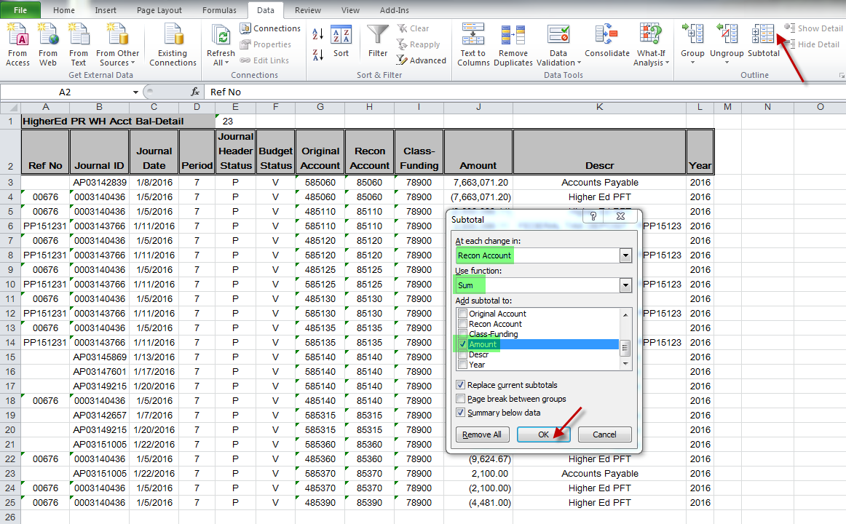
- Once you select ‘OK’, your spreadsheet will have ‘-‘ signs to the left of the rows. Click the #2 to display only the account totals.

Exhibit 6
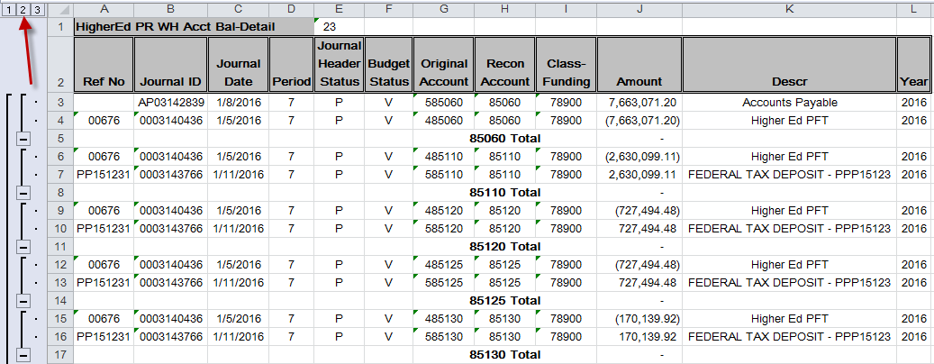

- After clicking the ‘2’ above, it will only show you the Totals of each Recon Account. As you can see, we have two account numbers that do not net to $0. Each one needs to be researched.

Exhibit 7
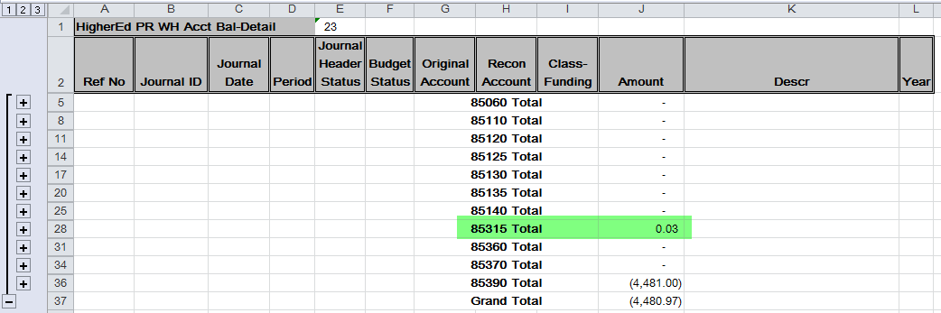

- To find out what makes up this remaining balance, open up the ‘+’ sign to the far left to reveal the GL transactions.

Exhibit 8
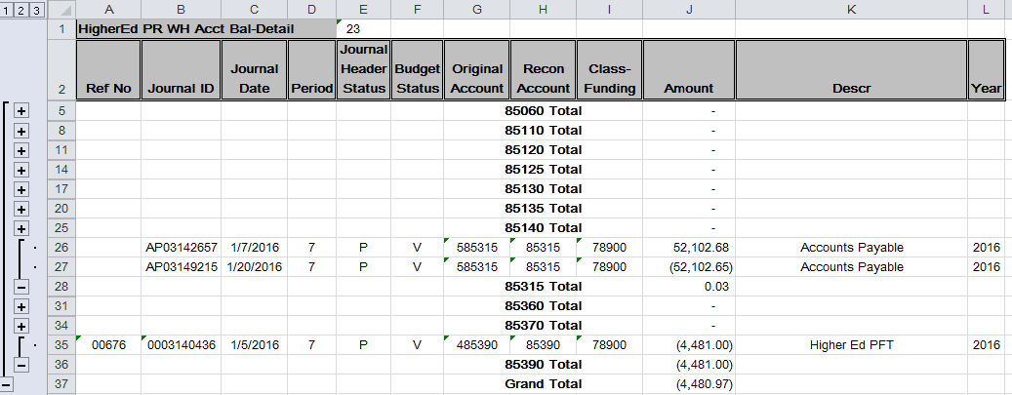

- The AP Journal ID’s can now be keyed into the OCP_HE_789_AP_JRNL_DETL public query to determine the exact voucher that needs to be researched. This query has prompts of Business Unit and Journal ID.

Exhibit 9
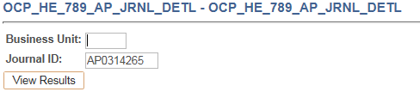

- The results are as follows:

Exhibit 10

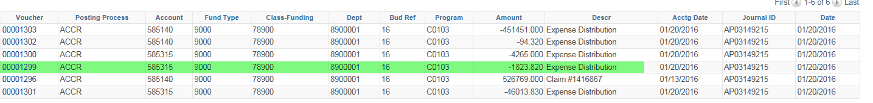

- If you notice, all Voucher IDs are shaded in blue. This query contains drilling urls which allow the user to click directly on the Voucher ID and the system will take you to the Accounts Payable voucher screen for further research. In this case, the 3 cent difference is a result of Vouchers 1293 and 1299 which would need to be researched.

If you have $0 for all account numbers you are reconciled. In this case above, once the 3 cents is resolved and the voucher is posted for the $4481 amount in Account 85390, this Business Unit will be balances through 1/29/2016. The next time the reconciliation is run, they would no longer need to look at transactions prior to 1/29/2016. They can make their journal date be 2/1/2016 to present on the OCP_HE_789_PR_WH_ACCT_DETL query.

