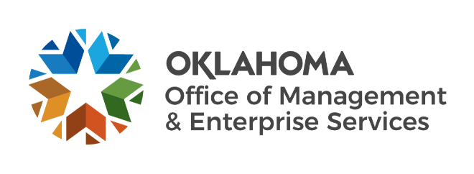

We are OMES recognition September 2022

August new hires – Welcome on board! Glad you have joined us.

EMPLOYEES GROUP INSURANCE DIVISION
Joy Stevens, Call Center Specialist.
Kayreesha Grayson, Call Center Specialist.

HUMAN CAPITAL MANAGEMENT
Ashlee Green, Training Specialist.
Katie Holderread, HR Special Projects Manager.
Laura Hatley, Civil Service Division Assistant.
Rylan Shackelford, Human Resources Specialist.

INFORMATION SERVICES
Chandra Smotherman, Intern.
Drew Graham, Network Technician.
Jalen Byford, Director of PC Support.
Rickey Jones, Administrative Officer.
Tristan Kilgore, Data Analyst.
William Habekott, IT Asset Manager.

LEGISLATIVE AND PUBLIC AFFAIRS
Aaron Niles, Copy Editor.
Catherine Davison, Technical Writer.

SERVICE OKLAHOMA
Jaclyn McDuffey, Service Oklahoma Chief Product Officer.
Kyla Moss, Associate Product Manager.
Marshall Welke, Service Oklahoma Senior Director of Performance.
Olivia Ucha, Associate Product Manager.

August position changes – Congratulations! Keep up the good work.
Aaron Martin, Technical Architect to Chief Technology Officer, Information Services.
Amanda Otis, EGID Deputy General Counsel to Central Purchasing Deputy General Counsel, General Counsel.
Cathrine Huckabee, Transactions Specialist to Statewide Accounts Payable Manager, Central Accounting and Reporting.
Deanna Ferron, Senior Class Comp Analyst to Director of Classification and Compensation, Human Capital Management.

August longevity – Thank you! You are much appreciated.
Ed Bejarano, 39 years of service.
Mark Sauchuk, 37 years of service.
Cardell Blevins, 25 years of service.
Maranda Whitaker, 25 years of service.
Betty Haddad, 25 years of service.
Toni Davis, 15 years of service.
Joel Rhodes, 15 years of service.
Jacob Charries, 15 years of service.
Jackie McKinley, 10 years of service.
Phillip Davidson, 10 years of service.
Patrick Granahan, 10 years of service.
Felicia Clark, 5 years of service.
Somer Culwell, 5 years of service.
Cara Guilfoyle, 5 years of service.

Retirements – Best of luck! We will miss you.

SEPTEMBER
Cathy Stephens, Principal Assistant, Employees Group Insurance Division, 32 years of service.
Linda Haley, Technical Account Manager, Information Services, 31 years of service.
Mike Howard, Agency/Statewide Services Manager, Central Purchasing, 6 years of service.
Ronald Cummings, Asset Management Specialist, Information Service, 6 years of service.

OCTOBER
Bob Howard, Facilities Technician, Information Services, 33 years of service.

