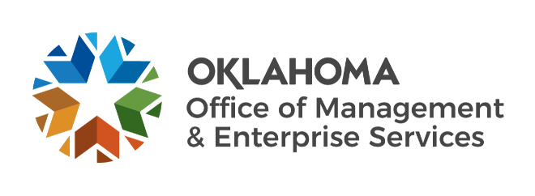

We are OMES recognition October 2022

September new hires – Welcome on board! Glad you have joined us.

ADMINISTRATION
John Laws, Cabinet Secretary of Budget, State Chief Financial Officer.
Kimra Coons, Finance Center of Excellence AP PeopleSoft Administrator.

EMPLOYEES GROUP INSURANCE DIVISION
Sylvia Love, Call Center Specialist.

HUMAN CAPITAL MANAGEMENT
Brandon Budig, Organizational Development Consultant.

INFORMATION SERVICES
Anita Lawrence, Service Desk Technician.
Barry Thornton, Computer Support Technician.
Earl Bell, Service Desk Technician.
Ethan Carpenter, Computer Support Technician.
Jonathon Black, Computer Support Technician.
LaShunda Brathwaite, Deputy Director of Application Development.
Mason Campbell, Computer Support Technician.
Matthew Johnston, Software Analyst.
Orlando Green-Bush, Temporary.
Robert Johnson, Computer Support Technician.
Ronald Maddox, Computer Support Technician.
Ryan Elliott, Computer Support Technician.
Ryan Turnage, Computer Support Technician.
Thomas Cole, Computer Support Technician.
Tyrese Stevenson, Computer Support Technician.

September position changes – Congratulations! Keep up the good work.
Lee Pennington, Network Technician to Network Administrator, Information Services.
Lori Carroll, Research and Resolution Specialist to Administrative Officer, Employees Group Insurance Division.

September longevity – Thank you! You are much appreciated.
Roberta Roads, 44 years of service.
Lindsay Swihart, 43 years of service.
Marsheila Ward, 38 years of service.
Cathy Higgins, 37 years of service.
Franklin Antao, 25 years of service.
Jason Nichols, 25 years of service.
Susan Edwards, 25 years of service.
Michael Wilson, 15 years of service.
Nawaz Syed, 15 years of service.
Tim Tuck, 10 years of service.
Jennifer Ramsey, 10 years of service.
Thomas Vergis, 10 years of service.

Retirements – Best of luck! We will miss you.

OCTOBER
Bob Howard, Information Services Facilities Technician, Capital Assets Management, 33 years of service.

NOVEMBER
Ellen Totimeh, Risk Management Information Coordinator, Capital Assets Management, 32 years of service.

