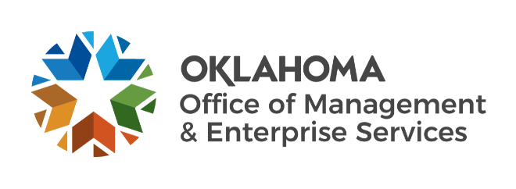

We are OMES recognition November 2022

October new hires – Welcome on board! Glad you have joined us.

ADMINISTRATION
John Suter, Chief Operating Officer, OMES Executive Director.

BUDGET, POLICY AND GAMING COMPLIANCE
Palista Kharel, Grants Analyst.

EMPLOYEES GROUP INSURANCE DIVISION
Chiew Tan, Accountant.
Dina Wright, Research and Resolution Specialist.

GENERAL COUNSEL
Mary Jackson, Central Purchasing Deputy General Counsel.
Robin Murphy, EGID Deputy General Counsel.

HUMAN CAPITAL MANAGEMENT
Alisha Whetstone, Training and Communications Coordinator.

INFORMATION SERVICES
April Gonzalez, Temporary.
Brianna Russell, Temporary.
Bryan Archer, Data Engineer.
David Patterson, Computer Support Technician.
Forrest Jackson, Network Technician.
Jayke Ratliff, Data Analyst.
Josiah Owen, Temporary.
Kevin Keeley, Computer Support Technician.
Kevin Wisdom, Computer Support Technician.
Lucas Holbrook, Temporary.
Marcus Griffis, Computer Support Technician.
Natalie Mercer, Applications Developer.
Roger Bunting, Server Operations Support.
Rudy Richmond, Computer Support Technician.
Steven Feldman, Computer Support Technician.
Tamara Brubaker, Computer Support Technician.
Timothy Bircher, Computer Support Technician.

SERVICE OKLAHOMA
Bonnie Campo, Senior Director of Communications and Partnerships.
Samie Harley, Training and Curriculum Manager.
Teresa Aita, HR Director.
Vanessa Castillo, Associate Project Manager.

October position changes – Congratulations! Keep up the good work.
April Kelso, Senior Policy and Legal Affairs Analyst to Director of Legal Operations and Policy, Service Oklahoma.
Carmin Eulitt, Training Intern to Learning and Development Assistant, Human Capital Management.
John Dill, Mobile Device Technician to Executive Support Specialist, Information Services.
Marshall Welke, Senior Director of Performance to Director of Programs, Service Oklahoma.

October longevity – Thank you! You are much appreciated.
Cynthia Shackelford, 42 years of service.
Jon Paulk, 40 years of service.
Glenn Alexander, 36 years of service.
Deadra Williams-Cooper, 25 years of service.
Lisa Bradley, 20 years of service.
Karen Schwartz, 15 years of service.
Michael White, 15 years of service.
Wendy Zhou, 15 years of service.
Jacy Cheadle, 10 years of service.
Mark Bright, 10 years of service.
Patrick Hickerson, 10 years of service.
Richard Williams, 10 years of service.
Amanda Otis, 5 years of service.
Cory Perschbacher, 5 years of service.
Jack Ripley, 5 years of service.
Kristin Pease, 5 years of service.
Laura Philbin, 5 years of service.

Retirements – Best of luck! We will miss you.

NOVEMBER
Ellen Totimeh, Risk Management Information Coordinator, Capital Assets Management, 32 years of service.

DECEMBER
Craig Dingler, Administrative Officer, Capital Assets Management, 42 years of service.
Beth Brox, Supplier Registration Lead, Central Accounting and Reporting, 26 years of service.
Sheri Diehm, Procurement Training Coordinator, Central Purchasing, 15 years of service.

