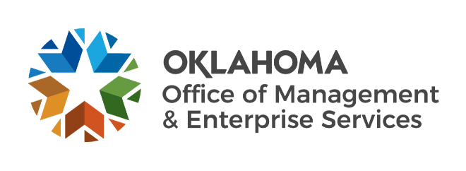

We are OMES recognition May 2022

April new hires – Welcome on board! Glad you have joined us.

CAPITAL ASSETS MANAGEMENT
Samuel Dodd, Senior Maintenance Technician.
William Garrett, Maintenance Technician II.

CENTRAL ACCOUNTING AND REPORTING
Kristen Banta, Procurement Specialist.

EMPLOYEES GROUP INSURANCE DIVISION
Candis Thompson, Call Center Specialist.
Tammy Filer, Former Employee Enrollment Specialist.

FINANCE
Christy Tubbs, Senior Financial Analyst.
Holly Woods, Budget Analyst.

HUMAN CAPITAL MANAGEMENT
Jasmin Sneed, Technical Training Intern.

INFORMATION SERVICES
Alexander Parcell, Threat Intelligence Analyst.
Amy Kulkarni, Business Analyst Intern.
Andrew Chilson, Deputy General Counsel.
Arthur Rice III, Network Technician.
Brandon Bussell, Grant Manager.
Chad Ward, Cyber Operations Analyst.
Jared Austin, Project Manager.
Russell Cole, Senior Security Engineer.
Valencia Edwards, Service Desk Technician.

April position changes – Congratulations! Keep up the good work.
Ashley Plyushko, OMES Chief Financial Officer to State Chief Financial Officer, Administration.
Jenna Thomas, Statewide Operations Coordinator to Senior Director of Statewide Transformation, Administration.
Justin Devero, Solutions Architect to Web Team Manager, Information Services.
LaMarr Adams, Service Delivery Representative to Project Manager, Information Services.
Mitchell Robinson, Network Technician to Computer Support Technician, Information Services.

April longevity – Thank you! You are much appreciated.
Eason George, 20 years of service.
Paul Spaulding, 20 years of service.
Amelia Glenn, 15 years of service.
Ronald Craun, 15 years of service.
Alan Beall, 10 years of service.
Brittany Smith, 10 years of service.
Johnathan Goldsberry, 10 years of service.
Kim De La Cruz, 10 years of service.
Kylee Halford, 10 years of service.
Matthew Reed, 10 years of service.
Nichole King, 10 years of service.
Shaw Wong, 5 years of service.

Retirements – Best of luck! We will miss you.

APRIL
Latisha Edwards, Procure to Pay Manager, Central Accounting and Reporting, 34 years of service.
Esther Ward, Senior Programs Officer, Capital Assets Management, 27 years of service.
James Glover, Firewall Technician, Information Services, 27 years of service.
Lynne Bajema, State Comptroller, Central Accounting and Reporting, 26 years of service.

MAY
Roger Power, Maintenance Technician, Capital Assets Management, 43 years of service.
Cortis Crosby, Construction/Maintenance Technician, Capital Assets Management, 11 years of service.

JUNE
John Burks, Application Services Manager, Information Services, 36 years of service.
Douglas Kellogg, Capitol Administrator, Capital Assets Management, 21 years of service.
Milton Bear, Applications Developer, Information Services, 11 years of service.

