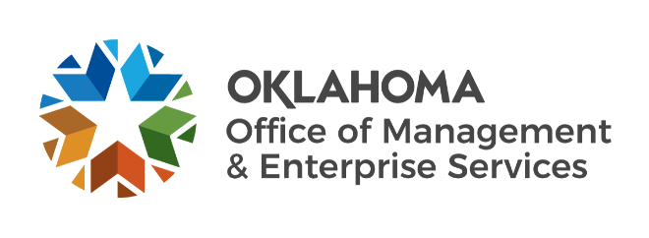

We are OMES recognition March 2022

February new hires – Welcome on board! Glad you have joined us.

ADMINISTRATION
Dedra Blackwell, Administrative Officer.
Eric Isaacs, Business Analyst.
Harold Jones, Administrative Assistant.

CENTRAL PURCHASING
Cristy Newton, Procurement Specialist.

EMPLOYEES GROUP INSURANCE DIVISION
Sarah Menefee, Insurance Subrogation/Reimbursement.

FINANCE
Elizabeth Gerhard, Accounts Payable Technician.
Luan Pham, Procurement Specialist.
Reagan Allen, Temporary.

HUMAN CAPITAL MANAGEMENT
Jade Hightower, Human Resources Business Partner.
Kevin Copeland, People Analytics Lead.

INFORMATION SERVICES
Abdul Nachi, Computer Support Technician.
Brandon Madl, Network Administrator.
David Martin, Business Process Engineer.
Hunter Tiffee, Computer Support Technician.
Travis Austin, Service Desk Technician.
Mark Gilbert, Mulesoft Administrator.
Steven Harrington, Network Technician.
Pablo Hernandez, Business Process Engineer.
Mason Oak, Systems Research Analyst.
Sean Wilson, Cyber Operations Analyst.
Stephanie Dunn, Cyber Operations Analyst.

February position changes – Congratulations! Keep up the good work.
Qhaurium Douglas, Compliance Specialist to Deputy General Counsel, Information Services.
Gwendolyn Martin, Contracting and Acquisitions Agent to Procurement Specialist, Central Accounting and Reporting.
Janet Morrow, Director of Risk Management to CAM Administrator, Capital Assets Management.
Melissa Milburn, Interim CAM Administrator to Construction and REALS Director, Capital Assets Management.
Danny Ingram, IT Manager to Chief Technology Officer, Information Services.
Kenneth Cox, Network Technician to Computer Support Technician, Information Services.
Ty Welch, Procurement Outreach Liaison to Contract Support Specialist, Central Purchasing.
Maddison Knoch, Temporary to Liability Advisor, Capital Assets Management.

February longevity – Thank you! You are much appreciated.
Priscilla Martin, 44 years of service.
William Raney, 37 years of service.
John Burks III, 36 years of service.
Robert Hight, 30 years of service.
Catherine Fellingham, 25 years of service.
Doug Corderman, 20 years of service.
Kenneth Cox, 20 years of service.
Mary Wood, 20 years of service.
Michael Askins, 15 years of service.
Jon Kirchen, 15 years of service.
Amy Miller, 15 years of service.
Peggy Utter, 15 years of service.
Darin Brinson, 10 years of service.
Randy Phan, 10 years of service.
Mitchell Robinson, 10 years of service.
Maurice White, 10 years of service.
Jennifer Knerr, 5 years of service.
Paul Thrower, 5 years of service.
Ismaila Yekini, 5 years of service.

Retirements – Best of luck! We will miss you.

FEBRUARY
Janice Francis, Asset Management Lead, Information Services, 43 years of service.
Paul King, Deputy Administrator, Employees Group Insurance Division, 35 years of service.
Kent Bynum, Former Employee Enrollment Specialist, Employees Group Insurance Division, 20 years of service.

MARCH
Mike Jones, Director of Construction and Properties, Capital Assets Management, 44 years of service.

APRIL
Latisha Edwards, Procure to Pay Manager, Central Accounting and Reporting, 34 years of service.
Esther Ward, Senior Programs Officer, Capital Assets Management, 27 years of service.
James Glover, Firewall Technician, Information Services, 27 years of service.
Lynne Bajema, State Comptroller, Central Accounting and Reporting, 26 years of service.

