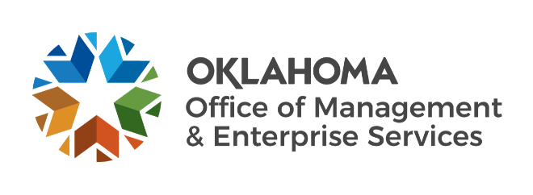

We are OMES recognition June 2023

May new hires – Welcome on board! Glad you have joined us.

CAPITAL ASSETS MANAGEMENT
Stephen Penton, Construction Specialist.

CENTRAL PURCHASING
Kaylan Haywood, Auditor I.

EMPLOYEES GROUP INSURANCE DIVISION
Amber Smith, Former Employee Enrollment Specialist.

FINANCE
Justin Stage, Accounts Payable Technician.

INFORMATION SERVICES
Adam Holman, Service Desk Supervisor.
Awais Shamim, Network Administrator.
Brian Kirkes, Computer Support Technician.
Charles Scott, Enterprise Program Manager.
Christopher Constable, Service Desk Technician.
Justin John, Computer Support Technician.
Keith Seppey, Computer Support Technician.
Kristin Bolding, Computer Support Technician.
Paul Ntumbong, SQL Server Database Administrator.
Robert Hutchison, Computer Support Technician.
Ryan Rogge, Business Continuity and Disaster Recovery Coordinator.

May position changes – Congratulations! Keep up the good work.
Berry Mulford, Senior Maintenance Technician to Facility Manager, Capital Assets Management.
Brandi Evans, Lease Assistant to Fleet Administrative Officer, Capital Assets Management.
Damian Ramirez, FinOps Intern to Budget Analyst I, Information Services.
Donald Yardley, Facility Administrator to Construction Consultants, Capital Assets Management.

May longevity – Thank you! You are much appreciated.
Sharon Saunders, 41 years of service.
Elsa Kunnel, 38 years of service.
Lisa McKeithan, 35 years of service.
Brian Kirkes, 30 years of service.
Keith Hillemeyer, 30 years of service.
Celeste Rogers, 25 years of service.
Tara Walker-Price, 25 years of service.
Steven Graham, 25 years of service.
Katherine Wendell, 20 years of service.
Chris Keeney, 15 years of service.
Sumita Pokharel, 15 years of service.
Nicholas Fortelney, 10 years of service.
Tyler Magar, 10 years of service.
James Saar, 10 years of service.
Tyler McNeely, 10 years of service.
Brandy Murray, 10 years of service.
Alicia Reel, 5 years of service.
Ash Taylor, 5 years of service.
Casey Jones, 5 years of service.

July retirements – Best of luck! We will miss you.
Laura Custer, Applications Specialist, Information Services, 37 years of service.
Julie-Ann Mathis, Contracting Officer, Capital Assets Management, 17 years of service.
Lori Pierce, Senior Compliance Specialist, Information Services, 9 years of service.

