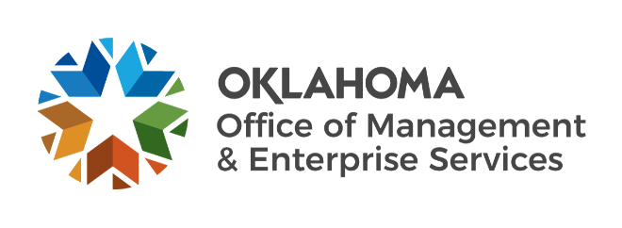

We are OMES recognition June 2022

May new hires – Welcome on board! Glad you have joined us.

BUDGET, POLICY AND GAMING COMPLIANCE
Jody King, Budget Analyst I.

CAPITAL ASSETS MANAGEMENT
Dylan Ellis, Maintenance Technician II.
Rob Santley, Maintenance Technician II.

CENTRAL ACCOUNTING AND REPORTING
Wanda Mayer, Certified Public Accountant.
Megan Patton, Procurement Specialist.
Karlie Hayes, HR Payroll Specialist.

CENTRAL PURCHASING
Richard Diaz, Procurement Specialist.

EMPLOYEES GROUP INSURANCE DIVISION
Jennifer Smith, Current Employee Reconciliation Specialist.
Shantel Allen, Current Employee Enrollment Specialist.

HUMAN CAPITAL MANAGEMENT
Carmin Eulitt, Training Intern.

INFORMATION SERVICES
Tia Blansett, Cyber Operations Supervisor.
Kennedy Carver, Junior Applications Developer.
Christopher Conner, Service Desk Technician.
John Corley, Business Analyst Intern.
Loc Do, Server Operations Support.
Miranda Gilbert, Digital Content Coordinator.
Christopher Giroux, Service Desk Technician.
Crystal Hamilton, Service Desk Supervisor.
Dylan Howard, IS Operations Specialist.
Edward Miller, Applications Developer.
Drake Robison, Network Technician.
Dee Schweitzer, Systems Analyst.
Joshua Shoffner, Chief Technology Officer.
Kayla Taylor, Technical Writer.
David Tomczak, IT Manager.
Jake Kinard, Systems Analyst.
Damian Ramirez, FinOps Intern.
Jacob Roby, Quality Specialist.

May position changes – Congratulations! Keep up the good work.
Felicia Clark, Director of Premium Accountability to Chief Financial Officer, Finance.
Joel Black, IS Operations Specialist to Systems Analyst, Information Services.
James Hall Jr., Network Technician to Computer Support Technician, Information Services.

May longevity – Thank you! You are much appreciated.
Sharon Saunders, 40 years of service.
Elsa Kunnel, 37 years of service.
Nancy Scott, 30 years of service.
Ayana Wilkins, 25 years of service.
Charles Morris, 25 years of service.
James Lutter, 20 years of service.
Randy Glenn, 20 years of service.
Michael Quinlan, 15 years of service.
Lisa Boyd, 10 years of service.
Tonya Orahood, 10 years of service.
Denise Varley, 5 years of service.
Thomas Nunn, 5 years of service.

Retirements – Best of luck! We will miss you.

MAY
Roger Power, Maintenance Technician, Capital Assets Management, 43 years of service.
Cortis Crosby, Construction/Maintenance Technician, Capital Assets Management, 11 years of service.

JUNE
Johnny Burks, Application Services Manager, Information Services, 36 years of service.
Douglas Kellogg, Capitol Administrator, Capital Assets Management, 21 years of service.
Milton Bear, Applications Developer, Information Services, 11 years of service.

